Đặc điểm sinh học dinh dưỡng của cá Thát lát (Notopterus notopterus) phân bố tại đầm Trà Ổ, tỉnh Bình Định

Đặng Thị Thạch Trúc^{1, 2*}, Võ Văn Chí¹

¹Khoa Khoa học tự nhiên, Trường Đại học Quy Nhơn, Việt Nam
²Trung tâm Giáo Dục Nghề Nghiệp – Giáo Dục Thường Xuyên, Việt Nam

*Tác giả liên hệ chính. Email: thachtruc95@gmail.com

TÓM TẮT
Nghiên cứu này được thực hiện để xác định đặc điểm sinh học dinh dưỡng của cá Thát lát (Notopterus notopterus) phân bố tại đầm Trà Ổ, tỉnh Bình Định. Mẫu cá được thu định kỳ hàng tháng để phân tích hình thái giải phẫu hệ tiêu hóa, chỉ số sinh trắc ruột (RLG) và thức ăn tự nhiên của cá. Hình thái cấu tạo của hệ tiêu hóa của cá (răng nhỏ nhọn, lưỡi có răng sắc nhọn, dạ dày lớn, ruột ngắn) và chỉ số sinh trắc ruột (RLG) (dao động từ 0,3 đến 0,36) cho thấy cá có tính ăn thiên về động vật. Thành phần thức ăn tự nhiên của cá gồm có giáp xác, ấu trùng côn trùng, rễ thực vật thủy sinh và mùn đáy, trong đó tần số xuất hiện của thức ăn động vật là rất cao (95,8%). Như vậy, có thể nói rằng, cá Thát lát có tính ăn tạp nhưng thiên về động vật.
Từ khóa: Cá Thát lát, hệ tiêu hóa, tập tính ăn, thức ăn tự nhiên.

Feeding Biology of Bronze featherback (Notopterus notopterus) distributed in Tra O lagoon, Binh Dinh province

Dang Thi Thach Truc^{1, 2*}, Vo Van Chi¹

¹Faculty of Natural Sciences, Quy Nhon University, Vietnam
²Center for Vocational Training - Continuing Education, Vietnam

*Corresponding author. Email: thachtruc95@gmail.com

ABSTRACT
This study was conducted to determine the feeding biology of Bronze featherback (Notopterus notopterus) distributed in Tra O lagoon, Binh Dinh province. Fish samples were monthly collected to analyze anatomical morphology of digestive system, the relative length of the gut (RLG) and natural food of fish. The morphological characteristics of the fish's digestive system (small sharp - pointed teeth, sharp teeth on the tongue, big stomach, short intestines) and the relative length of the gut (from 0.3 to 0.36) indicate that this fish is a carnivorous species. The natural food composition of fish included crustaceans, larvae of insects, aquatic plant roots and humus, of which the occurrence frequency of food which are animals was very high (95.8%). Thus, it can be said that Bronze featherback is an omnivore but focusing on animals.
Keywords: Bronze featherback, digestive system, feeding behavior, natural food.

1. INTRODUCTION
Tra O lagoon is a natural freshwater lagoon, having characteristics of the coastal lagoon system in Central Vietnam. The lagoon covers an area of about 1600 hectares. The lagoon supplies the local community with a large amount of aquatic products every year. Of which, there are many products having high economic value, that take a part to solve living needs of majority of coastal residents and contribute to the general socio-economic development of the locality and Binh Dinh province.
Bronze featherback distributed in this lagoon is one of economically valuable species that are considered. This fish species has delicious meat, especially plasticity of its meat, so it is often used to produce fish cakes, which is a special food in Phu My district in particular and Binh Dinh province in general. Therefore, the consuming demand of Bronze featherback inhabiting in Tra O lagoon is increasing. This is the cause of overexploitation, that leads to seriously decrease the mass of this fish in the wild and the commercial size of this fish is smaller and smaller. Thus, carrying out the complete and systematic studies on the basic biological characteristics of Bronze featherback, especially feeding biology, is essential to contribute to the effective conservation of this economically valuable species. In addition, studying on feeding biology of Bronze featherback will supply the important base for grow-out culture and breeding of this species to meet the market requirement and reduce pressure of exploitation for fish resources, as well as to diversify new cultured species in the locality.

2. SUBJECT AND METHODS
2.1. Subject
Bronze featherback (Notopterus notopterus) distributed in Tra O lagoon, Binh Dinh province.
2.2. Methods
2.2.1. Sampling and treating fish samples
Fish with different sizes were collected every month in Tra O lagoon. Based on size of fish collected, we divided fish into 3 groups: <15 cm, 15 - 18 cm and > 18 cm.
After being colleted, the fish were freezed and brought to the Animal Science Laboratory, Faculty of Natural Sciences, Quy Nhon University to analyse within the day or fixed in 5 - 10% formol solution for later analysis.
2.2.2. Examining the digestive system and feeding habit of fish
Describing the characteristics of the digestive system (focusing on organs such as mouth, teeth, gill rakers, intestine) by observing of morphological and anatomical characteristics.
Examining feeding habit of fish: Based on the relative length of the gut (RLG) according to Al-Hussainy.¹
RLG = $\frac{Li}{L}$
Where: + Li: Length of the gut of fish (cm)
+ L: Total length of fish (cm).
2.2.3. Analysing natural food of fish
We dissected fish to analyze natural food in fish stomachs or intestines. Stereomicroscope and optical microscope were used to analyze and identify prey items of fish. Then, these prey items were classified to the lowest possible taxon based on classification documents.^{2,3}
- We determined occurrence frequency (%O) of each of food item using formula of Hyslop:⁴
Oi% = $(\frac{Number of stomach containing prey i}{Total number of analysed stomach })×$ 100
3. RESULTS AND DISCUSSION
3.1. Digestive system and feeding habit of fish
According to our observation, the digestive system of Bronze featherback also included organs like most other fish species. To identify feeding habit of this fish, we focussed on describing some of the following organs:
- Mouth: Mouth was relatively large, with a short flat snout; maxilla extended to anterior eye orbit (Figure 1).
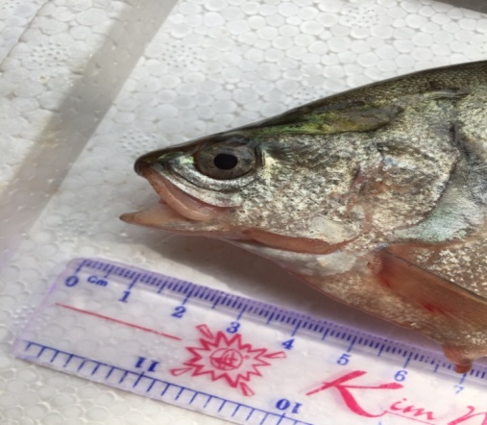
Figure 1. Morphology of mouth of Bronze featherback
- Teeth: There were small pointed teeth with rough teeth surface on both jaws (Figure 2). According to Nguyen Bach Loan,⁵ fish that eat small animals often have small, smooth teeth. Thus, based on the described teeth characteristics, Bronze featherback can be a predator.
- Tongue: The tongue was well developed and movable, that had sharp teeth on the tip (Figure 2). Such morphological characteristics of the tongue show the adaptation of fish as carnivorous behavior; it can be that tongue is used to hold or tear prey when fish eat.
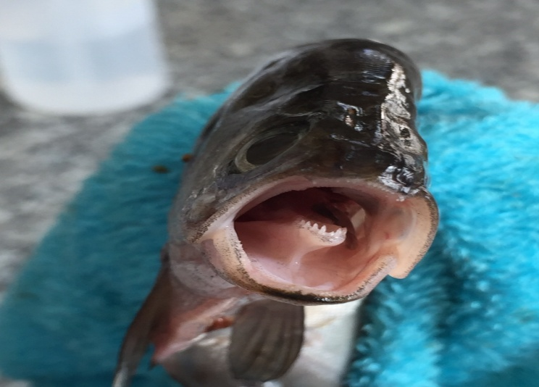
Figure 2. Morphology of teeth and tongue of Bronze featherback
- Gill rakers: As our observations, Bronze featherback had four separate pairs of gill arch. Each gill arch had 2 rows of white gill rakers. For the first gill arch, a row of gill rakers was rod-shaped, short, thin, relatively pointed and sparse, that has its bottom attached to gill arch and its tip directed to the mouth cavity while another row of gill rakers was spiny knobs. For other gill arches, both rows of gill rakers were spiny knobs (Figure 3). According to Vu Trung Tang and Nguyen Dinh Mao,⁶ the shape and size of gill rakers of fish are often suitable for their feeding behavior. Fish eating small animals have thin, and sparse gill rakers while gill arches of fish eating large animals have sharp spines or their gill rakers form spiny knobs.⁵ Thus, based on the morphological characteristics of gill rakers, it can be said that Bronze featherback can be a carnivore.
- Esophagus: Esophagus is linked to the pharynx, that moves food into the stomach. The esophagus of Bronze featherback was short, tubular, easily stretched and its wall was thick (Figure 4).
- Stomach: Stomach, that contains food and release digestive enzymes to digest food, is connected to the esophagus. Stomach of bronze featherback was bag-shaped, relatively large and its wall was thick (Figure 4).
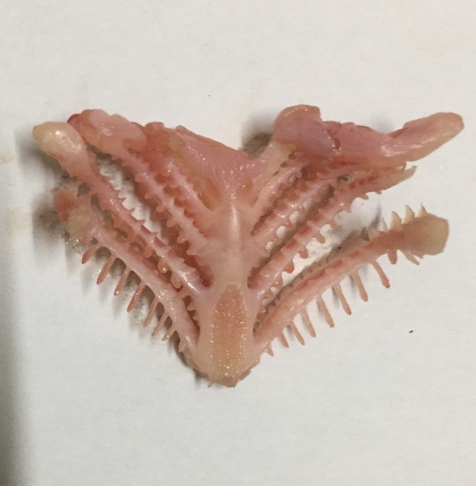
Gill raker
Gill arch
Figure 3. Morphology of gill arches and gill rakers of Bronze featherback
- Intestine: Intestine is the end part of the digestive tract, that connects the stomach and the anus of fish. It releases digestive enzymes and absorbs nutrients. The intestine of Bronze featherback was relatively short, large at the beginning, and had folds (Figure 4).
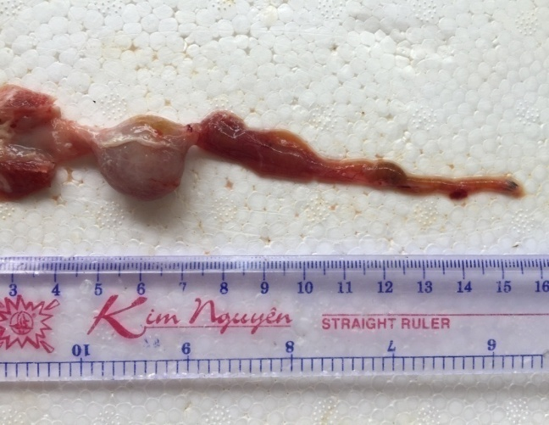
Esophagus
Stomach
Intestine
Figure 4. Morphology of stomach and intestin of Bronze featherback
The length of fish gut depends on natural food that they consume and this increases with increasing rate of plant in fish diet.⁷ Therefore, to determine more accurately feeding habit of fish, we calculated the correlation index between the gut length (Li) and total length of fish (L) (The relative length of the gut - RLG). Results recorded on 228 individuals of fish with 3 size classes are shown in Table 1.
Bronze featherback had relatively low value of RLG that was from 0.30 to 0.36 (Table 1). According to Nikolsky,⁸ carnivorous fish usually have RLG <1. Therefore, it can be said that Bronze featherback is also a carnivore. The results in Table 1 also showed that RLG varied between different size classes of fish. Specifically, RLG of size class of fish > 18cm (0.36) was higher than this of size class 15 - 18cm (0.35) and size class <15cm (0.30). This shift can be the adaptability of fish in each ontogenetic stage.
Table 1. RLG of Bronze featherback
Size class of fish (cm) | Length of gut - Li (cm) | Total length of fish - L (cm) | RLG
< 15 cm | 4.0 ± 0.13 | 13.6 ± 0.12 | 0.30
15 - 18 cm | 5.7 ± 0.08 | 16.5 ± 0.07 | 0.35
> 18 cm | 7.0 ± 0.16 | 19.5 ± 0.15 | 0.36
Based on analysed results of morphological characteristics of digestive system and RLG, it can be seen that Bronze featherback is a carnivore. However, to more exactly examine feeding habit of this fish, we analyzed the composition of natural food in their stomach. The results are shown in the next section.
3.2. Natural food of fish
Because it is impossible to directly observe feeding behavior of fish in the wild, so the best way to determine feeding habit of fish is to analyze the composition of food in the gut or stomach of fish.⁷
The results of analysing natural food composition in the stomachs containing food of 216 fish individuals are shown in Table 2.
It can be seen from Table 2 that the natural food of Bronze featherback included humus, aquatic plant roots, crustaceans, larvae of insects. Of which, crustacean had highest occurrence frequency (63,4%), followed by humus (44,0%), larvae of insects (32,4%) and aquatic plant roots (19,9%). For larvae of insects, family Petaluridae (order Odonata) appeared with the highest frequency (13,4%) while family Philopotamidae (order Trichoptera) had the lowest occurrence frequency (5,1%).
According to Vu Trung Tang and Nguyen Dinh Mao,⁶ for omnivores, that eat both plants and animals and also humus, there are those eating more animals than plants, and others eating more plants than animals. It can be seen that animals take 95.8% while plants only hold nearly 20% of the occurrence frequency in natural food composition of Bronze featherback. Thus, combining the results of analysis of natural food composition and the morphological and anatomical characteristics of the digestive system, it can be concluded that Bronze featherback is an omnivorous fish but focuses on animals.
Table 2. The natural food composition of Bronze featherback
Food composition | Occurrence frequency (%O)
Humus | 44.0
Aquatic plant roots | 19.9
Crustaceans | 63.4
Larvae of insects | 32.4
Order Trichoptera  - Family Philopotamidae | 5.1
Order Odonata  - Family Petaluridae | 13.4
Order Odonata  - Family Lestidae | 6.9
Order Diptera  - Family Chironomidae | 6.9
4. CONCLUSION
Bronze featherback has the relatively large mouth, small pointed teeth; there are sharp pointed teeth on tongue; there are two types of gill rakers: rod-shaped, short, thin, and sparse gill rakers and knob-shaped gill rakers.
Stomach of fish is relatively big and bag-shaped. Intestine is relatively short and has folds. The relative length of the gut (RLG) is from 0.3 to 0.36.
The morphological and anatomical characteristics of digestive system and RLG value show that Bronze featherback is a carnivore.
The natural food composition of this fish includes humus, aquatic plant roots, crustaceans, larvae of insects. Of which, animals are dominant prey that take 95,8% of occurrence frequency.
Based on all findings of this study, it can be said that Bronze featherback is an omnivore but tends to be a carnivore.
REFERENCE
- Al-Husainy, A.H. On the functional morphology of the alimentary tract of some fishes in relation to differences in their feeding habits, Quarterly Journal of Microscopical Science, 1949, 9(2), 190-240.
- Nguyen Xuan Quynh, Clive Pinder, Steve Tilling. Identification of freshwater invertebrates common in Vietnam, Hanoi National University Publishing House, Hanoi, 2001. (in Vietnamese).
- Đang Ngoc Thanh, Ho Thanh Hai. Shrimps, crabs in Vietnam (Palaemonidae, Atyidae, Parathelphusidae, Potamidae), Natural Sciences and Technology Publishing House, Ha Noi, 2012. (in Vietnamese).
- Hyslop E.J. Stomach contents analysis: a review of methods and their application, Journal of Fish Biology, 1980, 17, 411-429.
- Nguyen Thi Bach Loan. Ichthyology I, Faculty of Fisheries, Can Tho university, 2003. (in Vietnamese).
- Vu Trung Tang, Nguyen Đinh Mao. Ichthyology, Agriculture Publishing House, Ho Chi Minh, 2005. (in Vietnamese).
- Pham Thanh Liem and Tran Đac Đinh. Methods for studying fish biology, Can Tho university, 2004. (in Vietnamese).
- Nikolski G.V. Ecology of fishes, Acedemic press, London, 1963.

