DỰ ĐOÁN BỆNH TIỂU ĐƯỜNG SỬ DỤNG HỒI QUY LOGISICTIC DỰA VÀO TẬP DỮ LIỆU PIMA INDIANS
Nguyen Quoc Duong^{1,*}, Dang The Vinh Hien¹

¹Ngành Sư phạm Toán, Khoa Sư phạm, Trường Đại học Quy Nhơn, Việt Nam

*Tác giả liên hệ chính. Email: nguyenquocduongqnu1999@gmail.com

TÓM TẮT
Tiểu đường là một loại bệnh mãn tính và là một thách thức lớn đối với sức khỏe cộng đồng trên toàn thế giới. Sử dụng các phương pháp khai thác dữ liệu để giúp mọi người dự đoán bệnh tiểu đường đã trở thành một chủ đề phổ biến. Trong nghiên cứu này, Logistic Regression đã được đề xuất để dự đoán xem một bệnh nhân có mắc bệnh tiểu đường hay không. Bộ dữ liệu được sử dụng là bộ dữ liệu bệnh tiểu đường của người Pima Indians, bộ dữ liệu này thu thập thông tin của bệnh nhân mắc và không mắc bệnh tiểu đường loại 2. Ngôn ngữ R đã được sử dụng trong suốt nghiên cứu này. Cuối cùng, AUC (Area Under The Curve) được sử dụng để đánh giá kết quả của một dự đoán và độ chính xác của mô hình thu được là 83,3%.
Từ khóa: Mô hình hồi quy logisitic, bệnh tiểu đường, bệnh tiểu đường loại 2, Pima Indians diabetes, dự báo.

LOGISTIC REGRESSION MODEL FOR DIABETES PREDICTION BASED ON PIMA INDIANS DIABETES DATASET

Nguyen Quoc Duong^{1,*}, Dang The Vinh Hien¹

¹Mathematics Pedagogy, Department of Education, Quy Nhon University, Viet Nam

ABSTRACT

Diabetes is a chronic disease and a major public health challenge worldwide. Using data mining methods to aid people to predict diabetes has become a popular topic. In this study, Logistic Regressionwas proposed to predict if a patient has diabetes. The dataset used is the Pima Indians Diabetes Data Set, which collects the information of patients with and without developing Type-2 diabetes. R language was used throughout this study. Finally, the AUC (Area under the ROC curve) was used to evaluate the outcome of a prediction and the accuracy of the resulting model was 83.3%.

Keywords: Logisitic regression model, diabetes, type-2 diabete, Pima Indians diabetes, predict.

1. INTRODUCTION
Diabetes is a chronic, metabolic disease characterized by elevated levels of blood glucose (or blood sugar), which leads over time to serious damage to the heart, blood vessels, eyes, kidneys and nerves. The most common is type 2 diabetes, usually in adults, which occurs when the body becomes resistant to insulin or doesn't make enough insulin. Diabetes of all types can lead to complications in many parts of the body and can increase the overall risk of dying prematurely. Possible complications include kidney failure, leg amputation, vision loss and nerve damage. Adults with diabetes also have two to three fold increased risk of heart attacks and strokes. In pregnancy, poorly controlled diabetes increases the risk of fetal death and other complications. In the past three decades the prevalence of type 2 diabetes has risen dramatically in countries of all income levels. According to a study by the World Health Organization (WHO), about 422 million people worldwide have diabetes, the majority living in low-and middle-income countries, and 1.6 million deaths are directly attributed to diabetes each year. Both the number of cases and the prevalence of diabetes have been steadily increasing over the past few decades.¹
In developing nations, most publics with diabetes are aged between 35 and 64. WHO already made an alarm that Diabetes is the 7th leading cause of death in the world in 2030. In 2012, an estimated 1.5 million deaths were straightly triggered by diabetes. In this, more than 80% of diabetes deaths occur in low and middleincome countries. Total deaths from diabetes are projected to rise by more than 50% in the next 10 years.¹
Data mining is closely related to the statistics as an applied mathematical discipline with an analysis of data that could be defined as the extraction of useful information from data. Data mining has been developing, reliable, and supporting tool in the medical domain in recent years. The data mining method is used to preprocess and select the relevant features from the healthcare data, and the machine learning method helps automate diabetes prediction.² Data mining and machine learning algorithms can help identify the hidden pattern of data using the cutting-edge method; hence, a reliable accuracy decision is possible.³ Furthermore, developing medical intelligence out of the clinical data available will create healthcare system to be patient-centered and will reduce medical cost and hospital readmission too. Further, R is a simple, but very powerful data mining and statistical data processing tool and once “discovered”, it provides users with an entirely new, rich and powerful tool applicable in almost every field of research.
According to the reasons given above, the objective of this study is to predict if a patient has diabetes for the Pima Indians Diabetes Data set using logistic regression algorithm, based on information about the patient such as blood pressure, body mass index (BMI), age, etc. There have been many researchers reviewing this data set. Example, Wu applied improved k-means cluster algorithm, and logistic regression algorithm got 95.42% accuracy, which was 3.04% higher accuracy than the rest.⁴ Patil proposed Hybrid Prediction Model (HPM) which is based on basic $k$-means clustering algorithm and seeks to validate the chosen class label of provided data and obtained an accuracy of 92.38%.⁵ Tapak compared the traditional classification methods (logistic regression and Fisher linear discriminant analysis) and four machine learning classifiers (neural networks, support vector machines, fuzzy c-mean and random forests), among which the performance of support vector machine was the highest with an accuracy of 98.6%.⁶ Although many of the researchers worked in this field and found accuracy more than 90%, there is a chance of overfitting because of high accuracy rate. Overfitting occurs when the model tries to adapt too much to the training data. In other words, the model tries to learn the training data and fits really well to the dataset. The problem with overfitting is that when a new value is added to the dataset, the model misbehaves and is unable to classify because it is so well fitted to the training data.⁷
2. METHODOLOGY
2.1. Data
The data set used for the purpose of this study is Pima Indians Diabetes Database of National Institute of Diabetes and Digestive and Kidney Diseases. This diabetes database, donated by Vincent Sigillito, is a collection of medical diagnostic reports of 768 examples from a population living near Phoenix, Arizona, USA. In particular, all patients are females at least 21 years old of Pima Indian heritage. More information on the dataset can be read by accessing the website https://www.kaggle.com/-johndasilva/diabetes. Information available includes 9 variables, such as, Age, Number of Pregnancies, Glucose, Insulin, etc. The response variable in the dataset is a binary classifier, Outcome, that indicates if the person was diagnosed with Diabetes or not.
The data set is comprised of 768 observations and 9 variables. We will be using Outcome as our response/target variable. Data Description for the 9 variables are as follows: 1. Pregnancies: Number of times pregnant; 2. Glucose: Plasma glucose concentration at 2 hours in an oral glucose tolerance test; 3. BloodPressure: Diastolic blood pressure (mm Hg); 4. SkinThickness: Triceps skin fold thick-ness (mm); 5. Insulin: 2-Hour serum insulin ($μU/ml$); 6. BMI: Body mass index (weight in kg/(height in m)²); 7. DiabetesPedigree-Function: Synthesis of the history of Diabetes Mellitus in relatives, generic; 8. Age: Age of the individual (years); 9. Outcome: Occurrence of Diabetes.
2.1. Logistic regression
As we know that Logistic Regression is one of the most used Machine Learning algorithms for binary classifycation. It is a simple Algorithm that you can use as a performance baseline, it is easy to implement and it will do well enough in many tasks. Logistic regression models the probability of an event dependent on the values of independent variables, either categorical or numerical.⁸ The dependent variable in a logistic regression follows the Bernoulli’s distribution. Contrary to the binomial distribution, the probability distribution of the dependent variable in Bernoulli’s distribution is unknown. Thus, in logistic regression, an unknown probability, is estimated for any given linear combination of the independent variables. To perform this, it is required to link together the independent variables to the Bernoulli’s distribution using a link function, where the natural log of the odds ratio or the logit acts as link function. This function maps the linear combination of independent variables on to the Bernoulli’s probability distribution with a domain ranging from 0 to 1. The natural log of odds, in turn, is equal to a linear function of the independent variables. Hence, logistic regression models the logit-transformed probability as a linear relationship with the predictor variables and is shown by equation $\log\left(P\right)=log\left(\frac{P}{1-P}\right)=y$, where $log\left(\frac{P}{1-P}\right)$ is called the logarithm of the odd, also known as logodd or logit.
The odds reflect the possibility that the component fails. It is the ratio of “successes” to “non-successes” i.e., odds are the probability of the event that the component fails; divided by the probability of the event that component does not fail ($P$). Also, $y=β_{0}+β_{1}X_{1}+β_{2}X_{2}+…+β_{p}X_{p}$, where $y$ is the risk of failure, and $β_{0}, β_{1}, β_{2}, …, β_{p}$ are regression beta coefficients of explanatory variables $X_{1},X_{2}, …, X_{p}$. The risk of failure ($α$) is predicted in terms of $β_{0}, β_{1}, β_{2}, …, β_{p}$. The antilog of the logit function is expressed in equation $e^{y}=\frac{P}{1-P}$. Therefore, probability of the risk of failure, “$P$”, is obtained and is shown in equation $P=\frac{e^{β_{0}+β_{1}X_{1}+β_{2}X_{2}+…+β_{p}X_{p}}}{\left(1+e^{β_{0}+β_{1}X_{1}+β_{2}X_{2}+…+β_{p}X_{p}}\right)}$.
3. RESULTS AND DISCUSSION
3.1. Data Exploration
The code is used to analyze for this research is found at https://github.com/nguyenquocduong-qnu/diabetes. The response variable (Outcome) is the focus of a question in a study or experiment. The dataset has 268 observation that were diagnosed with Diabetes and 500 observation that did not have Diabetes. The sample has a high occurrence (34%) of positive records of Diabetes. We attain the output as shown in Figure 1.
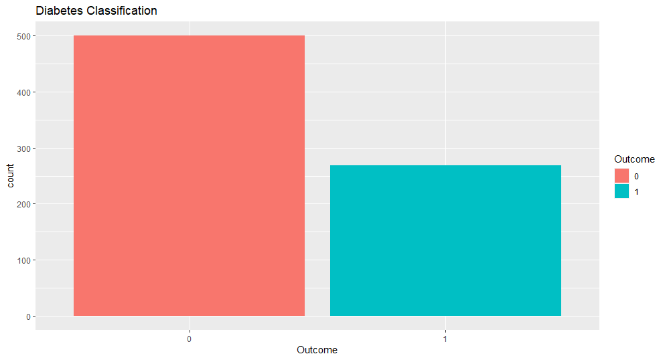
Figure 1. Explore Outcome variables.
Predictor variables Pregnancies: from the figures below, it’s evident that women who have been diagnosed with Diabetes have had more pregnancies than women who were not (in this dataset). However, from the histogram below, there’s no clear relationship between the number of pregnancies and the occurrence of Diabetes. We then have the output as shown in Figure 2.
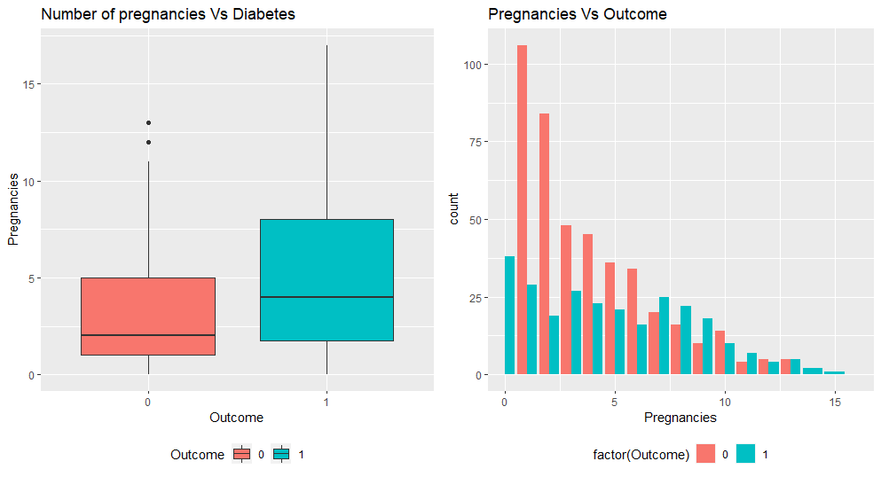
Figure 2. Explore Pregnancies variables.
Glucose variables: from the figures below, there’s a clear difference in the amount of Glucose present in the women who have been diagnosed with Diabetes and those who haven’t. While the density plot indicates an overlap in the levels of glucose in both categories of women, the below plots show that Glucose could be a good indicator of the response, the output is as Figure 3.
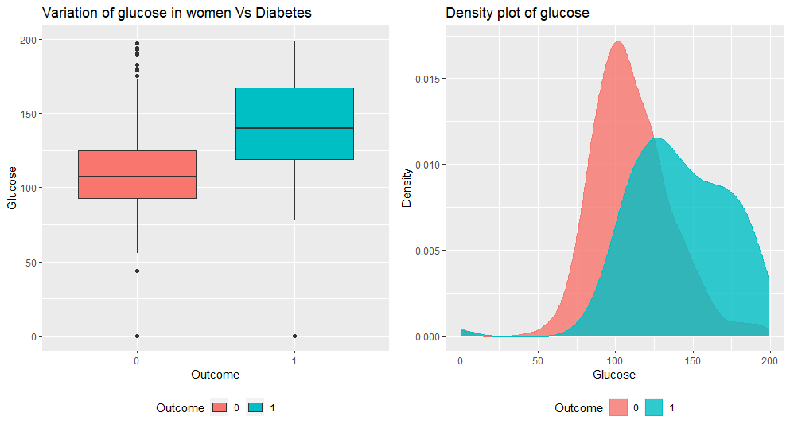
Figure 3. Explore Glucose variables.
BloodPressure variables: from the below plots, no clear difference is seen in the two categories of women who have and don’t have Diabetes. This shows that Blood Pressure might not be a good predictor of the response variable.
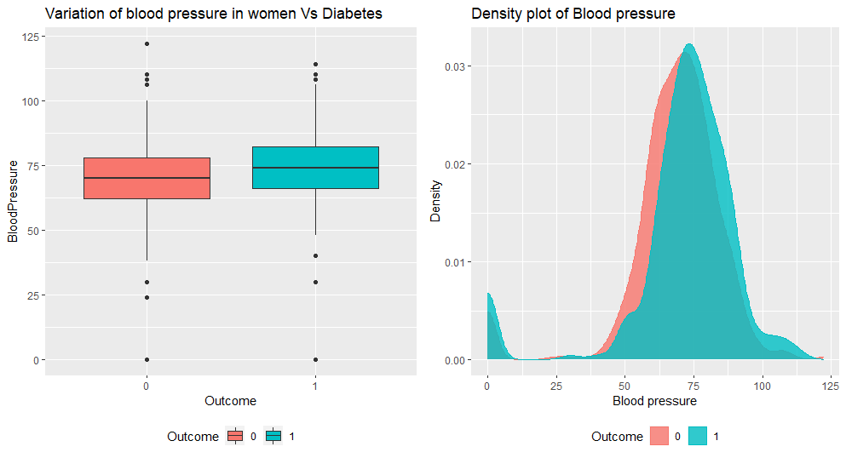
Figure 4. Explore BloodPressure variables.
SkinThickness variables: from the below plots, no clear difference can be seen in the two categories of women who have and don’t have Diabetes. This shows that Skin Thickness might not be a good predictor of the response variable.
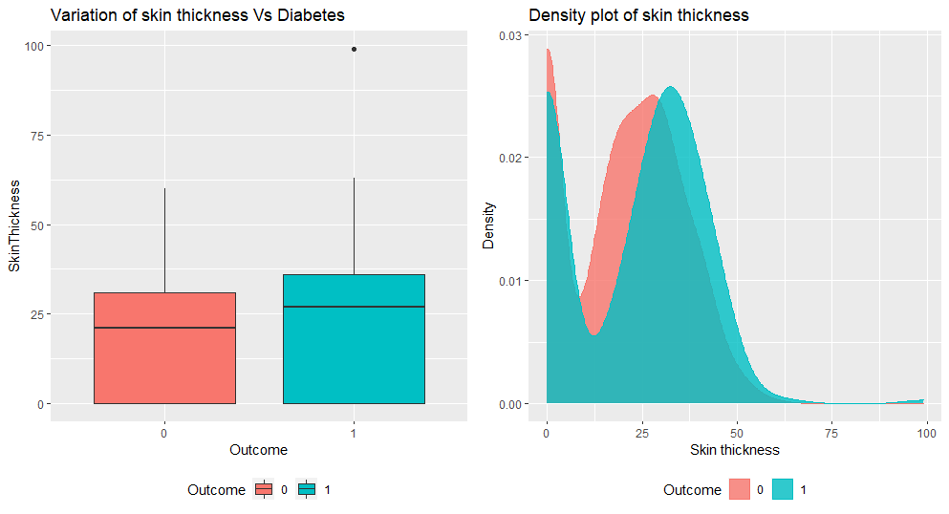
Figure 5. Explore SkinThickness variables.
Insulin variables: Again, no clear difference can be observed between the categories of women in the data, indicating Insulin may not be a good predictor of the response variable.
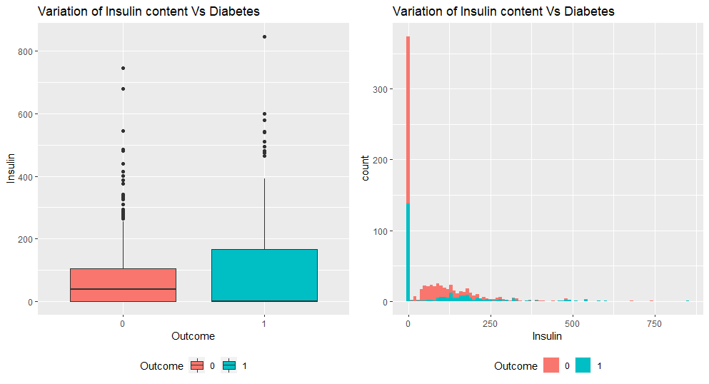
Figure 6. Explore Insulin variables.
BMI variables: The below plots show that all the women who had Diabetes had a BMI greater than 25, which is above the normal levels. On the other hand, women who did not have Diabetes had a BMI ranging from 18 to 60.
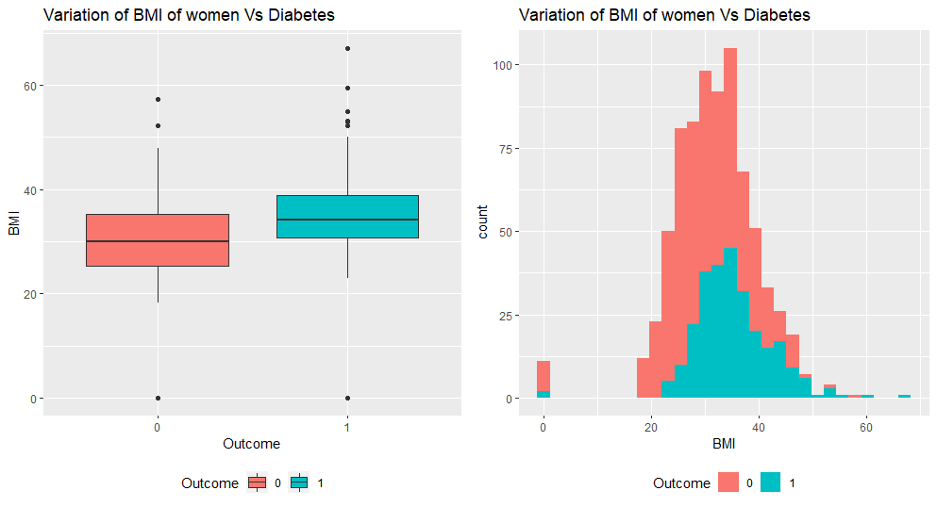
Figure 7. Explore BMI variables.
DiabetesPedigreeFunction variables: From fig 8, no clear difference can be seen in the two categories of women who have and don’t have Diabetes. This shows that DPF might not be a good predictor of the response variable.
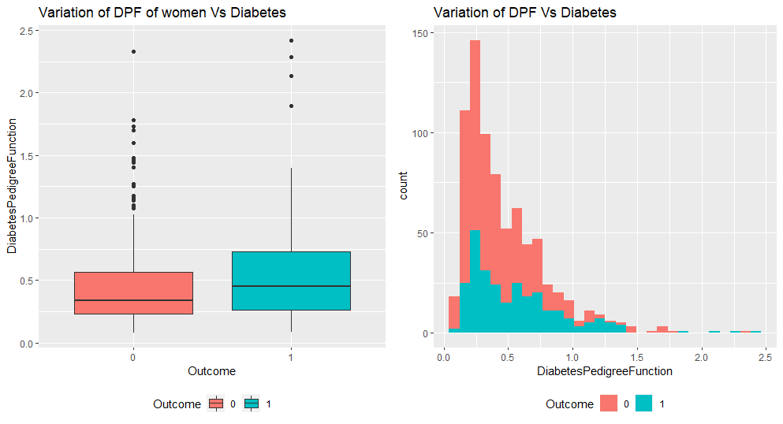
Figure 8. Explore DiabetesPedigreeFunction variables.
Age variables: Again, no clear distinction is seen in the distribution of the Age variables for women that have Diabetes versus those who don’t. We attain the output as shown in Figure 9.
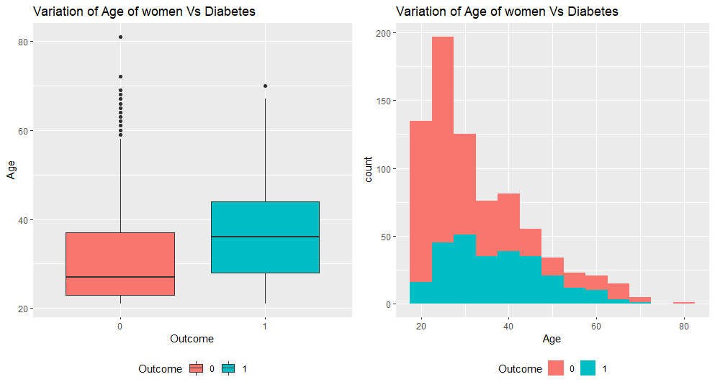
Figure 9. Explore Age variables.
Correlation analysis is a statistical method used to evaluate the strength of relationship between two quantitative variables. A high correlation means that two or more variables have a strong relationship with each other, while a weak correlation means that the variables are hardly related. Subsequently, a correlation plot was drawn between all the numerical variables to establish the linear association between each other. As observed in the bivariate associations, Insulin and Glucose, BMI and Skin Thickness had a moderate – high linear correlation. From Figure 10, the following inferences can be made:
- No clear boundary can be drawn that separates Non-diabetic and Diabetic women based on Number of Pregnancies vs Age.
- Non-diabetic women seemed to have lower levels of Insulin and Glucose as opposed to Diabetic women who recorded low to high levels of Insulin and high levels of Glucose.
- Women who have Diabetes can be differentiated from those who don’t have based on BMI and BP values.
- Women with low values of BMI and Skin Thickness did not have Diabetes.
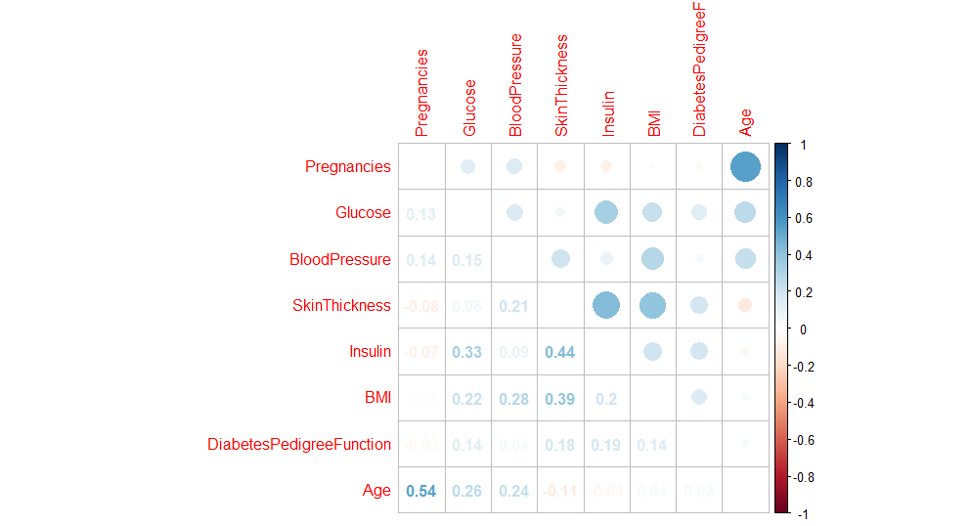
Figure 10. Correlation analysis.
From Figure 10, by looking at the scatterplot mattrices, we can make an assumption that the data’s dots in Skin Thickness might have correlation with BMI. The coefficient in the correlation plot shows 0.39 between BMI and Skin Thickness which means there is a moderate positive relationship. It also shows correlation coefficient of 0.54 between Age and Pregnancies and 0.33 between Insulin and Glucose. These coefficients measure the strength and direction of a linear relationship between two variables. However, these coefficients from the scatterplot are not strong enough to assure that there are a significant relationship among the covariates. So we can do further analysis without dropping any columns.
3.2. Modeling Approach
To build a predictive model that classifies women with/ without Diabetes, the following modeling approach was used.
- Model Building: The modeling technique performed on this data by Logistic Regression. The data set was split into an 80-20 train-test data set.
- Model Performance Evaluation: Model performance was evaluated for each model using sensitivity as the criterion for the 80% training (in-sample) and 20% (out-of-sample). Sensitivity is the ability of the model to determine the true cases correctly, in this case, identify the patients with Diabetes correctly.
A full model was built with Outcome as the response variable with the rest of the 8 predictor variables. Step-wise variable selection method was used to identify the most important variables. The final model chosen with AIC (Akaike’s Information Criteria) as the criterion for selection generated a logistic regression model with the lowest AIC value of 591.27 as below.
Outcome ~ Pregnancies + Glucose + BloodPressure + SkinThickness + Insulin + BMI + DiabetesPedigreeFunction + Age
#AIC= 592.28
Outcome ~ Pregnancies + Glucose + BloodPressure + SkinThickness + Insulin + BMI + DiabetesPedigreeFunction
#AIC = 593.27
Outcome ~ Pregnancies + Glucose + BloodPressure + Insulin + BMI + DiabetesPedigreeFunction
#AIC= 591.27
Outcome ~ Pregnancies + Glucose + BloodPressure + BMI + DiabetesPedigreeFunction
#AIC = 592.55

Model’s summary above contains lot of information. But, we need more focus on $Pr(>|t|)$ and AIC. From $Pr(>|t|)$ above, we can get information on which predictors have a significant influence on the target, if the value is below 0.05 (alpha), we asume that the variable has significant effect toward the model, and then the smaller the $Pr(>|t|)$ value, the more significant the predictors have on the target, and to make it easier, there is a star symbol which indicates the more stars the more significant the predictor’s influence on the target.
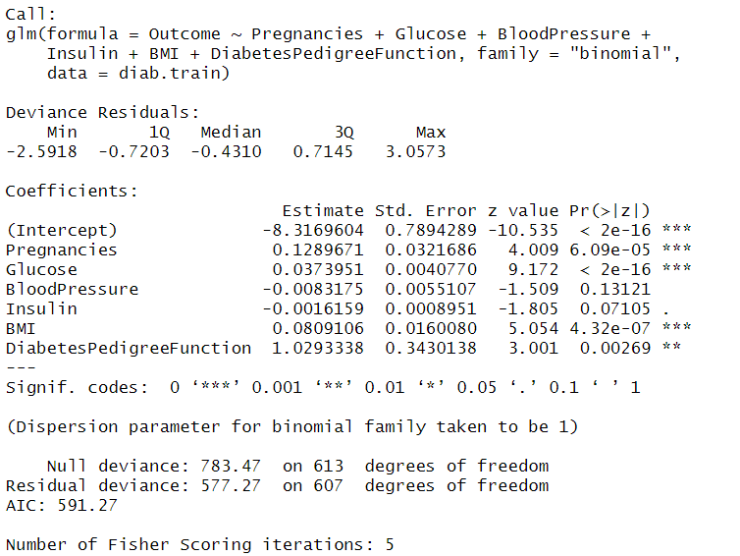
As we interpret estimated coefficent of our significant covariates, we come up with the conclusion that when a person have pregnancy, increasing Pregnancies, Glucose, Blood-Pressure, BMI and DiabetesPedigreeFunction will likely have diabetes. The model will look like:
$$Outcome = -8.31+ 0.12*Pregnancies + 0.03* Glucose-0.008*BloodPressure-0.001*Insulin+0.08* BMI + 1.02*DiabetesPedigreeFunction$$
3.3. Predicting and assessing model accuracy
After choosing the best model for our dataset, then we need to test our model performance using testing dataset that we have splitted above. The performance of the models was compared across the in-sample training data (80% of the data) and the out-of-sample testing data (20% of the data).
The ROC (Reciever Operating Characteris-tics) curve is a popular graphical measure for assessing the performance or the accuracy of a classifier, which corresponds to the total proportion of correctly classified observations. We can use the roc function from the pROC package to generate the ROC curve for our predictions. We attain the output as shown in Figure 11.
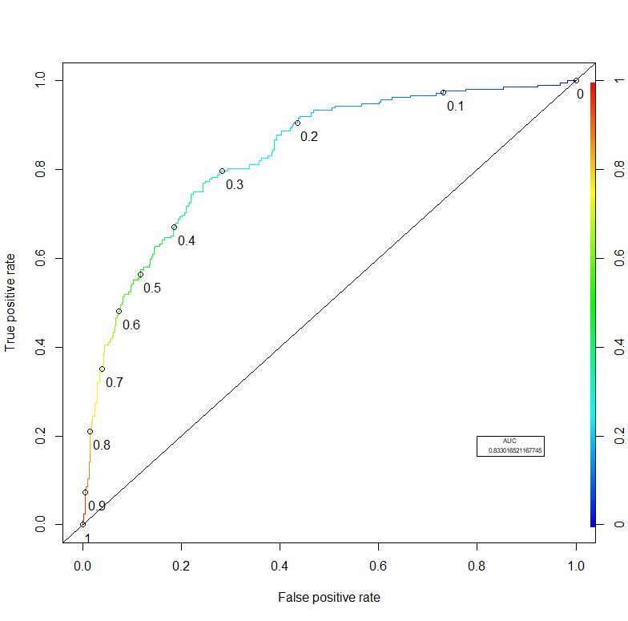
Figure 11. Reciever Operating Characteristics.
In general, we would like the curve to “hug” the right and upper borders of the plot (indicating high sensitivity and specificity). We can see that the ROC curve is really close to the top left corner which is just a way of saying that the model’s accuracy is good. From this ROC curve we can see that the model is better at discriminating between positives and negatives in general. The AUC is used to quantify the visual profile of the ROC. From the above graph it is inferred that AUC gives an accuracy rate of approx 83.3%. AUC metric ranges from 0.50 to 1.00 and more closer the AUC is to 1.00, more it indicates that the model does a good job in discriminating between the two categories which comprises our target variable - Outcome.
4. CONCLUSIONS
In this study, we used Logistic regression model to predict the presence of diabetes based on some relevant covariates. Our preferred model indicates that five of the variables in the data are related to diabetes. The model has an accuracy of around 83.3% on both training and testing data. Therefore, our model has performed reasonably well on the Prima Indian Diabetes dataset that speaks volumes about our model’s adaptability in predicting diabetes. Thus, the work seems to be beneficial for predicting type 2 diabetes.
High-risk factors of diabetic individuals vary dramatically, and many patients suffer complications and avoidable harm. Improving the identification level of high-risk factors would help to reduce the rate of complications. To do this, it is essential to analyze a person's medical record, detailed health information that currently requires doctors and is manual, time-consuming, and subjective.⁹
Diabetes is a growing problem in Vietnam and is associated with obesity, changes in dietary patterns, and other cultural transitions.¹⁰ More research is needed to better understand this health care problem and to devise targeted interventions. In the future, we are planning to use the present study as a baseline to perform a cohort study to investigate the incidence, causes, and prognosis of diabetes for datasets in Viet Nam.¹¹⁻¹³

REFERENCES
- Diabetes, https://www.who.int/healthtopics/-diabetes, accessed 05/04/2021.
- G. Swapna, R. Vinayakumar, K.P. Soman. Diabetes detection using deep learning algorithms, ICT Express, 2018, 243–246, http://dx.doi.org/10.1016/j.icte.2018.10.005.
- M.W. Craven, J.W. Shavlik. Using neural networks for data mining, Future Gener. Comput. Syst., 1997, 211–229, http://dx.doi.org/-10.1016/s0167-739x(97)00022-8.
- H. Wu, S. Yang, Z. Huang, J. He, X. Wang. Type 2 diabetes mellitus prediction model based on data mining, Inform Med Unlock, 2018, 100–107.
- B.M. Patil, R.C. Joshi, D. Toshniwal. Hybrid prediction model for type-2 diabetic patients, Expert Syst Appl, 2010, 8102–8108.
- L. Tapak, H. Mahjub, O. Hamidi, J. Poorolajal. Real-data comparison of data mining methods in prediction of diabetes in Iran, Healthcare informatics research, 2013, 177–185.
- Overfitting. https://en.wikipedia.org/wiki/Over-fitting, accessed 05/04/2021.
- C. Carlson. Effective FMEAs: Achieving safe, reliable, and economical products and processes using failure mode and effects analysis, John Wiley & Sons, 2012.
- S. Y. Rubaiat, M. M. Rahman and M. K. Hasan. Important Feature Selection & Accuracy Comparisons of Different Machine Learning Models for Early Diabetes Detection, International Conference on Innovation in Engineering and Technology (ICIET), 2018, pp. 1-6, https://doi.org/10.1109/CIET.2018.8660831.
- N. Thy Khue. Diabetes in Vietnam, Annals of Global Health, 2016, 870–873. http://doi.org/-10.1016/j.aogh.2016.01.003.
- PS Quoc, MA Charles, NH Cuong, et al. Blood glucose distribution and prevalence of diabetes in Hanoi (Vietnam), Am J Epidemiol, 1994.
- NTD Le, L Dinh Pham, T. Quang Vo. Type 2 diabetes in Vietnam: a cross-sectional, prevalence-based cost-of-illness study, Diabetes Metab Syndr Obes, 2017, 363-374 https://-doi.org/10.2147/DMSO.S145152.
- Ngoc Minh Pham and Karen Eggleston. Diabetes Prevalence and Risk Factors Among Vietnamese Adults: Findings From Community-Based Screening Programs, Diabetes Care, 2015, e77-e78. https://doi.org/10.2337/dc14-3093.

Contact information with corresponding author
*Corresponding author: Nguyen Quoc Duong
Author’s address: Mathematics Pedagogy, Department of Education, Quy Nhon University.
170 An Duong Vuong, Quy Nhon City, Binh Dinh Province, Viet Nam
Email: nguyenquocduongqnu1999@gmail.com
Phone number: 0375113359

