DESIGN OF DUAL-BAND PIFA ANTENNA FOR 5G COMMUNICATION SYSTEMS

Huynh Nguyen Bao Phuong
Faculty of Engineering and Technology, Quy Nhon University, Quy Nhon, Vietnam

Abstract
This paper proposes a dual-band PIFA antenna operating at 28/38 GHz for 5G communication systems. The PIFA antenna consists of two dielectric layers with an air gap is inserted between them. Both substrates are Roger RT dielectric with a relative dielectric constant of 2.2 and a thickness of 0.127 mm. The radiator of the antenna is a rectangular patch in which a spiral slot is etched on its surface to create dual-band frequencies at 28 GHz and 38 GHz. The proposed antenna is firstly designed based on the theoretical calculations and then is optimized by the Finite Element Method (FEM)-based simulation. The total length of the radiator is about 0.25$λ$g at the frequency of 28 GHz. The simulated results proved the proposed PIFA antenna can operate in a dual-band frequency with an impedance matching of 5.7 % (27 - 28.6GHz) for |S11|<–10dB and a peak gain up to 7.5dBi for the first resonant frequency at 28 GHz and an impedance matching of 14.5% (35.7 - 41.2 GHz) for |S11|<–10dB and a realized gain up to 7.5dBi for the second resonant one.
Keywords: Dual-band, PIFA antenna, 5G systems,

- Introduction
With rapid advancements in radio telecommunications systems, various wireless systems (60 GHz Wi-Fi, mm-wave 5G systems) are being developed to meet future’s high data requirements and will be integrated in modern devices in future. To integrate various wireless systems in a mobile device, smaller components size including small form factor antennas will be an essential requirement for compact integration and proper functionality. For 5G systems, 28 and 38 GHz frequencies are strong candidates and its suitability for high data rate and low latency systems are being investigated. Researchers are exploring design of different antennas with smaller foot print and wide bandwidth at both frequencies. One of the electrically small antennas is a PIFA antenna, which is a quarter wavelength antennas with low profile and good performance characteristics. Up till now, the use of PIFA antennas is mostly limited for its use in cell phones and other RF devices (frequency bands below 6 GHz). Because of their electrically small nature, recently PIFA antennas have drawn attention of researchers [1-2] for their possible integration in 5G systems. To enable the compact integration of antennas working at both (28 and 38 GHz), one of the solutions is designing high-performance multiband antennas [3-5] so that wireless transmission in different bands can be performed using one antenna enabling the miniaturization of the complete system. Recently a design of dual band PIFA antenna has been reported in [1] having bandwidth of 700 MHz and 300 MHz for 28GHz and 38GHz, respectively and a form factor of (1.3 mm x 1.83mm). The work in [1] had been designed on air substrate and shorting of the patch is done with rectangular metallic sheet. In this proposed work, for the first time a dual-band antenna on a low-cost substrate with the smallest form factor (1.3mm x 1.2 mm) and widest bandwidth of (3.34 GHz and 1.395 GHz at 28 and 38 GHz, respectively), is being presented. Moreover, this work also presents for the first time CPW and via fed antenna design to enable the measurements of mm-wave PIFA antenna (through probing or Microwave Connectors). The objective of this work was to increase the bandwidth of the antenna, minimize the foot-print and at the same time designing a feeding mechanism enabling and facilitating the fabrication and measurement of mm-wave PIFA antennas.
The rest of the paper is organized as follows: section II discusses the design of the dual band PIFA antenna followed by the discussion on results in Section III.
- Single band PIFA antenna design
This work is divided into three parts. Firstly, the model of the single band PIFA antenna is proposed. Based on the desired resonant frequency, all the dimensions of the proposed antenna are theoretically calculated. Finally, the numerical simulation software is used to simulate and optimize the initial dimensions for getting the final design.
  - Antenna geometry
The proposed PIFA antenna consists of two Roger RT dielectric layers with the same relative dielectric constant ε_{r} = 2.2 and a thickness H_s of 0.127 mm. A rectangular metal plate WxL (mm²) is printed on the first dielectric layer. This metal plate is the radiator of the antenna. This plate is connected to a metallic ground plane by a metallic via. Above the ground plane is the second dielectric layer, between the two dielectric layers is the air layer with a height H_air = 0.344 mm. The antenna is fed by a coaxial with an impedance of 50 Ω. The proposed PIFA antenna configuration is shown in Fig. 1.
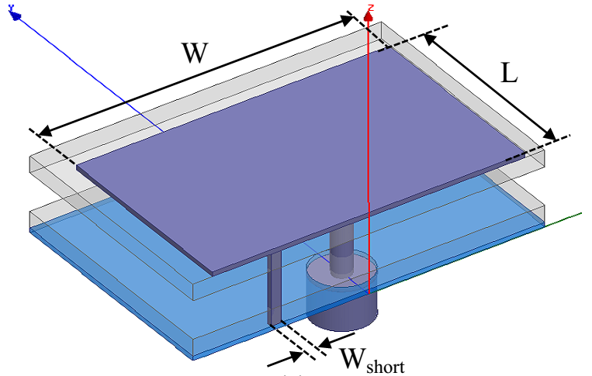 | 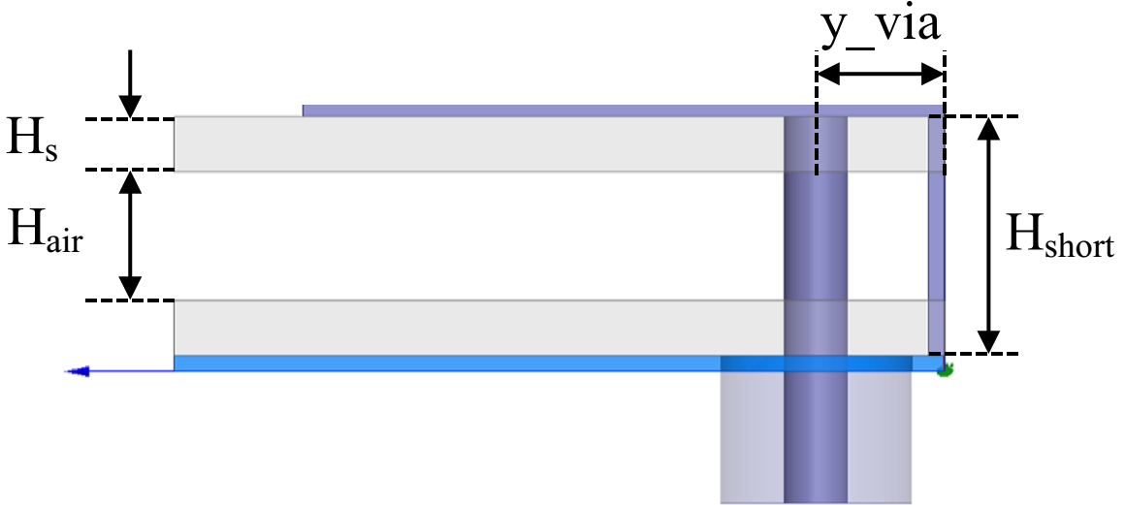
(a) Perspective view. | (b) Side view.
Fig. 1. Configuration of the proposed single PIFA antenna.

Theoretical calculation
Based on microstrip antenna theory, the PIFA resonances at the frequency corresponding to the antenna’s length is equal to ¼ wavelength at its resonant frequency [Modern antenna design]
$$\left(L+W-W_{short}\right)\sqrt{ε_{eff}}≈\frac{λ}{4}$$ |  | (1)
$$f= \frac{ c}{4(L + W- W_{short})\sqrt{ε_{eff}}}$$ |  | (2)
Where, | $$ε_{eff}=\frac{ε_{r}.ε_{air}\left(H_{s}+H_{air}\right)}{ε_{r}.H_{air}+ε_{air}{.H}_{s}}$$ | (3)
The effective dielectric constant $ε_{eff}$ is calculated:
$$ε_{eff}=\frac{2,2×1(0,127+0,354)}{2,2×0,354+1×0,127}≈1.17$$
The radiator size of the antenna operating at 28 GHz is calculated as Eq. (2). Thus, the total length of the PIFA antenna is
the initial dimensions of the antenna are chosen as follows: $L$ = 1,1 mm, $W$ = 1,32 mm và $W_{short}$ = 0,05 mm. It can be easily and added vào công thức (3.2), ta được:
$$f=\frac{300}{4\left(1,1+1.32-0,05\right)\sqrt{1.17}}≈28 GHz$$

The calculated results of the proposed antenna are presented in Table 1.

Table 1. Theoretical calculation dimensions of the proposed PIFA antenna (unit: mm)

Parameter | Value | Parameter | Value
W | 1,32 | L_{g} | 1,3
L | 1,1 | W_{short} | 0,05
W_{g} | 1,52 | H_{short} | 0,55

Optimal simulation
Return loss simulated result of the PIFA with the intial dimensions is shown in Fig. 2. It can be seen that the proposed single band PIFA yields a center frequency of 29.2 GHz. This simulated frequency is quite close to the one of theoretical calculation and it will be optimized to obtain the desired frequency of 28 GHz by investigating the dimensions of the PIFA antenna.

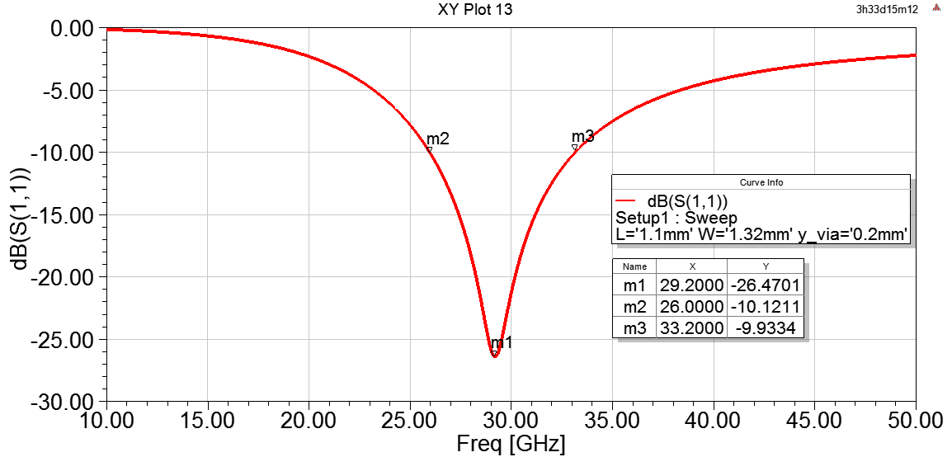
Fig 2. Simulated S11 of the proposed antenna with its theoretical calculation dimensions.

In order to determine the optimal dimensions corresponding to the desired resonant frequency at 28 GHz, the length L and the width W of the PIFA are selected for investigating. One parameter will be changed for investigating while the other one will be fixed. Firstly, the width W of the rectangular patch is considered when the length L is fixed at 1mm. The simulation reflection coefficient of the PIFA with different values ​​of W is shown in Figure 3. It is observed that the resonant frequency of the antenna decreases as the width of its radiator increases or the total electrical length of the proposed antenna increases. This is completely consistent with the theory when the frequency of the antenna is inversely proportional to its electrical length as shown in Eq. (2).

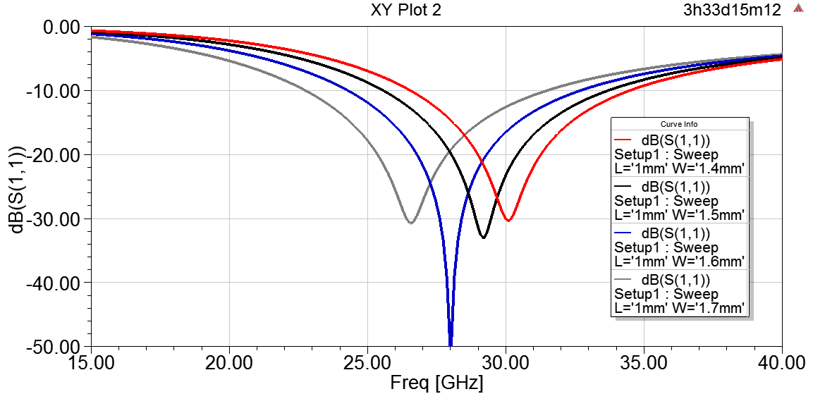
Fig. 3. Simulated S11 of the single band antenna with the various values of W
Next, the length of the patch L is investigated when the width W is set as 1.4 mm. Simulated S11 results of the antenna with different values of the length L ​​are shown in Fig. 4. Similarly, the increasing of the patch length lead to the decreasing of the resonant frequency. It is obvious that when the length of the patch changes, the antenna length changes, leading to the change in the resonant frequency.

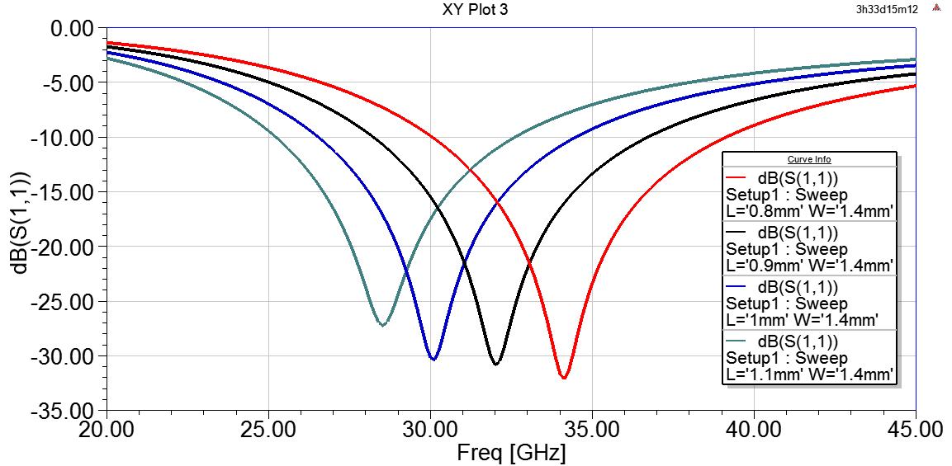
Fig. 4. Simulated S11 of the single band antenna with the various values of L
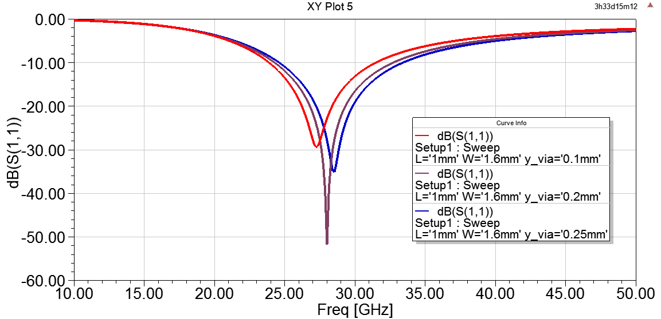
Fig. 5. Return loss simulated of the single antenna versus to different values of y_via

After adjusting W and L to optimize the center frequency of the PIFA at 30 GHz, the position of feeding will be considered for optimizing the impedance matching. This optimization is utilized by changing the value of y_via. The reflection coefficient simulated of the antenna with different values of the antenna’s feeding positions (y_via) is presented in Fig. 5. It is observed that the impedance matching of the antenna changes as the y-via value changes. In particular, when the value of y-via changed from 0.1 to 0.25 mm the antenna exhibits the best impedance matching as y_via is equal to 0.2 mm. The impedance of the rectangular patch antenna will be maximum at its edge and be zero at its center. Thus, the change in feeding leads to the change in antenna impedance. The optimal dimensions of the proposed single PIFA antenna at the frequency of 28 GHz are presented in Table 2.
Table 2. Optimal dimensions of the single band PIFA antenna (unit: mm)

Parameter | Value | Parameter | Value
W | 1,6 | W_{short} | 0,05
L | 1,1 | H_{short} | 0,55
W_{g} | 1,8 | x_via | 0
L_{g} | 1,3 | y_via | 0,2

The S11 simulated result of the final single antenna is shown in Fig. 6. As can be seen that the final PIFA yields a center frequency of 28 GHz with -10 dB bandwidth spreading from 24.26 to 32.66 GHz. In particular, the proposed antenna exhibits a very good impedance matching of -51.8 dB.

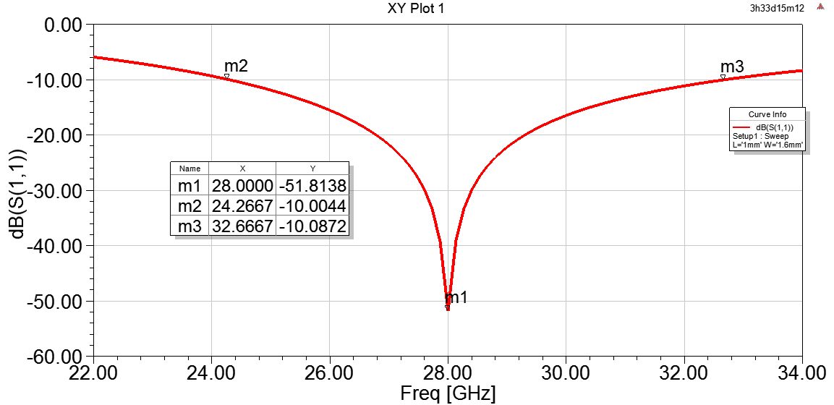
Fig. 6. S11 simulated of the final single PIFA antenna

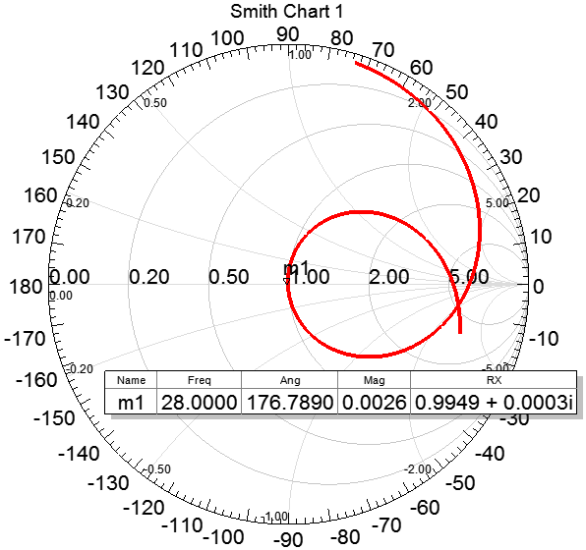
Fig. 7. Simulated input impedance of the final antenna at 28 GHz.

For validating the impedance matching ability between the 50 Ω feeder and the antenna, the impedance simulation is realized in the Smith chart as depicted in Fig. 7. As can be seen from this figure, the antenna has a normalized input impedance at 28 GHz (the point of m1) is 0.9949 at the real part and is approximate 0 at the imaginary part. The actual impedance of the antenna is approximate 50 Ω (0,9949×50). Thus, it proved that the final antenna yields a perfect impedance matching.
Figure 8 shows the radiation pattern simulated of the final antenna at 28 GHz. As can be seen that the antenna exhibits a directional in the yz plane with a peak gain of -6.38 dBi.

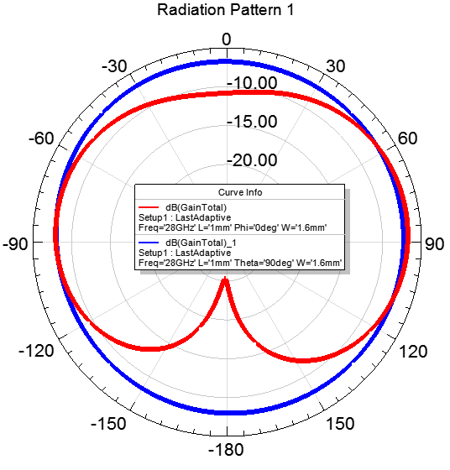
Fig. 8. Radiation pattern simulated of the single antenna at 28 GHz

The current distribution simulated of the antenna at 28 GHz is presented in Fig. 9. It is shown that the current is almost concentrated at the edges of the rectangular patch.
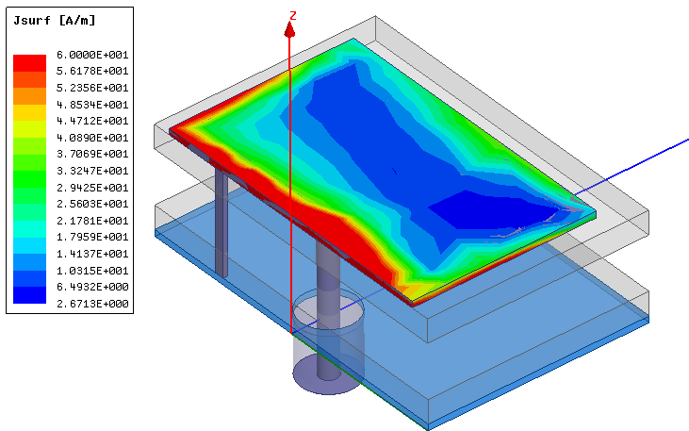
Fig 9. Current distribution simulated on antenna surface at 28 GHz
In the next part, the dual-band PIFA antenna will be designed based on the proposed single one. A spiral slot is etched on the rectangular patch of the single antenna to produce the second resonant mode.

Dual-band PIFA antenna design

Antenna geometry
The dual-band PIFA antenna is constructed based on the designed single band antenna in the previous part with a spiral etched slot on the surface of the patch. This is aimed to create the second resonance at 38 GHz. The configuration of the dual-band PIFA antenna is illustrated in Fig. 10. The spiral slot consists of five straight slots and its total length is the sum of the length of five straight slots.

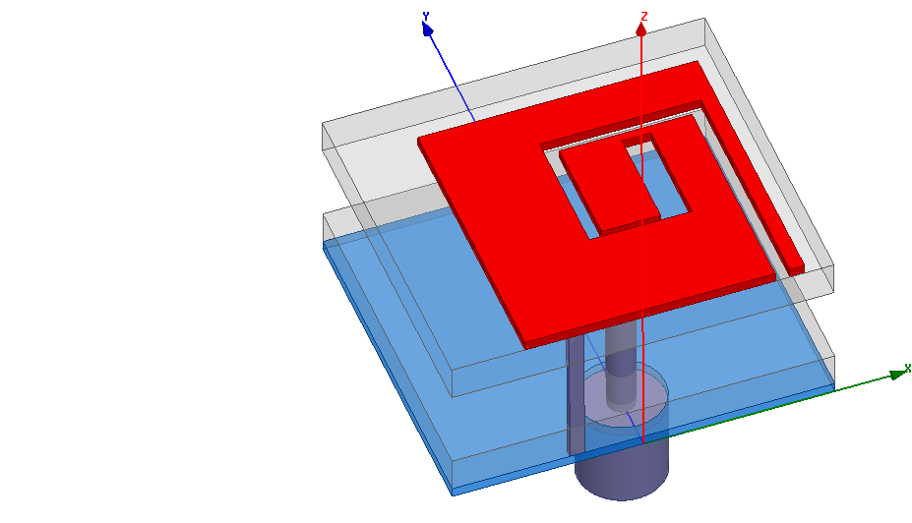 | 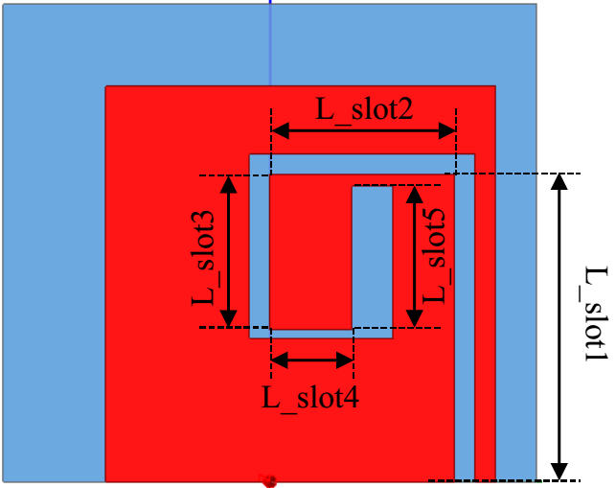
(a) Perspective view. | (a) Top view.
Fig. 10. Configuration of the proposed dual-band PIFA antenna.

Theoretical calculation
The spiral slot length $L_slot$ corresponding to the resonance of 38 GHz is calculated as follows:
$$f=\frac{ c}{4L_slot\sqrt{ε_{eff}}}$$ | (4)
$$L_slot=\frac{c}{4f\sqrt{ε_{eff}}}=\frac{3.{10}^{8}}{4.38.{10}^{9}\sqrt{1,17}}=1,82 mm$$
Where,
$$L_slot=L_slot1+L_slot2+L_slot3+L_slot4 + L_slot5$$
From the calculated $L_slot$, it is easily to choose the initial length of the straight slots: $L_slot1$ = 0,75 mm; $L_slot2$ = 0,45 mm; $L_slot3$ = 0,38 mm;$L_slot4$ = 0,2 mm and $L_slot2$ = 0,1 mm.

Optimal Simulation
Figure 11 presents the reflection coefficient simulated of the dual-band PIFA as its theoretical calculated dimensions. As can be observed from this figure that the PIFA antenna yields a dual-band performance with the lower and the higher frequencies centered at 29.45 and 41.05 GHz, respectively. From these calculated frequencies, the dimensions of the initial dual-band PIFA will be optimized to reach the final design of the dual-band antenna operating at 28 and 38 GHz.

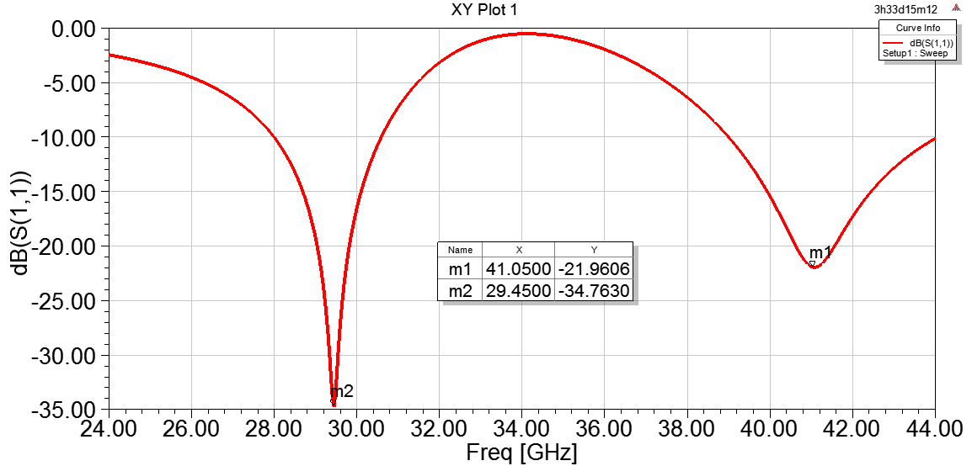
Fig. 11. Simulated S11 of the dual-band PIFA antenna as the theoretical calculation
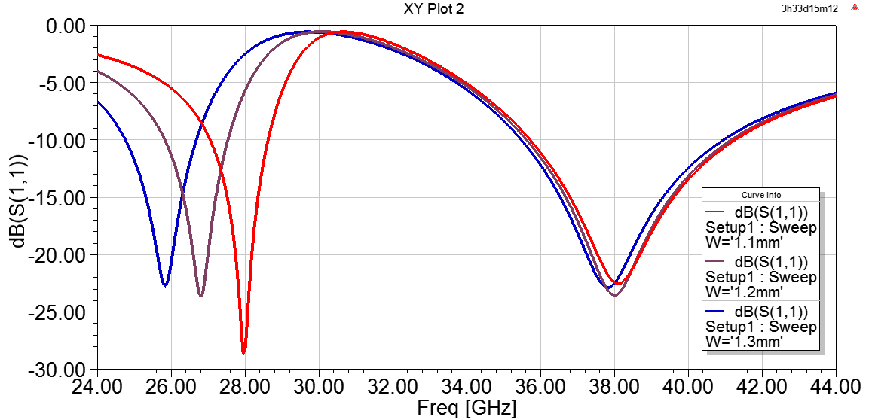
Fig. 12. Simulated S11 of the dual-band antenna with different values of W
The dimensions of the dual-band antenna will be changed to verify the center frequencies of the lower and the upper band. From that, the length and the width of the rectangular patch as well as the length and the width of the slot will be investigated with different values to find out the optimal values in which the dual-band PIFA antenna resonances at two center frequencies of 28 and 38 GHz.
Figure 12 describes the S11 simulated of the antenna with various values of the width of the patch while the other dimensions are fixed. As can be observed from this figure, the increase of the patch width lead to the decrease of the lower frequency while the higher one is not hardly change. It is clear that when the width W increases, the total length of antenna increases. Therefore, the lower resonance will be decreased since it is conversely proportional to the antenna’s total length.
Return loss simulated versus different values of patch length L is presented in Fig. 13. It can be seen that the two frequencies decrease as the length of patch increases. This result is quite match with the theory since the resonant frequency of antenna is conversely proportional to its length.

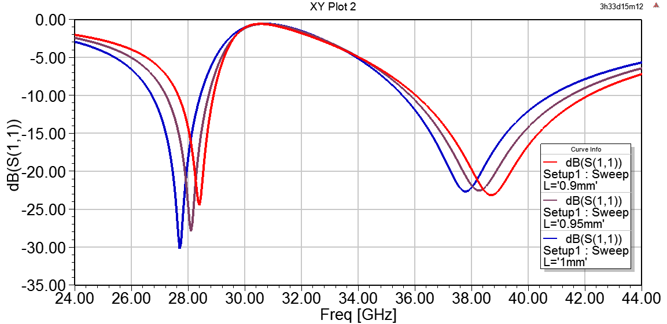
Fig 13. Simulated S11 versus different values of L

Next, the length L_slot5 and the width H_slot5 of the fifth slot are considered for optimizing the desired frequencies. Figure 14 presents the reflection coefficient simulated of the dual-band antenna with different values of L_slot5 while the width and the length of the patch are fixed at 1.1 mm and 0.95 mm, respectively. The S11 simulated of the antenna versus various values of H_slot5 is described in Fig. 15. In this work, the values of L_slot5 are set as 0.35 mm, and the values of W and L are also fixed as mentioned in the simulation scenario in Fig. 14. The simulated results presented in Fig. 14 and Fig. 15 show that the two center frequencies decrease while the two values decrease.
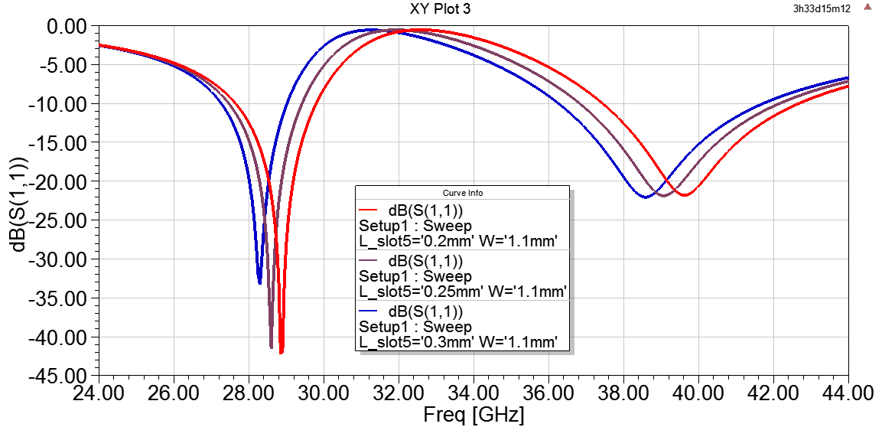
Fig 14. S11 simulated with different values of L_slot5
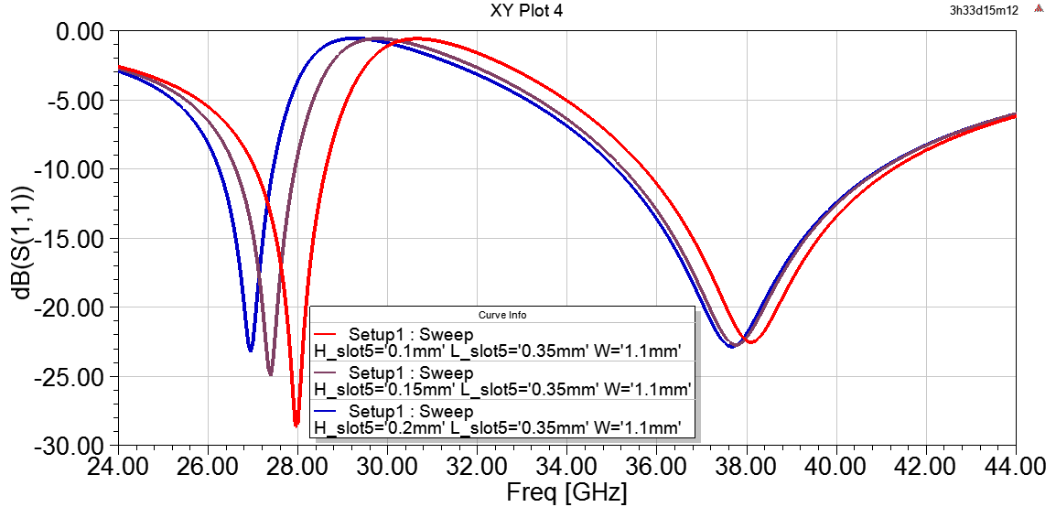
Fig 15. Simulated S11 with different values of H_slot5

The simulated S11 of the dual-band antenna at the final design is shown in Fig. 16. As can be seen that the final PIFA antenna achieves dual-band resonances operating at the center frequency of 28 and 38 GHz corresponding to the -10 dB bandwidth of 1.53 and 5.53 GHz. The optimal dimension of the final dual-band antenna is illustrated in Table 3. The optimal dimensions of the final antenna are shown in Table 3

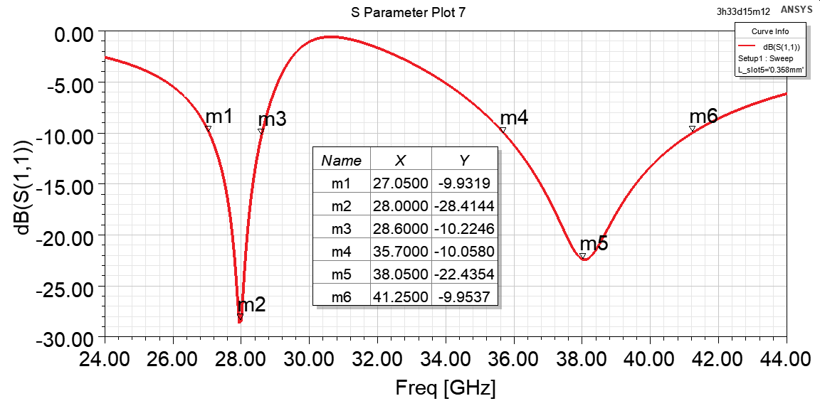
Fig 16. Simulated S11 of final dual-band PIFA antenna at 28 and 38 GHz

Table 3. Optimal dimensions of the dual-band PIFA antenna (unit: mm)

Parameter | Value | Parameter | Value
W | 1,1 | L_slot2 | 0,45
L | 0,965 | L_slot3 | 0,38
W_{g} | 1,8 | L_slot4 | 0,2
L_{g} | 1,3 | L_slot5 | 0,35
W_{short} | 0,05 | H_slot1 | 0,05
H_{short} | 0,55 | H_slot2 | 0,05
x_via | 0 | H_slot3 | 0,06
y_via | 0,2 | H_slot4 | 0,02
L_slot1 | 0,75 | H_slot5 | 0,1
In order to verify the role of the slot to the radiation of the proposed dual-band antenna, the current distribution simulation are realized and shown in Fig. 17. As can be observed from this figure, the current concentrates at the outside edges of the slot at 28 GHz while at the frequency of 38 GHz the current focus on the inside edges of the slot.

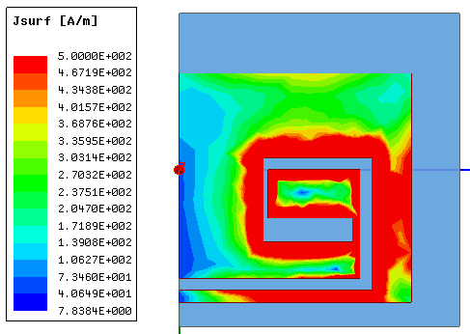 | 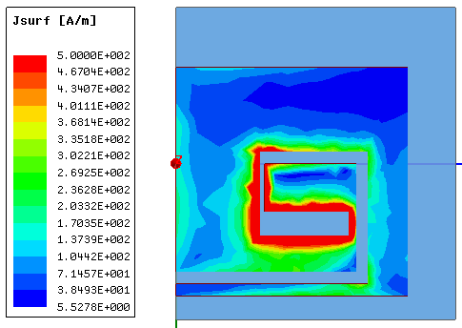
(a) at 28 GHz | (b) at 38 GHz
Fig. 17. Current distribution on the dual-band PIFA antenna

Figure 18 shows the simulation result of the radiation pattern of the final dual-band antenna at 28 and 38 GHz. From this figure, the antenna exhibits a directional pattern in xz plane with the peak-gain at 28 GHz and 38 GHz is A dBi and B dBi, respectively.

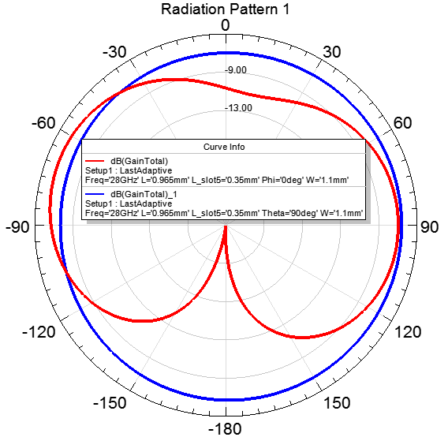
- at 28 GHz. | - at 38 GHz.
Fig 18. Simulated radiation pattern of the final dual-band antenna.
The performance of the antenna reported in this paper is compared to the other PIFA antennas reported in literature. Different parameters of the antenna are tabulated in Table 4. and are compared to the other antenna reported in the literature. It can be observed that dual band PIFA antenna proposed in this work shows the widest bandwidth and smallest form factor.

4. Conclusions
A dual-band PIFA antenna for 5G communication systems has been designed, simulated and optimized in this paper. The proposed antenna consists of two dielectric layers that separated by an air. Based on the PIFA antenna operate at 28 GHz, a spiral slot is etched on the patch radiator to create the second resonance at 38 GHz. Based on the initial results obtained by the theoretical calculation, the proposed PIFA antenna is optimized to achieve a dual-band resonances centred at the frequency of 28 and 38 GHz. The antenna exhibits good performances with wide -10 dB bandwidth of 1.53 GHz and 5.53 GHz and the realized gain of -3.44 dBi and -4 dBi corresponding to 28 GHz and 38 GHz. The proposed dual-band antenna can be applied for 5G communication systems.
References
- Vukelich, S.R.; and Jenkins, J.E. (1982). Evaluation of component buildup methods for missile aerodynamic prediction. Journal of Spacecraft and Rocket, 19(6), 481-488.
- Shahbhang, V.V.; and Rao, R.U. (1970). Normal force characteristics of cone-cylinder & ogive-cylinder bodies at Mach number 1.8. Technical memorandum No. TM-PR.235/69-70, National aeronautical laboratory, Bangalore.
- Lebedev, A.A.; and Chernobrovkin, L.S. (1973). Dinamika poleta bezpilotnykh letatelykh apparatov. "Flight dynamics of unmanned vehicles". Mashinostroenie, Moscow.
- Jankovic, S. (1979). Aerodynamika projektila. "Aerodynamics of projectiles" Masinski Fakultet, Univerziteta u Beogradu, Belgrade.
- Krasnov, N.F. (1985). Aerodynamics. Part 2 (Methods of Aerodynamic Calculations). Translated from the Russian language by G. Leib, Mir Publisher, Moscow.
- Hoerner, S.F. (1965). Fluid-dynamic drag. Horner Fluid Dynamics, Brick Town N.J.
- Cohen, R.J. (1951). Aerodynamic characteristics of four bodies of revolution showing some effects of afterbody shape and fineness ratio at free-stream Mach numbers from 1.5 to 1.99. NACA research memorandum, RM E51C06.
- Al-Obaidi, A.S.M. (2005). The influence of configuration design on the aerodynamics and stability of SSM at supersonic speeds. Ph.D. Thesis. Al-Rasheed College of Engineering and Science, University of Technology, Baghdad, Iraq.
- Brebner, G.G. (1971). A brief review of air flight weapons. AGARD Lectures No. 98 'Missile Aerodynamics', NATO. Aerodynamics Department, Royal Aircraft Establishment. Farnborough, Hants GU14 6TD, UK.
- Author, A.B. (2000). This is how to cite an internet reference. Retrieved October 5, 2010, from http://www.author.com.
- Hii, R.; Al-Obaidi, A.S.M.; and Shariff, N. (2000). This is an example in case there are more than two authors. Journal of Engineering Science and Technology (JESTEC), 12(1), 2001-2010.

