Nghiên cứu khả năng bắt giữ khí thải
của vật liệu khung hữu cơ kim loại Ni(BDC)(TED)_{0,5}
bằng phương pháp mô phỏng cổ điển

Nguyễn Thị Xuân Huynh^{1,}, Bùi Thị Duyên², Phạm Thảo Trâm², Trần Thị Diễm Thanh², Nguyễn Trương Mỹ Duyên²

¹Khoa Khoa học Tự nhiên, Trường Đại học Quy Nhơn, Việt Nam
²Khoa Sư phạm, Trường Đại học Quy Nhơn, Việt Nam

Ngày nhận bài: 19/04/2021, Ngày nhận đăng: 30/05/2021
TÓM TẮT
Sự phát thải các khí độc hại tác động tiêu cực ồ ạt đến môi trường và sức khỏe của con người như CO₂ và SO₂ do sự tăng nhanh dân số toàn cầu và việc đốt ngày càng nhiều nhiên liệu hóa thạch để đáp ứng nhu cầu năng lượng. Song song với việc tìm ra nguồn năng lượng thay thế nhiên liệu hóa thạch, việc tìm ra một biện pháp để bắt giữ, giảm tải và xử lý khí thải độc hại ra môi trường, gây hiệu ứng nhà kính cũng hết sức quan trọng và cấp bách nhằm ngăn chặn sự biến đổi khí hậu ngày càng trầm trọng hơn. Vật liệu khung hữu cơ kim loại ${\text{Ni(BDC)(TED)}}_{0,5}$ được đánh giá là vật liệu xốp có khả năng hấp phụ mạnh CO₂ và SO₂. Bằng phương pháp mô phỏng Monte Carlo chính tắc lớn, chúng tôi đã đánh giá được khả năng bắt giữ hai loại khí này của ${\text{Ni(BDC)(TED)}}_{0,5}$ với lượng hấp phụ SO₂ mạnh hơn CO₂ ở vùng áp suất thấp dưới $\text{25 bar}$; trong khi đó, ở vùng áp suất cao, lượng hấp phụ CO₂ có khuynh hướng tăng (đạt $\text{14,4 mmol/g}$ ở $\text{50 bar}$) nhưng hấp phụ SO₂ thì sớm bão hòa ở áp suất $\text{5 bar}$ với $\text{13,6 mmol/g}$. Sự hấp phụ mạnh hơn của SO₂ so với CO₂ trong vùng áp suất thấp cũng được làm sáng tỏ qua nhiệt hấp phụ của SO₂ ($\text{32,7 kJ/mol}$) lớn hơn nhiều so với CO₂ ($\text{17,3 kJ/mol}$) trong ${\text{Ni(BDC)(TED)}}_{0,5}$.
Từ khóa: Ni(BDC)(TED)_{0,5}, Mô phỏng Monte Carlo chính tắc lớn, Bắt giữ CO₂, Bắt giữ SO₂, Hấp phụ đẳng nhiệt.

Research on the capture of flue gases of the metal-organic framework Ni(BDC)(TED)_{0.5}
by the classical simulation method

Nguyen Thi Xuan Huynh^{1,}, Bui Thi Duyen², Pham Thao Tram², Tran Thi Diem Thanh², and Nguyen Truong My Duyen²

¹Faculty of Natural Sciences, Quy Nhon University, Vietnam
²Faculty of Pedagogy, Quy Nhon University, Vietnam

Received: 19/04/2021, Accepted: 30/05/2021

ABSTRACT
The emission of toxic gases has massive negative impacts on the environment and human health such as CO₂ and SO₂ because of the rapid increase of the global population and the burning of more and more fossil fuels to meet energy needs. Together with seeking alternative clean energy sources, finding methods to capture, reduce and treat harmful gases in the environment is urgent to prevent climate change and global warming. The metal-organic framework $Ni\left(BDC\right){\left(TED\right)}_{0.5}$ was evaluated as a porous material with strong adsorption of CO₂ and SO₂. By grand canonical Monte Carlo simulation, we quantitatively evaluated the capture capacities of CO₂ and SO₂ in $Ni\left(BDC\right){\left(TED\right)}_{0.5}$ based on the adsorption mechanism. Our results indicated the adsorption of SO₂ was higher than that of CO₂ in the pressures below 25 bar. Meanwhile, in the high-pressure range, the CO₂ adsorption in $Ni\left(BDC\right){\left(TED\right)}_{0.5}$ was still in increase, reaching $\text{14.40 mmol/g}$ at $\text{50 bar}$, but SO₂ adsorption was soon saturated at the pressure of $\text{5 bar}$ with $\text{13.6 mmol/g}$. The stronger adsorption of SO₂ compared with CO₂ in the low-pressure range was also elucidated by the isosteric heat of adsorption that was $Q_{st}$ of SO₂ ($\text{32.7 kJ/mol}$), which was much greater than that of CO₂ ($\text{17.3 kJ/mol}$) on $Ni\left(BDC\right){\left(TED\right)}_{0.5}$.
Keywords: Ni(BDC)(TED)_{0.5}, grand canonical Monte Carlo, CO₂ capture, SO₂ capture, adsorption isotherms.

1. INTRODUCTION
Flue gas emissions such as CO₂ and SO₂ have seriously affected the environment and human health. It is always the hot problem at conferences, workshops, and seminars due to the urgent need to find solutions to capture, treat and convert exhaust gases. Several studies have been performed on separating and capturing toxic gases from the gas mixture so far. Over the past few decades, adsorption-based gas capture and storage in porous materials have been noticed due to their extraordinary features such as high surface area, high pore, extra-high porosity up to 90% free volume, adjustable internal surface properties, and tunable pore size.¹ Many adsorbents have been investigated, such as activated carbon (AC), zeolite, silica gel (SG), and especially metal-organic frameworks (MOFs).^{2,3} Among porous materials, MOFs seem to be the most encouraging.
More than 90,000 MOFs have been synthesized, and more than 500,000 structures have been predicted up to now.⁴ Nevertheless, very few MOFs have been evaluated and analyzed for storage, capture, separation, and other applications. Among MOFs, ${\text{Ni(BDC)(TED)}}_{0.5}$ structure, in which the metal component is Ni²⁺ (nickel ion), and the organic linkers are H₂BDC = 1,4-benzene-dicarboxylate (C₄H₆-1,4-(CO₂H)₂, TED = triethylenediamine (C₆H₁₂N₂), has been noted for CO₂ and SO₂ captures. By both experiment and computation, K. Tan et al. showed that ${\text{Ni(BDC)(TED)}}_{0.5}$ had higher SO₂ adsorption than ${\text{M(BDC)(TED)}}_{0.5}$ (M = Zn, Mg) and many other MOF structures.⁵ However, this research was only performed in the pressure range below 2 bar. For CO₂, Arstad and co-workers also showed, at the room temperature, $Ni\left(BDC\right){\left(TED\right)}_{0.5}$ adsorbed $\text{14 wt\%}$ at the atmosphere pressure and up to $\text{60 wt\%}$ at $\text{25 atm}$.⁶
For comparing the experiment data and extending the uptake in the pressure range up to 50 bar, we performed grand canonical Monte Carlo (GCMC) simulations. The obtained results evaluate and explain the capture of CO₂ and SO₂ in ${\text{Ni(BDC)(TED)}}_{0.5}$ at 298 K and the pressures under 50 bar in detail.
2. GRAND CANONICAL MONTE CARLO METHOD
GCMC method⁷ was employed to quantitatively assess CO₂ and SO₂ uptakes on the surface of the ${\text{Ni(BDC)(TED)}}_{0.5}$ MOF. The interactions between gases (CO₂, SO₂) and the MOF are the pairing interaction between the atoms $i$ and $j$ at a distance $r_{ij}$, described by:
$U\left(r_{ij}\right)= k\frac{q_{i}q_{j}}{r_{ij}}+4ε_{ij}\left[{\left(\frac{σ_{ij}}{r_{ij}}\right)}^{12}-{\left(\frac{σ_{ij}}{r_{ij}}\right)}^{6}\right]$ (1)
In Formula (1), the first term describes the electrostatic (Coulomb) interactions between the pairs of atoms $i$ and $j$, where $k=\frac{1}{4πε_{0}}$ is the Coulomb constant ($ε_{0}$ is the electric constant), q_{i} is the $i^{th}$atomic charge in ${\text{Ni(BDC)(TED)}}_{0.5}$, including nickel (Ni), nitrogen (N), oxygen (O), carbon (C), and hydrogen (H). These partial charge parameters were calculated using DDEC (Density Derived Electrostatic and Chemical) algorithm to set the force field for electrostatic interactions. Besides, these interactions were handled using the Ewald summation technique⁸ with the cut-off radius of 12 Å. The remaining term in Formula (1) describes the van der Waals interactions with an Lennard-Jones (LJ) potential, 6-12 potential. Here, $ε_{ij}$, $σ_{ij}$ correspond to the depth and diameter of the potential well for each pair of atoms $i$ and $j$, handled using Lorentz–Berthelot rule:
$ε_{ij}=\sqrt{ε_{i}ε_{j}}; σ_{ij}=\frac{1}{2}(σ_{i}+σ_{j})$, (2)
where $σ_{i}$, $ε_{i}$ (i represents Ni, N, O, C, H of ${\text{Ni(BDC)(TED)}}_{0.5}$) were taken from general force fields for MOF in RASPA sofware⁷ (Table 1). A cut-off radius of 14 Å was utilized for the LJ interactions. This factor affects calculation results, therefore it was checked carefully and showed in the results and discussion section. The calculation used the TraPPE force field for CO₂ molecule⁹ with a linear three-point model with bonding length $d_{CO}= 1.16 Å$; whereas, SO₂ was modeled as the three-point model¹⁰ with
$d_{SO }= 1.43 Å$, ${}_{OSO}= 119.5°$. The force field parameters of CO₂ and SO₂ are also listed in
Table 1.
Our calculations used the $VT$ set, where volume V, temperature T and chemical potential $μ$ were constant in the simulation process. The room temperature (298 K) and pressures up to 50 bar were selected. The optimized primary unit cell of ${\text{Ni(BDC)(TED)}}_{0.5}$ has 22 C, 20 H, 8 O, 2 N, 2 Ni (54 atoms). In GCMC, the simulation box was kept fixed, while adsorbate molecules were moved randomly to reach equilibrium adsorption. Each calculated point ran ${10}^{4}$ equilibration cycles and followed by ${2×10}^{5}$ MC cycles. These parameters were checked carefully for their equilibrium.
Table 1. LJ parameters of the atoms in ${\text{Ni(BDC)(TED)}}_{0.5}$
Atoms | ε/k_{B} [K] | σ [Å] | q [e]
Ni (MOF) | 7.55 | 2.52 | 0.660
N (MOF) | 38.95 | 3.26 | -0.118
O (MOF) | 48.16 | 3.03 | -0.528
C (on BDC) | 47.86 | 3.47 | -0.067
C (BDC-TED) | 47.86 | 3.47 | -0.079
C (on TED) | 47.86 | 3.47 | -0.025
C (bonded with O) | 47.86 | 3.47 | 0.636
H (on BDC) | 7.65 | 2.85 | 0.093
H (on TED) | 7.65 | 2.85 | 0.071
C (CO₂) | 27.00 | 2.80 | +0.700
O (CO₂) | 79.00 | 3.05 | - 0.350
S (SO₂) | 145.90 | 3.62 | 0.471
O (SO₂) | 57.40 | 3.01 | -0.236

Note that for calculating gas adsorption in MOF, measured experimental data are usually the excess adsorption amount ($N_{ex}$). Simulations usually calculate the total adsorption amount or the absolute amount of gas adsorbed ($N_{ab}$). The expression describing the relationship between them is
$N_{ab}=N_{ex}+ρV_{p}$, (3)
In which, $V_{\text{p}}$ is the pore volume and $ρ$ is the density of gas (CO₂, SO₂) in the bulk phase.
3. RESULTS AND DISCUSSION
3.1. Optimizing and selecting the simulation box for $Ni\left(BDC\right){\left(TED\right)}_{0.5}$
${\text{Ni(BDC)(TED)}}_{0.5}$ has tetragonal structure symmetry with the lattice constants $a=b$ and the angles $α=β=γ=90°$ (Figure 1). In ${\text{Ni(BDC)(TED)}}_{0.5}$, the metal-oxide-carbon (Ni-O-C) clusters link to BDC and TED ligands. Herein, BDC and TED stand for 1,4-benzene dicarboxylate and triethylenediamine. Stability and high porosity of the paddle-wheel units in the heat are the noticed characteristics to improve the amount of gas adsorbed.¹¹
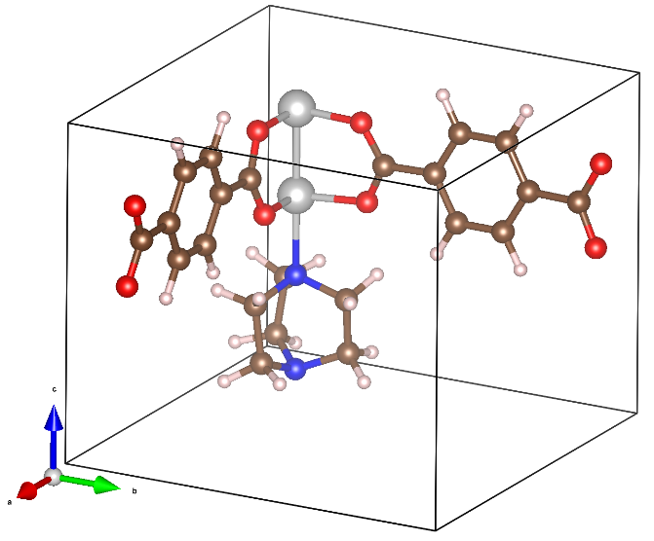
b
a
c
Figure 1. The primary unit cell of ${\text{Ni(BDC)(TED)}}_{0.5}$, herein the atoms Ni, N, O, C, and H correspond to light gray, blue, red, brown, and light pink balls.
After designing and optimizing the unit cell, all the atomic positions in the structure were relaxed to meet the equilibrium state based on the density functional theory with van der Waals (vdW-DF) correction.¹² The obtained results are
$a=b=11.98 Å$ and $c=9.38 Å$, leading to the volume of the unit cell is $\text{1131 }Å^{3}$. The simulated results are entirely close to the experiment data of Tan's group,⁵ $a=b=11.15 Å$ and $c=9.53 Å$. The lengths of the simulation box were repeated three times ($≥28 Å$) to perform GCMC simulations with high accuracy, as shown in
Figure 2.
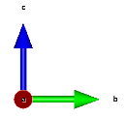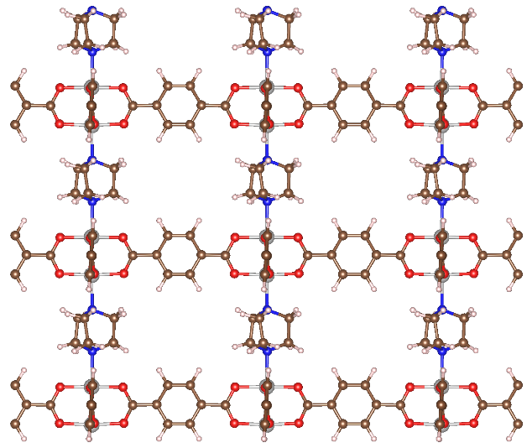
TED
Paddle-wheel units + BDC
b
c
Figure 2. The 2D box of GCMC simulation (viewed along a axis). Two paddle-wheel units and one BDC ligand are in the blue curve; the TED unit is in the orange curve.
3.2. The cut-off radius for Lennard–Jones interactions
The cut-off radius for electrostatic interactions was taken by default as 12 Å in the code because it has little impact on the amount of gas adsorbed to the MOF. In this section, the cut-off radius for the LJ interactions was regarded.
Based on the amount of gas adsorption in the MOF versus the LJ cut-off radius ($r_{c}$) at 1 bar, 5 bar and 10 bar (Figure 3), the value 14 Å was determined. Increasing $r_{c}$ can improve accuracy, but it is insignificant and takes a long time for calculations. Therefore, we selected the value of approximately $\text{14 Å}$ with the unit cell repeating up $\text{3}\text{3}\text{3}$ (i.e. 27 times) the unit cell in Figure 2. Furthermore, we also carefully checked the convergence of equilibration and MC cycles. The results achieved ${10}^{4}$ equilibration cycles and $2×{10}^{5}$ MC cycles.
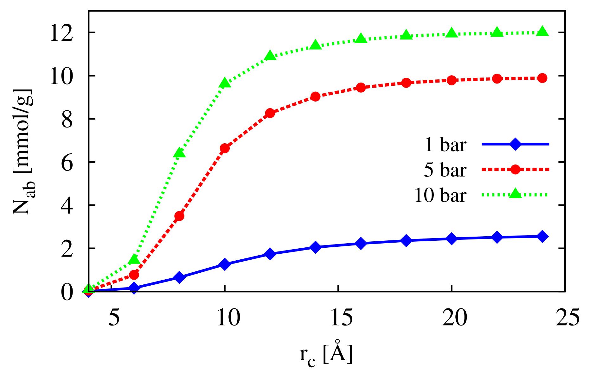
Figure 3. The selected LJ cut-off radius based on CO₂ adsorption in $\text{Ni}\left(\text{BDC}\right){\left(\text{TED}\right)}_{0.5}$.
3.3. Investigation of structural features of $\text{Ni}\left(\text{BDC}\right){\left(\text{TED}\right)}_{0.5}$
After relaxing the ions in the structure and selecting suitable parameters, we also calculated the specific surface area (SSA) and pore volume ($V_{p}$) of $\text{Ni}\left(\text{BDC}\right){\left(\text{TED}\right)}_{0.5}$, essential features of porous crystalline frameworks affecting gas capture. The parameters SSA and $V_{p}$ were determined by calculating the adsorption amount of nitrogen (N₂) at 77 K. This calculation proved to be relatively consistent with the Brunauer-Emmett-Teller (BET) method.¹³
The simulation results are and , in good agreement with previous measurement results of experimental groups with specific surface areas corresponding to $\text{1763} \text{m}\text{2}\text{/g}$¹¹ and $\text{1698} \text{m}\text{2}\text{/g}$.¹⁴ The achievements also show that although the SSA is smaller than the experimental data of X. Fan with $\text{1905 m}\text{2}\text{/g}$ for $\text{Ni}\left(\text{BDC}\right){\left(\text{TED}\right)}_{0.5}$, it closely resembles the remaining structural series $\text{M}\left(\text{BDC}\right){\left(\text{TED}\right)}_{0.5}$ (M = Zn, Co, Cu).¹⁵ Besides, the computed results also show that the pore volume of the MOF (0.76 cm³/g) is entirely suitable with the obtained experimental data of 0.757 cm³/g.¹⁵ Again, it is proved that our calculations are very reliable.
3.4. Evaluation of the gas capture capacities
Firstly, we selected and tested the force field models before performing the calculations. The amount of gas adsorption corresponding to two force field models for CO₂ molecules, TraPPE⁹ and EMP2,¹⁶ are similar at 298 K and under 1 bar (Figure 4). The obtained results are (i.e. 10.13 wt%) and (10 wt%) at room temperature and standard atmospheric pressure. These values are also relatively close to the experimental data of Arstad et al. with 14 wt% under the same conditions.⁶
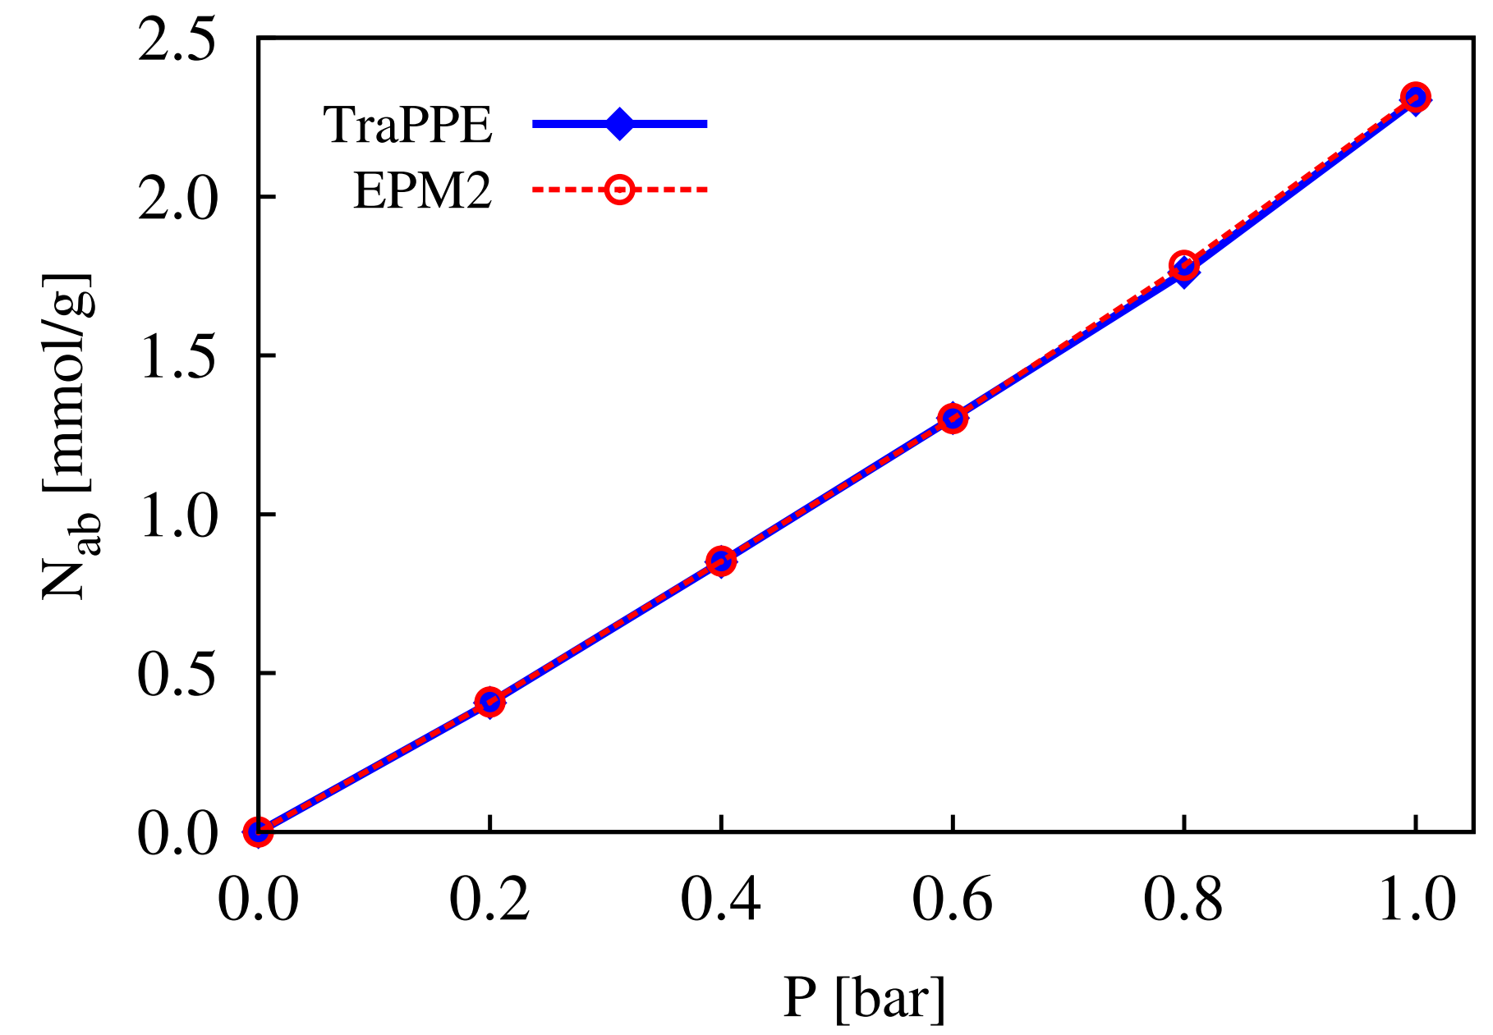
Figure 4. The CO₂ adsorption of $\text{Ni}\left(\text{BDC}\right){\left(\text{TED}\right)}_{0.5}$ using TraPPE and EMP2 force fields.
Two force field models give the same results, so we use the TraPPE model for CO₂ in this work. The gas sorption amounts in $Ni\left(BDC\right){\left(TED\right)}_{0.5}$ with various pressure points up to 50 bar were calculated, and then we plotted the adsorption isotherms for CO₂ and SO₂ at 298 K (Figure 5). At this temperature, CO₂ uptake in $\text{Ni}\left(\text{BDC}\right){\left(\text{TED}\right)}_{0.5}$ results in ($\text{59.53 wt\%}$) and ($\text{55}\text{.}\text{56 wt\%}$) at 25 bar. Under the conditions above, Arstad et al.⁶ experimentally measured . Furthermore, at 30 bar, our evaluated excess uptake is approximately 12.7 mmol/g. In this same condition, Chen and coworkers computed (i.e. 600 mg/g or 60 wt%) for $\text{Zn}\left(\text{BDC}\right){\left(\text{TED}\right)}_{0.5}$,¹⁷ listed in Table 2. In this publication, the highest amount of CO₂ capture in $\text{Ni}\left(\text{BDC}\right){\left(\text{TED}\right)}_{0.5}$ was achieved at the value of $\text{14}\text{.}\text{40 mmol/g}$ ($\text{63.37 wt\%}$) at $\text{50 bar}$. This value is also remarkable compared to other MOFs evaluated for CO₂ adsorption.¹⁸
For SO₂, Figure 5 determines that adsorption-based SO₂ capture in $\text{Ni}\left(\text{BDC}\right){\left(\text{TED}\right)}_{0.5}$ rapidly increases at low pressures under 5 bar. The adsorbed gas amount saturate at about 5 bar corresponding to Greater than 5 bar, the adsorbed amount insignificantly increase with increasing pressure to 50 bar (only 0.1 mmol/g achieved in this pressure range). At about 1 bar, our simulation indicated that the amount of gas adsorbed is 12 mmol/g, slightly higher than that of the K. Tan group with 10 mmol/g.⁵
Table 2. Absolute (total) and excess uptakes of CO₂ in $\text{Ni}\left(\text{BDC}\right){\left(\text{TED}\right)}_{0.5}$, compared to other MOFs.
Uptakes | Pressure [bar]
Uptakes | 1 | 25 | 30
N_{ab} (N_{ex}) [mmol/g] | 2.30 (2.27) | 13.53 (12.63) | 13.81 (12.68)
N_{ab} (N_{ex}) [wt%] | 10.14 (10.00) | 59.53 (55.56) | 60.76 (55.80)
Ni(BDC)  (TED)_{0.5}⁶  [wt%] | 14 | 60
Zn(BDC)  (TED)_{0.5}¹⁷  [mmol/g] |  |  | 13.6

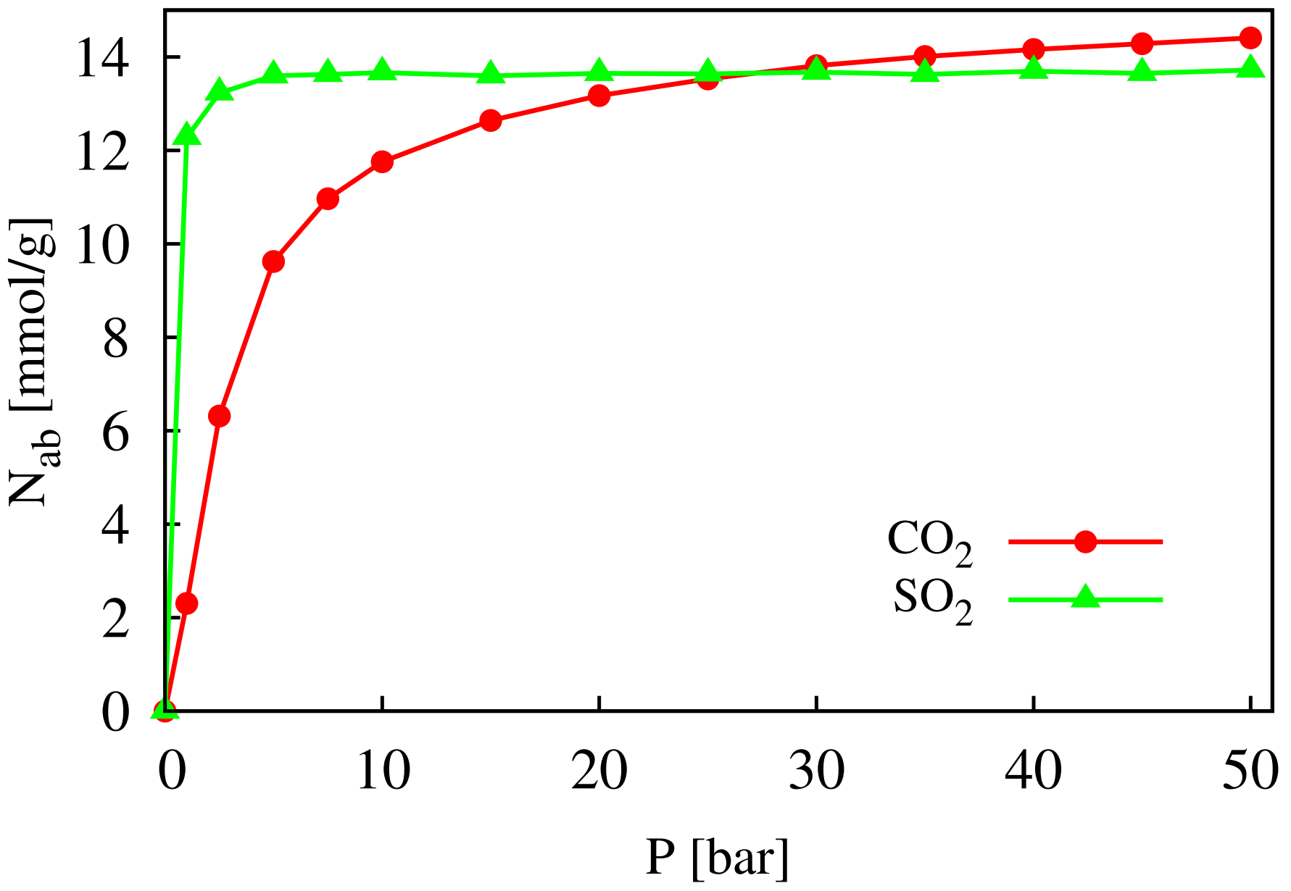
Figure 5. The CO₂ and SO₂ adsorption isotherms in $\text{Ni}\left(\text{BDC}\right){\left(\text{TED}\right)}_{0.5}$ at $T=298 K$ and $P 50$ bar.
Our results also show that SO₂ adsorbs much more powerfully than CO₂ in the low-pressure region below 25 bar. Remarkably, the amount of SO₂ saturates while the CO₂ adsorption continues to increase at higher pressures. Therefore, at 50 bar, it results in $N_{ab}\left(\text{C}{\text{O}}_{\text{2}}\right) \text{=} \text{14.4 mmol/g}$, slightly larger than that of SO₂ with $\text{13.7 mmol/g}$.
The gas adsorption (the linear 3-atom model) and SO₂ (the 3-atom model with the 119.5° angle) were also visualized via Figure 6 and Figure 7, respectively. Visualization of gases shows that there is slightly more SO₂ than CO₂ in $\text{Ni}\left(\text{BDC}\right){\left(\text{TED}\right)}_{0.5}$ at identical conditions. Significantly, the amount of SO₂ enormously increases compared to CO₂ according to the pressure up to 5 bar.
We also know the isosteric heat of adsorption ($Q_{st}$) is also an important parameter relating to gas adsorption. The results, calculated at low-pressures up to 1000 Pa (Figure 8), exhibit the average adsorption heats of SO₂ and CO₂ on $\text{Ni}\left(\text{BDC}\right){\left(\text{TED}\right)}_{0.5}$ with respect to 32.7 kJ/mol and 17.3 kJ/mol. These values also elucidate that this MOF captures SO₂ more highly than CO₂ in the low-pressure region. This tendency is also consistent with the results of D. N. Son et al. with the prediction of adsorption capacities of CO₂ and SO₂ by adsorption energy based on density functional theory.¹⁹ Herein, their work showed that, when studying the simultaneous adsorption of two gases, $Ni\left(BDC\right){\left(TED\right)}_{0.5}$ strongly adsorbs SO₂ than CO₂ due to the primary interactions between the $d$-orbitals of Ni metal with the states ($2n$, $3n$, $4n$) of the SO₂ molecule but barely interacting with those of the CO₂ molecule.
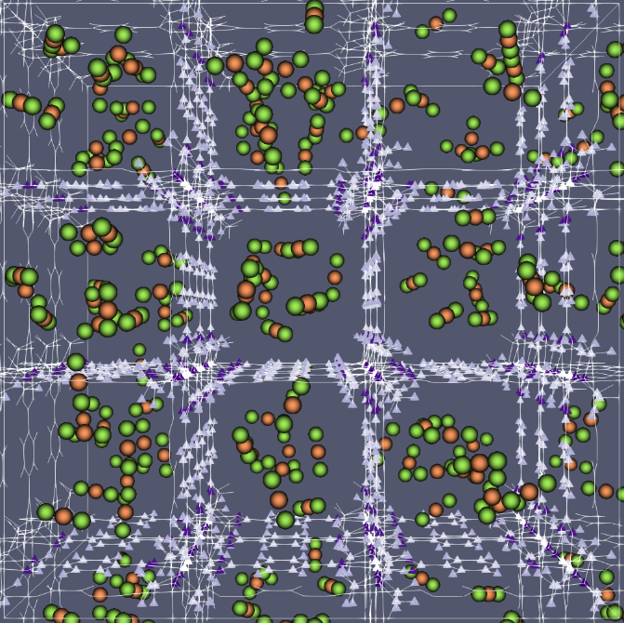
Frame of MOF
CO₂
Figure 6. Visualization of CO₂ adsorption in $Ni\left(BDC\right){\left(TED\right)}_{0.5}$ at $\text{0.1 bar}$ and $\text{298 K}$, herein C and O atoms of CO₂ correspond to dark-orange and light-green balls.
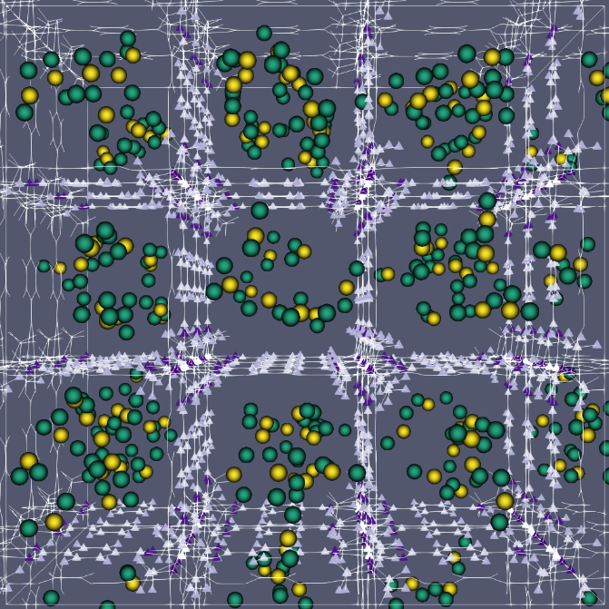
Frame of MOF
SO₂
Figure 7. Visualization of SO₂ adsorption in $Ni\left(BDC\right){\left(TED\right)}_{0.5}$ at $\text{0.1 bar}$ and $\text{298 K}$, in which S and O atoms of SO₂ correspond to yellow and green balls.
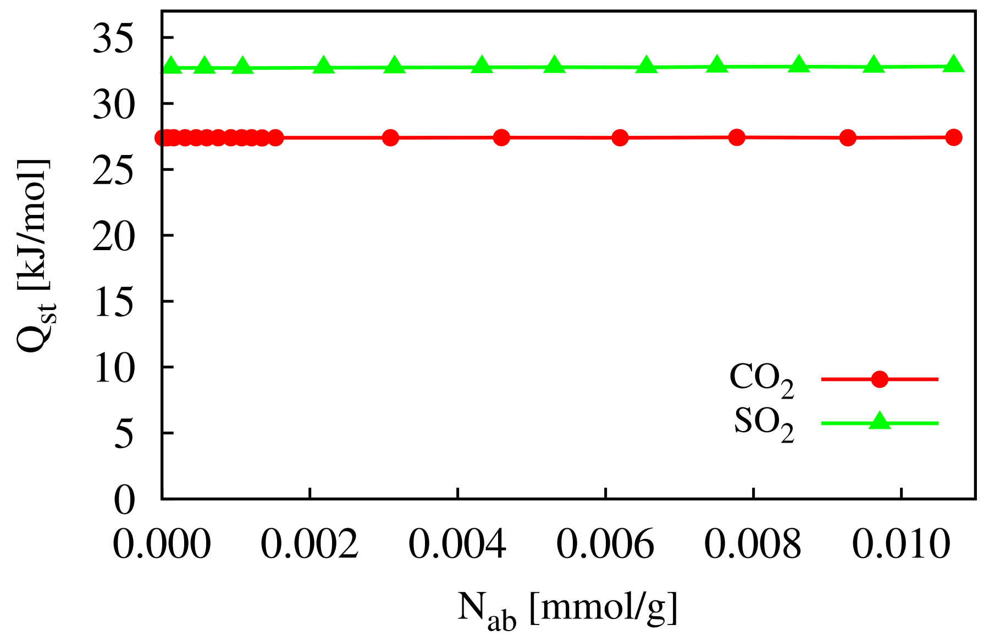Figure 8. Heat of adsorption ($Q_{st}$) for CO₂ and SO₂ on $\text{Ni}\left(\text{BDC}\right){\left(\text{TED}\right)}_{0.5}$ at 298 K.
4. CONCLUSIONS
In our research, the cut-off radius for the LJ potential with 14 Å is suitable for GCMC simulations to evaluate CO₂ and SO₂ capture capacities in $\text{Ni}\left(\text{BDC}\right){\left(\text{TED}\right)}_{0.5}$. This value is an important parameter affecting the gas amount adsorbed in the $\text{Ni}\left(\text{BDC}\right){\left(\text{TED}\right)}_{0.5}$ MOF.
Our calculations show that, at low pressures below 25 bar, the capture capacity of SO₂ is more robust than that of CO₂ in $\text{Ni}\left(\text{BDC}\right){\left(\text{TED}\right)}_{0.5}$. Until the pressure exceeds 25 bar, only CO₂ uptake increases slightly while SO₂ uptake saturates. The calculated results are significant with $\text{14.4 mmol/g}$ for CO₂ capture at 50 bar and $13.6 mmol/g$ for SO₂ at 5 bar.
The heat of gas adsorption on $\text{Ni}\left(\text{BDC}\right){\left(\text{TED}\right)}_{0.5}$ corresponding to the values 32.7 kJ/mol and 17.3 kJ/mol for SO₂ and CO₂ also shows that the SO₂ adsorbs more strongly than CO₂ in the MOF above in the low-pressure range.
Acknowledgment
This study is conducted within the framework of student scientific research projects at the institutional level of Quy Nhon University under the project code S2020.645.09.
REFERENCES
1. H. C. Zhou, J. R. Long, and O. M. Yaghi. Introduction to metal-organic frameworks, Chemical Reviews, 2012, 112, 673–674.
2. X. Peng, S. K. Jain, and J. K. Singh. Adsorption and separation of N₂/CH₄/CO₂/SO₂ gases in disordered carbons obtained using hybrid reverse Monte Carlo simulations, The Journal of Physical Chemistry C, 2017, 121, 13457–13473.
3. R. Sabouni, H. Kazemian, and S. Rohani. Carbon dioxide capturing technologies: A review focusing on metal organic framework materials (MOFs), Environmental Science and Pollution Research, 2014, 21, 5427–5449.
4. S. M. Moosavi et al. Understanding the diversity of the metal-organic framework ecosystem, Nature Communications, 2020, 11, 1–10.
5. K. Tan et al. Mechanism of preferential adsorption of SO₂ into two microporous paddle wheel frameworks M(bdc)(ted)_{0.5}, Chemistry of Materials, 2013, 25, 4653–4662.
6. B. Arstad, H. Fjellvåg, K. O. Kongshaug, O. Swang, and R. Blom. Amine functionalised metal organic frameworks (MOFs) as adsorbents for carbon dioxide, Adsorption, 2008, 14, 755–762.
7. D. Dubbeldam, S. Calero, D. E. Ellis, and R. Q. Snurr. RASPA: molecular simulation software for adsorption and diffusion in flexible nanoporous materials, Molecular Simulation, 2016, 42, 81–101.
8. M. P. Allen and D. J. Tildesley. Computer simulation of liquids, 2nd edition, Oxford University Press, Oxford-United Kingdom, 2017.
9. J. J. Potoff and J. I. Siepmann. Vapor-liquid equilibria of mixtures containing alkanes, carbon dioxide, and nitrogen, AIChE Journal, 2001, 47, 1676–1682.
10. F. Sokolić, Y. Guissani, and B. Guillot. Molecular dynamics simulations of thermodynamic and structural properties of liquid SO₂, Molecular Physics, 1985, 56, 239–253.
11. L. Peng et al. Application of metal organic frameworks M(bdc)(ted)_{0.5} (M = Co, Zn, Ni, Cu) in the oxidation of benzyl alcohol, RSC Advances, 2016, 6, 72433–72438.
12. M. Dion, H. Rydberg, E. Schröder, D. C. Langreth, and B. I. Lundqvist. Van der Waals density functional for general geometries, Physical Review Letters, 2004, 92, 246401-1–246401-4.
13. K. S. Walton and R. Q. Snurr. Applicability of the BET method for determining surface areas of microporous metal-organic frameworks, Journal of the American Chemical Society, 2007, 129, 8552–8556.
14. R. Fu, A. J. Hern, and S. P. Hern. Long and local range structural changes in M[(bdc)(ted)_{0.5}] (M = Zn, Ni or Cu) metal organic frameworks upon spontaneous thermal dispersion of LiCl and adsorption of carbon dioxide, Microporous and Mesoporous Materials, 2015, 212, 8–17.
15. H. Xiang et al. Selective adsorption of ethane over ethylene on M(bdc)(ted)_{0.5} (M = Co, Cu, Ni, Zn) metal-organic frameworks (MOFs), Microporous and Mesoporous Materials, 2020, 292, 109724-1–109724-12.
16. J. G. Harris and K. H. Yungt. Carbon dioxide’s liquid-vapor coexistence curve and critical properties as predicted by a simple molecular model, The Journal of Physical Chemistry, 1995, 99, 12021–12024.
17. Y. F. Chen, J. Y. Lee, R. Babarao, J. Li, and J. W. Jiang. A highly hydrophobic metal-organic framework Zn(BDC)(TED)_{0.5} for adsorption and separation of CH₃OH/H₂O and CO₂/CH₄: An integrated experimental and simulation study, The Journal of Physical Chemistry C, 2010, 114, 6602–6609.
18. K. Sumida et al. Carbon dioxide capture in metal–organic frameworks, Chemical Reviews, 2012 112, 724–781.
19. D. N. Son, T. T. T. Huong, and V. Chihaia. Simultaneous adsorption of SO₂ and CO₂ in an Ni(bdc)(ted)_{0.5} metal–organic framework, RSC Advances, 2018, 8, 38648–38655.

Tác giả liên hệ chính. Email: nguyenthixuanhuynh@qnu.edu.vn
Corresponding author. Email: nguyenthixuanhuynh@qnu.edu.vn

