Vật Liệu Huỳnh quang không pha tạp phát xạ ánh sáng toàn phổ ứng dụng trong đèn LED trắng

Võ Thị Phú¹, Tạ Thị Minh Luôn¹, Nguyễn M.C.H.P.Lan², Đặng Thị Tố Nữ¹, Lê Thị Thảo Viễn¹, Nguyễn Minh Thông², Nguyễn Thị Tùng Loan^{1*}

¹Khoa Khoa học Tự nhiên, Trường Đại học Quy Nhơn, 170 An Dương Vương,
Bình Định, Việt Nam.
²Viện đào tạo quốc tế về Khoa học Vật liệu (ITims), Trường đại học Bách Khoa Hà Nội (HUST), Số 01 Đại Cồ Việt, Hà Nội, Việt Nam.

*Tác giả liên hệ chính: tungloangreen6689@gmail.com

TÓM TẮT
Vật liệu huỳnh quang không pha tạp Zn₂SnO₄ – SnO₂ kích thước cỡ vài μm đã được chế tạo thành công bằng phương pháp phản ứng pha rắn và nung ở nhiệt độ 1100 °C trong bài báo này. Vật liệu huỳnh quang này phát ánh sáng trắng tương tự như phổ ánh sáng Mặt Trời với bước song phát xạ trong khoảng từ 400 – 800nn. Phổ phát xạ của mẫu được phân tích hàm Gauss cho các cực đại phát xạ ở các bước song khoảng 450, 515, 580, 680 and 740 nm. Bài báo cũng giải thích nguồn gốc của các đỉnh phát xạ dựa trên lý thuyết phát xạ của các sai hỏng. Bên cạnh đó, bài báo cũng đề xuất sơ đồ giải thích nguồn gốc của các đình phát xạ. Cuối cùng, khả năng ứng dụng của vật liệu trong chế tạo đèn LED chiếu ánh sáng trắng cũng được nghiên cứu trong bài báo này. Bột huỳnh quang sau khi chế tạo được phủ lên chip LED n-UV (310 nm) cho kết quả đèn LED phát ánh sáng trắng với chỉ số hoàn màu (CRI) bằng 95. Kết quả nghiên cứu cho thấy, vật liệu huỳnh quang Zn₂SnO₄ – SnO₂ có tiềm năng ứng dụng trong chế tạo LED trắng với giá thành rẻ và phương pháp đơn giản.
Từ khóa: SnO₂ - Zn₂SnO₄, Vật liệu huỳnh quang Zn₂SnO₄, Vật liệu huỳnh quang toàn phổ.

Full visible spectra of
Non-doped phosphor for WLED application

Vo Thi Phu¹, Ta Thi Minh Luon¹, Nguyen M.C.H.P.Lan², Dang Thi To Nu¹, Le Thi Thao Vien¹, Nguyen Minh Thong² and Nguyen Thi Tung Loan^{1*}

¹Department of Natural Science, Quy Nhon university, 170 An Duong Vuong street,
Binh Dinh, Vietnam.
²International Training Institute for Materials Science (ITIMS),
Hanoi University of Science and Technology (HUST), N₀ 01 Dai Co Viet, Hanoi, Vietnam.

*Corresponding authors: tungloangreen6689@gmail.com

ABSTRACT
The Zn₂SnO₄ – SnO₂ micro-composite has been successfully fabricated by the solid reaction technique followed by calcination at 1100 °C. The obtained powder gives a full visible range from 400 to 800 nm. The PL spectra were fitted into five Gaussian peaks in the blue – far – red region centred about 450, 515, 580, 680, and 740 nm. The origin of these emissions and the proposed diagram for explaining the PL mechanism have been given in this paper. Further, the prepared phosphors have been coated onto the n-UV LED chip, which shows white light with a high CRI of 95. The result approves that Zn₂SnO₄ – SnO₂ micro composite is potential applications in white light-emitting diodes by a cheap and straightforward method.
Keywords: SnO₂ - Zn₂SnO₄ powders, photoluminescence of Zn₂SnO₄, full visible spectra.

1. INTRODUCTION
Light-emitting devices such as LEDs, WLED, and other optoelectronic devices based on wide band gap (WBG) semiconductor oxide materials are showing high efficiency and usefulness in recent years because of their regular physical, thermal and chemical properties.^{1,2} One primary specification used in WLED and the lighting industry is the Color Rendering Index (CRI); thus, improving CRI for WLED is a significant and challenging task. One method commonly used to create WLED with high CRI is combining a semiconductor chip (blue or UV) with phosphors. Zinc oxide and tin dioxide are two of the most candidates for phosphors compared with others due to their simple synthesis and stable behavior.³ Recently, many scientists have tried combining the two oxides ZnO and SnO₂ as a composite or compound to create new properties that suit their applications. For instance, the coupling may slow the recombination of electron-hole pairs or improve performance in photocatalytic experiments.⁴ Zn₂SnO₄-SnO₂ composite and other phases based on ZnO and SnO₂ have been produced by various methods and applied for many purposes. Abdessalem et al. synthesized the ZnO-SnO₂ nanocomposites using the sol-gel method and application on photocatalytic.³ Precipitation –decomposition method was used to prepare the ZnO-SnO₂ composite by V.kuzhalosai et al.⁵. Also, the electrochemical properties of the pure phase Zn₂SnO₄ and composite Zn₂SnO₄:C were studied by W.S.Yuan et al. by using the hydrothermal method.⁶ In the same method, S. Dinesh et al. produced zinc stannate (Zn₂SnO₄) and applied it in photocatalytic and antibacterial activity.⁷ In addition, other shapes of Zn₂SnO₄, like nanobelts and nanorings, have been synthesized using thermal evaporation or simple chemical vapor deposition methods.^{8,9} High energy milling method, electrospinning, and combustion method also were applied in the synthesis of ZnO-SnO₂ composite and Zn₂SnO₄.¹⁰⁻¹². However, only a small number of reports focus on the optical properties of these host materials.¹³ Furthermore, the application of these phosphors on White LED has not been much regarded.
In this paper, by a simple method – solid reaction, we have successfully produced a SnO₂ - Zn₂SnO₄ micro composite. The PL spectra show a full visible range like the sunlight spectrum from 400 nm to 800 nm. When the prepared phosphor is coated onto the surface of an n-UV LED chip, the device shows warm white color with a CRI of 95. Other parameters related to the quality of WLED have been calculated. Further, The origin of PL emission and the proposed diagram for explaining the PL mechanism have been given in this research.
2. EXPERIMENTIAL
The sample was synthesized by solid reaction in this work as the following process:
i. 99.99% pure ZnO and SnO₂ powder are mixed. After that, the mixture is ground coarsely for 1 hour and further grounded by high-energy planetary ball milling (Restch PM400). The next step is putting the mixture into a furnace and annealing at 1100 °C.
ii. The powder was coated on to UV LED Chip.
iii. The parameters of WLED will be measured and compared with commercial products.
The prepared powders have been analyzed by X-ray diffraction (XRD) using CuKa radiation (Bruker D8 Advance) in the 2θ range of 100 – 800. The surface morphology and average size of particles are determined by ultra-high resolution scanning Electron Microscopy (SEM – Jeol JSM-7600F). In addition, the elemental analysis of the sample is studied by energy dispersive spectrometry (EDS) carried out on the Jeol JSM-7600F detector on the SEM over the range 0-20KeV. Horiba Jobin Yvon equipment was taken to investigate the luminescence characteristics at room temperature. Further, the i-DR S320A Desktop Dispensing system was used to cover the phosphor on to UV LED Chip, and the chromaticity coordinates of the phosphors were calculated by a LED testing system (Gamma Scientific).
3. RESULTS AND DISCUSSION
3.1. X-ray diffraction
Fig. 1 illustrates X-ray diffraction (XRD) patterns of Zn₂SnO₄ – SnO₂ composites prepared by solid reaction and annealed at different temperatures: uncalculated (a); 500 °C (b); 900 °C (c); 1000 °C (d); 1100 °C (e) and 1200 °C (f) for 2 hours in air. As shown in Fig. 1, The XRD peaks of the sample annealed at 1100 °C show the highest intensity and sharpest summit. All the diffraction peaks are indexed to the cubic phase Zn₂SnO₄ (JCPDS card no. 00-024-1470, space group Fd-3m (227) and cell parameters a = b = c = 8.657 Å¹⁴ (Fig. 4a) and Tetragonal phase SnO₂ (JCPDS card no. 00-021-1250, space group P42/mm (136) and cell constants a = b = 4.738 Å and c = 3.188 Å¹⁵ (Fig. 4b). Furthermore, as shown in figure 1f, the peak (101) of the SnO₂ phase begins to separate into two peaks and form a new peak (311) of Zn₂SnO₄ at 900 °C. The same phenomenon happens at the (422) peak of Zn₂SnO₄ at 1200 °C. The formation of the second phase may cause a decrease in the photoluminescence intensity of the sample, so we chose the optimal temperature of 1100 °C in this work.
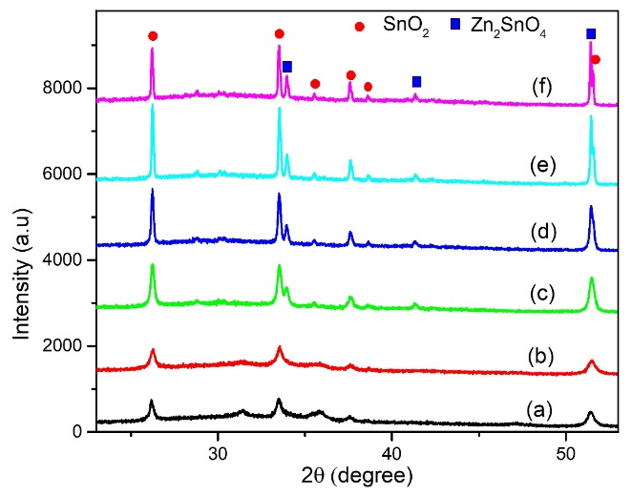
Fig. 1. XRD patterns of SnO₂-Zn₂SnO₄ ample unnealed (a) and annealed at different temperature of 500 °C (b); 900 °C (c); 1000 °C (d); 1100 °C (e) and 1200 °C (f)
3.2. Phosphor morphology
In order to determine phosphor morphology and size of the sample, a typical transmission electron microscope (SEM) have been carried out by ultra-high resolution scanning Electron Microscopy (SEM – Jeol JSM-7600F). Fig. 2 illustrates a typical transmission electron microscope image of the prepared Zn₂SnO₄-SnO₂ at different annealing temperature un-calcinated (a); 500 °C (b); 900 °C (c); 1000 °C; 1100 °C (d) and 1200 °C (f). Both particle shape and size are affected by changing calcination temperature dramatically. The powder particles of the un-annealed sample (a) have an average size of about 0,1 – 0,2 µm with irregular spherical particles. The surfaces of the foams show many cracks, and the grain size is greatly smaller but has bad crystallinity. When the annealing temperature increases to 1000 °C, the sample particle sizes are bigger and spherical morphology with particle bounds can be observed clearly. This result is well-matched with the XRD analysis mentioned above. The average particle size of the sample at 1100 °C is about 2-3 µm, which is a suitable size for LED applications. However, under high-temperature 1200 °C, a re-crystallization or particles cluster together to form massive or tiny particles.

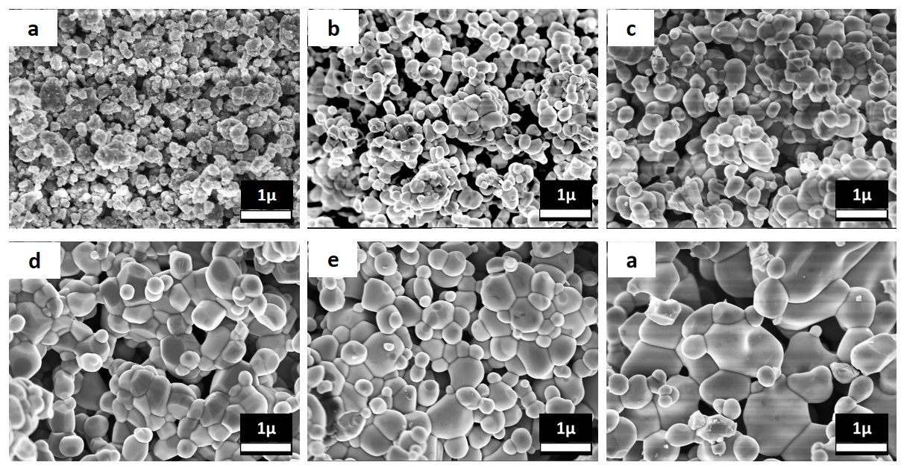
Fig. 2. FESEM images of SnO₂-Zn₂SnO₄ ample unnealed (a) and annealed at different temperature of 500 °C (b); 900 °C (c); 1000 °C (d); 1100 °C (e) and 1200 °C (f)

3.3. Optical properties

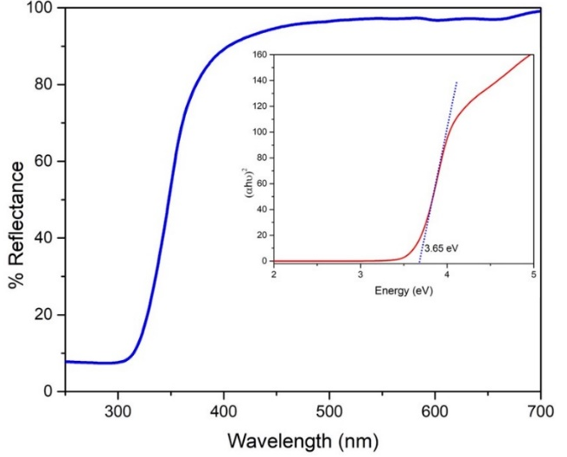
Fig. 3. UV-Vis spectra of the sample Zn₂SnO₄ – SnO₂ at calcination temperature of 1100 °C
The UV – vis spectroscopy was used to examine optical properties and estimate the band gap Eg of the prepared sample, as shown in Fig. 3. As seen from the Fig. 3, there is a significant rise in strong light reflection around over 310 nm and the most substantial absorption at about 310 nm, which can be assigned to intrinsic band gap absorption. The K-M formula¹⁶ has been used to estimate the optical absorption band gap of the prepared sample, as shown in the inset of the figure. The estimated value of the bandgap Eg is about 3.65 eV, which is slightly higher than the band gap value of bulk Zn₂SnO₄ (3.6 eV) but just under compared with the SnO₂ band gap (3.7 eV) reported by a previous report.¹⁷ The two-band gap may corresponding to 3.6 eV of Zn₂SnO₄ and 3.7 eV of SnO₂ phosphor. Furthermore, based on the XRD estimated result, the two phases, Zn₂SnO₄ and SnO₂, are nearly identical.
Fig. 4 illustrates the photoluminescence (PL) spectrum of the Zn₂SnO₄ – SnO₂ sample annealed with different temperature: un-calcinated (a); 500 °C (b); 900 °C (c); 1000 °C (d); 1100 °C (e) and 1200 °C (f). The spectra was recorded with the excitation wavelength 310 nm at room temperature by Nanolog - Horiba Jobin Yvon equipment. Overall, PL spectra of all samples anealed over 500 °C shows a broad visible band from 400 nm to 900 nm and nearly cover the full visible range blue – far-red emission. However, there are different intensities among them. It is observed that the PL intensity of the sample increases when the calcination temperature increases and the highest intensity belongs to the sample with an annealing temperature of 1100 °C (the inset of Fig.4). This result is suitable with XRD and SEM results. In order to clear the origin of PL peaks emission, the broadband emission has been fitted by Gaussian function as given in figure 4b. As shown in the figure, when the Gaussian was applied, the PL spectrum was fitted into five Gaussian peaks. Overall, there is no direct recombination process of a hole in the valence band to an electron in the conductor band because all five peaks' emission is smaller than the band gap of the prepared sample (3.65 eV). The first peak is in the blue region centered around 450 nm. Based on the calculated band gap of 3.65 eV, it is well-known from previous reports^{6, 11, 18, 19} that the band gap of bulk SnO₂ and Zn₂SnO₄ are around 3.87eV and 3.6 eV, respectively. So the peak emission at 450 nm is not due to the band-to-band gap emission of neither SnO₂ nor Zn₂SnO₄ phosphor. According to a former investigation,^{1, 7} the PL mechanisms have always been ascribed to other luminescent centers, such as oxygen vacancies and residual strain during the growth process. Hence, this work supports that the blue in the PL spectra can be attributed to oxygen vacancy defects in the SnO₂. The second band emission centered around 515 nm. This peak's origin was also discussed in Fu et al. research²⁰ and Baruah et al. report.²¹ According to them, the similar broad green emission centered at 520 nm in Zn₂SnO₄ under Xenon lamp excitation was caused by oxygen vacancy in Zn₂SnO₄ during the growth process. Moreover, Smilja et al. discussed in their report about the 546 nm emission in ZnO/SnO₂ spectra were that green emission implicates surface defects, as well as the defects just below the crystalline surface.²² So we suggest that the emission centered at 515 nm observed in PL spectra relates to oxygen vacancies in Zn₂SnO₄. Next, the third peak is in the yellow-orange region centered at 580 nm, which may attribute to SnO₂ defects such as Tin interstitials (Zni) or oxygen interstitials (Oi).⁸ The two final peaks are red and far-red, centered at 680 nm and 740 nm, which have not been observed and discussed in many previous reports. We suggest that they may relate to surface defects of the obtained sample, but the exact type and number of defect states depend on the method and parameters changing in the process.
Regarding the origin of the red emission band, Fu et al.²⁰ approved that stoichiometry Zn/Sn played a role in this emission. Furthermore, the red emission centered at 630 nm in SnO₂ PL spectra reported by Smilja et al.²² was considered related to deep–level defects within the gap of SnO₂, associated with oxygen vacancies and Sn interstitial formed during the synthesis procedure. The origin of this emission is still unclear and needs another measurement. Nevertheless, we agree with Chih-Hsien Cheng et al.²³ that the origin of the infrared 700 nm in his research is related to the transition states between neutral and ionized oxygen. In addition, from not only what is discussed above but also what is shown in PL spectra, we propose a diagram to explain the PL mechanism, as shown in Fig. 5. We believe defects formed during the calcination process play as energy states within the band gap. Hole traps are states that exit just over the valance band and fill holes, whereas electron traps are formed just under the conductor band and fill with electrons. The PL mechanism can be proposed as the following explanation. First, electrons from the valance band absorb excited energy as large as band gap energy and move to the conductor band to become excited electrons. Because the electron traps are just under the conductor band, excited electrons are trapped in electron traps easily without light-emitting. After that, these electrons release to lower energy states and depend on the gap between the two states that emit blue, green, red, or infrared.

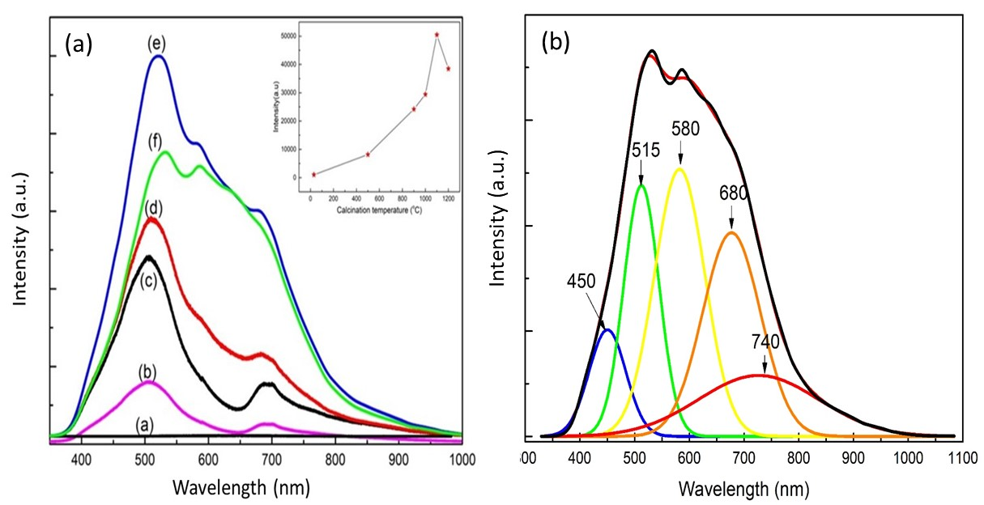
Fig.4. PL spectra of the Zn₂SnO₄ – SnO₂ phosphor annealed at different calcination temperatures (a) and PL of the sample annealed at 1100 °C fitted by Gaussian peak (b). The inset of the fig.a is the relative intensity of the Zn₂SnO₄ – SnO₂ phosphor annealed at different calcination temperatures

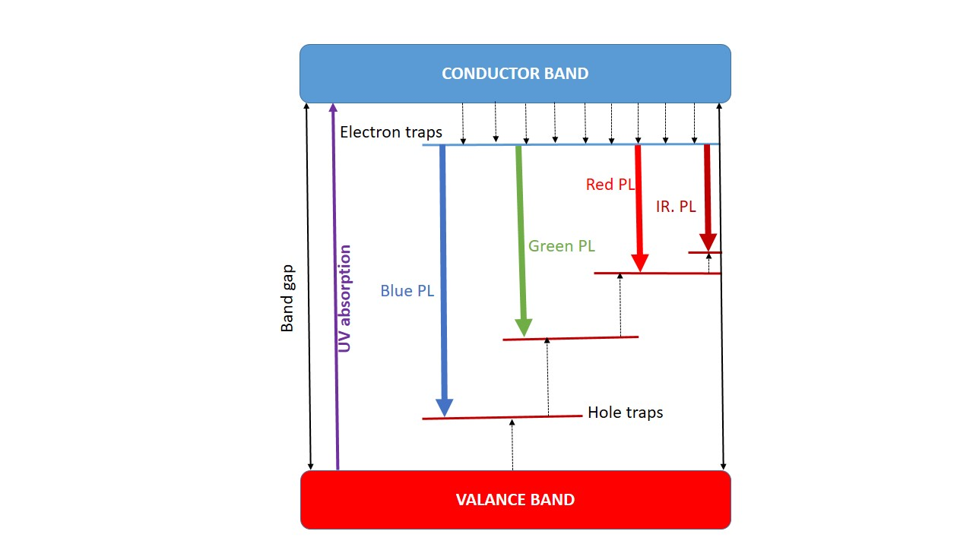
Fig. 5. Proposed energy band diagram for expalination PL machanism of Zn₂SnO₄ – SnO₂ sample showing the defect states and the transitions between the states
3.4. Electroluminescence properties of Zn₂SnO₄ – SnO₂ micro composite
The Zn₂SnO₄ – SnO₂ powder annealed at 1100 °C was covered on an LED chip 310 nm by the i-DR S320A Desktop Dispensing system. The device was then introduced into an integrating sphere system to calculate parameters related to the quality of WLED, as shown in Table 1. The LED has been supplied with a current of 0.2004 A and a voltage of 8.029 V during the process. As shown in Fig. 6, the CIE coordinates and CRI of White LED are (0.3755; 0.4173) and 95, respectively, which are very close to natural light. The color temperature is 4273 K which is energizing and most closely mimics natural daylight; it helps with tasks requiring focused attention, such as reading, computer work, carpentry, and drawing. These results demonstrate that Zn₂SnO₄ – SnO₂ micro composite phosphor shows a potential application in producing high both CRI and LER White LED.

Table 1. The WLED parameters (D_{uv}; Correlated colour temperature (CCT); Colour rendering index (CRI); Luminous efficacy of radiation (LER); R₉ and CIE coordinates(x,y)) of LED covered phosphor.
Sample | LED parameters
 | D_{uv} | CCT  (K) | CRI | LER  (lm/W) | R₉ | x | y
Zn₂SnO₄ – SnO₂ | 0.0194 | 4273 | 95 | 85 | 94 | 0.3755 | 0.4173
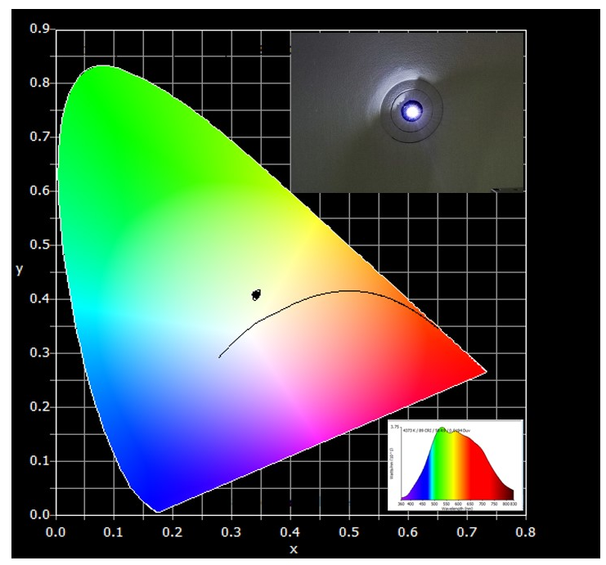
Fig. 6. CIE 2015-10° xy color chromaticity coordinates of the spectral emission from UV LED chip coated by prepared phosphor. The insets is the electroluminescence spectrum and the image captured by a digital camera of the white-emitting LED.

4. CONCLUSION
The Zn₂SnO₄ – SnO₂ micro composite was produced successfully by solid-state reaction followed by calcination at 1100 °C in air. The crystalline structure of samples was mixed of the cubic phase Zn₂SnO₄ (JCPDS card no. 00-024-1470, space group Fd-3m (227) and cell parameters a = b = c= 8.657 Å) and Tetragonal phase SnO₂ (JCPDS card no. 00-021-1250, space group P42/mm (136) and cell constants a = b = 4.738 Å and c = 3.188 Å. PL spectra of all samples show a broad visible band from 400 to 900 nm, nearly covering the full visible range of blue–far–red emission with peaks at around 450, 515, 580, 680, and 740 nm. A PL mechanism diagram has been proposed to explain the emission's origin. The LED chip 310 was used to cover obtained phosphor, getting a white LED. The CIE coordinates and CRI of White LED are (0.3755:0.4173) and 95, respectively. These results demonstrate that Zn₂SnO₄ – SnO₂ micro composite phosphor is potentially applicable in producing high CRI White LED.
Acknowledgment
This research is funded by Quy Nhon University under grand number T2022.747.03
References
1. P. K. Baitha and J. Manam. Structural and spectroscopic diagnosis of ZnO/SnO₂ nanocomposite influenced by Eu³⁺, J. Rare Earths, 2015, 33(8), 805–813.
2. Advanced Manufacturing Office. Wide Bandgap Semiconductors : Pursuing the Promise, Doe/Ee-0910, 2013, 120-128.
3. A. Hamrouni,N. Moussa, F. Parrino, A. Di Paola, A. Houas, and L. Palmisano, Sol-gel synthesis and photocatalytic activity of ZnO-SnO₂ nanocomposites, J. Mol. Catal. A Chem., 2014, 390, 133–141.
4. k. Abdulkareem omar, b. Ismael meena, and s. Ali muhammed. Study on the activity of zno-sno 2 nanocomposite against bacteria and fungi, Physicochem. Probl. Miner. Process, 2016, 52(2), 754–766, 2016.
5. V. Kuzhalosai, B. Subash, A. Senthilraja, P. Dhatshanamurthi, and M. Shanthi, “Synthesis, characterization and photocatalytic properties of SnO₂-ZnO composite under UV-A light” Spectrochim. Acta - Part A Mol. Biomol. Spectrosc., 2013, 115, 876–882.
6. W. S. Yuan, Y. W. Tian, and G. Q. Liu. Comparing the electrochemical properties of pure phase Zn₂SnO₄ and composite Zn₂SnO₄/C, Russ. J. Electrochem., 2011, 47(7), 829–834.
7. S. Dinesh, S. Barathan, V. K. Premkumar, G. Sivakumar, and N. Anandan. Hydrothermal synthesis of zinc stannate (Zn₂SnO₄) nanoparticles and its application towards photocatalytic and antibacterial activity, J. Mater. Sci. Mater. Electron., 2016, 27(9), 9668–9675.
8. Q. R. Hu. Synthesis and photoluminescence of Zn₂SnO₄ nanowires, J. Alloys Compd., 2009, 484(1–2), 25–27.
9. Q. Li. Preparation of Zn₂SnO₄/SnO₂ :Mn₂O₃ Microbox Composite Materials with Enhanced Lithium-Storage Properties, ChemElectroChem, 2017, 4(6), 1334–1340.
10. L. Ma.. Preparation of Ag-doped ZnO-SnO₂ hollow nanofibers with an enhanced ethanol sensing performance by electrospinning, Mater. Lett., 2017, 209, 188–192.
11. L. C. Nehru and C. Sanjeeviraja. Processing Research Controllable growth of Zn₂SnO₄ nanostructures by urea assisted microwave-assisted solution combustion process, ChemElectroChem, 2013, 14(5), 606–609.
12. L. Manzato, D. M. Trichês, S. Michielon de Souza, and M. Falcão de Oliveira. Synthesis of nanostructured SnO and SnO₂ by high-energy milling of Sn powder with stearic acid, J. Mater. Res., 2013, 29(1), 84–89.
13. J. X. Wang, S.S. Xie, H.J. Yuan, X.Q. Yan, D.F. Liu, Y. Gao, Z.P. Zhou, L. Song, L.F. Liu, X.W. Zhao, X. Y. Dou. Synthesis, structure, and photoluminescence of Zn₂SnO₄ single-crystal nanobelts and nanorings, Solid State Commun., 2004, 131(7), 435–440.
14. “JCPDS card no. 00-024-1470” 2017.
15. “JCPDS card no. 00-021-1250” 2014.
16. J. Tauc. Optical properties and electronic structure of amorphous Ge and Si, Mater. Res. Bull., 1968, 3(1), 37–46.
17. T. Jia, J. Zhao, F. Fu, Z. Deng, W. Wang, Z. Fu, F. Meng. Synthesis, characterization, and photocatalytic activity of Zn-doped SnO₂/Zn₂SnO₄ coupled nanocomposites, Int. J. Photoenergy, 2014, 1–7.
18. P. Wu. Correlation between photoluminescence and oxygen vacancies in In₂O₃ , SnO₂ and ZnO metal oxide nanostructures, J. Phys. Conf. Ser., 2009, 188(1), 12054.
19. A. Gaber, M. A. Abdel- Rahim, A. Y. Abdel-Latief, and M. N. Abdel-Salam. Influence of calcination temperature on the structure and porosity of nanocrystalline SnO₂ synthesized by a conventional precipitation method. Int. J. Electrochem. Sci., 2014, 9(1), 81–95.
20. B. R. Yakami, U. Poudyal, S. R, Nandyala, G. Rimal, J. K. Cooper, X. Zhang, J. Wang, W. Wang,J. M. Pikal. Steady state and time resolved optical characterization studies of Zn₂SnO₄ nanowires for solar cell applications J. Appl. Phys., 2016, 120(16), 163101.
21. S. Baruah and J. Dutta, Zinc stannate nanostructures: hydrothermal synthesis,” Sci. Technol. Adv. Mater., 2011, 12(1), 013004.
22. S. Marković, A. Stanković, J. Dostanić, L. Veselinović, L. Mančić, S. D. Škapin, Dražič, I. Janković-Častvan, D. Uskoković. Simultaneous enhancement of natural sunlight- and artificial UV-driven photocatalytic activity of a mechanically activated ZnO/SnO₂ composite, RSC Adv., 2017, 7(68), 42725–42737.
23. C. H. Cheng, W. L. Hsu, C. J. Lin, Y. H. Pai, and G. R. Lin. Performance of highly transparent and stable zinc oxide co-doped thin-film by aluminum and ytterbium, J. Disp. Technol., 2014, 10(10), 786–792.

Liên hệ: Nguyen Thi Tung Loan
Đại học Quy Nhơn
170 An Dương Vương, TP. Quy Nhơn, tỉnh Bình Định, Việt Nam
Email: tungloangreen6689@gmail.com
Điện thoại: 0366965268

