ĐÁNH GIÁ TỔNG QUAN TẾ BÀO NHIÊN LIỆU VI SINH: NHỮNG TIẾN BỘ GẦN ĐÂY VỀ CƠ CHẤT

TÓM TẮT
Trong hai thập kỷ qua, pin nhiên liệu vi sinh vật (Microbial fuel cells - MFCs) đã được chú ý vì chúng có thể chuyển đổi trực tiếp chuyển đổi năng lượng hóa học từ các hợp chất hữu cơ để tạo ra điện sinh học. Với việc sử dụng MFC, năng lượng sinh khối có thể được thu trực tiếp dưới dạng điện năng, đây là năng lượng sạch, phổ biến và tiện lợi nhất. Do đó, MFC được xem là một phương pháp đầy hứa hẹn khác để khai thác năng lượng bền vững trong sinh khối. Có nhiều cơ chất đã được nghiên cứu để sử dụng làm nguồn cấp nguyên liệu sử dụng trong MFC. Chúng bao gồm nhiều loại nước thải nhân tạo, nước thải thực và sinh khối lignocellulosic. Trong số các yếu tố, cơ chất là thách thức quan trọng nhất trong công nghệ MFCs, đòi hỏi sự ổn định lâu dài. Việc sử dụng cơ chất không ổn định ảnh hưởng trực tiếp đến hiệu suất của MFC. Tương tự, ảnh hưởng của các chất lên cộng đồng vi sinh vật cũng được thảo luận. Bài đánh giá này cập nhật những tiến bộ gần đây trong việc cải tiến công nghệ MFC, đặc biệt là các cơ chất khác nhau được phát hiện trong MFC cho đến nay, hiệu suất phát điện cũng như các cơ chất tiềm năng trong tương lai.
Từ khóa: Cơ chất, Mật độ năng lượng, Pin nhiên liệu vi sinh, Xử lý nước thải
A REVIEW OF THE GENERAL MICROBIAL FUEL CELL: RECENT ADVANCES IN SUBSTRATE

ABSTRACT
Over the past two decades, microbial fuel cells (MFCs) have gained attention because they can direct conversion convert chemical energy from organic compounds to create bio electricity. With the use of MFCs, biomass energy can be directly harvested in the form of electricity, which is the most convenient, widely available and clean energy. Therefore, MFCs are considered to be another promising way to harness sustainable energy in biomass and add new dimension to the biomass energy industry. There are many substrates that have been studied for use as data feeds. These include a variety of artificiality and real wastewater and lignocellulosic biomass. Among the factors, the substrate is the most important challenge in the MFCs, which requires long-term stability. The use of an unstable substrate directly affects the performance of the MFCs. Similarly, the effect of substances on the microbial community is discussed. This review updates recent advances in improving MFC technology, in particular the different substrates discovered in MFCs to date, power generation efficiency as well as potentially future substrates.
Keywords: Microbial fuel cell, Substrate, Wastewater treatment, Power density

INTRODUCTION
Fossil fuels given their unsustainable nature and bad impact on the environment have turned attention to renewable energy ¹. Renewable energy will be an important source to replace fossil fuels in the near future, because we can use these resources many times over to produce useful energy. In addition, water shortage is one of the hot issues of the whole world. According to climate change forecasts, this problem will be even more serious in the future ². The increase in water demand has led to an increase in the amount of wastewater generated. At the same time, there is an urgent need for renewable energy due to the rapid depletion of fossil fuels and growing concern about pollution ³. Many countries around the world are looking for alternative resources such as biomass as a more reliable, sustainable and benign resource to reduce the need for fossil fuels. To date, biomass can be converted into different types of energy products such as heat, gas, fuel and electricity ³. MFCs are a power generation device that uses bacteria as biological catalysts to generate electricity by oxidizing organic matter from the wastewater through respiration ⁴. It has considerable potential for applications in wastewater treatment ⁵, electrical equipment ⁶ and biosensors ⁷. Recently, there have been designed reactors with a scale of several hundred liters ⁸. Moving this technology from the laboratory scale to the current pilot scale will bring the technology closer to practical application. The actions of bacteria result in electron production from these substrates being transferred from the negative anode to the positive cathode through a conductive material and a load or resistor (Figure 1).
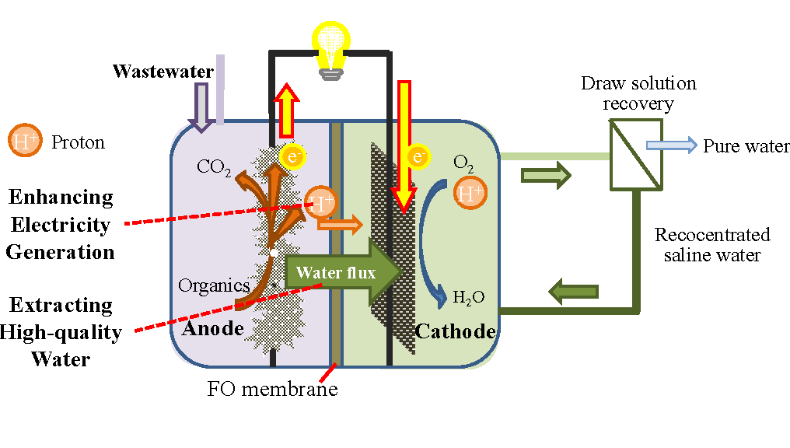
Figure 1 Structure diagram of microbial fuel cell ⁹
The substrate of the system must be replenished in a continuous or intermittent manner; otherwise, it is categorized as a bio-battery. Electron mediators or shuttles transfer electrons to anode ¹⁰ through electron transfer directly associated with the membrane, or through nanowires formed by bacteria ¹¹, or possibly through some other unexplored ways. Chemical mediators, such as neutral red or anthraquinone-2,6-disulfonate can be used in the MFC to facilitate electricity generation by bacteria that cannot use the electrode without aid ¹². Suppose the system has no added exogenous mediators. In that case, the MFC is considered as “mediator-less” even if the electron transfer mechanism may be unknown ¹³.
Research is increasing on MFCs constructed with various materials and configurations. The operating conditions also differ in temperature, pH, electron acceptor, operative time, surface areas of electrodes, and reactor size. Studies report potentials using different reference states and occasionally only using a single resistor (load). These and sometimes the lack of essential data such as resistance that is internal to the system, or power densities obtained from polarization curves using differing methods, has created a challenge in interpreting and comparing results among studies ¹⁴.
MFCs technology has been interested in more than 20 years not only by generating electric power but also known as an environmentally friendly wastewater treatment technology ¹⁵. Many types of wastewater today contain a lot of toxic waste, which is expensive to treat before being discharged into the environment. Previous studies have demonstrated the ability of MFCs to treat waste such as metal-derived wastewater, food and urine, and can even produce drinking water after the treatment process¹⁶⁻¹⁷. MFCs have coexisted with biological filter tanks in wastewater treatment to enhance pollution control and improve treatment capacity ¹⁸. Most of the treatment methods aim to remove organic compounds that reduce chemical oxygen demand (COD), azo dyes ¹⁹, and heavy metal waste ²⁰. The aeration system in wastewater treatment is reported to consume more than 54% of the electricity required in the treatment process, while the MFCs use anaerobic bacteria for the wastewater treatment process, which indicates a potential for energy saving of MFCs ¹⁹. In addition, MFCs used as biosensors are expected to be one of the promising applications of MFC-derived technology. Such biosensors have been studied to measure various parameters, including COD, volatile fatty acids, dissolved oxygen (DO), biochemical oxygen demad (BOD), toxic substances and microbial activity ²¹. This helps to reduce the time and cost required to measure toxicity in water.
A recent advancement in the application of power generation capabilities includes the use of MFCs to power a small computer (158 mW) directly and continuously without any management equipment, any power source ²². The performance enhancement of MFC is accomplished through many aspects, such as electrode material and surface, electrochemically active bacteria (EAB), substrate, load resistance.

LITERATURE REVIEW

Design of MFCs reactor
Currently, many types of MFC designs exist that are researched and developed. Each design has its own advantages and disadvantages and is suitable for specific uses. Various factors are considered in designing MFCs. The size, shape, and configuration of reactors widely differ and are wholly decided upon by the designer. There is no existing recommended standard design yet. MFC overall performance is significantly affected by reactor configurations, including the volume, oxygen supply, area of the membrane, and spacing between electrodes. Among the studied structures, double chamber H-type MFC is typically used because of its ion exchange membrane, facilitating proton diffusion and limiting the crossover of substrate and oxygen ²³. It is up to the designer to decide the aims of the project and plan the design accordingly. Presently, the available reactor designs are horseshoe-shaped, cylindrical, cubed, dual- and single-chamber, and H-type. Some are made of glass, while others are made up of a variety of plastic.
Also, sizes range widely, having reactor volumes of a few square millimeters and others of up to a square meter with volumes ranging from microliters to thousands of liters. The fuel cell design is an important element in the MFC/microbial electrolysis cell (MEC). From a two-chamber design, single-chamber cells have been created to eliminate the membrane ²⁴. Furthermore, single-chamber MFCs have shown promising results; however, dual-chamber is still widely studied. Dual-chamber cells are easier to construct than single-chamber reactors. A simple MFC device can either be dual- or single-chambered, based on the anode and cathode chamber assembly. Several adaptations of the MFC design and structure have been made from these two common designs ¹⁶.
H-shaped fuel cells, which usually consist of two bottles connected by a tube containing a separator, usually a cation exchange membrane (CEM) such as Nafion ¹² or Ultrex ²⁵, or a plain salt bridge ²⁶ (Figure 2A). The vital consideration for this design is choosing a membrane that allows proton transfer between the chambers but hinders the substrate or electron acceptor (usually oxygen) in the cathode chamber from crossing. Using a glass tube heated and bent to a U-shape is a cost-effective method to connect the bottles. Agar and salt are used as a CEM in the U-shaped glass tube and are inserted through the bottles’ lids (Figure 2A). However, it was observed that MFCs using salt bridge generates low power because of high internal resistance.
H-shaped MFC devices are generally accepted for basic parameter research. An example is testing the power produced using new materials or new microbes developing from some compound decomposition. But this MFC type typically generates low power densities. The relative surface area of the cathode to that of anode ²⁷ and the membrane surface ²⁸ affect the power generation.

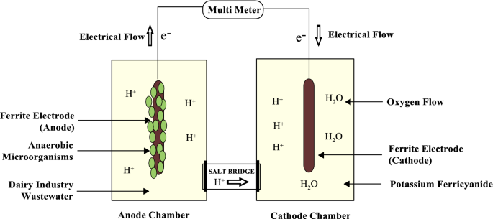
A
C
B
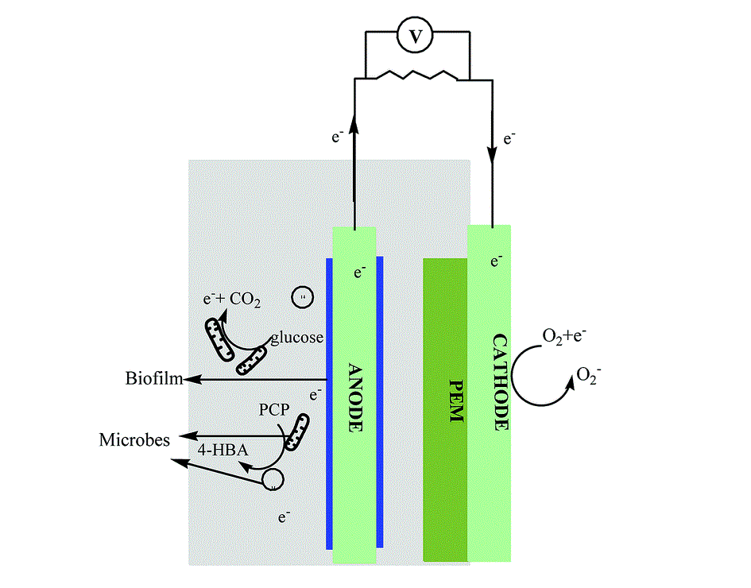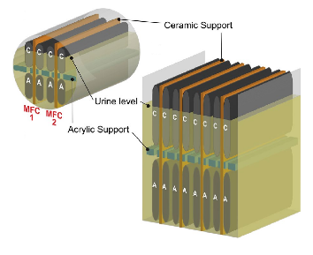
Figure 2 MFC types in studies: (A) device with a salt bridge (pointed by arrow) which is easily assembled ²⁹; (B) single-chamber, simple “tube” arrangement of air-cathode ³⁰; (C) stacked MFC, with one out of two
ceramic supports removed ³¹

Limitations to the power densities generated in these systems are typically due to considerable internal resistance, and losses from the electrodes. Therefore, upon comparing the systems’ production of power, it is logical to compare using anodes, cathodes, and membranes having the exact sizes ²⁸. Ferricyanide, the cathodic electron acceptor, improves power generation because of the high concentrations of electron acceptors. In an H-shaped reactor using Nafion as CEM, compared to a Pt-catalyst and dissolved oxygen in the cathode, ferricyanide increased the power produced by 1.5 to 1.8 times ²⁸. MFCs with the highest power densities and low internal resistances that have been published so far reported the use of ferricyanide at cathode chamber ¹⁰. Even though this chemical is excellent as a catholyte for system performance, it is not a sustainable practice since it is not chemically regenerated. Therefore, there exist restrictions on the use of ferricyanide in basic laboratory research only. Several studies have also explored using cathode directly in contact with air (Figure 2B, C), either with or without a membrane ³². In one study, a separator based on kaolin clay and cathode made of graphite was connected to combine the separator and cathode structure ³³. MFCs using air-cathodes improved power densities significantly compared to MFCs with aqueous-cathodes. The most straightforward configuration involves placing the anode and cathode on either side of a tube, sealing the anode against a flat plate, and exposing the cathode to air on one side and water on the other (Figure 2B).
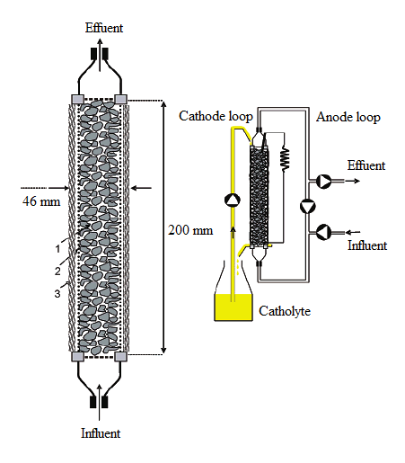
A
B
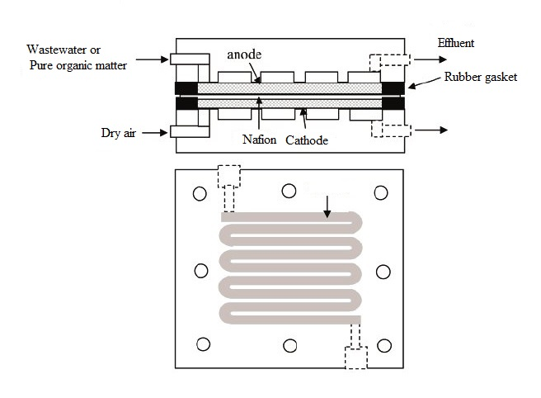

Figure 3 MFC operated continuously: (A) upward flowing, tubular type MFC with inner graphite bed anode and outer cathode ³⁴; (B) flat plate design where a serpentine pattern for fluid flow ³⁵
A membrane’s purpose in an air-cathode device is to prevent water leakage through the cathode. However, it also decreases oxygen diffusion into the anode chamber. The bacterial use of oxygen in the anode chamber can lower Coulombic efficiency, which is the fraction of electrons recovered over the maximum number to possibly be recovered ³². Although hydrostatic pressure on the cathode will cause water leaks, this can be minimized using coatings, such as polytetrafluoroethylene (PTFE), on the outside of the cathode. These coatings allow the diffusion of oxygen but limit the bulk loss of water ³⁶.
The systems mentioned so far are batch-operated devices. Several other basic designs also exist that provide flow continuously through the anode chamber. Some designs include an outer cylindrical reactor and a concentric inner cathode tube ³⁷. Some are the other way around having an internal cylindrical anode filled with granular media and outer cathode ³⁴ (Figure 3A). Another design variation is an upward flowing fixed-bed biofilm reactor, having flowing fluid continuously through permeable anodes on the way to a membrane that separates the anode from the cathode chamber ³⁸. System designs resembling hydrogen fuel cells have been employed, where a CEM is placed between the cathode and anode (Figure 3B). Stacking systems as a series of flat plates or linking together in series can increase overall system voltage (Figure 2C) ³¹.
Sediment MFCs have been developed. These are created by putting an electrode inside marine sediment abundant in sulfides and organic substances, and the other electrode being placed in the overlying oxic water. With these, electricity is produced sufficiently to provide power to some marine devices ³⁹. Graphite disks ¹² and platinum mesh electrodes ³⁹ have been used as electrodes. “Bottlebrush” cathodes have a high surface area and corrosive-resistant. Therefore, these find applications for seawater batteries and are promising for long-term operation ⁴⁰. H-tube dual-chamber systems have also been applied to sediment MFCs to study bacterial communities ¹². Modifications have also been done to produce hydrogen. Using a slight external potential in the MFC, the potential produced at the anode by the bacteria was assisted, making cathodic hydrogen generation possible ⁴¹. These are called bioelectrochemical assisted microbial reactors (BEAMRs) or bio-catalyzed electrolysis systems and are not considered as real fuel cells since they are operated to generate not electricity, but hydrogen. Having a second chamber for hydrogen gas capture would make it possible to develop various designs for hydrogen generation.

Factors affecting the activity of MFCs

Effect of electrode materials
An important goal of the anode chamber in the MFC reactor is to serve as a receiver for electrons for electric current. An effective anode material is determined to be electrically conductive, biocompatible, free from corrosion and fouling over time, inexpensive, and with a defined surface area ⁴². The electrode materials has a great influence on the performance of the MFC ⁴³. Carbon materials are used as electrodes in MFC because they are non-corrosive, highly biocompatible, and exhibit some distinctive surface characteristics of electrode materials. Modification of the electrode material has been shown to be an effective way to improve the performance of the MFC ⁴⁴.
Many studies have shown that electrodes with nanoparticle modification are more efficient than simple electrodes. This change in the physical and chemical properties of the electrode helps the microorganism better bind and transfer electrons. The efficiency of MFC can be increased through the improvement of bacterial adhesion and also electron transfer along with the modification of the electrode surface ⁴⁵. The biofilm attached to the electrode is an important element of electrochemical bioreaction ⁴⁶. The growth and development of biofilms on the MFC electrodes, especially on the anode electrode, will help carry out the oxidation of organic matter and transfer electrons to the cathode ⁴⁷. The anode electrode of the MFC must contain a stable and homogeneous bioreactor for enhanced energy generation ⁴⁸.
In summary, the electrode properties and the correlation between electrode, substrate and bacteria are the main factors affecting the performance of MFC. It can be seen that the development of MFC technology is a diverse combination of specialties such as biochemistry, electrochemistry, mechanical engineering and materials science.

Effect of Proton exchange system
In a dual-chamber design, the anode and the cathode compartments are separated by an ionselective membrane, allowing proton transfer from the anode to the cathode and preventing oxygen diffusion in the anode chamber from the cathode compartment. The membrane in the MFCs plays an important role on MFC performance. The most commonly used material for PEM affects the internal resistance and concentration of the polarisation loss of the MFCs system and influences the power output of the MFCs. There are several significant types of ion exchange membranes used in MFC systems: anion exchange membranes (AEM), cation exchange membranes (CEM), and polarized membranes (PBM) ⁴⁹.
The bioreactor architecture, material type, and reactor geometry determine the device's performance and cost. Studies aim to find the optimal combination of materials and design that will result in a high performance, low cost, and multiple functions to establish a standard for convenient and economically feasible scaling up. One such effort is the use of CEM such as Nafion that was derived from the existing technology on hydrogen PEMFC ⁵⁰ or treatment systems on water using membranes ³⁸. Since Nafion is expensive, most of the research is concentrated on possible alternatives, including investigations on materials such as nylon and glass fibers, j-cloth, biodegradable plastic bags, and ceramics ⁵⁰. Several waste materials have also been unusually tested, such as laboratory gloves and natural rubber ⁵¹. Results show that these materials offer benefits in terms of membrane fouling.
The principles of MFC operation is on the use of similar metals in different solutions, or different metals in similar solutions since liquid electrolytes are employed in the anode and cathode, as long as the cathode is not exposed to open air. Ions are contained in liquid solutions, which creates the need for an ion-exchange membrane. Therefore, in theory, a membrane is not a necessity for MFCs ³², given that the anode and cathode are either dissimilar (electrochemically separated), or they are identical but placed at a distance apart to avoid short-circuit.
Membrane-less MFC was therefore born ⁵². While this eliminates the need for high-cost membranes and fouling problems, the downside involves oxygen diffusion, which creates adverse competition with the anode on the available electrons. Most MFCs have been designed to have rigid, inert structural materials for housing anode and cathode half-cells, regardless of the presence of membranes. Currently, studies have emerged with the application of 3-D printing in the fabrication of MFCs ⁵³. 3-D printing of MFC bioreactors also has the benefit of creating complete reactors. As a result, these products can be applied to various applications and environments ⁵⁴.
The challenge of electrode spacing can be addressed by material type. Porosity, strength, chemical inertness, and longevity are the factors that may address this challenge while hindering oxygen penetration. The materials that have been studied so far are canvas ⁵², photocopy paper ⁵⁵, microporous filtration membranes ⁵⁶, and nylon infused membrane ⁵⁷.

Effect of pH
MFCs are very susceptible to the influence of external pH on their ability to generate renewable energy and remove contaminants. When the external pH changes, many physiological changes occur, including changes in ion concentration, proton shutdown, microbial cell pH, and biofilm formation at the anode electrode. pH value plays an important role in the growth of microorganisms, and it is necessary to consider the right pH conditions for the microorganisms to achieve maximum performance. The bacteria responsible for generating electricity in the MFC were more active at pH values of 6 to 8 in the anode chamber and neutral or slightly higher pH in the cathode chamber. The activities of the bacteria decrease as a result of the low pH in the anolyte, which has a tremendous effect on the biofilm formation and power output of the MFC. The main effect of pH regarding the electrolyte has to deal with its influence on the bacterial metabolism and the cathodic oxygen reduction reaction rate ⁵⁸.

Effect of Temperature
Temperature affects microbial metabolism, mass displacement and thermodynamics, leading to an effect on MFC performance. Orellana et al. ⁵⁹ report that MFCs operate stability at the temperature range of 25°C to 30°C. MFCs operating at higher temperatures have a performance advantage and substrate removal. This is because the temperature contributes to the initial biofilm formation, augmentation of the bacterial metabolism, and membrane permeability ⁶⁰. The optimum temperature for mesophilic microbes is in a range between 35 °C to 40 °C. Warmer temperatures, in general, have positive effects on the power generation, CE, and removal of COD ⁶¹. MFCs operating at higher temperature have a performance advantage and substrate removal. This is because of the temperature contributes to the initial biofilm formation, augmentation of the bacterial metabolism, and membrane permeability ⁶². These results indicate that temperature plays an important role in shaping microbial communities of the anode biofilms and the internal resistance of the cell in MFCs through changes in species evenness ⁶³.

SUBSTRATE
The substrate is considered to be one of the important biological factors related to the power efficiency in MFCs ⁶⁴. Organic substrates range from simple to complex and their mixtures can be used as a nutrient source by electrically active bacteria for power generation in MFCs. It has been reported that substrates ranging from simple (glucose, acetate, sucrose, etc.), to complex (i.e. amino proteins, acids, and even wastewater) can be used as substrate properties of the MFC ⁶⁵⁻⁶⁶. Besides, some wastewater such as seafood industrial wastewater ⁶⁷, petroleum recycling wastewater ⁶⁸, bamboo fermentation effluent ⁶⁹, were used as a complex substrate in MFC. In most cases, the ultimate purpose of wastewater use is to remove the pollutants present in the wastewater before releasing them into the environment. The researchers used different units to represent performance in the MFC in their study. A unit most often used is called power density, which can signify an amount of power (time rate of energy transfer) per unit unit area of the anode electrode surface (mW/m²) or the power density per volume of the cell (mW/m³). In this review, most routinely used substrates and the eﬀects they bring towards the performance of MFC are kick around in detail.

Acetate
In most of the research on MFC, acetate has been the widely used substrate type for electricity generation. As a simple substrate, acetate is rich in carbon electroactive microorganisms can easily metabolize. They are ions contained in acetic acid, and tend to prompt electroactive microbes. Notably, acetate is the final product of various different metabolic pathways for higher-order carbon sources ⁷⁰. Acetate being a simple compound is easier to degrade in MFCs ⁷¹. Liu et al. ⁷² observed that the acetate-fed single-chamber MFC obtained the power generation of 506 mW/m2, 800 mg/L which was approximately 66% higher than that of the one emitted by a butyrate (305 mW/m², 1000 mg/L). Liu et al. ⁶⁴ observed that the MFC fed by acetate substrate and acetate-acclimatized microbial consortia obtained more than twice higher power generation with half optimal external load resistance in comparison to MFC operated with protein-rich wastewater as substrate. However, a wide range of microbial community composition was observed in the anode biofilm for the protein-enriched wastewater compared to the acetate substrate. Chae et al. ⁷³ valuated the power generation of four diverse substrates where the acetate-fed MFC obtained the maximum power generation with CE of 72.3% while the other substrate-operated MFC achieved the lower power generation with butyrate (43.0%), propionate (36.0%) and glucose (15.0%). Dinh et al. ⁷¹ reported that the power density of 593.4 mW/m² produced from acetate at the concentration 10 mM. Power density with a mixture of acetate and lactate substrates at 30mM with a performance with a power density of 956.75 mW/m².

Glucose
Another common substrate used in MFC is glucose. The presence of glucose in wastewater sludge enhances the conductivity property of the MFC.
Generally, MFC using glucose as substrate achieves low by lower electron transfer (CE) efficiency between electroactive bacteria and electrode. Because they are explained by the fact that methanogenic and fermentative bacteria unrelated to electricity production in the MFC system can readily consume glucose ⁷⁴. Therefore, it is recommended recommended operating the MFC using a combination of substrates (i.e. a combination of simple and complex substrates ⁷³.

Synthetic Wastewater
Various synthetic or chemical wastewater with known composition have been used in MFCs as the conductivity, pH, and other parameters can easily be controlled. Mohan et al. ⁷⁵ operated MFCs fed with various loadings of synthetic wastewater to obtain an ideal loading rate.
A few media used during bacterial growth contain large quantities of redox mediators, including high-intensity wastewater composed of reduced species of sulphur and cysteine that can serve as an abiotic donor of electrons and improve power output for a brief period of time ⁷⁶. However, this does not adequately reflect the system’s performance. One solution for this is by utilizing a minimum salt solution containing only one electron donor, like glucose or acetate. Sun et al. ⁷⁷ using synthetic wastewater prepared fresh by dissolving glucose in tap water until the COD concentration was about 300 mg/L. The power density was 112.36 mW/m². The COD removal efficiency was about 60%, and the effluent COD was about 100 mg/L. Rodrigo et al. ⁷⁸ has studied the production of electricity and the oxidation of the pollutants contained in a synthetic wastewater fed with glucose and peptone of soybean as carbon sources. Waste-fed MFC that is slowly biodegradable generates higher energy, most likely because of the formation of intermediates that favor the production of electricity.

Brewery effluent
In general, brewery effluent is nontoxic and characterized by high COD and total nitrogen content in the presence of higher organic contents mainly consisting of protein and starch components ⁷⁹. Wang et al. ⁸⁰ reported that the power generation efficiency from brewery wastewater in the non-diaphragm MFC with a maximum power density of 483 mW/m² at 20 °C. The test results show that MFC can generate electricity from a high-intensity wastewater with COD concentrations ranging from 400 to 1,400 mg/L. Brewery wastewater is a preferred substrate in MFC because the strength is low and also because the organic matter is derived from food, thus resulting in low inhibitory compound concentrations, such as ammonia contained in animal wastewater ⁸¹.

Dye Wastewater
Azo dyes are abundant in the textile and dyeing industries. The presence of high concentrations of dyes will have very serious environmental effects such as blocking the passage of oxygen and light into the water, which will seriously affect aquatic life ⁸². Therefore, the removal of dyes from these eﬄuents before discharge into the environment is necessary. Some processing technology such as physical, chemical, and electrochemical treatments are being effectuated before discharging into the land ⁸³. Recently, the MFC technologies are able to convert chemical energy directly to electricity through a biological pathway ⁸⁴. Qiu et al. ⁸⁵ using a novel combined process of constructed wetland-microbial fuel cell and three dimensional biofilm electrode reactor was carried out for treatment of reactive brilliant red X-3B dye wastewater. The results showed that the decolorization rates of combination process was over 96%, and COD removal rate of 78.9%∼90.8%. Fatima et al. ⁸⁶ designed and optimized for efficient treatment of recalcitrant textile wastewater. Maximum power density of 120 mW/m² was obtained under optimized conditions. As a result, the color removal and COD reduction by the MFC was up to 81 and 58%. Consequently, treatment of wastewater containing azo dye and wastewater containing organic matter that is easily bio-degraded simultaneously can be performed by combining the two diﬀerent types of wastewater in MFC that can both improve cost and energy ⁸⁷. The downside is that this process still needs significant development to find a dense bacterial community capable of applying dyes mixed with simple sources of carbon to provide a solution that is realistic using MFC to treat this wastewater.

Lignocellulosic Biomass
The lignocellulosic biomass is abundantly available in nature, which is mainly generated from agricultural waste, and it is considered a promising and cost-effective feedstock for energy production ⁸⁸.
Due to their new availability and reproducibility, lignocellulosic compounds derived from agricultural by-products are favorable raw materials for low-cost electricity generation ⁸⁹. However, microorganisms in the MFC cannot use it is apparently lignocellulosic biomass for energy production. It must be broken down into monosaccharides or other reducing agents ⁷⁰.
Until now, a lot of biomass, including forest detritus in a forested wetland ⁹⁰, kitchen waste ⁹¹, chitin ⁹², cow dung ⁹³, orange peel waste biomass ⁹⁴, wheat straw ⁹⁵, algae grown ⁹⁶, rice straw ⁹⁷, potato wastes ⁹⁸, hydrothermal liquefied cornstalk biomass ⁹⁹, food waste ¹⁰⁰, lemon peel biomass ⁶⁰ has been exploited as fuel sources for bioenergy production in MFCs.
Dai et al. ⁶⁹ used wastewater from biohydrogen fermentation as a potential substrate. The wastewater used is reported to be containing end-product metatabs (acetic acid, lactic acid, and butyric acid), which constitute a rich source of substrates for bacteria. This is a type of wastewater with a stable composition, rich in nutrients and low in toxic components. Hou et al. ⁹¹ reported that kitchen waste anaerobically digested effluent treatment with the power density was 6255 mW/m³, biomass concentration which was 325 mg/L and COD removal efficiency of 43.59% when cultivated Golenkinia SDEC-16 in the single chamber MFC. Miran et al. ⁹⁴ demonstrated that bioelectricity production from orange peel waste without any chemical pretreatment or the addition of extra mediators. The maximum power density was 358.8 ± 15.6 mW/m². Liu et al. ⁹⁹ has shown the continuous production of electricity from cornstalk biomass after hydrothermal liquefaction treatment. A maximum power density 680 mW/m3. About 80% of COD and TOC were effectively removed. Li et al. ¹⁰⁰ electricity recovery was achieved with efficient organics biodegradation in the MFC using canteen-based food waste as substrates. A maximum power density of 5.6 W/m³ and an average output voltage of 0.51 V were obtained.
The quality of biomass is often determined by its inherent properties such as moisture content, bulk density, yield, size and shape, which affect its bioconversion and its ability to bioelectricity production in MFC ¹⁰¹. Most of the raw biomass or biomass derived from organic waste can be exploited as a substrate for MFC, which may imply that MFC would be widely adapted for energy harvesting from biomass.

APPLICATIONS OF MFC

Using MFCs technology is very attractive because the waste produced by being converted into energy, reducing waste disposal costs and increase economic efficiency. Developments in this technology have led to many important applications such as bioelectricity production, wastewater treatment, metal removal/recovery, biohydrogen production, biosensors, etc.

Wastewater treatment with generation of bioelectricity production
Wastewater treatment and bioelectricity generation have become the most heavily researched areas of MFC technology. Food processing wastewater, domestic wastewater, sewage sludge and many other types of wastewater are rich in organic matter and can provide a wide range of microorganisms used in MFC. Furthermore, wastewater containing heavy metals and other harmful pollutants has also been used as a substrate in MFC for the purpose of reducing pollution ¹⁰². They can remove COD up to 90% and columbic efficiency up to 80% ¹⁰³. Mehmood and et al reported that this a credible and highly cost effective method to remove nitrogen and organic matter from leachate, biological treatment ¹⁰⁴. The traditional wastewater treatment methods have many limitations such as energy consumption for the aeration of the first wastewater, the generation of harmful emissions to the environment ¹⁰⁵. MFC technology is used to treat wastewater with a completely different method because of its ability to capture energy ¹⁰⁶. Also, MFC could be an efficient method of electricity generation. Du Z. and et al reported that MFC has potential applications for wastes treatment and energy generation in spaceship ¹⁰⁷. Wang and et al have a report that the maximum of the password is 6,0 W/m³ with the line power being 1,9 ± 0,4 mA and high biomass retention ¹⁰³. Rojas-Flores and et al have been reported to have the maximum peak of voltage and current of 1.127 ± 0.096V and (1.130 ± 0.018 mA). The maximum PD was 3.155 ± 0.24 W/cm2 at 374.4 mA/cm² of CD was successfully using blueberry waste as substrate ¹⁰⁸.

Biosensors
MFCs used as biosensors have attracted increasing attention because of their simplicity and robustness, with various applications. The first type measures the amount of produced hydrogen peroxide and the lack of oxygen with the advantages of being easily fabricated and assembling small sized systems ¹⁰⁹. MFC-based biosensors are reported to be much more stable and durable than traditional BOD biosensors ¹¹⁰. MFC-based biosensors are an alternative strategy for dissolved oxygen (DO) measurement. They are based on the fundamental principle that is based on cathode behavior. Wang et al. using a mini autonomous MFC-based for monitoring hexavalent chromium in wastewater ¹¹¹. Also, a potential of remediating toxicants, such as phenols, formaldehyde and petroleum compounds is another application of MFC ¹¹²⁻¹¹³.

Biohydrogen production
Hydrogen will be produced in MFC such as secondary fuels, as a substitute for producing electricity. To generate hydrogen gas in typical MFC, anodic potential must be increased with a supplemental voltage of about 0.23 V or more and overcome this thermodynamic barrier, and also the oxygen in the cathode chamber should be evanced ¹⁰⁶. MFCs provide simultaneous wastewater remediation along with hydrogen generation has proven to be a sustainable process for energy production¹¹⁴. Chae et al. gave a demonstration of a solar-powered microbial electrolysis cell for hydrogen production. This work demonstrated that solar energy can be coupled into MFC device and provide a critical driving force for the bioelectrochemical reaction¹¹⁵. The production of hydrogen by MFC is an environmentally friendly method compared to glucose fermentation ¹¹⁶.

CONCLUSION
Power generation through a systematic MFC using quality substrates oxidized by bacterial species offers a promising technique for the future. In previous studies, simple substrates such as lactate and acetate were widely used; however, in recent years, a number of available substrates have been used as anode chamber nutrients to utilize waste biomass along with their treatment. The production of electricity from renewable waste biomass using MFC techniques has been considered a major development compared to traditional non-renewable biofuels. It is expected that the MFC technology will be designed to adapt a variety of substrates to make it a sustainable source of bioenergy.
The power generation efficiency of the systems is still very low and there are not many practical applications. It has been discovered that power density and combined efficiency can be higher through the right selection of micro-organisms, modes of operation, suitable materials for construction and improved types of MFCs. In addition, the large-scale application of MFCs is hindered by its high cost and low wastewater buffering capacity. Therefore, more technological advances are needed, especially the design of low-cost materials. The use of available substrates, especially wastewater, creates complexity in MFCs due to their high organic loads and inhibitory agents. It is necessary to establish a diverse and efficient microbial community to efficiently utilize the wastewater substrates and improve system performance. Combining MFC with conventional wastewater treatment technologies may be the best possible alternative for this technology.
In this review, substrates such as acetate, brewery water, bamboo fermentation wastewater, inorganic substances and azo coolants, which are harmful to the environment and organisms are discussed. There can new functions be explored through power generation through MFC as substrate. Until recently, a variety of substrates have been used in MFC for quality production. Even so, the big formulas for the practical use of MFCs need to be worked out and addressed, constraints such as power output and output reduction in order to expand regulation. These factors contribute to the difficulty of commercializing MFC, so more efforts are needed to provide a viable technology that can be effectively applied to commercialize MFC technology.
REFERENCES
1. Kumar, M., Social, economic, and environmental impacts of renewable energy resources. Wind Solar Hybrid Renewable Energy System 2020.
2. Mancosu, N.; Snyder, R. L.; Kyriakakis, G.; Spano, D., Water scarcity and future challenges for food production. Water 2015, 7 (3), 975-992.
3. Moradian, J. M.; Fang, Z.; Yong, Y.-C., Recent advances on biomass-fueled microbial fuel cell. Bioresources and Bioprocessing 2021, 8 (1), 1-13.
4. Obileke, K.; Onyeaka, H.; Meyer, E. L.; Nwokolo, N., Microbial fuel cells, a renewable energy technology for bio-electricity generation: A mini-review. Electrochemistry Communications 2021, 107003.
5. Liu, W.-f.; Cheng, S.-a., Microbial fuel cells for energy production from wastewaters: the way toward practical application. Journal of Zhejiang University SCIENCE A 2014, 15 (11), 841-861.
6. Arboleda Avilés, D. G.; Núñez Barrionuevo, O. F.; Sánchez Olmedo, O. F.; Chinchín Piñan, B. D.; Arboleda Briones, D. A.; Bahamonde Soria, R. A., Application of a direct current circuit to pick up and to store bioelectricity produced by microbial fuel cells. Revista Colombiana de Química 2019, 48 (3), 26-35.
7. Sun, J.-Z.; Peter Kingori, G.; Si, R.-W.; Zhai, D.-D.; Liao, Z.-H.; Sun, D.-Z.; Zheng, T.; Yong, Y.-C., Microbial fuel cell-based biosensors for environmental monitoring: a review. Water Science and Technology 2015, 71 (6), 801-809.
8. Hiegemann, H.; Littfinski, T.; Krimmler, S.; Lübken, M.; Klein, D.; Schmelz, K.-G.; Ooms, K.; Pant, D.; Wichern, M., Performance and inorganic fouling of a submergible 255 L prototype microbial fuel cell module during continuous long-term operation with real municipal wastewater under practical conditions. Bioresource technology 2019, 294, 122227.
9. Lu, Y.; Qin, M.; Yuan, H.; Abu-Reesh, I. M.; He, Z., When bioelectrochemical systems meet forward osmosis: accomplishing wastewater treatment and reuse through synergy. Water 2015, 7 (1), 38-50.
10. Rabaey, K.; Boon, N.; Siciliano, S. D.; Verhaege, M.; Verstraete, W., Biofuel cells select for microbial consortia that self-mediate electron transfer. Applied and environmental microbiology 2004, 70 (9), 5373-5382.
11. Bond, D. R.; Lovley, D. R., Electricity production by Geobacter sulfurreducens attached to electrodes. Applied and environmental microbiology 2003, 69 (3), 1548-1555.
12. Bond, D. R.; Holmes, D. E.; Tender, L. M.; Lovley, D. R., Electrode-reducing microorganisms that harvest energy from marine sediments. Science 2002, 295 (5554), 483-485.
13. Logan, B. E., Peer reviewed: extracting hydrogen and electricity from renewable resources. Environmental science & technology 2004, 38 (9), 160A-167A.
14. K. Rabaey, W. V., Microbial fuel cells: novel biotech-nology for energy generation. 2005, 23 (291-298).
15. Schechter, M.; Schechter, A.; Rozenfeld, S.; Efrat, E.; Cahan, R., Anode biofilm. Technology and Application of Microbial Fuel Cells 2014, 57.
16. Pant, D.; Van Bogaert, G.; Diels, L.; Vanbroekhoven, K., A review of the substrates used in microbial fuel cells (MFCs) for sustainable energy production. Bioresource technology 2010, 101 (6), 1533-1543.
17. Catal, T.; Kul, A.; Atalay, V. E.; Bermek, H.; Ozilhan, S.; Tarhan, N., Efficacy of microbial fuel cells for sensing of cocaine metabolites in urine-based wastewater. Journal of Power Sources 2019, 414, 1-7.
18. Mohammed, A. J.; Ismail, Z. Z., Slaughterhouse wastewater biotreatment associated with bioelectricity generation and nitrogen recovery in hybrid system of microbial fuel cell with aerobic and anoxic bioreactors. Ecological Engineering 2018, 125, 119-130.
19. Capodaglio, A. G.; Olsson, G., Energy issues in sustainable urban wastewater management: Use, demand reduction and recovery in the urban water cycle. Sustainability 2020, 12 (1), 266.
20. Mathuriya, A. S.; Yakhmi, J., Microbial fuel cells to recover heavy metals. Environmental chemistry letters 2014, 12 (4), 483-494.
21. Cui, Y.; Lai, B.; Tang, X., Microbial fuel cell-based biosensors. Biosensors 2019, 9 (3), 92.
22. Walter, X. A.; Greenman, J.; Ieropoulos, I. A., Microbial fuel cells directly powering a microcomputer. Journal of Power Sources 2020, 446, 227328.
23. Kondaveeti, S.; Lee, J.; Kakarla, R.; Kim, H. S.; Min, B., Low-cost separators for enhanced power production and field application of microbial fuel cells (MFCs). Electrochimica Acta 2014, 132, 434-440.
24. Call, D.; Logan, B. E., Hydrogen production in a single chamber microbial electrolysis cell lacking a membrane. Environmental science & technology 2008, 42 (9), 3401-3406.
25. Rabaey, K.; Lissens, G.; Siciliano, S. D.; Verstraete, W., A microbial fuel cell capable of converting glucose to electricity at high rate and efficiency. Biotechnology letters 2003, 25 (18), 1531-1535.
26. Min, B.; Cheng, S.; Logan, B. E., Electricity generation using membrane and salt bridge microbial fuel cells. Water research 2005, 39 (9), 1675-1686.
27. Oh, S.; Min, B.; Logan, B. E., Cathode performance as a factor in electricity generation in microbial fuel cells. Environmental science & technology 2004, 38 (18), 4900-4904.
28. Oh, S.-E.; Logan, B. E., Proton exchange membrane and electrode surface areas as factors that affect power generation in microbial fuel cells. Applied microbiology and biotechnology 2006, 70 (2), 162-169.
29. Sivakumar, D., Wastewater treatment and bioelectricity production in microbial fuel cell: salt bridge configurations. International Journal of Environmental Science and Technology 2021, 18 (6), 1379-1394.
30. Khan, N.; Khan, M. D.; Nizami, A.-S.; Rehan, M.; Shaida, A.; Ahmad, A.; Khan, M. Z., Energy generation through bioelectrochemical degradation of pentachlorophenol in microbial fuel cell. RSC advances 2018, 8 (37), 20726-20736.
31. Walter, X. A.; Gajda, I.; Forbes, S.; Winfield, J.; Greenman, J.; Ieropoulos, I., Scaling-up of a novel, simplified MFC stack based on a self-stratifying urine column. Biotechnology for biofuels 2016, 9 (1), 1-11.
32. Liu, H.; Logan, B. E., Electricity generation using an air-cathode single chamber microbial fuel cell in the presence and absence of a proton exchange membrane. Environmental science & technology 2004, 38 (14), 4040-4046.
33. Park, D. H.; Zeikus, J. G., Improved fuel cell and electrode designs for producing electricity from microbial degradation. Biotechnology and bioengineering 2003, 81 (3), 348-355.
34. Rabaey, K.; Clauwaert, P.; Aelterman, P.; Verstraete, W., Tubular microbial fuel cells for efficient electricity generation. Environmental science & technology 2005, 39 (20), 8077-8082.
35. Min, B.; Logan, B. E., Continuous electricity generation from domestic wastewater and organic substrates in a flat plate microbial fuel cell. Environmental science & technology 2004, 38 (21), 5809-5814.
36. Cheng, S.; Liu, H.; Logan, B. E., Increased performance of single-chamber microbial fuel cells using an improved cathode structure. Electrochemistry communications 2006, 8 (3), 489-494.
37. Liu, H.; Ramnarayanan, R.; Logan, B. E., Production of electricity during wastewater treatment using a single chamber microbial fuel cell. Environmental science & technology 2004, 38 (7), 2281-2285.
38. He, Z.; Minteer, S. D.; Angenent, L. T., Electricity generation from artificial wastewater using an upflow microbial fuel cell. Environmental science & technology 2005, 39 (14), 5262-5267.
39. Tender, L. M.; Reimers, C. E.; Stecher, H. A.; Holmes, D. E.; Bond, D. R.; Lowy, D. A.; Pilobello, K.; Fertig, S. J.; Lovley, D. R., Harnessing microbially generated power on the seafloor. Nature biotechnology 2002, 20 (8), 821-825.
40. Hasvold, Ø.; Henriksen, H.; Melv, E.; Citi, G.; Johansen, B. Ø.; Kjønigsen, T.; Galetti, R., Sea-water battery for subsea control systems. Journal of Power Sources 1997, 65 (1-2), 253-261.
41. Hutchinson, A. J.; Tokash, J. C.; Logan, B. E., Analysis of carbon fiber brush loading in anodes on startup and performance of microbial fuel cells. Journal of Power Sources 2011, 196 (22), 9213-9219.
42. Yaqoob, A. A.; Ibrahim, M. N. M.; Rodríguez-Couto, S., Development and modification of materials to build cost-effective anodes for microbial fuel cells (MFCs): An overview. Biochemical Engineering Journal 2020, 107779.
43. Kalathil, S.; Patil, S.; Pant, D., Microbial fuel cells: electrode materials. Elsevier, Amsterdam, The Netherlands: 2017; pp 1-10.
44. Zhou, M.; Chi, M.; Luo, J.; He, H.; Jin, T., An overview of electrode materials in microbial fuel cells. Journal of Power Sources 2011, 196 (10), 4427-4435.
45. Choudhury, P.; Prasad Uday, U. S.; Bandyopadhyay, T. K.; Ray, R. N.; Bhunia, B., Performance improvement of microbial fuel cell (MFC) using suitable electrode and Bioengineered organisms: A review. Bioengineered 2017, 8 (5), 471-487.
46. Gatti, M. N.; Milocco, R. H., A biofilm model of microbial fuel cells for engineering applications. International Journal of Energy and Environmental Engineering 2017, 8 (4), 303-315.
47. Lan, T.-H.; Wang, C.-T.; Sangeetha, T.; Yang, Y.-C.; Garg, A., Constructed mathematical model for nanowire electron transfer in microbial fuel cells. Journal of Power Sources 2018, 402, 483-488.
48. Wang, L.; Yang, C.; Sangeetha, T.; He, Z.; Guo, Z.; Lei, G.; Wang, A.; Liu, W., Methane production in a bioelectrochemistry integrated anaerobic reactor with layered nickel foam electrodes. Bioresource Technology 2020, 123657.
49. Rahimnejad, M.; Bakeri, G.; Najafpour, G.; Ghasemi, M.; Oh, S.-E., A review on the effect of proton exchange membranes in microbial fuel cells. Biofuel Research Journal 2014, 1 (1), 7-15.
50. Leong, J. X.; Daud, W. R. W.; Ghasemi, M.; Liew, K. B.; Ismail, M., Ion exchange membranes as separators in microbial fuel cells for bioenergy conversion: a comprehensive review. Renewable and Sustainable Energy Reviews 2013, 28, 575-587.
51. Winfield, J.; Chambers, L. D.; Rossiter, J.; Greenman, J.; Ieropoulos, I., Towards disposable microbial fuel cells: natural rubber glove membranes. International journal of hydrogen energy 2014, 39 (36), 21803-21810.
52. Zhuang, L.; Zhou, S.; Wang, Y.; Liu, C.; Geng, S., Membrane-less cloth cathode assembly (CCA) for scalable microbial fuel cells. Biosensors and Bioelectronics 2009, 24 (12), 3652-3656.
53. Ieropoulos, I.; Greenman, J.; Melhuish, C.; Horsfield, I. In EcoBot-III-A Robot with Guts, ALIFE, 2010; p e40.
54. Philamore, H.; Rossiter, J.; Walters, P.; Winfield, J.; Ieropoulos, I., Cast and 3D printed ion exchange membranes for monolithic microbial fuel cell fabrication. Journal of Power Sources 2015, 289, 91-99.
55. Winfield, J.; Chambers, L. D.; Rossiter, J.; Greenman, J.; Ieropoulos, I., Urine-activated origami microbial fuel cells to signal proof of life. Journal of Materials Chemistry A 2015, 3 (13), 7058-7065.
56. Zuo, Y.; Cheng, S.; Call, D.; Logan, B. E., Tubular membrane cathodes for scalable power generation in microbial fuel cells. Environmental science & technology 2007, 41 (9), 3347-3353.
57. Hernández-Fernández, F.; de los Ríos, A. P.; Mateo-Ramírez, F.; Godínez, C.; Lozano-Blanco, L.; Moreno, J.; Tomás-Alonso, F., New application of supported ionic liquids membranes as proton exchange membranes in microbial fuel cell for waste water treatment. Chemical Engineering Journal 2015, 279, 115-119.
58. Kim, M. H.; Iwuchukwu, I. J.; Wang, Y.; Shin, D.; Sanseverino, J.; Frymier, P., An analysis of the performance of an anaerobic dual anode-chambered microbial fuel cell. Journal of Power Sources 2011, 196 (4), 1909-1914.
59. Orellana, R.; Leavitt, J. J.; Comolli, L. R.; Csencsits, R.; Janot, N.; Flanagan, K. A.; Gray, A. S.; Leang, C.; Izallalen, M.; Mester, T., U (VI) reduction by diverse outer surface c-type cytochromes of Geobacter sulfurreducens. Applied and environmental microbiology 2013, 79 (20), 6369-6374.
60. Miran, W.; Nawaz, M.; Jang, J.; Lee, D. S., Sustainable electricity generation by biodegradation of low-cost lemon peel biomass in a dual chamber microbial fuel cell. International Biodeterioration & Biodegradation 2016, 106, 75-79.
61. Bohn, I.; Björnsson, L.; Mattiasson, B., Effect of temperature decrease on the microbial population and process performance of a mesophilic anaerobic bioreactor. Environmental technology 2007, 28 (8), 943-952.
62. Phung, N. T.; Lee, J.; Kang, K. H.; Chang, I. S.; Gadd, G. M.; Kim, B. H., Analysis of microbial diversity in oligotrophic microbial fuel cells using 16S rDNA sequences. FEMS microbiology letters 2004, 233 (1), 77-82.
63. Mei, X.; Xing, D.; Yang, Y.; Liu, Q.; Zhou, H.; Guo, C.; Ren, N., Adaptation of microbial community of the anode biofilm in microbial fuel cells to temperature. Bioelectrochemistry 2017, 117, 29-33.
64. Liu, Z.; Liu, J.; Zhang, S.; Su, Z., Study of operational performance and electrical response on mediator-less microbial fuel cells fed with carbon-and protein-rich substrates. Biochemical Engineering Journal 2009, 45 (3), 185-191.
65. Tariq, M.; Wang, J.; Bhatti, Z. A.; Bilal, M.; Malik, A. J.; Akhter, M. S.; Mahmood, Q.; Hussain, S.; Ghfar, A.; Al-Anazy, M. M., Bioenergy Potential of Albumin, Acetic Acid, Sucrose, and Blood in Microbial Fuel Cells Treating Synthetic Wastewater. Processes 2021, 9 (8), 1289.
66. Islam, M. A.; Karim, A.; Ameen, F., Effect of Substrates on the Performance of Microbial Fuel Cell for Sustainable Energy Production. In Progressive Thermochemical Biorefining Technologies, CRC Press: 2021; pp 161-176.
67. Jamal, M. T.; Pugazhendi, A.; Jeyakumar, R. B., Application of halophiles in air cathode MFC for seafood industrial wastewater treatment and energy production under high saline condition. Environmental Technology & Innovation 2020, 20, 101119.
68. Sevda, S.; Abu-Reesh, I. M., Improved petroleum refinery wastewater treatment and seawater desalination performance by combining osmotic microbial fuel cell and up-flow microbial desalination cell. Environmental technology 2019, 40 (7), 888-895.
69. Dai, H. N.; Nguyen, T.-A. D.; LE, L.-P. M.; Van Tran, M.; Lan, T.-H.; Wang, C.-T., Power generation of Shewanella oneidensis MR-1 microbial fuel cells in bamboo fermentation effluent. International Journal of Hydrogen Energy 2021, 46 (31), 16612-16621.
70. Yaqoob, A. A.; Serrà, A.; Ibrahim, M. N. M.; Yaakop, A. S., Self-assembled oil palm biomass-derived modified graphene oxide anode: An efficient medium for energy transportation and bioremediating Cd (II) via microbial fuel cells. Arabian Journal of Chemistry 2021, 14 (5), 103121.
71. Dinh, K. L.; Wang, C. T.; Dai, H. N.; Tran, V. M.; Le, M. L. P.; Saladaga, I. A.; Lin, Y. A., Lactate and acetate applied in dual‐chamber microbial fuel cells with domestic wastewater. International Journal of Energy Research 2021, 45 (7), 10655-10666.
72. Liu, H.; Cheng, S.; Logan, B. E., Production of electricity from acetate or butyrate using a single-chamber microbial fuel cell. Environmental science & technology 2005, 39 (2), 658-662.
73. Chae, K.-J.; Choi, M.-J.; Lee, J.-W.; Kim, K.-Y.; Kim, I. S., Effect of different substrates on the performance, bacterial diversity, and bacterial viability in microbial fuel cells. Bioresource technology 2009, 100 (14), 3518-3525.
74. Lee, H.-S.; Parameswaran, P.; Kato-Marcus, A.; Torres, C. I.; Rittmann, B. E., Evaluation of energy-conversion efficiencies in microbial fuel cells (MFCs) utilizing fermentable and non-fermentable substrates. Water research 2008, 42 (6-7), 1501-1510.
75. Mohan, S. V.; Mohanakrishna, G.; Reddy, B. P.; Saravanan, R.; Sarma, P., Bioelectricity generation from chemical wastewater treatment in mediatorless (anode) microbial fuel cell (MFC) using selectively enriched hydrogen producing mixed culture under acidophilic microenvironment. Biochemical Engineering Journal 2008, 39 (1), 121-130.
76. Kumar, S. S.; Kumar, V.; Kumar, R.; Malyan, S. K.; Pugazhendhi, A., Microbial fuel cells as a sustainable platform technology for bioenergy, biosensing, environmental monitoring, and other low power device applications. Fuel 2019, 255, 115682.
77. Sun, Y.; Zuo, J.; Cui, L.; Deng, Q.; Dang, Y., Diversity of microbes and potential exoelectrogenic bacteria on anode surface in microbial fuel cells. The Journal of general and applied microbiology 2010, 56 (1), 19-29.
78. Rodrigo, M. A.; Cañizares, P.; García, H.; Linares, J. J.; Lobato, J., Study of the acclimation stage and of the effect of the biodegradability on the performance of a microbial fuel cell. Bioresource technology 2009, 100 (20), 4704-4710.
79. Roveroto, G. P.; Teles, J. C.; Vuitik, G. A.; Batista, J. S. d. S.; Barana, A. C., Craft Brewery Wastewater Treatment: a Fixed-Bed Single-Batch Reactor with Intermittent Aeration to Remove COD and TN. Brazilian Archives of Biology and Technology 2021, 64.
80. Wang, X.; Feng, Y.; Lee, H., Electricity production from beer brewery wastewater using single chamber microbial fuel cell. Water Science and Technology 2008, 57 (7), 1117-1121.
81. Miran, W.; Nawaz, M.; Kadam, A.; Shin, S.; Heo, J.; Jang, J.; Lee, D. S., Microbial community structure in a dual chamber microbial fuel cell fed with brewery waste for azo dye degradation and electricity generation. Environmental Science and Pollution Research 2015, 22 (17), 13477-13485.
82. Khalid, S.; Alvi, F.; Fatima, M.; Aslam, M.; Riaz, S.; Farooq, R.; Zhang, Y., Dye degradation and electricity generation using microbial fuel cell with graphene oxide modified anode. Materials Letters 2018, 220, 272-276.
83. Slama, H. B.; Chenari Bouket, A.; Pourhassan, Z.; Alenezi, F. N.; Silini, A.; Cherif-Silini, H.; Oszako, T.; Luptakova, L.; Golinska, P.; Belbahri, L., Diversity of Synthetic Dyes from Textile Industries, Discharge Impacts and Treatment Methods. Applied Sciences 2021, 11 (14), 6255.
84. Zhang, L.; Wang, J.; Fu, G.; Zhang, Z., Simultaneous electricity generation and nitrogen and carbon removal in single-chamber microbial fuel cell for high-salinity wastewater treatment. Journal of Cleaner Production 2020, 276, 123203.
85. Qiu, D.; Liu, S. In Degradation of azo dye wastewater by the combination process of 3D BER and CW-MFC, IOP Conference Series: Earth and Environmental Science, IOP Publishing: 2021; p 012017.
86. Wreland Lindström, R., Low-cost Single Chamber MFC Integrated with Novel Lignin-based Carbon Fiber Felt Bioanode for Treatment of Recalcitrant Azo Dye. Frontiers in Energy Research 2021, 9, 260.
87. Cao, X.; Wang, H.; Li, X.-q.; Fang, Z.; Li, X.-n., Enhanced degradation of azo dye by a stacked microbial fuel cell-biofilm electrode reactor coupled system. Bioresource technology 2017, 227, 273-278.
88. Sharma, D.; Saini, A., Lignocellulosic Ethanol Production from a Biorefinery Perspective. Springer: 2020.
89. Yaqoob, A. A.; Ibrahim, M. N. M.; Yaakop, A. S.; Ahmad, A., Application of microbial fuel cells energized by oil palm trunk sap (OPTS) to remove the toxic metal from synthetic wastewater with generation of electricity. Applied Nanoscience 2021, 11 (6), 1949-1961.
90. Dai, J.; Wang, J. J.; Chow, A. T.; Conner, W. H., Electrical energy production from forest detritus in a forested wetland using microbial fuel cells. Gcb Bioenergy 2015, 7 (2), 244-252.
91. Hou, Q.; Nie, C.; Pei, H.; Hu, W.; Jiang, L.; Yang, Z., The effect of algae species on the bioelectricity and biodiesel generation through open-air cathode microbial fuel cell with kitchen waste anaerobically digested effluent as substrate. Bioresource technology 2016, 218, 902-908.
92. Li, S.-W.; Zeng, R. J.; Sheng, G.-P., An excellent anaerobic respiration mode for chitin degradation by Shewanella oneidensis MR-1 in microbial fuel cells. Biochemical Engineering Journal 2017, 118, 20-24.
93. Kumar, S.; Kumar, H. D.; Gireesh Babu, K., A study on the electricity generation from the cow dung using microbial fuel cell. Journal of Biochemical Technology 2012, 3 (4).
94. Miran, W.; Nawaz, M.; Jang, J.; Lee, D. S., Conversion of orange peel waste biomass to bioelectricity using a mediator-less microbial fuel cell. Science of the Total Environment 2016, 547, 197-205.
95. Song, T.-S.; Wang, D.-B.; Han, S.; Wu, X.-y.; Zhou, C. C., Influence of biomass addition on electricity harvesting from solid phase microbial fuel cells. International journal of hydrogen energy 2014, 39 (2), 1056-1062.
96. Gajda, I.; Greenman, J.; Melhuish, C.; Ieropoulos, I., Self-sustainable electricity production from algae grown in a microbial fuel cell system. Biomass and Bioenergy 2015, 82, 87-93.
97. Hassan, S. H.; El-Rab, S. M. G.; Rahimnejad, M.; Ghasemi, M.; Joo, J.-H.; Sik-Ok, Y.; Kim, I. S.; Oh, S.-E., Electricity generation from rice straw using a microbial fuel cell. international journal of hydrogen energy 2014, 39 (17), 9490-9496.
98. Du, H.; Li, F.; Huang, K.; Li, W.; Feng, C., Potato waste treatment by microbial fuel cell. Evaluation based on electricity generation, organic matter removal and microbial structure. Environment Protection Engineering 2017, 43 (1).
99. Liu, Z.; He, Y.; Shen, R.; Zhu, Z.; Xing, X.-H.; Li, B.; Zhang, Y., Performance and microbial community of carbon nanotube fixed-bed microbial fuel cell continuously fed with hydrothermal liquefied cornstalk biomass. Bioresource technology 2015, 185, 294-301.
100. Li, H.; Tian, Y.; Zuo, W.; Zhang, J.; Pan, X.; Li, L.; Su, X., Electricity generation from food wastes and characteristics of organic matters in microbial fuel cell. Bioresource technology 2016, 205, 104-110.
101. Tursi, A., A review on biomass: importance, chemistry, classification, and conversion. Biofuel Research Journal 2019, 6 (2), 962-979.
102. Abourached, C.; Catal, T.; Liu, H., Efficacy of single-chamber microbial fuel cells for removal of cadmium and zinc with simultaneous electricity production. Water Research 2014, 51, 228-233.
103. Wang, Y.-P.; Liu, X.-W.; Li, W.-W.; Li, F.; Wang, Y.-K.; Sheng, G.-P.; Zeng, R. J.; Yu, H.-Q., A microbial fuel cell–membrane bioreactor integrated system for cost-effective wastewater treatment. Applied Energy 2012, 98, 230-235.
104. Mehmood, M.; Adetutu, E.; Nedwell, D.; Ball, A., In situ microbial treatment of landfill leachate using aerated lagoons. Bioresource technology 2009, 100 (10), 2741-2744.
105. Wei, Y.; Van Houten, R. T.; Borger, A. R.; Eikelboom, D. H.; Fan, Y., Minimization of excess sludge production for biological wastewater treatment. Water research 2003, 37 (18), 4453-4467.
106. Logan, B. E., Microbial fuel cells. John Wiley & Sons: 2008.
107. Du, Z.; Li, H.; Gu, T., A state of the art review on microbial fuel cells: a promising technology for wastewater treatment and bioenergy. Biotechnology advances 2007, 25 (5), 464-482.
108. Rojas-Flores, S.; Benites, S. M.; La Cruz-Noriega, D.; Cabanillas-Chirinos, L.; Valdiviezo-Dominguez, F.; Quezada Álvarez, M. A.; Vega-Ybañez, V.; Angelats-Silva, L., Bioelectricity Production from Blueberry Waste. Processes 2021, 9 (8), 1301.
109. Gerritsen, M.; Jansen, J.; Lutterman, J., Performance of subcutaneously implanted glucose sensors for continuous monitoring. The Netherlands journal of medicine 1999, 54 (4), 167-179.
110. Kim, B. H.; Chang, I. S.; Gil, G. C.; Park, H. S.; Kim, H. J., Novel BOD (biological oxygen demand) sensor using mediator-less microbial fuel cell. Biotechnology letters 2003, 25 (7), 541-545.
111. Wang, C. T.; Ubando, A. T.; Katiyar, V.; Li, T. T.; Lin, Y. A.; Culaba, A. B.; Jang, J. H., Feasibility study on a mini autonomous biosensor based on microbial fuel cell for monitoring hexavalent chromium in wastewater. International Journal of Energy Research 2021, 45 (4), 6293-6302.
112. Luo, H.; Liu, G.; Zhang, R.; Jin, S., Phenol degradation in microbial fuel cells. Chemical Engineering Journal 2009, 147 (2-3), 259-264.
113. Yang, W.; Wei, X.; Fraiwan, A.; Coogan, C. G.; Lee, H.; Choi, S., Fast and sensitive water quality assessment: a μL-scale microbial fuel cell-based biosensor integrated with an air-bubble trap and electrochemical sensing functionality. Sensors and Actuators B: Chemical 2016, 226, 191-195.
114. Saravanan, A.; Karishma, S.; Kumar, P. S.; Yaashikaa, P.; Jeevanantham, S.; Gayathri, B., Microbial electrolysis cells and microbial fuel cells for biohydrogen production: current advances and emerging challenges. Biomass Conversion and Biorefinery 2020, 1-21.
115. Chae, K.-J.; Choi, M.-J.; Kim, K.-Y.; Ajayi, F. F.; Chang, I.-S.; Kim, I. S., A solar-powered microbial electrolysis cell with a platinum catalyst-free cathode to produce hydrogen. Environmental science & technology 2009, 43 (24), 9525-9530.
116. Nanda, S.; Rana, R.; Zheng, Y.; Kozinski, J. A.; Dalai, A. K., Insights on pathways for hydrogen generation from ethanol. Sustainable Energy & Fuels 2017, 1 (6), 1232-1245.

