Pin nhiên liệu vi sinh sử dụng màng trao đổi Poly (vinyl alcohol) liên kết chéo ứng dụng xử lý nước thải bệnh viện

Đinh Kha Lil^{1,}*, Imee A. Saladag²

¹Khoa Khoa học Tự nhiên, Trường Đại học Cần Thơ, Việt Nam
²Khoa Công Nghệ, Đại học bang Eastern Visayas, Phi-líp-pin

*Tác giả liên hệ chính. Email: lildk93@gmail.com

TÓM TẮT
Trong nghiên cứu này tập trung vào việc sản xuất điện bằng cách sử dụng pin nhiên liệu vi sinh hai buồng sử dụng nước thải bệnh viện. Mật độ công suất cao nhất 209,85 mW m⁻² và điện áp tối đa tạo ra là 652,75 mV khi sử dụng màng trao đổi 5%PVA. Các phát hiện chứng minh những ưu điểm của việc sử dụng thiết kế MFC dựa trên màng trao đổi thay thế Nafion chế độ tĩnh để xử lý nước thải bệnh viện là tiết kiệm chi phí vận hành, sản lượng điện cao. Các màng PVA liên kết chéo có thể là một giải pháp thay thế đầy hứa hẹn cho các vật liệu phân tách để xây dựng các hệ thống MFC thực tế.
Từ khóa: Pin nhiên liệu vi sinh, màng polyvinyl alcohol (PVA) liên kết chéo, xử lý nước thải, nước thải bệnh viện.

Microbial Fuel Cells using crosslinked Poly(vinyl alcohol) membrane separator for hospital wastewater treatment

Kha Lil Dinh^{1,*}, Imee A. Saladag ²

¹College of Natural Sciences, Can Tho University, Vietnam
²College of Engineering, Eastern Visayas State University, Philippines

*Corresponding author. Email: lildk93@gmail.com

ABSTRACT
The present study is focused on the production of electricity using double chambered microbial fuel cells. Hospital wastewater treatment was examined using double-chamber MFCs. The highest power density of 209.85 mW m⁻²and the maximum voltage generated of of 652.75 mV when using is 5%PVA membrane. The findings demonstrate that the main advantages of using static mode Nafion alternative membrane based MFC configurations for hospital wastewater treatment are savings on operational cost, high power output, negligible crossover, and higher treatment efficiency. The crosslinked PVA membranes can be a promising alternative to separation materials for building practical MFC systems.
Keywords: Microbial Fuel Cells, crosslinked polyvinyl alcohol (PVA) membrane, wastewater treatment, hospital wastewater

1. INTRODUCTION
Conventional wastewater treatment is an energy intensive process, with aeration accounting for 50% of the operating cost for removal of organic compounds.¹ Wastewaters are a source of large amount of potential energy in the form of pollutants.² Besides, anaerobic treatment of wastewater although produces biogas but the energy recovery is discouraging. With escalating energy demands, the necessity for low-energy wastewater treatment has never been greater. ³ Microbial fuel cells (MFCs) are an emerging, sustainable technology which with the aid of bacteria enable the recovery of energy out of wastewater, while limiting both the energy input and the excess sludge production. The most promising application is the energy-efficient treatment of wastewater.⁴
MFC is classified as membrane or membrane-less, membrane acts as a barrier between the anode and cathode electrodes. Although membrane-less MFCs help reduces design costs, diffusion of oxygen from the cathode to the anode side occurs, resulting in low power generation efficiency.⁵ An ideal separative membrane should prevent the transfer of the substrate and oxygen between the cathode chamber and the anode chamber while allowing protons to pass.⁶ Major challenges in the realization of MFC for practical application are in terms of material costs and energy recovery efficiency The commonly used membrane type is Nafion - this is a persistent material due to the presence of fluorine in the structure that is harmful to the environment and also accounts for 38% of the total capital cost.⁷
Hospitals have an important role in the health of humans. Their activities require large amounts of water and generate large amounts of wastewater. In general, the characteristics of wastewater hospitals (WWH) are similar to those of domestic wastewater, but a part of WWH including drugs, organic substances, toxic metals, radioactive tracer. They also carry microorganisms such as viruses, bacteria, fungi, protozoa and helminths. There is increasing evidence that WHH treatment systems contribute to the spread of antimicrobial resistant bacteria into the environment.⁸ Following our previous report on crosslinked PVA membrane with GA as separator in domestic wastewater fed MFCs which exhibited high power density and COD removal with antibacterial property, thermo-mechanical stability and negligible fuel crossover. In this study, GA-linked biodegradable PVA was used as a low-cost dynamic honeycomb MFC separator fed hospital wastewater that was evaluated for practical application. The microbiota in wastewater acts as a biological catalyst while wastewater is used as a substrate.
2. MATERIALS AND METHODS
2.1 Synthesis of PVA membranes
The membranes were synthesized using solution casting and solvent evaporation. After the synthesis, all films were stored at room temperature. The synthesis of each membrane is described below:
nPVA membrane: 2 g (95 wt. %) of PVA powder was added to 100 mL of deionized water to obtain a film of about 100 μm thick. The mixture was continuously stirred at 650 rpm at 85 °C. Then, 60 mL of homogeneous PVA solution was placed on Teflon plates and airdried at room temperature. The neat sample is, here onwards, called the NPVA membrane.⁹
5%PVA membrane: The steps for preparation of the membrane are followed as reported earlier. To achieve a thickness of about 100 μm, the film was synthesized using 2 g (95 wt. %) of PVA dissolved in 100 mL deionized water with continuous stirring (650 rpm) at 85 °C. To crosslink the polymer, 5 wt. % glutaraldehyde (GA) was mixed drop by drop to the PVA solution and was stirred further for 15 min. Attached to its backbone, neat PVA consists of hydroxyl groups. The addition of the crosslinker causes the acetal linkages and aldehyde side chain formations.⁹
2.2 Reactor design, setup, and operation
2.2.1 MFC setup and operation
The shape of double chamber H-cell membrane reactor for MFCs is illustrated in Figure 1. Three identical H-cell MFC were composed of two glass chambers with a volume of 250 mL each separated by a proton exchange membrane in between the two chambers. The anode and cathode are composed of graphite felts with dimensions of 5 cm × 5 cm with nPVA and 5%PVA membranes of size 3 cm in diameter in the experimental case. Another MFCs using Nafion-117, Dupont Co., USA (with similar size) was considered as the control case.
Meanwhile, the Nafion-117 membrane were treated in 5% H₂O₂ solution at 70 ºC for 1 h, repeatedly rinsed with deionized water (DI), and then treated in 0.5 M H₂SO₄ at 90 ºC for 1 h. These were rinsed repeatedly and stored in DI water for later use. Graphite felt electrodes were used as cathodes and anode. The electrodes were pretreated in 10% H₂O₂ solution for 3 h at 90 ºC followed by airdrying at ambient temperature for at least two days before use.
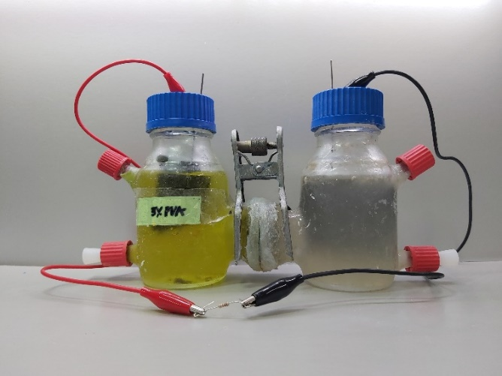
Figure 1. The schematic representation of the MFCs fed with hospital wastewater.
According to the PEM applied, three MFCs were used in this study labeled as Nafion-117, nPVA and 5%PVA. All were operated batch-wise and tested at 25 °C. A steady voltage was achieved for at least three consecutive cycles before output measurements were performed.
2.2.2 Anode biofilm acclimation
A mixed culture of bacteria had the source of hospital wastewater, obtained from the National Yang Ming Chiao Tung University Hospital Xinmin Branch, Yilan City, Taiwan, used as anode inoculum. Mixture hospital wastewater containing mixed culture of bacteria and 50 mM phosphate buffer nutrient solution (1:1 ratio) as the inoculum in the anode chamber. Phosphate buffer nutrient solution (PBS) was composed of Na₂HPO₄, 9.16 g L^{–1}; NaH₂PO₄·2H₂O, 5.56 g L^{–1}; NH₄Cl, 0.638 g L^{–1}; and KCl, 0.278 g L^{–1}. Sodium acetate (1 g) was added per liter of the solution as the electroactive bacteria (EAB) substrate.
During the EAB acclimation, a 1:1 solution of 100 mM K₃[Fe(CN)₆] (32.924 g L^{–1}) and 100 mM PBS solution served as the catholyte. The anolyte and catholyte were replaced with new solutions when the voltage production declined to 10% of the maximum voltage produced, which indicates the end of each fed-batch cycle. A titanium wire was inserted in each electrode and then connected to a 1,000-Ω external resistance using copper wire to reduce the biofilms’ acclimation time.¹⁰ The MFCs were operated on for 3 months to obtain a robust bacterial biofilm.
2.3 Biofilm characterizations
After HMFC operations, electrode samples were microanalysis by scanning electron microscopy (SEM). To characterize the bacterial anode and microalgae cathode’s surface morphology and structure biofilms.
2.4 Electrochemical measurements
MFCs voltage was measured every 2 h during the operations. Open circuit condition of the HMFCs was maintained for 4 h before polarization and electrochemical impedance spectroscopy (EIS) tests. Linear sweep voltammetry (LSV) was done three times at a scan rate of 10 mV s−1 starting from the measured open-circuit voltage (OCV) to zero. Data were acquired at 10 points per second using a multifunctional electrochemical analyzer (JIEHAN 5640, JIEHAN Technology Group, Taiwan).
The current was calculated from Ohm’s Law, I = V/R, where I is the current (A) and V is the output voltage (mV) through a resistance, R (Ω). Power ($P$, mW) was calculated from $P$ = V $×$ I. Current density ($I_{D}$, mA m⁻²) and power density ($P_{D}$, mW m⁻²) were calculated using the total anode surface area (0.005 m²).¹¹
Electrochemical impedance spectroscopy (EIS) was carried out using HIOKY 3522-50 LCR Hi-TESTER (Japan) by applying a 10-mV AC signal within 100 kHz to 0.1 Hz frequency range. An equivalent circuit was used to fit the EIS spectra and calculate internal resistance values in EC Lab software.¹²
3. RESULTS AND DISCUSSION
Crosslinking of PVA with GA improves the properties of the pristine PVA membrane making it suitable for real wastewater treatment which has been reported below. The continuous operation of the MFC condition with crosslinked membrane as separator is analyzed in the latter section.
3.1 Bioelectricity production in the double chambered MFC
Under the fed-batch mode of operation, the MFCs investigated took a period of 1 month to reach stable conditions. A gradual increase in voltage under an external load of 1000 Ω was observed. No significant lag in the voltage generation was observed during start-up which is indication of the microbial cell to anode adhesion efficiency. In order to inoculate the graphite electrode with mixed culture of bacteria present in hospital wastewater, three successive acclimation cycles were carried out with acetate as the carbon source.
The current and power density curves are shown in Figure 2. Among the three MFCs, the highest power density was achieved by Naﬁon-117 membranes MFC at 316.17 mW m⁻². It also obtained the maximum voltage generated of 736.83 mV. The 5%PVA membrane MFC followed with respective power current and maximum voltage generated: 209.85 mW m⁻² and 652.75 mV while nPVA membrane MFC achieved 116.46 mW m⁻² and 522.24 mV. The enhanced performance of the crosslinked membrane can be ascribed to the crosslinking and branching with GA as it successfully altered the undesirable properties of the nPVA membrane with enhanced stability in terms of chemical, thermal, and mechanical properties, and controlled water uptake and degree of swelling, which has been reported in the previous study by our research group.¹³ It is known that the water uptake capacity with the optimum swelling ratio is desired in the transport of protons across the polymeric membrane since it aids the proton transfer across the membrane in MFCs. However, higher water content with high swelling negatively impacts its mechanical integrity. The nPVA being a straight-chain polymer, forms intramolecular and intermolecular hydrogen bonding with water. On crosslinking with GA, acetal ring linkage is formed with a reduction in available hydroxyl groups in PVA. The nPVA demonstrated water uptake up to 250%, which was reduced to 50% for the crosslinked membrane. Similarly, the %swelling reduced from 50% for the neat PVA membrane to 20% for the crosslinked membrane.¹³

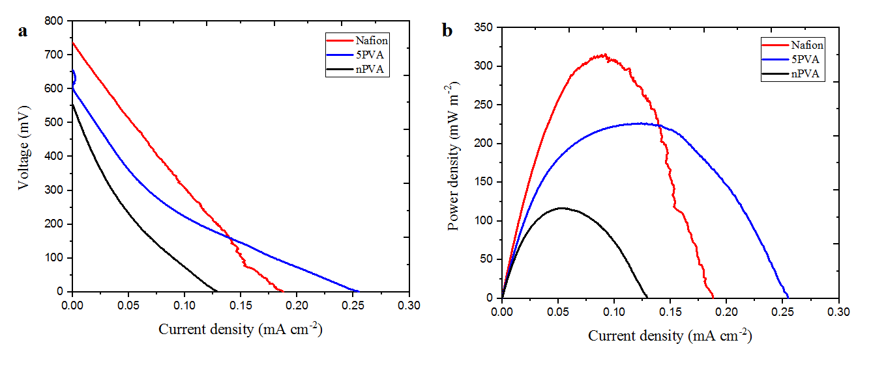
Figure 2. Polarization curves (a) and power density generated (b) by MFCs equipped with different types of membranes.
Table 1. Power density reported of different exchange membrane in MFCs.
Electrode material | Anode volume (mL) | Exchange membrane | Power density (mW m^{–2} ) | Ref.
Graphite granules | 390 | UltrexeCMI7000, Membranes International Inc., USA) | 8 ± 5 | Rabaey et al.¹⁴
Graphite granules | 60 | UltrexeCMI7000, Membranes International Inc., USA) | 14 ± 1 | Aelterman et al.¹⁵
Aluminium | 2,000 | Gar-salt bridge | ~0.25 | Shakunthala et al.¹⁶
Carbon cloth | 100 | Ceramic-separator | 168.91±3.89 | Chaijak et al.¹⁷
Graphite felts | 250 | Nafion-117, Dupont Co., USA | 316.17 | This work
Graphite felts | 250 | nPVA | 116.46 | This work
Graphite felts | 250 | 5%PVA | 209.85 | This work

Hospital wastewater is not a common source of substrate tested for electricity production by MFCs technology. The production of bioelectricity from these wastewaters depends on the type of organic compounds present in the effluent. Especially, particulate organic matters that have complex chemical structures must be converted into low molecular weight substrates, and then these substrates can then be used by microbes. Table 1 provides a series of characteristics ability to generate electricity of hospital wastewater as substrate for bioelectricity formation with MFCs in our study. MFCs is improving and power density of 209.85 mW m⁻² and maximum voltage generated of 652.75 mV using an crosslinked 5%PVA membrane. The results showed that hospital wastewater can be successfully employed as a cheap substrate for electricity production in MFC. However, the challenges due to the hazardous compounds in the effluents, for example dialysis hospital wastewater has a high content of organic load and salt concentration.
3.2 Biofilm Analysis
A mixed consortium is preferred for performance enhancement in MFCs fed with wastewater compared to the pure culture. The reason is it exhibits a “nutrient cycle ecosystem” in which some species degrade the organic matter, while some species act against harmful pollutants present in wastewater.¹⁸
The bacterial mixture in hospital wastewater has grown a biofilm on the anode, as shown in the SEM images in Figure 4. Variations on the biofilm can be observed with uniform growth and clumps as well as undeveloped areas. In previous studies, clumping growth has been associated with detrimental effects on power output as it can inhibit electron transfer. As can be seen, biofilms are dominated by growth uniform growth, which is a good indication of a good bacterial colonization.¹⁹ The combination of bacteria contributes to the diversity of biofilms. It produces a higher specific capacity than MFCs operating with monocultures in the anode compartment. The stable biofilm developed favored low resistance to the electrochemical reaction at the anode surface, as demonstrated by the low Rct value in EIS analysis.

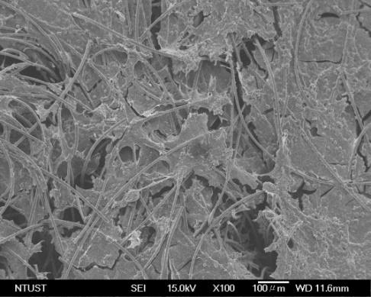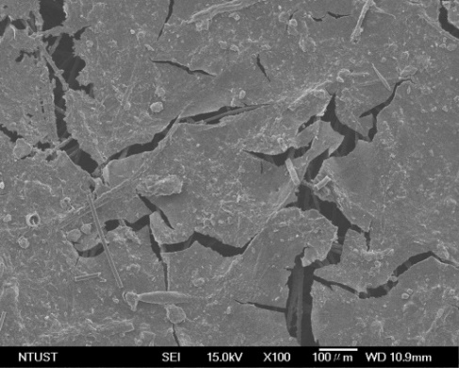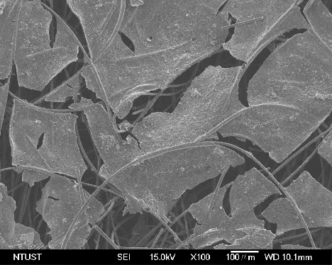
(b)
(c)
(a)
Figure 4. SEM images of anodes with electroactive bacteria biofilm were grown with: (a) Nafion membrane, (b) nPVA membrane and (c) 5%PVA membrane.

3.3 Internal resistance of the MFC with crosslinked membrane
The proton exchange membrane is one of the most critical components in the fuel cell configuration. It not only provides a separation between the two electrolytes, but also provides electroneutrality by facilitating transport of H⁺ to compensate for transport of electrons. In order to assess the internal resistance of the MFCs equipped with the membranes, the EIS results were interpreted according to the Randles equivalent circuit shown in Figure 4 (a). R₁, R₂, C₂ and W₂ represent the ohmic resistance, charge transfer resistance, double layer capacitance, and Warburg impedance, respectively which are components of the internal resistances. The diameter of the semicircle in the low frequency side of the Nyquist plot as seen from Figure 4 (b) represents the charge transfer resistance while the linear portion in low frequency side represents diffusion resistance. The difference between origin to the initial start of the semicircle gives the ohmic resistance.²⁰ Nafion exhibited lower ohmic resistance compared to the crosslinked membrane which is mainly due to the presence of sulphonic acid groups in its polymer chain.²¹ Although PVA is an insulating material with no polar groups,²² yet the charge transfer resistance was found to be lower in case of the PVA based MFCs and comparable to the charge transfer resistance observed in the Nafion based MFCs. This can be attributed to crosslinking with GA which resulted in low value of charge transfer indicating better charge transport through the crosslinked membrane due to optimum water content facilitating proton transfer through vehicular mechanism.²³

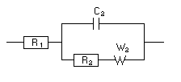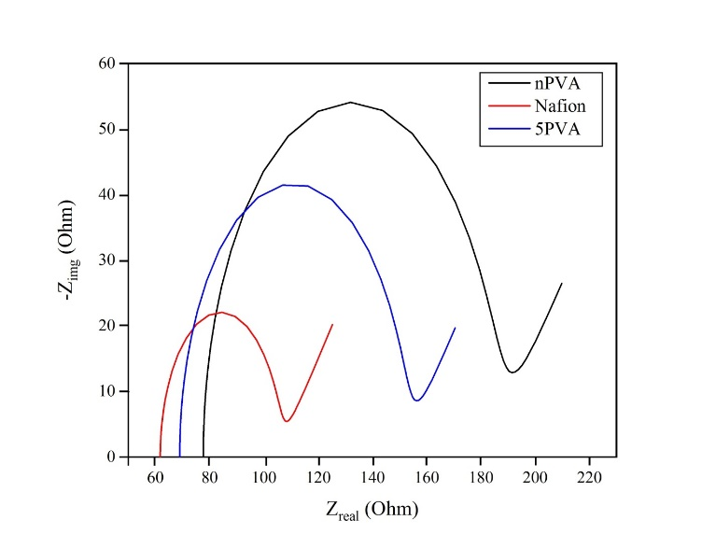
(a)
(b)
Figure 4. (a) Equivalent circuit of MFC, (b) Nyquist plot of MFC fit: Nyquist diagram from Z-fit by EC Lab software.
Table 3. Internal resistance of MFCs and other circuit parameter values.
 | Membrane | R₁ (Ω) | R₂ (Ω) | C₂ (F) | W₂
 | Nafion | 62.58 | 41.53 | 43.14×10^{–6} | 15.93
 | 5%PVA | 68.97 | 82.31 | 51.98×10^{–6} | 15.35
 | nPVA | 84.14 | 105.26 | 58.46×10^{–6} | 15.64

4. CONCLUSIONS
In this work, crosslinked PVA membrane as separators with hospital wastewater has been successfully demonstrated in MFC. Using the low-cost membranes with hospital wastewater as substrate not only drastically reduces its capital and operational costs with but also helps to treat hospital wastewater eco-friendly technology, which is an excellent advantage for the practical application of MFCs in the futuer.
REFERENCES
1. Chen, Y.; Zhang, H.; Yin, Y.; Zeng, F.; Cui, Z., Smart energy savings for aeration control in wastewater treatment. Energy Reports, 2022, 8, 1711-1721.
2. Khalid, K. M., Correlation between Air Quality and Wastewater Pollution. In Environmental Sustainability-Preparing for Tomorrow, IntechOpen: 2021.
3. Rozendal, R. A.; Hamelers, H. V.; Rabaey, K.; Keller, J.; Buisman, C. J., Towards practical implementation of bioelectrochemical wastewater treatment. Trends in biotechnology, 2008, 26 (8), 450-459.
4. Nawaz, A.; ul Haq, I.; Qaisar, K.; Gunes, B.; Raja, S. I.; Mohyuddin, K.; Amin, H., Microbial fuel cells: Insight into simultaneous wastewater treatment and bioelectricity generation. Process Safety and Environmental Protection, 2022, 161, 357-373.
5. Zhou, M.; Wang, H.; Hassett, D. J.; Gu, T., Recent advances in microbial fuel cells (MFCs) and microbial electrolysis cells (MECs) for wastewater treatment, bioenergy and bioproducts. Journal of Chemical Technology & Biotechnology, 2013, 88 (4), 508-518.
6. Lovley, D. R., Bug juice: harvesting electricity with microorganisms. Nature Reviews Microbiology, 2006, 4 (7), 497-508.
7. González-Pabón, M. J.; Figueredo, F.; Martínez-Casillas, D. C.; Corton, E., Characterization of a new composite membrane for point of need paper-based micro-scale microbial fuel cell analytical devices. PloS one, 2019, 14 (9), e0222538.
8. Kumari, A.; Maurya, N. S.; Tiwari, B., Hospital wastewater treatment scenario around the globe. In Current developments in Biotechnology and Bioengineering, Elsevier: 2020; pp 549-570.
9. Das, B.; Gaur, S. S.; Katha, A. R.; Wang, C.-T.; Katiyar, V., Crosslinked poly (vinyl alcohol) membrane as separator for domestic wastewater fed dual chambered microbial fuel cells. International Journal of Hydrogen Energy, 2021, 46 (10), 7073-7086.
10. Buitrón, G.; López-Prieto, I.; Zúñiga, I. T.; Vargas, A., Reduction of start-up time in a microbial fuel cell through the variation of external resistance. Energy Procedia, 2017, 142, 694-699.
11. Logan, B. E.; Hamelers, B.; Rozendal, R.; Schröder, U.; Keller, J.; Freguia, S.; Aelterman, P.; Verstraete, W.; Rabaey, K., Microbial fuel cells: methodology and technology. Environmental science & technology, 2006, 40 (17), 5181-5192.
12. Hutchinson, A. J.; Tokash, J. C.; Logan, B. E., Analysis of carbon fiber brush loading in anodes on startup and performance of microbial fuel cells. Journal of Power Sources, 2011, 196 (22), 9213-9219.
13. Das, B.; Gaur, S. S.; Katha, A. R.; Wang, C.-T.; Katiyar, V., Crosslinked poly (vinyl alcohol) membrane as separator for domestic wastewater fed dual chambered microbial fuel cells. International Journal of Hydrogen Energy, 2020.
14. Rabaey, K.; Clauwaert, P.; Aelterman, P.; Verstraete, W., Tubular microbial fuel cells for efficient electricity generation. Environmental science & technology, 2005, 39 (20), 8077-8082.
15. Aelterman, P.; Rabaey, K.; Clauwaert, P.; Verstraete, W., Microbial fuel cells for wastewater treatment. Water Science and Technology, 2006, 54 (8), 9-15.
16. Shakunthala, C.; Manoj, S. In Energy Harvesting from Dairy and Hospital Wastewater Using Microbial Fuel Cell (MFC), International Conference on Cognitive Computing and Information Processing, Springer: 2017; pp 440-446.
17. Chaijak, P.; Lertworapreecha, M.; Changkit, N.; Sola, P., Electricity generation from hospital wastewater in microbial fuel cell using radiation tolerant bacteria. Bioint. Res. Appl. Chem, 2022, 12 (4), 5601.
18. Li, M.; Zhou, M.; Tian, X.; Tan, C.; McDaniel, C. T.; Hassett, D. J.; Gu, T., Microbial fuel cell (MFC) power performance improvement through enhanced microbial electrogenicity. Biotechnology advances, 2018, 36 (4), 1316-1327.
19. Cao, Y.; Mu, H.; Liu, W.; Zhang, R.; Guo, J.; Xian, M.; Liu, H., Electricigens in the anode of microbial fuel cells: pure cultures versus mixed communities. Microbial cell factories, 2019, 18 (1), 1-14.
20. Neethu, B.; Bhowmick, G.; Ghangrekar, M., A novel proton exchange membrane developed from clay and activated carbon derived from coconut shell for application in microbial fuel cell. Biochemical Engineering Journal, 2019, 148, 170-177.
21. Wong, C. Y.; Wong, W. Y.; Loh, K. S.; Daud, W. R. W.; Lim, K. L.; Khalid, M.; Walvekar, R., Development of poly (vinyl alcohol)-based polymers as proton exchange membranes and challenges in fuel cell application: a review. Polymer reviews, 2020, 60 (1), 171-202.
22. Rudra, R.; Kumar, V.; Kundu, P. P., Acid catalysed cross-linking of poly vinyl alcohol (PVA) by glutaraldehyde: effect of crosslink density on the characteristics of PVA membranes used in single chambered microbial fuel cells. RSC advances, 2015, 5 (101), 83436-83447.
23. Zinadini, S.; Zinatizadeh, A.; Rahimi, M.; Vatanpour, V.; Rahimi, Z., High power generation and COD removal in a microbial fuel cell operated by a novel sulfonated PES/PES blend proton exchange membrane. Energy, 2017, 125, 427-438.

