Hoạt tính xúc tác quang phân hủy metylen blue bằng vật liệu nano bán dẫn ZnO pha tạp Eu và Mn: Một nghiên cứu so sánh

Nguyễn Thị Khả Vân¹, Imee Saladaga Padillo², Đinh Kha Lil^{1,}*

¹Trung tâm GDNN – GDTX quận Ninh Kiều, Việt Nam
²Khoa Công Nghệ, Đại học bang Eastern Visayas, Phi-líp-pin
³Khoa Khoa học Tự nhiên, Trường Đại học Cần Thơ, Việt Nam

*Tác giả liên hệ chính. Email: lildk93@gmail.com

TÓM TẮT
Nghiên cứu này được thực hiện nhằm tổng hợp vật liệu nano ZnO pha tạp Eu và Mn có tính chất quang học thích hợp cho ứng dụng quang xúc tác. Vật liệu nano ZnO với 1%, 5% và 10% mol kim loại pha tạp được điều chế bằng phương pháp thủy nhiệt. Các đặc tính cấu trúc, hình thái, quang học và từ tính của các hạt nano chuẩn bị được nghiên cứu bằng cách sử dụng nhiễu xạ tia X (X-ray diffraction - XRD), kính hiển vi điện tử quét (scanning electron microscope - SEM) và quang phổ phân tán năng lượng tia X (energy dispersion spectroscopy - EDS). Kết quả cho thấy các hạt nano ZnO pha tạp Eu và ZnO pha tạp Mn có cấu trúc wurtzite lục giác. Hoạt tính của các chất xúc tác quang chuẩn bị được đánh giá dựa trên sự phân huỷ quang học của metyl blue (MB) dưới tia cực tím UV. Vật liệu ZnO pha tạp 5% mol Eu và vật liệu ZnO pha tạp 1% mol Mn cho thấy hoạt tính quang xúc tác tốt nhất. Hơn nữa, phản ứng phân hủy MB được quan sát là tuân theo một phản ứng bậc nhất. Cuối cùng, vật liệu ZnO pha tạp kim loại tổng hợp rất dễ phục hồi và có khả năng tái sử dụng cao.
Từ khóa: Tổng hợp ZnO cấu trúc nano, ZnO pha tạp kim loại, phương pháp thủy luyện, tính chất quang.

Photocatalytic decomposition of methylene blue using Eu- and Mn-doped ZnO semiconductor nanomaterials: A comparative study

Kha-Van Nguyen-Thi¹, Padillo, Imee Saladaga², Kha Lil Dinh^{3,}*

¹Center for Vocational Education - Secondary Education in Ninh Kieu District
²College of Engineering, Eastern Visayas State University, Philippines
³College of Natural Sciences, Can Tho University, Vietnam

*Corresponding author. Email: lildk93@gmail.com

ABSTRACT
This study was carried out to synthesize Eu- and Mn-doped ZnO nanomaterials with optical properties suitable for catalytic applications. ZnO nanomaterials with 1%, 5%, and 10% mol of dopant were prepared using hydrothermal method. The structural, morphological, optical, and magnetic properties of the as-prepared nanoparticles were investigated using X-ray diffraction (XRD), scanning electron microscope (SEM), and X-ray energy dispersion spectroscopy (EDS). The results showed that the Eu-doped ZnO and Mn-doped ZnO nanoparticles exhibit a hexagonal wurtzite structure. The activity of the prepared photocatalysts was evaluated based on the optical degradation of methyl blue (MB) under ultraviolet light UV. ZnO materials doped with 5% mol Eu and ZnO materials doped with 1% mol Mn showed the best photocatalytic activity. Furthermore, the MB degradation reaction was observed to follow a first-order reaction. Finally, synthesized metal-doped ZnO materials are easy to recover and highly reusable.
Keywords: Synthesis ZnO nanostructures, Metal-doped ZnO, hydrothermal method, optical properties.

- INTRODUCTION
In recent years, the pollution of surface water and groundwater has increased due to population growth and industrial development.¹{Alderman, 1993 #6} The main sources of environmental pollution are organic dyes, which are used in the food and textile industries due to their high toxicity and non-biodegradability, which has a carcinogenic effect for human.²⁻³ MB dyes are used by various industries, for example, as dyes in silk; as a food additive; and dyeing of wool, leather, cotton, jute and paper.⁴⁻⁵ Methylene blue dyes have powerful effects on the immune, reproductive, and carcinogenic systems.⁶⁻⁷ Therefore, the dangerous dyes must be removed from industrial wastewater. Several methods, such as biological treatment,⁸⁻⁹ adsorption,¹⁰ and photocatalytic,¹¹⁻¹² have been used to remove these dyes from industrial wastewater. The use of photocatalysts to reduce organic compounds or convert them into harmless chemicals has been extensively studied to reduce the damage caused by organic dye pollution to the environment and to humans.¹³ Semiconductors, which are oxides such as TiO₂, ZnO, SnO₂, WO₂, and CeO₂, are abundant in nature, are widely used as a photochemical catalyst, especially photocatalysts for heterogeneous processes.¹⁴⁻¹⁵ Among them, ZnO oxide is considered to be a promising catalyst in the decomposition of organic pigments as well as water disinfection. The photochemical catalytic capacity of ZnO is higher than that of TiO₂ and some other semiconductor oxides on the basis of absorbing solar radiation.¹⁶⁻¹⁷ ZnO has a nanostructured, due to its unique chemical, structural, electrical, thermal and surface properties that can be used in a wide range of applications depending on its shape size. Properties are controlled and material dependent.¹⁸⁻¹⁹ As one of the dominant materials for Nanotechnology, ZnO's flexibility increases the range of applications due to their structure, a sizeable band gap energy (3.37 eV), and large exciton binding energy (60 meV), size and thermal stability create ZnO suitable for a wide range of devices.²⁰⁻²¹ In order to expand the application scope of ZnO, it is necessary to change the electron properties in the nanostructures of ZnO, to narrow the band gap energy and reduce the rate of electron recombination and photoelectric holes. Metal or nonmetallic doping into ZnO network is one of the effective methods to increase the activity of ZnO,²²⁻²³ On the basis of equipment conditions of the ZnO nanomaterial synthesis research laboratory Eu, Mn doping has the ability to absorb visible light and evaluate their photo-oxidizing ability through the photo-catalytic reaction to decompose MB in water of the materials under ultraviolet light.
- MATERIALS AND METHODS
2.1 Nanostructures Synthesis
The Mn-doped ZnO and Eu-doped ZnO photocatalyst was synthesized using the hydrothermal method. Dissolve ZnCl₂ in deionized water and stir with magnetic stirrer for 30 minutes. Continue to keep the ZnCl₂ solution on a magnetic stirrer then slowly drip the doped metal ion solution then stir from the mixture for 30 minutes. Next, adjust the pH of the mixture with 1M NaOH solution to pH = 10, then stir for 1 more hour. Transfer the whole mixture into the Teflon flask of the thermos flask and stabilize it in the oven at 190ºC for 20 hours. After the reaction time, the resulting solution was centrifuged at 5500 rpm and washed with 3 times deionized water and 3 times with alcohol to separate the suspended particles from the solution at the same time. Eliminate unwanted impurities. Dry the product at 100 °C for 20 hours, obtained material.
2.2 Characterization techniques
X-ray diffraction measurements (XRD) obtained with the Diffractometer X-ray on the Bruker D8 Advance device (Germany), with a wavelength of λ = 1.5406 Å was used. The peak extension of the diffraction test peak can give us information about the average crystal size through Scherrer's (1)²⁴:
(1)
Where D: average crystal size, ∆ (2θ) = FWHM: half width of diffraction line.
The metal distribution in the materials is characterized by scanning electron microscope field emission scanning (SEM, HitachiX650) equipped with an energy dispersion X-ray system (EDS).
2.3. Photocatalysis experiments
The photocatalytic activity of synthetic materials was assessed based on the photo-catalytic degradation reaction of MB. The remaining MB concentration over time of the photocatalytic reaction was determined on the UV-VIS Spectrophotometer Optima SP-3000 (Japan). Irradiated light source for the photochemical reaction from a 20 W UV lamp.
2.3.1 Establish a standard curve to investigate the linear range of MB solution
Phase solution MB with concentration of 100 mg/L, then dilute to solutions with corresponding concentrations: 0.1; 0.5; 1.0; 1.5; 2.0; 4.0; 6.0; 8.0; 10.0; 12.0; 14.0; 16.0; 18.0; 20.0; 22.0 and 24.0 mg/L. Conduct UV - VIS spectroscopy with wavelengths in the range 200 - 800 nm. Determine the maximum absorption wavelength, linear range, plot the standard line of MB solution.
2.3.2 Carry out the photocatalytic reaction
The adsorption of the dye to the surface of the catalyst is well known depending on the pH of the solution used.²⁵ Faouzi Achouri et al. (2006) showed that the catalytic activity was high for the doped ZnO materials at pH = 9.²⁶ Add a certain amount of synthetic material to 100 ml of MB solution of pre-determined concentration, the solution is adjusted with 1M NaOH solution to pH = 9, stir the reaction mixture in the dark on a magnetic stirrer. Until adsorption equilibrium is reached. Then take out 5 ml of reaction mixture to centrifuge to separate solids and measure optical density (time t = 0, optical density A_{o}). Illuminate the solution with a 20 W UV bulb with a distance of about 20 cm from the lamp to the surface of the MB solution and continue stirring. Every 30 minutes, take 5 ml of sample solution, centrifuge the catalytic powder and measure the optical density (A_{t}), carry out the investigation for 270 minutes.
The decomposition efficiency of MB is calculated by Equation 2:
(2)
Where C_{o} is the initial concentration of MB and C_{t} is the concentration of MB at different irradiation time.
- RESULTS AND DISCUSSION
3.1 The Eu-doped ZnO characteristics
3.1.1 Effect of the amount of Eu dopant
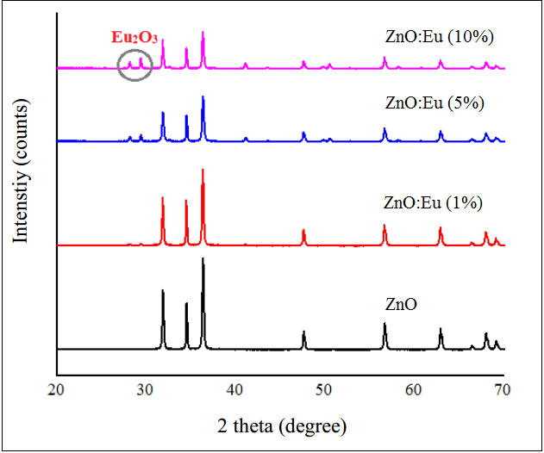
a
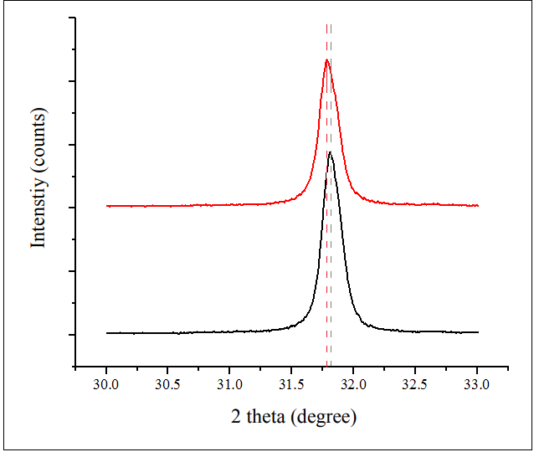
b
Figure 1. (a) The XRD patterns for Eu-doped ZnO with different doped Mn molar ratios, (b) Comparison of XRD diffraction peak positions of Eu-doped ZnO and ZnO.
The XRD results (Figure 1a) show that the high intensity diffraction peaks correspond to the network plane families (100), (002), (101) and diffraction peaks with lower intensity respectively. lattice plane (102), (110), (103), (200), (112), (201), this result is consistent with JCPDS Card No-00-00500664 of the characteristic of the ZnO lattice has a Wurtzite hexagonal structure.²⁷ Diffraction peaks of samples with molar ratio Eu³⁺ min had a slight shift towards 2 theta angle less than diffraction peaks of synthetic ZnO under the same conditions (Figure 1b), indicating that Eu was doped into ZnO.²⁸
Figure 1a shows that, when the molar ratio of doped Eu is less than 5%, the resulting XRD pattern of Eu – ZnO has a hexagonal monophasic structure of ZnO. However, when the molar ratio of Eu is doped from 5%, in addition to the hexagonal phase of ZnO, there is also a cubic Eu₂O₃ phase corresponding to the JCPDS Card No-00-002-1306 tag of Eu₂O₃. The formation of the Eu₂O₃ phase when increasing the content of doped Eu can be explained because zinc ions and Eu ions have different charges and their difference in radius is quite large (Eu³⁺: 0.95 Å; Zn²⁺: 0.74 Å).²⁹
Table 1. The crystal size of ZnO nanoparticles according to different doped Eu.
The concentration of doped Eu³⁺ | β (degree) | 2θ ( degree) | D (nm)
1% | 0,217 | 36,287 | 38,60
5% | 0,239 | 36,305 | 34,92
10% | 0,219 | 36,294 | 38,17
Table 1 shows that the material Eu-doped ZnO synthesized with a 5% mol doped manganese content has the smallest crystal size. Therefore, the 1% mol doped manganese content was selected to examine the characteristic properties and photo-oxidation capabilities through the photo-catalytic reaction.
3.1.2 Characteristic properties of Eu-doped ZnO material
Figure 2 shows the presence of Eu in the Eu-doped ZnO material over the EDS spectrum. This result shows the presence of elements in the sample such as Zn, O and Eu. In addition, there was no foreign element present. These data once again demonstrate the existence of europium in high purity samples and prepared materials.
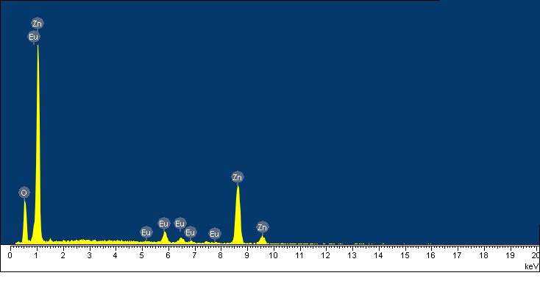
Figure 2 EDS spectra of (5%) Eu-doped ZnO nanoparticles.
Figure 3. SEM images of (5%) Eu-doped ZnO nanoparticles.
The shape and size of Eu-doped ZnO shown in SEM image (Figure 3). The results of SEM analysis showed that Eu – ZnO particles are spherical, the particle size with width in the range 32 - 72 nm; approximately 127 nm - 367 nm in length.
3.2 The Mn-doped ZnO characteristics
3.2.1 Effect of the amount of Mn dopant
Materials Mn-doped ZnO after synthesis was studied by XRD method. XRD results show that the concentration of ions Mn²⁺ doped does not affect the crystal phase composition. No presence of diffraction peaks of manganese metal or manganese oxides was observed. Diffraction peaks correspond to the network plane families (100), (002), (101), (102), (110), (103) in accordance with the XRD scheme of the block ZnO - JCPDS Card No-00-036-145 (Figure 4). The XRD results also showed that the Mn²⁺ ions were systematically replaced for the Zn²⁺ ions in the sample without changing the wurtzite structure.³⁰
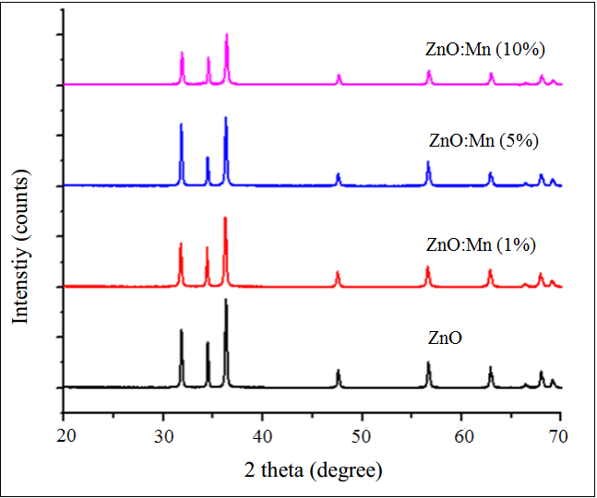
a
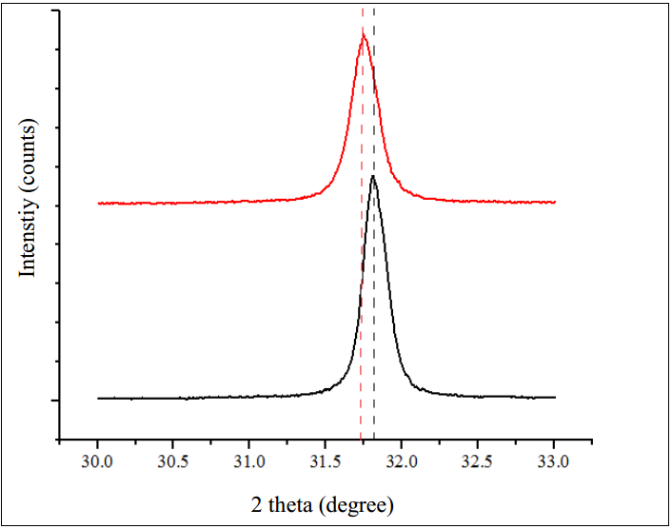
b
Figure 4. The XRD patterns for Mn-doped ZnO with different doped Mn molar ratios, (b) Comparison of XRD diffraction peak positions of Mn-doped ZnO and ZnO.
The XRD results also show that the effect of the doped manganese content is related to the displacement of diffraction peaks towards a smaller 2 theta angle and a decrease in peak intensity compared to diffraction peaks of synthetic ZnO at the same thing. This fact (Figure 4a) shows that manganese was successfully doped into the ZnO network.³¹ In it, the Mn²⁺ ions have replaced the Zn²⁺ ions. Mn²⁺ and Zn²⁺ ions have the same charge and their ionic radius is not much different, so Mn²⁺ ions can easily enter the crystal lattice of ZnO by partially replacing the Zn²⁺ ion position or entering the lattice holes ZnO.
Table 2 shows that the Mn-doped ZnO material synthesized with a 1% mol doped manganese content has the smallest crystal size. Therefore, the 1% mol doped manganese content was chosen to examine its characteristic properties and photooxicity.
Table 2. Effect of Mn doping on structural parameters of ZnO.
The concentration of doped Mn²⁺ | β (degree) | 2θ ( degree) | D (nm)
1% | 0,222 | 36,240 | 37,65
5% | 0,205 | 36,291 | 40,78
10% | 0,218 | 36,368 | 38,36

3.2.2 Characteristic properties of Mn-doped ZnO material
Figure 5. SEM images of (1%) Mn-doped ZnO nanoparticles.
The material's surface morphology was shown by SEM image of Mn-doped ZnO (Figure 5). Show that, Mn – ZnO material has short rod shape, quite uniform, width size about 19 nm to 56 nm, length size about 127 nm - 219 nm.
The synthetic Mn-doped ZnO material is of high purity. This result is proved by EDS spectra of Mn-doped ZnO (Figure 6). Shows the presence of elements zinc, oxygen, manganese in the sample. In addition, the presence of foreign elements was not observed.
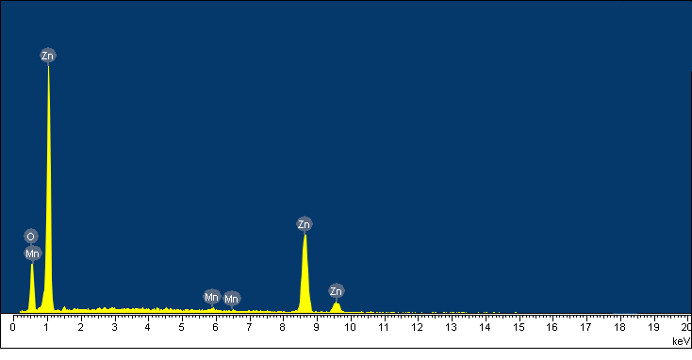
Figure 6. EDS spectra of (1%) Mn-doped ZnO nanoparticles.
3.3 Optical activity of metal ion-doped ZnO nanostructures
Photocatalytic activity of representative materials Eu-, Mn-doped ZnO was investigated based on MB degradation reaction under ultraviolet light. The results of Figure 7 show that, the relationship between optical density and the concentration of MB solution has a good linear range at low concentration of MB solution. In the MB concentration range from 0.1 mg/L to 24 mg/L, this relationship has a relatively good linearity (correlation coefficient R² = 0.9927). However, in the MB concentration range of 4.0 mg/L to 16 mg/L this relationship has the best linearity (correlation coefficient R² = 0.9975). Therefore, the concentration MB at 10 mg/L was chosen for the photocatalytic reaction.
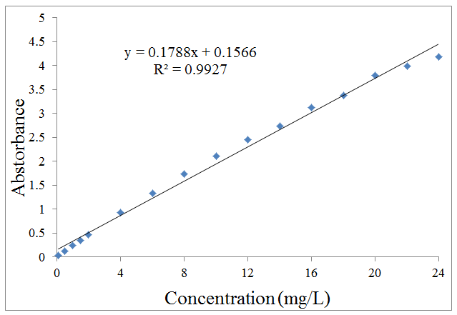
Figure 7. Calibration curve of MB solutions at λ_{max} = 664.4 nm.
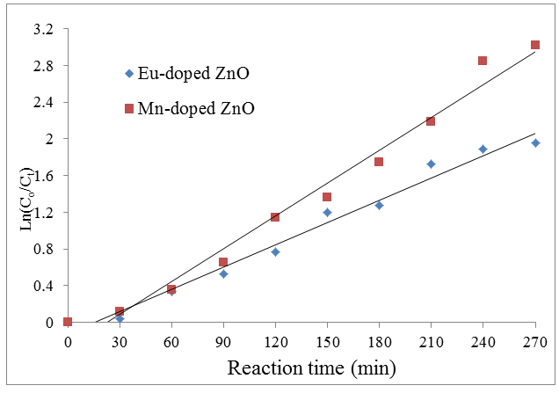
a
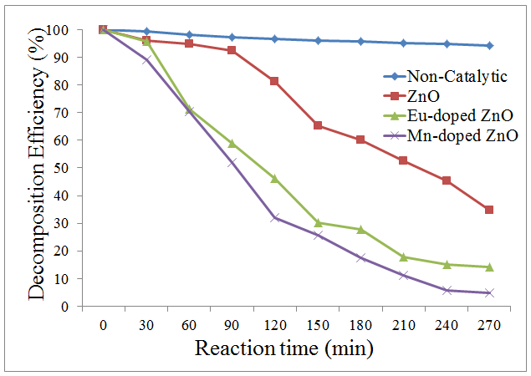
b
Figure 8. (a) Compare MB decomposition efficiency of Eu-, Mn-doped ZnO with ZnO; (b) The relationship between Ln(C_{o}/C_{t}) by time of MB decomposition reaction under ultraviolet light of the materials.
Figure 8a shows that the degradation efficiency of MB under UV light of the synthesized materials Eu – and Mn-doped ZnO is higher than that of ZnO. This result confirmed that europium and manganese doping changed the optical properties of ZnO.
The lines showing the relationship between Ln(C_{o}/C_{t}) and MB decay time were almost linear (Figure 8b). Thereby, it shows that, the MB decomposition reaction kinetics of the materials investigated under the visible light follow the Langmuir – Hinshelwood model and follow simple 1st order reaction kinetics. k for Eu-doped ZnO material is 0.008 min^{–1} and for Mn-doped ZnO material is 0.012 min^{–1}. The reaction rate constant of the Mn-doped ZnO catalyst is higher, which is consistent with the MB decomposition rate of the Mn-doped ZnO catalyst faster than the Eu-doped ZnO.
Thus, the doping of europium or manganese metal into ZnO increases the photocatalytic activity of ZnO in the ultraviolet light. Metal doping into ZnO leads to the formation of a new band gap energy state just within the ZnO band gap. This new state is capable of absorbing visible light.^{1, 32} On the other hand, the doping of europium or manganese into ZnO increases defects. Both the new band gap energy states and lattice defects are intermediate factors that induce the excitation of electrons from the valence band to the gravitational zone when absorbing visible light.³³ One of the noteworthy effects of manganese doping into ZnO was the increase in defect concentration.³³⁻³⁴
3.4 Material refundability
Reusability is one of the very important factors when deciding on a material for the purpose of economic efficiency and environmental protection.²⁶ Materials Eu- and Mn-doped ZnO after the photocatalytic reaction were rinsed several times with deionized water, dried at 90 °C for 12 hours, continued to be reused to assess the photocatalytic ability then proceeded to Practice examining the structure as well as the composition of the crystal phase.
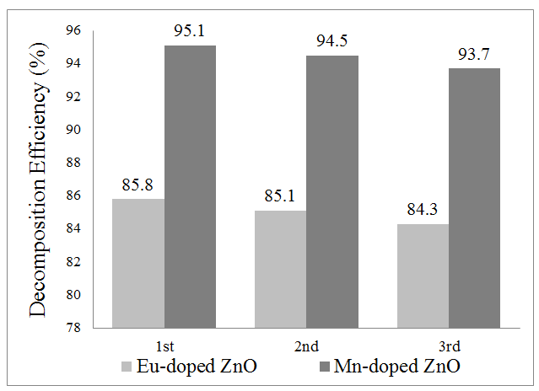
Figure 9. The MB decomposition efficiency of Eu – and Eu-doped ZnO materials after three reuse.
Figure 9 shows the results of the reusability of the two materials Eu – and Mn-doped ZnO. The results showed that, after each reuse, the MB degradation efficiency decreased slightly, after three times of reuse, MB degradation efficiency still reached 84.34% with materials Eu-doped ZnO and 93.7% with Mn-doped ZnO.
- CONCLUSION
This study is an attempt to synthesize Eu- and Mn-doped ZnO materials and by hydrothermal method. So the obtained data has high crystallization and photocatalytic activity. In addition, out of all the materials tested, effective reuse was observed. This study also shows that high substrate concentration can inhibit the growth and formation of biofilm systems. The results showed that there is an optimal value for the substrate concentration. These findings will provide useful and progressive insights into the future applications of photocatalytic processing in dyeing waste treatment.
REFERENCES
1. Boretti, A.; Rosa, L., Reassessing the projections of the world water development report. NPJ Clean Water, 2019, 2 (1), 1-6.
2. Vikrant, K.; Giri, B. S.; Raza, N.; Roy, K.; Kim, K.-H.; Rai, B. N.; Singh, R. S., Recent advancements in bioremediation of dye: current status and challenges. Bioresource technology, 2018, 253, 355-367.
3. Ito, T.; Adachi, Y.; Yamanashi, Y.; Shimada, Y., Long–term natural remediation process in textile dye–polluted river sediment driven by bacterial community changes. Water research, 2016, 100, 458-465.
4. Srivastava, S.; Sinha, R.; Roy, D., Toxicological effects of malachite green. Aquatic toxicology 2004, 66 (3), 319-329.
5. Sarmah, S.; Kumar, A., Photocatalytic activity of polyaniline-TiO2 nanocomposites. Indian Journal of Physics, 2011, 85 (5), 713-726.
6. Rao, K., Inhibition of DNA synthesis in primary rat hepatocyte cultures by malachite green: a new liver tumor promoter. Toxicology letters, 1995, 81 (2-3), 107-113.
7. Alderman, D.; Clifton‐Hadley, R., Malachite green: a pharmacokinetic study in rainbow trout, Oncorhynchus mykiss (Walbaum). Journal of Fish Diseases, 1993, 16 (4), 297-311.
8. Saikia, L.; Bhuyan, D.; Saikia, M.; Malakar, B.; Dutta, D. K.; Sengupta, P., Photocatalytic performance of ZnO nanomaterials for self sensitized degradation of malachite green dye under solar light. Applied Catalysis A: General, 2015, 490, 42-49.
9. Qiao, M.; Wei, K.; Ding, J.; Liu, Z.; Zhang, K.-Q.; Huang, X., Decolorizing activity of malachite green and its mechanisms involved in dye biodegradation by Achromobacter xylosoxidans MG1. Microbial Physiology, 2011, 20 (4), 220-227.
10. Mittal, A., Adsorption kinetics of removal of a toxic dye, Malachite Green, from wastewater by using hen feathers. Journal of hazardous materials, 2006, 133 (1-3), 196-202.
11. Pare, B.; Sarwan, B.; Jonnalagadda, S., Photocatalytic mineralization study of malachite green on the surface of Mn-doped BiOCl activated by visible light under ambient condition. Applied Surface Science, 2011, 258 (1), 247-253.
12. Liu, Y.; Ohko, Y.; Zhang, R.; Yang, Y.; Zhang, Z., Degradation of malachite green on Pd/WO3 photocatalysts under simulated solar light. Journal of Hazardous Materials, 2010, 184 (1-3), 386-391.
13. Herrmann, J.-M.; Disdier, J.; Pichat, P., Effect of chromium doping on the electrical and catalytic properties of powder titania under UV and visible illumination. Chemical Physics Letters, 1984, 108 (6), 618-622.
14. Khan, M. M.; Ansari, S. A.; Pradhan, D.; Han, D. H.; Lee, J.; Cho, M. H., Defect-induced band gap narrowed CeO2 nanostructures for visible light activities. Industrial & Engineering Chemistry Research, 2014, 53 (23), 9754-9763.
15. Chen, C.; Liu, T.; Lin, L.; Xie, X.; Chen, X.; Liu, Q.; Liang, B.; Yu, W.; Qiu, C., Multi-walled carbon nanotube-supported metal-doped ZnO nanoparticles and their photocatalytic property. Journal of nanoparticle research, 2013, 15 (1), 1-9.
16. Yan, H.; Hou, J.; Fu, Z.; Yang, B.; Yang, P.; Liu, K.; Wen, M.; Chen, Y.; Fu, S.; Li, F., Growth and photocatalytic properties of one-dimensional ZnO nanostructures prepared by thermal evaporation. Materials Research Bulletin, 2009, 44 (10), 1954-1958.
17. Kansal, S.; Singh, M.; Sud, D., Studies on photodegradation of two commercial dyes in aqueous phase using different photocatalysts. Journal of hazardous materials, 2007, 141 (3), 581-590.
18. Li, L.; Zhai, T.; Bando, Y.; Golberg, D., Recent progress of one-dimensional ZnO nanostructured solar cells. Nano Energy, 2012, 1 (1), 91-106.
19. Zhang, H.; Chen, B.; Jiang, H.; Wang, C.; Wang, H.; Wang, X., A strategy for ZnO nanorod mediated multi-mode cancer treatment. Biomaterials, 2011, 32 (7), 1906-1914.
20. Wu, G.; Zhuang, Y.; Lin, Z.; Yuan, X.; Xie, T.; Zhang, L., Synthesis and photoluminescence of Dy-doped ZnO nanowires. Physica E: Low-dimensional Systems and Nanostructures, 2006, 31 (1), 5-8.
21. Liu, H.; Cheng, X.; Liu, H.; Yang, J.; Liu, Y.; Liu, X.; Gao, M.; Wei, M.; Zhang, X.; Jiang, Y., Structural, optical and magnetic properties of Cu and V co-doped ZnO nanoparticles. Physica E: Low-dimensional Systems and Nanostructures, 2013, 47, 1-5.
22. Li, J.; Wu, N., Semiconductor-based photocatalysts and photoelectrochemical cells for solar fuel generation: a review. Catalysis Science & Technology, 2015, 5 (3), 1360-1384.
23. Wang, Z.; Liu, Y.; Huang, B.; Dai, Y.; Lou, Z.; Wang, G.; Zhang, X.; Qin, X., Progress on extending the light absorption spectra of photocatalysts. Physical Chemistry Chemical Physics, 2014, 16 (7), 2758-2774.
24. Langford, J. I.; Wilson, A., Scherrer after sixty years: a survey and some new results in the determination of crystallite size. Journal of applied crystallography, 1978, 11 (2), 102-113.
25. Velmurugan, R.; Swaminathan, M., An efficient nanostructured ZnO for dye sensitized degradation of Reactive Red 120 dye under solar light. Solar Energy Materials and Solar Cells, 2011, 95 (3), 942-950.
26. Achouri, F.; Corbel, S.; Balan, L.; Mozet, K.; Girot, E.; Medjahdi, G.; Said, M. B.; Ghrabi, A.; Schneider, R., Porous Mn-doped ZnO nanoparticles for enhanced solar and visible light photocatalysis. Materials & Design, 2016, 101, 309-316.
27. Dang, W.; Fu, Y. Q.; Luo, J.; Flewitt, A.; Milne, W., Deposition and characterization of sputtered ZnO films. Superlattices and Microstructures, 2007, 42 (1-6), 89-93.
28. Wang, M.; Huang, C.; Huang, Z.; Guo, W.; Huang, J.; He, H.; Wang, H.; Cao, Y.; Liu, Q.; Liang, J., Synthesis and photoluminescence of Eu-doped ZnO microrods prepared by hydrothermal method. Optical Materials, 2009, 31 (10), 1502-1505.
29. Shahroosvand, H.; Ghorbani-asl, M., Solution-based synthetic strategies for Eu doped ZnO nanoparticle with enhanced red photoluminescence. Journal of Luminescence, 2013, 144, 223-229.
30. El Ghoul, J.; Barthou, C.; Saadoun, M.; El Mir, L., Synthesis and optical characterization of SiO2/Zn2SiO4: Mn nanocomposite. Physica B: Condensed Matter, 2010, 405 (2), 597-601.
31. Hao, Y.-M.; Lou, S.-Y.; Zhou, S.-M.; Yuan, R.-J.; Zhu, G.-Y.; Li, N., Structural, optical, and magnetic studies of manganese-doped zinc oxide hierarchical microspheres by self-assembly of nanoparticles. Nanoscale Research Letters, 2012, 7 (1), 1-9.
32. Samadi, M.; Zirak, M.; Naseri, A.; Khorashadizade, E.; Moshfegh, A. Z., Recent progress on doped ZnO nanostructures for visible-light photocatalysis. Thin Solid Films, 2016, 605, 2-19.
33. Mahmood, M. A.; Baruah, S.; Dutta, J., Enhanced visible light photocatalysis by manganese doping or rapid crystallization with ZnO nanoparticles. Materials Chemistry and Physics, 2011, 130 (1-2), 531-535.
34. Xiao, Q.; Ouyang, L., Photocatalytic photodegradation of xanthate over Zn1− xMnxO under visible light irradiation. Journal of Alloys and Compounds, 2009, 479 (1-2), L4-L7.

