TRIBOELECTRIC NANOGENERATOR: THE PROMISING SOLUTION
FOR MODERN ENERGY

Phan Hai^{1,2,*}, Nguyen Huu Duc³, Pham Duc Thang⁴
1 VNU University of Engineering and Technology
2 Key laboratory for micro and nano technology, Vietnam National University, Hanoi
3 Vietnam National University, Hanoi
4 Phenikaa University
Abstract
The global energy crisis is accompanied by the long-term interest of scientific and technological innovation. At the macro level, traditional fossil fuels such as coal, oil and gas are gradually being exhausted due to rapid industrialization and urbanization. Because of these characteristics, the search for clean and renewable sources of artificial energy is always a top priority of scientists to aim at the sustainable development of society. Triboelectric nanogenerators (TENGs) was introduced in 2012 by Z.L. Wang group. Since then, a wide range of nanogenerator designs have proven application potential and unique advantages. TENGs has also demonstrated the potential in mechanical energy to electrical energy conversion by capturing many forms of ambient mechanical energy. The operation of TENG depends on the effect of electric friction, which induces static electricity between two material surfaces when in contact. Therefore, TENGs are considered as a kind of "nanogenerators" due to their dependence on electrostatically induced nano-electrical friction and displacement currents during operation. In this paper, the fundamental theory, experiments, and applications of TENGs are introduced as a foundation of the energy for the new era.
Keyword: Nanogenerator, Triboelectric, renewable energy.

Introduction
Mechanical energy is the most common source of energy that exists around us. It can take the form of human movement, breathing, heartbeat or vehicle movement, the shaking of things such as leaves or waves (table 1). In essence, these mechanical energies are the result of the conversion of energy from one form to another. For example, the energy that exists internally in fuels such as gasoline is converted into the mechanical energy that drives the vehicle when it is burned in the fuel chamber. The motion of the car just mentioned is one of the prime examples that shows that the mechanical energies around us can be generated from simple small parts of life with specific purposes. In the process of producing these energies, there are many techniques that can be developed to capture and use them for necessary human activities or convert them directly into electricity.
Electromagnetic induction is the scientific basis for most electric generators. The operating principle of the generator is based on the phenomenon of electromagnetic induction which is Faraday's law. That law states that when the magnetic flux through a coil and changes due to the external mechanical forces, an induced current will be introduced inside. This principle is widely used in devices that capture energy from the surrounding environment. The traditional electromagnetic generator structure consists of the following parts:
The generator has the function of generating electromagnetic energy from the raw material supplied to the machine. The generator is composed of two main parts, the inductor (roto) and the armature (stator). These two small parts work in harmony with each other to create motion between electromagnetic and electrical.
- Stator - armature: consists of coils of the same shape and size, the number of turns is also the same.
- Roto - inductor: consists of an electromagnet (powered by 1-way oscillations) rotating around a fixed axis. The rotor's job is to generate a variable magnetic field.
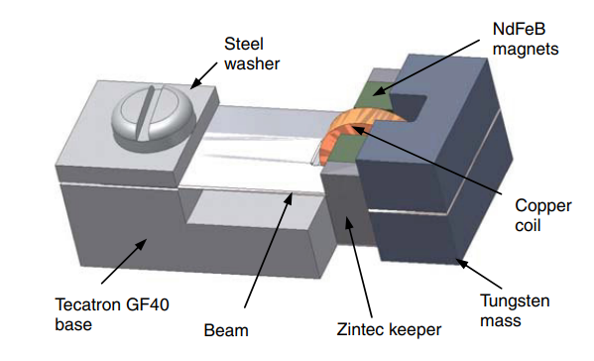
Figure 1: Micro generator structure based on electromagnetic induction [1]
Most studies on small/tiny power generators based on electromagnetic induction are also conducted. A good example of a generator based on electromagnetic induction is the generator developed by Beeby's research group [8] with the structure shown in Figure 1. The structure of this device consists of four magnets attached to the tip of the vibrating blade. When the unit is in operation, the generator generates a maximum power of 46 µW from 60 mg of acceleration at an external load of 4000 Ω. The power density can be calculated as approximately 307 W/m3. Energy conversion efficiency is about 30%.
The drawback of generators based on electromagnetic induction effect is the need for large magnets, resulting in large size and unsuitable for mobile applications.
Piezoelectric generator
The piezoelectric effect is one of the most popular and widely studied effects in the field of energy conversion. Devices that collect energy based on the piezoelectric effect operate on the piezoelectric properties of the materials they use. The piezoelectric effect in each material is described as the phenomenon in which a material generates an electrical charge (or potential difference) when acted upon by a mechanical stress. Some popular piezoelectric materials are studied and used such as quartz, Lead Zirconate Titanate (PZT), Zinc oxide (ZnO) or Polyvinylidene Fluoride (PVDF). These materials have been widely used to fabricate MEMS microelectromechanical systems and large piezoelectric energy collectors. In the last few years, along with the concept of micro/nano effect generator, piezoelectric materials are also used to fabricate power converters based on the micro/nano piezoelectric effect [2-6].
Electrostastic Induction generator
Electrostatic induction-based generators were one of the first human electromechanical energy conversion technologies in which a differential voltage was generated between two sheets of material leading to induced electrification. static electricity [7-10]. The best example of electrostatic induction-based generators are those that use Electret, which is a polymer that can hold electrostatic charges on their surfaces almost permanently. Before operating the device, a surface charge process is carried out to create electrostatic charges on the surface of the electret. As the electret material moves, the electrostatic effect directs the electrons to move between the two electrodes under short-circuit conditions.
2. Generator based on triboelectric effect
In recent years, a new electromechanical energy conversion mechanism named triboelectric generation has been developed as a new method for electromechanical energy conversion [11].
2.1. Triboelectric effect and Triboelectric nanogenerator
The Triboelectric effect (TE) is a classic physical phenomenon in which two dissimilar materials become electrically charged after rubbing against each other under the action of an external force. In human life, the electric friction effect occurs everywhere in the form of Contact Electrification (CE), on many kinds of things and manifests itself in the electrostatic phenomenon [12].
The electric friction effect is one of the classic physical phenomena that explored thousands of years. Although triboelectric effect was encountered every day, the mechanism of electric friction is still being studied. In general, scientists think that when two different materials physically rub together, a chemical bond is formed between some parts of the two planes and is collectively known as adhesion. [13]. Then, the charges will move from one material to another to balance their electrochemical potential. Those displaced charges can be electrons, ions, or material molecules. When the two materials are no longer rubbing against each other, some of the chemical bond atoms tend to retain electrons and a few other bonded atoms tend to give away electrons. Thereby generating electric friction charges on the surface of materials.
The electric friction charge density is the most important value that determines the output signal of the nano friction generator. However, the origin of the electric friction charges or in other words the origin of the electric friction mechanism is not really clear, especially when the structure of TENG always contains at least one insulating material or polymer. Controversy surrounds the electric charge due to friction as a result of ion-electron transfer. With the phenomenon of electrification due to friction is a very common phenomenon that can occur with a variety of materials, such as solid - solid, solid - liquid, solid - gas ... etc. . Therefore, the in-depth study of the phenomenon of electric charge due to friction will make a great contribution to the development of physics - chemistry - biology.
Wang and co-workers found that the mechanism of CE between two solids is ion exchange [14]. Considering specifically for the case of a pair of triboelectric materials, a conductive and an insulator, surface state and Fermi level models were used to verify the above conclusion. If the distance between two materials is greater than the bond length (BE), the two atoms tend to attract each other. Experimental studies indicate that CE can only occur when the atomic distance is shorter than the bond length. To account for the exchange of electrons between two substances, electron cloud cover is used as shown in Figure 2. Figure 2a simulates the electron cloud of two materials before rubbing together. When two atoms of different matter come closer and rub against each other, a more electron cloud will cover the junction of the two electrons under the action of a force leading to a lowering of the potential barrier and allowing electrons move between the two atoms (Figure 2b). Mechanical force is essential to close the intraatomic gap and maximize electron cloud cover (Figures 2c and 2d).
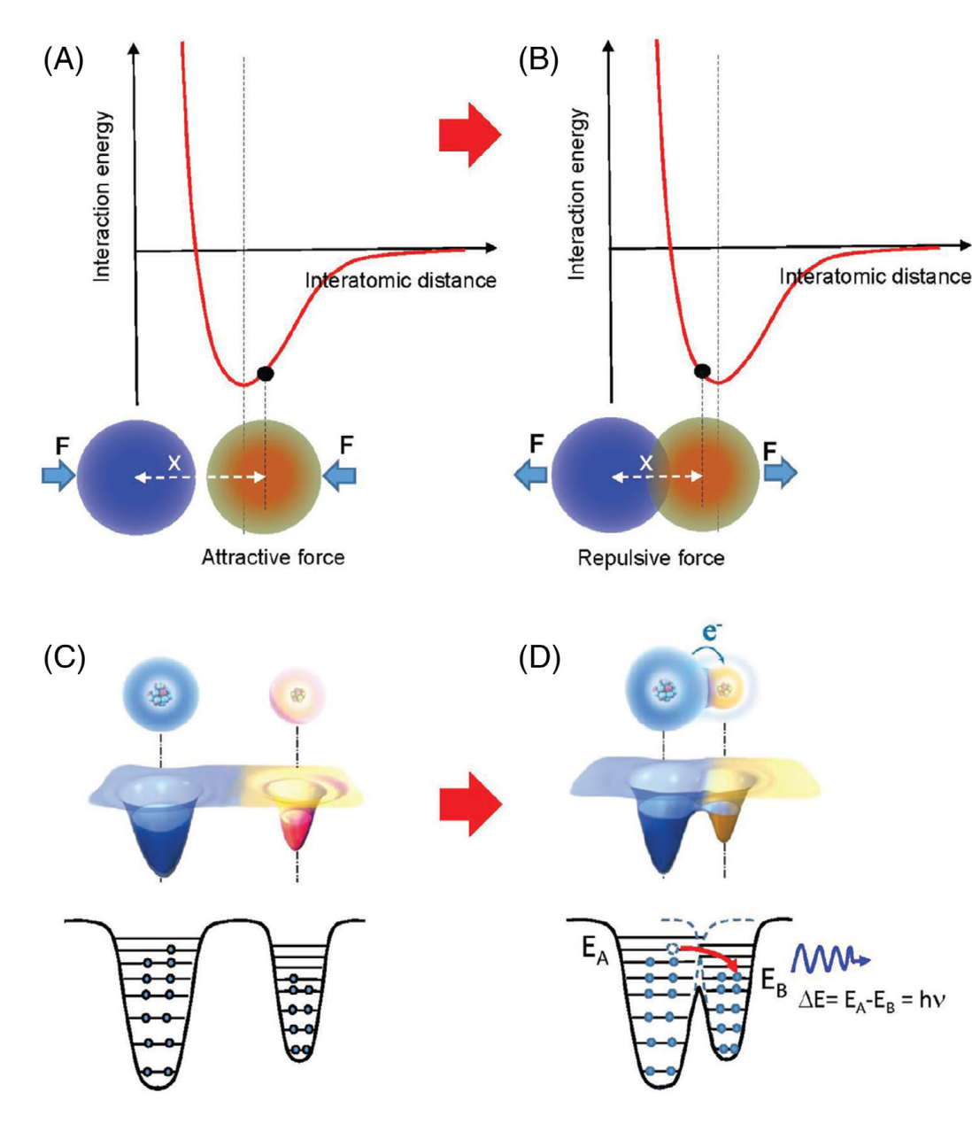
Figure 2. The process of electrification due to the friction of a pair of triboelectric materials [14].
Besides, photon emission is also believed to exist during CE and is being investigated for clarification. CE between solid and liquid materials has been studied and is thought to include two steps. The first step is the exchange of electrons between the solid and liquid material. The second step is the interaction between the different ions in the liquid. In research practice, ion absorption and electron exchange occur and exist at the liquid and solid interface.
2.2. The popular electrical friction materials
All materials known to man have tribological properties, including metals and polymers, fabrics, wood, etc. Therefore, all such materials can be suitable material objects for TENG studies in specific cases and also confirm the material choice for ghost generator application. nanoscale is extremely abundant.
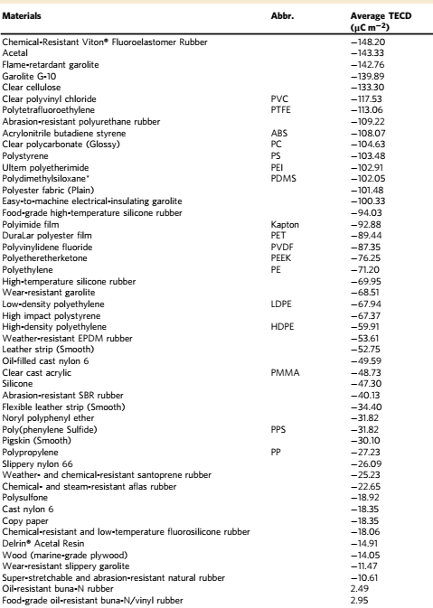
Table 1. Comparison chart of electric friction properties of common materials [15]
However, whether that electric friction property is strong or weak depends greatly on the charge polarity of each material. Materials with strong tribological properties are usually low conductivity or dielectric. As a result, these materials tend to retain charges that travel between two material surfaces and retain those charges for long periods of time, resulting in the generation of electrostatic charges, which are causes of negative effects in daily life and the development of technology. The most obvious is the electric shock when touching the winter doorknob or sucking hair into nylon fabrics...etc. The positive/negative character of the charge generated by friction on materials depends on the intrinsic electrical polarity of the material relative to the material that is rubbing against it.
2.3. Capacitance characteristics of TENG
The working principle of TENG is a combination of the effect of electric friction and electrostatic induction. While electrical friction induces electrostatic charge polarization, electrostatic induction is the main mechanism for converting mechanical energy into electrical energy based on the existence of electrostatic charge that has formed under the action of magnetism. close to electricity. Studies on devices that operate on and on the electrostatic principle have shown that the formation of capacitors is the nature of the device, therefore, TENG also has inherent capacitive behavior/characteristics of current. electrostatic phenomena in matter [15].
In order to clarify the inherent capacitive behavior of TENG, a simple structure of TENG consisting of a pair of electric friction (two different materials) is used for the analysis. Let the distance between two opposite surfaces of the materials be x. And suppose the charge passing through the two electrodes at the moment of consideration is Q and –Q. The potential difference between the two electrodes is contributed from two parts. The first part is the polarization of the charge generated by the electric friction process V_{OC}(x). Besides, the displaced charge Q also contributes to the formation of this potential difference. If assuming that the charges caused by electric friction do not exist, then the electric friction pair structure is a mere capacitor, then the contribution of Q is calculated as –Q/C(x) where C is capacitance of the capacitor between two electrodes. Based on the principle of electric field superposition, the total potential difference between the two electrodes is:
V = -1/C(x) Q + V_{OC}(x) (1)
The above equation is the basic equation for all TENGs and shows the capacitive nature of this type of device. During the operation of the TENG, the separation of the electric friction charges will form the potential difference between the two electrodes. If an external circuit is connected between the two electrodes, this potential difference will cause electrons to move from one electrode to another in order to balance the potential difference between the two electrodes. Under short circuit conditions (Short Circuit (SC), QSC balances the potential difference created by the electric friction charge polarization. From there, the QSC calculated from formula (1) is:
Q_{SC}(x) = C(x).V_{OC}(x) (2)
The equivalent circuit of TENG is described as follows
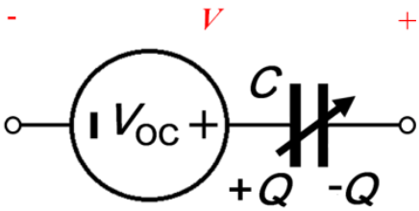
Figure 3: Analog circuit showing the intrinsic characteristics of TENG
The impedance of the TENG is mostly the capacitance of the internal capacitor. With TENG designs, the intrinsic resistance of the device is almost immeasurable because of the mandatory insulation between the two electrodes. Therefore, in the equivalent circuit structure of TENG, this part of the resistance is ignored.
3. The basic mechanism of TENG
The basic model of TENG was first built with the structure shown in Figure 4. This structure uses two material sheets, Kapton and Polymethyl Methacrylate (PMMA) placed opposite each other, metal electrodes are coated on the other side of them. Figures 4a and 4b show how TENG operates under open circuit (OC) and short circuit (SC) conditions.
As shown in figure 4a, in the initial state, no charge is generated or applied, no potential difference between the two electrodes (figure 4a-I). With a displacement by an external force, the two polymers are brought into contact. The charge moves across the surface at the contact area due to the effect of electric friction. The magnetic charge is injected (PMMA) into the Kapton, resulting in a negative charge at the Kapton surface and a positive charge at the PMMA surface. It is remarkable that the insulating properties of the polymers allow the retention of high charges for long periods of time for hours or even days. As confined to the surface, opposite charges are almost in the same plane, practically producing no potential difference between the two electrodes (Fig. 4a-II).
When the generator starts working, the Kapton pad tends to return to its original position due to its own resilience. When the two polymers separate, a potential difference is established between the two electrodes under open circuit conditions due to the charges separating during friction (Figure 4 a-III).
When the generator is active, Voc continues to increase until it reaches the maximum value when the Kapton membrane returns to its original state (Figure 4a-IV,V). Such a signal will be constant provided that the input impedance of the galvanometer is infinitely large. If pressed immediately, the potential difference starts to decrease as the two polymer layers get closer together. As a result, the V_{OC} decreased from the maximum value to zero when the two polymers were in full contact again (Figure 4a-V,VI).
If in the short-circuited state, a voltage difference is established as the two polymer sheets separate electrons from the upper electrode to the lower electrode (Figure 4b-III), resulting in an instantaneous current during the dissolution process. zoom (Figure 4b-IV). When we press the transmitter again, reducing the distance between the layers will cause the upper electrode to have a higher potential than the lower electrode. As a result, electrons are directed from the lower electrode back to the upper electrode, reducing the number of induced charges (Figure 4b-VI). This process corresponds to an instantaneous reverse current (Figure 4b-V). When the two polymers are in contact again, all induced charges are neutralized (Figure 4b-II). By explaining the above operating principle, it can be seen that the signal of TENGs has the form of alternating pulses.
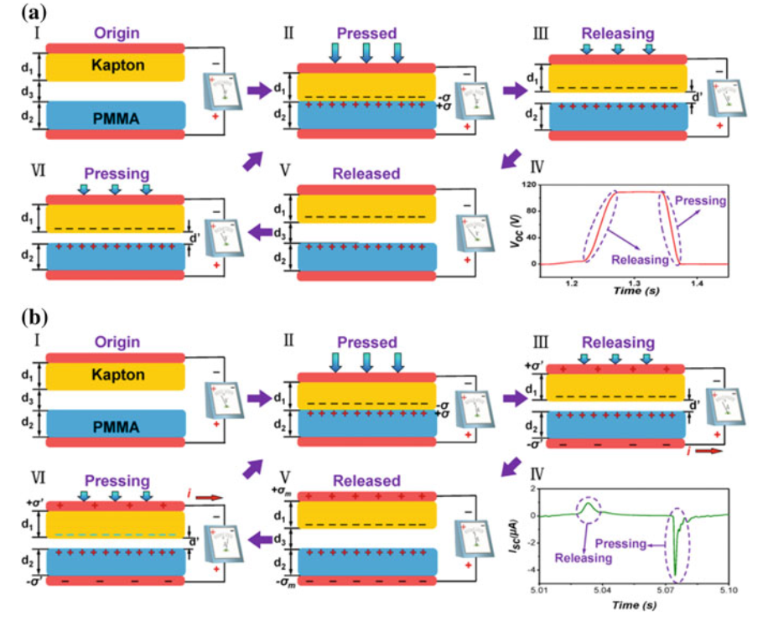
Figure 4: Working mechanism of TENG in (a) circuit conditions and (b) short circuit conditions [15].
Based on the basic principle, scientists have divided into four different TENG modes as follows:
3.1. Vertical contact mode
The simplest design model of TENG is detailed in Figure 5. In this structure, two different insulating materials (or an insulator and a conductive material) are placed opposite (collectively, the triboelectric material). Each layer of insulation is covered with a metal electrode on the other side. When two layers of materials come to rub together in a perpendicular direction under the action of an external force, an electric friction charge will be generated at the surface of those two layers of material. Once the external force is removed, the two layers of material tend to separate and the distance between them gradually increases. Then, a potential difference between the two surfaces of the material will be generated, and, if the two electrodes are connected through an electrical circuit, the free charges generated in each electrode will move through the circuit to balance. equal to the electric friction potential mentioned above. When the distance between the two rods returns to zero, the electric friction potential disappears and the electrons move in the opposite direction again [16].
Based on the types of electric friction materials shown in Figure 1.6, the vertical contact mechanism nano friction generators are divided into two main types: TENG using a pair of insulating materials (Figure 5a) and TENG using a pair of insulating and conductive materials (Figure 5b)
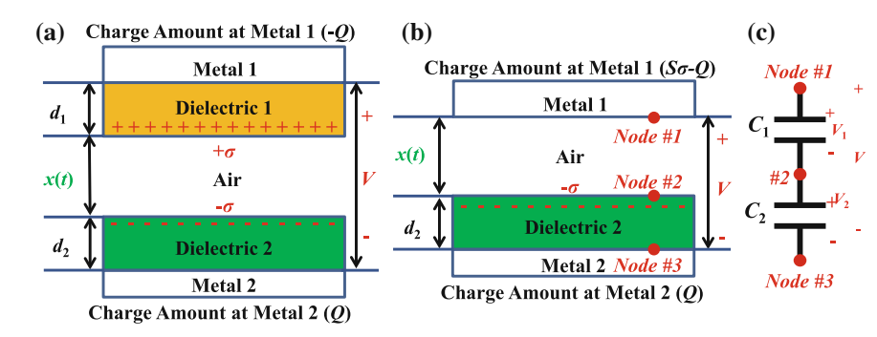
Figure 5: Detailed structure of TENGs (a) using pairs of insulating materials and (b) using pairs of insulating and conductive materials. (c) Equivalent circuit of TENG using an insulating-conductive pair [17]
3.2. Horizontal sliding mode
The operating principle of sliding mode TENG (Sliding mode TENGs - STENG) was clearly indicated by Wang in the study [21]. Similar to the vertical contact mode, the horizontal slide mode also starts with two rods of different electro-frictional material coated with electrodes on opposite sides. Figure 6 describes the structure of STENG in detail according to the types of pairs of electric friction materials used. Initially, two rods of material are placed exactly on top of each other. When the external force causes them to slide relative to each other's surface and generate electric friction charges and charge polarization in the sliding direction, thereby generating electron flow in the external circuit to balance the generated electric field. by electric friction charge. In studies, these sliding movements can be sliding in a horizontal plane or sliding in a curved surface.
Different from the vertical friction direction discussed in depth above, this mechanism of the nano friction generator operates in the form of the relative sliding friction of the two materials in the horizontal direction.
The nano friction generator works based on the charge distribution mechanism. In this model, STENG is also divided into two types based on the pair of materials used.
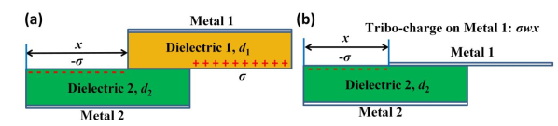
Figure 6: Detailed structure of STENGs (a) using pairs of insulating materials and (b) using pairs of insulating and conductive materials. [17]
Structural analysis uses two types of insulating materials as electrical friction materials, assuming the width w of the material layers is much larger than their respective thicknesses as shown in the figure. The length dimensions of the two insulating layers are l and their respective thicknesses are d1 and d2. Two metal electrodes are made on their remaining surfaces. If considered in the initial state, the two layers of material almost coincide, then when they start to move to rub horizontally, the rubbing distance is called x. At that time, the contact surface of the two materials will be charged oppositely at the non-contact surface due to the effect of electric friction. Assuming that the electric friction charges are evenly distributed at these two surfaces, let be the electric friction charge density at the surface of material 1 and - is the electric friction charge density at the surface of the object. data 2. The electric friction charge density in the overlapping area can be considered as o because the distance between them is close to each other.
3.3. Single electrode mode
The vertical contact and sliding mode TENG discussed above always require insulating materials with respective electrodes coated on the opposite surface. To overcome this weakness, several structures of TENG have been studied and completely ignored the relative motion of the electrodes [22]. One of these two models is called single-electrode-mode nano-friction generators (Single Electrode TENG – SETENGs). In this section, the basic working mechanism of SETENGs will be discussed in detail.
Many studies have been conducted to demonstrate the usability of SETNGs. In this structure, only one electrode is coated on the surface of a triboelectric material (primary electrode). Another electrode called the reference electrode is placed in any position or grounded. The two electrodes mentioned above have different roles. Similar to the two TENGs above, SETENGs have two modes of vertical contact and sliding mode with almost the same characteristics. Here, our research focuses mainly on the vertical exposure mode SETENGs.
The figure below shows the structure of SETENGs using a pair of conductive and insulating materials. In it, an insulator and a conductive sheet of length l and width w are placed opposite each other with a distance x to form an electric friction pair. The insulating layer has a thickness of d1 and the conductive layer has a thickness of dm. The reference electrode is about the same size as the primary electrode and is separated by a distance of g from the primary electrode.
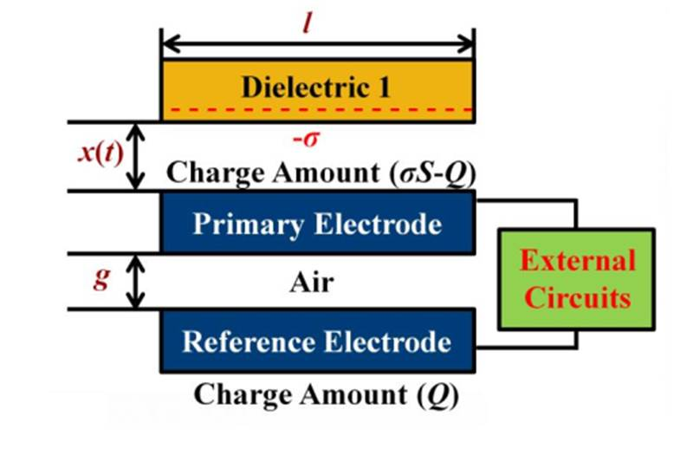
Figure 7: Basic theoretical model of SETENG [18]
The two electrodes are fixed in position while the insulator plate can be easily moved vertically under external force. As an inevitable result of the process of electrification due to friction, when two layers of triboelectric materials rub together, the surface of the insulating sheet becomes negatively charged with a surface charge density of –σ. Assuming that the electric friction charge is evenly distributed over the surface on a large scale, then the charge charged on the surface of the insulator is σwl. Let Q be the charge that moves from the primary charge to the counter charge, the charges at those two electrodes are σwl-Q and Q, respectively.
3.4. Freestanding electrode mode
In reality, a moving object cannot avoid becoming electrified by rubbing against other potential bodies or air. These charges remain on the surface for hours. If a pair of symmetric electrodes are placed underneath and of a size-distance equivalent to that of the insulating rod, the relative near- and far-away movements of the insulating material cause the induced charges at the difference between the two electrodes leads to an electric current flowing between the two electrodes to balance the difference.
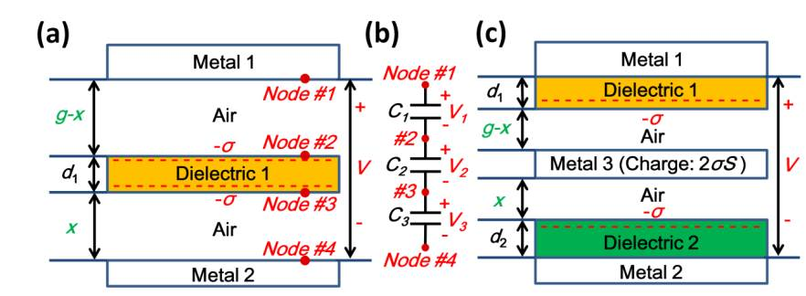
Figure 8: Basic theoretical model of FETENG [19]
Vertical contact suspension electrode mode of TENG (Freestading TENG – FSTENG) suspension electrode model is described as shown in Figure 8. An insulating sheet of thickness d1 with an insulation constant of εr1 and two metal plates are placed opposite each other and form pairs of electric friction materials. These two metal plates also serve as two electrodes. The space between the two electrodes is called g. When an insulating sheet is subjected to an external force and comes into contact with two metal plates, both sides of it will be charged due to the phenomenon of electric friction. Assuming this surface charge density is –σ on both sides, at the same time the two metal plates will have the same amount of positive charge.
4. Performance enhancement methods
Experimental and theoretical studies on TENG have shown that the electric friction charge density is the main factor that directly affects the performance of the TENG. In order to increase the density of electric friction charge, the commonly used methods are: treatment of material composition, increase of local contact area and change of environmental conditions.
Material composition handling:
Surface chemical functional group treatment is a method whereby changing the functional groups coated on the friction surface to enhance the ability of the material surface to capture the charge during the electric friction process [21]. Zhong Lin Wang's group used this method when using functional groups (–NH2) introduced into the surface of Au, in this way, the output signal of TENG was greatly increased. If the group (-NH2) is replaced by the group (–Cl), the performance of TENG is much worse.
Increase the contact area by surface modification
The local contact area between two layers of materials can be significantly increased with surface modification by creating micro-nanostructures on their surface. The two layers of materials can then come into deeper, more frictional contact because the surface structure allows for such a higher level of contact. Surface structures that have been exploited include nanowires, cubic, pyramidal, and nanofiber surface structures. Surface treatment technologies are used such as chemical etching [20], plasma-electron-ray etching [28, 29], lithography - lithography [23], fusion molding [24], or femtolaser [25]…etc. All the methods mentioned significantly increase the efficiency of TENG from 3 to 21 times.
Changing environmental conditions
This method deals with influencing factors in the operating environment of TENG such as temperature or pressure, humidity, etc. Studies [26–29] have shown the effect of temperature on the performance of TENG using teflon, showing that the TENG in this study can perform well and stably in the temperature range from 20ºC to 100ºC. The temperature dependence of the performance is related to the dielectric coefficient and to the surface deterioration of the material under high temperature such as oxidation of the surface matter or the reduction of fluorine radicals.
According to studies, the main application directions of TENGs can be divided into four different areas including: micro-nano-scale energy sources for self-powered devices system; active sensors for biomedical, human-machine, human-machine interaction applications; low frequency mechanical energy harvesting equipment system; and power supplies for high voltage applications [30].
5. Potential Application
Micro/nano energy source
With the advantages such as light weight, low cost, plenty structural and material choices, TENG possess wide applications as micro power source for self-powered systems by harvest ambient energy, such as human movement, vibration, wind energy or water motion. Because of the outstanding performance at low frequencies, biomechanical energy harvesting using TENG is of great importance and has been explored since the early stages of TENG development.
Active Sensing and Self-Powered Sensors
Since TENG can directly convert a mechanical trigger into an electrical signal, it has been extensively studied for use as self-powered sensors, such as touch sensors, acoustic sensors, sensors, motion and acceleration, and even chemical sensors. With the rapid development of technology, the challenges of interaction and power/energy will be limitations for its further advancement.
Blue energy
Among the application of TENG in harvesting natural mechanical energy from wind, raindrop, and ultrasonic, the wave energy in ocean as blue energy is especially important, owing to the higher efficiency of TENG for harvesting low-frequency vibration energy compared with an electromagnetic generator. Compared to other prototypes of TENGs reported for the blue energy, the fully enclosed rolling spherical structure has been identified as the most promising method.
6. Conclusion
TENG has become a promising energy conversion technology due to its advantage in fabrication, low-cost, wide choice of materials and high efficiency. TENG operates by the combination of electrostatic induction effects and contact electrification. The ambient mechanical energy in various forms such as rotation, motion, vibration, impact… etc. The devices structures can be considered in four models: vertical contact mode, sliding mode, freestanding mode and single electrode mode. TENG has many features such as light weight, high output strength and small volume, which makes it very interesting in the field of energy extraction. TENG can be a more efficient good solution for self-powered devices and systems fabrication. Moreover, TENG is expected to be the key technology which bring the solution for energy crisis.
References
- S.P. Beeby, R.N. Torah, M.J. Tudor, P. Glynne-Jones, T. O’Donnell, C.R. Saha, S. Roy (2007), “A micro electromagnetic generator for vibration energy harvesting”, J. Micromechanics Microengineering. https://doi.org/10.1088/0960-1317/17/7/007.
- X. Niu, W. Jia, S. Qian, J. Zhu, J. Zhang, X. Hou, J. Mu, W. Geng, J. Cho, J. He, X. Chou (2019), “High-Performance PZT-Based Stretchable Piezoelectric Nanogenerator”, ACS Sustain. Chem. Eng. https://doi.org/10.1021/acssuschemeng.8b04627.
- M.P. Lu, J. Song, M.Y. Lu, M.T. Chen, Y. Gao, L.J. Chen, Z.L. Wang (2009), “Piezoelectric nanogenerator using p-type ZnO nanowire arrays”, Nano Lett. https://doi.org/10.1021/nl900115y.
- Arnau, D. Soares (2008), “Fundamentals of piezoelectricity”, in: Piezoelectric Transducers Appl.,. https://doi.org/10.1007/978-3-540-77508-9_1.
- Z.L. Wang, J. Song (2006), “Piezoelectric nanogenerators based on zinc oxide nanowire arrays”, Science. https://doi.org/10.1126/science.1124005.
- Chang, V.H. Tran, J. Wang, Y.K. Fuh, L. Lin (2010), “Direct-write piezoelectric polymeric nanogenerator with high energy conversion efficiency”, Nano Lett. https://doi.org/10.1021/nl9040719.
- R. Tashiro, N. Kabei, K. Katayama, F. Tsuboi, K. Tsuchiya (2002), “Development of an electrostatic generator for a cardiac pacemaker that harnesses the ventricular wall motion”, J. Artif. Organs. https://doi.org/10.1007/s100470200045.
- Y. Xie, D. Bos, L.J. De Vreede, H.L. De Boer, M.J. Van Der Meulen, M. Versluis, A.J. Sprenkels, A. Van Den Berg, J.C.T. Eijkel (2014), “High-efficiency ballistic electrostatic generator using microdroplets”, Nat. Commun. https://doi.org/10.1038/ncomms4575.
- G. Zhu, Y.S. Zhou, P. Bai, X.S. Meng, Q. Jing, J.Chen, Z.L. Wang, “A Shape-Adaptive Thin-Film-Based Approach for 50% High-Efficiency Energy Generation Through Micro-Grating Sliding Electrification”, Adv. Mats., 26(23), 3788-3796
- F.R. Fan, Z.Q. Tian, Z. Lin Wang (2012), “Flexible triboelectric generator”, Nano Energy. 1, 328–334. https://doi.org/10.1016/j.nanoen.2012.01.004.
- S. Pan, Z. Zhang (2019), “Fundamental theories and basic principles of triboelectric effect: A review”, Friction. https://doi.org/10.1007/s40544-018-0217-7.
- J.J. Shao, T. Jiang, Z.L. Wang (2020), “Theoretical foundations of triboelectric nanogenerators (TENGs)”, Sci. China Technol. Sci. https://doi.org/10.1007/s11431-020-1604-9.
- Z.L. Wang, A.C. Wang (2019), “On the origin of contact-electrification”, Mater. Today. https://doi.org/10.1016/j.mattod.2019.05.016.
- Z.L. Wang (2017), “On Maxwell’s displacement current for energy and sensors: the origin of nanogenerators”, Mater. Today. https://doi.org/10.1016/j.mattod.2016.12.001.
- Z.L. Wang, L. Lin, J. Chen, S. Niu, Y. Zi (2016), “Triboelectric Nanogenerator: Vertical Contact-Separation Mode”, https://doi.org/10.1007/978-3-319-40039-6_2.
- S. Wang, L. Lin, Y. Xie, Q. Jing, S. Niu, Z.L. Wang (2013), “Sliding-triboelectric nanogenerators based on in-plane charge-separation mechanism”, Nano Lett. https://doi.org/10.1021/nl400738p.
- S. Niu, Y. Liu, S. Wang, L. Lin, Y.S. Zhou, Y. Hu, Z.L. Wang (2014), “Theoretical investigation and structural optimization of single-electrode triboelectric nanogenerators”, Adv. Funct. Mater. https://doi.org/10.1002/adfm.201303799.
- Van-Tien Bui, Jung-Hwan Oh, Jong-Nam Kim, Qitao Zhou, Dai Phu Huynh, Il-Kwon Oh (2020), “Nest-inspired nanosponge-Cu woven mesh hybrid for ultrastable and high-power triboelectric nanogenerator”, Nano Energy, 71, 104561
- Hai Phan, Dong-Myeong Shin, Sang Heon Jeon, Tae Young Kang, Pyunghwa Han, Gyu Han Kim, Hyung Kook Kim, Kyujung Kim, Yoon-Hwae Hwang, Suck Won Hong (2017), “Aerodynamic and aeroelastic flutters driven triboelectric nanogenerators for harvesting broadband airflow energy”, Nano Energy, 33, 476-484.
- S. Wang, Y. Zi, Y.S. Zhou, S. Li, F. Fan, L. Lin, Z.L. Wang (2016), “Molecular surface functionalization to enhance the power output of triboelectric nanogenerators”, J. Mater. Chem. A. https://doi.org/10.1039/c5ta10239a.
- W. Kim, T. Okada, H.W. Park, J. Kim, S. Kim, S.W. Kim, S. Samukawa (2019), “D. Choi, Surface modification of triboelectric materials by neutral beams”, J. Mater. Chem. A. 7, 25066–25077. https://doi.org/10.1039/c9ta09990e.
- Z. Lin, J. Chen, X. Li, Z. Zhou, K. Meng, W. Wei, J. Yang, Z.L. Wang (2017), “Triboelectric Nanogenerator Enabled Body Sensor Network for Self-Powered Human Heart-Rate Monitoring”, ACS Nano. 11, 8830–8837. https://doi.org/10.1021/acsnano.7b02975.
- S.Y. Chou, P.R. Krauss, P.J. Renstrom (1996), “Nanoimprint lithography”, J. Vac. Sci. Technol. B Microelectron. Nanom. Struct. 14, 4129–4133. https://doi.org/10.1201/b11626-12.
- S. Wang, L. Lin, Z.L. Wang (2012), “Nanoscale triboelectric-effect-enabled energy conversion for sustainably powering portable electronics”, Nano Lett. https://doi.org/10.1021/nl303573d.
- J. Huang, X. Fu, G. Liu, S. Xu, X. Li, C. Zhang, L. Jiang (2019), “Micro/nano-structures-enhanced triboelectric nanogenerators by femtosecond laser direct writing”, Nano Energy. 62, 638–644. https://doi.org/10.1016/j.nanoen.2019.05.081.
- V. Nguyen, R. Zhu, R. Yang (2014), “Environmental effects on nanogenerators”, Nano Energy. https://doi.org/10.1016/j.nanoen.2014.11.049.
- V. Nguyen, R. Yang (2013), “Effect of humidity and pressure on the triboelectric nanogenerator”, Nano Energy. https://doi.org/10.1016/j.nanoen.2013.07.012.
- C.X. Lu, C.B. Han, G.Q. Gu, J. Chen, Z.W. Yang, T. Jiang, C. He, Z.L. Wang (2017), “Temperature Effect on Performance of Triboelectric Nanogenerator”, Adv. Eng. Mater. https://doi.org/10.1002/adem.201700275.
- Wu, A.C. Wang, W. Ding, H. Guo, Z.L. Wang (2019), “Triboelectric Nanogenerator: A Foundation of the Energy for the New Era”, Adv. Energy Mater. 9. https://doi.org/10.1002/aenm.201802906.
- J. Huang, X. Fu, G. Liu, S. Xu, X. Li, C. Zhang, L. Jiang (2019), “Micro/nano-structures-enhanced triboelectric nanogenerators by femtosecond laser direct writing”, Nano Energy. 62, 638–644. https://doi.org/10.1016/j.nanoen.2019.05.081.

