Rung chuông vàng Tiếng Anh lớp 2

https://quizizz.com/admin/quiz/5e6a03adf30667001c70046c/rung-chuong-vang-ting-anh-lp-2

Bộ câu hỏi rung chuông vàng tiếng Anh lớp 3
1. How are you?
A. I’m fine
B. Yes, and you?
C. I’m five
2. What is he doing?

A. He’s eating
B. He’s listening to music
C. He’s going fishing
3. What’s your name?
A. Is
B. Am
C. Are
4. What is capital of Vietnam
A. Vien Chan
B. HCM city
C .Hanoi
5. People will cook meals in…..
A. Bedroom
B. Living room
C. Kitchen
6. Thera are….in a week.
A. 5 days
B. 7 days
C.10 days
7. What is this?
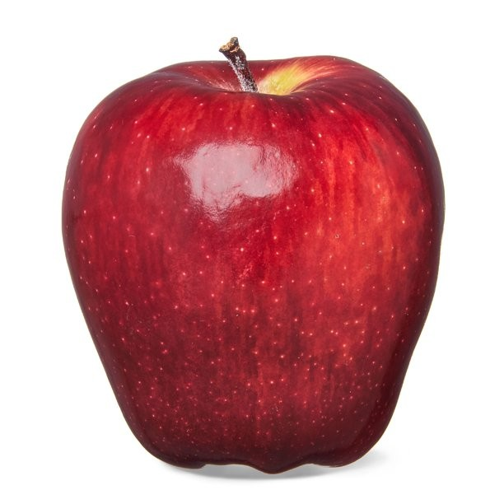
A. This is a apple
B.This is an apple
C.This is apple
8. Which word has meaning?
A. bird
B. Brid
C. Dirb
9. What is this?
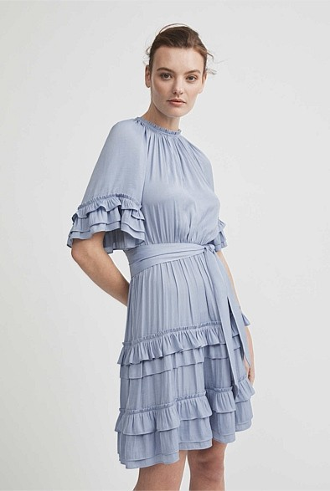
10. What is the name of this flower?
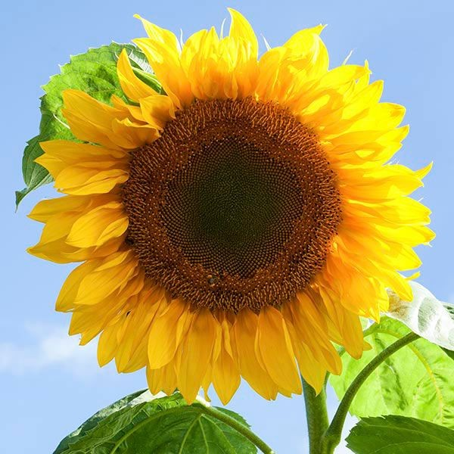
A. sunflower
B. rose
C. tuylips
11. How many limes are there?
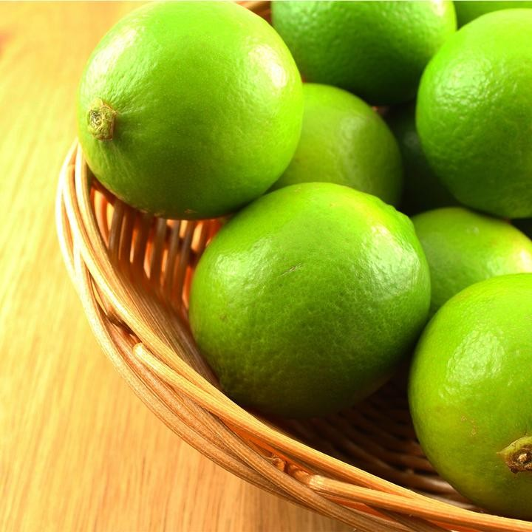
A. 3
B. 2
C. many
12. what is she wearing?
A. trouser
B. dress
C. Skirt
13. Odd one out:
A. tree
B. money
C. computer
D. go
14. My husband come from
A. Vietnam
B. Vietnamese
C. Spanish
15. __. See you tomorrow.
A: Hi there
B: Hello
C: Goodbye
16. June is the...month of the year
A. 4th
B. 5th
C.. 6th
17. How many days in a year?
A. 215
B. 365
C. 300
18. In the English alphabet, before "M" is ........
A. G
B. N
C. L
19. The day after Tuesday is……
→ Write your answer.
20. What…. is your pen?
A. colour
B. group
C. like

Bộ câu hỏi rung chuông vàng tiếng Anh cho học sinh lớp 4
1. How….people are there in the class?
A. many
B. much
C. less
2. Today is Friday. What day will be tomorrow?
A. Monday
B. Tuesday
C. Saturday
3. Does she go to class in the morning?
A. No, she doesn’t
B. No, she does
C. Yes, she does not
D. Yes, she do
4. What is the date today ?
- It’s the ____________ of May
A. five
B.fifth
C. five times
5. Odd one out:
A. Saturday
B. Cake
C. Sunday
6. What festival is it?

A. Tet holiday
B. Halloween
C. Christmas
7. What are they doing?
A. They are going out
B. They are having dinner
C. They are sleeping
8. What kind of fruits do monkeys like most?
A. banana
B. lime
C. apple
9. What does she do?

A. doctor
B. driver
C. farmer
10. Where ________ he 2 days ago?
A. were
B. was
C. are
11. What is she doing? She is….. games.
A. playing
B. plays
C. played
12. I have ….cat
A. a
B. an
C. 3
13. Odd one out
A. table
B. Chair
C. Board
D. beef
14. I can….

A. play football
B. do karate
C. play piano
15. Where do you live? I live … Tran Hung Dao stress
A. in
B. at
C.on

Bộ câu hỏi rung chuông vàng tiếng Anh cho học sinh lớp 5
1. Who is this? This is my….
A. pen
B. dog
C. father
2. Lan’s birthday is the sixth day of this month. When is her birthday?
A: 6/11
B: 3/10
C: 16/3
D: 11/6
3. A ….. looks after patients in hospital.
A. waiter
B. nurse
C. driver
4. Bac Giang province is in the...of vietnam
A. north
B. south
C. central
5. Where did you go on your holiday last year?
A. I went to Nha Trang beach
B. I am going to Nha Trang beach
C. I go to Nha Trang beach
6. What ...would you like to eat, Huy?
A. dishes
B. computer
C. pen
7. I have put on weight. What do I have to do now?
A. do more exercise
B. eat more junk food
C. sleep more
8. My brother is a chef. He works in a…
A. restaurant
B. hospital
C. field
9. Find the mistake in this sentence!
He like playing football very much so he often plays it every day.
A B C
10. What is the...today?
A.man
B. weather
C. favorite bag
11. What country is it?

→ Write your answer
- What flower is the symbol of VietNam?
→ Write your answer
13. Your father gives you 49 apples. You give your sister 11 apples. How many apples do you have?
→ Write your answer
14. What is the highest mountain in Vietnam ?
A. Fansipan
B. Hang Mua
C. Putaleng
15. Which place has a lot of trees, plants and we can do exercise, children can play there?
→ Write your answer

