Xác định hàm lượng aflatoxin B1 trong sản phẩm ngũ cốc dinh dưỡng cho trẻ em bằng phương pháp sắc ký lỏng siêu hiệu năng cao đầu dò khối phổ hai lần (UPLC-MS/MS) làm sạch bằng cột ái lực miễn nhiễm
Nguyễn Thị Hồng^{1,2}, Nguyễn Trương Nhật Ni¹, Đặng Tấn Hiệp^{2,*}, Phạm Cẩm Nam^{3,*}

¹ Công ty TNHH Dịch vụ Khoa học Công Nghệ Khuê Nam, 2/17 Phạm Văn Bạch, phường 15, quận Tân Bình, TP HCM
² Trường Đại học Công nghiệp Thực Phẩm Thành phố Hồ Chí Minh, 140, Lê Trọng Tấn, phường Tây Thạnh, quận Tân Phú, TP. Hồ Chí Minh
³ Khoa Hóa, Trường Đại học Bách Khoa - Đại học Đà Nẵng, 54 Nguyễn Lương Bằng, Hoà Khánh Bắc, Liên Chiểu, Đà Nẵng
Tác giả chịu trách nhiệm: hongedc@gmail.com, hiepdt@hufi.edu.vn; pcnam@dut.udn.vn
Ngày nhận bài: xx/xx/2023; Ngày nhận đăng: xx/xx/202x; Ngày xuất bản: xx/xx/202x

Tóm tắt
Kết quả nghiên cứu quy trình phân tích độc tố aflatoxin B1 (AFB1) với kỹ thuật sắc ký lỏng siêu hiệu năng đầu dò khối phổ (MS) hai lần (UPLC/MS-MS) trong nền mẫu sản phẩm ngũ cốc dinh dưỡng cho trẻ em được thể hiện trong nghiên cứu này. Theo kết quả nghiên cứu, phương pháp UPLC/MS-MS có khả năng xác định aflatoxin B1, B2, G1 và G2 theo đường nền trong thời gian chạy 2,5 phút bằng cách sử dụng cột BEH C18 1,7 µm (2,1×150 mm), pha động đẳng dòng metanol/nước (70:30). Điều kiện phân mảnh để định lượng AFB1: cặp ion định lượng m/z:313,3>285,1 và cặp ion định tính (m/z) 313,3>241,2. Kết quả nghiên cứu cho thấy, hệ số xác định (R²) của đường chuẩn đạt giá trị trên 0,9993; độ lặp lại (C ≤ 1µg/kg) là 6,72 - 9,00; độ tái lặp đạt 7,89 - 10,4; giới hạn phát hiện (LOD) là 0,03 µg/kg; giới hạn định lượng (LOQ) 0,10 µg/kg và độ không đảm bảo đo (U, Uncertanty) là ±17,1%.
Từ khóa: Aflatoxin B1; UPLC/MS-MS (IAC), bột ngũ cốc cho trẻ nhỏ.

Determination of Aflatoxin B1 in Food Cuck Products for Children Using Ultra-Performance Liquid Chromatography Double Mass Spectrometry (UPLC-MS/MS) Cleaning up by an Immunoaffinity Column
Nguyễn Thị Hồng^{1,2}, Nguyễn Trương Nhật Ni¹, Đặng Tấn Hiệp^{2,*}, Phạm Cẩm Nam^{3,*}

¹ Công ty TNHH Dịch vụ Khoa học Công Nghệ Khuê Nam, 2/17 Phạm Văn Bạch, phường 15, quận Tân Bình, TP HCM
² Trường Đại học Công nghiệp Thực Phẩm Thành phố Hồ Chí Minh, 140, Lê Trọng Tấn, phường Tây Thạnh, quận Tân Phú, TP. Hồ Chí Minh
³ Khoa Hóa, Trường Đại học Bách Khoa - Đại học Đà Nẵng, 54 Nguyễn Lương Bằng, Hoà Khánh Bắc, Liên Chiểu, Đà Nẵng

Corresponding authors: hongedc@gmail.com, hiepdt@hufi.edu.vn, pcnam@dut.udn.vn

Abstract
This work studied on developing the analytical procedure for determination of aflatoxin B1 (AFB1) in nutritional cereal products for children by using ultra-performance liquid chromatography double mass spectrometry detector (UPLC/MS-MS). Under optimal conditions, the retention time of AFB1 is identified at 2.5 minute as using a molten core C18 column and volume ratio methanol/water isocurrent mobile phase is 70/30 (v/v). The mass-to-charge ratio (m/z) of AFB1 for quantitative and qualitative analyses are 313.3 > 241.2 and 313.3 > 285.1, respectively. Furthermore, the obtained results are validated. Typically, the statistical parameters are significant such as coefficient of determination (R²) ≥ 0.9993, repeatability (C ≤ 1µg/kg) in range of 6.72 - 9.00, 7.89 - 10.4 of reproducibility and uncertainty ±17.1%, while the limit of detection (LOD) and the limit of quantitation (LOQ) are 0.03 µg/kg and 0.10 µg/kg, respectively.
Keywords: Aflatoxin B1; UPLC/MS-MS (IAC), cereal for infants.

1. INTRODUCTION
Currently, food safety has become the most important issue in protecting the health of consumers in Vietnam as well as in the world. Foods that contain viruses, bacteria, biological toxins and toxic chemicals (such as synthetic dyes, antibiotic residues and pesticides, etc.) are considered unsafe and can cause diseases. from diarrhea to cancer¹. They can be present in agricultural and food products (peanut, corn, wheat, coffee) and products made from these products. Aspergillus, Fusarium, and Penicillium are the main fungi causing mycotoxins in agricultural products and foods. Up to now, more than 300 types of mycotoxins have been identified and documented. However, the group of mycotoxins that frequently contaminate food and animal feed are aflatoxins, ochratoxins, fumonisin, patulin, zearalenone, deoxynivalenol, and T2-toxin.² Among them, aflatoxin (AF) is the most influential and most concerned which needs to be controled. In high concentrations, aflatoxin can lead to acute poisoning (aflatoxicosis) and can be life-threatening, usually through liver damage. They can cause genetic changes, damage genes (DNA) and cause liver cancer in animals and humans.³
Until now, about 17 different types of aflatoxin have been recorded and studied. Of these, the four most common bis-furanocoumarin compounds are named B1, B2, G1, and G2, respectively. In terms of prevalence, aflatoxin B1 (AFB1) is the most abundantly found in nature and culture, followed by aflatoxin G1 (AFG1), aflatoxin B2 (AFB2), and then aflatoxin G2 (AFG2) and other substances have a rather low ratio.⁴

Cereals are important in providing primary nutrients for the growth and development of infants and children. Therefore, the accurate analysis and identification of food contaminants, food poisoning such as mycotoxins, common contaminants in cereals, etc. is a matter of concern. Currently, strict quality control standards in Europe and around the world for mycotoxins have been adjusted, updated and controlled⁵. In Vietnam, the Ministry of Health has set the maximum allowable limit for aflatoxin (B1) at 0.1 µg/kg.⁶
Most of the AFB1 analytical methods used fluorescence detector high performance liquid chromatography (HPLC/FLD) using trifluoroacetic acid (TFA) derivatives to achieve sensitivity, meeting the allowable limit for AFB1 in food analysis. However, for nutritional foods for children, only TCVN 9522:2012¹¹ has the declared level of LOD = 0.05 µg/kg lower than the regulation. However, theoretically it is not easy to get the LOQ to 0.1 µg/kg when the LOD is 0.05. Moreover, TFA is a very toxic acid that affects the health of the analyst as well as the environment. Recent work by Nguyen Thanh Duy et al [7] has presented a procedure for aflatoxin B1, B2, G1 and G2 analysis by UPLC-FLD fluorescence detector super-performance liquid chromatography for shows that the method is selective, the standard curve is linear in the range of 0.5 - 7.5 µg/L, the recovery ranges from 80.7 to 98.8% with the relative standard deviation (RSD) below 5% was obtained for each aflatoxin. The method detection limit (MDL) and method quantification limit (MQL) were 0.025 - 0.1 and 0.075-0.3 μg/kg, respectively. In which the MDL of aflatoxin B1 is 0.1 μg/kg, therefore the MQL will not meet the maximum allowable limit of 0.1 μg/kg.
In addition, compared with other analytical methods, the UPLC/MS-MS method applied to analyze AFB1 in nutritional cereals for children is evaluated to have the advantage of increasing sensitivity and meeting current regulatory levels. operating, more environmentally friendly, reducing analysis time, reducing operating pressure, reducing solvent costs, reducing environmental pollution⁸. Despite certain advantages, the analysis of AFB1 in nutritious cereals for children has not yet attracted the proper attention of scientists in Vietnam. Moreover, in order to build and develop an analysis procedure for AFB1 in nutritious cereals for children with the real conditions of Vietnam to diversify the analysis process as well as the system of state assessment standards for the method. As an analytical method, this study has focused on the development, development and validation of a super-performance liquid chromatography-coupled mass spectrometer (UPLC/MS-MS) method for the determination of AFB1 toxin in the sample matrix. nutritious cereal products for children.

2. APPARATUS, MATERIALS, AND METHODS
2.1. Apparatus
- The experiments were carried out at Khue Nam Science and Technology Service Co., Ltd – address: 2/17 Pham Van Bach, Ward 15, Tan Binh District, Ho Chi Minh City, Vietnam (https://khuenam.vn/nang-luc.php).
- The equipment used is the Acquity UPLC/MS/MS Xevo TQD by Waters supplier, and the analytical column is BEH C18 1.7 µm (2.1 × 150 mm).
- Other instruments and supporting equipment are required.
2.2. Chemicals
2.2.1 Reagents and Standards
The chemicals in this study are methanol (MeOH), formic acid (HCOOH) of HPLC grade, NaCl with a purity of ≥ 99%, and phosphate buffer solution pH 7.4 (PBS), water of HPLC grade. The immunoaffinity column used is Aflatoxin with a column volume of 3 mL (IAC- AflaTest). The stock solution of aflatoxin standard mixture consists of B1 (10 µg/mL), B2 (3 µg/mL), G1 (10 µg/mL), G2 (3 µg/mL) diluted in acetonitrile solvent.
2.2.2. Standard Preparation
Intermediate mixed standard of 260 µg/L, 26 µg/L was prepared from a stock standard of 2600 µg/mL of acetonitrile (ACN) solvent, in which concentration of AFB1 standard is 1000 µg/L.
Working solutions were used to make a standard calibration curve of five points in AFB1 concentration of 0.2, 0.4, 0.8, 1.6, 3.2 µg/L. MeOH is solvent in preparing the calibration curve.
2.2.3. Solution Preparation
MeOH/H₂O extraction solution (70/30) by volume: 150 mL of water was mixed with 350 mL of MeOH.
Phosphate buffer salt (PBS): Dissolve 8g NaCl, 1.16g Na2HPO4, 0.2g KH2PO4, and 0.2g KCl in 1.0 L of DI water. The pH is adjusted to 7.4 by 30% NaOH solution.
5 mM amonium acetate solution: Dissolve 0.385 g amonium acetate in 1.0 L of water in HPLC grade.
0.1% HCOOH/MeOH solution: Transfer 1.0 mL of formic acid into a 1.0 L volumetric flask and make up to the mark with MeOH.

2.2.3. Cereal sample preparation
The cereal powder sample was homogenized using a dry grinder. 10.0 g of accurately weighed powder was transferred to a centrifuge tube and 40 mL of MeOH/H₂O = 70/30 (v/v) was added. The mixture was vortexed for 1.0 minute and shaken for 30 minutes. It was sonicated for 30 minutes to extract the sample, then centrifuged at 3000 rpm for 5 minutes. The solution was filtered through a ∅110 mm diameter filter paper. 10 mL of the filtrate was collected and mixed with 20 mL of PBS buffer. The solution was gently mixed and passed through an IAC column. The column was washed twice with 20 mL of distilled water. The column was dried and eluted with 1.0 mL of MeOH. The eluate was filtered through a 0.22 µm PTFE membrane and analyzed using UPLC/MS-MS. ⁹
2.3. Chromatographic conditions
To develop an analytical procedure for testing AFB1 in cereal powder using ultra-high performance liquid chromatography-tandem mass spectrometry (UPLC/MS-MS) without using derivatives, the chromatographic conditions, including the mobile phase and fragmentation conditions, are listed in Tables 1 and 2.

Table 1. Mobile phase condition
Time | Flow rate (mL/min) | %A | %B
initial | 0.30 | 90 | 10
4,00 | 0.30 | 0 | 100
5,00 | 0.30 | 0 | 100
6,00 | 0.30 | 90 | 10
7,00 | 0.30 | 90 | 10
Solution A (5mM Amonium acetate/H₂O); Solution B (0,1% HCOOH in MeOH)
Table 2. Fragmentation condition
Analytes | Parents ion (m/z) | Product ion (m/z) | Cone Volt, (V) | (Collision energy, eV)
Aflatoxin B1 | 313.05 | 241.00 | 50 | 30
Aflatoxin B1 | 313.05 | 285.00^{(*)} | 50 | 37
^{(*)} Quantitative ion pair

3. Results and Discussion
3.1. Determine the linearity of the standard curve

Calibration curve for AFB1 was constructed based on AFB1 standard solution in MeOH with five specific standards of 0.2; 0.4; 0.8; 1.6; 3.2 µg/L, the results of the calibration curve are presented in Figure 1.
The statistical analysis was performed using the least-squares method, and the resulting linear equation was AUC = 1028.75×Conc. - 29.36 with a coefficient of determination, (R²) ≥ 0.9993. Here, AUC represents the peak area and Conc. stands for the concentration of AFB1.
3.2. Method evaluation
To evaluate the analysis method for determining AFB1 content, the method parameters were analyzed and evaluated. The evaluated parameters include repeatability, reproducibility, recovery efficiency, measurement uncertainty, limit of detection, and limit of quantification, which are specifically presented in Table 3.
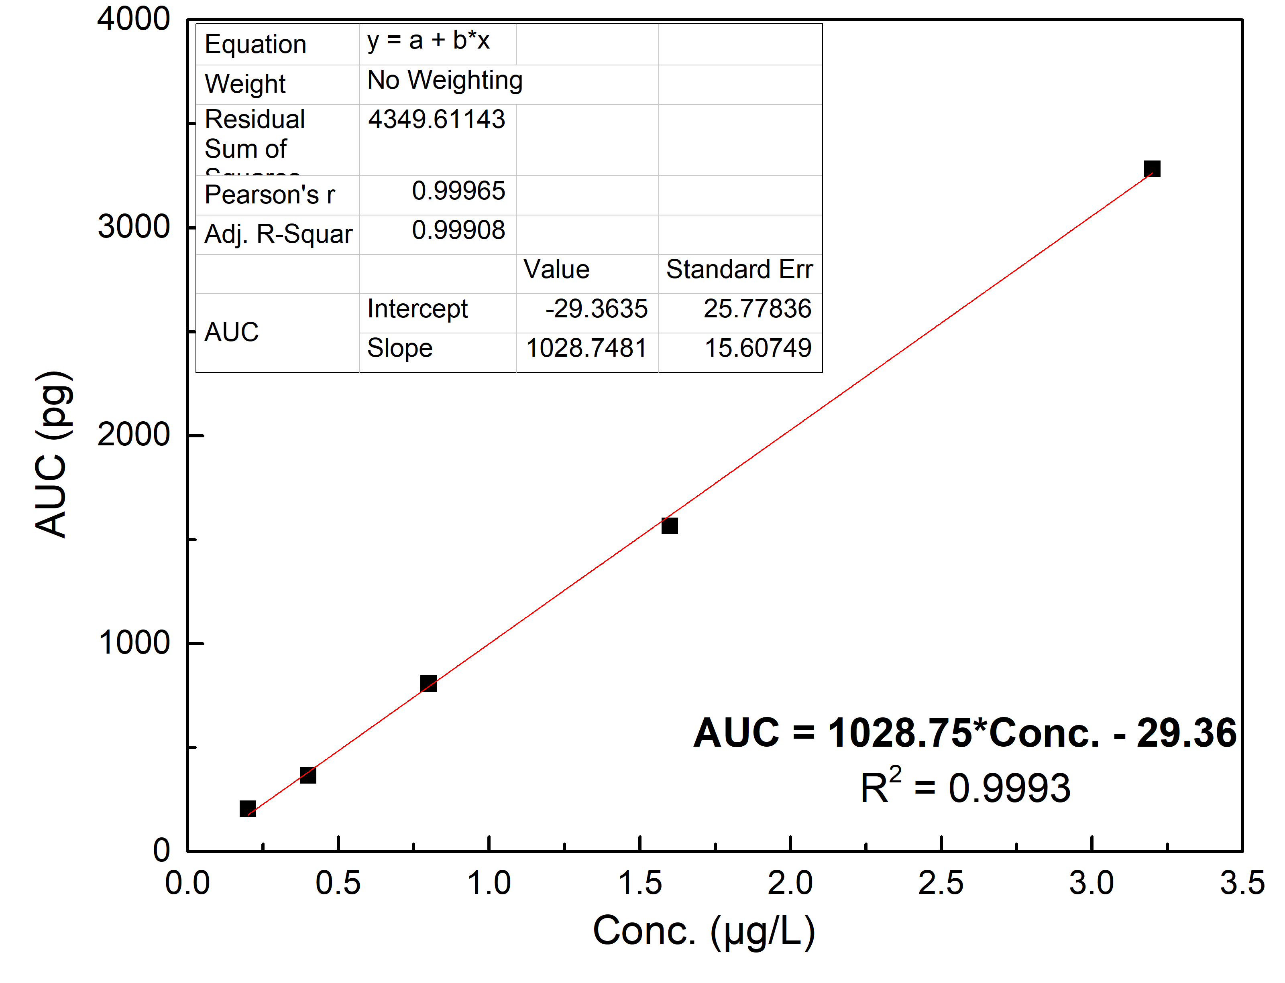

Figure 1. The calibration curve for determination of AFB1

From this evaluation result, we certainly confirm that the UPLC/MS-MS method developed in this study can be used to determine the AFB1 content in the actual sample. That is the basis for studying and analyzing AFB1 on a sample of nutritious cereal powder for children in Ho Chi Minh City market.
3.3 Analysis of nutritional cereal powder samples for children in the Ho Chi Minh city market
To evaluate the AFB1 content on the actual sample, conduct an assessment of the AFB1 content of the sample "Supplementary Food Supplements Vanilla Organic Milk Powder with Vitamin B1 Babybio/Infant Cereals Vanilla/Babybio Céréales Vanille". Samples of weaning powder including cereals and milk for children over six months old, batch number: 3288131500102. According to the analytical procedure UPLC/MS-MS has been developed and evaluated as described in Sections 3.1. and 3.2. The analysis results obtained for the specific sample are as shown in Figure 4.
From the analytical results obtained on the chromatogram (Figure 2C), we can conclude that the proposed and validated method is UPLC-MS/MS, which is a highly accurate and sensitive analytical technique. The method's limit of quantitation (LOQ) is 0.10 µg/kg, which means that it is capable of detecting very low levels of AFB1 in a sample of Babybio/Infant Cereals Vanilla/Babybio Céréales Vanille.

Table 3. The results of the evaluation of the analytical method through the parameters
No | Parameters | Criteria ¹⁰ | Result | Evaluation
1 | Linearity of the standard curve | R² ≥ 0.99 | R² ≥ 0,9993 | Qualified
2 | Repeatability (C ≤1µg/kg) | RSDr ≤ 30% | 6,72 - 9,00 | Qualified
3 | Reproducibility (C ≤1µg/kg) | RSD_{R} ≤ 45% | 7,89 - 10,4 | Qualified
4 | Recovery efficiency | 40 -120% | 73,6 - 110 | Qualified
5 | Limit of detection (LOD), µg/kg | 0.03 | 0,03 | Qualified
6 | Limit of quantitation (LOQ), µg/kg | 0.10 | 0,10 | Qualified
7 | Uncertainty of measurement (%) | - | ± 17.1 | -

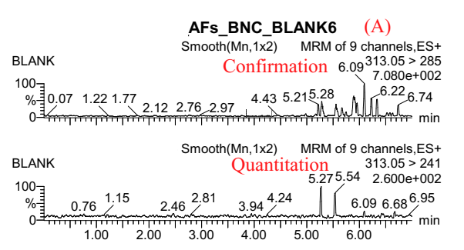

.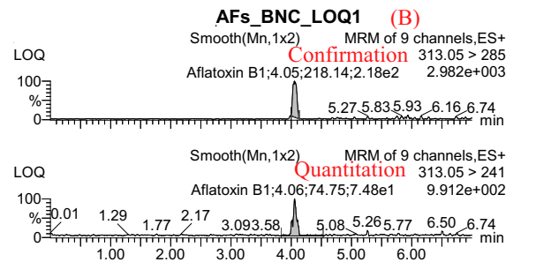
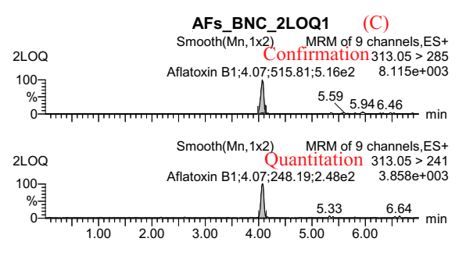
Figure 2. UPLC/MS-MS chromatograms of aflatoxins: (A) standard AFB1 blank sample (B) concentration control sample (<0.1 g/kg) (C) supplemental food sample powdered organic milk powder with added vanilla flavor vitamin B1 Babybio/Infant Cereals Vanilla/Babybio Céréales Vanille.

4. Conclusions
The analytical procedure for determining the content of aflatoxin B1 by UPLC/MS-MS method has been developed in samples of nutritious cereal powder for children.
The method of determining the content of aflatoxin B1 by UPLC/MS-MS method has been validated in samples of nutritious cereal powder for children. This method has the advantage of a simple sample processing technique, and the results of the verification of the analytical parameters are in line with the standards allowed by AOAC. Parameters such as selectivity, calibration curve, residual solvent, repeatability, reproducibility, recovery efficiency, measurement uncertainty, sample stability on UPLC/MS-MS with collection efficiency recovery ranged from 73.6 to 110% with a relative standard deviation of less than 15%, detection limit of 0.03 g/kg and limit of quantification 0.1 g/kg meeting the strict regulation of AFB1 in powders Weaning food for children from 6 months to 36 months according to QCVN 8:1:2011/BYT.
We have applied this developed analysis and appraisal process to analyze AFB1 in a sample of baby food powder. The product is a supplement that contains organic vanilla-flavored milk mixed with vitamin B1, meant for infants and is called Babybio/Infant Cereals Vanilla/Babybio Céréales Vanille. The result of the analysis is that AFB1 was not detected in the sample.

References

- El-Sayed, Raghda A., Ali B. Jebur, Wenyi Kang, Mohamed A. El-Esawi, and Fatma M. El-Demerdash. "An overview on the major mycotoxins in food products: Characteristics, toxicity, and analysis." Journal of Future Foods 2, no. 2 (2022): 91-102.
- Marin, S., A. J. Ramos, German Cano-Sancho, and V. Sanchis. "Mycotoxins: Occurrence, toxicology, and exposure assessment." Food and chemical toxicology 60 (2013): 218-237.
- WHO, “Mycotoxins”, https://www.who.int/news-room/fact-sheets/detail/mycotoxins (15/06/2022)
- Klich, Maren A. "Aspergillus flavus: the major producer of aflatoxin." Molecular plant pathology 8, no. 6 (2007): 713-722.
- Pereira, Cheila, Sara C. Cunha, and José O. Fernandes. "Mycotoxins of concern in children and infant cereal food at European level: Incidence and bioaccessibility." Toxins 14, no. 7 (2022): 488.
- Ministry of Health, “Circular promulgating national technical regulations for chemical contamination limits in food. Official Gazette/No. 535+ 536”. October 25, 2011, 2011.
- Duy, Nguyễn Thành, Nguyễn Thuý Ngân Hà, Đặng Thị Kim Hằng, Nguyễn Lâm Kiều Diễm, Chu Vân Hải, and Nguyễn Quang Trung. “Building and validating a process for analyzing aflatoxin B1, B2, G1, G2 in weaning powder by super-performance liquid chromatography with fluorescence detector UPLC-FLD”, Jourmal of Analytical Sciences, 27(1), 2022, 77-81.
- Acquity UPLC/MS-MS for multi mycotoxin analysis - Application no: 72002137 – Water
- AOAC 2005.08: Aflatoxins in Corn, Raw Peanuts, and Peanut Butter Liquid Chromatography with Post-Column Photochemical Derivatization
- AOAC Appendix F: Guidelines for Standard Method Performance Requirements
- TCVN 9522:2012: Foodstuffs standard TCVN 9522:2012 (EN 15851:2010) - Determination of aflatoxin B1 in cereal-based foods for infants and young children - High performance liquid chromatography (HPLC) method with immunoaffinity column cleaning and fluorescence detector.

