Role of O–H∙∙∙O/S conventional hydrogen bonds in considerable C_{sp2}–H blue-shift in the binary systems of acetaldehyde and thioacetaldehyde with the substituted carboxylic and thiocarboxylic acids

Nguyen Truong An¹, Nguyen Thi Duong¹, Nguyen Ngoc Tri^{1,2}, Nguyen Tien Trung^{1,2}*

¹Faculty of Natural Sciences, Quy Nhon University, Quy Nhon, Vietnam,
²Laboratory of Computational Chemistry and Modelling (LCCM), Quy Nhon University, Quy Nhon, Vietnam
* Corresponding author: nguyentientrung@qnu.edu.vn

Abstract
Stable binary complexes of RCZOH∙∙∙CH₃CHZ (R = CH₃, H, F; Z = O, S) are contributed by O–H∙∙∙O/S and C_{sp2}–H∙∙∙O/S hydrogen bonds. The strength of C_{sp2}/O–H∙∙∙O is 1.5 to 2 times larger than C_{sp2}/O–H∙∙∙S bonds. Substitution of H(C_{sp2}) of HCZOH by CH₃ causes a decrease in complex stability, while the opposite trend occurs for F atom. A very large red shift of the O–H stretching frequency in O–H∙∙∙O/S bonds was observed. A surprising C_{sp2}-H blue shift up to 104.5 cm⁻¹ has been observed for the first time. It is found that the presence of O–H∙∙∙O/S hydrogen bond and a decisive role of intramolecular hyperconjugation interaction in the complex cause a significant blue shift of C_{sp2}–H covalent bond. A striking role of O compared to S atom in determining blue shift of C_{sp2}-H stretching vibration and stability of binary complexes is proposed. The obtained results show that the ratio of deprotonation enthalpy and proton affinity could be considered as an index for classification of nonconventional hydrogen bond. SAPT2+ results show that the strength of RCSOH∙∙∙CH₃CHS complexes are dominated by the electrostatic and induction energy, while a larger contribution to the stability of remaining complexes is detected for the electrostatic component.

Keywords: Blue-shift, Hydrogen bond, sp2-hybridized carbon, Electrostatic interaction, SAPT, NBO, AIM

1. Introduction
Despite exhibiting a much lower energy and directionality in comparison to covalent bonds, non-covalent interactions still demonstrate a dominant role owing to its ubiquity in nature and the contribution to the cohesion of chemical systems. The most significant type in non-covalent interactions is hydrogen bond, which is of great importance in chemistry, biochemistry, especially in biological systems: DNA, RNA, proteins,…^{1–3}. The A–H∙∙∙B conventional hydrogen bond is a weak non-covalent interaction, in which A and B are high electronegative elements, and B usually contains a region of high electron density (a lone pair, a negative charge, or a π-system). Conventional hydrogen bonds (so-called red-shifting hydrogen bonds) characterized by a A–H bond elongation along with a decrease of its stretching vibration are well-known, and this frequency shift is due to electrostatic attraction between H atom and B atom ⁴. The red shift of A–H stretching vibrational frequency of A–H bond is proposed by the n(B)→σ*(A–H) intermolecular electron density transfer overcoming the increase in s-character and the A–H bond polarization⁵. Nonconventional hydrogen bonds with a A–H contraction associated with an increase in its stretching vibration were discovered in complexes of ﬂuoroparaﬃns with pyridine, acetone, and dioxane by Trudeau et al. in 1980. ⁶ Such a nonconventional hydrogen bond is named blue-shifting hydrogen bond.
Several hypotheses from both theoretical and experimental research works have been proposed to unravel the phenomenon of blue-shifting hydrogen bond, ^{2,7–13} however, it has not been deeply understood yet. For instance, Wu et al. indicated that the reason for the shift of A–H stretching vibration arises from the short-range hyperconjugative interaction of n(B)→σ*(A–H) electron density transfer in competition with the long-range electrostatic interaction of A–H bond and B atom¹⁴. In another report, based on different physical components of interaction energy, Mao et al. suggested that an enhancement of A–H stretching vibration is encouraged by Pauli repulsion, whereas a combination of electrostatic and dispersion forces cause a diminishing of A–H stretching vibration⁷. The electrostatic and Pauli repulsion energies dominating the sum of polarization and charge transfer interaction define a A–H bond contraction and an increase in its stretching frequency ¹³. An interesting approach that notices the inherent characteristics of proton donor and acceptor monomers to unfold the origin of blue-shifting hydrogen bond has been proposed ^{15–18}.
The blue-shifting hydrogen bond is mainly discovered in complexes involving C–H bond acting as a proton donor, such as in C–H∙∙∙O/N/halogen/π hydrogen bonds, which are significant due to their abundance and diversity in nature ^{19–29}. Studies were then further expanded in characterizing the blue-shifting hydrogen bond based on the different hybridization types of the C atom in the C–H bond ^{30–32}. It is noteworthy that for the demand for elucidating the characteristics and nature of the blue-shifting hydrogen bond, the nonconventional hydrogen bond involving C_{sp3}–H bond as a proton donor has been experimentally and theoretically examined much more than the C_{sp2}–H and C_{sp}–H one. A few publications suggested that for the same proton acceptor, the lower polarity of the proton donor is, the larger blue-shift of stretching frequency is, and vice versa ^{33–35}. Consequently, most reports have focused on the C_{sp3}–H bond with its lowest polarity as compared to both the C_{sp2}–H and C_{sp}–H ones. Indeed, in 1999, Hobza et al. used double-resonance infrared ion-depletion (IR-R2PI) spectroscopy to give a predicted blue shift of the C_{sp3}–H stretching frequency of 14 cm⁻¹ for the chloroform∙∙∙fluorobenzene complex ³⁶. A very slight C_{sp3}–H stretching frequency blue-shift of 8.7 cm⁻¹ in C_{sp3}–H∙∙∙N nonconventional hydrogen bond was recently observed in the complex between chloroform with acetonitrile in gas phase with Fourier transform IR (FTIR) spectroscopy by Behera et al. ²⁷. Remarkably, a similar change of the C_{sp3}−H stretching frequency from blue shift in the gas phase to red shift in the argon matrix was also observed in complexes of deuterated chloroform with acetone and cyclohexanone ³⁷.
Recently, the blue shift of stretching frequency was found in C_{sp2}–H bond and its extent of stretching frequency is even much higher than that of C_{sp3}–H bond as a proton donor, in spite of the larger polarity of the former with respect to the latter one. Indeed, a C_{sp2}–H significant blue shift by 81÷96 cm⁻¹ in the C_{sp2}–H∙∙∙O hydrogen bond formed in complexes of formic acid with formaldehyde and thioformaldehyde has been recently discovered ³³. An investigation at B3LYP/6-311++G(d,p) level in the interaction between CH₃CHO with two molecules of water predicted a significant blue shift of the C_{sp2}–H vibration amounting to 93 cm⁻¹ in C_{sp2}–H···O hydrogen bond ³⁸. Our group’s further reports of the considerable blue shift of C_{sp2}–H stretching vibration in the C_{sp2}–H···O/S nonconventional hydrogen bonds in XCHO∙∙∙2H₂Z (X = H, F, Cl, Br; Z = O, S, Se, Te) complexes were given in ref. ³⁹. Following complexation, a decrease of stretching frequency of O–H bond in the dimer of carboxylic acids ^{40,41} and an increase in C_{sp2}–H stretching vibrational frequency in the complexes of acetaldehydes ^{42–44} were reported. Kaur et al. suggested that the blue shift of C_{sp2}–H stretching vibrational frequency results from the presence of the O–H···O bond in the complexes formed between carbonyl compounds and hydrogen bond donors HOR (R = H, Cl, CH₃, NH₂, C(O)H, C₆H₅) ⁴⁵.
Although some publications related to the considerable blue shifts of C_{sp2}–H stretching vibrational frequencies in the complexes containing carbonyl (C_{sp2}=O) group are reported ^{33,35,46–48}, a systematic investigation of binary complexes stabilized by hydrogen bonds with C_{sp2}–H bond acting as proton donor for having an insight of the nature of blue-shifting hydrogen bond is desirable. As a consequence, a study of the complexes formed by interactions of acetaldehyde (CH₃CHO) and thioacetaldehyde (CH₃CHS) with the substituted carboxylic and thiocarboxylic acids (RCZOH, with R = F, H, CH₃ and Z = O, S) is performed in the present work to acquire a better understanding of the characteristics of conventional and nonconventional hydrogen bonds along with their mutual impact. The impact of the presence of O–H···O/S hydrogen bond on the stability of C_{sp2}–H···O/S nonconventional hydrogen bonds and the blue shift of C_{sp2}–H stretching vibration is estimated. In addition, the effect of R substituents of RCZOH (F and CH₃) acting as electron-withdrawing and electron-donating groups on the strength of binary complexes as well as the characteristics and stability of O–H···O/S and C_{sp2}–H···O/S hydrogen bonds are evaluated. Furthermore, the role of O compared to S in CH₃CHZ in affecting the characteristics of nonconventional and conventional hydrogen bonds is investigated thoroughly.

2. Computational methods
The optimized geometries of the monomer, the complexes and their stretching vibrations are determined on the potential energy surface by means of the Gaussian 09 package⁴⁹ using MP2 (second-order Moller−Plesset perturbation theory)⁵⁰ combined with 6-311++G(3df,2pd)^{51,52}. Proton affinity (PA) at the O and S sites and deprotonation enthalpy (DPE) of C–H and O–H bonds are calculated at the CCSD(T)/6-311++G(3df,2pd) level. Interaction energy (ΔE*) corrected by both zero–point vibrational energy (ZPE) and basis set superposition error (BSSE) ⁵³ is carried out at the CCSD(T)/6-311++G(3df,2pd) based on the optimizing geometries at the MP2/6-311++G(3df,2pd) level by the supramolecular method, in which, ΔE* is defined as the difference in total electronic energy between the stable complexes (E_{complex}) and the sum of two optimized monomers (E_{monomer-1}, E_{monomer-2}) given by
AIM (Atom In Molecule) analysis is made to determine the bond critical points (BCP), electron density (ρ(r_{C})), Laplacian of electron density (∇²ρ(r_{C})) using AIMAll package⁵⁴. The local electron energy density (H(r_{C})) at BCP is computed by H(r_{C}) = G(r_{C}) + V(r_{C}), in which V(r_{C}) and G(r_{C}) are the electron potential energy density and the electron kinetic energy density. The individual energy of each hydrogen bond (E_{HB})^{55–58} was calculated based on the experience formula revealed by topological analyses of the electron density: E_{HB} = 0.5V(r_{C}).⁵⁸ A natural bond orbital (NBO) analysis using the GenNBO5.G program⁵⁹ for a comprehensive understanding of the nature of hydrogen bond is carried out by calculating the hyperconjugation energies for intramolecular and intermolecular electron density transfer and orbital occupancies. NCIplot description is further utilized to visualize the weak hydrogen bonds ^{60,61}. Moreover, the Molecular Electrostatic Potential (MEP) analysis^{24,62} of the monomers is investigated at the MP2/6-311++G(3df,2pd) level. In particular, electrostatic potential, V(r) has been considered to be an important property for analyzing the nature and predicting the strength of several non-covalent interactions. Herein, we used the maximum and minimum surface electrostatic potential denoted by V_{s,max} and V_{s,min}, respectively, in order to character hydrogen-bonded complexes. Generally, V(r) is created by the nuclei and electrons of a molecule at any point r in the surrounding space, given by,
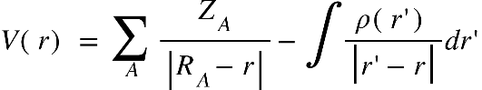
In which, Z_{A} is the charge on nucleus A, located at R_{A} and ρ(r’) is molecule’s total electronic density with r’ is a dummy integration variable.
To evaluate physically meaningful components contributing to the stability of investigated complexes, the SAPT (Symmetry-Adapted Perturbation Theory) analysis ⁶³ using Psi4 program⁶⁴ at the MP2/def2-TZVP//MP2/6-311++G(3df,2pd) level is employed. The total interaction energy (∆E^{SAPT2+}) can be decomposed into the four basic components: exchange-repulsion (E_{exch}), electrostatic (E_{elst}), induction (E_{ind}), dispersion (E_{disp}) terms, and is defined by:
ΔE_{SAPT2+} = E_{elst} + E_{exch} + E_{ind} + E_{disp} + δE_{int,r}^{HF}
where δE_{int,r}^{HF} is a term containing the third-order and higher-order induction and exchange-induction contributions.

3. Results and Discussion
3.1. Geometric structures, and AIM and NCI analyses
Stable structures of binary complexes of CH₃CHZ and RCZOH (with Z = O, S; R = CH₃, H, F) at the MP2/6-311++G(3df,2pd) level are shown in Figure 1a. Twelve stable complexes are located on potential energy surfaces named by RZ-Z, in which, R is M, H, F corresponding to CH₃, H, F substitution groups. The O atom or S atom is represented by Z in RCZOH and CH₃CHZ, denoted Z2 and Z7 in the complexes. The sp²-hybridized carbon atom in CH₃CHZ is labelled hereafter as C_{sp2}. From Figure 1a, it can be seen that all structures contain a ring connected by two intermolecular interactions: one C_{sp2}–H∙∙∙Z2 with an angle deviation from linearity and one O–H∙∙∙Z7 with an angle of ~180$°$. The chalcogen atoms (Z) act as proton-accepting centers and C_{sp2}–H or O–H bonds in the isolated monomers are proton-donating sites ^{40,65,66}. Remarkably, a rotational spectrum study of formic acid – isopropylformate by Spada et al. suggested a similar geometry with hydrogen bonds including O–H∙∙∙O and C_{sp2}–H∙∙∙O ⁶⁷.
Some typical parameters in the observed complexes are tabulated in Table S1. The distances of all H∙∙∙O7, H∙∙∙S7, H∙∙∙O2, and H∙∙∙S2 contacts are close to the sum of the Van der Waals radii of relevant atoms (this sum is 3.00 and 2.72 Å for the corresponding pair of S and H, O and H atoms). These results roughly suggest the presence of O–H∙∙∙Z7 conventional and C_{sp2}–H∙∙∙Z2 nonconventional hydrogen bonds in the binary complexes. The length of H∙∙∙O distances in C_{sp2}–H∙∙∙O ^{33,45} and O–H∙∙∙O ^{33,45,68} interactions are comparable to those in the complexes of this work. Additionally, the H∙∙∙S distances of O–H∙∙∙S7 hydrogen bond in HO-S are close to those obtained at the MP2/aug-cc–pVDZ level ³³.
The topological results from Figure 1b according to AIM analysis show the bond critical points (BCP) in red between the lines connecting H atoms with Z7 and H atoms with Z2 for all complexes (cf. Figure S1a, S1b). These BCPs show that the O–H∙∙∙Z7 and C_{sp2}–H∙∙∙Z2 contacts in the binary complexes of RCZOH and CH₃CHZ are hydrogen bonds. Besides, their existence is confirmed by the values of electron density ρ(r_{C}) and Laplacian at BCPs ∇²ρ(r_{C}), which fall within the criteria for the formation of hydrogen bonds ⁶⁹. All values of ρ(r_{C}) and ∇²ρ(r_{C}) at these BCPs (cf. Table S2 of Electronic Supporting Information, ESI) are indeed in the range of 0.0096-0.0521 au and 0.027-0.105 au, respectively. The presence of conventional and nonconventional hydrogen bonds in the complexes is emphasized by values of local electron energy densities (H(r_{C})) at BCPs ^{70,71}. The positive values of ∇²ρ(r_{C}) and negative values of H(r_{C}) at BCPs of O–H∙∙∙Z7 contacts in the complexes suggest a partly covalent character of the conventional hydrogen bonds⁴⁵. Meanwhile, the positive ∇²ρ(r_{C}) and H(r_{C}) given values, the C_{sp2}–H∙∙∙Z2 nonconventional hydrogen bonds are considered to be weak hydrogen bonds.
The E_{HB} values from Table S2 suggest that the O–H∙∙∙O7 is twice more stable than the O–H∙∙∙S7 and the C_{sp2}–H∙∙∙S2 is about 1.5 times less stable than the C_{sp2}–H∙∙∙O2. This implies that the O–H∙∙∙Z7 hydrogen bonds keep a substantial part in stabilizing further the complexes, in addition to the stabilization by the C_{sp2}–H∙∙∙Z2 hydrogen bonds. This observation is also reported in the hydrogen-bonded complexes between carbonyl derivatives and water^{38,46,72}. It is found that the contribution to the RZ–Z stabilization is larger for the C_{sp2}–H∙∙∙O2/O–H∙∙∙O7 hydrogen bonds than the C_{sp2}–H∙∙∙S2/O–H∙∙∙S7 ones, which is consistent with a report in systems of aldehydes³⁹. The second-order correlations between individual energy of hydrogen bond (E_{HB}) with the value of electron density (ρ(r_{C})) at the BCP and the distance H∙∙∙Z (r(H∙∙∙Z)) are plotted in Figure 2. It shows that the more negative the E_{HB} values are, the larger ρ(r_{C}) values and the shorter r(H∙∙∙Z) at BCPs are. In other words, the ρ(r_{C}) at BCP of hydrogen bond is inversely proportional to r(H∙∙∙Z). This result implies a dominant role of O–H∙∙∙Z7 bond compared to C_{sp2}–H∙∙∙Z2 bond in contributing to complexation.
Concerning C_{sp2}–H∙∙∙Z2 bonds, the H∙∙∙Z2 distance is increased when R is an electron-withdrawing group (F) while the opposite is true for an electron-donating group (CH₃). Meanwhile, a converse trend is obtained with O–H∙∙∙Z7 bonds. For explaining the observation, the effect of proton-donating or -accepting ability of the isolated monomers on the strength of hydrogen bonds is evaluated through deprotonation enthalpy (DPE) of O/C_{sp2}–H bonds and proton affinity (PA) at the Z sites of CH₃CHZ and RCZOH (Table 1). By changing R substitution in RCZOH, the O–H∙∙∙Z7 intermolecular distance in complexes increases in the order of F < H < CH₃, which implies the decrease in the strength of these hydrogen bonds following this sequence (cf. Table S2 of ESI). This change accompanies with a decrease in the polarity of O–H bond in RCZOH as one goes from F to H to CH₃ substitution (Table 1). Besides, the strength of C_{sp2}–H∙∙∙Z2 nonconventional hydrogen bonds rises in the substitution order: F < H < CH₃, which relates directly to the increasing proton affinity of Z2 site in RCZOH and the decreasing distance of the hydrogen bond. With the different substitution of Z2 or Z7 atoms, AIM data shows a larger strength of C_{sp2}–H∙∙∙O2 hydrogen bond compared to C_{sp2}–H∙∙∙S2 one and a larger strength of O–H∙∙∙O7 bond in comparison with O–H∙∙∙S7 one, which was also observed in the complexes between aldehydes and hydrogen chalcogenides ⁷². The NBO charges given in Table S1 of ESI show a larger positive charge of H atom in C_{sp2}–H∙∙∙O2 bond in RO-Z as compared to that in C_{sp2}–H∙∙∙S2 one in RS-Z. Besides the charge of O2 atom is also more negative than that of S2 atom in the complexes. This signifies a stronger electrostatic attraction between O2 and H than between S2 and H. Likewise, the NBO charge on O7 atoms has large negative values, whereas positive charges are found on S7 atoms. In addition, more positive charges of H of the –OH group in RZ-O as compared to those in RZ-S are also observed (cf. Table S1). In consequence, the electrostatic attraction is stronger in O–H∙∙∙O7 bond than in O–H∙∙∙S7 bond.
For a more obvious understanding of the existence and strength of conventional and nonconventional hydrogen bonds in the complexes, NCI (Non-Covalent Interaction) calculations are performed. The reduced density gradient (RDG) isosurfaces and their 2D plots for all complexes are displayed in Figure S2a, S2b. Here, the FO-O complex is chosen as a good example for analysis (Figure 3). In 2D plots, the low-density and low reduced gradient in the region where the second eigenvalue (λ₂) of the electron-density Hessian matrix is negative, indicating the weak and non-covalent attractive interactions between CH₃CHZ and RCZOH molecules. In particular, two spikes (blue and green) are detected in the negative region, confirming again the attendance of the O–H∙∙∙Z7 and C_{sp2}–H∙∙∙Z2 hydrogen bonds in the complexes. The O–H∙∙∙Z7 bond is recognized by the blue spike lying at the high negative region (~0.05 au). This indicates the stronger O–H∙∙∙Z7 hydrogen bonds compared to C_{sp2}–H∙∙∙Z2 ones in the complexes, in agreement with the results reported by Lei et al. ⁷³ and Cuc et al. ^{39,72}. Moreover, the spike found at the positive region with only about 0.01 au in electron density implies a repulsive non-covalent interaction at the RCP interior to the ring.

3.2. Complex stability and physical energetic components
To evaluate the role of conventional and nonconventional hydrogen bonds in stabilizing the complexes, the second-order perturbative energies E_{inter} from NBO calculations at the MP2/6-311++G(3df,2pd) level are given in Table 2. The large positive values of electron density transfer (EDT) of ca. 0.039 - 0.079 e show that the electron density is considerably transferred from CH₃CHZ to RCZOH following complexation. These EDT values are taken from a stronger electron density transfer from n(Z7) to σ*(O–H) orbital versus n(Z2) to σ*(C_{sp2}–H) one in each binary complex. The values of E_{inter}[n(Z7)→σ*(O–H)] (ca. 22.6-37.4 kJ.mol⁻¹) are indeed 10÷17 times larger than E_{inter}[n(Z2)→σ*(C_{sp2}–H)] (ca. 1.4-3.1 kJ.mol⁻¹). It could be thus drawn that the charge-transfer interaction of n(Z7)→σ*(O–H) in the conventional hydrogen bond plays a dominant role in stabilizing each complex, as compared to those of the n(Z2)→σ*(C_{sp2}–H) electron transfer in the nonconventional ones.
Interaction energies (ΔE*) including ZPE and BSSE corrections and SAPT2+ analysis of the studied complexes are listed in Table 3. Generally, the values of the interaction energy range from -27.1 to -46.5 kJ.mol⁻¹, implying that the considered complexes are stable. The stability of CH₃CHZ∙∙∙RCZOH complexes lies between that of (CH₃CHZ)₂ and (RCZOH)₂ dimers, with R = H, CH₃, F and Z = O, S (cf. Table 4). Particularly, the values of interaction energy of (HCOOH)₂ and (CH₃COOH)₂ are calculated to be in turn -61.9 and -66.6 kJ.mol⁻¹ at the MP2/aug-cc-pVTZ level⁴⁰. The less negative interaction energy of -14.8 kJ.mol⁻¹ is found for (CH₃CHO)₂ dimer at M062X/6-311++G(3df,3pd) level.⁴² The investigated complexes are more stable than CH₃CHS∙∙∙HOBr (ΔE* is -22.8 kJ.mol⁻¹ at the MP2/aug-cc-pVTZ level) ⁷⁴ and CH₃CHO∙∙∙H₂O and CH₃CHS∙∙∙H₂O (ΔE* are -15.3 and -11.7 kJ.mol⁻¹, respectively, at CCSD(T)/6-311++G(3df,2dp)//MP2/6-311++G(3df,2dp)) ⁷².
With the same atoms Z2 and Z7, the interaction energy of complexes tend to decrease as going from MZ-Z to HZ-Z and finally to FZ-Z. As a result, the substitution of H by F attached to the carboxyl group in HCZOH gives rise to an enhancement of the stabilization energy, while the attachment of CH₃ group diminishes this value. This observation is well consistent with the trend in the strength of O–H∙∙∙O/S hydrogen bonds in the complexes. The E_{inter}[n(Z7)→σ*(O–H)] values thus increase in the order of CH₃ < H < F substitutions, which are in line with the tendency of enhancement in polarity of O-H covalent bonds in RCZOH (cf. Table 1). Following this substitution, as observed in Table 2, the E_{inter}[n(Z2)→σ*(C_{sp2}–H)] values decrease slightly, which is due to a lower proton affinity at Z2 site in the isolated isomers. This indicates a dominant role of the O–H∙∙∙O/S compared to C_{sp2}–H∙∙∙O/S hydrogen bonds in stabilizing the complexes. The more negative values of the interaction energy were obtained in CH₃CHO∙∙∙HCOOH (-39.8 kJ.mol⁻¹) in comparison with CH₃CHO∙∙∙CH₃COOH (-38.0 kJ.mol⁻¹) at the B3LYP-D3/aug-cc-pVTZ level ⁶⁸ (Table 4), which shows that the H substitution of C_{sp2}–H group in HCOOH by CH₃ group causes a decrease in the stability of hydrogen-bonded complexes. This observation is also similar to the obtained result in this work and in the complexes of alcohol derivatives and amine⁷⁵.
The values of the maximum surface electrostatic potential (V_{s,max}) at the H atom of -OH groups in substituted carboxylic and thiocarboxylic acids (RCZOH) are displayed in Figure S3. As expected, V_{s,max} of RCZOH molecule at H atom decreases with the substitution of CH₃ group, whereas it increases with the presence of F atom, corresponding to the changing trend of the interaction energy in the complexes. Indeed, the F substituted RCZOH having the highest V_{s,max} is accompanied by the largest negative interaction energy, whereas the CH₃ substitution having the lowest V_{s,max} is associated with the least negative interaction energy. The linear correlations (R² > 0.92; R² > 0.94) between the interaction energy of complexes and the magnitude of V_{s,max} value are observed in the present study as given in Figure S4 of ESI. It shows that the stability of the investigated complexes increases when there is an enhancement of the positive electrostatic potential of H atom in RCZOH monomers and vice versa.
With the same substituent group R and Z7, the interaction energy of RO-Z is slightly more negative than those of RS-Z, around 0.1–1.6 kJ.mol⁻¹, while E_{inter}[n(S2)→σ*(C_{sp2}–H)] is larger than E_{inter}[n(O2)→σ*(C_{sp2}–H)]. This indicates that the larger strength of C_{sp2}−H∙∙∙O2 versus C_{sp2}−H∙∙∙S2 is caused by the electrostatic attraction between H and Z2 overcoming the charge transfer from n(Z2) to σ*(C_{sp2}–H) orbital. With the same R and Z2, the RZ-O is ca. 7.0-11.7 kJ.mol⁻¹ in energy more stable than RZ-S, although electron transfer energy from n(S7) to σ*(O–H) orbital is stronger than that from n(O7) to σ*(O–H) one (cf. Table 2, 3). Consequently, the stability of complexes is governed by the electrostatic interaction of Z7 and H atom as opposed to the energy for the charge transfer from n(Z7) to σ*(O–H) orbital. In short, it is apparent that the larger stability of RO-Z versus RS-Z or RZ-O versus RZ-S comes from the contribution of electrostatic attraction between O and H atoms, overwhelming that between S and H atoms. Indeed, as seen from Table S3, the NBO charges at O site are much more negative than those at S site in acids and aldehydes. The considerable role of attractive electrostatic interaction was also suggested by Cuc et al. ⁷² in a study of complexes of chalcogenoaldehydes and water. Similarly, the larger stability of HCOOH∙∙∙CH₃CHO as compared to HCOOH∙∙∙CH₃CHS at the MP2/aug-cc-pVTZ level was reported by Trung et al. ³³.
The energy components⁷⁶ were evaluated by employing the SAPT2+ procedures at MP2/def2-TZVP basis set (Table 3). The calculated results indicate that the interactions in the investigated complexes are mainly contributed by E_{elst} (36-47%) and E_{ind} (29-38%) components, while E_{disp} and δE^{HF} only contribute less a half of those, by 14–18% and 8–10%, respectively. As a consequence, the electrostatic and induction components play an important role in stabilizing the complexes, which is in agreement with the report in ref. ³³, especially a considerable role of electrostatic energy in complex stabilization. An approximation of the contributions in percentage of physical energy terms to the stability of the complexes for both electron-donating (CH₃) and electron-withdrawing (F) substituent groups is observed (cf. Figure S5). A great contribution of the electrostatic term to the complex stability occurs in RZ-O in comparison to RZ-S, making the former to be about 1.3-1.4 times more stable than the latter (Table 3). The high values of E_{exch} seem to be the additional reason for the less stable RS-S versus RO-O. Besides, there are approximate contributions of E_{elest} and E_{ind} components, about 36% – 38% in RS–S and even the induction term is slightly larger than the electrostatic one in contribution to the FS-S strength (Figure S5).

3.3. Changes in lengths and stretching frequencies of C_{sp2}–H and O–H bonds
The results obtained for the changes in the values of lengths (Δr, mÅ) and stretching frequencies (Δν, cm⁻¹) of O–H and C_{sp2}–H bonds at MP2/6-311++G(3df,2pd) level are tabulated in Table S4 and displayed in Figure 4. The C_{sp2}–H bond length decreases by 0.5 to 7.6 mÅ, accompanied by an increase in its stretching vibration by 11.0 to 104.5 cm⁻¹ in comparison with the corresponding values in the initial monomers. This observation is remarkable, given that as introduced in Section 1, a considerable contraction of a C_{sp2}–H bond length has rarely been observed owing to its polarity. The changes of C_{sp2}–H stretching frequency indicate that all C_{sp2}–H∙∙∙Z2 hydrogen bonds in the studied complexes are blue-shifted. For comparison, a concise summary of theoretical and experimental publications on the change in stretching frequencies of C_{sp}–H, C_{sp2}–H, C_{sp3}–H bonds upon complex formation is given in ESI (Table S5). It is seen that the red shift in stretching frequency of C_{sp}–H bond was found at high levels of theory, while both red or blue shifts of C_{sp3}–H stretching frequencies with weak and moderate magnitude were observed.
The extent of changes in C_{sp2}–H stretching frequencies have been observed in several binary hydrogen-bonded systems (cf. Table S5 in ESI)^{33,38,39,46,77}. Moderate and strong C_{sp2}-H blue shifts were reported in some complexes between carbonyl/thiocarbonyl compounds with water^{38,46,77}. In complexes between aldehydes and hydrogen chalcogenides³⁹, the C_{sp2}–H stretching frequencies undergo a significant blue shift, amounting to 92 cm⁻¹. Remarkably, a strong blue shift of C_{sp2}–H stretching vibration up to 96 cm⁻¹ in binary complexes between formic acid with acetaldehyde and thioacetaldehyde was reported in ref. 33.
Comparing the C_{sp2}–H∙∙∙Z types, it is found that the magnitude of blue shift in the C_{sp2}–H stretching vibrational frequency in O7=C_{sp2}–H∙∙∙Z2 (RZ-O) is larger than that in S7=C_{sp2}–H∙∙∙Z2 (RZ-S). This likely relates to the stronger polarity of C_{sp2}–H bond in CH₃CHS with respect to CH₃CHO (cf. Table 1). As seen in Figure 4, a larger contraction of C_{sp2}–H bond length accompanied by a larger increase in its stretching vibrational frequency are observed for the C_{sp2}–H∙∙∙O2 hydrogen bonds in comparison to the C_{sp2}–H∙∙∙S2. This difference is owing to the larger gas phase basicity at S site in RCSOH as compared to that at O site in RCOOH (cf. Table 1). These results are in line with recent reports on complexes of aldehydes and carboxylic acids ³³ or aldehydes/chalcogenoaldehydes and hydrogen chalcogenides ^{39,72}, which denotes a more prominent role of O versus S atom in larger magnitude of the blue shift of C_{sp2}–H stretching frequency involving hydrogen bond. Importantly, a good correlation between Δν(C_{sp2}-H) and DPE(C_{sp2}-H) along with PA(Z2) is found with R² = 0.97 (illustrated in Figure S6). Hence, the results of the present work demonstrate the fact that the blue shift of stretching vibrational frequency is dependent on the inherent property of the monomer, as discussed in some recent work ^{18,33–35,39}. As seen from Table 1 and Table S4, it is found that the higher DPE/PA ratio for the C_{sp2}–H∙∙∙Z2 is, the larger blue-shift of C_{sp2}–H stretching vibration will be, and vice versa. It is also found that the DPE/PA ratio for the C_{sp2}–H∙∙∙Z2 bonds in the complexes with CH₃CHZ is larger for Z = O than for Z = S. The highest DPE/PA is estimated in FO-O, and the lowest value is obtained in HS-S. Therefore, it could be proposed that the DPE/PA ratio can be used for the evaluation of the category of hydrogen bond and the extent of blue shift of stretching frequency.
The C_{sp2}–H stretching frequency in C_{sp2}–H∙∙∙Z2 bond experiences a strong enhancement upon the F substitution in RCZOH compared to H and CH₃ substitutions, which has been rarely reported before (cf. Table S5). It is suggested that a contraction in length of C_{sp2}–H bond and a remarkable increase of its stretching vibrational frequencies are affected by the presence of O–H∙∙∙Z7 hydrogen bonds in complexes, especially O–H∙∙∙O hydrogen bonds ⁴⁵. For instance, the highest extent of the blue shift in C_{sp2}–H∙∙∙Z2 bonds belongs to FO-O (connected by C_{sp2}–H∙∙∙O and O–H∙∙∙O bonds) with a C_{sp2}–H contraction of 7.6 mÅ and a strong increase in its stretching vibration of 104.5 cm⁻¹. This result arises from the largest decrease in electron density of the σ*(C_{sp2}–H) antibonding orbital (0.015 e) which strengthens the C_{sp2}–H bond, and thereby contributes to a blue shift of the C_{sp2}–H stretching vibration.
Table 2 points out that the trend in the change of electron density in the σ*(C_{sp2}–H) orbitals is quite comparable to the change in C_{sp2}-H stretching frequency. Meanwhile, the increase in the percentage of s–character of C_{sp2} in C_{sp2}-H covalent bond is not too much different in the complexes. As a consequence, a decrease of electron density in the σ*(C_{sp2}–H) orbitals, which overwhelms an increase in %s character in the hybridization of C_{sp2}(H), governs the magnitude of the blue shift of C_{sp2}-H stretching frequency in the complexes. All complexes including CH₃CHO exhibit a large decrease in electron densities in the σ*(C_{sp2}-H) (0.007-0.015 e), while a slight increase of 0.002 e or a slight decrease of 0.001 e in electron density of the σ*(C_{sp2}-H) is estimated for RS-S complexes. Besides, the decreases of the electron density in the σ*(C_{sp2}-H) for H or CH₃ substituted complexes are comparable and are much smaller than that for F substitutions, which confirms again the strong blue shift of C_{sp2}-H stretching frequency with F substituent.
Considering the second-order stabilization energy of interaction ¹¹ from Table 2, it shows that a larger decrease of intramolecular hyperconjugation energies of n(Z7)→σ*(C_{sp2}–H) electron density transfer versus intermolecular hyperconjugation energies of n(Z2)→σ*(C_{sp2}–H) transfer determines the decrease of σ*(C_{sp2}–H) orbital population. It is also noted that a decrease in the hyperconjugation energies associated with intramolecular electron density transfer from n(O7) to σ*(C_{sp2}–H) is twice as larger as that from n(S7) to σ*(C_{sp2}–H). A good linear correlation of the changes in electron density at the σ*(C_{sp2}–H) with both E_{inter}[n(Z2)→σ*(C_{sp2}–H)] and ΔE_{intra}[n(Z7)→σ*(C_{sp2}–H)] with R² = 0.97 is found in Figure S7. The results show a crucial role in the decrease of hyperconjugation interaction of intramolecular electron transfer from (Z7) to σ*(C_{sp2}–H) orbital overcoming the increase in electron density transfer from n(Z2)→σ*(C_{sp2}–H) orbital. This result leads to a large decrease of the σ*(C_{sp2}–H) occupation in the complexes, which governs a C_{sp2}–H bond contraction and the associated blue shift.
On the other hand, the changes of Δr(O-H) and Δν(O-H) in Figure 4 denote a strong red shift of O-H stretching frequencies along with its bond elongation in O–H∙∙∙Z7 hydrogen bonds upon complexation. This observation is accompanied by a large enhancement of σ*(O–H) occupation (ca. 0.041-0.083 e) overcoming an increase in the percentage of s-character at O(H) atom (ca. 3.52-4.18%) which does not favor an O–H bond elongation that accompanies an associated red shift of stretching vibration. From Table 2, the strong hyperconjugation energy for the intermolecular n(Z7)→σ*(O–H) transfer (amounting to 22.6÷37.4 kJ.mol⁻¹) is the reason for the increase in the occupation of σ*(O–H) orbital in complexes. The remarkable red shift of O–H stretching vibration in the O–H∙∙∙O7 hydrogen bond was also observed in the complexes between HCOOH and HCHO derivatives (363÷604 cm⁻¹)^{45,68,78,79} (Table 4) or between acetic acid and acetaldehyde (436 cm⁻¹)⁶⁸. Similar results were also reported in a recent investigation on HCOOH∙∙∙CH₃CHS and HCOOH∙∙∙CH₃CHO complexes ³³.
The red-shift of O-H stretching frequency of the O–H bond in O–H∙∙∙Z7 hydrogen bonds follows the ordering of CH₃ < H < F substitutions, in good agreement with the enhancement of the polarity of O–H bond in RCZOH in going from CH₃ to H and finally to F (Table 1). The red shift of O–H stretching frequency is greater for RS-Z than for RO-Z, which accords with the higher polarity of O–H bond in RCSOH as compared to its value in RCOOH (cf. Table 1). The obtained result indicates that the red shift of O–H stretching frequency in the O–H∙∙∙Z7 hydrogen bond is determined by an increase of σ*(O–H) electron density. From Figure 4, it is seen that for the same Z2, this O–H stretching frequency red shift in RZ-O is greater than that in RZ-S. Thus, the O–H red-shifting stretching frequency is mainly due to a larger attractive electrostatic force between Z7 and H, which overcomes the n(Z7)→σ*(O–H) charge transfer.

4. Concluding Remarks
In the present study, twelve stable ring structures of CH₃CHZ∙∙∙RCZOH (R = H, F, CH₃; Z = O, S) stabilized by O–H∙∙∙O/S and C_{sp2}–H∙∙∙O/S hydrogen bonds, with the interaction energies from –27.1 to –46.5 kJ.mol^{–1} were thoroughly investigated using quantum chemical methods. The substitution of H by the F atom in RCZOH induces an increase in thermodynamic stability of complexes, while the opposite is true for CH₃, which is due to the overwhelming contribution of O–H∙∙∙O/S bonds compared to C_{sp2}–H∙∙∙O/S counterparts. Besides, arising from electrostatic interaction, a larger role of the O atom in comparison with the S atom in affecting the characteristics and strength of hydrogen bonds as well as the stability of complexes is elucidated in these systems. The strength of C_{sp2}/O–H∙∙∙O is 1.5÷2 times larger than C_{sp2}/O–H∙∙∙S counterparts. SAPT2+ analysis indicates that the attractive electrostatic term plays a crucial role in stabilizing the complexes containing C_{sp2}/O–H∙∙∙O hydrogen bonds. Meanwhile, stabilizing the complexes by C_{sp2}/O–H∙∙∙S hydrogen bonds is due to both electrostatic and induction terms.
The C_{sp2}–H stretching frequency in C_{sp2}–H∙∙∙O/S nonconventional hydrogen bond increases when substituting one H of –CH group in HCZOH with both a halogen atom and CH₃ group. The largest blue shift of C_{sp2}-H bond up to 104.5 cm⁻¹ in the FO-O binary complex is observed for the first time, which corresponds to the smallest basicity at O atom in FCOOH as compared to that in the other monomers. It is realized that with the presence of O–H∙∙∙O/S bonds, a large decrease of electron density in σ*(C_{sp2}–H) orbital predominating an increase of the percentage of s-character, causes an abnormal blue-shift of the C_{sp2}–H stretching vibration of ca. 82.5-104.5 cm⁻¹. Besides, the ratio of DPE/PA can be considered as a factor in identifying the type of hydrogen bond and magnitude of blue shift observed upon complexation. NBO results show that the considerable blue shift of C_{sp2}–H stretching vibration is governed by intramolecular hyperconjugation interaction overcoming intermolecular one. Moreover, the shift of C_{sp2}-H stretching frequency as a function of net second hyperconjugative energy for the σ*(C_{sp2}–H) orbital is observed.
All the O–H bonds in the O–H⋯O/S conventional hydrogen bonds are red-shifted. The significant elongation of O–H bonds in O–H⋯O/S hydrogen bonds and the strong decrease of their stretching vibrational frequency come from considerable increases in the σ*(O–H) electron density overcoming an increase in percentage of the s-character of O/S hybridized atom. It is found that the red shifting of O–H⋯O bond is larger than that of the O–H⋯S one, and increases in the ordering of CH₃Z-Z < HZ-Z < FZ-Z binary complexes.

Acknowledgments
This research is funded by Vietnam National Foundation for Science and Technology Development (NAFOSTED) under grant number 104.06–2020.28.
We are sincerely thankful to Professor Thanh-Tung Nguyen-Dang, Université Laval - Canada for valuable discussion.
Conflict of interest The authors declare that they have no conflict of interest
Supporting Information Tables and Figures List of contact distances, the AIM analysis, MEP analysis, SAPT analysis, NCI plot, length changes, and stretching frequency shifts of the C_{sp2}–H and O–H bonds in the complexes.
Authors Information.
Corresponding Author. nguyentientrung@qnu.edu.vn

TABLE
Table 1. Values of PA and DPE at CCSD(T)/6–311++G(3df,2pd)//MP2/6–311++G(3df,2pd) and the ratios of DPE/PA for C_{sp2}–H∙∙∙Z2 bonds in the complexes
Monomer | CH₃CHO | CH₃CHS | CH₃COOH | CH₃CSOH | HCOOH | HCSOH | FCOOH | FCSOH
PA (Z), kJ.mol⁻¹ | 767.2  (768.5) | 807.1 | 768.2  (783.7) | 809.3 | 722.3  (742.0) | 770.3 | 698.5 | 744.0
DPE (C_{sp2}/O–H),  kJ.mol⁻¹ | 1641.0  (1645.1±4.0) | 1610.0  (1461.0±17.0) | 1454.8  (1457.0±5.9) | 1392.7 | 1440.1  (1449.0±5.0) | 1381.9 | 1366.5 | 1312.4
 |  | DPE/PA | MO-O | MS-O | HO-O | HS-O | FO-O | FS-O
 |  | DPE/PA | 2.14 | 2.03 | 2.27 | 2.13 | 2.35 | 2.21
 |  | DPE/PA | MO-S | MS-S | HO-S | HS-S | FO-S | FS-S
 |  | DPE/PA | 2.10 | 1.99 | 2.23 | 2.09 | 2.30 | 2.16
Experimental values in parentheses are taken from NIST webpage (https://webbook.nist.gov/chemistry/)

Table 2. Selected NBO results for C_{sp2}−H∙∙∙Z2 and O−H∙∙∙Z7 hydrogen bonds at MP2/6-311++G(3df,2pd)
Complex | EDT (e) | Δ%s (%) |  | Δσ* (e) |  | E_{inter} (kJ.mol⁻¹) |  | ΔE_{intra} (kJ.mol⁻¹)
Complex | EDT (e) | O(H) | C_{sp2}(H) | O−H | C_{sp2}−H | n(Z7)  →σ*(O−H) | n(Z2)  →σ*(C_{sp2}−H) | n(Z7)  →σ*(C_{sp2}−H)
MO–O | 0.039 | 3.71 | 1.37 | 0.041 | -0.012 | 23.1 | 1.7 | -7.6
MS–O | 0.040 | 3.99 | 1.16 | 0.043 | -0.007 | 26.2 | 2.5 | -7.2
HO–O | 0.042 | 3.81 | 1.31 | 0.043 | -0.012 | 25.6 | 1.7 | -7.8
HS–O | 0.041 | 4.14 | 1.12 | 0.044 | -0.007 | 27.8 | 2.4 | -7.4
FO–O | 0.055 | 3.82 | 1.26 | 0.055 | -0.015 | 35.6 | 1.4 | -8.7
FS–O | 0.056 | 3.99 | 1.15 | 0.060 | -0.011 | 37.4 | 2.2 | -8.6
MO–S | 0.050 | 3.52 | 1.62 | 0.054 | -0.004 | 22.6 | 2.6 | -3.9
MS–S | 0.054 | 3.82 | 1.41 | 0.061 | 0.002 | 26.0 | 3.1 | -3.2
HO–S | 0.056 | 3.73 | 1.55 | 0.059 | -0.004 | 25.1 | 2.6 | -3.8
HS–S | 0.057 | 4.03 | 1.39 | 0.064 | 0.002 | 28.4 | 3.1 | -3.4
FO–S | 0.076 | 3.99 | 1.50 | 0.074 | -0.006 | 33.0 | 2.1 | -4.1
FS–S | 0.079 | 4.18 | 1.39 | 0.083 | -0.001 | 37.0 | 2.7 | -3.7
Δ%s: change in s-character percentage; Δσ*: change in electron density of anti-bonding orbital; E_{inter}: intermolecular hyperconjugation interaction energy; ΔE_{intra}: difference of Intramolecular hyperconjugation interaction energy in isolated monomer and complex

Table 3. Interaction energy (ΔE*) at CCSD(T)/6-311++G(3df,2pd)//MP2/6-311++G(3df,2pd) and SAPT2+ analysis at MP2/def2-TZVP//MP2/6-311++G(3df,2pd), all in kJ.mol⁻¹
Complex | E_{elest} | E_{ind} | E_{disp} | δE^{HF} | E_{exch} | E^{SAPT2+} | ΔE*
MO-O | -71.1(47) | -44.4(29) | -24.5(16) | -12.5(8) | 99.3 | -53.1 | -35.7
MS-O | -73.1(43) | -53.2(32) | -26.9(16) | -15.0(9) | 118.2 | -49.9 | -35.0
HO-O | -73.9(47) | -47.0(30) | -24.4(15) | -13.4(8) | 103.4 | -55.4 | -36.5
HS-O | -75.3(44) | -55.0(32) | -26.8(16) | -15.9(9) | 120.8 | -52.2 | -35.3
FO-O | -82.0(46) | -53.9(30) | -25.1(14) | -15.9(9) | 112.9 | -63.9 | -46.5
FS-O | -84.0(44) | -61.1(32) | -27.8(15) | -18.8(10) | 129.7 | -61.9 | -46.4
MO-S | -53.3(40) | -43.8(33) | -24.1(18) | -10.9(8) | 95.9 | -36.4 | -28.7
MS-S | -53.2(37) | -52.7(36) | -26.8(18) | -12.7(9) | 114.6 | -30.7 | -27.1
HO-S | -54.7(40) | -46.6(34) | -23.8(17) | -11.8(9) | 99.5 | -37.4 | -28.8
HS-S | -54.6(37) | -54.7(37) | -26.6(18) | -13.6(9) | 117.4 | -32.1 | -27.5
FO-S | -58.9(39) | -54.7(36) | -24.2(16) | -13.7(9) | 109.7 | -41.7 | -36.2
FS-S | -58.5(36) | -60.7(38) | -27.0(17) | -15.6(10) | 124.8 | -37.0 | -34.7

Table 4. Summary of interaction energy and changes in bond length, stretching frequency of O–H, C_{sp2}–H bonds involving hydrogen bond at the different levels of theory in some complexes
Complexes | Level of theory | Ref | Interaction Energy (kJ.mol⁻¹) | Δr(O/C_{sp2}–H) (Å) | Δν(O/C_{sp2}–H) (cm⁻¹)
(HCOOH)₂ | MP2/6-311++G(d,p)  MP2/Aug-cc-pVDZ | 41 | -56.9  - | 0.0210  0.0270 | -  -
(HCOOH)₂ | MP2/aug-cc-pVDZ  MP2/aug-cc-pVTZ | 40 | -60.2  -61.9 | 0.0262  0.0290 | -  -
(CH₃COOH)₂ | MP2/6-311++G(d,p)  MP2/Aug-cc-pVDZ | 41 | -60.7  - | 0.0230  0.0330 | -  -
(CH₃COOH)₂ | MP2/aug-cc-pVDZ  MP2/aug-cc-pVTZ | 40 | -65.3  -66.6 | 0.0277  0.0303 | -  -
(CH₃CHO)₂ | M062X/6-311++G(3df,3pd)  MP2/6-311++G(d,p)  MP2/6-31+G(d) | 42  44  43 | -14.8  -11.6  -9.3 | -0.0030  -0.0040  -0.0039 | 50  -  56.3; 56.6
HCOOH∙∙∙CH₃CHO | B3LYP-D3/aug-cc-pVTZ | 68 | -39.8 | 0.0241 (OH) | -478 (OH)
HCOOH∙∙∙CH₃CHO | CCSD(T)/aug-cc-pVDZ //MP2/aug-cc-pVDZ | 33 | -31.7 | -0.0073 (CH)  0.0210 (OH) | 96 (CH)  -432 (OH)
CH₃COOH∙∙∙CH₃CHO | B3LYP-D3/aug-cc-pVTZ | 68 | -38.0 | 0.021 (OH) | -436 (OH)
HCOOH∙∙∙CH₃CHS | CCSD(T)/aug-cc-pVDZ //MP2/aug-cc-pVDZ | 33 | -25.4 | -0.0018 (CH)  0.0167 (OH) | 30 (CH)  -352 (OH)

FIGURE
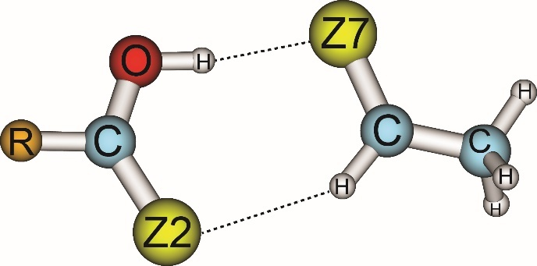  (a) | 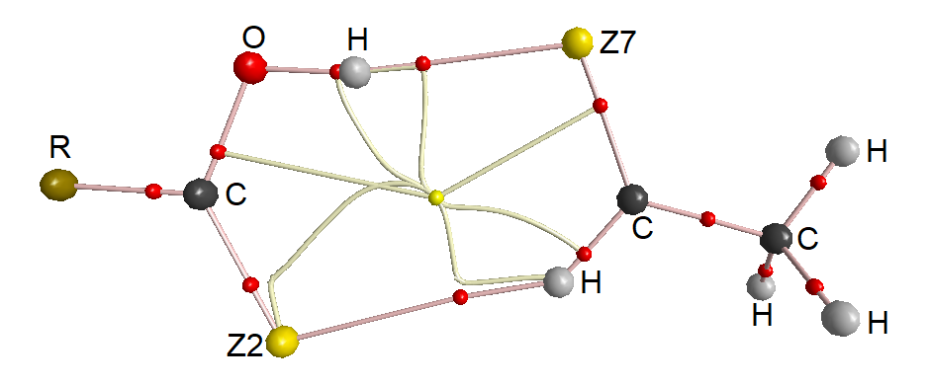  (b)
Figure. 1. Geometries (a) and topological features (b) of RZ–Z complexes (with R = CH₃, H, F; Z = O, S) at MP2/6–311++G(3df,2pd)

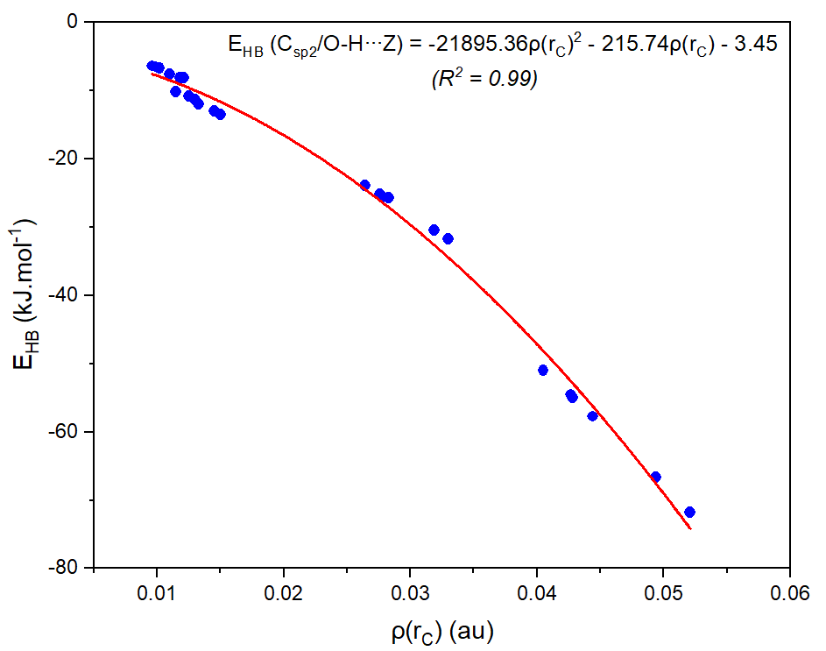  (a) | 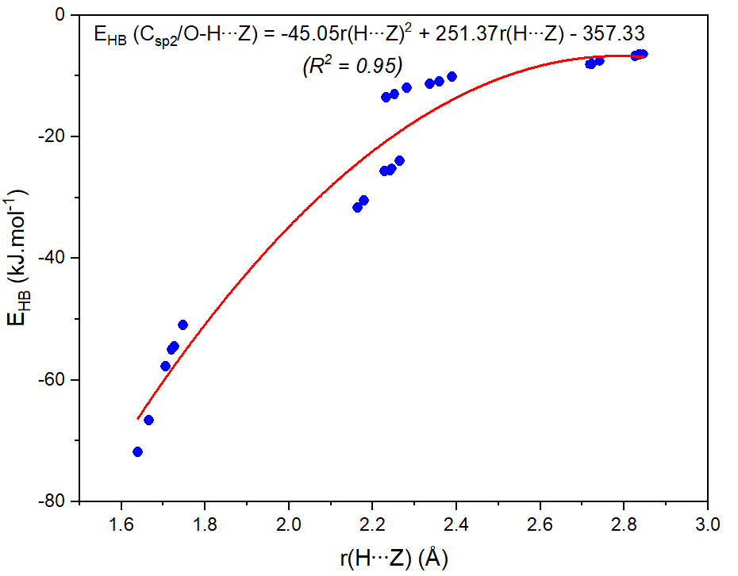  (b)
Figure. 2. The second-order correlations of individual hydrogen bond energies (E_{HB}) with respect to electron density ρ(r_{C}) at BCPs (a) and intermolecular distances (b) for RZ-Z (Z = O, S; R = CH₃, H, F)

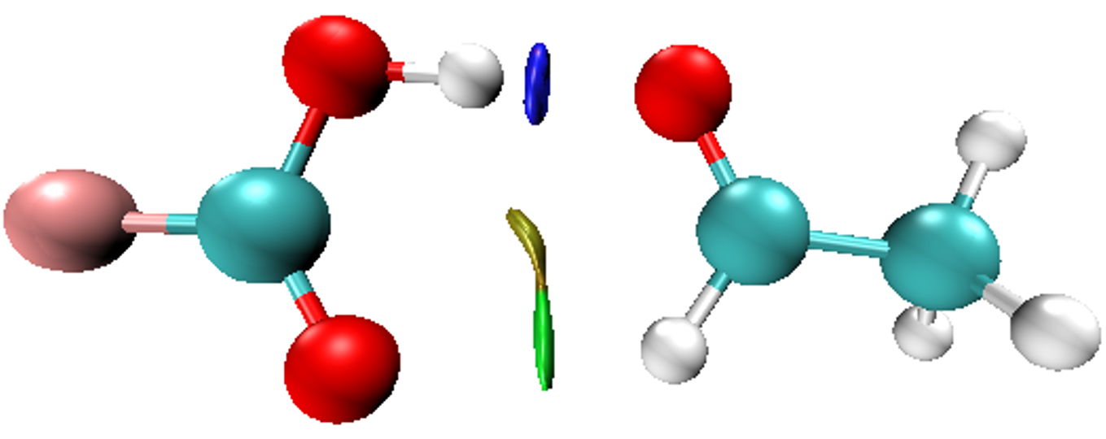 | 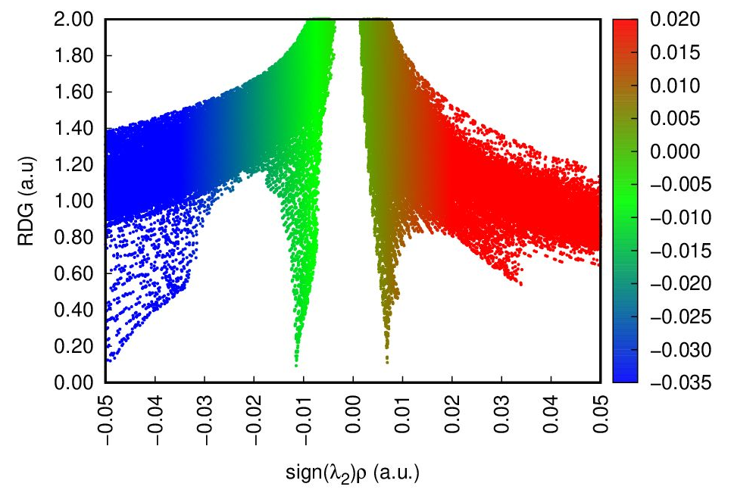
Figure. 3. NCI isosurface (3D) and plots of RDG as a function of sign(λ₂)ρ(r_{C}) (2D) for FO-O complex
(The isosurfaces are colored according to the values of sign(λ₂)ρ(r_{C}) from −0.05 to 0.05 au)

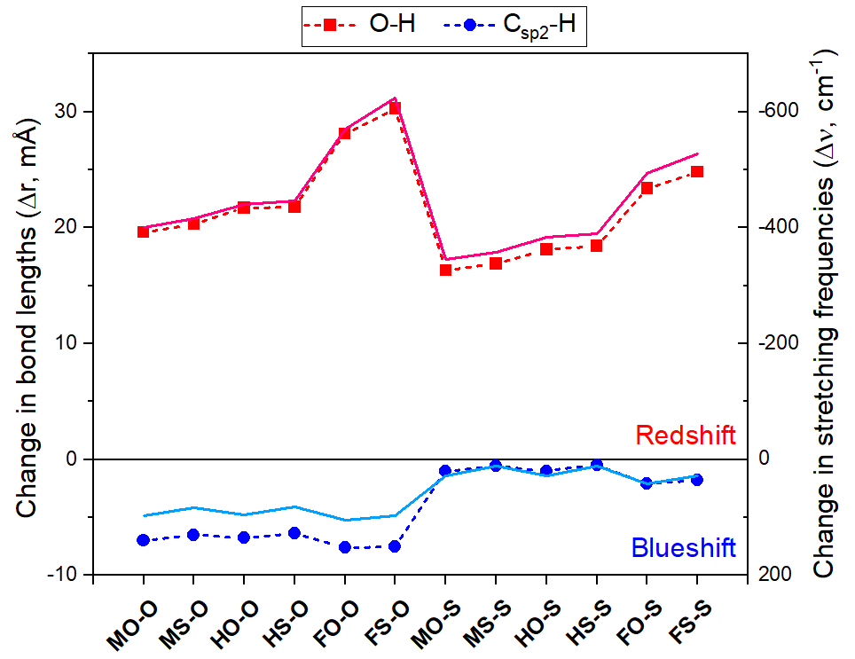
Figure. 4. The relationship of changes in C_{sp2}/O–H bond length (dots and dash) and corresponding stretching frequency (lines) with different R substitutions for RCZOH∙∙∙CH₃CHZ (R = H, F, CH₃; Z = O, S)

References
1 J. Lehn, Supramolecular Chemistry: Concepts and Perspectives, Wiley, 1st edn., 1995.
2 X. Li, L. Liu and H. B. Schlegel, J. Am. Chem. Soc., 2002, 124, 9639–9647.
3 S. Scheiner, J. Phys. Chem. B, 2006, 110, 18670–18679.
4 Linus. Pauling, J. Am. Chem. Soc., 1931, 53, 1367–1400.
5 I. V. Alabugin, M. Manoharan, S. Peabody and F. Weinhold, J. Am. Chem. Soc., 2003, 125, 5973–5987.
6 G. Trudeau, J. M. Dumas, P. Dupuis, M. Guérin and C. Sandorfy, Top Curr Chem, 1980, 93, 91–125.
7 Y. Mao and M. Head-Gordon, J. Phys. Chem. Lett., 2019, 10, 3899–3905.
8 A. Vashchenko and A. Afonin, Journal of Structural Chemistry, 2014, 55, 636–643.
9 M. Domagała and S. J. Grabowski, J. Phys. Chem. A, 2005, 109, 5683–5688.
10 J. Joseph and E. D. Jemmis, J. Am. Chem. Soc., 2007, 129, 4620–4632.
11 F. Weinhold and C. R. Landis, Valency and Bonding: A Natural Bond Orbital Donor-Acceptor Perspective, Cambridge University Press, Cambridge, 2005.
12 O. Donoso-Tauda, P. Jaque and J. C. Santos, Phys. Chem. Chem. Phys., 2011, 13, 1552–1559.
13 C. Wang, D. Danovich, S. Shaik and Y. Mo, J. Chem. Theory Comput., 2017, 13, 1626–1637.
14 Y. Mo, C. Wang, L. Guan, B. Braïda, P. C. Hiberty and W. Wu, Chemistry – A European Journal, 2014, 20, 8444–8452.
15 S. Michielssens, N. T. Trung, M. Froeyen, P. Herdewijn, M. T. Nguyen and A. Ceulemans, Phys. Chem. Chem. Phys., 2009, 11, 7274–7285.
16 N. T. Trung, T. T. Hue, M. T. Nguyen and T. Zeegers-Huyskens, Phys. Chem. Chem. Phys., 2008, 10, 5105–5113.
17 N. T. Trung, T. T. Hue and M. T. Nguyen, Can. J. Chem., 2010, 88, 849–857.
18 N. T. Trung, T. T. Hue and M. T. Nguyen, Phys. Chem. Chem. Phys., 2009, 11, 926–933.
19 Y. Gu, T. Kar and S. Scheiner, J. Am. Chem. Soc., 1999, 121, 9411–9422.
20 A. C. Pierce, E. ter Haar, H. M. Binch, D. P. Kay, S. R. Patel and P. Li, J. Med. Chem., 2005, 48, 1278–1281.
21 S. Pingali, J. P. Donahue and F. Payton-Stewart, Acta Crystallogr C Struct Chem, 2014, 70, 388–391.
22 L. Spada, Q. Gou, M. Vallejo-López, A. Lesarri, E. J. Cocinero and W. Caminati, Phys. Chem. Chem. Phys., 2014, 16, 2149–2153.
23 P. Hobza and Z. Havlas, Chem. Rev., 2000, 100, 4253–4264.
24 S. R. Garde and R. N. Shirsat, Electrostatics of Atoms and Molecules, Sangam Books Ltd, Hyderabad, 2001.
25 P. Hobza, V. Špirko, H. L. Selzle and E. W. Schlag, J. Phys. Chem. A, 1998, 102, 2501–2504.
26 R. Gopi, N. Ramanathan and K. Sundararajan, J. Phys. Chem. A, 2014, 118, 5529–5539.
27 B. Behera and P. K. Das, J. Phys. Chem. A, 2019, 123, 1830–1839.
28 K. S. Rutkowski, S. M. Melikova, M. Rospenk and A. Koll, Phys. Chem. Chem. Phys., 2011, 13, 14223–14234.
29 I. S. Sosulin, E. S. Shiryaeva, D. A. Tyurin and V. I. Feldman, J. Phys. Chem. A, 2018, 122, 4042–4047.
30 X. Chang, Y. Zhang, X. Weng, P. Su, W. Wu and Y. Mo, J. Phys. Chem. A, 2016, 120, 2749–2756.
31 R. H. Crabtree and A. Lei, Chem. Rev., 2017, 117, 8481–8482.
32 P. Khanh, V. Ngan, N. Man, N. T. Ai Nhung, A. Chandra and N. Trung, RSC Advances, 2016, 6, 106662–106670.
33 N. T. Trung, P. N. Khanh, A. J. P. Carvalho and M. T. Nguyen, J Comput Chem, 2019, 40, 1387–1400.
34 N. Thi Hong Man, P. Le Nhan, V. Vo, D. Tuan Quang and N. Tien Trung, Int J Quantum Chem, 2017, 117, e25338.
35 N. T. Trung, N. P. Hung, T. T. Hue and M. T. Nguyen, Phys. Chem. Chem. Phys., 2011, 13, 14033–14042.
36 P. Hobza, V. Špirko, Z. Havlas, K. Buchhold, B. Reimann, H.-D. Barth and B. Brutschy, Chemical Physics Letters, 1999, 299, 180–186.
37 I. Bhattacharya, J. Sadhukhan, S. Biswas and T. Chakraborty, J. Phys. Chem. A, 2020, 124, 7259–7270.
38 A. K. Chandra and T. Zeegers-Huyskens, Journal of Atomic, Molecular, and Optical Physics, 2012, 2012, e754879.
39 N. T. T. Cuc, C.-T. D. Phan, N. T. A. Nhung, M. T. Nguyen, N. T. Trung and V. T. Ngan, J. Phys. Chem. A, 2021, 125, 10291–10302.
40 K. Tabayashi, O. Takahashi, H. Namatame and M. Taniguchi, Chemical Physics Letters, 2013, 557, 1–9.
41 R. W. Gora, S. J. Grabowski and J. Leszczynski, J. Phys. Chem. A, 2005, 109, 6397–6405.
42 T. S. Thakur, M. T. Kirchner, D. Bläser, R. Boese and G. R. Desiraju, Phys. Chem. Chem. Phys., 2011, 13, 14076–14091.
43 Y. Yang and W. Zhang, Acta Chimica Sinica, 2009, 67, 599–606.
44 A. Kovács, A. Szabó, D. Nemcsok and I. Hargittai, J. Phys. Chem. A, 2002, 106, 5671–5678.
45 D. Kaur and R. Kaur, J Chem Sci, 2015, 127, 1299–1313.
46 A. K. Chandra and T. Zeegers-Huyskens, Journal of Computational Chemistry, 2012, 33, 1131–1141.
47 N. T. Trung, T. T. Hue and M. T. Nguyen, J. Phys. Chem. A, 2009, 113, 3245–3253.
48 D. Voet, J. G. Voet and C. W. Pratt, Fundamentals of Biochemistry, Wiley, New York, Upgrade edition., 2001.
49 M. J. Frisch, G. W. Trucks, H. B. Schlegel, G. E. Scuseria, M. A. Robb, J. R. Cheeseman, J. A. Pople, Gaussian 09 (Revision B.01), Wallingford, CT: Gaussian Inc, 2009.
50 M. Head-Gordon, J. A. Pople and M. J. Frisch, Chemical Physics Letters, 1988, 153, 503–506.
51 K. E. Riley, J. A. Platts, J. Řezáč, P. Hobza and J. G. Hill, J. Phys. Chem. A, 2012, 116, 4159–4169.
52 K. E. Riley and P. Hobza, J. Phys. Chem. A, 2007, 111, 8257–8263.
53 S. F. Boys and F. Bernardi, Molecular Physics, 1970, 19, 553–566.
54 T. A. Keith, T. K. Gristmill, AIMAll (Version 19.10.12) Software, Overland Park KS, USA, 2019.
55 P. L. Popelier, Atoms in Molecules: An Introduction, Prentice Hall, Harlow, 1 edition., 2000.
56 R. F. W. Bader, Atoms in molecules: a quantum theory, Clarendon Press, Oxford ; New York, 1990.
57 R. F. W. Bader, Chem. Rev., 1991, 91, 893–928.
58 E. Espinosa, E. Molins and C. Lecomte, Chemical Physics Letters, 1998, 285, 170–173.
59 E. D. Glemdeming, J. K. Baderhoop, A. E. Reed, J. E. Carpenter, J. A. Bohmann, C. M. Morales, F. Weinhold, GenNBO5.G, Theoretical Chemistry Institute, University of Wisconsin Madison, WI, 2001.
60 J. Contreras-García, E. R. Johnson, S. Keinan, R. Chaudret, J.-P. Piquemal, D. N. Beratan and W. Yang, J. Chem. Theory Comput., 2011, 7, 625–632.
61 E. R. Johnson, S. Keinan, P. Mori-Sánchez, J. Contreras-García, A. J. Cohen and W. Yang, J. Am. Chem. Soc., 2010, 132, 6498–6506.
62 P. A. Kollman, in Chemical Applications of Atomic and Molecular Electrostatic Potentials: Reactivity, Structure, Scattering, and Energetics of Organic, Inorganic, and Biological Systems, eds. P. Politzer and D. G. Truhlar, Springer US, Boston, MA, 1981, pp. 243–255.
63 R. Bukowski, W. Cencek, M. Jeziorska, B. Jeziorski, V. F. Lotrich, A. J. Misquitta, R. Moszyński, K. Patkowski, R. Podeszwa, F. Rob, S. Rybak, K. Szalewicz, R. J. Wheatley, E. S. Paul, P. E. S. Wormer, P. S. Żuchowski, SAPT2012.2, Warsaw, Poland, 2013.
64 R. M. Parrish, L. A. Burns, D. G. A. Smith, A. C. Simmonett, A. E. DePrince, E. G. Hohenstein, U. Bozkaya, A. Yu. Sokolov, R. Di Remigio, R. M. Richard, J. F. Gonthier, A. M. James, H. R. McAlexander, A. Kumar, M. Saitow, X. Wang, B. P. Pritchard, P. Verma, H. F. Schaefer, K. Patkowski, R. A. King, E. F. Valeev, F. A. Evangelista, J. M. Turney, T. D. Crawford and C. D. Sherrill, J. Chem. Theory Comput., 2017, 13, 3185–3197.
65 R. Kalescky, E. Kraka and D. Cremer, Molecular Physics, 2013, 111, 1497–1510.
66 W. Qian and S. Krimm, J. Phys. Chem. A, 2002, 106, 11663–11671.
67 L. Spada, L. Evangelisti, W. Li, R. Orlacchio and W. Caminati, J. Phys. Chem. A, 2019, 123, 1785–1789.
68 Q. Zhang and L. Du, Computational and Theoretical Chemistry, 2016, 1078, 123–128.
69 U. Koch and P. L. A. Popelier, J. Phys. Chem., 1995, 99, 9747–9754.
70 W. D. Arnold and E. Oldfield, J. Am. Chem. Soc., 2000, 122, 12835–12841.
71 I. Rozas, I. Alkorta and J. Elguero, J. Am. Chem. Soc., 2000, 122, 11154–11161.
72 N. T. T. Cuc, N. T. An, V. T. Ngan, A. K. Chandra and N. T. Trung, RSC Adv., 2022, 12, 1998–2008.
73 J. Lei, S. Alessandrini, J. Chen, Y. Zheng, L. Spada, Q. Gou, C. Puzzarini and V. Barone, Molecules, 2020, 25, 4899.
74 Q.-Z. Li, B. Jing, R. Li, Z.-B. Liu, W.-Z. Li, F. Luan, J.-B. Cheng, B.-A. Gong and J.-Z. Sun, Phys. Chem. Chem. Phys., 2011, 13, 2266–2271.
75 A. S. Hansen, L. Du and H. G. Kjaergaard, Phys. Chem. Chem. Phys., 2014, 16, 22882–22891.
76 B. Jeziorski, R. Moszynski and K. Szalewicz, Chem. Rev., 1994, 94, 1887–1930.
77 N. T. T. Cuc, H. Q. Dai, N. T. A. Nhung, N. P. Hung and N. T. Trung, Vietnam Journal of Chemistry, 2019, 57, 425–432.
78 Q. Gou, L. B. Favero, S. S. Bahamyirou, Z. Xia and W. Caminati, J. Phys. Chem. A, 2014, 118, 10738–10741.
79 E. Sánchez-García, L. A. Montero and W. Sander, J. Phys. Chem. A, 2006, 110, 12613–12622.

