Supporting Information
Role of O–H∙∙∙O/S conventional hydrogen bonds in considerable C_{sp2}–H blue-shift in the binary systems of acetaldehyde and thioacetaldehyde with the substituted carboxylic and thiocarboxylic acids

Nguyen Truong An¹, Nguyen Thi Duong¹, Nguyen Ngoc Tri,^{1,2} Nguyen Tien Trung^{1,2}*

¹Faculty of Natural Sciences, Quy Nhon University, Quy Nhon, Vietnam,
²Laboratory of Computational Chemistry and Modelling (LCCM), Quy Nhon University, Quy Nhon, Vietnam
* Corresponding author: Email: nguyentientrung@qnu.edu.vn

Table S1. Intermolecular parameters (distances in Å, angles in °, NBO charge in e) in the binary systems formed between substituted CH₃CHZ and RCZOH calculated at MP2/6–311++G(3df,2pd)
Complex | r(H∙∙∙Z) (Å) |  |  | θ (°) |  |  | q (e)
Complex | O–H∙∙∙Z7 | C_{sp2}–H∙∙∙Z2 |  | ∠O-H-Z | ∠C_{sp2}-H-Z |  | Z2 | H ^{a)} | Z7 | H ^{b)}
MO–O | 1.747 | 2.337 |  | 179.5 | 130.3 |  | -0.621 | 0.502 | -0.546 | 0.139
MS–O | 1.720 | 2.826 |  | 170.2 | 128.2 |  | -0.119 | 0.507 | -0.544 | 0.128
HO–O | 1.727 | 2.359 |  | 179.7 | 130.4 |  | -0.607 | 0.500 | -0.547 | 0.138
HS–O | 1.706 | 2.837 |  | 171.5 | 129.1 |  | -0.115 | 0.502 | -0.545 | 0.127
FO–O | 1.666 | 2.389 |  | 179.0 | 127.9 |  | -0.615 | 0.510 | -0.550 | 0.138
FS–O | 1.639 | 2.846 |  | 172.2 | 127.5 |  | -0.148 | 0.516 | -0.547 | 0.131
MO–S | 2.265 | 2.233 |  | 177.9 | 146.7 |  | -0.613 | 0.482 | 0.067 | 0.207
MS–S | 2.246 | 2.718 |  | 167.7 | 145.1 |  | -0.098 | 0.485 | 0.082 | 0.195
HO–S | 2.242 | 2.252 |  | 178.8 | 146.8 |  | -0.598 | 0.478 | 0.070 | 0.205
HS–S | 2.228 | 2.722 |  | 169.2 | 150.0 |  | -0.093 | 0.478 | 0.084 | 0.194
FO–S | 2.180 | 2.282 |  | 179.8 | 143.6 |  | -0.607 | 0.486 | 0.079 | 0.205
FS–S | 2.164 | 2.741 |  | 170.1 | 143.7 |  | -0.126 | 0.490 | 0.093 | 0.195
^{a)}For H of –OH group of RCZOH in the complexes; ^{b)}For H of –CHZ group of CH₃CHZ in the complexes

Table S2. Selected parameters at the BCPs of intermolecular contacts at MP2/6-311++G(3df,2pd)
Complex | ρ(r_{C}), in au |  | ∇²ρ(r_{C}), in au |  | H(r_{C})^{a)} , in au |  | E_{HB}^{b)}, in kJ.mol⁻¹
Complex | O–H∙∙∙Z7 | C_{sp2}–H∙∙∙Z2 | (1) | (2) | (1) | (2) | (1) | (2)
MO–O | 0.0405 | 0.0130 | 0.097 | 0.045 | -0.0073 | 0.0012 | -51.0 | -11.4
MS–O | 0.0428 | 0.0102 | 0.100 | 0.027 | -0.0084 | 0.0008 | -55.0 | -6.8
HO–O | 0.0427 | 0.0125 | 0.098 | 0.042 | -0.0084 | 0.0011 | -54.5 | -10.9
HS–O | 0.0444 | 0.0099 | 0.101 | 0.027 | -0.0094 | 0.0008 | -57.7 | -6.5
FO–O | 0.0494 | 0.0115 | 0.103 | 0.040 | -0.0124 | 0.0012 | -66.6 | -10.2
FS–O | 0.0521 | 0.0096 | 0.105 | 0.027 | -0.0142 | 0.0009 | -71.8 | -6.4
MO–S | 0.0264 | 0.0150 | 0.046 | 0.053 | -0.0034 | 0.0015 | -23.9 | -13.5
MS–S | 0.0276 | 0.0118 | 0.046 | 0.031 | -0.0039 | 0.0008 | -25.2 | -8.1
HO–S | 0.0278 | 0.0145 | 0.046 | 0.051 | -0.0040 | 0.0014 | -25.6 | -13.0
HS–S | 0.0283 | 0.0121 | 0.046 | 0.030 | -0.0040 | 0.0007 | -25.7 | -8.1
FO–S | 0.0319 | 0.0133 | 0.045 | 0.048 | -0.0060 | 0.0015 | -30.5 | -11.9
FS–S | 0.0330 | 0.0110 | 0.044 | 0.030 | -0.0065 | 0.0009 | -31.7 | -7.6
^{a)} the total electron energy density; ^{b )}individual energy of each hydrogen bond; ⁽¹⁾for O–H∙∙∙Z7 and ⁽²⁾for C_{sp2}–H∙∙∙Z2

Table S3. Some selected parameters of monomers at MP2/6–311++G(3df,2pd)
Monomer | CH₃CHO | CH₃CHS | CH₃COOH | CH₃CSOH | HCOOH | HCSOH | FCOOH | FCSOH
r(C_{sp2}/O–H), Å | 1.106  (1.114) | 1.091  (1.089) | 0.967  (1.100) | 0.969 | 0.968  (0.972) | 0.970 | 0.965 | 0.966
r(C=Z), Å | 1.211 | 1.614 | 1.207 | 1.624 | 1.202 | 1.613 | 1.188 | 1.610
q(Z), e | -0.51 | 0.09 | -0.58 | -0.05 | -0.56 | -0.04 | -0.57 | -0.07
q(C_{sp2}/O), e | 0.44^{a)} | -0.27^{a)} | -0.70^{b)} | -0.67^{b)} | -0.69^{b)} | -0.64^{b)} | -0.68^{b)} | -0.65^{b)}
q(H), e | 0.09^{a)} | 0.17^{a)} | 0.48^{b)} | 0.49^{b)} | 0.48^{b)} | 0.48^{b)} | 0.50^{b)} | 0.50^{b)}
σ*(C_{sp2}/O–H), e | 0.082 | 0.062 | 0.030 | 0.035 | 0.031 | 0.037 | 0.024 | 0.026
q, r and σ* denoted for NBO charge, bond length and electron density on σ*antibonding orbital; ^{a)}for C_{sp2} or H atom in C_{sp2}-H bond; ^{b)}for O or H in O-H bond; experimental values in parentheses taken from NIST webpage

Table S4. Change of bond lengths (Δr, mÅ) and corresponding stretching frequency (Δν, cm⁻¹) in the complexes at MP2/6-311++G(3df,2pd)
Complex | MO-O | MS-O | HO-O | HS-O | FO-O | FS-O
Δr(O–H) | 19.6 | 20.3 | 21.7 | 21.8 | 28.1 | 30.3
Δν(O–H) | -401.1 | -416.0 | -441.4 | -445.6 | -569.7 | -622.8
Δr(C_{sp2}–H) | -7.0 | -6.5 | -6.8 | -6.4 | -7.6 | -7.5
Δν(C_{sp2}–H) | 96.6 | 83.8 | 95.3 | 82.5 | 104.5 | 96.7
Complex | MO-S | MS-S | HO-S | HS-S | FO-S | FS-S
Δr(O–H) | 16.3 | 16.9 | 18.1 | 18.4 | 23.4 | 24.8
Δν(O–H) | -344.9 | -358.3 | -382.7 | -389.5 | -494.0 | -528.3
Δr(C_{sp2}–H) | -1.0 | -0.6 | -1.0 | -0.5 | -2.1 | -1.8
Δν(C_{sp2}–H) | 28.1 | 11.9 | 28.3 | 11.0 | 42.3 | 27.7

Table S5. Summary of stretching frequency changes of C–H bonds involving hydrogen bonds in the complexes
Complexes | Level of theory/Experiment | Δν(C_{sp3}–H) (cm⁻¹) | Ref
CH₃CHO∙∙∙1H₂O/CH₃CHO∙∙∙2H₂O  CH₂FCHO∙∙∙1H₂O  CH₂FCHO∙∙∙2H₂O  CH₃CFO∙∙∙1H₂O/CH₃CFO∙∙∙2H₂O | B3LYP/6-311++G(d,p) | 6/-11  10;13  -19;-21  -2/-23 | ¹
CH₃CHS∙∙∙1H₂O  CH₃CHS∙∙∙2H₂O  CH₃CHS∙∙∙3H₂O | MP2/aug-cc-pVDZ | 16.9  26.7  15.6; -23.1 | ²
(CH₃CHO)₂ | M062X/6-311++G(3df,3pd) | -16, -14, -8 | ³
CHX₃∙∙∙HNO (X = F, Cl, Br) | MP2/6-311++G(d,p) | 7÷41 | ⁴
F₃CH∙∙∙H₂O | Exp. | 20.3; 32.3 | ⁵
Complexes | Level of theory/Experiment | Δν(C_{sp2}–H) (cm⁻¹) | Ref
RCHO∙∙∙1H₂O  (R = H, F, CH₃, CH₂F, C₂H₅) | B3LYP/6-311++G(d,p) | 28 ÷ 53 | ⁶
CH₃CHO∙∙∙1H₂O/CH₃CHO∙∙∙2H₂O  CH₂FCHO∙∙∙1H₂O/ CH₂FCHO∙∙∙2H₂O | B3LYP/6-311++G(d,p) | 52/93  44/61 | ¹
CH₃CHS∙∙∙1H₂O  CH₃CHS∙∙∙2H₂O  CH₃CHS∙∙∙3H₂O | MP2/aug-cc-pVDZ | 24.0  33.1  62.2 | ²
XCHO∙∙∙1H₂Z  XCHO∙∙∙2H₂O  (X= H, F, Cl, Br, CH₃; Z= O, S) | MP2/aug-cc-pVDZ | 2.9 ÷ 52  4.0 ÷ 92.3 | ⁷
RCHZ∙∙∙HCOOH  (R= H, F, Cl, Br, CH₃, NH₂; Z= O, S) | MP2/aug-cc-pVDZ | 81÷96 | ⁸
RCHO∙∙∙R’OH (R = NH₂, CF₃, CH₃O, CN, H; R’ = H, CH₃, NH₂, C(O)H) | MP2/cc-pVTZ | 23.01 ÷ 92.69 | ⁹
HCHO-NH₂OH  CH₃COCHO-NH₂OH | Exp. | 14.6  16.3 | ¹⁰
CHOCHO∙∙∙H₂O₂ | Exp. | 28.9 | ¹¹
CHOCHO∙∙∙H₂O | Exp. | 2.5 | ¹²
CHOCHO∙∙∙H₂O | Exp. | 14.7 | ¹²
4-fluorobenzaldehyde dimer | Exp. | 8 | ¹³
2-methoxybenzaldehyde dimer | Exp. | 21 | ¹⁴
Complexes | Level of theory | Δν(C_{sp}–H) (cm⁻¹) | Ref
C₂HX∙∙∙C₆H₆  (X = H, F, Cl, Br, CH₃, NH₂) | MP2/aug-cc-pVDZ | -15.7 ÷ -24.9 | ¹⁵
C₂H₂∙∙∙C₂H₂  C₂H₂∙∙∙HCN  C₆H₆∙∙∙C₂H₂  C₆H₆∙∙∙HCN | MP2/aug-cc-pVTZ | -21  -61  -17  -50 | ¹⁶

1 A. K. Chandra and T. Zeegers-Huyskens, J. At. Mol. Opt. Phys., 2012, 2012, e754879.
2 N. T. T. Cuc, H. Q. Dai, N. T. A. Nhung, N. P. Hung and N. T. Trung, Vietnam J. Chem., 2019, 57, 425–432.
3 T. S. Thakur, M. T. Kirchner, D. Bläser, R. Boese and G. R. Desiraju, Phys. Chem. Chem. Phys., 2011, 13, 14076–14091.
4 N. T. Trung, T. T. Hue and M. T. Nguyen, Phys. Chem. Chem. Phys., 2009, 11, 926–933.
5 C. D. Keefe and M. Isenor, J. Phys. Chem. A, 2008, 112, 3127–3132.
6 A. K. Chandra and T. Zeegers-Huyskens, J. Comput. Chem., 2012, 33, 1131–1141.
7 N. T. T. Cuc, C.-T. D. Phan, N. T. A. Nhung, M. T. Nguyen, N. T. Trung and V. T. Ngan, J. Phys. Chem. A, 2021, 125, 10291–10302.
8 N. T. Trung, P. N. Khanh, A. J. P. Carvalho and M. T. Nguyen, J. Comput. Chem., 2019, 40, 1387–1400.
9 D. Kaur and R. Kaur, J. Chem. Sci., 2015, 127, 1299–1313.
10 B. Golec, M. Sałdyka and Z. Mielke, Mol. Basel Switz., 2021, 26, 1144.
11 M. Mucha and Z. Mielke, Chem. Phys. Lett., 2009, 482, 87–92.
12 M. Mucha and Z. Mielke, J. Phys. Chem. A, 2007, 111, 2398–2406.
13 P. J. A. Ribeiro-Claro, M. P. M. Marques and A. M. Amado, ChemPhysChem, 2002, 3, 599–606.
14 P. J. A. Ribeiro-Claro, M. G. B. Drew and V. Félix, Chem. Phys. Lett., 2002, 356, 318–324.
15 P. Khanh, V. Ngan, N. Man, N. T. Ai Nhung, A. Chandra and N. Trung, RSC Adv., 2016, 6, 106662–106670.
16 P. Jantimapornkij, P. Jundee, N. Uttamapinant, S. Pianwanit and A. Karpfen, Comput. Theor. Chem., 2012, 999, 231–238.

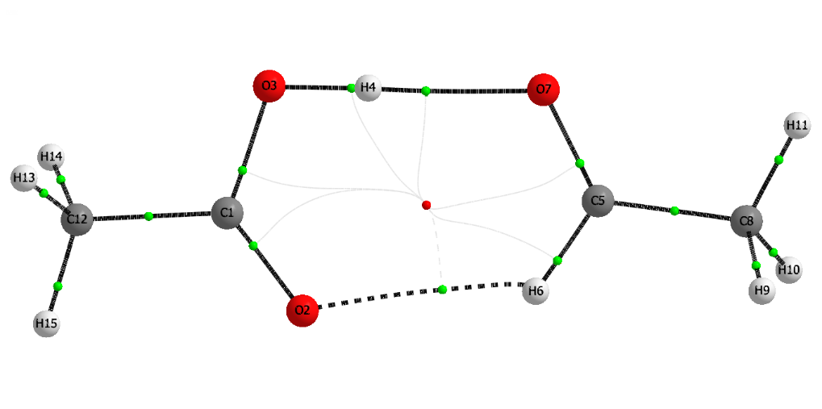 | 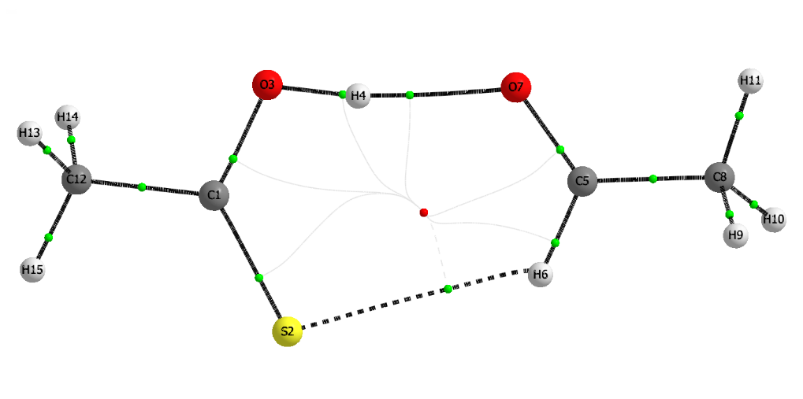
MO-O | MS-O
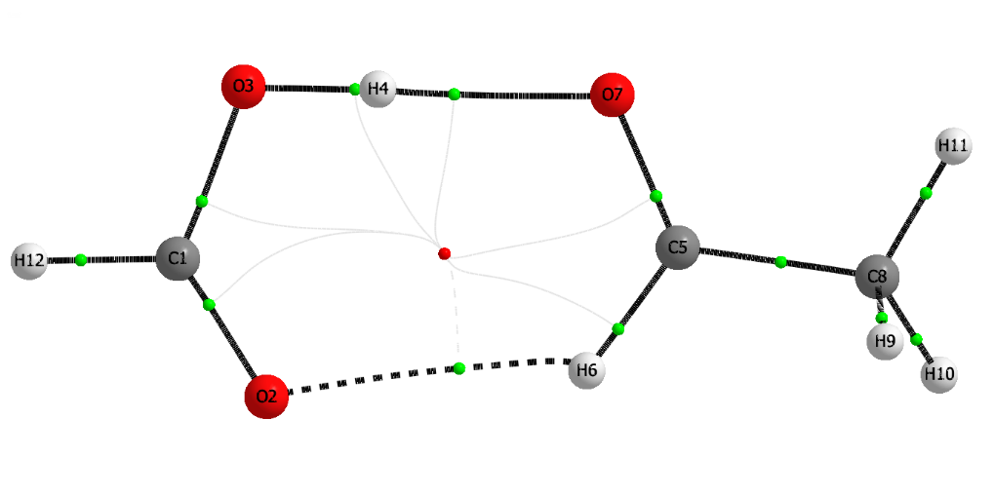 | 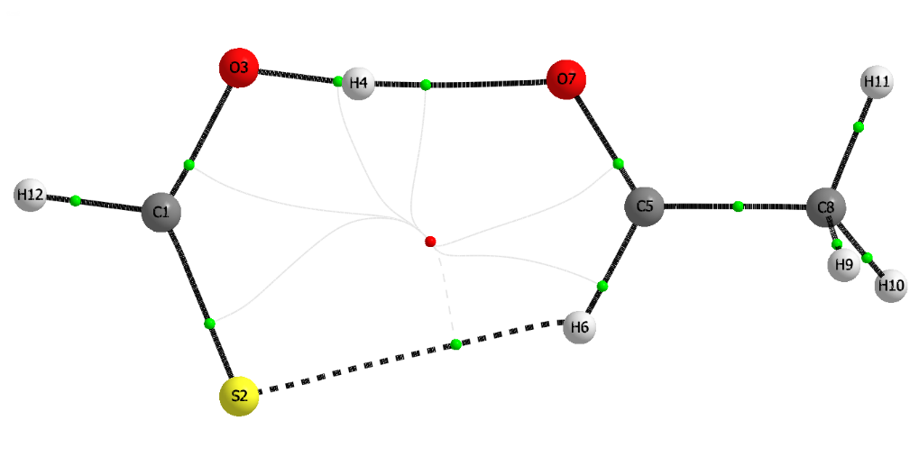
HO-O | HS-O
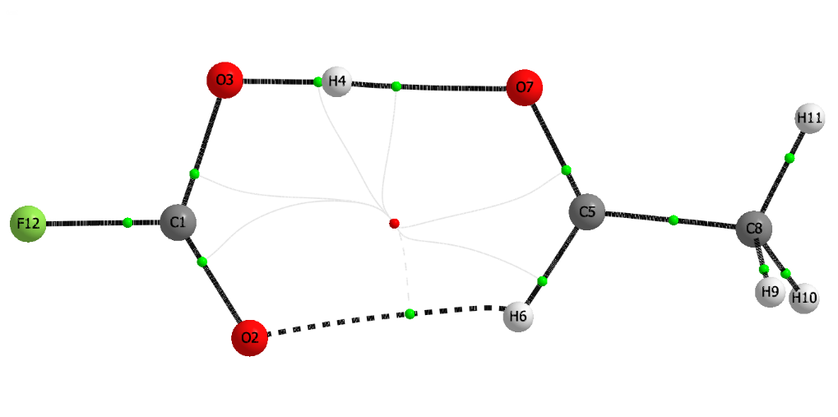 | 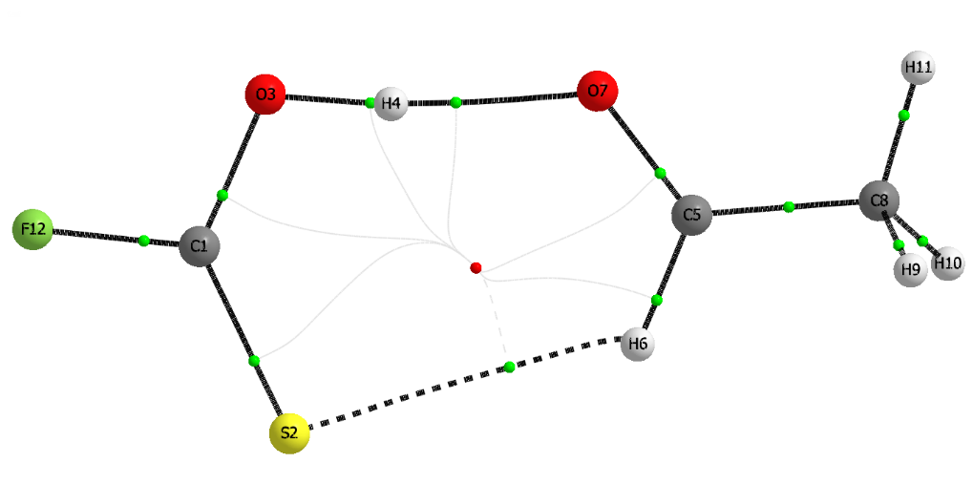
FO-O | FS-O

Figure. S1a. Topological geometries of stable complexes plotted at MP2/6-311++G(3df,2pd)

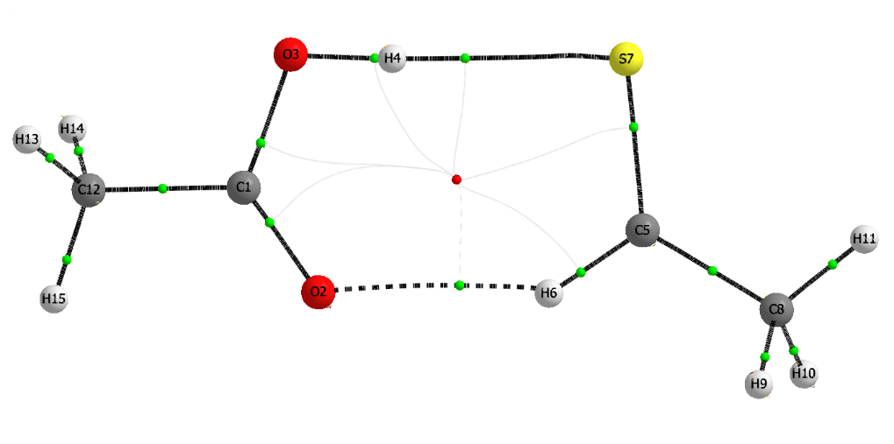 | 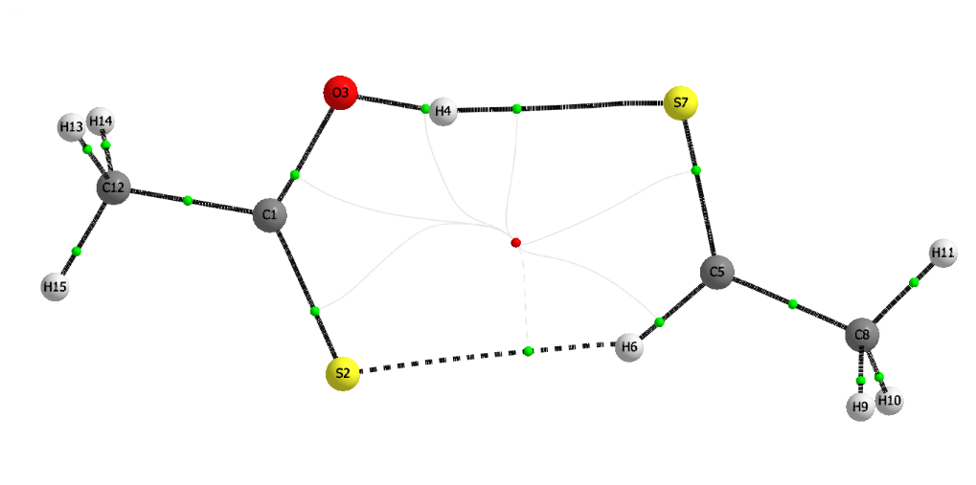
MO-S | MS-S
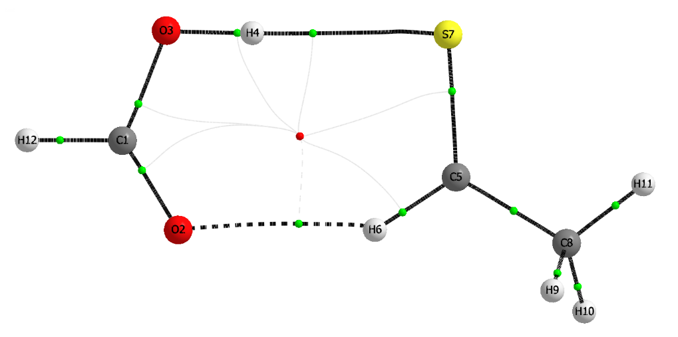 | 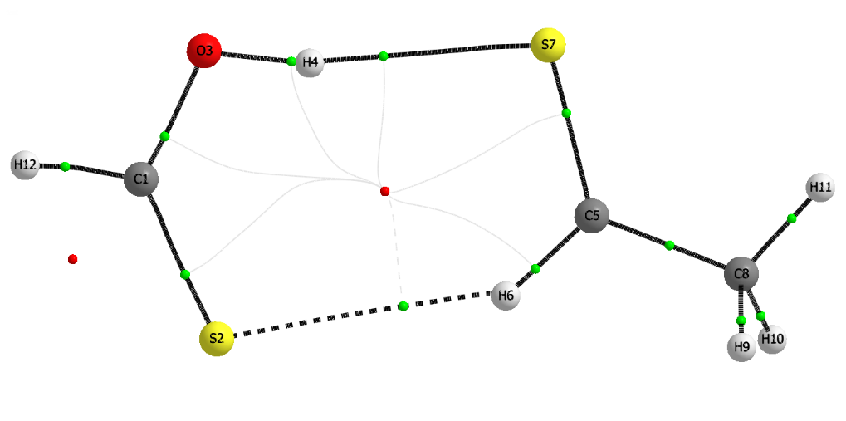
HO-S | HS-S
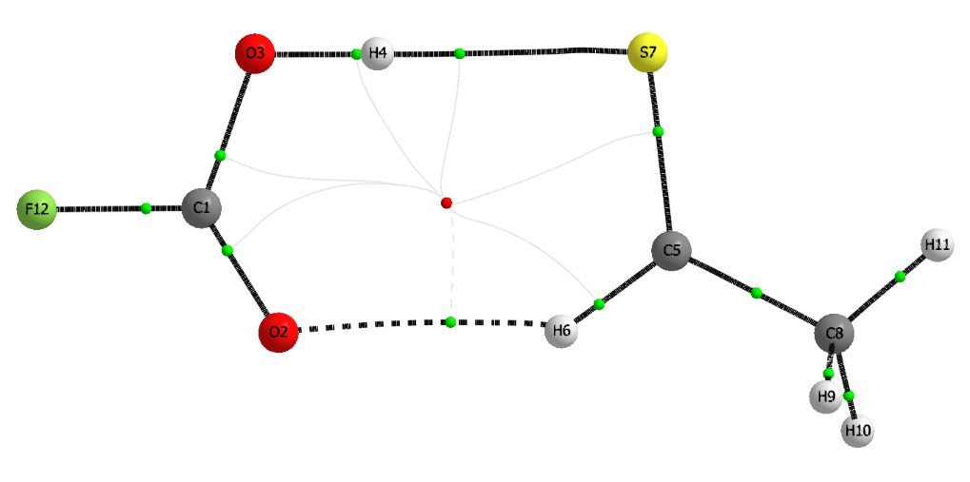 | 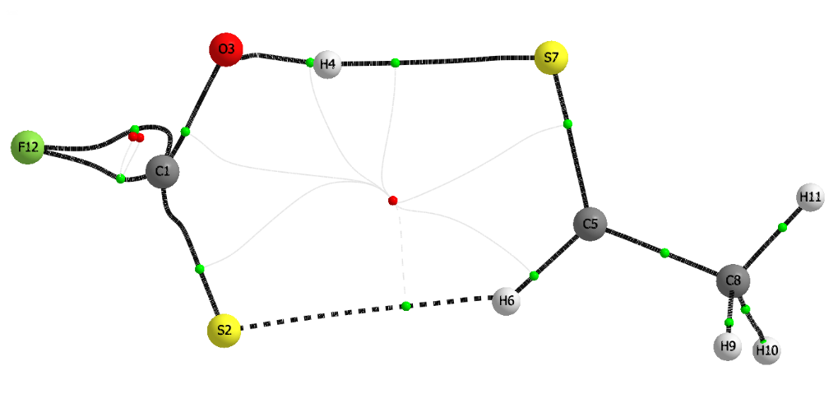
FO-S | FS-S

Figure. S1b. Topological geometries of stable complexes plotted at MP2/6-311++G(3df,2pd)

NCI isosurface (3D) | 2D-Plots | NCI isosurface (3D) | 2D-Plots
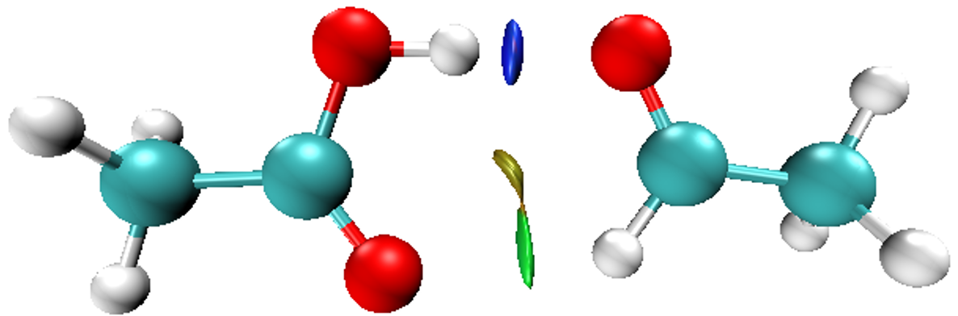 | 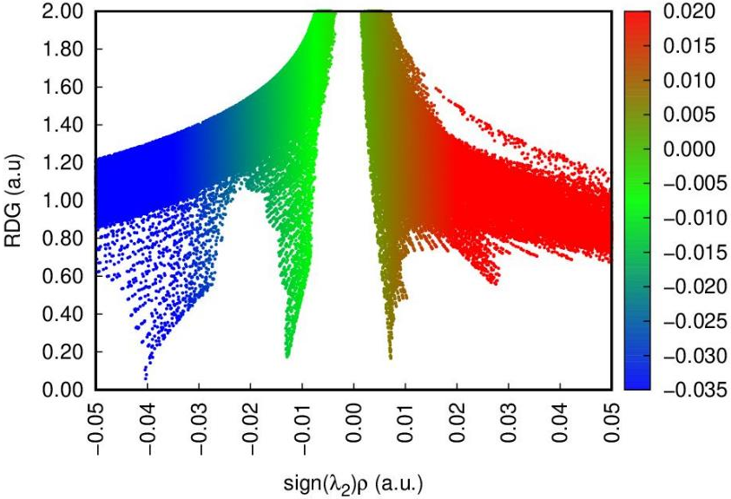 | 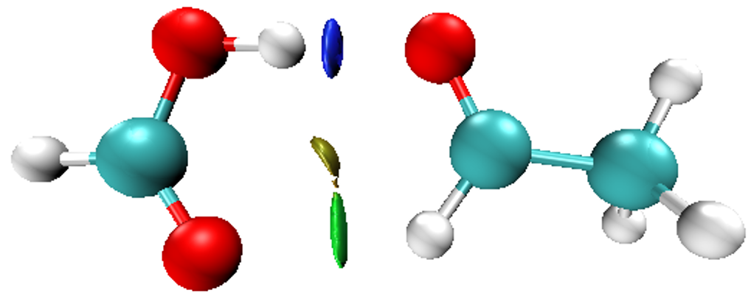 | 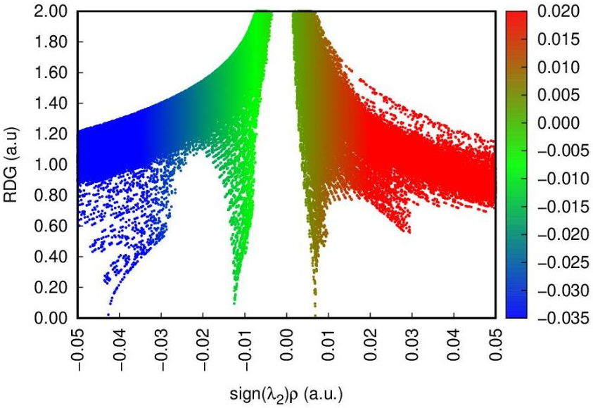
MO-O |  | HO-O
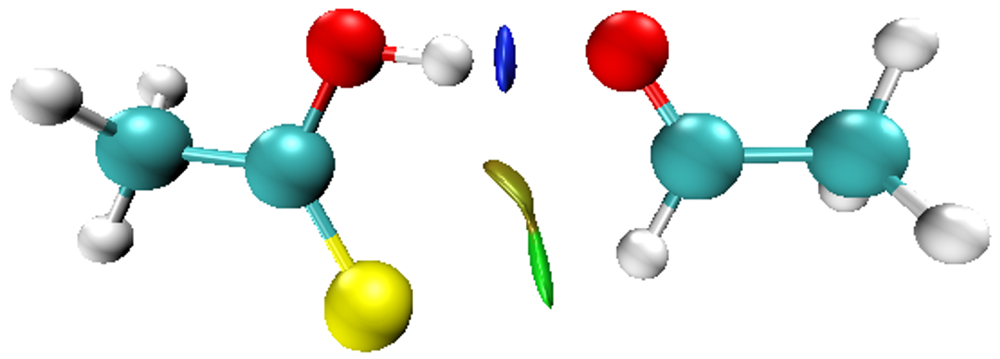 | 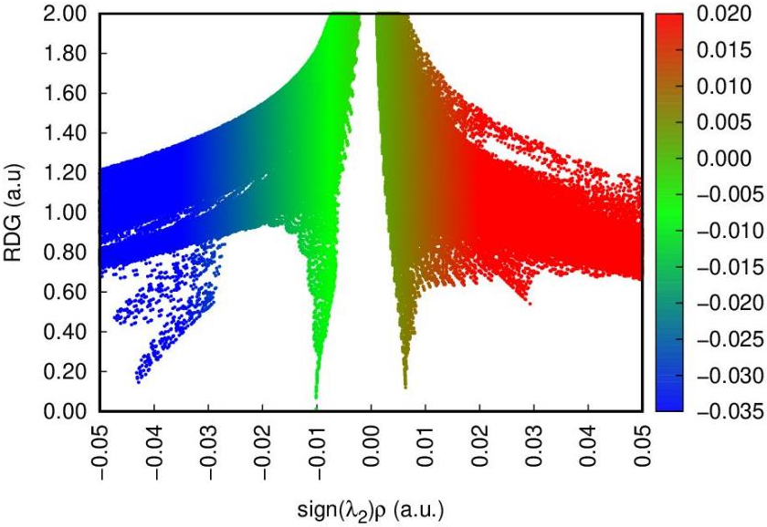 | 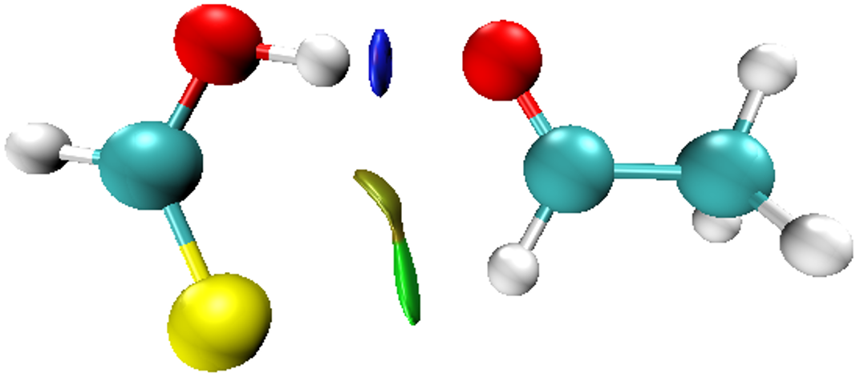 | 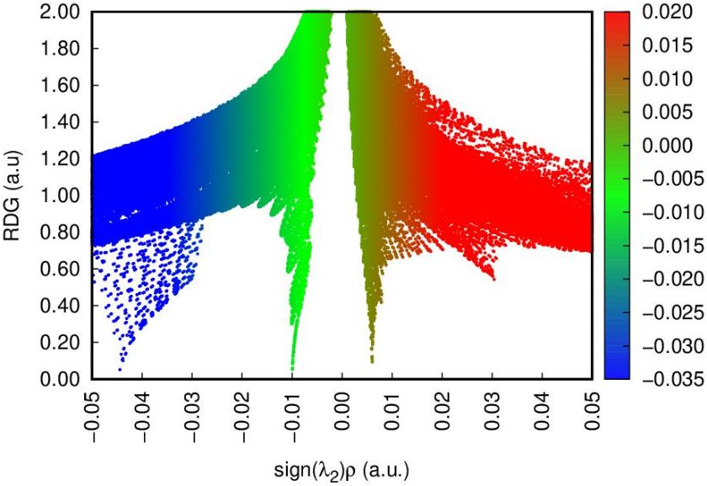
MS-O |  | HS-O
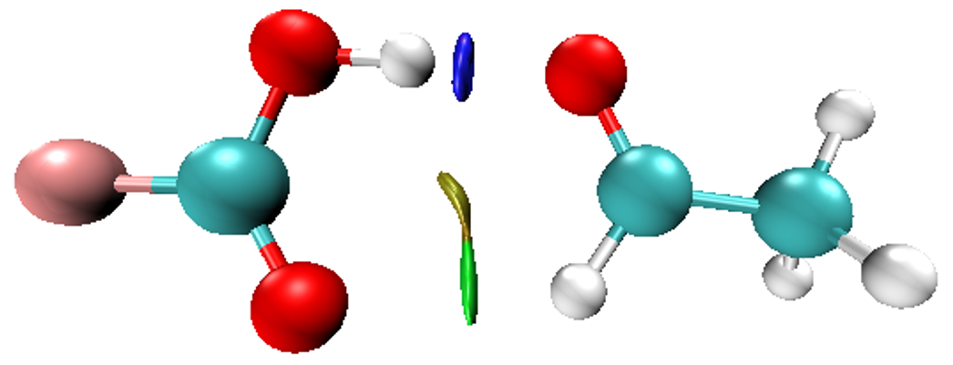 | 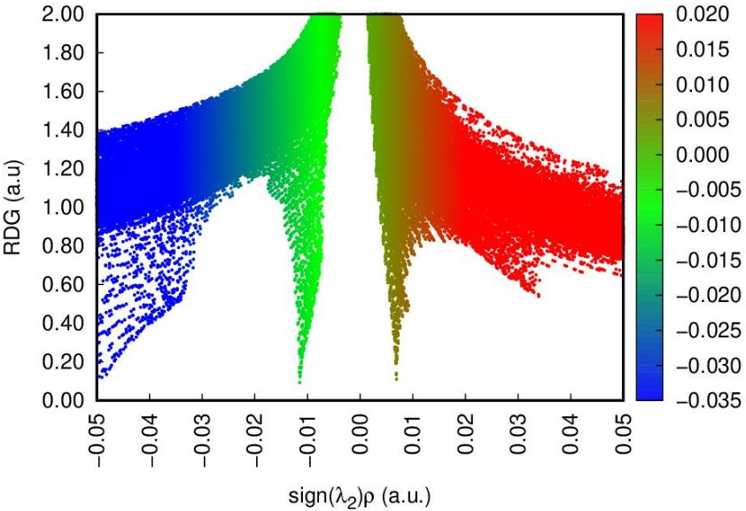 | 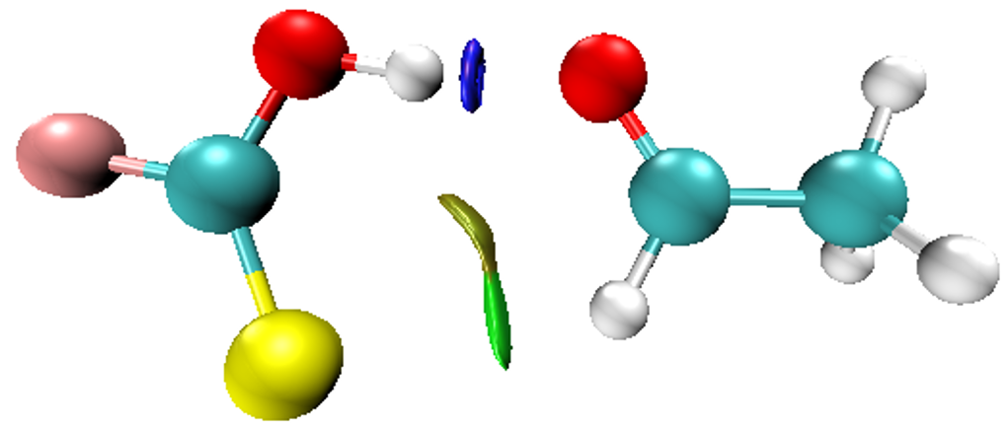 | 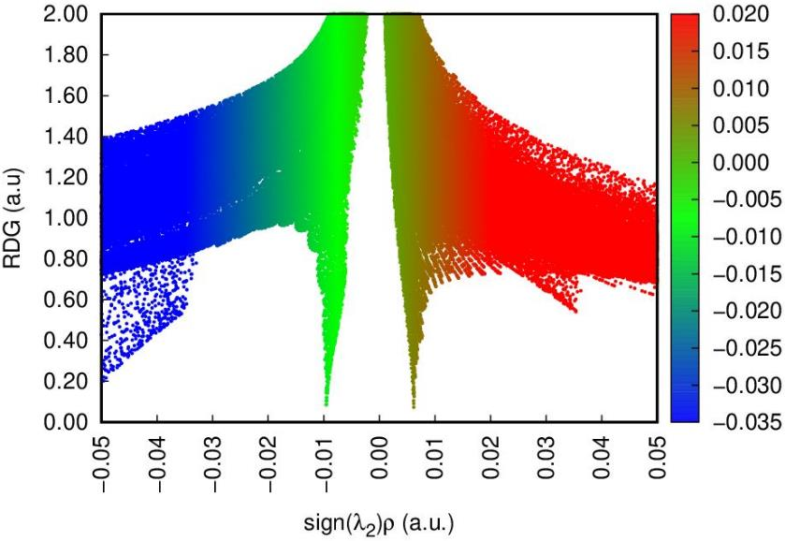
FO-O |  |  | FS-O

Figure. S2a. NCI isosurface and 2D-plots of reduced density gradient (RDG) versus the electron density multiplied by the sign of the second Hessian eigenvalue (sign(λ₂)ρ(r_{C})) for RZ-O complexes, with R= CH₃, H, F; and Z = O, S.
(The surfaces are colored on a blue-green-red scale according to the values of sign(λ₂)ρ(r_{C}) ranging from −0.05 to 0.05 au)

NCI isosurface (3D) | 2D-Plots | NCI isosurface (3D) | 2D-Plots
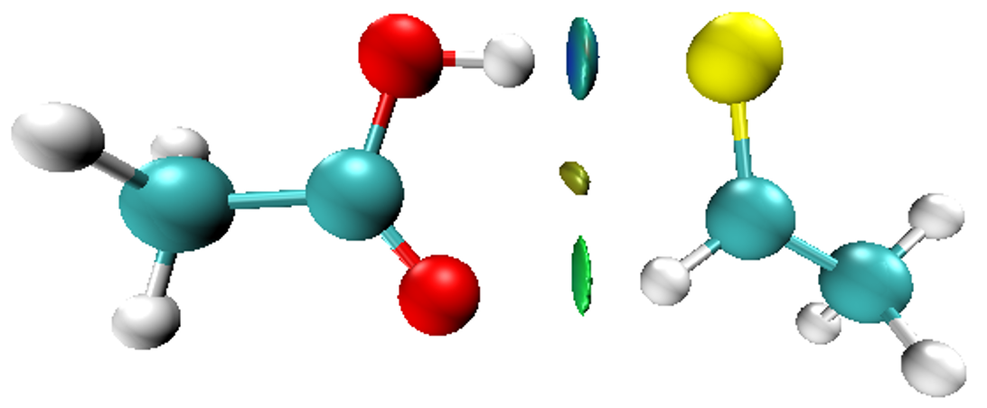 | 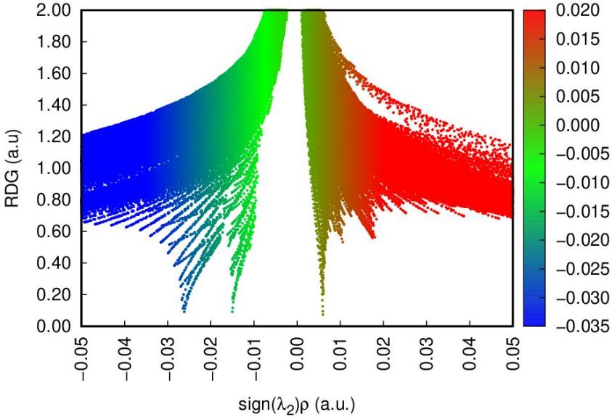 | 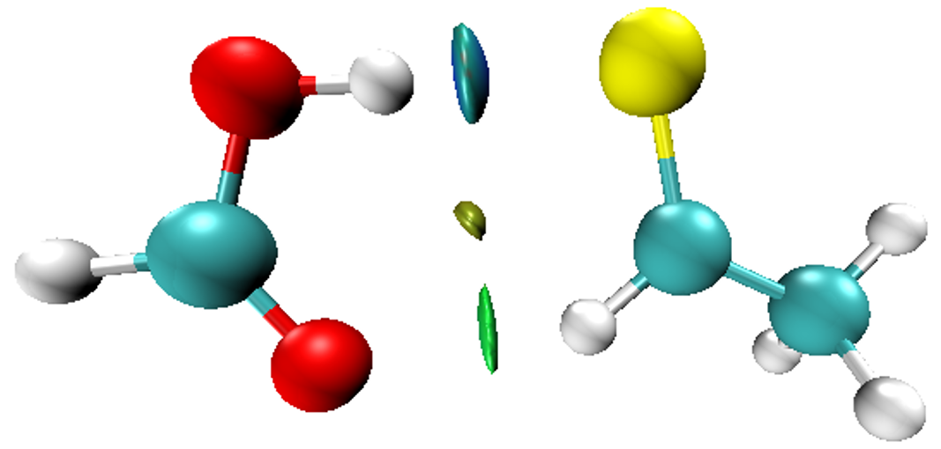 | 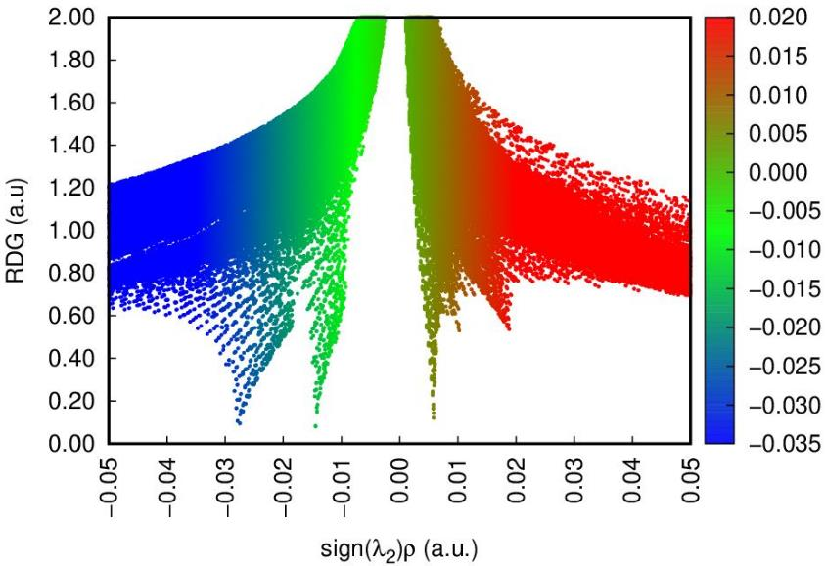
MO-S |  | HO-S
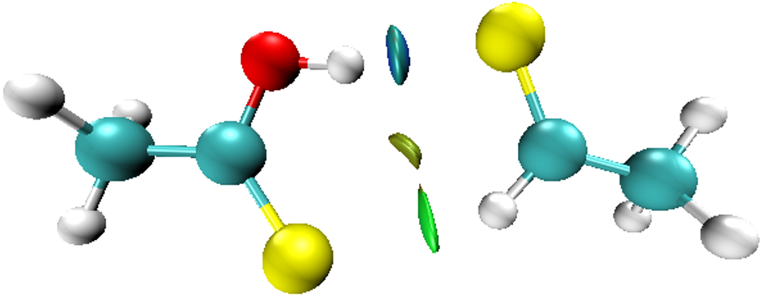 | 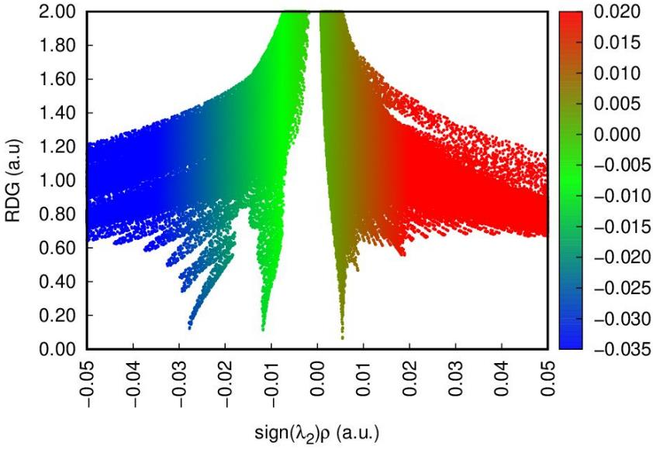 | 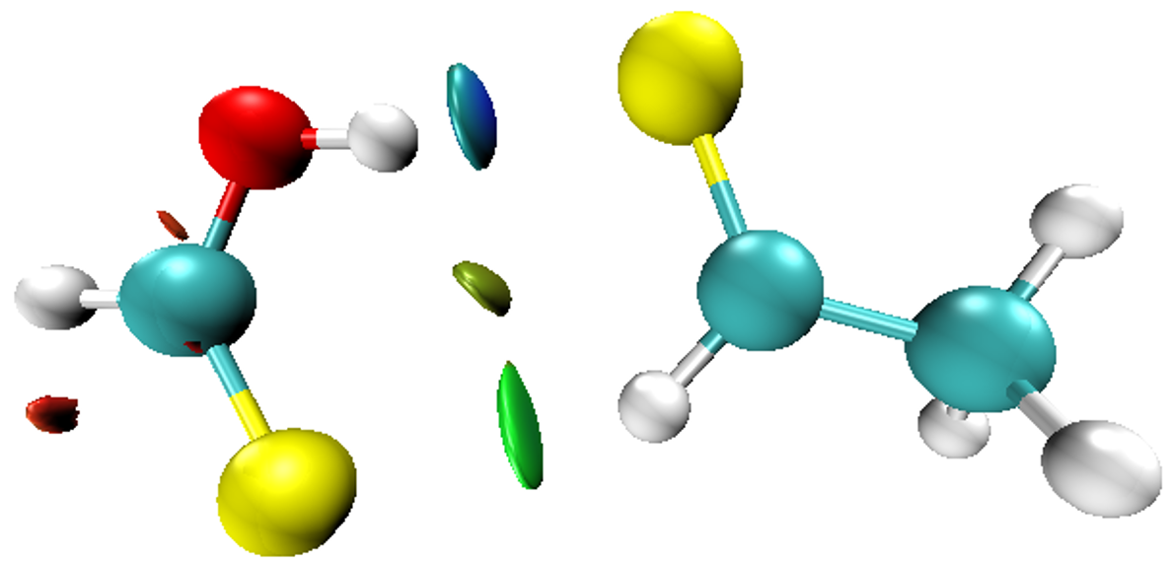 | 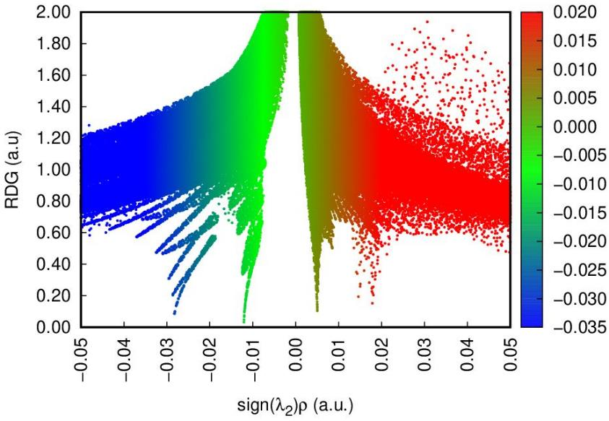
MS-S |  | HS-S
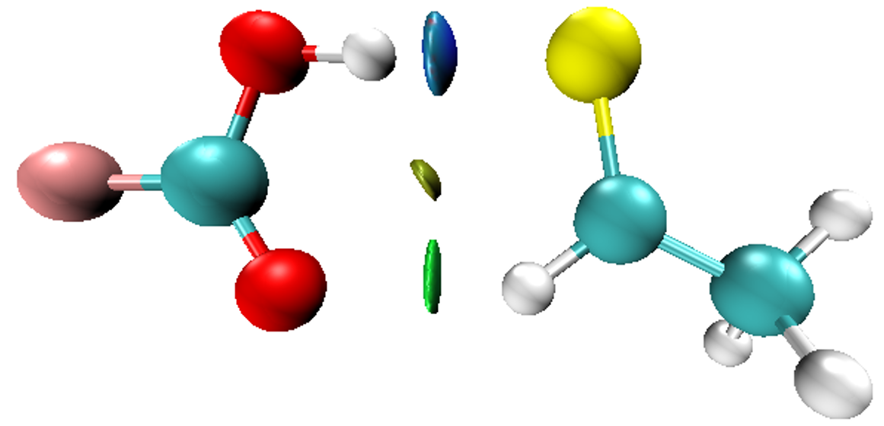 | 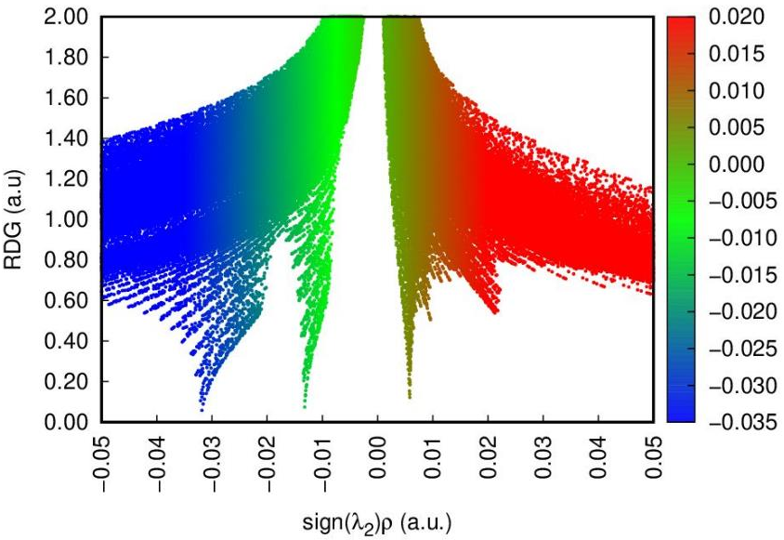 | 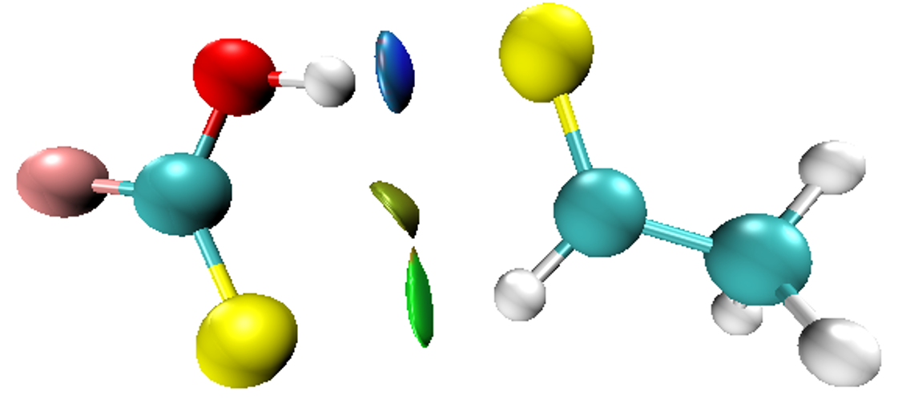 | 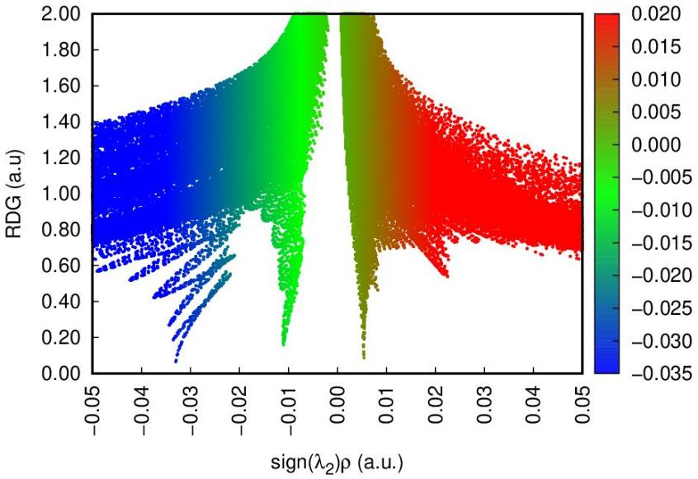
FO-S |  | FS-S

Figure. S2b. NCI isosurface and 2D-plots of reduced density gradient (RDG) versus the electron density multiplied by the sign of the second Hessian eigenvalue (sign(λ₂)ρ(r_{C})) for RZ-S complexes, with R= CH₃, H, F; and Z = O, S
(The surfaces are colored on a blue-green-red scale according to the values of sign(λ₂)ρ(r_{C}) ranging from −0.05 to 0.05 au)

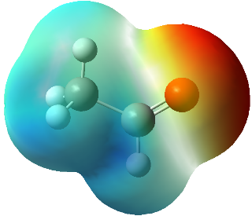  -35.86  +20.70 |  |  | 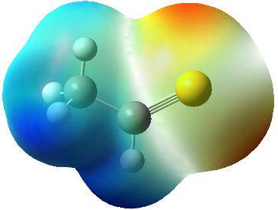  +25.74  -22.43
CH₃CHO |  |  | CH₃CHS
-17.45  +66.09 |  |  | -7.55  -13.84
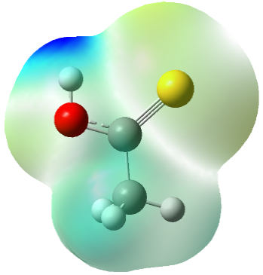 |  | 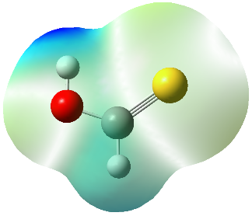  +70.85 |  |  | 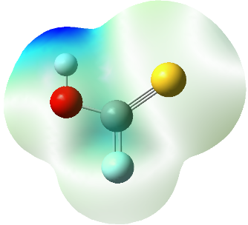  +85.33
CH₃CSOH |  | HCSOH |  |  | FCSOH
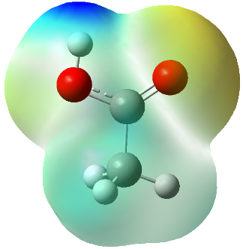  +66.96 | -35.36 | 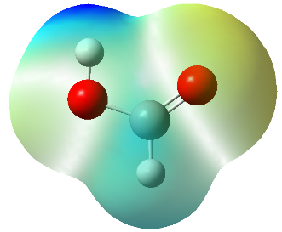  +72.84  -32.48 |  |  | 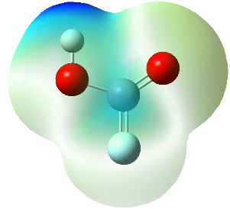  -27.86  +87.62
CH₃COOH |  | HCOOH |  |  | FCOOH
(isovalue = 0.002 au)
Figure. S3. Molecular electrostatic potential (in kcal.mol⁻¹) of the CH₃CHZ and RCZOH (R = CH₃, H, F; Z = O, S) at MP2/6–311++G(3df,2pd) level

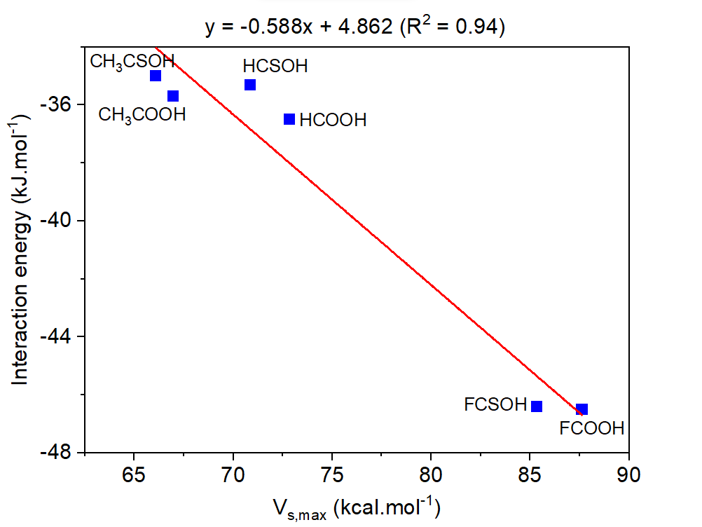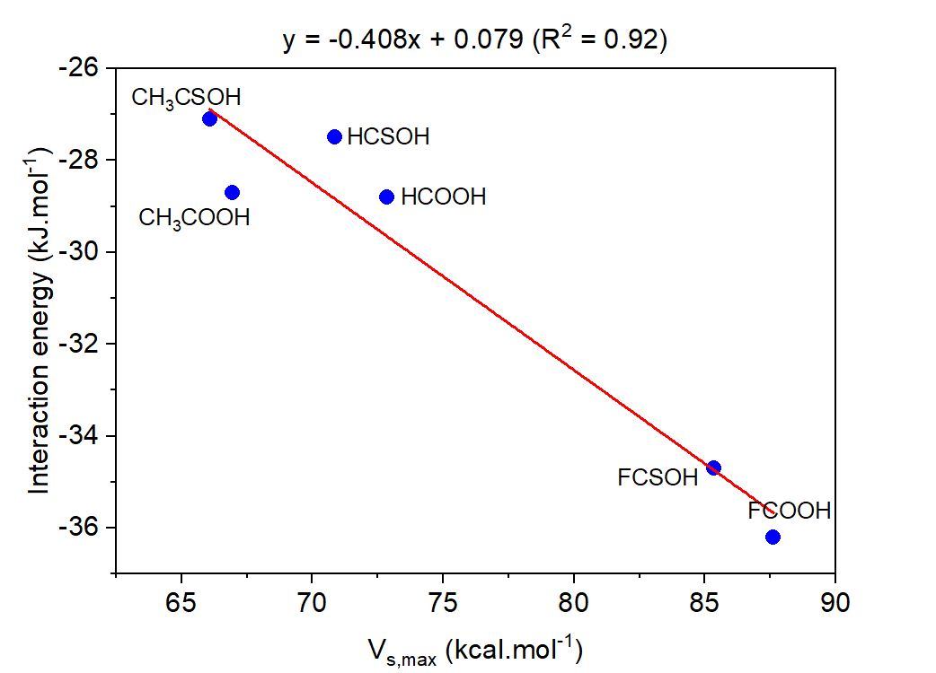
(a) | (b)
Figure. S4. Relationship of the interaction energies of the investigated complexes for CH₃CHO-complexes (a) and for CH₃CHS-complexes (b) with electrostatic potential of H atom in monomers acting as proton donor at MP2/6-311++G(3df,2pd) level.
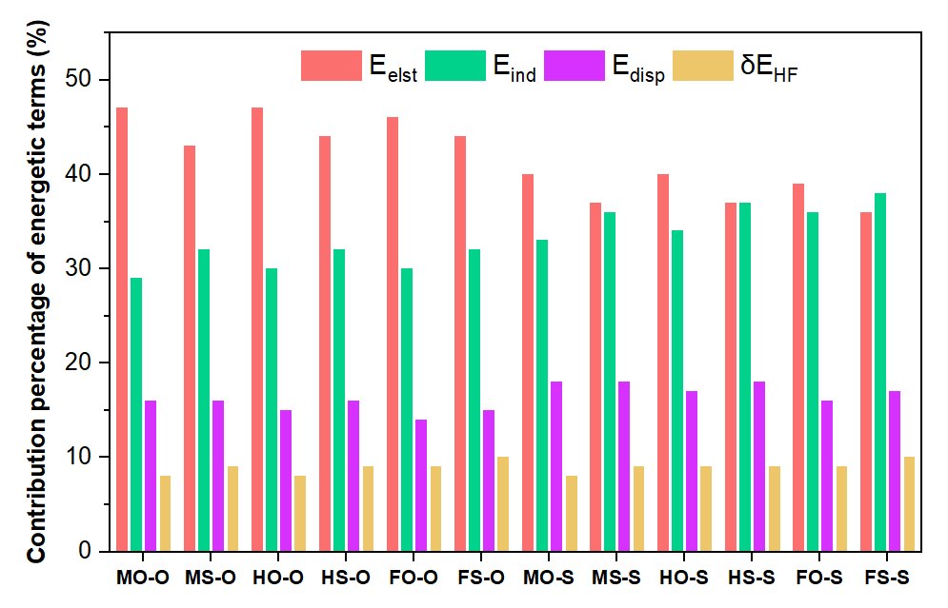
Figure. S5. Diagram for contribution percentage of different energy components into total stabilization energy of the complexes for RCZOH∙∙∙CH₃CHZ, with R = CH₃, H, F; Z = O, S

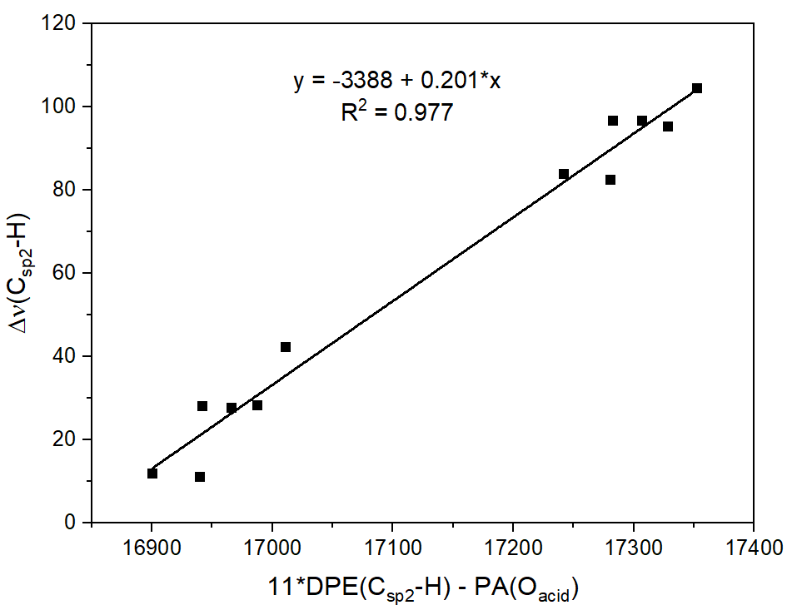
Figure. S6. The linear correlation of Δν(C_{sp2}-H) (in cm⁻¹) versus DPE(C_{sp2}-H) (in kJ.mol⁻¹) of CH₃CHZ and PA(O) (in kJ.mol⁻¹) of RCZOH
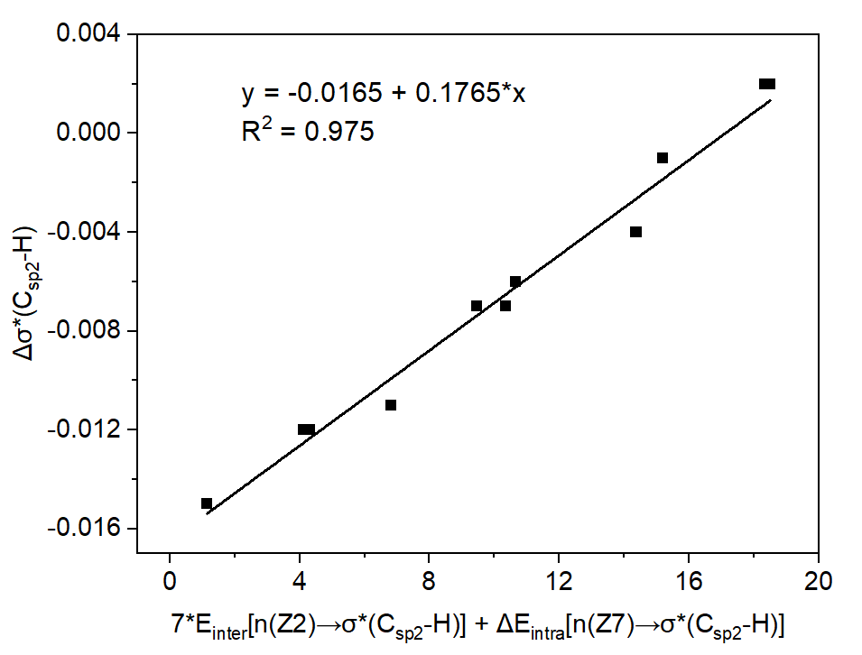
Figure. S7. The linear correlation of Δσ*(C_{sp2}-H) (in electron) versus intermolecular hyperconjugative interaction energies (in kJ.mol⁻¹) and changes of intramolecular hyperconjugative interaction energies (7*E_{inter} +ΔE_{intra}) (in kJ.mol⁻¹) for the complexes

