Tổng hợp polyvinyl alcohol/liginin hydrogel và khảo sát khả năng hấp phụ methylene blue
Bùi Thị Thảo Nguyên*, Huỳnh Quang Phú, Phan Quốc Huy

Đại học Bách Khoa - Đại học Quốc gia Thành phố Hồ Chí Minh, Việt Nam

*Tác giả liên hệ chính. Email: btnguyen@hcmut.edu.vn

TÓM TẮT
Trong nghiên cứu này, hydrogel từ polyvinyl alcohol và lignin đã được tổng hợp. Glyoxal được sử dụng làm chất liên kết chéo với vai trò hình thành liên kết giữa các phân tử polyvinyl alcohol và lignin. Khả năng hấp phụ của hydrogel đối với methylene blue (MB) đã được nghiên cứu với các nồng độ ban đầu của dung dịch methylen blue (MB). Nghiên cứu đường đẳng nhiệt hấp phụ được thực hiện ở nhiệt độ 31ºC và pH 7 với mô hình Langmuir và Freundlich. Các hệ số tương quan (R²) của đồ thị cho thấy số liệu thực nghiệm phù hợp với mô hình Langmuir. Điều này chứng tỏ rằng MB được hấp phụ trên hydrogel theo cơ chế hấp phụ đơn lớp. Hiệu suất hấp phụ MB lớn hơn 88%. Ngoài ra, các đặc tính của hydrogel PVA/lignin đã được nghiên cứu bằng một số phương pháp phân tích, bao gồm quang phổ hồng ngoại biến đổi Fourier (FTIR), phương pháp nhiễu xạ tia X (XRD) và phương pháp quang phổ nhìn thấy UV (UV-Vis).
Từ khoá: Hấp phụ, methylene blue, polyvinyl alcohol, lignin, hydrogel.

Preparation of poly vinyl alcohol/lignin hydrogels and investigation of the adsorption for methylene blue
Bui Thi Thao Nguyen*, Huynh Quang Phu, Phan Quoc Huy
Ho Chi Minh City University of Technology - Vietnam National University Ho Chi Minh City, Vietnam
*Corresponding author. Email: btnguyen@hcmut.edu.vn
ABSTRACT
In this study, the hydrogels based on polyvinyl alcohol and lignin were synthesized. The glyoxal was used as crosslinker with the role of forming linkages between polyvinylalcohol and lignin moleculars. The adsorption capacity of the hydrogels for methylene blue (MB) was investigated with the various initial concentrations of methylene blue (MB) solution. The adsorption isotherm studies were conducted at 31ºC and pH 7 with Langmuir and Freundlich models. The correlation coefficients (R²) of the linear graphs showed that the experimental data fitted Langmuir model. This revealed that MB adsorbed on the hydrogel by monolayer adsorption. The removal effiency for MB from aqueous solution was over 88 %. Additionally, the properties of PVA/lignin hydrogels were investigated by several analytical methods, including Fourier-transform infrared spectroscopy (FTIR), X-ray diffraction method (XRD) and UV–visible spectrophotometry (UV-Vis).
Keywords. Adsorption, methylene blue, polyvinyl alcohol, lignin, hydrogel.

1. INTRODUCTION
Environmental pollution becomes a serious issue not only for Vietnam but also for the whole world. Along with the rapid development of industry, the water environment is being seriously impacted. The lack of overall planning in the operation of factories, hospitals, and industrial zones in Vietnam has led to the discharge of untreated wastewater into the environment. Wastewater from industries, especially the textile dyeing industry, often contains high alkalinity and significant organic content, negatively affecting drainage systems and water environmen ¹⁻⁵. The presence of colorants in wastewater also creates a serious problem, affecting the ecological process and landscape. A typical dye waste is methylene blue, which is widely used in the textile, paper dyeing, plastic and rubber dyeing, and cosmetics industries. Methylene blue (MB) is an organic dye that has a negative impact on the water environment. About 10-15% of MB dyes from the textile industry are discharged into the environment each year. Wastewater from the dye industry has a high alkalinity (pH 8 - 11) and contains a significant amount of organic matter (COD 620 - 4585 mg/L). This causes water pollution, reduces dissolved oxygen in water, and negatively affects the life of aquatic organisms. Prolonged exposure to MB can cause vomiting, increased heart rate, shock, cyanosis, and jaundice ⁶⁻⁸. The dyes in wastewater, including MB dye, inhibit the penetration of sunlight into water, affecting the photosynthesis of aquatic species and adversely affecting the landscape. Additionaly, MB is considered toxic and has the potential to cause cancer for human being. Prolonged exposure to MB can cause symptoms such as vomiting, increased heart rate, and impact on body systems ^{6, 9}.
In an effort to eliminate wastewater pollution, hydrogel has been researched and developed as a potential adsorbent material ¹⁰⁻¹². Hydrogel is a type of polymer with a 3D network structure, capable of superior water absorption. The kinetic and chemical properties of hydrogel allow it to adapt to different environmental conditions, and therefore, hydrogel can be used in many fields, including the absorption of pollutants, drug delivery, and water filtration ^{12, 13}.
Although various methods have been applied to treat wastewater containing dyes, such as microbial treatment, coagulation, oxidation-reduction, membrane filtration technology, and a combination of other methods, they may encounter complex barriers and be economically inefficient in practice. Meanwhile, the absorption method, although traditional, is still widely used as a practical and economical solution to remove dye-contaminated wastewater due to its simplicity, high efficiency, flexibility, and compatibility with most current wastewater treatment processes ¹⁴⁻¹⁶.
The issue of environmental pollution and the need for research on hydrogel materials, a type of material with high performance in absorption, flexibility, adaptability, and flexibility, is an important issue atrracting much attention. The development and application of hydrogel can provide potential solutions in reducing pollution and treating industrial wastewater effectively and sustainably. Especially those hydrogels with biodegradable components such as PVA, a non-toxic polymer, and lignin, a natural biomass substance are familiar and popular ¹⁷⁻¹⁹.
In this work, the hydrogel adsorbents from polyvinyl alcohol and lignin were synthesized. The glyoxal as crosslinker for the hydrogels was utilized to create three-dimensional network for the hydrogel. The adsorption capacity of these prepared hydrogels for MB was studied by Langmuir and Freundlich adsorption isotherms. The characterization of the hydrogel was investigated by FTIR, SEM, and UV-Vis.
2. MATERIALS AND METHODS
2.1 Materials
PVA (average Mw = 205 000 g/mol, 98-99% hydrolyzed) was supplied by Sigma Aldrich (Germany). Glyoxal and lignin (average Mw = 15 000 g/mol) were purchased from Wako Chemical Industries (Japan). All other chemicals were obtained from Guangdong Guanghua Sci-Tech Company (China).
2.2 Synthesis of PVA/lignin hydrogel
There were several steps in the synthesizing process. First, Slowly adding PVA to the flask containing hot water at 90 ºC, then the PVA particles dissolved in the water and the solution stirred steadily for 60 minutes. Weighing glyoxal, slowly pouring it into the solution, and then stirring the solution for 15 minutes to homogenize it. After that the lignin was placed into the solution and the mixture was stirred for 30 minutes. Pouring the mixture into a pre-prepared mold, and putting the mold into the oven at 70 ºC for about 90 minutes until solidification completed.
2.3. Adsorption Isotherms
The adsorption equilibrium experiments were investigated with the initial concentration (C_{o}) of MB solutions ranging from 10 to 50 mg/L. The hydrogel samples were placed into MB solutions, until the solution reached equilibrium concentrations at 31 ºC, pH 7. The equilibrium concentrations (C) were determined by the relationship between the absorbance and the colored solutions. The absorbance of MB solution was tested by UV-Vis spectrophotometer ﻿(UV/UV-NIR Horiba Dual-FL).
Adsorption capacity was the mass of adsorbate per unit mass of adsorbent at equilibrium under defined conditions of concentration and temperature. The adsorption capacity q (mg/g) and removal efficiency E% were calculated by the equations below ²⁰:
$q=\frac{\left(C_{0}-C\right).V}{m}$ (1)
$E= \frac{C_{0}-C}{C_{0}} x 100\%$ (2)
Where C_{o} and C (mg/L) were the initial and equilibrium concentration of the MB solution, respectively. V (L) and m (g) were the volume of the Cr (VI) solution and he weight of the hydrogel, respectively.
Langmuir isotherm (4) and Freundlich isotherm (5) models were used to study the adsorption process. The Langmuir isotherm model described adsorption behavior related to monolayer adsorption on the surface of the adsorbent while the Freundlich isotherm model illustrated that adsorbate covered the surfaces like multilayers ^{21, 22}:
$\frac{C}{q}=\frac{C}{q_{∞}}+\frac{1}{bq_{∞}}$ (3)
$\ln{q}=\frac{1}{n}lnC+lnK$ (4)
Where q∞ (mg/g) was the maximum adsorption capacity, b (L/m.g) was a Langmuir constant presented for the adsorption energy, K (mg/g) was a Freundlich constant associated with the adsorption capacity of the adsorbent, and 1/n was the Freundlich coefficient relative heterogeneity.
﻿The dimensionless equilibrium parameter, R_{L}, showing the chemical affinity between the absorbent and the absorbate, was calculated as follows ²¹:
$R_{L}=\frac{1}{1+bC_{0}}$ (5)
The favorable values of R_{L} were less than 1
2.4. Analytical methods
The characterization of hydrogel was studied by Frontier FT-IR/NIR instrument model at Institute of Applied Materials science, Ho Chi Minh City, Vietnam with the scan rate and speed being 4000 – 4500 cm⁻¹ and 0.2 mm/s, respectively and SEM system at Research Laboratories of Saigon Hi-tech Park, Ho Chi Minh City, Vietnam. Crystal phases of the hydrogel samples were investigated with the X-ray diffraction method (XRD) with Cu-Kα radiation (λ=1.54184 Å).
3. RESULTS AND DISCUSSION
3.1 Analysis of crystal structure by X-ray diffraction method
X-ray diffraction (XRD) is the method for analyzing the crystal structure of materials by measuring the angle of reflection and intensity of X-rays when irradiated on a sample. The XRD spectrum can provide information about the size and shape of crystals, the arrangement of atoms in the crystal, and the presence of different phases in the sample.
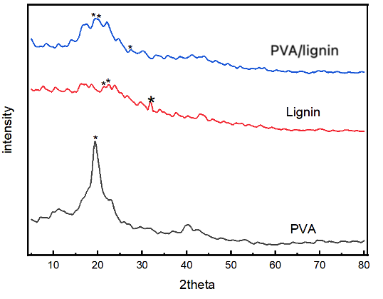
Figure 1. XRD spectrum of lignin and sample
In this study, the XRD spectra of PVA, lignin, and PVA/lignin composite with glyoxal solidifying agent were measured using an X-ray diffraction spectrometer with a scan range from 5 ° to 80 °. From Figures 1, it could be seen that PVA had a main peak around the 2θ angle of 20 °, which was a high and narrow signal peak indicating a specific crystal structure. This characterized the semi-crystallinity structure of PVA polymer. Lignin had a very light XRD spectrum with a few small peaks, indicating that lignin has an amorphous structure.
The PVA/lignin composite with glyoxal agent had some weak and unclear peaks at the positions which was similar to pure PVA. This indicated the the formation of cross-links between PVA and lignin by glyoxal made the changes in the structure of PVA network and crystal parts of the PVA were disordered and become amorphous parts.
3.2 Analysis of the specific functional groups by FT-IR spectra
In the FTIR infrared spectrum of PVA in Figure 2, the broad peak at 3267 cm⁻¹ corresponded to the stretching vibration of the OH group in PVA, indicating the presence of alcohol groups in the polymer. The peak at 2939 cm⁻¹ was the symmetric stretching vibration CH groups in PVA. The peaks appearing at 1430 cm⁻¹ reflected CH₂. The sharp peak at 1707 cm⁻¹ represented the C=O stretching vibration in the amorphous region of PVA and attributed to carbonyl functional groups from residual acetate radicals after PVA synthesis from polyvinyl acetate hydrolysis. The peak at 1089 cm⁻¹ was the C-O stretching vibration in PVA.
The FTIR spectrum of lignin in Figure 2 showed greater complexity in its structure, with a peak at 1595 cm⁻¹, indicating the presence of hydroxycinnamic esters in the lignin sample. The peak at 1361 cm⁻¹ associated with the syringyl molecular structure of lignin, manifested through C-O stretching during contraction. The peak at 1267 cm⁻¹ corresponded to the contraction of the guaiacyl ring, accompanied by C=O stretching. The peak at 1209 cm⁻¹ reflected the vibration of C-O-C bonds in ether and ester compounds, or phenolic hydroxyls. The frequency band at 1130 cm⁻¹ related to the in-plane deformation vibration of C-H in syringyl aromatic ring groups. Finally, the peak at 1035 cm⁻¹ originated from the in-plane deformation of C-H in aromatic rings and C-O bending in primary alcohol catalysis, belonging to the guaiacyl type. The peak at 3453 cm⁻¹ presented the vibration of the hydroxyl group.

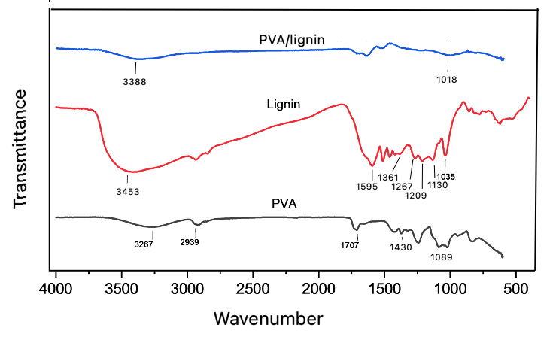
Figure 2. FTIR spectrum of PVA, lignin and PVA/lignin sample

In the FTIR spectrum of the PVA/lignin in Figure 2, the broad peak at 3388 cm⁻¹ reflected the vibration of the hydroxyl group. The shift of the -OH functional group from the 3267 cm⁻¹ region in the PVA spectrum and 3453 cm⁻¹ peak in lignin spectrum to the field region of 3388 cm⁻¹ in the PVA/lignin sample occured in the hydrogel. In the sample, the cross-linkages between chains which was created by the reaction between hydroxyl groups reduced the number of hydroxyl groups and the effect of OH groups contributed from various resources including PVA, lignin and glyoxal made the change of the wave number at -OH vibration in the PVA/lignin sample. The sample had weak spectra signals at wave numbers 1018 cm⁻¹, which was asymmetric stretching of the C-O groups.
3.3 Investigation of adsorption capacity for methylene blue
The adsorption capacity and removal efficiency of the PVA/lignin hydrogel were investigated at 31 ºC, pH 7, shown in Table 1 and Figure 3.
Table 1. The adsorption capacity of PVA/lignin hydrogel.
C₀ (mg/L) | C (mg/L) | q (mg/g) | E%
10 | 0.57 | 9.43 |  | 94.32
20 | 1.17 | 18.83 |  | 94.16
30 | 2.14 | 27.86 |  | 92.86
40 | 4.19 | 35.81 |  | 89.53
50 | 5.92 | 44.08 |  | 88.16
From Table 1 and Figure 3, the adsorption capacity for MB of PVA/lignin hydrogel increased linearly with the equilibrium concentration of MB solution. When equilibrium concentrations were from 0.57 (mg/L) to 5.92 (mg/L), which was the results of the adsorption process with initial concentrations from 10 to 50 mg/L, the amount of MB inserting into the hydrogel increased from 9.43 (mg/g) to 44.08 (mg/g) and the removal efficiency ranged from 88.16% to 94.32%. These data presented that the MB adsorption depended on the moving process of MB from the initial solution to the hydrogels. With increasing concentrations of MB solution, the the amount of MB adsorbing on the hydrogel increased to equilibrium. The removal efficiency obtained over 88% and the highest value about94 %.
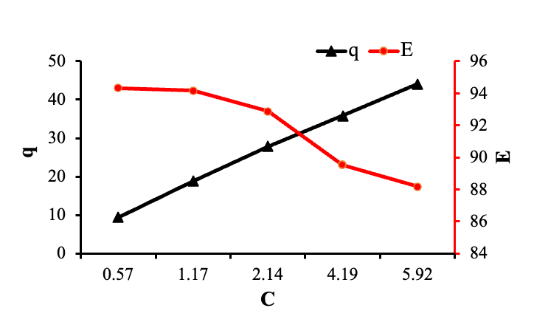
Figure 3. The effect of concentrations on the adsorption amount and removal efficiency.
3.4 Study of adsorption Isotherms
The equilibrium adsorption had been studied by isotherm models, Langmuir and Freundlich models. The relationship between q and C according to Langmuir model was presented in the Figure 4a. The relationship between lnq and lnC according to Freundlich model was expressed in Figure 4b.
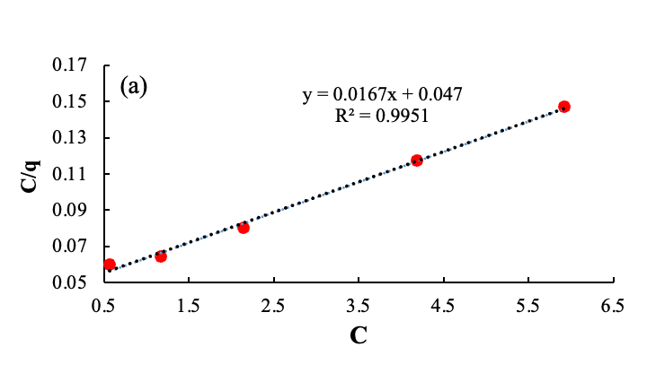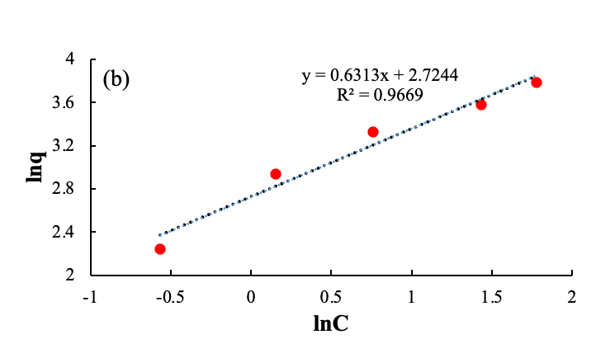
Figure 4. Adsorption isotherms of MB on the hydrogel, Langmuir model (a) and Freundlich model (b).
The maximum amount of MB moleculars adsorbing on the hydrogel could be drawn from Langmuir model, which was about 60 (mg/g). From the correlation coeficients (R²) in the line graphs (Figure 4a and 4b), it could be seen that the Langmuir curve fitted the experimental parameters. The correlation coefficients (R²) of the linear form for Langmuir isotherm model were 0.9951 which was much closer to 1.0 than that of Freundlich models. These data revealed that Langmuir model described properly the MB adsorption of PVA/lignin hydrogel adsorbents and affirmed that adsorption occured by the monolayer adsorption on the surface of the hydrogel.
R_{L} parameter which discovered the affinity of adsorption on hydrogel, following Langmuir model, could be calculated from the equation (5), which was from 0.05 to 0.2. These values of R_{L} were smaller than 1, so this is favorable. The results showed the good affinity between MB moleculars and the PVA/lignin hydrogel.
4. CONCLUSION
In this study, the hydrogels based on PVA and lignin were successfully synthesized by using glyoxal crosslinker. The adsorption process was conducted by batch experimental procedure at 31 ºC, pH 7. The maximum adsorption capacity was about 60 mg/g. The experimental data agreed with Langmuir isotherm model, showed that MB adsorbed by monolayer coverages on the hydrogel surfaces.The affinity parameter was lower than 1, described good affinity between MB adsorbents and the hydrogel. Moreover, removal efficiency was higher than 88%. Consequently, the hydrogels can be applied for the removal of methylene blue from aqueous solution.
Acknowledgements. We acknowledge the technical support from the Faculty of Materials Technology, Ho Chi Minh City University of Technology (HCMUT), VNUHCM for this study.
REFERENCES
1. G. Zhao, T. Sun, D. Wang, S. Chen, Y. Ding, Y. Li, G. Shi, H. Sun, S. Wu, Y. Li, C. Wu, Y. Li, Z. Yu, Z. Chen. Treated wastewater and weak removal mechanisms enhance nitrate pollution in metropolitan rivers, Environmental Research, 2023, 231, 116182.
2. S. Pal, S. Debanshi. Exploring the effect of wastewater pollution susceptibility towards wetland provisioning services, Ecohydrology & Hydrobiology, 2023, 23, 162-176.
3. F. Kazembeigi, S. Bayad, A. Yousefi Nasab, M. Doraghi, I. Parseh. Techno-environmental study on the consequences of carwash wastewater and its management methods, Heliyon, 2023, e19764.
4. P. Chowdhary, A. Raj, R. N. Bharagava. Environmental pollution and health hazards from distillery wastewater and treatment approaches to combat the environmental threats: A review, Chemosphere, 2018, 194, 229-246.
5. F. B. Elehinafe, O. Agboola, A. D. Vershima, G. O. Bamigboye. Insights on the advanced separation processes in water pollution analyses and wastewater treatment – A review, South African Journal of Chemical Engineering, 2022, 42, 188-200.
6. R. Sivakumar, N. Y. Lee. Adsorptive removal of organic pollutant methylene blue using polysaccharide-based composite hydrogels, Chemosphere, 2022, 286, 131890.
7. E. U. Mughal, A. Javaid, M. Imran, M. A. S. Abourehab, E. B. Elkaeed, N. Naeem, A. Y. A. Alzahrani, A. Sadiq, S. F. Kainat. Complexes of terpyridine scaffold as efficient photocatalysts for the degradation of methylene blue pollutant in wastewater effluents, Inorganica Chimica Acta, 2023, 546, 121329.
8. S. S. Vedula, G. D. Yadav. Wastewater treatment containing methylene blue dye as pollutant using adsorption by chitosan lignin membrane: Development of membrane, characterization and kinetics of adsorption, Journal of the Indian Chemical Society, 2022, 99, 100263.
9. N. P. F. Gonçalves, S. M. Olhero, J. A. Labrincha, R. M. Novais. 3D-printed red mud/metakaolin-based geopolymers as water pollutant sorbents of methylene blue, Journal of Cleaner Production, 2023, 383, 135315.
10. S. Park, S. Yoo, S.-M. Cho, S. S. Kelley, S. Park. Production of single-component cellulose-based hydrogel and its utilization as adsorbent for aqueous contaminants, International Journal of Biological Macromolecules, 2023, 243, 125085.
11. H. T. Nguyen, F. A. Ngwabebhoh, N. Saha, T. Saha, P. Saha. Gellan gum/bacterial cellulose hydrogel crosslinked with citric acid as an eco-friendly green adsorbent for safranin and crystal violet dye removal, International Journal of Biological Macromolecules, 2022, 222, 77-89.
12. A. A. Hamid, J. Alam, A. K. Shukla, F. A. A. Ali, M. Alhoshan. Sustainable removal of phenol from wastewater using a biopolymer hydrogel adsorbent comprising crosslinked chitosan and κ-carrageenan, International Journal of Biological Macromolecules, 2023, 251, 126340.
13. S. Ahmad, M. S. Tanweer, T. A. Mir, M. Alam, S. Ikram, J. N. Sheikh. Antimicrobial gum based hydrogels as adsorbents for the removal of organic and inorganic pollutants, Journal of Water Process Engineering, 2023, 51, 103377.
14. L. Sellaoui, F. Abdulaziz, S. Chebaane, L. Manai, A. Azhary, A. H. Alsehli, M. M. Alsowayigh, A. Piscitelli, A. Erto. Adsorption of pharmaceutical pollutants on activated carbon: Physicochemical assessment of the adsorption mechanism via advanced modelling, Journal of Molecular Liquids, 2023, 389, 122929.
15. X. Huang, W. Mu, C. Chang. CTAB Intercalation into Two-Dimensional Transition-Metal Carbides: Enhancing Adsorption Performance of Cr (VI), Journal of Alloys and Compounds, 2023, 172012.
16. X. Cheng, Y. Cheng, C. Wang, B. Hu, J. Wang. Calculation methods on methane adsorption phase density in coal: A critical review and new insights, Chemical Engineering Journal, 2023, 472, 144778.
17. Z. Chen, J. Luo, Y. Hu, Y. Fu, J. Meng, S. Luo, L. Wang, Y. Zhang, J. Zhou, M. Zhang, H. Qin. Fabrication of lignin reinforced hybrid hydrogels with antimicrobial and self-adhesion for strain sensors, International Journal of Biological Macromolecules, 2022, 222, 487-496.
18. K. Ingtipi, B. J. Choudhury, V. S. Moholkar. Ultrasound assisted lignin-decorated MWCNT doped flexible PVA–Chitosan composite hydrogel, Materials Today Communications, 2023, 35, 105676.
19. L. Wu, S. Huang, J. Zheng, Z. Qiu, X. Lin, Y. Qin. Synthesis and characterization of biomass lignin-based PVA super-absorbent hydrogel, International Journal of Biological Macromolecules, 2019, 140, 538-545.
20. D. Choque-Quispe, C. A. Ligarda-Samanez, Y. Choque-Quispe, A. M. Solano-Reynoso, B. S. Ramos-Pacheco, M. M. Zamalloa-Puma, G. J. Álvarez-López, A. Zamalloa-Puma, K. Choque-Quispe, H. Alzamora-Flores. Multimetal removal in aqueous medium using a potato starch/nopal mucilage copolymer: A study of adsorption kinetics and isotherms, Results in Engineering, 2023, 18, 101164.
21. B. Wu, X. Chen, D. Hou. Modeling of monolayer water adsorption on surface of cement minerals by molecule simulation and adsorption isotherm, Materials Today Communications, 2023, 36, 106646.
22. O. M. Adedeji, K. Jahan. Removal of pollutants from aqueous product of Co-hydrothermal liquefaction: Adsorption and isotherm studies, Chemosphere, 2023, 321, 138165.

