Nghiên cứu đánh giá ảnh hưởng của các thông số kết cấu đến chất lượng phun nhiên liệu trên động cơ Diesel
Kubota D1703-M-DI

Nguyễn Quốc Hoàng^{1,*}, Dương Trọng Chung²

^{1,2}Bộ môn kỹ thuật ô tô, Trường Đại học Quy Nhơn, Việt Nam

*Tác giả liên hệ. Email: nguyenquochoang@qnu.edu.vn

TÓM TẮT
Trên cơ sở nghiên cứu lý thuyết quá trình cung cấp nhiên liệu, quá trình hình thành hỗn hợp trong động cơ Diesel.^{3,6,8,9} Dựa vào cơ sở lý thuyết tính toán trong phần mềm Hydsim,⁵ và kết hợp với quá trình khảo sát, đo đạt và phân tích đặc điểm kết cấu hệ thống cung cấp nhiên liệu trên động cơ Diesel Kubota D1703-M-DI.^{1,7} Nhóm tác giả đã ứng dụng phần mềm Hydsim để mô phỏng quá trình cung cấp nhiên liệu động cơ Diesel Kubota D1703-M-DI trên cơ sở điều kiện mô phỏng với tải định mức, tải trung bình và không tải và có sự thay đổi giá trị các thông số kết cấu: biên dạng cam, tỉ số D/h_{i}, đường kính lỗ phun, chiều dài lỗ phun, độ cứng lò xo vòi phun, …. Dựa trên kết quả mô phỏng thu được, nhóm tác giả sẽ phân tích, đánh giá kết quả mô phỏng và đưa ra các kết luận liên quan về ảnh hưởng của các thông số kết cấu đến chất lượng phun nhiên liệu trên động cơ Diesel Kubota D1703-M-DI. Từ đó, đưa ra các đề xuất cải tiến về mặt thông số kết cấu phù hợp hơn.⁴ Việc làm này có ý nghĩa quan trọng trong việc giảm tiêu hao nhiên liệu, giảm tiếng ồn, và giảm hàm lượng các chất ô nhiễm do khí xả động cơ.²
Từ khóa: mô phỏng, hệ thống cung cấp nhiên liệu động cơ Diesel, máy cày Kubota L3804VN, bơm cao áp tập trung, vòi phun cao áp.

Research to evaluate the influence of structural parameters on fuel injection quality on Kubota D1703-M-DI Diesel engine

Quoc Hoang Nguyen^{1,*}, Trong Chung Duong²

^{1,2}Device of Automotive Engineering, Quy Nhon University, Vietnam.

*Author contact. Email: nguyenquochoang@qnu.edu.vn

ABSTRACT
Based on theoretical research on the fuel supply process and mixture formation process in Diesel engines.^{3,6,8,9} Based on the theoretical basis of calculations in Hydsim software,⁵ and combined with The process of surveying, measuring and analyzing the structural characteristics of the fuel supply system on the Kubota D1703-M-DI Diesel engine.^{1,7} The authors have applied Hydsim software to simulate the supply process. Kubota D1703-M-DI Diesel engine fuel based on simulation conditions with rated load, average load and no load and with changes in the values of structural parameters: cam profile, D/ h_{i} ratio, nozzle diameter, nozzle length, nozzle spring hardness, etc. Based on the simulation results obtained, the authors will analyze and evaluate the simulation results and draw relevant conclusions about the influence of structural parameters on the quality of fuel injection on the Kubota D1703-M-DI Diesel engine. From there, suggestions for improvements in terms of more appropriate structural parameters are made.⁴ This is important in reducing fuel consumption, reducing noise, and reducing the content of pollutants caused by engine exhaust gas.²
Keywords: Simulation, Diesel engine fuel supply system, Kubota L3804VN tractor, centralized high pressure pump, high pressure injector.

1. INTRODUCTION
In the period of industrialization and modernization of the country, especially in the current mechanization of rural agriculture. Internal combustion engines in general and Diesel engines in particular are indispensable. With advantages such as large capacity, high efficiency, and cheaper fuel cost than gasoline, Diesel engines are widely used today. In particular, small-sized Diesel engines, with a power range of 5 ÷ 40 HP (Horsepower), are highly economical and meet the needs of users, so they are increasingly approaching rural life and construction sites built and used as the main power source for services such as plows, cultivators, harrows, water pumps, harvesters, etc; milling machine, rice screening machine, etc; Agricultural vehicles, motorboats, etc; small capacity concrete mixer; Air compressors with small and medium capacity.
Currently, the number and scale of engine manufacturers in our country are still very limited, mainly producing small single-cylinder diesel engines serving agriculture and construction. Due to product price conditions, and to ensure competitiveness with engines produced in other countries, these types of engines currently mostly use old-style fuel supply systems (using high-pressure pumps of mechanical).
Among them, we must mention engines with capacity from 5 to 25 HP from Vikyno company, with characteristics of low fuel consumption, durable use, and production process requiring high precision such as: VIKYNO RV-70, RV-105, RV-125, RV-195, KND5B, D9. These products are used on agricultural machinery products such as plows, generators, milling machines, water pumps, etc machines serving the construction industry, favored by domestic and foreign consumers like. Most of these products are transferred production technology under copyright from KUBOTA (Japan) with an increasing rate of localization of details, from 40% in 1992 to 70-80% in 2004 and currently about 90%.
However, these types of engines have a small working capacity range, are noisy, and do not meet consumer needs. The problem is that it is necessary to quickly research and produce multi-cylinder engines with a wider power range, higher efficiency and economy.
To meet consumer needs. Agricultural machinery trading companies have imported many products such as plows, combine harvesters, etc. from brands such as: KUBOTA, YANGMA, MITSUBISI, ISUZU, etc these products are equipped with engines 3, 4 cylinder Diesel engine, with capacity from 20 ÷ 40 HP. Among them are the products of the Japanese company KUBOTA, which are very chosen by our country's consumers. However, the biggest drawback of these types of imported engines is that the price of the product is too high, replacement parts are expensive and it takes a lot of time to order. In addition, during engine operation at high load and high speed, the quality of the fuel injection process is poor, producing a lot of black smoke due to the phenomenon of falling, burning on the expansion line, consuming a lot of fuel. When running at idle speed, the engine design is unstable. Causes environmental pollution and reduces engine economy. One of the reasons is the poor quality of the fuel injection process.
The problem is that it is necessary to research to improve or research new designs of engines in general and fuel systems of these types of engines in particular to suit the conditions of use in our country and bring benefits. highest economic benefit for users. But calculating, designing, manufacturing, renovating, installing new and doing experiments is very complicated and takes a lot of time. Therefore, researching and exploiting the application of information technology software in calculating design, simulating engines in general and the process of supplying fuel to internal combustion engines in particular will help significantly shorten the time. design, testing, and optimization of the fuel supply process of the engine fuel system. This will significantly reduce costs for design, manufacturing, and testing, thereby reducing product costs.
Currently, in the world there have appeared a lot of information technology software related to simulating engines in general and hydrodynamic processes in particular such as KIVA software: Calculation and simulation of thermodynamic processes of engine); PROMO software (from Germany): Calculate thermodynamics of the engine's working process based on CFD (computational Fluit Dynamics) computational fluid dynamics theory; BOOST, FIRE, HYDSIM, EXCITE, GLIDE, TYCON, BRICKS software from AVL (Republic of Austria): This is a very powerful toolkit in calculating and simulating kinematic, dynamic and thermodynamic processes, hydrodynamics, etc of structures and systems in internal combustion engines; AUTOMATION STUDIO software: Calculate and simulate hydraulic and pneumatic systems; FluidSIM 5.0 software from Festo: Calculate and simulate hydraulic and pneumatic systems; Fluent Software: Software capable of modeling cylinder engines, ballistics, turbomachinery and equipment, and multiphase systems; etc. These software can be used for in-depth research on engine work cycles, capable of designing models, testing theoretical models, etc. In Vietnam, these software have just been put into use. used in recent years so is currently in the research stage. In addition to those specialized software, there are also some very commonly used software such as MATLAB SIMULINK software. The software can handle most mathematical operations simply based on the available command set, moreover, it is capable of simulating systems in mechanics as well as electronics.
In short, each software has its own advantages in a certain area. In particular, Hydsim software is a software in the AVL Workspace software suite of the Republic of Austria, which is an in-depth software for calculating and simulating the fuel supply process of Diesel engines. In addition, Hydsim software is also good for calculating and simulating the fuel supply process for gasoline engines and engines using other alternative fuels such as alcohol, biogas, LPG, etc. The software has been widely applied in developed countries, as well as in modern automobile companies such as: Audi, Fiat,etc. In Vietnam the software has been used by a number of officials, lecturers, students and research and application students.
Therefore, the authors applied Hydsim software to simulate the fuel supply process of the Kubota D1703-M-DI Diesel engine based on simulation conditions with rated load, average load and no load and with change in the value of structural parameters. Based on the simulation results obtained, the authors will analyze and evaluate the simulation results and draw relevant conclusions about the influence of structural parameters on the quality of fuel injection on the Kubota Diesel engine D1703-M-DI. From there, suggestions for improvements in terms of more appropriate structural parameters are proposed,⁴ which is important in reducing fuel consumption, noise, and pollutant content. contamination in engine exhaust gas.²
2. ANALYSIS OF STRUCTURAL CHARACTERISTICS AND BUILDING A SIMULATION MODEL OF FUEL SUPPLY SYSTEM OF KUBOTA DIESEL ENGINE D1703-M-DI
2.1. Analyze structural features
2.1.1. Kubota Diesel Engine D1703-M-DI
The Kubota D1703-M-DI engine is a Diesel engine, 4-stroke, 3-cylinder, 1-2-3 firing order, placed vertically, compression ratio 20:1, displacement 1.647 liters, maximum capacity. 22.7 kW power, etc. The engine uses a unified combustion chamber, has a ω-shaped piston top cutout, and injects fuel directly onto the piston top, creating a swirling movement of the gas flow, optimizing the process. mix the mixture, thus reducing up to 50% of PM particles compared to level 2 of the EPA standard. Thanks to the MoS₂ plating layer on the valve body and piston, noise is reduced by 1-2 dBA compared to a conventional engine. Manufactured by the Japanese company Kubota and used on tractors type L3408VN (Figure 1) of KUBOTA, Japan. The D1703-M-DI engine complies with temporary regulations on EPA (US) tier 4 exhaust standards and EU (European) stage 3A standards passed in 2012 and has been recognized by the European market.
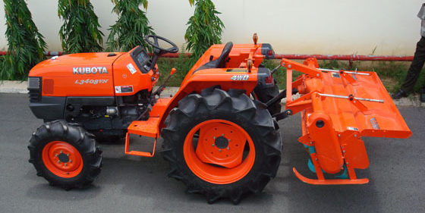
Figure 1. KUBOTA L3408VN tractor.
2.1.2. Kubota D1703-M-DI Diesel engine fuel system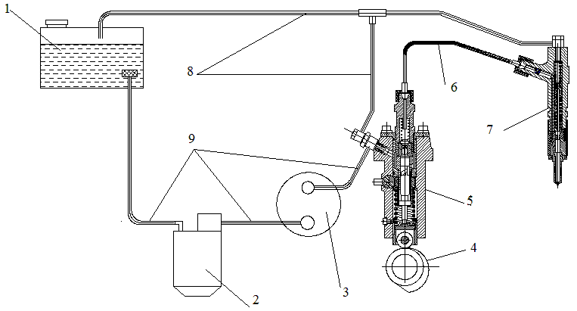
Figure 2. Structure diagram of Kubota D1703-M-DI Diesel engine fuel system. 1. Oil tank, 2. Oil filter, 3. Low pressure pump, 4. Camshaft, 5. High pressure pump, 6. High pressure pipe, 7. Injector, 8. Oil return pipe, 9. Supply oil pipe.
Kubota D1703-M-DI Diesel engine uses a Diesel engine fuel system with a 3-cylinder, in-line (5) centralized high-pressure pump of the Bosch “K” Type Mini Pump, each pump unit supplies fuel for one machine (Figure 3). Fuel is injected directly into the combustion chamber through closed nozzles (7) of the Bosch "P" Type Hole Nozzle type with 5 spray holes (Figure 11). The oil tank is stamped from steel plate, with a capacity of 34 liters. Oil filter uses paper type filter element, pleated, increases filtration efficiency, compact structure. Diaphragm type low-pressure pump, located on the side of the engine body and driven by the high-pressure pump camshaft.
The low-pressure pump sucks fuel from the tank through the filter into the pump and then is pumped to the high-pressure pump. Filters filter out dirt mixed in fuel. The high-pressure pump compresses the fuel further into the high-pressure line to the nozzle. At the end of the compression process, fuel is injected into the engine combustion chamber. Then the injected fuel beam is shredded, heated, evaporated and mixed evenly with air to create a mixture that then spontaneously ignites. Excess fuel in the injector and high-pressure pump passes through the return valve back to the tank.
a. High pressure pump
The Kubota D1703-M-DI Diesel engine uses a centralized high-pressure pump, 3 machines in line, with a fuel supply order of 1-2-3. The removable camshaft is installed in the engine body. The high-pressure pump consists of 3 pump groups, each pump group includes: a pair of high-pressure pump piston-cylinder. The control of changing the amount of fuel supplied for each cycle is thanks to the oblique groove on the piston and the piston is controlled to rotate by the rack and pinion mechanism. The special feature of this type of pump is that to adjust the fuel quantity between pump units, we adjust it by rotating the adjustment tube (6) back or forth.
* Structure (Figure 3): This is a high-pressure pump that adjusts the amount of fuel supplied to the cycle with a piston valve, changing the amount of fuel supplied by changing the useful stroke of the piston. The main details of the high pressure pump are the pair of pistons (15) and cylinders (16). This is a super precise pair, requiring very high precision manufacturing, chosen to be installed together and when replaced, the entire pair must be replaced. The cylinder is inserted into the hole in the adjusting tube body, positioned by the pin on the adjusting tube (6). The space inside the cylinder is connected to the fuel chamber in the pump body by a port and is also connected to the high-pressure fuel line when the high-pressure valve is open.
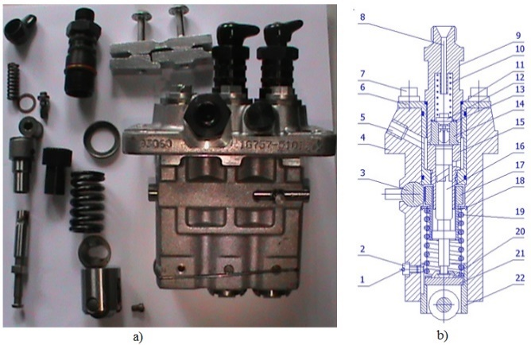
Figure 3. Structure of high pressure pump of Kubota D1703-M-DI Diesel engine. (a) Real image of high pressure pump, (b) longitudinal section of a pump unit. 1. Locking ring, 2. Locating pin, 3. Pinion rack, 4. High pressure pump body, 5. Oil inlet line, 6. Adjusting tube, 7. Retainer bolt, 8. Fuel to injector, 9 . High pressure hose connector, 10. High pressure valve spring, 11. Oil seal, 12. High pressure valve, 13. Copper gasket, 14. High pressure valve seat, 15. Cylinder, 16. Piston, 17. Pipe teeth, 18. Upper spring stop plate, 19. Piston return spring, 20. Lower spring stop plate, 21. Adjusting pad, 22. Roller head.
The high-pressure pump also has another super-precise pair, which is the high-pressure valve (12) and valve seat (14). The screw (9) is screwed tightly onto the adjusting pipe body (the adjusting pipe is screwed tightly on the pump body) to press the high pressure valve seat tightly onto the cylinder head (16), so the contact surface between the valve seat (14) and the cylinder (16) always tight. Thanks to the high-pressure valve spring (10), the high-pressure valve (12) is pressed tightly against the conical surface of the valve seat, separating the space above the piston of the pump unit from the high-pressure pipe. The tooth rack (3) and tooth tube (17) are connected to the piston tail and are used to adjust the amount of fuel injection supplied to the cycle.
* Working principle (Figure 4):
Fuel suction process: When the cam driving the high-pressure pump rotates, the roller will roll on the cam profile. When the rocker roller goes down thanks to the force of the piston return spring, the high pressure valve closes thanks to the high pressure valve spring. At this time, under the Influence of the high-pressure pump spring, it will push the piston (1) down, creating a vacuum in the cylinder chamber (5). When the piston opens the port (4), the fuel from the fuel chamber (3) will be loaded. into the cylinder chamber until the piston is at its lowest position.
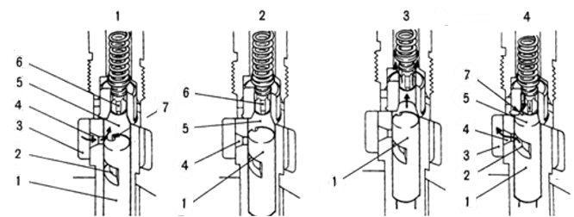
Figure 4. Fuel suction and ejection stroke of the high-pressure pump. 1. High pressure pump piston, 2. Groove on piston, 3. Fuel compartment, 4. Diaphragm port, 5. Cylinder cavity, 6. High pressure valve, 7. Groove on high pressure valve.
Fuel pushing process: When the piston (1) is pushed up by the rotating cam, the fuel is initially pushed out through the hole (4). When the piston covers the hole, the pressure fuel supply process begins. In the high-pressure pump, the effect on the high-pressure valve continues to increase, until the tension of the high-pressure valve spring and residual pressure on the high-pressure pipe are overcome, the high-pressure valve opens, fuel enters the high-pressure line, to the nozzle. The fuel supply process continues until the piston's inclined groove opens the port (4), ending the fuel supply. Leading to a sudden decrease in fuel pressure in the pump chamber, the high-pressure valve closes tightly on the valve seat (under the Influence of the high-pressure valve spring and fuel pressure on the high-pressure pipe). The fuel injection ends even though the piston continues to move up. Complete a fueling cycle and then repeat the cycle as above. Due to the throttling phenomenon of the port (4) and the compression phenomenon of the fuel, the actual supply start and end times are different from the geometric supply start and end times.
Controlling the amount of fuel supplied: To change the amount of fuel supplied to an engine's working cycle, we control it by moving the rack, the gear tube will rotate, thereby making the piston also rotate. The result is a change in the useful stroke of the pump piston.
* Structure of main details in high pressure pump:
- Ultra-precise piston and cylinder duo:
High pressure pump pistons and cylinders have precise geometric shapes and good wear resistance. The manufacturing material is Cr15 steel with a stable microstructure and more stable geometric dimensions of the part. Heat-treated to meet the requirements of the friction surfaces of the piston and cylinder pair having a hardness not less than HRC58, the end faces not less than HRC 55.
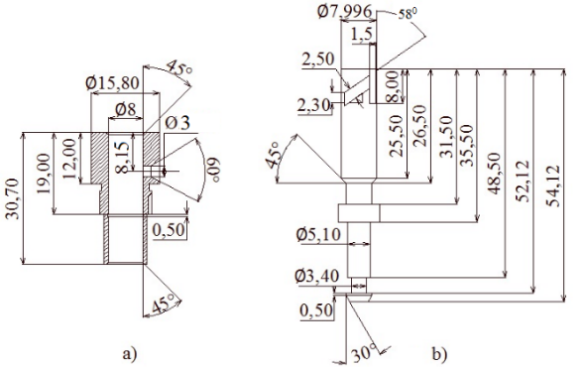
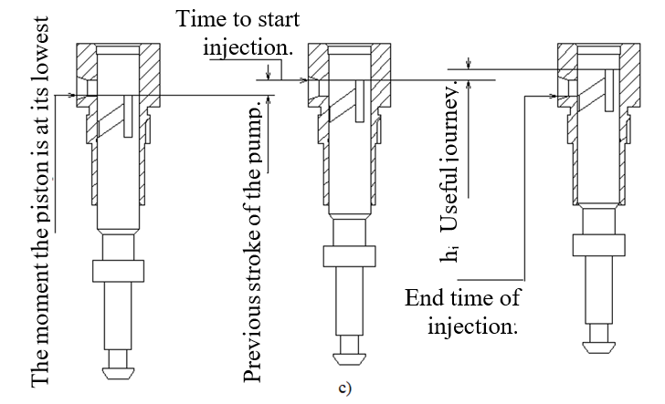
Figure 5. Measurement parameters of the high-pressure pump piston-cylinder duo. (a) Cylinder, (b) piston, (c) Pump working parameters.
Main parameters of piston and cylinder (Figure 5):
+ The mass of the piston is: m_{p} = 15.7 g.
+ Piston diameter: d_{p} = 7.996 mm.
+ Suction hole diameter: d_{lh} = 3.0 mm.
+ Spiral groove elevation angle (oblique): α = 32 degrees.
+ Spiral groove width (oblique): b = 2.5 mm.
+ Vertical chamfer width (vertical): b₁ = 1.5 mm.
+ Piston front stroke: h_{t} = 2.8 mm.
- Piston return spring: responsible for returning the pump piston during the cam lowering stroke. Make sure the roller of the roller is always in contact with the cam surface. The parameters of the piston return spring are shown in Figure 6:
+ Mass of piston return spring: m_{lx} = 16.6 g.
+ Number of twist steps: 5 steps.
+ Initial pressure of plunger piston spring: F₀ = 185 N.
+ Hardness: k = 32000 N/m.
+ Damping degree: C = 10 N.s/m.
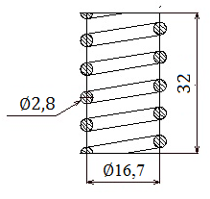
Figure 6. Measurement parameters of piston return spring.
- Roller jack: helps reduce friction during contact between the roller and cam. Thanks to that, the cam can rotate easily, avoiding the phenomenon of cam jamming. Has a total mass of 46.5 g (including spring stop disc and adjusting pad).
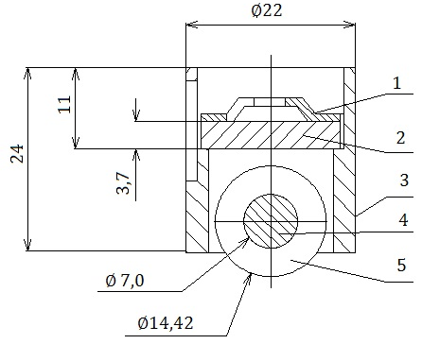
Figure 7. Measurement parameters of the roller handle. 1. Spring stop disc, 2. Adjusting pad, 3. Jack body, 4. Roller shaft, 5. Roller.
- Pair of high-pressure valves and high-pressure valve seats: Each pump unit is equipped with a high-pressure valve cluster, with the following tasks: Prevent gas from the engine cylinder from entering the high-pressure pump cylinder; Prevent fuel on the high pressure pipe from flowing back to the high pressure pump cylinder; Complete the fuel supply process decisively, avoiding the phenomenon of dropped spray.
The high pressure valve pair is a precision pair made of Cr15 alloy steel, the valve has a hardness after heat treatment of about HRC 56÷62 and the valve seat HRC 60÷64. The valve and valve seat must be ground together. The tightness of a high-pressure valve is usually checked by using compressed air with a residual pressure of 0.4 ÷0.5 MN/m², immersing the valve in a barrel of kerosene, there must be no air bubbles. Main parameters of high pressure valve assembly (Figure 8):
+ Mass of high pressure valve spring: m_{lxv} = 1.9 g.
+ Mass of high pressure valve: m_{v} = 2.2 g.
+ Valve spring hardness: k_{lxv} = 13500 N/m.
+ Valve spring damping degree: C_{lxv} = 5 N.s/m.
+ Valve seat hardness: k_{dv} = 50000000 N/m.
+ Valve seat damping degree: C_{dv} = 50 N.s/m.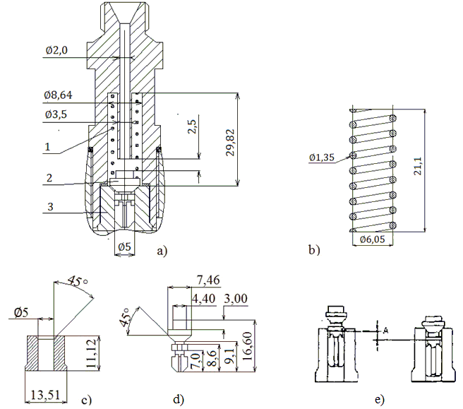
Figure 8. Measurement parameters of the valve duo and high pressure valve seat. (a) High pressure valve assembly, (b) high pressure valve spring, (c) High pressure valve seat, (d) High pressure valve, (e) High pressure valve lift stroke A, 1. High pressure valve spring , 2. High pressure valve, 3. High pressure valve seat.
- High-pressure pump camshaft: The camshaft is cast in one piece, designed with an almost straight beveled cam face, so as the cam lift stroke increases, the piston's movement speed increases, rapidly increasing fuel pressure.
Main parameters:
+ Base circle radius of cam: R=17.04 mm.
+ Roller radius: r_{roll}=7.21 mm.
+ Effective width of roller: b_{roll}=8.5 mm.
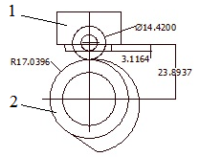
Figure 9. High pressure pump cam profile of Kubota D1703-M-DI engine. 1. Roller shaft, 2. High pressure pump camshaft.
b. High pressure hose
High-pressure steel pipe with high hardness, used to carry high-pressure fuel from high-pressure pump to high-pressure injector.
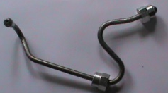
Figure 10. D1703-M-DI engine high pressure hose.
Main parameters:
+ Overall length: l = 325 mm.
+ High pressure oil hole diameter: d = 1.5 mm.
+ High pressure pipe wall thickness: δ = 1.5 mm.
c. High pressure nozzle
The Kubota D1703-M-DI engine uses a two-stage nozzle, the nozzle head is arranged with 5 spray holes with a diameter of about 0.2 mm distributed around with angles spaced about 75 degrees apart, to suit the Combustion chamber structure to create the best mixture. This injector will inject more fuel in the 2nd stage as the fuel pressure increases. The use of a 2-stage nozzle allows for reduced injection pressure to lift the injector, thereby improving low-speed injection stability as well as improving unloading capability. On the other hand, because the initial amount of fuel injection is small, it improves typing and smoothness of motion.
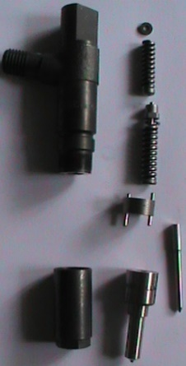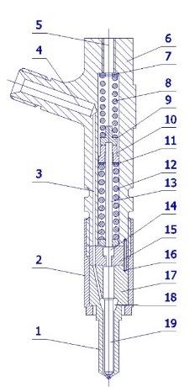
Figure 11. Structure of D1703-M-DI engine nozzle. 1. Injector body, 2. Locking nut, 3. Body longitudinal fuel pipe, 4. High pressure hose connection, 5. Oil return line connection, 6. Injector body, 7. Adjusting gasket, 8 . 1st stage spring, 9. Spring stop plate, 10. Guide tube, 11. Adjusting pad, 12. 2nd stage spring, 13. Push rod, 14. Intermediate connecting pin, 15. Setting base maximum injector lift stroke position, 16. Locating pin, 17. Nozzle body, 18. High pressure chamber, 19. Injector.
Two springs (No. 8 and No. 12) and push rod (No. 14 and No. 13) are located inside the nozzle body. A gap between pin 14 and pin 13 for fuel injection in this two-gap stage is called initial lift.
The initial lift, the tension of spring No. 8 (stage 1 fuel pressure) and the tension of spring No. 12 (stage 2 fuel pressure) are adjusted by replacing the corresponding adjusting pads. nominate them.
Stage 1 (Figure 12): when the fuel pressure increases due to the operation of the high-pressure pump and reaches about 190 kgf/cm², it overcomes the tension of spring number 8 and causes the injector to be pushed upward and injection begins. After pin 14 comes into contact with spring base 12, the lift of the injector does not change until the pressure increases to about 230 kgf/cm².
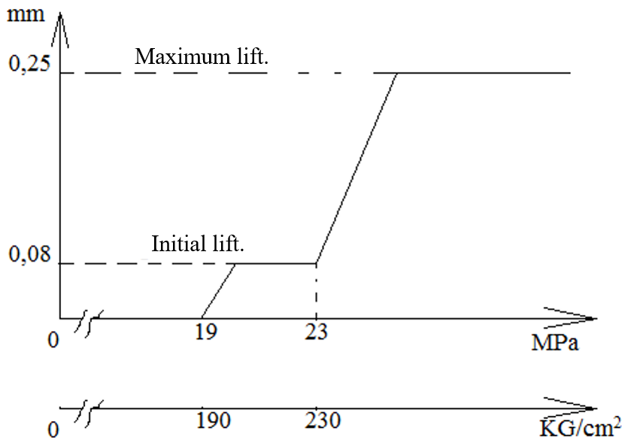
Figure 12. Graph of nozzle operating pressure evolution.
Stage 2 (Figure 12): when the fuel pressure reaches about 230 kgf/cm², it overcomes the tension of springs No. 8 and No. 12 and lifts the injector higher. Once the injector contacts the spacer (15), the needle lift will not change anymore even if the fuel pressure increases.
Therefore, when there is a light load applied to the engine, only a small amount of fuel is injected at the low lift stage, on the other hand under heavy load a small amount of fuel is injected at the initial lift stage, then 1 Large amounts of fuel are injected at a more advanced stage. The main parameters of the nozzle are shown in Figures 13 and 14.
+ Injector mass: m_{kim}= 2.9 g.
+ Spray hole length: mm.
+ Nozzle cavity diameter at hole: mm.
+ Injector base angle:.
+ Diameter of injector spring wire 1: dlx1 = 1.86 mm.
+ Average diameter of injector spring 1: dtb = 4.52 mm.
+ Mass of injector spring 1: m_{lx1} = 3.0 g.
+ Diameter of injector spring wire 2: d_{lx2} = 2.05 mm.
+ Average diameter of injector spring 2: d_{tb} = 5.25 mm.
+ Mass of injector spring 2: m_{lx2} = 4.4 g.
+ Number of injector spring steps 1,2: 10 steps.
+ Push rod mass: m_{tđ} = 1.2 g.
+ Mass of connecting pin: m_{cn} = 0.4 g.
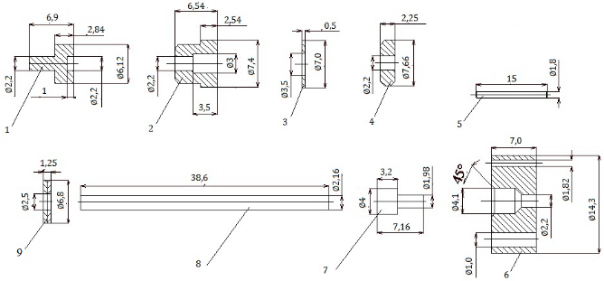
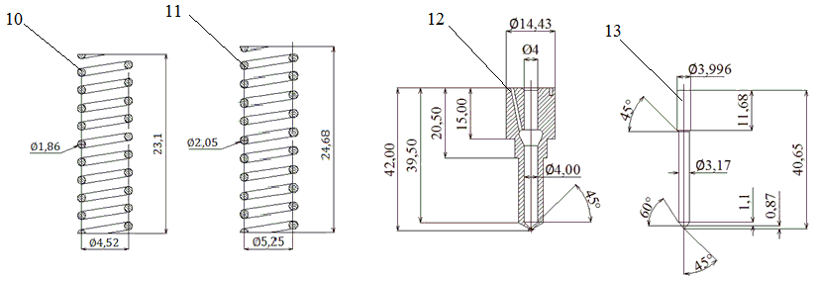
Figure 13. Parameters of high-pressure nozzle of Diesel engine D1703-M-DI. 1. 1st stage spray spring stopper disc, 2. Guide tube, 3. 2nd stage spray spring adjustment pad, 4. 2nd stage spray spring stopper disc, 5. Locating pin, 6. Fixing base maximum injector lift stroke position, 7. Intermediate connection pin, 8. Push rod, 9. Stage 1 injection spring adjustment pad, 10. Stage 1 injection spring, 11. Stage 2 injection spring, 12. Nozzle body, 13. Injector.
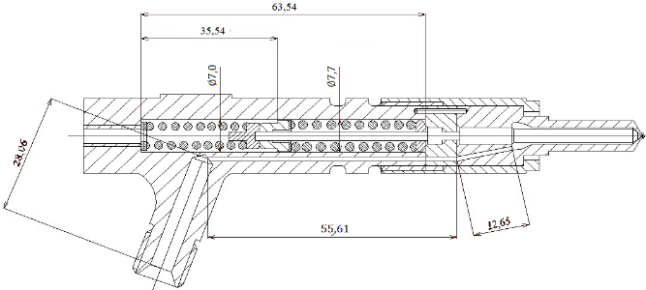
Figure 14. Basic parameters of the nozzle.
d. Combustion chamber shape
The Kubota D1703-M-DI Diesel engine uses a unified combustion chamber and ω-shaped piston top to create a vortex of air flow, improving the quality of mixture formation.
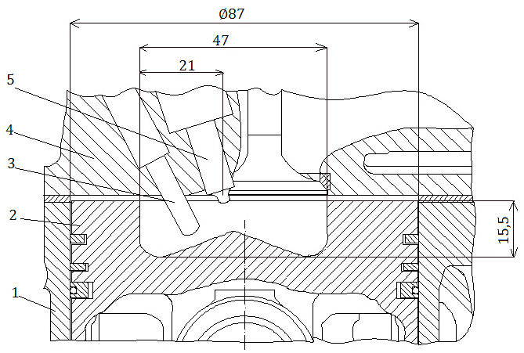
Figure 15. Combustion chamber parameters of Kubota D1703-M-DI Diesel engine. 1. Cylinder, 2. Piston, 3. Dryer shaft, 4. Engine cover, 5. Nozzle.
Conclusion: The quality of fuel injection in a Diesel engine (average fuel particle diameter, spray beam taper angle and spray beam length) will determine the quality of mixture formation and combustion. The quality of fuel injection depends on many parameters such as: fuel system structural parameters, operating conditions, engine type, fuel properties used, etc. to achieve the best fuel injection quality. We must research, calculate, and choose so that these parameters are the most optimal.
2.2. Build a model and simulate the fuel supply system of the Kubota D1703-M-DI Diesel engine
2.2.1. Algorithm diagram
Based on simulation theory, calculation on Hydsim software and based on the structure and actual working conditions of the Kubota D1703-M-DI Diesel engine fuel system. We have created a schematic diagram of the Kubota D1703-M-DI Diesel engine fuel supply system simulation program (Figure 16).
Simulated object.
Structural analysis.
Build simulation models.
Actual working conditions of the object.
Enter input data.
Fundamentals of object theory.
Characteristics of objects.
Data processing.
Export results:
- Relationship characteristics.
- Detailed set of parameters.
- Image.
True
False

Figure 16. Algorithm diagram of the simulation program.
2.2.2. Build simulation models
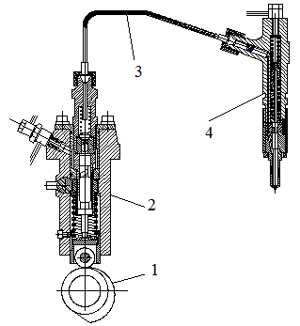
Figure 17. Main assemblies used for simulation. 1. High pressure pump camshaft, 2. High pressure pump assembly, 3. High pressure pipe, 4. Injector nozzle.
The main detailed assemblies used to simulate the Kubota D1703-M-DI Diesel engine fuel system (Figure 17), structurally are a combination of 3 main groups of elements: high pressure pump, pipes high pressure, and high pressure injectors.
The in-line high-pressure pump consists of 3 pump groups. The pump groups have completely the same structure, so the simulation is only performed for 1 pump group.
The structure of a pump unit includes: Cam (4) (convex cam) rotates thanks to the drive shaft, causing the pump piston to move up and down (piston plunger). The cam (4) has a convex cam lobe, so during its one revolution, the plunger piston goes up and down once. The cavity above the plunger piston is the pressure chamber (chamber before the high pressure valve). Fuel from the low-pressure pump enters the common intake chamber of the high-pressure pump (Pressure margin), then through the fuel inlet (inline inlet/overflow type) and then into the high-pressure pump chamber. Here, the fuel is compressed by the plunger piston, and the fuel is pushed through the high-pressure valve (the high-pressure valve has a pressure reducing rim) to the chamber behind the high-pressure valve (this chamber has residual pressure). From here, high-pressure fuel follows the high-pressure pipe to the high-pressure injector (high-pressure oil chamber that lifts the injector). Part of the fuel leaks through the gap between the plunger piston and the cylinder through the port to the fuel tank.
The high-pressure pipeline is responsible for transporting high-pressure fuel from the high-pressure pump to each injector. During the working process, there is the expansion and contraction of high pressure pipes.
High pressure fuel from the high pressure pipe follows the pipeline along the nozzle body to the high pressure chamber in the nozzle body. When the oil pressure applied to the injector cone surface is enough to overcome the injector spring tension (2 springs), the injector is lifted (2 stages), high-pressure fuel is injected into the engine combustion chamber through the spray hole on the nozzle head.
When the inclined groove on the pump piston head (metering groove) opens the inlet/pressure chamber in the high pump chamber before the high pressure valve suddenly decreases, the high pressure valve closes to reduce the high pressure oil pressure in the high pressure pipe and the return force. By pressing the high-pressure valve spring, the injector closes, ending the fuel injection process.
From analyzing the structural characteristics of the fuel supply system of the Kubota D1703-M-DI Diesel engine, we select the corresponding elements in Hydsim software to perform the simulation. Once the corresponding elements have been identified, we proceed to create a block model of the equipment in the fuel system.
a. Create a high pressure pump block model
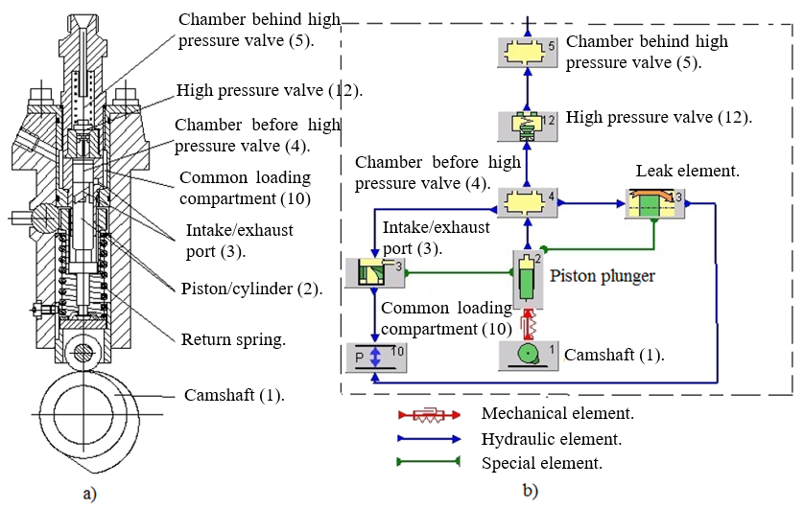
Figure 18. Model of Kubota D1703-M-DI Diesel engine high pressure pump block. (a) Real high-pressure pump structure, (b) High-pressure pump block model.
b. Create a high pressure pipeline block model

Figure 19. Kubota D1703-M-DI Diesel engine high pressure pipe block model.
c. Create a nozzle block model
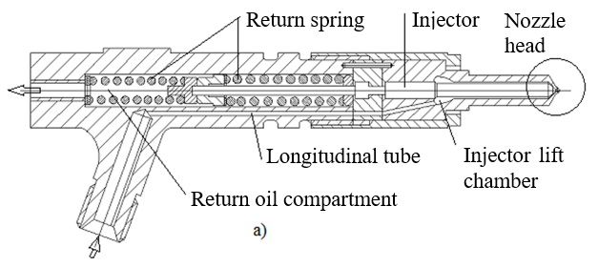
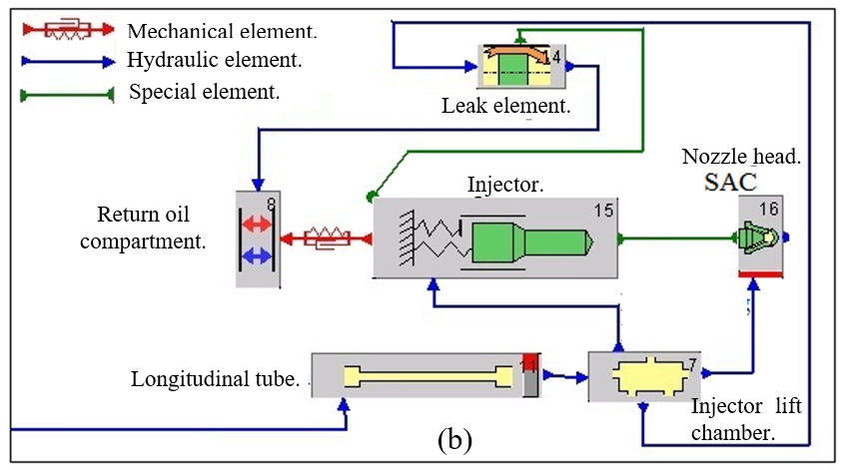
Figure 20. Model of Kubota D1703-M-DI Diesel engine high-pressure injector block. (a) Real structure of high-pressure nozzle, (b) block model of high-pressure nozzle.
d. Create a block model of the combustion chamber

Figure 21. Model of the combustion chamber block of the Kubota D1703-M-DI Diesel engine.
2.2.3. Simulation model of Kubota D1703-M-DI engine fuel system
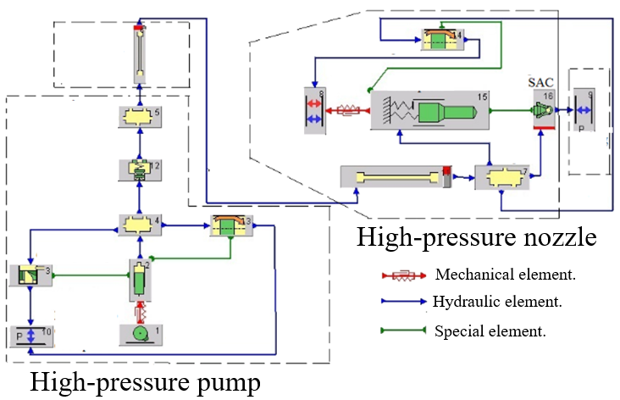
Figure 22. Simulation model of D1703-M-DI Diesel engine fuel system. 1. Camshaft (1), 2. Piston, 3. Intake/exhaust port, 4. Chamber before high pressure valve, 5. Chamber behind high pressure valve, 6. High pressure pipe, 7. Injector lift chamber, 8. Return oil compartment, 9. Combustion chamber, 10. Common loading compartment, 11. Longitudinal tube, 12. High pressure valve, 13,14. Leak element, 15. Injector, 16. Nozzle head SAC.
2.2.4. Analysis of simulation calculation mode of Kubota D1703-M-DI engine fuel supply system
The parameters of the fuel equipment, combustion chamber structure, charging mechanism, as well as engine rotation to ensure good atomization and mixture quality are designed with the rated working mode (revolution and rated load). Changing the engine's working mode causes the quality of the mist and mixture to deteriorate, affecting the economy, reliability and longevity of the engine.
a. Rated load mode
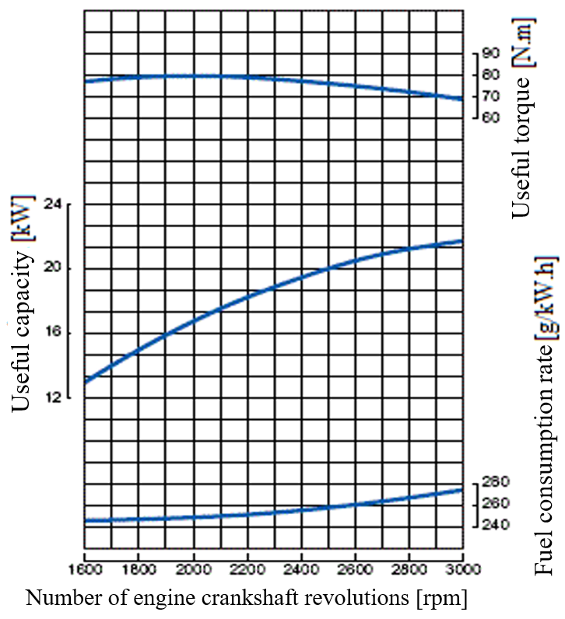
Figure 23. External speed characteristic graph of D1703-M-DI engine.
The characteristic parameter for the rated load mode at the rated number of revolutions and rated load is (h_{imax}: maximum useful stroke of the high-pressure pump piston). Based on the external speed characteristic graph of the D1703-M-DI engine (Figure 23) and the technical specifications of the D1703-M-DI engine, we can determine that the rated speed of the engine is 2800 rpm, rated power N_{e}= 22.7 kW. The remaining thing is to determine the himax. The amount of fuel supplied to a cylinder during a working cycle is calculated according to the following formula:²
[mm³] (1)
We have: τ = 4; i = 3;
The D1703-M-DI engine uses Diesel fuel so it has: ρ_{nl} = 0.82 g/cm³.
Considering the speed of 2800 rpm: look at the graph in Figure 23, we get: N_{e} = 22.7 kW; g_{e} = 265 g/kW.h.
Substitute numbers into equation (1). We get: V_{x} = 29,111 mm³.
From there we can calculate the useful stroke of the pump piston: h_{imax} ≈ 0.85 mm.
b. Idle mode
Idle mode is the mode in which the engine operates stably at the lowest speed when carrying no external load. The no-load mode corresponds to the smallest useful stroke of the high-pressure pump piston (h_{imin}).
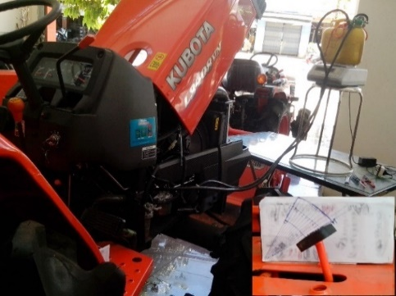
Figure 24. Measuring fuel consumption of Kubota D1703-M-DI engine.
Table 1. Engine fuel consumption without external load.
Accelerator pedal displacement (%) | 0 | 20 | 40 | 60 | 80 | 100
Amount of fuel consumed in 60 seconds (g) | 4 | 8.5 | 12 | 16 | 27 | 30.3
Number of crankshaft revolutions (rpm) | 1000 | 1600 | 2000 | 2400 | 2650 | 2800
Useful stroke of Himin pump piston (mm) | 0.08 | 0.11 | 0.12 | 0.13 | 0.21 | 0.22
From the results of measuring actual fuel consumption (Figure 24) according to the accelerator pedal stroke from 0% to 100% when the engine is not carrying a load (Table 1), with the error of the electronic weighing device being 0.1 g, we can determine the minimum useful stroke of the high-pressure pump piston corresponding to the no-load mode h_{imin} ≈ 0.08 mm.
c. Intermediate loading mode
Based on actual working conditions of the Kubota D1703-M-DI engine on the L3408VN tractor. We see, when the plow is operating (plowing), the engine mostly operates in the area of 80 ÷ 100% of the accelerator pedal stroke (the plow runs in 2nd gear) at a speed of 1600 ÷ 2000 rpm. However, when moving, changing direction, etc, the engine usually runs at an average load 40 ÷ 70% of the accelerator pedal stroke, with a speed of about 2000 ÷ 2800 rpm. Therefore, determining the useful stroke in local load modes is very complicated. For simplicity here, I choose to select the useful stroke at representative local load modes for general simulation as h_{itb}= 0.42 mm.
Conclusion: To clearly see the influence of structural parameters of the fuel system and engine operating mode (speed, load: useful stroke of high pressure pump) on the quality of the fuel supply process, we choose the simulation mode corresponding to 4 engine crankshaft speed positions: 1600, 2000, 2400, 2800 rpm. For each simulated speed position, we conduct a thin tissue corresponding to the 3 high-pressure pump rack positions: h_{imax} = 0.85 mm, h_{itb} = 0.42 mm and h_{imin} (Table 1).
2.2.5. Declare input data for elements
Declare input and output data for elements. Declaring boundary conditions and properties of Diesel fuel. Run the simulation and export the results.
3. ANALYSIS AND EVALUATION OF THE INFLUENCE OF STRUCTURAL PARAMETERS ON THE QUALITY OF FUEL SUPPLY PROCESS OF KUBOTA D1703-M-DI ENGINE
3.1. Influence of cam profile
The Kubota D1703-M-DI engine high-pressure pump camshaft is designed with high rigidity and a sudden growth profile (almost straight bevel).
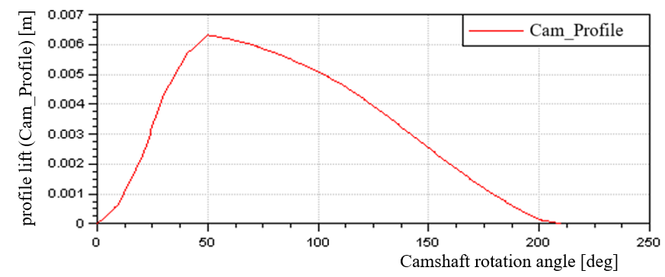
Figure 25. Lift graph of cam profile.
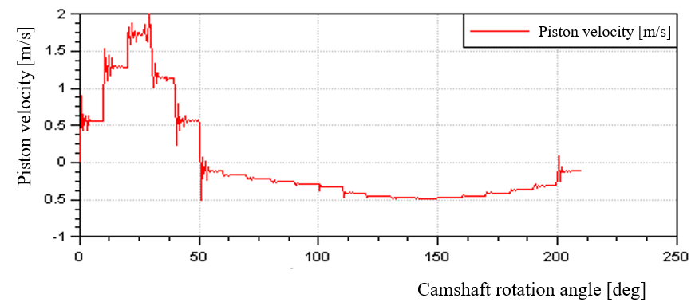
Figure 26. Graph of variation of pump piston displacement speed.
The lift of the cam profile is in the x direction (Figure 25). During the cam lift stroke, the piston is raised at high speed (Figure 26), the fuel pressure in the pump chamber increases rapidly, leading to high chamber pressure behind the valve. Pressure, high pressure pipe and injector lift chamber increase rapidly (Figure 27). When this pressure overcomes injector spring tension, the injector lifts up and injects fuel into the engine combustion chamber. The process of injecting fuel into the combustion chamber lasts until the inclined groove on the piston begins to open, and the injection process ends.
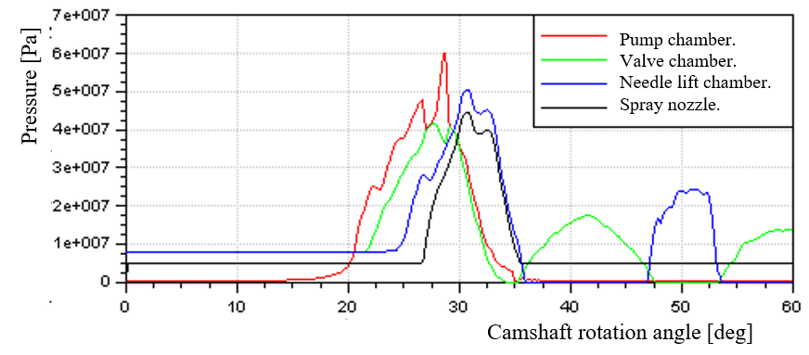
Figure 27. Graph of fuel pressure variation in the fuel system.
Due to the Influence of the sudden growth of the cam profile, the fuel pressure in the system increases rapidly. The compression stroke of the piston is turbulence, this turbulence is in the form of a pressure wave that propagates in the fuel like in an elastic medium with the speed of sound, this speed depends on the compressibility and fuel density. The pressure wave reaches the injector later than the fuel supply period. High injection pressure and fuel compressibility not only cause a phase shift in the fuel supply in the pump and nozzle, but also cause complex oscillatory motion of the fuel layer in the high-pressure pipeline, thus causing the circulation process to change. The movement of fuel through the injector orifice sometimes has a pulsating character. The source of pressure fluctuation interference is the movement of pistons, injectors and high-pressure valves. Due to strong fluctuations in fuel pressure, after closing, the injector can open repeatedly, causing spray drop. Fuel injection on the expansion line, poor atomization quality due to low injection pressure. Drop injection increases the combustion period on the expansion path and reduces engine economy.
In the delay and main injection stages, due to high fuel injection pressure, the fuel injection quality is quite good. The average fuel particle diameter is small and uniform (Figure 28), the spray beam taper angle (Figure 29) and the spray beam length (Figure 30) gradually increase. However, in the free-flow phase (fuel supply has stopped), the fuel injection process takes place thanks to the fuel compression energy and elasticity of the high-pressure pipeline, so the injection pressure gradually decreases, the diameter The average fuel particle increases, the spray beam taper angle and spray beam length gradually decrease.
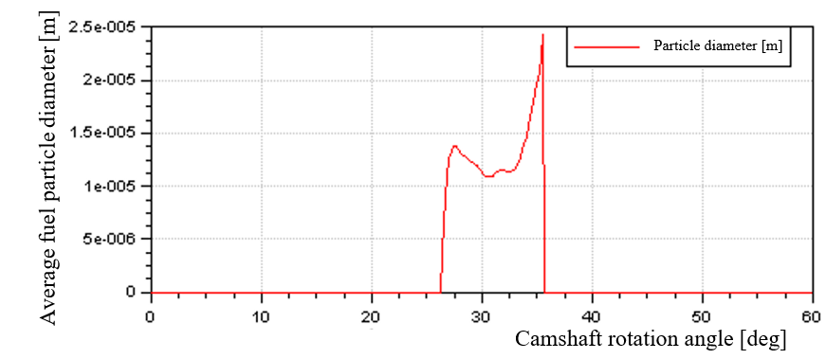
Figure 28. Graph of average fuel particle diameter variation.
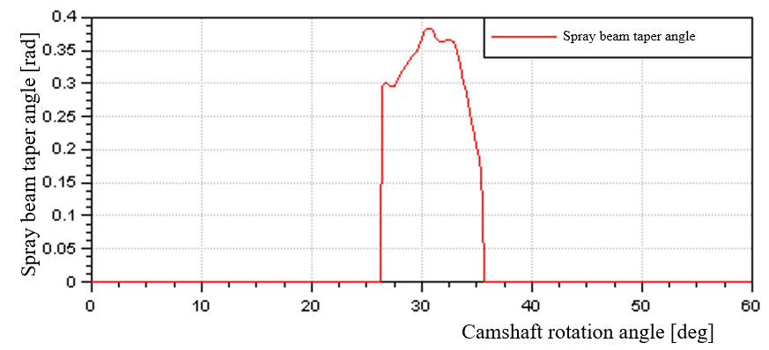
Figure 29. Graph of fuel injection beam cone angle variation.
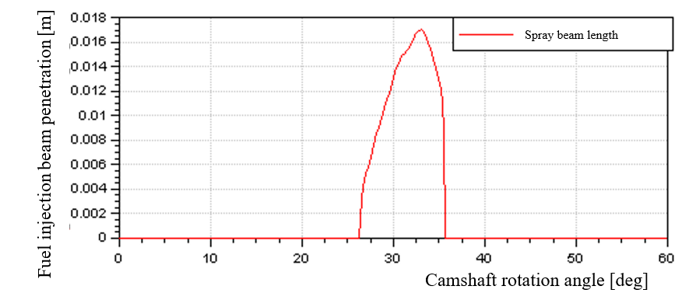
Figure 30. Graph of fuel injection beam length variation.
In general, the quality of fuel injection at the beginning and end of injection is not good, negatively affecting the quality of mixture formation and combustion, reducing engine economy, and causing environmental pollution. The quality of fuel injection is relatively good at about 30 ÷ 33⁰ camshaft rotation angle (average fuel particle diameter is small and even, spray beam taper angle is large, beam length is large enough.
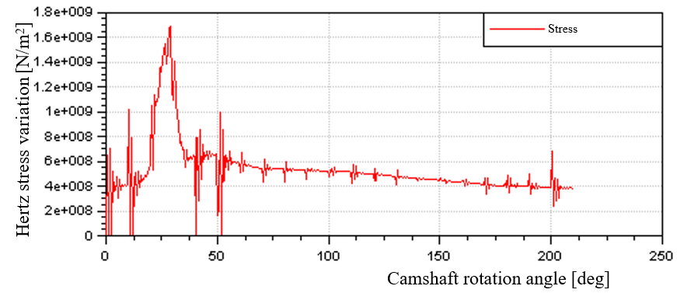
Figure 31. Hertz stress variation graph.
Value as well as variation of contact stress between roller file and convex cam during working process (Figure 31). The greatest stress at the position where the plunger piston goes up compresses the fuel with the highest pressure at about 28-29⁰ camshaft rotation angle (GQTC). Then the stress decreases rapidly corresponding to the moment the inclined groove on the piston head opens the exhaust port, the fuel pressure in the pump chamber suddenly decreases along with the elasticity of the high-pressure pump spring causing the stress to fluctuate strongly, then The stress gradually decreases when only the elastic force of the spring remains, causing the cam lowering stroke.
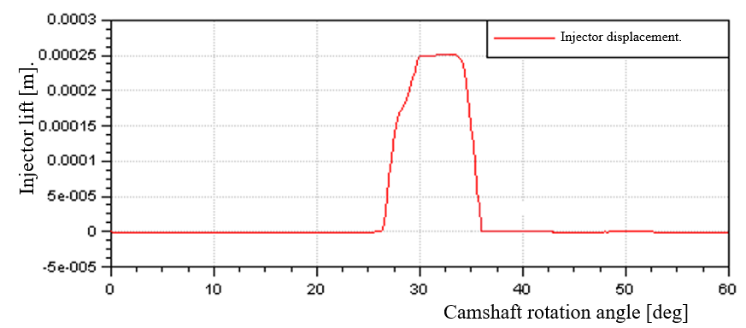
Figure 32. Graph of injector lift variation
Due to the sudden lift of the cam, the pressure in the injector lift chamber increases rapidly. The hydraulic force acting on the needle is very large, overcoming the tension of both injector springs, so the injector is lifted up to inject fuel into the engine combustion chamber. When fuel begins to be injected into the combustion chamber, the pressure in the injector lift chamber decreases slightly, then continues to increase, causing a slow increase in the injector lift stroke.
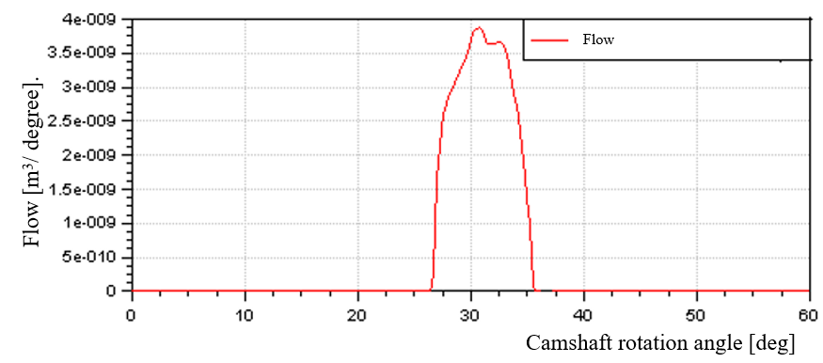
Figure 33. Graph of fuel injection flow variation
The amount of fuel supplied in one working cycle of a pumping unit corresponding to the rated mode is about 26 mm³ (Figure 34), at the beginning and end of the injection process, due to low injection pressure, the flow is small, the injection flow is the largest about 3.8 mm³/degree (Figure 33), injection time is about 0.00119 s.
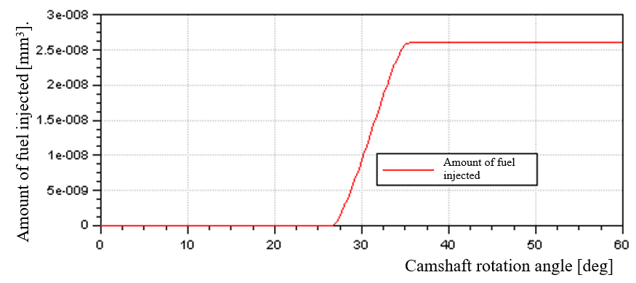
Figure 34. Graph of fuel injection volume variation in one cycle.
3.2. Influence of D/h_{i} ratio
To study the Influence of the ratio between piston diameter and useful stroke (D/h_{i}) on fuel injection quality under the same conditions. Corresponding to the same amount of fuel supplied for one engine cycle at rated load mode is 29.11 mm³. We choose the piston diameter to be 8, 7.5, 7, 6.5, 6 mm we can calculate the corresponding maximum useful journey: 0.85, 0.96, 1.11, 1.28, 1.50 mm.
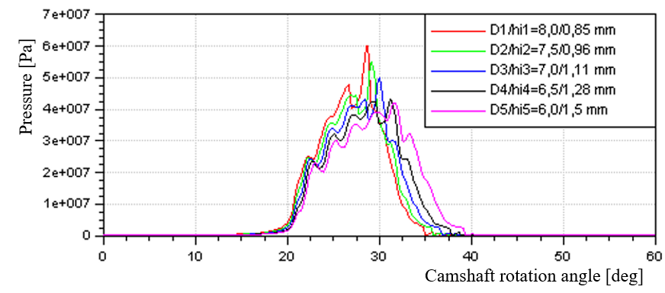
Figure 35. Influence of D/h_{i} ratio on pump chamber fuel pressure
Simulation results show that: the smaller the piston diameter, the larger the piston's useful stroke, the lower the pressure in the system and the larger the fluctuations (Figure 35). However, the pressure pulse at the end of the injection process has a gradually decreasing amplitude (Figure 36), meaning that the spray drop phenomenon is gradually overcome. As the pressure in the injector lift chamber decreases, the hydraulic force acting on the injector also decreases (Figure 37), so the injector lift gradually decreases (Figure 38). Therefore, the fuel circulation cross-section through the injector base also decreases (Figure 39). As a result, the fuel flow through the nozzle decreases (Figure 40), prolongs the fuel injection completion time, and negatively affects the process of mixture formation and combustion.
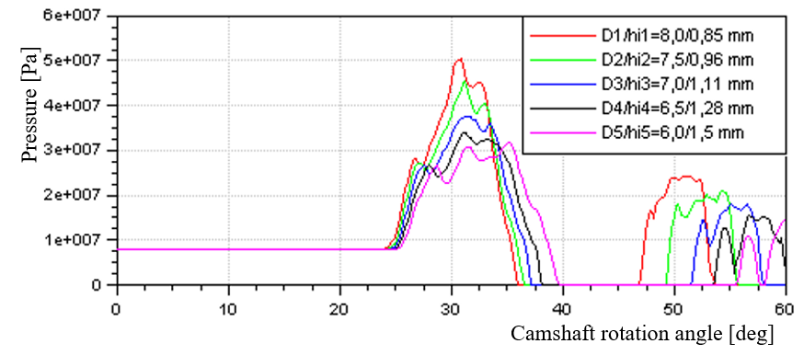
Figure 36. Influence of D/h_{i} ratio on injector lift chamber pressure.
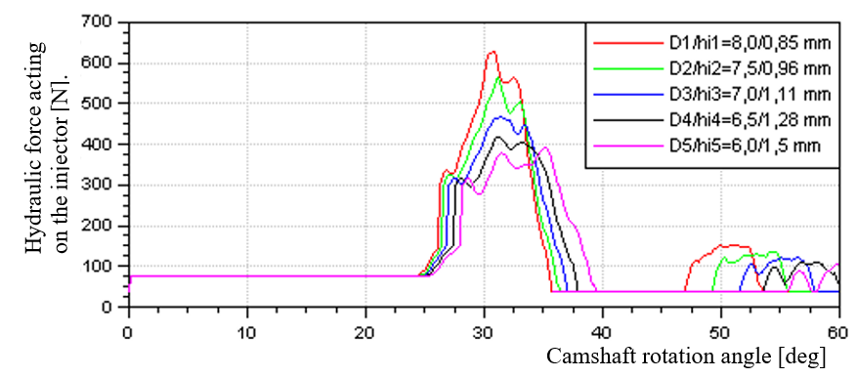
Figure 37. Influence of D/h_{i} ratio on hydraulic force acting on the injector.
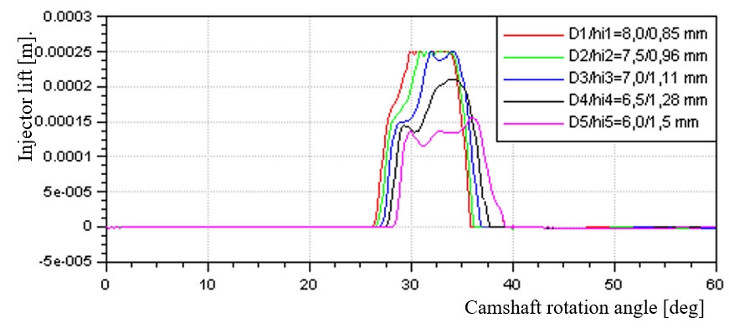
Figure 38. Influence of D/h_{i} ratio on injector lift.
As the piston diameter becomes smaller, the useful stroke of the piston becomes larger, we see: the injection start time is gradually delayed and the average particle diameter gradually increases (Figure 41), the spray beam taper angle decreases (Figure 42) and the direction of the spray beam decreases (Figure 42). The spray beam length gradually decreases (Figure 43) and the injection end time is gradually delayed, the average fuel particle diameter gradually decreases, the spray beam taper angle decreases (Figure 42) and the spray beam length gradually increases (Figure 43).
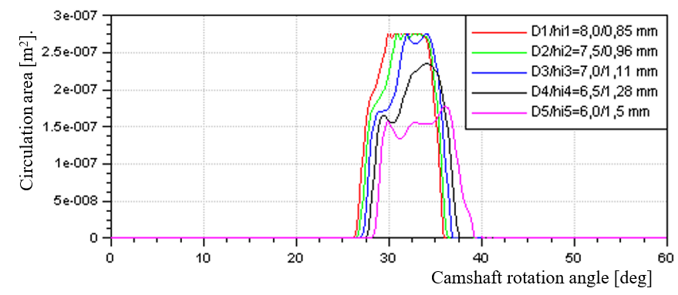
Figure 39. Influence of D/h_{i} ratio on the flow cross section to the injector.
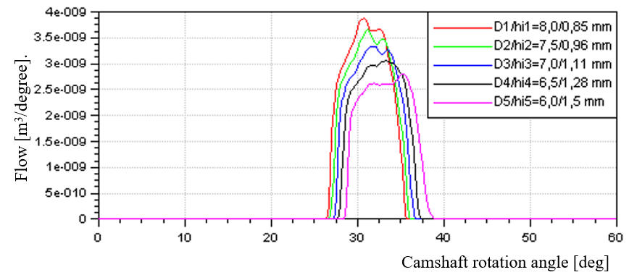
Figure 40. Influence of D/hi ratio on fuel injection flow.
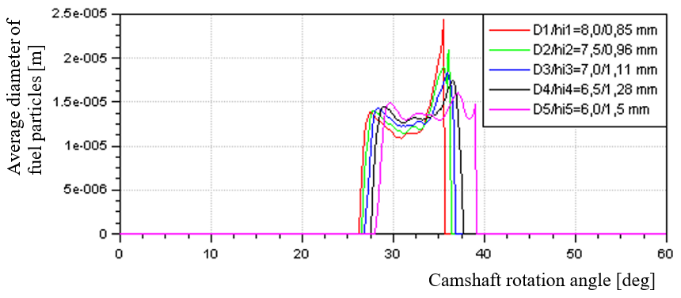
Figure 41. Influence of D/h_{i} ratio on average fuel particle diameter.
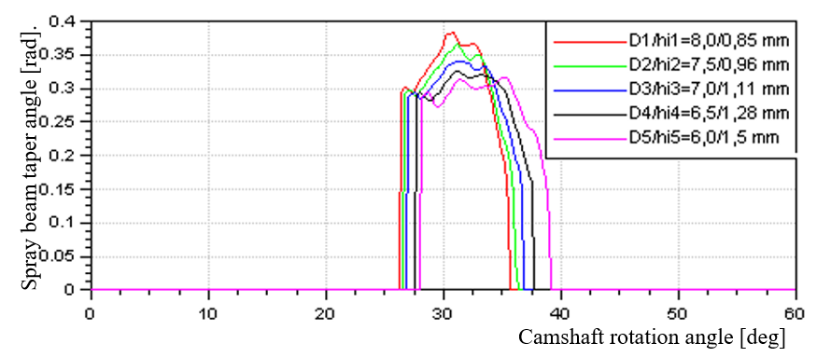
Figure 42. Influence of D/h_{i} ratio on fuel injection beam taper angle.
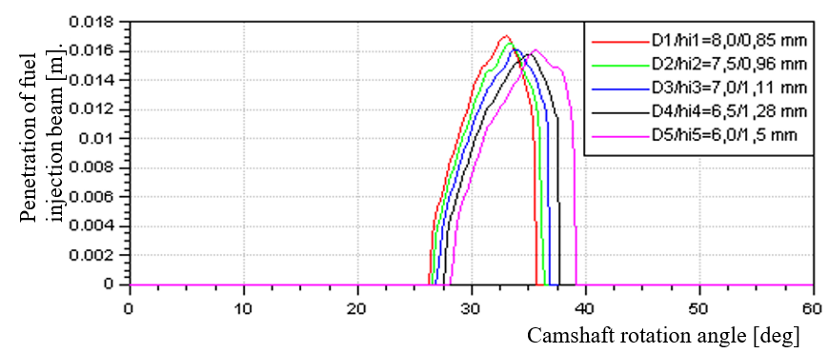
Figure 43. Influence of D/h_{i} ratio on fuel injection beam length.
Conclusion: When changing the D/h_{i} ratio, we see a huge change in the system's fuel injection quality. With the same amount of fuel supplied to a cycle, the more we reduce the piston diameter, the more useful stroke the pump piston will have. Therefore, the spraying time is longer. Due to the decrease in piston diameter, the instantaneous compressed fuel flow through the high pressure valve decreases, and the pressure in the system decreases. The force lifting the injector decreases, the fuel flow through the injector decreases, and the fuel flow leaking through the injector decreases. In general, the average fuel particle diameter is small and uniform throughout the injection process, the spray beam taper angle and spray length are reduced but not significantly.
3.3. Influence of nozzle diameter
When other conditions are equal. We change the nozzle hole diameter by 0.18, 0.22, 0.25 mm and 0.30 mm and run the simulation at rated load mode. To consider the impact on fuel injection quality compared to when the nozzle hole diameter is 0.20 mm. The results show that:
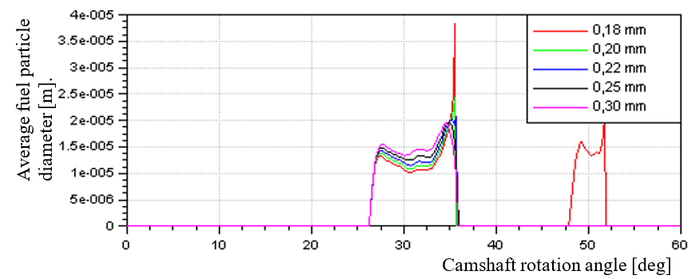
Figure 44. Influence of nozzle diameter on average fuel particle diameter.
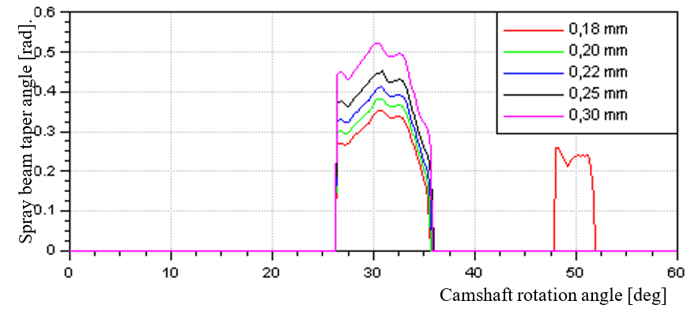
Figure 45. Influence of nozzle diameter on fuel injection beam taper angle.
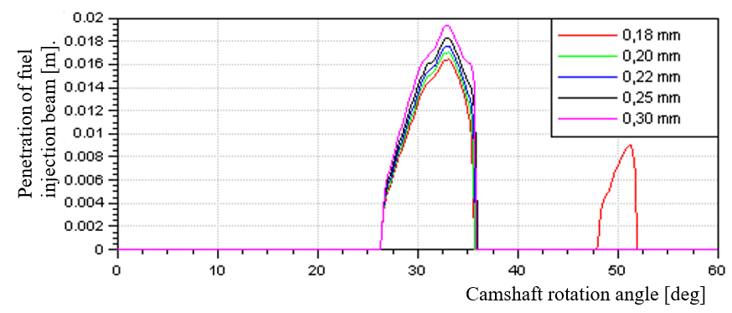
Figure 46. Influence of nozzle diameter on fuel injection beam length.
When the nozzle hole diameter is smaller (0.18 mm), the fuel flow through the nozzle is smaller (Figure 47), and the spray beam quality is uneven. In the delay and main injection stages, the average fuel particle diameter is the smallest (0.1÷0.13) μm, but in the free injection stage at the end of the injection process, the average fuel particle diameter is 0.38 μm (Figure 44), the spray beam taper angle (Figure 45) and the spray beam length are too small (Figure 46) and when spraying starts at the nozzle mouth, mist often condenses into mist, and at the end of the spraying process. There is a phenomenon of spray drop due to pressure pulsation in the system. Adversely affects the quality of the mixture formation and combustion process, reduces engine economy and causes environmental pollution.
As the nozzle hole diameter becomes larger, the fuel flow through the nozzle increases (Figure 47), so the fuel injection pressure gradually decreases (Figure 48). This results in the average fuel particle diameter gradually increasing (Figure 44), the spray beam taper angle gradually increasing (Figure 45) and the spray beam length gradually increasing (Figure 46), and the average final fuel particle diameter is too high. spraying process gradually decreases. At the same time, it overcomes the phenomenon of creating pressure pulses in the system, avoiding the phenomenon of spray drops. However, the diameter of the nozzle hole must not be too large, leading to the average diameter of the fuel particles being too large, rough, difficult to tear apart, and evaporation slow, leading to poor mixture formation quality.
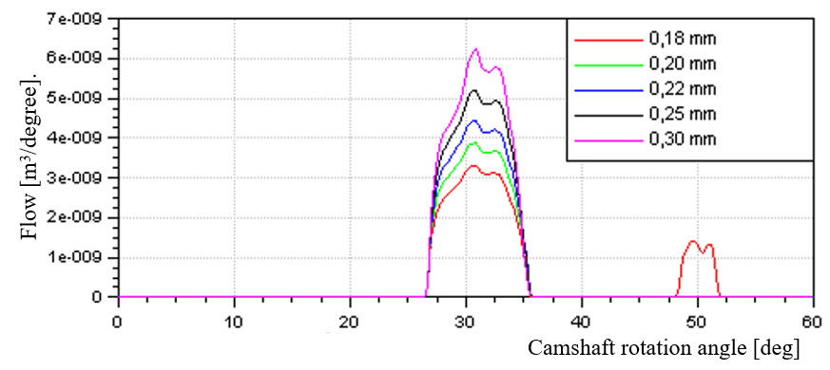
Figure 47. Influence of nozzle diameter on fuel injection flow.
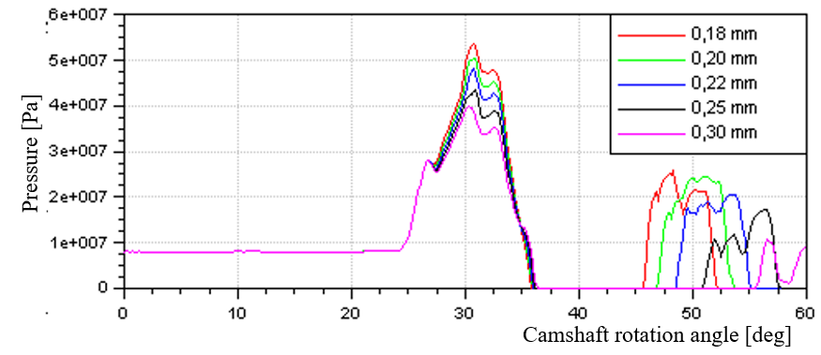
Figure 48. Influence of injection hole diameter on injector lift chamber pressure
Conclusion: when increasing the nozzle diameter of the nozzle from 0.20 mm to 0.22, 0.25, 0.30 mm the spray circulation area will increase, the amount of fuel injected will increase, and the fuel flow will increase. large amounts. Therefore, the oil pressure in the injector lift chamber decreases, leading to an increase in the average fuel particle diameter, an increase in the spray taper angle and an increase in the spray length (poor tearing level). In this case, we see a decrease in fuel flow leaking through the injector.
When reducing the nozzle diameter of the nozzle from 0.20 mm to 0.18 mm the spray circulation cross-section will be reduced, the amount of fuel injected and the fuel injection flow will decrease. Therefore, the oil pressure in the injector lift chamber increases and the injector opens large, leading to a decrease in the average fuel particle diameter, a decrease in the spray taper angle and a decrease in the spray length (due to too strong tearing). In this case, we see an increase in the amount of fuel leaking through the injector. However, in this case, pressure pulses appear, causing spray drop, negatively affecting the quality of the mixture formation process.
3.4. Influence of nozzle length
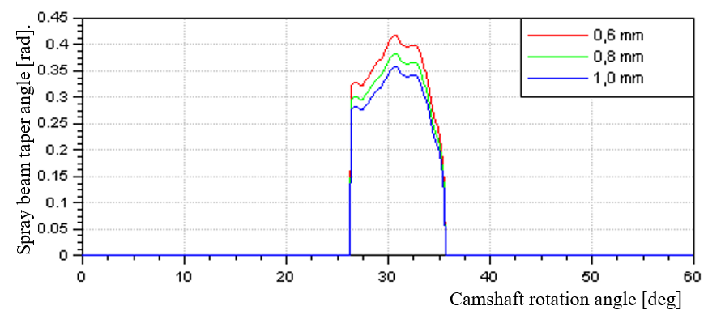
Figure 49. Influence of nozzle length on spray beam taper angle.
When we increase the nozzle length from 0.8 mm to 1.0 mm, we see that the spray cone angle decreases and vice versa, when we decrease the nozzle length from 0.8 mm to 0.6 mm, the beam taper angle decreases. spray increases.
3.5. Influence of nozzle spring stiffness
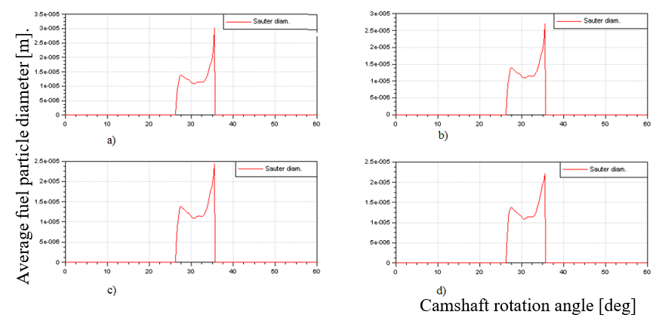
Figure 50. Influence of injector spring stiffness on average fuel particle diameter. (a) k₁=200000 N/m and k₂=300000 N/m, (b) k₁=225000 N/m and k₂=325000 N/m, (c) k₁=250000 N/m and k₂=350000 N/m, (d) k₁=275000 N/m and k₂=375000 N/m.
When changing the stiffness of the two injector springs with other conditions remaining constant. We can see that the greater the injector spring stiffness, the better the fuel injection quality, the smaller and more uniform the average diameter of fuel particles at the end of the injection process. However, the hardness of the two injector springs must not be too high, which will affect the injector lift and fuel circulation cross-section through the injector base.
4. CONCLUSION
Through the process of researching and applying HydSim software to simulate, analyze and evaluate the influence of structural parameters on the quality of the fuel supply process of the D1703-M-DI engine, we see that Hydsim is A software used to simulate and calculate the fuel system is quite powerful. The simulation parameters achieved are close to the actual parameters of the engine, the simulation results accurately and clearly reflect the influence of structural parameters, operating conditions, and combustion chamber pressure on quality. fuel injection.
During the implementation of the project, with many runs and tests, the desired analytical results were achieved. In general, the quality of the fuel injection beam is satisfactory, but there are some limitations such as: at high speeds and large loads, the average diameter of fuel particles at the end of the large injection process, there is a phenomenon of spray drop; The fuel injection beam taper angle is small, the spray penetration is small (L/S<1.05). To improve fuel injection quality we can proceed by:
- Because the cam profile is not reasonable, the pressure in the system increases suddenly and fluctuates strongly. When the engine operates at high speed and high load at the end of the injection process, because the pressure in the system is still large and fluctuates strongly, the injector does not close tightly, leading to the injection falling.
- The diameter and useful stroke of the pump piston are not suitable, combined with the sudden growth of the cam profile and high operating speed, the time for fuel injection into the combustion chamber is too short, the free flow injection period is long, the pressure drops sharply so the average diameter of fuel particles at this stage is large, negatively affecting the quality of mixture formation and combustion. According to the simulation results of section 3.2, the best spray quality is selected with a piston diameter of 7 mm and a piston stroke of 1.11 mm.
- The nozzle hole diameter is small, so when the engine operates at high speed and high load, the injector opens repeatedly, causing spray to drop or spray on the expansion line. According to the simulation results in section 3.3, the best spray hole diameter is from 0.22 ÷ 0.25 mm.
- The length of the spray hole only affects the spray beam taper angle. Due to the large design nozzle length, the spray beam taper angle is small, and the ability to fill the combustion chamber space is not good. Therefore, the mixing quality is not good, the larger the spray beam, the better. According to the simulation results of section 3.4, we need to reduce the spray hole length to 0.6 mm.
- The injector hardness is not suitable and small, causing the injector to close slowly and not decisively, leading to dropped injection, spraying on the expansion path, and the average size of fuel particles at the end of the injection process is large. According to the simulation results in section 3.5, it is necessary to increase the injector hardness (K₁=275000 N/m and K₂=375000 N/m).
In addition, other structural parameters of the fuel system such as: pump spring stiffness, high pressure pipe length, viscosity of fuel used, ... and the influence of operating parameters such as: speed The degree of the high-pressure pump camshaft, the useful stroke of the high-pressure pump (h_{i}), and the compressed air pressure in the combustion chamber at the time of fuel injection also need to be thoroughly studied as a whole. From there, we propose solutions to improve this engine fuel system to become more complete and more suitable for operating conditions in our country.
Acknowledgment
This study is conducted within the framework of science and technology projects at institutional level of Quy Nhon University under project code T2023.808.18.

REFERENCES
1. Viet Dung Duong. Textbook of the course Internal Combustion Engine Structure, Danang Polytechnic University, University of Danang, 2007.
2. Van Ga Bui, Thi Bong Van, Xuan Mai Pham, Van Nam Tran, Hai Tung Tran Thanh. Cars and environmental pollution, Education Publishing House, Hanoi, 1999.
3. Viet Luong Le. Diesel Engine Theory, Education Publishing House, 2000.
4. Ngoc Tuoc Vu. Computer modeling and simulation, Education Publishing House, 2001.
5. Hydsim Reference Manual v2013.2, AVL LIST GmbH, 2013.
6. Anton Beer. Diesel fuel injection, Robert Bosch Gmbh, 1994.
7. Kubota-03 series Diesel engine, KUBOTA Corporation, Japan, 2009.
8. Rolf Reit-Roger Krieger. Diesel fuel injection and sprays, Society of automative engineers, Inc, 1998.
9. T.Uzkan. Fuel injection and combustion, The internal combustion engine division, ASME, 1990.

Liên hệ: Nguyễn Quốc Hoàng, Bộ môn Kỹ thuật ô tô.
Trường Đại học Quy Nhơn.
170 An Dương Vương, TP. Quy Nhơn, tinh Bình Định, Việt Narn.
Email: nguyenquochoang@qnu.edu.vn
Điện thoại: 0984894212

