Tăng cường khả năng bắt giữ khí SO₂ của
M₂(BDC)₂TED (M = Mg, V, Co, or Ni) bằng nghiên cứu
tính toán

Nguyễn Quang Vinh¹, Nguyễn Trương Mỹ Duyên^{1,2}, Nguyễn Lê Bảo Trân¹,
Nguyễn Thị Xuân Huynh^{1,∗}

¹Khoa Khoa học Tự nhiên, Trường Đại học Quy Nhơn, 170 An Dương Vương, Quy Nhơn, Bình Định
²Trung tâm Khám phá khoa học và Đổi mới sáng tạo, 10 Đại lộ khoa học, Quy Nhơn, Bình Định

*Tác giả liên hệ chính. Email: nguyenthixuanhuynh@qnu.edu.vn

TÓM TẮT
cm)
Cùng với việc phát triển các nguồn năng lượng sạch bền vững thì bảo vệ môi trường là vấn đề hết sức cấp thiết vì không khí ngày càng ô nhiễm bởi các khí độc hại. Trong đó, khí SO₂ ảnh hưởng nghiêm trọng đến sức khỏe con người. Do đó, việc loại bỏ khí SO₂ làm sạch môi trường sống là vô cùng cấp bách. Đã có rất nhiều công nghệ khác nhau được đề xuất để giải quyết vấn đề này nhưng chưa thực sự hiệu quả. Sự nổi lên của vật liệu xốp có bề mặt riêng cực lớn và tính xốp siêu cao đã thu hút nghiên cứu bắt giữ khí SO₂. Trong đó, vật liệu khung hữu cơ kim loại rất được quan tâm trong lĩnh vực hấp phụ, tách lọc và một số ứng dụng tiềm năng khác. Trong nghiên cứu này, nhóm M₂(BDC)₂TED (M = Mg, V, Co, Ni) được chọn để nghiên cứu bắt giữ SO₂ bằng phương pháp mô phỏng. Nghiên cứu được thực hiện tại nhiệt độ phòng 298 K và áp suất đến 2,5 bar. Kết quả chỉ ra thứ tự của kim loại làm tăng dần lượng khí SO₂ hấp phụ trong M₂(BDC)₂(TED) là: Co < Ni < V < Mg. Tại 298K và 2.5 bar, lượng hấp phụ SO₂ trong Mg-MOF lớn nhất là khoảng 16 mmol/g và khoảng 13 – 14 mmol/g cho các M-MOF còn lại (M = V, Ni, Co). Nghiên cứu cũng làm sáng tỏ các yếu tố làm tăng cường hấp phụ SO₂ trong M-MOFs nói trên gồm nhiệt hấp phụ, diện tích bề mặt riêng (SSA) và thể tích rỗng (V_{p}$)$. Đáng kể nhất là SSA và V_{p} của M-MOFs gần như làm tăng tuyến tính khả năng bắt giữ SO₂ ở nhiệt độ phòng và áp suất thấp.
Từ khóa: M₂(BDC)₂TED, Monte Carlo chính tắc lớn, Bắt giữ SO₂, Diện tích bề mặt riêng, Thể tích rỗng.

Computational study on enhancing SO₂ capture capacity of M₂(BDC)₂TED (M = Mg, V, Co, or Ni)

Nguyen Quang Vinh¹, Nguyen Truong My Duyen^{1,2}, Nguyen Le Bao Tran¹,
Nguyen Thi Xuan Huynh^{1,*}

¹Faculty of Natural Sciences, Quy Nhon University, 170 An Duong Vuong, Quy Nhon, Binh Dinh
²ExploraScience Quy Nhon, 10 Science Avenue, Quy Nhon, Binh Dinh.

*Corresponding author. Email: nguyenthixuanhuynh@qnu.edu.vn

ABSTRACT
cm)
Along with finding and developing sustainable clean energy sources, environmental protection is highly urgent because the air is increasingly polluted by more and more toxic gases. In particular, the presence of toxic gas SO₂ seriously affects human health. Therefore, removing toxic SO₂ gas to clean the living environment is extremely urgent. Many technologies have been suggested to solve this problem but have not been effective yet. In recent years, the emergence of porous materials with ultra-large specific surface areas and ultra-high porosity has attracted the attention of scientists in SO₂ capture. Among porous materials, metal-organic frameworks are intensely interested in adsorption, separation, and other potential applications. Here, we select the porous materials M₂(BDC)₂TED (M = Mg, V, Co, Ni) to study the SO₂ capture using simulation approachs. The research was performed at room temperature 298 K and pressure under 2.5 bar. Our results show that the order of metals gradually increasing the SO₂ adsorption uptake in M₂(BDC)₂(TED) is Co < Ni < V < Mg. Specifically, at 298K and 2.5 bar, the amount of SO₂ adsorption is about 16 mmol/g for Mg-MOF, and about 13 – 14 mol/g for the M-MOF (M = V, Ni, Co). The study also elucidated the influencing factors that enhance SO₂ adsorption in M₂(BDC)₂TED, including adsorption isosteric heat, specific surface area, and pore volume. Noticeably, the specific surface areas and pore volumes of M-MOFs almost linearly enhance the SO₂ capture capability at room temperature and low pressure.
Keywords: M₂(BDC)₂TED, Grand canonical Monte Carlo, SO₂ capture, Specific surface area, Pore volume.

1. INTRODUCTION
Sulfur dioxide (SO₂) is a colorless, non-flammable, and common pollutant in industrial production as well as daily life. Exposure to SO₂ may irritate the nose, throat, and eyes. Besides, SO₂ is a corrosive gas with high solubility (120 g/l) in water and can combine with water and air to form sulfuric acid, the main component of acid rain.^{1,2,3} Despite the low SO₂ content in the air, it is classified as a toxic gas and one of the six most common environmental pollutants by the US Environmental Protection Organization.⁴ Notably, significant amounts of sulfur oxides (SO_{x}), especially SO₂, are released into the environment after the combustion of petroleum-based fuels in internal combustion engines utilized in motorized vehicles.³ Therefore, removing or reducing the quantities of SO₂ in the atmosphere is exceptionally urgent. Among many technologies, SO₂ capture based on the adsorption mechanism has been remarkable.⁵ Metal-organic frameworks (MOFs) among porous materials are an exciting alternative for SO₂ capture due to outstanding structural properties such as ultrahigh surface area, high porosity, and controllable structural characteristics.^{2,4} Therefore, SO₂ capture in nano-porous materials has attracted scientific interest. Many MOFs and other porous candidates have been studied and highly appreciated for SO₂ adsorption. Fu and co-workers showed that functionalized covalent triazine framework (CTF–CSU41) achieved the highest uptake of SO₂ with a maximum capacity of 6.7 mmol/g (i.e., 42.9 wt%) at (298 K, 0.15 bar).^{3,6} For MOFs, MOF-177 exhibited the highest SO₂ uptake with 25.7 mmol/g at (293 K, 1 bar). Some other MOFs also showed high SO₂ capture capacity, ranging from 4,8 to 17,3 mmol/g.³ Besides many other MOFs, M₂(BDC)₂(TED) or M(BDC)(TED)_{0.5} materials have been attractive for applications in capturing toxic gases (CO₂, SO₂, CH₄, NH₃, H₂S, NO_{x}, …).⁴ In this research, we use simulations to find optimum M₂(BDC)₂(TED) MOFs for SO₂ capture, where M is magnesium (Mg), vanadium (V), cobalt (Co) or nickel (Ni); BDC = 1,4-Benzenedicarboxylate; TED = Triethylen-diamine or DABCO: 1.4-Diazabicyclo[2.2.2]octane.⁷
2. COMPUTATIONAL PHYSICS
The research approach combines density functional theory (DFT) calculations and grand canonical Monte Carlo (GCMC) simulations. Firstly, we used DFT calculations to optimize the geometries of M₂(BDC)₂(TED) MOFs, namely M-MOFs. Secondly, GCMC simulations were used to obtain the isotherms and isosteric heat of SO₂ adsorption as well as calculate the structural characteristics of the M-MOFs.
To optimize the unit cell and extract partial atomic charges of the M-MOFs, we utilized the Vienna ab initio simulation package (VASP)^{8,9} for the van der Waals dispersion-corrected density functional theory (vdW-DF).^{10,11} The plane-wave basis set with the cut-off energy of 700 eV for the plane-wave basis set.^{12,13} We performed the surface Brillouin-zone integrations using the Monkhorst and Pack k-point sampling technique with the 3×3×3 mesh grid and the Gamma point at the center.¹⁴ The Methfessel-Paxton smearing of order 1 was used for the ions and geometry relaxation, and atomic charge calculation with the smearing width sigma of 0.1 eV.¹⁵
GCMC simulations using the RASPA code were selected to study the gravimetric uptakes of SO₂ in the M-MOFs.¹⁶ These simulations were performed in constant volume, temperature, and chemical potential at room temperature (298 K) and pressures up to 2.5 bar. The number of 300,000 MC steps were simulated for the random insertion, deletion, translation, and rotation of SO₂ molecules in the simulation box, repeated 3×3×3 times of the primary unit cell along the a, b, and c lengths.
The interactions between atoms of SO₂ gas and the MOFs were described by ($i$) the Coulombic or electrostatic interactions with its cut-off radius of 13 Å, and ($ii$) the van der Waals interactions with the simple Lennard-Jones (LJ) model with the
LJ cut-off radius of 20 Å.^{17,18} The cut-off radius and other parameters were carefully checked before performing the GCMC simulation. The partial charges of atoms of the M-MOFs were extracted from the density-derived electrostatic and chemical (DDEC6) atomic charges method, listed in Table 1, with the symbols for the atoms shown in Figure 1.^{19–22} The qualities of the LJ potential well depth and diameter were determined by the Lorentz−Berthelot combining rules, one of the most common types of mixing rules for unlike atoms.^{23,24} The parameters for $σ_{i}$ and $ε_{i}$ ($i$ refers to the atoms like Fe, H, C, O in the M-MOFs or S, O in SO₂) were selected from the generic force fields for MOFs in the RASPA software package.^{16,25}
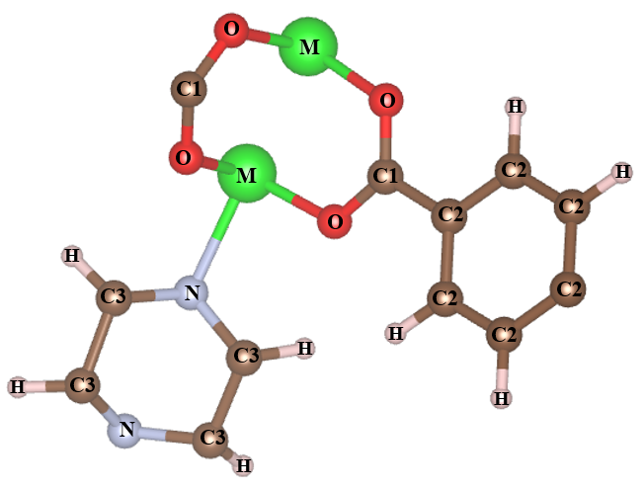
Figure 1. The symbol for atomic types with different charges of M-MOFs.
Table 1. The LJ (ε, σ) and charge parameters (q) for atomic types of M-MOFs and SO₂.
M-MOFs | Atomic types | LJ parameters |  | $q$ (e)
M-MOFs | Atomic types | $ε/k_{B}$$ε/k_{B}$ (K) | σ (Å) | $q$ (e)
M = Mg | C1 | 47.856 | 3.472 | 0.739
M = Mg | C2 | 47.856 | 3.472 | -0.073
M = Mg | C3 | 47.856 | 3.472 | 0.011
M = Mg | H | 7.648 | 2.846 | 0.088
M = Mg | N | 38.949 | 3.262 | -0.362
M = Mg | O | 48.158 | 3.033 | -0.721
M = Mg | Mg | 55.857 | 2.691 | 1.385
M = V | C1 | 47.856 | 3.472 | 0.627
M = V | C2 | 47.856 | 3.472 | -0.073
M = V | C3 | 47.856 | 3.472 | -0.012
M = V | H | 7.648 | 2.846 | 0.076
M = V | N | 38.949 | 3.262 | -0.174
M = V | O | 48.158 | 3.033 | -0.574
M = V | V | 8,051 | 2,801 | 0.926
M = Co | C1 | 47.856 | 3.472 | 0.613
M = Co | C2 | 47.856 | 3.472 | -0.071
M = Co | C3 | 47.856 | 3.472 | -0.025
M = Co | H | 7.648 | 2.846 | 0.076
M = Co | N | 38.949 | 3.262 | -0.099
M = Co | O | 48.158 | 3.033 | -0.491
M = Co | Co | 7.045 | 2.558 | 0.573
M = Ni | C1 | 47.856 | 3.472 | 0.636
M = Ni | C2 | 47.856 | 3.472 | -0.071
M = Ni | C3 | 47.856 | 3.472 | -0.025
M = Ni | H | 7.648 | 2.846 | 0.079
M = Ni | N | 38.949 | 3.262 | -0.118
M = Ni | O | 48.158 | 3.033 | -0.539
M = Ni | Ni | 7.548 | 2.524 | 0,660
SO₂^{25,26} | O | 58.725 | 3.198 | -0.201
SO₂^{25,26} | S | 189.353 | 3.410 | 0.402
3. RESULTS AND DISCUSSION
3.1. Optimization of the unit cell of M₂(BDC)₂(TED)
First, we constructed a unit cell based on experimental and computational works for Ni₂(BDC)₂(TED) (BDC = Benzene dicarboxylate, and TED = Triethylenediamine) (Figure 2).^{4,27} We optimized all ions and the size of the unit cells. Then, we replaced Ni with other bivalent metals such as Mg, V, and Co, which often appear in MOFs and greatly influence gas adsorption. The results obtained for the unit cells are listed in Table 2 and compared with the experimental data for
M = Ni,²⁷ showing that these optimal results show reliability with 1.61%, 1.57%, and 4.81% for a (or b), c lengths, and the cell volume. The unit cell volume (V_{M-MOF}) of the M-MOFs also does not change much, and they are in slightly increasing order: V_{Co-MOF} < V_{V-MOF} ≈ V_{Ni-MOF} < V_{Mg-MOF}.
: Metal  : Oxygen  : Carbon  : Nitrogen  : Hydrogen | 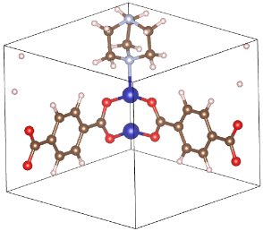 | 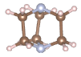  TED  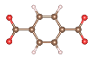1,4 – BDC
Figure 2. A primary unit cell of M-MOFs (M = Mg, V, Co or Ni).
Table 2. The optimized parameters of the unit cell of the M₂(BDC)₂TED structures, compared with other works.
M₂(BDC)₂TED | Lattice constant ($Å$) |  | Volume of unit cell ($Å^{3}$)
M₂(BDC)₂TED | a = b | c | Volume of unit cell ($Å^{3}$)
M = Mg | 10.98 | 9.39 | 1130
M = V | 10.96 | 9.37 | 1125
M = Co | 10.90 | 9.31 | 1113
M = Ni | 10.97 | 9.38 | 1128
M = Ni (exp. data)²⁸ | 11.15 | 9.53 | 1185
Error compared  exp. data (%) | 1.61 | 1.57 | 4.81
3.2. The SO₂ capture capability of M₂(BDC)₂TED MOFs
The SO₂ adsorption isotherms are shown in Figure 3 for both excess and absolute uptakes at pressures up to 2.5 bar. The results show these two uptakes are nearly similar for SO₂ on the M-MOFs (M = Mg, V, Co, or Ni) at low pressure under 2.5 bar. The adsorption uptakes for all metals are listed in Table 3. Our data are also compared to other ones. Compared to MOF-177, the best SO₂ capture to date, M-MOFs strongly adsorb SO₂ at low pressure below 0.5 bar.¹ On the contrary, above 0.5 bar, MOF-177 shows an outstanding uptake compared to our M-MOFs and other MOFs.¹
The adsorption tendency in Mg-MOF is more substantial than in Ni-MOF, which is consistent with the experimental data of Kui Tan et al. at the same temperature and pressure conditions (0.11 bar, 298 K),²⁷ and and V. B. López-Cervantes et al (Table 3).^{29,30} In this work, we study the adsorption capacity of M-MOFs for SO₂ up to a pressure of 2.5 bar because researching at high pressures is unnecessary, and the results achieved only change a little.¹⁷ The results show that Mg-MOF has the strongest adsorption of SO₂, followed by V-MOF, Ni-MOF, and Co-MOF. Here, Mg-MOF adsorbs superiorly compared to the remaining M-MOFs (M = V, Ni, Co). At 2.5 bar and 298 K, the the best uptakes reach for Mg-MOF with $n_{exc}=$15.82 mmol/g, $n_{abs}=$ 15.92 mmol/g, followed by V-MOF ($n_{exc}=$13.77 mmol/g, $n_{abs}=$ 13.85 mmol/g), Ni-MOF ($n_{exc}=$13.46 mmol/g, $n_{abs}=$ 13.54 mmol/g), and Co-MOF ($n_{exc}=$13.00 mmol/g,
$n_{abs}=$ 13.08 mmol/g).

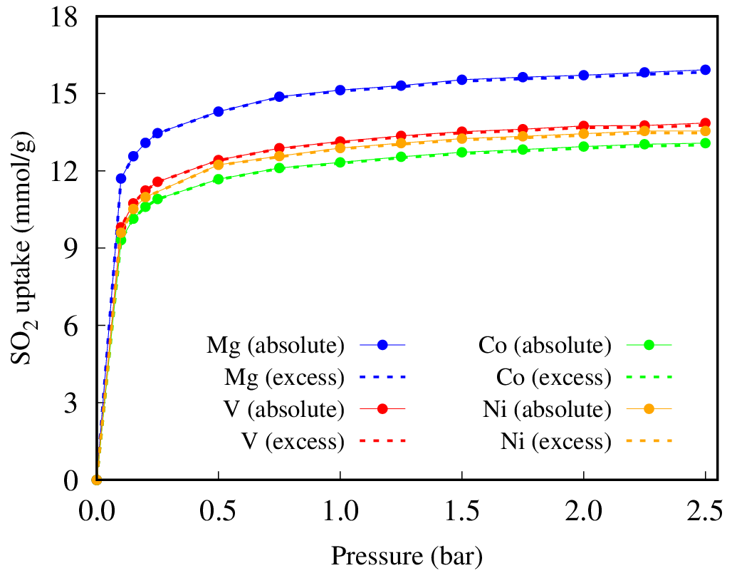
Figure 3. Absolute and excess isotherms of SO₂ on M₂(BDC)₂(TED) at 298 K, where dashed lines and solid lines refer to absolute and excess uptakes.
Table 3. Absolute and excess SO₂ uptakes on M₂(BDC)₂(TED) at 298 K and the pressures under 2.5 bar.
M-MOFs | SO₂ uptakes at 298 K,  (mmol/g)
M-MOFs | 0.1 bar | 1 bar | 2.5 bar
M = Mg | 11.69 | 15.13 | 15.92
M = V | 9.80 | 13.13 | 13.85
M = Co | 9.31 | 12.32 | 13.07
M = Ni | 9.59 | 12.88 | 13.54
M = Ni¹⁷ |  |  | 13.6 (50 bar)
M = Mg²⁷ | 6.44 (0.11 bar) | 8.60 (1.02 bar)
M = Ni²⁷ | 4.54 (0.11 bar) | 9.97 (1.13 bar)
Mg(II)-MOF²⁹ |  | 19.5
Ni(II)-MOF³⁰ |  | 12.5
MOF-177^{1,29} | 1.3 | 25.7 (maximum, 293 K, 0.97 bar) | -
3.3. Effect of structural characteristics and isosteric heat on the SO₂ adsorption of M₂(BDC)₂(TED)
To explain the reason Mg increases the ability to capture SO₂ based on the adsorption mechanism compared to other metals, we analyze the factors that have a substantial impact on the gas adsorption of MOFs, which are the structural characteristics (specific surface area and pore volume) and adsorption isosteric heat.
Isosteric heat of adsorption, $Q_{st}$, is an essential factor required to describe the thermal performance of adsorptive systems.³¹ The $Q_{st}$ of SO₂ for the M-MOF series calculated in low pressures under 1.0 kPa are presented in Figure 4. The results show that $Q_{st}$ tends to increase as pressure increases. However, the values change little in the low-pressure region. At higher pressures, the $Q_{st}$ value of SO₂ for M-MOFs is most significant for Mg-MOF, rising from
42.03 kJ/mol to 47.97 kJ/mol. Meanwhile, other M-MOFs increase slightly with pressure. Specifically, uptakes of SO₂ in V-MOF: 40.61 – 44.73 kJ/mol, Co-MOF: 40.93 – 45.37 kJ/mol, and Ni-MOF: 40.78 – 44.94 kJ/mol.
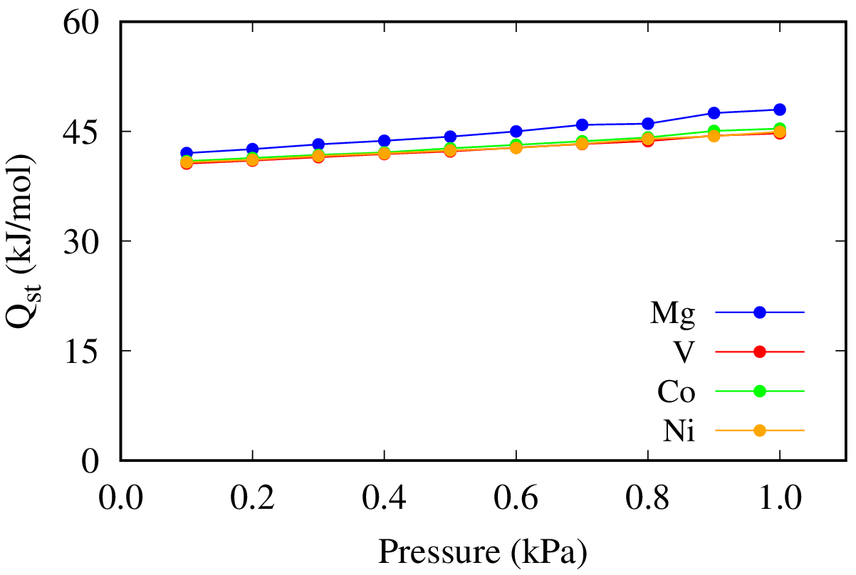
Figure 4. Isosteric heats of SO₂ adsorption for M-MOFs vs the pressure.
The $Q_{st}$ value of SO₂ adsorption is in the order V-MOF ≈ Ni-MOF ≈ Co-MOF < Mg-MOF, exhibiting that SO₂ adsorption on Mg₂(BDC)₂(TED) is the most noticeable as analyzed above.
Moreover, we also research the influence of specific surface area (SSA) and pore volume ($V_{p}$) on the adsorptive ability of SO₂ on the M-MOFs. The SSA values are smaller than many other MOFs, but the pore volume is relatively large, as detailed in Table 4. The SSA and pore volume of the M-MOFs are in increasing order Co < Ni < V < Mg. This tendency is consistent with H. Xiang's work for M(BDC)(TED)_{0.5} with M is Ni and Co.³²
Table 4. The specific surface area and the pore volume of M₂(BDC)₂(TED), compared to another research.
M-MOFs |  | This work |  | H. Xiang³²
 |  | SSA  (m²/g) | V_{p}  (cm³/g) | SSA  (m²/g) | V_{p}  (cm³/g)
M = Mg | 1930.95 |  | 0.87 | - | -
M = V | 1727.18 |  | 0.78 | - | -
M = Co | 1627.58 |  | 0.74 | 1708 | 0.619
M = Ni | 1686.09 |  | 0.76 | 1905 | 0.757

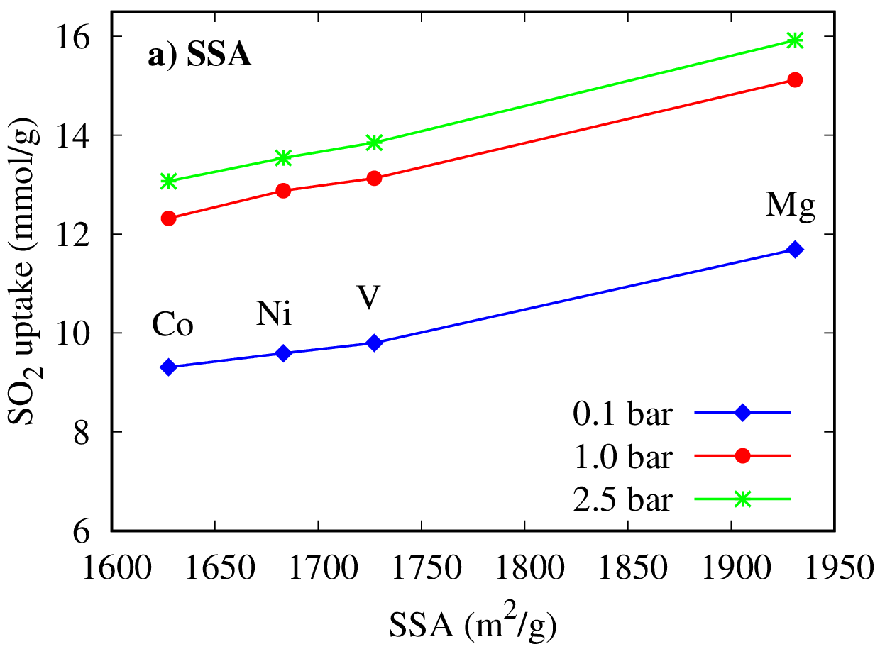
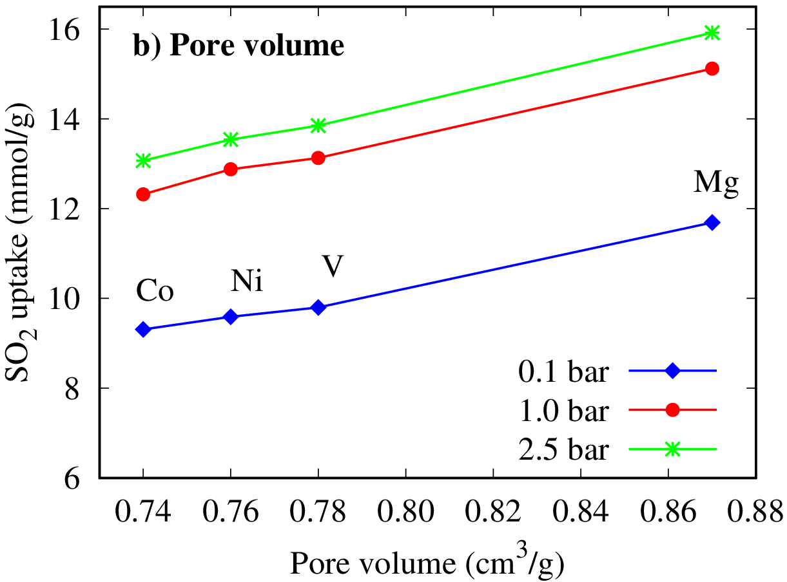
Figure 5. The correlation between the uptakes and (a) the specific surface area (SSA), (b) pore volume (Vp) of M₂(BDC)₂(TED) at 298 K.
The results in Figure 5 express that the amounts of SO₂ adsorption increase almost entirely linearly with SSA and $V_{p}$. Among them, the M-MOF with M = Mg is outstanding, which explains the most excellent SO₂ adsorption into Mg₂(BDC)₂(TED). Therefore, these two structural characteristics ($V_{p}$ and SSA) have a powerful impact on the ability to capture SO₂ on MOFs at room temperature.

4. CONCLUSION
After optimizing the structure for Ni(BDC)(TED), we replaced the metal to obtain optimized geometries for M(BDC)(TED), with M being Mg, V, and Co by calculations based on vdW-DF. Unit cell volumes are in ascending order of Co < V ≈ Ni < Mg.
The order of metals increasing the SO₂ adsorption uptakes on M₂(BDC)₂(TED) is Co < Ni < V < Mg. At 298K and 2.5 bar, SO₂ uptakes are about 16 mmol/g for Mg-MOF ($n_{exc}$ = 15.82 mmol/g, $n_{abs}$ = 15.92 mmol/g) and about 13 – 14 mol/g for the M-MOF (M = V, Ni, Co).
Our work also elucidates the factors that enhance the amounts of SO₂ adsorption in M₂(BDC)₂TED, including the adsorption isosteric heat, specific surface area, and pore volume. Remarkably, the specific surface areas and pore volumes of M-MOFs almost linearly enhance the SO₂ capture at room temperature and low pressure.
Acknowledgments: This work was financially supported by the Ministry of Education and Training of Vietnam under the grant number B2022-DQN-05. We also acknowledge supporting the computer time and software granted by the Lab of Computational Chemistry and Modelling (LCCL), Faculty of Natural Sciences, Quy Nhon University, Quy Nhon, Vietnam.
References
1. C. Janiak. Metal-organic frameworks with potential application for SO₂ separation and fluegas desulfurization, ACS Appl. Mater. Interfaces, 2019, 11, 17350−17358.
2. E. Martínez-Ahumada, M. L. Díaz-Ramírez, M. de J. Velásquez-Hernández, V. Jancik and I. A. Ibarra. Capture of toxic gases in MOFs: SO₂, H₂S, NH₃ and NO_{x}, Chem. Sci., 2021, 12, 6772–6799.
3. C. G. Livas, D. Raptis, E. Tylianakis and G. E. Froudakis. Multiscale theoretical study of sulfur dioxide (SO2) adsorption in metal-organic frameworks, Molecules, 2023, 28, 3122 (1–12).
4. T. T. T. Huong, P. N. Thanh, N. T. X. Huynh and D. N. Son. Metal – organic frameworks: State-of-the-art material for gas capture and storage, VNU J. Sci. Math. – Phys., 2016, 32, 67–85.
5. E. Martínez-Ahumada, A. López-Olvera, V. Jancik, J. E. Sánchez-Bautista, E. González-Zamora, V. Martis, D. R. Williams and I. A. Ibarra. MOF materials for thecapture of highly toxic H2S and SO2, Organometallics, 2020, 39, 883–915.
6. Y. Fu, Z. Wang, S. Li, X. He, C. Pan, J. Yan and G. Yu. Functionalized covalent triazine frameworks for effective CO₂ and SO₂ removal, ACS Appl. Mater. Interfaces, 2018, 10, 36002–36009.
7. K. Tan, P. Canepa, Q. Gong, J. Liu, D. H. Johnson, A. Dyevoich, P. K. Thallapally, T. Thonhauser, J. Li and Y. J. Chabal. Mechanism of preferential adsorption of SO₂ into two microporous paddle wheel frameworks M(bdc)(ted)0.5, Chem. Mater., 2013, 25, 4653–4662.
8. G. Kresse and J. Furthmüller. Efficient iterative schemes for ab initio total-energy calculations using a plane-wave basis set, Phys. Rev. B, 1996, 54, 11169–11186.
9. G. Kresse and J. Furthmüller. Efficiency of ab-initio total energy calculations for metals and semiconductors using a plane-wave basis set, Comput. Mater. Sci., 1996, 6, 15–50.
10. J. P. Perdew, J. Chevary, S. Vosko, K. Jackson, M. Pederson, D. Singh and C. Fiolhais. Atoms, molecules, solids, and surfaces: Applications of the generalized gradient approximation for exchange and correlation, Phys. Rev. B, 1992, 46, 6671–6687.
11. J. P. Perdew, K. Burke and M. Ernzerhof. Generalized gradient approximation made simple, Phys. Rev. Lett., 1996, 77, 3865–3868.
12. P. E. Blöchl. Projector augmented-wave method, Phys. Rev. B, 1994, 50, 17953–17979.
13. G. Kresse and D. Joubert. From ultrasoft pseudopotentials to the projector augmented-wave method, Phys. Rev. B, 1999, 59, 1758–1775.
14. J. D. Pack and H. J. Monkhorst. Special points for Brillouin-zone integrations, Phys. Rev. B, 1976, 13, 5188–5192.
15. M. Methfessel and A. T. Paxton. High-precision sampling for Brillouin-zone integration in metals, Phys. Rev. B, 1989, 40, 3616–3621.
16. D. Dubbeldam, S. Calero, D. E. Ellis and R. Q. Snurr. RASPA: molecular simulation software for adsorption and diffusion in flexible nanoporous materials, Mol. Simul., 2016, 42, 81–101.
17. N. T. X. Huynh, B. T. Duyen, P. T. Tram, T. T. D. Thanh and N. T. M. Duyen. Research on the capture of flue gases of the metal-organic framework Ni(BDC)(TED)_{0.5} by the classical simulation method, J. Sci. - Quy Nhon Univ., 2021, 15, 5–12.
18. N. T. X. Huynh, T. T. Nam and D. N. Son. Evaluation of H₂ and CO₂ adsorption into MIL-88A-Fe by Grand canonical Monte Carlo simulation, J. Sci. - Quy Nhon Univ., 2021, 15, 5–12.
19. T. A. Manz and N. G. Limas. Introducing DDEC6 atomic population analysis: Part 1. Charge partitioning theory and methodology, RSC Adv., 2016, 6, 47771–47801.
20. N. G. Limas and T. A. Manz. Introducing DDEC6 atomic population analysis: Part 2. Computed results for a wide range of periodic and nonperiodic materials, RSC Adv., 2016, 6, 45727–45747.
21. T. A. Manz. Introducing DDEC6 atomic population analysis: Part 3. Comprehensive method to compute bond orders, RSC Adv., 2017, 7, 45552–45581.
22. N. G. Limas and T. A. Manz. Introducing DDEC6 atomic population analysis: Part 4. Efficient parallel computation of net atomic charges, atomic spin moments, bond orders, and more, RSC Adv., 2018, 8, 2678–2707.
23. H. A. Lorentz. Ueber die anwendung des satzes vom virial in der kinetischen theorie der gase, Ann. Phys., 1881, 248, 127–136.
24. D. Berthelot. Sur le mélange des gaz, Acad. Sci., 1898, 126, 1703–1855.
25. D. Dubbeldam, K. S. Walton, T. J. H. Vlugt and S. Calero. Design,parameterization, and implementation of stomic force fields for adsorption in nanoporous materials, Adv. Theory Simulations, 2019, 2, 1900135 (2–62).
26. I. Matito-Martos, A. Martin-Calvo, J. J. Gutiérrez-Sevillano, M. Haranczyk, M. Doblare, J. B. Parra, C. O. Ania and S. Calero. Zeolite screening for the separation of gas mixtures containing SO₂, CO₂ and CO, Phys. Chem. Chem. Phys., 2014, 16, 19884–19893.
27. K. Tan, P. Canepa, Q. Gong, J. Liu, D. H. Johnson, P. K. Thallapally, T. Thonhauser, J. Li and Y. J. Chabal. Mechanism of preferential adsorption of SO₂ into two microporous paddle wheel frameworks M(bdc)(ted)0.5, Chem. Mater., 2013, 25, 4653–4662.
28. K. Tan, N. Nijem, P. Canepa, Q. Gong, J. Li, T. Thonhauser and Y. J. Chabal. Stability and hydrolyzation of metal organic frameworks with paddle-wheel SBUs upon hydration, Chem. Mater., 2012, 24, 3153–3167.
29. M.-A. Eva, D. won Kim, W. Mohammad, C.-M. Paulina, A. López-Olvera, D. R. Williams, V. Martis, H. A. Lara-García, S. López-Morales, D. Solis-Ibarra, G. Maurin, A. I. Ilich and C. S. Hong. Capture and detection of SO₂ by a chemically stable Mg(II)-MOF, J. Mater. Chem. A, 2022, 10, 18636–18643.
30. V. B. López-Cervantes, D. W. Kim, J. L. Obeso, E. Martínez-Ahumada, Y. A. Amador-Sánchez, E. Sánchez-González, C. Leyva, C. S. Hong, I. A. Ibarra and D. Solis-Ibarra. Detection of SO2 using a chemically stable Ni(II)-MOF, Nanoscale, 2023, 15, 12471–12475.
31. I. E. Men’shchikov, A. V. Shkolin, E. M. Strizhenov, E. V. Khozina, S. S. Chugaev, A. A. Shiryaev, A. A. Fomkin and A. A. Zherdev. Thermodynamic behaviors of adsorbed methane storage systems based on nanoporous carbon adsorbents prepared from coconut shells, Nanomaterials, 2020, 10, 1–26.
32. H. Xiang, A. Ameen, P. Gorgojo, F. R. Siperstein, S. M. Holmes and X. Fan. Selective adsorption of ethane over ethylene on M(bdc)(ted)0.5 (M = Co, Cu, Ni, Zn) metal-organic frameworks (MOFs), Microporous Mesoporous Mater., 2020, 292, 109724.

