Tổng hợp polyvinyl alcohol/liginin hydrogel và khảo sát khả năng hấp phụ methylene blue
Bùi Thị Thảo Nguyên*, Huỳnh Quang Phú, Phan Quốc Huy

Đại học Bách Khoa - Đại học Quốc gia Thành phố Hồ Chí Minh, Việt Nam

*Tác giả liên hệ chính. Email: btnguyen@hcmut.edu.vn

TÓM TẮT
Trong nghiên cứu này, hydrogel từ polyvinyl alcohol và lignin đã được tổng hợp. Glyoxal được sử dụng làm chất liên kết chéo với vai trò hình thành liên kết giữa các phân tử polyvinyl alcohol và lignin. Khả năng hấp phụ của hydrogel đối với methylene blue (MB) đã được nghiên cứu với các nồng độ ban đầu của dung dịch methylen blue (MB). Nghiên cứu đường đẳng nhiệt hấp phụ được thực hiện ở nhiệt độ 31ºC và pH 7 với mô hình Langmuir và Freundlich. Các hệ số tương quan (R²) của đồ thị cho thấy số liệu thực nghiệm phù hợp với mô hình Langmuir. Điều này chứng tỏ rằng MB được hấp phụ trên hydrogel theo cơ chế hấp phụ đơn lớp. Hiệu suất hấp phụ MB lớn hơn 88%. Ngoài ra, các đặc tính của hydrogel PVA/lignin đã được nghiên cứu bằng một số phương pháp phân tích, bao gồm quang phổ hồng ngoại biến đổi Fourier (FTIR), phương pháp nhiễu xạ tia X (XRD) và phương pháp quang phổ nhìn thấy UV (UV-Vis).
Từ khoá: Hấp phụ, methylene blue, polyvinyl alcohol, lignin, hydrogel.

Preparation of poly vinyl alcohol/lignin hydrogels and investigation of the adsorption for methylene blue
Bui Thi Thao Nguyen*, Huynh Quang Phu, Phan Quoc Huy
Ho Chi Minh City University of Technology - Vietnam National University Ho Chi Minh City, Vietnam
*Corresponding author. Email: btnguyen@hcmut.edu.vn
ABSTRACT
In this study, hydrogels from polyvinyl alcohol and lignin were synthesized. Glyoxal was used as crosslinking agent with the role of forming bonds between polyvinyl alcohol and lignin molecules. The adsorption capacity of the hydrogels for methylene blue (MB) was investigated with the various initial concentrations of methylene blue (MB) solution. The study of adsorption isotherm was conducted at 31ºC and pH 7 with Langmuir and Freundlich models. The correlation coefficients (R²) of the graphs showed that the experimental data fitted Langmuir model. This proved that MB adsorbed on the hydrogel by mono-layer adsorption mechanism. MB adsorption effiency was over 88 %. In addition, the properties of PVA/lignin hydrogels were studied by several analytical methods, including Fourier-transform infrared spectroscopy (FTIR), X-ray diffraction method (XRD) and UV–visible spectrophotometry (UV-Vis).
Keywords. Adsorption, methylene blue, polyvinyl alcohol, lignin, hydrogel.

1. INTRODUCTION
Environmental pollution becomes a serious issue not only for Vietnam but also for the whole world. Along with the rapid development of industry, the water environment is being seriously affected. The lack of overall planning in the operation of factories, hospitals, and industrial parks in Vietnam has led to the discharge of untreated wastewater into the environment. Wastewater from industries, especially the textile dyeing, often contains high alkalinity and dangerous organic content, negatively affecting drainage systems and water environment ¹⁻⁶. The presence of colorants in wastewater also creates a serious problem, affecting the ecological process and landscapes. A typical dye waste is methylene blue, which is widely used in the textile, paper dyeing, plastic and rubber dyeing, and cosmetics industries. Methylene blue (MB) is an organic dye that has a negative impact on the water environment. About 10-15% of MB dyes from the textile industry are discharged into the environment each year. Wastewater from the dye industry has a high alkalinity (pH 8 - 11) and contains a significant amount of organic matter (COD 620 - 4585 mg/L). This pollutes water, reduces dissolved oxygen in water, and negatively affects the life of aquatic organisms. Prolonged exposure to MB can cause vomiting, increased heart rate, shock, cyanosis, and jaundice ⁷⁻⁹. Dyes in wastewater, including MB dye, inhibit the penetration of sunlight into water and affect the photosynthesis of aquatic species. In addition, MB is considered toxic and potentially carcinogenic to humans.
In order to eliminate wastewater pollutants, hydrogel has been researched and developed as a potential adsorbent material. Hydrogel is a polymer with a 3D network structure, which has an outstanding water absorption capacity. The kinetic adsorption and chemical properties of hydrogel also allow it to adapt to different environmental conditions. Therefore, hydrogel can be used in many fields, including adsorption of pollutants, drug delivery, and water purification ^{10, 11}.
Although various methods have been applied to treat dye-containing wastewater, such as microbial treatment, coagulation, oxidation-reduction, membrane filtration technology, and a combination of other methods, they may encounter complex barriers and be economically inefficient. Meanwhile, the adsorption method is still widely used as an economical solution to treat wastewater due to its simplicity, high efficiency, flexibility, and compatibility with most current wastewater treatment processes ¹²⁻¹⁴.
The issue of environmental pollution and the attraction of impressive potential of hydrogel materials lead to the application of hydrogel in water pollution treatment. Especially those hydrogels with biodegradable components such as polyvinyl alcohol (PVA), a non-toxic polymer, and lignin, a natural biomass substance, are familiar and popular ¹⁵⁻¹⁷.
In this work, the hydrogel adsorbents from polyvinyl alcohol and lignin were synthesized. The glyoxal as a crosslinker for the hydrogels was utilized to create three-dimensional network for the hydrogel, which made hydrogel not soluble in the water. The outstanding property is that the preparation of the hydrogel was facile and simple by moulding at 70ºC. The raw materials are environmentally friendly. The adsorption capacity of these prepared hydrogels for MB was studied by Langmuir and Freundlich adsorption isotherms. The characterization of the hydrogel was investigated by FTIR, SEM, and UV-Vis.
2. MATERIALS AND METHODS
2.1 Materials
PVA (average Mw = 205 000 g/mol, 98-99% hydrolyzed) was supplied by Sigma Aldrich (Germany). Glyoxal and lignin (average Mw = 15 000 g/mol) were purchased from Wako Chemical Industries (Japan). All other chemicals were obtained from Guangdong Guanghua Sci-Tech Company (China).
2.2 Synthesis of PVA/lignin hydrogel
Firstly, PVA was slowly added to the flask containing hot water, then the PVA particles would dissolve in the water to form the solution by stirring steadily at 90ºC for 60 minutes. After that, glyoxal was poured into the solution, and dispersed in the solution for 15 minutes to obtain a homogenous solution. Next, lignin was placed into the solution under stirring for 30 minutes. Then, the mixture was poured into a prepared mold which would be put into the oven at 70 ºC for about 90 minutes in order to create the hydrogel samples ¹⁸.
2.3. Adsorption Isotherms
The adsorption equilibrium experiments were carried out with the initial concentrations (C_{o}) of MB solutions, ranging from 10 to 50 mg/L. The hydrogel samples were soaked into MB solutions, until the solution reached equilibrium concentrations at 31 ºC, pH 7. The equilibrium concentrations (C) were determined by the relationship between the absorbance and the colored solutions. The absorbance of MB solution was tested by UV-Vis spectrophotometer.
The adsorption capacity q (mg/g) and removal efficiency E% were calculated by the equations below ¹⁹:
$q=\frac{\left(C_{0}-C\right).V}{m}$ (1)
$E= \frac{C_{0}-C}{C_{0}} x 100\%$ (2)
Where C_{o} and C (mg/L) were the initial and equilibrium concentration of the MB solution, respectively. V (L) and m (g) were the volume of the MB solution and the weight of the hydrogel, respectively.
Langmuir (3) and Freundlich isotherm (4) models were used to study the adsorption. The Langmuir isotherm model described the adsorption behavior relating to monolayer adsorption on the surface of the adsorbent while the Freundlich isotherm model reflected multilayers adsorption ^{20, 21}:
$\frac{C}{q}=\frac{C}{q_{∞}}+\frac{1}{bq_{∞}}$ (3)
$\ln{q}=\frac{1}{n}lnC+lnK$ (4)
Where q∞ (mg/g) was the maximum adsorption capacity, b (L/m.g) was a Langmuir constant presented for the adsorption energy, K (mg/g) was a Freundlich constant associated with the adsorption capacity of the adsorbent, and 1/n was the Freundlich coefficient relative heterogeneity.
﻿The dimensionless equilibrium parameter, R_{L}, showing the chemical affinity between the absorbent and the absorbate, was calculated as follows ²⁰:
$R_{L}=\frac{1}{1+bC_{0}}$ (5)
The favorable values of R_{L} were less than 1
2.4. Analytical methods
The characterization of hydrogel was studied by Frontier FT-IR/NIR instrument model at Institute of Applied Materials science, Ho Chi Minh City, Vietnam with the scan rate and speed being 4000 – 4500 cm⁻¹ and 0.2 mm/s, respectively and SEM system at Research Laboratories of Saigon Hi-tech Park, Ho Chi Minh City, Vietnam. Crystal phases of the hydrogel samples were investigated with the X-ray diffraction method (XRD) with Cu-Kα radiation (λ=1.54184 Å). The MB solution was examined its absorbance by UV/UV-NIR Horiba Dual-FL at Ho Chi Minh City University of Technology - Vietnam National University Ho Chi Minh City.
3. RESULTS AND DISCUSSION
3.1 Analysis of crystal structure by X-ray diffraction method
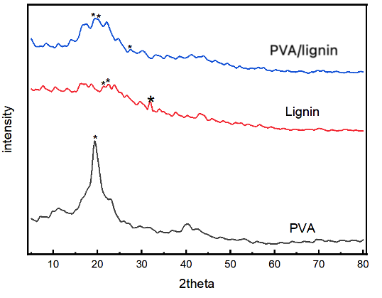
Figure 1. XRD spectrum of lignin and sample
In this study, the XRD spectra of PVA, lignin, and PVA/lignin composite hydrogel were measured by an X-ray diffraction spectrometer with a scan range from 5 ° to 80 °. From Figures 1, it could be seen that PVA had a main peak around the 2θ angle of 20 °, which was a high and narrow signal peak, indicating a specific crystal structure. This characterized the semi-crystallinity structure of PVA polymer. Lignin had a very light XRD spectrum with a few small peaks, indicating that lignin has an amorphous structure.
The PVA/lignin composite with glyoxal agent had some weak and unclear peaks at the positions which was similar to pure PVA. This indicated the the formation of cross-linkages between PVA by glyoxal, which made the changes in the structure of PVA network. Therefore, crystal parts of the PVA were disordered and became amorphous parts.
3.2 Analysis of the specific functional groups by FT-IR spectra
In the FTIR infrared spectrum of PVA in Figure 2, the broad peak at 3267 cm⁻¹ corresponded to the stretching vibration of the OH group in PVA, indicating the presence of alcohol groups in the polymer. The peak at 2939 cm⁻¹ was the symmetric stretching vibration CH groups in PVA. The peaks appearing at 1430 cm⁻¹ reflected CH₂. The sharp peak at 1707 cm⁻¹ represented the C=O stretching vibration in the amorphous region of PVA and attributed to carbonyl functional groups from residual acetate radicals after PVA synthesis from polyvinyl acetate hydrolysis. The peak at 1089 cm⁻¹ was the C-O stretching vibration in PVA⁶.
The FTIR spectrum of lignin in Figure 2 showed greater complexity in its structure, with a peak at 1595 cm⁻¹, indicating the presence of hydroxycinnamic esters in the lignin sample. The peak at 1361 cm⁻¹ associated with the syringyl molecular structure of lignin, manifested through C-O stretching during contraction. The peak at 1267 cm⁻¹ corresponded to the contraction of the guaiacyl ring, accompanied by C=O stretching. The peak at 1209 cm⁻¹ reflected the vibration of C-O-C bonds in ether and ester compounds, or phenolic hydroxyls. The frequency band at 1130 cm⁻¹ related to the in-plane deformation vibration of C-H in syringyl aromatic ring groups. Finally, the peak at 1035 cm⁻¹ originated from the in-plane deformation of C-H in aromatic rings and C-O bending in primary alcohol catalysis, belonging to the guaiacyl type. The peak at 3453 cm⁻¹ presented the vibration of the hydroxyl group ²².

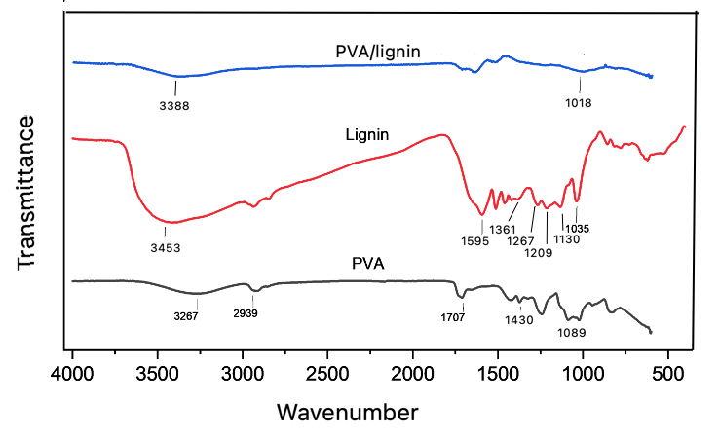
Figure 2. FTIR spectrum of PVA, lignin and PVA/lignin sample

In the FTIR spectrum of the PVA/lignin in Figure 2, the weak spectra signal at wave numbers 1018 cm⁻¹ was asymmetric stretching of the C-O groups in lignin structure. The broad peak at 3388 cm⁻¹ reflected the vibration of the hydroxyl group. The shift of the -OH functional group from the 3267 cm⁻¹ region in the PVA spectrum and 3453 cm⁻¹ peak in lignin spectrum to the field region of 3388 cm⁻¹ in the PVA/lignin sample occured in the hydrogel ²³. This result revealed that the cross-linkages which was created by the reaction between hydroxyl groups of PVA with glyoxal (Figure 3) led to the change of the wave number at -OH vibration in the PVA/lignin sample ²⁴. Moreover, the hydrogen linkage was formed between -OH groups between PVA and lignin ^{25, 26}.
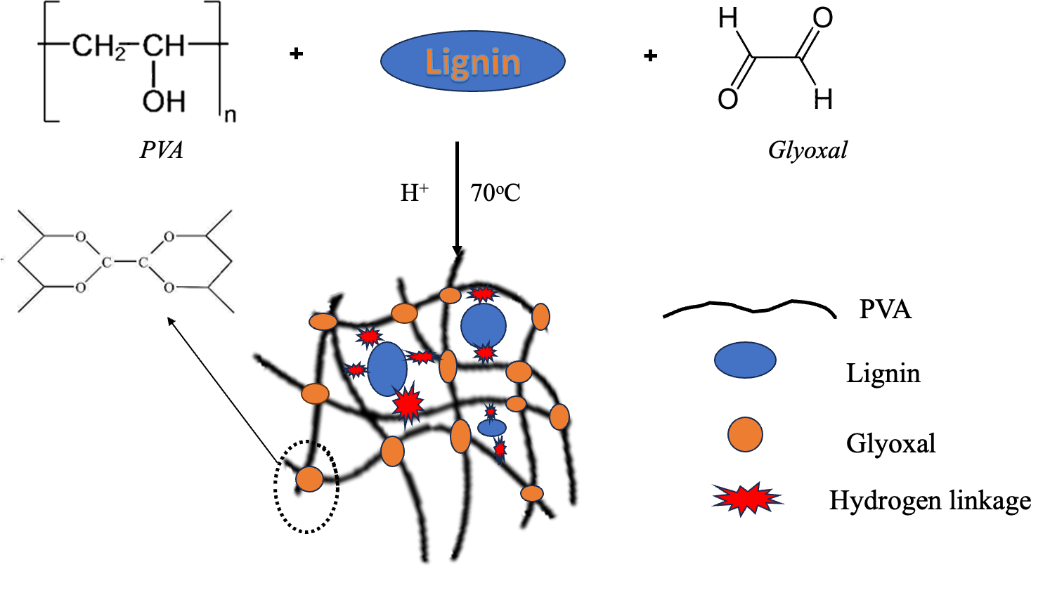
Figure 3. The chemical linkage between PVA, lignin and glyoxal ^{25, 26}
3.3 Morphology of PVA/lignin hydrogel by SEM image
The SEM image (Figure 4) showed that the surface hydrogel was rough with uneven distribution of PVA and lignin molecules. It also had many pores and holes which illustrated 3D network structure of the hydrogel. The walls between pores was thin and smooth. The hydrogel had continuous structure with various pore, which proved that the hydrogel had high crosslinking density.
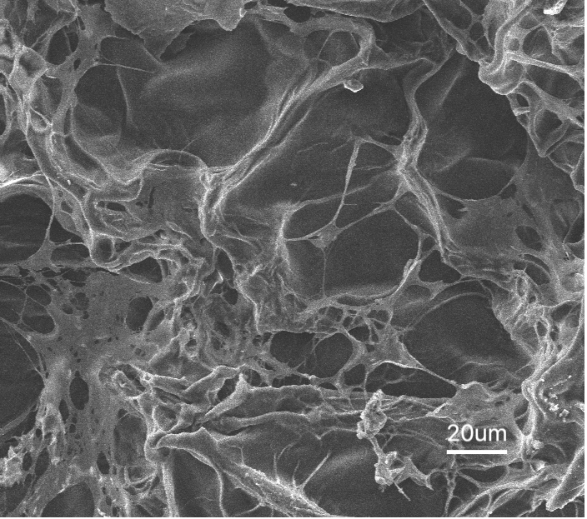
Figure 4. SEM image of PVA/lignin hydrogel
3.4 Investigation of adsorption capacity for methylene blue
The adsorption capacity and removal efficiency of the PVA/lignin hydrogel were investigated at 31 ºC, pH 7, shown in Table 1 and Figure 5.
Table 1. The adsorption capacity of PVA/lignin hydrogel.
C₀ (mg/L) | C (mg/L) | q (mg/g) | E%
10 | 0.57 | 9.43 |  | 94.32
20 | 1.17 | 18.83 |  | 94.16
30 | 2.14 | 27.86 |  | 92.86
40 | 4.19 | 35.81 |  | 89.53
50 | 5.92 | 44.08 |  | 88.16
From Table 1 and Figure 5, the adsorption capacity for MB of PVA/lignin hydrogel increased linearly with the equilibrium concentration of MB solution. When equilibrium concentrations were from 0.57 (mg/L) to 5.92 (mg/L), which was the results of the adsorption process with initial concentrations from 10 to 50 mg/L, the amount of MB inserting into the hydrogel increased from 9.43 (mg/g) to 44.08 (mg/g) and the removal efficiency ranged from 88.16% to 94.32%. These data presented that the MB adsorption depended on the moving process of MB from the initial solution to the hydrogels. With increasing concentrations of MB solution, the the amount of MB adsorbing on the hydrogel increased to equilibrium. The removal efficiency obtained over 88% and the highest value about 94 %. MB was also used as an organic dye in some adsorption experiments by various adsorbents. Chitosan-based composite hydrogel adsorbed MB at adsorption efficiency above 85 % ²⁷. Hydrogels loaded with Huangshui polysaccharides, polyvinyl alcohol, and sodium carboxyl methyl cellulose had MB adsorption ability of 71.07 mg/g ²⁸. Cellulose based hydrogel showed MB removal capacity up to 83% ²⁹. Compared to the previous research, the PVA/lignin hydrogel had outstanding removal efficiency over 88.16%.
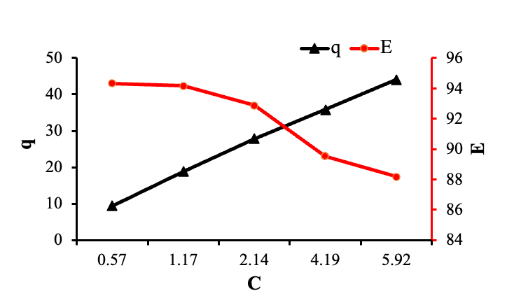
Figure 5. The effect of concentrations on the adsorption amount and removal efficiency.
3.4 Study of adsorption Isotherms
The equilibrium adsorption had been studied by isotherm models, Langmuir and Freundlich models. The relationship between q and C according to Langmuir model was presented in the Figure 6a. The relationship between lnq and lnC according to Freundlich model was expressed in Figure 6b.
The maximum amount of MB moleculars adsorbing on the hydrogel could be drawn from Langmuir model, which was about 60 (mg/g). From the correlation coeficients (R²) in the line graphs (Figure 6a and 6b), it could be seen that the Langmuir curve fitted the experimental parameters. The correlation coefficients (R²) of the linear form for Langmuir isotherm model were 0.9951 which was much closer to 1.0 than that of Freundlich models. These data revealed that Langmuir model described properly the MB adsorption of PVA/lignin hydrogel adsorbents and affirmed that adsorption occured by the monolayer adsorption on the surface of the hydrogel.
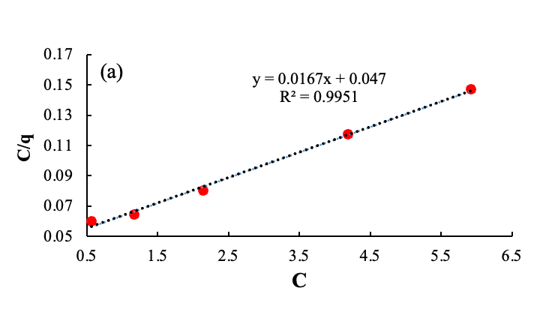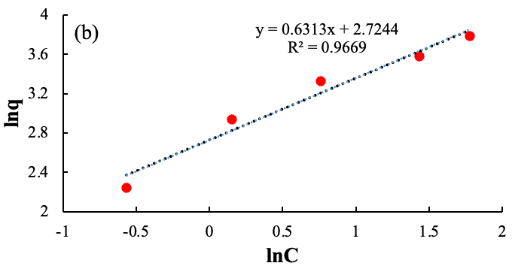
Figure 6. Adsorption isotherms of MB on the hydrogel, Langmuir model (a) and Freundlich model (b).
R_{L} parameter which discovered the affinity of adsorption on hydrogel, following Langmuir model, could be calculated from the equation (5), which was from 0.05 to 0.2. These values of R_{L} were smaller than 1, so this is favorable. The results showed the good affinity between MB moleculars and the PVA/lignin hydrogel.
4. CONCLUSION
In this study, the hydrogels based on PVA and lignin were successfully synthesized by using glyoxal crosslinker. The adsorption process was conducted by batch experimental procedure at 31 ºC, pH 7. The maximum adsorption capacity was about 60 mg/g. The experimental data agreed with Langmuir isotherm model, showed that MB adsorbed by monolayer coverages on the hydrogel surfaces.The affinity parameter was lower than 1, described good affinity between MB adsorbents and the hydrogel. Moreover, removal efficiency was higher than 88%. Consequently, the hydrogels can be applied for the removal of methylene blue from aqueous solution.
Acknowledgements. We acknowledge the technical support from the Faculty of Materials Technology, Ho Chi Minh City University of Technology (HCMUT), VNUHCM for this study.
REFERENCES
1. G. Zhao, T. Sun, D. Wang, S. Chen, Y. Ding, Y. Li, G. Shi, H. Sun, S. Wu, Y. Li, C. Wu, Y. Li, Z. Yu, and Z. Chen. Treated wastewater and weak removal mechanisms enhance nitrate pollution in metropolitan rivers, Environmental Research, 2023, 231, 116182.
2. S. Pal and S. Debanshi. Exploring the effect of wastewater pollution susceptibility towards wetland provisioning services, Ecohydrology & Hydrobiology, 2023, 23(1), 162-176.
3. F. Kazembeigi, S. Bayad, A. Yousefi Nasab, M. Doraghi, and I. Parseh. Techno-environmental study on the consequences of carwash wastewater and its management methods, Heliyon, 2023, e19764.
4. P. Chowdhary, A. Raj, and R. N. Bharagava. Environmental pollution and health hazards from distillery wastewater and treatment approaches to combat the environmental threats: A review, Chemosphere, 2018, 194, 229-246.
5. F. B. Elehinafe, O. Agboola, A. D. Vershima, and G. O. Bamigboye. Insights on the advanced separation processes in water pollution analyses and wastewater treatment – A review, South African Journal of Chemical Engineering, 2022, 42, 188-200.
6. C.-Y. Lai, Y.-M. Sun, and Y.-L. Liu. Water-soluble ozonated lignin as a hydrophilic modifier for poly(vinyl alcohol) membranes for pervaporation desalination, Journal of Membrane Science, 2023, 685, 121959.
7. R. Sivakumar and N. Y. Lee. Adsorptive removal of organic pollutant methylene blue using polysaccharide-based composite hydrogels, Chemosphere, 2022, 286, 131890.
8. E. U. Mughal, A. Javaid, M. Imran, M. A. S. Abourehab, E. B. Elkaeed, N. Naeem, A. Y. A. Alzahrani, A. Sadiq, and S. F. Kainat. Complexes of terpyridine scaffold as efficient photocatalysts for the degradation of methylene blue pollutant in wastewater effluents, Inorganica Chimica Acta, 2023, 546, 121329.
9. S. S. Vedula and G. D. Yadav. Wastewater treatment containing methylene blue dye as pollutant using adsorption by chitosan lignin membrane: Development of membrane, characterization and kinetics of adsorption, Journal of the Indian Chemical Society, 2022, 99(1), 100263.
10. A. A. Hamid, J. Alam, A. K. Shukla, F. A. A. Ali, and M. Alhoshan. Sustainable removal of phenol from wastewater using a biopolymer hydrogel adsorbent comprising crosslinked chitosan and κ-carrageenan, International Journal of Biological Macromolecules, 2023, 251, 126340.
11. S. Ahmad, M. S. Tanweer, T. A. Mir, M. Alam, S. Ikram, and J. N. Sheikh. Antimicrobial gum based hydrogels as adsorbents for the removal of organic and inorganic pollutants, Journal of Water Process Engineering, 2023, 51, 103377.
12. L. Sellaoui, F. Abdulaziz, S. Chebaane, L. Manai, A. Azhary, A. H. Alsehli, M. M. Alsowayigh, A. Piscitelli, and A. Erto. Adsorption of pharmaceutical pollutants on activated carbon: Physicochemical assessment of the adsorption mechanism via advanced modelling, Journal of Molecular Liquids, 2023, 389, 122929.
13. X. Huang, W. Mu, and C. Chang. CTAB Intercalation into Two-Dimensional Transition-Metal Carbides: Enhancing Adsorption Performance of Cr (VI), Journal of Alloys and Compounds, 2023, 172012.
14. X. Cheng, Y. Cheng, C. Wang, B. Hu, and J. Wang. Calculation methods on methane adsorption phase density in coal: A critical review and new insights, Chemical Engineering Journal, 2023, 472, 144778.
15. Z. Chen, J. Luo, Y. Hu, Y. Fu, J. Meng, S. Luo, L. Wang, Y. Zhang, J. Zhou, M. Zhang, and H. Qin. Fabrication of lignin reinforced hybrid hydrogels with antimicrobial and self-adhesion for strain sensors, International Journal of Biological Macromolecules, 2022, 222, 487-496.
16. K. Ingtipi, B. J. Choudhury, and V. S. Moholkar. Ultrasound assisted lignin-decorated MWCNT doped flexible PVA–Chitosan composite hydrogel, Materials Today Communications, 2023, 35, 105676.
17. L. Wu, S. Huang, J. Zheng, Z. Qiu, X. Lin, and Y. Qin. Synthesis and characterization of biomass lignin-based PVA super-absorbent hydrogel, International Journal of Biological Macromolecules, 2019, 140, 538-545.
18. K. Enoch, R. C. S, and A. A. Somasundaram. Improved mechanical properties of Chitosan/PVA hydrogel – A detailed Rheological study, Surfaces and Interfaces, 2023, 41, 103178.
19. D. Choque-Quispe, C. A. Ligarda-Samanez, Y. Choque-Quispe, A. M. Solano-Reynoso, B. S. Ramos-Pacheco, M. M. Zamalloa-Puma, G. J. Álvarez-López, A. Zamalloa-Puma, K. Choque-Quispe, and H. Alzamora-Flores. Multimetal removal in aqueous medium using a potato starch/nopal mucilage copolymer: A study of adsorption kinetics and isotherms, Results in Engineering, 2023, 18, 101164.
20. B. Wu, X. Chen, and D. Hou. Modeling of monolayer water adsorption on surface of cement minerals by molecule simulation and adsorption isotherm, Materials Today Communications, 2023, 36, 106646.
21. O. M. Adedeji and K. Jahan. Removal of pollutants from aqueous product of Co-hydrothermal liquefaction: Adsorption and isotherm studies, Chemosphere, 2023, 321, 138165.
22. D. D. Edmundson, R. R. Gustafson, and A. B. Dichiara. Sonochemical synthesis of lignin nanoparticles and their applications in poly (vinyl) alcohol composites, International Journal of Biological Macromolecules, 2024, 254, 127487.
23. T. Liu, Y. Yang, L. Yan, B. Lin, L. Dai, Z. Huang, and C. Si. Custom-designed polyphenol lignin for the enhancement of poly(vinyl alcohol)-based wood adhesive, International Journal of Biological Macromolecules, 2024, 258, 129132.
24. D. Panigrahi, S. Kumar, and A. Dhar. Modulating chain conformations of polyvinyl alcohol through low cost and nontoxic glyoxal crosslinker: Application in high performance organic transistors, Organic Electronics, 2019, 65, 193-200.
25. M. Li, Q. Tu, X. Long, Q. Zhang, H. Jiang, C. Chen, S. Wang, and D. Min. Flexible conductive hydrogel fabricated with polyvinyl alcohol, carboxymethyl chitosan, cellulose nanofibrils, and lignin-based carbon applied as strain and pressure sensor, International Journal of Biological Macromolecules, 2021, 166, 1526-1534.
26. H. Bian, L. Jiao, R. Wang, X. Wang, W. Zhu, and H. Dai. Lignin nanoparticles as nano-spacers for tuning the viscoelasticity of cellulose nanofibril reinforced polyvinyl alcohol-borax hydrogel, European Polymer Journal, 2018, 107, 267-274.
27. X. Wan, Z. Rong, K. Zhu, and Y. Wu. Chitosan-based dual network composite hydrogel for efficient adsorption of methylene blue dye, International Journal of Biological Macromolecules, 2022, 222, 725-735.
28. Z. Wu, Q. Liao, P. Chen, D. Zhao, J. Huo, M. An, Y. Li, J. Wu, Z. Xu, B. Sun, and M. Huang. Synthesis, characterization, and methylene blue adsorption of multiple-responsive hydrogels loaded with Huangshui polysaccharides, polyvinyl alcohol, and sodium carboxyl methyl cellulose, International Journal of Biological Macromolecules, 2022, 216, 157-171.
29. Y. El Bouazzaoui, A. Habsaoui, and M. E. Touhami. Hydrogel synthesis using extracted cellulose from Opuntia Ficus indica seeds and its application in methylene blue dye removal, Chemical Data Collections, 2022, 41, 100918.

