Research of undrained shear strength of soft clay in the Lo Voi residential area, Ward one, Tuy Hoa City, Phu Yen province by unconfined compressive strength and direct simple shear test

Thi khanh Ngan Nguyen¹

¹MS, Lecturer, Faculty of Technology and Technique, Quy Nhon Univesity

Email: <nguyenthikhanhngan@qnu.edu.vn>

ABSTRACT
The undrained shear strength of soft clays is a key parameter for the design of embankments, shallow foundations, and pile foundations. The standard methods to determine the undrained shear strength of soils are broadly classified as laboratory (e.g., unconfined compression, unconsolidated/undrained (UU) triaxial compression, consolidated undrained (CU) triaxial compression, simple shear, and laboratory vane) and in situ procedures (e.g., cone penetration test (CPT)/T-bar/ball penetration test and vane test). This study employed intact clay samples with a diameter 90 mm obtained using geological drilling machine in the Lo Voi residential area, Ward 1, Tuy Hoa City, Phu Yen province. Laboratory tests include the unconfined compressive strength of cohesive soil and direct simple shear tests. The values of undrained shear strength (S_{u}) from the unconfined compressive strength test were compared with the values of shear stress (τ) from the simple shear test.
Keywords: soft clays, undrained shear strength, unconfined compressive strength, direct simple shear tests.

1. INTRODUCTION
In recent years, the Central Coast region has been considered one of the regions with a relatively strong tourism economic development rate, especially Phu Yen province where dense population, political, economic, and cultural centers gather. Therefore, localities are making efforts to renovate and upgrade transport infrastructure, connecting road systems, railways, airways, houses, offices, apartments... However, the geological characteristics of this area are quite complex and quite new. In this geological area, there is almost a young sedimentary soft layer, this layer is widely and deeply distributed along the coastal route extending to Binh Dinh province. This greatly affects work such as geological surveys, underground design, and underground construction methods. Most geological engineers of laboratories in the region encounter many difficulties in conducting sampling and laboratory testing to determine physical and mechanical criteria, deformation characteristics and shear strength of soft clays.
The Lo Voi area is located in north Phu Yen province as illustrated in Figure 1. This paper presents a full geotechnical characterization, and engineering properties of the soft site in the Lo Voi residential area, Ward 1, Tuy Hoa City, Phu Yen province.
The scope of the topographic survey in the expected survey area is as follows: The North borders vacant land and current residential status. The South borders Tran Quang Khai Street and Ong Chu Bridge. The East borders Nguyen Tat Thanh Street and the West borders Chua River.

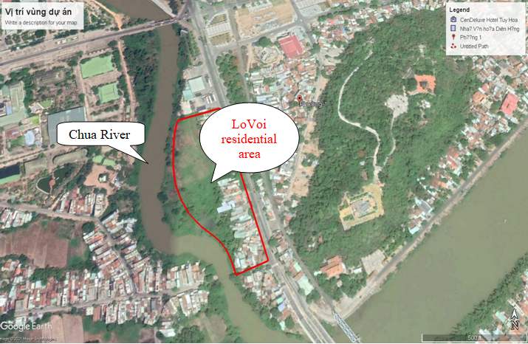
Figure 1: Map of the Lo Voi residential area, Ward 1, Tuy Hoa City, Phu Yen province

2. METHODOLOGY
2.1. Unconfined compressive test (ASTM D2166)
This test method covers the determination of the unconfined compressive strength of cohesive soil in the undisturbed, remolded, or compacted condition, using strain-controlled application of the axial load.⁶
In this test method, unconfined compressive strength (q_{u}) is taken as the maximum load attained per unit area or the load per unit area at 15 % axial strain, whichever is secured first during the performance of a test. Shear strength (s_{u})—for unconfined compressive strength test specimens, the shear strength is calculated to be 1⁄2 of the compressive stress at failure.⁶
$S_{u}=\frac{q_{u}}{2}$ (1)
Where s_{u} is Shear strength and q_{u} is the compressive stress at failure.
In this study, the compression device used the Triplex II advanced as Figure 2.
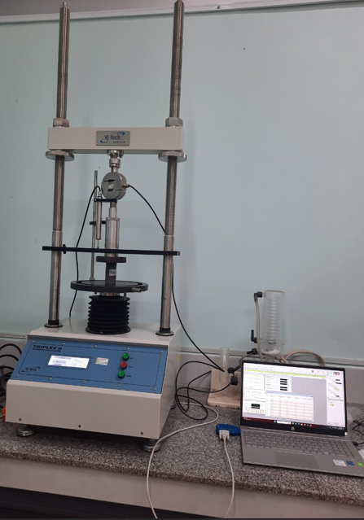
Figure 2. The Tripex II advanced
2.2. The direct simple shear test
The direct simple shear test which is an experiment in geotechnical engineering determines the shear strength of clays. In this test, the shear strength is evaluated using the Mohr-Coulomb failure criteria as
$s=c+δtanφ$ [2]
Where c is cohesion and ϕ is the angle of friction of the soil.¹
The shear device uses a two-speed soil shearing machine which is made in China as illustrated in Figure 3.
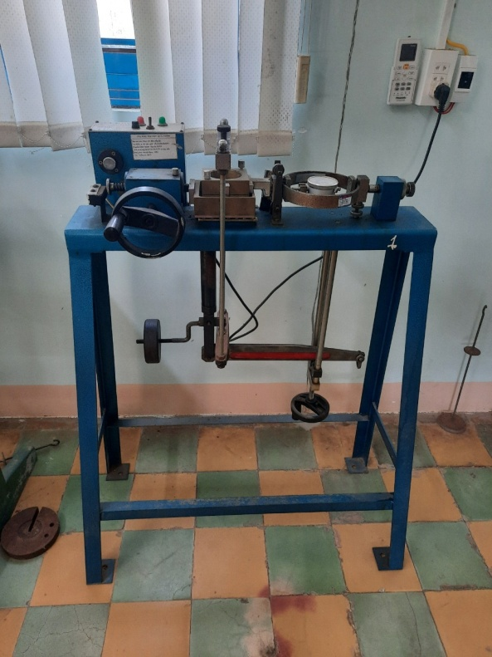
Figure 3. The two-speed soil shearing machine
2.3. Test Specimens
Testing was conducted on six reconstituted clay specimens with high plasticity. Onsoy clay samples were retrieved from a depth of 2–6 m in a test pit in the Lo Voi residential area, Ward 1, Tuy Hoa City, Phu Yen province. The samples in the unconfined compressive test were 48 mm in diameter and 70 mm in height. The samples in the direct simple shear test were 60 mm in diameter and 20 mm in height.⁶ The characterizations of the soft clay samples are listed in Table 1 and the results of geotechnical characterization are plotted in Table 1 and Table 2.

Table 1: The Specifications of the specimens
Sample | Deep | Described test sample | Test | Diameter | Height
Sample | (m) | Described test sample | Test | (cm) | (cm)
1 | 1.8-2 | Soft, gray, sandy lean clay, low plasticity. | Unconfined compressive test (ASTM D2166) | 48 | 76
2 | 3.8-4 | Soft, gray, lean clay, high plasticity, Pasty state. | Unconfined compressive test (ASTM D2166) | 48 | 76
3 | 5.8-6 | Soft, gray, lean clay, high plasticity, Pasty state. | Unconfined compressive test (ASTM D2166) | 48 | 76
4 | 1.8-2 | Soft, gray, sandy lean clay, low plasticity. | Direct simple shear test (TCVN 8868:2011) | 60 | 20
5 | 3.8-4 | Soft, gray, lean clay, high plasticity, Pasty state. | Direct simple shear test (TCVN 8868:2011) | 60 | 20
6 | 5.8-6 | Soft, gray, lean clay, high plasticity, Pasty state. | Direct simple shear test (TCVN 8868:2011) | 60 | 20
Table 2: Geotechnical characterization of soft clays in the Lo Voi residential area, Ward 1, Tuy Hoa City, Phu Yen province
Simple | Deep | γ | γ_{d} | w | w_{L} | w_{P} | I_{P} | I_{L} | e₀
Simple | m | kN/m³ | kN/m³ | % | % | %
1 | 1.8-2 | 16.09 | 9.81 | 63.98 | 60.6 | 28.5 | 32.1 | 1.11 | 1.696
2 | 3.8-4 | 16.1 | 9.6 | 68 | 54.3 | 33.6 | 20.7 | 1.67 | 1.828
3 | 5.8-6 | 17.2 | 11.1 | 54.63 | 55.1 | 34.1 | 21 | 0.98 | 1.445

3. RESULTS AND DISCUSSION
The samples in the direct shear test had an unequal distribution of stress over the shear surface. The stress is greater at the edges than at the center. This type of stress distribution results in progressive failure. The failure plane predetermined by the shear box of the testing equipment as shown in Figure 4
In this Unconfined compressive test, axial stress on the specimen is gradually increased until the specimen fails. The shear stress is distributed over the specimens. The failure plane appeared with a random tilt angle from the center to the outer edge of the specimen as shown in Figure 5. This means, pure shear only exists at the center of the specimen.
The values of undrained shear strength of soft clays in the Lo Voi residential area, Ward 1, Tuy Hoa City, Phu Yen province from the unconfined compressive test are smaller than the direct simple shear test. The value difference ranges from 1.19% to 1.2% as shown in Figure 4.
The shear strength of soft clays increases gradually with depth in the same soil layer as shown in Figure 5.

Figure 4. The values of undrained shear strength of soft clays in Lo Voi residential area, ward 1, Tuy Hoa city, Phu Yen province from unconfined compressive test and direct simple test.

Figure 5. The values of undrained shear strength of soft clays in Lo Voi residential area, ward 1, Tuy Hoa city, Phu Yen province from unconfined compressive test and effective vertical stress of soil.

4. CONCLUSIONS
Designers should use the unconfined compression test instead of the direct simple shear test to determine the undrained shear strength of soft clays.
The value of the unconfined compression strength q_{u} of very soft clays and soft clays with similar characteristics as in the study ranges from 1 kN/m² to 48 kN/m².¹

REFERENCES
1. M. D. Braja. Advanced Soil Mechanics, 3th Edition, Taylor & Francis Group, 2008.
2. Md. l kramul Hoque, Muzamir Hasan*, Nusrat Jahan Mim. Shear strength of soft clay reinforced with single encased stone dust columns, Jurnal Teknologi, 2023, 27-34.
3. Takashi Tsuchida. Evaluation of undrained shear strength of soft clay with consideration of sample quality, Soils and foundations, 2000, 40, 29-42.
4. Aleksander S. Gundersen*, Ragnhild C. Hansen, Tom Lunne, Jean-Sebastien L’Heureu and Stein O. Strandvik. Characterization and engineering properties of the NGTS Onsoy soft clay site, AIMS Geosciences, 2019, 5(3), 665-703.
5. Bin Huang, Shiqian Cai1*, Jingjing Li, Kunming Wu and Wenhui Yang. Undrained strength of clay determined from simple shear test, Frontiers in Earth Science, 2023, 1-13.
6. Standard test method for unconfined compressive strength of cohesive soil, ASTM Committee D18 on Soil and
Rock, 2000, 19428-2959.
7. Rolf Larsson. Basic behavior of Scandinavian soft clays, Rapport No 4, Swedish geotekniska instiut, 1977.

Liên hệ: Nguyễn Thị Khánh Ngân
Trường Đại học Quy Nhơn
170 An Dương Vương, TP. Quy Nhơn, tỉnh Bình Định, Việt Nam
Email: nguyenthikhanhngan@qnu.edu.vn
Điện thoại: 0383358320

