GIẢI TRÌNH, BỔ SUNG, CHỈNH SỬA BÀI BÁO

Tên bài báo
Synthesis of g-C₃N₄/ZnO composite with enhanced visible light photocatalytic activity
Căn cứ vào nhận xét phản biện, thay mặt nhóm tác giả xin gửi bản giải trình, bổ sung, chỉnh sửa bài báo như sau:
TT | Nội dung nhận xét của phản biện | Giải trình, chỉnh sửa, bổ sung của nhóm tác giả

REVIEWER 1
1 | The author should give more evidence to show that g-C₃N₄ and ZnO have interacted. | Thanks you for your suggestion. The authors accepted the comments of the reviewers and asked for further explanation about the interaction between g-C₃N₄ and ZnO.  According to the results from the XRD diagram (Figure 1), the ZnO/g-C₃N₄ (ZCN) composite sample has all the peaks of single ZnO materials (2θ = 31.76º, 34.44º, 36.26º, 47.56º, 56.64º, 62.94º and 68.19º) and CN (12.87º and 27.69º) with lower peak intensity than single material samples, this shows that ZCN composite material has been successfully synthesized.
2 | The porosity of materials cannot be observed by SEM image. Instead, the author should take the BET surface area analysis and give more details on the porosity of the photocatalysts. | The authors received the comments of the reviewers and revised the comments in the article in accordance with the results in Figure 3 of section 3.1. Regarding analysis using the BET method, the analysis results will be clearer, but the authors would like permission to publish them in future works.  SEM image of ZnO in uneven sheet form. After combining with g-C₃N₄, the morphology of ZCN changed significantly.This change in morphology can be ascribed to the surface deposition of g-C₃N₄ on the ZnO. The thin nanosheets encircled ZnO can be ascribed to g-C₃N₄ nanosheets. The ZnO core was uniformly beset with thin g-C₃N₄ flakes.
3 | The SEM image of ZCN does not give clear details on ZnO particles and the EDS result showed inappropriate amount of Zn as well. It is imcompatible to XRD patterns or FTIR spectra. | The authors accepted the comments of the reviewers and changed the SEM images of materials with clear morphology in Figure 3, section 3.1. As the results showed, CN acts as a substrate for the formation of ZnO from the precursor during the chemical precipitation process. The results show that ZnO is formed on the surface and overlapped with the CN sheets. Besides, the CN sheets are stacked on top of each other so it is difficult to see the clear shape of the ZnO particles in the composite material.  EDS results are mainly to determine the presence of elements in material samples. The mass % composition is qualitative, so it is difficult to accurately determine the content of elements.  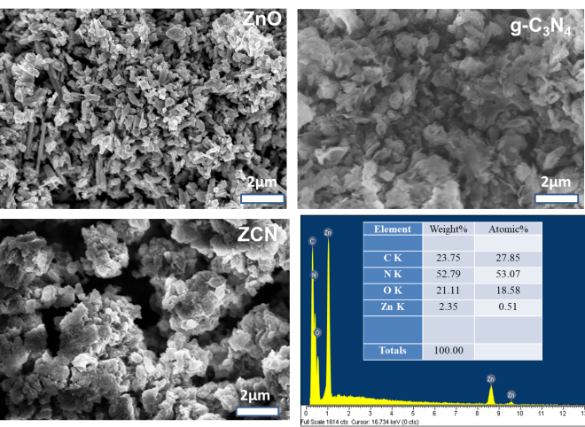
4 | What is the specific purpose of having strong oxidizing agent H₂O₂ in the photocatalytic process? Had the author proceeded photocatalytic without H₂O₂? | The authors would like to accept the comments of reviewers and add additional information on the catalytic process of ZCN material without the presence of H₂O₂.  The results show that, in the presence of H₂O₂, the photocatalytic efficiency is improved compared to materials without H₂O₂, specifically, ZCN+H₂O₂ reaches 94.75% and ZCN sample only reaches 59.73%. This shows that H₂O₂ plays an important role in improving the catalytic activity of composite materials. H₂O₂ is considered a “green” oxidant. Especially in the presence of light, H₂O₂ will create hydroxyl radicals (OH·) that decompose organic compounds [1]. H₂O₂ is effectively used to decompose organic pollutants when combined with a photocatalyst. And it was successful when combined with ZCN to enhance the photocatalytic activity to decompose organic substances and this is clearly shown in the Figure below in accordance with the observation of Wang et al [2].  [1] M. M. D. Dipendu Saha, Tyler J. Hoinkis, Erik J. Smeltz, Ryan Thorpe, Dale K. Hensley, Shirley G. Fischer-Drowos, Jihua Chen, "Influence of hydrogen peroxide in enhancing photocatalytic activity of carbon nitride under visible light: An insight into reaction intermediates," Journal of Environmental Chemical Engineering, 2018.  [2] Z. D. Y. Cui, P. Liu, M. Antonietti, X. Fu. X. Wang, "Metal-free activation of H₂O₂ by g-C₃N₄ under visible light irradiation for the degradation of organic pollutants," Phys Chem Chem Phys., vol. 14, pp. 1455-1462, 2012.
5 | There is a new absorption peak at around 470 nm in UV-Vis-DRS spectrum of ZCN and the author has not analyzed this phenomenon. | ZnO is a material whose absorption occurs at wavelengths shorter than 400 nm with a band gap energy calculated according to the kubelka-munk formula of 3.08 eV. This shows that ZnO is a semiconductor material with good photoelectric properties in the UV light region. The absorption edge of g-C₃N₄ is 445 nm with a direct bandgap energy level of 2.85 eV. The ZCN composite has increased light absorption intensity in the visible region and has a clear red shift when the absorption edge increases to 470 nm. This indicates a narrowing of the band gap of the ZCN sample compared to pure g-C₃N₄ and the band gap of ZCN is clearly reduced to 2.37 eV. Therefore, the ZCN composite significantly improves the photocatalytic efficiency in the visible light region compared to single materials.
6 | What is the originality of this study? | A simple calcination method was used to synthesize the ZCN composite.  The photocatalytic degradation performance of Rhodamine B over ZCN was significantly improved.

REVIEWER 3
 | Correcting spelling errors, such as "dye" (page 1) and "time" (figure 5), is imperative.  X-ray Photoelectron Spectroscopy (XPS) Analysis, photocurrent, and transient photoluminescence spectroscopy. These analyses provide valuable insights into the surface chemistry, chemical state, charge carrier behavior, and recombination processes, confirming its photocatalytic efficiency.  Future investigations should focus on unraveling the underlying mechanism behind the enhanced photocatalytic activity, exploring stability, recyclability, and performance under diverse experimental conditions. These endeavors hold the potential for significant advancements in the field. | Thanks you for your suggestion. The authors accepted the comments of the reviewers.  The authors removed the word "dye" in line 7 of the abstract and the phrase "adsorption time = 30 min" in Figure 5.  The authors would like to thank the reviewers for their comments. Surely in the next works, we will feature additional evidence such as X-ray Photoelectron Spectroscopy (XPS) Analysis, photocurrent, and transient photoluminescence spectroscopy and some surveys of influencing factors such as catalyst amount, pH, and mechanism of the reaction.

Xin trân trọng cảm ơn!
Ngày 7 tháng 3 năm 2024
TM NHÓM TÁC GIẢ

