Evaluate the agro-biological traits and medicinal value of wild bitter gourd accessions (Momordia charantia L. var. abbreviata Ser.) collected from South Central region of Vietnam

Bui Hong Hai∗, Nguyen Thi Y Thanh, Ho Tan
Faculty of Natural Sciences, Quy Nhon University

Received:
Accepted:

ABSTRACT
Bitter gourd (Momordica charantia L.) was widely grown in Vietnam and many countries around the world. This plant species was used as a vegetable and medicinal herb to treat diabetes, hepatitis, kidney (stone), cancer, anti-oxidation... Bitter gourd fruit contains active pharmaceutical ingredients including glycosides, alkaloids, triterpenes, steroids, and especially high concentrations of saponins. Wild bitter gourd (Momordica charantia L. var. abbreviata Ser.) has higher medicinal properties and resistance than commercial varieties. However, collecting and evaluating wild bitter gourd varieties has been still limited. The study aimed to evaluate the agro-biological traits and quantify the saponin content of 12 wild bitter gourd accessions collected from the South Central region. The initial research results showed that collected 12 wild bitter gourd accessions have a low germination rate (10.34 - 44.19%), different germination time (2 - 20 days), and first fruit harvest time from 37 to 55 days after planting. The characteristics of leaves, fruits and seeds differ within studied wild bitter gourd accessions: leaf size (11.90 - 20.23 cm x 9.95 - 16.4 cm), petiole length (3.97 - 8.71 cm), deeply lobed leaf blades with 5 or 7 lobes; fruit size (4.09 - 8.77 cm x 2.05 - 3.5cm) with fruit weight (4.41 - 30.09 g.fruit⁻¹) and fresh fruit yield (114.84 - 614.045 g fresh fruit.plant⁻¹); seed size (9.36 - 13.18 mm x 5.0 - 8.0 mm). Total saponin content ranges from 13.26 to 18.98 mg.g⁻¹ dry fruit. The BD4 and QN2 accessions with high yields (614.04 g.plant⁻¹ and 613.55 g.plant⁻¹ respectively) should be promising for breeding to enhance yield. The BD3 and QN3 with high total saponin content (18.98 mg.g⁻¹ dry fruit and 16.77 mg.g⁻¹ dry fruit respectively) should be suitable for breeding to increase saponin properties.
Keywords: Wild bitter gourd, Momordia charantia L. var. abbreviata Ser., South Central region, agro-biological traits, medicinal value.

1. INTRODUCTION
Bitter gourd (Momordica charantia L.) or bitter melon which belongs to Cucurbitaceae was widely grown in Vietnam and other countries in Asia, East Africa, Amazon, and the Caribbean countries.^{1,2} Besides using as a vegetable, bitter gourd is also used as herbal medicine to treat diabetes, kidney (stone), eczema, malaria, hepatitis, gout, laxatives, AIDS, cancer, ...^{3,4,6} Bitter gourd contains active pharmaceutical ingredients including glycosides, saponins, alkaloids, triterpenes, and steroids.^{4,5} The important pharmaceutical components that were isolated are saponin and monordicin.⁴ Saponin is a compound containing charantin, acts as an insulin that has a safe effect on lowering blood sugar. Momordicin is a mixture of charantin, protein, adenine, betanin, vitamins B, C... could kill bacteria and viruses, effectively inhibit cancer cells,^{4,6} prevent DNA damage caused by H₂O₂ as well as inhibit the activity of enzyme α-amylase, anti-inflammatory,⁷ improve the antioxidant activity of enzymes,⁸ supporting the control of disorders blood lipids and oxidative stress in type 2 diabetic patients.⁹
The precedent research results showed that wild bitter gourd varieties (Momordica charantia L. var. abbreviata Ser.) have higher pharmacological activities than commercial varieties.^{10,11} In especially, these wild varieties have also better resistance to bacteria and cytotoxic activities,^{12,13} to fruit flies (Bactrocera cucurbitae) than cultivated bitter gourd varieties.¹¹. However, recent research has just focused on expanding wild bitter melon production due to market demand and their potential to increase income for producers. Collecting and studying on growth and agro-biological characteristics of wild bitter gourd varieties is still limited in Vietnam. In recent research, Phan D.T.P. and colleagues collected and evaluated 9 wild bitter melon accessions/varieties in Binh Phuoc province, including the AB5 variety with high yield potential and the BT2 variety with high saponin content.¹⁴ Bui T.X. and colleagues also evaluated and analyzed the genetic diversity of 12 wild bitter melon varieties in many different regions.¹⁵ In the South-Central region, there are diverse natural conditions that promise an abundance of wild bitter melon accessions. Therefore, this research aims to collect, evaluate, and initially create starting materials for breeding in the future.
2. METHODS
2.1. Materials

12 wild bitter gourd accessions were collected from the South Central region from April to September 2023 presented in Table 1.

Table 1. The list of collected wild bitter gourd accessions
No. | Accession Code | Collection location | Date
1 | QN1 | An My ward, Tam Ky city, Quang Nam province | 23/7/2023
2 | QN2 | Dien Phuong commune, Dien Ban district, Quang Nam province | 23/7/2023
3 | QN3 | Nui Thanh town, Nui Thanh district, Quang Nam province | 27/7/2023
4 | QNg1 | Tinh Long commune, Quang Ngai city, Quang Ngai province | 30/4/2023
5 | QNg2 | Nghia Ha commune, Tu Nghia district, Quang Ngai province | 30/4/2023
6 | QNg3 | Binh Phuoc commune, Binh Son district, Quang Ngai province | 29/4/2024
7 | BD1 | Tay Giang commune, Tay Son district, Binh Dinh province | 01/9/2023
8 | BD2 | Cat Minh commune, Phu Cat district, Binh Dinh province | 20/6/2023
9 | BD3 | My Chau commune, Phu My district, Binh Dinh province | 23/5/2023
10 | BD4 | Nhon Phu ward, Quy Nhon city, Binh Dinh province | 10/5/2023
11 | PY1 | An Nghiep commune, Tuy An district, Phu Yen province | 20/6/2023
12 | BT1 | Thuan Hoa commune, Ham Thuan Bac district, Binh Thuan province | 10/4/2023

2.2. Methods
2.2.1. Experimental design
The experiment was conducted from September 2023 to February 2024 in the net house at the Applied Research Garden for Agriculture and Environment, Quy Nhon University. Experimental conditions during the study period included average temperature (28.15 °C), relative humidity (80 %), average sunshine hours per month (140 hours.month⁻¹), and average monthly rainfall (334 mm.month⁻¹).
The experiment was laid out as a completely randomized design with 12 plots of 5 m² (5x1m). Each plot planted 10 plants of a wild bitter gourd accession, two plants 50 cm apart and two rows 80 cm apart. The total experimental area is 60 m² (10m x 6m) not including protection path and isolation distances.
2.2.2. Cultivation process
Experimental procedure according to QCVN 01-153:2014/BNNPTNT¹⁶, the studied wild bitter gourd plants were grown in black nylon bags (20x40cm). The planting substrate includes 50 % treated coconut fiber, 20 % smoked rice husk, 20 % soil, and 10 % Gianh River microbiological organic fertilizer (v:v). The nutrient solution is mixed from 10 g of GATIT NPK soluble fertilizer 17-6-17+TE (https://www.gatvn.com/products/gatit-npk-17-6-17-te) in 30 liters of water and watered by using a drip system. The amount of nutrient solution is adjusted to suit each stage of plant growth.
The seeds are washed, soaked in warm water for 2 hours, and incubated in a damp cloth until germination. Germinated seeds were then planted in a plastic tray containing Tribat clean soil, and watered for keeping moist. 13 days after sowing, the seedlings had 2 to 3 true leaves and were transplanted one plant in a black nylon bag.
2.3.3. Indicators and measurement
Agro-biological traits were evaluated according to QCVN 01-153:2014/BNNPTNT¹⁶ including growth stages; leaf length (cm), leaf width (cm), petiole length (cm), fruit length (cm), fruit diameter (cm), fruit weight (g), seed length (mm), seed width (mm), seed thickness (mm), seed mass (mg) were determined through 15 samples; number of fruits per plant (fruits) and fresh fruit yield (g.plant⁻¹) were measured for 30 days from the first fruit harvest date. Total saponin content was determined by using spectrophotometry at 560 nm with UV-Vis 1800i equipment (Shimadzu, Japan).¹⁷ Dry matter content (%) was determined by weighing and drying at 55 ºC for 36 hours.
The research data were analyzed by using MS. Excel 2010 and Statistix (ver. 8.0). The experimental results were statistically analyzed by one-way ANOVA analysis with LSD (least significant difference) test for multiple comparisons at a 5 % significance level.
3. RESULTS AND DISCUSSION
3.1. Growth stages and yield
The results of the growth stages are shown in Table 2. Research data indicated the collected wild bitter gourd accessions have a low germination rate from 10.34 % (QN1) to 44.19 % (QN3) and the germination time is not consistent within accessions from 2 days (QN3 and PY1) to 20 days (QN2). Male flowering time is usually earlier than its female flowers and this indicator also differs greatly between studied accessions from 27 days after planting (DAP) in BT1 to 40 DAP (PY1). Female flowering time ranges from 20 DAP (BT1) to 41 DAP (QN2). In particular, some studied wild bitter gourd accessions have the appearance of male flowers before female flowers such as BT1 (7 days in advance), PY1 (2 days in advance), or male and female flowers appearing on the same day (BD1). The first fruit harvest time ranges from 37 DAP (BT1) to 55 DAP (QN2), corresponding after the appearance of female flowers from 9 days (BD1, QNg1) to 15 days (QNg3, BD4, and PY1).

Table 2. Growth stages and yield of studied wild better gourd accessions
Accession  Code | Germination rate (%) | Germination time (day) | Male flowering time (DAP) | Female flowering time (DAP) | First harvest time (DAP) | Num. of fruit per plant (fruit) | Yield (g)
QN1 | 10.34 | 18 | 34 | 39 | 49 | 24.7de | 261.82^{d}
QN2 | 11.11 | 20 | 35 | 41 | 55 | 35.1^{b} | 613.55ª
QN3 | 44.19 | 2 | 31 | 36 | 49 | 28.3^{c} | 283.00^{d}
QNg1 | 11.11 | 13 | 38 | 45 | 54 | 39.7ª | 457.74^{c}
QNg2 | 18.75 | 13 | 30 | 37 | 51 | 36.9^{ab} | 453.87^{c}
QNg3 | 34.48 | 3 | 31 | 35 | 50 | 24.8de | 248.00de
BD1 | 38.71 | 6 | 39 | 39 | 48 | 22.3^{ef} | 532.97^{b}
BD2 | 12.50 | 16 | 31 | 36 | 48 | 38.6ª | 582.86ª
BD3 | 13.04 | 13 | 24 | 34 | 47 | 38.2^{ab} | 255.94^{d}
BD4 | 25.00 | 6 | 25 | 29 | 44 | 20.4^{fg} | 614.04ª
PY1 | 44.00 | 2 | 40 | 38 | 53 | 17.8^{g} | 206.48e
BT1 | 37.78 | 12 | 27 | 20 | 37 | 26.1^{cd} | 114.84^{f}
LSD_{0,05} | - | - | - | - | - | 3.34 | 44.94
CV (%) | - | - | - | - | - | 12.79 | 13.15

Note: Mean followed by the same letter is not significantly different within the columns according to an LSD test at the 0.05 significance level; CV - coefficient variance; LSD: least significant difference; DFP: the day after planting.

After 30 days of harvesting, the number of fruits per plant of wild bitter melon accessions ranges from 17 fruits.plant⁻¹ (PY1) to 39.1 fruits.plant⁻¹ (QNg1), the fresh yield ranges from 114.84 to 614.04 g.plant⁻¹. The accessions with high fresh fruit yield are BD4 (614.04 g.plant⁻¹), QN2 (613.55 g.plant⁻¹), BD2 (582.86 g.plant⁻¹), BD1 (532.97 g.plant⁻¹). The accessions with low fresh fruit yield are BT1 (114.84 g.plant⁻¹), and PY1 (206.48 g.plant⁻¹). The number of fruits per plant is lower, but the fresh fruit yield of the studied wild bitter melon accessions is equivalent in comparison with the results of some varieties collected in Binh Phuoc during the same harvest time, such as BT4 (500 g.plant⁻¹) and HC2 (610 g.plant⁻¹).¹⁴
3.2. Leaf morphological traits
The leaf is an important organ of a plant that performs photosynthesis to create organic matter, thereby generating energy for all living activities. Leaf size shows the photosynthetic ability of a plant as well as its yield potential.¹⁸ The characteristics of leaf blade size, petiole length, and leaf descriptions of studied wild bitter gourd accessions are shown in Table 3 and Figure 1.

Table 3. Leaf morphological traits of studied wild better gourd accessions
Accession  Code | Leaf length (cm) | Leaf width (cm) | Petiole length (cm) | Leaf descriptions
QN1 | 12.63^{fg} | 9.95^{g} | 4.37^{h} | Small leaf blade size, light green, deeply lobed leaf blade with 5 lobes, heart-shaped at the base of leaf blade, and slightly pointed at the tip of a leaf lobe.
QN2 | 14.53e | 12.13^{d} | 6.03e | Medium leaf blade size, dark green, deeply lobed leaf blade with 7 lobes, heart-shaped at the base of leaf blade, and pointed at the tip of a leaf lobe.
QN3 | 17.47^{b} | 15.30^{b} | 4.73^{g} | Medium leaf blade size, light green, deeply lobed leaf blade with 5 lobes, heart-shaped at the base of leaf blade, and slightly pointed at the tip of a leaf lobe.
QNg1 | 14.87e | 10.97^{ef} | 5.10^{f} | Small leaf blade size, light green, deeply lobed leaf blade with 5 lobes, heart-shaped at the base of leaf blade, and slightly pointed at the tip of a leaf lobe.
QNg2 | 15.97^{d} | 14.17^{c} | 4.45^{gh} | Medium leaf blade size, medium green, deeply lobed leaf blade with 7 lobes, heart-shaped at the base of leaf blade, and pointed at the tip of a leaf lobe.
QNg3 | 13.40^{f} | 11.53de | 5.19^{f} | Medium leaf blade size, medium green, deeply lobed leaf blade with 7 lobes, heart-shaped at the base of leaf blade, and pointed at the tip of a leaf lobe.
BD1 | 17.23^{b} | 14.03^{c} | 8.02^{b} | Large leaf blade size, medium green, deeply lobed leaf blade with 7 lobes, heart-shaped at the base of leaf blade, and pointed at the tip of a leaf lobe.
BD2 | 17.19^{bc} | 11.98^{d} | 6.98^{c} | Small leaf blade size, light green, deeply lobed leaf blade with 7 lobes, heart-shaped at the base of leaf blade, and pointed at the tip of a leaf lobe.
BD3 | 12.70^{fg} | 10.97^{ef} | 6.48^{d} | Small leaf blade size, dark green, deeply lobed leaf blade with 5 lobes, heart-shaped at the base of leaf blade, and slightly obtuse at the tip of a leaf lobe.
BD4 | 20.23ª | 16.40ª | 8.71ª | Large leaf blade size, light green, deeply lobed leaf blade with 7 lobes, heart-shaped at the base of leaf blade, and pointed at the tip of a leaf lobe.
PY1 | 16.30^{cd} | 13.53^{c} | 8.11^{b} | Medium leaf blade size, light green, deeply lobed leaf blade with 5 lobes, heart-shaped at the base of leaf blade, and slightly pointed at the tip of a leaf lobe.
BT1 | 11.90^{g} | 10.40^{fg} | 3.97^{i} | Small leaf blade size, light green, deeply lobed leaf blade with 5 lobes, heart-shaped at the base of leaf blade, and slightly pointed at the tip of a leaf lobe.
LSD_{0,05} | 0.92 | 0.81 | 0.35 | -
CV (%) | 8.31 | 8.90 | 8.11 | -

The data in Table 3 shows that the studied wild bitter gourd accessions have leaf lengths ranging from 11.90 cm to 20.23 cm and leaf blade widths ranging from 9.95 cm to 16.4 cm. The accessions with small leaf sizes are BT1 (11.9 x 10.4 cm), QN1 (12.63 x 9.95 cm), and BD3 (12.7 x 10.97 cm). The accessions with large leaf sizes are BD4 (20.23 x 16.4 cm), QN3 (17.47 x 15.3 cm), and BD1 (17.23 x 14.03 cm). The petiole length ranged from 3.97 cm (BT1) to 8.71 cm (BD4). The leaf size of the studied wild bitter gourd accessions is equivalent to the research result of Bui Thi Xuan et al. (12.1 - 24.2 cm x 9.1 - 16.7cm).¹⁵
The leaf blades of all studied wild bitter gourd accessions are heart-shaped at the leaf bases. The tip of a leaf lobe is slightly pointed, pointed, or slightly obtuse. The leaf blades are deeply lobed with 5 or 7 lobes. The accessions that have the leaf blade with 5 deep lobes include QN1, QN3, QNg1, BD3, PY1, and BT1. The accessions that own leaf blades with 7 deep lobes include QN2, QNg2, QNg3, BD1, BD2, and BD4 (Figure 1). The leaf morphological characteristics of the studied wild bitter gourd accessions are similar to the result investigated by Bui Thi Xuan and colleagues.¹⁵
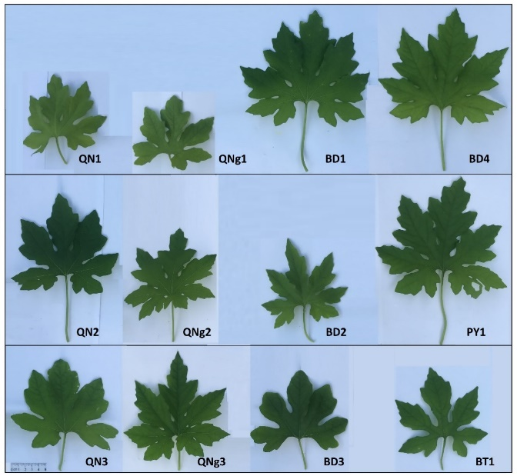
Figure 1. Leaf morphology of the studied wild bitter gourd accessions
3.3. Fruit morphological traits
The traits of fruit including fruit length, fruit diameter, cross-section shape, color of skin, and wart size are used to classify group varieties in breeding testing.¹⁶ The fruit traits of studied wild bitter gourd accessions are shown in Table 4 and Figure 2.
Data in Table 4 shows that the fruit length ranges from 4.09 cm to 8.77 cm, the fruit diameter ranges from 2.05 cm to 3.5 cm, and the fruit weight ranges from 4.41 g.fruit⁻¹ to 30.09 g.fruit⁻¹. The wild bitter gourd accessions with large fruit sizes are BD4 (8.77 x 3.53cm, 30.09 g.fruit⁻¹), and BD1 (7.19 x 3.24 cm, 23.87 g.fruit⁻¹). The accessions with small fruit sizes are BT1 (4.09 x 2.05 cm, 4.41 g.fruit⁻¹), and BD3 (4.15 x 2.99 cm, 6.74 g.fruit⁻¹). The fruit size of the studied wild bitter gourd accessions is smaller than the fruit size of the wild bitter melon accessions studied by Bui Thi Xuan and colleagues (5.5 - 14.9 cm x 2.9 - 6.7 cm)¹⁵ but it is larger than the wild bitter melon varieties studied by Phan Dang Thai Phuong and colleagues (2.79 - 4.38 cm x 1.54 - 1.82 cm).¹⁴ This difference may be due to differences in genotype between accessions/varieties collected, as well as different time and experimental conditions of the studies.
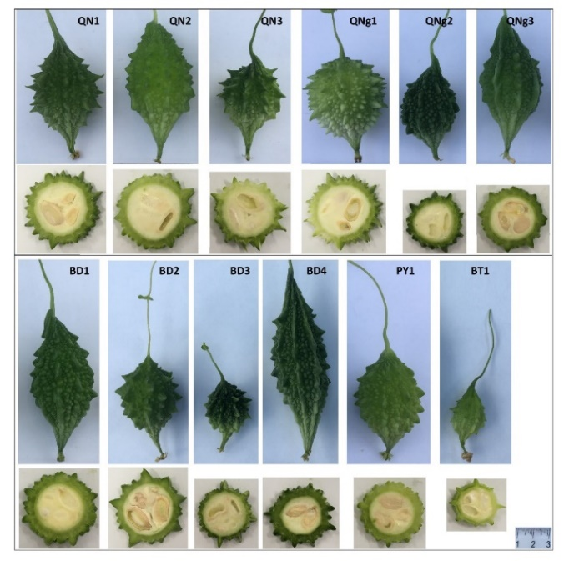
Figure 2. Shape and cross-section of the fruit of studied wild bitter gourd accessions
The fruit's longitudinal shape, color of skin, and wart size of the studied wild bitter gourd accessions are varied. The longitudinal shapes of fruit include rhomb (QN1, BD2, and PY1), oval (QN2, QNg3, BD1, BD4, and BT1) and ovoid (QN3, QNg1, QNg2, and BD3). The color of skin include dark green (QNg2 and BD4), medium green (QN1, BD1, BD2 and BD3) and light green (QN2, QN3, QNg1, QNg3, PY1, and BT1). The fruit surfaces of studied wild bitter gourd accessions are different in wart sizes, the shape of top wart, and ridges. The accessions with acute warts (QN1, QN3, QNg1, BD2, BD3, BT1). The accessions with obtuse warts (QN2, QNg2, QNg3, BD1, BD4, PY1). The accessions with ridges include QNg3, BD1, and BD4.

Table 4. Fruit morphological traits of studied wild bitter gourd accessions
Accession  Code | Fruit length (cm) | Fruit diameter (cm) | Fruit mass (g) | Fruit descriptions
QN1 | 5.32de | 2.97^{cd} | 10.62e | Fruit with rhombic shape, acute at base and apex, medium green, surface with medium-large acute warts and many small acute warts.
QN2 | 6.55^{c} | 3.07^{bc} | 17.48^{c} | Fruit with oval shape, acute at base and apex, white green, surface with many medium acute warts.
QN3 | 4.88e | 2.93^{cde} | 10.05^{ef} | Fruit with avoid shape, acute at base and apex, white green, surface with few large acute warts and many small obtuse warts.
QNg1 | 5.53^{d} | 3.03^{bc} | 11.53e | Fruit with avoid shape, obtuse at base and acute at apex, white green, surface with few large acute warts and many small acute warts.
QNg2 | 5.35de | 3.15^{bc} | 12.32de | Fruit with avoid shape, acute at base and apex, dark green, surface with few large acute warts and many small obtuse warts.
QNg3 | 4.88e | 3.14^{bc} | 10.05^{ef} | Fruit with oblong oval shape, acute at base and apex, white green, surface with many small obtuse warts and long ridges.
BD1 | 7.19^{b} | 3.24^{7b} | 23.87^{b} | Fruit with oval shape, acute at base and apex, medium green, surface with many small obtuse warts and few short ridges.
BD2 | 5.57^{d} | 3.50ª | 15.09^{cd} | Fruit with rhombic shape, acute at base and apex, medium green, surface with medium-large acute warts and medium-small acute warts.
BD3 | 4.15^{f} | 2.99^{ed} | 6.74^{fg} | Fruit with avoid shape, acute at base and apex, medium green, surface with medium-large acute warts and many small acute warts.
BD4 | 8.77ª | 3.53ª | 30.09ª | Fruit with oblong oval shape, acute at base and apex, dark green, surface with many small abtuse warts and long ridges.
PY1 | 5.33de | 2.73e | 11.65e | Fruit with rhombic shape, acute at base and apex, white green, surface with many small rounded warts and few obtuse warts.
BT1 | 4.09^{f} | 2.05^{f} | 4.41^{g} | Fruit with oval shape, acute at base and apex, white green, surface with few large acute warts and many small obtuse warts.
LSD_{0,05} | 5.82 | 2.33 | 3.33
CV (%) | 13.96 | 10.74 | 32.21

3.4. Seed morphological traits
The seed size of studied wild bitter gourd accessions also has significant differences as shown in Table 4 and Figure 3. In detail, seed length ranges from 9.36 mm (BT1) to 13.18 mm (BD2), seed width ranges from 5.0 mm (QNg2) to 8.0 mm (BD4), grain thickness ranges from 2.61 mm (BD5) to 3.97 mm (BD2), grain weight ranges from 71.64 mg.seed⁻¹ (BT1) to 180.64 mg.seed⁻¹ (BD4) ). The accessions with small seeds include BT1, QN1, QN3, QNg1, and QNg2. The accession with large seeds include QN2, QNg3, BD1, BD2, BD3, BD4, and PY1. The seed size of the studied accessions is similar to the research result of Bui Thi Xuan and colleagues (9.1 - 15.6 mm x 5.0 - 9.4 mm x 3.0 - 4.8 mm).¹⁵

Table 5. Seed morphological traits of the studied wild bitter gourd accessions
Accession Code | Seed length (mm) | Seed width (mm) | Seed thickness (mm) | Seed mass (mg) | Seed descriptions
QN1 | 11.68^{cd} | 6.32e | 3.21^{cd} | 99.91^{f} | Oval shape, dark gray, smooth surface with or without black spots in the middle, and small edges.
QN2 | 12.09^{bc} | 7.45^{b} | 3.79^{ab} | 140.36^{cd} | Oval shape, light brown, lumpy surface with stripes, and indentation in middle, and small edges.
QN3 | 11.50^{d} | 6.09e | 3.40^{c} | 101.09^{f} | Oval shape, light gray, smooth surface with or without black spots, and very small edges.
QNg1 | 12.36^{b} | 6.73^{d} | 2.95e | 134.09de | Oval shape, dark gray, smooth surface with unclear stripes, and small edges.
QNg2 | 10.55e | 5.00^{f} | 3.03de | 81.73^{g} | Long oval shape, light brown, light mumpy surface with clear stripes, and very small edges.
QNg3 | 12.09^{bc} | 7.09^{bcd} | 3.84^{ab} | 149.73^{bc} | Oval shape, dark brown, lumpy surface with clear stripes, and small edges.
BD1 | 12.09^{bc} | 7.86ª | 3.94^{ab} | 154.36^{b} | Oval shape, dark brown, smooth surface with unclear stripes, and small edges.
BD2 | 13.18ª | 7.86ª | 3.97ª | 175.09ª | Oval shape, light brown, lumpy surface with clear stripes and indentation in middle, and small edges.
BD3 | 12.23^{b} | 7.00^{cd} | 3.73^{b} | 155.36^{b} | Oval shape, light brown, smooth surface with few stripes, and small edges.
BD4 | 13.00ª | 8.00ª | 3.82^{ab} | 180.64ª | Oval shape, dark brown, lumpy surface with clear stripes and dark brown indentation in middle, and small edges.
PY1 | 11.27^{d} | 7.27^{bc} | 3.09de | 124.18e | Oval shape, light brown, lumpy surface with clear stripes and dark brown indentation in the middle, and small edges.
BT1 | 9.36^{f} | 5.23^{f} | 2.61^{f} | 71.64^{g} | Oval shape, light gray, smooth surface with or without dark gray spots, and very small edges.
LSD_{0,05} | 0.51 | 0.38 | 0.24 | 13.29
CV(%) | 5.15 | 6.66 | 8.36 | 12.05

The seed surface and color of testa also varied between studied accessions. The accessions with gray testa include QN1, QN3, QNg1 and BT1. The accessions with brown testa include QN1, QNg2, QNg3, BD1, BD2, BD3, BD4, and PY1. The seed surface with clear stripes is shown QN2, QNg2, QNg3, BD2, BD4, and PY1 accessions.
3.5. Saponin and fruit dry matter content
Saponin is the most important medicinal ingredient in fruit bitter gourd and has an effect for lowering blood sugar,⁹ killing bacteria and viruses, effectively inhibiting cancer cells,^{4,6} limiting DNA damage caused by H₂O₂, anti-inflammatory,⁷ anti-oxidant.⁸ Quantifying saponin content serves to evaluate the medicinal value of studied bitter gourd accessions, the research results are shown in Figure 4.
Total saponin content in dried fruit of studied wild bitter melon accessions was relatively uniform between accessions from 13.26 to 18.98 mg.g⁻¹ dry fruit. However, the two accessions with high total saponin content are BD3 (18.98 mg.g⁻¹ dry fruit) and QN3 (16.77 mg.g⁻¹ dry fruit).
The fruit dry matter content ranged from 8.44 % to 12.9 7%. The accessions with high fruit dry matter content include BD2 (12.97 %) and BD3 (12.49 %). The accessions with low fruit dry matter content include BD1 (8.44 %), BT1 (9.28 %), and QN1 (9.37 %).

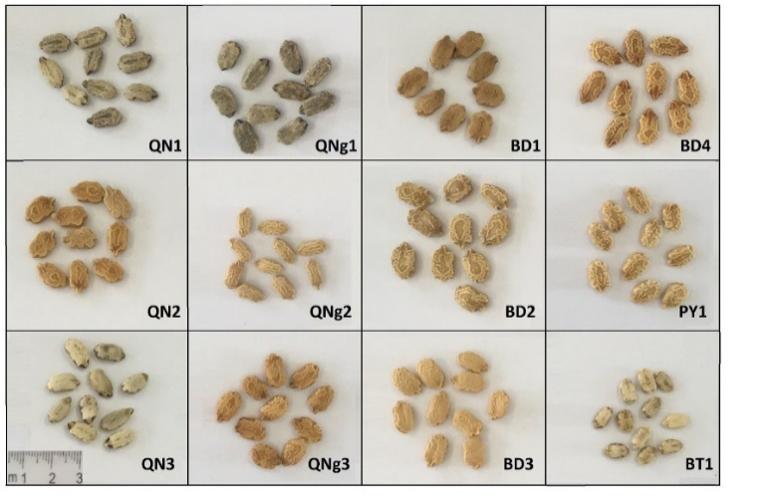
Figure 3. Seed of studied wild bitter gourd accessions
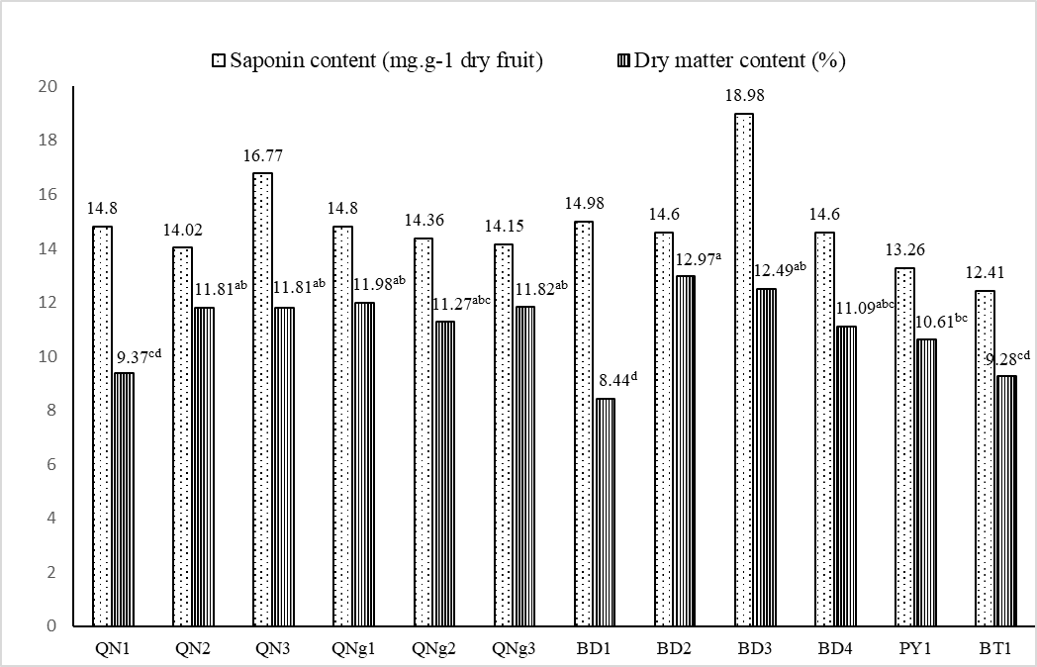
Figure 4. Total saponin content and fruit dry matter content of studied wild bitter gourd accessions

CONCLUSION
The collected 12 wild bitter gourd accessions have a low germination rate (from 10.34 % to 44.19 %), uneven germination time (from 2 to 20 days), and varied first harvest time (from 37 to 55 days after planting). The traits of leaf, fruit, and seed differ between studied wild bitter gourd accessions. In detail, leaf blade size ranges from 11.90 - 20.23 cm x 9.95 - 16.4 cm, petiole length ranges from 3.97 cm to 8.71 cm, deeply lobed leaf blades with 5 or 7 lobes; Fruit size ranges from 4.09 - 8.77 cm x 2.05 - 3.5cm with fruit weight from 4.41 to 30.09 g.fruit⁻¹ and fresh fruit yield from 114.84 to 614.045 g.plant⁻¹; seed size ranges from 9.36 - 13.18 mm x 5.0 - 8.0 mm. Total saponin content ranges from 13.26 to 18.98 mg.g⁻¹ dry fruit. The dry matter content in the fruit ranges from 8.44 to 12.97%.
The studied wild bitter gourd accessions with high yields are BD4 (614.04 g.plant⁻¹) and QN2 (613.55 g.plant⁻¹) which should be following breeding selection for yield. The accessions with high saponin content are BD3 (18.98 mg.g⁻¹ dry fruit) and QN3 (16.77 mg.g⁻¹ dry fruit) should be suitable for breeding to enhance total saponin content.
Acknowledgment
This research is conducted within the framework of science and technology projects at the institutional level of Quy Nhon University under the project code T2023.799.09.
REFERENCES
1. Ahmad N., Hasan N., Ahmad Z., Zishan M., Zohrameena S. Momordica charantia: for traditional uses and pharmacological actions. Journal of Drug Delivery & Therapeutics, 2016, 6 (2), 40-44.
2. Reyes R.M. Current status of bitter gourd production and marketing in Asia and market potential of bitter gourd as a functional vegetable, International Bitter Gourd Conference, Hyderadad, India, 2014.
3. Arafat S.Y., Nayeem M., Jahan S., Karim Z., Reza H.M., Hossain M.H., Shohel M., Alam M.A.. Ellagic acid-rich Momordica charantia fruit pulp supplementation prevented oxidative stress, fibrosis and inflammation in the liver of alloxan-induced diabetic rats. Orient. Pharm. Exp. Med., 2016, 16 (4), 267-278.
4. J. K. Grover, S. P. Yadav. Pharmacological action and potential uses of Momordica charantia: a review, J Ethnopharmacol, 2004, 93, 123-132.
5. Raman, A., Lau, C. Anti-diabetic properties and phytochemistry of Momordica charantia L. (Cucurbitaceae). Phytomedicine, 1996, 2, 349-362.
6. Jing-Ru Weng. A triterpenoid from wild bitter gourd inhibits breast cancer cells, Scientific Reports, 2016, 6, 22419.
7. Pham TMH., Ngo DH., Ngo DN., Vo TS. Investigation of biological activities of wild bitter melon (Momordica charantia L. var. abbreviata Ser.). Biomolecules, 2019, 9(6), 211.
8. Sagor A.T., Chowdhury M.R.H., Tabassum N., Hossain H., Rahman M.M., Alam M.A. Supplementation of fresh ucche (Momordica charantia L. var. muricata Willd) prevented oxidative stress, fibrosis and hepatic damage in CCl4 treated rats. BMC Complement Altern Med., 2015, Apr 11, 15:115.
9. Poovitha, S, Parani, M. Protein extracts from Momordica charantia var. charantia and M. charantia var. muricata show anti-lipidemic and antioxidant properties in experimental type 2 diabetic rats. J Food Biochem, 2020, 44, e13370.
10. L.Y. Bai, Chang-Fang Chiu, Po-Chen Chu, Wei-Yu Lin, Shih Jiuan Chiu, Y.L. Lu, Yuh-Hwa Liu, Jong-Ho Chyuan, Kur-Ta Cheng, Wen-Li Liang, and Wen-Chi Hou. Antioxidant activities of different wild bitter gourd (Momordica charantia L. var. abbreviata Seringe) cultivars, Botanical Studies, 2012, 53, 207-214.
11. Dhillon, M K and Naresh, J S and Singh, R and Sharma, N K. Reaction of different bitter gourd (Momordica charantia L.) genotypes to melon fruit fly, Bactrocera cucurbitae (Coquillett). Indian Journal of Plant Protection, 2005, 33 (1), 55-59.
12. Lu, Y.-L., et al. Antibacterial and cytotoxic activities of different wild bitter gourd cultivars (Momordica charantia L. var. abbreviata Seringe), Botanical Studies, 2011, 52, 427-434.
13. N. P. Dam, V. M. Dien, L. H. V. Thanh, P. T. T. Hien, and N. T. T. Tram, Investigation of antimicrobial activity and chemical constituents of Momordica charantia L. var. abbreviata Ser., Vietnam J. Sci. Technol., 2019, 57 (2), 155–161.
14. Phan D.T.P., Tran T.D.T., Vu V.B. Initial assessment of yields and medicinal value of some wild bitter melon varieties in Binh Phuoc (in Vietnamese). Vietnam Journal of Science and Technology, 2017, 13(2), 13-17.
15. Bui T.X., Tran T.L., To M.T., Tran T.K.D., Nguyen Q.T., Nguyen V.T. Evaluation of agro-morphological characterisation and genetic diversity of wild bitter gourd (Momordica charantia L. var. abbreviata Ser.) accessions, Journal of Agriculture and Rural Development, 2022, 1(4), 12-23.
16. Department of Agriculture and Rural Development, QCVN 01-153:2014/BNNPTNT - National technical regulation on testing for distinctness, uniformity and stability of bitter gourd varieties, Hanoi, Vietnam, 2014.
17. Tan S.P. et al. Optimized aqueous extraction of saponin from bitter melon for production of a saponin-enriched bitter melon powder, J. Food Sci., 2014, 79, 1372-1381.
18. Lincoln Taiz, Eduardo Zeiger. Plant physiology and development (6th ed.), Sinauer Associate Inc., Sunderland, Massachusetts, USA, 2015.

Đánh giá đặc điểm nông sinh học và giá trị dược liệu của một số dòng mướp đắng rừng (Momordica charantia L. var. abbreviata Ser.) thu thập ở khu vực Nam Trung Bộ

Bùi Hồng Hải*, Nguyễn Thị Y Thanh, Hồ Tân

Khoa Khoa học Tự Nhiên, Đại học Quy Nhơn, Việt Nam
*Tác giả liên hệ chính: Email: buihonghai@qnu.edu.vn

TÓM TẮT
Cây mướp đắng (Momordica charantia L.) được trồng phổ biến và sử dụng làm rau, dược liệu nhằm chữa trị một số bệnh như tiểu đường, viêm gan, sỏi thận, ung thư, ... do chứa nhiều dược chất như glycosides, alkaloids, triterpenes, đặc biệt hàm lượng saponin cao. Mướp đắng rừng (M. charantia L. var. abbreviata Ser.) có hàm lượng dược chất và tính chống chịu cao hơn nhiều so với các giống thương mại. Tuy nhiên công tác thu thập, đánh giá các dòng/giống mướp đắng rừng còn nhiều hạn chế. Nghiên cứu nhằm đánh giá các đặc điểm nông sinh học và định lượng saponin của 12 dòng mướp đắng rừng thu thập ở khu vực Nam Trung Bộ. Kết quả nghiên cứu bước đầu cho thấy 12 dòng thu thập được có tỉ lệ nảy mầm thấp (10.34 - 44.19 %), thời gian nảy mầm không đồng đều (2 - 20 ngày), thời gian thu quả đợt đầu từ 37 đến 55 ngày sau trồng. Đặc điểm về lá, quả và hạt khác nhau giữa các dòng: kích thước lá (11.90 - 20.23 cm x 9.95 - 16.4 cm), phiến lá xẻ thùy sâu với 5 hoặc 7 thùy; kích thước quả (4.09 - 8.77 cm x 2.05 - 3.5 cm) và năng suất quả tươi (114.84 - 614.045 g quả tươi/cây); kích thước hạt (9.36 - 13.18 mm x 5.0 - 8.0 mm). Hàm lượng saponin tổng số từ 13.26 đến 18.98 mg/g quả khô. BD4 (614.04 g/cây) và QN2 (613.55 g/cây) có triển vọng trong hướng chọn giống về năng suất. Các dòng có hàm lượng saponin cao là BD3 (18.98 mg/g quả khô) và QN3 (16.77 mg/g quả khô) thích hợp với hướng chọn giống tăng hàm lượng saponin.
Từ khóa: Mướp đắng rừng (Momordia charantia L. var. abbreviata Ser.), Nam Trung Bộ, đặc điểm nông sinh học, giá trị dược liệu.

Liên hệ: Bùi Hồng Hải
Trường Đại học Quy Nhơn
170 An Dương Vương, TP. Quy Nhơn, tỉnh Bình Định, Việt Nam
Email: buihonghai@qnu.edu.vn
Điện thoại: 0983.230.599

∗Corresponding author. Email: buihonghai@qnu.edu.vn

