Nghiên cứu về ảnh hưởng của hàm lượng xi măng đến khả năng chịu lực của cọc xi măng đất để xử lý đất sét yếu ở khu đô thị sông Hà Thanh, thành phố Quy Nhơn.

Phạm Văn Trực¹, Phạm Thị Lan¹, Nguyễn Thị Khánh Ngân¹, Hoàng Công Duy^{1,*}

¹Khoa Kỹ thuật & Công nghệ, Trường Đại học Quy Nhơn

*Tác giả liên hệ chính. Email: hoangcongduy@qnu.edu.vn

TÓM TẮT
Trong thực tiễn hiện tại của các nền tảng xây dựng được đặt trên đất mềm ở Việt Nam, công nghệ cọc xi măng được sử dụng ngày càng rộng rãi vì những lợi thế nổi bật của nó. Cọc đất xi măng là cọc được làm từ đất địa phương trộn với một lượng xi măng và phụ gia nhất định tùy thuộc vào đặc tính địa kỹ thuật của đất trong khu vực dự án. Mục đích chính của nghiên cứu này là xác định hàm lượng xi măng tối ưu cho cọc xi măng-đất. Nhiều yếu tố ảnh hưởng đến cường độ của cọc đất xi măng, trong đó hàm lượng xi măng được sử dụng đóng một vai trò quan trọng và cần được nghiên cứu cẩn thận. Nghiên cứu này nhằm mục đích cung cấp thông số hàm lượng cấp phối xi măng phù hợp cho các cọc đất xi măng được áp dụng cho các dự án xây dựng ở khu vực đất yếu của sông Hà Thanh, thành phố Quy Nhơn. Các mẫu được tạo ra bằng cách trộn đất với hàm lượng xi măng thay đổi từ 5% đến 25%. Nhóm tác giả tiến hành xác định ứng suất dọc trục của các mẫu cọc đất xi măng ở thời điểm 7 ngày tuổi và 28 ngày tuổi bằng thí nghiệm nén một trục nở hông. Kết quả cho thấy hàm lượng xi măng tối ưu cho cọc đất xi măng đạt được từ 12% đến 15% đối với đất sét yếu khu đô thị Hà Thanh, thành phố Quy Nhơn, tỉnh Bình Định.
Từ khóa: cọc xi măng-đất, sức chịu tải của cọc, đất yếu, xử lý nền đất yếu.

Research on the influence of cement content on the bearing capacity of the soil-cement pile to treat soft clay in the Ha Thanh River urban area, Quy Nhon City.

Van Truc Pham¹, Thi Lan Pham¹, Thi Khanh Ngan Nguyen¹, Cong Duy Hoang^{1,*}

¹MS, Lecturer, Faculty of Engineering and Technology, Quy Nhon Univesity

*Corresponding author. Email: hoangcongduy@qnu.edu.vn

ABSTRACT
In the current practice of building foundations placed on soft soil in Vietnam, cement-soil pile technology is increasingly widely used because of its outstanding advantages. The cement-soil pile is a pile made from local soil mixed with a certain amount of cement and additives depending on the geotechnical characterization of the soil in the project area. The main purpose of this study is to propose the optimal cement content for cement-soil piles. Many factors affect the compressive strength of cement-soil piles, in which the cement content used plays an important role and needs to be carefully studied. This study aims to provide appropriate cement gradation content parameters for cement-soil piles applied to construction projects in the soft soil area of Ha Thanh River, Quy Nhon City. In the paper, the samples were created by mixing soil with cement content varying from 5% to 25%. The authors determined the axial stress of soil-cement pile samples at 7 days old and 28 days old using the unconfined compressive test. The results show that the optimal cement content for cement-soil piles ranges from 12% to 15% for soft clay in the Ha Thanh urban area, Quy Nhon City, Binh Dinh province.
Keywords: soil-cement pile, bearing capacity, soft soil, soft soil treatment method.

1. INTRODUCTION

The continuous development and progress of society, especially in the coastal and lagoon areas of Quy Nhon City, Binh Dinh province, and the construction of high-rise buildings, ports, and roads on weak foundations is extremely urgent. In this process, the soft soil treatment method will encounter more and more complex problems, thus creating opportunities for developing new soft soil foundation treatment technologies. Therefore, reasonable and effective treatment of soft soil foundations has become a key issue in engineering buildings. Among them, the cement-soil pile method is widely used for industrial and civil buildings, docks, and highways. In this study, the survey location was located at the An Phu Thinh social housing apartment building project at land lot B1 - 32, An Phu Thinh new urban area, location: Dong Da ward, Quy Nhon City, Binh Dinh province as shown in Figure 1. Soil stratification of the survey location is illustrated in Figure 1.

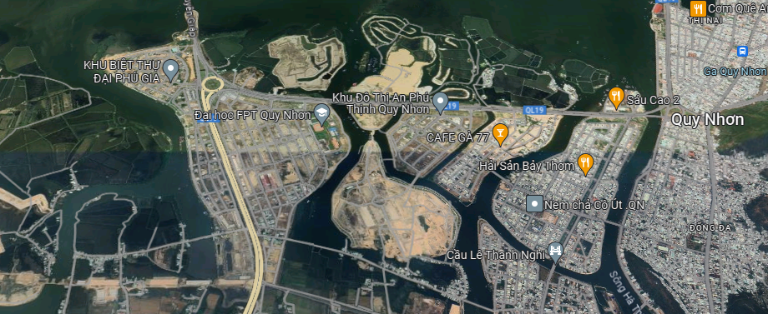
Figure 1. Location of the An Phu Thinh social housing apartment building project at land lot B1 - 32, An Phu Thinh new urban area, location: Dong Da ward, Quy Nhon City, Binh Dinh province.
2. METHODOLOGY

2.1. The geological structural conditions in the survey area.
The survey area has relatively flat terrain because it has been partially leveled with river bottom materials. Regarding geomorphology, the area belongs to agglomeration morphology, the geological formations are river and lake sediments with many types of heterogeneous materials. Conduct drilling and take soil and water samples and bring them to the laboratory to determine physical and mechanical criteria. The geotechnical parameters of the soft clays are shown in Table 1.

Table 1. Geotechnical parameters of soft clays in the An Phu Thinh social housing apartment building project at land lot B1 - 32, An Phu Thinh new urban area, Dong Da ward, Quy Nhon City, Binh Dinh province.
Depth(m) | Sample test | Description |  |  |  |  |  |  | SPT  (N-Value)
10-52m | Soft clay | Soft, blue-gray, dark gray, organic content of 13.1%, low plasticity |  |  |  |  |  |  | <3
Mechanical consistency of soft clay
γ | c | ϕ | G_{s} | W | W_{L} | W_{P} | I_{P} | I_{L} | e₀
kN/m³ | kN/m² | ⁰ |  | % | % | %
16.3 | 27.01 | 7 | 2.72 | 69.9 | 40.9 | 22.4 | 63.3 | 1.28 | 1.843

2.2. Stabilization of soft soil- The soil cement column method (TCVN 9403:2012)
In this study, the group of authors used the dry mixing method to cast sample tests. The process includes mechanically loosening the soil in the field and mixing dry cement powder with soil with or without additives. The method of creating soil-cement samples was followed TCVN9403:2012.⁸ Water and cement in the required amount were mixed manually until there was obtained homogeneous state of “laitance”. The amount of cement is determined by the weight ratio of dry soil. After the cement mortar was mixed with soil which is specific humidity. The obtained mixture was mixed to a homogeneous mass over 5 minutes in cylinders with dimensions h=100 mm and d=50 mm. The samples were pulled from the blocks on the second day and they were retained period till the test when 7 days and 28 days.⁸ The Parameters of test samples are presented in Table 2.

Table 2. The Parameters of test samples in the axial load test
Sample group | Number of samples | Weight of samples |  | Size of samples
Sample group | Number of samples | Cement (g) | Soil (g) | Height (mm) | Diameter (mm)
5% | 6 | 74.23 | 1814.27 | 100 | 50
8% | 6 | 118.77 | 1814.27 | 100 | 50
10% | 6 | 148.47 | 1814.27 | 100 | 50
12% | 6 | 178.16 | 1814.27 | 100 | 50
15% | 6 | 222.70 | 1814.27 | 100 | 50
18% | 6 | 267.24 | 1814.27 | 100 | 50
20% | 6 | 296.93 | 1814.27 | 100 | 50
25% | 6 | 371.17 | 1814.27 | 100 | 50
2.3. The axial load test

This test method is used to determine the unconfined compressive strength of cohesive soil in the undisturbed, remolded, or compacted condition by using strain-controlled application of the axial load.^{7,8} The equipment used in the unconfined compressive test is the Triplex II advanced as shown in Figure 2. In this test, the
unconfined compressive strength (q_{u}) is extracted as the maximum load attained per unit area or the load per unit area at 20% axial strain.⁷
$q_{u}=σ_{1}-σ_{3}$ (1)
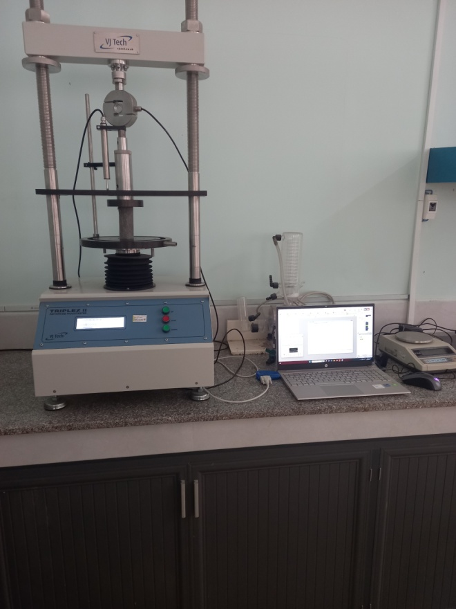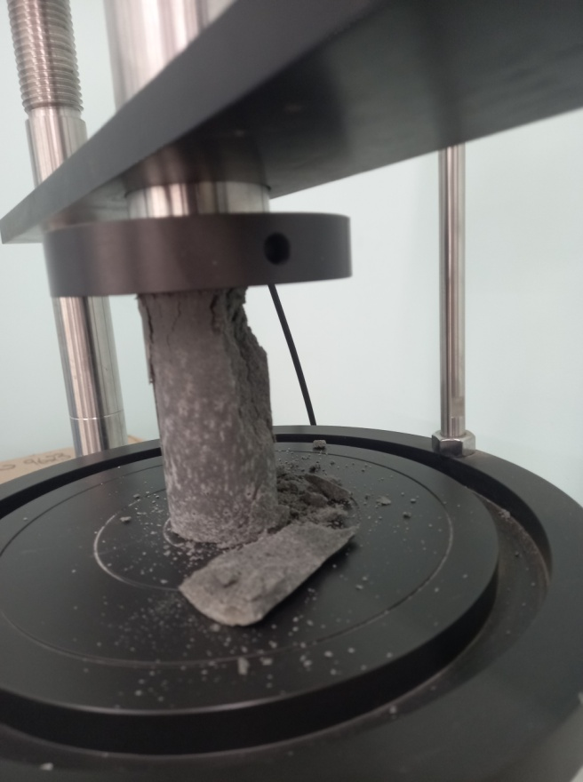
Figure 2: The Triplex II advanced and form of cement-soil piles damage.

3. RESULTS AND DISCUSSION
The soil-cement strength is increasing over time. As the cement content of the cement-soil pile increases, the unconfined compressive strength increases shown in Figure 3.^{1,2}
The unconfined compressive strengths of cement-soil piles increase rapidly when cement content increases from 12% to 15% as presented in Figure 4.¹ The results of this study are consistent with the results of the authors' research N. Zotsenko, Yu. Vynnykov, and V. Zotsenko.^{1,9}
When the cement content of the samples increases from 12% to 15%, the compressive strength of cement-soil plies increases from 70% to 99% as presented in Figure 4.
When the cement content of the sample increases from 15% to 20%, the increase in compressive strength of the cement-soil pile decreases from 99% to 15% as presented in Figure 4.

Figure 3. The unconfined compressive strengths of cement-soil piles at 7 days and 28 days.

Figure 4. The percent increase in cement content and the percent increase in unconfined compressive strength of the sample groups.

4. CONCLUSIONS
Therefore, the authors suggested reasonable cement content for soft clay in the An Phu Thinh social housing apartment building project at land lot B1 - 32, An Phu Thinh new urban area, Dong Da ward, Quy Nhon City, Binh Dinh province is from 12% to 15%
The cement-soil pile method is proposed to treat soft clay for 4 to 8-storey buildings, located in the Ha Thanh River urban area, Quy Nhon City.
Acknowledgment
This research is conducted within the framework of science and technology projects at institutional level of Quy Nhon University under the project code T2023.805.15.
REFERENCES
1. N. Zotsenko, Yu. Vynnykov, V. Zotsenko. Soil-cement piles by drilling-mixing method, Construction and Geotechnics, 2015, (4), 122-133.
2. Seregin, Nikolay. An integrated way to improve the properties of soil-cement pile foundations, E3S Web of Conferences, 2020, Vol. 157.
3. Jiang, Xiaoyi, et al. Research progress of soft soil foundation treatment technology, In: IOP Conference Series: Earth and Environmental Science, 2020, Vol. 455, No. 1, p. 012081.
4. Gue, See Sew, and Chang Shin Gue. Geotechnical challenges on soft ground. Journal of Civil Engineering, Science and Technology, 2022, 84-96.
5. M. D. Braja. Advanced Soil Mechanics, 3th Edition, Taylor & Francis Group, 2008.
6. Okyay, U. S., and D. Dias. Use of lime and cement treated soils as pile supported load transfer platform, Engineering geology , 2010, 34-44.
7. Standard test method for unconfined compressive strength of cohesive soil, ASTM Committee D18 on Soil and Rock, 2000, 19428-2959.
8. TCVN 9403:2012. Stabilization of soft soil-The soil cement column method, 2012.
9. Son Hong Thai, Thu Minh Tran, Van Cong Trinh. Cement content and water-cement ratio or soil stabilization by soil cement deep mixing method in coastal zone of Mekong delta area, Journal of Water Resources & Environmental Engineering, 2014, (44), 58-62.

Liên hệ: Hoàng Công Duy
Trường Đại học Quy Nhơn
170 An Dương Vương, TP. Quy Nhơn, tỉnh Bình Định, Việt Nam
Email: hoangcongduy@qnu.edu.vn
Điện thoại: 0906379296

