Một số đặc điểm sinh học của cá bống cát (Glossogobius giuris) phân bố ở vùng hạ lưu sông Tam Quan, Hoài Nhơn, Bình Định
Ngô Kim Khuê¹, Võ Văn Chí^{1*}, Vương Thị Mỹ Ly²
¹Khoa Khoa học Tự nhiên, Trường Đại học Quy Nhơn, Việt Nam
²Trường THCS Ân Mỹ, Hoài Ân, Bình Định, Việt Nam
*Email: vovanchi@qnu.edu.vn
TÓM TẮT
Cá bống cát (Glossogobius giuris) là một trong những loài cá phân bố ở vùng hạ lưu sông Tam Quan được người dân địa phương ưa chuộng, tuy nhiên nguồn lợi tự nhiên của chúng đang bị suy giảm bởi việc khai thác quá mức. Một số đặc điểm sinh học của loài cá này được nghiên cứu để làm cơ sở khoa học cho công tác bảo vệ nguồn lợi cá. Tổng cộng 193 cá thể được thu để khảo sát một số đặc điểm sinh học như hình thái cấu tạo một số cơ quan tiêu hóa, tập tính ăn và sức sinh sản. Kết quả cho thấy hình thái cấu tạo của các cơ quan tiêu hóa (có răng sắc nhọn, có dạ dày, ruột ngắn,...) và chỉ số RLG của cá dao động từ 0,68 đến 0,74 đã thể hiện tính ăn thiên về động vật. Thành phần thức ăn tự nhiên của cá bao gồm cá và giáp xác, trong đó giáp xác là thức ăn quan trọng hơn (với IRI% là 79,01%). Sức sinh sản tuyệt đối của cá bống cát đạt trung bình là 48.605 ± 19.507 trứng/cá cái và sức sinh sản tương đối của cá đạt trung bình 1.920 ± 572 trứng/g cá cái.
Từ khóa: Cá bống cát, Glossogobius giuris, RLG, sức sinh sản, tập tính ăn

Some biological characteristics of tank goby (Glossogobius giuris) distributed in the downstream of Tam Quan river, Hoai Nhon district, Binh Dinh province

Ngo Kim Khue¹, Vo Van Chi^{1*}, Vuong Thi My Ly²
¹Faculty of Natural Sciences, Quy Nhon University, Vietnam
²An My Secondary School, Hoai An, Binh Dinh, Vietnam
*Email: vovanchi@qnu.edu.vn

ABSTRACT
Tank goby (Glossogobius giuris) is one of fish species inhabiting in the downstream of Tam Quan river that has been the favorite food of local residents, however, the natural resource of this species is being reduced by overfishing. Some biological characteristics of this fish were examined to provide the scientific information for fish resource conservation. Total of 193 fish were collected to examine some biological characteristics such as morphology of some digestive organs, feeding habit and fecundity of fish. The results showed that morphology of some digestive organs (sharp teeth, clear stomach or short intestine, etc) and value of RLG from 0.68 to 0.74 implied the carnivorous feeding habits of this fish species. The natural food of tank goby composed crustaceans and fish, of which crustaceans were more important food (with IRI% of 79.01%). The absolute and relative fecundity of fish were 48,605 ± 19,507 eggs/female and 1,920 ± 572 eggs/g body weight of female respectively.
Keywords: fecundity, feeding habits, Glossogobius giuris, RLG, tank goby

1. INTRODUCTION
In the abundant river system of Binh Dinh province, Tam Quan river is one of the rivers playing an important role in the livelihood of fishermen in Hoai Nhon town. Tam Quan River is located in Tam Quan Bac ward, Hoai Nhon town, Binh Dinh province, with the main direction of North – South. It originates from Hoai Chau and Hoai Son, and flows into Tam Quan sea. This is one of the rivers that provides the abundant water source for production in the area and the source of valuable aquatic species. In the downstream area of the river, there are many different aquatic species distributed such as groupers, gobies, cobia, shrimp, crabs,...which provide the main income for local fishermen. Along with many other aquatic species, goby species here are the important fish for local residents.
There are 5 families of gobies in Vietnam (Eleotridae, Gobiidae, Periophthalmidae, Apocrypteidae và Gobioididae)¹, of which, Gobiidae has the most abundance of genus and species (32 genuses and 60 species) followed by Eleotridae with 3 genuses and 7 species. As surveyed, there are lots of goby species inhabiting in the downstream of Tam Quan river such as Oxyeleotris urophthalmus, Oxyurichthys tentacularis, Eleotris melanosoma, Glossogobius giuris,…However, because local consumption demand is increasing, goby species here (including tank goby) have been overexploited, negatively affecting natural resources. In the current situation, it is very necessary to conduct research to protect goby resources in general and tank goby in particular. Therefore, we conducted this study to examine some biological characteristics of tank goby distributed in the downstream of Tam Quan river to collect scientific basis for the protection of fish resources in this area.
2. METHODS
2.1. Sample collection
Tank goby (G. giuris) was indentified using the classification documents of Carpenter and Niem² and Vuong Di Khang³. Fish were collected monthly in the downstream of Tam Quan river (Figure 1) from March to July 2022. Cage nets were the main fishing gear used to catch fish. After being collected, the fish were frozen and transferred to the laboratory for analysis on the same day or fixed in 10% formalin solution for later analysis.
A total of 193 goby individuals were used to examine some biological characteristics, of which 147 individuals with food in their stomachs were used to analyze their natural food.
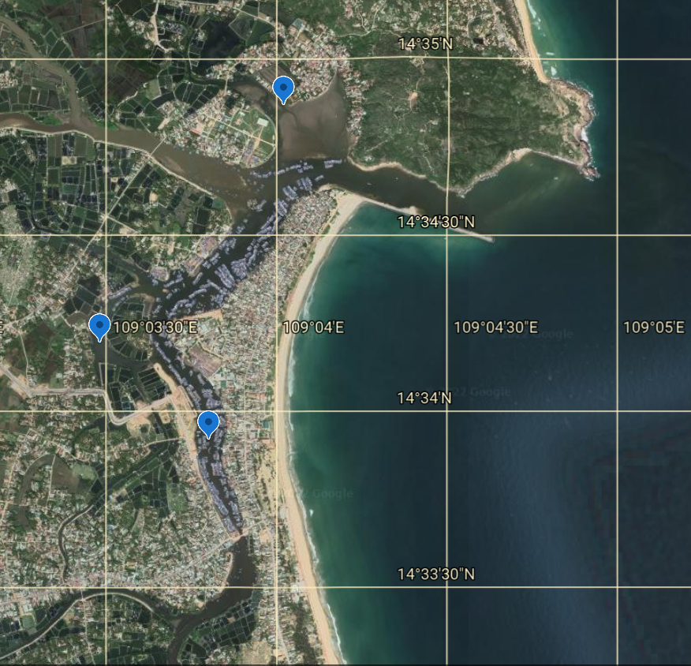
Figure 1. The sampling locations in the downstream of Tam Quan river
2.2. Examining some characteristics of the digestive organs and feeding habits of fish
- The characteristics of some digestive organs such as the mouth, gill rakers and intestines were described by combining observations of external and anatomical features.
- The feeding habits of fish was determined based on the correlation between the intestine length and the body length of fish through the relative length of the gut (RLG) according to Al-Hussainy⁴.
RLG = $\frac{Li}{L}$
Where: + Li: Length of the gut of fish (cm)
+ L: Total length of fish (cm).
According to Nikolski⁵, carnivorous fish have RLG ≤ 1, omnivorous fish have RLG of from 1 to 3, and herbivorous fish have RLG ≥ 3.
2.3. Analysing the natural food of fish
Fish were dissected to analyze natural food in the stomachs. The stereo microscope and binocular microscope were used to observe and identify the food items in the fish stomachs based on documents of Conway et al⁶, Nguyen Van Thuong and Truong Quoc Phu⁷, Vuong Di Khang³. The frequency of occurrence, percentage in number, percentage in weight and percentage of relative importance of food were calculated⁸.
- The frequency of occurrence of each food item:
%Oi = $\left(\frac{Total number of the stomachs containing food item i}{Total number of analysed stomachs}\right)×100$
- Percentage in number of each food item:
%Ni = $\left(\frac{Total number of food item i}{Total number of food items }\right)×100$
- Percentage in weight of each food item:
%Wi = $\left(\frac{Total weight of food item i}{Total weight of food items}\right)×100$
- The relative importance of each food item in the stomachs:
IRIi = Oi% (Ni% + Wi%)
Percentage of the relative importance of each food item in the stomachs⁹.
$$\%IRIi=\left(\frac{IRIi}{∑IRIi}\right)×100$$
2.4. Examining the fecundity of fish
A total of 14 female fish with the gonad of stage IV were used to define the absolute and relative fecundity.
- The absolute fecundity (Fa)¹⁰:
Fa = n.Wg/Ws
Where:
Wg: The weight of whole gonad of fish (g)
Ws: The weight of the sub sample of gonad (g)
n: Number of eggs of the sub sample
- The relative fecundity (Fr)¹¹:
F_{r} = Fa/W
Where:
F: The absolute fecundity
W: The body weight of fish (g)
3. RESULTS AND DISCUSSION
3.1. Characteristics of the digestive organs and feeding habits of fish
Observing some digestive organs of the tank gobies, we recorded the followings:
- Mouth: This fish species had a wide mouth, with the lower jaw more protruding than the upper jaw, so this fish had an upper mouth type. In the fish mouth, there were teeth distributed in both jaws; each jaw had 2 rows of teeth; the outer row of teeth had larger, sharper and more sparse teeth than the inner row. Inside the mouth, there was a tongue with a groove in the middle (Figure 2).
- Gill: The gill slit was wide. The gills consisted of 4 pairs of gill arches (Figure 3), with has a row of short white gill rakers attached to each gill arch and was symmetrical to the long, dark red gill filaments.
- Esophagus: It was quite short with the thick walls and many large folds at the inner surface.
- Stomach and intestine: The fish stomach was clear (Figure 4) with the thick walls and many folds at the inner surface. The intestine was short (Figure 4) with the quite thick wall and the also many folds inner surface.

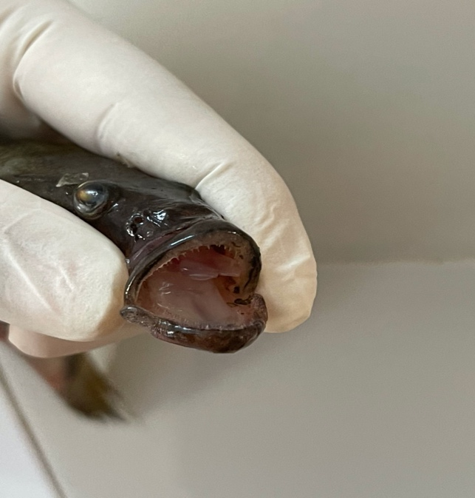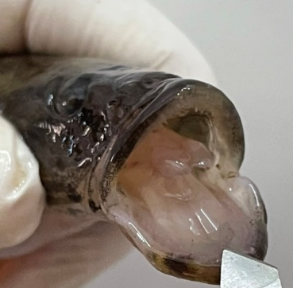
Figure 2. The mouth of the tank goby

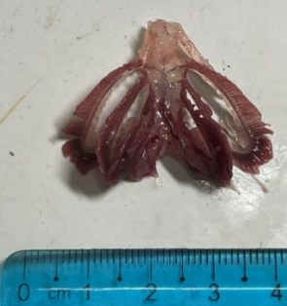  Figure 3. The gill arches of tank goby | 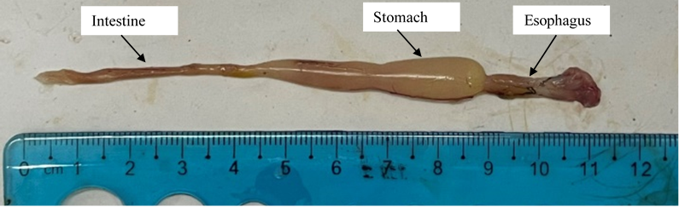  Figure 4. The digestive tract of tank goby

Based on the the results recorded on the characteristics of the digestive organs mentioned above, it is speculated that the tank goby is a carnivorous species. Our findings on digestive organs is similar to the results reported by Do Thi Xuan Tru¹².
Besides examining the characteristics of the digestive organs, we also determined the relative length of the gut (RLG) to predict the feeding habits of fish. Fish samples were divided into 4 groups based on body length distribution to determine RLG and the results are shown in Table 1.
Table 1. RLG of the tank goby

The size class of fish  (cm) | The body length of fish (L)  (cm) | The gut length of fish (Li)  (cm) | RLG
< 12.5 | 11.14 ± 0.95 | 7.87 ± 0.99 | 0.71
12.5 - 14.6 | 13.77 ± 0.62 | 10.15 ± 1.72 | 0.74
14.7 - 16.4 | 15.34 ± 0.47 | 10.58 ± 1.23 | 0.69
> 16.4 | 17.41 ± 1.05 | 11.76 ± 1.86 | 0.68

The results showed that RLG was relatively low, ranging from 0.68 to 0.74. In general, this index decreased in larger fish classes. It can be seen that RLG of the tank goby in different size classes was less than 1. According to Nikolsky⁵, fish species with RLG less than 1 are carnivorous species. Therefore, it can be said that the tank goby fish belongs to carnivorous fish. Do Thi Xuan Tru¹² reported that RLG of the tank goby collected in Thi Nai lagoon, Binh Dinh province ranged from 0.47 to 0.48, lower than our recorded findings. Thus, despite the same tank goby, if they distribute in different ecological regions, RLG can be different.
The findings on the digestive organs and RLG mostly show the carnivorous feeding habits of the tank goby studied.
3.2. The natural food of fish
The natural food of tank goby consisted of two main groups which were crustaceans and fish (Table 2). Of which, the occurence frequency (70.07%), percentage in weight (97.6%), percentage in number (69.78%) of crustaceans were higher than those of fish (respectively 35.37%, 31.23% and 30.22%). The results also showed that crustaceans were the most important natural food of the tank goby (with IRI% of 79.01%). Based on the results of examining natural food and anatomical morphology of the digestive organs, it can be defined that the tank goby distributed in the downstream of Tam Quan river is a carnivore.
Table 2. The natural food of the tank goby (n=147)

Natural food | O% | W% | N% | IRI%
Crustaceans | 70.07 | 97.60 | 69.78 | 79.01
Shrimp | 66.67 | 66.37 | 55.50 | 78.46
Lucifer | 3.40 | 2.40 | 14.29 | 0.55
Fish | 35.37 | 31.23 | 30.22 | 20.99

Vo Van Chi et al¹³ analyzed the natural food of the tank goby individuals collected in Thi Nai lagoon and also showed that the two natural food groups of this fish were crustaceans and fish although the IRI% of fish and crustaceans was not largely different, with the values of 46.25% and 53.75% respectively. However, Achakzai et al¹⁴ reported that the tank goby inhabiting in Manchar Lake - Pakistan ingested a variety of food, of which the main food were fish, insects and crustaceans. Thus, it can be said that the natural food of tank goby may depend on their distribution areas or habitats, but in general, fish and crustaceans are important natural food of this species. In addition, crustaceans and fish are also the dominant natural food in the food spectrum of some other goby species such as Awaous guamensis, Rhinogobius longipinnis, Glossogobius sparsipapillus distributed in Tra Khuc river - Quang Ngai¹⁵.
3.3. The fecundity of tank goby
The average absolute and relative fecundity of the tank goby were 48,605 ± 19,507 eggs/female and 1,920 ± 572 eggs/g body weight of female, respectively (Table 3). Comparing to the results of other studies (Table 3), it can be seen that the absolute fecundity of the tank goby in our study ranges from 23,055 - 78,399 eggs/female, equivalent to the results recorded by Pham Thi My Xuan and Tran Dac Dinh (16,985 - 77,298 eggs/female)¹⁶ or Tran Thi Phuong Thao and Nguyen Van Long (15,555 - 76,861)¹⁷ but average absolute fecundity of the tank goby in our study (48,605 eggs/individual) is higher than that recorded by Tran Thi Phuong Thao and Nguyen Van Long (32,246 eggs/female)¹⁷. Although there were individuals in our study having higher absolute fecundity (78,399 eggs/female) than that in the research of Do Thi Xuan Tru (65,524 eggs/female fish)¹², the average absolute fecundity of fish in our study (48,605 eggs/female) is lower than that of fish in the study of Do Thi Xuan Tru (55,092 eggs/female). However, the average relative fecundity of the goby individuals recorded in our study is lower than that of fish three studies mentioned above. Thus, it can be seen that tank goby inhabiting in different areas can have different fecundity. This may be due to the influence of different habitats or food sources in distribution areas, and may also be due to the difference in size of fish in the studies.
Table 3. The fecundity of tank goby reported in some studies

Study areas | Absolute fecundity (Number of eggs/female) | Relative fecundity (Number of eggs/g body weight of female)
Tam Quan river (the current study) | 23,055 – 78,399  48,605 ± 19,507 | 769 – 2,850  1,920 ± 572
Thi Nai lagoon (Do Thi Xuan Tru)¹² | 46,621 – 65,524  55,092 ± 9,603 | 2,792 – 4,255  3,333 ± 803
Can Tho city (Pham Thi My Xuan, Tran Đac Đinh)¹⁶ | 16,985 – 77,298 | 2,262 ± 329
Thu Bon river - Quang Nam (Tran Thi Phuong Thao, Nguyen Van Long)¹⁷ | 15,555 - 76,861  32,246 ± 18,799 | 2,150 - 5,044  3,379 ± 877

4. CONCLUSION
The RLG of the tank goby distributed in the downstream of Tam Quan River - Binh Dinh ranges from 0.68 to 0.74.
The natural food spectrum of the tank goby includes fish and crustaceans, of which crustaceans are the important food of this fish species, with IRI% of 79.01%.
From our findings on natural food and anatomical morphology of the digestive organs, it can be confirmed that the tank goby distributed in the downstream of Tam Quan river is a carnivore.
The average absolute and relative fecundity of tank goby are 48,605 ± 19,507 eggs/female and 1,920 ± 572 eggs/g body weight of female, respectively.
REFERENCES
1. Mai Đinh Yen, Nguyen Van Trong, Nguyen Van Thien, Le Hoang Yen, Hua Bach Loan. Southern freshwater fish classification. Science and Technology Publishing House, Ha Noi, 1992.
2. K. E. Carpenter, V. H. Niem (eds.). FAO species identification guide for fishery purposes. The living marine resources of the Western Central Pacific, Volume 6 - Bony fishes part 4, Rome, FAO, 2001.
3. Vuong Di Khang. Fish taxonomy (Vietnamese translation by Nguyen Ba Mao), Rural Publishing House, 1963.
4. A. H. Al-Hussainy. On the functional morphology of the alimentary tract of some fishes in relation to differences in their feeding habits, Quarterly Journal of Microscopical Science, 1949, 9(2), 190-240.
5. G. V. Nikolsky. Ecology of fishes, Academic press, London, 1963.
6. D. V. P. Conway, R. G. White, J. Hugues – Dit –Ciles, C. P. Gallienne, D. P. Robins. Guide to the coastal and surface zooplankton of the south-western Indian Ocean. Occasional Publication of the Marine Biological Association of the United Kingdom, No 15, Plymouth, UK, 2003.
7. Nguyen Van Thuong, Truong Quoc Phu. Fish taxonomy II, Can Tho university, 2003.
8. E. J. Hyslop. Stomach contents analysis: a review of methods and their application, Journal of Fish Biology, 1980, 17, 411- 429.
9. E. Cortés. A critical review of methods of studying fish feeding based on analysis of stomach contents: application to Elasmobranch fishes, Canadian Journal of Fisheries and Aquatic Sciences, 1997, 54, 726-738.
10. K. Sivashanthini, G. A. Charles, S. Shutharsan. Fecundity studies of Gerres abbreviatus (Bleeker, 1850) from the Jaffna lagoon, Srilanka, Journal of Fisheries and Aquatic Science, 2008, 3(5), 320-327.
11. M. D. Y. Hossain, M. D. M. Rahman, E. M. Abdallah. Relationships between body size, weight, condition and fecundity of the threatened fish Puntius ticto (Hamilton, 1822) in the Ganges River, Northwestern Bangladesh, Sains Malaysiana, 2012, 41(7), 803–814.
12. Do Thi Xuan Tru. Research on some biological characteristics of broadhead sleeper (Eleotris melanosoma) and tank goby (Glossogobius giuris) distributed in Thi Nai lagoon, Binh Dinh province, Master thesis in Experimental Biology, Quy Nhon University, 2020.
13. Vo Van Chi, Do Thi Xuan Tru, Vo Dieu. Feeding biology of broadhead sleeper (Eleotris melanosoma) and tank goby (Glossogobius giuris) distributed in Thi Nai lagoon, Binh Dinh province, Journal of Science and Technology – Da Nang University, 2020, 18, 48-51.
14. W. M. Achakzai, S. Saddozai, W. A. Baloch, Z. Massod, H. U. Rehman, Musarrat-ul-Ain. Food and feeding habits of Glossogobius giuris (Hamilton and Buchannan, 1822) collected from Manchar lake distt. Jamshoro, Sindh, Pakistan, Global Veterinaria, 2015, 14(4), 613-618.
15. Vo Thi Ngoc Tram, Vo Van Nha. Feeding characteristics of some economically valuable goby species in Tra Khuc river, Quang Ngai province, Journal of Fisheries Science and Technology, 2013, 3, 107-111.
16. Pham Thi My Xuan, Tran Dac Dinh. Some reproductive characteristics of tank goby Glossogobius giuris (Hamilton, 1822) in Can Tho city, Can Tho University Journal of Science, 2013, 27, 161-168.
17. Tran Thi Phuong Thao, Nguyen Van Long. Reproductive characteristics of tank goby Glossogobius giuris (Hamilton, 1822) distributed in the downstream of Thu Bon river, Quang Nam province, Journal of Marine Science and Technology, 2017, 17(4A), 169-176.

