Nghiên cứu cường độ chống cắt không thoát nước của đất sét mềm khu dân cư Lò Vôi, phường 1, thành phố Tuy Hòa, tỉnh Phú Yên bằng thí nghiệm nén một trục nở hông và thí nghiệm cắt phẳng

Nguyễn Thị Khánh Ngân

Khoa Kỹ thuật & Công nghệ, Trường Đại học Quy Nhơn

Email: nguyenthikhanhngan@qnu.edu.vn

TÓM TẮT
Sức kháng cắt không thoát nước của đất sét yếu là thông số quan trọng để thiết kế nền đắp, móng nông và móng cọc. Sức kháng cắt không thoát nước của đất được xác định từ thí nghiệm trong phòng (ví dụ: nén ba trục, cắt đơn giản, nén mộ trục nở hông) và các thí nghiệm tại hiện trường ( ví dụ: thí nghiệm CPT, thí nghiệm cắt cánh). Trong nghiên cứu này tác giả sử dụng mẫu đất sét nguyên dạng có đường kính 90 mm thu được tại khu dân cư Lò Vôi, phường 1, thành phố Tuy Hòa, tỉnh Phú Yên. Mục đích chính của nghiên cứu này là dùng thí nghiệm nén một trục nở hông và thí nghiệm cắt trực tiếp để khảo sát giá trị cường độ sức chống cắt của loại đất sét yếu phân bố phổ biến địa chất tại khu vực này. Sau đó, các giá trị cường độ cắt không thoát nước (S_{u}) từ thí nghiệm nén một trục nở hông được so sánh với các giá trị ứng suất cắt (τ) từ thí nghiệm cắt phẳng. Kết quả cho thấy sức chống cắt không thoát nước của mẫu thu được từ thí nghiệm nén một trục nở hông và thí nghiệm cắt trực tiếp đều có kết quả nhỏ hơn 25kN/m²và phần trăm chênh lệch thu được cả hai phương pháp thí nghiệm này là khoảng 1.2%. Từ đó đánh giá được mẫu đất sét tại khu dân cư Lò Vôi, phường 1, thành phố Tuy Hòa, tỉnh Phú Yên là loại đất sét yếu và rất yếu. Vì vậy, khi xây dựng công trình trên nền đất sét này với bề dày phân bố tương đối lớn thì cần tiến hành xử lý đất yếu.
Keywords: đất sét yếu, sức kháng cắt không thoát nước, thí nghiệm nén một trục nở hông, thí nghiệm cắt trực tiếp.

Research of undrained shear strength of soft clay in the Lo Voi residential area, Ward one, Tuy Hoa City, Phu Yen province by unconfined compressive strength and direct simple shear test

Thi khanh Ngan Nguyen

Faculty of Engineering and Technology, Quy Nhon Univesity

Email: nguyenthikhanhngan@qnu.edu.vn

ABSTRACT
The undrained shear strength of soft clays is an important parameter for designing embankments, shallow foundations, and pile foundations. The undrained shear strength of soil is determined from laboratory tests (e.g., triaxial test, direct shear test, unconfined compressive test ) and field tests (e.g., CPT tests, vane shear test). In this study, the author used intact clay samples with a 90 mm diameter collected in the Lo Voi residential area, Ward 1, Tuy Hoa City, Phu Yen province. The main purpose of this study is to use the unconfined compressive test and direct shear test to investigate the shear strength value of samples. Then, The values of undrained shear strength (S_{u}) from the unconfined compressive strength test were compared with the values of shear stress (τ) from the simple shear test. The results show that the undrained shear strength of the samples obtained from the unconfined compressive test and the direct shear test are both less than 25kN/m2 and the percentage difference is obtained from both testing methods about 1.2%. The soft clays in the survey area are classified as soft and very soft. Therefore, buildings are built on this clay foundation with a relatively large distribution thickness, so it is necessary to treat the soft soil.
Keywords: soft clays, undrained shear strength, unconfined compressive strength, direct simple shear tests.

1. INTRODUCTION
In recent years, the Central Coast region has been considered one of the regions with a relatively strong tourism economic development rate, especially Phu Yen province where dense population, political, economic, and cultural centers gather. Therefore, localities are making efforts to renovate and upgrade transport infrastructure, connecting road systems, railways, airways, houses, offices, apartments... However, the geological characteristics of this area are quite complex and quite new. In this geological area, there is almost a young sedimentary soft layer, this layer is widely and deeply distributed along the coastal route extending to Binh Dinh province. This greatly affects work such as geological surveys, underground design, and underground construction methods. Most geological engineers of laboratories in the region encounter many difficulties in conducting sampling and laboratory testing to determine physical and mechanical criteria, deformation characteristics, and shear strength of soft clays^{1,5}.
The Lo Voi area is located in north Phu Yen province as illustrated in Figure 1. This paper presents a full geotechnical characterization, and engineering properties of the soft site in the Lo Voi residential area, Ward 1, Tuy Hoa City, Phu Yen province.
The scope of the topographic survey in the expected survey area is as follows: The North borders vacant land and current residential status. The South borders Tran Quang Khai Street and Ong Chu Bridge. The East borders Nguyen Tat Thanh Street and the West borders Chua River.
The Lo Voi residential area project is a synchronous technical infrastructure construction project including a western landslide prevention embankment; Leveling the ground; Road system; Rainwater drainage system; Sewerage system; Plumbing system and fire protection system; Power supply and lighting system.
The construction engineer used the undrained shear strength to calculate the bearing capacity of the foundation, the thickness of the embankment layer, and the embankment stages in the basic design phase of leveling work for the project. Therefore, the undrained shear strength of the soft clays was determined by laboratory tests (e.g., triaxial test, direct shear test, unconfined compressive test).

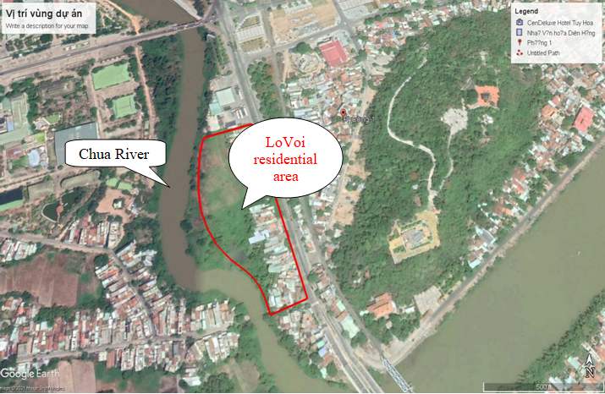
Figure 1. Map of the Lo Voi residential area, Ward 1, Tuy Hoa City, Phu Yen province

2. METHODOLOGY
2.1. Unconfined compressive test (ASTM D2166)
This test method covers the determination of the unconfined compressive strength of cohesive soil in the undisturbed, remolded, or compacted condition, using strain-controlled application of the axial load ^{1,5,6}.
In this test method, unconfined compressive strength (q_{u}) is taken as the maximum load attained per unit area or the load per unit area at 15 % axial strain, whichever is secured first during the performance of a test. Shear strength (s_{u})—for unconfined compressive strength test specimens, the shear strength is calculated to be 1⁄2 of the compressive stress at failure ^{5,6,7} and is expressed as¹
$S_{u}=\frac{q_{u}}{2}$ (1) (1)
Where s_{u} is Shear strength and q_{u} is the compressive stress at failure.
In this study, the compression device used the Triplex II advanced as Figure 2.
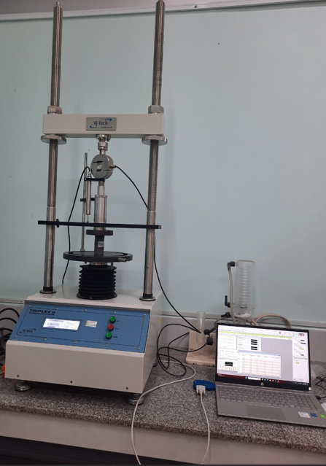
Figure 2. The Triplex II advanced
2.2. The direct simple shear test
The direct simple shear test which is an experiment in geotechnical engineering determines the shear strength of clays. In this test, the shear strength is evaluated using the Mohr-Coulomb failure criteria and is given by $s=c+σtan⁡(φ)$ (2)
Where c is cohesion, σ is the normal stress, and ϕ is the angle of internal friction of the soil ¹
In this theory, failure along a plane in a material occurs by a critical combination of normal and shear stresses. Consider the stress at points a, b, and c as shown in Figure 3. The shear failure along that plane will not appear as point A but it occur if the stresses plot as point B. The stress plotting as point C cannot exist because a shear failure had happened before this condition was reached.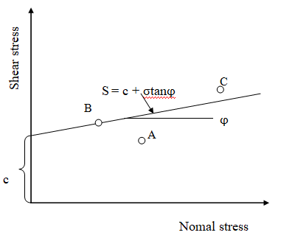
Figure 3. The failure criteria of Mohr-Coulomb
The shear device uses strain controlled direct shear apparatus (two speed) which is made in China as illustrated in Figure 4. The product parameters of the equipment are stated in the Table 1
Table 1. The product parameters of the strain controlled direct shear apparatus (two speed)
Vertical load | 400kPa, 300kPa, 200kPa, 100kPa, 50kPa, 25kPa
Horizontal load | 1.2kN
Lever ratio | 1:12
Specimen size | 30cm2
Power supply | 220VAC 50Hz

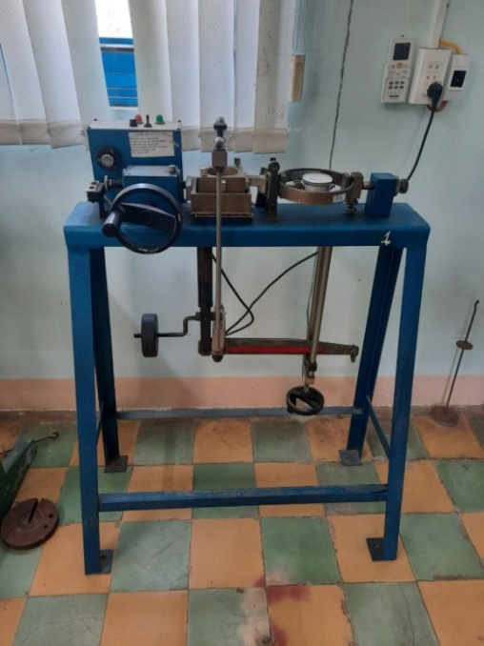
Figure 4. The two-speed soil shearing machine
The experimental method is based on standard TCVN 4199:2012^{1,5}.
2.3. Test Specimens
Testing was conducted on six reconstituted clay specimens with high plasticity. Onsoy clay samples were retrieved from a depth of 2–6 m in a test pit in the Lo Voi residential area, Ward 1, Tuy Hoa City, Phu Yen province. The samples in the unconfined compressive test were 48 mm in diameter and 70 mm in height. The samples in the direct simple shear test were 60 mm in diameter and 20 mm in height ^{6,8,9}. The characterizations of the soft clay samples are listed in Table 1 and the results of geotechnical characterization are plotted in Table 2 and Table 3.

Table 2. The Specifications of the specimens
Sample | Deep | Described test sample | Test | Diameter | Height
Sample | (m) | Described test sample | Test | (cm) | (cm)
1 | 1.8-2 | Soft, gray, sandy lean clay, low plasticity. | Unconfined compressive test (ASTM D2166) | 48 | 76
2 | 3.8-4 | Soft, gray, lean clay, high plasticity, Pasty state. | Unconfined compressive test (ASTM D2166) | 48 | 76
3 | 5.8-6 | Soft, gray, lean clay, high plasticity, Pasty state. | Unconfined compressive test (ASTM D2166) | 48 | 76
4 | 1.8-2 | Soft, gray, sandy lean clay, low plasticity. | Direct simple shear test (TCVN 8868:2011) | 60 | 20
5 | 3.8-4 | Soft, gray, lean clay, high plasticity, Pasty state. | Direct simple shear test (TCVN 8868:2011) | 60 | 20
6 | 5.8-6 | Soft, gray, lean clay, high plasticity, Pasty state. | Direct simple shear test (TCVN 8868:2011) | 60 | 20
Table 3. Geotechnical characterization of soft clays in the Lo Voi residential area, Ward 1, Tuy Hoa City, Phu Yen province
Simple | Deep | γ | γ_{d} | w | w_{L} | w_{P} | I_{P} | I_{L} | e₀
Simple | m | kN/m³ | kN/m³ | % | % | %
1 | 1.8-2 | 16.09 | 9.81 | 63.98 | 60.6 | 28.5 | 32.1 | 1.11 | 1.696
2 | 3.8-4 | 16.1 | 9.6 | 68 | 54.3 | 33.6 | 20.7 | 1.67 | 1.828
3 | 5.8-6 | 17.2 | 11.1 | 54.63 | 55.1 | 34.1 | 21 | 0.98 | 1.445

3. RESULTS AND DISCUSSION
The samples in the direct shear test had an unequal distribution of stress over the shear surface. Because the impact load on the sample is the axial load but the shear failure plane is cut in the horizontal direction. This result is partly due to the equipment's unstable load increase speed. This type of stress distribution results in progressive failure. The failure plane predetermined by the shear box of the testing equipment as shown in Figure 5^{1,4,8,9}.
In this Unconfined compressive test, axial stress on the specimen is gradually increased until the specimen fails. The shear stress is distributed over the specimens. The failure plane appeared with a random tilt angle from the center to the outer edge of the specimen as shown in Figure 6. This means, pure shear only exists at the center of the specimen.
The values of undrained shear strength of soft clays in the Lo Voi residential area, Ward 1, Tuy Hoa City, Phu Yen province from the unconfined compressive test are smaller than the direct simple shear test. The value difference ranges from 1.19% to 1.2%
As seen, the value of the undrained shear strength from the unconfined compression test varies from 4.6 kN/m² to 20.45 kN/m² and the value of the undrained shear strength from the direct shear test varies from 5.5 kN/m² to 24.3 kN/m² as shown in Figure 5.
The shear strength of soft clays increases gradually with depth in the same soil layer as shown in Figure 6 ^{1,3,4}.

Figure 5. The values of undrained shear strength of soft clays in Lo Voi residential area, ward 1, Tuy Hoa city, Phu Yen province from unconfined compressive test and direct simple test.

Figure 6. The values of undrained shear strength of soft clays in Lo Voi residential area, ward 1, Tuy Hoa city, Phu Yen province from unconfined compressive test and effective vertical stress of soil.

4. CONCLUSIONS
As outlined by Nguyen, T. N. Yen, et al³, the undrained shear strengths of 123 soft clay samples were determined from three method tests inclusion: triaxial test (UU), direct shear test, and vane shear test. These values were given results of less than 20 kN/m².
In this study, the value of the unconfined compression strength q_{u} of very soft clays and soft clays with similar characteristics as in the study ranges from 20.45 kN/m² to 24.3 kN/m² ^{1,3,4} for both the unconfined compressive test and direct shear test.
As stated by Aleksander S. Gundersen, et al⁵, the undrained shear strengths of clay samples at depths from 2 m to 5 m were determined from the triaxial test (UU), and a value is given of 15.3 kN/m².
The undrained shear strength of soft clay was determined by the unconfined compression test shows that it is more suitable for the actual working conditions of the ground than the direct shear test and gives approximately to the published results before.
Designers should use the unconfined compression test instead of the direct simple shear test to determine the undrained shear strength of soft clays for large projects.
However, actual experiments show that the accuracy of the results test depends largely on the level of damage to the soil sample due to the process of sampling, transporting, preserving, and cutting the sample. In particular, for very soft clays, laboratory testing is not always convenient because it is not possible to get intact samples¹⁰.
Acknowledgment
This research is conducted within the framework of science and technology projects at institutional level of Quy Nhon University under the project code T2023.803.13.

REFERENCES
1. Braja M. Das. Advanced Soil Mechanics, 5th Edition, Taylor & Francis Group, London New York, 2019.
2. Md. l kramul Hoque, Muzamir Hasan*, Nusrat Jahan Mim. Shear strength of soft clay reinforced with single encased stone dust columns, Jurnal Teknologi, 2023, 27-34.
3. Nguyen, T. N. Yen, Nguyen, T. P. Khue. Characteristics of deformation-Consolidation and shear strength of some types of clay soil distributed in Da Nang city, The university of Danang journal of science and Technology, 2016, Vol 7(104), 67-71.
4. Bin Huang, Shiqian Cai*, Jingjing Li, Kunming Wu and Wenhui Yang. Undrained strength of clay determined from simple shear test, Frontiers in Earth Science, 2023, 1-13.
5. Aleksander S. Gundersen*, Ragnhild C. Hansen, Tom Lunne, Jean-Sebastien L’Heureu and Stein O. Strandvik. Characterization and engineering properties of the NGTS Onsoy soft clay site, AIMS Geosciences, 2019, 5(3), 665-703.
6. Standard test method for unconfined compressive strength of cohesive soil, ASTM Committee D18 on Soil and Rock, 2000, 19428-2959.
7. Takashi Tsuchida. Evaluation of undrained shear strength of soft clay with consideration of sample quality, Soils and foundations, 2000, 40, 29-42.
8. Rolf Larsson. Basic behavior of Scandinavian soft clays, Rapport No 4, Swedish geotekniska instiut, 1977.
9. Nguyen, T. P. Khue. Some results of unconfined compressive strength testing of soil by trixial compression equipment, The university of Danang journal of science and Technology, 2020, Vol 18. No 1, 17-22.
10. H.E. Low*, T. Lunne, K. H. Andersen, M. A. Sjursen, X. Li and M. F. Randolph. Estimation of intact and remoulded undrained shear strength from penetration tests in soft clays, Geotechnique, 2010, No. 11, 843-859.

Liên hệ: Nguyễn Thị Khánh Ngân
Trường Đại học Quy Nhơn
170 An Dương Vương, TP. Quy Nhơn, tỉnh Bình Định, Việt Nam
Email: nguyenthikhanhngan@qnu.edu.vn
Điện thoại: 0383358320

