Balance the neutral point of T-type neutral point converter using the hysteresis control

Nguyễn Bảo Anh¹

¹Ho Chi Minh city University of Technology
Received: dd/mm/yyyy; Revised: dd/mm/yyyy;
Accepted: dd/mm/yyyy; Published: dd/mm/yyyy

ABSTRACT
This paper presented a space vector modulation method that considers neutral point voltage balance for three –level T-type converter. The space vector modulation is based on dividing the working plane into sectors, each sector is formed by fundamental vectors, therefore, the dwell time of each vector is calculated accurately to synthesize the required voltage. The unbalance of the neutral point affects the magnitude of fundamental vectors and performance of system. Therefore, the voltage of DC capacitor needs to be kept at equality to balance the neutral point. This idea is realized by adjusting the dwell time of corresponding vectors to appropriate value through a control algorithm without additional hardware or complex calculation. The MATLAB/SIMULINK programme is used to simulate the operation of this method.
Keywords: T-type three-level neutral point clamped converter (TNPC), space vector modulation (SVM), neutral point voltage balance, 3-level hysteresis control

1. INTRODUCTION
In recent years, interest in multilevel converters has been increasing because they have many applications in high power electronics fields such as motor control, renewable energy...^{1,2} Multilevel converter has the following advantages: reducing the operating voltage of the semiconductor switches, reducing the total harmonic distortion (THD) of the output voltage as well as reducing the size of the filter.³ The main disadvantage of multilevel converter is the amount of semiconductor switches which increases with the number of level of the converter.⁴
Multilevel converters are divided into groups according to configuration: neutral point clamp (NPC), flying capacitor (FC), cascade H-bridge and modular multilevel converter (MMC). Among them, the NPC configuration is the most widely used. Currently, T-type NPC configuration (TNPC) is proposed to replace the traditional NPC configuration to improve working performance.⁵⁻⁷
The configuration of the three-phase T-type converter includes 12 semiconductor switches. The DC-link part is divided into two capacitors to create different voltage levels. To optimize the output voltage quality, the voltages of the two DC-link capacitors need to keep at equal values. If these values ​​are different, the voltages on the semiconductor switches can exceed the rate voltage and cause system damage. Moreover, the THD distortion of voltage and current increases due to the predominance of low-order harmonics.^{8,9}
The voltages of the DC-link capacitors are unbalanced due to the following reasons: capacitance differences due to the manufacturing process, inconsistent switching characteristics of the semiconductor switches, and unbalance of the three-phase load.¹⁰ Directly solving the above causes is a difficult problem, so many methods which intervene in the control process have been proposed such as using space vectors,¹¹⁻¹⁴ carrier wave adjustment^{15,16}, PID controller¹⁷ or predictive control.¹⁸
This paper proposed a simple method to adjust the voltage balance of DC-link capacitors by adjusting the appropriate switching time of semiconductor switches through control algorithm.

2. THREE-LEVEL SPACE VECTOR MODULATION
2.1. Three-level TNPC configuration
The traditional three-phase three-level neutral point clamp (NPC) configuration is shown in Figure 1. In comparison with the two-level configuration, this configuration uses 2 additional semiconductor switches and 2 diodes to clamp the neutral point and output of each phase. This configuration allows the working voltage on the semiconductor switches to be half the DC supply voltage.
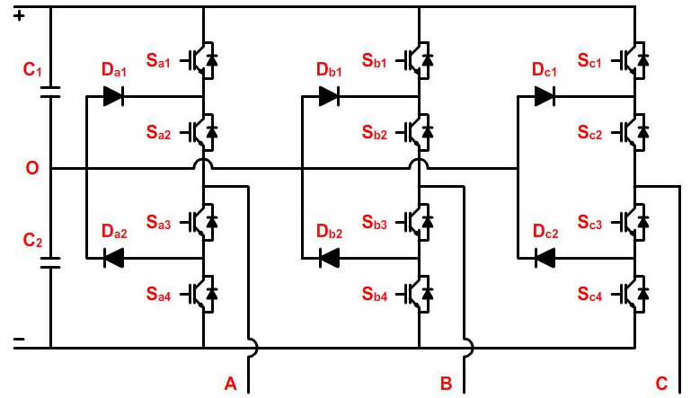
Figure 1. Three-level NPC configuration.
The T-type three-phase three-level converter (TNPC) configuration is shown in Figure 2. This configuration includes twelve semiconductor switches, reducing six diodes in comparison with the traditional three-level NPC configuration. This configuration is similar to the traditional two-level configuration, but it uses additional bidirectional switches to connect the neutral point to the phase outputs.
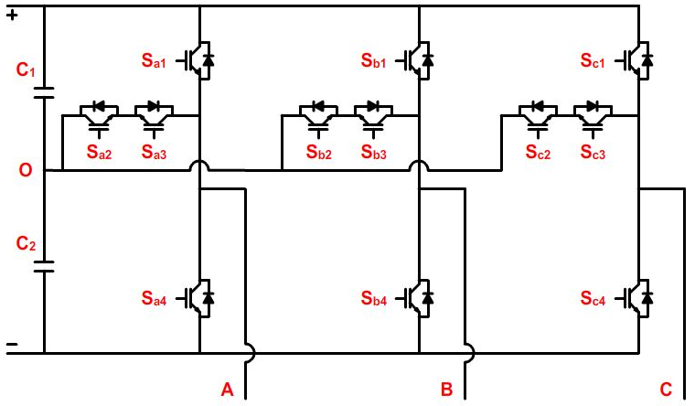
Figure 2. Three-level T-type NPC configuration.
Two semiconductor switches in the same branch (S_{x1} and S_{x4}) are not allowed to operate at the same time because this is a short circuit state that causes device damage. Therefore, the working voltage of these switches is equal to the DC-link voltage. In addition, the working voltage of the bidirectional switches (S_{x2} and S_{x3}) is equal to half of DC supply voltage. Therefore, components with low rated voltage can be used in this position.
2.2. Three-level space vector modulation
The operation of the TNPC is based on the switching status of the semiconductor switches on each phase which are shown in Table 1.
Table 1. Switching status of each phase.
Status | Amplitude | Switching status  (x = A,B,C)
Status | Amplitude | S_{x1} | S_{x2} | S_{x3} | S_{x4}
2 | $$V_{DC}/2$$ | ON | OFF | OFF | OFF
1 | 0 | OFF | ON | ON | OFF
0 | $${-V}_{DC}/2$$ | OFF | OFF | OFF | ON
Therefore, the three-phase TNPC can create 125 switching states to be arranged into 27 basic vectors, forming a vector system as shown in Figure 3.
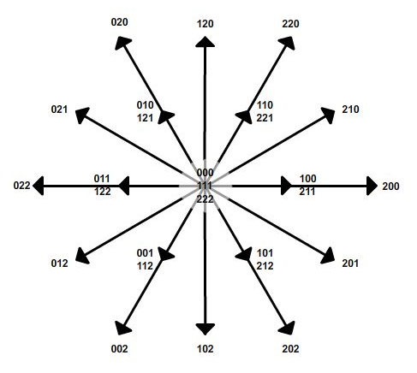
Figure 3. Three-level space vectors diagram
Vectors are divided into 4 types, details are shown in Table 2.
At a moment, the three-phase output voltage is represented by a vector V_{ref} . Initial point of this vector is at the coordinate center, and the terminal point is in a triangle formed by the three nearest active vectors, which is called a sector as shown in Figure 4.
The modulation algorithm is based on the magnitude and phase angle of the reference voltage vector to determine the sector and related active vectors. Then, the durations of the active vectors are calculated by solving the system of equations (1) to synthesize the required voltage vector.

Table 2. Voltage vectors of three-phase TNPC.
Vector | Amplitude | State
Zero | 0 | 000  111  222
Small | $$\frac{V_{DC}}{3}$$ | Type P | Type N
Small | $$\frac{V_{DC}}{3}$$ | 211  221  121  122  112  212 | 100  110  010  011  001  101
Medium | $$\frac{V_{DC}}{\sqrt{3}}$$ | 210  120  021  012  102  201
Large | $$\frac{2V_{DC}}{3}$$ | 200  220  020  022  002  202
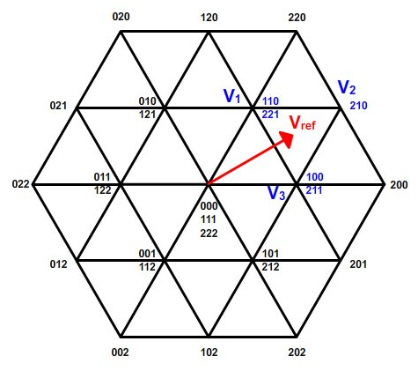
Figure 4. Sectors of three-level vector space.
$\left\{\begin{aligned}T_{1}\vec{V_{1}}+T_{2}\vec{V_{2}}+T_{3}\vec{V_{3}}=T_{PWM}\vec{V_{ref}} \\ T_{1}+T_{2}+T_{3}=T_{PWM}\end{aligned}\right.$ (1)
with:
- V₁, V₂, V₃ are the active vectors
- T₁, T₂, T₃ are switching duration corresponding to the active vectors
- T_{PWM} is switching period
- V_{ref} is reference voltage vector
The switching sequence of the active vectors V₁, V₂, V₃ is chosen so that only one switch commutate at a time. The vector which is chosen as the central vector must have at least two switching states. The duration of this vector is divided into two equal parts, each part is a different state, which are placed at the beginning and the end of the switching sequence in one cycle. For example, in Figure 5, either V₁ or V₃ can be selected as the central vector, if V₁ is selected then the switching sequence 110 → 210 → 211 → 221 will be used, otherwise, if V₃ is selected then the switching sequence 100 → 110 → 210 → 211 will be used.
2.3. The proposed modulation algorithm
During the operation of the TNPC, the neutral point is affected by the voltage vectors. The influence is described as follows:
- Zero vector: the neutral point is not connected to the load in case 000 and 222 or connected to all three load in case 111, because the three-phase load is balanced so there is no energy exchange between load and neutral point. Therefore, this vector does not affect the balance.
- Large vector: the neutral point is not connected to the load in any case, so this vector does not affect the balance.
- Medium vector: the neutral point is connected to one of three load, neutral voltage depends on the direction of this current phase
- Small vector: the neutral point is connected to one or two loads. If this one is a P-type vector, the load current go into the neutral point and causes the neutral voltage to increase. In contrast, if this one is a N-type vector, the load current will go out of the neutral point and causes the neutral voltage to decrease. An example of a small vector operation is shown in Figure 5.
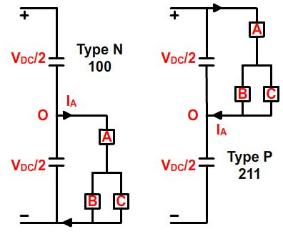
Figure 5. Effect of small vector on the neutral point
The small vector has two switching states, each state affects the neutral point differently and it is independent of the current directions of the load phases. So, these vectors are chosen as the central vector of switching sequence. In proposed algorithm, space vector diagram is divided into six regions, each region includes six sectors with the central small vector. The space vector diagram is shown in Figure 6.
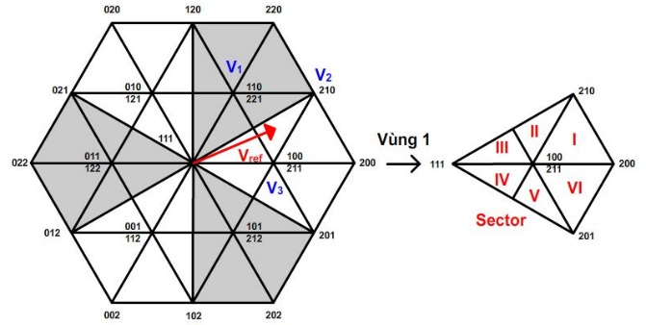
Figure 6. Sectors of proposed algorithm.
The small vector plays an important role in balancing the neutral voltage, this vector is placed at the beginning in type N and at the end in type P of a switching sequence. Duration of these two states are T_{N} and T_{P} respectively.
In figure 6, the required voltage vector is located in sector II of region 1, selects vector V₃ as the central vector and V₁ and V₂ as the active vectors. The switching sequence of this case is shown in Figure 7.
The proposed algorithm is based on the feedback voltage of two DC-link capacitors to adjust the duration of two P-type and N-type vectors and restore the equilibrium state of the DC system. However, the algorithm must ensure that the total duration of two types of vector is equal to the value which is calculated from the space vector modulation algorithm as in (2).
$T_{N}+T_{P}=T_{3}$ (2)

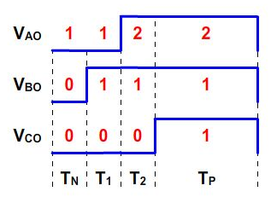
Figure 7. Switching pattern in sector II of region 1
Let ε be the deviation of the neutral point voltage, this one is calculated as in (3).
$ε=V_{C1}-V_{C2}$ (3)
This deviation is compared to the upper threshold values ​​BW_{T}, lower threshold BW_{B} and threshold 0 in the three-level hysteresis controller. When the deviation reaches the upper or lower threshold value, the duration of P-type vector or N-type vector will be changed respectively to drive the neutral point to the balanced state. Similarly, when the deviation reaches the threshold value 0, the duration of the two states will be equal to prevent the neutral point from drifting away from the equilibrium state. This delay controller is described in Figure 8. The flow chart of control algorithm is shown in Figure 9.
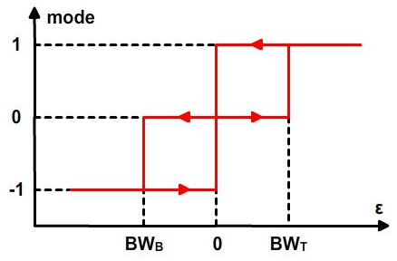
Figure 8. Three-level hysteresis control.
Let ΔT be the deviation time of the two states P and N, this value is determined from the output of the three-level hysteresis controller as shown in (4).
$ΔT=\left\{\begin{aligned}K\frac{T_{3}}{2} \\ 0 \\ -K\frac{T_{3}}{2}\end{aligned}\right.$ ${\begin{aligned}when mode = 1 \\ \end{aligned} \atop \begin{aligned}when mode = 0 \\ \\ when mode = -1\end{aligned}}$ (4)
with K ∈(0 1)
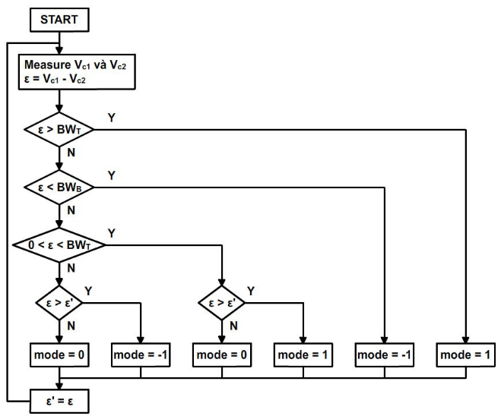
Figure 9. Flowchart of three-level hysteresis control.
And two vectors type P and N are calculated as in (5)
$\left\{\begin{aligned}T_{N}=\frac{T_{3}}{2}-ΔT \\ T_{P}=\frac{T_{3}}{2}+ΔT\end{aligned}\right.$ (5)
3. SIMULATION RESULTS
The proposed space vector modulation algorithm is simulated by the MATLAB/SIMULINK program. Simulation parameters are given in Table 3, with modulation index as (6)
$M=\frac{\overset{→}{|V_{ref}|}}{{V_{DC}}/{\sqrt{3}}}$ (6)
Table 3. Simualation parameters
DC-link voltage | V_{DC} = 100 V
Capacitance of DC-link capacitor | C₁ = C₂ = 1000 μF
Switching frequency | f_{PWM} = 10 kHz
Modulation index | M = 0.9
Balanced three-phase load | R = 10 Ω, PF = 0.9
Threshold | BW_{T} = BW_{B} = 2 V
Coeeficient K | K = 0.9
The proposed algorithm is simulated in two cases:
- Case 1: Balance the neutral point when the DC-link capacitors have different capacitance, with C1 = 1000 μF and C2 = 100 μF. The proposed algorithm is applied at time 0.2s, before that, the conventional algorithm is applied. The simulation results are shown in Figures 10
- Case 2: Balance the neutral point when the modulation index M is changed from 0.3 to 0.9 at time 0.2s. The simulation results are shown in Figures 11
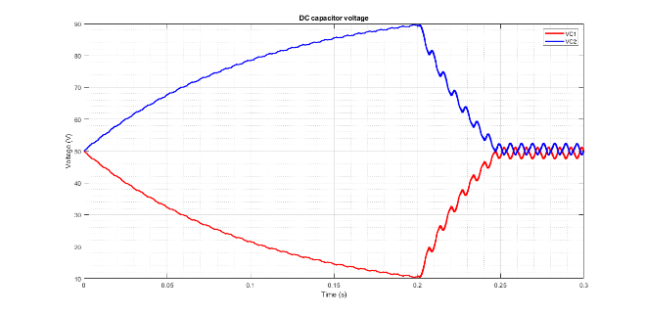
(a)
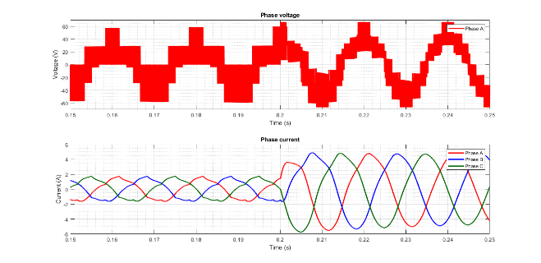
(b)
Figure 10. Simulation results of case 1
(a) DC-link voltage
(b) Load voltage and load current

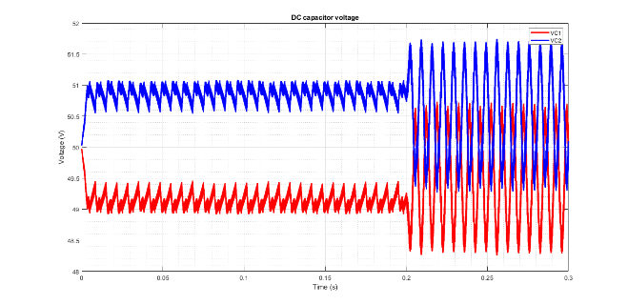
(a)
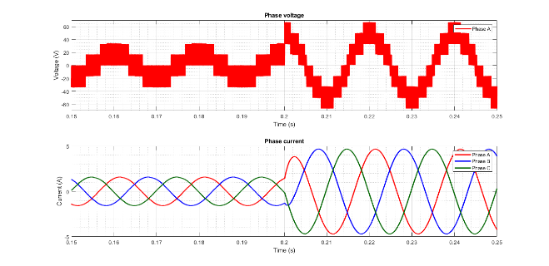
(b)
Figure 11. Simulation results of case 2
(a) DC-link voltage
(b) Load voltage and load current

Table 4. THD analysis results
THD (%) | Voltage V_{AN} |  | Current I_{AN}
THD (%) | Before 0.2s | After 0.2s | Before 0.2s | After 0.2s
Case 1 | 43.42 | 32.96 | 12.18 | 0.63
Case 2 | 105.66 | 33.16 | 1.44 | 0.55
The simulation results have demonstrated that the proposed algorithm can balance the voltage of two DC-link capacitors well in the three-level TNPC converter:
- Case 1: the neutral point deviates from the value of 50V when the proposed algorithm is not applied, then the proposed algorithm is executed to rebalance the neutral point in 0.03s. The distortion of voltage and current is also improved.
- Case 2: the proposed algorithm can balance the neutral point at high and low modulation index, however, the balance and distortion of the signals are better when the modulation index increases.
4. CONCLUSION
The paper has presented a solution to balance the neutral point of a three-phase three-level T-type converter by changing the switching time of small vectors accordingly. The proposed algorithm increases the convergence speed and stabilize the neutral point voltage in comparison with the traditional space vector modulation algorithm. The simulation results have demonstrated the value and feasibility of this algorithm.

REFERENCE
- J. Rodriguez, S. Bernet, P. K. Steimer, I. E. Lizama. A survey on neutral-point-clamped inverters, IEEE Transactions on Industrial Electronics, 2010, 57, 2219–2230.
- L. G. Franquelo, J. Rodríguez, J. I. León, S. Kouro, R. Portillo, M. M. Prats. The age of multilevel converters arrives, IEEE Transactions on Industrial Electronics, 2008, 2, 28–39.
- Shuxi Liu, Shan Li, Xiaoduo Yang. A new neutral point voltage control strategy for NPC three level inverters, 2nd International Conference on Electrical Engineering and Automation, ICEEA 2018, Chengdu, China.
- J. Rodriguez, S. Bernet, W. Bin, J. O. Pontt, S. Kouro. Multi-level voltage-source-converter topologies for industrial medium-voltage drives, IEEE Transactions on Industrial Electronics, 2007, 54, 2930-2945.
- E. Serban, C. Pondiche, M. Ordonez. Power-loss analysis in 3-Level TNPC inverters: modulation effects. IEEE Energy Conversion Congress and Exposition, 2017, 490-497
- M. Schweizer and J. W. Kolar. Design and implementation of a highly efficient three-level T-type converter for low-voltage applications. IEEE Transactions on Power Electronics, 2013, 28, 899-907.
- H. Peng, Z. Yuan, B. Narayanasamy, X. Zhao, A. Deshpande, F. Luo. Comprehensive Analysis of Three-phase Three-level T-type Neutral-Point-Clamped Inverter with Hybrid Switch Combination. IEEE 10th International Symposium on Power Electronics for Distributed Generation Systems, 2019, 816-821
- A.Nabae, I.Takahashi, H. Akagi. A new neutral-point clamped PWM inverter. IEEE Transactions on Industry Applications, 1981, IA-17, 518-523.
- U. Abronzini, C. Attaianese, M. Di Monaco, G. Tomasso and M. D'Arpino. SVM of three-level NPC inverter with unbalanced DC-link. IEEE Energy Conversion Congress and Exposition, 2018, 2215-2221.
- M.S. Newton C, Neutral point control for multilevel inverters: theory, design and operational limitations. IEEE transaction on Industrial application, 1997, 2, 1336-1343.
- Qingqing Yuan, An Li, Jinyue Qian, Kun Xia. DC-link capacitor voltage control for the NPC three-level inverter with a newly MPC-based virtual vector modulation, IET Power Eletronics, 2020, 13, 1093-1102.
- Y.H. Ko, B.G.Park, R.Y.Kim, D.S.Hyun, H.J.Jung. A simple space vector PWM scheme with neutral point balancing for three-level neutral point clamped inverter. Proceedings IEEE Industry Applications Society, 2011, 1–6.
- Y. Jiao, F. C. Lee, and S. Z Lu. Space vector modulation for three-level NPC converter with neutral point voltage balance and switching loss reduction. IEEE Transactions on Power Electronics, 2014, 29, 5579-5591.
- H. B. Zhang, S. J. Finney, A. Massoud, and B. W. Williams. An SVM algorithm to balance the capacitor voltages of the three-level NPC active power filter. IEEE Transactions on Power Electronics, 2008, 23, 2694-2702.
- U. M. Choi, J. S. Lee, K. B. Lee. New modulation strategy to balance the neutral-point voltage for three-level neutral-clamped inverter systems, IEEE Transactions on Energy Conversion, 2014, 29, 91-100.
- J. Pou, J. Zaragoza, S. Ceballos, M. Saeedifard, and D. Boroyevich. A carrier-based PWM strategy with zero-sequence voltage injection for a three-level neutral-point-clamped converter. IEEE Transactions on Power Electronics, 2012, 27, 642–651.
- H. J. Lee, T. G. Woo, S. Kim, Y. D. Yoon, Improved neutral-point voltage balancing control with time delay compensation and antiwindup loop for a three-level NPC inverter, IEEE Transactions on Industry Applications, 2021, 57, 4970-4980.
- M. A. Hossain, M. Tariquzzaman, A. K. Podder, M. S. Hossain Sabbir, M. Habibullah. Predictive current control of a simplified three-level neutral-point clamped inverter. 3rd International Conference on Electrical, Computer & Telecommunication Engineering, 2019, 280-28

