COVER LETTER
Dear Reviewers and Editor,
Thank you so much for your comments, recommendations, and correction suggestions to improve this manuscript. Listed and highlighted below are our corrections and responses.
FOR REVIEWER 1:
*The English and Vietnamese title do not match.
Response: The Vietnamese title has been added “Việt Nam” and corrected following your suggestion.
* The abstract is not well-written yet. An unnecessary summary introduces the bitter gourd.
The abstract has been revised by removing unnecessary information and using more informative words.
* Keywords need to be reconsidered
The keywords have been changed following your recommendations.
* The materials and methods section should be checked this characteristic “fruit dry matter content (%)” this is the “dry weight of fruit (g/fruit)” or “percentage of dry weight reduction compared to frest weight (%)”
We have used “The dry weight of fruit (%)” as suggested.
* Results and discussion section should be checked Grammar English structure.
Results and discussion section has been revised carefully in term of English grammar. All changes have been highlighted in bright green.
* Some references of the manuscript was not according to format of Journal.
The references number 4, 10, and 13 have been revised.

FOR REVIEWER 2:
* The experimental methods do not describe data collection on germination, flowering, and fruiting times. There is no statistical analysis of the results, please do it.
Data collection on germination, flowering, and fruiting times have been described in the experimental methods section. In detail, the time of germination, flowering, and harvesting are determined at the time point when 50% of individuals reveal the traits.
* Please specify how many seeds are used for the experiment.
The number of used seeds has been added in Table 1. The sowing was carried out twice to provide a sufficient number of plants.
* Please describe in what state the fruit can be harvested.
The fruits were harvested once they fully matured when the middle fruits and warts were plumped.
* Improving English is required.
The manuscript has been revised carefully in terms of English grammar. All changes have been highlighted in bright green and turquoise.
* Please check the format of the journal and format the manuscript carefully, to avoid spelling error.
The manuscript has been checked in terms of format, grammar, and spelling.

I’m deeply grateful for your revisions.
Kind regards,
Bui Hong Hai

Evaluate the agronomical traits and saponin content of wild bitter gourd accessions (Momordica charantia L. var. abbreviata Ser.) collected from South Central region of Vietnam

Bui Hong Hai∗, Nguyen Thi Y Thanh, Ho Tan
Faculty of Natural Sciences, Quy Nhon University

Received:
Accepted:

ABSTRACT
Bitter gourds (Momordica charantia L.) have been widely grown and used as a vegetable and medicinal herb to treat diabetes, hepatitis, kidney (stone), cancer, anti-oxidation... as they contain active pharmaceutical substances like glycosides, alkaloids, triterpenes, steroids, and especially saponins with a high concentration. Wild bitter gourds (Momordica charantia L. var. abbreviata Ser.) have higher medicinal properties and resistance than their commercial varieties. However, the number of studies evaluating wild bitter gourd varieties was still very limited. This study aimed to evaluate the agronomical traits and quantify the saponin content of 12 wild bitter gourd accessions collected from the South Central region of Vietnam. The research results showed that 12 wild bitter gourd accessions had a low germination rate (10.34 - 44.19%), various germination time (2 - 20 days), and different first fruit harvest time ranging from 37 to 55 days after planting. The characteristics of leaves, fruits, and seeds differed among collected wild bitter gourd accessions: leaf size (11.90 - 20.23 cm x 9.95 - 16.4 cm), petiole length (3.97 - 8.71 cm), deeply lobed leaf blades with 5 or 7 lobes; fruit size (4.09 - 8.77 cm x 2.05 - 3.5 cm), fruit weight (4.41 - 30.09 g.fruit⁻¹), fresh fruit yield (114.84 - 614.045 g fresh fruit.plant⁻¹); and seed size (9.36 - 13.18 mm x 5.0 - 8.0 mm). The total saponin content ranged from 13.26 to 18.98 mg.g⁻¹ dry fruit. The BD4 and QN2 accessions were found to have a high yield (614.04 g.plant⁻¹ and 613.55 g.plant⁻¹ respectively) which should be used for breeding to enhance their yield. The BD3 and QN3 were found to have a high total saponin content (18.98 mg.g⁻¹ dry fruit and 16.77 mg.g⁻¹ dry fruit respectively) which should be suitable for breeding research to increase saponin properties.
Keywords: Wild bitter gourd, Momordia charantia L. var. abbreviata Ser., South Central region, agronomical traits, saponin content.

1. INTRODUCTION
Bitter gourds (Momordica charantia L.) or bitter melons which belong to Cucurbitaceae, have been widely grown in Vietnam and other countries in Asia, East Africa, Amazon, and the Caribbean countries.^{1,2} Besides using as a vegetable, bitter gourds are also used as a herbal medicine to treat diabetes, kidney (stone), eczema, malaria, hepatitis, gout, laxatives, AIDS, cancer...^{3,4,6} Bitter gourds contain active pharmaceutical substances including glycosides, saponins, alkaloids, triterpenes, and steroids.^{4,5} The most important pharmaceutical components are saponin and monordicin.⁴ Saponin is a compound containing charantin, which acts as an insulin having a safe effect on lowering blood sugar. Momordicin is a mixture of charantin, protein, adenine, betanin, vitamins B, C... which can kill bacteria and viruses, effectively inhibiting cancer cells,^{4,6} preventing DNA damage caused by H₂O₂ inhibiting the activity of enzyme α-amylase, fighting inflammatory,⁷ improving the antioxidant activity of enzymes,⁸ and supporting the control of disorders blood lipids and oxidative stress in type 2 diabetic patients.⁹
The related research results showed that wild bitter gourd varieties (Momordica charantia L. var. abbreviata Ser.) had higher pharmacological activities than their commercial varieties.^{10,11} More especially, these wild varieties also had better resistance to bacteria, to cytotoxic activities,^{12,13} and to fruit flies (Bactrocera cucurbitae) than cultivated bitter gourd varieties.¹¹. However, recent research just focused on expanding wild bitter melon production due to market demand and their potential to increase income for producers. The number of studies on growth and agronomical characteristics of wild bitter gourd varieties was still limited in Vietnam. In recent research, 09 wild bitter melon accessions/varieties were collected in Binh Phuoc province and evaluated, including the AB5 variety with high yield potential and the BT2 variety with high saponin content.¹⁴ The genetic diversity of 12 wild bitter melon varieties in many different regions was also evaluated and analyzed.¹⁵ In the South Central region of Vietnam, there are diverse natural conditions that promise an abundance of wild bitter melon accessions. Therefore, this research aimed to collect, analyze, and evaluate wild bitter melon accession, thereby providing potential data for later breeding research.

2. METHODS
2.1. Materials

12 wild bitter gourd accessions were collected from the South Central region presented in Table 1.

Table 1. The list of wild bitter gourd accessions
No. | Accession Code | Place of collection | Number of used seeds
1 | QN1 | An My ward, Tam Ky city, Quang Nam province | 116
2 | QN2 | Dien Phuong commune, Dien Ban district, Quang Nam province | 108
3 | QN3 | Nui Thanh town, Nui Thanh district, Quang Nam province | 86
4 | QNg1 | Tinh Long commune, Quang Ngai city, Quang Ngai province | 108
5 | QNg2 | Nghia Ha commune, Tu Nghia district, Quang Ngai province | 96
6 | QNg3 | Binh Phuoc commune, Binh Son district, Quang Ngai province | 58
7 | BD1 | Tay Giang commune, Tay Son district, Binh Dinh province | 62
8 | BD2 | Cat Minh commune, Phu Cat district, Binh Dinh province | 96
9 | BD3 | My Chau commune, Phu My district, Binh Dinh province | 92
10 | BD4 | Nhon Phu ward, Quy Nhon city, Binh Dinh province | 48
11 | PY1 | An Nghiep commune, Tuy An district, Phu Yen province | 50
12 | BT1 | Thuan Hoa commune, Ham Thuan Bac district, Binh Thuan province | 90

2.2. Methods
2.2.1. Experimental design
The experiment was conducted from September 2023 to February 2024 in the net house at the Applied Research Garden for Agriculture and Environment, Quy Nhon University, Binh Dinh, Vietnam. Experimental conditions during the study period included average temperature (28.15 °C), relative humidity (80 %), average sunshine hours per month (140 hours.month⁻¹), and average monthly rainfall (334 mm.month⁻¹).
The experiment was laid out as a completely randomized design with 12 plots of 5 m² (5m x 1m). Each plot planted 10 plants of a wild bitter gourd accession, with two plants 50 cm apart and two rows 80 cm apart. The total experimental area is 60 m² (10 m x 6 m) not including protection paths and isolation distances.
2.2.2. Cultivation process
The experimental procedure was according to QCVN 01-153:2014/BNNPTNT¹⁶, the wild bitter gourd plants were grown in black nylon bags (20 cm x 40 cm). The planting substrate includes 50 % treated coconut fiber, 20% smoked rice husk, 20% soil, and 10% Song Gianh River microbial organic fertilizer (v:v). The nutrient solution was mixed from 10 g of GATIT NPK soluble fertilizer 17-6-17+TE (https://www.gatvn.com/products/gatit-npk-17-6-17-te) in 30 liters of water and watered by using a drip system. The amount of nutrient solution was adjusted to adapt to each stage of the plant growth.
The seeds were washed, soaked in warm water for 2 hours, and incubated in a damp cloth until germination. Germinated seeds were then planted in a plastic tray containing Tribat clean soil, and kept moist by periodic watering. 13 days after sowing, each seedling with 3 true leaves has been transplanted in a black nylon bag.
2.3.3. Indicators and measurement
The germination rate (%) is percentage of the number of germinated seeds compared to the total used seeds which ranged from 48 to 116 seeds (Table 1).
Agronomical traits were evaluated according to QCVN 01-153:2014/BNNPTNT¹⁶ including growth stages (the time point is when 50% of individuals reveal the traits). Accordingly, the leaf length (cm), leaf width (cm), petiole length (cm), fruit length (cm), fruit diameter (cm), fruit weight (g), seed length (mm), seed width (mm), seed thickness (mm), and seed mass (mg) were determined through 15 samples. The number of fruits per plant (fruits) and fresh fruit yield (g.plant⁻¹) were measured in 30 days starting from the first fruit harvest date. The fruits were harvested once they fully matured when the middle fruits and warts were plumped. The total saponin content was determined by using spectrophotometry at 560 nm with UV-Vis 1800i equipment (Shimadzu, Japan).¹⁷ Dry fruit sample was ultrasonically extracted with ethanol 80%. The filtrate was distilled to recover the solvent under reduced pressure to get the extract which was dissolved in distilled water and extracted with n-butanol. After removing n-butanol, the extract was dissolved with ethanol 80% and made a color-forming reaction with vailin 8% and H₂SO₄ 72% at 60ºC for 15 minutes. The absorption of the mixture was measured at 560 nm. The reference was momordicoside - G dissolved in ethanol 80% at 35, 75, 150, 300, 600, và 800 µg.ml⁻¹. The dry weight of fruit (%) was determined by weighing and drying at 55 ºC for 36 hours.
The research data were analyzed by using MS. Excel 2010 and Statistix (ver. 8.0). The experimental results were statistically analyzed by one-way ANOVA analysis with LSD (least significant difference) test for multiple comparisons with a significance level of 0.05.
3. RESULTS AND DISCUSSION
3.1. Growth stages and yield
The results of the growth stages were shown in Table 2. Research data indicated that the collected wild bitter gourd accessions had a low germination rate which ranged from 10.34% (QN1) to 44.19% (QN3) and the germination time was not consistent among the accessions, ranging from 2 days (QN3 and PY1) to 20 days (QN2). Male flowering time was usually earlier than the female counterpart and this indicator also differed greatly among the studied accessions, ranging from 27 days after planting (DAP) with BT1 to 40 DAP with PY1. Female flowering time also varied, from 20 DAP with BT1 to 41 DAP with QN2. Interestingly, some studied wild bitter gourd accessions had their male flowers appeared before their female flowers such as BT1 (7 days in advance) and PY1 (2 days in advance), while BD1 had their male and female flowers appeared on the same day. The first fruit harvest time also witnessed a difference among the accessions, ranging from 37 DAP (BT1) to 55 DAP (QN2), corresponding after the appearance of female flowers from 9 days (BD1, QNg1) to 15 days (QNg3, BD4, and PY1).

Table 2. Growth stages and yield of wild better gourd accessions
Accession  Code | Germination rate (%) | Germination time (day) | Male flowering time (DAP) | Female flowering time (DAP) | First harvest time (DAP) | Num. of fruit per plant (fruit) | Yield (g)
QN1 | 10.34 | 18 | 34 | 39 | 49 | 24.7de | 261.82^{d}
QN2 | 11.11 | 20 | 35 | 41 | 55 | 35.1^{b} | 613.55ª
QN3 | 44.19 | 2 | 31 | 36 | 49 | 28.3^{c} | 283.00^{d}
QNg1 | 11.11 | 13 | 38 | 45 | 54 | 39.7ª | 457.74^{c}
QNg2 | 18.75 | 13 | 30 | 37 | 51 | 36.9^{ab} | 453.87^{c}
QNg3 | 34.48 | 3 | 31 | 35 | 50 | 24.8de | 248.00de
BD1 | 38.71 | 6 | 39 | 39 | 48 | 22.3^{ef} | 532.97^{b}
BD2 | 12.50 | 16 | 31 | 36 | 48 | 38.6ª | 582.86ª
BD3 | 13.04 | 13 | 24 | 34 | 47 | 38.2^{ab} | 255.94^{d}
BD4 | 25.00 | 6 | 25 | 29 | 44 | 20.4^{fg} | 614.04ª
PY1 | 44.00 | 2 | 40 | 38 | 53 | 17.8^{g} | 206.48e
BT1 | 37.78 | 12 | 27 | 20 | 37 | 26.1^{cd} | 114.84^{f}
LSD_{0,05} | - | - | - | - | - | 3.34 | 44.94
CV (%) | - | - | - | - | - | 12.79 | 13.15

Note: Mean followed by the same letter is not significantly different within the columns according to an LSD test at the significance level of 0.05; CV - coefficient variance; LSD: least significant difference; DAP: number of days after planting.

After 30 days of harvesting, the number of fruits per plant of wild bitter melon accessions ranged from 17 fruits.plant⁻¹ (PY1) to 39.1 fruits.plant⁻¹ (QNg1), and the fresh yield ranged from 114.84 to 614.04 g.plant⁻¹. The accessions with high fresh fruit yield were BD4 (614.04 g.plant⁻¹), QN2 (613.55 g.plant⁻¹), BD2 (582.86 g.plant⁻¹), and BD1 (532.97 g.plant⁻¹). The accessions with low fresh fruit yield were BT1 (114.84 g.plant⁻¹), and PY1 (206.48 g.plant⁻¹). Although the number of fruits per plant was lower, the fresh fruit yield of the wild bitter melon accessions was equivalent to the yield of some varieties collected in Binh Phuoc during the same harvest time, such as BT4 (500 g.plant⁻¹) and HC2 (610 g.plant⁻¹).¹⁴
3.2. Leaf morphological traits
The leaf is an important plant organ that performs photosynthesis to create organic matter, thereby generating energy for all living activities. Leaf size shows the photosynthetic ability of a plant as well as its yield potential.¹⁸ The characteristics of leaf blade size, petiole length, and leaf descriptions of wild bitter gourd accessions were shown in Table 3 and Figure 1.

Table 3. Leaf morphological traits of wild better gourd accessions
Accession  Code | Leaf length (cm) | Leaf width (cm) | Petiole length (cm) | Leaf descriptions
QN1 | 12.63^{fg} | 9.95^{g} | 4.37^{h} | Small leaf blade size, light green, deeply lobed leaf blade with 5 lobes, heart-shaped at the base of leaf blade, and slightly pointed at the tip of a leaf lobe.
QN2 | 14.53e | 12.13^{d} | 6.03e | Medium leaf blade size, dark green, deeply lobed leaf blade with 7 lobes, heart-shaped at the base of leaf blade, and pointed at the tip of a leaf lobe.
QN3 | 17.47^{b} | 15.30^{b} | 4.73^{g} | Medium leaf blade size, light green, deeply lobed leaf blade with 5 lobes, heart-shaped at the base of leaf blade, and slightly pointed at the tip of a leaf lobe.
QNg1 | 14.87e | 10.97^{ef} | 5.10^{f} | Small leaf blade size, light green, deeply lobed leaf blade with 5 lobes, heart-shaped at the base of leaf blade, and slightly pointed at the tip of leaf lobes.
QNg2 | 15.97^{d} | 14.17^{c} | 4.45^{gh} | Medium leaf blade size, medium green, deeply lobed leaf blade with 7 lobes, heart-shaped at the base of leaf blade, and pointed at the tip of leaf lobes.
QNg3 | 13.40^{f} | 11.53de | 5.19^{f} | Medium leaf blade size, medium green, deeply lobed leaf blade with 7 lobes, heart-shaped at the base of leaf blade, and pointed at the tip of leaf lobes.
BD1 | 17.23^{b} | 14.03^{c} | 8.02^{b} | Large leaf blade size, medium green, deeply lobed leaf blade with 7 lobes, heart-shaped at the base of leaf blade, and pointed at the tip of leaf lobes.
BD2 | 17.19^{bc} | 11.98^{d} | 6.98^{c} | Small leaf blade size, light green, deeply lobed leaf blade with 7 lobes, heart-shaped at the base of leaf blade, and pointed at the tip of leaf lobes.
BD3 | 12.70^{fg} | 10.97^{ef} | 6.48^{d} | Small leaf blade size, dark green, deeply lobed leaf blade with 5 lobes, heart-shaped at the base of leaf blade, and slightly obtuse at the tip of leaf lobes.
BD4 | 20.23ª | 16.40ª | 8.71ª | Large leaf blade size, light green, deeply lobed leaf blade with 7 lobes, heart-shaped at the base of leaf blade, and pointed at the tip of leaf lobes.
PY1 | 16.30^{cd} | 13.53^{c} | 8.11^{b} | Medium leaf blade size, light green, deeply lobed leaf blade with 5 lobes, heart-shaped at the base of leaf blade, and slightly pointed at the tip of leaf lobes.
BT1 | 11.90^{g} | 10.40^{fg} | 3.97^{i} | Small leaf blade size, light green, deeply lobed leaf blade with 5 lobes, heart-shaped at the base of leaf blade, and slightly pointed at the tip of leaf lobes.
LSD_{0,05} | 0.92 | 0.81 | 0.35 | -
CV (%) | 8.31 | 8.90 | 8.11 | -

The data in Table 3 showed that the wild bitter gourd accessions had a variety in terms of leaf lengths from 11.90 cm to 20.23 cm and leaf blade widths from 9.95 cm to 16.4 cm. The accessions with small leaf sizes were BT1 (11.9 cm x 10.4 cm), QN1 (12.63 cm x 9.95 cm), and BD3 (12.7 cm x 10.97 cm). The accessions with large leaf sizes are BD4 (20.23 cm x 16.4 cm), QN3 (17.47 cm x 15.3 cm), and BD1 (17.23 cm x 14.03 cm). The petiole length also varied among the accessions. Specifically, BT1 was recorded as the shortest with 3.97 cm and BD4 was the longest with 8.71 cm. Interestingly, the leaf size of the studied wild bitter gourd accessions was equivalent to its counterpart in the study of Bui Thi Xuan (12.1 - 24.2 cm x 9.1 - 16.7cm).¹⁵
The leaf blades of all wild bitter gourd accessions were heart-shaped at the leaf bases. The tip of leaf lobes was slightly pointed, clearly pointed, or slightly obtuse. The leaf blades were deeply lobed with 5 or 7 lobes. The accessions that had the leaf blade with 5 deep lobes were QN1, QN3, QNg1, BD3, PY1, and BT1. The ones that had 7 deep lobes per leaf blade were QN2, QNg2, QNg3, BD1, BD2, and BD4 (Figure 1). The leaf morphological characteristics of the wild bitter gourd accessions were similar to those found in the study of Bui Thi Xuan.¹⁵
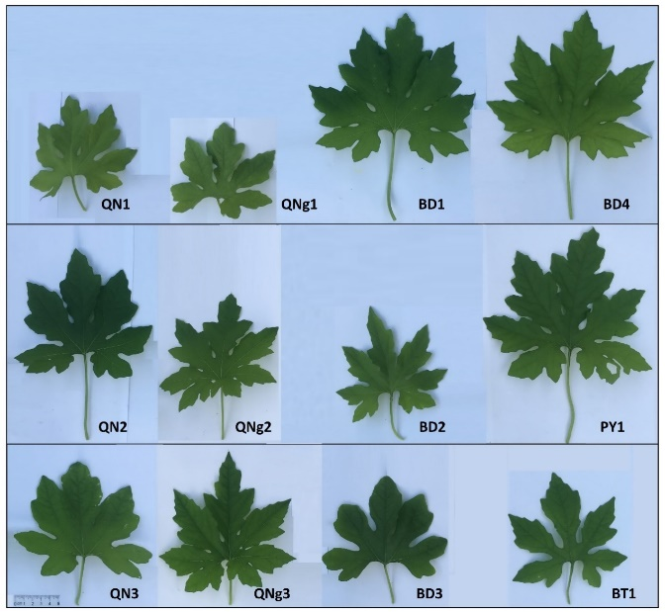
Figure 1. Leaf morphology of the wild bitter gourd accessions
3.3. Fruit morphological traits
The traits of fruits including fruit length, fruit diameter, cross-section shape, color of skin, and wart size were used to classify group varieties in breeding testing.¹⁶ The fruit traits of studied wild bitter gourd accessions were shown in Table 4 and Figure 2.
Data in Table 4 showed that the studied fruit length ranged from 4.09 cm to 8.77 cm, the fruit diameter ranged from 2.05 cm to 3.5 cm, and the fruit weight ranged from 4.41 g.fruit⁻¹ to 30.09 g.fruit⁻¹. The wild bitter gourd accessions with large fruit sizes were BD4 (8.77 cm x 3.53 cm, 30.09 g.fruit⁻¹), and BD1 (7.19 cm x 3.24 cm, 23.87 g.fruit⁻¹). The accessions with small fruit sizes were BT1 (4.09 cm x 2.05 cm, 4.41 g.fruit⁻¹), and BD3 (4.15 cm x 2.99 cm, 6.74 g.fruit⁻¹). The fruit size of the wild bitter gourd accessions in this study was smaller than the fruit size of the wild bitter melon accessions studied by Bui Thi Xuan (5.5 - 14.9 cm x 2.9 - 6.7 cm)¹⁵ but it was greater than the wild bitter melon varieties studied by Phan Dang Thai Phuong (2.79 - 4.38 cm x 1.54 - 1.82 cm).¹⁴ This difference might be due to the differences in genotype among accessions collected, as well as the different time and experimental conditions of the studies.
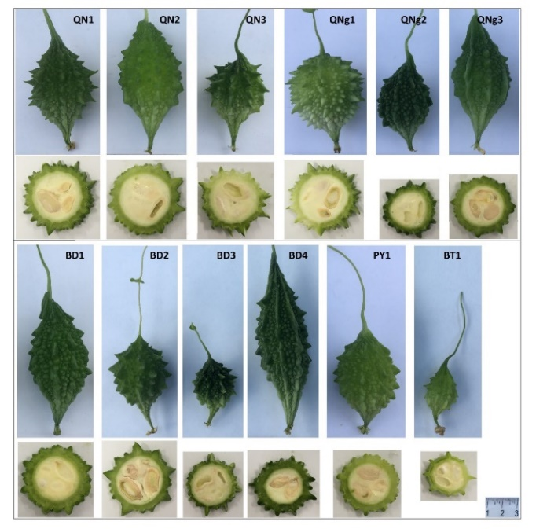
Figure 2. Shape and cross-section of the fruit of wild bitter gourd accessions
Other fruit morphological traits including longitudinal shape, skin color, and wart size varied among the studied wild bitter gourd accessions. In terms of longitudinal shapes of fruits, some accessions were rhomb (QN1, BD2, and PY1), some were oval (QN2, QNg3, BD1, BD4, and BT1), and the others were ovoid (QN3, QNg1, QNg2, and BD3). Regarding the color of skin, some accessions were dark green (QNg2 and BD4), some were medium green (QN1, BD1, BD2, and BD3), and others were light green (QN2, QN3, QNg1, QNg3, PY1, and BT1). The fruit surfaces also varied among the wild bitter gourd accessions in terms of wart sizes, the shape of top wart, and ridges. Some had acute warts (QN1, QN3, QNg1, BD2, BD3, BT1), obtuse warts (QN2, QNg2, QNg3, BD1, BD4, PY1), and ridges include (QNg3, BD1, and BD4).

Table 4. Fruit morphological traits of wild bitter gourd accessions
Accession  Code | Fruit length (cm) | Fruit diameter (cm) | Fruit mass (g) | Fruit descriptions
QN1 | 5.32de | 2.97^{cd} | 10.62e | Fruits with rhombic shape, acute at base and apex, medium green, surface with medium-large acute warts and many small acute warts.
QN2 | 6.55^{c} | 3.07^{bc} | 17.48^{c} | Fruits with oval shape, acute at base and apex, white green, surface with many medium acute warts.
QN3 | 4.88e | 2.93^{cde} | 10.05^{ef} | Fruits with avoid shape, acute at base and apex, white green, surface with few large acute warts and many small obtuse warts.
QNg1 | 5.53^{d} | 3.03^{bc} | 11.53e | Fruits with avoid shape, obtuse at base and acute at apex, white green, surface with few large acute warts and many small acute warts.
QNg2 | 5.35de | 3.15^{bc} | 12.32de | Fruits with avoid shape, acute at base and apex, dark green, surface with few large acute warts and many small obtuse warts.
QNg3 | 4.88e | 3.14^{bc} | 10.05^{ef} | Fruits with oblong oval shape, acute at base and apex, white green, surface with many small obtuse warts and long ridges.
BD1 | 7.19^{b} | 3.24^{7b} | 23.87^{b} | Fruits with oval shape, acute at base and apex, medium green, surface with many small obtuse warts and few short ridges.
BD2 | 5.57^{d} | 3.50ª | 15.09^{cd} | Fruits with rhombic shape, acute at base and apex, medium green, surface with medium-large acute warts and medium-small acute warts.
BD3 | 4.15^{f} | 2.99^{ed} | 6.74^{fg} | Fruits with avoid shape, acute at base and apex, medium green, surface with medium-large acute warts and many small acute warts.
BD4 | 8.77ª | 3.53ª | 30.09ª | Fruits with oblong oval shape, acute at base and apex, dark green, surface with many small obtuse warts and long ridges.
PY1 | 5.33de | 2.73e | 11.65e | Fruits with rhombic shape, acute at base and apex, white green, surface with many small rounded warts and few obtuse warts.
BT1 | 4.09^{f} | 2.05^{f} | 4.41^{g} | Fruits with oval shape, acute at base and apex, white green, surface with few large acute warts and many small obtuse warts.
LSD_{0,05} | 5.82 | 2.33 | 3.33
CV (%) | 13.96 | 10.74 | 32.21

3.4. Seed morphological traits
The studied wild bitter gourd accessions also had significant differences in their seed size as shown in Table 4 and Figure 3. In detail, seed length ranged from 9.36 mm (BT1) to 13.18 mm (BD2), seed width ranged from 5.0 mm (QNg2) to 8.0 mm (BD4), grain thickness ranged from 2.61 mm (BD5) to 3.97 mm (BD2), and grain weight ranged from 71.64 mg.seed⁻¹ (BT1) to 180.64 mg.seed⁻¹ (BD4). The accessions with small seeds were BT1, QN1, QN3, QNg1, and QNg2. The accession with large seeds include QN2, QNg3, BD1, BD2, BD3, BD4, and PY1. The seed size of the accessions in this study was similar to the one in the study of Bui Thi Xuan (9.1 - 15.6 mm x 5.0 - 9.4 mm x 3.0 - 4.8 mm).¹⁵

Table 5. Seed morphological traits of the wild bitter gourd accessions
Accession Code | Seed length (mm) | Seed width (mm) | Seed thickness (mm) | Seed mass (mg) | Seed descriptions
QN1 | 11.68^{cd} | 6.32e | 3.21^{cd} | 99.91^{f} | Oval shape, dark gray, smooth surface with or without black spots in the middle, and small edges.
QN2 | 12.09^{bc} | 7.45^{b} | 3.79^{ab} | 140.36^{cd} | Oval shape, light brown, lumpy surface with stripes, an indentation in middle, and small edges.
QN3 | 11.50^{d} | 6.09e | 3.40^{c} | 101.09^{f} | Oval shape, light gray, smooth surface with or without black spots, and very small edges.
QNg1 | 12.36^{b} | 6.73^{d} | 2.95e | 134.09de | Oval shape, dark gray, smooth surface with unclear stripes, and small edges.
QNg2 | 10.55e | 5.00^{f} | 3.03de | 81.73^{g} | Long oval shape, light brown, lumpy surface with clear stripes, and very small edges.
QNg3 | 12.09^{bc} | 7.09^{bcd} | 3.84^{ab} | 149.73^{bc} | Oval shape, dark brown, lumpy surface with clear stripes, and small edges.
BD1 | 12.09^{bc} | 7.86ª | 3.94^{ab} | 154.36^{b} | Oval shape, dark brown, smooth surface with unclear stripes, and small edges.
BD2 | 13.18ª | 7.86ª | 3.97ª | 175.09ª | Oval shape, light brown, lumpy surface with clear stripes and indentation in middle, and small edges.
BD3 | 12.23^{b} | 7.00^{cd} | 3.73^{b} | 155.36^{b} | Oval shape, light brown, smooth surface with few stripes, and small edges.
BD4 | 13.00ª | 8.00ª | 3.82^{ab} | 180.64ª | Oval shape, dark brown, lumpy surface with clear stripes and dark brown indentation in middle, and small edges.
PY1 | 11.27^{d} | 7.27^{bc} | 3.09de | 124.18e | Oval shape, light brown, lumpy surface with clear stripes and dark brown indentation in the middle, and small edges.
BT1 | 9.36^{f} | 5.23^{f} | 2.61^{f} | 71.64^{g} | Oval shape, light gray, smooth surface with or without dark gray spots, and very small edges.
LSD_{0,05} | 0.51 | 0.38 | 0.24 | 13.29
CV(%) | 5.15 | 6.66 | 8.36 | 12.05

The seed surface and color of testa also varied among accessions. The accessions with gray testa included QN1, QN3, QNg1 and BT1. The accessions with brown testa included QN1, QNg2, QNg3, BD1, BD2, BD3, BD4, and PY1. The seed surface with clear stripes was found in QN2, QNg2, QNg3, BD2, BD4, and PY1 accessions.
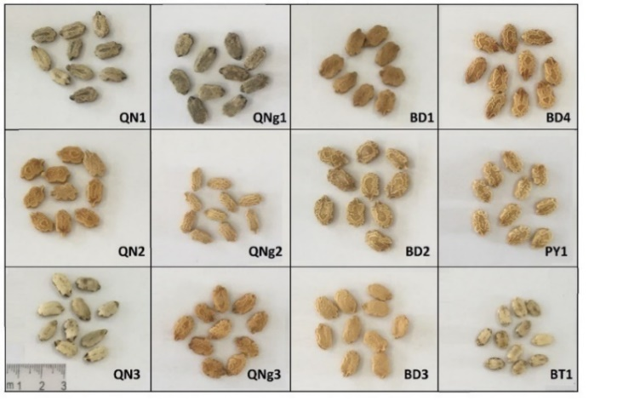
Figure 3. Seeds of wild bitter gourd accessions
3.5. Saponin content and dry weight of fruit
Saponin is the most important medicinal substance in bitter gourds which was found to have a great beneficial impact on health. It could lower blood sugar,⁹ kill bacteria and viruses, effectively inhibit cancer cells,^{4,6} limit DNA damage caused by H₂O₂, fight inflammation,⁷ and resist oxidation.⁸ Quantifying the saponin content was believed to facilitate the evaluation of potential medicinal values of bitter gourd accessions in this study, which was shown specifically in Figure 4.
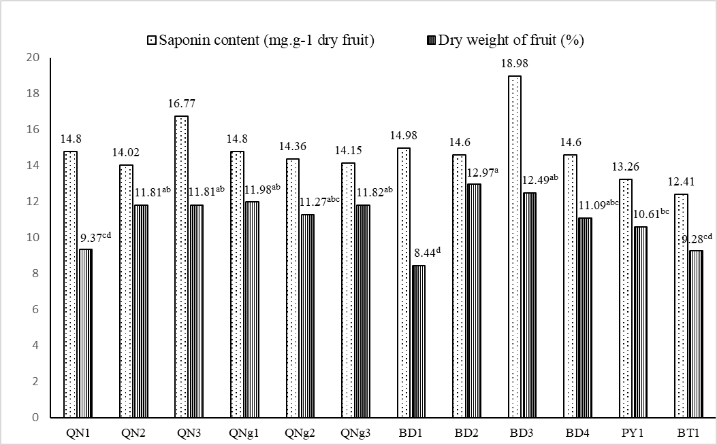
Figure 4. Total saponin content and dry weight of fruit of wild bitter gourd accessions
The total saponin content in dried fruit of wild bitter melon accessions was relatively uniform among accessions, ranging from 13.26 to 18.98 mg.g⁻¹ dry fruit. The two accessions with highest total saponin content were BD3 (18.98 mg.g⁻¹ dry fruit) and QN3 (16.77 mg.g⁻¹ dry fruit).
The dry weight of fruit ranged from 8.44% to 12.97%. The accessions with high fruit dry matter content included BD2 (12.97%) and BD3 (12.49%). The accessions with low fruit dry matter content included BD1 (8.44%), BT1 (9.28%), and QN1 (9.37%).

CONCLUSION
The collected 12 wild bitter gourd accessions had a low germination rate (from 10.34% to 44.19%), various germination time (from 2 to 20 days), and different first harvest time (from 37 to 55 days after planting). The traits of leaves, fruits, and seeds differed among wild bitter gourd accessions. In terms of leaf characteristics, leaf blade size ranged from 11.90 - 20.23 cm x 9.95 - 16.4 cm, petiole length ranged from 3.97 cm to 8.71 cm, number of deep lobes per leaf blade was 5 or 7 lobes; fruit size ranged from 4.09 - 8.77 cm x 2.05 - 3.5 cm, fruit weight ranged from 4.41 to 30.09 g.fruit⁻¹, and fresh fruit yield ranged from 114.84 to 614.045 g.plant⁻¹. Regarding seeds, seed size ranged from 9.36 - 13.18 mm x 5.0 - 8.0 mm. The total saponin content in the studied accessions ranged from 13.26 to 18.98 mg.g⁻¹ dry fruit, and the dry weight of fruit ranged from 8.44 to 12.97%.
Results of the study revealed that the accessions having the highest yield were BD4 (614.04 g.plant⁻¹) and QN2 (613.55 g.plant⁻¹) which should be followed by breeding selection for high yield experiments and studies. The accessions having high saponin content were BD3 (18.98 mg.g⁻¹ dry fruit) and QN3 (16.77 mg.g⁻¹ dry fruit) which should be suitable for breeding to enhance total saponin content.
Acknowledgment
This research was conducted within the framework of a science and technology project at the institutional level of Quy Nhon University under the project code T2023.799.09.
REFERENCES
1. Ahmad N., Hasan N., Ahmad Z., Zishan M., Zohrameena S. Momordica charantia: for traditional uses and pharmacological actions. Journal of Drug Delivery & Therapeutics, 2016, 6 (2), 40-44.
2. Reyes R.M. Current status of bitter gourd production and marketing in Asia and market potential of bitter gourd as a functional vegetable, International Bitter Gourd Conference, Hyderadad, India, 2014.
3. Arafat S.Y., Nayeem M., Jahan S., Karim Z., Reza H.M., Hossain M.H., Shohel M., Alam M.A.. Ellagic acid-rich Momordica charantia fruit pulp supplementation prevented oxidative stress, fibrosis and inflammation in the liver of alloxan-induced diabetic rats. Orient. Pharm. Exp. Med., 2016, 16 (4), 267-278.
4. Grover J. K., Yadav S. P.. Pharmacological action and potential uses of Momordica charantia: a review, J Ethnopharmacol, 2004, 93, 123-132.
5. Raman, A., Lau, C. Anti-diabetic properties and phytochemistry of Momordica charantia L. (Cucurbitaceae). Phytomedicine, 1996, 2, 349-362.
6. Jing-Ru Weng. A triterpenoid from wild bitter gourd inhibits breast cancer cells, Scientific Reports, 2016, 6, 22419.
7. Pham TMH., Ngo DH., Ngo DN., Vo TS. Investigation of biological activities of wild bitter melon (Momordica charantia L. var. abbreviata Ser.). Biomolecules, 2019, 9(6), 211.
8. Sagor A.T., Chowdhury M.R.H., Tabassum N., Hossain H., Rahman M.M., Alam M.A. Supplementation of fresh ucche (Momordica charantia L. var. muricata Willd) prevented oxidative stress, fibrosis and hepatic damage in CCl4 treated rats. BMC Complement Altern Med., 2015, Apr 11, 15:115.
9. Poovitha S., Parani M.. Protein extracts from Momordica charantia var. charantia and M. charantia var. muricata show anti-lipidemic and antioxidant properties in experimental type 2 diabetic rats. J Food Biochem, 2020, 44, e13370.
10. Lu Y.-L., Liu Y.-H., Chyuan J.-H., Cheng K.-T., Liang W.-L., and Hou W.-C.. Antioxidant activities of different wild bitter gourd (Momordica charantia L. var. abbreviata Seringe) cultivars, Botanical Studies, 2012, 53, 207-214.
11. Dhillon, M K and Naresh, J S and Singh, R and Sharma, N K. Reaction of different bitter gourd (Momordica charantia L.) genotypes to melon fruit fly, Bactrocera cucurbitae (Coquillett). Indian Journal of Plant Protection, 2005, 33 (1), 55-59.
12. Lu, Y.-L., et al. Antibacterial and cytotoxic activities of different wild bitter gourd cultivars (Momordica charantia L. var. abbreviata Seringe), Botanical Studies, 2011, 52, 427-434.
13. Dam N. P., Dien V. M., Thanh L. H. V., Hien P. T. T., and Tram N. T. T.. Investigation of antimicrobial activity and chemical constituents of Momordica charantia L. var. abbreviata Ser., Vietnam J. Sci. Technol., 2019, 57 (2), 155–161.
14. Phan D.T.P., Tran T.D.T., Vu V.B. Initial assessment of yields and medicinal value of some wild bitter melon varieties in Binh Phuoc (in Vietnamese). Vietnam Journal of Science and Technology, 2017, 13(2), 13-17.
15. Bui T.X., Tran T.L., To M.T., Tran T.K.D., Nguyen Q.T., Nguyen V.T. Evaluation of agro-morphological characterisation and genetic diversity of wild bitter gourd (Momordica charantia L. var. abbreviata Ser.) accessions, Journal of Agriculture and Rural Development, 2022, 1(4), 12-23.
16. Department of Agriculture and Rural Development, QCVN 01-153:2014/BNNPTNT - National technical regulation on testing for distinctness, uniformity and stability of bitter gourd varieties, Hanoi, Vietnam, 2014.
17. Tan S.P. et al. Optimized aqueous extraction of saponin from bitter melon for production of a saponin-enriched bitter melon powder, J. Food Sci., 2014, 79, 1372-1381.
18. Lincoln Taiz, Eduardo Zeiger. Plant physiology and development (6th ed.), Sinauer Associate Inc., Sunderland, Massachusetts, USA, 2015.

Đánh giá đặc điểm nông học và hàm lượng saponin của một số mẫu giống mướp đắng rừng (Momordica charantia L. var. abbreviata Ser.) thu thập ở khu vực Nam Trung Bộ, Việt Nam

Bùi Hồng Hải*, Nguyễn Thị Y Thanh, Hồ Tân

Khoa Khoa học Tự Nhiên, Đại học Quy Nhơn, Việt Nam
*Tác giả liên hệ chính: Email: buihonghai@qnu.edu.vn

TÓM TẮT
Cây mướp đắng (Momordica charantia L.) được trồng phổ biến và sử dụng làm rau, dược liệu nhằm chữa trị tiểu đường, viêm gan, sỏi thận, ung thư, ... do chứa nhiều dược chất như glycosides, alkaloids, triterpenes, đặc biệt hàm lượng saponin cao. Mướp đắng rừng (M. charantia L. var. abbreviata Ser.) có hàm lượng dược chất và tính chống chịu cao hơn nhiều so với các giống thương mại. Tuy nhiên, công tác thu thập, đánh giá các mẫu giống mướp đắng rừng còn nhiều hạn chế. Nghiên cứu nhằm đánh giá các đặc điểm nông học và định lượng saponin của 12 mẫu giống mướp đắng rừng thu thập ở khu vực Nam Trung Bộ, Việt Nam. Kết quả nghiên cứu bước đầu cho thấy 12 mẫu giống thu thập được có tỉ lệ nảy mầm thấp (10,34 – 44,19 %), thời gian nảy mầm không đồng đều (2 - 20 ngày), thời gian thu quả đợt đầu từ 37 đến 55 ngày sau trồng. Đặc điểm về lá, quả và hạt khác nhau giữa các mẫu giống: kích thước lá (11,90 – 20,23 cm x 9,95 – 16,4 cm), phiến lá xẻ thùy sâu với 5 hoặc 7 thùy; kích thước quả (4,09 – 8,77 cm x 2,05 – 3,5 cm) và năng suất quả tươi (114.84 - 614,045 g quả tươi/cây); kích thước hạt (9,36 – 13,18 mm x 5,0 – 8,0 mm). Hàm lượng saponin tổng số từ 13,26 đến 18,98 mg/g quả khô. BD4 (614,04 g/cây) và QN2 (613,55 g/cây) có triển vọng trong hướng chọn giống về năng suất. Các mẫu giống có hàm lượng saponin cao là BD3 (18,98 mg/g quả khô) và QN3 (16,77 mg/g quả khô) thích hợp với hướng chọn giống tăng hàm lượng saponin.
Từ khóa: Mướp đắng rừng, Nam Trung Bộ, đặc điểm nông học, hàm lượng saponin.

Liên hệ: Bùi Hồng Hải
Trường Đại học Quy Nhơn
170 An Dương Vương, TP. Quy Nhơn, tỉnh Bình Định, Việt Nam
Email: buihonghai@qnu.edu.vn
Điện thoại: 0983.230.599

∗Corresponding author. Email: buihonghai@qnu.edu.vn

