NGHIÊN CỨU, CHẾ TẠO HỆ THỐNG ĐÓNG CẮT VÀ GIÁM SÁT THÔNG SỐ HỆ THỐNG ĐIỆN DỰA TRÊN
XỬ LÝ ẢNH VÀ IoT

Lương Ngọc Toàn^{1,}*, Đoàn Đức Tùng², Lê Tuấn Hộ¹

¹Địa chỉ của tác giả: Khoa Kỹ thuật và Công Nghệ, Trường Đại Học Quy Nhơn
²Địa chỉ của tác giả: Khoa Kỹ thuật và Công Nghệ, Trường Đại Học Quy Nhơn

*Tác giả liên hệ chính. Email: luongngoctoan@qnu.edu.vn

TÓM TẮT
Trong bài báo này chúng tôi đã đi vào nghiên cứu, chế tạo hệ thống đo lường, giám sát các thông số trong hệ thống điện dựa trên công nghệ IoT, và đóng cắt thiết bị trong phạm vi rộng dựa trên công nghệ xử lý ảnh để phát hiện đối tượng. Phần cứng của hệ thống được chế tạo với bộ thiết bị nhận diện đối tượng, UART PZEM-004T, esp32, Aptomat thông minh để thu thập các thông số dòng điện, điện áp, công suất, hệ số công suất, điện năng tiêu thụ và nhận diện đối tượng trong phạm vi giám sát. Các dữ liệu này sẽ được gửi lên server Node-Red chạy ở chế độ cục bộ hoặc Cloud thông qua giao thức Message Queuing Telemetry Transport (MQTT). Sau khi chế tạo hệ thống vận hành ổn định, có khả năng tự động đóng cắt thiết bị khi phát hiện đối tượng, người sử dụng có thể theo dõi trạng thái, điều khiển và cài đặt các thông số thông qua giao diện trên máy tính và điện thoại. Hệ thống còn có chức năng lưu trữ dữ liệu trên GoogleSheet, cảnh báo qua Email, điện thoại. Phần cứng của hệ thống được chế tạo với phần khung vỏ của các thiết bị đang có trên thị trường nên có khả năng ứng dụng cao trong thực tế.
Từ khóa: IoT, TensorFlow, Node-Red, hệ thống điện

RESEARCH AND DEVELOPMENT OF A MONITORING AND SWITCHING SYSTEM OF ELECTRICAL PARAMETERS BASED ON IMAGE PROCESSING AND IOT
Luong Ngoc Toan ^{1,}*, Doan Duc Tung ², Le Tuan Ho ¹

¹Address of the author: Faculty of Engineering and Technology, Quy Nhon University
²Address of the author: Quy Nhon University

*Primary contact author. Email: luongngoctoan@qnu.edu.vn

ABSTRACTS
This paper studies designing an Internet of Things (IoT) system for measuring and monitoring some electrical parameters. This system applies image processing technologies and object recognition devices to measure and monitor some electrical parameters such as current, voltage, power, and temperature. The data collected is then sent to the Node-Red server using the Message Queuing Telemetry Transport (MQTT) protocol for further analysis. Once the system is operational, it can automatically switch off devices upon object detection. Users can monitor the system's status, control, and set parameters through an interface on their computer or phone. The system also can store data on Google and alert users via email or phone in case of any issues or anomalies. According to the paper, the system's hardware has been designed using the shell of existing devices available in the market, making it highly applicable in real-life scenarios.
Từ khóa: IoT, TensorFlow, Node-Red, Power-system

1. INTRODUCTION
It's fascinating to see how the industry is evolving with the 4.0 revolution, Internet of Things (IoT) technology, and Artificial Intelligence (AI). With the development of such technologies, we are witnessing the creation of more functional devices, particularly in electrical systems and sensors. Moreover, the servers being free for users and the introduction of embedded computers with small sizes and strong configurations like Raspberry Pi and Jesson Nano have made it easier for users to access IoT and AI.
The application of image processing technology in real-life scenarios is becoming increasingly popular, primarily in industry, environmental monitoring, and traffic surveillance¹. In the electrical system, this technology is also applied to identify winding faults in transformers² and to determine power quality^{3,4}.
In Vietnam, the number of offices and public sector facilities is increasing rapidly. However, it can be challenging to save electricity in these areas based on user behavior, and current efforts are often inefficient⁵. With the rapid development of IoT technology, the application of smart switchgear such as switches and automats has partly solved the limitations in this area.
However, these devices often work with small currents, switching based on the control on the phone or in combination with sensors such as motion sensors, and infrared sensors. Current devices are designed to either control or monitor electrical equipment, but they lack integration and the ability to detect people in large spaces such as classrooms or halls. Image processing technology has not been widely implemented in these devices to enable this functionality.
Based on the aforementioned issues, the author has conducted research and developed a system that includes functions such as wide-range image recognition for human detection to automatically switch electrical equipment. Additionally, the system can monitor, control, warn, and store data on parameters in the electrical system such as voltage, current, and power.
Although existing energy monitoring systems in previous studies can monitor electrical parameters and store data in the cloud, these systems have not yet integrated human recognition devices to Automatically control equipment switching. This not only ensures greater flexibility and security but also improves convenience and efficiency in power system management.^{6,7}
2. RESEARCH AND DEVELOPMENT OF THE SYSTEM
2.1. IoT system
IoT stands for the Internet of Things. A network of sensors, software, and other technologies that connect objects and devices, enabling them to collect and exchange data with each other^{8,9}.
Figure 1. The working principle of an IoT system
The Internet of Things has vast application potential across all sectors. It's important to note that every complete IoT system encompasses four key steps as shown in Figure 1: data collection, data sharing, data processing, and decision-making.
An IoT system typically comprises four main components: devices (Things), gateways (Gateways), network infrastructure (Network and Cloud), and analysis and data processing (Service and Solution Layers)^{10,11}. These components work together to create a network of connected devices that can collect and exchange data with each other, enabling the creation of smart systems and applications.
Sensors within the research system measure electrical parameters, recognize objects, and convert them into data for the Internet. Users can easily process the signals and make necessary changes through phone or computer applications.
2.2. Image processing based on TensorFlow
TensorFlow has indeed become the most popular deep-learning library in recent years. With TensorFlow, users have the flexibility to create various Deep Learning models such as convolutional Neural Networks (CNNs)¹², Recurrent Neural Networks (RNNs), and artificial neural networks. It's a powerful tool that has transformed how we approach machine learning and data analysis¹³.
TensorFlow is a powerful software library that enables numerical computations through data flow graphs. It is highly adaptable and can be used to program and train neural networks in multiple programming languages such as C, Java, and Python. Additionally, it allows for deploying applications on various platforms, including the cloud, machine local server, and mobile devices.
2.2.1. Core Elements in TensorFlow
TensorFlow is a library used for numerical computation and graphical representation of data that helps in creating and training machine learning models. These graphs consist of nodes and edges that represent calculations and corresponding data in the model. In general, the process of training a machine learning model in TensorFlow follows the steps shown in Figure 2.
Figure 2. Data flow chart for the training process.
In this training process, the user defines the computational graph structure by declaring variables and operations in the model. The processing is then defined to measure the difference between the model's predicted output and the actual value.
The data obtained after processing will be analyzed to determine the best parameter values that can minimize the loss function. The resulting values are then used to train and update the model. After the training, the model is tested with fresh data to assess its performance. Finally, the trained model is utilized to predict and categorize new data¹⁴.
2.2.2. Application of TensorFlow library on Raspberry Pi
Raspberry is a computer that is designed to be compact and embedded, making it perfect for use in IoT projects. Suppose you want to object detection models. In that case, you can use TensorFlow Lite, which is a TensorFlow library that is specifically designed to work with Raspberry Pi 3 and Raspberry Pi 4 when they are running either Rasbpian Buster or Rasbpian Stretch. The process for installing and running this program on Raspberry is illustrated in Figure 3.
Figure 3. TensorFlow installation procedure.
During the test, the results were displayed as depicted in Figure 4. To capture the camera frame, we used the OpenCV object. After capturing the frame, it was flipped horizontally and vertically for proper alignment and conversion to the required format that the model could process. The output of the model was a list of objects present in the frame, along with their corresponding parameters.
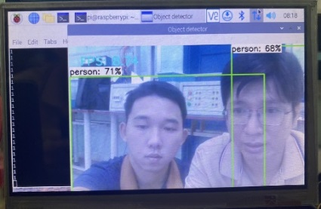
Figure 4. Object detection with TensorFlow Lite model.
The Object Detection model provides information on the location, class, and reliability of objects detected in a frame. To draw bounding boxes around an object, the model uses the coordinates of its upper-left and lower-right points. The layer's name is displayed with the bounding frame when a person is detected. Additionally, the class name is compared to a predefined label to determine its presence in the frame and the percentage match to the sample.
2.3. System Development Research
2.3.1. System Design
The following study puts forward a system that is capable of monitoring the parameters in the electrical system and can be operated through object recognition within the observation field. It is combined with both local and remote control through the control interface which is depicted in Figure 5 and system device parameters as shown in Table 1.
Figure 5. Schematic diagram of online monitoring structure for a distribution power system based on image processing and IoT.
The following are the primary stages of the system.
A: Webcam and Raspberry Pi 4 are combined for image processing to monitor and detect people within its range.
B: The server and database are installed on the computer and run in the cloud.
C: Measurement and switching are carried out using Pzem - 004T and smart automatic TuyA devices. These two measuring and switching devices are connected to Esp32 to transmit data to the server.
D: Monitor and control using your phone and computer.
Table 1. Main Device Specifications in the System
No. | Device Name | Specifications
1 | WebCam-PC-SWC-02 | Resolution: 1080P, USB connection, 140-degree scanning angle.
2 | Raspberry Pi 4 Model B | RAM: 8GB, GPIO: 40-pin standard, 2 Micro HDMI display outputs, Micro-SD slot for OS and storage.
3 | WiFi Tuya Controllable Circuit Breaker | Voltage: 220V ~ 50Hz, Load capacity: 63A (1 phase 2P), Overload and short circuit protection, WiFi: 2.4GHz IEEE 802.11b/g/n.
4 | WiFi BLE ESP32 NodeMCU-32S Kit (CH340) | SPI Flash: 32Mbits, Frequency Range: 2400~2483.5MHz, Bluetooth: BLE 4.2 BR/EDR, WiFi: 802.11 b/g/n/e/i.
5 | PZEM-004T AC Multi-Functional Meter UART Module | Voltage range: 80 ~ 260VAC / 50 - 60Hz, Accuracy: 0.01, Current range: 0 ~ 100A, UART TTL 5VDC logic level interface, default baud rate: 9600, 8, 1.
The measurement and switching stage (C) involves using the PZEM-004T sensor to measure parameters such as voltage, current, frequency, power, power factor, and power consumption. These measurements are then uploaded to the server via ESP32. At the same time, the identification and image processing (A) system sends a signal to the server to detect the presence or absence of people within the field of view. The server is equipped with a monitoring and control interface and a control program for the data received from (A) and (C).
The control signal is generated based on certain conditions such as the presence or absence of people in the field of view, overcurrent, and overvoltage. Data transmission between the stages is carried out using the MQTT protocol, and the microcontroller sends an automatic control signal to perform the power supply switching process.
2.3.2. Research and manufacture hardware
The system structure depicted in Figure 4 requires the installation and fabrication of hardware in two stages, namely (A) and (C). In the data recognition and processing stage (A), we make use of WebCam-PC-SWC-02 to connect to Raspberry Pi 4 Mode B. To observe the image processing, we employ a Waveshare 7-inch HDMI screen. Upon linking the devices, we obtain the results as depicted in Figure 6.
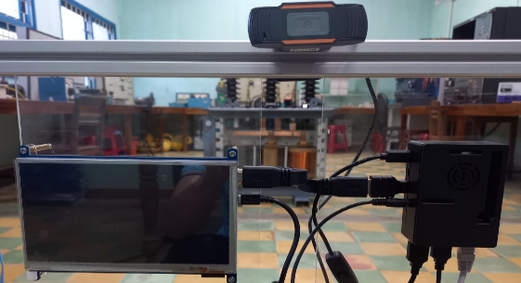
Figure 6. Installation of object recognition and handling equipment
To produce switchgear and measuring equipment, we carry out the following steps:
Step 1. To understand the structure and operating principle of the TuyA smart Aptomat, an experiment was conducted to find the control signal on the device, as shown in Figure 7. As a result, the signal-receiving pin will be detected, then this pin will be connected to the ESP32 Module using an intermediate relay.
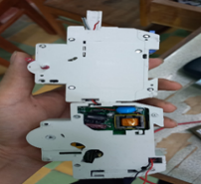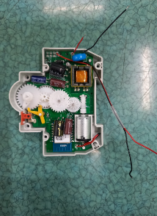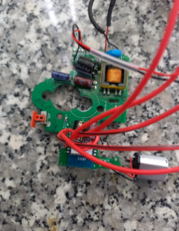Figure 7. Construction and simulation of control circuit signals for switchgear
Step 2. To measure all parameters in the power system, we need to install a UART PZEM-004T measurement circuit with ESP32. This circuit is highly versatile and allows us to measure the electrical signal and voltage. The measurement pins are integrated with the Aptopmat to measure the signal even when the power is turned off as Figure 8.
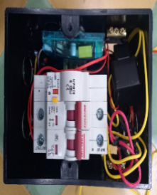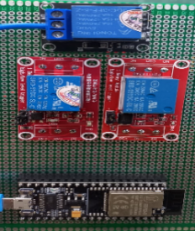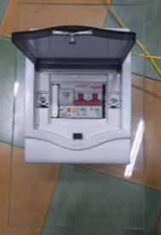
Figure 8. Installation of measuring equipment and switchgear
Step 3. Fabricate and install a smart switch using an existing mechanical switch, ESP32, and relay to control devices. Following the installation process, we will have a manual manipulator, which is depicted in Figure 9.
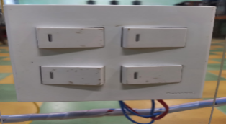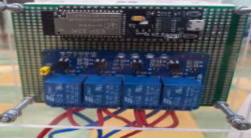
Figure 9. Renovate the mechanical switch.
2.4. Building a server for the system
2.4.1. Server and communication protocols
The system used to build the server involves Node-RED, a programming tool that enables the connection of hardware devices, Application Programming Interfaces (APIs), and online services. It is primarily designed for IoT (Internet of Things) applications, but can also be used to quickly link different service flows for other applications. The construction of the data transmission scheme is illustrated in Figure 10.
Figure 10. Diagram of data transmission and reception in the system.
The Node-RED tools and software, database, and communication protocol will be installed on the server or cloud server. We will use influxDB and Google sheet to store system data, and all communication within the system will be done using MQTT communication. For this reason, we will install the Mosquitto broker on the server. The server will have an IP address which will serve as the host address to identify the object sending the monitoring state (publish) to the server. The measurement stage will publish the parameters in the power system to the server and, at the same time, receive data from the server through data registration (subscribe).
3. RESEARCH RESULTS
After fabrication, the devices are connected to form a complete system as depicted in Figure 11.
Figure 11. Actual results of the whole system.
After running the test, it was determined that the system operates stably and meets the requirements outlined in Figure 12.
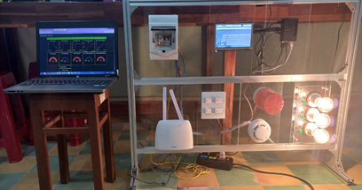
Figure 12. Run a system test
The system can automatically switch electrical circuits based on signals from image recognition and processing on a Raspberry Pi. It also allows for local switching, remote access through Aptomat, as well as control through computers and phones. Additionally, users can monitor important electrical parameters such as voltage, current, and power consumption, which can help them evaluate their ability to save electricity while using the product.
The graph interface displays the parameters and stores them on the Google Sheet, as shown in Figure 13 and Figure 14. This feature allows the user to monitor the switchgear status, the status of people being monitored, as well as the real-time values of voltage and current.
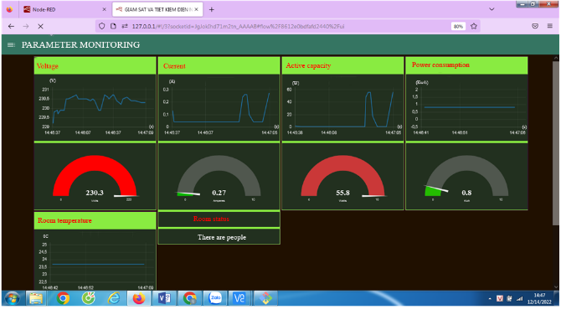
Figure 13. System monitoring interface
On the control interface, we can set threshold values ​​for alarms and protection against overcurrent, overvoltage, and increased room temperature. These setting values ​​will be based on the process of monitoring parameters at the monitoring interface to ensure system safety. The system has two levels of protection: warning and trouble. Suppose the warning level exceeds the set threshold. In that case, the system will send an email as shown in Figure 14 and the system parameters will be continuously stored on Google Sheets as shown in Figure 15, and display a notification on the phone application. phone as shown in Figure 16.
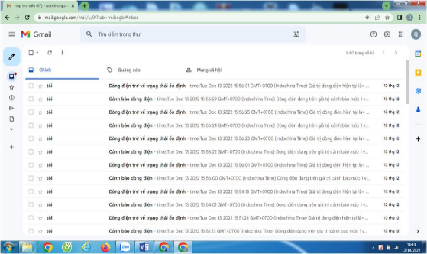
Figure 14. Warning results on Gmail
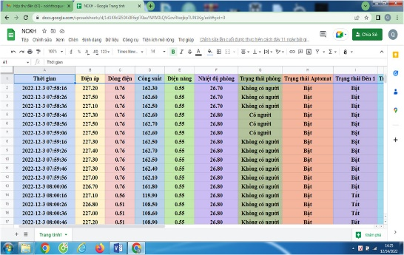
Figure 15. The results of the parameters are stored on Google Sheet
In addition to computer monitoring and control, the system also allows phone interface and function synchronization as shown in Figure 16.
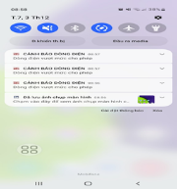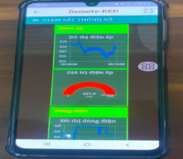
Figure 16. Phone alerts, monitoring, and controls.
4. CONCLUSION
After completing the research, the installation and testing of the system showed stable operation and met requirements. The devices used in the system are built on the frames and housings of devices currently on the market and used by consumers. Preliminary results show that the product has potential for practical applications and can replace existing devices. However, further testing and evaluation is required to ensure product reliability.
The integration of image monitoring units via esp32-Cam image transmission to Raspberry Pi for image processing enhances monitoring scope and device control flexibility.
Acknowledgments.
We would like to express our gratitude to Quy Nhon University for funding this research, through scientific research project No. T2023.802.12.
REFERENCES
1. A. S. Putra, H. L. H. S. Warnars. Intelligent traffic monitoring system (ITMS) for smart cities based on IoT monitoring. In: 2018 Indonesian Association for Pattern Recognition International Conference (INAPR). IEEE, 2018. p. 161-165.
2. O. Aljohani, A. Abu-Siada. Application of digital image processing to detect short-circuit turns in power transformers using frequency response analysis. IEEE Transactions on Industrial Informatics, 2016, 12(6), 2062-2073.
3. H. Shareef, A. Mohamed, A. A. Ibrahim. An image processing-based method for power quality event identification. International Journal of Electrical Power & Energy Systems, 2013, 46, 184-197.
4. M. Abdelsattar, A. Diab, I. Hamdan. A Review on Detection of Solar PV Panels Failures Using Image Processing Techniques. In: 2023 24th International Middle East Power System Conference (MEPCON). IEEE, 2023. p. 1-6.
5. H. V. Hao. Officers’ Electricity Saving in Open Offices: Exploring the Role of Perceived Behavior Control and Accessibility to Control. VNU Journal of Economics and Business 2023, 3(1), p.112-120.
6. Dr. P. Karrupusamy. A sensor based IoT monitoring system for electrical devices using Blynk framework. Journal of Electronics and Informatics, 2020, 2(3), 182-187.
7. J. V. Aldás, S. Silva, G. Palacios-Navarro. IoT-based alternating current electrical parameters monitoring system. Energies, 2022, 15(18), 6637.
8. G. Bedi, G. K. Venayagamoorthy, R. Singh. Navigating the challenges of the Internet of Things (IoT) for power and energy systems. In: 2016 Clemson University Power Systems Conference (PSC). IEEE, 2016. p. 1-5.
9. A. Al-Fuqaha, M. Guizani, M. Mohammadi, M. Aledhari. Internet of Things: A survey on enabling technologies, protocols, and applications. IEEE communications surveys & tutorials, 2015, 17(4), 2347-2376.
10. R. Khan, S. Khan, R. Zaheer, S. Khan. Future Internet: the Internet of Things architecture, possible applications, and key challenges. In: 2012 10th international conference on frontiers of information technology. IEEE, 2012. p. 257-260.
11. Z. Yang, Y. Peng, Y. Yue, X. Wang, Y. Yang, W. Liu. Study and application of the architecture and key technologies for IoT. In: 2011 international conference on multimedia technology. IEEE, 2011. p. 747-751.
12. Z. Zeng, Q. Gong, J. Zhang. CNN model design of gesture recognition based on the TensorFlow framework. In: 2019 IEEE 3rd Information Technology, Networking, Electronic and Automation Control Conference (ITNEC). IEEE, 2019. p. 1062-1067.
13. F. Ertam, G. Aydin. Data classification with deep learning using TensorFlow. In: 2017 international conference on computer science and engineering (UBMK). IEEE, 2017. p. 755-758.
14. M. Abadi, P. Barham, J. Chen, Z. Chen, A. Davis, J. Dean, M. Devin, S. Ghemawat, G. Irving, M. Isard, M. Kudlur, J. Levenberg, R. Monga, S. Moore, D. G. Murray, B. Steiner, P. Tucker, V. Vasudevan, P. Warden, M. Wicke, Y. Yu, X. Zheng. TensorFlow: a system for Large-Scale machine learning. 12th USENIX symposium on operating systems design and implementation (OSDI 16). 2016. p. 265-283.

Liên hệ: Lương Ngọc Toàn
Trường Đại học Quy Nhơn
170 An Dương Vương, TP. Quy Nhơn, tỉnh Bình Định, Việt Nam
Email: luongngoctoan@qnu.edu.vn
Điện thoại: 0935895479

