Nghiên cứu ứng dụng phần mềm SCADA Designer thiết kế chương trình quản lý nhu cầu sử dụng điện năng

Trần Tiến Đạt¹, Nguyễn Vũ Hoà¹, Ngô Minh Khoa^{2,}*

¹Lớp KTĐ K43A, Khoa Kỹ thuật và Công nghệ, Trường Đại học Quy Nhơn
²Khoa Kỹ thuật và Công nghệ, Trường Đại học Quy Nhơn

Ngày nhận bài: 01/04/2024; Ngày sửa bài: dd/mm/2024;
Ngày nhận đăng: dd/mm/yyyy; Ngày xuất bản: dd/mm/2024

TÓM TẮT
Quản lý nhu cầu sử dụng điện năng (DSM) là một trong những thách thức chính của lưới điện nói chung và lưới điện thông minh nói riêng. Nó sẽ góp phần hỗ trợ khách hàng và đơn vị sản xuất, kinh doanh sử dụng điện một cách hiệu quả, tiết kiệm thông qua các giải pháp phân bố lại nhu cầu phụ tải giờ cao điểm, thấp điểm và bình thường. Bài báo này nghiên cứu ứng dụng phần mềm SCADA Designer để thiết kế chương trình điều khiển và giám sát DSM cho một hệ thống điện trong phạm vi phòng thí nghiệm. Mô hình thực nghiệm bao gồm các thiết bị phần cứng như: Động cơ không đồng bộ ba pha rô to lồng sóc, động cơ servo, tải điện trở, đồng đồ đo lường và các thiết bị phụ trợ khác được kết nối giả lập cho mô hình phụ tải hỗn hợp của khách hàng sử dụng điện. Bài báo đã đưa ra lưu đồ thuật toán để thiết kế chương trình phần mềm bằng SCADA Designer. Ngoài ra, đồ thị phụ tải cũng được giả định bởi việc điều khiển động cơ servo nhằm thiết lập các kịch bản thí nghiệm kỹ thuật DSM. Các trường hợp thí nghiệm thực tế dựa trên hệ thống mô hình đã kiểm chứng được hiệu quả làm việc của kỹ thuật DSM trong bài báo này, đồng thời nó còn góp phần giảm công suất cực đại giờ cao điểm của hệ thống điện, loại bỏ các đỉnh phụ tải của hệ thống điện.
Từ khóa: Lưới điện thông minh, quản lý nhu cầu sử dụng điện, tiết kiệm năng lượng, SCADA Designer.
*Corresponding author.
Email: ngominhkhoa@qnu.edu.vn

A study of SCADA Designer application for developing demand side management program

Tran Tien Dat¹, Nguyen Vu Hoa¹, Ngo Minh Khoa^{2,}*

¹Class KTD K43A, Faculty of Engineering and Technology, Quy Nhon University
²Faculty of Engineering and Technology, Quy Nhon University

Received: 01/04/2024; Revised: dd/mm/2024;
Accepted: dd/mm/yyyy; Published: dd/mm/2024

ABSTRACT
Demand side management (DSM) is one of the main challenges of general power systems and smart grids. It plays a vital role in supporting customers and utilities to use electricity efficiently and economically through techniques that redistribute peak, off-peak and normal load demand. This paper has studied the application of SCADA Designer software to design a DSM controlling and monitoring program for an electrical system in our laboratory. The experimental system includes hardware devices such as a three-phase asynchronous motor with a squirrel cage rotor, a servo motor, a resistive load, a measurement meter and other auxiliary devices that are connected to simulate a mixed load of electricity customers. The paper has developed an algorithm flowchart for designing the software program using SCADA Designer. Additionally, the load profile is controlled by the servo motor to establish various DSM operation scenarios. These scenarios based on the experimental system have verified the working efficiency of the DSM technique in this paper, and it also contributes for reducing the peak load of the power system.
Keywords: Smart grid, demand side management, energy saving, SCADA Designer.

1. INTRODUCTION
The economic and environmental challenges posed by the use of fossil fuels have led to a restructuring of the conventional power system. As a result, future grids, known as smart grids, incorporate newer types of digital and high-tech devices that enable two-way communication between the supply and demand sides. These systems offer additional options, such as real-time monitoring, controlling and monitoring between supply and demand, which enhance efficiency, reduce energy consumption and improve system reliability, help the power system operate safely, flexibly and intelligently. These benefits are achieved through the application of various the demand side management (DSM) techniques.^{1,2}
DSM is a set of technical, technological, economic, social and control solutions to use electricity effectively and economically. DSM is a part of the overall Supply Side Management (SSM) and Demand Side Management (DSM) programs. In previous years, to satisfy the increasing energy demand, people were interested in investing in the exploitation and construction new power plants. Nowadays, due to the rapid development of electricity demand, the amount of capital invested in the electricity industry has become a burden for countries. In addition, the use of coal, oil, gas and other resources in power plants is increasing, leading to increasingly serious environmental pollution. This has resulted in the DSM being recognized as the cheapest and cleanest source of electricity supply process.^{3,4} The DSM helps us to mitigate the investment capital in building new power plants, save resources, and reduce environmental pollution. Not only that, but thanks to DSM consumers can be also be provided with cheap and higher quality electricity.
*Corresponding author.
Email: ngominhkhoa@qnu.edu.vn
In fact, the results of DSM implementation in countries around the world have concluded that the DSM can reduce more than 10% of energy demand at a cost of only 0.3 to 0.5 of the costs required to build power plants and networks to meet the corresponding amount of electricity. As a result, the DSM brings economic as well as environmental benefits to the country, power sectors and customers. The main objective of the DSM is to reshape the load graph and regulate the maximum and minimum daily demand profile to make the most efficient use of energy sources to relieve the need to build new power plants.⁵ This may result in the direction of energy using during normal hours. Virtually all DSM programs aim to maximize efficiency in order to avoid or slow down the construction of new power plants. In addition, other reasons for implementing the DSM programs are social relationships, environmental reasons and changing customers' electricity habits both during peak and normal hours to save energy.⁶
In order to manage, monitor, collect data and control the electrical system with the application of the DSM techniques, the Supervisory Control and Data Acquisition (SCADA) system is one of the optimal solutions to be applied. The SCADA system helps operators to monitor and control the power system effectively, thereby making accurate and timely control decisions. Besides, the SCADA also contributes to improving the reliability of the power system, optimizing energy use, reducing power loss and operating costs of the power system.^{7,8}
From the above issues, this paper focuses on researching the application of SCADA Designer software to design a DSM program within the laboratory range. The hardware structure is designed based on the laboratory equipment including a three-phase squirrel cage rotor asynchronous motor, a variable resistive load, a servo motor, a power meter, etc. In addition, the SCADA Designer software is applied to design a system monitoring control program based on the DSM technique. The guide user interface (GUI) is designed to make it easy for users to manipulate and monitor the operation of the system in real time.
2. DSM AND SCADA
2.1. DSM programs in Vietnam
The national program on electricity Demand Side Management (DSM) - brings great benefits, of which a basic benefit is that the cost to change, adjust to reduce or save 01 MW of power load capacity during peak hours will be cheaper than the cost to provide 01 MW of additional power capacity by building new power plants or mobilizing high-priced power sources and grid infrastructure systems.⁹
Over the past decade, in the global context, primary energy sources (coal, oil, gas) have been increasingly depleted, in contrast to the growing trend of energy consumption, electricity consumption and climate change. In order to ensure electricity supply security, energy security and sustainable development, in addition to paying attention to SUPPLY side development, it is also necessary to pay attention to the demand side. For that reason, Vietnam focuses on building research and promoting the DSM programs. Currently, the DSM programs in Vietnam have gone through many stages and have brought many practical results to the power system.¹⁰ Since the implementation of the DSM stages, the DSM program has mainly implemented programs to change customers' electricity use habits, including: programs that reduce electricity use, both during peak and normal hours, without specifically affecting the quality of service provided to customers. The DSM replaces old equipment with modern equipment to provide services at the same (or higher) level for electricity users (e.g., lighting, heating, cooling, etc.) that consume less electricity.^{11,12}
The electricity using reduction programs are implemented during peak hours in the power system of a power company or a specific area of the power transmission or distribution grid. These programs consist of time-of-use pricing, also known as Time of Use/TOU, and direct load control. The programs that adjust electricity rates, equipment cycles, or power outages in response to changes in energy costs or energy sources, these programs can provide flexibility in the shape of the load graph. This can be achieved through instant pricing and pro rata pricing of time spent on electricity. Furthermore, breakable load schedules, live load control, and other load management programs may be included, as long as they do interfere with peak load periods.¹³
The programs that change electricity rates, equipment cycles, or power outages in response to specific changes in energy costs or energy sources can achieve flexibility in the shape of the load graph. These include instant pricing and pro rata pricing of time spent on electricity. They may also include breakable load schedules, live load control, and other load management programs when these activities are not limited by peak load periods.¹⁴
Electricity load building programs are designed to increase the use of electrical equipment or shift electricity consumption from peak hours to normal hours in order to increase total electricity sales. These programs include increasing electricity use during normal and off-peak hours to help stabilize the system.
2.2. DSM techniques
The DSM programs bring many benefits including electricity customers, electricity suppliers, and society, but electricity customers will be the biggest ones. For electricity suppliers, the benefits are to increase investment efficiency, power supply reliability, power quality, optimize supply and demand balance, reduce investment pressure to upgrade new power sources and expand the grid, and reduce production and business costs.¹⁴ For customers, the benefits are reducing electricity costs, being served with a higher power quality, receiving certain supports (depending on each specific DSM program), increasing electricity efficiency, and improving production and business efficiency. For society, the advantage is to reduce the pressure of increasing electricity prices, which contribute to the development of a sustainable electricity and energy sector, socio-economic stability, and sustainable environmental development. In order to bring about the above benefits, the DSM program has applied the following techniques: peak load reduction, power load adjustment, off-peak load filling, strategic load growth, load chart shifting, and efficient and economical use of electricity.^{1,2,10} These techniques are shown visually in Figure 1.
Figure 1. DSM techniques.
Each DSM technique has different advantages and disadvantages. We use the corresponding techniques to bring the best efficiency to customers, depending on the characteristics of the load.^{6,15}
This research model is mainly focused on peak cutting and valley filling techniques as shown in Figure 2. To analyze the peak cutting method, the initial load factor, the average demand can be calculated using Equations (1) and (2) from the load time curve.
 | $$LF=\frac{P_{avg}}{P_{max}}$$ | (1)
 | $$P_{avg}=\frac{\sum_{i=1}^{n}{P_{i}}}{\sum_{t=1}^{24}{T_{i}}}$$ | (2)
 | $$C_{d}=LF*C_{e}*\sum{T}$$ | (3)
where $LF$ is the load factor value; $P_{avg}$ is the average capacity of the load; $P_{max}$ is the maximum capacity of the load; $n$ is the number of loads; $P_{i}$is the capacity of all types of loads $i=1,…,n$; $T_{i}$ is the time period for each type of load $t=1,...,24$; $C_{d}$ is the demand cost; $C_{e}$ is the energy cost.
Figure 2. Load curve illustrating DSM program.
2.3. SCADA
SCADA is the process of collecting real-time data from objects to process, perform, store, analyse and potentially manipulate those objects.³⁻⁵ A SCADA system can be divided into two parts: a hardware system for data collection, communication, control and operation, and a software system for data storage, construction, visualization, optimization, alarm management, etc. A SCADA system is shown in Figure 3 and has the following basic components:
- Remote Terminal Unit (RTU): the RTU is to perform processing and control tasks in real-time mode (There are two types of real-time systems: hard real-time systems and soft real-time systems). The RTUs range from primitive sensors that collect information from objects to multiprocessing machines that process information and control it in real-time. The use of a processor-enabled RTU reduces the requirement for the speed of the transmission channel in connection with the control center.
- Master Terminal Unit (MTU): the MTU is a dispatch center that performs data processing and control at a high level in real-time mode. One of the basic functions of MTU is to provide an interface between people and observers of the system. The MTU can take different forms, from a single computer with old devices to a mainframe system including servers and clients.
- Communication System (CS): the communication channel is required to transmit data from remote locations to the MTU and transmit the control signal to the RTU.
Figure 3. SCADA system model.³⁻⁵
At the first level of the SCADA system, there are sections with monitoring and control functions for each individual device. The most common in the power system are the protection relays. When the equipment is in trouble, these relays can completely calculate and act on predetermined parameters without communicating with the superior system. In addition to the control function, the elements of this level also have the function of collecting data and parameters from the devices to send to the servers at the station. In modern systems, these elements are collectively referred to as intelligent electronic devices (IDEs) that have different working principles and functions but have the same communication standards, allowing this IED to exchange information with other IEDs in the same station (peer to peer) and communicate with the server of the station. In principle, failure of an IED in maintenance will not affect other IEDs in the system.¹⁶
The second level of the SCADA system is the Substation Server, with the main function of collecting data from the IEDs managed by it, stored in the database, serving the needs of reading local data via HMIs (Human Machine Interfaces).
The third level is the Control Center of the whole system, which collects data from Substation Servers, performs calculation functions to assess the state of the system, forecast load demand, and performs important control functions such as redistributing power generation between factories and planning the operation of the whole system.
Due to the large scale of the power transmission system, the central control stations can also be divided into levels - central control center (Central Control Center or Central Dispatching Center) and area control stations (Area Control Center). Currently, people often use the SCADA/EMS system.¹⁷
3. EXPERIMENTAL SYSTEM
3.1. Hardware configuration
The experimental system within the laboratory range includes some basic equipment such as a power source, a power meter, a multifunctional relay and loads such as resistive loads and motor loads in addition to some other loads such as capacitive loads, inductive loads, bulb loads. The technical specifications of these devices are shown in Table 1. Here we assume the motor load is the critical load and continuous operation, and the resistive load is the less critical load and can be operated at any time. This model allows us to simulate the typical process of energy management through two techniques of bottom lifting and peak cutting, thereby helping us understand the process of managing electricity demand. The hardware equipment system and the wiring diagram between the hardware devices are shown in Figure 4 and Figure 5.
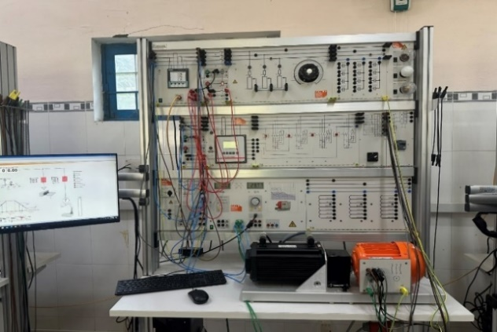
Figure 4. Hardware configuration.
The system consists of two loads: the static load is the resistive load and the dynamic load is the three-phase asynchronous motor of the squirrel cage rotor. In which, the critical load requires continuous operation and the resistive load is a secondary load and less important can be operated at any time. The system operates through the SCADA Viewer software. Here, we set the maximum total power value and the minimum total power when running in auto DSM mode, and then the system will run according to a pre-programmed cycle. When the maximum power value is set, the system will cut the resistive load out of the system, leading to a decrease in power and when the power is less than the minimum value when set, the system closes the static load into the cycle. The bottom part is the interface of a simple electricity demand management simulation program.
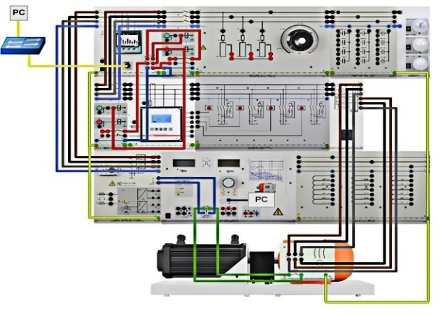
Figure 5. Wiring diagram of test system.
Table 1. The technical specifications.
No. | Device  name | Technical  specifications
1 | Three-phase power meter | Siemens  PAC4200
2 | Servo  power  tester | P_{nominal} = 1.4 kW;  U_{nominal} = 390 V;  I_{nominal} = 3.3 A;  n = 2000 rpm;  cosϕ = 0.75
3 | Three-phase asynchronous motor | P_{nominal} = 1 kW;  U_{nominal} = 390/690 V;  I_{nominal} = 2.1/1.2 A;  n = 2900 rpm;  cosϕ = 0.83
4 | Resistive load | P_{max} = 1 kW
3.2. Software program
The software program is designed based on the algorithm flowchart as shown in Figure 6. This flowchart consists of the following basic steps:
Step 1: Start
Step 2: Initialize the initial signal and set the parameters of the system. In this step, the program will take the input signals such as voltage, frequency, current, and power from the meters and also receive the initial set values such as the total maximum power $ΣP_{Max}$, the total minimum power $ΣP_{Min}$, the load profile and other set values from the SCADA control monitor.
Figure 6. Algorithm flowchart.
Step 3: Run the DSM technique. The step of running the DSM technique is that the program will check whether the DSM mode is active or not. If the DSM mode does not work, the program will return the wrong (NO) conditions, then the loads will operate normally according to the operating mode of each load and return the data to the SCADA control monitor. Conversely, when the DSM mode is activated, the program returns the true (YES) condition and continues to check the next condition.
Step 4: Check conditions in the DSM mode. In this step, the program will check the condition of the total load power ($ΣP$) with the minimum total load power $ΣP_{Min}$. If the total load power is less than the total minimum load power ($ΣP<ΣP_{Min}$) then the program will return the true (YES) condition and turn on the resistive load. In contrast, if the total load power is greater than the total minimum load power ($ΣP>ΣP_{Min}$), the program will return the wrong (NO) condition and continue to check the condition of the total load power with the total maximum load power $ΣP_{Max}$). Under this condition, if the total load power is greater than the total maximum power ($ΣP>ΣP_{Max}$), the program will return the true (YES) condition and turn off the resistive load. Conversely, if the total load power is less than the total maximum load power ($ΣP<ΣP_{Max}$), the program will return the wrong (NO) condition and send a signal to the SCADA monitor and controller, then continue to check the original condition. In this step, when turning off or turning on the resistive load, the regulator returns the data to the SCADA control monitor.
Step 5: Stop.
3.3. GUI design
The SCADA Designer software is applied to design the GUI of the SCADA program in this paper. The SCADA Designer is a software with a hardware key that is equipped in the laboratory to assist in the design of controlling and monitoring programs for electrical grids in the laboratory range.¹⁸ The GUI is shown as Figure 7. It consists of the main parts numbered on the Figure 7 and has the following basic function:
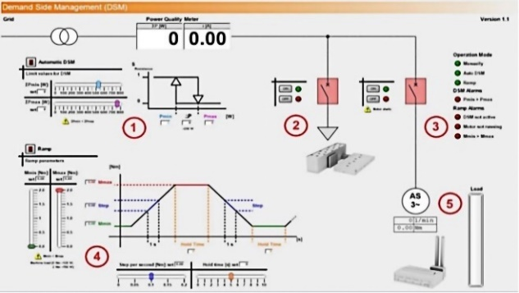
Figure 7. SCADA program GUI.
Block 1 is the load adjustment operation and the configuration of the limits. In this block, the user can mainly set the minimum and maximum load power $(ΣP_{Min}$ and $ΣP_{Max}$) for the DSM operating mode. With this model, we configure the $ΣP_{Max}$ value range to be 800W and minimum and maximum load power must strictly comply with the following conditions:
 | $${ΣP}_{Min}<ΣP_{Max}$$ | (4)
Our set values are visually represented on the register and on a descriptive chart. The graph clearly shows the limit values and also the power difference $∆P$.
Block 2 is the manual load control via the load switches. The load blocks are used to describe two typical loads of the model, motor load and resistive load. Motor load is considered a critical load of the system and has a predominant operating time. The impedance load is the secondary load, which is less important and is turned on at any time during the operation of the system. Here the resistive load can be replaced by other types of loads such as lamp loads, capacitive loads, etc. On the GUI, the load block is operated in two automatic and manual modes through emulator buttons on the interface.
Block 3 is to display the mode and the operating status. The status block visually represents the functions in operation.
Block 4 is the ramp gradient configuration for the motor load. The ramp block allows the motor load to operate according to the pre-setting curve with the established parameters. This includes settings such as the torque, holding time, and step. Thereby it is easy to observe the load demand controlling process.
Block 5 shows the load level of the dynamic load.
The data logger window in Figure 8 allows us to record the operation parameters of the loads in the form of a profile so that we can easily observe the operation in the different modes. From there, it is easy to assess the operating status of the system as well as the power management process.¹⁹
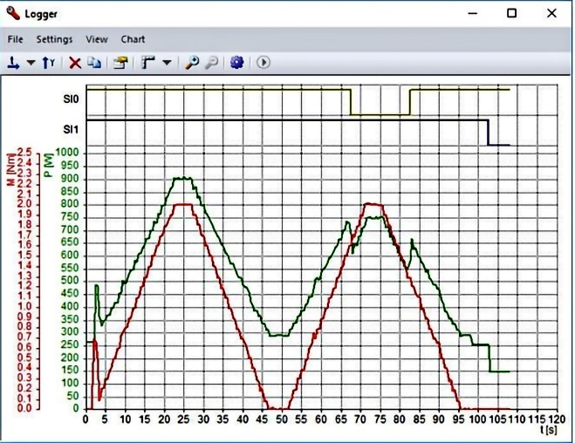
Figure 8. Data logger logging window.
4. RESULTS AND DISCUSSION
The experimental results from the test system are analysed and discussed in this section. From these results, it can be seen how the two techniques of peak cutting and bottom lifting work in the process of power demand management. When the system is operated in the auto mode or DSM mode, it is easy to see that when the total load power $∆P$) reaches the maximum load power $ΣP_{Max}$), the resistive load is turned off from the network and when the total load power $ΣP$) is reduced to the value lower than the minimum load power ${ΣP}_{Min}$), the resistive load is turn on. Thereby, in order to stabilize the supply capacity and help the loads operate most efficiently and optimally, thereby helping to save economically for both the supply side and the demand side. The two cases studied in this paper are as follows:
Case 1: Without DSM
In Case 1, the DSM technique is not activated, the experimental results are shown in Figure 9. The torque and total load power curves in Figure 9c illustrate the motor torque and the load power profile during three working cycles. From this figure, it can be observed that the total load power is operated according to a given curve, with a peak load power of approximately 900 W and a minimum load power of approximately 400 W. The difference between the peak and valley load power is significant. Consequently, in conjunction with the algorithm flowchart, it can be deduced that when the DSM mode is not activated, these loads operate independently with their respective modes, resulting in a large power difference. Simultaneously, when examining the switching state chart of the loads in Figures 9(a), (b) the SI0 and SI1 switch states remain at the constant value of 1 throughout the operation period.
Figure 9. Experimental results without DSM:
(a) SI0 contact state, (b) SI1 contact state, (c) Total load power and the torque of the motor.
Case 2: With DSM
In Case 2, the DSM mode is activated, the motor torque and total load power curves in Figure 10c, this figure shows that the difference between peak and valley load power is reduced in this case compared with the first case. This reduction is due to the application of the peak cutting and valley filling techniques in the DSM program. The program sets the total maximum load power to 760 W and the total minimum load power to 530 W, resulting in a difference of 230 W between these two values. The curve clearly demonstrates this technique, as the load power quickly decreases when the total load power reaches 760 W, and increases again when it falls below 530 W. This corresponds to Step 4 of the algorithm flowchart. In this step, the program checks the conditions of the DSM mode and, upon detecting a decrease in total load power to the minimum load power of 530 W, it will turn on the resistive load. This causes the power curve to increase again. When the graph reaches the maximum total load power value of 760 W, the system will turn off the resistive load, leading to a decrease in the curve. This process is repeated throughout the operation of the system, as shown in Figure 10c. Figures 10(a), (b) depict the switching state of the loads. When the DSM technique is applied, the SI0 contact continuously switches its status between 0 and 1, due to continuous switching of the resistive load during working cycles. The SI1 contact is always maintained at the level 1, because it represents a critical load. Therefore, the DSM technique allows for flexibly operations of the load and reduces the large difference between peak and valley load power, resulting in a flatter aggregate load graph.
Figure 10. Experimental results with DSM:
(a) SI0 contact state, (b) SI1 contact state, (c) Total load power and the torque of the motor.
5. Conclusion
This paper applied SCADA Designer software to design a program for demand side management (DSM) technique. The article studies the calculation of energy saving solutions for factories and enterprises to bring economic efficiency to companies and avoid unnecessary loss of electrical energy through the flexible adjustment of load using SCADA. In addition, the research results show that the application of the SCADA program for energy management is an inevitable trend. It helps the operation cycles to communicate with each other, thereby creating an energy ecosystem. Combining SCADA with typical energy management measures such as DSM not only benefits companies and businesses but also reduces capacity demand, saves electricity, and reduces CO2 emissions. This helps to mitigate the greenhouse effect. Furthermore, it makes it easy to manage special electricity consumption activities, which is very important for energy management for the national power system.

REFERENCES
- F. N. Budiman, M. A. M. Ramli, H. R. E. H. Bouchekara, A. H. Milyani. Optimal scheduling of a microgrid with power quality constraints based on demand side management under grid-connected and islanding operations, International Journal of Electrical Power & Energy Systems, 2024, 155, 109650.
- R. Elazab, A. T. Abdelnaby, A. A. Ali. Impacts of multiple demand-side management strategies on microgrids planning: a literature survey, Clean Energy, 2024, 8(1), 36-54.
- N. Ortiz, A. A. Cardenas, A. Wool. Scada world: An exploration of the diversity in power grid networks, Proceedings of the ACM on Measurement and Analysis of Computing Systems, 2024, 8(1), 1-32.
- R. Pandit, J. Wang. A comprehensive review on enhancing wind turbine applications with advanced SCADA data analytics and practical insights, IET Renewable Power Generation, 2024, 18(4), 722-742.
- V. L. Srinivas, J. Wu, B. Singh, S. Mishra. Hybrid state-estimation in combined heat and electric network using SCADA and AMI measurements, International Journal of Electrical Power & Energy Systems, 2024, 156, 109726.
- H. Sun, X. Cui, H. Latifi. Optimal management of microgrid energy by considering demand side management plan and maintenance cost with developed particle swarm algorithm, Electric Power Systems Research, 2024, 231, 110312.
- M. Wadinger, M. Kvasnica. Adaptable and Interpretable Framework for Anomaly Detection in SCADA-based industrial systems, Expert Systems With Applications, 2024, 246, 123200.
- M. Wolsink. Conceptualizations of smart grids–anomalous and contradictory expert paradigms in transitions of the electricity system, Energy Research & Social Science, 2024, 109, 103392.
- M. Yin, H. Cai, A. Gattiglio, F. Khayatian, R. S. Smith, P. Heer. Data-driven predictive control for demand side management: Theoretical and experimental results, Applied Energy, 2024, 353, 122101.
- N. M. Khoa, T. T. Dat, N. V. Hoa. An Application of Genetic Algorithm for Optimizing Demand Side Management Problem in Distribution Network Systems, Journal of Applied Science and Engineering, 2024, 27(10), 3283-3292.
- M. S. Bakare, A. Abdulkarim, M. Zeeshan, A. N. Shuaibu. A comprehensive overview on demand side energy management towards smart grids: challenges, solutions, and future direction, Energy Informatics, 2023, 6(4), 1-59.
- S. Althaher, P. Mancarella, J. Mutale. Automated demand response from home energy management system under dynamic pricing and power and comfort constraints. IEEE Trans Smart Grid, 2015, 6(4):1874-1883.
- D. Arcos-Aviles, J. Pascual, F. Guinjoan, L. Marroyo, P. Sanchis, M. P. Marietta. Low complexity energy management strategy for grid profle smoothing of a residential grid-connected microgrid using generation and demand forecasting. Appl Energy, 2017, 205, 69-84.
- A. Arteconi, N. J. Hewitt, F. Polonara. State of the art of thermal storage for demand-side management. Appl Energy, 2012, 93, 371-389.
- G. Strbac. Demand side management: Benefits and challenges, Energy Policy, 2008, 36(12), 4419-4426.
- J. Reeser, T. Jankowski, G. M. Kemper. Maintaining HMI and SCADA Systems Through Computer Virtualization, IEEE Transactions on Industry Applications, 2015, 51(3), 2558-2564.
- M. S. Thomas, P. Kumar, V. K. Chandna. Design, development, and commissioning of a supervisory control and data acquisition (SCADA) laboratory for research and training, IEEE Transactions on Power Systems, 2004, 19(3), 1582-1588.
- T. Asenov. Improvement of a laboratory micro/nanogrid SCADA system, 12th Electrical Engineering Faculty Conference (BulEF), 09-12 September 2020, Varna, Bulgaria.
- N. M. Khoa, L. V. Dai, N. A. Toan, D. D. Tung. A New Design of IoT-Based Network Architecture for Monitoring and Controlling Power Consumption in Distribution Grids, International Journal of Renewable Energy Research, 2021, 11(3), 1460-1468.

