Nghiên cứu khả năng hấp phụ và tách lọc carbon dioxide
của vật liệu MIL-53(Cr) bằng phương pháp mô phỏng cổ điển

Nguyễn Thị Xuân Huynh^{1,2,}*, Trần Thị Diễm Thanh^{1,2}, Nguyễn Lê Bảo Trân^{1,2}, Nguyễn Ngọc Khoa Trường¹

¹Khoa Khoa học Tự nhiên, Trường Đại học Quy Nhơn, 170 An Dương Vương, Quy Nhơn, Bình Định
²Phòng Hóa tính toán và Mô phỏng, Trường Đại học Quy Nhơn, 170 An Dương Vương, Quy Nhơn, Bình Định

*Tác giả liên hệ chính. Email: nguyenthixuanhuynh@qnu.edu.vn

TÓM TẮT
cm)
Các nguồn năng lượng dựa trên nhiên liệu hóa thạch ngày càng cạn kiệt và lượng khí thải độc hại, đặc biệt là carbon dioxide (CO₂), đang tăng rất nhanh và báo động đến môi trường và sức khỏe con người. Do đó, việc làm giảm hoặc chuyển đổi CO₂ thành các hợp chất có giá trị là hết sức cấp thiết. Trong những thập niên gần đây, việc ứng dụng các vật liệu có độ xốp cao như nhóm vật liệu khung kim loại hữu cơ (MOF) để hấp phụ CO₂ và tách lọc khí CO₂/H₂ đang rất thu hút. Trong các vật liệu MOF, MIL, đặc biệt là MIL-53 rất được chú ý với khả năng hấp phụ và tách lọc cao nhờ vào tính ổn định nhiệt, diện tích bề mặt riêng lớn và chứa các vị trí kim loại mở, v.v. Do vậy, công trình này muốn làm sáng tỏ khả năng hấp phụ và tách lọc CO₂ ở nhiệt độ phòng và áp suất thấp dưới 50 bar bằng phương pháp mô phỏng Monte Carlo chính tắc lớn. Kết quả chỉ ra MIL-53 có khả năng hấp phụ CO₂ cao kể cả khi có và không có mặt H₂ và độ tách lọc CO₂/H₂ cũng rất đáng chú ý. Lượng khí CO₂ (tinh khiết) hấp phụ trong MIL-53(Cr) đạt được là 9,18 mmol/g ở 298 K và 50 bar. Ở 298 K, độ tách lọc CO₂/H₂ cực đại của MIL-53(Cr) là $S_{CO_{2}/H_{2}(max)}=$ 116. Kết quả đáng chú ý đó là $S_{CO_{2}/H_{2}(max)}$ gần như không phụ thuộc vào tỉ lệ mol CO₂:H₂ mà chỉ làm thay đổi áp suất đạt được $S_{CO_{2}/H_{2}(max)}$ đó, nhưng lại phụ thuộc rất mạnh vào nhiệt độ, cụ thể $S_{CO_{2}/H_{2}(max)}$ = 245 khi giảm nhiệt độ đến 273 K.
Từ khóa: Hấp phụ CO₂, Bắt giữ CO₂, Tách lọc CO₂/H₂, Vật liệu MIL-53, Mô phỏng cổ điển.

A classical simulation study for carbon dioxide adsorption and separation capacity of MIL-53(Cr)

Nguyen Thi Xuan Huynh^{1,2,}*, Tran Thi Diem Thanh^{1,2}, Nguyen Le Bao Tran^{1,2}, and Nguyen Ngoc Khoa Truong¹

¹Faculty of Natural Sciences, Quy Nhon University, 170 An Duong Vuong, Quy Nhon, Binh Dinh
²Lab of Computational Chemistry and Modelling, Quy Nhon University, 170 An Duong Vuong, Quy Nhon, Binh Dinh

*Corresponding author. Email: nguyenthixuanhuynh@qnu.edu.vn

ABSTRACT
cm)
In addition to the escalating depletion of fossil fuel-based energy sources, toxic emissions, particularly carbon dioxide (CO₂), are rapidly increasing, leading to an alarming impact on the environment and human health. Therefore, reducing or converting CO₂ into high-value chemicals is necessary. In recent decades, CO₂ capture and CO₂/H₂ separation based on the adsorption of highly porous materials, especially metal-organic frameworks (MOFs), has become very attractive. Among MOFs, MIL, notably MIL-53, has been a top concern for its noteworthy adsorption and separation capacity due to its thermal stability, ultra-high specific surface, open metal sites, etc. Therefore, this work mainly uses grand canonical Monte Carlo simulations to study CO₂ adsorption and separation with and without H₂ at room temperatures and low pressures below 50 bar. The high CO₂ adsorption capacity with and without hydrogen and remarkable CO₂/H₂ selectivity of MIL-53(Cr) are explored. For pure CO₂, the absolute CO₂ uptake in MIL-53(Cr) is 9.18 mmol/g at 298 K and 50 bar. Besides, the maximum CO₂/H₂ selectivity of MIL-53(Cr) is $S_{CO_{2}/H_{2}(max)}=$ 116 at 298 K. Remarkably, this value of $S_{CO_{2}/H_{2}(max)}$ is almost independent on the CO₂/H₂ mole fraction, which only changes pressure corresponding to that $S_{CO_{2}/H_{2}(max)}$, but dramatically dependent on temperature, reaching $S_{CO_{2}/H_{2}(max)}=$ 245 when the temperature drops to 273 K.
Keywords: CO₂ adsorption, CO₂ capture, CO₂/H₂ selectivity, MIL-53 material, classical simulations.

1. INTRODUCTION
Fossil fuels are our primary energy source, and their consumption is increasingly uncontrollable. This problem has a significantly negative impact on the environment and human health due to the increasing amount of emissions such as CO₂, CO, NO_{x}, etc., and causes serious energy shortage issues. Furthermore, CO₂ capture, H₂ purification, and CO₂ separation over H₂ are significant in combustion plants and refineries.^{1–3} To overcome those problems, the demand for clean energy production, gas separation, and efficient storage has been growing dramatically. Tremendous advances have been achieved in both theory and experiments thanks to the outstanding properties of porous materials.^{4–6}
A new type of inorganic-organic hybrid porous materials, metal-organic frameworks (MOFs) with a periodic network, appears as a potential technology.^{6–9} Since the early 1990s, MOFs have gained increasing attention, leading to more MOFs have been successfully synthesized by experiments and proposed by simulation methods. Researchers have successfully synthesized about 100,000 MOFs through experiments and have predicted over 500,000 structures by simulations or theories, but only nearly 3,500 works related to MOFs have been published.^{10,11}
MILs (Material Institute of Lavoisiers), a class of MOFs, have gained recognition as promising adsorbents for H₂ purification and CO₂ capture thanks to unique properties such as extraordinary chemical and thermal properties, water stability, ultra-large specific surface areas, high porosity, coordinately unsaturated or open metal sites, etc.^{12–15} In 2002, the first MIL introduced by Ferey and co-workers was the MIL-53 with M = chromium(III) (Cr³⁺).^{16,17} MIL-53, obtained by the hydrothermal method, has many potential applications because of its good thermal stability and flexibility compared to other MOFs.^{18,19} Several works have displayed that MIL-53 (Cr or Al) materials have superior CO₂ capture^{20–22} and high selective adsorption for binary mixtures such as CO₂/H₂, CO₂/CH₄, and CO₂/N₂.^{19,23,24}
Due to the potential of MIL-53, in this work, we use the classical grand canonical Monte Carlo (GCMC) simulation (a suitable approach to simulate the equilibrium of the physisorption of small gases in porous at well-defined pressure and temperature) to study the capacities of CO₂ capture and CO₂/H₂ separation on MIL-53(Cr).
2. COMPUTATIONAL APPROACHES
GCMC simulations are carried out using the RASPA software²⁵ to calculate the gravimetric amount of gases (CO₂ and H₂) adsorbed in a solid porous material, MIL-53(Cr), at room temperature and pressures up to 50 bar. The simulation cycles are performed up to 3.0 $×$10⁵ Monte Carlo (MC) cycles followed by 1.5$×$10⁴ equilibration steps.
In order to obtain the simulation box, a unit cell of MIL-53 (including 20 hydrogen, 32 carbon, 20 oxygen, and 4 chromium) was optimized by using the density functional theory (DFT),²⁶ and then repeated the unit cell to 2, 2, and 4 times for $a$, $b$, and $c$ lengths (Å, Å, Å), leading to Å, Å, and Å, respectively (Figure 1).
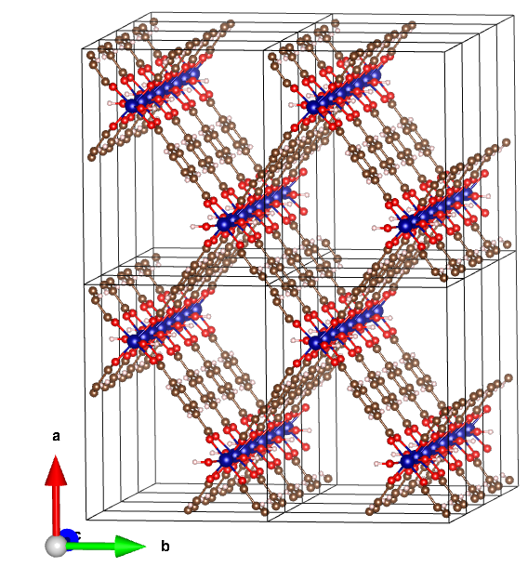
Figure 1. The simulation box of MIL-53(Cr). Each rectangular cubic represents a unit cell.
The interactions between gases (CO₂, H₂) and MIL-53(Cr) include (i) van der Waals (vdW) interactions using the Lennard-Jones (LJ) model and (ii) electrostatic interactions.
First, the LJ 12-6 repulsive and attractive interactions between pairs of atoms of gases and MIL-53 are described by
, (1)
Herein, ε_{ij} and σ_{ij} are pair LJ parameters, calculated using the pair combining rule of Lorentz and Berthelot,²⁵ in which σ_{i} and ε_{i} are taken from the force fields for MOFs with universal force field for metal (Cr) and DREIDING for other elements of MIL-53 (H, C, O),²⁷ listed in Table 1. The cut-off radius used for the vdW interaction is 16 Å, tested for reliability.
Second, electrostatic or Coulomb interactions between pairs of atoms are as follows:
, (2)
where k_{c} is the Coulomb constant and q_{i} is the partial point charge of atom i, calculated by the DFT-based density-derived electrostatic and chemical charges (Table 1 with the labeled atoms as in Figure 2).²⁸ Additionally, TraPPE force fields are used for CO₂ and H₂, listed in Table 1.
The adsorption separation or selectivity of CO₂ over H₂ in a mixture of H₂ and CO₂ is calculated via the formula¹³
, (3)
where are the amount of adsorbed CO₂ and H₂ (mol/g) in MIL-53 and are mole fraction of the CO₂ and H₂ component in the mixture, respectively. The investigated molar fractions of CO₂:H₂ includes 1:9, 2:8, 3:7, 4:6, 5:5, 6:4, 7:3, 8:2, 9:1.
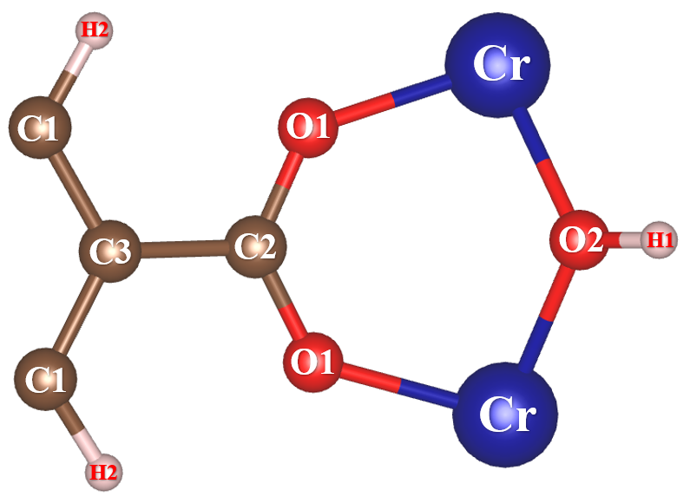
Figure 2. The labeled atoms of MIL-53(Cr), where hydrogen (H), carbon (C), oxygen (O), and chromium (Cr) atoms are displayed by soft pink, brown, red, and blue balls, successively.
Table 1. LJ parameters and partial atomic charges of MIL-53 and gases (H₂ and CO₂).
Atoms | ε/k_{B} (K) | σ (nm) | Atomic charges (e)
Cr | 7.548 | 0.269 | +1.581
H1 | 7.649 | 0.285 | +0.414
H2 | 7.649 | 0.285 | +0.100
C1 | 47.856 | 0.347 | -0.077
C2 | 47.856 | 0.347 | +0.636
C3 | 47.856 | 0.347 | -0.033
O1 | 48.158 | 0.303 | -0.589
O2 | 48.158 | 0.303 | -0.938
C [CO₂]²⁹ | 27.000 | 0.280 | +0.700
O [CO₂]²⁹ | 79.000 | 0.305 | -0.350
H_{COM} [H₂]³⁰ | 36.700 | 0.296 | -0.936
H [H₂]³⁰ | - | - | +0.468
3. RESULTS AND DISCUSSION
3.1. CO₂ adsorption of MIL-53(Cr)
Firstly, the absolute CO₂ adsorption capacity or uptake is computed and compared with available experimental data. The results (Figure 3) show that the CO₂ uptake increases rapidly in the pressure region below 5 bar, then increases slightly with increasing pressure. The absolute CO₂ uptake is 9.18 ± 0.02 mmol/g or ​​403.70 ± 0.88 mg/g at 50 bar (the maximum excess CO₂ uptake is 8.02 ± 0.02 mmol/g or 387.23 ± 0.93 mg/g at 30 bar). Our findings show that the absolute amount of CO₂ adsorption on MIL-53(Cr) is consistent with the available data of Bourrelly et al., about 10 mmol/g at 30 bar and 304 K.²⁰ Otherwise, the obtained CO₂ adsorption heat of MIL-53(Cr) is 30.04 kJ/mol, consistent with data of Bourrelly and co-workers (about 32 kJ/mol).²⁰ We also find that, at 298 K, the CO₂ adsorption isotherm obtained from molecular simulations also agrees well with the experimental results of the Schneemann group (Figure 3).³¹ These agreements between simulation and experimental measures indicate the reliability of the GCMC simulations.
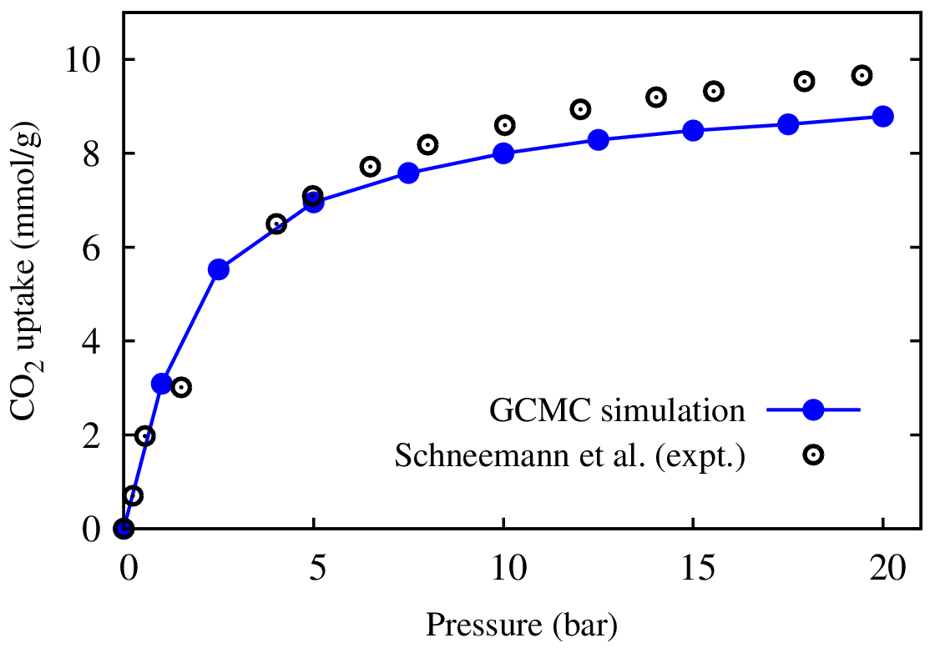
Figure 3. The comparison of the absolute CO₂ adsorption capacity on MIL-53(Cr) at 298 K between GCMC simulation and experimental (expt.) data.³¹
MIL-53(Cr) does not capture CO₂ as strongly as the most highly evaluated MOFs available today; however, these results are comparable to the MIL-88 series (4.0 – 12.1 mmol/g), highly evaluated for CO₂ uptakes¹⁴ with the isosteric heat of adsorption of the MIL-88 series (31.8 – 34.9 kJ/mol).
Next, we study the co-adsorption capacity of MIL-53 for H₂ and CO₂ in their mixture at many different mole fractions (CO₂:H₂ = 1:9, 2:8, 3:7, 4:6, 5:5, 6:4, 7:3, 8:2, 9:1) at 298 K and pressures $p ≤$ 50 bar. Our simulations also exhibit that the CO₂ adsorption is much higher than H₂ because of its high isosteric heat of adsorption (30.04 kJ/mol) compared to H₂ (12.87 kJ/mol) at 298 K and in the low-pressure range. Indeed, Figure 4 shows that MIL-53(Cr) adsorbs CO₂ (9.16 $→$ 6.26 mmol/g) superiorly than H₂ (0.02 $→$ 0.55 mmol/g) when the molar ratio of CO₂:H₂ changes from 1:9 to 9:1. Indeed, the CO₂ uptake insignificantly decreases when the molar ratio of H₂ increases, less than 70% in the mixture, i.e. decreasing from 9.18 mol/g (pure CO₂) to 8.37 mmol/g with 8.82% at CO₂:H₂ = 4:6. When the mole fraction of H₂ occupies a large portion of the mixture, the CO₂ uptake decreases significantly. More specifically, the CO₂ uptake in MIL-53(Cr) decreases by 12.64% (9.18 $→$ 8.02 mmol/g), 18.52% (9.18 $→$ 7.48 mmol/g), and 31.81% (9.18 $→$ 6.26 mmol/g) when the molar ratio of H₂ is 70% (CO₂:H₂ = 3:7), 80% (CO₂:H₂ = 2:8), and 90% (CO₂:H₂ = 1:9) compared with pure CO₂ uptake (Table 2). These data demonstrate that MIL-53(Cr) has good selective adsorption of separation for CO₂ over H₂ in the binary mixture of CO₂ and H₂.
Table 2. The absolute CO₂ and H₂ uptakes of MIL-53(Cr) with the different mole fractions of CO₂:H₂, compared to pure CO₂ uptake at room temperature.
CO₂:H₂ mole- fraction | CO₂ uptake  (50 bar) | Decrease in comparison to pure CO₂ (%) | H₂ uptake  (50 bar)
Pure CO₂ | 9.18 |  | -
Pure CO₂ | 10 (30 bar)²⁰ |  | -
9:1 | 9.16 | 0.22 | 0.02
8:2 | 9.08 | 1.09 | 0.04
7:3 | 8.95 | 2.51 | 0.06
6:4 | 8.80 | 4.14 | 0.09
5:5 | 8.61 | 6.21 | 0.12
4:6 | 8.37 | 8.82 | 0.16
3:7 | 8.02 | 12.64 | 0.22
2:8 | 7.48 | 18.52 | 0.32
1:9 | 6.26 | 31.81 | 0.55
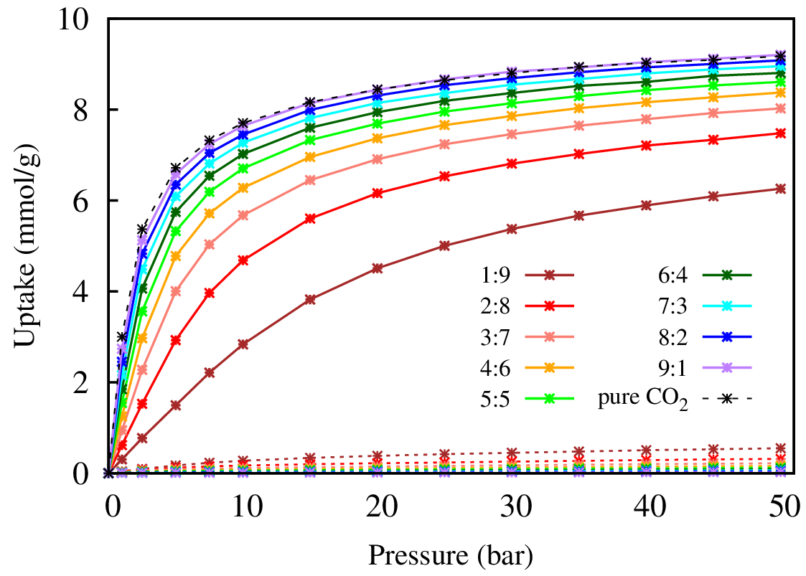
Figure 4. The CO₂ and H₂ co-adsorption isotherms of MIL-53(Cr) at 298 K with different CO₂:H₂ ratios from 1:9 to 9:1. Solid and dot lines refer to the adsorption amount of CO₂ and H₂ on MIL-53(Cr). The black dashed line represents pure CO₂ adsorption on MIL-53(Cr).
3.2. CO₂/H₂ separation of MIL-53(Cr)
From Figure 5b, it can be seen that, at 298 K, the highest selectivity achieved for each CO₂:H₂ mole-fraction greatly depends on pressure. Specifically, they sharply increase at low pressure, reach a peak with the maximum selectivity of CO₂/H₂, and then gradually decrease with pressure to 50 bar. As a result, the maximum CO₂/H₂ selectivity is different for mole ratios of the gas mixture, listed in Column 3 of Table 3 (298 K). When the CO₂ mole-fraction increases, the selectivity reaches its maximum at low pressure
(5 – 25 bar). More detail, the maximum selectivity $S_{{CO_{2}}/{H_{2}}(max)}=$ 107.87 at 25 bar for CO₂:H₂ = 1:9, …, and $S_{{CO_{2}}/{H_{2}}(max)}=$118.25 at 5 bar for CO₂:H₂ = 9:1 (Table 3). Nevertheless, the maximum selectivity does almost not change with the change of the mole ratio between CO₂ and H₂, $S_{CO_{2}/H_{2}}=$ 116 (pink line in Figure 6). This trend is similar to the case of MOF5 and Cu-BTC studied previously.^{32,33} Remarkably, our data also shows that the CO₂/H₂ selectivity, $S_{{CO_{2}}/{H_{2}}}$ of MIL-53(Cr) is higher to that of many previous MOFs such as microporous silica (3.5), activated carbon (45.0), zeolites Na-4A (70.7), Cu-BTC ($S_{{CO_{2}}/{H_{2}(max)}}≈$ 150 at 12.5 bar), MOF-5 ($S_{{CO_{2}}/{H_{2}}(max)}≈$ 36 at 50 bar)³² and IR-MOF-n with $n=9, 10,⋯,14$ ($S_{{CO_{2}}/{H_{2}}(max)}≤$ 100).³³
Furthermore, in this study, we also clarify the effect of temperature on the selectivity of CO₂/H₂ in MIL-53(Cr). Therefore, we performed further research at temperatures of 273 K, 323 K, and 348 K surrounding 298 K. The obtained results, visualized in Figure 5, indicate that the selectivity sharply increases as the temperature decreases. Besides, the pressure at which $S_{CO_{2}/H_{2}}$ is maximal decreases with the lowering temperature (Figure 5 and Table 3). For instance, with CO₂:H₂ = 5:5, the maximum selectivities are $S_{{CO_{2}}/{H_{2}}(max)}=$ 39.81 at 15 bar (348 K), 65.17 at 10 bar (323 K), 118.31 at 7.5 bar (298 K), and 246.43 at 2.5 bar (273 K). Figure 5 also shows that the peaks representing the maximum CO₂/H₂ selectivity also reduce as the temperature increases. The maximum CO₂/H₂ selectivity and the pressure corresponding to different mole ratios at four temperatures are listed in Table 3.
Surprisingly, the obtained maximum $S_{CO_{2}/H_{2}}$values are nearly constant when the CO₂ mole-fraction changes from 1/10 to 9/10 of the binary mixture. We determine the average maximum selectivities, $S_{CO_{2}/H_{2} }=$ 245, 116, 64, and 39 at 273 K, 298 K, 323 K, and 348 K, respectively (Figure 6). This work also shows that the CO₂/H₂ separation significantly increases with decreasing temperature. More importantly, for the maximum $S_{CO_{2}/H_{2}}$, when the temperature drops from 348 K to 273 K, the variation of CO₂/H₂ separation dramatically increases with $∆S_{CO_{2}/H_{2}}=$ 25 (348 K to 323 K), 53 (323 K to
298 K), 128 (298 K to 273 K). Therefore, in order to effectively increase the CO₂ selective adsorption in the mixture (CO₂ and H₂), the temperature can be reduced to achieve the desired separation at suitable pressures for the determined CO₂/H₂ mole-fraction.
Table 3. Maximum CO₂/H₂ selectivity versus mole ratios of CO₂/H₂ at 273 K, 298 K, 323 K, and 348 K.
CO₂:H₂ | 273 K | 298 K | 323 K | 348 K
1:9 | 233.97  (15 bar) | 107.87  (25 bar) | 57.73  (40 bar) | 35.27  (50 bar)
2:8 | 243.04  (7.5 bar) | 114.30  (15 bar) | 61.95  (30 bar) | 37.82  (30 bar)
3:7 | 244.17  (5 bar ) | 116.68  (10 bar) | 63.55  (20 bar) | 38.75  (20 bar)
4:6 | 246.44  (5 bar) | 117.30  (7.5 bar) | 64.33  (15 bar) | 39.54  (20 bar)
5:5 | 246.43  (2.5 bar) | 118.31  (7.5 bar) | 64.74  (10 bar) | 39.81  (15 bar)
6:4 | 248.46  (2.5 bar) | 118.34  (5 bar) | 65.17  (10 bar) | 39.95  (15 bar)
7:3 | 248.44  (2.5 bar) | 118.96  (5 bar) | 64.89  (7.5 bar) | 40.02  (10 bar)
8:2 | 247.38  (2.5 bar) | 116.78  (5 bar) | 65.23  (7.5 bar) | 40.04  (10 bar)
9:1 | 243.44  (2.5 bar) | 118.25  (5 bar) | 65.37  (5 bar) | 40.02  (7.5 bar)

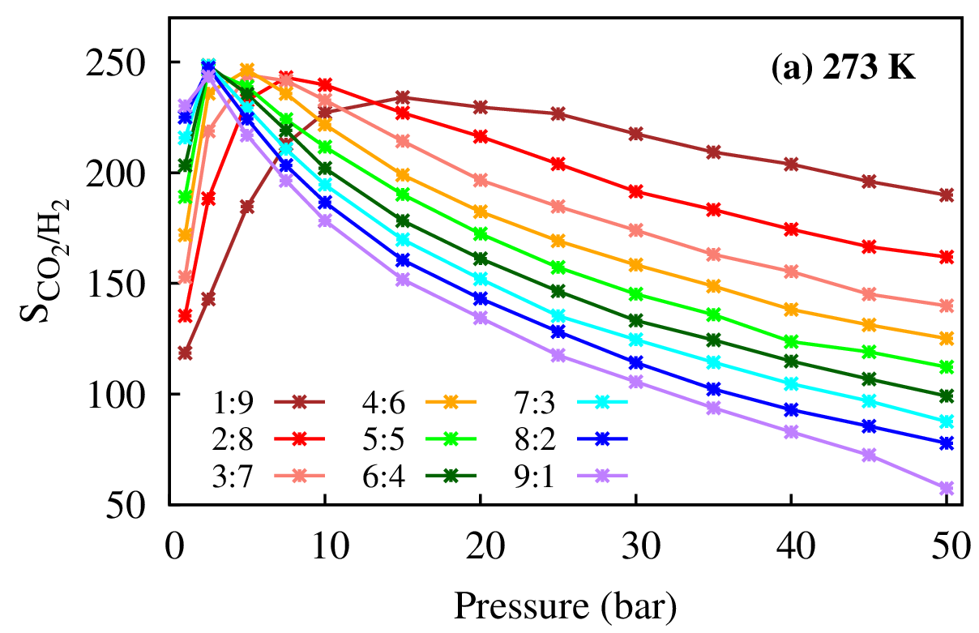 | 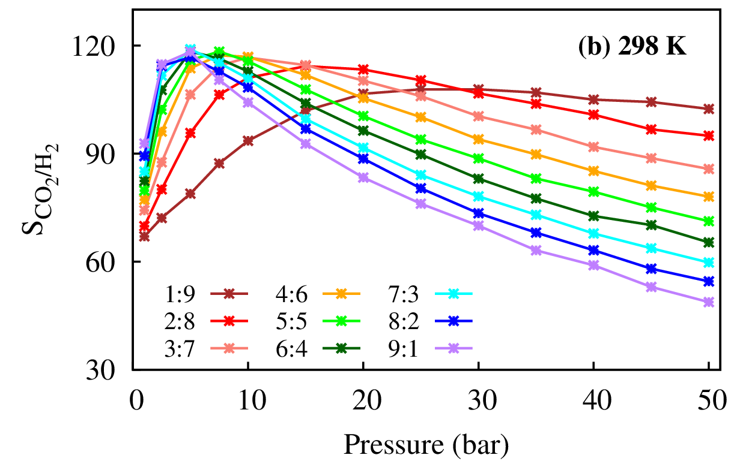
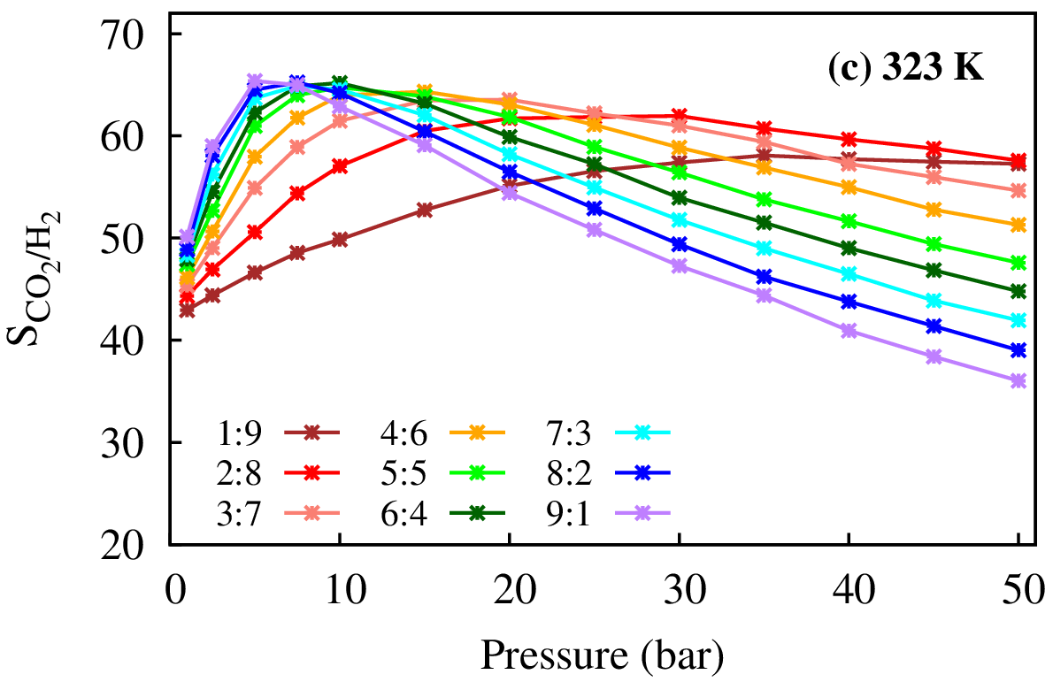 | 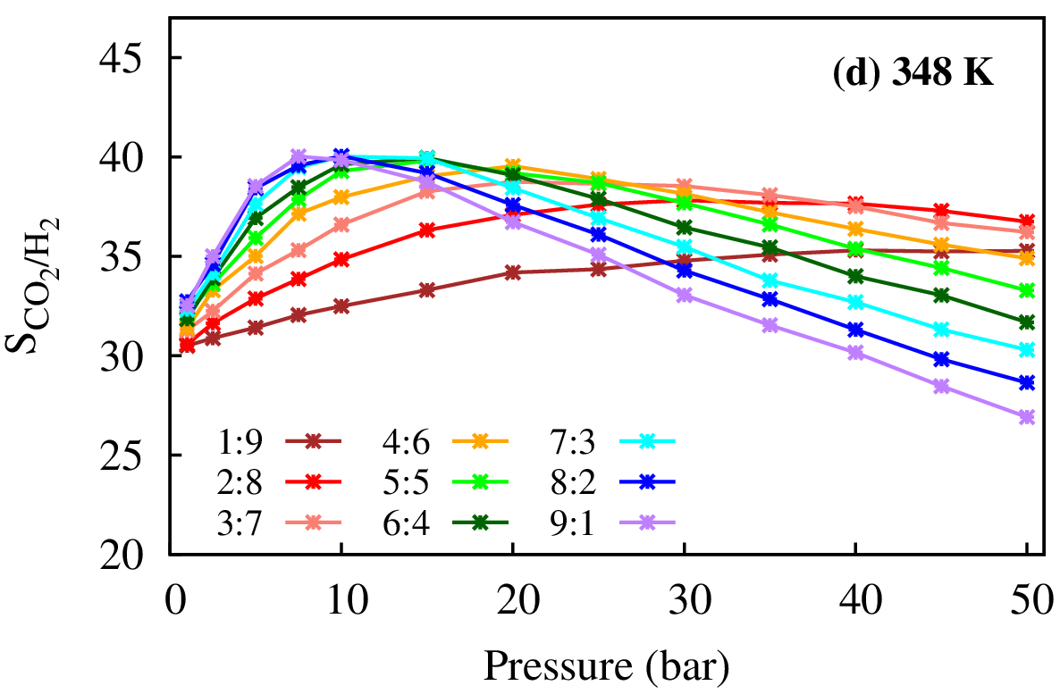
Figure 5. CO₂/H₂ selectivity of MIL-53(Cr) with different CO₂/H₂ mole fractions at temperatures: (a) 273 K, (b) 298 K, (c) 323 K, and (d) 348 K.

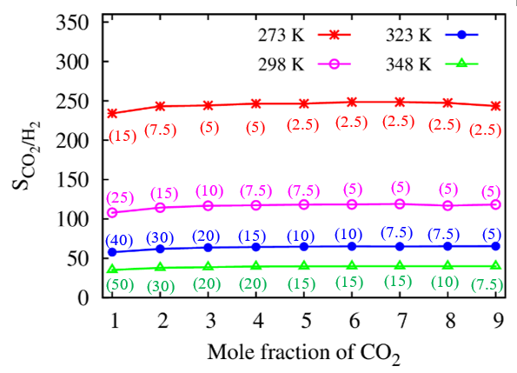
Figure 6. Dependence of maximum CO₂/H₂ selectivity on the mole ratios of CO₂ at 273 K, 298 K, 323 K, and 348 K. The values ​​in parentheses refer to the pressure at which the CO₂/H₂ selectivity is maximum.
4. CONCLUSIONS
This study obtained the important results as follows:
- The CO₂ uptakes in MIL-53(Cr) are high even with the H₂ absence and presence. The CO₂ capture capacity insignificantly decreases when the molar fraction of H₂ increases no more than 60%, i.e., decreasing from 9.18 mmol/g (pure CO₂) to 8.37 mmol/g (CO₂:H₂ = 4:6) with 8.82%.
- The high CO₂/H₂ selectivity is also elucidated at various molar fractions of CO₂:H₂ and at different temperatures (273 K, 298 K, 323 K, and 348 K). The results exhibit that when the CO₂ mole-fraction in the binary mixture increases, the maximum CO₂/H₂ selectivity remains nearly constant, but the pressure corresponding to this maximal selective adsorption remarkably decreases. Moreover, the temperature strongly affects the CO₂ over H₂ separation capacity (116 to 245 for maximum CO₂/H₂ selectivity with decreasing temperature 298 K to 273 K). This work evidences that reducing the temperature can increase the selective adsorption efficiency of CO₂/H₂. Additionally, adjusting the mole fraction between hydrogen and carbon dioxide can help achieve the CO₂/H₂ selectivity at low pressure.
Acknowledgments
This study is conducted within the framework of science and technology projects at the institutional level of Quy Nhon University under project code T2023.794.04. We also acknowledge support for the calculations from the Lab of Computational Chemistry and Modeling (LCCM), Quy Nhon University, Vietnam.
References
1. G. Avci, I. Erucar and S. Keskin. Do new mofs perform better for CO₂ capture and H₂ purification? Computational screening of the updated mof database, ACS Appl. Mater. Interfaces, 2020, 12, 41567–41579.
2. H. Demir, G. O. Aksu, H. C. Gulbalkan and S. Keskin. MOF membranes for CO₂ capture: Past, present and future, Carbon Capture Sci. Technol., 2022, 2, 100026.
3. B. Dziejarski, J. Serafin, K. Andersson and R. Krzyżyńska. CO₂ capture materials: A review of current trends and future challenges, Mater. Today Sustain., 2023, 24, 100483.
4. L. F. Chuah, A. Bokhari, S. Asif, J. J. Klemeš, D. J. Dailin, H. El Enshasy and A. H. M. Yusof. A review of performance and emission characteristic of engine diesel fuelled by biodiesel, Chem. Eng. Trans., 2022, 94, 1099–1104.
5. X. Tan, S. Wang and N. Han. Metal organic frameworks derived functional materials for energy and environment related sustainable applications, Chemosphere, 2023, 313, 137330.
6. Y. Cao, X. Li, G. Yu and B. Wang. Regulating defective sites for pharmaceuticals selective removal: Structure-dependent adsorption over continuously tunable pores, J. Hazard. Mater., 2023, 442, 130025.
7. G. Ferey. Hybrid porous solids: Past, present, future, Angew. Chemie Int. Ed., 2008, 37, 191–214.
8. H. Furukawa, K. E. Cordova, M. O. Keeffe and O. M. Yaghi. The chemistry and applications of metal-organic frameworks, Science, 2013, 341, 1230444.
9. I. Hussain, S. Iqbal, C. Lamiel, A. Alfantazi and K. Zhang. Recent advances in oriented metal–organic frameworks for supercapacitive energy storage, J. Mater. Chem. A, 2022, 10, 4475–4488.
10. S. M. Moosavi, A. Nandy, K. M. Jablonka, D. Ongari, J. P. Janet, P. G. Boyd, Y. Lee, B. Smit and H. J. Kulik. Understanding the diversity of the metal-organic framework ecosystem, Nat. Commun., 2020, 11, 1–10.
11. H. Daglar and S. Keskin. Recent advances, opportunities, and challenges in high-throughput computational screening of MOFs for gas separations, Coord. Chem. Rev., 2020, 422, 213470.
12. B. E. Keshta, H. Yu and L. Wang. MIL series-based MOFs as effective adsorbents for removing hazardous organic pollutants from water, Sep. Purif. Technol., 2023, 322, 124301.
13. D. N. Son, N. Thi, X. Huynh, N. Thoai and P. T. Kien. Highly selective separation of CO₂ and H₂ by MIL-88A metal organic framework, VNU J. Sci. Math. – Phys., 2021, 37, 9–21.
14. N. T. X. Huynh, O. K. Le, T. P. Dung, V. Chihaia and D. N. Son. Theoretical investigation of CO₂ capture in the MIL-88 series: Effects of organic linker modification, RSC Adv., 2023, 13, 15606–15615.
15. N. T. X. Huynh, V. Chihaia and D. N. Son. Hydrogen storage in MIL-88 series, J. Mater. Sci., 2019, 54, 3994–4010.
16. S. Tomar and V. K. Singh. Review on synthesis and application of MIL-53, Mater. Today Proc., 2021, 43, 3291–3296.
17. C. Serre, F. Millange, C. Thouvenot, M. Noguès, G. Marsolier, D. Louër and G. Férey. Very large breathing effect in the first nanoporous Chromium(III)-based solids: MIL-53 or Cr^{III}(OH)·{O₂C−C₆H₄−CO₂}·{HO₂C−C₆H₄−CO₂H}_{x}·H₂Oy, J. Am. Chem. Soc., 2002, 124, 13519–13526.
18. F. Millange and R. I. Walton. MIL-53 and its isoreticular analogues: A review of the chemistry and structure of a prototypical flexible metal-organic framework, Isr. J. Chem., 2018, 58, 1019–1035.
19. F. Millange, C. Serre and G. Férey. Synthesis, structure determination and properties of MIL-53as and MIL-53ht: the first Cr^{III} hybrid inorganic–organic microporous solids, Chem. Commun., 2002, 8, 822–823.
20. S. Bourrelly, P. L. Llewellyn, C. Serre, F. Millange, T. Loiseau and G. Férey. Different adsorption behaviors of methane and carbon dioxide in the isotypic nanoporous metal terephthalates MIL-53 and MIL-47, J. Am. Chem. Soc., 2005, 127, 13519–13521.
21. D. Panda, S. Patra, M. K. Awasthi and S. K. Singh. Lab cooked mof for CO₂ capture: A sustainable solution to waste management, J. Chem. Educ., 2020, 97, 1101–1108.
22. J. L. de Miranda, T. P. de Abreu, J. M. B. Neto, D. de Pontes Souza, I. Coelho, F. Stavale, S. de S. A. Oliveira and L. C. de Moura. A case study for an eco-design of aluminum terephthalate metal-organic framework- MIL-53(Al) for CO₂ and methane adsorption, Sustain. Mater. Technol., 2023, 37, e00689.
23. Y. Jiao, Z. Li, Y. Ma, G. Zhou, S. Wang and G. Lu. The studies on gas adsorption properties of MIL-53 series MOFs materials, AIP Adv., 2017, 7, 085009.
24. P. Rallapalli, K. P. Prasanth, D. Patil, R. S. Somani, R. V. Jasra and H. C. Bajaj. Sorption studies of CO₂, CH₄, N₂, CO, O₂ and Ar on nanoporous aluminum terephthalate [MIL-53(Al)], J. Porous Mater., 2011, 18, 205–210.
25. D. Dubbeldama, S. Calerob, D. E. Ellisc, R. Q. Snurr, D. Dubbeldam, S. Calero, D. E. Ellis and R. Q. Snurr. RASPA: molecular simulation software for adsorption and diffusion in flexible nanoporous materials, Mol. Simul., 2016, 42, 81–101.
26. J. P. Perdew, K. Burke and M. Ernzerhof. Generalized gradient approximation made simple, Phys. Rev. Lett., 1996, 77, 3865–3868.
27. A. K. Rappe, C. J. Casewit, K. S. Colwell, W. A. Goddard III and W. M. Skiff. UFF, a full periodic table force field for molecular mechanics and molecular dynamics simulations, J. Am. Chem. Soc., 1992, 114, 10024–10035.
28. N. Q. Vinh, N. T. M. Duyen, N. L. B. Tran, N. Van Nghia, L. T. T. V. Vien, H. T. M. Thanh and N. T. X. Huynh. Computational study on enhancing SO₂ capture capacity of M₂(BDC)₂TED (M = Mg, V, Co, or Ni), Quy Nhon Univ. J. Sci., 2024, 18, 91–100.
29. J. J. Potoff and J. I. Siepmann. Vapor-liquid equilibria of mixtures containing alkanes, carbon dioxide, and nitrogen, AIChE J., 2001, 47, 1676–1682.
30. D. Levesque, A. Gicquel, F. L. Darkrim and S. B. Kayiran. Monte Carlo simulations of hydrogen storage in carbon nanotubes, J. Phys. Condens. Matter, 2002, 14, 9285–9293.
31. A. Schneemann, V. Bon, I. Schwedler, I. Senkovska, S. Kaskel and R. A. Fischer. Flexible metal-organic frameworks, Chem. Soc. Rev., 2014, 43, 6062–6096.
32. Q. Yang and C. Zhong. Molecular simulation of carbon dioxide/methane/hydrogen mixture adsorption in metal-organic frameworks, J. Phys. Chem. B, 2006, 110, 17776–17783.
33. Y. Qingyuan, X. U. Qing, L. I. U. Bei and Z. Chongli. Molecular simulation of CO₂/H₂ mixture separation in metal-organic frameworks : Effect of catenation and electrostatic interactions, Chinese J. Chem. Eng., 2009, 17, 781–790.

Liên hệ: Nguyễn Thị Xuân Huynh
Trường Đại học Quy Nhơn
170 An Dương Vương, TP. Quy Nhơn, tỉnh Bình Định, Việt Nam
Email: nguyenthixuanhuynh@qnu.edu.vn
Điện thoại: 0989225650

