Nghiên cứu thu thập dữ liệu và giám sát chất lượng điện áp
sử dụng Ad-hoc LoRa và PLC Siemens
thông qua mạng truyền thông Modbus TCP/IP

Trần Xuân Khoa*, Huỳnh Đức Hoàn, Phan Gia Trí

Khoa Kỹ thuật và Công nghệ, Trường Đại học Quy Nhơn, Việt Nam
*Tác giả liên hệ chính. Email: tranxuankhoa@qnu.edu.vn

TÓM TẮT
Một trong những vấn đề nghiên cứu quan trọng trong lĩnh vực đo lường thông minh là đảm bảo truyền tải chính xác các số liệu đo lường từ các điểm thu thập dữ liệu đến các thiết bị giám sát. Đảm bảo độ ổn định và tính liên tục của quá trình truyền dẫn luôn là ưu tiên hàng đầu trong các ứng dụng này. Bài báo này nghiên cứu và xây dựng hệ thống giám sát thông số về điện áp của lưới điện của các điểm dân cư, các điểm có hệ thống điện riêng biệt, sử dụng phương thức truyền thông không dây Lora. Mục đích của bài viết này là kiểm tra tính khả thi của hệ thống trong môi trường đô thị khi sử dụng các thiết bị đơn giản, nhỏ gọn và dễ lắp đặt, vận hành và bảo dưỡng đơn giản. Điện áp của điểm cần giám sát được kiểm tra, các giá trị này được gửi từ các Node về trung tâm sử dụng kiến trúc mạng Ad-hoc LoRa network cho khả năng tự thiết lập và duy trì kết nối mạng với nhau mà không phụ thuộc vào cơ sở hạ tầng mạng cố định. Các Node trung gian có thể được thêm vào để đảm bảo tính ổn định và mở rộng cho mạng lưới với chi phí thấp. Dữ liệu sau khi thu thập được hiển thị trên giao diện Wincc Unified của Siemens. Việc sử dụng thiết bị giám sát là PLC cùng giao thức Modbus TCP/IP cho phép tối ưu hóa khả năng tương thích của hệ thống khi triển khai vào thực tế tại các cơ sở vốn luôn có sẵn thiết bị PLC. Hệ thống vận hành trên thực tế với độ chính xác cao, hệ thống hoạt động ổn định, đáp ứng được các yêu cầu về độ tin cậy và thời gian phản hồi của hệ thống giám sát và thu thập dữ liệu. Nghiên cứu này đã chứng minh rằng Ad-hoc LoRa có thể là giải pháp thay thế cho hệ thống truyền thông sử dụng mạng viễn thông hiện nay.

Từ khóa: Ad-hoc LoRa network, Modbus TCP/IP, Kalman filter, Wincc Unified, Smart Metering System

Research on Data Collection and Monitoring Voltage Quality Using Ad-hoc LoRa and Siemens PLC through Modbus TCP/IP Communication

Tran Xuan Khoa*, Huynh Duc Hoan, Phan Gia Tri

Faculty of Engineering and Technology, Quy Nhon University, Vietnam
* Corresponding author. Email: tranxuankhoa@qnu.edu.vn

ABSTRACT
Ensuring the accurate transmission of measurement data from data collection points to monitoring devices is a crucial research issue in the field of intelligent measurement. Stability and continuity of data transmission processes are of paramount importance in these applications. This paper investigates and develops a voltage monitoring system for the power grid at sites with separate electrical systems, utilizing LoRa wireless communication technology. The objective of this study is to assess the feasibility of the system in urban environments using devices that are characterized by being simple, compact, easy to install, operate, and maintain. The voltage at each points is measured, then transmitted from the Nodes to the Base using an Ad-hoc LoRa network architecture. This architecture enables self-establishment and maintenance of network connections without relying on fixed network infrastructure. Intermediate Nodes can be added to ensure stability and scalability of the network at a low cost. Collected data is displayed on WinCC Unified interface of Siemens. Using a PLC as a monitoring device with the Modbus TCP/IP allows for optimizing the system's compatibility when deployed in facilities that always have PLC equipment available. The system operates with high accuracy and stability, meeting the requirements of reliability and response time for the monitoring and data collection system. This study has demonstrated that Ad-hoc LoRa can be an alternative solution to the current telecommunication network communication system.
Từ khóa: Ad-hoc LoRa network, Modbus TCP/IP, Kalman filter, Wincc Unified, Smart Metering System

- INTRODUCTION
With the rapid development of our nation's economy, residential, commercial, and industrial loads increasingly demand higher standards for the development of the power grid and the quality of electricity supplied^{1,2}. Data collection, monitoring, and analyzing the parameters of the power grid are crucial in the management and operation of the grid. As the demand for electricity and the complexity of the grid continue to grow, data collection plays a vital role by providing essential and timely information for the analysis, management, and operation of the power grid. The use of advanced monitoring technologies such as smart sensors, automated systems, and artificial intelligence enables operators to gain a comprehensive and detailed view of the grid's performance. Data collected from these devices and systems can be analyzed to detect potential issues early, optimize operational processes, and make strategic decisions regarding the operation, maintenance, upgrading, and expansion of the system.
Nowadays, collecting data from points along transmission lines through hilly and sparsely populated areas using 4G cellular networks provided by telecom operators offers several advantages. This method allows direct data transmission to a central hub, ensuring high-security levels through the use of modems provided by the network operators. However, the requirement to equip 4G modems from the network provider implies initial investment costs and significant operational expenses (approximately 20-30 million VND per modem and an annual fee of around 1 million VND per Node). In certain cases, power transmission lines traverse complex terrain and encounter limited telecommunications infrastructure. Maintaining stable connectivity under such conditions poses significant challenges. Particularly, the need for continuous 24/24 operation pushes devices into a thermal overload state, resulting in frequent disconnections from the central hub. This not only impedes data collection but also affects the effectiveness of system monitoring and management within the electrical grid.
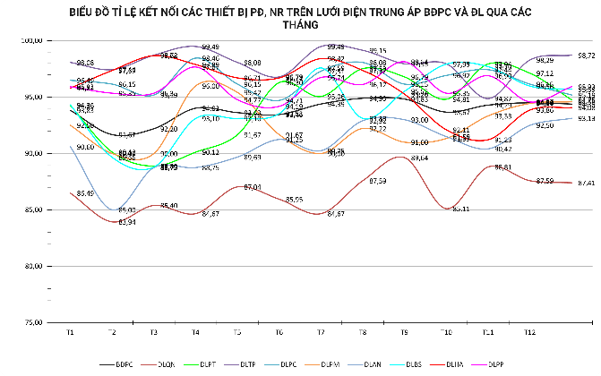
Figure 1. Connection rate of devices on the medium voltage grid of BĐPC and DL through the months of 2023
Here are statistics from Binh Dinh Provincial Power Company regarding the connectivity loss rates of communication devices within the province’s power grid in 2023. The chart illustrates the highest connectivity rate at approximately 98%, with most devices maintaining connection levels fluctuating around 95% of total operating time. However, certain segments experience lower connectivity, reaching only 79.4%. Ensuring reliable data collection necessitates maintaining consistent connectivity.
On the other hand, wireless networks such as ZigBee, Wireless Fidelity (Wi-Fi), Narrowband Internet of Things (NB-IoT), SigFox, and Long Range (LoRa) are increasingly developing and have the potential to provide multiple options for wireless communication systems³. Among these, low-energy consumption networks with long communication ranges, such as LoRa, help overcome coverage and internet access issues in remote areas where networks like Wi-Fi cannot reach⁴. Wireless technology opens the door for the more efficient and flexible deployment of monitoring systems, particularly in areas with challenging geographical conditions and limited telecommunications infrastructure. This not only presents opportunities for expanding the range and accuracy of monitoring systems but also helps optimize the cost and reliability of the system.
In this paper, an Ad-hoc LoRa network is employed to develop a network of devices for collecting and transmitting voltage data to a central hub, with a focus on optimizing data transmission and ensuring connection continuity. A complete system has been constructed and deployed in Quy Nhon City to assess the project's feasibility.
- RELATED WORKS
Traditional power grids are continually evolving in the era of smart grids. This evolution necessitates the implementation of precise monitoring strategies to assess system conditions. Eduardo Viciana and colleagues have proposed a multifunctional device model capable of measuring and calculating data related to energy and power quality features in three-phase electrical networks. Designed to perform advanced calculations involving voltage, current, frequency, power, and energy, this device addresses the growing demand for accurate monitoring in our interconnected power systems⁵.
Roach and colleagues deployed smart meters in 129 commercial buildings to investigate the impact of load profiles on building characteristics⁶. Additionally, Czétány and colleagues evaluated the database obtained from using smart meters to determine electricity consumption profiles based on time series data and annual load patterns⁷. Sánchez-Sutil and colleagues developed a device for monitoring and controlling the functions of a power quality analyzer using a LoRa LPWAN (Low Power Wide Area Network) ⁸.
Low Power Wide Area Networks (LPWANs) represent a promising solution for long-range, low-power communication in Internet of Things (IoT) and Machine-to-Machine (M2M) applications. These networks are resource-constrained and have critical requirements, including long battery life, extended coverage, high scalability, and cost-effective device deployment. LPWANs enable devices to operate for 5-10 years using battery power as their energy source ⁹. The advent of these technologies has led to the emergence of new services supporting data collection across diverse organizations in industries, academia, and government. Deployments of such solutions have already begun, utilizing sensor devices to gather various types of data¹⁰.
Rodrigues-Junior and colleagues utilized smart metering systems to monitor power quality, thereby detecting disturbances in smart grids¹¹. Preti Kumari and her colleagues have proposed an intelligent measurement system that saves energy by utilizing Edge computing and Long Range (LoRa) technology¹².
Due to the Low-Power Wide-Area (LPWA) networks not adhering to the TCP/IP protocol and utilizing their own proprietary protocols, LPWA-equipped sensors face challenges in direct Internet connectivity, Jumpei Sakamoto and colleagues have established a TCP/IP network via LoRa and are exploring ways to enhance TCP communication performance using the Private LoRa interface ^{13,14}.
This study proposes a solution for data collection and voltage quality monitoring. The system employs voltage sensors connected to an Arduino to read voltage values at the observed nodes. Then, the collected data is transmitted to a central via an Ad-hoc LoRa network. At the central node (Base), the TCP/IP protocol facilitates communication between the Ad-hoc LoRa network and existing industrial devices, such as Programmable Logic Controllers (PLCs).
The monitoring interface is built on WinCC Unified, enhancing integration with established systems.
- Ad-hoc LoRa NETWORK FOR ENNERGY GRID
Figure 2. Overall structural block diagram of the system
LoRa (Long Range) is a wireless communication technology that enables long-distance data transmission with minimal energy consumption. The Ad-hoc LoRa network for power grids offers a flexible and cost-effective solution for monitoring and controlling electrical systems. This network allows easy deployment without the need for fixed communication infrastructure, reducing costs and deployment time. LoRa devices can connect thousands of network nodes simultaneously, efficiently collecting data from various points within the power system¹⁵.
By utilizing LoRa networks, grid operators can remotely monitor and manage devices in the power grid. This includes measuring energy consumption, detecting faults, and optimizing grid operations. These capabilities enhance the reliability and efficiency of the electrical system while minimizing downtime and maintenance costs
  - SENSOR LAYER
The data collection layer comprises sensor nodes and measurement devices, serving the primary purpose of gathering and processing physical data. The collected data may include current intensity, voltage, as well as parameters from smart electricity meters, or variables such as temperature and humidity inside electrical cabinets.
In this study, the voltage sensor was employed to collect voltage data from various locations within the power grid. The three-phase voltage data obtained from these sensors undergo noise filtering and are subsequently forwarded to the next processing layer.
  - COMMUNICATION NETWORK LAYER
The main components of the network include sensors at data collection points, data concentrators, and the data management system. Remote data collection and monitoring of energy consumption are crucial for both end-users and operators (electric utility companies or providers).
In the system, sensor devices (Nodes) transmit collected data to a central hub (referred to as Base) through an Ad-hoc LoRa network. The wireless Ad-hoc LoRa network consists of self-forming nodes that operate independently of existing infrastructure. These nodes manage the network and control tasks using distributed algorithms and multipoint routing, where packets are relayed by intermediate nodes, enhancing network efficiency¹⁶.
The key advantages of AD-HOC LoRa networks include adaptability to specific needs and the ability to form a network with any available nodes. They also offer cost-effective investment, operational efficiency, rapid deployment, simplified reconfiguration due to their distributed architecture, and integrated redundancy features. This flexibility allows for the establishment of a network between nodes without the need for complex infrastructure structures¹⁷. The data transmission process can be carried out in the following ways:
- Direct transmission from the sending point to the destination: When two points are within the connection range, data will be transmitted directly to the destination.
- Transmission via intermediate nodes: If the destination and sending point are beyond the connection range, intermediate Nodes which located between the sending point and the destination will be used to establish a network. In this configuration, data will be forwarded from point to another until it reaches the requested destination in the packet. This setup allows for expanding the data transmission range and overcoming physical barriers
  - APPLICATION LAYER
Through LoRa, Nodes transmit data to the Base, including the following information:
- Node Address: Each node device in the system is assigned a unique address for identification and differentiation. The greater the distance from the Node to the Base, the higher the address number (this address is determined during device configuration).
- Data: Nodes collect information as required. in this project, voltage data is collected. After noise filtering, the data is transmitted to the Base for analysis and monitoring of the operational status of the measurement points.
- Received Signal Strength Indicator (RSSI): The LoRa signal strength is a crucial parameter for assessing the quality of the connection between the node and the Base. It affects the communication range and the system’s stability.
- Signal-to-Noise Ratio (SNR): This is the ratio of the received signal power to the noise floor level.
- Timing: The interval between two packets from the Nodes. This parameter is used to evaluate the continuity of the connection between the Nodes.
All data transmitted to the Bases will be sent to the SCADA system via the Modbus TCP/IP protocol. The monitoring and operation system of the power sector can easily integrate this data to understand and control the system’s performance.
- METHODOLOGY AND DESIGN
In this project, the authors implement an Ad-hoc LoRa network based on LoRa technology to transmit data to the control center, with the primary application being the monitoring of power quality at designated locations. Several parameters, such as voltage stability and phase loss, are collected to preliminarily assess the power quality at the connection points. A practical system has been constructed using voltage sensors, Arduino, LoRa modules, and PLC to evaluate operational capability. In this system, the voltage sensor collects voltage data, transmits it to the Arduino for initial processing, and then sends it to the control center via LoRa signals. At the monitoring center, the WinCC Unified interface on the PLC displays the parameters received from the Arduino through Modbus TCP/IP communication.
  - DATA INPUT COLLECTION.
With the varying requirements of the data acquisition system, different types of sensors can be utilized to collect data. One of the critical functions of the system is the collection and processing of voltage data. The authors employ the AC Voltage Sensor ZMPT101B to measure alternating current (AC) voltage. This sensor is directly connected to an Arduino. After the sensor collects the voltage data, it is converted to a direct current (DC) voltage of 0-5V and then measured by the Arduino for processing.
To ensure data quality and eliminate unwanted noise, the authors apply the Kalman filter algorithm. This filter can estimate the true value of the signal from measurements affected by noise. This process is a crucial step to ensure that the collected voltage data is reliable and can be effectively used in management and control.
Comparisons were made using sensors from two nodes simultaneously, where one node transmitted raw, unprocessed data to the control center, and the other node used the Kalman filter to process the signal and remove noise, thereby selecting appropriate coefficients for the filter.
- Node 200 collected raw data without using the Kalman filter:
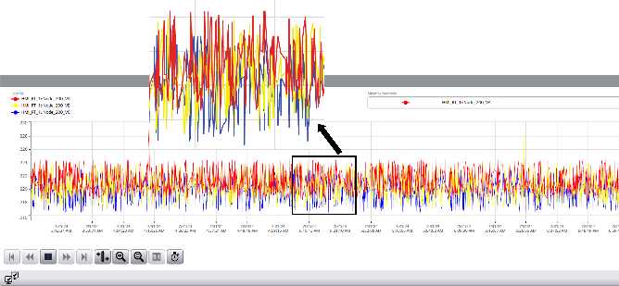
Figure 3. 3 phases voltage data collected from Node200
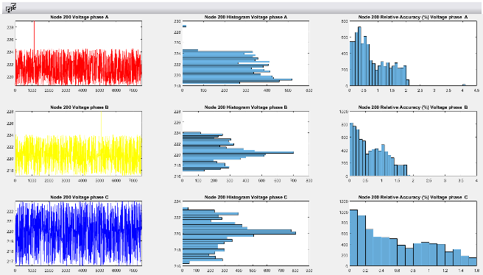
Figure 4. Voltage analysis in Node 200
Several criteria were used to evaluate the reliability of the measurement results over 252 minutes:
Table 1. Amplitude of VAC oscillation in Node 200
 | Phase A | Phase B | Phase C
Min | 218.5 | 217 | 216.5
Max | 229 | 228 | 222.99
Table 2. % Amplitude of oscillation and standard deviation in Node 200
 | Phase A | Phase B | Phase C
% Min | 1.27 | 1.56 | 1.56
% Max | 3.47 | 3.43 | 1.40
Standard Deviation | 1.78 | 1.78 | 1.63
The raw data collected from the sensors exhibited significant amplitude fluctuations, ranging from 1.27% to 3.47% compared to the average value. The maximum standard deviation reached 1.78, indicating a considerable dispersion of the measured values from the average. The relative accuracy of the raw data ranged from 0% to 4.5%. These statistical parameters and relative accuracy indicate that the unprocessed raw data is significantly affected by measurement noise and errors, failing to meet the necessary reliability and accuracy requirements for related applications. Therefore, appropriate signal processing and filtering measures must be implemented to improve data quality before use.
- Node 201 collects data and processes noise using the Kalman filter
Several criteria were used to evaluate the reliability of the measurement results over 252 minutes:
Table 3. Amplitude of VAC oscillation in Node 201
 | Phase A | Phase B | Phase C
Min | 218.55 | 217.01 | 216.50
Max | 224.49 | 223.95 | 222.98
Table 4. % Amplitude of oscillation and standard deviation in Node 201
 | Phase A | Phase B | Phase C
% Min | 0.74 | 1.48 | 1.64
% Max | 1.96 | 1.67 | 1.30
Standard Deviation | 0.48 | 0.83 | 0.96
Based on the provided measurement parameters, an assessment of the accuracy and reliability of the data after applying the Kalman filter can be performed.
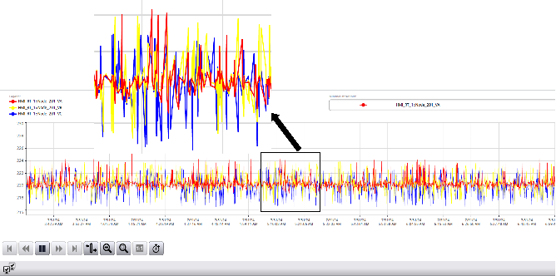
Figure 5. 3 phases voltage data collected from Node200
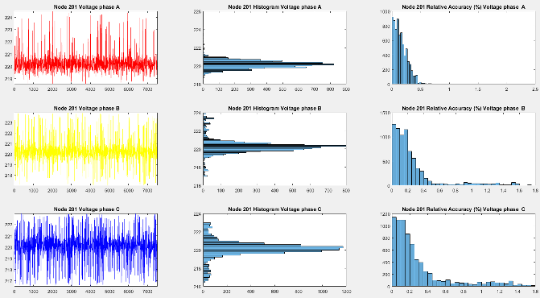
Figure 6. Voltage analysis in Node 201
The amplitude fluctuations of the data after applying the Kalman filter ranged only from 0.74% to 1.96% compared to the average value, indicating significant stability and noise reduction. The maximum standard deviation was 0.96, showing a relatively concentrated dispersion of the measured values from the average. The relative accuracy of the filtered data ranged from 0.5% to 1.8%, demonstrating the high suitability and reliability of the measurement results after processing. This ensures that the obtained data can be used with reliable accuracy.
The statistical parameters and relative accuracy indicate that the data after applying the Kalman filter has small amplitude fluctuations, low standard deviation, and high relative accuracy, meeting the necessary reliability and accuracy requirements.
  - Ad-hoc LoRa NETWORK
a. Node
Figure 7. Node general algorithm flowchart
Each node performs functions:
- Collect and process input data.
- Prepare data packets including:
- Packet ID
- Data to be transmitted
- Transmit signals to the Base. To ensure data integrity, each packet is sent three times.
- After each cycle, if the Node does not receive a response from the Base, it will send a request for the Base to resend the previous packet.
- Receive and process incoming packets:
- If the packet is not intended for the node itself, it will forward the packet to the address mentioned in the packet.
- If the packet is intended for the node, it will check the transmission results:
  - If the packet was successfully transmitted, it will delete the packet with that ID.
  - If the packet requests the retransmission of data for a specific ID, it will resend the corresponding data packet.
- Data collection node: uses Arduino as the MCU to collect and process data from sensors, which is then transmitted via the LoRa Module using a 12db antenna.
- Another configuration that can be deployed to extend the data transmission range is the use of an intermediate Node. This node consists only of an Arduino and LoRa, with the task of forwarding packets to the destination address specified in the packet.
- In this study, the nodes use batteries through a voltage converter to power all their activities. This increases the flexibility of the experiments.
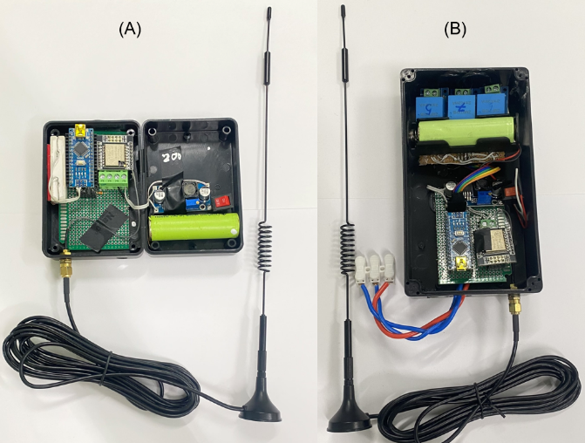
Figure 8. Intermediate node (A) Data collection node (B)
b. Base
The Base performs functions:
- Receive signals from the Nodes. Check the continuity of the IDs, and if any ID is missing, send a request to the Node to resend that ID.
- Prepare packets for the Nodes, including the following information:
- Destination of the packet
- Transmission result of the previous packet
- Resend request with ID (if any)
- Send data to the SCADA software, including the Node address and data.
- The Base uses an Arduino connected to a PLC S7 1200 via the TCP/IP protocol. Data from the Nodes, once received by the Arduino, is transmitted through the PLC to be displayed on the WinCC Unified interface.
Figure 9. Base general algorithm flowchart
  - MONITORING INTERFACE
In monitoring and data acquisition systems, the user interface (UI) serves as a critical component that facilitates user interaction, observation, and manipulation of the displayed data. This interface provides a direct means for users to engage with the system, enabling them to monitor key parameters and important data, as well as perform essential tasks such as adjusting parameters, acknowledging alarms, scheduling, and analyzing historical data.
In this study, a Programmable Logic Controller (PLC) was utilized as the communication device between the LoRa network and the monitoring interface to meet the requirements for reliability and compatibility with existing systems. Specifically, a PLC S71200 was employed to connect to the LoRa Base via Modbus TCP/IP communication. The collected data was then transmitted from the Base to the PLC, which subsequently displayed the information on the user interface. To ensure high reliability and compatibility, the WinCC Unified tool was utilized, offering diverse connectivity and seamless integration with PLC systems and other devices. This approach helped optimize the monitoring and control processes of the industrial system.
The user interface will display data including:
- The three-phase voltage at Nodes 200 and 201.
- Received Signal Strength Indicator (RSSI) from the Nodes over time.
- Signal-to-Noise Ratio (SNR), which is the ratio of the received signal power to the noise floor level.
- The interval between two packets from the Nodes to the Base (Timing).
- All data can be exported to an Excel file using the WinCC Unified tool at 2-second intervals throughout the survey period. This data is then imported into Matlab for analysis and graphing.
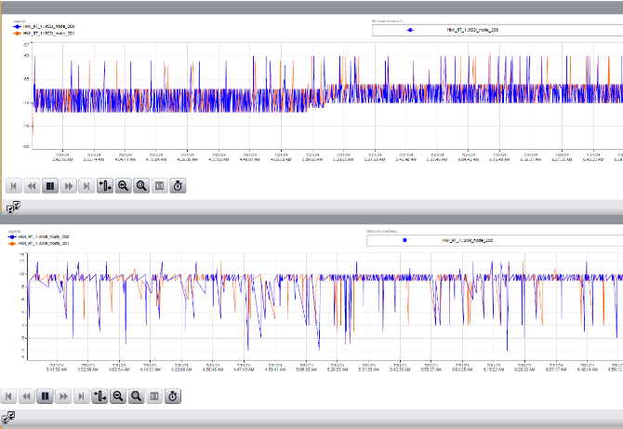
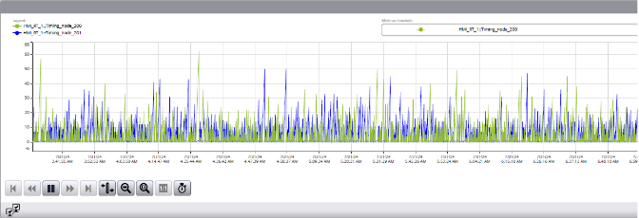
Figure 10. Voltage and signal quality data from Nodes displayed over time on the local web interface using WinCC Unified
- RESULTS
A. CASE SETUP
This study aims to evaluate the feasibility and effectiveness of using a LoRa wireless communication network to collect and monitor voltage data from nodes sent to the control center. Factors such as distance and terrain characteristics are prioritized in the scenarios.
To establish the scenarios, several initial conditions need to be considered when deploying the Ad-hoc LoRa network. Specifically, the study will examine different cases regarding the placement of the Base and Nodes, as well as the variation in distance between them, including scenarios with obstacles and open spaces.
The scenarios are designed to assess the ability to reliably and efficiently collect and transmit voltage data through the LoRa network. Parameters such as transmission speed, reliability, coverage range, and the ability to cope with terrain factors will be measured and analyzed.
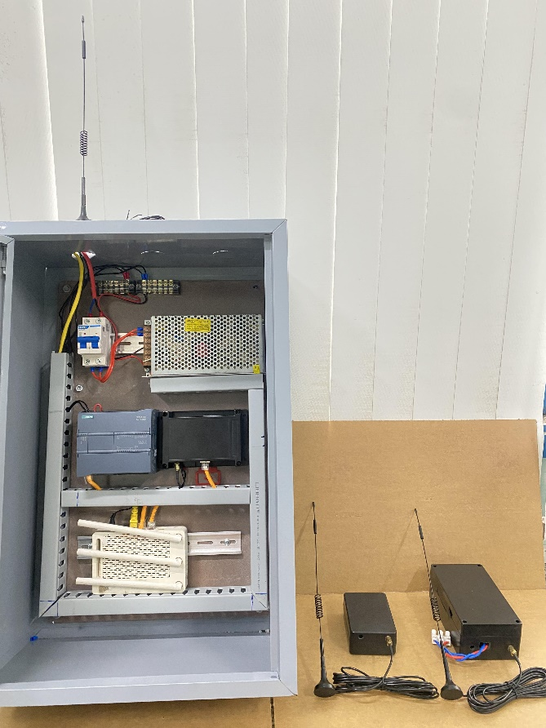
Figure 11. System image
RSSI (Received Signal Strength Indicator) and SNR (Signal-to-Noise Ratio) are two crucial parameters in evaluating signal stability. RSSI is an indicator that measures the signal strength received at the receiver. It provides information about the strength or weakness of the LoRa signal. A higher RSSI generally corresponds to a better connection and higher data transmission capability. SNR is the ratio between the signal strength and the noise. It measures the quality of the LoRa signal. A higher SNR indicates that the LoRa signal is stronger compared to the noise, thus having a better data transmission capability.
In LoRa applications, the continuous monitoring and optimization of RSSI and SNR are imperative to ensure stable connections and optimal data transmission performance. Additionally, the interval between two packets is monitored to assess the continuity of the connection.
The results of this study will provide important information about the capabilities and limitations of using the LoRa network in voltage data monitoring and collection applications. This will enable designers and implementers to make appropriate decisions regarding the application of this technology in real-world systems.
B. TEST RESULTS
The authors evaluate real-world scenarios with variations in distance, Node and Base installation locations, and terrain between the Nodes. This assessment aims to evaluate signal stability and the environmental impacts on the experiment.
The energy consumption of each Node is disregarded in these scenarios.
These devices are mounted on poles 1.8 meters above the ground.
- Case1: The Base and Node are located in an open area with few obstacles, while Node1 and Node2 are situated along a route flanked by tall buildings on both sides.
- The Base is located at “PD DH SU PHAM.”
- Node1 is located at “PD EO BIEN,” 476 meters from the Base.
- Node2 is located at “PD CHO KHU 2,” 282 meters from Node1.
The survey was conducted over 252 minutes.
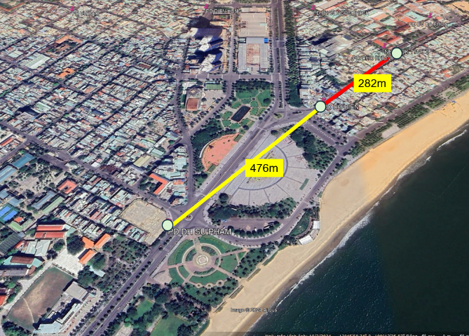
Figure 12. The layout map of the devices in Case 1
Analysis of the distribution of RSSI (Received Signal Strength Indicator), SNR (Signal-to-Noise Ratio), and Timing values in Case1:
The RSSI values were observed to fluctuate between -60dBm and -75dBm, with an average RSSI of -69.18dBm for the Base-Node1 connection and -67.67dBm for the Base-Node2 connection. These RSSI levels are considered quite ideal for applications requiring reliable and timely data delivery¹⁸.
The SNR values also exhibited a similar range of 2dB to 12dB across the two connections, with positive SNR indicating that the received signal was operating above the noise floor. The average SNR values of 8.96dB for Base-Node1 and 8.92dB for Base-Node2 are within the optimal range for LoRa modulation to perform well¹⁸.
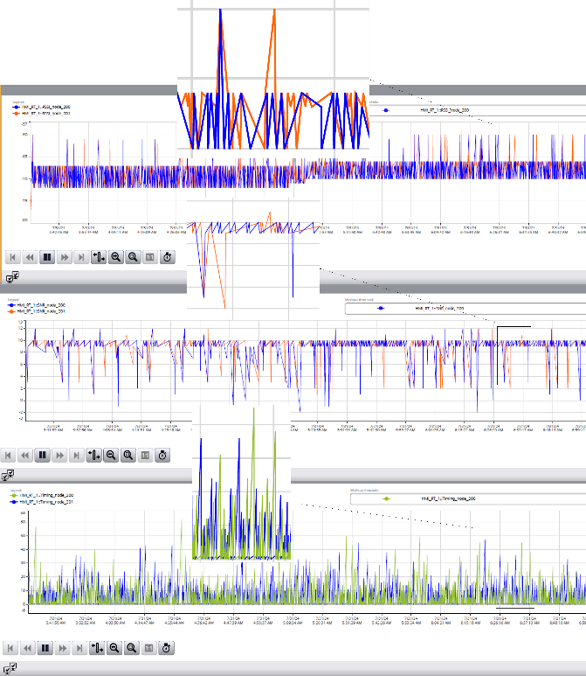
Figure 13. RSSI, SNR, Timing data between packets from Node to Base in Case1
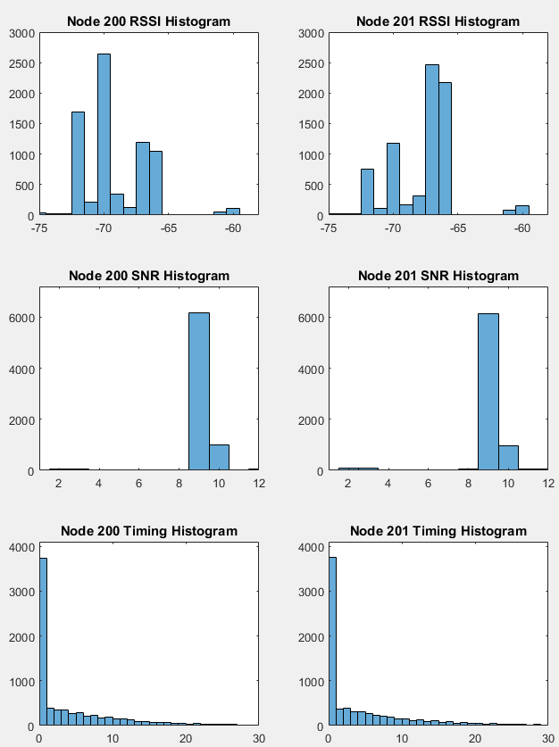
Figure 14. Histogram of RSSI, SNR and Timing values in Case1
Table 5. Mean revalent parameter in Case1
Mean | Base - Node 1 | Base - Node 2
RSSI | -69,18 | -67,67
SNR | 8,96 | 8,92
Time | 4,53 | 4,57
The maximum time interval observed was 60 seconds for the Base-Node1 link and 50 seconds for the Base-Node2 connection. The average time interval between packets is very similar for both links, at 4.53 seconds for Base-Node1 and 4.57 seconds for Base-Node2. The relatively low average time gaps and the absence of significant deviations suggest that the communication between the nodes and the base station is occurring at a reliable and stable.
The consistent and stable fluctuations in RSSI and SNR, along with the stable data transmission rate, suggest a reliable connection between the Nodes and the Base station. This favorable outcome can be attributed to the relatively unobstructed propagation environment. Overall, the observed RSSI, SNR, and Timing characteristics indicate a robust and reliable communication system, well-suited for the targeted applications.
- Case 2: Both the Base and Node are located along a road with high-rise buildings on both sides. The Base and Node2 are obstructed by a densely populated urban area with many high-rise buildings.
- The Base is located at "PD EO BIEN"
- Node1 is placed at "PD CHO KHU 2", 282 meters away from the Base
- Node2 is placed at "PD PHAM NGOC THACH", 293 meters away from Node1
The survey was conducted over 300 minutes.
In this case, Node 2 was unable to transmit data directly to Node 1 due to exceeding the transmission range.
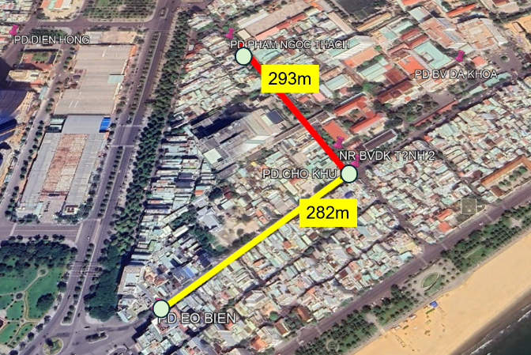
Figure 15. The layout map of the devices in Case 2
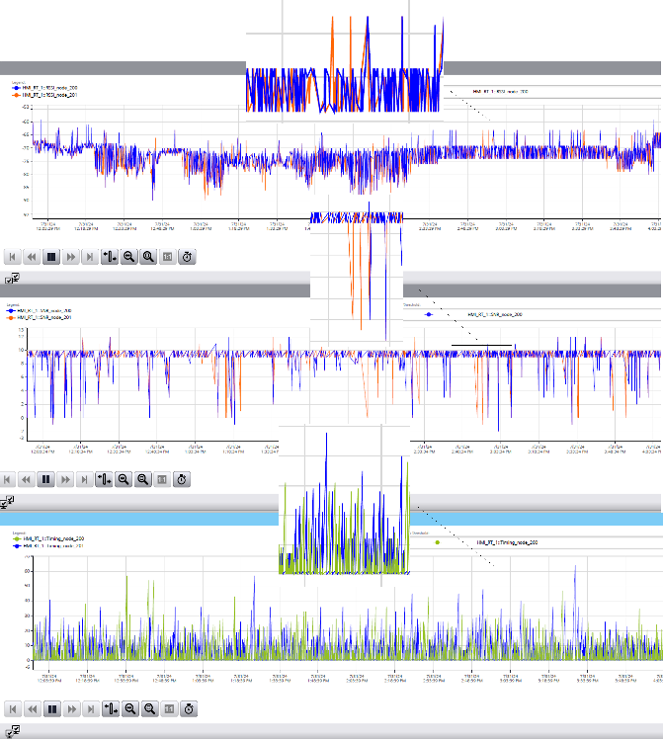
Figure 16. RSSI, SNR, Timing data between packets from Node to Base in Case2
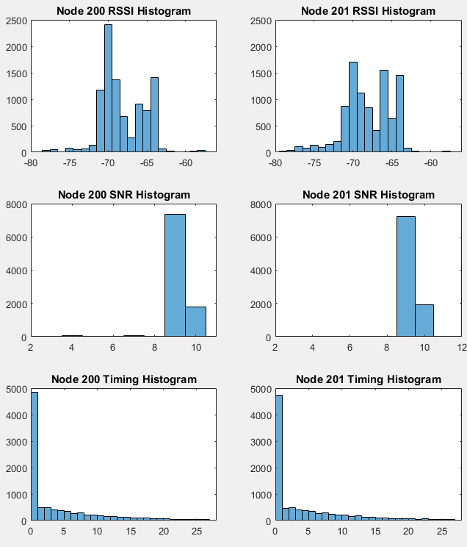
Figure 17. Histogram of RSSI, SNR and Timing values in Case2
Table 6. Mean revalent parameter in Case2
Mean | Base - Node 1 | Base - Node 2
RSSI | -68.16 | -68.05
SNR | 8.99 | 9.00
Time | 4.35 | 4.68
Analysis of the distribution of RSSI (Received Signal Strength Indicator), SNR (Signal-to-Noise Ratio), and Timing values in Case2:
The RSSI parameter of the Nodes fluctuated between -78dBm and -58dBm, primarily concentrating in the range of -65dBm to -70dBm. The average RSSI for the Node1-Base connection was -68.16dBm, while for the Node2-Base connection, it was -67.85dBm. The difference in RSSI values between these two connections could be attributed to the presence of large trees along the Node2-Base route. Nevertheless, the values indicate stable signal strength, ensuring reliable connectivity¹⁸.
The SNR parameter for both connections fluctuated similarly, ranging from 4dB to 12dB. For the Node2-Base connection, the SNR values were mostly stable around 9-10dB, unlike the Node1-Base connection, which exhibited more fluctuation. The average SNR was approximately 8.99dB for the Base-Node1 link and 9dB for the Base-Node2 link, which is ideal for effective LoRa signal modulation¹⁸.
Throughout the survey period, the average interval between two packets was 4.35 seconds for the Node1-Base connection and 4.68 seconds for the Node2-Base connection. The stable and high consistency of the RSSI and SNR values indicate the stability of the connection. The data transmission speed remained consistently below 4.7 seconds at most times, demonstrating stable connectivity between the Nodes and the Base station.
In Case 2, both the RSSI and Timing indices showed fewer similarities compared to Cas 1, possibly due to the influence of obstacles such as trees along the route. However, the SNR values remained relatively consistent in both scenarios.
- Summary
Practical experiments were conducted to analyze the impact of distance, installation location, and terrain conditions on signal strength and data transmission time between the Nodes and the Base. The survey was divided into different scenarios to evaluate the system’s performance under conditions with few obstacles and conditions surrounded by tall buildings.
The results indicate that the accuracy of voltage measurement results was significantly improved by the Kalman algorithm. The deployment scenarios for data collection at existing power system locations in Quy Nhon City demonstrated that the system could operate stably under various terrain and shielding conditions.
The system operated stably in both surveyed scenarios, meeting the reliability and response time requirements of the application. Terrain and shielding factors affected the connection quality, but the system could still function effectively.
In the absence of obstacles (Case1), the connection between the Base and the Nodes was of good quality, with an average RSSI of approximately -64.2dBm, an SNR of around 8.9dB, and a response time of less than 4.6 seconds. In the presence of tall buildings and trees (Case2), the connection quality was maintained, with an average RSSI of approximately -68.1dBm and a response time of around 4.5 seconds.
The practical results show that transmission distance can affect the SNR, while distance, the presence of obstacles, and propagation factors influence the RSSI of the received signal. Along with the stability of the RSSI signal and data transmission time recorded in the practical results, the study indicates that the choice of installation locations for the Node and Base devices is a crucial factor significantly affecting the performance of the wireless communication system.
- CONCLUSION
In this paper, the authors propose a measurement system utilizing a Ad-hoc LoRa network to transmit data to a monitoring center connected to commonly available industrial infrastructure. The system is practically deployed in Quy Nhon City, comprising one data collection and monitoring station and two data collection nodes.
Practical experiments were conducted to assess the feasibility of deploying voltage measurement and data collection in an urban environment, as well as to analyze the impact of distance, installation location, and terrain conditions on signal strength and data transmission time between connection points. The experimental results indicate that the system operates stably in an urban environment with appropriate distances, meeting the reliability and response time requirements of the system. However, the LoRa network also includes other parameters, such as the impact of energy consumption of the nodes, to provide a more comprehensive evaluation of the system’s performance and applicability. Additionally, the feasibility of deploying the LoRa network on a larger scale with more nodes should be assessed to evaluate its practicality for more realistic scenarios.
Acknowledgment
This research is conducted within the framework of science and technology projects at institutional level of Quy Nhon University under the project code T2024.845.15
REFERENCES
- Ghada S. Elbasuony, Shady H.E. Abdel Aleem, Ahmed M. Ibrahim, Adel M. Sharaf. A unified index for power quality evaluation in distributed generation systems, Energy, 2018, Volume 149, 607-622.
- Suhail Khokhar, Abdullah Asuhaimi B. Mohd Zin, Ahmad Safawi B. Mokhtar, Mahmoud Pesaran. A comprehensive overview on signal processing and artificial intelligence techniques applications in classification of power quality disturbances, Renewable and Sustainable Energy Reviews, 2015, Volume 51, 1650-1663.
- A-Goldsmith, Andrea. Wireless Networks (8nd edition), Cambridge University Press, New York, 2013.
- J. P. Shanmuga Sundaram,W. Du, and Z. Zhao. A Survey on LoRa Networking: Research Problems, Current Solutions and Open Issues, IEEE Communications Surveys Tutorials, 2020, Volume 22, 371 – 388.
- Eduardo Viciana, Francisco M. Arrabal-Campos, Alfredo Alcayde, Raul Baños, Francisco G. Montoya. All-in-one three-phase smart meter and power quality analyzer with extended IoT capabilities, Measurement, 2023, Volume 206,112309.
- Cameron Roach. Estimating electricity impact profiles for building characteristics using smart meter data and mixed models, Energy and Buildings, 2020, Volume 211,109686.
- László Czétány, Viktória Vámos, Miklós Horváth, Zsuzsa Szalay, Zsófia Deme-Bélafi, Tamás Csoknyai. Development of electricity consumption profiles of residential buildings based on smart meter data clustering, Energy and Buildings, 2021, Volume 252, 111376.
- Francisco Sánchez-Sutil, Antonio Cano-Ortega. Design and Testing of a Power Analyzer Monitor and Programming Device in Industries with a LoRA LPWAN Network, Electronics, 2021, Volume 10(4), 453.
- A. Rahman and M. Suryanegara. The development of IoT LoRa: A performance evaluation on LoS and non-LoS environment at 915 MHz ISM frequency, International Conference on Signals and Systems (ICSigSys), 1st, Bali-Indonesia, 2017.
- Y. Ishida, D. Nobayashi, and T. Ikenaga. Experimental performance evaluation of the collisions in LoRa communications, 2018 International Conference on Computational Science and Computational Intelligence (CSCI), 6th, Las Vegas, NV, USA, 2018.
- Wilson L. Rodrigues Junior, Fabbio A.S. Borges, Artur F. da S. Veloso, Ricardo de A.L. Rabêlo, Joel J.P.C. Rodrigues . Low voltage smart meter for monitoring of power quality disturbances applied in smart grid, Measurement, 2019, Volume 147, 106890.
- Preti Kumari; Rahul Mishra; Hari Prabhat Gupta; Tanima Dutta; Sajal K. Das. An Energy Efficient Smart Metering System Using Edge Computing in LoRa Network, IEEE Transactions on Sustainable Computing, 2021, Volume 7, 786 – 798.
- Jumpei Sakamoto; Daiki Nobayashi; Kazuya Tsukamoto; Takeshi Ikenaga; Goshi Sato; Kenichi Takizawa. Poster:Implementation and Performance Evaluation of TCP/IP Communication over Private LoRa, 2022 IEEE 30th International Conference on Network Protocols (ICNP), 30th, Lexington, KY, USA, 2022.
- Jumpei Sakamoto; Daiki Nobayashi; Kazuya Tsukamoto; Takeshi Ikenaga; Goshi Sato; Kenichi Takizawa. Improvement of TCP Performance based on Characteristics of Private LoRa Interface, 2023 IEEE 47th Annual Computers, Software, and Applications Conference (COMPSAC), 47th, Torino, Italy,2023.
- William David Paredes, Hemani Kaushal, Iman Vakilinia, Zornitza Prodanoff. LoRa Technology in Flying Ad Hoc Networks: A Survey of Challen, ges and Open Issues, Sensors, 2023, Volume 23(5), 2403.
- Jian Wu; Jianliang Zhang; Junwei Ma; Min Zhao; Xudong Wang; Xurui Gao; Hongliu Zhang. Energy Efficient 5G LoRa Ad-Hoc Network for Smart Grid Communication, 2021 IEEE 11th International Conference on Electronics Information and Emergency Communication (ICEIEC)2021 IEEE 11th International Conference on Electronics Information and Emergency Communication (ICEIEC), 11th, Beijing, China, 2021.
- Silvano Bertoldo; Claudio Lucianaz; Miryam Paredes; Marco Allegretti; Lorenzo Carosso; Patrizia Savi. Feasibility Study of LoRa Ad-Hoc Network in an Urban Noisy Environment, 2018 18th Mediterranean Microwave Symposium (MMS), 18th, Istanbul, Turkey, 2018.
- Mohammad Arshad, Muhammad Moid Sandhu, Mukhtaj Khan, Ahsan Mahmood, Tahir Muhammad, and Muhammad Ali Khan.Review of Applications and Challenges of LoRa Technology for the Internet of Things (IoT), Journal of Sensor and Actuator Networks, 2017, Volume 6(2), 0007.

Liên hệ: Trần Xuân Khoa
Trường Đại học Quy Nhơn
170 An Dương Vương, TP. Quy Nhơn, tỉnh Bình Định, Việt Nam
Email: tranxuankhoa@qnu.edu.vn
Điện thoại: 0935799977

