Nghiên cứu điều tra các yếu tố gây mất hứng thú trong việc học kỹ năng nói của sinh viên không chuyên tiếng Anh năm nhất trường Đại học Quy Nhơn và những giải pháp cải thiện
Nguyễn Trần Ý Nhi*, Lê Hà Cẩm Tiên, Nguyễn Trần Yến Nhi

Khoa Ngoại ngữ, Trường Đại học Quy Nhơn, Bình Định, Việt Nam

*Tác giả liên hệ chính. Email: nhi4557510173@st.qnu.edu.vn

TÓM TẮT
Bài viết này trình bày một nghiên cứu về những vấn đề mà sinh viên năm nhất không chuyên tiếng Anh tại Đại học Quy Nhơn gặp phải khi mất hứng thú học kỹ năng nói tiếng Anh. Có 200 sinh viên năm nhất không chuyên ngành tiếng Anh thuộc các ngành như Kinh tế, Kế toán, Quản lý Tài nguyên và Môi trường, Công nghệ Thực phẩm, Kỹ thuật Xây dựng, v.v. tại Đại học Quy Nhơn đã được lựa chọn làm đối tượng nghiên cứu. Bảng câu hỏi, bao gồm mười câu hỏi đóng và mở, đã được sử dụng để thu thập dữ liệu. Các kết quả cho thấy rằng sinh viên năm nhất không chuyên ngành tiếng Anh đối mặt với nhiều yếu tố gây mất động lực trong việc học kỹ năng nói tiếng Anh. Yếu tố phổ biến nhất liên quan đến thái độ học tập. Các yếu tố khác liên quan đến cơ hội thực hành giao tiếp, môi trường lớp học, cơ sở vật chất, năng lực và hiệu suất của giáo viên. Yếu tố cuối cùng và ít gây vấn đề nhất là tài liệu giảng dạy. Dựa trên kết quả khảo sát, nhóm nghiên cứu cũng đề xuất một số giải pháp cải thiện mà hầu hết sinh viên và giáo viên đồng ý.
Keywords: Mất động lực, kỹ năng nói, năm nhất, sinh viên các ngành không chuyên Anh.

Investigation into the factors causing demotivation in learning English speaking skills of first-year non-English major students at Quy Nhon University and solutions
Nguyen Tran Y Nhi*, Le Ha Cam Tien, Nguyen Tran Yen Nhi

Department of Foreign Language, Quy Nhon University, Binh Dinh, Vietnam

*Corresponding author. Email: nhi4557510173@st.qnu.edu.vn

ABSTRACT
This article reports on a research ha into the problems that non-English major freshmen at Quy Nhon University face when they lose interest in learning English speaking skills. The subjects were 200 first-year non-English majors belonging to non-English majors such as Economics, Accounting, Natural Resources and Environmental Management, Food Technology, Construction Engineering, etc. at Quy Nhon University. The questionnaire, which consists of ten closed-ended and open-ended questions, was utilized to collect the data. The findings suggest that first-year non-English majors face many factors causing demotivation in learning English speaking skills. The most common one is related to learning attitudes. Others are related to speaking practice opportunities, classroom climate, facilities, and teacher’s competence and performances. The last and least problematic one is teaching materials. Based on the survey results, the research team also proposed some improvement solutions that most students and instructors agreed upon.
Keywords: Demotivation, speaking skills, first-year, non-English majors students.
1. INTRODUCTION

English holds a paramount position as the primary international language in the current era of globalization. In Vietnam, English has become ubiquitous, penetrating every aspect of life, including education, commerce, communication, and entertainment. The pervasive presence of English speakers in various sectors has made English the most widely learned foreign language in the country. Despite its widespread adoption, mastering English, particularly speaking, remains a formidable challenge for second language learners. Research consistently highlights speaking as the weakest skill among L2 speakers, with its real-time nature and lack of editing opportunities posing significant obstacles. Scholars emphasize the paramount importance of speaking proficiency, considering it the cornerstone skill encompassing the other language competencies. Crystal stresses the global prevalence of English as a lingua franca, underscoring its indispensable role across various domains.¹ Given its complexity and significance, prioritizing the development of speaking skills becomes imperative in language education to meet the demands of today's globalized world.
2. THEORETICAL BACKGROUND
2.1. Theoretical background
2.1.1. Notions of speaking and teaching speaking skills
2.1.1.1. Speaking skill
Different scholars have different definitions of this skill. Speaking is the verbal use of language and a medium through which human beings communicate with each other.² According to Bygate in Leong & Ahmadi, speaking is the production of auditory signals to produce different verbal responses to listeners.³ It is intended as a systematic combination to form meaningful sentences. Meanwhile, COBUILD defines "speaking" as a way to indicate your position or viewpoint in what you are saying.⁴ Speaking skills in English include the ability to interact and express opinions and thoughts in English. This is the process of communicating your message clearly and effective use of vocabulary, grammar, and other linguistic devices. This capability is pivotal for acquiring a range of social experiences and professional prospects, in addition to being a necessary element of learning English. Thus, it is evident that speaking skills stand out as a pivotal skill demanded to master effective communication.
2.1.1.2. Speaking skill teaching strategies and methods
As Richards states, the goal of teaching speaking is to provide learners with communicative competence and classroom activities that develop learners’ ability to express themselves through speech.⁵ Students need to practice their speaking skills with the assistance of instructors. Teachers can apply speaking teaching methods such as the Drilling method which is the repeated practice of language skills such as grammar, vocabulary, or language reflexes. Thornbury has encouraged combining drilling with creative, practical, and interactive activities to enhance teaching effectiveness. In addition, the TBLT (Task-based Language Teaching) teaching method proposed by Willis should also be applied.⁶ This is an effective and popular method in the field of language education.
2.1.1.3. Characteristics of a successful speaking activity
Learning effective English speaking skills plays an important role in developing learners' communication abilities. Both teachers and learners of English speaking skills need to understand the characteristics of successful speaking activities. In “A Course in Language Teaching” Ur reports that a successful speaking activity has characteristics such as:
- Learners talk a lot.
- Participation is even.
- Motivation is high.
- Language is of an acceptable level.⁷
Besides, a successful speaking activity is also purposeful, interactive, challenging, and adaptable, fostering a positive and motivating environment for learners to develop their speaking skills effectively.
2.1.1.4. Problems with teaching speaking
Some English language practitioners said that teaching speaking skills is a challenging task for instructors. It becomes more difficult when speaking skill is being taught in large classes.⁸ Often it is handed over to novice teachers, but as compared to novice teachers, speaking can be taught by trained teachers rather than inexperienced teachers.^{9,10}
Moreover, Ur mentions some problems in teaching speaking, including inhibition—fear of making mistakes, losing face, criticism, shyness; nothing to say—learners have problems with finding motives to speak, formulating opinions or relevant comments; low or uneven participation—often caused by the tendency of some learners to dominate in the group; mother-tongue use—particularly common in less disciplined or less motivated classes, where learners find it easier or more natural to express themselves in their native language.⁷
These issues can potentially lead to a cascade of negative impacts, ranging from a decrease in self-confidence, influencing learning attitudes, to diminishing the ability to employ language flexibly in communication. Addressing these challenges requires particular attention to teaching methodologies, the learning environment, and the provision of dedicated support to encourage the active participation of learners in the process of learning spoken English.
2.1.2. Motivation and demotivation
2.1.2.1. Motivation
Participation in English speaking activities necessitates a specific level of motivation from the students. The conceptualization of motivation comprises its constituent elements rather than a singular definition. Gardner also confirmed that “motivation is a very complex phenomenon with many facets, so it is not possible to give a simple definition”.¹¹ Deci and Ryan have delineated and underscored three pivotal components of motivation: autonomy, competence, and relatedness.¹² In order to promote academic motivation, students require to be provided with abundant learning opportunities and continuous encouragement to support their efforts in honing their English speaking skills.
2.1.2.2. Demotivation
Loss of interest, also known as loss of motivation, is a concept of negative attitude. Negative attitudes, as has been rightly pointed out, can impede language learning, since you usually get those attitudes when you are not interested or have difficulties with the teacher or with other students. Falout claims that demotivation is a condition in which students lose interest in learning a second language in early phases.¹³ This can have harmful long-term effects, including failure, a decline in confidence, self-blame, and struggling too much to become motivated during the learning process. Differing from motivation, demotivation refers to a state wherein learners perceive a lack of control and a dearth of significance in the learning process. For instance, Hu described that while motivational factors positively impact language learning achievement, demotivating factors hinder the learning process. Various factors, such as external pressures, diminished interest, or a disconnect from personal objectives, can contribute to the erosion of motivation.¹⁴ This phenomenon may manifest when students experience feelings of inadequacy or fail to recognize the purpose behind enhancing their English speaking skills. Harmer said: “If the students lose confidence in the teaching methods of teachers, they will become demotivated”.¹⁵
2.1.3. Factors affecting students’ demotivation in learning English speaking skills
2.1.3.1. Factors related to learning attitudes
Stern, as cited in Rahman, distinguishes three types of attitudes in second-language learning situations:
- Attitudes towards the community and people who speak L2 (group-specific attitudes).
- Attitudes towards learning the language concerned.
- Attitude towards languages and language learning in general.¹⁶
Fear and anxiety are also attitude factors that can lead to a loss of interest. Students may fear making mistakes, fear criticism, or fear failure when performing speaking skills in front of others. This attitude can cause students to avoid practice opportunities and be unwilling to develop their communication abilities. Understanding attitudes toward foreign language learning is not only an essential aspect of the teaching and learning process but also influences the effectiveness and success of language learning.
2.1.3.2. Factors related to teacher’s competence and performances
Language teachers should understand the sources of students’ demotivation in order not to be the primary cause of demotivation.¹⁷ According to Kaboody, it is the teacher's responsibility to help learners remotivate and develop positive attitudes toward learning the target language.¹⁸ Language teachers can help their students enhance their self-motivation by attracting their attention to practical strategies like “favorable expectations, incentives, dealing with procrastination and boredom, and eliminating distractions”.¹⁸ A positive and nurturing learning environment plays a crucial role in fostering students' interest and motivation. Therefore, the role of the teacher extends beyond imparting knowledge; they also serve as motivators, encouragers, and creators of a positive learning atmosphere to help students develop their speaking skills confidently and effectively.
2.1.3.3. Factors related to facilities
To achieve quality education in English as a foreign language, the learning environment and facilities are essential variables.¹⁹ School facilities affect learning. Longitudinal configurations, noise, heat, cold, light, and air quality bear on students’ and teachers’ ability to perform.²⁰ Teachers play an undeniable role in leveraging facilities to construct a positive and effective learning environment. They impart knowledge and encourage students to utilize available resources for self-improvement. Language is best learned through the use of learning facilities and communication among students. This type of collaboration results in benefits for all or both learners.²¹
2.1.3.4. Factors related to teaching materials
Teaching and learning materials directly affect students’ learning achievements.²² Teaching materials play a crucial role in influencing students' loss of interest in developing speaking skills. When materials are not designed to be engaging and interesting, students may lose motivation and fail to find enthusiasm to participate in the learning process. These materials include textbooks, workbooks, writing paper, pens/pencils, chalk, blackboards, wall pictures, tapes, tape recorders, television, radio, reading material, and a library. All those materials affect students’ attitudes toward English learning.²²⁻²⁵
The use of rich and realistic teaching materials is significant. Teachers need to select materials that align with students' proficiency levels and needs. Moreover, they should create engaging and positive activities to stimulate students' interest and participation in the process of learning speaking skills.
2.1.3.5. Factors related to classroom climate
A socially active and productive classroom climate is marked by students interacting in supportive and sympathetic interactions with peers.^{26,27} Creating an ideal classroom climate is a key factor in developing students' English-speaking skills. A positive classroom climate for the best forms of learning to occur is marked by teachers trying to establish effective positive interactions in the environment of the class.²⁸ The necessity of such a favorable climate lies in the fact that when language teachers and students interact in a positive atmosphere, they can have better concentration, feel calmer, achieve better educational goals, and work to their best.²⁷
2.1.3.6. Factors related to speaking practice opportunities
Throughout the learning process, having opportunities to practice speaking helps learners become more confident in language usage. These opportunities may include engaging in dialogues, participating in group discussions, performing communicative tasks, and joining language-oriented activities. Likewise, Yuliandasari and Kusriandi believe that participating in an English club is also an opportunity for students to practice speaking regularly.²⁹ Additionally, utilizing technology, such as online English learning applications and chat forums, also opens up numerous new avenues for flexible and effective speaking practice. For the development of communication skills, creating and leveraging speaking practice opportunities is undeniable.
2.2. Previous studies
Research on students' English speaking difficulties is not the first. Before this research, there were many types of research that studied students' speaking difficulties at school or the university. Some related research results are presented in the following:
First was a case study by Park and Lee, which investigated the connection between second language learners’ anxiety, self-confidence, and speaking performance. One hundred and thirty-two Korean learners participated in this research. The results obtained from this research showed that students’ anxiety levels had a negative relationship to their oral performance.³⁰
The second is Juhana, with the title "Psychological Factors That Hinder Students from Speaking in English Class (A Case Study in a Senior High School in South Tangerang, Banten, Indonesia)." The study aims to find out the psychological factors that hinder students from speaking and the causes of the factors, as well as the possible solutions to overcome the factors. The data were obtained through classroom observations, questionnaires, and interviews. In terms of findings, the study revealed that psychological factors such as fear of making mistakes, shyness, anxiety, lack of confidence, and lack of motivation hinder students from speaking in English class. Those factors, like fear of making mistakes, were commonly caused by their fear of being laughed at by their friends.³¹
Third, Aida Fitria, in her research entitled “ An Analysis of Students’ Speaking Problems at English Education Department, State Institute of Islamic Studies Sunan Ampel, Surabaya”, aimed to analyze students’ problems in speaking English and why those problems occur in the fifth semester of English Education Department at IAIN Sunan Ampel Surabaya. The researcher found the problems of the students' speaking problems are inhibition, which consists of students feeling shy of being attention when speaking English, worried about making mistakes, and afraid of being criticized when speaking English incorrectly, it is caused by their low understanding in grammar, low vocabulary, and low level of pronunciation mastery. The next problem is nothing to say, students are afraid of being faulted, have no idea how to speak English, and lazy to speak English. It is caused by uninteresting topics, and difficult material/topics. The problem related to low or uneven participation is found to be that the students seldom speak English in class and are uncertain about speaking English. It is caused by their low understanding of grammar, low vocabulary, and low level of pronunciation. The last problem is mother tongue used. Students usually use mother tongue during the lesson. It is caused by their low vocabulary.³²
The fourth is Yusica's research about "Problem Faced by Thai students in Speaking English." This study is intended to find out the problem faced by Thai students. This investigates the reason most students in Thailand have difficulties in speaking English. Language skill is one of the four skills in English, which could be the most difficult process for the student to make a deal with. Many factors cause Thai students to have difficulty in speaking English. There are so many problems that remain in Thai student's oral communication. Those are because of the history of Thailand which has never been colonized by any European country, age, or maturational constraints, aural medium, socio-cultural factors, and effective factors. The effective factors still have a great deal with the psychological factors of Thai student's attitudes, including anxiety, a feeling of uneasiness, frustration, self-doubt, apprehension fear of mistakes, shyness, lack of confidence, and lack of motivation. Not only that, the teacher could be a great factor that affects the success of English classroom teaching. Non-native teachers are still applying the teacher-centered approach and go for teaching grammar more than speaking performance.³³
Finally, Nguyen & Tran carried out a study on “Factors affecting students' speaking performance at Le Thanh Hien High School.”. This study aimed to explore the speaking problems of the students at Le Thanh Hien High School and the factors affecting their speaking performance. The participants included two hundred and three grade 11 students and ten teachers of English. The results from the questionnaires and classroom observation indicated that students faced various problems, such as speaking English very little or not at all, not being able to think of anything to say, using Vietnamese instead of English when discussing in groups or in pairs, having low participation, being fearful of criticism or losing face, having a habit of translating the information in the textbooks into Vietnamese before speaking, and looking at their textbooks when speaking. From the findings above, the authors proposed some possible solutions for both teachers and students to improve teaching and learning speaking skills.³⁴
3. METHODOLOGY
3.1. Participant
First-year non-English major students and their English language teachers took part in the study at Quy Nhon University. An interview was conducted with the intention of systematizing their responses so that a questionnaire regarding demotivating factors that impact the learning of speaking skills could be developed. In the primary data-gathering stage of the research, 200 students were chosen at random and asked to respond to pre-formulated questionnaires. These are freshmen studying non-English subjects at Quy Nhon University, with an average age of 18. Upon finishing the standard English course, students are expected to comprehend fundamental materials and initiate self-expression in everyday contexts.
126 (63%) of the 200 students who took part in the study were female, and 74 (37%) were male. Before starting college, the majority of students who are eighteen years old studied English for at least seven years.
3.2. Research questions
The research questions discussed in this research could have been determined from the background research mentioned above. Those were:
- What are the factors that cause demotivation in learning English speaking skills of first-year non-English major students at Quy Nhon University?
- What solutions should be made to seek to avoid demotivation of the students in learning English speaking skills?
3.3. Research method
This project utilized the quantitative method to identify demotivation factors in English speaking among first-year non-English students at Quy Nhon University and proposes solutions to address these challenges.
3.4. Data collection
The survey was conducted on first-year students (K46) in non-English majors at Quy Nhon University. The questionnaire that was constructed is based on the existing literature as well as the one that was utilized in Foreign Language Learning Demotivation: A Construct Validation Study by Afrough, Rahimi, and Zarafshan.³⁵ The questionnaire consists of two main questions. The first one assists in identifying the demotivating factors that non-English majors face, which include a number of additional minor elements from which students might choose. The researcher chose to look into six main demotivating factors based on the literature review that was presented. These include the students' attitudes toward English and their ability to speak it, factors related to teachers and facilities, the climate in the classroom, the teaching materials, and the opportunities for practice. The second key query is to summarize data regarding methods for lowering non-English majors' motivation levels. The student surveys were given out in Vietnamese to avoid misunderstandings and hesitation.
3.5. Data analysis
After collecting data from student responses to the survey through Google Form, we downloaded the data, filtered and cleaned the data. The filtered data were analyzed using the Excel data analysis tool. Analysis results are presented in the form of tables and graphs for convenient reference and evaluation.
4. RESULT AND DISCUSSION
4.1. Result
4.1.1. Demographic information
The following tables will give the basic demographic information about 200 non-English majors involving in this study.

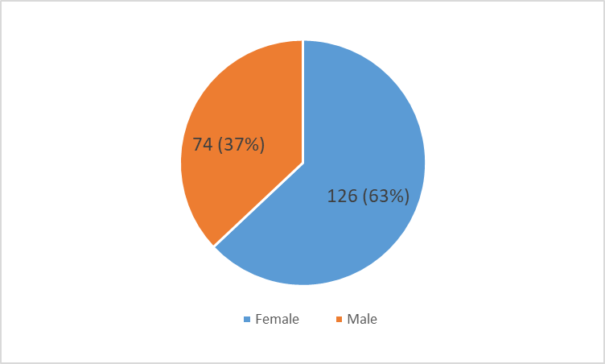
Figure 1. Gender.
Table 1. Student's major.
Majors | Quantity
Accounting | 38 (19%)
Economics | 32 (16%)
Food Technology | 37 (18.5%)
Pedagogy | 30 (15%)
Construction Engineering | 35 (17.5%)
Natural resources and environmental management | 15 (7.5%)
Hotel management | 13 (6.5%)
Total | 200 (100%)

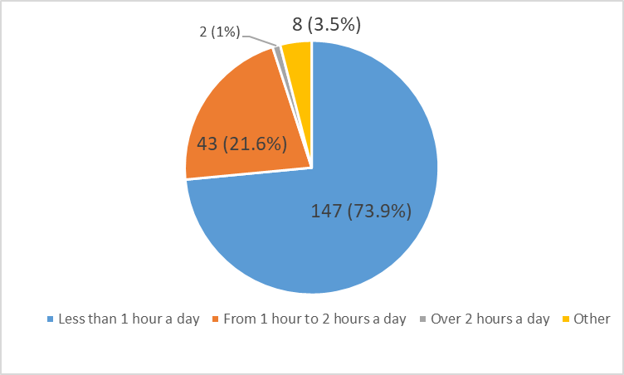
Figure 2. Self-study time for English speaking skill.
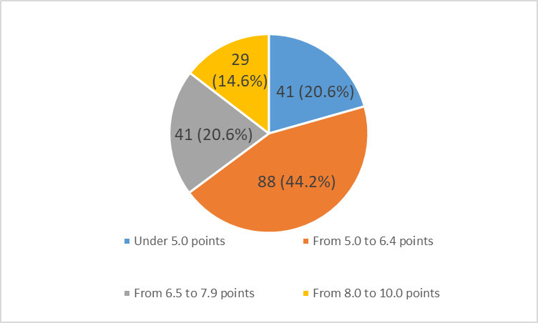
Figure 3. Current English average score.
The "current English average score" refers to the average score achieved by students in English language-related assessments or examinationsin in the English 1 and English 2 modules. This score is a statistical representation of how well students, as a group, performed in a particular set of tests or assessments focused on English language skills.
Current English average scores were available at the end of term/end of semester.

4.1.2. Demotivating factors in speaking lessons of first year non-English majors at Quy Nhon University
This section deals with the answers collected from students through the questionnaires to answer the first research questions.

4.1.2.1 Factors related to learning attitudes

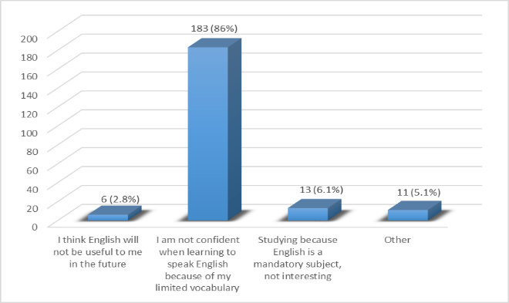
Figure 4. Factors related to learning attitudes.
Factors related to learning attitude have a significant influence on English speaking proficiency. Our survey identified underlying factors related to students' speaking attitudes. Among the 183 options, the top factor hindering confidence in English communication comes from limited vocabulary, accounting for 86% of the total votes for factors related to learning attitude. Students with a rich English vocabulary often encounter fewer problems when speaking English. In contrast, other factors contribute very little; Only 13 chose to learn English out of obligation, accounting for only 6.1% of respondents. Furthermore, a small number of students think that learning English is not useful in their future, accounting for only 2.8% of the total responses. Other factors account for 5.1%. With 11 different opinions, some students think that they have no talent for speaking English or lack the basics of the language.

4.1.2.2. Factors related to teacher’s competence and performances

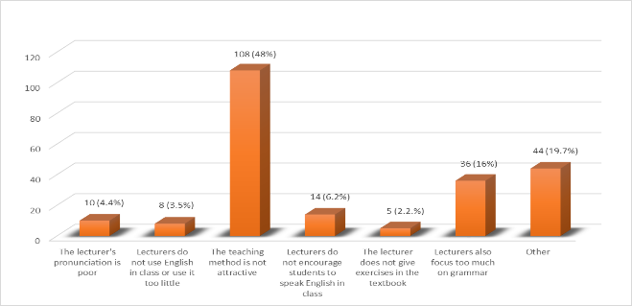
Figure 5: Factors related to teacher’s competence and performance.
When conducting a survey on factors related to competence and teacher performance, we offer more and more specific choices. We realize that students are very interested in teachers' teaching methods. The teaching method is considered by students to be not attractive enough to attract students' interest. The data clearly proves that with 108 opinions agreeing, equivalent to 48%, almost half of the total number of votes were for factors related to teachers. Next is the 36 votes in the teacher section that focus too much on grammar, accounting for 16%, which is also not a small factor. The remaining factors are that teachers do not encourage students to speak English in class, teachers have poor pronunciation, teachers rarely use English, teachers do not give exercises in textbooks, 14 selections (6.2%), 10 selections (4.4%), 8 selections (3.5%), and 5 selections (2.2%), respectively. We also received 44 other opinions (5.1%) from students about factors related to teachers, such as teachers not being really enthusiastic and some students feeling discouraged from practicing speaking because teachers only pay attention to students who can speak English well.

4.1.2.3. Factors related to facilities
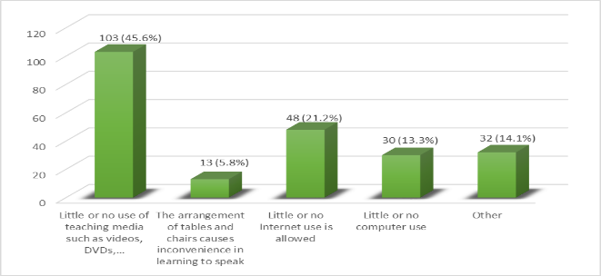
Figure 6. Factors related to facilities.

Through evaluation, the majority of students participating in the survey said that using little or no teaching equipment, such as videos and DVDs, has an impact on their learning to speak English. We calculate that out of 226 options, 103 students chose this factor, accounting for 45.6%. Meanwhile, the second most students chose not to use computers, with 48 choices (21.2%), although only nearly half of them chose not to use teaching methods such as videos and DVDs. Not being able to use computers also hinders students from learning to speak English, especially in a new era like today.
Statistics show that 30 students choose this factor, accounting for a rate of 13.3%. Another factor is the arrangement of desks in the classroom, chosen by 13 students (5.8%), although it accounts for a small percentage, it also has a more or less significant impact on students' learning to speak English. In addition, 32 other opinions (14.1%) were given by students about the classroom not having air conditioning, lacking a microphone for students to practice speaking, etc.

4.1.2.4. Factors related to teaching materials
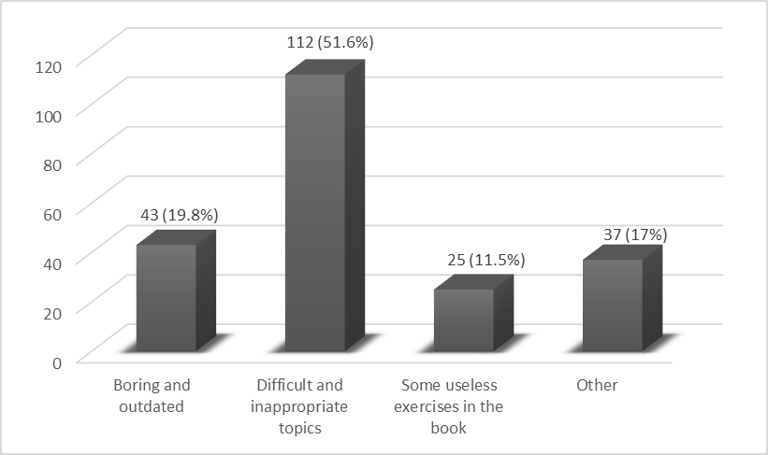
Figure 7. Factors related to teaching material.
The chart above shows that students seem to find the topics difficult and inappropriate for them, this factor has 112 choices (51.6%). 19.8% of the choices were for the factor that the materials were boring and outdated, with 43 students choosing this factor. The material was also mentioned as exercises in the book that were useless to students, but not too many students chose it, with 25 choosing it (11.5%). Other opinions include difficult topics and lack of attractive practice exercises, accounting for 17 % of the 37 opinions.

4.1.2.5. Factors related to classroom climate
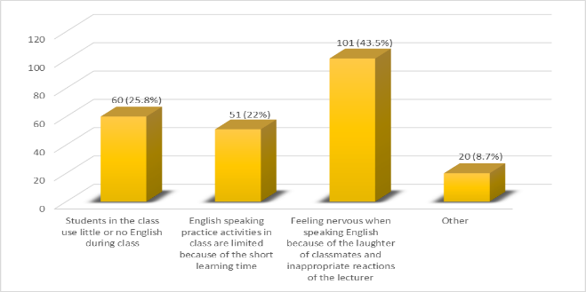
Figure 8: Factors related to classroom climate.
Regarding factors related to classroom climate, a large number of students think that the fact that they use little or no English during class makes them lose interest in practicing English speaking, up to 60 (25.8%) of choices in this factor. However, the majority of students, specifically 101 students (43.5%), still agree that they are afraid to communicate in English because they are afraid of the laughter of other students in the classroom and the inappropriate reactions of the teacher. Not only that, the short study time is not enough for students to practice speaking English, which is a factor chosen by 51 students, accounting for 22% of the total. Besides the factors we mentioned, we received a few other opinions, such as that students are afraid to speak because their classmates have an indifferent attitude, are not focused, the classroom atmosphere is too quiet, and the teacher is not proactive. stirring up the class atmosphere, these factors accounted for 8.7%, with 20 opinions given.

4.1.2.6. Factors related to speaking practice opportunities
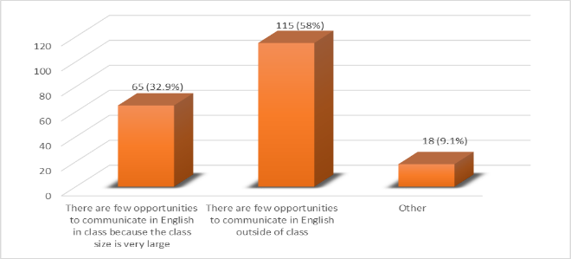
Figure 9. Factors related to speaking practice opportunities.
The other important factor our survey mentioned was in terms of opportunities to practice speaking English. We offered two options and students added different factors. According to the statistical chart, most students have little opportunity to practice speaking English outside of class. Only counting the number of students participating in the survey, there were 115 choices for this factor, accounting for 58%. The remaining factor related to limited speaking practice is the large class size, pointed out by 65 students ( 32.9%). Students are also interested in speaking opportunities. Other opinions added by students (18 comments, accounting for 9.1%) focus on opportunities to communicate with foreigners. Especially speaking English with native speakers, but there are few opportunities, and there are not enough foreign teachers to teach all classes. There is an opinion that theory is taught a lot while there is little time to practice English with classmates.

4.1.3. Possible solutions
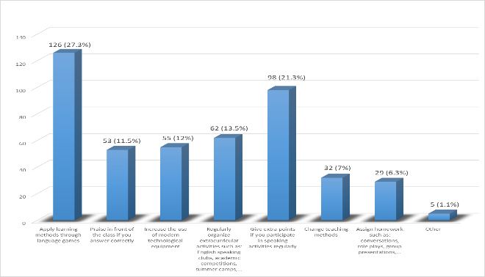
Figure 10. Possible solutions.
Along with that, students can choose solutions that they consider practical to the situation of losing interest in learning to speak English. Our proposed solutions are designed to suit the specific circumstances of first-year non-English major students at Quy Nhon University and are well received by students. The statistics are clearly presented in the table above. It can be seen that all proposed remedies received consensus in the student community when there were 455 choices for a total of 7 solutions that we offer and 5 blank choices.
The solution that received the most votes from students was to apply the method of learning through language games. With 126 (27.7%) choices for this solution, students said that combining learning and playing brings learning stimulation to them, and the joy of winning these games is also a strong motivator.
Test scores are fixed, and students can improve their GPA by adding points to midterm exams. This is a solution that has been applied by many English teachers at Quy Nhon University and is equally highly appreciated by students, with up to 98 (21.3%) choices from survey participants.
Another solution chosen by a large number of students (62 choices, equivalent to 13.5%) is to regularly organize extracurricular activities such as English speaking clubs, academic competitions, summer camps, etc. This is a solution that provides many speaking practice opportunities for students and needs to be organized more.
We have counted that there are 2 solutions chosen with an almost equal number of choices: the first is increasing the use of modern technological equipment in English-speaking teaching with 55 choices (12%), and the second is the teacher's action of praising in front of the class if the student answers correctly with 53 choices (11.5%). The solutions that receive less attention are changing teaching methods. 32 students chose this solution. Most students feel okay with the current teaching methods of the lecturers. This option accounts for 7%. But the lowest is the solution of assigning homework such as conversation, role-play, group presentation, etc., which is not too difficult to recognize when there are only 29 choices (6.3%) in this solution. Homework assignments like this have been and are being applied for at Quy Nhon University. Students also proposed 5 opinions (accounting for 1.1%) to improve English speaking skills by practicing basic daily communication sentences, speaking directly with foreigners, etc.
4.2. Discussion
4.2.1. Students’ negative attitude toward language learning and speaking
All participants concur that students recognize the pivotal role of English in their development and deem it advisable to proficiently master both spoken and written forms of the language. Rather than a sense of obligation, it is the sense of necessity that drives students' strong inclination to undertake English courses.
Upon reviewing both qualitative and quantitative research findings, it becomes apparent that the primary demotivating factor hindering students' participation in speaking activities is their limited vocabulary. Both students and teachers candidly acknowledge that inadequate vocabulary renders learners incapable of articulating their ideas effectively in class. At times, students become disengaged from thinking and working as they struggle to find the precise words required to express even simple thoughts.
4.2.2. Teacher-related factors
The competence of teachers has been found not to pose any significant issues for students, as only a small number of participants fail to highly rate their teachers' pronunciation. This discrepancy can be attributed to variations in students' learning styles. However, there is genuine concern regarding teachers' instructional methods. Both students and educators acknowledge that instructional styles and techniques should be diverse to prevent monotony and accommodate different subjects and learning preferences. Uninterested teaching methods are identified as a significant demotivator among first-year students in non-English majors at QNU. Depending on the subject matter, teachers recognize the importance of employing visual aids for some topics, while others may necessitate audio elements or student engagement activities during class.
4.2.3. Facility–related factors
The issue of facilities is a subject of considerable debate. Some students argue that the Internet is dispensable for conducting successful speaking lessons and assert that a computer is unnecessary for class participation. They contend that effective preparation by teachers suffices for engaging lectures. Conversely, there are those who stress the indispensable role of the Internet, viewing its absence as a hindrance to students' learning. Furthermore, they advocate for rearranging classroom furniture, as the current layout inhibits dynamic educational activities. While engaging English lessons require active participation, the rigid arrangement of tables and chairs poses a significant obstacle to such activities. Engaging classroom tasks necessitate mobility, encouraging learners to explore fresh perspectives. This objective can be achieved through necessary equipment upgrades.
4.2.4. Teaching material
Currently, the status of English-speaking teaching materials at Quy Nhon University is still not really suitable for students, as they still face many challenges. One of the main challenges is the limited availability of teaching materials, especially for non-English majors. More than half of the students participating in the survey mostly feel that the existing teaching materials often have difficult topics and are not suitable for learners, and one-fifth of the students rated that the materials used by teachers teaching materials are not updated regularly. Therefore, students may feel that the knowledge and skills they learn do not accurately reflect the needs and requirements of the labor market or real life later. In summary, the situation of English speaking teaching materials at Quy Nhon University is causing challenges for students' speaking practice and needs to be improved to create more favorable conditions for the learning process, develop English communication skills, and raise students' learning motivation.
4.2.5. Unfavorable classroom climate
In English classrooms, errors are inevitable, yet non-English major students often fear making mistakes and facing criticism from peers and teachers. This fear of appearing foolish leads to reluctance in speaking, hindering effective learning. Students learning a foreign language often feel under constant evaluation, both real and perceived, inhibiting their participation and limiting their progress in speaking. Additionally, some students mimic peers by avoiding teacher questions, further reducing their chances to practice the language.
4.2.6. Insufficient opportunities for speaking practice
Despite its convenient location in Quy Nhon, a popular tourist destination in Vietnam, Quy Nhon University still sees limited numbers of foreign visitors, making it challenging for students to find opportunities to converse in English with foreigners.
Furthermore, the overcrowded classrooms limit the chance for numerous students to engage in English speaking practice, with many only able to speak two to three times at most, while others are left without an opportunity to utter a single word.
In essence, a lack of speaking opportunities poses a significant challenge for students aiming to improve their English-speaking skills.
5. CONCLUSION
This study investigates factors causing demotivation among first-year non-English major students at Quy Nhon University in speaking English in class and proposes solutions to improve speaking skills. Despite limited English proficiency, most students show interest in speaking English. Findings highlight challenges including student attitudes, teacher competency and performances , facilities, teaching materials, classroom climate and speaking practice opportunities, all contributing to reduced motivation for English communication in class.
There are other solutions that help encourage students to participate in speaking activities, such as Applying learning methods through language games, Praising students in front of the class if they answer correctly, Increasing the use of modern technological equipment, Regularly organizing extracurricular activities such as English speaking clubs, academic competitions, summer camps, etc., Giving bonus points if students participate in speaking activities regularly, Changing teaching methods, Assigning homework such as conversations, role plays, group presentations, etc.
The research is limited by constraints in time and resources, restricting the inclusion of a wider range of student and teacher participants, resulting in less diverse perspectives. Additionally, reliance on quantitative data from student questionnaire surveys poses limitations, as students in non-English majors may be distracted by unrelated inquiries, potentially skewing their responses. Furthermore, some proposed solutions lack empirical testing, adding another limitation to the study.
This study employed questionnaire surveys to gather student perspectives, but supplementing with methods like case studies and observations could improve rigor and depth. Limitations were encountered due to a smaller research population, and the absence of input from teachers restricts a comprehensive understanding. Future research should aim for a comparative analysis of student and teacher perspectives to enrich insights. Additionally, exploring methods to enhance vocabulary acquisition and addressing challenges during speaking lessons is recommended. While a quantitative approach was utilized, incorporating qualitative techniques like interviews can provide deeper insights into demotivational factors for English speaking among foreign language learners.
REFERENCES
- D. Crystal. English as a global language (2nd ed.), Cambridge University Press, Cambridge, 2003.
- G. Fulcher. Testing second language speaking, Pearson ESL, London, 2003.
- L. M. Leong, S. M. Ahmadi. An analysis of factors influencing learners‟ English speaking skill, International journal of research in English education, 2017, 2(1), 34-41.
- C. Cobuild. Advanced dictionary of English, Heinle ELT, American, 2007.
- J. C. Richards. Communicative language teaching today, Cambridge University Press, Cambridge, 2006.
- Jane Willis. A framework for task-based learning, Addison Wesley Longman, Harlow, 1996.
- P. Ur. A course in language teaching: practice and theory, Cambridge University Press, Cambridge, 1996.
- J. House. Teaching oral skills in English as a Lingua Franca. Principles and practices for teaching English as an international language, Routledge, New York, 2012.
- S. Baleghizadeh, M. N. Nasrollahi Shahri. EFL teachers’ conceptions of speaking competence in English, Teachers and teaching, 2014, 20(6), 738-754.
- S. G. Rivkin, A. Hanushek, J. F. Kain, J. M. Markman. Do Peers Affect Student Achievement?, Journal of applied econometrics, 2003, 18(5), 44-527.
- R. C. Gardner. The socio-educational mole of second language acquisition: A research paradigm, Eurosla yearbook, 2006, 6(1), 237-260.
- R. M. Ryan, E. L. Deci. The general causality orientations scale: self-determination in personality, Journal of research in personality, 1985, 19(2), 109-134.
- J. Falout. Coping with demotivation: EFL learners‟ remotivation processes, TESL-EJ, 2012, 16(3), 1-29.
- R. Hu. The relationship between demotivation and EFL learners’ English language proficiency, English language teaching, 2011, 4(4), 88–96.
- J. Harmer. The practice of English language teaching, Longman, London, 1991.
- S. Rahman. Orientations and motivation in English language learning: a study of Bangladeshi students at undergraduate level, The Asian EFL journal, 2005, 7(1), 29-55.
- H. Sakai, K. Kikuchi. An analysis of demotivators in the EFL classroom, System, 2009, 37(1), 57-69.
- A. Kaboody. Second language motivation; the role of teachers in learners’ motivation, Journal of academic and applied studies, 2013, 3(4), 45-54.
- D. H. Lim, M. L. Morris. Learner and instructional factors influencing learning outcomes within a blended learning environment, Educational technology & society, 2009, 12(4), 282-293.
- S. Lavy, J. L. Nixon. Applications, enrollment, attendance, and student perfor- mance in rebuilt school facilities: a case study, International journal of construction education and research, 2017, 13(2), 125-141.
- J. Lei, G. Hu. Doctoral candidates’ dual role as student and expert scholarly writer: an activity theory perspective, English for specific purposes, 2019, 54, 62–74.
- D. A. Wilkins. Second language learning and teaching, Edward Arnold, London, 1974.
- R. J. Wlodwoski. Enhancing adult motivation to learn, Jossey-Bass, San Francisco, 1985.
- B. Tomlinson. Materials development in language teaching, University Press, Cambridge, 1998.
- W. Guariento, J. Morley. Text and authenticityin EFL classroom, ELT journal, 2001, 55(4), 347–353.
- K. K. Dwyer et al. Communication and connectedness in the classroom: development of the connected classroom climate inventory, Communication research reports, 2004, 21(3), 264-272.
- T. Taherian, A. M. Fazilatfar, G. Mazdayasna. Joint growth trajectories of trait emotional intelligence subdomains among L2 language learners: estimating a second-order factor-of-curves model with emotion perception, Frontiers in psychology, 2021, 12, 1-17.
- S. Shapiro. Strategies that create a positive classroom climate, The clearing house, 1993, 67(2), 91–97.
- Yuliandasari, Kusriandi. Students’ perception on English club extracurricular in speaking practices at Madrasah, Academic journal perspective: education, language, and literature, 2018, 3(2), 305-316.
- H. Park, R. L. Adam. L2 learners’ anxiety, self-confidence, and oral performance, Proceedings of the 10th conference of pan-pacific association of applied linguistics, Edinburgh University, 2005.
- Juhana. Psychological factors that hinder students from speaking in English class (A case study in a senior high school in South Tangerang, Banten, Indonesia), Journal of education and practice, 2012, 3(12), 100-110.
- A. Fitria. An analysis of students speaking problems at English education department state institute of islamic studies Sunan Ampel, Surabaya, Undergraduate thesis, UIN Sunan Ampel Surabaya, 2013.
- U. Yusica, Problem faced by Thai students in speaking English, Unpublished master’s thesis, The state islamic institute of Tulungagung, 2014.
- N. Tuan, T. Mai. Factors affecting students speaking performance at Le Thanh Hien High school, Asian journal of educational research, 2015, 3(2), 2-8.
- T. Afrough, A. Rahimi, M. Zarafshan. Foreign language learning demotivation: a construct validation study, Procedia—social and behavioral sciences, 2014, 136, 49-53.

