Phân tích toàn diện phổ của berberin, hợp chất chính trong bài thuốc dân gian Việt Nam "Đại tràng hoàn Bà Giằng

Nguyễn Hoàng Sa¹*
Trường Đại học Khánh Hòa, 01 Nguyễn Chánh, Nha Trang, Khánh Hòa, Việt Nam
Ngày nhận bài: ; Ngày sửa bài: ;
Ngày nhận đăng: ; Ngày xuất bản: .

TÓM TẮT
"Đại tràng hoàn Bà Giằng", một bài thuốc dân gian nổi tiếng gắn liền với tên tuổi của lương y Bà Giằng, đã được sử dụng rộng rãi ở Việt Nam trong hơn một thế kỷ qua với tác dụng điều trị viêm loét đại tràng và tiêu chảy. Trong nghiên cứu này, các mẫu thảo dược khô được chiết xuất bằng ethanol 70% để thu được dịch chiết DTBG. Berberin, một hợp chất nổi bật trong DTBG, đã được tách chiết bằng phương pháp sắc ký cột silica gel. Cấu trúc của hợp chất tách chiết được xác định thông qua phân tích phổ và so sánh với dữ liệu đã công bố. Báo cáo này cung cấp bình luận chi tiết về phổ của berberin, sử dụng các kỹ thuật phổ UV-Vis, FT-IR, EI-MS, ¹D-NMR và ²D-NMR.
Từ khóa: berberin, phổ hồng ngoại, phổ khối ion hóa điện tử, phổ cộng hưởng từ hạt nhân

Complete spectral analysis of berberine, a key compound in Vietnamese traditional remedy “Đại tràng hoàn Bà Giằng”

Nguyen Hoang Sa¹
¹University of Khanh Hoa, 01 Nguyen Chanh, Nha Trang, Khanh Hoa, Vietnam
Received: ; Revised: ;
Accepted: ; Published: .

ABSTRACT.
"Đại tràng hoàn Bà Giằng", a herbal remedy attributed to the herbalist "Bà Giằng", has been extensively used in Vietnam for over a century for its purported efficacy in managing ulcerative colitis and diarrhea. In this study, dried material powders were extracted using 70% ethanol to produce an extract called DTBG. Berberine, a prominent compound from DTBG, was isolated using silica gel column chromatography. Structural elucidation of the isolated compounds was conducted through a combination of spectral analysis and comparison with reported data. The ensuing report provides a comprehensive comment of berberine spectra, utilizing UV-Vis, FT-IR, EI-MS, ¹D-NMR, and ²D-NMR techniques.
Keywords: berberine, Infrared spectroscopy, Electron ionization Mass spectrum, Nuclear magnetic resonance spectroscopy

- INTRODUCTION
For centuries, Vietnamese traditional medicine (VTM) has relied on herbal remedies, believed to be safe, natural, and free from side effects. Among the diseases treated by VTM, ulcerative colitis, characterized by symptoms like abdominal pain, diarrhea, rectal bleeding, and weight loss, stands out as a significant concern [1]. Dating back to the early 20th century, "Đại tràng hoàn Bà Giằng" (BG) has been a staple in treating inflammatory bowel disease and diarrhea in Vietnamese traditional medicine.
Alkaloids, which are organic compounds containing at least one nitrogen atom in their structure, are commonly found in plants and are renowned for their diverse chemical structures and medicinal properties. The biosynthesis of alkaloids is intricate and can vary significantly among the different plant species found in BG. BG, a traditional herbal remedy, consists of a combination of key ingredients, such as Radix Glycyrrhizae (Cam thảo), Atractylodes macrocephala (Bạch truật), Rhizoma Coptidis (Hoàng liên), Saussurea lappa (Mộc hương), Poria cocos (Bạch linh), Codonopsis pilosulae (Đảng sâm), a fermentative mixture of herbs (Thần khúc), Myristica fragrans (Nhục đậu khấu), Citrus reticulata (Trần bì), Hordeum vulgare (Mạch nha), Malus doumeri (Sơn trà), Dioscorea persimilis (Hoài sơn), and Amomum villosum (Sa nhân).
Several of these ingredients have demonstrated potent bioactivities. For instance, Rhizoma Coptidis (Hoàng Liên) exhibits cytotoxic effects against various cell lines [2] and anti-proliferative activity on human esophageal cancer cells [3]. Its primary constituents, alkaloids, has been shown to inhibit arthritis [4]. Atractylodes macrocephala shows inhibitory effects against NO production in activated macrophages, along with neuroprotective and anti-inflammatory activities, and induction of apoptosis in human leukemia cells [5,6,7,8].
In this study, dried powders of BG's herbal materials were extracted using 70% ethanol to yield an ethanol extract (DTBG). In the investigation of the primary chemical constituents of DTBG, berberine was identified, and its structure was clarified. This study presents a comprehensive analysis of UV-Vis, FT-IR, EI-MS, all ¹H/¹³C resonances in NMR spectra of berberine in DMSO-d₆ through one-dimensional ¹H/¹³C and two-dimensional NMR experiments.
- METHODS
  - General
EI-MS spectrum was obtained on Agilent mass spectrometer. ¹H NMR (500.13 MHz) and ¹³C NMR (125.77 MHz) spectral data were measured on a Bruker Avance 500 NMR spectrometer at room temperature. Chemical shifts were expressed in δ (ppm) downfield from as DMSO-d₆ an internal standard and coupling constants were reported in Hertz.
  - HPLC-DAD detection of the concentrations of the DTBG
The components' concentrations were determined via HPLC-DAD using an Eclipse XDB-C₁₈ column (5 µm, 4.6 mm × 250 mm) at 30°C. The mobile phase comprised solvent A (water with 0.1% formic acid) and solvent B (acetonitrile with 0.1% trifluoroacetic acid). Gradient elution started at 35% B, increasing to 65% B over 45 minutes at 0.5 mL/min. Detection occurred over 60 minutes at 0.25 mL/min, monitoring at 290 nm and 294 nm. Injection volume: 5 μL. Berberine was detected with a retention time (R_{t}) of 13.37 minutes in the HPLC chromatogram.
  - Herb materials, extraction, isolation, and purification
The herb materials were provided by Ba Giang Pharmaceutical Company in Thanh Hoa, Vietnam. 1 kg of dried BG powder underwent three extractions, each overnight, at temperatures between 60-80°C using 70% ethanol. Evaporation of the solvent under reduced pressure produced a crude ethanolic extract (DTBG), yielding 220 g. DTBG was fractionated through silica gel column chromatography, eluting with acetone-methanol (100:5) to yield eleven fractions. Fraction 5 (3.55 g) was further separated on silica gel using acetone-methanol mixtures of increasing polarity, resulting in five subfractions. The 4th subfraction (1.27 g) was purified using acetone-methanol (1:1) as the eluent, followed by additional purification over silica gel using acetone-methanol-acetic acid (30:30:1) to obtain raw berberine (722 mg).
The raw berberine is dissolved in 10 mL of methanol and acidified with five drops of concentrated hydrochloric acid while gently warming on a water bath. The resulting deep yellow solution is then filtered through a filter paper placed in a warmed funnel into a pre-warmed flask. After allowing the solution to cool to room temperature, it is transferred to a refrigerator (+ 4°C) and left to stand overnight. Yellow crystals of berberine chloride are obtained, which are filtered and washed with a few milliliters of ice-cold methanol. The yield of berberine chloride is 565 mg, with a melting point of 195-197°C.
Berberine can be seen on TLC with the eluent n-butanol/ cold acetic acid/water 12:3:4 (v/v) as a yellow spot with R_{f} = 0.53. It also shows an intensive yellow fluorescence, when irradiated with long wavelength UV-radiation (366 nm).
- RESULTS AND DISCUSSION
The isolated compound structure was identified as berberine by comparing spectral data with those reported in references [9,10]. Berberine are classified as protoberberine alkaloid, belonging to the isoquinoline alkaloid group. These alkaloids are commonly found either as protoberberinium salts, such as berberine or berberine chloride, or as tetrahydroprotoberberines. Berberine is known for its intense green-yellow fluorescence, which is utilized in histology to stain heparin in mast cells, thereby making them visible under fluorescent microscopy.
Berberine chloride : yellow powder, EI-MS m/z 336 [M]⁺ (rel.% = 2.6), ¹H NMR (DMSO-d₆, 500.13 MHz): δ_{H} 9.92 (1H, s, H-8), 8.97 (1H, s, H-13), 8.21 (1H, d, J = 9.0, H-11), 8.01 (1H, d, J = 9.0, H-12), 7.81 (1H, s, H-14), 7.12 (1H, s, H-4), 6.15 (2H, s, H-2), 4.95 (1H, t, J = 6.5, H-6), 4.12 (3H, s, 9-OCH₃), 4.10 (3H, s, 10-OCH₃), 3.20 (1H, t, J = 6.5, H-5);
¹³C NMR (DMSO-d₆, 125.77 MHz): δ_{C} 149.9 (C-10), 149.3 (C-3a), 147.2 (C-14a), 145.0 (C-8), 143.1 (C-9), 137.0 (C-13a), 132.5 (C-12a), 130.2 (C-4a), 126.2 (C-11), 123.0 (C-12), 120.9 (C-13b), 120.0 (C-8a), 119.7 (C-13), 107.8 (C-4), 104.8 (C-14), 101.5 (C-2), 61.5 (C-15), 56.4 (C-16), 54.7 (C-6), 25.8 (C-5).
Figure 1. Structures of berberine chloride from DTBG
Fig. 2 displays the HPLC analysis of the pure isolated compound, berberine, from DTBG. The purity of the isolated berberine was determined to be 98.7%. Additionally, HPLC was utilized to quantify the content of several marker substances, including berberine, in DTBG. The analysis revealed that the berberine content in DTBG is approximately 0.63%, as illustrated in Fig. 3.
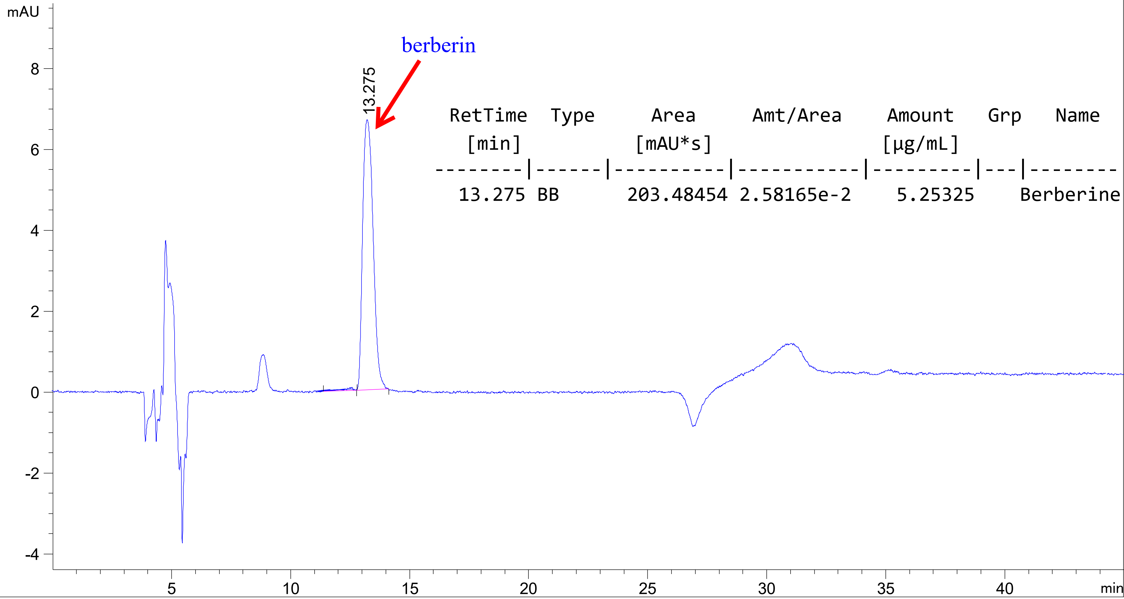
Figure 2. Analysis of berberine by HPLC. The mobile phase was ACN-H₂O:0.1% TFA in linear gradient mode as follows: 0-45 min. The flow rate was 1.5 mL/min
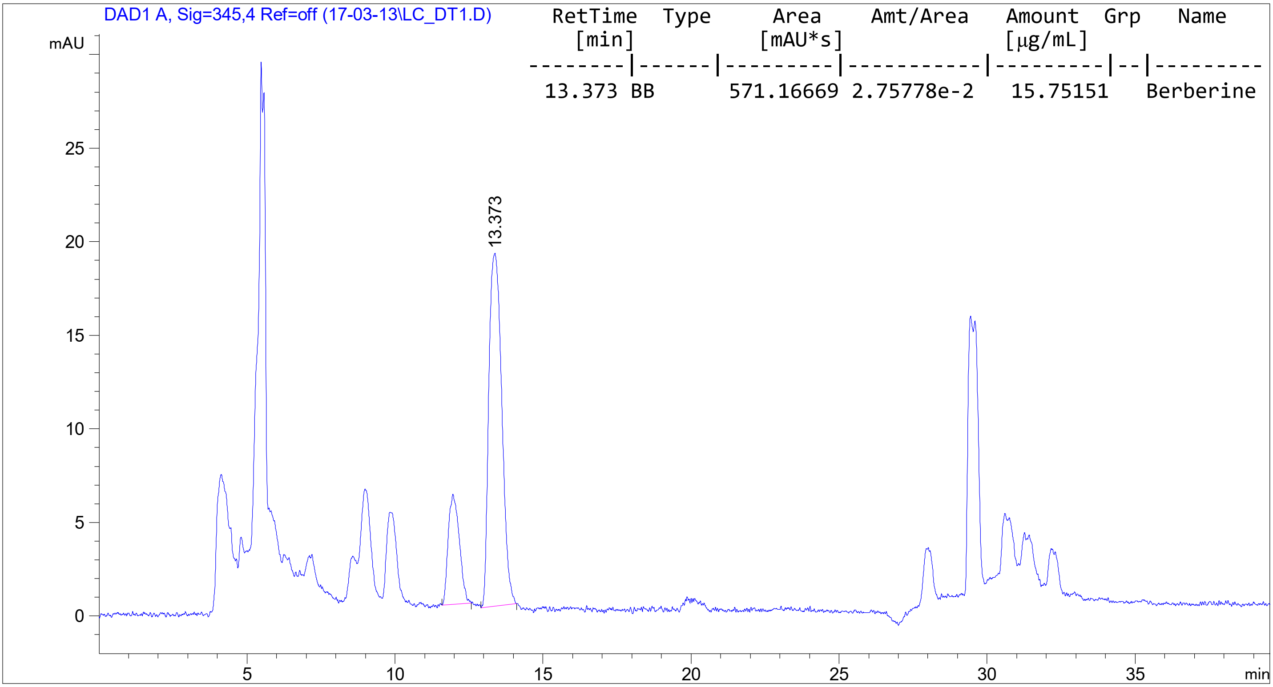
Figure 3. Chromatogram of berberine from DTBG. The mobile phase was ACN-H₂O:0.1% TFA in linear gradient mode as follows: 0-45 min. The flow rate was 1.5 mL/min

The most deshielded proton signal at δ_{H} 9.92 is assigned to H-8 due to its proximity to the positively charged N-atom. Correspondingly (Fig. 4), the signal at δ_{H} 8.97 is attributed to proton H-13 in the same aromatic ring. Signals at δ_{H} 8.21 and 8.01 form an AB-spin system with J = 9.0 Hz, easily identified as the aromatic protons H-11 and H-12. The NOESY spectrum aids in individual assignment (Fig. 5). The signal at δ_{H} 8.21 shows an NOE contact with a methoxy group at δ_{H} 4.10, thus assigned to H-11. By deduction, the methoxy signal is attributed to H-16. Two singlets at δ_{H} 7.81 and 7.12 likely belong to H-14 and H-4. NOESY spectrum confirms the assignment, as H-13 and H-14 exhibit an NOE contact. The singlet at 6.15 for two protons is assigned to H-2 based on its chemical shift, while multiplets at δ_{H} 4.95 and 3.20 are assigned to methylene protons H-6 and H-5.

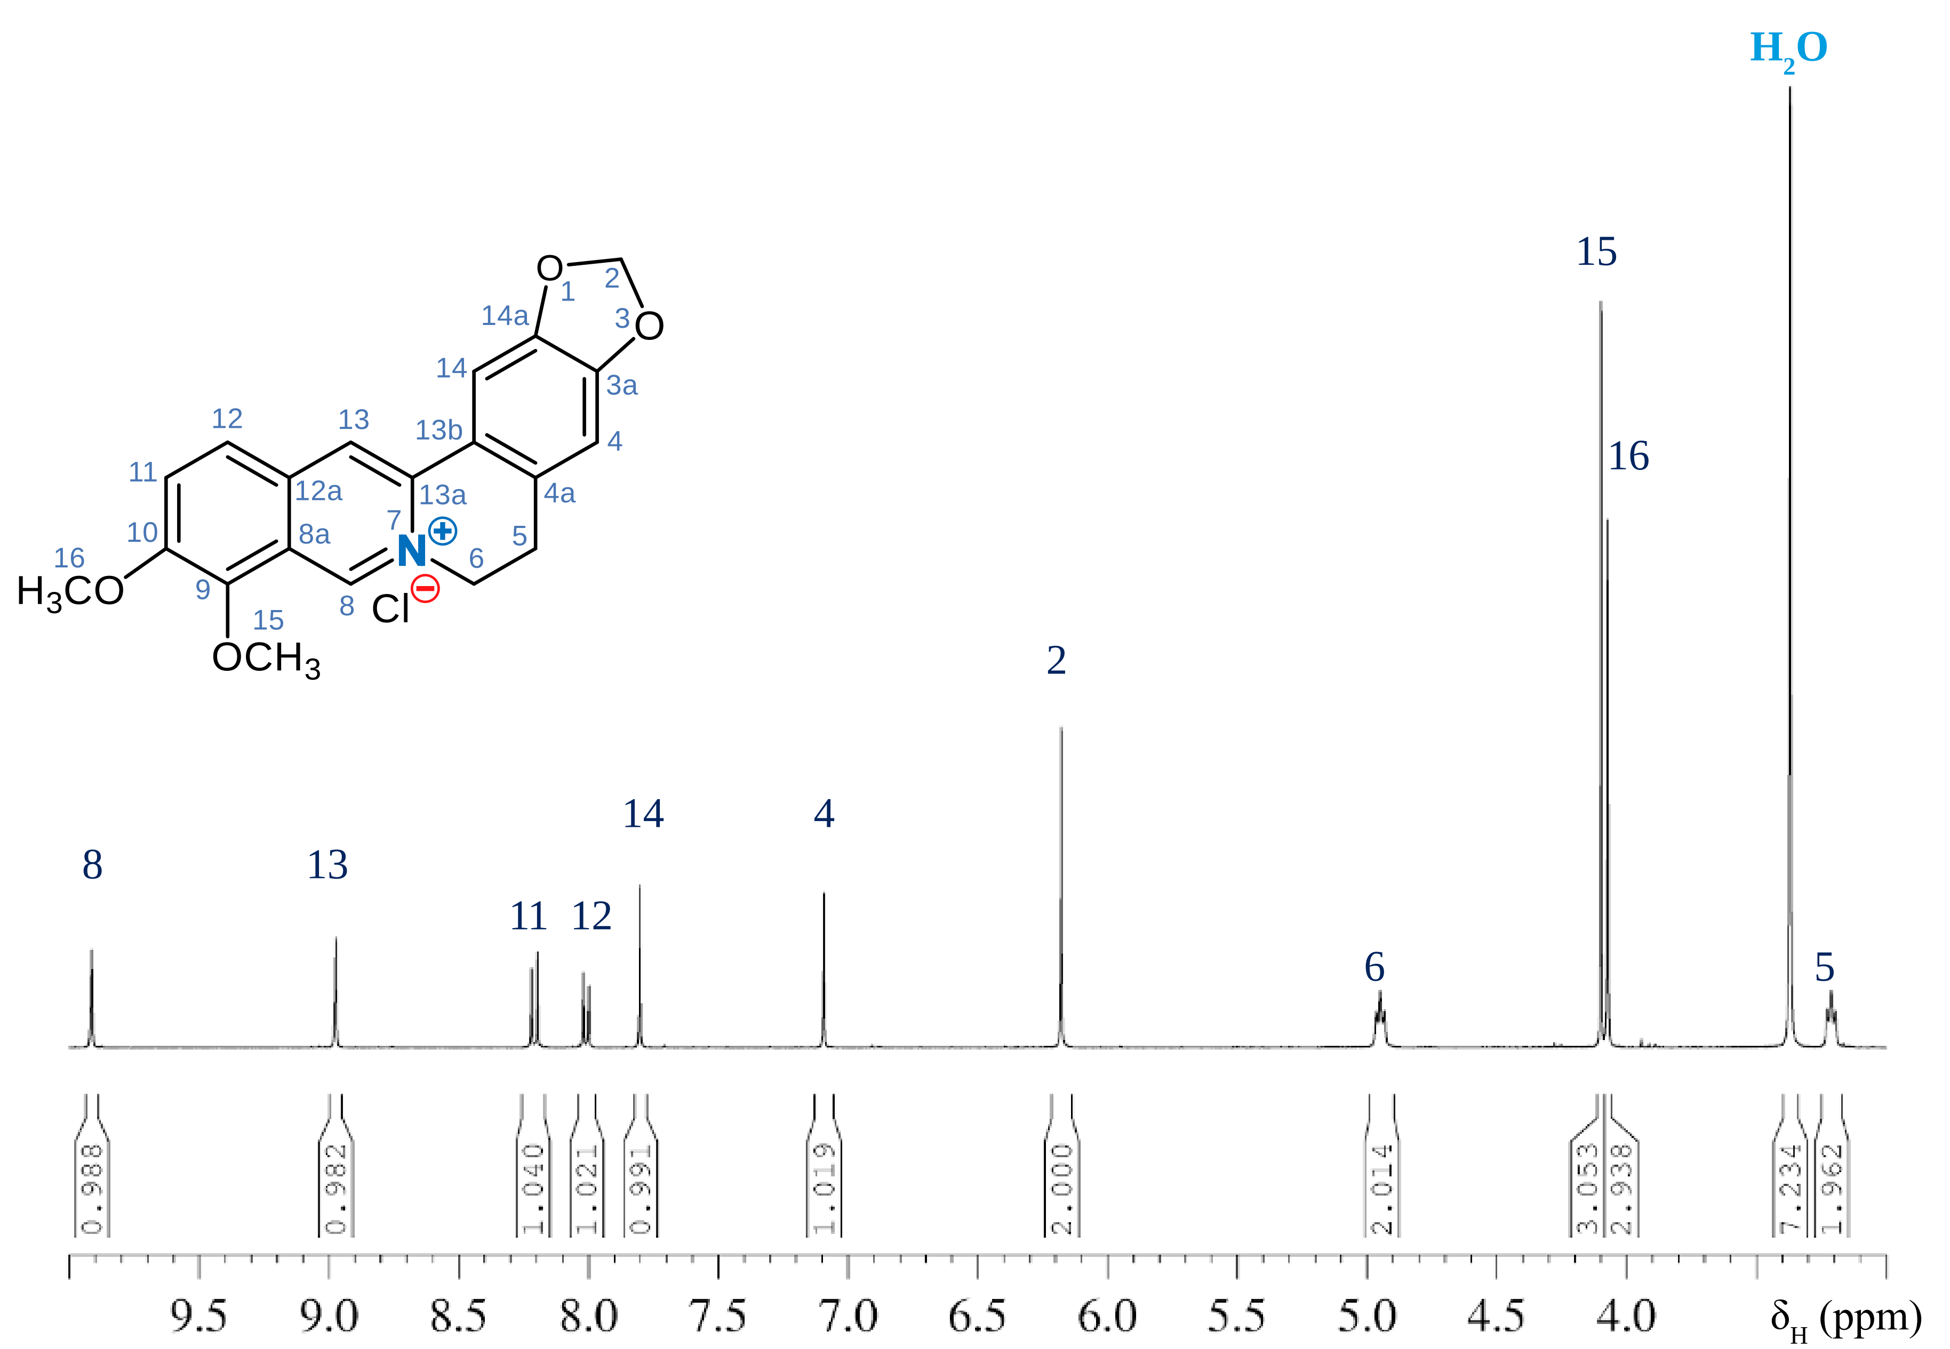
Figure 4. ¹H-NMR spectrum of berberine chloride in DMSO-d₆
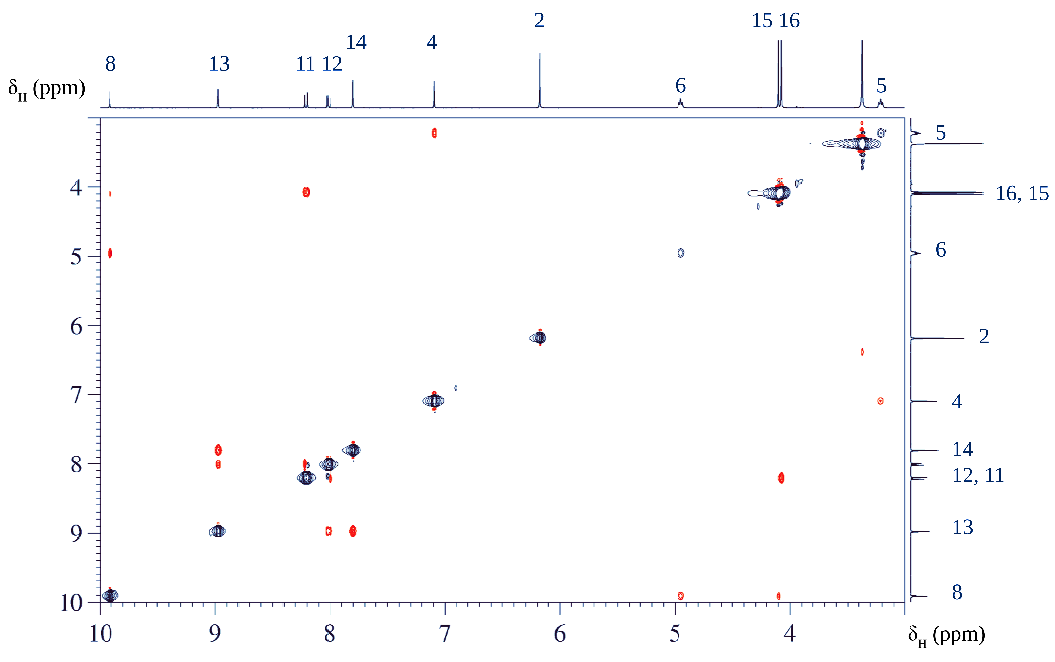
Figure 5. NOESY spectrum of berberine chloride.

Since the proton signals have been fully assigned, all C-atoms carrying protons can be identified
through the HSQC spectrum (Fig. 6). Indeed, the ¹³C chemical shifts are notably influenced by the solvent choice, leading to potential discrepancies in assignments. The measured values (Fig. 7) acquired in DMSO-d₆ align with the assignments reported by Blasko et al. [9]. However, identifying the signals corresponding to the quaternary carbon atoms remains a challenge, often requiring analysis of the HMBC spectrum for resolution.
From H-8, we anticipate five HMBC correlations (Fig. 8 and Fig. 9) to C-6, C-13a, C-12a, and C-9 over three bonds, and one to C-8a over two bonds. C-9 should also correlate with the methoxy protons H-15, as evident, hence the signal at δ_{C} 143.1 is ascribed to C-9. C-12a should also be seen from H-11. Consequently, the signal at δ_{C} 132.5 is designated for C-12a. A similar rationale applies to C-13a, which correlates with H-14; hence the signal at δ_{C} 137.0 is assigned to C-13a.

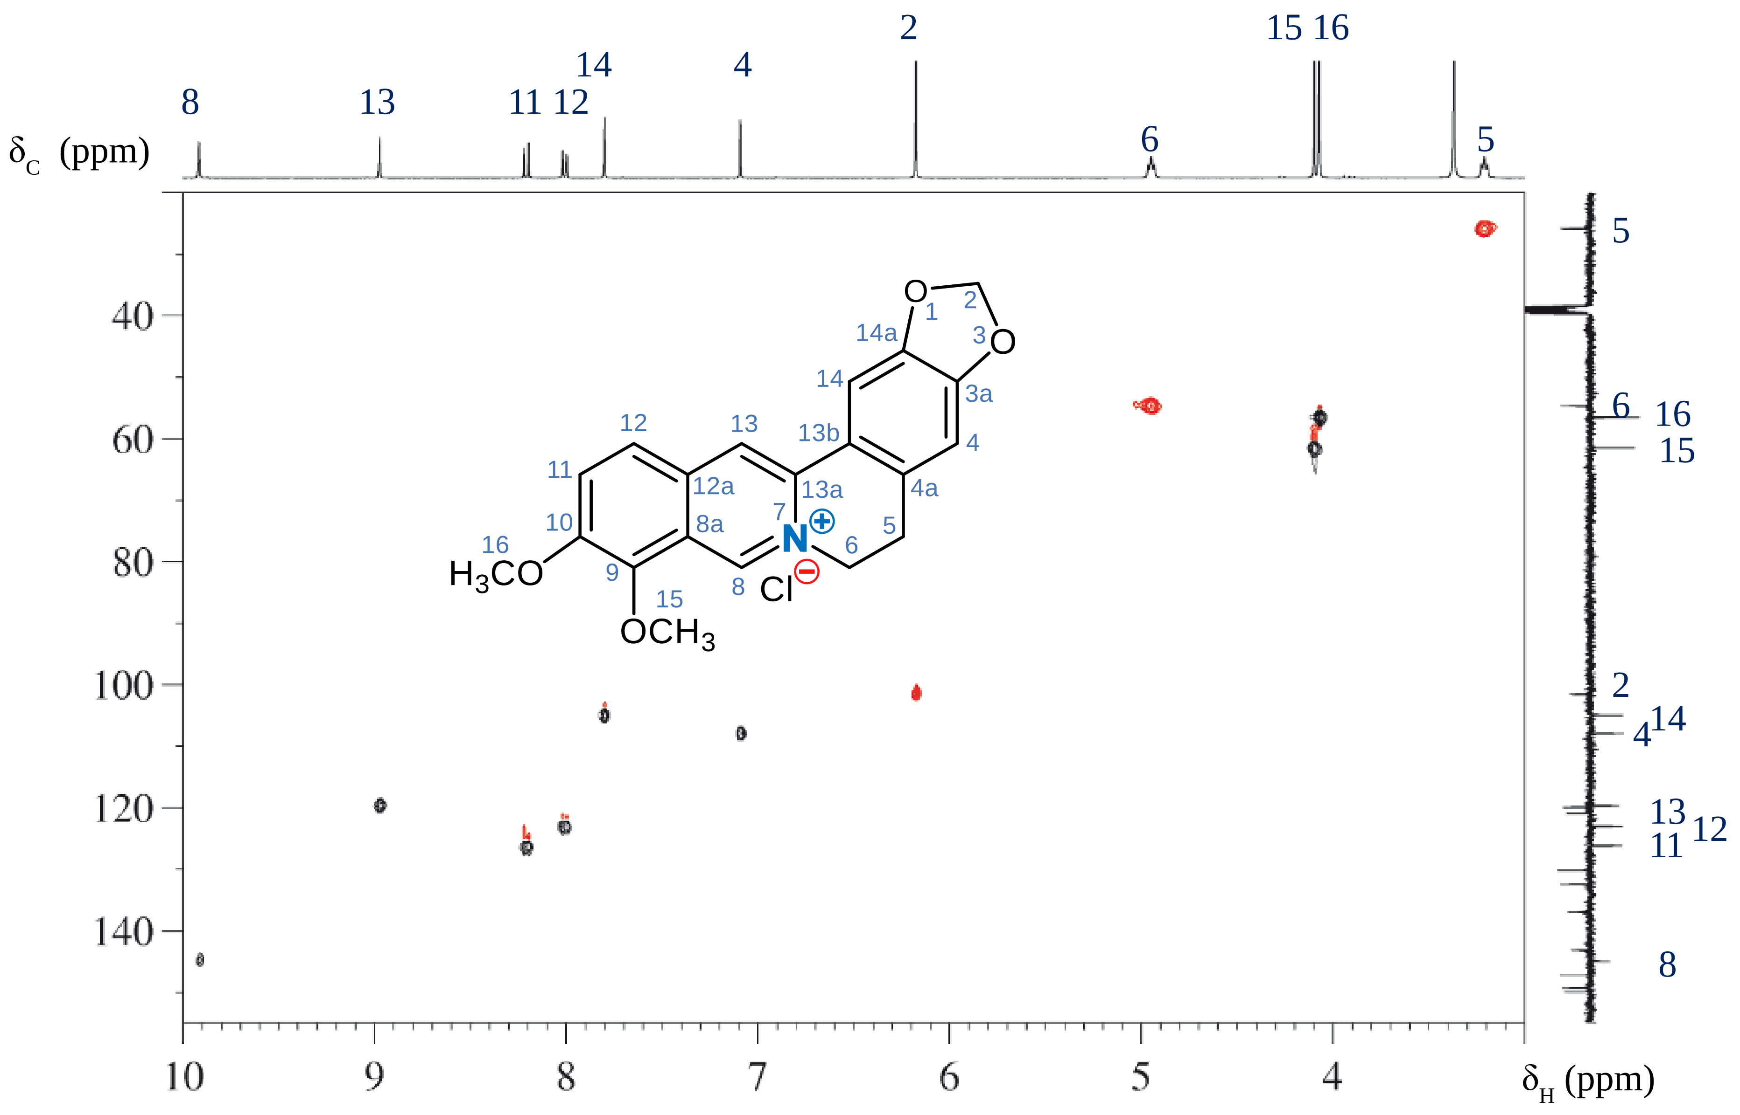
Figure 6. HSQC spectrum of berberine chloride.

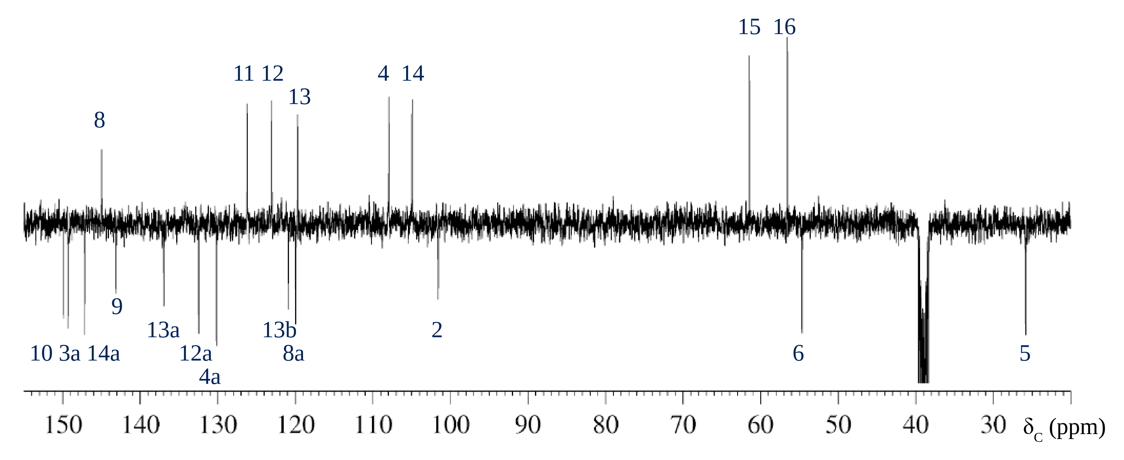
Figure 7. APT ¹³C-NMR spectrum of berberine chloride.

C-8a should be seen from H-12 and H-13, as is the case for the signal at δ_{C} 120.0, which therefore belongs to C-8a. All five HMBC correlations starting from H-8 are therefore assigned. In the linear annulated aromatic ring only the assignment of the quaternary C-atom C-10 is missing, which, however, is easily found via H-16 and H-12 at δ_{C} 149.9. The four remaining quaternary C-signals are those from C-4a, C-13b, C-14a and C-3a from the isolated aromatic ring. C-3a should correlate with H-2 and H-14. This is the case for the signal at δ_{C} 149.3. Analogously, C-14a should be linked to H-2 and H-4, this applies to the signal at δ_{C} 147.2. The signal from C-13b at δ_{C} 120.9 is recognized by H-13 and H-4. Finally, the signal from C-4a is assigned via H-14 and H-6 to δ_{C} 130.2.
The UV-Vis spectrum of berberine chloride (Fig. 10) reveals three maxima peaks at 227 nm, 252 nm, and 354 nm, characterized by the logarithm of the molar absorptivity (lgε) values of 0.75. There is also a weaker fourth peak at 423 nm, having a lgε value of 0.15. This absorption in the blue part of the visible light spectrum gives the substance its yellow color. The bands in the compound's conjugated π-system undergo a bathochromic shift due to the presence of four auxochromic oxygen substituents and the positively charged quaternary nitrogen atom.

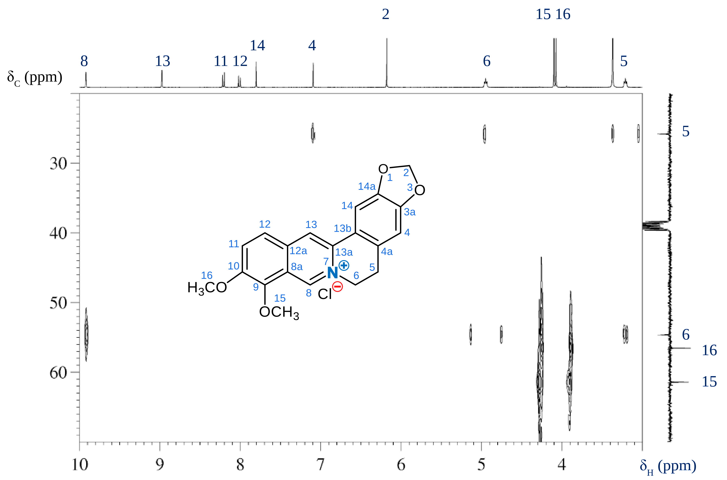
Figure 8. HBMC spectrum of berberine chloride in the aliphatic ¹³C region.

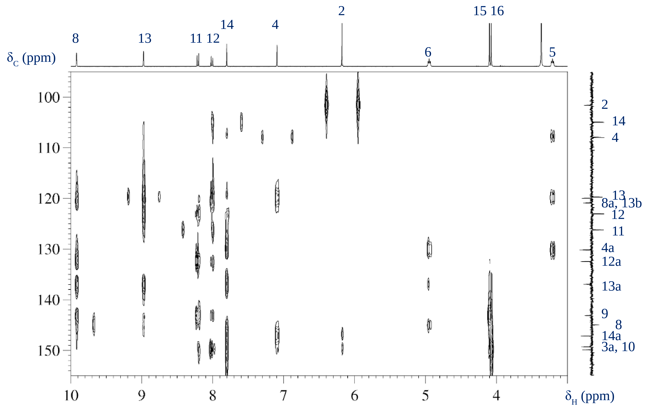
Figure 9. HBMC spectrum of berberine chloride in the aromatic ¹³C region.

The berberine chloride crystallizes with four water molecules, which explains the strong O―H vibrational band at 3200 cm^{–1} (Fig. 11) in FT-IR spectrum. The C―H stretching region indicates sp³ and sp² hybridized carbon atoms. The broad band at 1630 cm^{–1} is attributed to a C=N vibration, while the sharp band at 1600-1450 cm^{–1} corresponds to the C=C stretching of the aromatic rings.

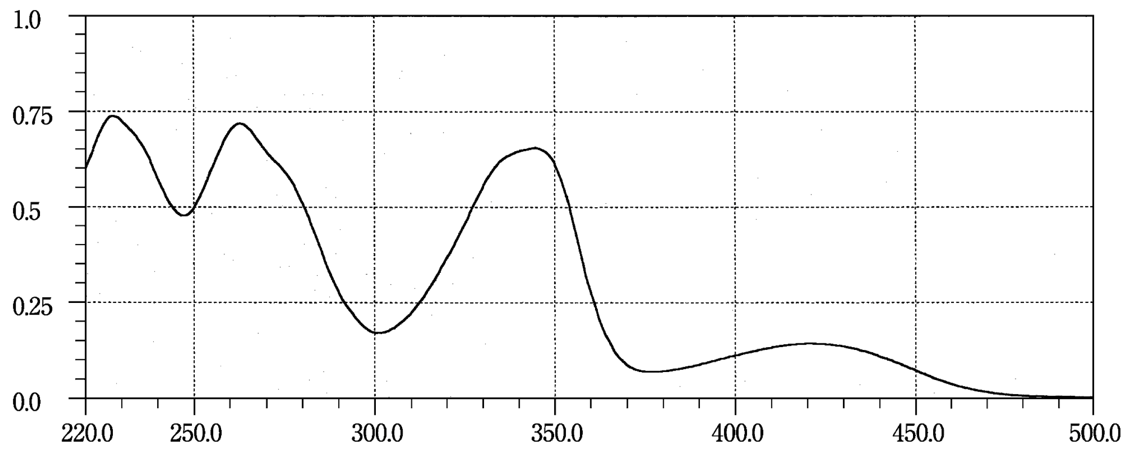
Figure 10. UV-Vis spectrum of berberine chloride

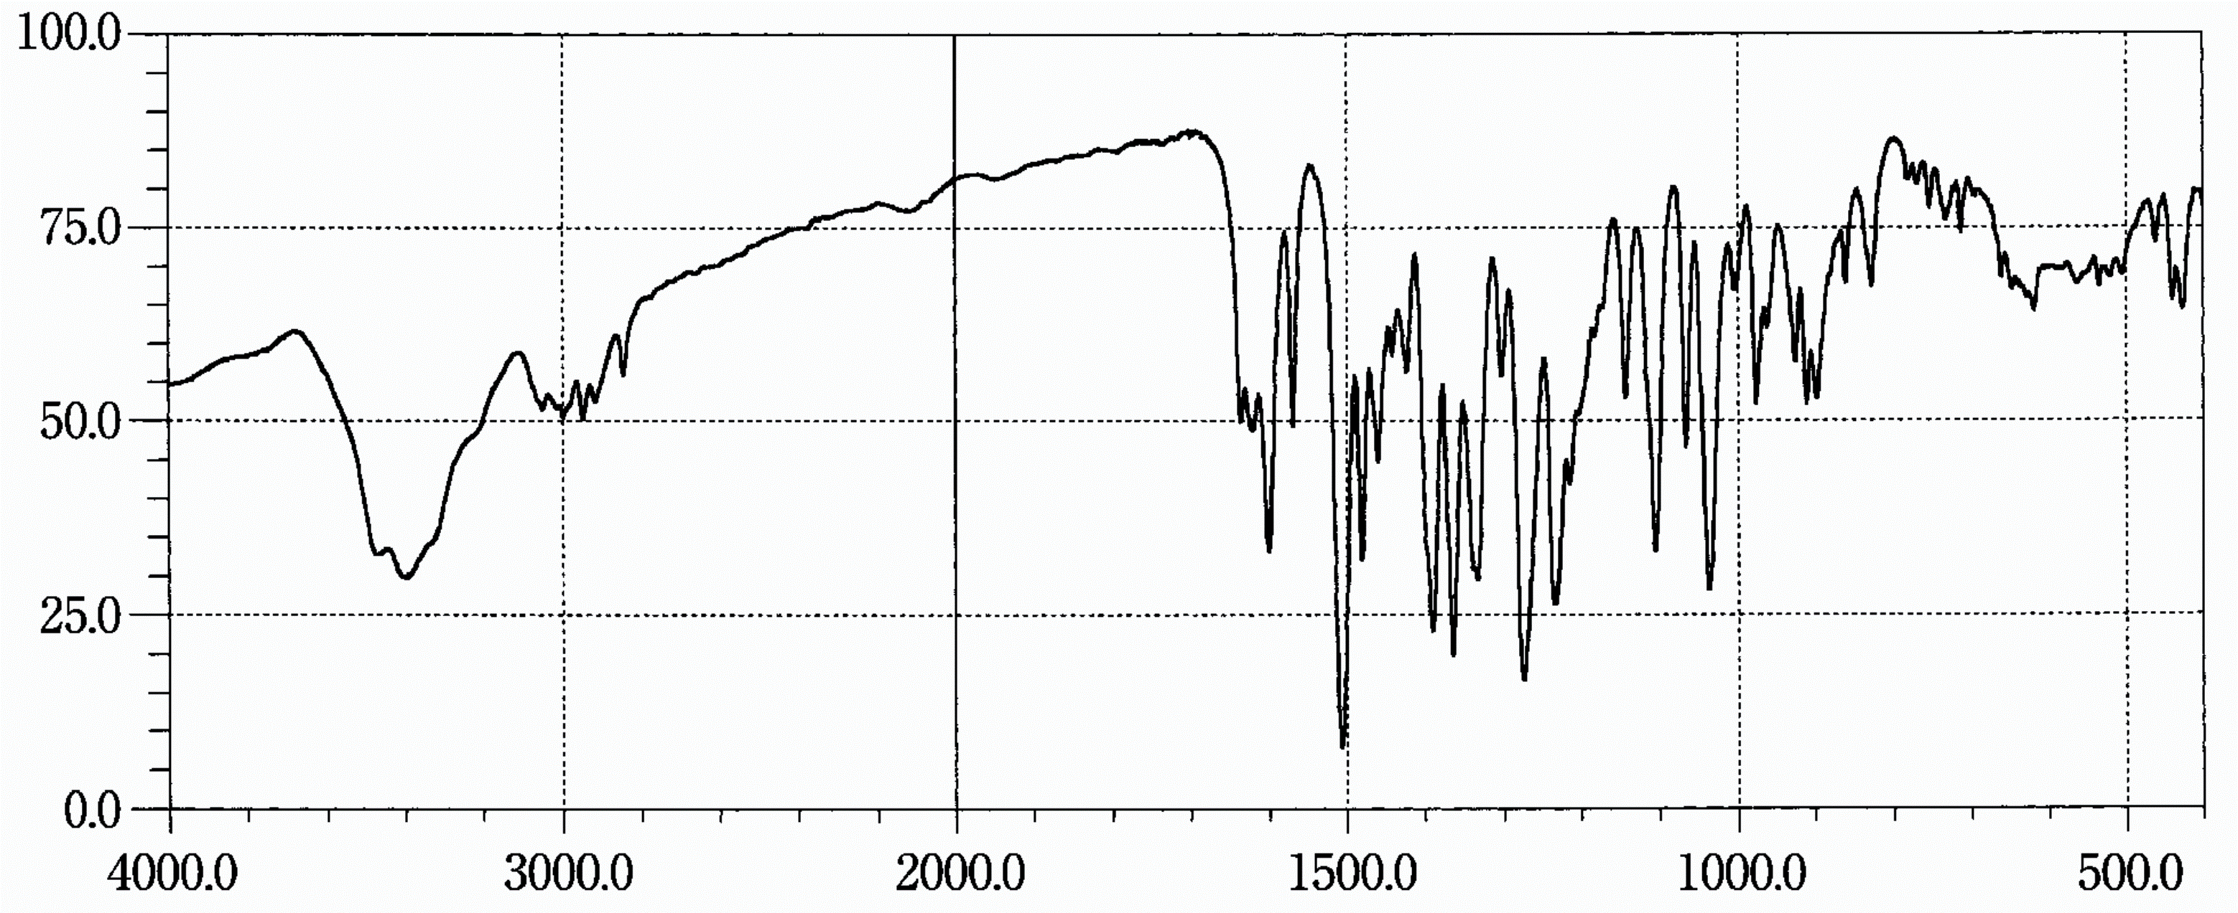
Figure 11. FT-IR spectrum of berberine chloride in KBr
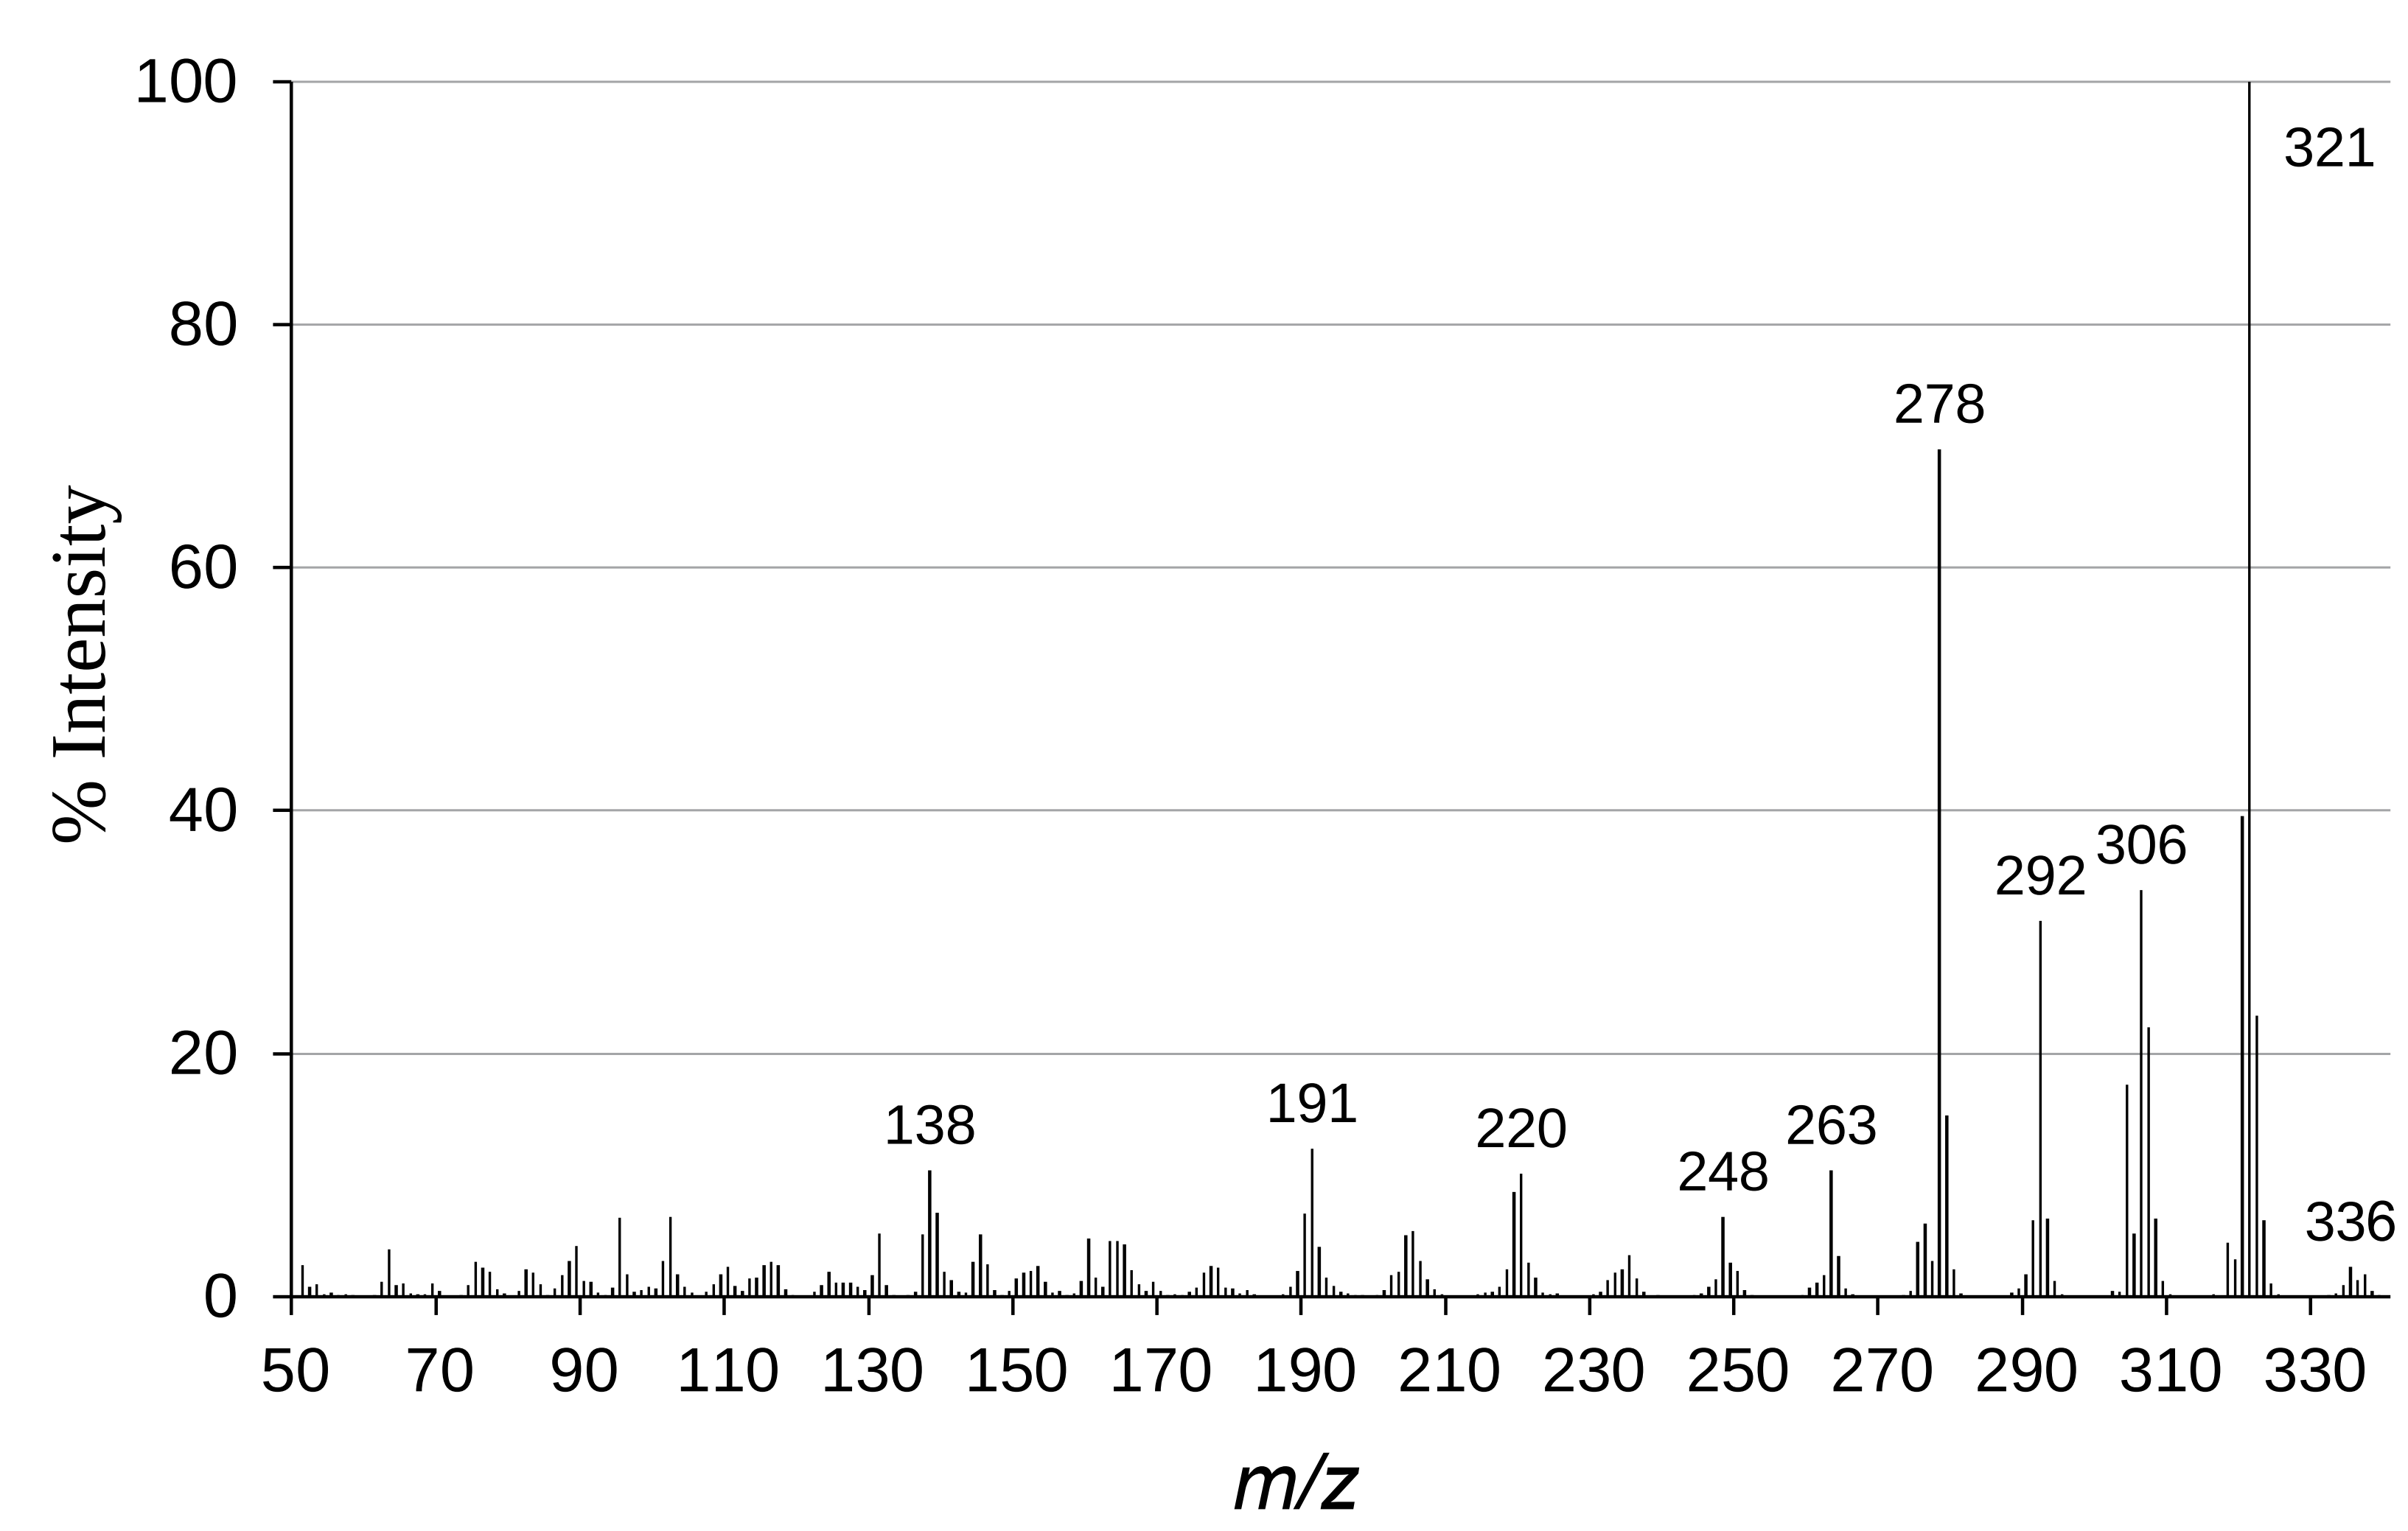
Figure 12. EI-MS spectrum of berberine chloride

Figure 13. Electron transfer in the inlet system results in the formation of ions M⁺ (m/z 336), A^{+•} (m/z 337), and B^{+•} (m/z 335).

The generation of ions seen in the mass spectrum (Fig. 12) is elucidated by the initial transfer of an electron from the anion to the cation. The cation M⁺ from berberine chloride transforms into the radical M•, which then loses the extra electron in the ion source, resulting in the detection of an ion with m/z 336 in the mass spectrum. The two associated ions with m/z 335 and 337 are produced through the disproportionation of the radical M⁺ into the neutral molecules A and B, followed by ionization (Fig. 13).
The ions at m/z 320, 304, 292, and 278 are formed through a common cleavage mechanism. It is likely that these ions, having an even number of electrons, follow similar pathways as depicted here (Fig. 14).

Figure 14. Cleavage of a methyl group from radical M• resulting in the formation of neutral molecule C and its corresponding fragment ions.

- CONCLUSION
In summary, the ¹H-NMR and ¹³C-NMR spectra of berberine chloride have been fully assigned. Comprehensive signal interpretation was conducted using various 2D-NMR spectroscopies: HSQC, NOESY, and HMBC. Furthermore, supplementary techniques including UV-Vis, FT-IR, and EI-MS were utilized, yielding precise data for the thorough structural elucidation of berberine.

REFERENCES

- R.J. Xavier, D.K. Podolsky. Unravelling the pathogenesis of inflammatory bowel disease, Nature, 2007, 448(7152), 427-434.
- B.L. Ma, Y.M. Ma, R. Shi, T.M. Wang, N. Zhang, C.H. Wang, Y. Yang. Identification of the toxic constituents in Rhizoma Coptidis. Journal of Ethnopharmacology, 2010, 128(2): 357-364.
- N. Iizuka, K. Miyamoto, K. Okita, A. Tangoku, H. Hayashi, S. Yosino, T. Abe, T. Morioka, S. Hazama, M. Oka. Inhibitory effect of Coptidis Rhizoma and berberine on the proliferation of human esophageal cancer cell lines, Cancer Letters, 2000, 148(1): 19-25.
- X. Zhou, X. Lin, Y. Xiong, L. Jiang, W. Li, J. Li, L. Wu. Chondroprotective effects of palmatine on osteo arthritis in vivo and in vitro: A possible mechanism of inhibiting the Wnt/β-catenin and Hedgehog signaling pathways, International Immunopharmacology, 2016, 34, 129-138.
- C.M. Yao, X.W. Yang. Bioactivity-guided isolation of polyacetylenes with inhibitory activity against NO production in LPS-activated RAW264.7 macrophages from the rhizomes of Atractylodes macrocephala. Journal of Ethnopharmacology, 2014, 151(1), 791-799.
- N. Zhang, C. Liu, T.M. Sun, X.K. Ran, T.G. Kang, D.Q. Dou. Two new compounds from Atractylodes macrocephala with neuroprotective activity, Journal of Asian Natural Products Research, 2017, 19(1), 35-41.
- L.S. Hoang, M.H. Tran, J.S. Lee, T.Q.M. Ngo, M.H. Woo, B.S. Min. Inflammatory Inhibitory Activity of Sesquiterpenoids from Atractylodes macrocephala Rhizomes, Pharmaceutical Society of Japan, 2016, 64(5), 507-511.
- H.L. Huang, T.W. Lin, Y.L. Huang, R.L. Huang, Induction of apoptosis and differentiation by atractylenolide-1 isolated from Atractylodes macrocephala in human leukemia cells, Bioorganic & Medicinal Chemistry Letters, 2016, 26(8), 1905-1909.
- G. Blaskó, G.A. Cordell, S. Bhamarapravati, C.W.W. Beecher. Carbon-13 NMR Assignments of Berberine and Sanguinarine. Heterocycles, 1988, 27, 911–916.
- R. Marek, P. Seckarova, D. Hulova, J. Marek, J. Dosta, V. Sklenar. Palmatine and Berberine Isolation Artifacts, Journal of Natural Products, 2003, 66, 481–486.

* Tác giả liên hệ chính. Email: nhoangsa@gmail.com
Corresponding author Email: nhoangsa@gmail.com

