Nghiên cứu khả năng hấp phụ và tách lọc carbon dioxide
của vật liệu MIL-53(Cr) bằng phương pháp mô phỏng cổ điển

Nguyễn Thị Xuân Huynh^{1,2,}*, Trần Thị Diễm Thanh^{1,2}, Nguyễn Lê Bảo Trân^{1,2}, Nguyễn Ngọc Khoa Trường¹

¹Khoa Khoa học Tự nhiên, Trường Đại học Quy Nhơn, 170 An Dương Vương, Quy Nhơn, Bình Định
²Phòng Hóa tính toán và Mô phỏng, Trường Đại học Quy Nhơn, 170 An Dương Vương, Quy Nhơn, Bình Định

*Tác giả liên hệ chính. Email: nguyenthixuanhuynh@qnu.edu.vn

TÓM TẮT
Nồng độ khí CO₂ đang tăng rất nhanh đe dọa sự nóng lên toàn cầu, cảnh báo đến môi trường và sức khỏe của con người. Do đó, việc làm giảm hoặc chuyển đổi CO₂ thành các hợp chất có giá trị là hết sức cấp thiết. Trong những thập kỷ gần đây, việc ứng dụng các vật liệu có độ xốp cao như vật liệu khung hữu cơ kim loại (MOF) để hấp phụ và tách lọc khí CO₂ đang rất thu hút. Trong nhóm MOF, vật liệu MIL, điển hình là MIL-53(Cr) rất được chú ý với khả năng hấp phụ và tách lọc cao nhờ vào tính ổn định nhiệt, diện tích bề mặt riêng rất lớn và chứa các vị trí kim loại mở, v.v. Do vậy, nghiên cứu này sử dụng chính phương pháp mô phỏng Monte Carlo chính tắc lớn, một phương pháp mô phỏng phân tử cổ điển, để tính lượng khí hấp phụ trong MIL-53(Cr) và làm sáng tỏ khả năng hấp phụ CO₂ và tách lọc CO₂/H₂ ở nhiệt độ phòng và áp suất dưới 50 bar. Kết quả chỉ ra khả năng hấp phụ CO₂ và tách lọc CO₂/H₂ của MIL-53(Cr) được đánh giá cao. Cụ thể, lượng khí hấp phụ CO₂ tinh khiết trong MIL-53(Cr) đạt đến 9,18 mmol/g ở 298 K và 50 bar. Độ tách lọc CO₂/H₂ lớn nhất, $S_{CO_{2}/H_{2}(max)},$ của MIL-53(Cr) đạt 116 ở 298 K. Nghiên cứu cũng chỉ ra tỉ lệ mol CO₂:H₂ gần như không làm thay đổi giá trị $S_{CO_{2}/H_{2}(max)}$ mà chỉ làm thay đổi áp suất đạt $S_{CO_{2}/H_{2}(max)}$ đó. Hơn nữa, việc giảm nhiệt độ cũng làm tăng đáng kể khả năng tách lọc khí CO₂/H₂, cụ thể $S_{CO_{2}/H_{2}(max)}$ = 245 khi giảm nhiệt độ đến 273 K.
Từ khóa: Hấp phụ CO₂, Bắt giữ CO₂, Tách lọc CO₂/H₂, Vật liệu MIL-53, Mô phỏng cổ điển.

A classical simulation study for carbon dioxide adsorption and separation capacity of MIL-53(Cr)

Nguyen Thi Xuan Huynh^{1,2,}*, Tran Thi Diem Thanh^{1,2}, Nguyen Le Bao Tran^{1,2}, and Nguyen Ngoc Khoa Truong¹

¹Faculty of Natural Sciences, Quy Nhon University, 170 An Duong Vuong, Quy Nhon, Binh Dinh
²Lab of Computational Chemistry and Modelling, Quy Nhon University, 170 An Duong Vuong, Quy Nhon, Binh Dinh

*Corresponding author. Email: nguyenthixuanhuynh@qnu.edu.vn

ABSTRACT
cm)
Carbon dioxide (CO₂) concentrations are increasing, threatening global warming limits and leading to an alarming impact on the environment and human health. Therefore, reducing or converting CO₂ into high-value chemicals is necessary. In recent decades, CO₂ capture and separation based on the adsorption of highly porous materials, especially metal-organic framework (MOF) materials, has become very attractive. Among MOFs, MIL material, notably MIL-53(Cr), has been a top concern for its noteworthy adsorption and separation capacity due to its thermal stability, ultra-high specific surface, open metal sites, and more. Therefore, this work mainly uses grand canonical Monte Carlo simulation, a classical molecular simulation method, to calculate the amount of gas adsorbed in MIL-53(Cr) and study CO₂ adsorption and CO₂/H₂ separation capacity in the mixture of hydrogen (H₂) and CO₂ at room temperatures and low pressures below 50 bar via adsorption isotherms. This research explored the high CO₂ adsorption capacity and the impressive CO₂/H₂ selectivity of MIL-53(Cr). For pure CO₂, the absolute CO₂ uptake in MIL-53(Cr) is 9.18 mmol/g at 298 K and 50 bar. Besides, the maximum CO₂/H₂ selectivity of MIL-53(Cr) is $S_{CO_{2}/H_{2}(max)}=$ 116 at 298 K. Remarkably, the CO₂/H₂ mole fraction has almost no effect on the value of the maximum SO₂/H₂ separation, $S_{CO_{2}/H_{2}(max)}$, but leads to the change of pressure reaching $S_{CO_{2}/H_{2}(max)}$. Furthermore, reducing the temperature significantly increases the separation capacity of CO₂/H₂, specifically $S_{CO_{2}/H_{2}(max)}=$ 245 when the temperature drops to 273 K.
Keywords: CO₂ adsorption, CO₂ capture, CO₂/H₂ selectivity, MIL-53 material, classical simulations.

1. INTRODUCTION
Fossil fuels are our primary energy source, and their consumption is increasingly uncontrollable. This problem has a significantly negative impact on the environment and human health due to the increasing amount of emissions such as CO₂, CO, NO_{x}, and more, and causes severe energy shortage issues. Furthermore, CO₂ capture, H₂ purification, and CO₂ separation over H₂ are significant in combustion plants and refineries.^{1–3} To overcome those problems, the demands for clean energy production, gas separation, and efficient storage have grown dramatically. Tremendous advances have been achieved in both theory and experiments thanks to the outstanding properties of porous materials.^{4–6}
Metal-organic framework (MOF), a new type of inorganic-organic hybrid porous material with a periodic network, appears as a potential technology.^{6–9} Since the early 1990s, MOFs have gained increasing attention, leading to more MOFs have been successfully synthesized by experiments and proposed by simulation methods. Researchers have successfully synthesized about 100,000 MOFs through experiments and have predicted over 500,000 structures by simulations or theories, but only nearly 3,500 works related to MOFs have been published.^{10,11}
MILs (Material Institute of Lavoisiers), a class of MOFs, have gained recognition as promising adsorbents for H₂ purification and CO₂ capture thanks to unique properties such as extraordinary chemical and thermal properties, water stability, ultra-large specific surface areas, high porosity, coordinately unsaturated or open metal sites, and more.^{12–15} In 2002, the first MIL, published by Ferey and co-workers, was the MIL-53 with M = chromium(III) (Cr³⁺).^{16,17} MIL-53, obtained by the hydrothermal method, has many potential applications because of its good thermal stability and flexibility compared to other MOFs.^{18,19} Several works have displayed that MIL-53 (Cr or Al) materials have superior CO₂ capture^{20–22} and high selective adsorption for binary mixtures such as CO₂/H₂, CO₂/CH₄, and CO₂/N₂.^{19,23,24}
Due to the potential of MIL-53, in this work, we use the classical grand canonical Monte Carlo (GCMC) simulation (a suitable approach to simulate the equilibrium of the physisorption of small molecules in porous at well-defined pressure and temperature) to study the capacities of CO₂ capture and CO₂/H₂ separation on MIL-53(Cr).
2. COMPUTATIONAL APPROACHES
GCMC simulations are carried out using the RASPA software²⁵ to calculate the gravimetric amount of gases (CO₂ and H₂) adsorbed in a solid porous material, MIL-53(Cr), at room temperature and pressure up to 50 bar. The GCMC simulations run up to 3.0 $×$10⁵ cycles after an initial equilibration of 1.5$×$10⁴ steps.
In order to obtain the simulation box for GCMC, a unit cell of MIL-53 (including 20 hydrogen, 32 carbon, 20 oxygen, and 4 chromium) was optimized using the density functional theory (DFT),²⁶ and then repeated the unit cell to 2, 2, and 4 times for $a$, $b$, and $c$ lengths (Å, Å, Å), leading to Å, Å, and Å, respectively (Figure 1).
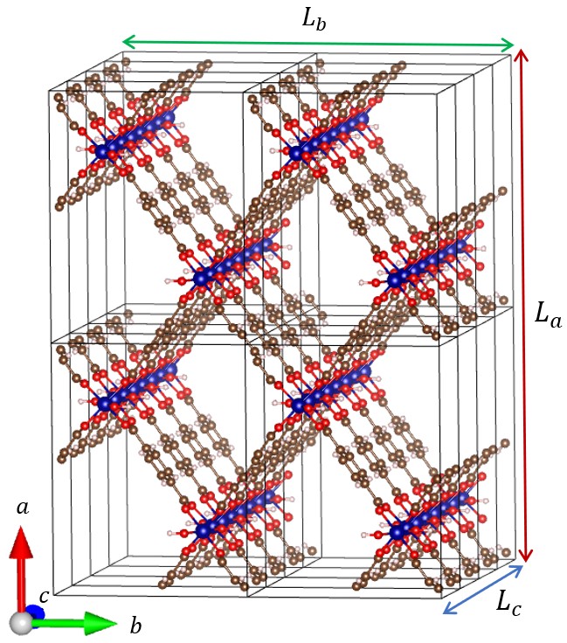
Figure 1. The simulation box of MIL-53(Cr). Each rectangular cubic represents a unit cell.
The interactions between gases (CO₂, H₂) and MIL-53(Cr) include (i) van der Waals (vdW) interactions using the Lennard-Jones (LJ) model and (ii) electrostatic interactions.
First, the LJ 12-6 repulsive and attractive interactions between pairs of atoms of gases and MIL-53 are presented by
, (1)
herein, ε_{ij} and σ_{ij} are pair LJ parameters, calculated using the pair combining rule of Lorentz and Berthelot,²⁵ in which σ_{i} and ε_{i} are taken from the force fields for MOFs with universal force field for metal (Cr) and DREIDING for other elements of MIL-53 (H, C, O),²⁷ listed in Table 1. The cut-off radius used for the vdW interaction is 16 Å, tested for reliability.
Second, electrostatic or Coulomb interactions between pairs of atoms are as follows:
, (2)
where k_{c} is the Coulomb constant and q_{i} is the partial point charge of atom i, calculated by the DFT-based density-derived electrostatic and chemical charges (Table 1 with the labeled atoms as in Figure 2).²⁸ Additionally, TraPPE force fields are used for CO₂ and H₂ (Table 1).
The adsorption separation or selectivity of CO₂ over H₂ (CO₂/H₂) in their mixture is calculated via the formula¹³
, (3)
where and are the amount of adsorbed CO₂ and H₂ (mol/g) in MIL-53, respectively; and are mole fractions of the CO₂ and H₂ components in the mixture, respectively. The investigated molar fractions of CO₂:H₂ includes 1:9, 2:8, 3:7, 4:6, 5:5, 6:4, 7:3, 8:2, 9:1.
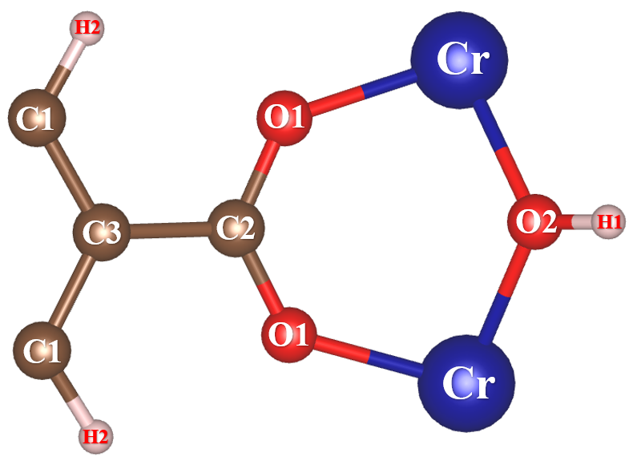
Figure 2. The labeled atoms of MIL-53(Cr), where hydrogen (H), carbon (C), oxygen (O), and chromium (Cr) atoms are displayed by soft pink, brown, red, and blue balls, successively.

Table 1. LJ parameters and partial atomic charges of MIL-53 and gases (H₂ and CO₂).
Atoms | ε/k_{B} (K) | σ (nm) | Partial point charges (e)
Cr | 7.548 | 0.269 | +1.581
H1 | 7.649 | 0.285 | +0.414
H2 | 7.649 | 0.285 | +0.100
C1 | 47.856 | 0.347 | -0.077
C2 | 47.856 | 0.347 | +0.636
C3 | 47.856 | 0.347 | -0.033
O1 | 48.158 | 0.303 | -0.589
O2 | 48.158 | 0.303 | -0.938
C [CO₂]²⁹ | 27.000 | 0.280 | +0.700
O [CO₂]²⁹ | 79.000 | 0.305 | -0.350
H_{COM} [H₂]³⁰ | 36.700 | 0.296 | -0.936
H [H₂]³⁰ | - | - | +0.468

3. RESULTS AND DISCUSSION
3.1. CO₂ adsorption of MIL-53(Cr)
Firstly, the absolute CO₂ adsorption capacity or uptake is determined and compared with available experimental data. The results (Figure 3) show that the CO₂ uptake increases rapidly in the pressure region below 5 bar, then increases slightly with increasing pressure. The absolute CO₂ uptake is 9.18 ± 0.02 mmol/g or ​​403.70 ± 0.88 mg/g at the maximum pressure of 50 bar (blue solid line). However, the maximum excess CO₂ uptake is 8.02 ± 0.02 mmol/g or 387.23 ± 0.93 mg/g at the saturated pressure of 30 bar (red dashed line). Our findings show that the absolute amount of CO₂ adsorption on MIL-53(Cr) is consistent with the available data of Bourrelly et al., about 10 mmol/g at 30 bar and 304 K.²⁰ Moreover, the obtained CO₂ adsorption heat of MIL-53(Cr) is 30.04 kJ/mol, consistent with data of Bourrelly and co-workers (about 32 kJ/mol).²⁰ We also find that, at 298 K, the absolute CO₂ adsorption isotherm obtained from molecular simulations (blue line with solid circles) also agrees well with that of the Schneemann group (back open circles for experimental data) (Figure 3).³¹ These agreements between simulation and experimental measures indicate the reliability of the GCMC simulations.
At room temperature, MIL-53(Cr) is not able to capture CO₂ as strongly as the most highly evaluated MOFs available today, such as MOF-200 (2400 mg/g at 50 bar), MOF-210 (2396 mg/g at 50 bar), MOF-117 (33.5 mmol/g), MIL-100(Cr) (18 mmol/g), and more;¹⁴ however, these results are comparable to the MIL-88 series (4.0 – 12.1 mmol/g), relatively well recorded for CO₂ uptake with the isosteric heat of adsorption of the MIL-88 series (31.8 – 34.9 kJ/mol).¹⁴
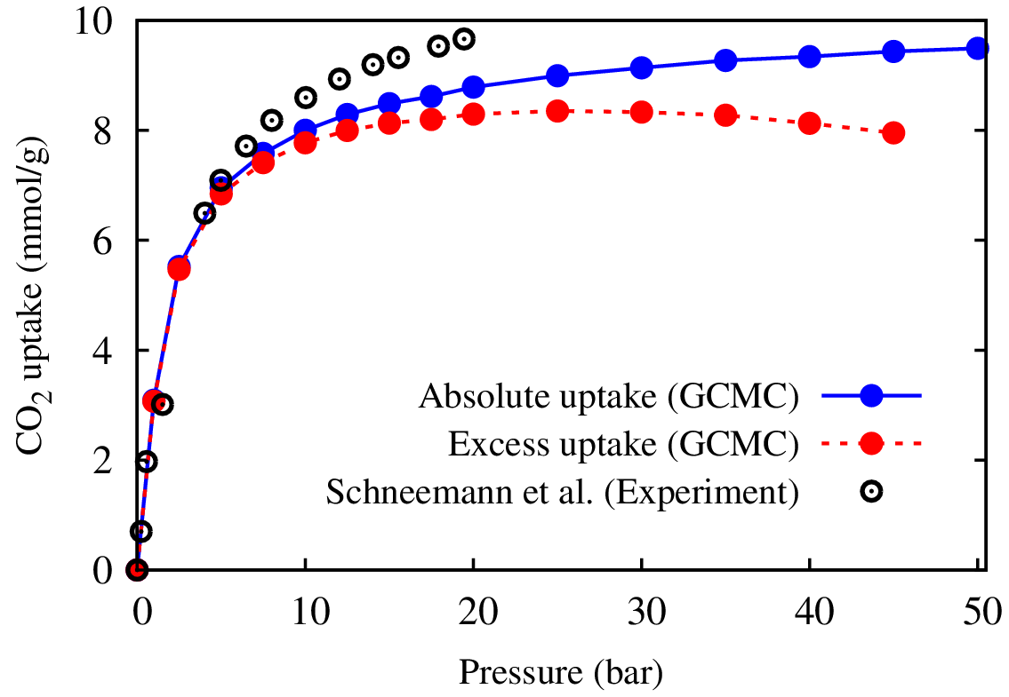
Figure 3. The comparison of the absolute CO₂ adsorption capacity on MIL-53(Cr) at 298 K between GCMC simulation and experimental data.³¹
Next, we study the co-adsorption capacity of MIL-53 for H₂ and CO₂ in the binary mixture at many different mole fractions (CO₂:H₂ = 1:9, 2:8, 3:7, 4:6, 5:5, 6:4, 7:3, 8:2, 9:1) at 298 K and pressures below 50 bar (Figure 4 and Table 2). At 298 K, our simulations also exhibit that the uptake of CO₂ is much higher than that of H₂. This conclusion is reasonable because the average adsorption heat of CO₂ (30.04 kJ/mol) is more than two times higher than that of H₂ (12.87 kJ/mol) in the low-pressure range. Indeed, Figure 4 shows that MIL-53(Cr) adsorbs CO₂
(9.16 $→$ 6.26 mmol/g) superiorly than H₂
(0.02 $→$ 0.55 mmol/g) when the molar ratio of CO₂:H₂ changes from 1:9 $→$ 9:1. The exciting result is that the CO₂ uptake insignificantly changes when the molar ratio of H₂ is less than or equal to 60% in the mixture. For example, the CO₂ uptake decreases from 9.18 mol/g for pure CO₂ adsorption to 8.37 mmol/g for the case of CO₂:H₂ = 4:6 (40% CO₂ and 60% H₂), making an only 8.82% reduction compared to pure CO₂. The presence of a high mole fraction of H₂ in the mixture leads to a significant decrease in CO₂ uptake of MIL-53(Cr). More specifically, compared to pure CO₂ uptake (9.18 mmol/g), the CO₂ uptake decreases by 12.64% to 8.02 mmol/g, 18.52% to 7.48 mmol/g, and 31.81% to 6.26 mmol/g when the molar ratio of H₂ in the binary mixture occupies 70% (CO₂:H₂ = 3:7), 80% (CO₂:H₂ = 2:8), and 90% (CO₂:H₂ = 1:9) (Table 2), respectively. These impressive results demonstrate that MIL-53(Cr) has stable and good selective adsorption for CO₂ over H₂ in their binary mixture.
Table 2. The absolute CO₂ and H₂ uptakes of MIL-53(Cr) with the different mole fractions of CO₂:H₂, compared to pure CO₂ uptake at room temperature.
CO₂:H₂ mole- fraction | CO₂ uptake  (50 bar) | Decrease in comparison to pure CO₂ (%) | H₂ uptake  (50 bar)
Pure CO₂ | 9.18 |  | -
Pure CO₂ | 10 (30 bar)²⁰ |  | -
9:1 | 9.16 | 0.22 | 0.02
8:2 | 9.08 | 1.09 | 0.04
7:3 | 8.95 | 2.51 | 0.06
6:4 | 8.80 | 4.14 | 0.09
5:5 | 8.61 | 6.21 | 0.12
4:6 | 8.37 | 8.82 | 0.16
3:7 | 8.02 | 12.64 | 0.22
2:8 | 7.48 | 18.52 | 0.32
1:9 | 6.26 | 31.81 | 0.55
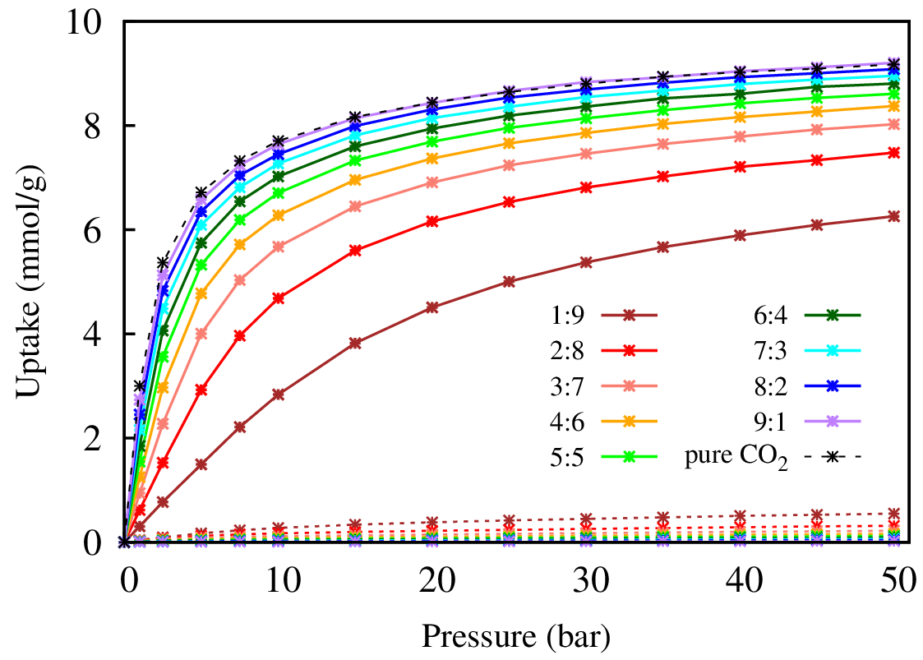
Figure 4. The CO₂ and H₂ co-adsorption isotherms of MIL-53(Cr) at 298 K with different CO₂:H₂ ratios from 1:9 to 9:1. Solid and dot lines refer to the adsorption amount of CO₂ and H₂ on MIL-53(Cr). The black dashed line represents pure CO₂ adsorption on MIL-53(Cr).
3.2. CO₂/H₂ separation of MIL-53(Cr)
From Figure 5a, it is evident that at 298 K, the highest selectivity achieved for each CO₂:H₂ mole-fraction greatly depends on pressure. Specifically, the CO₂/H₂ selectivity sharply increases at low pressure, peaks at the maximum CO₂/H₂ selectivity [$S_{{CO_{2}}/{H_{2}}(max)}$], and then gradually decreases with pressure to 50 bar. As a result, the maximum CO₂/H₂ selectivity varies for CO₂:H₂ mole ratios, listed in Column 3 of Table 3 (298 K). In addition, the pressure corresponding to the maximum CO₂/H₂ selectivity decreases with an increase in CO₂ mole fraction and a decrease in H₂ mole fraction. More detail, the maximum selectivity $S_{{CO_{2}}/{H_{2}}(max)}=$ 107.87 at 25 bar for CO₂:H₂ = 1:9, 114.30 at 15 bar for CO₂:H₂ = 2:8, …, and 118.25 at 5 bar for CO₂:H₂ = 9:1 (at 298 K of Table 3). Surprisingly, the maximum CO₂/H₂ selectivity in MIL-53(Cr) remains nearly consistent regardless of the change in the molar ratio between CO₂ and H₂, averaging $S_{CO_{2}/H_{2}}=$ 116 at 298 K (pink line in Figure 6). This tendency is similar to the case of MOF-5 and Cu-BTC studied by experiments.^{32,33} Remarkably, our data also shows that the CO₂/H₂ selectivity, $S_{{CO_{2}}/{H_{2}}}$ of MIL-53(Cr) is higher to that of many previous MOFs, such as microporous silica (3.5), activated carbon (45.0), zeolites Na-4A (70.7), Cu-BTC (150 at 12.5 bar), MOF-5 (36 at 50 bar)³² and IR-MOF-n with $n=9, 10,⋯,14$ ( ≤ 100).³³
Furthermore, our study delves into the influence of temperature on the selectivity of CO₂/H₂ in MIL-53(Cr). To accomplish this, we perform further investigation at temperatures of 273 K, 323 K, and 348 K surrounding 298 K, visualized in Figure 5b, c, and d, respectively. Our results show the pressure with the maximal value of $S_{CO_{2}/H_{2}}$ decreases with the lowering temperature (Figure 5 and Table 3). For instance, at CO₂:H₂ = 5:5, the maximum selectivities are $S_{{CO_{2}}/{H_{2}}(max)}=$ 39.81 at 15 bar (348 K), 65.17 at 10 bar (323 K), 118.31 at 7.5 bar (298 K), and 246.43 at 2.5 bar (273 K). Figure 5 also shows that the peaks for CO₂/H₂ separation broaden as the temperature increases (Figure 5). The maximum CO₂/H₂ selectivity and the pressure corresponding to different mole ratios at four temperatures are listed in Table 3.
Similar to the case of 298 K discussed above, the maximum $S_{CO_{2}/H_{2}}$values in MIL-53(Cr) also remain constant with changes in the molar ratio between CO₂ and H₂ at 273 K, 323 K, and 348 K. The average maximum selectivities are 245, 116, 64, and 39 at 273 K, 298 K, 323 K, and 348 K, respectively (Figure 6). These results indicate that decreasing temperature significantly increases CO₂/H₂ separation. More importantly, for the maximum $S_{CO_{2}/H_{2}}$, when the temperature drops from 348 K to 273 K, the variation of CO₂/H₂ separation dramatically increases. Specifically, the maximum CO₂/H₂ selectivity increases 25, 53, and 128 when the temperature drops from 348 K to 323 K, 323 K to 298 K, and 298 K to 273 K, successively. As reported in the literature, the gas adsorption capacity at different temperatures strongly depends on the gas-MOF interactions.³⁴ At higher temperatures, the reduction in CO₂/H₂ selectivity is attributed to the weaker interaction between CO₂ and MIL-53, causing a remarkable decrease in the CO₂ adsorption of MIL-53. Conversely, the H₂ adsorption in MIL-53 is minimal, so it remains largely unaffected by changes in temperature compared to CO₂.¹ Therefore, the CO₂/H₂ separation capacity strongly depends on the temperatures. It should also be noted that in order to gain insight into the interactions between H₂, CO₂ and MIL-53(Cr), first-principles calculations are essential, and it takes a long time to implement; therefore, we will explore this issue further in future studies.
It can be concluded that to significantly boost the CO₂ selective adsorption in the mixture of CO₂ and H₂, lowering the temperature is able to achieve the desired CO₂/H₂ separation at appropriate pressures based on the determined CO₂:H₂ mole fraction.

Table 3. Maximum CO₂/H₂ selectivity versus mole ratios of CO₂/H₂ at 273 K, 298 K, 323 K, and 348 K.
CO₂:H₂ | 273 K | 298 K | 323 K | 348 K
1:9 | 233.97 (15.0 bar) | 107.87 (25.0 bar) | 57.73 (40.0 bar) | 35.27 (50.0 bar)
2:8 | 243.04 (7.5 bar) | 114.30 (15.0 bar) | 61.95 (30.0 bar) | 37.82 (30.0 bar)
3:7 | 244.17 (5.0 bar ) | 116.68 (10.0 bar) | 63.55 (20.0 bar) | 38.75 (20.0 bar)
4:6 | 246.44 (5.0 bar) | 117.30 (7.5 bar) | 64.33 (15.0 bar) | 39.54 (20.0 bar)
5:5 | 246.43 (2.5 bar) | 118.31 (7.5 bar) | 64.74 (10.0 bar) | 39.81 (15.0 bar)
6:4 | 248.46 (2.5 bar) | 118.34 (5.0 bar) | 65.17 (10.0 bar) | 39.95 (15.0 bar)
7:3 | 248.44 (2.5 bar) | 118.96 (5.0 bar) | 64.89 (7.5 bar) | 40.02 (10.0 bar)
8:2 | 247.38 (2.5 bar) | 116.78 (5.0 bar) | 65.23 (7.5 bar) | 40.04 (10.0 bar)
9:1 | 243.44 (2.5 bar) | 118.25 (5.0 bar) | 65.37 (5.0 bar) | 40.02 (7.5 bar)

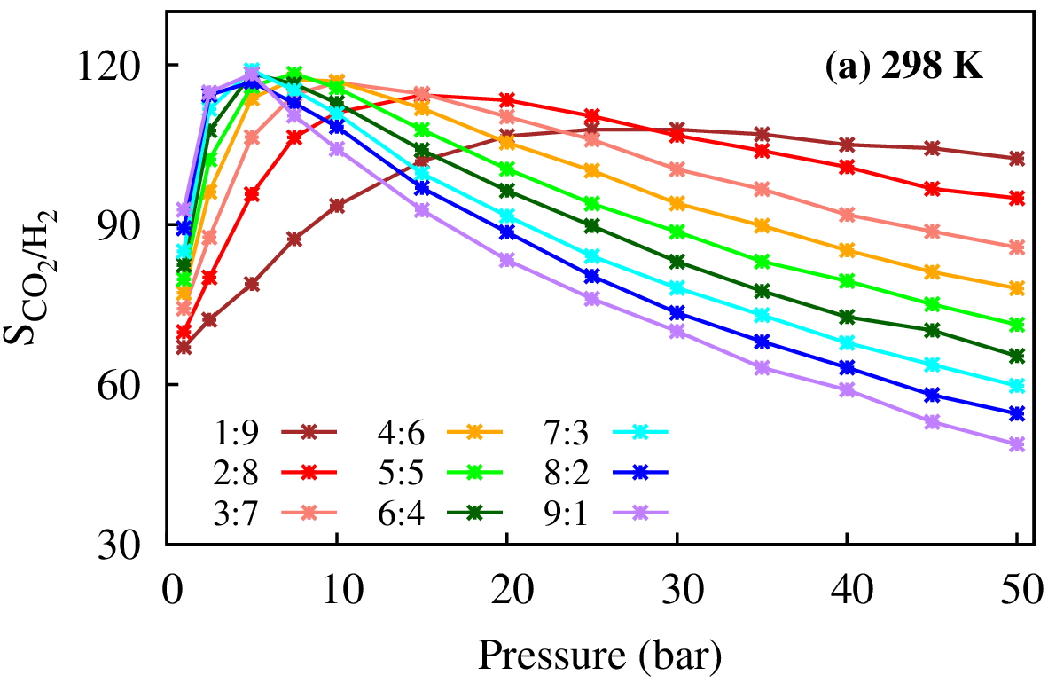 | 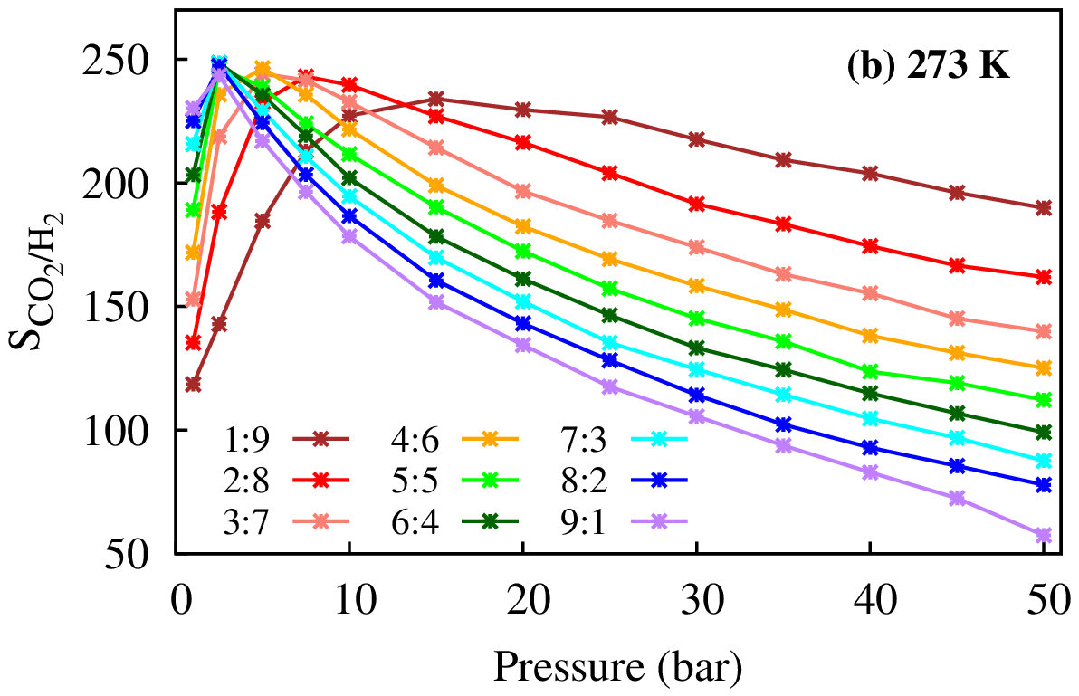
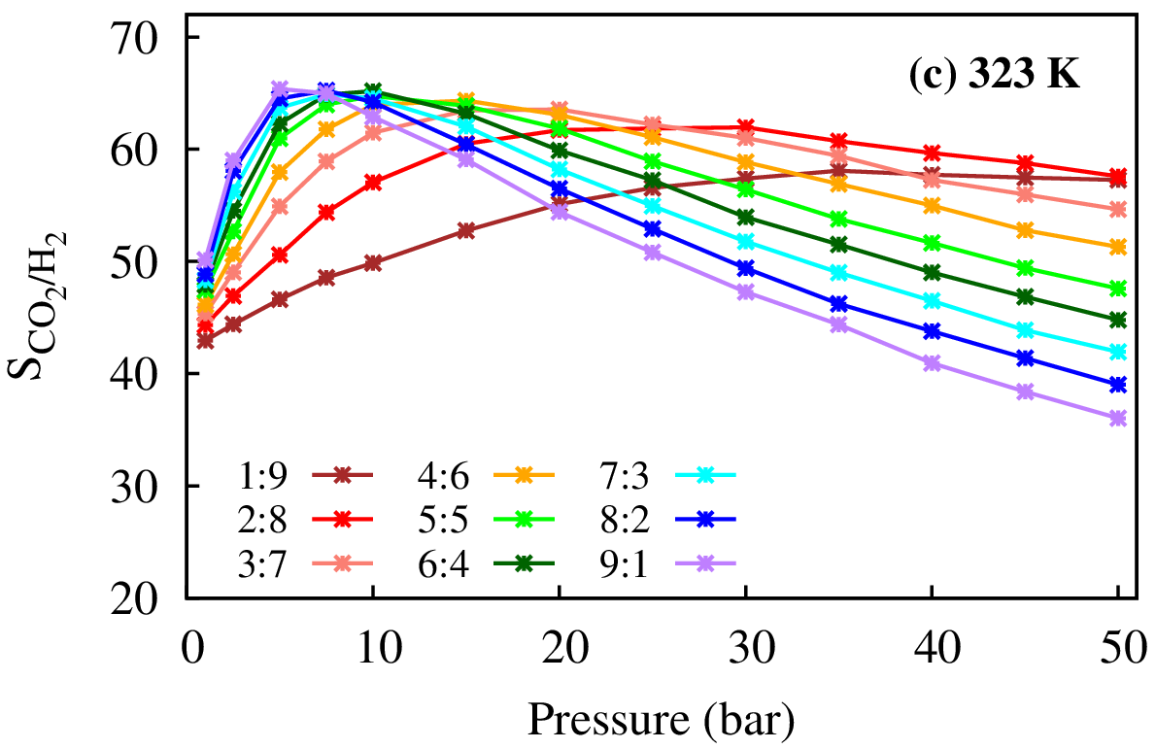 | 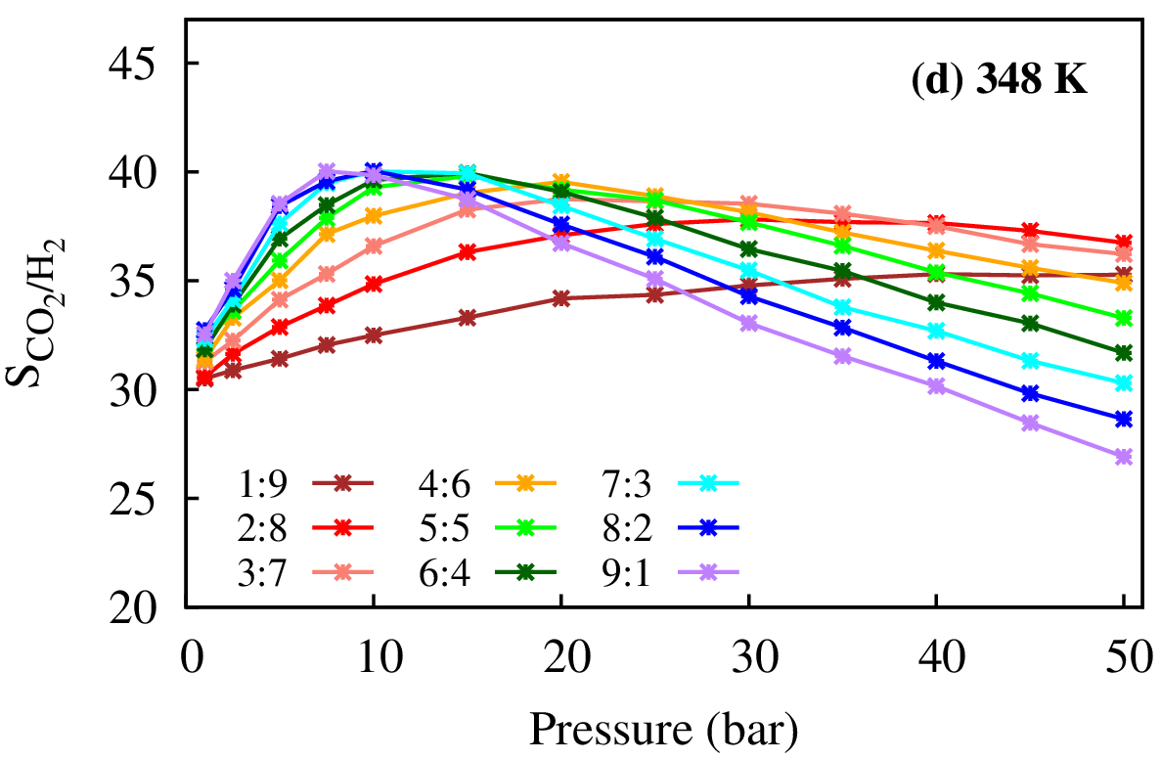
Figure 5. CO₂/H₂ selectivity of MIL-53(Cr) with different CO₂/H₂ mole fractions at temperatures: (a) 298 K, (b) 273 K, (c) 323 K, and (d) 348 K.

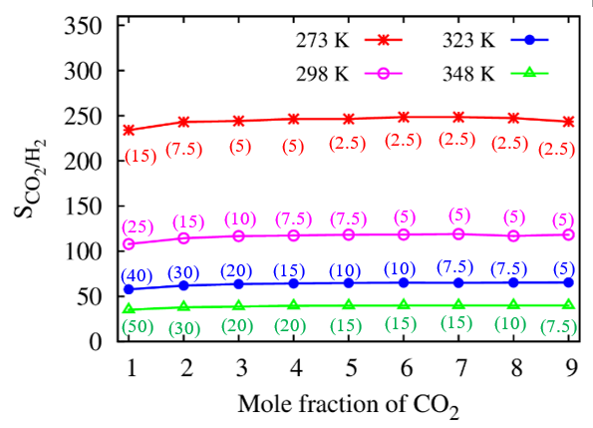
Figure 6. Dependence of maximum CO₂/H₂ selectivity on the mole ratios of CO₂ at 273 K, 298 K, 323 K, and 348 K. The values ​​in parentheses refer to the pressure corresponding to the maximum CO₂/H₂ selectivity for each CO₂:H₂ mole fraction.
4. CONCLUSIONS
This study obtained significant results:
- The CO₂ uptakes in MIL-53(Cr) are high with the absence and presence of H₂. The CO₂ capture capacity insignificantly decreases when the molar fraction of H₂ increases no more than 60%, i.e., decreasing from 9.18 mmol/g (pure CO₂) to 8.37 mmol/g (CO₂:H₂ = 4:6) with 8.82%.
- The high CO₂/H₂ selectivity is also elucidated at various molar fractions of CO₂:H₂ and different temperatures (273 K, 298 K, 323 K, and 348 K). The results exhibit that when the CO₂ mole-fraction in the binary mixture increases, the maximum CO₂/H₂ selectivity remains nearly constant, but the pressure corresponding to this maximal selective adsorption remarkably decreases. Moreover, the temperature strongly affects the separation capacity of CO₂ over H₂. Specifically, the maximum CO₂/H₂ selectivity decreases from 116 to 245 with the decreasing temperature from 298 K to 273 K. This work evidences that reducing the temperature can increase the selective adsorption efficiency of CO₂/H₂. Additionally, adjusting the mole fraction between hydrogen and carbon dioxide can help achieve the CO₂/H₂ selectivity at low pressure.
Acknowledgments
This study is conducted within the framework of science and technology projects at the institutional level of Quy Nhon University under project code T2023.794.04. We also acknowledge support for the calculations from the Lab of Computational Chemistry and Modeling (LCCM), Quy Nhon University, Vietnam.

References

Liên hệ: Nguyễn Thị Xuân Huynh
Trường Đại học Quy Nhơn
170 An Dương Vương, TP. Quy Nhơn, tỉnh Bình Định, Việt Nam
Email: nguyenthixuanhuynh@qnu.edu.vn
Điện thoại: 0989225650

