SUPPORTING INFORMATION

The C_{sp2}-H⋅⋅⋅O/Se/Te and O-H⋅⋅⋅Se/Te nonconventional hydrogen bonds in the systems of formic acid with selenoformaldehyde and telluroformaldehydes
Nguyen Tien Trung*¹, Nguyen Truong An², Nguyen Ngoc Tri¹, Vu Thi Ngan¹

¹Lab of Computational Chemistry and Modelling, Faculty of Natural Sciences, Quy Nhon University 170 An Duong Vuong Street, Quy Nhon City 590000, Vietnam
²Department of Computational Chemistry, J. Heyrovsky Institute of Physical Chemistry, Czech Academy of Sciences, Dolejskova 2155/3, 18223 Prague 8, Czech Republic

*Corresponding author, Email: nguyentientrung@qnu.edu.vn

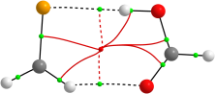 | 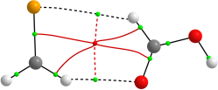 | 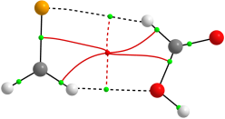 | 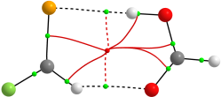 | 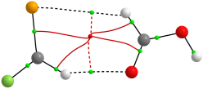 | 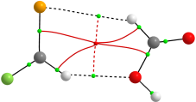
HSe-1 | HSe-2 | HSe-3 | FSe-1 | FSe-2 | FSe-3
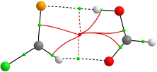 | 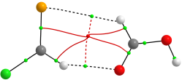 | 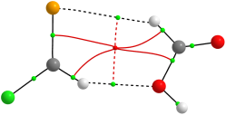 | 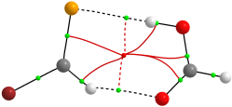 | 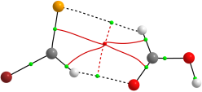 | 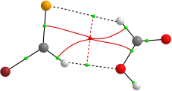
ClSe-1 | ClSe-2 | ClSe-3 | BrSe-1 | BrSe-2 | BrSe-3
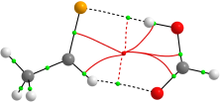 | 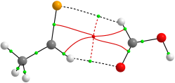 | 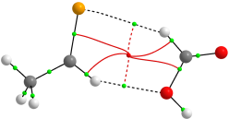 | 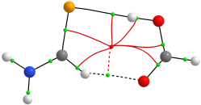 | 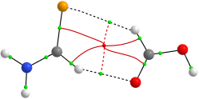 | 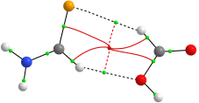
CH₃Se-1 | CH₃Se-2 | CH₃Se-3 | NH₂Se-1 | NH₂Se-2 | NH₂Se-3
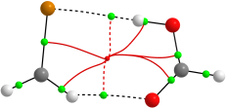 | 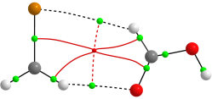 | 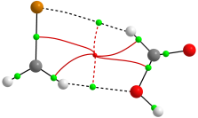 | 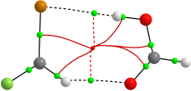 | 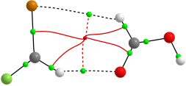 | 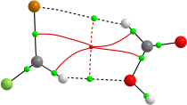
HTe-1 | HTe-2 | HTe-3 | FTe-1 | FTe-2 | FTe-3
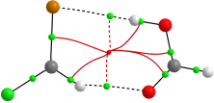 | 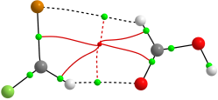 | 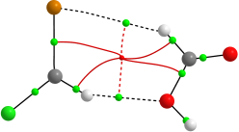 | 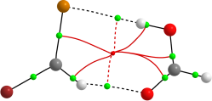 | 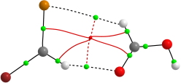 | 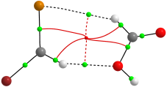
ClTe-1 | ClTe-2 | ClTe-3 | BrTe-1 | BrTe-2 | BrTe-3
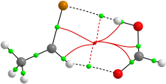 | 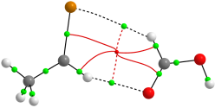 | 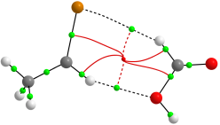 | 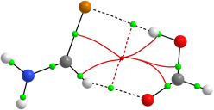 | 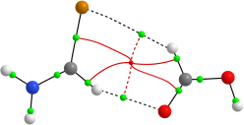 | 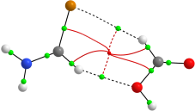
CH₃Te-1 | CH₃Te-2 | CH₃Te-3 | NH₂Te-1 | NH₂Te-2 | NH₂Te-3

Figure S1. Topological features of complexes upon interactions of HCOOH with XCHZ
(X = H, F, Cl, Br, CH₃, NH₂; Z = Se, Te) at MP2/6-311++G(3df,2pd)

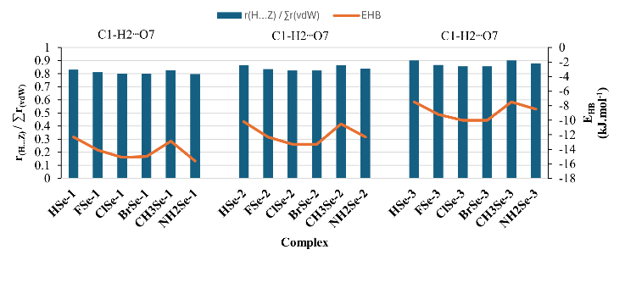
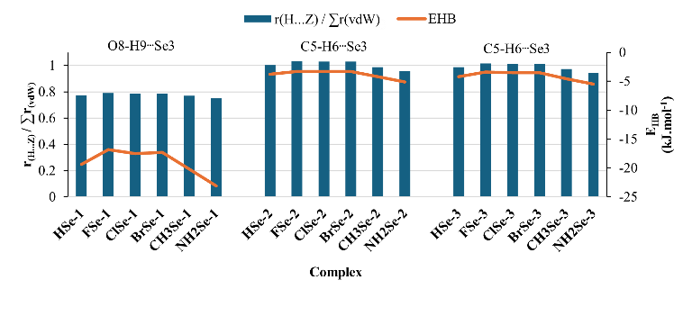
Figure S2. The relationship between the r_{H∙∙∙Z} /$\sum{r_{vdW}}$ ratio and E_{HB} of hydrogen bonds in complexes of RSe-1, RSe-2, and RSe-3
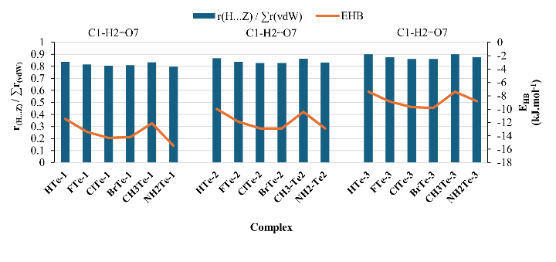
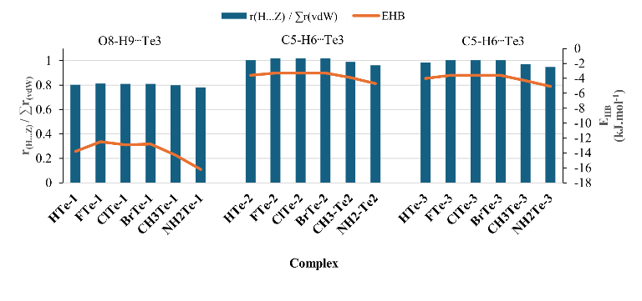
Figure S3. The relationship between the r_{H∙∙∙Z} /$\sum{r_{vdW}}$ ratio and E_{HB} of hydrogen bonds in complexes of RTe-1, RTe-2, and RTe-3

Table S1. Intermolecular distances R(H∙∙∙Z), electron density (ρ(r)), Laplacian of electron density (∇²ρ(r)), total electron energy density (H(r)) and energy of H-bond (E_{HB}) at BCPs of contacts in RCHZ∙∙∙HCOOH complexes at MP2/6-311++G(3df,2pd)
Complex | H-bond | R(H∙∙∙Z) | ρ(r)(au) | ∇²ρ(r) (au) | H(r) (au) | E_{HB}  (kJ.mol⁻¹) | r_{H∙∙∙Z} /$\sum{r_{vdW}}$
HSe-1 | C1-H2∙∙∙O7 | 2.26 | 0.0139 | 0.050 | 0.0015 | -12.3 | 0.83
HSe-1 | O8-H9∙∙∙Se3 | 2.40 | 0.0235 | 0.039 | -0.0026 | -19.4 | 0.77
HSe-2 | C1-H2∙∙∙O7 | 2.35 | 0.0116 | 0.040 | 0.0011 | -10.2 | 0.86
HSe-2 | C5-H6∙∙∙Se3 | 3.11 | 0.0065 | 0.017 | 0.0007 | -3.8 | 1.00
HSe-3 | C1-H2∙∙∙O8 | 2.45 | 0.0088 | 0.032 | 0.0012 | -7.5 | 0.90
HSe-3 | C5-H6∙∙∙Se3 | 3.06 | 0.0072 | 0.018 | 0.0007 | -4.2 | 0.99
HTe-1 | C1-H2∙∙∙O7 | 2.28 | 0.0130 | 0.047 | 0.0015 | -11.5 | 0.84
HTe-1 | O8-H9∙∙∙Te3 | 2.62 | 0.0196 | 0.030 | -0.0014 | -13.8 | 0.80
HTe-2 | C1-H2∙∙∙O7 | 2.36 | 0.0113 | 0.039 | 0.0011 | -10.0 | 0.87
HTe-2 | C5-H6∙∙∙Te3 | 3.27 | 0.0064 | 0.015 | 0.0005 | -3.6 | 1.00
HTe-3 | C1-H2∙∙∙O8 | 2.45 | 0.0087 | 0.032 | 0.0012 | -7.4 | 0.90
HTe-3 | C5-H6∙∙∙Te3 | 3.21 | 0.0071 | 0.016 | 0.0004 | -4.0 | 0.98
FSe-1 | C1-H2∙∙∙O7 | 2.21 | 0.0154 | 0.056 | 0.0017 | -14.1 | 0.81
FSe-1 | O8-H9∙∙∙Se3 | 2.45 | 0.0209 | 0.038 | -0.0016 | -16.8 | 0.79
FSe-2 | C1-H2∙∙∙O7 | 2.27 | 0.0136 | 0.049 | 0.0014 | -12.3 | 0.83
FSe-2 | C5-H6∙∙∙Se3 | 3.20 | 0.0056 | 0.015 | 0.0006 | -3.3 | 1.03
FSe-3 | C1-H2∙∙∙O8 | 2.36 | 0.0105 | 0.039 | 0.0014 | -9.2 | 0.87
FSe-3 | C5-H6∙∙∙Se3 | 3.15 | 0.0061 | 0.016 | 0.0007 | -3.4 | 1.02
FTe-1 | C1-H2∙∙∙O7 | 2.22 | 0.0147 | 0.054 | 0.0017 | -13.4 | 0.82
FTe-1 | O8-H9∙∙∙Te3 | 2.65 | 0.0182 | 0.030 | -0.0010 | -12.5 | 0.81
FTe-2 | C1-H2∙∙∙O7 | 2.28 | 0.0132 | 0.047 | 0.0014 | -11.9 | 0.84
FTe-2 | C5-H6∙∙∙Te3 | 3.33 | 0.0059 | 0.014 | 0.0005 | -3.3 | 1.02
FTe-3 | C1-H2∙∙∙O8 | 2.38 | 0.0102 | 0.038 | 0.0014 | -8.9 | 0.88
FTe-3 | C5-H6∙∙∙Te3 | 3.27 | 0.0065 | 0.014 | 0.0004 | -3.6 | 1.00
ClSe-1 | C1-H2∙∙∙O7 | 2.18 | 0.0164 | 0.059 | 0.0016 | -15.1 | 0.80
ClSe-1 | O8-H9∙∙∙Se3 | 2.44 | 0.0216 | 0.038 | -0.0019 | -17.5 | 0.79
ClSe-2 | C1-H2∙∙∙O7 | 2.24 | 0.0146 | 0.051 | 0.0014 | -13.3 | 0.82
ClSe-2 | C5-H6∙∙∙Se3 | 3.19 | 0.0056 | 0.015 | 0.0007 | -3.3 | 1.03
ClSe-3 | C1-H2∙∙∙O8 | 2.33 | 0.0113 | 0.042 | 0.0014 | -10.0 | 0.86
ClSe-3 | C5-H6∙∙∙Se3 | 3.14 | 0.0063 | 0.016 | 0.0006 | -3.5 | 1.01
ClTe-1 | C1-H2∙∙∙O7 | 2.19 | 0.0156 | 0.056 | 0.0016 | -14.3 | 0.81
ClTe-1 | O8-H9∙∙∙Te3 | 2.64 | 0.0186 | 0.030 | -0.0011 | -12.9 | 0.81
ClTe-2 | C1-H2∙∙∙O7 | 2.25 | 0.0142 | 0.050 | 0.0013 | -12.9 | 0.83
ClTe-2 | C5-H6∙∙∙Te3 | 3.33 | 0.0058 | 0.014 | 0.0005 | -3.3 | 1.02
ClTe-3 | C1-H2∙∙∙O8 | 2.34 | 0.0110 | 0.041 | 0.0014 | -9.7 | 0.86
ClTe-3 | C5-H6∙∙∙Te3 | 3.27 | 0.0065 | 0.014 | 0.0004 | -3.6 | 1.00
BrSe-1 | C1-H2∙∙∙O7 | 2.18 | 0.0163 | 0.058 | 0.0016 | -15.0 | 0.80
BrSe-1 | O8-H9∙∙∙Se3 | 2.44 | 0.0215 | 0.038 | -0.0018 | -17.3 | 0.79
BrSe-2 | C1-H2∙∙∙O7 | 2.24 | 0.0146 | 0.051 | 0.0013 | -13.3 | 0.82
BrSe-2 | C5-H6∙∙∙Se3 | 3.19 | 0.0056 | 0.015 | 0.0007 | -3.3 | 1.03
BrSe-3 | C1-H2∙∙∙O8 | 2.33 | 0.0113 | 0.042 | 0.0014 | -10.0 | 0.86
BrSe-3 | C5-H6∙∙∙Se3 | 3.14 | 0.0062 | 0.016 | 0.0006 | -3.5 | 1.01
BrTe-1 | C1-H2∙∙∙O7 | 2.20 | 0.0155 | 0.056 | 0.0016 | -14.2 | 0.81
BrTe-1 | O8-H9∙∙∙Te3 | 2.64 | 0.0185 | 0.030 | -0.0011 | -12.8 | 0.81
BrTe-2 | C1-H2∙∙∙O7 | 2.25 | 0.0142 | 0.050 | 0.0013 | -12.9 | 0.83
BrTe-2 | C5-H6∙∙∙Te3 | 3.33 | 0.0059 | 0.014 | 0.0005 | -3.3 | 1.02
BrTe-3 | C1-H2∙∙∙O8 | 2.34 | 0.0111 | 0.041 | 0.0014 | -9.8 | 0.86
BrTe-3 | C5-H6∙∙∙Te3 | 3.27 | 0.0065 | 0.014 | 0.0004 | -3.6 | 1.00
CH3Se-1 | C1-H2∙∙∙O7 | 2.25 | 0.0143 | 0.050 | 0.0014 | -12.9 | 0.83
CH3Se-1 | O8-H9∙∙∙Se3 | 2.39 | 0.0244 | 0.039 | -0.0028 | -20.2 | 0.77
CH3Se-2 | C1-H2∙∙∙O7 | 2.35 | 0.0118 | 0.040 | 0.0009 | -10.5 | 0.86
CH3Se-2 | C5-H6∙∙∙Se3 | 3.06 | 0.0071 | 0.019 | 0.0007 | -4.2 | 0.99
CH3Se-3 | C1-H2∙∙∙O8 | 2.45 | 0.0088 | 0.032 | 0.0012 | -7.5 | 0.90
CH3Se-3 | C5-H6∙∙∙Se3 | 3.02 | 0.0077 | 0.019 | 0.0007 | -4.6 | 0.97
CH3Te-1 | C1-H2∙∙∙O7 | 2.27 | 0.0135 | 0.048 | 0.0014 | -12.1 | 0.83
CH3Te-1 | O8-H9∙∙∙Te3 | 2.60 | 0.0202 | 0.031 | -0.0016 | -14.3 | 0.80
CH3Te-2 | C1-H2∙∙∙O7 | 2.35 | 0.0117 | 0.040 | 0.0010 | -10.4 | 0.86
CH3Te-2 | C5-H6∙∙∙Te3 | 3.23 | 0.0069 | 0.016 | 0.0005 | -3.9 | 0.99
CH3Te-3 | C1-H2∙∙∙O8 | 2.45 | 0.0087 | 0.032 | 0.0011 | -7.4 | 0.90
CH3Te-3 | C5-H6∙∙∙Te3 | 3.17 | 0.0076 | 0.017 | 0.0001 | -4.3 | 0.97
NH2Se-1 | C1-H2∙∙∙O7 | 2.17 | 0.0167 | 0.060 | 0.0016 | -15.6 | -15.6
NH2Se-1 | O8-H9∙∙∙Se3 | 2.33 | 0.0269 | 0.039 | -0.0040 | -23.1 | -23.1
NH2Se-2 | C1-H2∙∙∙O7 | 2.28 | 0.0135 | 0.047 | 0.0011 | -12.3 | -12.3
NH2Se-2 | C5-H6∙∙∙Se3 | 2.97 | 0.0083 | 0.022 | 0.0007 | -5.1 | -5.1
NH2Se-3 | C1-H2∙∙∙O8 | 2.39 | 0.0098 | 0.037 | 0.0013 | -8.5 | -8.5
NH2Se-3 | C5-H6∙∙∙Se3 | 2.93 | 0.0091 | 0.022 | 0.0007 | -5.5 | -5.5
NH2Te-1 | C1-H2∙∙∙O7 | 2.17 | 0.0166 | 0.060 | 0.0016 | -15.5 | -15.5
NH2Te-1 | O8-H9∙∙∙Te3 | 2.55 | 0.0223 | 0.031 | -0.0023 | -16.2 | -16.2
NH2Te-2 | C1-H2∙∙∙O7 | 2.26 | 0.0140 | 0.048 | 0.0011 | -12.9 | -12.9
NH2Te-2 | C5-H6∙∙∙Te3 | 3.14 | 0.0080 | 0.018 | 0.0005 | -4.7 | -4.7
NH2Te-3 | C1-H2∙∙∙O8 | 2.38 | 0.0101 | 0.038 | 0.0014 | -8.8 | -8.8
NH2Te-3 | C5-H6∙∙∙Te3 | 3.09 | 0.0087 | 0.019 | 0.0004 | -5.1 | -5.1

Table S2. Different energetic components (in kcal.mol⁻¹ and % in brackets) into stabilization energy of RCHZ∙∙∙HCOOH complexes with def2-TZVPD basis set
Complex | E_{ele} | E_{disp} | E_{ind}
HSe-1 | -47.1(38.2) | -21.8(17.7) | -44.4(36.1)
HSe-2 | -18.8(46.5 | -11.1(27.5) | -8.2(20.3)
HSe-3 | -14.1(42.4) | -10.1(30.5) | -7.1(21.3)
HTe-1 | 5.6(0.0) | -13.0(31.5) | -26.2(63.4)
HTe-2 | -11.0(40.2) | -8.4(30.6) | -6.7(24.4)
HTe-3 | -14.4(45.2) | -7.6(23.8) | -8.8(27.5)
FSe-1 | -45.5(39.1) | -21.3(18.3) | -40.4(34.7)
FSe-2 | -21.9(47.8) | -11.7(25.5) | -9.6(21.0)
FSe-3 | -14.9(43.7) | -10.3(30.0) | -7.2(21.0)
FTe-1 | -27.3(34.6) | -15.2(19.2) | -32.1(40.7)
FTe-2 | -16.8(47.5) | -9.1(25.7) | -7.6(21.5)
FTe-3 | -19.5(49.6) | -8.5(21.5) | -9.9(25.2)
ClSe-1 | -46.7(38.5) | -22.4(18.5) | -42.5(35.0)
ClSe-2 | -22.1(46.7) | -12.4(26.2) | -10.0(21.1)
ClSe-3 | -15.4(42.8) | -11.0(30.6) | -7.6(21.1)
ClTe-1 | 1.3(0.0) | -14.5(32.9) | -26.6(60.3)
ClTe-2 | -28.0(53.3) | -10.5(19.9) | -11.4(21.7)
ClTe-3 | -10.1(8.4) | -8.5(7.1) | -8.1(6.8)
BrSe-1 | -45.6(38.1) | -22.5(18.8) | -42.0(35.1)
BrSe-2 | -21.7(46.2) | -12.5(26.7) | -9.9(21.0)
BrSe-3 | -15.1(42.3) | -11.1(31.1) | -7.5(20.9)
BrTe-1 | 1.3(0.0) | -14.8(33.6) | -26.3(59.6)
BrTe-2 | -26.1(51.3) | -10.9(21.3) | -11.2(22.0)
BrTe-3 | -18.1(46.2) | -9.5(24.2) | -9.9(25.2)
CH₃Se-1 | -50.5(38.1) | -23.1(17.4) | -48.3(36.4)
CH₃Se-2 | -20.0(34.1) | -26.8(45.8) | -2.6(15.8)
CH₃Se-3 | -15.3(41.8) | -11.0(30.0) | -2.2(22.3)
CH₃Te-1 | -29.2(34.9) | -16.1(19.2) | -34.0(40.6)
CH₃Te-2 | -10.8(38.5) | -9.3(33.4) | -6.5(23.3)
CH₃Te-3 | -8.2(33.5) | -8.1(32.9) | -7.5(30.4)
NH₂Se-1 | -64.3(39.4) | -26.1(16.0) | -13.7(36.2)
NH₂Se-2 | -27.5(47.6) | -13.9(24.1) | -3.6(22.1)
NH₂Se-3 | -20.7(43.3) | -12.7(26.5) | -3.0(23.9)
NH₂Te-1 | -34.3(34.7) | -18.3(18.5) | -40.5(41.0)
NH₂Te-2 | -25.4(48.6) | -11.6(22.3) | -12.5(23.9)
NH₂Te-3 | -17.6(42.7) | -10.0(24.3) | -11.9(29.0)

