Liên kết hydrogen không cổ điển C_{sp2}-H⋅⋅⋅O/Se/Te and O-H⋅⋅⋅Se/Te trong các hệ phức giữa acid formic acid và selenoformaldehyde, telluroformaldehydes

Nguyễn Tiến Trung*¹, Nguyễn Trường An², Nguyễn Ngọc Trí¹, Vũ Thị Ngân¹

¹Phòng Thí nghiệm Hóa học tính toán và Mô phỏng, Khoa Khoa học Tự nhiên, Trường Đại học Quy Nhơn

²Department of Computational Chemistry, J. Heyrovsky Institute of Physical Chemistry, Czech Academy of Sciences, Dolejskova 2155/3, 18223 Prague 8, Czech Republic

*Tác giả liên hệ, Email: nguyentientrung@qnu.edu.vn

Nhận bài: Chỉnh sửa: Chấp nhận:

Tóm tắt
Trong nghiên cứu này, độ bền các phức cũng như các liên kết hydrogen và đặc trưng của chúng trong các hệ giữa acid formic với các dẫn xuất aldehyde được khảo sát một cách đầy đủ. Nhìn chung, độ bền của các phức được tăng cường đáng kể đối với các nhóm thế cho hoặc nhận electron trong các dẫn xuất aldehyde. Các phức với sự thay thế Se được tìm thấy bền hơn so với các phức thế Te. Các phức đối với sự thế halogen được đánh giá kém bền hơn các phức của dẫn xuất thế -CH₃ và –NH₂. Các kết quả thu được chỉ ra độ bền đáng kể của liên kết O–H∙∙∙Se/Te trong việc làm bền các phức so với C–H∙∙∙O. Các kết quả tính toán cũng cho thấy rằng độ bền các liên kết hydrogen không cổ điển giảm theo thứ tự O–H∙∙∙Se > O–H∙∙∙Te ~ C–H∙∙∙O > C–H∙∙∙Se/Te. Sự chuyển dời xanh của liên kết hydrogen C–H∙∙∙Se mạnh hơn so với C–H∙∙∙Te. Phân tích NBO thấy rằng xu hướng chuyển dời xanh của tần số dao động liên kết C_{sp2}–H phụ thuộc chính vào sự giảm mật độ electron ở σ*(C_{sp2}–H) trong quá trình hình thành phức. Sự chuyển dời đỏ trong các liên kết hydrogen không cổ điển O-H∙∙∙Se/Te được quyết định bởi sự tăng đáng kể mật độ electron tại σ*(O–H) so với sự tăng cường %s(O) trong quá trình tạo phức.
Từ khóa: liên kết hydrogen không cổ điển O/C_{sp2}-H∙∙∙O/Se/Te, Se/Te-aldehydes, acid formic.

The C_{sp2}-H⋅⋅⋅O/Se/Te and O-H⋅⋅⋅Se/Te nonconventional hydrogen bonds in the systems of formic acid with selenoformaldehydes and telluroformaldehydes

Nguyen Tien Trung*¹, Nguyen Truong An², Nguyen Ngoc Tri¹, Vu Thi Ngan¹

¹Lab of Computational Chemistry and Modelling, Faculty of Natural Sciences, Quy Nhon University
²Department of Computational Chemistry, J. Heyrovsky Institute of Physical Chemistry, Czech Academy of Sciences, Dolejskova 2155/3, 18223 Prague 8, Czech Republic

*Corresponding author, Email: nguyentientrung@qnu.edu.vn

Received: Revised: Accepted:

ABSTRACT
In this study, a thorough investigation into the stability of complexes as well as the hydrogen bonds along with their characteristics in the systems between formic acid and chalcoaldehyde derivatives. Generally, the strength of complexes is enhanced irrespective of electron donating or withdrawing substitution in chalcoaldehyde derivatives. It is found that the complexes involving Se-substitution are slightly more stable than Te-one. The halogenated complexes are less stable than CH₃- and NH₂-substituted ones, in which the largest stability belongs to the complexes involving NH₂-substituted group. The obtained results show a dominant role of O–H∙∙∙Se/Te compared to C–H∙∙∙O in contributing to the stabilization of complexes. Calculated results indicate that the strength of nonconventional hydrogen bonds decreases in the order of O–H∙∙∙Se > O–H∙∙∙ Te ~ C–H∙∙∙O > C–H∙∙∙Se/Te. The larger blue shift of C-H bond in the complexes investigated is observed in C–H∙∙∙O compared to C–H∙∙∙Se/Te. The magnitude of blue shift is larger in the case of C–H∙∙∙Se than in C–H∙∙∙Te hydrogen bonds. NBO analysis shows that the blue-shifted stretching frequency of C_{sp2}–H depends mainly on a reduction of electron density at σ*(C_{sp2}–H) orbital. The redshift in O-H∙∙∙Se/Te hydrogen bonds in these systems is determined by a considerable increase of electron density at σ*(O–H) orbitals overcoming a s-character enhancement of O site upon complexation.
Keywords: O/C_{sp2}-H∙∙∙O/Se/Te nonconventional hydrogen bonds, Se/Te-aldehydes, formic acid.

1. INTRODUCTION

Hydrogen bonds play an extremely important role because of their great properties in molecular information recognition, protein folding, structural rearrangement of nucleic acids, crystallization, polymerization, supramolecular chemistry, solvation, or in organic synthesis.^{1,2} Many investigations were performed to understand the characteristics of hydrogen bonds as well as their importance in arrangement of molecules, reaction mechanism, as well as adsorption process, surface phenomena.³⁻⁶ Noticeably, non-classical hydrogen bonds of the form C-H∙∙∙O/N/X/π (X= F, Cl, Br) were detected in many systems including proteins, DNA, RNA, crystal structures of many materials, and surface reactions. Besides, the activation of C-H groups in intermediate structures is one of the issues of current interest in organic synthesis.^{7,8} Experimental, Raman and theoretical findings of blue-shifted C-H bonds involved in hydrogen bonds have been reported, of which the most abundant is the C-H∙∙∙O/N form.⁹⁻¹⁷ With these interesting findings on nonconventional hydrogen bonds, several investigations focused on explaining the nature of blue-shifted hydrogen bonding, but none of them can be universally applied to other complex systems stabilized by hydrogen bonds.^{9,16-20} Given the important role of hydrogen bonds in biological systems, the strength and properties of classical hydrogen bonds O/S-H∙∙∙O/S have been studied and reported, for example, in some dimers of H₂O, H₂S, and H₂O∙∙∙H₂S system, by both theoretical and experimental methods.^{21,22} Many nonconventional hydrogen bonds have been discovered recently and play important roles in proteins, catalysis... Indeed, the hydrogen bonds O/N-H∙∙∙Se/Te were recently discovered experimentally.²³⁻²⁵ However, systematic studies of the O-H∙∙∙Se/Te hydrogen bond system to understand their strength and properties have not been reported. In addition, the influence of this O-H∙∙∙Se/Te on the strength and characteristics of the C_{sp2}–H∙∙∙Se/Te was not considered and evaluated in literature.
In addition, the compounds having carbonyl group, including aldehydes, carboxylic acid, their halogenated and amides derivatives, are commonly found not only in the biologic structures such as proteins, lipid-membranes but also in other biologically active compounds like drugs. Theoretical studies indicated that the origin of stabilization in the complexes of carboxylic acids and amides is charge-delocalizationof .^{2,26} The experimental and theoretical investigations into O-H redshift and C_{sp2}-H blueshift in the hydrogen bonds in the complexes of formic acid, acetic acid, and acetaldehyde was reported.²⁷⁻²⁹ Besides, strength and nature of blue- and redshifting hydrogen bonds were examined in the systems of formamide, aldehydes, hydroxyl derivatives, carboxylic acids.³⁰⁻³² More recently, the C_{sp2}-H blue shifting in the C_{sp2}–H···O hydrogen bonds have been reported for the complexes of aldehydes with formic acid, adding water into chalcogenoaldehydes, and in the binary systems of aldehyde and carboxylic acids.^{16,33,34}
Further, a theoretical study on the nature of hydrogen bonds in NH₂CYH∙∙∙XH complexes with Y = O, S, Se, Te; X = F, HO, NH₂ was examined by quantum chemistry analyses.³⁵ Noticeably, the C_{sp2}-H∙∙∙O/S/Se/Te hydrogen bonds were evaluated in the XCHO∙∙∙nH₂Z and dimers of chalcogenoaldehyde derivatives systems.^{36,37} However, the two hydrogen-bond systems between selenoformaldehyde or telluroformaldehyde and carboxylic acid along with their derivatives in consideration of the strength and the shifting of stretching frequency has not yet been observed clearly. In addition, the effects of various X substituents relating to the strength of nonconventional hydrogen bonds, which have essential role in stabilizing complexes as well as the shifts in C_{sp2}-H or O-H stretching frequency need to be addressed. Furthermore, the existence and role of various interactions following complexation such as O-H···Se/Te and C_{sp2}-H···O/Se/Te should be examined in the complexes of Se/Te derivatives to have insights into the nonconventional hydrogen bonds. In this work, the interaction complexes between aldehyde derivatives and formic acid are selected to have thorough insights into the effects of different substituent group on the polarity of C_{sp2}-H and the gas phase basicity of Se/Te, as well as their role to the stability and characteristics of O-H∙∙∙Se/Te, C_{sp2}-H∙∙∙Se/Te nonconventional hydrogen bonds, and the complex strength.
2. COMPUTATIONAL METHODS
The optimized geometries for monomers and complexes are considered at the MP2/6-311++G(3df,2pd) level of theory with the correction of zero-point vibrational energies (ZPE). The interaction energy of each complex is calculated and corrected for basis set superposition errors (BSSE) at the CCSD(T)/6-311++G(3df,2pd)//MP2/6-311++G(3df,2pd) level. Particularly, ΔE* is represented as the difference in total electronic energy between the complexes (E_{c}) and the sum of XCHZ and HCOOH monomers (E_{m1}, E_{m2}) given by the expression: ΔE* = E_{c} – (E_{m1} + E_{m2}) (1). Moreover, deprotonation enthalpy (DPE) is defined as the enthalpy change for the deprotonation reactions: XC(Z)H → XCZ⁻ + H⁺ (2) and HCOOH → HCOO⁻ + H⁺ (3) and is considered as DPE of C-H and O-H bonds in both XCHZ and YCOOH monomers. Proton affinity (PA) is defined as the enthalpy change for the protonation reaction: XC(Z)H + H⁺ → XC(ZH⁺)H (4) and is considered as PA at the Se and Te sites in XCHZ monomers. These calculations are performed by the Gaussian 16 package.³⁸
The Atoms-in-Molecules (AIM) analysis is observed at the MP2/6-311++G(3df,2pd) level through the AIMAll program.^{39,40} The local electron energy density (H(r)) is computed from potential (V(r)) and kinetic (G(r)) terms by the equation: H(r) = G(r) + V(r) (5). The individual energy of each hydrogen bond (E_{HB}) is estimated using the formula E_{HB} = 0.5V(r) (6).⁴¹ Further, the natural bond orbital (NBO) analysis is examined by using NBO 5.G software at the range-separated hybrid functional ωB97X-D/6-311++G(3df,2pd) level.^{42,43,44} Besides, Symmetry Adapted Perturbation Theory (SAPT) calculations based on the Psi4 program with the def2-TZVPD basis set are applied to unravel the different contributions of energy components, including the electrostatic (E_{elec}), induction (E_{ind}), and dispersion (E_{disp}) to the stability of examined complexes.⁴⁵
3. RESULTS AND DISCUSSION
3.1. Stable geometry and AIM analysis
The interaction of XCHZ with HCOOH induces 36 stable complexes, denoted by XZ-n (with X = H, F, Cl, Br, CH₃, NH₂; Z = Se, Te and n =1-3) with three geometries XZ-n displayed in Figure 1. The sp²-hybridized carbon atom in XCHZ is labeled hereafter as C_{sp2}. Each complex contains a ring that is stabilized by two intermolecular contacts, including O–H∙∙∙Se/Te and C_{sp2}–H∙∙∙O in XZ-1, C–H∙∙∙Se/Te and C_{sp2}–H∙∙∙O in XZ-2 and XZ-3. All H∙∙∙O, H∙∙∙Se and H∙∙∙Te distances (Table S1) are in the range of 2.18–2.45 Å, 2.33–3.20 Å and 2.65–3.33 Å, respectively, close to the sums of van der Waals radii of relevant atoms (being 2.72 Å for H∙∙∙O, 3.00 Å for H∙∙∙Se and 3.16 Å for H∙∙∙Te). The presence of H∙∙∙Se/Te and C_{sp2}–H∙∙∙O/Se/Te nonconventional hydrogen bonds through the bonding critical points (BCPs, green points in Figure S1) is confirmed by the values of electron density, Laplacian, and H(r) at BCPs (Table S1).⁴⁰ Moreover, the C_{sp2}/O-H∙∙∙Se/Te distances are also close to those in complexes between NH₂CHSe and NH₂CHTe, with HF/H₂O/NH₃.⁴⁶ The intermolecular contacts with the presence of chalcogen atoms (O, S, Se, Te) in hydrogen bonds were also reported in some studies.^{16,33,35,47}

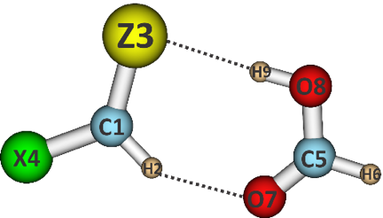 |  | 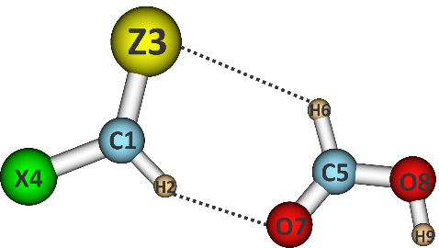 |  | 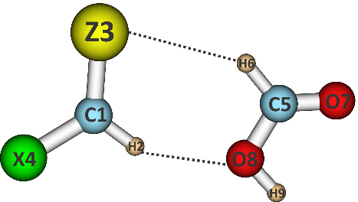
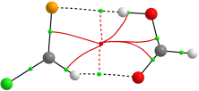 | 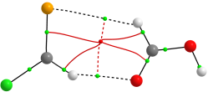 |  | 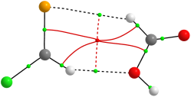
XZ-1 | XZ-2 |  | XZ-3
Figure 1: The stable structures and topological features of XCHZ and HCOOH complexes (X = H, F, Cl, Br, CH₃, NH₂ and Z = Se, Te)

In addition, the decreasing tendency of strength for hydrogen bonds is from O–H∙∙∙Se to O–H∙∙∙Te ~ C–H∙∙∙O and then to C–H∙∙∙Se/Te (Table S1). Indeed, the E_{HB} values indicate that the stability of C–H∙∙∙O (-7.4 ÷ -15.6 kJ.mol⁻¹) is 2÷3 times as large as that of C–H∙∙∙Se/Te (-3.3 ÷ -5.5 kJ.mol⁻¹) and the strength of O–H∙∙∙Se (-16.8 ÷ -23.1 kJ.mol⁻¹) is 1.5 times as large as that of O–H∙∙∙Te (-12.5 ÷ -13.8 kJ.mol⁻¹). Along with the results of individual hydrogen bond energies in literature by Khanh et al.¹⁶, it is found that the hydrogen bond stability decreases in going from O–H∙∙∙O >> O–H∙∙∙S > O–H∙∙∙Se > O–H∙∙∙Te. These results are also supported by a previous investigation of hydrogen bonding complexes containing chalcogen atoms.³³ Besides, the second correlation of energy (E_{HB}) vesus distances R(C-H∙∙∙O/Se/Te) is obtained according to expression E_{HB} = -134.24 + 85.52R(C-H∙∙∙O/Se/Te) -13.98R²(C-H∙∙∙O/Se/Te) (R² = 0.96) as given in Figure 2. However, a highly linear correlation of E_{HB} with respect to R(O-H∙∙∙Se/Te is observed as expression E_{HB} = 29.205R(O-H∙∙∙Se/Te) -78.638 (R² = 0.98). The obtained results indicate that the shorter intermolecular distance is the stronger the nonconventional hydrogen bond is, and vice versa.
As given in Table S1 of ESI, it can be suggested that the C–H∙∙∙O hydrogen bonds play a main role in stabilizing XZ-2 and XZ-3 along with addition of the C–H∙∙∙Se/Te ones. Nevertheless, for XZ-1 complexes, the C–H∙∙∙O hydrogen bonds serve as a supplementary factor along with a substantial importance of the O–H∙∙∙Se/Te ones in complex stabilization. To clarify the relationship between the strength of nonconventional hydrogen bond and r_{H∙∙∙O/Z} /$\sum{r_{vdW}}$ ratio, the The r_{H∙∙∙Z} /$\sum{r_{vdW}}$ ratios are gathered and plotted in Table S1 and Figures S2, S3 of ESI. The results indicate a good agreement between the r_{H∙∙∙Z} /$\sum{r_{vdW}}$ ratio and E_{HB} of nonconventional hydrogen bonds in investigated complexes. Indeed, the r_{H∙∙∙Z} /$\sum{r_{vdW}}$ ratios of C-H⋅⋅⋅O hydrogen bonds in the XSe/Te-1 are smaller than those in XSe/Te-2, and XSe/Te-3, consistent with the high stability of C-H⋅⋅⋅O hydrogen bonds in XSe/Te-1 compared to XSe/Te-2, and XSe/Te-3. The r_{H∙∙∙Z} /$\sum{r_{vdW}}$ ratio of C-H⋅⋅⋅O increases in the order of NH₂ < Cl ~ Br < F < CH₃ < H substitutions, along with the decrease of C-H⋅⋅⋅O strength in the order: NH₂ > Cl ~ Br > F > CH₃ > H substituted derivatives. It is worth noted that the O-H⋅⋅⋅Se/Te hydrogen bonds are much more stronger than the C_{sp2}-H⋅⋅⋅Se/Te ones, which is proven by the much smaller r_{H∙∙∙Z} /$\sum{r_{vdW}}$ ratio of O-H⋅⋅⋅Se/Te that that of C_{sp2}-H⋅⋅⋅Se/Te hydrogen bonds. For XZ-2 and XZ-3, the r_{H∙∙∙Z} /$\sum{r_{vdW}}$ ratios of C-H⋅⋅⋅Se/Te are larger than those of C-H⋅⋅⋅O, being in line with the weaker strength of the C-H⋅⋅⋅Se/Te than the C-H⋅⋅⋅O.

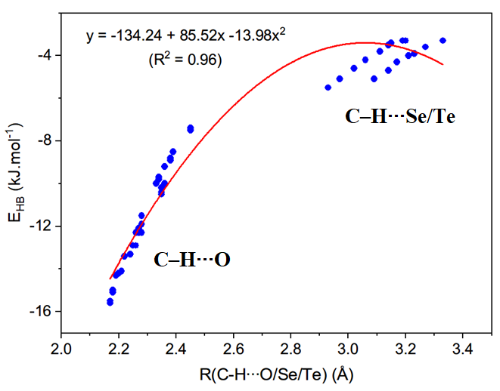 | 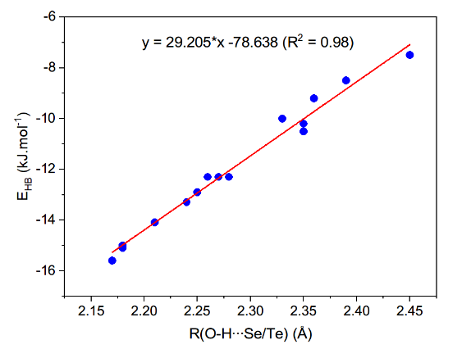
Figure 2: The relationships between E_{HB} and R(C/O-H∙∙∙O/Se/Te) in the complexes
Table 1: Deprotonation enthalpies of C_{sp2}–H (DPE) and proton affinities at Z sites (PA) at the CCSD(T)/6-311++G(3df,2pd) (in kJ.mol⁻¹)
Monomer | HCHSe | FCHSe | ClCHSe | BrCHSe | CH₃CHSe | NH₂CHSe
PA(Se) | 775.0 | 737.9 | 766.3 | 773.0 | 811.7 | 860.0
DPE(C_{sp2}-H) | 1623.6 | 1567.2 | 1551.7 | 1539.0 | 1620.7 | 1595.6
Monomer | HCHTe | FCHTe | ClCHTe | BrCHTe | CH₃CHTe | NH₂CHTe
PA(Te) | 812.2 | 780.7 | 802.7 | 807.9 | 841.0 | 884.6
DPE(C_{sp2}-H) | 1612.7 | 1561.0 | 1550.7 | 1540.8 | 1615.5 | 1582.3

Some characteristics of XCHZ monomers including deprotonation enthalpies (DPE) and proton affinities (PA) are examined in Table 1. With the same Z in XCHZ, the strength of O-H∙∙∙Z hydrogen bonds in XZ-1 decreases in the order of NH₂ > CH₃ > H > F/Cl/Br substitutions (cf. Table S1), which are consistent to a decrease of gas-phase basicity (PA) at Se/Te site in XCHZ (cf. Table 1). However, a decrease of strength of C-H∙∙∙O hydrogen bonds in XZ-1 is in the ordering NH₂ > F/Cl/Br > CH₃ > H substitutions, which differs from trend of the polarity of C_{sp2}-H bond in the isolated XCHZ. As a result, the strength of XZ-1 is mainly proposed by the presence of O-H∙∙∙Z. Similarly, a decrease in gas-phase basicity at Se/Te site in the sequence of NH₂ > CH₃ > H > F/Cl/Br derivatives causes a reduction of strength of C-H∙∙∙Z hydrogen bonds in XZ-2, XZ-3 decrease in the same tendency. The strengthening trend of C-H∙∙∙O hydrogen bonds in XZ-2 and XZ-3 is also suitable for an increase in the polarity of C_{sp2}-H bond in XCHZ in the order of H < CH₃ < NH₂ < F/Cl/Br (cf. Table S1). With the alike X in XCHZ, the stronger strength of O–H∙∙∙Se hydrogen bonds compared to O–H∙∙∙Te ones is observed in XZ-1. However, for the same X in the isolated XCHZ, proton affinity at Te site is larger than that at Se one (cf. Table 1), and accordingly these hydrogen bonds should be assigned by a larger electrostatic attraction of H and Se relative to H and Te.
3.2. Interaction energy and SAPT analysis
Interaction energies (ΔE*) of complexes, including both ZPE and BSSE correction at the CCSD(T)/6-311++G(3df,2pd)//MP2/6-311++G(3df,2pd) level are listed in Table 2, and their relationship is plotted in Figure 3. Generally, the ΔE* values in the range of -7.1 and -37.2 kJ.mol⁻¹ indicate that the obtained complexes are quite stable, in which the XZ-1 complexes are 2÷3 times as stable as XZ-2 and XZ-3 complexes. The considerable strength of XZ-1 is suggested by the presence of O-H∙∙∙Z hydrogen bond with respective to the remaining nonconventional C-H∙∙∙O/Z hydrogen bonds. The larger stability of XZ-2 relative to XZ-3 is due to the larger gas phase basicity of O site of >C=O as compared to that of O site of –OH in formaldehyde acid. Both of them are stablized by the C-H∙∙∙O/Z hydrogen bonds.
It is found that the most stable structures (XZ-1) of XCHZ∙∙∙HCOOH in the present work have a comparable strength of XCHO∙∙∙HCOOH complexes and slightly larger than that of XCHS∙∙∙HCOOH.¹⁶ The XZ-1 complexes are more stable than the binary complexes of small aldehydes, and less stable than dimers of typical carboxlic acids. Indeed, the interaction energies of HCHO∙∙∙HCHO, HCHO∙∙∙HCHS, HCHS∙∙∙HCHS are in turn -12.3, -11.7, -10.7 kJ.mol⁻¹ at CCSD(T)-F12/heavy-aug-cc-pVTZ level of theory.⁴⁸ The complexes of HCHO∙∙∙HCHO and CH₃CHO∙∙∙CH₃CHO have interaction energies of -21.0 and -22.4 kJ.mol⁻¹ at MP2/aug-cc-pVTZ.⁴⁹ The very large interaction energies of CH₃COOH∙∙∙CH₃COOH and HCOOH∙∙∙HCOOH at MP2/aug-cc-pVTZ are -60.7 kJ.mol⁻¹ and -56.9 kJ.mol⁻¹.⁵⁰

Table 2: Interaction energy corrected by both ZPE and BSSE (ΔE*, kJ.mol⁻¹) of the complexes RCHZ∙∙∙HCOOH at CCSD(T)/6-311++G(3df,2pd)//MP2/6-311++G(3df,2pd)
Complex | △E* | Complex | △E* | Complex | △E*
HSe-1 | -24.4 | HSe-2 | -10.7 | HSe-3 | -7.3
FSe-1 | -23.9 | FSe-2 | -13.0 | FSe-3 | -8.1
ClSe-1 | -24.9 | ClSe-2 | -12.9 | ClSe-3 | -8.4
BrSe-1 | -24.7 | BrSe-2 | -12.9 | BrSe-3 | -8.6
CH₃Se-1 | -28.4 | CH₃Se-2 | -12.3 | CH₃Se-3 | -8.9
NH₂Se-1 | -37.2 | NH₂Se-2 | -16.6 | NH₂Se-3 | -11.7
HTe-1 | -22.3 | HTe-2 | -10.2 | HTe-3 | -7.1
FTe-1 | -22.9 | FTe-2 | -12.7 | FTe-3 | -8.1
ClTe-1 | -23.6 | ClTe-2 | -12.7 | ClTe-3 | -8.3
BrTe-1 | -23.5 | BrTe-2 | -12.6 | BrTe-3 | -8.5
CH₃Te-1 | -25.8 | CH₃Te-2 | -11.8 | CH₃Te-3 | -8.4
NH₂Te-1 | -34.7 | NH₂Te-2 | -16.6 | NH₂Te-3 | -11.4

It is noticeable that the interaction energy of XSe–n is ca. 0.1–2.6 kJ.mol⁻¹ slightly more negative than that of XTe–n, about for the same X in XCHZ derivatives. This indicates a slightly less strength of XTe–n as compared to XSe–n, which should be resulting from stronger electrostatic force of Se and H atoms overcoming Te and H atoms.³³ Generally, the strength of XZ-n complexes is enhanced irrespective of electron donating or withdrawing X substitution (cf. Table 2 and Figure 3). For the alike Z, it is found that the halogenated complexes are less stable than CH₃- and NH₂-substituted ones, in which the largest stability belongs to the complexes NH₂Z-n with more negative values of 2.8-13.3 kJ.mol⁻¹. It can be suggested that O–H∙∙∙Se/Te and C–H∙∙∙O/Se/Te nonconventional hydrogen bonds play a significant role in contributing to the stability of NH₂Z-n compared to other complexes.

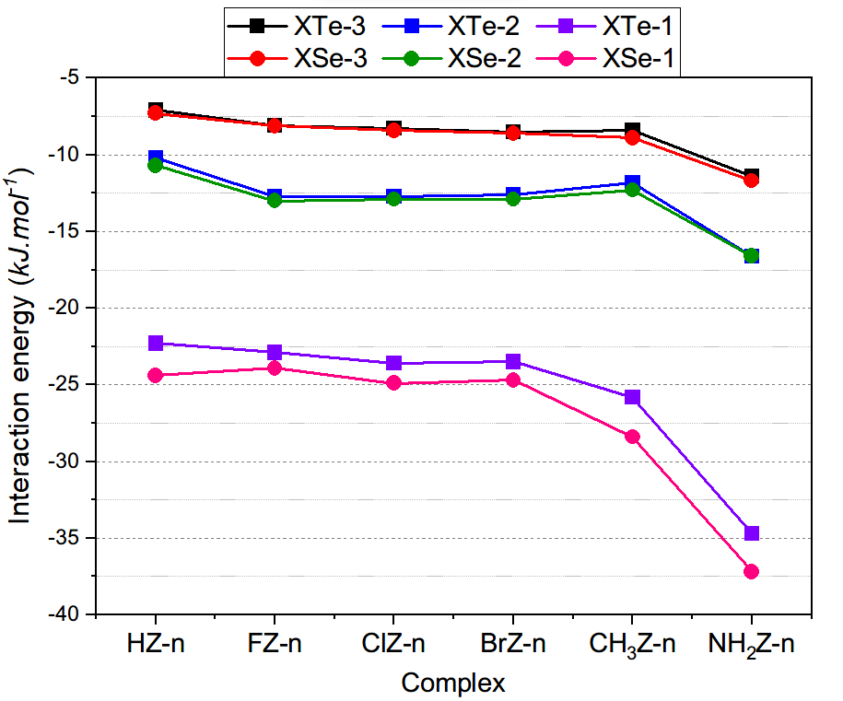
Figure 3: The relationship of the interaction energies and different X substitutions

As seen from Table 2, the interaction energy of complexes indeed increases in the substituting order: F < H < Br ~ Cl < CH₃ < NH₂ for XSe-1 and H < F < Br ~ Cl < CH₃ < NH₂ for XTe-1. This result is suitable for the changing trend in the stability of O–H∙∙∙Se/Te hydrogen bonds, affirming a main role of O–H∙∙∙Se/Te along with an addition of C–H∙∙∙O hydrogen bonds in stabilizing XZ-1. The energetic components based on the SAPT2+ approach are observed in Table S2. The calculated results imply the stability of complexes are mainly contributed by three terms including electrostatic, dispersion, and induction with contributing percentages of ca. 8-53%, 7-46% and 7-63% respectively. The dominating role of electrostatic components contributing to the complex stability is also reported in the complexes of XCHO∙∙∙HCOOH and XCHS∙∙∙HCOOH.¹⁶
3.3. Characteristics of C_{sp2}-H⋅⋅⋅Se/Te and O-H⋅⋅⋅Se/Te nonconventional hydrogen bonds
The formation of C–H∙∙∙Z, C–H∙∙∙O and O–H∙∙∙Z interactions in the complexes are further clarified by the change in lengths (Δr, mÅ) and the stretching frequencies (Δν, cm⁻¹) of O–H and C_{sp2}–H bond participating in the considered hydrogen bonds. The results at MP2/6-311++G(3df,2pd) are gathered in Table 3.
Considering the nonconventional hydrogen bonds of C–H∙∙∙Se/Te, the C–H length in XZ-2 and XZ-3 decreases slightly in the range of 0.07–0.93 mÅ, accompanied by an increase in their stretching frequency of 1.9–14.8 cm⁻¹ as compared to the corresponding values of isolated monomers. Therefore, these C–H∙∙∙Se/Te contacts belong to blue-shifting hydrogen bonds. The larger blue shift of C-H bond in the complexes investigated is observed in C–H∙∙∙O compared to C–H∙∙∙Se/Te, and has a much smaller magnitude than that in the complexes of XCHO∙∙∙HCOOH. It was found that all C-H∙∙∙Se/Te nonconventional hydrogen bonds in dimers of RCHZ (R=H, F, Cl, Br or CH₃, Z= Se, Te) are red-shifted.¹⁶ In the present work, a small C_{sp2}-H elongation of 0.10–0.52 mÅ along with a decrease in stretching frequency of 0.2–6.5 cm⁻¹ is found in the case of NH₂Se-3, BrTe-3, HTe-3, CH₃Te-3, and NH₂Te-3, indicating red shifting hydrogen bonds. These values are quite close to a previous report of hydrogen bonded complexes.³⁶ The largest shortening of C-H bond length is observed for FZ-2 and FZ-3, associated with the strongest electron-withdrawing group being F, whereas the smallest is observed in NH₂Z-2 and NH₂Z-3. Besides, the blue shift of C–H6 bond in C5–H6∙∙∙Z3 interaction in XZ-2 and XZ-3 decreases in the substituting order: F > Cl > Br > H > CH₃ > NH₂. This result is consistent with increased basicity at the Se/Te site in XCHZ (Table 1). The blue shift of the C_{sp2}-H bonds with the Z same is more strongly affected by electron-withdrawing groups (F, Cl, Br) than by electron-donating groups (CH₃, NH₂). The magnitude of C5–H6 blue shift is larger for C–H∙∙∙Se than for C–H∙∙∙Te, which is in an align with the increasing tendency of the proton affinity at Te relative to Se site (cf. Table 1). Furthermore, the larger blueshift of C–H bond in C–H∙∙∙Z hydrogen bonds of XZ-2 in comparison with that of XZ-3 is observed, which relate to the more crucial role of C–H∙∙∙O hydrogen bond in XZ-2 compared to that in XZ-3, toward the blue shift of C–H bonds.

Table 3: Changes in bond lengths (in mÅ) and their corresponding stretching frequencies (in cm⁻¹) at MP2/6-311++G(3df,2pd)
Complex | HSe-1 | FSe-1 | ClSe-1 | BrSe-1 | CH₃Se-1 | NH₂Se-1 | HTe-1 | FTe-1 | ClTe-1 | BrTe-1 | CH₃Te-1 | NH₂Te-1
△r(C1H2) | 0.42 | 0.76 | 1.54 | 1.77 | -0.37 | 0.22 | 1.09 | 0.51 | 1.37 | 1.55 | -0.08 | 0.69
△ν(C1H2) | 8.4 | 3.8 | -4.5 | -6.8 | 18.9 | 8.1 | 0.3 | 7.2 | -2.4 | -4.6 | 14.3 | 1.6
△r(O8H9) | 15.32 | 12.49 | 13.24 | 13.17 | 16.80 | 21.18 | 13.97 | 12.20 | 12.78 | 12.69 | 15.09 | 19.24
△ν(O8H9) | -326.2 | -266.6 | -284.0 | -282.5 | -355.5 | -439.4 | -299.5 | -261.9 | -274.6 | -273.1 | -322.1 | -402.6
Complex | HSe-2 | FSe-2 | ClSe-2 | BrSe-2 | CH₃Se-2 | NH₂Se-2 | HTe-2 | FTe-2 | ClTe-2 | BrTe-2 | CH₃Te-2 | NH₂Te-2
△r(C1H2) | 0.17 | 0.21 | 0.76 | 0.92 | -0.34 | 0.18 | 0.84 | 0.04 | 0.72 | 0.89 | -0.20 | 0.53
△ν(C1H2) | 7.8 | 7.8 | 3.0 | 1.2 | 15.6 | 6.9 | -0.3 | 10.0 | 3.3 | 1.0 | 12.8 | 1.3
△r(C5H6) | -0.73 | -0.93 | -0.79 | -0.76 | -0.47 | -0.30 | -0.52 | -0.78 | -0.65 | -0.60 | -0.28 | -0.07
△ν(C5H6) | 11.8 | 14.8 | 13.0 | 12.5 | 8.7 | 6.5 | 7.3 | 11.2 | 9.5 | 8.8 | 4.3 | 1.9
Complex | HSe-3 | FSe-3 | ClSe-3 | BrSe-3 | CH₃Se-3 | NH₂Se-3 | HTe-3 | FTe-3 | ClTe-3 | BrTe-3 | CH₃Te-3 | NH₂Te-3
△r(C1H2) | -0.07 | -0.33 | -0.17 | -0.07 | -0.48 | -0.21 | 0.51 | -0.36 | -0.09 | -0.04 | -0.43 | -0.05
△ν(C1H2) | 10.1 | 13.4 | 13.6 | 12.6 | 16.7 | 12.5 | 3.5 | 13.6 | 12.5 | 11.8 | 15.2 | 9.9
△r(C5H6) | -0.07 | -0.43 | -0.20 | -0.17 | 0.09 | 0.24 | 0.18 | -0.16 | 0.06 | 0.10 | 0.38 | 0.52
△ν(C5H6) | 3.2 | 8.5 | 5.4 | 4.9 | 1.1 | -1.0 | -1.8 | 3.3 | 0.3 | -0.2 | -4.4 | -6.5

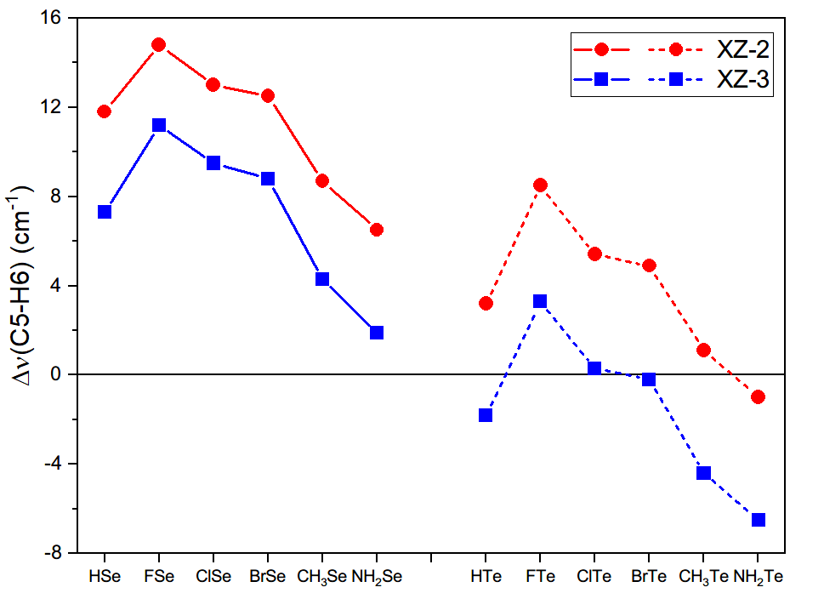
Figure 4: The relationship between the change in C-H stretching frequency and different X substitutions in XZ-2 and XZ-3

For XZ-3, the C-H∙∙∙O hydrogen bond displays a blue shift with a small contraction and an increase of C-H stretching frequency (Δr = -0.04 ÷ -0.48 mÅ and Δν = 9.9 ÷16.7 cm⁻¹), except for a small elongation in HTe-3. Besides, the blue shift of the C-H bond observed in XZ-2 is emphasized by a slight enhancement of in its bond length and stretching frequency (except for HTe-2 with a slight redshift of C-H). The slight redshift is observed in ClZ-1 and BrZ-1, while most XZ-1 structures indicate a blue shifting of C–H∙∙∙O hydrogen bonds. The redshift for hydrogen bonds in ClZ-1 and BrZ-1 is based on the high polarity of the C_{sp2}-H bonds in ClCHZ and BrCHZ monomers (Z = Se, Te).¹⁶ As shown in Table 3, a C-H bond contraction and an increase in its stretching frequency in XSe-n are larger than those in XTe-n. This observation is induced by the C-H strong polarity in XCHTe compared to XCHSe. Meanwhile, with the same Z in XZ-3, the larger blueshift in CH₃Z-3 in comparison with F/Cl/BrZ-3 comes from the smaller polarity of the C-H bond in CH₃Z-3. A very small blue shift of C_{Sp2}-H in C–H∙∙∙O in XCHZ∙∙∙HCOOH (Z=Se, Te) as compared to the considerable blue shift of that in XCHO∙∙∙HCOOH (up to 100 cm⁻¹) was attained.¹⁶ This shows that a profound role of O-H∙∙∙O relative to O-H∙∙∙Se/Te in increasing the very considerable blue shift of C_{sp2}-H bond. In the other words, it implies a noticeable role of O related to S, Se and Te in the blue shifting of C–H∙∙∙O hydrogen bonds.
On the other hand, for O–H∙∙∙Se/Te hydrogen bonds in XZ-1 form, the bond elongation of 12.5–21.2 mÅ for O–H∙∙∙Se and 12.2–19.2 mÅ and O–H∙∙∙Te is observed which is accompanied by a remarkable decrease of 266.6–439.4 cm⁻¹ and 261.9–402.6 cm⁻¹ in their stretching frequency, respectively (cf. Table 3). These changes show the redshift of O-H stretching frequencies involved in the O–H∙∙∙Se/Te nonconventional hydrogen bonds. Particularly, with the same X in XCHZ, the redshift phenomenon in the O–H∙∙∙Se hydrogen bonds is larger than the O–H∙∙∙Te ones. In the case of the same Z, the redshift of O–H∙∙∙Z hydrogen bonds is found in the increasing order of F/Cl/Br < H < CH₃ < NH₂ substitutions, and agrees with the enhancement of proton affinity of chalcogen atom in the XCHZ (Table 1). The obtained result of O-H red shift in the hydrogen bonds is similar to previous reports in complexes of chalcogen derivatives and formic acid.^{16,33}
3.4. NBO analysis
In order to determine the strength and characteristics of intermolecular interactions and complexes investigated, the NBO analysis is carried out at ωB97X-D/6-311++G(3df,2pd) as presented in Table 4. The positive values of electron density transfer (EDT) for most of complexes (0.0003–0.0587 e) imply that the electron density is transferred mainly from XCHZ to HCOOH. This tendency is caused by the large energy of electron transfer n(Z3)→σ*(C5–H6) (7.02-20.57 kJ.mol⁻¹) and n(Z3)→σ*(O8–H9) (65.42-109.35 kJ.mol⁻¹) in comparison to n(O7/O8)→σ*(C1–H2) (2.88-14.59 kJ.mol⁻¹), except for FSe-2, ClSe-2 and BrSe-2 with the negative values of EDT. Hence, the n(Z3)→σ*(C5–H6) and n(Z3)→σ*(O8–H9) electron density transfers play a dominant role in stabilizing most of complexes as compared to the n(O7/O8)→σ*(C–H) transfers, except for a larger role of n(O7)→σ*(C1–H2) (10.58-11.41 kJ.mol⁻¹) related to n(Z3)→σ*(C5–H6) (7.02-7.48 kJ.mol⁻¹) found in FSe-2, ClSe-2 and BrSe-2 (cf. Table 4) This should be due to the stronger polarity of C-H bond in XCHSe (with X=F, Cl, Br), leading to the larger ability of electron acceptance of σ*(C1–H2) orbital.
The very large E_{inter} values of n(Z3)→σ*(O8–H9) in XZ-1 compared to n(Z3)→σ*(C5–H6) in XZ-2 and XZ-3 indicate that the much stronger electron density transfers from lone pair of electrons from Z3 to σ*(O8–H9) orbitals are much more stronger than from Z3 to σ*(C5–H6) ones. Moreover, E_{inter}[n(O7/O8)→σ*(C1–H2)] is higher for XZ-1 than XZ-2 and XZ-3, implying a stronger electron density transfer in XZ-1. These obtained results of E_{inter} are in good consistency with the trend in stability of hydrogen bond as analyzed in AIM part above.
For changing X in XCHZ, E_{inter}[n(Z3)→σ*(C5–H6)] in XZ-2, XZ-3 and E_{inter}[n(Z3) → σ*(O8–H9)] in XZ-1 increase in the order of F/Cl/Br < H < CH₃ < NH₂ substituents, suitable for the increasing trend of the proton affinity at Z3 site (Table 1). In other words, the intermolecular charge density transfers from XCHZ to HCOOH are rised by the presence of CH₃ and NH₂ groups, and are diminished by halogen substituents. It is noted that the increase in values of E_{inter}[n(O7/O8)→σ*(C1–H2)] is attained by the substitution of electron-donating or electron-withdrawing groups.

Table 4: Electron density transfer (EDT), hyperconjugation interaction energies (E_{inter}, in kJ.mol⁻¹), and changes of electron density (△σ*, in electron) and s-character percentage of atom involving hydrogen bond (△%s, in %)
Complex | HSe-1 | FSe-1 | ClSe-1 | BrSe-1 | CH₃Se-1 | NH₂Se-1 | HTe-1 | FTe-1 | ClTe-1 | BrTe-1 | CH₃Te-1 | NH₂Te-1
EDT | 0.051 | 0.036 | 0.039 | 0.038 | 0.052 | 0.059 | 0.050 | 0.039 | 0.041 | 0.040 | 0.050 | 0.056
E_{inter}[n(O7)→σ*(C1-H2)] | 9.28 | 12.54 | 13.21 | 12.25 | 9.91 | 14.59 | 7.36 | 9.99 | 10.83 | 10.03 | 8.23 | 13.54
E_{inter}[n(Z3)→σ*(O8-H9)] | 84.06 | 68.05 | 70.77 | 68.76 | 90.54 | 109.35 | 75.32 | 65.42 | 67.51 | 66.00 | 77.16 | 95.35
△σ*(C1-H2) | -0.002 | -0.002 | -0.002 | -0.002 | -0.002 | -0.002 | -0.001 | -0.001 | -0.001 | -0.001 | -0.001 | -0.001
△%s(C1) | 1.51 | 1.68 | 1.71 | 1.71 | 1.52 | 1.74 | 1.43 | 1.66 | 1.72 | 1.74 | 1.43 | 1.71
△σ*(O8-H9) | 0.052 | 0.042 | 0.045 | 0.045 | 0.055 | 0.064 | 0.051 | 0.044 | 0.046 | 0.046 | 0.053 | 0.061
△%s(O8) | 3.37 | 2.97 | 3.07 | 3.03 | 3.57 | 4.07 | 3.05 | 2.78 | 2.85 | 2.83 | 3.23 | 3.70
Complex | HSe-2 | FSe-2 | ClSe-2 | BrSe-2 | CH₃Se-2 | NH₂Se-2 | HTe-2 | FTe-2 | ClTe-2 | BrTe-2 | CH₃Te-2 | NH₂Te-2
EDT | 0.003 | -0.002 | -0.002 | -0.002 | 0.003 | 0.003 | 0.005 | 0.001 | 0.001 | 0.001 | 0.004 | 0.004
E_{inter}[n(O7)→σ*(C1-H2)] | 7.61 | 10.58 | 11.41 | 10.78 | 7.61 | 10.45 | 6.65 | 8.69 | 9.78 | 9.32 | 6.98 | 10.7
E_{inter}[n(Z3)→σ*(C5-H6)] | 9.41 | 7.02 | 7.48 | 7.48 | 11.37 | 14.59 | 10.91 | 9.03 | 9.28 | 9.28 | 12.79 | 16.39
△σ*(C1-H2) | -0.001 | -0.002 | -0.002 | -0.002 | -0.002 | -0.001 | -0.001 | -0.001 | -0.001 | -0.001 | -0.001 | -0.001
△%s(C1) | 1.13 | 1.3 | 1.44 | 1.5 | 1.1 | 1.21 | 1.12 | 1.31 | 1.46 | 1.52 | 1.11 | 1.26
△σ*(C5-H6) | 0.001 | -0.001 | -0.001 | -0.001 | 0.001 | -0.001 | 0.003 | 0.002 | 0.002 | 0.002 | 0.003 | 0.002
△%s(C5) | 0.50 | 0.38 | 0.39 | 0.38 | 0.61 | 0.86 | 0.45 | 0.37 | 0.37 | 0.37 | 0.55 | 0.80
Complex | HSe-3 | FSe-3 | ClSe-3 | BrSe-3 | CH₃Se-3 | NH₂Se-3 | HTe-3 | FTe-3 | ClTe-3 | BrTe-3 | CH₃Te-3 | NH₂Te-3
EDT | 0.007 | 0.002 | 0.002 | 0.002 | 0.006 | 0.007 | 0.009 | 0.005 | 0.005 | 0.005 | 0.008 | 0.010
E_{inter}[n(O8)→σ*(C1-H2)] | 3.51 | 5.68 | 5.89 | 5.39 | 3.64 | 4.85 | 2.88 | 4.39 | 4.93 | 4.51 | 2.97 | 4.47
E_{inter}[n(Z3)→σ*(C5-H6)] | 12.5 | 9.45 | 10.03 | 9.82 | 14.3 | 18.22 | 14.71 | 12.46 | 12.79 | 12.58 | 16.59 | 20.57
△σ*(C1-H2) | -0.001 | -0.001 | -0.001 | -0.001 | -0.001 | -0.001 | -0.001 | -0.001 | -0.001 | -0.001 | -0.001 | 0.001
△%s(C1) | 0.72 | 0.84 | 0.94 | 0.97 | 0.68 | 0.76 | 0.72 | 0.85 | 0.96 | 1.00 | 0.68 | 0.80
△σ*(C5-H6) | 0.003 | 0.001 | 0.002 | 0.002 | 0.003 | 0.002 | 0.005 | 0.004 | 0.004 | 0.004 | 0.005 | 0.005
△%s(C5) | 0.72 | 0.64 | 0.64 | 0.63 | 0.83 | 1.15 | 0.66 | 0.62 | 0.61 | 0.60 | 0.75 | 1.09
(EDT, E_{inter} at ωB97X-D/6-311++G(3df,2pd); △σ*, △%s at MP2/6-311++G(3df,2pd))

The C1-H2 blueshift in C1–H2∙∙∙O7/O8 is caused by a small decrease of electron density at σ*(C1–H2) orbital from 0.001e to 0.002e (excepting for a very slight increase of σ*(C_{sp2}−H) occupation in NH₂Te-3). Generally, the blueshift of C5-H6 in the complexes is emphasized by a slight increase in electron density at σ*(C5–H6) from -0.001e to 0.005e. The O8-H9 redshift is induced by a large increase in electron density at σ*(O8-H9) orbital from 0.042e to 0.064e. The larger blueshift of C5-H6 is observed in XSe-n compared to XTe-n. Indeed, the electron density of the σ*(C5−H6) orbital gets a larger increase when Se is replaced by Te, and s–character percentage of C5 is smaller for C5–H6∙∙∙Te3 than C5–H6∙∙∙Se3. The larger blueshift of C5-H6∙∙∙Se3 bonds, which relates directly to the smaller values of Δσ*(C5-H6), is found in XZ-2 in comparison to XZ-3. Moreover, the substitution of the H atom in HCHZ by electron-donating groups (CH₃, NH₂) leads to an enhancement of C_{sp2}–H stretching frequency involving C_{sp2}–H∙∙∙Z hydrogen bonds. At the same time, the corresponding diminishment is caused by the presence of electron-withdrawing groups (F, Cl, Br). Consequently, it can be underlined that the larger contraction of the C_{sp2}-H bond and its stretching frequency blueshift is identified by a decrease in the population of electron density at σ*(C5–H6) orbitals and an increase in the percentage of s-character of C_{sp2} atom. This observation is similar to results obtained in complexes of aldehydes and carboxylic acids.^{16,33,36}
For C1-H2∙∙∙O7/O8 hydrogen bonds, the stronger blueshift of C1-H2 in XSe-n compared to that in XTe-n relates to a larger decrease of electron density in σ*(C1–H2) orbital. The larger redshift phenomenon in the O8–H9∙∙∙Se hydrogen bonds compared to the O8–H9∙∙∙Te ones (cf. Table 4) arises from a significant enhancement in occupation of σ*(O8–H9) orbital. Besides, the increase in electron density of σ*(O8–H9) orbital and s-character percentage of the O8 site is smaller for halogenated derivatives than for CH₃ and NH₂ substitutions. It can be suggested that the increasing occupation of σ*(O8–H9) orbital is the main factor in determining red-shifting hydrogen bonds in all examined complexes.
4. CONCLUSION
Thirty-six stable structures of XCHZ-HCOOH complexes with three various geometric structures (X = H, F, Cl, Br, CH₃, NH₂; Z = Se, Te) are located on the potential energy surfaces. The binding energy of C_{sp2}–H∙∙∙Se/Te bonds (from -3.3 to -5.5 kJ.mol⁻¹) is smaller than C_{sp2}–H∙∙∙O and O–H∙∙∙Te nonconventional hydrogen bonds (from -7.4 to -15.6 kJ.mol⁻¹) and is ca. half of O–H∙∙∙Se ones (from -12.4 to -23.1 kJ.mol⁻¹). Following complexation, the O–H∙∙∙Se/Te bond strength is determined by proton affinity at the Z atom of XCHZ, while the polarity of C_{sp2}–H covalent bonds in XCHZ plays a decisive role in stabilizing C_{sp2}–H∙∙∙O/Se/Te hydrogen bonds. The existence and stability of nonconventional hydrogen bonds in the investigated systems are clarified by AIM and NBO analyses. With the same X, the C_{sp2}–H∙∙∙O/Se/Te hydrogen bonds in XSe-2, XTe-2 are more stable than in XSe-3, XTe-3, respectively. The significantly larger stability of O–H∙∙∙Se hydrogen bonds compared to C_{sp2}–H∙∙∙O/Se/Te causes a larger strength of XSe-1 and XTe-1, in which XZ-1 is twice more stable than XZ-2 and XZ-3. With the same Z, the stability of complexes experiences an enhancement upon substituting one H in XCHZ by a CH₃ group, a NH₂ group, or a halogen atom (F, Cl, Br). Remarkably, it is found that the electron donating groups make the complex more stable than the electron withdrawing groups. Furthermore, the results from NBO analysis illustrate that all the O–H∙∙∙Se/Te hydrogen bonds are redshifted resulting from a noticeably electron density increase of σ*(O–H) orbital following complexation. The C_{sp2}–H bond in the C–H∙∙∙O/Se/Te is transferred from the blueshift to redshift in the ordering of O and Se and then to Te substitution. This is suggested by a slight decrease of electron density at σ*(C_{sp2}–H) orbital and a rise in s-character percentage of C in C_{sp2}–H bonds upon complexation.
Acknowledgements
This research is funded by Vietnam Ministry of Education and Training (MOET) under grant number B2024-DQN-01.
REFERENCES
- G. A. Jeffrey, W. Saenger. Hydrogen bonding in biological structures, Springer-Verlag Berlin Heidelberg, 1991.
- S. J. Grabowski. Hydrogen bonding – New insights, In J. Leszczynski (Ed.), Series challenges and advances in computational chemistry and physics, New York, NY: Springer, 2006.
- J. D. Olivier, F. Marc, C. Enric. Activation of C−H⋅⋅⋅halogen (Cl, Br, and I) hydrogen bonds at the organic/inorganic interface in fluorinated tetrathiafulvalenes salts, Chem. Eur. J., 2001, 7(12), 2635.
- J. J. J. Dom, B. Michielsen, B. U. W. Maes, W. A. Herrebout, B. J. van der Veken. The C–H⋯π interaction in the halothane/ethene complex: a cryosolution infrared and Raman study, Chem. Phys. Lett., 2009, 469, 85.
- J. M. Hermida-Ramon, A. M. Grana. Blue-shifting hydrogen bond in the benzene–benzene and benzene–naphthalene complexes, J. Comput. Chem., 2007, 28, 540.
- C. D. Keefe, M. Isenor. Ab initio study of the interaction of CHX₃ (X = H, F, Cl, or Br) with benzene and hexafluorobenzene, J. Phys. Chem. A, 2008, 112, 3127.
- L. S. Sremaniak, J. L. Whitten, M. J. Truitt, J. L. White. Weak hydrogen bonding can initiate alkane C−H bond activation in acidic zeolites, J. Phys. Chem. B, 2006, 110(42), 20762.
- R. E. Plata, D. E. Hill, B. E. Haines, D. G. Musaev, L. Chu, D. P. Hickey, M. S. Sigman, J-Q. Yu. Blackmond D. G., A Role for Pd(IV) in catalytic enantioselective C–H functionalization with monoprotected amino acid ligands under mild conditions, J. Am. Chem. Soc., 2017, 139 (27), 9238.
- P. R. Shirhatti, S. Wategaonkar. Blue shifted hydrogen bond in 3-methylindole·CHX₃ complexes (X = Cl, F), Phys. Chem. Chem. Phys., 2010, 12, 6650.
- P. R. Shirhatti, D. K. Maity, S. Wategaonkar. C–H···Y hydrogen bonds in the complexes of p-cresol and p-cyanophenol with fluoroform and chloroform, J. Phys. Chem. A, 2013, 117, 2307.
- W. A. Herrebout, S. M. Melikova, S. N. Delanoye, K. S. Rutkowski, D. N. Shchepkin, B. J. van der Veken. A cryosolution infrared study of the complexes of fluoroform with ammonia and pyridine: evidence for a C−H···N pseudo blueshifting hydrogen bond, J. Phys. Chem. A, 2005, 109, 3038.
- B. G. Oliveira, R. C. M. U. de Araújo, M. N. Ramos. A theoretical study of blueshifting hydrogen bonds in π weakly bound complexes, J. Mol. Struct. (Theochem.), 2009, 908, 79.
- R. Gopi, N. Ramanathan, K. Sundararajan. Experimental evidence for blue-shifted hydrogen bonding in the fluoroform–hydrogen chloride complex: a matrix-isolation infrared and ab initio study, J. Phys. Chem. A, 2014, 118, 5529.
- B. Behera, P. K. Das. Blue-shifted hydrogen bonding in the gas phase CH/D₃CN···HCCl₃ complexes, J. Phys. Chem. A, 2019, 123, 1830.
- I. S. Sosulin, E. S. Shiryeva, D. A. Tyurin, V. I. Feldman. Matrix isolation and ab initio study on the CHF₃···CO complex, J. Phys. Chem. A, 2018, 122, 4042.
- N. T. Trung, P. N. Khanh, A. J. P. Carvalho, M. T. Nguyen. Remarkable shifts of C_{sp2}-H and O-H stretching frequencies and stability of complexes of formic acid with formaldehydes and thioformaldehydes, J. Comput. Chem., 2019, 40, 1387.
- R. Gopi, N. Ramanathan, N. Sundararajan. Blueshift of the C-H stretching vibration in CHF₃-H₂O complex: matrix isolation infrared spectroscopy and ab initio computations, Chem. Phys., 2016, 476, 36.
- Y. Mao, M. Head-Gordon. Probing blue-shifting hydrogen bonds with adiabatic energy decomposition analysis, J. Phys. Chem. Lett., 2019, 10, 3899.
- C. Wang, D. Danovich, S. Shaik, Y. Mo. A unified theory for the blue- and red-shifting phenomena in hydrogen and halogen bonds, J. Chem. Theory Comput., 2017, 13, 1626.
- Y. Mo, C. Wang, L. Guan, B. Braïda, P. C. Hiberty, W. Wu. On the nature of blueshifting hydrogen bonds, Chem. – Eur. J., 2014, 20, 8444.
- B. J. Mintz, J. M. Parks. Benchmark interaction energies for biologically relevant noncovalent complexes containing divalent sulfur, J. Phys. Chem. A, 2012, 116, 1086.
- S. Sarkar, M. B. Bandyopadhyay. Cooperative nature of the sulfur centered hydrogen bond: investigation of (H₂S)_{n} (n = 2–4) clusters using an affordable yet accurate level of theory, Phys. Chem. Chem. Phys., 2019, 21, 25439.
- K. K. Mishra, S. K. Singh, K. Kumar, G. Singh, B. Sarkar, M. S. Madhusudhan, A. Das. Water-mediated selenium hydrogen-bonding in proteins: pdb analysis and gas-phase spectroscopy of model complexes, J. Phys. Chem. A, 2019, 123, 5995.
- K. K. Mishra, S. K. Singh, P. Ghosh, D. Ghosh, A. Das. The nature of selenium hydrogen bonding: gas phase spectroscopy and quantum chemistry calculations, Phys. Chem. Chem. Phys., 2017, 19, 24179.
- V. R. Mundlapati, D. K. Sahoo, S. Ghosh, U. K. Purame, S. Pandey, R. Acharya, N. Pal, P. Tiwari, H. S. Biswal. Spectroscopic evidences for strong hydrogen bonds with selenomethionine in proteins, J. Phys. Chem. Lett., 2017, 8, 794.
- R. W. Gora, S. J. Grabowski, J. Leszczynski. Dimers of formic acid, acetic acid, formamide and pyrrole-2 carboxylic acid: an ab initio study, J. Phys. Chem. A, 2005, 109, 6397.
- R. W. Góra, M. Maj and S. J. Grabowski. Resonance-assisted hydrogen bonds revisited. Resonance stabilization vs. charge delocalization, Phys. Chem. Chem. Phys., 2013, 15, 2514.
- K. C. Asit and Z.-H. Therese. Theoretical Investigation of the Cooperativity in CH₃CHO···2H₂O, CH₂FCHO···2H₂O, and CH₃CFO···2H₂O Systems, Journal of Atomic, Molecular, and Optical Physics, 2012, 0, 1.
- K. Tabayashi, O. Takahashi, H. Namatame, M. Taniguchi. Substituent R-effects on the core–electron excitation spectra of hydrogen-bonded carboxylic-acid (R–COOH) clusters: Comparison between acetic-acid and formic-acid clusters, Chem. Phys. Lett., 2013, 557, 1.
- T. S. Thakur, M. T. Kirchner, D. Bläser, R. Boese, G. R. Desiraju. Nature and strength of C–H⋯O interactions involving formyl hydrogen atoms: computational and experimental studies of small aldehydes, Phys. Chem. Chem. Phys., 2011, 13, 14076.
- K. Damanjit, K. Rajinder. Theoretical Characterization of Hydrogen Bonding Interactions between RCHO (R = H, CN, CF₃, OCH₃, NH₂) and HOR′ (R′= H, Cl, CH₃, NH₂, C(O)H, C₆H₅), J. Chem. Sci., 2015, 127, 1299.
- Q. Zhang, L. Du. Hydrogen bonding in the carboxylic acid–aldehyde complexes, Comput. Theor. Chem., 2016, 1078, 123.
- N. T. T. Cuc, N. T. An, V. T. Ngan, N. T. Trung. Importance of water and intramolecular interaction governs substantial blue shift of C_{sp2}–H stretching frequency in complexes between chalcogenoaldehydes and water, RSC Adv., 2022, 12, 1998-2008.
- N. T. An, V. T. Ngan, N. T. Trung. Profound importance of the conventional O–H O hydrogen bond versus a considerable blue shift of the C_{sp2}–H bond in complexes of substituted carbonyls and carboxyl, Phys. Chem. Chem. Phys., 2024, 26, 22775.
- Y. Yang, W. T. Zhang. Theoretical study on blue-shifted hydrogen bonds in CH₃CHO dimers, Acta Chim. Sin., 2009, 67, 599.
- N. T. T. Cuc, P. D. Cam-Tu, N. T. A. Nhung, M. T. Nguyen, N. T. Trung, V. T. Ngan. Theoretical Aspects of Nonconventional Hydrogen Bonds in the Complexes of Aldehydes and Hydrogen Chalcogenides, J. Phys. Chem. A, 2021, 125(48), 10291.
- L. T. T. Quyen, B. N.Tung, P. N. Thach, N. N. Tri and N. T. Trung. Characteristics of nonconventional hydrogen bonds and stability of dimers of chalcogenoaldehyde derivatives: a noticeable role of oxygen compared to other chalcogens, RSC Adv., 2024, 14, 14114.
- M. J. Frisch, G. W. Trucks and H. B. Schlegel, et al. Gaussian 16 Rev. A. 03, Gaussian Inc., Wallingford CT, 2016.
- T. A. Keith. AIMAll (Version 19.10.12), TK Gristmill Software, Overland Park KS, USA, 2019.
- P. L. Popelier. Atoms in Molecules: An Introduction, Prentice Hall, London, 2000.
- I. Mata, I. Alkorta, E. Espinosa, E. Molins. Relationships between interaction energy, intermolecular distance and electron density properties in hydrogen bonded complexes under external electric fields, Chem. Phys. Lett., 2011, 507, 185.
- E. D. Glendening, J. K. Baderhoop, A. E. Read, J. E. Carpenter, J. A. Bohmann and F. Weinhold. GenNBO 5.G, Theoretical Chemistry Institute, University of Wisconsin Madison, WI, 2001.
- F. Weinhold and C. R. Landis. Natural Bond Orbitals and Extensions of Localized Bonding Concepts, Chem. Educ. Res. Pract., 2001, 2, 91.
- J. D. Chai and M. Head-Gordon. Long-range corrected hybrid density functionals with damped atom–atom dispersion corrections, Phys. Chem. Chem. Phys., 2008, 10, 6615.
- J. M. Turney, A. C. Simmonett, R. M. Parrish, E. G. Hohenstein, F. A. Evangelista, J. T. Fermann, B. J. Mintz, L. A. Burns, J. J. Wilke, M. L. Abrams, N. J. Russ, M. L. Leininger, C. L. Janssen, E. T. Seidl, Q. D. Allen, H. F. Schaefer, R. A. King, E. F. Valeev, C. D. Sherrill, T. D. Crawford. Psi4: an open-source ab initio electronic structure program, WIREs. Comput. Mol. Sci., 2012, 2(4), 556.
- S. Bedoura, H.-W. Xi, K. H. Lim. Hydrogen bond nature in formamide (CYHNH₂···XH; Y= O, S, Se, Te; X = F, HO, NH₂) complexes at their ground and low-lying excited states, J. Phys. Org. Chem., 2014, 27(3), 226.
- N. T. An, N. T. Duong, N. N. Tri, and N. T. Trung. Role of O–H⋯O/S conventional hydrogen bonds in considerable C_{sp2}–H blueshift in the binary systems of acetaldehyde and thioacetaldehyde with substituted carboxylic and thiocarboxylic acids, RSC Adv., 2022, 12(54), 35309.
- E. V. Dornshuld, C. M. Holy, G. S. Tschumper. Homogeneous and heterogeneous noncovalent dimers of formaldehyde and thioformaldehyde: structures, energetics, and vibrational frequencies, J. Phys. Chem. A, 2014, 118, 3376.
- I. V. Alabugin, S. Bresch, M. Manoharan. Hybridization Trends for Main Group Elements and Expanding the Bent’s Rule Beyond Carbon: More than Electronegativity, J. Phys. Chem. A, 2014, 118, 3663.
- G. A. Dolgonos. Which isomeric form of formaldehyde dimer is the most stable – a high-level coupled-cluster study, Chem. Phys. Lett., 2013, 585, 37.

