Nghiên cứu đặc trưng cấu trúc và hoạt tính quang xúc tác phân hủy dung dịch RhB của vật liệu màng C/g-C₃N₄/PVDF

Phan Thị Thùy Trang¹, Trịnh Ngọc Đạt², Lê Vũ Trường Sơn², Đinh Thanh Khẩn², Huỳnh Văn Nam¹, Đinh Quốc Việt¹, Nguyễn Thị Lan¹

¹Khoa Khoa học Tự nhiên, Trường Đại học Quy Nhơn, Việt Nam
²Trường Đại học Sư phạm, Đại học Đà Nẵng, Việt Nam

*Tác giả liên hệ chính. Email: phanthithuytrang@qnu.edu.vn, nguyenthilan@qnu.edu.vn

TÓM TẮT
Khi thế giới đang phải đối mặt với tình trạng thiếu nước và khủng hoảng ô nhiễm, việc phát triển các chất xúc tác quang mới hoạt động dưới ánh sáng khả kiến ​​để làm sạch nguồn nước là vô cùng cấp thiết. Trong những thập kỷ qua, hầu hết các chất xúc tác quang được báo cáo đều ở dạng bột hoặc dạng hạt, gây ra những khó khăn trong việc tách và tái chế. Để khắc phục những thách thức này, một vật liệu composite carbon/ graphit carbon nitride/ polyvinylidene fluoride (C/g-C₃N_{4/}PVDF) có cấu trúc dị thể đã được tổng hợp bằng cách phương pháp đảo pha đơn giản. Trong vật liệu composite, PVDF được sử dụng làm chất nền để loại bỏ và tách chất xúc tác quang khỏi dung dịch. So với g-C₃N₄ tinh khiết, vật liệu composite C/g-C₃N_{4/}PVDF thể hiện phạm vi mở rộng ánh sáng của g-C₃N₄ về vùng ánh sáng khả kiến. Các chất mang quang sinh được chuyển và tách hiệu quả trên nền carbon dưới sự chiếu xạ của ánh sáng khả kiến, do đó làm tăng hoạt động quang xúc tác của chất xúc tác quang. Ngoài ra, vật liệu composite linh hoạt thể hiện khả năng phân hủy thuốc nhuộm với hiệu suất cao. Chi phí thấp, khả năng tái sử dụng, hấp thụ ánh sáng khả kiến, tổng hợp dễ dàng, và hiệu suất quang xúc tác tốt của vật liệu composite, chất xúc tác quang dự kiến ​​sẽ được sử dụng để xử lý nước.
Từ khóa: composite, polyvinylidene fluoride, C/g-C₃N₄/PVDF, chất xúc tác quang, rhodamine B.

Study structure characteristics and the photocatalytic activities degradation of RhB solution on C/g-C₃N₄/PVDF membrane material

Phan Thi Thuy Trang^{1,*}, Trinh Ngoc Đat², Le Vu Truong Son², Đinh Thanh Khan², Huỳnh Văn Nam¹, Đinh Quốc Việt¹, Nguyen Thi Lan^{1,*}

¹Faculty of Natural Sciences, Quy Nhon University, Vietnam
² The University of Da Nang, University of Science and Education, Viet Nam

*Corresponding author. Email: phanthithuytrang@qnu.edu.vn, nguyenthilan@qnu.edu.vn

ABSTRACT
As the world is facing a water shortage and pollution crisis, developing new photocatalysts that work under visible light for water purification is urgently needed. In the past decades, most of the reported photocatalysts were in powder or granular form, which caused difficulties in separation and recycling. A simple phase inversion method was used to synthesize a heterostructured carbon/graphite carbon nitride/polyvinylidene fluoride (C/g-C3N4/PVDF) composite to overcome these challenges. The composite used PVDF as a substrate to remove and separate the photocatalyst from the solution. Compared with pure g-C₃N₄, the C/g-C₃N₄/PVDF composite exhibited an extended light range of g-C₃N₄ to the visible light region. The photogenerated carriers were efficiently transferred and separated on the carbon substrate under visible light irradiation, thereby enhancing the photocatalytic activity of the photocatalyst. In addition, the flexible composite material exhibited high efficiency in dye degradation. With the composite material's low cost, reusability, visible light absorption, easy synthesis, and good photocatalytic performance, the photocatalyst is expected to be used for water treatment.
Keywords: composite, polyvinylidene fluoride, C/g-C₃N₄/PVDF, rhodamine B, photocatalyst.

1. INTRODUCTION
In recent decades, photocatalysis has been recognized as the most promising green technology due to its environmental friendliness, low cost, and high efficiency. It has been widely used in environmental management and energy conversion.^{1,2} The key to photocatalytic technology is to create new photocatalysts that can fully use solar light sources to meet the urgent need for environmental remediation today.
In recent years, various technologies have been explored to achieve an effective treatment method for the complete removal of pharmaceutical compounds from water.^{3,4} Among them, advanced oxidation processes (AOPs) have been reported as an effective technology for the treatment of difficult-to-react compounds and have received considerable attention, with several works demonstrating high efficiency in the removal of pharmaceuticals by heterogeneous photocatalysis.^{5,6} In summary, photocatalysts absorb photons emitted from an external light energy source to generate electron-hole pairs, which can then participate in redox reactions. Among several options, graphitic carbon nitride (g-C₃N₄) has emerged as a promising metal-free layered photocatalyst that can be easily synthesized by thermal condensation using inexpensive and abundant organic precursors in soil, such as urea.⁷
As a narrow band gap semiconductor (2.7 eV), g-C₃N₄ exhibits stable physicochemical properties, thermal stability, and remarkable photoelectron transfer performance. Furthermore, it is non-toxic, easy to store, and can be obtained from various sources.⁸ Recently, it is an optimal choice for forming heterostructured materials with wide-bandgap semiconductors. For example, Wang et al. developed a novel in situ microwave-assisted synthesis method to fabricate N-TiO₂/g-C₃N₄ composites, and the products exhibited significant improvements in their photocatalytic activity.⁹ Miranda et al. obtained g-C₃N₄/TiO₂ composites with high photoactivity by combining hydrothermal and sintering methods, and the final conversion rate of phenol was about 90%.¹⁰
Therefore, they are challenging to recycle after photocatalysis.^{11,12} This not only causes a significant waste of photocatalysts but also causes secondary pollution to the environment. Several recovery methods for inorganic photocatalytic materials have been reported, such as adding magnetic materials, creating durable, recyclable, and flexible thin-film materials, and loading them into organic polymer materials.^{13,14}
Polyvinylidene fluoride (PVDF) is one of the most commonly used materials for membrane fabrication, due to its high mechanical strength, chemical resistance, and thermal stability.^{15,16} Several g-C₃N₄-PVDF membranes have been developed and successfully applied in studies to remove pollutants from water in continuous flow mode, using photocatalysts as self-cleaning materials with antifouling properties.^{17,18}
The main objective of this study is to modify the surface of polyvinylidene fluoride (PVDF) membranes with graphite-carbon nitride. The performance of the modified membranes was used to degrade Rhodamine B dye.
2. EXPERIMENTAL SECTION
2.1. Material synthesis
Chemicals: All chemicals for materials synthesis include Potassium hydroxide (KOH, 90%), Hydrochloric acid (HCl, 37%), Polyvinylidene fluoride (PVDF), N-Methy-2-pyrrolidone (NMP) urea (CO(NH₂)₂, ≥99%) (Sigma-Aldrich) and rhodamine B (C₂₈H₃₁ClN₂O₃) Merck.
2.2. Materials synthesis:
2.2.1. Synthesis of C/g-C₃N₄
The mixture of urea (15 g) with C (0.1 g) was dispersed in a solution of water and alcohol (ratio 1:1), ultrasonic vibration (30 minutes), then stirred continuously at 60 ºC until water and alcohol evaporated completely. The resulting mixture is ground and heated in Argon gas at 550 ºC for 1 hour. The solid is washed, filtered and dried for 12 hours at 80 ºC to obtain the product denoted as C/g-C₃N₄.
2.2.2. Synthesis of C/g-C₃N₄/PVDF membrane material
0.1 gram of C/g-C₃N₄ material into a glass jar with a lid, add 5 mL of N-Methy-2-pyrrolidone (NMP), sonicate for 10 minutes, and stir for 30 minutes. Continue sonicating for another 20 minutes and stirring for 20 minutes. Add 0.646 grams of polyvinylidene fluoride (PVDF) and stir at 40 ºC for 4 hours. Let the mixture stand for 3 hours. Use a stainless steel knife (250 micrometres x 15 cm), roll the mixture evenly onto the glass to form a composite film, and quickly put the glass with the film into the water to perform the phase reversal process.¹⁹ The resulting product is denoted as C/g-C₃N₄/PVDF.
Dispersing g-C₃N₄ onto PVDF polymer is carried out similarly (denote g-C₃N₄/PVDF).
2.3. Material characterization
The synthesized materials were characterized by infrared spectroscopy (IR – Shimadzu IR Prestige-21), crystal phase by X-ray diffraction (XRD – Siemen D-500 - Bruker), scanning electron microscopy (SEM) and X-ray energy dispersive spectroscopy (EDS) were examined on a JSM-7600F device, photoluminescence (PL) spectrum was measured on a Hitachi F-7000 device, excitation wavelength was 360 nm.
2.4. Photocatalytic properties
The photocatalytic activity of the material was determined by the decomposition reaction of RhB in aqueous solution under visible light. The membrane containing 0.1 gram of the material was added to 100 mL of RhB solution with a concentration of 10 mg/L stirred in the dark for 30 minutes to reach adsorption-desorption equilibrium. Then, the photocatalytic process was carried out under a 30W LED light. Every 20 minutes, 5 mL of the solution was centrifuged to remove the solid part. The concentration of RhB in the solution was determined on a UV-Vis meter (CE-2011) at a wavelength of 553 nm.
3. RESULTS AND DISCUSSION
3.1. Material characteristics
XRD patterns were used to determine the crystalline phase of g-C₃N₄/PVDF, and the resulting C/g-C₃N₄/PVDF are shown in Figure 1.
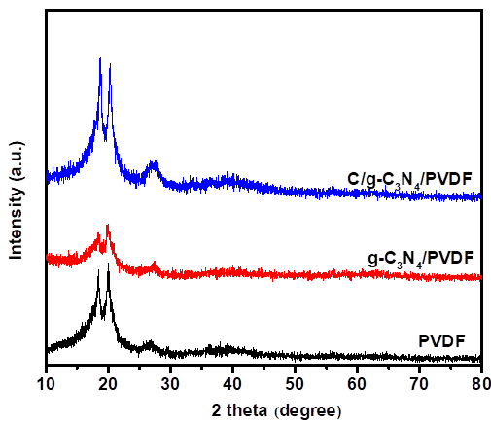
Figure 1. XRD patterns of PVDF, g-C₃N₄/PVDF and C/g-C₃N₄/PVDF.
PVDF is a semi-crystalline polymer, with two main crystalline phases, α and β.^{20,21} The results in Figure 1 show that there are three characteristic peaks at 18.5º, 20.1º, 26.7º assigned to the reflection planes (020), (110), and (021) corresponding to the α crystalline phase. When adding g-C₃N₄ C/g-C₃N₄ to the PVDF polymer, no significant change was observed compared to the pure PVDF sample. The three peaks attributed to the reflection of PVDF still appear at almost the same position but with different intensities. In addition, the characteristic peak at 27.6º corresponding to the (002) plane of g-C₃N₄ appears in the g-C₃N₄/PVDF, C/g-C₃N₄/PVDF samples in Figure 1 but is shifted and overlapped with the characteristic diffraction peak at 26.6º of PVDF. The peak at 27.6º corresponding to the (002) plane of g-C₃N₄ is believed to be the alternating stacking of conjugated aromatic units similar to the structure of graphite.²² The diffraction peaks of the C/g-C₃N₄/PVDF material sample are higher than those in the g-C₃N₄ sample, which can be attributed to the presence of carbon increasing the intensity of the peaks in this material sample.
The chemical bond characteristics of the samples were characterized by FT-IR spectroscopy. The results are shown in Figure 2.
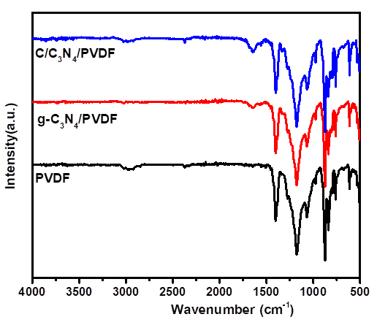
Figure 2. FT-IR spectra of PVDF, g-C₃N₄/PVDF and C/g-C₃N₄/PVDF.
The results of the FTIR spectrum of the PVDF membrane show that the peak at 763 cm⁻¹ is the bending vibration of the CF2 group, the peaks at 794 and 977 cm⁻¹ are assigned to the shaking vibration of the CF2 group and the peak at 1170 cm⁻¹ is considered to be the valence vibration of the CF2 group.^{23,24} The peak at 1413 cm⁻¹ is deemed to be the valence vibration of the C-H functional group. In addition, the PVDF sample also has peaks at 875, 615, 531, 490 cm⁻¹ and all the peaks of PVDF belong to the α phase crystal structure.²⁵ For the composite membrane material samples g-C₃N₄/PVDF and C/g-C₃N₄/PVDF, the peak appearing at 1639 cm⁻¹ is considered the valence vibration of the C=N group.²⁶ The peaks at 2979 and 1411 cm-1 are assigned to the valence and deformation vibrations of the CH₂ group. In addition, the peak at 1181 cm-1 vibration is related to the valence vibration of the CF2 group.²⁷
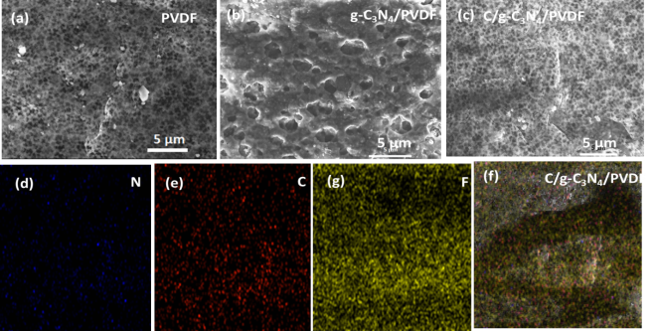
Figure 3. FE-SEM images of PVDF (a), g-C₃N₄/PVDF (b), C/g-C₃N₄/PVDF (c) samples, mapping images of C/g-C₃N₄/PVDF (d) and N (d), C (e), F (g) material.
The SEM images show that the surface of pure PVDF (Figure 3.a) exhibits a homogeneous morphology. Compared with the surface of pure PVDF, it can be seen that the SEM image of g-C₃N₄/PVDF (Figure 3.b) has many voids between g-C₃N₄ and polymer chains formed due to the distribution of particles during sample preparation. Observation of the SEM image of the C/g-C₃N₄/PVDF composite sample (Figure 3.c) shows that many small particles are evenly dispersed on the PVDF substrate. The SEM image confirms that the voids between particles and polymer chains depend on the presence of carbon in the composite sample.²²
The EDX spectrum determines the presence of elements in the characterized C/g-C₃N₄/PVDF composite film material. The results are presented in Figure 4.
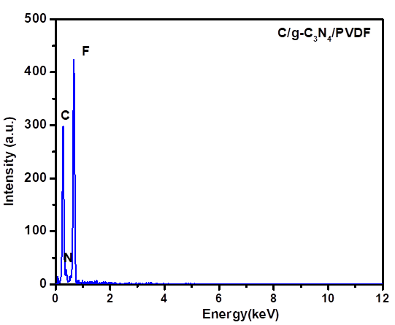
Figure 4. EDX spectrum of C/g-C₃N₄/PVDF material.
The results in Figure 3d, c, f and Figure 4 show the full presence of C, F, and N elements in the C/g-C₃N₄/PVDF composite material. The photocatalytic activity of semiconductor materials is greatly affected by the recombination rate of photogenerated electron and hole pairs; the photoluminescence (PL) spectrum is used to evaluate the recombination ability. The photoluminescence spectra of PVDF, g-C₃N₄/PVDF and C/g-C₃N₄/PVDF materials are presented in Figure 5.
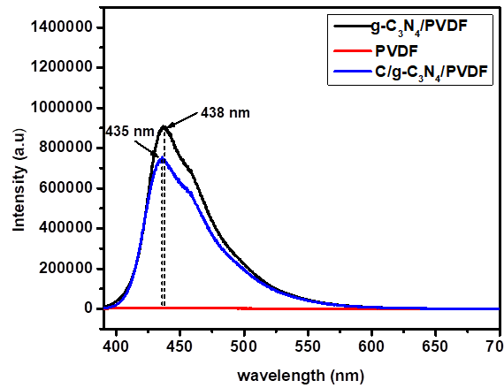
Figure 5. PL spectra of PVDF, g-C₃N₄/PVDF and C/g-C₃N₄/PVDF materials.
PL spectrum analysis with excitation wavelength of film material samples is 390 nm. As shown in Figure 5, for the samples without photocatalyst, the luminescence intensity from the composite material sample C/g-C₃N₄/PVDF is 435 nm, g-C₃N₄/PVDF sample is 438 nm, C/g-C₃N₄/PVDF material has lower emission intensity than g-C₃N₄/PVDF, this may be because adding carbon to g-C₃N₄ makes the material better dispersed. For PVDF membrane, no significant PL intensity is observed across the entire measured PL spectrum, only adsorption properties, so the luminescence intensity is very low and almost non-existent. PVDF does not have luminescence, so the PL shift is due to the excitation effect when adding g-C₃N₄ and carbon.²⁸ The PL spectral results demonstrated the ability to recombine electron and hole pairs of C/g-C₃N₄/PVDF>g-C₃N₄/PVDF materials, creating conditions for photogenerated electrons to diffuse to the catalyst surface to interact with adsorbed H₂O or O₂ molecules to create active free radicals to increase the efficiency of treating pollutants.
3.2. Photocatalytic properties of materials
The photocatalytic decomposition of RhB under LED light of g-C₃N₄/PVDF, C/g-C₃N₄/PVDF, and C/g-C₃N₄ materials was carried out after 60 minutes in the dark to reach the adsorption and desorption equilibrium time; the results are shown in Figure 6. The results showed that after 160 minutes of illumination, the RhB decomposition efficiency of the C/g-C₃N₄/PVDF composite membrane material reached 89%, higher than that of C₃N₄/PVDF, C/g-C₃N₄ materials at 45.92 and 82.97%, respectively. This result opens up a new prospect for practical membrane-material environmental treatment applications.
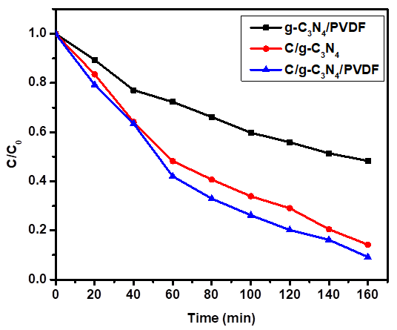
Figure 6. RhB decomposition under visible light of g-C₃N₄/PVDF, C/g-C₃N₄ and C/g-C₃N₄/PVDF materials.
4. Conclusion
The phase inversion method successfully synthesized g-C₃N₄/PVDF C/g-C₃N₄/PVDF materials. Modern physicochemical methods characterized all materials. The crystal phase was clearly shown in the XRD analysis. The shape and dispersion of materials were clearly shown in SEM images. The materials were tested through the decomposition reaction of RhB solution, in which the C/g-C₃N₄/PVDF membrane material achieved RhB decomposition efficiency of nearly 90%.
Acknowledgments
This research is funded by the Vietnamese Ministry of Education and Training under the Grant B2023-DQN-02.

REFERENCES
1. K.N. Harish, H.S.Bhojya Naik, P.N. Prashanth Kumar, and R. Viswanath. Optical and photocatalytic properties of solar light active Nd-substituted Ni ferrite catalysts: for environmental protection, ACS Sustainable Chemistry & Engineering, 2013,1(9),1143-1153.
2. J. Chen and C.S.Poon, Photocatalytic cementitious materials: influence of the microstructure of cement paste on photocatalytic pollution degradation, Environmental science & technology, 2009, 43(23), 8948-8952.
3. J. Benner, D.E. Helbling, H.P.E. Kohler, J. Wittebol, E. Kaiser, C. Prasse, T.A. Ternes, C.N. Albers, J. Aamand, B. Horemans, and D. Springael. Is biological treatment a viable alternative for micropollutant removal in drinking water treatment processes?. Water research, 2013, 47(16), 5955-5976.
4. D. Kanakaraju, B.D. Glass and M. Oelgemöller. Advanced oxidation process-mediated removal of pharmaceuticals from water: A review, Journal of environmental management, 2018, 219, 189-207.
5. M. Antonopoulou, C. Kosma, T. Albanis, and I. Konstantinou. An overview of homogeneous and heterogeneous photocatalysis applications for the removal of pharmaceutical compounds from real or synthetic hospital wastewaters under lab or pilot scale, Science of the total environment, 2021,765(4), 144163-144245.
6. J. Meijide, G. Lama, M. Pazos, M.A. Sanromán, and P.S. Dunlop. Ultraviolet-based heterogeneous advanced oxidation processes as technologies to remove pharmaceuticals from wastewater: An overview. Journal of Environmental Chemical Engineering, 2022,10(3), 107630.
7. J. Wen, J. Xie, X. Chen, and X. Li. A review on g-C₃N₄-based photocatalysts, Applied surface science, 2017, 391, 72-123.
8. S. Zhou, Y. Liu, J. Li, Y. Wang, G. Jiang, Z. Zhao, D. Wang, A. Duan, J. Liu and Y. Wei, Facile in situ synthesis of graphitic carbon nitride (g-C₃N₄)-N-TiO₂ heterojunction as an efficient photocatalyst for the selective photoreduction of CO₂ to CO, Applied Catalysis B: Environmental, 2014, 158, 20-29.
9. X.J. Wang, W.Y. Yang, F.T. Li, Y.B. Xue, R.H. Liu, and Y.J. Hao, In situ microwave-assisted synthesis of porous N-TiO₂/g-C₃N₄ heterojunctions with enhanced visible-light photocatalytic properties. Industrial & Engineering Chemistry Research, 2013, 52(48), 17140-17150.
10. C. Miranda, H. Mansilla, J. Yáñez, S. Obregón and G. Colón, Improved photocatalytic activity of g-C₃N₄/TiO₂ composites prepared by a simple impregnation method, Journal of Photochemistry and Photobiology A: Chemistry, 2013, 253, 16-21.
11. C. Yao, A. Yuan, H. Zhang, B. Li, J. Liu, F. Xi and X. Dong, Facile surface modification of textiles with photocatalytic carbon nitride nanosheets and the excellent performance for self-cleaning and degradation of gaseous formaldehyde, Journal of colloid and interface science, 2019, 533, 144-153.
12. J. Zhao, J. Wang, L. Fan, E. Pakdel, S. Huang and X. Wang, Immobilization of titanium dioxide on PAN fiber as a recyclable photocatalyst via co-dispersion solvent dip coating, Textile Research Journal, 2017, 87(5), 570-581.
13. C. Shi, J. Zhu, X. Shen, F. Chen, F. Ning, H. Zhang, Y.Z. Long, X. Ning and J. Zhao, Flexible inorganic membranes used as a high thermal safety separator for the lithium-ion battery, Rsc Advances, 2018, 8(8), 4072-4077.
14. H. Liu, Z.G. Zhang, X.X. Wang, G.D. Nie, J. Zhang, S.X. Zhang, N. Cao, S.Y. Yan, and Y.Z. Long, Highly flexible Fe₂O₃/TiO₂ composite nanofibers for photocatalysis and utraviolet detection, Journal of Physics and Chemistry of Solids, 2018, 121, 236-246.
15. F. Yang, G.,Ding, J. Wang, Z. Liang, B. Gao, M. Dou, C. Xu and S. Li, Self-cleaning, antimicrobial, and antifouling membrane via integrating mesoporous graphitic carbon nitride into polyvinylidene fluoride. Journal of Membrane Science, 2020, 606, 118146.
16. T.T. Zhou, F.H. Zhao, Y.Q. Cui, L.X. Chen, J.S. Yan, X.X. Wang and Y.Z. Long, Flexible TiO₂/PVDF/g-C₃N₄ nanocomposite with excellent light photocatalytic performance, Polymers, 2019, 12(1), 55.
17. I. Kolesnyk, J. Kujawa, H. Bubela, V. Konovalova, A. Burban, A. Cyganiuk, W. Kujawski, Photocatalytic properties of PVDF membranes modified with g-C₃N₄ in the process of Rhodamines decomposition, Separation and Purification Technology, 2020, 250, 117231.
18. J. Huang, J. Hu, Y. Shi, G. Zeng, W. Cheng, H. Yu, Y. Gu, L. Shi and K. Yi, Evaluation of self-cleaning and photocatalytic properties of modified g-C₃N₄ based PVDF membranes driven by visible light, Journal of colloid and interface science, 2019, 541, 356-366.
19. L. Valenzuela, M. Pedrosa, A. Bahamonde, R. Rosal, A. Torres-Pinto, C.G. Silva, J.L. Faria and A.M. Silva, Carbon nitride–PVDF photocatalytic membranes for visible-light degradation of venlafaxine as emerging water micropollutant, Catalysis Today, 2023, 418, 114042.
20. S. Vidhate, A. Shaito, J. Chung and N.A. D'Souza, Crystallization, mechanical, and rheological behavior of polyvinylidene fluoride/carbon nanofiber composites, Journal of applied polymer science, 2009, 112(1), 254-260.
21. R. Song, D. Yang and L. He, Effect of surface modification of nanosilica on crystallization, thermal and mechanical properties of poly (vinylidene fluoride), Journal of materials science, 2007, 42, 8408-8417.
22. L. Zhu, Y. Wang, F. Hu and H. Song, Structural and friction characteristics of g-C₃N₄/PVDF composites, Applied Surface Science, 2015, 345, 349-354.
23. N. Abzan, M. Kharaziha, S. Labbaf, Development of three-dimensional piezoelectric polyvinylidene fluoride-graphene oxide scaffold by non-solvent induced phase separation method for nerve tissue engineering, Materials & Design, 2019, 167, 107636.
24. M. Kim, YS. Wu, EC. Kan, J. Fan, Breathable and flexible piezoelectric ZnO@ PVDF fibrous nanogenerator for wearable applications, Polymers, 2018, 10(7), 745.
25. KS. Tan, WC. Gan, TS. Velayutham, WH. Abd Majid, Pyroelectricity enhancement of PVDF nanocomposite thin films doped with ZnO nanoparticles, Smart materials and structures, 2014, 23(12), 125006.
26. Y. Cui, L. Yang, M. Meng, Q. Zhang, B. Li, Y. Wu, Y. Zhang, J. Lang, C. Li, Facile preparation of antifouling gC₃N₄/Ag₃PO₄ nanocomposite photocatalytic polyvinylidene fluoride membranes for effective removal of rhodamine, Korean Journal of Chemical Engineering, 2019, 36, 236-247.
27. N. Nikooe, E. Saljoughi, Preparation and characterization of novel PVDF nanofiltration membranes with hydrophilic property for filtration of dye aqueous solution, Applied Surface Science, 2017, 413, 41-49.
28. Z. Vilamova, L. Svoboda, J. Bednar, Z. Simonova, R. Dvorsky, CG. Silva, JL. Faria, Enhancing photocatalytic g-C₃N₄/PVDF membranes through new insights into the preparation methods, Polymer, 2024, 127238-127249.

