Tự học kỹ năng viết tiếng Anh của sinh viên chuyên ngành Tiếng Anh tại Đại học Quy Nhơn
Nguyễn Trần Yến Nhi*, Nguyễn Trần Ý Nhi, Lê Nhân Thành

Khoa Ngoại ngữ, Trường Đại học Quy Nhơn, Bình Định, Việt Nam

*Tác giả liên hệ chính. Email: nhi4557510172@st.qnu.edu.vn

TÓM TẮT
Nghiên cứu này điều tra các hoạt động tự học viết tiếng Anh của sinh viên năm thứ ba chuyên ngành Ngôn ngữ Anh và Sư phạm tiếng Anh tại Đại học Quy Nhơn. Mục đích của nghiên cứu này là đánh giá nhận thức và thực tiễn của sinh viên liên quan đến tầm quan trọng, mục đích và hiệu quả của các hoạt động tự học viết. Sử dụng phương pháp tiếp cận hỗn hợp, dữ liệu được thu thập thông qua các cuộc khảo sát trên Google Forms và được phân tích định lượng bằng Excel, cùng với dữ liệu định tính thu thập được từ các câu hỏi mở được phân tích bằng phân tích nội dung. Kết quả cho thấy hầu hết sinh viên nhận thức được vai trò quan trọng của tự học trong việc cải thiện kỹ năng viết, đặc biệt là nâng cao động lực, sự tự tin và khả năng tự quản lý. Tuy nhiên, vẫn tồn tại sự khác biệt trong cách thực hành tự học, khi một số sinh viên duy trì thói quen học tập đều đặn, trong khi nhiều người gặp khó khăn trong việc xây dựng lịch trình hiệu quả. Sinh viên chủ yếu học vào buổi tối tại nhà nhưng chưa tận dụng đa dạng phương pháp học. Dựa trên những phát hiện này, nghiên cứu đề xuất tăng cường tần suất luyện viết, xây dựng kế hoạch học tập có cấu trúc, ứng dụng công nghệ hỗ trợ viết và tham gia các hoạt động viết nhóm để nâng cao hiệu quả tự học.
Keywords: Tự học, Kỹ năng viết tiếng Anh, Năm thứ ba, Nhận thức, Thực tiễn.

Self-study in English Writing Skills by Quy Nhon University's English-majors
Nguyen Tran Yen Nhi*, Nguyen Tran Y Nhi, Le Nhan Thanh

Department of Foreign Language, Quy Nhon University, Binh Dinh, Vietnam

*Corresponding author. Email: nhi4557510172@st.qnu.edu.vn

ABSTRACT
This study investigated the self-study English writing activities of third-year English Language and English Teaching students at Quy Nhon University. The purpose of this study was to assess students’ perceptions and practices regarding the importance, purpose, and effectiveness of self-study writing activities. Using a mixed-methods approach, data were collected through Google Forms surveys and analyzed quantitatively using Excel, along with qualitative data collected from open-ended questions analyzed using content analysis. The findings indicate that most students recognize the importance of self-study in improving their writing skills, particularly in enhancing motivation, confidence, and self-regulation. However, variations exist in self-study practices, with some students maintaining consistent study habits while others struggle to establish an effective learning schedule. Students primarily study in the evening at home but have yet to fully utilize diverse learning methods. Based on these findings, the study suggests increasing writing practice frequency, developing structured study plans, utilizing writing support technologies, and engaging in collaborative writing activities to enhance self-study effectiveness.
Keywords: Self-study, English writing skills, Third-year, Perceptions, Practices.
1. INTRODUCTION

English has become the dominant international language, playing a vital role in various fields such as science, technology, business, education, and diplomacy. Hyland asserts that writing skills are crucial for language development, while Crystal highlights English as the world's lingua franca.^{1, 2} In non-English-speaking countries like Vietnam, English is essential for academic and professional success.³ In higher education, students must develop competence in listening, speaking, reading, and writing, with writing being the most challenging.^{1,4} Writing requires mastering grammar, organizing ideas logically, and using appropriate vocabulary.⁵ Harmer views writing as a cognitive process that strengthens language acquisition, while Makalela considers it the most complex language skill.^{6, 7} EFL learners often struggle with linguistic and cultural challenges in producing coherent texts.⁸
Self-study is a key strategy for improving writing skills outside the classroom, offering flexibility and personalized learning. It is particularly relevant for third-year English majors at Quy Nhon University as they transition to academic writing. Little emphasizes learner autonomy in language development, noting that students who take responsibility for their learning are more likely to succeed.⁹ Benson further supports autonomy in writing as it allows students to address weaknesses and explore different styles.¹⁰ The role of self-study in writing development is widely recognized. Benson argues that learner autonomy enhances motivation, self-regulation, and personalized strategies.¹¹ Self-directed learning provides access to diverse resources like online materials, writing software, and peer feedback, which are especially crucial for English majors at Quy Nhon University facing constraints such as limited class hours. Holec defines autonomy as "the ability to take charge of one's own learning," which is essential where formal instruction is insufficient.¹²
Despite its benefits, self-study poses challenges. EFL learners often struggle with idea generation, coherence, grammar, and vocabulary.⁸ The lack of immediate feedback and issues like time management and motivation further hinder effective self-study.¹³ Addressing these obstacles is essential for maximizing the benefits of self-directed learning. This study, Self-Study in English Writing Skills by Quy Nhon University's English Majors, examines students' perceptions and practices of self-study. It explores how third-year English majors view self-study, the methods and tools they use, and the challenges they face. The findings aim to provide insights and recommendations for enhancing self-directed learning in writing.
As Dörnyei notes, autonomous learning not only improves language proficiency but also fosters critical thinking and problem-solving skills.¹⁴ In writing, self-study encourages reflection, helping students identify strengths and weaknesses. This study contributes to EFL writing literature by providing a localized perspective on Vietnamese students' self-study practices and practical recommendations for educators at Quy Nhon University. In conclusion, writing is a complex skill, but self-study empowers students to take ownership of their learning. Hyland highlights that successful writing requires linguistic competence, critical thinking, and clear communication.¹ By investigating the self-study practices of English majors at Quy Nhon University, this research aims to support students in overcoming writing challenges and becoming more autonomous, confident writers.
2. THEORETICAL BACKGROUND
2.1. Theoretical background
2.1.1. Concepts of Self-Study in Language Learning
Self-study represents a pivotal aspect of language learning, especially in the context of enhancing writing skills. According to Benson, self-study encompasses the activities undertaken by learners outside formal instruction to advance their language proficiency.¹⁵ This form of learning is fundamental as it empowers learners to independently direct and tailor their educational experiences according to their personal needs and goals.
The concept of self-study in language learning is closely associated with learner autonomy, which has been a central theme in second language acquisition (SLA) research. Holec defines autonomy as the learner’s “ability to take charge of one’s own learning.”¹² This ability underpins self-study, allowing learners to manage their own learning activities outside the classroom, addressing linguistic and cognitive challenges with flexibility and personalization. Knowles expands this idea with his concept of Self-Directed Learning (SDL), emphasizing the necessity for learners to set their own educational objectives, select relevant resources, and evaluate their progress autonomously.¹⁶ This model highlights the importance of initiative and responsibility in organizing and adjusting the learning process, which is crucial for effective self-study.
Self-study allows for the customization of learning approaches based on individual needs, preferences, and skill levels.¹⁰ Language acquisition is not a one-size-fits-all process, and self-study enables learners to focus on their specific strengths and weaknesses in listening, speaking, reading, and writing. For instance, a learner who finds writing particularly challenging may engage in targeted activities such as drafting essays, revising previous works, and practicing specific grammatical structures. Nation asserts that such focused efforts foster a deeper understanding of language use and build confidence.¹⁷
Moreover, self-study leverages various tools and techniques to facilitate language learning. Modern digital resources, such as language learning apps, online writing labs, and digital dictionaries, provide learners opportunities to engage with the target language at any time. Oscarson highlights the importance of self-assessment in writing, emphasizing that tools allowing for metacognitive reflection can significantly enhance learner autonomy and awareness.¹⁸ Sun and Wang further assert that integrating self-regulated learning (SRL) strategies, such as goal setting and self-evaluation, into self-study enhances writing proficiency by enabling students to independently monitor and adjust their learning behaviors.¹⁹
In the domain of English writing, self-study activities may include thematic writing exercises, reading diverse texts to explore writing styles, and utilizing grammar-checking tools. Murray emphasizes that consistent practice, coupled with feedback from various sources, is instrumental in improving writing skills and enhancing understanding of grammar and vocabulary.²⁰ Hyland also highlights that academic writing is a complex skill requiring mastery of syntax, grammar, vocabulary, and cohesive techniques, all of which necessitate consistent practice beyond the classroom.¹
Despite its advantages, self-study is not without challenges. Oxford identifies maintaining motivation and selecting appropriate learning materials as significant hurdles.¹³ Effective self-study requires learners to develop time management, goal-setting, and self-assessment skills, which can be difficult without proper guidance. Hinkel further notes obstacles such as limited access to reliable study materials, lack of immediate feedback, and the slow pace of progress in skills like writing, which can discourage learners.⁸ Nguyen and Hamid observed that Vietnamese students often struggled with maintaining motivation during self-study, especially when progress in writing was hard to assess independently.³
In the context of English majors at Quy Nhon University, self-study is particularly relevant given the academic requirements and career aspirations of the students. As these students progress into higher academic years, self-study becomes essential for developing competencies in areas such as writing. Self-study provides the flexibility to focus on specific areas of improvement, enabling learners to refine their writing skills and familiarize themselves with academic writing conventions critical for both academic success and future teaching roles.
In conclusion, self-study is an indispensable component of language learning, particularly in developing writing skills. By fostering autonomy and providing opportunities for personalized learning experiences, self-study equips learners with the tools to overcome challenges and achieve proficiency. This theoretical foundation highlights the importance of self-study strategies and resources, setting the stage for exploring practical applications in the context of English majors at Quy Nhon University.
2.1.2. Importance of Self-Study in English Writing
2.1.2.1. Promotion of Independent Learning and Autonomy
Self-study fosters independent learning by enabling learners to take ownership of their educational journey. According to Korthagen et al. effective teacher education emphasizes a "realistic approach" that starts from the learners' personal experiences and encourages systematic reflection.²¹ This reflective process helps learners connect practical experiences with theoretical understanding, fostering autonomy and self-regulation. By reflecting on their practices, learners can identify gaps, develop personalized strategies, and refine their skills in a structured yet self-directed manner. Such autonomy is essential in developing advanced writing skills, as it empowers students to approach their writing with critical perception and independence.
2.1.2.2. Opportunities for Practice Beyond the Classroom
Writing is a skill that thrives on consistent practice, and self-study provides a flexible platform to complement structured classroom learning. According to Bailey, Curtis, and Nunan reflective practices such as journaling, videotaping, and portfolio creation allow learners to evaluate their approaches critically and refine their strategies over time.²² Sun and Wang emphasize the integration of technology-driven tools, such as online writing platforms and grammar-checking software, which offer students additional avenues for practice and immediate feedback.¹⁹ These methods create opportunities for students to practice diverse writing tasks in low-pressure environments, thereby developing their skills incrementally.
Furthermore, as emphasized by Peercy the importance of practice extends to creating targeted opportunities for implementing and refining new skills.²³ Peercy highlighted the necessity of providing learners with focused practice sessions, accompanied by meaningful feedback, to ensure sustained improvement. This iterative approach enables students to experiment, identify their strengths and weaknesses, and engage actively with their learning process. Together, these strategies empower students to extend their writing proficiency beyond classroom boundaries, fostering deeper engagement and skill mastery.
2.1.2.3. Deepening Understanding of Writing Concepts
Self-study enables students to deepen their understanding of writing concepts by engaging with diverse resources and reflective practices. As Golombek emphasizes, tools like reflection journals help learners not only articulate their tacit understandings but also connect their thoughts and emotions to refine their approaches.²⁴ In parallel, exploring grammar guides, tutorials, and workshops supports the independent mastery of effective writing techniques. By integrating these practices, students are empowered to discover strategies tailored to their needs and pace, ensuring consistent improvement in writing quality and style.
2.1.2.4. Enhanced Motivation and Engagement
One of the key advantages of self-study is its ability to foster motivation and engagement in the writing process. Sun and Wang demonstrated that students with high self-efficacy are more likely to sustain their motivation and achieve better outcomes in writing.¹⁹ This is particularly evident when learners have opportunities to explore topics and writing styles that align with their personal interests. Bandura's theory further supports the idea that intrinsic motivation and self-efficacy significantly enhance learners' persistence and success.²⁵ Moreover, the use of technology, such as writing platforms and feedback tools, provides immediate rewards and sustains learner engagement.
2.1.2.5. Overcoming Challenges with Self-Discipline and Feedback
Despite its many benefits, self-study presents challenges, particularly in maintaining self-discipline and obtaining structured feedback. Sun and Wang highlight the role of self-regulated learning (SRL) strategies, such as goal setting, self-monitoring, and systematic review, in overcoming these barriers.¹⁹ Incorporating feedback mechanisms, whether through peer review or digital platforms, is crucial. Hayes emphasizes that a supportive learning environment combined with structured self-regulation fosters sustained progress.²⁶ For example, tools that allow learners to track their performance and receive constructive feedback can mitigate the absence of immediate external evaluation.
2.1.2.6. Integration of Self-Study with Formal Instruction
Self-study is not a substitute for formal education; rather, it complements it by offering flexibility and personalization. By integrating self-study with classroom instruction, students can create a more comprehensive and effective writing education. This combination allows students to practice independently while receiving guidance and feedback from instructors. The blend of formal instruction and self-study ensures that students at Quy Nhon University develop both the technical writing skills and the autonomy necessary to succeed in their academic and professional careers.
2.2. Previous studies
Research on students' self-study practices in developing English writing skills has been explored in various contexts, providing valuable insights into learners’ behaviors and challenges. These studies often focus on the role of individual goals, cultural influences, and educational environments in shaping writing development. While differing in scope and methodology, they offer theoretical and practical foundations that align with the objectives of this study, which investigates the self-study habits of third-year English Language and English Pedagogy students at Quy Nhon University. The following section highlights relevant research that informs and supports this focus.
The study "ESL Students’ Readiness for Self-Directed Learning in Improving English Writing Skills" by Adnan and Sayadi provides valuable insights into the relationship between self-directed learning (SDL) and English writing skill improvement, highlighting students' readiness and self-directedness as critical factors. Building on this, the current research shifts focus to the practical aspects of self-study among third-year English Language and Pedagogy students at Quy Nhon University, emphasizing their perceptions of self-study’s importance, objectives, and effectiveness, as well as the tools and methods they employ. While SDL encompasses broader autonomy and self-regulation frameworks, this study narrows its scope to university-level learners' specific self-study practices for English writing, addressing gaps in understanding how readiness translates into action and providing practical recommendations to enhance independent learning.²⁷
The study "College Students' Writing Self-Efficacy and Writing Self-Regulated Learning Strategies in Learning English as a Foreign Language" by Sun and Wang examines the relationship between writing self-efficacy, self-regulated learning (SRL) strategies, and writing proficiency among EFL learners. Using questionnaires and test scores, the study found that both writing self-efficacy and SRL strategies significantly predict writing performance, with writing self-efficacy contributing most. The findings emphasize that efficacious students are more motivated, persistent, and perform better, while frequent use of SRL strategies like planning, revision, and evaluation enhances writing proficiency. By focusing on college students in an EFL context, the study highlights the importance of fostering self-regulation and self-efficacy in writing instruction, providing a valuable framework for understanding how learners can independently improve their English writing skills. This aligns with the current research’s focus on exploring self-study practices in English writing and further underscores the relevance of psychological and strategic factors in independent learning.¹⁹
Che Wan Ibrahim, Prain, and Collet investigated the perceived learning strategies of Malaysian university students in Web 2.0-based informal English as a Second Language (ESL) learning. Using quantitative methods, the study surveyed 400 students across eight universities and revealed that learners intentionally employed metacognitive and collaborative strategies to improve their English skills. Tools such as Facebook, YouTube, and wikis provided a platform for peer collaboration, self-regulated learning, and language practice in informal, low-pressure settings. The research highlighted the importance of strategies like reflection, trial-and-error, and social interaction in fostering autonomous language learning. The findings suggest that these Web 2.0-based approaches not only enhanced the students' writing abilities but also cultivated lifelong learning skills. This study contributes valuable insights into how digital platforms can support informal self-study, aligning with the broader goals of fostering autonomy and engagement in English writing.²⁸
In her dissertation titled The Effects of a Self-Regulated Writing Intervention on English Learners’ Academic Writing Skills, Diana Akhmedjanova investigated the impact of a self-regulated learning (SRL) intervention on improving the persuasive writing skills of English learners (ELs). The study employed a mixed-methods approach, including a single-case quasi-experimental design and focus group interviews, to assess the effectiveness of integrating SRL instruction into writing curricula. The findings revealed that while the intervention demonstrated weak or no evidence of significantly enhancing students’ writing quality or SRL skills within the study's timeframe, it highlighted that these skills are teachable and require extended instructional periods and tailored strategies. Akhmedjanova’s research provides critical insights into the potential and limitations of SRL-based interventions, particularly in addressing the specific needs of multilingual learners in authentic educational settings.²⁹
Cumming’s chapter provides valuable insights into the role of goal-setting in shaping second-language (L2) writing abilities. Drawing from two distinct research contexts—international students in a pre-university English program and at-risk adolescents in a tutoring initiative—Cumming explores how learners’ goals are influenced by their socio-cultural and educational environments. The study emphasizes that writing development is not uniform but varies based on individual abilities, aspirations, and contexts. Cumming also highlights the significance of dynamic assessment and scaffolding in helping learners set meaningful and achievable goals, ultimately fostering self-regulated learning and long-term growth. This work is relevant to the current research as it underscores the importance of aligning learning goals with learners’ unique needs and circumstances, offering a theoretical foundation to examine how third-year students in Vietnam approach self-study practices in English writing. By connecting the theoretical underpinnings of goal theory with practical applications, Cumming’s work complements the focus on individual agency and strategic learning within self-directed writing improvement.³⁰
3. METHODOLOGY
3.1. Participant
The study involved third-year students majoring in English Language and English Teaching at Quy Nhon University. The primary objective was to systematically collect data through surveys to investigate the perception and practices of self-study in English writing skills among these students.
Initially, 100 third-year students from the English Language and English Teaching majors were selected to participate in the survey. These students were enrolled in advanced English courses, having completed basic English courses prior to their enrollment in the university. On average, participants had been studying English for over seven years. Among the participants, 56% were English Language and 44% were English Teaching, with an average age of 21.
3.2. Research questions
The research questions discussed in this research could have been determined from the background research mentioned above. Those were:
- What are QNU's third-year English majors' perceptions of self-study?
- How do they practice self-study in English writing skills?
3.3. Research method
This project utilized the quantitative method to explore students' perception and practices of self-study in English writing. The research is structured around descriptive research, which seeks to provide a comprehensive overview of the current state of self-study practices among third-year English Language and English Teaching students at Quy Nhon University. By analyzing survey data, this approach allows for a clear understanding of the frequency, duration, and methods employed by students in their self-study routines.
3.4. Data collection
The survey was conducted on students specializing in English Language and English Teaching at Quy Nhon University. The questionnaire was designed based on relevant literature and adapted to examine students' perceptions and practices regarding self-study in English writing.
The questionnaire consists of four key sections. The first section collects demographic information, including participants' major fields of study. This data establishes the context for the study and ensures that the findings are representative of the target group.
The second section assesses students' perceptions of self-study in English writing. It includes statements rated on a 5-point Likert scale to measure how self-study influences motivation, confidence, responsibility, and writing improvement. The responses provide insights into students' attitudes and beliefs about the role of self-directed learning in enhancing their writing skills.
The third section focuses on the practical aspects of self-study, including when and where students engage in writing practice, the frequency and duration of their self-study sessions, and the methods and tools they commonly use. This section aims to capture students' learning habits and preferences in self-directed writing practice.
The final section invites students to suggest effective strategies and resources to enhance self-study in English writing. Common recommendations, such as using online resources, attending writing workshops, and setting specific goals, were analyzed to identify practical ways to support and improve independent learning. To ensure clarity and avoid misunderstandings, the questionnaire was administered in Vietnamese.
3.5. Data analysis
After gathering student responses via Google Forms, the data was downloaded, processed, and refined. The cleaned dataset was then analyzed using Excel's data analysis tools. The findings are displayed through tables and graphs to facilitate easy reference and evaluation.
4. RESULT AND DISCUSSION
4.1. Result
4.1.1. Demographic information
The following table will give the basic demographic information about 100 English majors involving in this study.

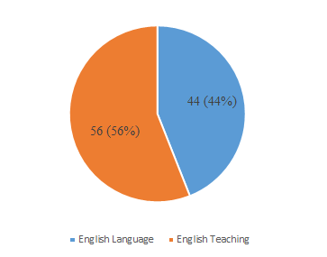
Figure 1. Student major.

In this survey sample, the proportions of students majoring in English Language and English Teaching were 44% and 56%, respectively, corresponding to 44 out of 100 students majoring in English Language and 56 out of 100 students majoring in English Teaching.

4.1.2. Perception of self-study of English writing skills
4.1.2.1. The main purpose of self-studying English writing
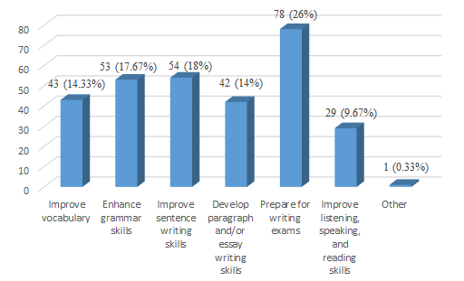

Figure 2. The main purpose of self-studying English writing.

The survey results show that the most common purpose for self-studying English writing is preparing for writing exams (78 students, 26%). Following this, students prioritize improving sentence writing skills (54 students, 18%) and enhancing grammar skills (53 students, 17.67%). Less common purposes include improving vocabulary (43 students, 14.33%) and developing paragraph or essay writing skills (42 students, 14%). Improving listening, speaking, and reading skills is selected by 29 students (9.67%), while the least chosen category is to enhance autonomy in learning with only 1 response (0.33%).

4.1.2.2. The importance of self-study English writing

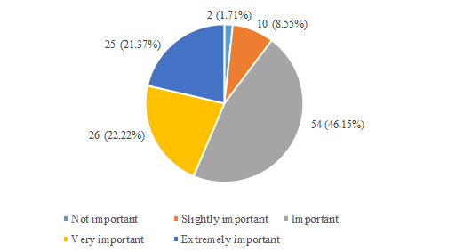
Figure 3. The importance of self-study English writing.

The findings indicate the varying levels of importance assigned to self-studying English writing by participants. A significant proportion of respondents classified it as important (54 students, 46.15%), followed by those who deemed it very important (26 students, 22.22%). Additionally, 25 respondents (21.37%) considered it not important, while a smaller percentage rated it as slightly important (10 students, 8.55%). Only a minority of participants (2 students, 1.71%) perceived self-studying English writing as extremely important.

4.1.2.3. The impact of self-study English writing

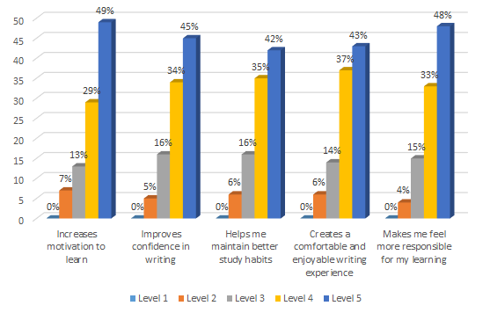
Figure 4. The impact of self-study English writing.
The survey results indicate that self-studying English writing has a significant impact on various aspects of students' learning experiences. Most notably, 49% of participants rated "Increases motivation to learn" at Level 5, the highest level, with 29% selecting Level 4. Similarly, "Improves confidence in writing" received high agreement, with 45% at Level 5 and 34% at Level 4. Additionally, 42% and 35% of respondents rated "Helps me maintain better study habits" at Levels 5 and 4, respectively. For "Creates a comfortable and enjoyable writing experience," 43% selected Level 5 and 37% Level 4. Finally, "Makes me feel more responsible for my learning" had the strongest agreement, with 48% at Level 5 and 38% at Level 4.

4.1.3. Self-study practices
4.1.3.1. Time to self-study English writing
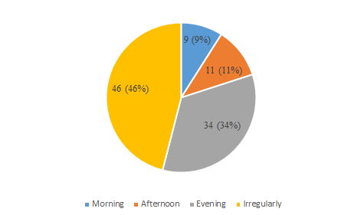
Figure 5. Time to self-study English writing.
The survey results indicate varied preferences among students for the timing of self-studying English writing. The largest proportion, 46%, reported studying irregularly. Evening study ranked second, with 34% of students favoring this time. Afternoon study was less common, with only 11% of participants choosing this option, while morning study was the least preferred, reported by just 9%.

4.1.3.2. Average time per self-study session for English writing
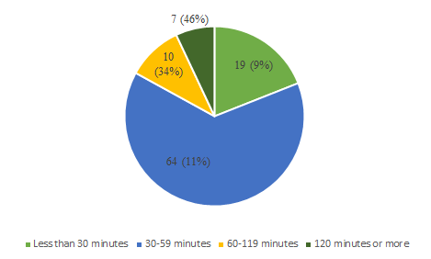
Figure 6. Average time per self-study session for English writing.

The data illustrate the average amount of time students spent on self-study of English writing per session. The majority, 46%, spent less than 30 minutes on self-study of English writing. Approximately 34% of respondents reported studying for 30–59 minutes, while 11% spent 60–119 minutes per session. Only 9% of participants spent 120 minutes or more, reflecting a small proportion of long study sessions.

4.1.3.3. Frequency of self-study English writing
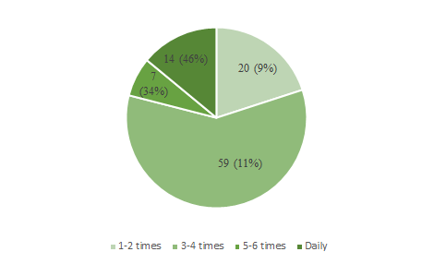
Figure 7. Frequency of self-study English writing.
The frequency of self-study of English writing varied among students. The largest group, 46%, reported practicing daily. Meanwhile, 34% engaged in English writing practice 5–6 times a week. Another 11% of respondents reported practicing 3–4 times a week, while only 9% practiced English writing 1–2 times a week.

4.1.3.4. Place to self-study English writing
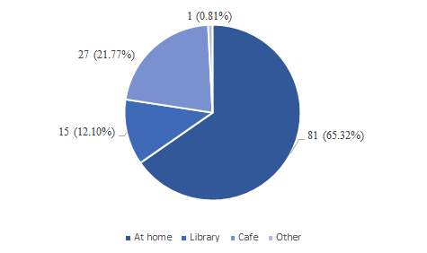
Figure 8. Place to self-study English writing.
The majority of students, 65.32%, preferred to practice writing English at home. The library was the second most popular location, chosen by 21.77% of the participants. Coffee shops accounted for 12.10% of the responses. Only 0.81% of students said they practiced at other unspecified locations, frequently changing locations.

4.1.3.5. Self-study practice method for writing English

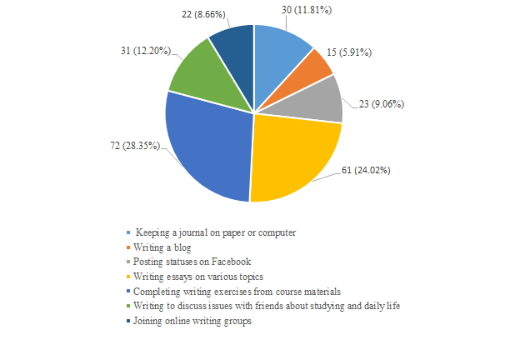
Figure 9. Self-study practice method for writing English.
Among the various methods used for self-practicing English writing, completing writing exercises from course materials is the most common, with 28.35% of participants choosing this approach. Writing essays on various topics follows closely at 24.02%. Keeping a journal, whether on paper or computer, is selected by 11.81%, while posting statuses on Facebook accounts for 9.06%. Writing to discuss issues with friends about studying and daily life is chosen by 12.20%, and joining online writing groups by 8.66%. Writing a blog is the least popular method, with only 5.91% of participants adopting this approach.

4.1.3.6. Participants in self-study of English writing
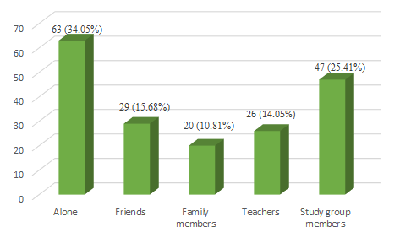
Figure 10. Participants in self-study of English writing.
When participating in self-study of English writing, the majority of participants (34.05%) prefer to study alone. The choice of studying with study group members accounts for 25.41%. Self-study of English writing with friends is chosen by 15.69% of participants. Studying with a teacher is chosen by 14.05%. Finally, studying with family members accounts for the smallest percentage, with 10.81%.

4.1.3.7. Tools and resources used in self-study of English writing
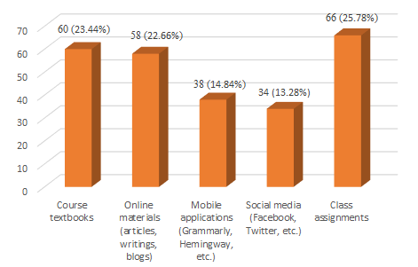
Figure 11. Tools and resources used in self-study of English writing.

The findings reveal that class assignments are the most commonly used tool for self-studying English writing, with 66 participants (25.78%) selecting this option. Course textbooks are the second most utilized resource, reported by 60 participants (23.44%). Online materials, including articles, writings, and blogs, are chosen by 58 participants (22.66%). Mobile applications, such as Grammarly and Hemingway, are used by 38 participants (14.84%), while social media platforms, including Facebook and Twitter, are employed by 34 participants (13.28%).

4.1.4. Effective strategies and recommendations
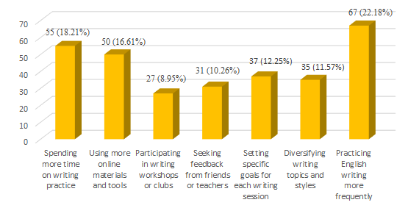
Figure 12. Effective strategies and recommendations.

The findings from the survey highlight several strategies and recommendations deemed effective for enhancing English writing skills. The most frequently endorsed approach is practicing English writing more frequently, with 67 participants (22.18%) identifying this as a key strategy. Spending additional time on writing practice is also emphasized, as reported by 55 participants (18.21%). Utilizing more online materials and tools is suggested by 50 participants (16.61%). Setting specific goals for each writing session is recommended by 37 participants (12.25%), while 35 participants (11.57%) advocate for diversifying writing topics and styles. Seeking feedback from friends or teachers is noted by 31 participants (10.26%), and participating in writing workshops or clubs is highlighted by 27 participants (8.95%).

4.2. Discussion

4.2.1. Importance and impact of self-study
The findings from this study highlight the crucial role of self-study in developing students' English writing proficiency. A considerable proportion of respondents recognize self-study as an essential component of their academic progress. Engaging in independent writing practice allows students to refine their writing skills, enhance their understanding of grammar, and build confidence in their abilities. These findings align with previous research indicating that self-directed learning contributes to improved academic performance and fosters long-term retention of writing skills.
A particularly significant observation is the relationship between self-study and increased motivation in learning. The data reveal that nearly half of the respondents rated self-study as highly motivating, suggesting that students who take initiative in their learning process experience greater enthusiasm and commitment to improving their writing. Motivation plays a critical role in language acquisition, and when students develop a habit of independent writing practice, they become more engaged with the learning material and exhibit higher levels of persistence in overcoming challenges. This increased motivation is closely linked to confidence in writing, as students who engage in frequent writing tasks tend to experience reduced anxiety and greater assurance in their ability to produce coherent and well-structured texts.
Furthermore, self-study encourages autonomy and self-regulation, two essential skills for lifelong learning. The survey findings indicate that students who engage in regular self-study develop stronger discipline and responsibility for their learning. However, the relatively low percentage of students selecting autonomy as a primary reason for self-study suggests that many students still perceive independent writing practice as a necessity rather than a self-driven effort to improve their skills. This highlights the need for academic institutions to promote self-regulated learning strategies and provide guidance on how students can take greater ownership of their writing development.
4.2.2. Self-study practices
A detailed analysis of students' self-study habits reveals notable variations in their approaches to independent writing practice. The study identifies key trends in study timing, frequency, and duration. While a significant number of students reported studying irregularly, those who followed a structured schedule predominantly preferred evening study sessions. This suggests that although students recognize the benefits of self-study, maintaining consistency remains a challenge for many. A lack of structured study habits can lead to ineffective learning outcomes, underscoring the importance of time management skills in academic success.
Regarding the duration of self-study, the majority of students spend less than 30 minutes per session on writing practice, with only a small percentage dedicating over two hours per session. While short study sessions may be beneficial for reinforcing specific writing skills, they may not provide sufficient depth for comprehensive skill development. Writing is a complex cognitive process that requires sustained practice, revision, and reflection. Therefore, students who engage in extended writing sessions are more likely to experience meaningful improvements in their writing proficiency. Institutions and educators should encourage students to balance short writing exercises with longer, more in-depth writing sessions to maximize learning outcomes.
The study also examines the preferred locations for self-study, with home being the most commonly chosen environment. While home study offers comfort and convenience, it may also present distractions that hinder productivity. Libraries, on the other hand, provide a more structured learning environment, yet they are less frequently utilized. The relatively low percentage of students studying in coffee shops or other public spaces suggests that most learners prefer familiar and controlled environments for writing practice. To enhance self-study efficiency, students should be encouraged to establish dedicated writing spaces with minimal distractions and access to necessary resources.
The analysis of self-study methods reveals a strong reliance on course materials and structured writing exercises. While these methods provide essential practice, students could benefit from diversifying their writing approaches. Activities such as journaling, engaging in peer discussions, and participating in online writing groups are underutilized despite their potential to enhance creativity, critical thinking, and collaborative learning. Expanding writing practice beyond conventional exercises can help students develop a more comprehensive skill set and prepare them for real-world writing tasks.
4.2.3. Effective strategies and recommendations
Based on the findings, several strategies can be implemented to optimize students’ self-study practices and enhance their writing proficiency. The most frequently cited recommendation is to increase the frequency and duration of writing practice. Repeated exposure to writing tasks enables students to internalize grammatical structures, refine their argumentation skills, and develop greater fluency in expressing ideas. Establishing structured study schedules can help students overcome inconsistencies in their self-study habits and promote sustained engagement with writing tasks.
Leveraging digital tools and resources is another key recommendation. Writing assistance software, such as Grammarly and Hemingway, provides immediate feedback and helps students identify common errors. Online learning platforms, blogs, and writing forums expose students to diverse writing styles and foster independent learning. Integrating these digital resources into self-study routines can enhance the overall writing experience and provide students with valuable support outside of the classroom.
Setting clear objectives for each writing session is also crucial for effective learning. Students should focus on specific aspects of writing, such as coherence, organization, or grammatical accuracy, to track their progress systematically. By setting measurable goals, learners can maintain motivation and continuously refine their writing abilities.
Furthermore, diversifying writing tasks is essential for developing adaptability across different writing genres. Engaging in various forms of writing, including essays, research papers, creative writing, and technical reports, helps students become more versatile writers. Exposure to different writing styles enhances their ability to structure arguments effectively and tailor their writing to different audiences and purposes.
Seeking feedback from peers and instructors is another critical strategy for improving writing proficiency. Constructive criticism enables students to identify weaknesses and refine their writing techniques. Participation in writing workshops, peer review sessions, and collaborative writing projects provides valuable learning opportunities and fosters a supportive learning community. Encouraging students to actively seek and incorporate feedback can significantly enhance their writing skills over time.
In conclusion, the study underscores the significant role of self-study in the development of English writing skills while highlighting challenges related to consistency and engagement. By implementing structured and diverse self-study strategies, students can maximize their writing potential and achieve greater academic success. Future research should explore additional pedagogical interventions to support self-study habits and examine their long-term effects on language acquisition and academic performance.
5. CONCLUSION
This study explores the perception and practice of self-study in English writing among third-year English major students at Quy Nhon University. The findings indicate that while most students recognize the importance of self-study in improving their writing skills—particularly in enhancing motivation, confidence, and self-regulation—there are significant variations in how they engage in self-study. Some students maintain consistent writing habits, whereas others struggle with scheduling and sustaining effective practice. Many rely primarily on course materials and structured exercises rather than exploring diverse learning methods such as journal writing, peer collaboration, or online writing platforms.
To optimize self-study effectiveness, students should increase the frequency of writing practice, establish structured study plans, and diversify their writing activities across different formats. The integration of digital writing tools, participation in peer review sessions, and engagement in collaborative writing groups can further support skill development. Encouraging students to actively seek and incorporate feedback from instructors and peers is also crucial for improving writing proficiency and fostering long-term learning autonomy.
Despite its contributions, this study has certain limitations. The sample is limited to third-year English major students at Quy Nhon University, which may affect the generalizability of the findings. Additionally, reliance on self-reported data may introduce biases, as students’ perceptions do not always accurately reflect their actual writing performance. Some recommended strategies for enhancing self-study practices require further empirical validation.
Future research should incorporate qualitative methods such as in-depth interviews and case studies to provide deeper insights into students' self-study behaviors. A comparative analysis of student and instructor perspectives could offer a more comprehensive understanding of effective self-study strategies. Additionally, further research could explore the impact of technology-assisted writing tools on students’ motivation, engagement, and writing outcomes. While this study primarily employs a quantitative approach, integrating qualitative methods could provide a more nuanced perspective on the challenges and benefits of self-directed learning in academic writing.
REFERENCES
- K. Hyland. Second language writing, Cambridge University Press, New York, 2003.
- D. Crystal. English as a Global Language (2nd edition), Cambridge University Press, 2003.
- T. Hedge. Writing (2nd edition), Oxford University Press, 2005.
- I. Nation. Teaching ESL/EFL Reading and Writing, Routledge, 2009.
- J. Harmer. How to Teach Writing, Longman, 2004.
- D. Little. Learner Autonomy 1: Definitions, Issues, and Problems, Authentik, 1991.
- H. T. M. Nguyen , M. O. Hamid. Globalization, English Language Policy, and Teacher Agency: Focus on Asia, The International Education Journal, 2016, 18(2), 53-68.
- E. Hinkel. Teaching academic ESL writing: Practical techniques in vocabulary and grammar, Lawrence Erlbaum Associates, 2004.
- L. Makalela. Differential error types in second-language students’ written and spoken texts: Implications for instruction in writing, Written Communication, 2004, 22(4), 368-385.
- P. Benson. Teaching and Researching Autonomy in Language Learning, Longman, 2011.
- P. Benson. Autonomy in language teaching and learning, Language Teaching, 2007, 40(1), 21-40.
- H. Holec. Autonomy and Foreign Language Learning, Pergamon Press, 1981.
- R. Oxford. Language Learning Strategies: What Every Teacher Should Know, Heinle & Heinle, 1990.
- Z. Dörnyei. The Psychology of the Language Learner: Individual Differences in Second Language Acquisition, Routledge, 2005.
- P. Benson. Teaching and Researching Autonomy in Language Learning, Pearson Education, 2001.
- M. S. Knowles. Self-Directed Learning: A Guide for Learners and Teachers, Association Press, 1975.
- I. S. P. Nation. Learning Vocabulary in Another Language, Cambridge University Press, 2009.
- A. Dragemark-Oscarson. Self-Assessment of Writing in Learning English as a Foreign Language. A Study at the Upper Secondary School Level, PhD Dissertation, University of Gothenburg, 2009.
- T. Sun, C. Wang. College students’ writing self-efficacy and writing self-regulated learning strategies in learning English as a foreign language, System, 2020, 90(3).
- D. E. Murray. Feedback in Writing: The Role of Written Feedback in the Writing Process, TESOL Quarterly, 2003, 37(2), 135-152.
- F. A. J. Korthagen, J. Kessels, B. Koster, B. Lagerwerf, T. Wubbels. Linking practice and theory: The pedagogy of realistic teacher education, Erlbaum, New York, 2001.
- K. M. Bailey, A. Curtis, D. Nunan. Undeniable insights: The collaborative use of three professional development practices, TESOL Quarterly, 1998, 32(3), 546–556.
- M. M. Peercy. Challenges in enacting core practices in language teacher education: A self-study, Studying Teacher Education, 2014, 10(2), 146–162.
- P. R. Golombek. Redrawing the boundaries of language teacher cognition: Language teacher educators’ emotion, cognition, and activity, The Modern Language Journal, 2015, 99(3), 470–484.
- A. Bandura. Self-efficacy: The exercise of control, Freeman, New York, 1997.
- J. R. Hayes. A new framework for understanding cognition and affect in writing, Perspectives on writing: Research, theory, and practice, International Reading Association, Newark, 2000.
- N. H. Adnan, S. S. Sayadi. ESL students’ readiness for self-directed learning inimproving English writing skills, Arab World English Journal, 2021, 12, 503–520.
- C. W. I. R. C. Wan, V. Prain, P. Collet. Perceived Learning Strategies of Malaysian University Studentsin Web 2.0-based English as a Second Language Informal Learning, GEMA Online® Journal of LanguageStudies, 2014, 14(1). 29-42.
- D. Akhmedjanova, M. Moeyaert. Self-Regulated Writing of English Learners: Intervention Development, Frontiers in Education, 2022.
- A. Cumming. Goal theory and second-language writing development, two ways. L2 Writing Development: Multiple Perspectives, DeGruyter Mouton, Berlin, 2012.

