A green and simple approach for synthesizing graphene
from graphite via electrochemical exfoliation
Duoc Phan Nguyen Duc*, Nguyen Phan Nhat, Cuong Phan Van
Department of Physics, Faculty of Electrical and Electronic Engineering, Nha Trang University, 02 Nguyen Dinh Chieu street, Nha Trang, Khanh Hoa, Vietnam
* Corresponding author: duocpnd@ntu.edu.vn
ABSTRACT
In this work, high-quality graphene with large lateral dimensions was synthesized using a green and simple electrochemical exfoliation method from graphite rods. The graphite electrode utilized was a commercially available graphite rod, and the electrolyte solution consisted of ammonium sulfate (NH₄)₂SO₄, both readily accessible and cost-effective materials. The effects of various conditions on the quality of graphene were examined in detail, including temperature, current, and potential. Graphene materials were fabricated via an electrochemical exfoliation approach in ammonium sulfate, employing a constant voltage range of 4.5-10 V. The characteristics of the graphene were confirmed by Scanning electron microscope (SEM), Energy dispersive X-ray (EDX), Fourier-transform infrared spectroscopy (FTIR), and Raman spectroscopy. Through this environmentally friendly and straightforward method, few-layer graphene was successfully produced, exhibiting high quality, large surface areas, and excellent dispersion in water. At an appropriate voltage (6-8 V), the graphene demonstrated a high yield (70%), larger surface areas, a high C/O ratio (4.3), low defect density (I_{D}/I_{G}=0.47), and good dispersion in water (Zeta potential = -39.4 mV). The obtained graphene holds potential for applications in environmental treatment and composite materials.
Keywords: Graphene, electrochemical exfoliation, graphite, constant voltage

- INTRODUCTION
Graphene is a single-layer two-dimensional honeycomb lattice of carbon atoms with sp² hybridization. Graphene possesses many remarkable properties such as high electrical and thermal conductivity, high mechanical strength, and high electron mobility [1–3]. Due to its unique properties, graphene has found applications in a wide range of fields, such as corrosion prevention [3], composite materials [4], supercapacitors and batteries [5], sensors [2], and environmental remediation [6].
Currently, there are two main approaches to synthesize graphene: bottom-up and top-down. Bottom-up methods typically include chemical vapor deposition [7] and organic synthesis in solution [8]. Top-down methods are referred to as graphite exfoliation methods, including high energy milling, micromechanical cleavage, the Hummer’s method (chemical), and electrochemical exfoliation [9,10]. The fabrication of graphene often faces a significant challenge in balancing two factor: the yield and the quality of the graphene material. While the chemical vapor deposition (CVD) method can produce single layer and large area films, it requires relatively complex conditions such as high-temperature, inert reaction chambers and expensive experimental equipment. Mechanical exfoliation (without chemical modification) generally high-yield quality but suffers from very low production efficiency [11]. On the other hand, chemical exfoliation methods for producing graphene oxide typically offer high yields and are commercially viable. However, the presence of oxygen-containing functional groups on the large surface area, resulting in a low C/O ratio, significantly reduces the properties of graphene oxide compared to pristine graphene. This significantly impacts the potential applications of the obtained product.
In recent years, the electrochemical method has emerged as a fast, simple, efficient, and environmentally friendly technique for graphene fabrication, attracting significant attention from scientists. Electrochemical exfoliation of graphene from graphite involves applying a negative (cathodic) or positive (anodic) potential to one end of graphite electrode, with the other end connected to a counter electrode, typically platinum or graphite. Under the influence of the electric field within the electrolyte solution, positive ions (Li⁺) migrate and intercalate between the layers of the graphite cathode, separating the layers to form graphene (cathodic exfoliation). Conversely, negative ions (SO4²⁻) can be attracted to the anode to exfoliate graphite into graphene (anodic exfoliation). Various forms of graphite materials are used for electrochemical graphene fabrication, including graphite sheets, rods, and highly oriented pyrolytic graphite. Several factors influence the yield and quality of electrochemically exfoliated graphene, with four primary factors being (1) the shape of the graphite electrode, (2) the applied voltage, (3) the electrolyte solution, and (4) the reduction method employed after graphene or graphene oxide synthesis.
Graphite electrodes used in electrochemical exfoliation are typically natural graphite in the form of foils, rods, or sheets, as well as highly oriented pyrolytic graphite (HOPG). Munuera et al. demonstrated that using graphite foil can reduce the oxidation of graphene during electrochemical exfoliation compared to HOPG [11]. Fuertes et al. also indicated that graphite rods or sheets generally exhibit lower exfoliation rates than graphite foils. However, graphite rods produce graphene material with a thickness of about two layers and a high C/O ratio (11.7), with graphene sheet sizes around 1 µm [12]. Green et al. showed that graphite rods can be used to produce high-quality graphene through electrochemical methods, but with the drawback of low efficiency when using a constant voltage [13]. Chen et al. utilized pencil cores containing a mixture of graphite and clay as graphite electrodes. After electrochemical exfoliation, the obtained graphene material floats on the surface of the solution while the clay settles to the bottom, allowing for easy collection of graphene after synthesis [14].
The quality and yield of graphene production also depend on the voltage applied to the graphite electrode, encompassing both anodic and cathodic exfoliation. Studies have shown that alternating current (AC) or direct current (DC) can be used in electrochemical methods for graphene fabrication. Yang et al. demonstrated the feasibility of using an AC source with [TBA.HSO₄] as the conductive medium to obtain graphene that meets both quality and yield criteria [15]. Their results showed that graphene (1-3 layers) accounted for over 75% of the obtained product with a high C/O ratio. Srivastava et al. also employed a constant voltage with varying values from 2-10 V to evaluate the quality and yield of graphene in electrochemical fabrication. The findings indicated that while higher voltages lead to increased yields, the quality of graphene decreases due to increased defect density and higher oxygen content in the graphene [16]. Eredia et al. further highlighted that longer electrochemical exfoliation times result in lower C/O ratios, significantly impacting the quality of graphene [17]. To enhance graphene quality, several research groups have introduced equipment modifications. For instance, Xu et al. proposed limiting the contact between the graphite rod and the electrolyte surface during electrochemical exfoliation by continuously replenishing the electrolyte solution as the graphite rod is consumed [18], this approach yielded graphene with fewer than three layers and sizes ranging from 3-5 µm. Additionally, other groups have introduced innovative techniques such as pressing graphite powder into rods using filter membranes or combining it with an electric field to cut graphite layers within the electrolyte solution for higher efficiency [13,19].
The electrolyte solution significantly influences the quality and yield of graphene in electrochemical fabrication. The ions in the electrolyte solution must have a size compatible with the interlayer spacing in the graphite structure (0.35 nm). Commonly used electrolytes include H₂SO₄, (NH₄)₂SO₄, Na₂SO₄, NaBr, NaI, and KOH, as their dissociated ions have sizes comparable to the interlayer spacing of graphite [11]. After electrochemical graphene synthesis, the oxygen content can vary depending on the experimental conditions, leading to the formation of graphene oxide (GO). While graphene oxide exhibits good dispersion in organic solvents and finds applications in various fields, it has limitations due to altered physicochemical properties compared to pristine graphene. Typically, graphene oxide is converted to reduced graphene oxide through thermal reduction at high temperatures (500-800 °C) under suitable conditions [20,21].
- EXPERIMENTAL
2.1 Materials
An electrode for fabricating graphene is a cheap, commercially cylindrical graphite rod (carbon; 99.9%) with a length of 100 mm and a diameter of 10 mm which acts as the positive electrode. The negative electrode is the other same graphite rod. The power supply is a programmable control source (IT6832A) manufactured by ITECH (Taiwan). This power supply can adjust the DC voltage from 0 to 32 V and the maximum current up to 6 A. The programmable source can be adjusted using buttons or knobs, the voltage or current values can be held at constant values or varied arbitrarily with different pulse modes dependent on time and amplitude. Ammonium sulfate solution (NH₄)₂SO₄ was bought from Sigma Aldrich. Filtration film MCE (Mixed Cellulose Ester, Advantec) with a pore size of 0.45 μm and a diameter of 47 mm.
In this experiment, an electrolyte solution of (NH₄)₂SO₄ 0.5 M (200 mL) is placed in a heat-resistant glass beaker, and constant voltages are applied, including 4.5 V, 6 V, 8 V, and 10 V. The samples are labeled as GR4, GR6, GR8 and GR10, respectively. Initial temperature conditions are measured using a thermometer, indicating a range of 25-27°C, and the currents are 0.6 A, 1.1 A, 1.9 A, and 2.8 A, respectively (Table 1).

Table 1. Constant voltages applied with 0.5 M (NH₄)₂SO₄ electrolyte solution
Voltage (V) | 4.5 | 6 | 8 | 10
Sign | GR4 | GR6 | GR8 | GR10
Initial temperature (⁰C) | 26 | 25 | 26 | 27
Initial ampere (A) | 0.6 | 1.1 | 1.9 | 2.8

2.2 Characterization
The surface morphologies, structure and electro-physical measurements of the fabricated materials were investigated using scanning electron microscopy (SEM, Hitachi S-4800, Japan) with X-ray energy dispersive spectrometry (EDS), Raman spectroscopy (Horiba, Japan) with 532 nm excitation source, Fourier transform infrared spectroscopy (FTIR) spectroscopy (Bruker, Germany) was used to investigate the functional groups of the nanocomposite, Zeta potential of nanoparticle samples was investigated by Zeta potential analyzer (SZ-100, Horiba).
- RESULT AND DISCUSION
3.1 The efficiency of graphite electrode exfoliation
The structure of graphite is an arrangement of graphene sheets through π-π* bonds with a distance of approximately 0.35 nm between the layers. Under the influence of a positive potential, the anions in the electrolyte solution (SO₄²⁻) ions with a diameter of approximately 0.46 nm) are dissociated and move toward the anode electrode. Due to the expansion of the electrodes in the electrolyte solution along with the appropriate size of SO₄²⁻ ions, these ions can easily intercalate into the layers of graphite leading to the electrochemical exfoliation process. Graphite rod electrodes with a mass of 11.2 g (± 0.1 g) after being exfoliated in an (NH₄)₂SO₄ 0.5 M for 2 hours at several voltages of 4.5 V, 6 V, 8 V, and 10 V are depicted in Fig. 1.

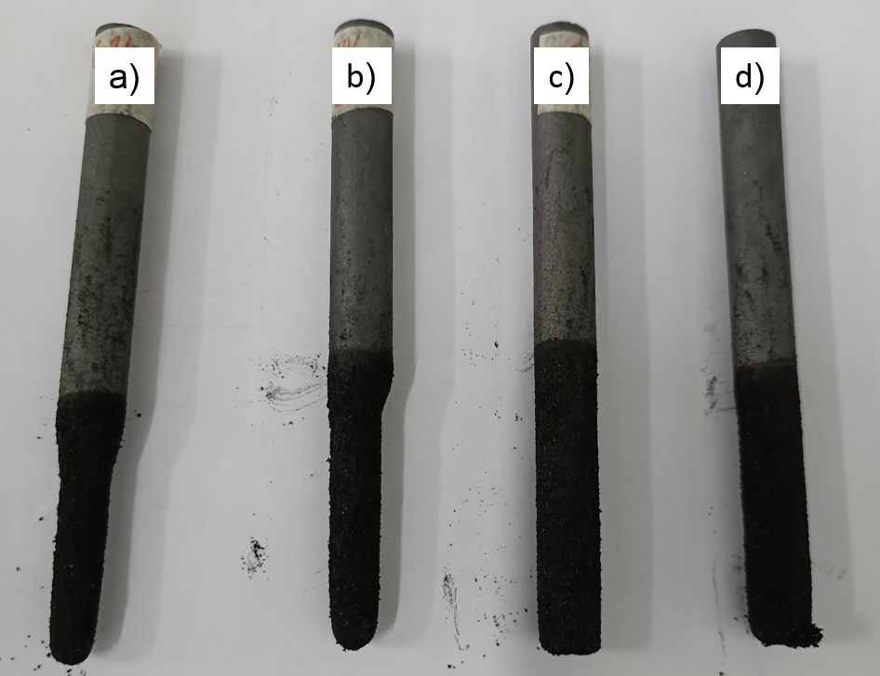
Figure 1. Images of the graphite electrode after erosion at different voltages: (a) 10 V, (b) 8 V, (c) 6 V, and (d) 4.5 V

The results show the extent of graphite electrode erosion depends on the applied voltage across the electrodes. With a voltage of 10 V (Fig.1a), the mass of the sample GR10 obtained is 3.36 g and represents the highest value among the surveyed voltages. Upon decreasing the voltage to 8 V (Fig. 1b), the mass of the exfoliated GR8 decreased to 2.69 g. Fig. 1c, d illustrate the relatively low levels of electrode erosion for the graphite electrode corresponding to voltages of 4.5 V and 6 V, yielding 0.45 g (sample GR4) and 0.85 g (sample GR6), respectively. Thus, as the voltage increases, the mass of exfoliation also increases within the same experimental duration. To assess the efficiency of obtaining graphene from graphite, the solution after electrochemical exfoliation was filtered, washed, sonicated for 1 hour, and centrifuged at 5000 rpm for 10 minutes. The ratio of the mass of the graphene obtained after centrifugation to the mass of exfoliated graphite was determined as the efficiency of graphene synthesis (Table 2).

Table 2. Effect of applied voltage on electrode exfoliation level and graphene yield
Voltage | 10 V | 8 V | 6 V | 4.5 V
Exfoliated mass (g) | 3.36 | 2.69 | 0.85 | 0.45
Yield (%) | 55 | 61 | 70 | 80
Sample sign | GR10 | GR8 | GR6 | GR4

Although GR10 exhibits significant exfoliation mass, the obtained efficiency is low (55%) due to the high voltage applied to the electrolyte solution, which not only generates small-sized graphene due to intense oxidation but also results in the presence of a large quantity of large-sized graphite particles created by the high voltage. In contrast, with a voltage of 8 V, the obtained GR8 shows an increased efficiency of 61%, representing a 6% improvement. This result also demonstrates that GR8 exhibits more uniform size due to reduced oxidation compared to the 10 V. As the voltage is further reduced to 6 V and 4.5 V, the efficiencies of GR6 and GR4 increase to 70% and 80%, respectively, indicating a more uniform size distribution in the obtained graphene materials.
The mechanism of the electrochemical exfoliation of graphite rods can be described as follows: when a sufficiently high voltage is applied across the electrodes, water reduction reactions occur at the cathode producing hydroxyl ions (OH•) that act as strong nucleophiles in the electrolyte solution. These strong nucleophiles migrate to the graphite anode and undergo initial reactions in the vicinity of the graphite rod. Oxidation occurs in the electrode vicinity, leading to changes in the charge and expansion of the graphite layers. This creates favorable conditions for sulfate ions (SO₄²⁻) to intercalate into the layers of graphite. During this process, water molecules can also intercalate simultaneously with the SO₄²⁻ ions. The reduction of sulfate ions and the auto-oxidation of water produce gases such as SO₂, O₂, CO₂, etc., observed as gas bubbles emitted at the electrodes during the electrochemical exfoliation. At the positive electrode, the reduction of sulfate ions to form SO₂ may exert a force large enough to separate the graphite layers into thinner sheets, with the reaction equation taking the form:
$O_{4}^{2-}+4H^{+}+4e^{-}→SO_{2}+2H_{2}O$ (1)
During the electrochemical exfoliation process, under the application of an applied voltage across the two electrode ends, electrons flow out from the anode and several reactions take place, including carboxylation, carbonylation, and water oxidation. These reactions can be described as follows:
$C_{b}+H_{2}O⇌C_{b}OH+H^{+}+e^{-}$ (2)
$C_{b}+2H_{2}O⇌C_{b-1}COOH+3H^{+}+3e^{-}$ (3)
The reactions can be explained as follows: when a sufficiently high voltage is applied to the graphene electrode, hydroxide ions (OH•) generated from water attack the sp² carbon bonds in the graphite, leading to the formation of hydroxyl groups and carboxyl groups. Additionally, other functional groups such as epoxy and carbonyl groups may also form during the electrochemical process.
The oxidation process is associated with gas bubbling at the negative electrode. The appearance of gas bubbles is due to the formation of O₂ gas through the self-oxidation of water and CO₂ gas formation through the C-O bond formation at the electrode, following the reactions [22]:
$C+2H_{2}O→CO_{2}+4H^{+}+4e^{-}$ (4)
$2H_{2}O→O_{2}+4H^{+}+4e^{-}$ (5)
The change in electrolyte solution temperature was monitored during the electrochemical exfoliation process (Table S1). The results demonstrate that as the exfoliation time increases, the solution temperature also rises. This indicates that the dynamic processes occurring within the solution continuously move ions, resulting in an increase in the system's thermal energy and, consequently, the solution temperature.
To assess the impact of graphene oxide after exfoliation and immersion in an electrolyte solution, we also measured the current passing through the circuit, and the results obtained are shown in Fig. S1. The obtained results indicate that the current through the circuit with different constant voltages tends to slightly increase, then gradually decrease towards the initial value at the end of the experiment. The detailed analysis results are presented in Table S2.
3.2 Morphology of graphene
The surface morphology of the graphene material synthesized at constant voltages of 4.5 V, 6 V, 8 V, and 10 V is illustrated in the SEM image of Fig. 2. The results indicate that at a voltage of 4.5 V (Fig. 2a), the GR4 material exhibits exfoliation into small layers with relatively smooth surfaces and considerable thickness, suggesting minimal oxidation occurred in the GR4 samples. Upon increasing the voltage to 6 V (Fig. 2b), the GR6 sample shows the formation of thinner layers, larger-sized GR, and evident folds, indicating that oxidation occurred during the electro-exfoliation process, signifying a significant ion intercalation process leading to the formation of thin layers of graphene with larger sizes. Upon further increasing the voltage to 8 V (Fig. 2c), the obtained results also illustrate the exfoliation of the GR8 material into easily observable thin layers, with a reduction in the lateral size compared to the 6 V voltage. This indicates a significant increase in the ion intercalation into the graphene layers, making the obtained GR8 layers thinner. However, higher voltage also signifies a stronger oxidation process, making it easier to break the larger graphene layers into smaller ones. With a voltage of 10 V (Fig. 2d), it is observable that the lateral size of GR10 is smaller compared to the 6 V and 8 V voltages, displaying fragmentation due to intense oxidation, signifying significant damage in the GR10 sample. Thus, a voltage too low (<6 V) may lead to minimal electrode oxidation and increased ion insertion rate, resulting in small lateral size and low efficiency of GR. Conversely, a voltage too high (>10 V) may induce intense oxidation and material damage.

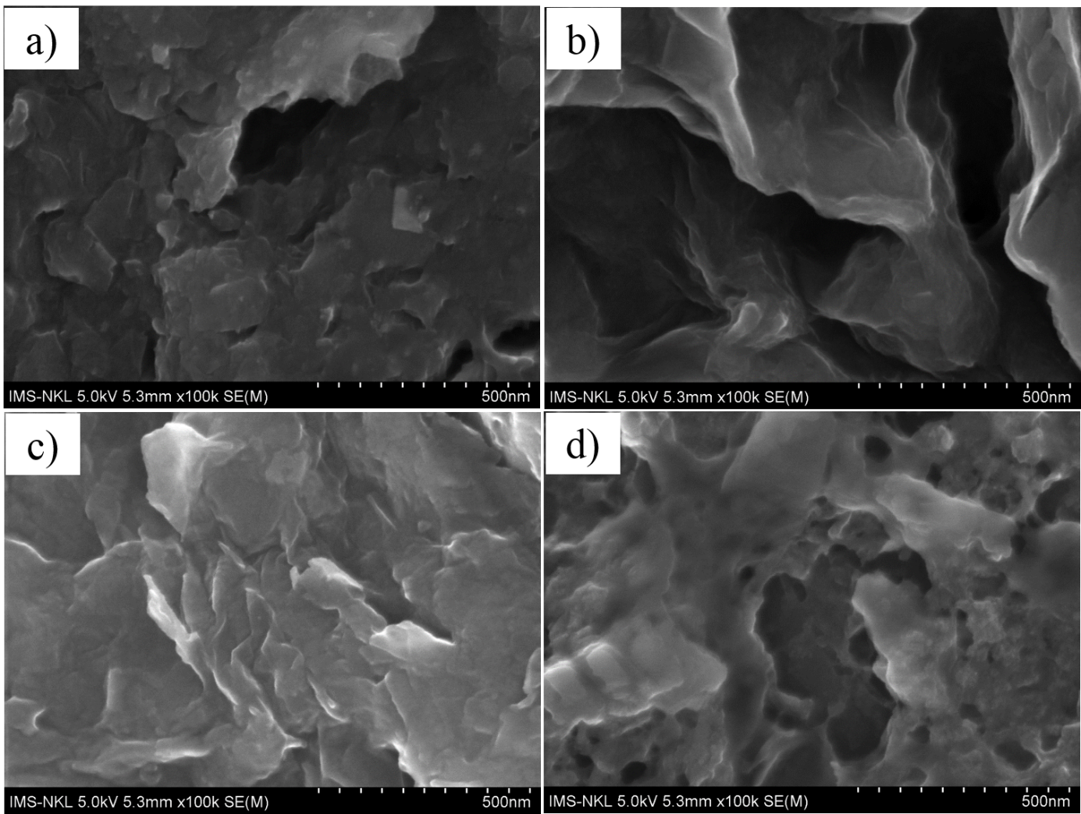
Figure 2. SEM images of graphene at different applied voltages: (a) 4.5 V, (b) 6 V, (c) 8 V, and (d) 10 V

3.3 Content of oxygen in graphene material
Based on the analysis provided, the 4.5 V voltage resulted in a non-ideal graphene sample, leading to its exclusion from further studies. Fig. 3 illustrates the chemical composition analysis of graphene at constant voltages of 6 V, 8 V, and 10 V. At 6 V, the GR6 sample exhibited a carbon content of 80.59%, oxygen content of 18.87%, and a corresponding C/O ratio of 4.3. This result reaffirms that the 6 V voltage induced electrode oxidation, although the degree of oxidation was not significant, as evidenced by the high C/O ratio. At 8 V, the GR8 sample displayed carbon and oxygen contents of 75.21% and 23.47%, respectively, resulting in a C/O ratio of 3.0. This indicates a substantial increase in the oxygen content, signifying a stronger oxidation process. Upon increasing the voltage to 10 V, the carbon and oxygen contents were 56.00% and 38.99%, with a corresponding C/O ratio of 1.9. This signifies a high oxygen content in the sample, indicating an intense oxidation process. Therefore, as the voltage increases, the oxidation process becomes more pronounced, leading to higher oxygen content, indicating an increase in sample damage.
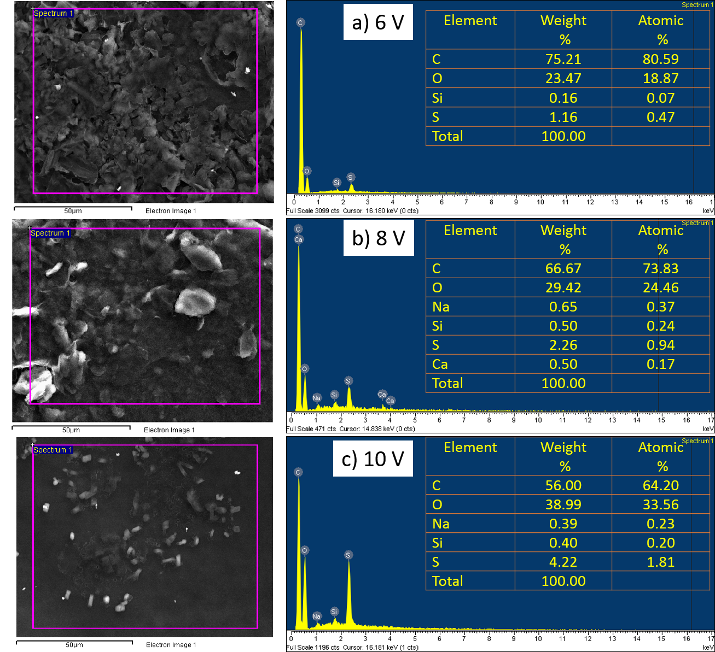
Figure 3. EDX analysis of graphene under different voltages

3.4 FTIR analysis
In FTIR analysis, the absorption of infrared radiation occurs when a photon encounters a molecule and excites it to a higher energy state. The excited state generates molecular bond vibrations (stretching, bending, twisting, etc.) occurring at different wavelengths (or frequencies) in the infrared region of the electromagnetic spectrum. The wavelength of each absorption peak is determined by the inherent physicochemical properties of the corresponding molecules, characterized by functional groups such as C-H, O-H, C-O, C=O, etc. FTIR spectroscopy is a powerful tool for determining the presence of functional groups in graphene, especially oxygen-containing groups [23], recorded in the wavenumber range from 4000-400 cm⁻¹ (Fig. 4), and the peak positions are indicated in Table S3. The FTIR spectrum in Fig. 4a of GP shows two characteristic peaks corresponding to OH bonds (3438 cm⁻¹) and C=C bonds (1632 cm⁻¹). The stretching vibration of the O-H functional group appears due to absorbed water molecules in GP, which can be attributed to the electrode strip being exposed to high humidity conditions in the laboratory, resulting in a large peak intensity and width. The characteristic infrared absorption peak around the position of 1632 cm⁻¹ is confirmed to be the stretching vibration of the C=C bond in the aromatic ring of carbon atoms network [24], which is indicative of the sp² structure of the carbon atom network [25].

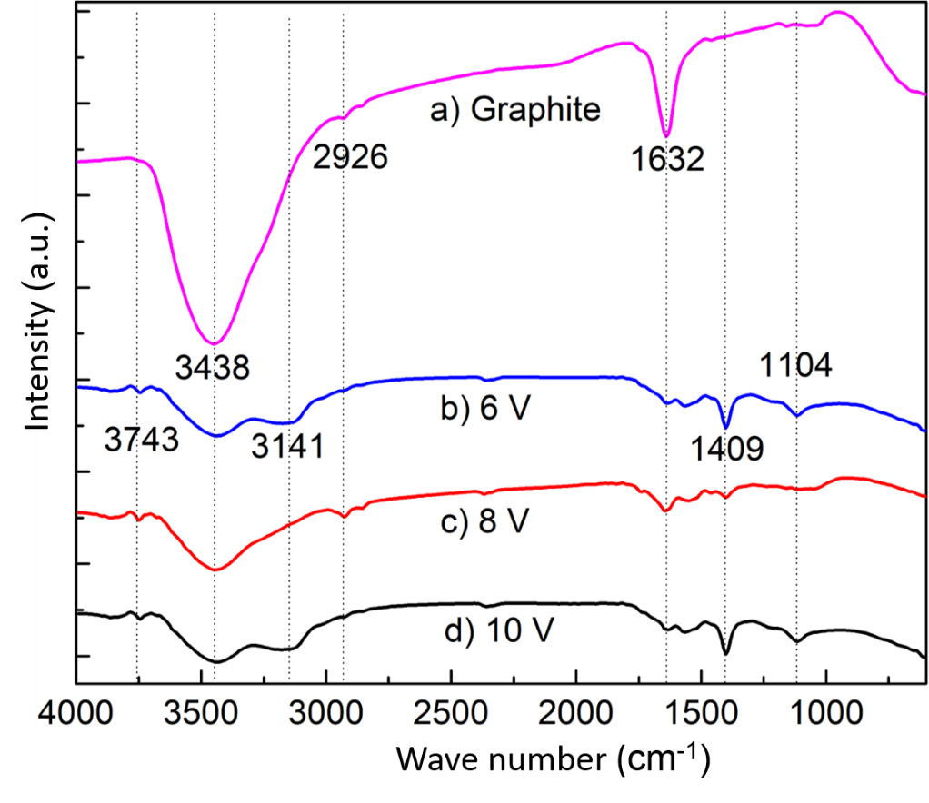
Figure 4. FTIR spectroscopy of exfoliated graphene under different voltages

After the electrochemical exfoliation process, the presence of an absorption peak at a wavenumber of 2926 cm⁻¹ indicates the stretching vibration of C-H bonds, which is a hydrocarbon group inherited from the graphene rod and thus still present in the graphene samples. Peaks appearing at wavenumbers of 1104 cm⁻¹ indicate the stretching vibration of C-O bonds, and 1409 cm⁻¹ indicates the stretching vibration of COO-H and/or CO-H bonds, which are carboxyl groups [26]. This suggests that oxidation reactions have occurred at the GP electrode, leading to the formation of oxygen-containing functional groups. These functional groups play an important role in improving the dispersibility of graphene in organic solvents.
3.5 Raman spectra
The Raman spectra in the wavenumber range of 600-3000 cm⁻¹ for GP, GR6, GR8, and GR10 samples are shown in Fig. 5. The results indicate that both graphite and graphene samples exhibit three characteristic peaks: D (1335-1345 cm⁻¹), G (1578-1589 cm⁻¹), and 2D (2646-2703 cm⁻¹) related to the GP lattice structure. The D peak represents the presence of disordered carbon and the loss of hexagonal structure in the GP lattice. The G peak corresponds to the ordered structure in the GP lattice with sp² hybridization, indicating the high-energy E_{2g} phonon vibration at the Brillouin zone center, and the I_{D}/I_{G} ratio reflects the degree of lattice defects [27]. The 2D peak describes the vibration mode of two second-order phonons and strongly depends on the excitation laser energy frequency. Fig. 5a illustrates the structure of the GP material with characteristic peaks of D, G, and 2D, and an I_{D}/I_{G} ratio of 0.11. Observations show a slight downshift of the 2D peak towards lower wavenumbers, confirming the presence of multilayered graphene in the electrochemically exfoliated samples [28]. With a voltage of 10 V, the structural analysis of the GR10 material reveals significant defects with an I_{D}/I_{G} ratio of 0.77 (Fig. 5b). With higher voltages, the ions move at a faster rate, resulting in thinner exfoliated layers and increased defects. When applying a voltage of 8 V, the I_{D}/I_{G} ratio of 0.63 indicates a significant reduction in the level of defects within the material. Further reducing the voltage to 6 V leads to a greater reduction in the level of defects, with an I_{D}/I_{G} ratio of 0.47.
Furthermore, the positions of the D, G, and 2D peaks for the GP, GR6, GR8, and GR10 samples are also evaluated as shown in Table S4. Observations of increased peak widths for D and 2D peaks, as well as the downshift and increased intensity of these peaks, are indicative of structural changes, defect levels, and the formation of graphene structures in the obtained samples.

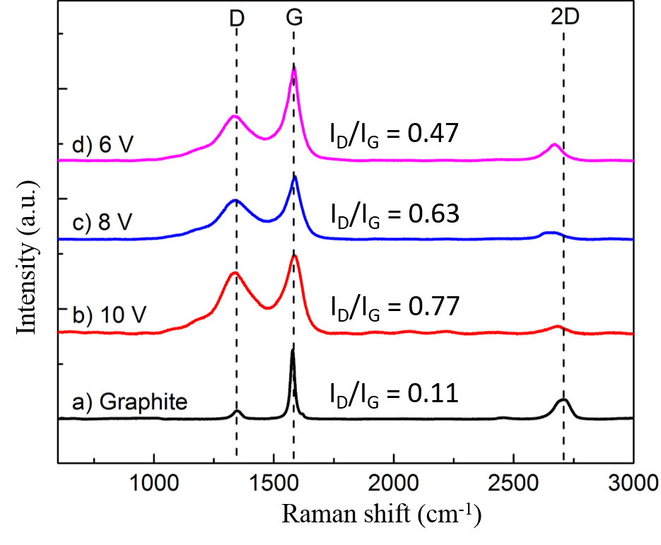
Figure 5. Raman spectra of graphite and exfoliated graphene at different applied voltages

As the applied voltage across the two electrode ends increases, the D and 2D peak spectra become broader and shifted to lower wavenumbers compared to the GP material. Therefore, through Raman spectroscopy analysis, we can observe a greater degree of material damage as the voltage increases. Consequently, the ideal research results for a constant voltage are determined to be in the range of 6-8 V, with the optimal value being 8 V.
3.6 Effective dispersion of exfoliated graphene in water
Zeta potential is used to determine the dispersibility and stability of colloidal suspensions and provides information about the sign and magnitude of the effective surface charge of graphene sheets. Samples with a Zeta potential more negative than -30 mV or more positive than +30 mV are considered to have good dispersibility and stability in the environment. If the Zeta potential is more negative than -45 mV or more positive than +45 mV, it indicates excellent dispersibility and long-term stability [29]. The graphene samples obtained in this study all show good dispersibility and stability in water. This stability is attributed to the negative charges on the surface and edges of the graphene sheets, resulting from the ionization of different functional groups present on graphene, such as C-OH, C-O-C, C=O.
The Zeta potential of graphene in water at different voltages was determined as shown in Fig. 6a. Overall, the GR6, GR8, and GR10 samples all exhibit good dispersibility in water, as their respective Zeta potentials are lower than -30 mV.

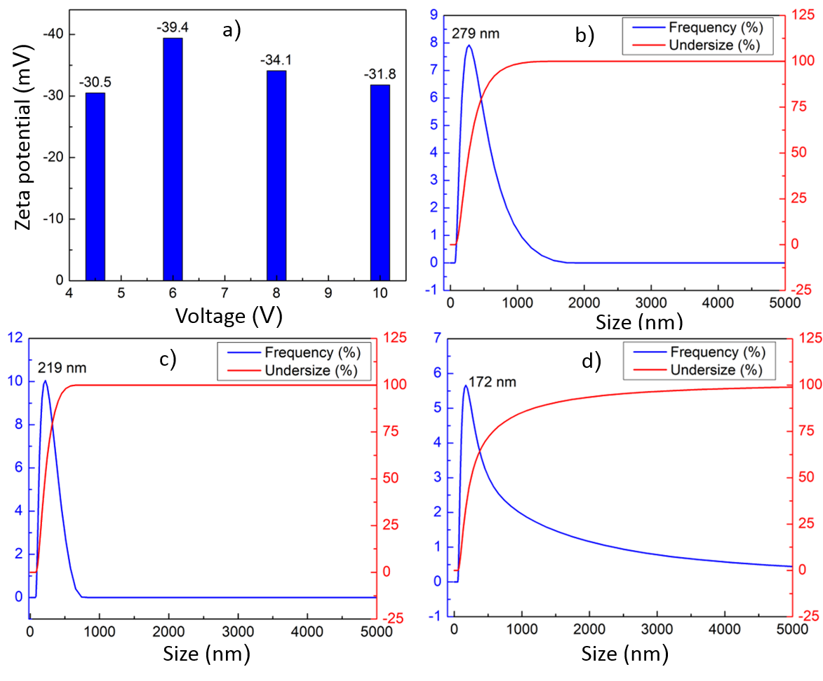
Figure 6. Zeta potential and size distributions of graphene samples at different applied voltages

Detailed evaluations reveal that the Zeta potential of GR6 is -39.4 mV, which is the highest value among the samples, indicating better dispersibility and stability. This can be explained by the lower applied voltage, resulting in a smaller current being generated. As a result, the exfoliation process produces thin graphene sheets with a larger lateral area, leading to a higher density of surface charges. For the GR8 sample, the obtained Zeta potential is around -34.1 mV, also indicating good dispersibility in the solution. This suggests that the obtained graphene sheets are smaller in size due to a higher applied voltage, but not large enough to undergo significant oxidation. With a voltage of 10 V, the GR10 sample shows a reduced Zeta potential of approximately -31.8 mV. The lower value indicates a reduction in lateral size of the graphene sheets due to strong oxidation, leading to the breaking of C-C bonds between carbon atoms. Additionally, the number of layers obtained is relatively thin.
The evaluation results of the size distribution of graphene in solution at different constant voltages are shown in Fig. 6b, c, d. Although the measured particle size distribution does not accurately reflect the thickness or boundary size of graphene in the solution, it reflects the uniformity level of the graphene as a thin nano-film material, influenced by its shape when dispersed in water. For a voltage of 6 V (Fig. 6b), the GR6 particle size is concentrated in the range of 0 to 1000 nm, with no occurrence of graphene particles larger than 1000 nm. The most frequent size is at 279 nm, indicating a relatively even distribution of the obtained graphene sample. In Fig. 6c, the size distribution of GR8 ranges from 0 to 600 nm, with almost no graphene particles larger than 600 nm. The most frequent size is at 172 nm, indicating a uniform distribution of graphene in the solution. Fig. 6d shows that GR10 in the solution has an uneven size distribution, ranging from 100 to 3000 nm. Although the size density is concentrated around 172 nm, it also exhibits large-sized graphene particles due to changes in the electrical resistance in the electrolyte solution over prolonged exfoliation time. This suggests that with a higher applied voltage, GR10 is exfoliated into thin layers and smaller sizes, while also producing large-sized graphene particles when the exfoliation time becomes sufficiently long. On the other hand, at 8 V, a lower-quality sample like GR8 can be produced, but the exfoliation yield is three times higher compared to the 6 V condition. Therefore, the appropriate voltage should be selected based on the quality requirements and the desired exfoliation yield for further application-oriented research.
- CONCLUSION
Graphene materials were fabricated via an electrochemical exfoliation approach in ammonium sulfate, using a constant voltage range of 4.5-10 V. The characteristics of the graphene were confirmed by SEM, EDX, FTIR, and Raman spectroscopy. Through this green and simple method, few-layer graphene was successfully produced with high quality, large surface areas, and excellent dispersion in water. At an appropriate voltage (6-8 V), the graphene exhibited a high yield (70%), larger surface areas, a high C/O ratio (4.3), low defect density (I_{D}/I_{G}=0.47), and good dispersion in water (Zeta potential = -39.4 mV). The obtained graphene could be used as a material for environmental treatment and composite applications.
ACKNOWLEDGEMENTS
This work was supported by Nha Trang University (No. 2024.13.11). We would like to thank Nha Trang University.
REFERENCES
1. Murata, H., Nakajima, Y., Saitoh, N., Yoshizawa, N., Suemasu, T., Toko, K. High-Electrical-Conductivity Multilayer Graphene Formed by Layer Exchange with Controlled Thickness and Interlayer. Sci. Rep. 2019, 9, 4068
2. Duoc, P.N.D., Binh, N.H., Hau, T. Van, Thanh, C.T., Trinh, P. Van, Tuyen, N.V., Quynh, N. Van, Tu, N. Van, Duc Chinh, V., Thi Thu, V., et al. A Novel Electrochemical Sensor Based on Double-Walled Carbon Nanotubes and Graphene Hybrid Thin Film for Arsenic(V) Detection. J. Hazard. Mater. 2020, 400, 123185
3. Van Hau, T., Van Trinh, P., Van Tu, N., Duoc, P.N.D., Phuong, M.T., Toan, N.X., Phuong, D.D., Nam, N.P.H., Lam, V.D., Minh, P.N., et al. Electrodeposited Nickel–Graphene Nanocomposite Coating: Influence of Graphene Nanoplatelet Size on Wear and Corrosion Resistance. Appl. Nanosci. Switz. 2021, 11, 1481–1490
4. Zhao, Z., Zhang, J., Wang, W., Sun, Y., Li, P., Hu, J., Chen, L., Gong, W. Synthesis and Electrochemical Properties of Co3O4-rGO/CNTs Composites towards Highly Sensitive Nitrite Detection. Appl. Surf. Sci. 2019, 485, 274–282, doi:10.1016/j.apsusc.2019.04.202.
5. Zang, X., Jiang, Y., Sanghadasa, M., Lin, L. Chemical Vapor Deposition of 3D Graphene/Carbon Nanotubes Networks for Hybrid Supercapacitors. Sens. Actuators Phys. 2020, 304, 111886
6. Shen, Y., Fang, Q., Chen, B. Environmental Applications of Three-Dimensional Graphene-Based Macrostructures: Adsorption, Transformation, and Detection. Environ. Sci. Technol. 2015, 49, 67–84
7. Thanh, C.T., Binh, N.H., Van Tu, N., Thu, V.T., Bayle, M., Paillet, M., Sauvajol, J.L., Thang, P.B., Lam, T.D., Minh, P.N., et al. An Interdigitated ISFET-Type Sensor Based on LPCVD Grown Graphene for Ultrasensitive Detection of Carbaryl. Sens. Actuators B Chem. 2018, 260, 78–85
8. Narita, A., Wang, X.Y., Feng, X., Müllen, K. New Advances in Nanographene Chemistry. Chem. Soc. Rev. 2015, 44, 6616–6643
9. Anurag, K., Kumar, S.R. Synthesis of Graphene through Electrochemical Exfoliation Technique in Aqueous Medium. Mater. Today Proc. 2021, 44, 2695–2699
10. Edward, I.I., Abdul Manaf, N., Tahir Abdul Muthalib, S.A., Musram Rakunman, M.R., Tan, L.S., Tsuji, T. Synthesis of Graphene Oxide via Electrochemical Process: A Short Review towards Flexible Synthesis Method. IOP Conf. Ser. Mater. Sci. Eng. 2021, 1142, 012019
11. Liu, F., Wang, C., Sui, X., Riaz, M.A., Xu, M., Wei, L., Chen, Y. Synthesis of Graphene Materials by Electrochemical Exfoliation: Recent Progress and Future Potential. Carbon Energy 2019, 1, 173–199
12. Sevilla, M., Ferrero, G.A., Fuertes, A.B. Aqueous Dispersions of Graphene from Electrochemically Exfoliated Graphite. Chem. – Eur. J. 2016, 22, 17351–17358
13. Achee, T.C., Sun, W., Hope, J.T., Quitzau, S.G., Sweeney, C.B., Shah, S.A., Habib, T., Green, M.J. High-Yield Scalable Graphene Nanosheet Production from Compressed Graphite Using Electrochemical Exfoliation. Sci. Rep. 2018 81 2018, 8, 1–8
14. Chen, K., Xue, D., Komarneni, S. Nanoclay Assisted Electrochemical Exfoliation of Pencil Core to High Conductive Graphene Thin-Film Electrode. J. Colloid Interface Sci. 2017, 487, 156–16
15. Yang, S., Ricciardulli, A.G., Liu, S., Dong, R., Lohe, M.R., Becker, A., Squillaci, M.A., Samorì, P., Müllen, K., Feng, X. Ultrafast Delamination of Graphite into High-Quality Graphene Using Alternating Currents. Angew. Chem. Int. Ed Engl. 2017, 56, 6669–6675
16. Punith Kumar, M.K., Shanthini, S., Srivastava, C. Electrochemical Exfoliation of Graphite for Producing Graphene Using Saccharin. RSC Adv. 2015, 5, 53865–53869
17. Eredia, M., Bertolazzi, S., Leydecker, T., El Garah, M., Janica, I., Melinte, G., Ersen, O., Ciesielski, A., Samorì, P. Morphology and Electronic Properties of Electrochemically Exfoliated Graphene. J. Phys. Chem. Lett. 2017, 8, 3347–3355
18. Zhou, Q., Lu, Y., Xu, H. High-Yield Production of High-Quality Graphene by Novel Electrochemical Exfoliation at Air-Electrolyte Interface. Mater. Lett. 2019, 235, 153–156
19. Shinde, D.B., Brenker, J., Easton, C.D., Tabor, R.F., Neild, A., Majumder, M. Shear Assisted Electrochemical Exfoliation of Graphite to Graphene. Langmuir ACS J. Surf. Colloids 2016, 32, 3552–3559
20. Marković, Z.M., Budimir, M.D., Kepić, D.P., Holclajtner-Antunović, I.D., Marinović-Cincović, M.T., Dramićanin, M.D., Spasojević, V.D., Peruško, D.B., Špitalský, Z., Mičušik, M., et al. Semi-Transparent, Conductive Thin Films of Electrochemical Exfoliated Graphene. RSC Adv. 2016, 6, 39275–39283
21. Gurzȩda, B., Florczak, P., Wiesner, M., Kempiński, M., Jurga, S., Krawczyk, P. Graphene Material Prepared by Thermal Reduction of the Electrochemically Synthesized Graphite Oxide. RSC Adv. 2016, 6, 63058–63063
22. Exfoliation of Graphite into Graphene in Aqueous Solutions of Inorganic Salts | Journal of the American Chemical Society Available online: https://pubs.acs.org/doi/10.1021/ja5017156 (accessed on 3 October 2024).
23. Anurag, K., Kumar, S.R. Synthesis of Graphene through Electrochemical Exfoliation Technique in Aqueous Medium. Mater. Today Proc. 2021, 44, 2695–2699
24. Boehm, H.P. Surface Oxides on Carbon and Their Analysis: A Critical Assessment. Carbon 2002, 40, 145–149
25. Dato, A., Lee, Z., Jeon, K.-J., Erni, R., Radmilovic, V., Richardson, T.J., Frenklach, M. Clean and Highly Ordered Graphene Synthesized in the Gas Phase. Chem. Commun. 2009, 6095–6097
26. Liu, J., Yang, H., Zhen, S.G., Poh, C.K., Chaurasia, A., Luo, J., Wu, X., Yeow, E.K.L., Sahoo, N.G., Lin, J., et al. A Green Approach to the Synthesis of High-Quality Graphene Oxide Flakes via Electrochemical Exfoliation of Pencil Core. RSC Adv. 2013, 3, 11745–11750
27. K, P.K.M., Shanthini, S., Srivastava, C. Electrochemical Exfoliation of Graphite for Producing Graphene Using Saccharin. RSC Adv. 2015, 5, 53865–53869
28. Niu, L., Li, M., Tao, X., Xie, Z., Zhou, X., Raju, A.P.A., Young, R.J., Zheng, Z. Salt-Assisted Direct Exfoliation of Graphite into High-Quality, Large-Size, Few-Layer Graphene Sheets. Nanoscale 2013, 5, 7202–7208
29. Konkena, B., Vasudevan, S. Understanding Aqueous Dispersibility of Graphene Oxide and Reduced Graphene Oxide through pKa Measurements. J. Phys. Chem. Lett. 2012, 3, 867–872

