Supplementary

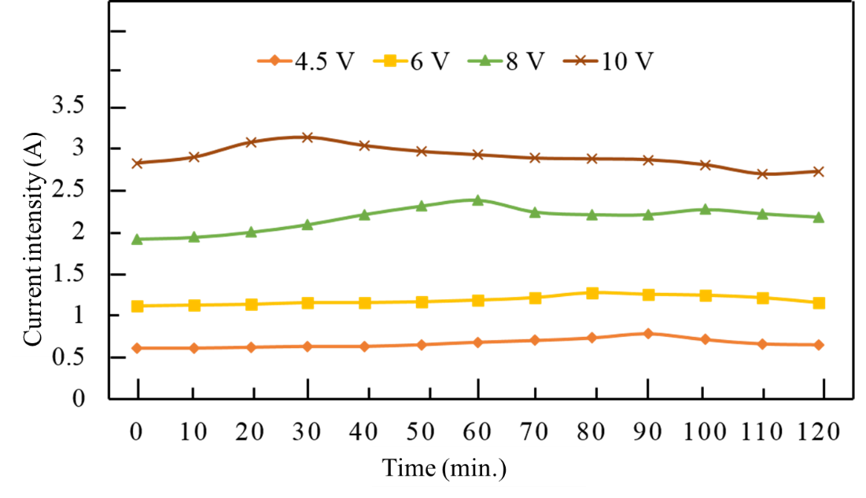
Figure S1. The current change in electrolyte solution

Table S1. Change of temperature into electrolyte solution in electrochemical exfoliated process (supplementary)
Time  Voltage | 0 min | 30 mins | 60 mins | 90 mins | 120 mins
4.5 V | 26⁰C | 30⁰C | 32⁰C | 33⁰C | 33⁰C
6 V | 25⁰C | 28⁰C | 30⁰C | 32⁰C | 34⁰C
8 V | 26⁰C | 33⁰C | 35⁰C | 39⁰C | 42⁰C
10 V | 27⁰C | 43⁰C | 51⁰C | 54⁰C | 55⁰C

Table S2. The current change in electrolyte solution
Time (min.) | 4.5 V | 6 V | 8 V | 10 V
0 | 0.60 | 1.10 | 1.90 | 2.80
10 | 0.60 | 1.11 | 1.92 | 2.87
20 | 0.61 | 1.12 | 1.98 | 3.05
30 | 0.62 | 1.14 | 2.07 | 3.11
40 | 0.62 | 1.14 | 2.19 | 3.01
50 | 0.64 | 1.15 | 2.29 | 2.94
60 | 0.67 | 1.17 | 2.36 | 2.90
70 | 0.69 | 1.20 | 2.22 | 2.86
80 | 0.72 | 1.26 | 2.19 | 2.85
90 | 0.77 | 1.24 | 2.19 | 2.84
100 | 0.70 | 1.23 | 2.25 | 2.78
110 | 0.65 | 1.20 | 2.20 | 2.67
120 | 0.64 | 1.14 | 2.16 | 2.70

Table S3. Functional groups on graphene
Functional groups | Wave number (cm⁻¹)
C = C | 1632
– OH | 3438
C – O | 1102
COO – H | 1409
C – H | 2926

Table S4. The characteristics peaks D, G, 2D of graphite and graphene
Materials | D (cm⁻¹) | G (cm⁻¹) | 2D (cm⁻¹)
GP | 1345 | 1578 | 2703
GR-6 | 1337 | 1586 | 2680
GR-8 | 1339 | 1589 | 2657
GR-10 | 1339 | 1584 | 2671

