Manuscript # QNUJS-B2433
Fabrication of core/shell nanofiber membrane from chitosan, carrageenan, polyvinyl alcohol, and curcumin by two-layer coaxial electrospinning

Response to the comments from Editor and Reviewers
and changes made in the revised manuscript

The authors would like to thank Editor and Reviewers for careful and thorough reading of this manuscript and for the thoughtful comments and constructive suggestions, which help to improve the quality of this manuscript. Our responses are as followed.

Reviewer 1: (The edited part is highlighted in yellow)
- PVA/CCM@PVA/CS/CG nanofibers were fabricated by electrospinning method for biomedical applications. Electrospinning is a simple and effective method for manufacturing uniformly shaped polymer fibers.
Respond: Thank you for your valuable contribution. Indeed, to integrate curcumin (CCM) into the nanofibers, coaxial electrospinning was employed as a simple, one-step method for manufacturing uniformly shaped polymer fibers. This information was provided to the manuscript (Introduction section).
- The author has investigated factors affecting fiber formation such as polymer concentration; electric field; injection speed...
Respond: Thank you for your comment. Coaxial electrospinning is considered as a technique which can produce nanofibers with uniform size and contain bioactive molecules such as drug or growth factor delivery therapies for sustained and controlled release to elicit a positive therapeutic effects. In technical terms, coaxial electrospinning is a multiphysical procedure whose outcome is affected by multiple designs, processes, and material parameters. The processing parameters such as applied voltage, flow rate, working distance, and material factor namely volume proportion between polymer solutions, polymer concentrations are the five most commonly studied parameters contributing to the final nanofiber properties including morphology and size of electrospun nanofibers.
- The author explains quite clearly the influence of factors on fiber formation.
Respond: Thank you for your valuable compliments.
- Optical microscope images should be replaced by scanning electron microscope images.
Respond: Thank you for your helpful recommendation. The major objective of optical microscope images in this research is observed the influences of PVA/CS/CG ratio, carrageenan concentration, sampling distance, applied voltage and injection flow on the morphology of produced nanofibers. From the optical microscope images observation, we can determine the fiber, bead-fiber or bead formation, and can choose optimal values from these results, therefore, we humbly believe that optical microscope images can obtain the major objective of this assays, and there is no need to replace the microscope image with scanning electron microscope (SEM) images. Additionally, accomplished SEM images (Figure. 8a) of nanofiber produced from these optimal parameters is also provided to observe the surface of nanofiber.
- The author should demonstrate more clearly the core-shell structure of the fiber (TEM images do not clearly demonstrate this).
Respond: Thank you for your kind understanding. From the fabrication procedure, using the coaxial electrospinning method, the core/shell solutions were separated prepared and subjected to separate compartments of the machine syringe, as described in the Methods section. From these settings, it has been reported that the core-shell fibers could be successfully formulated¹⁻². Moreover, from our analytical data such as the FTIR, it was confirmed that the four components of CS, CG, PVA and CCM, were strongly interacted via electrostatic interactions. Additionally, the TEM images (Figure. 8b) demonstrated the core-shell structures of the fibers, with a light shell layer coating around the dark core. Therefore, we humbly think that these data were adequate to confirm the formation of the core-shell fiber structures. This information was provided to the 3.2.1 section of the manuscript.
References
[1] H. Qu, S. Wei, Z. Guo. Coaxial electrospun nanostructures and their applications, Journal of Materials Chemistry A, 2013, 1(38), 11513-11528.
[2] S. F. Chou, D. Carson, K. A. Woodrow, K. Current strategies for sustaining drug release from electrospun nanofibers, Journal of Controlled Release, 2015, 220, 584-591.
- In idea 3.1, why did the author choose the ratios 7:2:1, 7:1:2, and 8:1:1 respectively PVA/CS/CG? According to the author, which substance plays a decisive role in fiber formation?
Respond: Thank you for your insightful question. The PVA/CS/CG ratios of 7:2:1, 7:1:2 and 8:1:1 were chosen based on the previous reports³⁻⁶, which indicated that the PVA/CS ratio of 7:3 was optimal value for nanofiber preparation. In this study, the CG component was added into the nanofiber to improve their properties, thus the ratios of PVA/CS/CG were modified to 7:2:1, 7:1:2 and 8:1:1.
PVA is a “guest” polymer which plays a vital role in fiber formation. Because CS and CG have rigid structure, strong hydrogen bonding, non-thermoplastic behavior, and high crystallinity result in low mechanical characteristics, which can complicate the electrospinning process⁷. Therefore, to address these challenges, incorporating an electrospinnable polymer such as PVA can improve the processability and by prevailing electrospinning limits⁸. Thereby, the combination of these components could enhance the nanofiber properties and more applications in the future. This information was described in the Introduction section.

References
[3] J. Guo, H. Zhou, M. Y. Akram, X. Mu, J. Nie, G. Ma. Characterization and application of chondroitin sulfate/polyvinyl alcohol nanofibres prepared by electrospinning, Carbohydrate polymers, 2016, 143, 239-245.
[4] M. Koosha, H. Mirzadeh. Electrospinning, mechanical properties, and cell behavior study of chitosan/PVA nanofibers, Journal of Biomedical Materials Research Part A, 2015, 103(9), 3081-3093.
[5] N. H. Cao‐Luu, H. V. T. Luong, T. V. Nguyen, B. T. Nguyen‐Thi, D. T. Pham, N. C. Pham, M. H. Ho. Curcumin‐Loaded Co‐Axial Electrospun Chitosan/Polyvinyl Alcohol/Calcium Chloride Nanofibrous Membranes for Wound Healing Enhancement. ChemistrySelect, 2024, 9(38), e202402644.
[6] C. L. N. Hanh, N. T. B. Thuyen, N. T. Vy, N. T. N. Mai, N. T. Ty. Fabrication of electrospun chitosan/polyvinyl alcohol membranes with antibacterial ability to aid in the open wound healing, CTU Journal of Innovation and Sustainable Development, 2024 (Accepted).
[7] S. Biranje, P. Madiwale, R. V. Adivarekar. Electrospinning of chitosan/PVA nanofibrous membrane at ultralow solvent concentration, Journal of Polymer Research, 2017, 24, 1-10.
[8] H. Adeli, M. T. Khorasani, M. Parvazinia. Wound dressing based on electrospun PVA/chitosan/starch nanofibrous mats: Fabrication, antibacterial and cytocompatibility evaluation and in vitro healing assay, International journal of biological macromolecules, 2019, 122, 238-254.

Reviewer 2: (The edited part is highlighted in green)
- Explain how the combination of CS, CG, PVA, and curcumin enhances the membrane’s properties.
Respond: We think this is an extremely appropriate question. The combination of CS, CG, PVA and curcumin enhances the membrane’ properties by combining the physiochemical feature properties of each component into a nanofiber membrane for potential wound healing applications.
CS is a potential polysaccharide material for wound dressing formulation due to its ability to encapsulate and controlled release the bioactive molecules such as growth factors, drugs, or proteins⁹, its inherent anti-microbial activity its biocompatibility and its biodegradability with non-toxic residues¹⁰. CS play a positive role in various stages of wound healing such as hemostatic, stimulate fibroblast proliferation, angiogenesis, and adjust in the arrangement of collagen fibers at scar tissue allowing a good re-epithelialization¹¹, and CS interacts with many cellular processes that enable wound healing acceleration¹².
(CG) is another notable biopolymer with potential for wound healing. CG shows antioxidant and antimicrobial properties¹³. Key benefits of CG in wound healing were ability of keeping the wound and periwound damp as well as absorb the wound exudate, making it a commonly used material in wound dressing applications. Additionally, as a polycanionic polymer, CG can form electrostatic cross-links when combined with polycationic chitosan (CS), enhancing the structural integrity and stability of the nanofiber matrix¹⁴.
PVA is a synthetic polymer recognized for its excellent electrospinnability, making it an ideal support material for the CS/CG matrix to overcome the limitations of electrospinning and produce uniform nanofibers¹⁵, and the addition of PVA to the CS/CG polymer matrix enhance mechanical properties of the nanofiber¹⁶. PVA aids in the wound healing process because of its hydrophilicity, which allows it to retain moisture and maintain a moist healing environment, thus promoting faster heal¹⁷.
Curcumin has been proven safe and effective in human, making it a promising chemical for promoting wound healing applications¹⁸. Curcumin possesses high anti-inflammatory, anti-oxidant, and anti-microbial properties¹⁹. CCM supports different stages of the natural healing process and impedes numerous adverse reactions, thus positively influencing the wound-healing process²⁰. CCM enhance fibroblast migration, granulation tissue formation, collagen deposition and in general re-epithelization during the proliferation phases, thus improving wound healing progress²¹.
From the above properties, the combination of CS, CG, PVA and curcumin into nanofiber membrane has multiple biochemical effects on wound dressing applications. The properties of nanofiber membrane from this combination will be evidenced in our future studies. Thank you so much for your kind understanding.
The necessity of using such a high concentration should be justified. Does it impact fiber morphology, stability, or drug encapsulation?
Respond: Thank you for your insightful question. Polymeric concentrations represent for the polymer chain entanglement, which responsible for the particle (electro-spraying) or fiber (electrospinning) formation, and Figure 1 shows the effect of different polymer concentration on the nanofiber morphology. The formation of beads at lower polymer concentrations and the increase in fiber diameter with increase in solution concentration was attributed to the increase in viscosity of the solution²². Solution viscosity is related to the extent of polymer chain molecules entanglement within a solution. Increase in polymer chain entanglement due to the increase in number of polymer molecules results in an increase in its viscosity. During electrospinning, a solution with low viscosity possesses a low viscoelastic force, which is not suitable for the electrostatic, and columbic repulsion forces that stretch the electrospinning jet. This causes the jet to partially break up and bead-fiber formation. Conversely, polymer solution concentration is increased, an increase in viscosity occurs, causing an improvement in the viscoelastic force. Hence, partial breakup of the jet is prevented. The increased polymer chain entanglement with increase in solution concentration also enables the solvent molecules to be distributed over the entangled polymer molecules leading to formation of smooth fibers and improved fiber uniformity²³.
From the above information/discussions, it is indicated that high concentration of polymer solution will produce nanofiber with stable and uniform morphology without defect creations. Furthermore, the dense structure of nanofiber shell due to high polymer concentration, acts as a protective barrier, preventing AV leaking and contributing to the high encapsulated drug content observed in nanofibers.
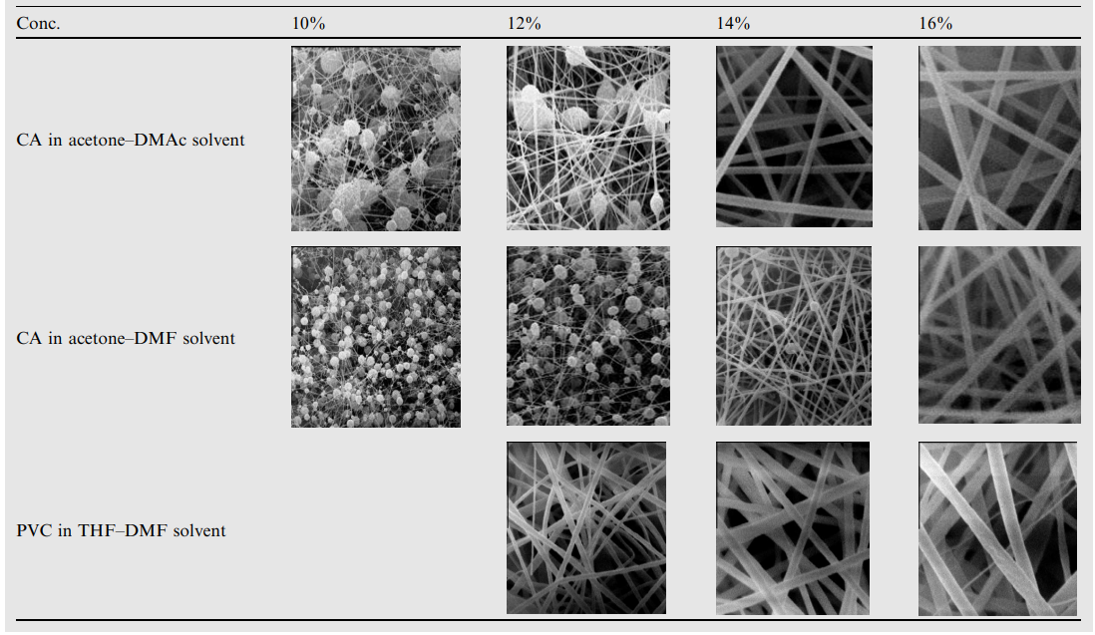
Figure 1. SEM images of electrospun nanofiber produced at different concentration
References
[9] S. Saghazadeh, C. Rinoldi, M. Schot, S. S. Kashaf, F. Sharifi, E. Jalilian, A. Khademhosseini. Drug delivery systems and materials for wound healing applications, Advanced drug delivery reviews, 2018, 127, 138-166.
[10] S. F. Chou, D. Carson, K. A. Woodrow. Current strategies for sustaining drug release from electrospun nanofibers, Journal of Controlled Release, 2015, 220, 584-591.
[11] R. Jayakumar, M. Prabaharan, P. S. Kumar, S. V. Nair, H. J. B. A. Tamura, H. Biomaterials based on chitin and chitosan in wound dressing applications, Biotechnology advances, 2011, 29(3), 322-337.
[12] V. Patrulea, V. Ostafe, G. Borchard, O. Jordan. Chitosan as a starting material for wound healing applications, European Journal of Pharmaceutics and Biopharmaceutics, 2015, 97, 417-426.
[13] L. Y. Madruga, R. M. Sabino, E. C. Santos, K. C. Popat, K. D. C. Balaban, M. J. Kipper. Carboxymethyl-kappa-carrageenan: A study of biocompatibility, antioxidant and antibacterial activities, International journal of biological macromolecules, 2020, 152, 483-491.
[14] C. Li, S. Hein, K. Wang. Chitosan‐carrageenan polyelectrolyte complex for the delivery of protein drugs, International Scholarly Research Notices, 2013, 2013(1), 629807.
[15] H. Adeli, M. T. Khorasani, M. Parvazinia. Wound dressing based on electrospun PVA/chitosan/starch nanofibrous mats: Fabrication, antibacterial and cytocompatibility evaluation and in vitro healing assay, International journal of biological macromolecules, 2019, 122, 238-254.
[16] G. C. D. Mata, M. S. Morais, W. P. D. Oliveira, M. L. Aguiar. Composition effects on the morphology of PVA/chitosan electrospun nanofibers, Polymers, 2022, 14(22), 4856.
[17] A. Rafique, K. M. Zia, M. Zuber, S. Tabasum, S. Rehman. Chitosan functionalized poly (vinyl alcohol) for prospects biomedical and industrial applications: A review, International journal of biological macromolecules, 2016, 87, 141-154.
[18] V. Vivcharenko, A. Przekora. Modifications of wound dressings with bioactive agents to achieve improved pro-healing properties, Applied Sciences, 2021, 11(9), 4114.
[19] S. Fahimirad, H. Abtahi, P. Satei, E. Ghaznavi-Rad, M. Moslehi, A. Ganji. Wound healing performance of PCL/chitosan based electrospun nanofiber electrosprayed with curcumin loaded chitosan nanoparticles, Carbohydrate polymers, 2021, 259, 117640.
[20] P. Zhou, H. Zhou, J. Shu, S. Fu, Z. Yang. Skin wound healing promoted by novel curcumin-loaded micelle hydrogel, Annals of Translational Medicine, 2021, 9(14):1152.
[21] M. Panchatcharam, S. Miriyala, V. S. Gayathri, L. Suguna. Curcumin improves wound healing by modulating collagen and decreasing reactive oxygen species, Molecular and cellular biochemistry, 2006, 290, 87-96.
[22] B. Tarus, N. Fadel, A. Al-Oufy, M. El-Messiry. Effect of polymer concentration on the morphology and mechanical characteristics of electrospun cellulose acetate and poly (vinyl chloride) nanofiber mats, Alexandria Engineering Journal, 2016, 55(3), 2975-2984.
[23] C. Mit‐uppatham, M. Nithitanakul, P. Supaphol, P. Ultrafine electrospun polyamide‐6 fibers: effect of solution conditions on morphology and average fiber diameter, Macromolecular chemistry and physics, 2004, 205(17), 2327-2338.
Why PVA/CS/CG Ratio (8:1:1) used?
Respond: Thank you for your question. As the above answer, the PVA/CS/CG ratios of 7:2:1, 7:1:2 and 8:1:1 were chosen for investigation based on the previous reports³⁻⁴. From the result of survey, the fiber is created continuously and without breaking or bead-fiber formation with the ratio of 8:1:1 compared to other PVA/CS/CG volume proportions. The previous report²⁴ have indicated that the addition more amount of CG (ratios of 7:1:2 and 7:2:1) increases the conductivity of nanofiber solution, resulting in stronger repulsive forces between the charged polymer groups, which enhances the elongation forces during eletrospinning, resulting in thinner fiber with breaking formation. Thus the PVA/CS/CG of 8:1:1 were selected for further experiments, and this information were provided into the manuscript at 3.1.1. Effect of PVA/CS/CG ratio section.

References
[24] Z. P. Rad, J. Mokhtari, M. Abbasi. Fabrication and characterization of PCL/zein/gum arabic electrospun nanocomposite scaffold for skin tissue engineering, Materials Science and Engineering: C, 2018, 93, 356-366.
How does the core/shell structure improve the nanofiber's performance compared to single-layer nanofibers?
Respond: Thank you for your valuable contribution. The core/shell structure of nanofiber structures aids in the controlled release of healing agents (curcumin), promoting effective wound healing compared to single-layer nanofibers. In the wound healing, hemostatic and antibacterial activities occurred in the early stages of wound healing process, thereby CS plays a vital role in this period. It is indicated that the premature release of CCM was not necessary due to the effects of CCM were truly efficient in the anti-inflammatory and proliferative phases, thus CCM played an anti-inflammatory and a healing agent in the wound healing membrane. Therefore, the layered structure of nanofiber membrane containing active compound was a promising approach for healing applications and this study had achieved important results in successfully fabricating layered structures of nanofibers. This information was provided to the 3.2.1. Fiber morphology results by SEM and TEM analysis section.
Ensure all figures (SEM images, standard curves) have clear and descriptive captions, including experimental details and scale bars
Respond: Thank you for your helpful contribution. All figures (optical microscope images, SEM and TEM images) were clarified the scale bars. The figure captions and experimental were described more detail for reproducibility.

