Thiết kế mô hình dự báo chuỗi thời gian mờ tối ưu
dựa trên đại số gia tử

Lê Xuân Việt^{1,*}, Nguyễn Ngọc Dũng¹, Đỗ Thành Hậu²

¹Khoa Công nghệ thông tin, Trường Đại học Quy Nhơn
²Sinh viên lớp Công nghệ thông tin K44, Trường Đại học Quy Nhơn

*Tác giả liên hệ chính. Email: lexuanviet@qnu.edu.vn

TÓM TẮT
Dự báo chuỗi thời gian mờ đã thu hút được sự chú ý đáng kể nhờ khả năng xử lý sự không chắc chắn và thiếu chính xác trong dữ liệu chuỗi thời gian. Các mô hình chuỗi thời gian mờ truyền thống thường gặp hạn chế trong việc nắm bắt các mối quan hệ phức tạp giữa các biến. Để giải quyết thách thức này, chúng tôi đề xuất một mô hình tiếp cận mới gọi là mô hình dự báo chuỗi thời gian mờ dựa trên đại số gia tử (OHAM). Đầu tiên, chúng tôi giới thiệu khái niệm về đại số gia tử và ứng dụng của chúng trong phân tích chuỗi thời gian mờ. Sau đó, chúng tôi trình bày các bước xây dựng mô hình, bao gồm việc xác định các nhãn ngôn ngữ trong đại số gia tử, xây dựng các quan hệ mờ từ dữ liệu, chia đoạn cho không gian tham chiếu. Tiếp đó, chúng tôi đề xuất một thuật toán tối ưu hóa để tinh chỉnh các tham số của OHAM, nhằm đạt được hiệu quả dự báo tối ưu. Cuối cùng là thử nghiệm trên một số bộ dữ liệu cụ thể để đánh giá tính hiệu quả của mô hình. Kết quả thử nghiệm cho thấy mô hình mới đề xuất ít sai số hơn so với nhiều mô hình khác.

Từ khóa: Dự báo, chuỗi thời gian mờ, đại số gia tử, từ mờ, giá trị ngôn ngữ.

Design of Optimal Hedge-Algebras-based Model for
Fuzzy Time Series Forecasting

Le Xuan Viet ^{1,*}, Nguyen Ngoc Dung¹, Do Thanh Hau²

¹Department of Information Technology, Quy Nhon University
²Student of K44 Information Technology, Quy Nhon University

*Corresponding author. Email: lexuanviet@qnu.edu.vn

ABSTRACT
Fuzzy time series forecasting has garnered significant attention due to its ability to handle uncertainty and imprecision in time series data. Traditional fuzzy time series models often face limitations in capturing complex relationships between variables. To address this challenge, we propose a novel approach called the Optimal Hedge-Algebras-based Model (OHAM). First, we introduce the concepts of hedge algebra and its application in fuzzy time series analysis. Subsequently, we present the model construction steps, including defining linguistic labels in hedge algebra, constructing fuzzy relations from data, and partitioning the universe of discourse. Following this, we propose an optimization algorithm to fine-tune the parameters of OHAM, aiming to achieve optimal forecasting performance. Finally, experiments are conducted on several specific datasets to evaluate the effectiveness of the model. The experimental results demonstrate that the newly proposed model exhibits better accuracy than many others.
Keywords: Forecasting, Fuzzy Time Series, Hedge Algebras, Vague Words, Linguistic Terms.

1. INTRODUCTION
The proposed hedge algebra by N. C. Ho^{1,2,3} has been tested in various applications, yielding positive results in problems such as fuzzy control, classification, fuzzy clustering, and fuzzy time series forecasting,^{4,5} among others.
Forecasting plays a crucial role in numerous fields such as finance, weather prediction, and stock market analysis.^{6,7} In recent years, fuzzy time series forecasting models have gained attention due to their ability to handle the uncertainty and vagueness present in real-world data. One such model is the hedge-algebras-based forecasting model.⁸
The hedge-algebras-based forecasting model utilizes an algebraic structure to capture the relationships between historical data and future predictions. However, the performance of this model heavily relies on parameter calibration. Determining optimal parameters is a challenging task that requires an efficient optimization algorithm.
In this paper, we propose the application of the Artificial Bee Colony (ABC) algorithm to optimize the parameters of the hedge-algebras-based forecasting model for fuzzy time series. The ABC algorithm is a metaheuristic optimization technique inspired by the foraging behavior of honey bees. It has been successfully applied to various optimization problems and showcases robustness and convergence efficiency.
By employing the ABC algorithm, this research aims to enhance the accuracy and reliability of the hedge-algebras-based forecasting model. The ABC algorithm will efficiently search the parameter space, finding the optimal combination of parameters for the model. This process will help in achieving improved forecast accuracy, reduced error rates, and enhanced decision-making capabilities in diverse applications.
To evaluate the proposed approach, extensive experiments will be conducted using real-world datasets from different domains. Comparative analyses will be carried out, comparing the performance of the optimized hedge-algebras-based forecasting model with other well-established optimization techniques. The results obtained will provide insights into the effectiveness and efficiency of the ABC algorithm in parameter optimization for fuzzy time series forecasting models.

2. Problem of Fuzzy Time Series Forecasting
The problem in time series forecasting is to accurately predict future values or trends based on historical data. This involves addressing challenges such as identifying and modeling trends, handling seasonality and noise, accounting for non-linear relationships and non-stationarity, and choosing the optimal model and parameters. The goal is to develop a robust forecasting method that can generalize well beyond the training data and provide reliable predictions for effective decision-making. Overcoming these challenges requires a combination of statistical techniques, machine learning algorithms, and domain expertise to achieve accurate and meaningful forecasts.
Fuzzy time series, a concept derived from fuzzy set theory, is a powerful tool for modeling and forecasting time-dependent data with inherent uncertainty and imprecision. Unlike traditional time series analysis, which assumes crisp values, fuzzy time series allows for the representation of vague and uncertain information through linguistic terms and membership functions. By incorporating fuzzy logic into the modeling process, fuzzy time series enables the handling of complex data, making it particularly suitable for real-world scenarios where uncertainty is prevalent. This approach has found applications in various domains, including finance, economics, weather prediction, and decision-making systems, providing valuable insights and accurate predictions in situations where conventional methods may fall short.
The problem is stated as follow: Given n values y(t₁), y(t₂),…, y(t_{n}) where t₁, t₂, …, t_{n} are point times. How to predict the next value?

2.1. Some Basic Concepts and Definitions
The fuzzy time series model was first proposed by Q. Song and B. S. Chissom.⁹ Then, it is improved by S.M Chen^{10,11} to process some arithmetic calculations. From that point, they can get more exact forecasting results. In this session, we briefly review the concepts of fuzzy time series as in Q.Song.⁹
Let U be the universe of discourse, where U = {u₁, u₂,..., u_{n}}. A fuzzy set defined in the universe of discourse U can be represented as follows:
A = f_{A}(u₁)/u₁ + f_{A}(u₂)/u₂ + ··· + f_{A}(u_{n})/u_{n} , where f_{A} denotes the membership function of the fuzzy set A, f_{A} : U → [0, 1], and f_{A}(u_{i}) denotes the degree of membership of u_{i} belonging to the fuzzy set A, and f_{A}(u_{i}) ∈ [0, 1], and 1 ≤ i ≤ n.
Definition 1. Let Y(t) (t = ...,0,1,2,...) be the universe of discourse and be a subset of R. Assume f_{i}(t) (i = 1,2,...) are defined on Y(t), and assume that F(t) is a collection of f₁(t), f₂(t), ..., then F(t) is called a fuzzy time series definition Y(t) (t = ...,0,1,2,...).
Definition 2. Assume that F(t) is caused by F(t−1) only, denoted as F(t − 1) → F(t), then this relationship can be expressed as F(t) = F(t−1)◦R(t,t − 1), where F(t) = F(t − 1)◦ R(t, t−1) is called the first-order model of F(t), R(t, t − 1) is the fuzzy relationship between F(t − 1) and F(t), and “◦” is the Max-Min composition operator.
Definition 3. Assume that the fuzzified input data of the i^{th} year/month is A_{j} and the fuzzified input data of the i+1th year/month is A_{k}, where A_{j} and A_{k} are two fuzzy sets defined in the universe of discourse U, then the fuzzy logical relationship can be represented by A_{j} → A_{k}, where A_{j} is called the current state of the fuzzy logical relationship.
If we have A_{i} → A_{j1}, A_{i} → A_{j2}, ..., A_{i} → A_{jk} then we can write A_{i} → A_{j1,} A_{j2}, ..., A_{jk.}

2.2. Rules for Calculating Output Value
Assume that A_{j} is the value of F(t − 1), the forecasted output F(t) be defined as below:
If there exists a relation 1-1 within the group of the relations where Aj is on the left of the rule, suppose that A_{j} → A_{k} , and the maximum membership value of A_{k} occurs at interval u_{k} , then the output of F(t) is the middle point of u_{k} .

If A_{k} = ∅, that means A_{j} → ∅ and the maximum membership value of A_{j} occurs at interval u_{j}, then the output of F(t) is the middle point of u_{j}.

If we have A_{j} → A₁, A₂ ,…, A_{n}, and the maximum membership values of A₁, A₂ ,…, A_{n} occur at intervals u₁, u₂,…, u_{n} respectively, then the output of F(t) is average of the middle points m₁, m₂, …, m_{n} of u₁, u₂ ,…, u_{n}, that is (m₁ + m₂ + … + m_{n})/n.

3. The Model of Forecasting Time Series Based on Hedge Algebras
In this section, we shall give a short overview of the algebraic approach to the semantics of vague words in natural languages investigated in research¹⁻⁴ and construct a new forecasting method based on hedge algebra theory.

3.1. A Short Overview of Hedge Algebras
Hedge algebras, denoted as AX = (𝒳, 𝔾, ℂ, ℋ, ≤), are a mathematical structure to handle uncertainty and vagueness. In hedge algebras, 𝒳 represents a set of words ℋ is the set of linguistic hedges or modifiers considered as 1-ary operations of the algebra AX; ℂ = {0, W, 1} is a set of special words which are, respectively, the least, the medium and the greatest elements of 𝒳 and regarded as constants of AX since they are fixed points; 𝔾 = {c−, c+} is a set of the primary or atomic words of the linguistic variable X, the first one is called the negative word, and the second, the positive one. 𝔾 ∪ ℂ is the set of the generators of the algebra AX that is ℋ(𝔾 ∪ ℂ) = 𝒳 = ℂ ∪ ℋ(𝔾), the underlying set of AX where for a subset Z of 𝒳, the set ℋ(Z) denotes the set of all elements freely generated from the words in Z. I.e. ℋ(Z) = {σx : x ∈ Z and σ ∈ ℋ*}, where ℋ* is the set of all strings of hedges in ℋ, including the empty string ε. Note that for σ = ε, εx = x and, hence, Z ⊆ ℋ(Z). In the case Z = {x} we shall write ℋ(x) instead of ℋ({x}). ≤ is a semantical order relation upon 𝒳.
Consider a hedge algebra AX = (𝒳, 𝔾, ℂ, ℋ, ≤) of an attribute X with numeric reference interval domain U normalized to be [0,1], for convenience in a unified presentation of the quantification of the hedge algebras. Formally, the numeric semantics of the words of 𝒳 can be determined by a so-called Semantically Quantifying Mapping (SQM),
f : 𝒳 → [0, 1], defined as follows.
Definition 4. A mapping f: 𝒳 → [0, 1] is said to be an SQM of AX, if we have:
- f is an order isomorphism, i.e. it is one-to-one and for ∀x, y ∈ 𝒳, x ≤ y ⇒ f(x) ≤ f(y).
- The image of 𝒳 under f, f(𝒳), is topologically dense in the universe [0, 1].
Definition 5. A function fm: 𝒳 → [0, 1] is said to be a fuzziness measure of the hedge algebra AX associated with the given variable X, if it satisfies the following axioms, for any x ∈ 𝒳 and h ∈ ℋ:
- fm(c−) + fm(c+) = 1.
- $\sum_{-q ≤j ≤p, j ≠ 0 }{fm(h_{j}x)}=fm(x)$.
- fm(hx) = μ(h)fm(x), where μ(h) is called for convenience the fuzziness measure of h as well.
- For x = h_{n}h_{n – 1} … h₁c, fm(x) = fm(h_{n}h_{n – 1} … h₁c) = μ(h_{n})μ(h_{n – 1}) … μ(h₁)fm(c), c ∈𝔾 = { c−, c+}.
- Setting $\sum_{-q ≤j ≤ -1 }{μ(h_{j})}=α$ & $\sum_{1 ≤j ≤ p }{μ(h_{j})}=β$, we have $α+ β=\sum_{-q ≤j ≤p, j ≠ 0 }{μ(h_{j})}=1$.
In the general case, for given values of the fuzziness parameters of X, we can establish a recursive expression to compute the SQM υ_{fm}, called the SQM induced by the given fm, as follows:
- υ_{fm}(W) = κ = fm(c⁻), υ_{fm}(c⁻) = κ − αfm(c⁻)= βfm(c⁻), υ_{fm}(c⁺) = κ +αfm(c⁺);
- ${}_{fm}\left(h_{j}x\right)={}_{fm}\left(x\right)+sign\left(h_{j}x\right)×\left(\sum_{i=sign\left(j\right)}^{j-1}{μ_{i}\left(h_{i}\right)+\left(1-ω\left(h_{j}x\right)\right)μ\left(h_{j}\right)}\right)fm(x)$
where
$ω\left(h_{j}x\right)=\frac{1}{2}\left[1+sign\left(h_{j}x\right)sign({h_{p}h}_{j}x)(β-α)\right]∈\left\{α,β\right\}$, for all j ∈ [−q…p], j ≠ 0, and sign() function is defined as in research^{3,4}.

3.2. Semantization and Desemantization
To convert the values from the reference domain to the semantic domain of a variable X and vice versa, we synthesize some transformations as: Assume that [a, b] is a reference domain of the variable X, and [a_{s},b_{s}] ⊆ [0, 1] is the semantic domain. The conversion value x from [a, b] to [a_{s},b_{s}] is called semantization, denoted S(x) and the conversion value y from [a_{s},b_{s}] to [a,b] is called desemantization, denoted D(y).
For flexibility in semantization or desemantization, we add some parameters sp, dp ∈[-1, 1] then: S(x) = f(x, sp), satisfy 0 ≤ f(x, sp) ≤ 1 , f(x=a, sp) = 0, f(x=b, sp) = 1. And, D(y) = g(y, dp), satisfy a ≤ g(y, dp) ≤ b, g(y = 0, dp) = a, g(y = 1, dp) = b.
In this paper, we use the functions: S(x) = f(x, sp) = (sp×x(1-x)+x)/(b-a) and D(y) = g(y, dp) = dp×(f(y, sp)– a)×(b – f(y, sp))/(b – a)+ f(y, sp).
Figure 1 illustrates the hedge algebra AX = (𝒳, 𝔾, ℂ, ℋ, ≤) with the hedge set ℋ ={Very-V, More-M, Rather-R, Less-L} and the transfer of values from the semantic domain to the reference domain and vice versa.

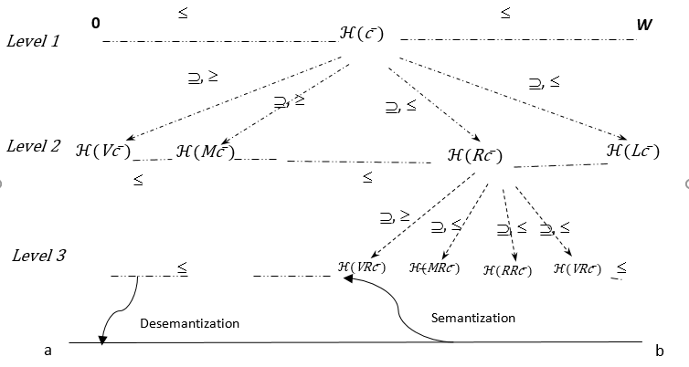
Figure 1. A graph representation of ℋ(Z) ⊆ ℋ(c⁻) and transform a value from [0, 1] to [a, b] and vice versa.

3.3. Hedge-Algebras-based Model (HAM) for Time Series Forecasting

Algorithm 1. HAM(PAR)
INPUT:
- n values of data {y(t₁), y(t₂),…, y(t_{n})} with t₁, t₂, …, t_{n} are point times.
- System of the parameters of hedge algebras and sp, dp for semantization and desemantization, denoted PAR.

OUTPUT: the forecasted value F(t_{i}).

Step 1. Define the discourse U

Put U = [D_{min}, D_{max}] where D_{min} = min{y(t₁), y(t₂),…, y(t_{n})} and D_{max} = max{y(t₁), y(t₂),…, y(t_{n})}.

Step 2. Building the intervals upon U by using the fuzziness model of hedge algebra.

Based on an algebra AX = (𝒳, 𝔾, ℂ, ℋ, ≤) we divide U into k intervals u₁, u₂, …, u_{k} w.r.t level l (see Fig. 1). The interval u_{i} is labeled A_{i}, i = 1, 2,…, k satisfying A₁ < A₂ < … < A_{k}. We calculate f_{ui} = fm(A_{i})×(D_{max} - D_{min}), i = 1, 2, …, k. So we have u₁ = [u_{1d}, u_{1c}] = [D_{min}, D_{min} + f_{u1}], u₂ = [u_{2d}, u_{2c}] = [u_{1c}+1, u_{2d}+f_{u2}], …, u_{k} = [u_{kd}, u_{kc}] = [u_{(k-1)c}+1, u_{kd}+f_{uk}].

Step 3. Quantifying semantics of the linguistic values A₁, A_{2,} …, A_{k} .

To quantify the semantic of A₁, A₂, …, A_{k}, we use SQM υ_{fm} as SA₁ = υ_{fm}(A₁), SA₂ = υ_{fm}(A₂), ..., SA_{k} = υ_{fm}(A_{k}). By properties of hedge algebras, it is clear that SA₁ < SA₂ < ... < SA_{k}.

Step 4. Constructing the relationships

Suppose that, F(t − 1) is A_{i}, F(t) is A_{j}, and F(t) is caused by F(t − 1). Clearly, we have a relation between A_{i} and A_{j}, denoted A_{i} → A_{j}.

Step 5. Grouping relationships

If A_{i} → A_{j1}, A_{i} → A_{j2},..., A_{i} → A_{jm}, then we establish the relation by grouping all of them into a unique relation A_{i} → A_{j1}, A_{j2}, ..., A_{jm}.

Step 6. Calculating output value

From a group of the relations in Step 5, applying the rules as in Section 2.2 we get the results of F(t), scilicet: If there is a relation A_{i} → A_{j}, then F(j) = D(SA_{j}) upon u_{j} = [u_{jd}, u_{jc}]. If A_{i} → ∅ then F(j) = D(∅) upon u_{i} = [u_{id}, u_{ic}]. If A_{i} → A_{j1}, A_{j2}, ..., A_{jk} then F(j) = D(W_{i,j1}×SA_{j1} + W_{i,j2}×SA_{j2} +... + W_{i,jk}×SA_{jk}) upon interval [min{u_{j1d}, u_{j2d}, ..., u_{jkd}}, max{u_{j1c}, u_{j2c}, ..., u_{jkc}}] where W_{i,j} is the weights measured in the ratio number of times of real data in the interval u_{i} to sum of number of times of real data in the intervals u_{j1}, u_{j2}, ..., u_{jk}.
Step 7. Return the values F(t_{i}), i = 1,…, n.

4. The Optimal Hedge-Algebras-based Model
In Step 2 of the HAM model above, we assume that each point at a time will belong to a word in the hedge algebra AX = (𝒳, 𝔾, ℂ, ℋ, ≤), ℂ = {c⁻, c⁺}, ℋ = {h_{-q}, …, h₋₁, h₁,…h_{p}} with given parameters μ(h_{i}), h_{i} ∈ ℋ. Obviously, all parameters to be used in HAM contain n = p+q+2 parameters, which are μ(h_{-q}), μ(h_{-q+1}),… μ(h-₁), μ(h₁),…, μ(h_{p}), and sp, dp for semantization and desemantization. So we can present that by the vector PAR = (x₁, x₂, …, x_{n}) where x₁ = μ(h_{-q}) ,
x₂ = μ(h_{-q+1}) ,… x_{n-2} = μ(h_{p}) , x_{n-1} = sp , x_{n} = dp. Vector PAR is also an artificial bee in the OHAM below.
To optimize the parameters, we choose the fitness function to be the Root Mean Square Error (RMSE), where a smaller value indicates better fitness. The root mean squared error can be expressed as follows:
RMSE = $\sqrt{\frac{Σ_{t=1}^{n}{\left(y_{t}-{\hat{y}}_{t}\right)}^{2}}{n}}$
where $y_{t}$ is the actual data point at time t, and ${\hat{y}}_{t}$ is the predicted value at time t.
The fitness function can be written:
Algorithm 2. Fitness(PAR)
INPUT: A system of parameters PAR represented for a bee; a real dataset ${\{y_{t}\}}_{t=1}^{n}.$
OUTPUT: Value of fitness of PAR.
Step 1. Generate language lattice of HA and quantify those values based on parameters in PAR.
Step 2. Calculate forecast values ${\hat{y}}_{t}$(t = 1,…, n) by HAM(PAR).
Step 3. Set Err = 0.
Step 4. For each real value $y_{t}$ and forecasted value ${\hat{y}}_{t}$at t time, we put:
Err = Err + ${(y_{t}- {\hat{y}}_{t})}^{2}.$
Step 5. RMSE = $\sqrt{\frac{Err}{n}}.$
Step 6. Return value RMSE.

The model is built as:

Algorithm 3. OHAM()
INPUT: n values of data {y(t₁), y(t₂),…, y(t_{n})} with t₁, t₂, …, t_{n} are point times.
OUTPUT: the best system of parameters for solving optimization forecast problems.

Step 1. Initialization
Start by randomly initializing a population of artificial bees, where each bee represents a potential solution to the optimization problem. The population size is typically defined beforehand.

Step 2. Employed Bees' Phase
Each employed bee explores a new solution by adjusting its current position based on information shared with a randomly selected neighbor bee. The new solution is generated by modifying the position using specific search operators or strategies. After generating the new solution, the fitness of both the current and new solutions is evaluated.

Step 3. Onlooker Bees' Phase
Onlooker bees probabilistically choose a solution to explore based on the fitness values of employed bees. The better the fitness value, the higher the probability of being chosen. This phase allows good solutions to be shared among the population and improves the overall search process.

Step 4. Scout Bees' Phase
If an employed bee exhausts its exploration resources without finding a better solution, it becomes a scout bee. Scout bees generate a new random solution to diversify the search space and prevent the algorithm from getting stuck in local optima.

Step 5. Memorize the best solution (BestPAR) achieved so far.

Step 6. Termination
The algorithm will be stopped if a termination condition is satisfied. If not, go back to Step 2.
Step 7. Return BestPAR.

5. EXPERIMENTAL RESULTS
In this section, the proposed approach is applied to forecast the price of State Bank of India (SBI) shares at BSE India from April 2008 to March 2010, the enrollments at the University of Alabama from years 1971 to 1992, and the TAIEX Index of November and December 2004. The result will then be compared with different published methods. To measure the accuracy of the forecasting methods, the following metrics are used for comparison with RMSE.
For each test dataset, we used hedge algebra consisting of four hedge operators: Very, More, Possible, and Little, along with two parameters, sp and dp, for semantization and desemantization. The OHAM model was implemented using the ABC optimization algorithm with a maximum of 3000 iterations, and the number of employed and onlooker bees was set to 50. The optimal parameters obtained correspond to the experimental datasets: the SBI price, student enrollment at the University of Alabama, and the TAIEX stock index, as presented in Table 1.
Using the RMSE metric to evaluate forecasting performance, it is evident that the OHAM model produces less error than other models (see the last column of Tables 2-4). Visually, from Figures 2-4, the forecasted data curves generated by the proposed method follow the actual trend more closely compared to other models. Notably, at points with large amplitude variations, the OHAM model's predictions remain closer to the actual values, further demonstrating the high adaptability of the proposed model.
Table 1. The optimal parameters obtained by OHAM.

Parameters  Forecasting problems | µ(Little) | µ(Possible) | µ(More) | µ(Very) | sp | dp
SBI | 0.316 | 0.286 | 0.204 | 0.194 | 0.467 | -0.457
Enrollment | 0.205 | 0.213 | 0.395 | 0.187 | 0.066 | -0.167
TAIEX | 0.194 | 0.239 | 0.149 | 0.418 | 0.113 | -0.449

5.1. SBI prices Forecasting
Table 2. Results of the forecasting models for SBI data.

Months | Actual SBI Prices | Chen¹⁰  (1996) | Huarng¹²  (2001) | Pathak and  Singh¹³ (2011) | Joshi and  Kumar¹⁴ (2012) | Kumar and  Gangwar¹⁵ (2015) | Bisht and Kumar⁶  (2016) | OHAM
April-08 | 1819.95 | - | - | - | - | - | - | -
May-08 | 1840.00 | 1900 | 1855 | 1770.00 | 1777.80 | 1725.98 | 1877.657 | 1867.00
June-08 | 1496.70 | 1900 | 1855 | 1832.50 | 1865.71 | 1725.98 | 1877.657 | 1583.00
July-08 | 1567.50 | 1500 | 1575 | 1470.00 | 1531.50 | 1512.39 | 1466.360 | 1583.00
August-08 | 1638.90 | 1500 | 1505 | 1570.00 | 1531.50 | 1512.39 | 1466.360 | 1583.00
September-08 | 1618.00 | 1600 | 1610 | 1670.00 | 1777.80 | 1574.35 | 1533.504 | 1583.00
October-08 | 1569.90 | 1600 | 1610 | 1603.33 | 1531.50 | 1574.35 | 1533.504 | 1583.00
November-08 | 1375.00 | 1500 | 1505 | 1670.00 | 1531.50 | 1512.39 | 1466.360 | 1366.00
December-08 | 1325.00 | 1433 | 1482 | 1382.50 | 1504.23 | 1305.52 | 1520.652 | 1366.00
January-09 | 1376.40 | 1433 | 1365 | 1332.50 | 1504.23 | 1665.90 | 1520.652 | 1366.00
February-09 | 1205.90 | 1433 | 1482 | 1332.50 | 1504.23 | 1305.52 | 1520.652 | 1192.00
March-09 | 1132.25 | 1433 | 1155 | 1195.00 | 1258.23 | 1294.27 | 1144.718 | 1192.00
April-09 | 1355.00 | 1300 | 1365 | 1145.00 | 1258.23 | 1294.27 | 1322.446 | 1366.00
May-09 | 1891.00 | 1433 | 1482 | 1357.50 | 1504.23 | 1665.90 | 1520.652 | 1867.00
June-09 | 1935.00 | 1900 | 1890 | 1882.50 | 1865.71 | 2006.51 | 1877.657 | 1867.00
July-09 | 1840.00 | 1900 | 1890 | 1970.00 | 1883.93 | 2006.51 | 1895.491 | 1867.00
August-09 | 1886.90 | 1900 | 1855 | 1470.00 | 1865.71 | 1725.98 | 1877.657 | 1867.00
September-09 | 2235.00 | 1900 | 1855 | 1970.00 | 1865.71 | 2006.51 | 1877.657 | 2259.00
October-09 | 2500.00 | 2300 | 2485 | 2245.00 | 2142.04 | 2520.00 | 2311.382 | 2498.00
November-09 | 2394.00 | 2300 | 2415 | 2470.00 | 2245.65 | 2420.00 | 2374.204 | 2384.00
December-09 | 2374.75 | 2300 | 2345 | 2395.00 | 2191.75 | 2365.99 | 2352.723 | 2384.00
January-10 | 2315.25 | 2300 | 2205 | 2395.00 | 2191.75 | 2365.99 | 2352.723 | 2384.00
February-10 | 2059.95 | 2300 | 2205 | 2295.00 | 2142.04 | 2020.00 | 2311.382 | 2083.00
March-10 | 2120.05 | 2100 | 2135 | 2070.00 | 1883.93 | 2120.00 | 2166.247 | 2083.00
RMSE |  | 187.26 | 164.04 | 205.96 | 200.17 | 131.28 | 179.03 | 36.50

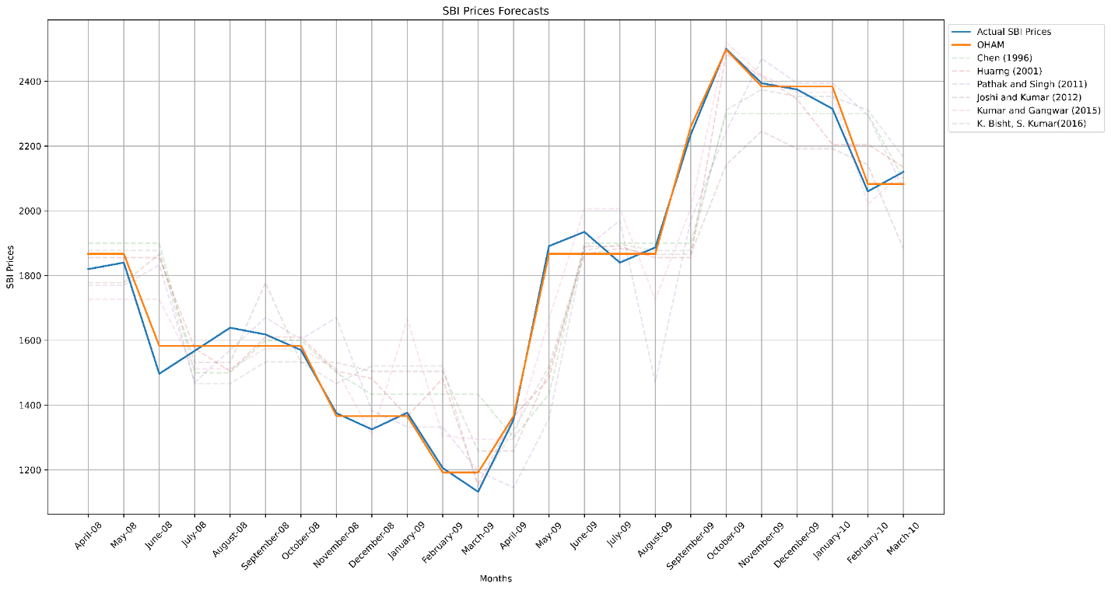
Figure 2. Line chart of forecast method results for SBI data.

5.2. Enrollment student Forecasting
Table 3. Results of the forecasting models for enrollment student.

Actual data | Song and Chissom⁹ (1993) | Chen¹⁰ (1996) | Huarng¹² (2001) | Lee and Chou¹⁶ (2004) | SC_time variant¹⁷ (1994) | Cheng et al.¹⁸ (2006) | Cheng et al.¹⁹ (2008) | Yolcu et al.²⁰ (2009) | Qiu et al.²¹ (2011) | Joshi and Kumar¹⁴ (2012) | Kumar and Gangwar¹⁵ (2015) | Bisht and Kumar⁶  (2016) | OHAM
13055 | - | - | - | - | - | - | - | - | - | - | - | - | -
13563 | 14000 | 14000 | - | 14025 | - | 14230 | 14242 | 14031.35 | 14195 | 14250 | - | 13595.67 | 13752
13867 | 14000 | 14000 | - | 14568 | - | 14230 | 14242 | 14795.36 | 14424 | 14246 | 13693 | 13814.75 | 13752
14696 | 14000 | 14000 | 14000 | 14568 | - | 14230 | 14242 | 14795.36 | 14593 | 14246 | 13693 | 14929.79 | 14753
15460 | 15500 | 15500 | 15500 | 15654 | 14700 | 15541 | 15474.3 | 14795.36 | 15589 | 15491 | 14867 | 15541.27 | 15341
15311 | 16000 | 16000 | 15500 | 15654 | 14800 | 15541 | 15474.3 | 16406.57 | 15645 | 15491 | 15287 | 15540.62 | 15341
15603 | 16000 | 16000 | 16000 | 15654 | 15400 | 15541 | 15474.3 | 16406.57 | 15634 | 15491 | 15376 | 15540.62 | 15341
15861 | 16000 | 16000 | 16000 | 15654 | 15500 | 16196 | 15474.3 | 16406.57 | 16100 | 16345 | 15376 | 15540.62 | 16040
16807 | 16000 | 16000 | 16000 | 16197 | 15500 | 16196 | 16146.5 | 16406.57 | 16188 | 16345 | 15376 | 16254.5 | 16879
16919 | 16813 | 16833 | 17500 | 17283 | 16800 | 16196 | 16988.3 | 17315.29 | 17077 | 15850 | 16523 | 17040.41 | 16879
16388 | 16813 | 16833 | 16000 | 17283 | 16200 | 17507 | 16988.3 | 17315.29 | 17105 | 15850 | 16066 | 17040.41 | 16040
15433 | 16789 | 16833 | 16000 | 16197 | 16400 | 16196 | 16146.5 | 17315.29 | 16369 | 15850 | 17519 | 16254.5 | 15341
15497 | 16000 | 16000 | 16000 | 15654 | 16800 | 15541 | 15474.3 | 16406.57 | 15643 | 15450 | 16606 | 15540.62 | 15341
15145 | 16000 | 16000 | 15500 | 15654 | 16400 | 15541 | 15474.3 | 16406.57 | 15648 | 15450 | 15376 | 15540.62 | 15341
15163 | 16000 | 16000 | 16000 | 15654 | 15500 | 15541 | 15474.3 | 16406.57 | 15622 | 15491 | 15376 | 15541.27 | 15341
15984 | 16000 | 16000 | 16000 | 15654 | 15500 | 15541 | 15474.3 | 16406.57 | 15623 | 15491 | 15376 | 15541.27 | 16040
16859 | 16000 | 16000 | 16000 | 16197 | 15500 | 16196 | 16146.5 | 16406.57 | 16231 | 16345 | 15287 | 16254.5 | 16879
18150 | 16813 | 16833 | 17500 | 17283 | 16800 | 17507 | 16988.3 | 17315.29 | 17090 | 17950 | 16523 | 17040.41 | 18283
18970 | 19000 | 19000 | 19000 | 18369 | 19300 | 18872 | 19144 | 19132.79 | 18325 | 18961 | 17519 | 18902.3 | 19291
19328 | 19000 | 19000 | 19000 | 19454 | 17800 | 18872 | 19144 | 19132.79 | 19000 | 18961 | 19500 | 19357.3 | 19291
19337 | 19000 | 19000 | 19000 | 19454 | 19300 | 18872 | 19144 | 19132.79 | 19000 | 18961 | 19000 | 19168.56 | 19291
18876 | - | 19000 | 19000 | - | 19600 | 18872 | 19144 | 19132.79 | 19000 | 18961 | 19500 | 19168.56 | 19291
RMSE | 650.40 | 880.73 | 638.36 | 476.97 | 501.28 | 511.04 | 478.45 | 805.17 | 511.33 | 433.76 | 493.56 | 428.63 | 178.21

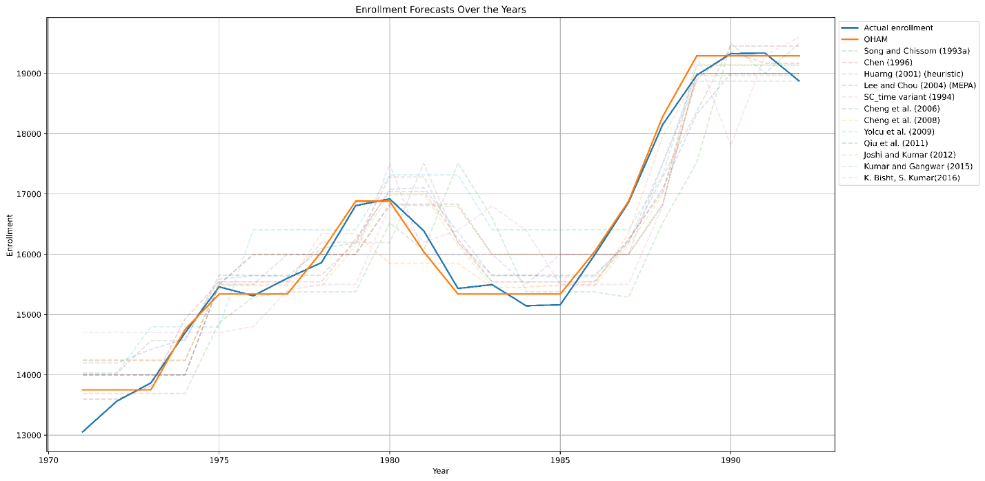
Figure 3. Line chart of forecast method results for enrollment student data.

5.3. TAIEX index Forecasting
Table 4. Results of the forecasting models for TAIEX index.

Date |  | Actual Index | Chen’ Forecasted Index¹⁰ | Loc’ Forecasted  Index⁷ (a) | Loc’ Forecasted  Index⁸ (b) | OHAM
2/11/2004 |  | 5759.61 | 5674.81 | 5743.00 |  | 5768
3/11/2004 |  | 5862.85 | 5768.14 | 5852.00 | 5886 | 5863
4/11/2004 |  | 5860.73 | 5854.81 | 5876.04 | 5886 | 5863
5/11/2004 |  | 5931.31 | 5908.26 | 5876.04 | 5934 | 5942
8/11/2004 |  | 5937.46 | 5934.81 | 5912.05 | 5934 | 5942
9/11/2004 |  | 5945.2 | 5943.81 | 5912.05 | 5934 | 5942
10/11/2004 |  | 5948.49 | 5934.81 | 5912.05 | 5978 | 5942
11/11/2004 |  | 5874.52 | 5937.12 | 5912.05 | 5886 | 5863
12/11/2004 |  | 5917.16 | 5908.26 | 5919.27 | 5934 | 5903
15/11/2004 |  | 5906.69 | 5934.81 | 5919.27 | 5934 | 5903
16/12/2004 |  | 5910.85 | 5934.81 | 5919.27 | 5934 | 5903
17/11/2004 |  | 6028.68 | 5937.12 | 5919.27 | 5978 | 6038
18/11/2004 |  | 6049.49 | 6068.14 | 5979.18 | 5978 | 6038
19/11/2004 |  | 6026.55 | 6068.14 | 5979.18 | 5978 | 6038
22/11/2004 |  | 5838.42 | 5976.47 | 5979.18 | 5886 | 5833
23/11/2004 |  | 5851.10 | 5854.81 | 5876.04 | 5886 | 5833
24/11/2004 |  | 5911.31 | 5934.85 | 5876.04 | 5934 | 5903
25/11/2004 |  | 5855.24 | 5934.81 | 5919.27 | 5886 | 5863
26/11/2004 |  | 5778.65 | 5854.81 | 5876.04 | 5768 | 5768
29/11/2004 |  | 5785.26 | 5762.12 | 5797.89 | 5768 | 5768
30/11/2004 |  | 5844.76 | 5762.12 | 5852.00 | 5886 | 5833
1/12/2004 |  | 5798.62 | 5834.85 | 5876.04 | 5768 | 5768
2/12/2004 |  | 5867.95 | 5803.26 | 5797.89 | 5886 | 5863
3/12/2004 |  | 5893.27 | 5854.81 | 5876.04 | 5886 | 5903
6/12/2004 |  | 5919.17 | 5854.81 | 5919.27 | 5934 | 5903
7/12/2004 |  | 5925.28 | 5937.12 | 5912.05 | 5934 | 5942
8/12/2004 |  | 5892.51 | 5876.47 | 5912.05 | 5886 | 5903
9/12/2004 |  | 5913.97 | 5854.81 | 5919.27 | 5934 | 5903
10/12/2004 |  | 5911.63 | 5934.81 | 5919.27 | 5934 | 5903
 | 13/12/2004 | 5878.89 | 5937.12 | 5919.27 | 5863 | 5863
 | 14/12/2004 | 5909.65 | 5854.81 | 5919.27 | 5903 | 5903
 | 15/12/2004 | 6002.58 | 5934.81 | 5919.27 | 5994 | 5994
 | 16/12/2004 | 6019.23 | 6068.14 | 5979.18 | 6038 | 6038
 | 17/12/2004 | 6009.32 | 6062.12 | 5979.18 | 5994 | 5994
 | 20.12.2004 | 5985.94 | 6062.12 | 5979.18 | 5994 | 5994
 | 21/12/2004 | 5987.85 | 5937.12 | 5979.18 | 5994 | 5994
 | 22/12/2004 | 6001.52 | 5934.81 | 5979.18 | 5994 | 5994
 | 23/12/2004 | 5997.67 | 6068.14 | 5979.18 | 5994 | 5994
 | 24/12/2004 | 6019.42 | 5934.81 | 5979.18 | 6038 | 6038
 | 27/12/2004 | 5985.94 | 6068.14 | 5979.18 | 5994 | 5994
 | 28/12/2004 | 6000.57 | 5937.12 | 5979.18 | 5994 | 5994
 | 29/12/2004 | 6088.49 | 6068.14 | 5979.18 | 6125 | 6125
 | 30/12/2004 | 6100.86 | 6062.12 | 6119.36 | 6125 | 6125
 | 31/12/2004 | 6139.69 | 6137.12 | 6143.57 | 6125 | 6125
 | RMSE |  | 56,86 | 48.02 | 26.88 | 12.731

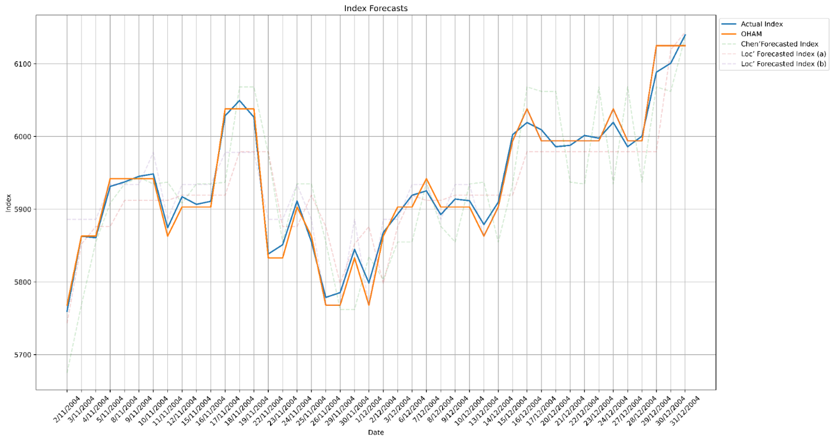
Figure 4. Line chart of forecast method results for TAIEX index data.
6. CONCLUSIONS
In this study, we propose a new fuzzy time series forecasting method using hedge algebra. We also introduce a segmentation approach for the reference space based on k-level and the fuzziness measure of linguistic terms of hedge algebra.
The effectiveness of this fuzzy time series forecasting method is demonstrated by applying it to the benchmark problem of forecasting the enrollment numbers at the University of Alabama. The relatively small RMSE value indicates that the proposed model outperforms other methods suggested by Song and Chissom (1993), Chen (1996), Huarng (2001), Lee and Chou (2004), Cheng et al. (2006, 2008), Yolcu et al. (2009), Qiu et al. (2011), Joshi et al. (2012), Kumar (2015), and Bisht et al. (2016). Moreover, financial time series exhibit intrinsic characteristics such as relatively high volatility and frequent fluctuations in individual time series data over time, making forecasting more challenging compared to other types of time series data. Even well-established time series forecasting methods tend to produce high forecasting errors. However, the proposed OHAM model proves to be highly suitable and effective for forecasting financial time series, where nonlinearity, intrinsic characteristics, and fuzziness complicate the forecasting process.

References
- N. C. Ho, W. Wechler. Hedge algebras: An algebraic approach to structures of sets of linguistic domains of linguistic truth variable, Fuzzy Sets and Systems, 1990, 35 (3), 281-293.
- N. C. Ho, W. Wechler. Extended hedge algebras and their application to Fuzzy logic, Fuzzy Sets and Systems, 1992, 52, 259-281.
- N. C. Ho, H. V. Nam. Towards an Algebraic Foundation for a Zadeh Fuzzy Logic, Fuzzy Sets and Systems, 2002, 129, 229-254.
- N. C. Ho, V. N. Lan, L. X. Viet. Optimal hedge-algebras-based controller: Design and application, Fuzzy Sets and Systems, 2008, 159, 968-989.
- N. C. Ho, W. Pedrycz, D. T. Long, T. T. Son. A genetic design of linguistic terms for fuzzy rule based classifiers, International Journal of Approximate Reasoning, 2012, 54, 1-21.
- K. Bisht, S. Kumar. Fuzzy time series forecasting method based on hesitant fuzzy sets, Expert Systems with Applications, 2016, 64, 557-568.
- V. M. Loc, V. H. Dung, P. T. Yen. The Context-Aware Calculating Method in Language Environment Based on Hedge Algebras Approach to Improve Result of Forecasting Time Series, Lecture Notes of the Institute for Computer Sciences, Social Informatics and Telecommunications Engineering, (LNICST 217 Springer), 2017, 217, 110-123.
- V. M. Loc, V. H. Dung. Hedge Algebra Approach for Fuzzy Time series To Improve Result Of Time Series Forecasting, EAI Endorsed Transactions on Context-aware Systems and Applications, 2018, 4, 1-11.
- Q. Song, B. S. Chissom. Fuzzy time series and its models, Fuzzy Sets and Systems, 1993, 54, 269–277.
- S. M. Chen. Forecasting Enrollments Based on Fuzzy Time Series, Fuzzy Sets and Systems, 1996, 81, 311–319.
- S. M. Chen. Forecasting Enrollments based on High Order Fuzzy Time Series, Cybernetics and Systems An International Journal, 2002, 33, 1-16.
- K. Huarng. Effective length of intervals to improve forecasting in fuzzy time series, Fuzzy Sets and Systems, 2001, 123, 387–394.
- H. K. Pathak, P. Singh. A new bandwidth interval based forecasting method for enrollments using fuzzy time series, Applied Mathematics, 2011, 2, 504 507.
- B. P. Joshi, S. Kumar. Intuitionistic fuzzy sets based method for fuzzy time series forecasting, Cybernetics and Systems, 2012, 43, 34–47.
- S. Kumar, S. Gangwar. Intuitionistic fuzzy time series: An approach for handling non-determinism in time series forecasting, IEEE Transactions on Fuzzy Systems, 2015, doi: 10.1109/TFUZZ.2015.2507582.
- H. S. Lee, M. T. Chou. Fuzzy forecasting based on fuzzy time series, International Journal of Computer Mathematics, 2004, 81, 781–789.
- Q. Song, B. S. Chissom. Forecasting enrollments with fuzzy time series, Part II, Fuzzy Sets and Systems, 1994, 64, 1–8.
- C. Cheng, J. Chang, C. Yeh. Entropy-based and trapezoid fuzzification based fuzzy time series approaches for forecasting IT project cost, Technological Forecasting and Social Change, 2006, 73, 524–542.
- C. H. Cheng, G. W. Cheng, J. W. Wang. Multi-attribute fuzzy time series method based on fuzzy clustering, Expert Systems with Applications, 2008, 34, 1235–1242.
- U. Yolcu, E. Egrioglu, V. R. Uslu, M. A. Basaran, C. H. Aladag. A new approach for determining the length of intervals for fuzzy time series, Applied Soft Computing, 2009, 9, 647–651.
- W. Qiu, X. Liu, H. Li. A generalized method for forecasting based on fuzzy time series, Expert Systems with Applications, 2011, 38, 10446–10453.

