Thích ứng khung nhìn theo QoE cho việc truyền phát video
360 độ với đa hướng và đơn hướng

Phạm Hồng Thịnh^{1,*}, Hồ Văn Phi¹, Đào Minh Hưng¹, Nguyễn Viết Hùng²

1Trường Đại học Quy Nhơn, Quy Nhơn, Việt Nam
2Trường Đại học Công nghệ Đông Á, Bắc Ninh, Việt Nam
*Email: phamhongthinh@qnu.edu.vn

TÓM TẮT
Nhờ vào khả năng cung cấp trải nghiệm nhập vai cho người dùng, video 360 độ đã trở thành một trong những công cụ hỗ trợ chính của thực tế ảo (VR). Truyền phát trực tiếp video 360 độ mang đến một chất lượng trải nghiệm (QoE) hấp dẫn bằng cách cho phép người dùng thay đổi trường nhìn (FoV) tức thời. Các nghiên cứu gần đây đã đề xuất một mô hình truyền phát video 360 độ thích ứng khung nhìn sử dụng khả năng thích nghi tốc độ bit trong miền không gian và thời gian để sử dụng hiệu quả băng thông hạn chế. Trong bài báo này, chúng tôi giới thiệu một phương pháp ước tính cho việc truyền phát trực tiếp video 360 độ bằng cách sử dụng kỹ thuật đa hướng và đơn hướng qua mạng di động, nhằm mục đích tối ưu hóa việc phân bổ băng thông giữa các nhóm người dùng để cải thiện trải nghiệm bằng cách tận dụng sự khác biệt tự nhiên về điều kiện mạng và trường nhìn của người dùng. Kết quả thí nghiệm của chúng tôi cho thấy giải pháp đề xuất nâng cao ít nhất từ 11,04% đến 24,05% về tốc độ bit FoV khi so sánh với một số giải pháp đang tồn tại.
Từ khóa: Truyền tải thích ứng, Chất lượng trải nghiệm, Thực tế ảo, Video 360 độ.

QoE-Driven Viewport Adaptation for Live 360⁰ Video Streaming with Multicast and Unicast

Pham Hong Thinh^{1,*}, Ho Van Phi¹, Dao Minh Hung¹, Nguyen Viet Hung²

1Quy Nhon University, Quy Nhon, Vietnam
2East Asia University of Technology, Bac Ninh, Vietnam
*Corresponding author. Email: phamhongthinh@qnu.edu.vn

Abstract
Due to its capacity to deliver an immersive experience to users, 360⁰ video has emerged as a crucial component of Virtual Reality (VR). Live 360-degree video streaming offers an engaging Quality of Experience (QoE) by enabling users to change their Field of View (FoV) instantly. Recent studies have proposed a viewport-adaptive 360-degree video streaming model that uses bitrate adaptation in spatial and temporal domains to utilize limited bandwidth resources efficiently. In this paper, we introduce an estimation approach for Live 360⁰ video streaming using multicast and unicast over mobile networks, aiming to optimize bandwidth allocation across user groups to improve user experience by leveraging the natural diversity in network conditions and users’ fields of view. Our experimental results show that the proposed solution enhances at least 11.04% up to 24.05% in term of FoV bitrate in comparison with some existing solutions.
Keywords: Adaptive Streaming, Quality of Experience, Virtual Reality, 360-degree Video.

1. INTRODUCTION
Virtual reality¹⁻⁴ is a simulated environment generated by computer technology that users can explore in 360 degrees. It enables users to view, navigate, and engage with three-dimensional (3D) worlds. Virtual Reality provides an interactive and immersive experience that brings virtual environments to life through the use of VR headsets or other display technologies. As technology continues to advance, VR applications have been adopted across multiple fields, including entertainment, manufacturing, healthcare and education.
Viewed from a different angle, High-Efficiency Video Coding (HEVC) is a video compression standard designed to greatly enhance compression efficiency without compromising video quality⁵. Compared to H.265/AVC, HEVC can reduce the bitrate by as much as 50%, while still supporting multiple high and ultra high resolution videos.
In addition, the study in paper⁶ demonstrates that EMBMS (Evolved Multimedia Broadcast Multicast Services), supported by a 4G mobile network, enables multicast transmission to multiple terminals. This allows a group of users to stream and watch 360⁰ video live via mobile network using virtual reality device. As shown in Figure 1, EMBMS provides an effective solution for distributing video content of high quality via mobile networks by employing video standardization through HEVC/H.265 to the encoder⁷. EMBMS technology enhances network resource utilization and decreases the total bandwidth needed to deliver video content to multiple users by employing multicast and multimedia streaming⁸.
Through mobile networks, to design for multiple users of VR services, in this study we introduce a new approach for predicting the viewport of 360⁰ videos. Based on client-side approach, referred to as QoE-ViLA (Viewport-based Live-streaming Adaptation in multicast and unicast), allows for the assessment of data rate per bandwidth to enhance video signal quality for users in the context of QoE-Driven Viewport Adaptation for Live 360° Video Streaming in both multicast and unicast modes. Within QoE-ViLA, each video tile is encoded in different quality levels (called versions) using High-Efficiency Video Coding (HEVC). The main contributions of the proposed method are outlined as follows:

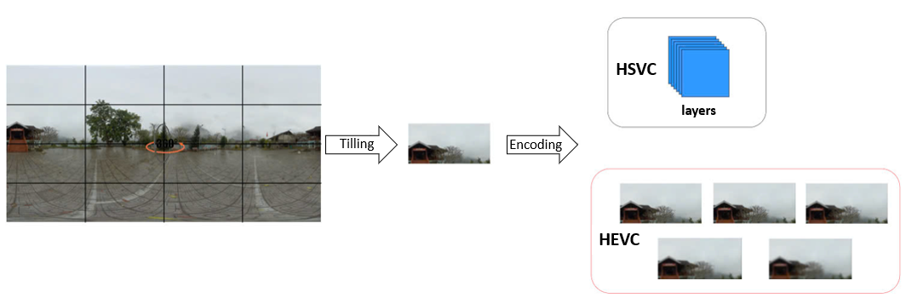
Figure 1. Video encoding standardized using H.265/HEVC

- Throughout a video streaming session, tiles beyond the user's viewing area are assigned only basic representatios to maintain a minimal quality level, while tiles within the viewport are transmitted in several enhanced versions. As a result, QoE-ViLA achieves more efficient use of available network resources compared to traditional methods.
- Impact of spectrum efficiency on different versions of multicast transport modes for minimizing network bandwidth usage.
The structure of this paper is outlined as follows: Section 2 discusses about the state of the art. The resource allocation problem is shown in Section 3. The proposed method - QoE-ViLA - is described in Section 4 followed by an evaluation in Section 5. Finally, the conclusion is discussed in Section 6.
2. RELATED WORKS
Currently, researchers are making significant efforts to provide smooth omnidirectional video streaming with low latency, ensuring a satisfying viewing experience for users even under constrained network bandwidth. In the referenced study⁹, the content introduced a 360⁰ video streaming framework that adjusts bitrate according to the user's viewport. This approach incorporates the spatiotemporal rate-distortion properties of 360⁰ videos along with user navigation patterns. By analyzing user behavior to predict viewport transitions, the system adapts video quality accordingly, resulting in an enhanced quality of experience¹⁰. Another study¹¹ proposes an optimized video streaming approach using a chunk download scheduling framework, which enables the adjustment of each parallel stream's quality based on current bandwidth availability and the probability of stream switching.
Several recent studies¹²⁻¹⁴ have addressed the challenges associated with multicasting/unicasting 360⁰ video to multiple mobile users, including large video data volumes, varying network conditions, limited bandwidth resources, and levels of user interaction. Paper¹⁴ presents a multi-quality multicast streaming approach for 360⁰ videos targeting multiple users via Time Division Multiple Access (TDMA). To enhance transmission efficiency, the authors propose dividing encoded tiles into several representations at varying quality levels, enabling optimized decisions on quality selection, time allocation, and power distribution. Meanwhile, in paper¹³, users are grouped into multiple multicast clusters, each assigned a specific quality representation to maximize perceived video quality. This approach ensures smooth playback quality of 360⁰ content while conserving energy without compromising visual fidelity. In paper¹², the authors introduced an innovative cross-layer framework designed for streaming 360⁰ video to multiple users over cellular networks. At the content level, tiles are encoded into several layers using Scalable Video Coding. Meanwhile, at the transport level, these tile layers are transmitted to users through a combination of unicast and multicast modes (For reference, we refer to this method as Multi-Hyb). Paper¹⁵ introduced a scalable framework for live 360-degree video streaming via multicast. It includes a rate-distortion analysis to model the trade-off between video quality and bitrate, an optimization approach for allocating data rates to different spatial regions of the video, and a scalable representation of 360⁰ video data. In which, users are categorized into different classes based on their network bandwidth, with each layer corresponding to a multicast group receiving an identical set of tiles. In paper¹⁶, a multicast fusion approach is introduced for adaptive multi-user 360⁰ video streaming, aiming to maintain high quality of experience (QoE) in bandwidth-constrained scenarios. This solution allows for dynamic selection between multicast and unicast modes, as well as bitrate adaptation for each cell based on the user's available bandwidth and field of view (FoV).

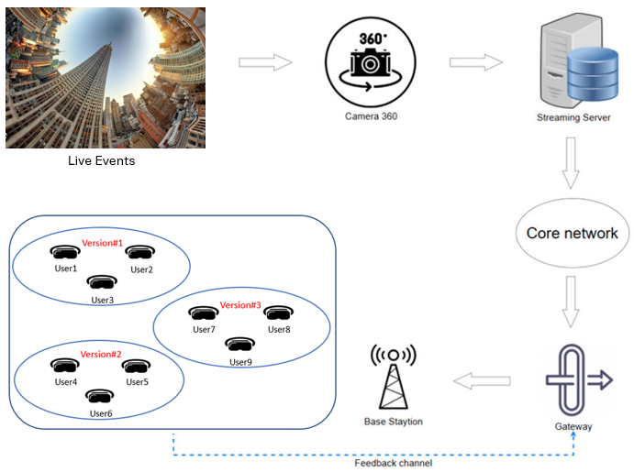
Figure 2. System Architecture Overview
Alternatively, Viewport Adaptive Streaming (VAS) enhances user experience under fluctuating network throughput and dynamic head movements. Besides, VAS approaches also rely on accurate head movement data and highly reliable viewport motion prediction¹⁷. By leveraging users’ past viewport data, cross-user behavior patterns¹⁸, and video content characteristics^{19,20}, it is possible to forecast users’ future viewport positions. To address this challenge, another solution involves using Scalable Video Coding (SVC). Its goal is to ensure smooth video playback at the best achievable quality, even under difficult network conditions. This is achieved through the use of SVC's base and enhancement layers²¹. Initially, all tiles of the base layer are preloaded, while the enhancement layers of visible tiles are subsequently retrieved to enhance frame quality and video playback will be smoother under varying frame and network conditions. This approach also allows users the flexibility to select which part of the video they wish to view at the highest Quality of Experience (QoE), limited to the visible portion within the video’s viewport. In paper²², the authors propose a method that maintains a high buffer level and ensures consistent quality in subsequent segments, even when the average bitrate drops, thereby improving overall QoE. Since users seldom view areas outside their current viewports, more than 80% of bandwidth is wasted during 360° video streaming²³. Viewport Adaptive Streaming addresses this inefficiency by delivering the viewport region in high version and encoding the other areas with lower version, thereby optimizing bandwidth usage and reducing data waste²⁴.
3. PROBLEM FORMULATION
Based on the aforementioned related works, our proposed architecture—illustrated in Figure 2—enables the flexible distribution of multimedia content in multiple versions for live 360⁰ video streaming over a network system. This system leverages HEVC technology to efficiently allocate network bandwidth.
Let β_{tl} denote the bitrate, and ∆_{tl} denote the quality of tile t in layer l. Respectively, the parameters T, L, and U indicate the number of tiles, layers, and users. In telecommunication networks, an RB (resource block) is the basic resource unit in the frequency and time domains. Here we let B be a resource block. In addition, the group traffic is allocated B resource blocks and let η be the lowest efficiency of the group's spectrum usage.
Suppose that B blocks of network resources have been allocated to a specific group of users. The efficiency of spectrum usage for user u (where 1 ≤ u ≤ U) characterizes the quality of the wireless link between the base station and the user's terminal device. A live 360⁰ video stream is divided into T tiles, each of which is encoded into (L + 1) layers of different quality levels, with each layer representing a distinct version. For each tile t (1 ≤ t ≤ T), layer l (0 ≤ l ≤ L) is associated with a bitrate β_{tl} and quality ∆_{tl}, corresponding to version h. In addition, each video quality level (version) is divided into segments, and each segment has a duration of τ seconds. The following formula specifies the amount of network resource blocks, denoted as B_{utl}, necessary to transmit version l of each tile t to user u:
$$B_{utl}=\frac{β_{tl}×τ }{η^{u}}$$ | (1)
where $η^{u}$ denotes the spectrum utilization efficiency of the wireless communication link between the base station and the user's terminal device.
In the proposed architecture, multicast and unicast transmission techniques can be employed to deliver different video versions. In multicast mode, the versions are distributed to a group of users, whereas in unicast mode, each version is transmitted to an individual user. Furthermore, the spectral efficiency of multicast transmissions is constrained by the user with the lowest spectral efficiency in the group, which limits the overall multicast capacity.
4. PROPOSED SOLUTIONS (QoE-ViLA)
When viewing 360-degree videos under fluctuating mobile network bandwidth conditions that may cause buffering or playback interruptions, it becomes essential to adapt in real-time by dynamically modifying parameters like tile quality and transmission rate. By constantly tracking network performance and factoring in available resources, device capabilities, latency, and the viewer’s current viewport, the proposed architecture is able to maintain high visual quality and smooth playback, providing viewers with an immersive real-world experience.
In the proposed solution, we present two transmission models for each layer of each tile using two binary variables, γ_{tl}, φ_{utl} ∈ {0, 1}, ∀l ∈ L, t ∈ T, u ∈ U. If a tile layer is transmitted via the multicast model to all users, then γ_{tl} = 1. If it is delivered through the unicast model to a particular user u, then φ_{utl} = 1; otherwise, γ_{tl} = 0 or φ_{utl} = 0.
The following expression defines the goal function for allocating network resources in multi-user streaming scenarios.
$$maxx\sum_{u∈U}{\sum_{t∈T}{\sum_{l∈L}{Ω_{ut}∆_{tl}(γ_{tl}+φ_{utl})}}}$$ | (2)
With constraints:

Table 1. The quality (dB) and average bitrate (kbps) of the four 360⁰ videos used in the experiment for the Multi-Hyb and Multi-SVC approaches.
Version | RollerCoaster |  | Venice |  | Paris |  | Diving
Version | Quality | Bitrate | Quality | Bitrate | Quality | Bitrate | Quality | Bitrate
# 1 | 39.45 | 55.33 | 32.73 | 50.34 | 38.20 | 61.44 | 34.50 | 158.72
# 2 | 42.72 | 106.74 | 35.92 | 114.24 | 41.94 | 88.75 | 38.25 | 313.76
# 3 | 44.75 | 179.11 | 38.50 | 216.24 | 44.63 | 114.02 | 40.85 | 504.54
# 4 | 27.14 | 389.12 | 41.57 | 483.58 | 47.55 | 191.33 | 43.89 | 1036.97
# 5 | 49.24 | 632.94 | 44.53 | 824.70 | 50.42 | 293.75 | 46.23 | 1418.46
Table 2. The quality (dB) and average bitrate (kbps) of the four 360⁰ videos used in the experiment for the JUMP and QoE-ViLA approaches
Version | RollerCoaster |  | Venice |  | Paris |  | Diving
Version | Quality | Bitrate | Quality | Bitrate | Quality | Bitrate | Quality | Bitrate
# 1 | 39.44 | 54.85 | 32.72 | 60.06 | 38.20 | 60.79 | 34.48 | 158.14
# 2 | 42.87 | 131.72 | 36.08 | 183.03 | 42.20 | 130.40 | 38.23 | 393.64
# 3 | 44.98 | 250.54 | 38.70 | 384.88 | 44.98 | 209.69 | 40.98 | 752.27
# 4 | 47.27 | 515.86 | 41.77 | 826.39 | 47.87 | 340.26 | 44.02 | 1481.53
# 5 | 49.43 | 933.85 | 44.77 | 1520.16 | 50.73 | 532.45 | 46.58 | 2499.03

$$\sum_{t∈T}{\sum_{l∈L}{\frac{β_{tl}×τ}{\min_{U∈β_{tl})=1}η^{u}}≤B}}$$  Where:  β_{tl}​={ u∈ {1,...,U} ∣ γ_{tl​}+φ_{utl}​=1} | (3)
$$\sum_{u}{\sum_{t}{φ_{utl}≤1, ∀u ϵ U, t ϵ T, l≥1}}$$ | (4)
$$\sum_{t}{γ_{t0}+φ_{ut0}=1, ∀u ϵ U,∀t ϵ T}$$ | (5)
$$η^{u}=\frac{B_{t}(1-γ) }{BW}$$ | (6)
Where: Ω_{ut} represents the weighting of tile t corresponding to user u; BW denotes the user's bandwidth, while BW also refers to the channel bandwidth at the core; B_{u} indicates how many network resource blocks are available to user u; and $η^{u}$ has been presented above in Equation 1.
Accurate prediction of the future viewport direction is essential for effective network resource allocation, as it guides the selection of γ_{tl} and φ_{utl} values (as defined in Equation 2). The predicted direction influences γ_{tl}, responsible for assigning weights to the views or tiles in the 360⁰ video. By anticipating which areas the viewer is likely to focus on, those regions’ tiles can receive higher γ_{tl} values, ensuring attention is directed toward the most relevant content. Likewise, φ—which represents the video quality or amount of visual detail for each tile—is also influenced by the predicted viewing direction, enabling optimized visual fidelity where it is most needed. To enhance visual fidelity and vividness in the expected viewing areas, it is necessary to estimate the viewing direction in advance. Based on this prediction, higher bitrate tiles or higher-quality versions can then be allocated to those areas.
On the other hand, to optimize view-based streaming adaptation in both multicast and unicast scenarios, the proposed solution imposes the following conditions:
- The overall resources assigned for multicast and unicast must not exceed the value of B as defined in Equation 3.
- The constraints in Equations 4 and 5 guarantee that each user receives every FoV tile only once.
- The base layer of every tile is delivered to all users.
5. PERFORMANCE EVALUATION
5.1. Experimental Settings
This section introduces four 360⁰ videos — Diving, Paris, Venice, and RollerCoaster — prepared for the experimental setup and evaluation. All videos have a resolution of 3840×2048 and a fixed duration of 60 seconds. The videos were converted into the CubeMap format at a resolution of 2890×1920 using the 360Lib tool. Subsequently, each video was partitioned into 24 tiles, each sized 480×480 pixels. Each tile undergoes sequential encoding into five layers, including four booster layers and one fundamental layer. The quantization parameters for the respective layers are fixed as specified in Table 1 and Table 2.
Following the setup in paper²⁵, we set the number of users U to 15, 30, 45 and 60. The $η^{u}$ values are applied as defined in Equation 6. The experimental evaluation was conducted on a system running a Windows 10 (64-bit version) operating system with 16GB of RAM and a 4.5GHz HP EliteBook Core i7 processor. We compared the proposed solution (QoE-ViLA) with reference methods, including the approach from paper²⁵ (referred to as Multi-SVC), Multi-Hyb¹², and JUMP²⁶. The Multi-svc method streams multi-user VR video over a cellular network by combining Scalable Video Coding (SVC) and multicast to deliver popular tiles to users. In this method, tiles are encoded into multiple layers using SVC and then delivered to users via multicast. The JUMP approach enables a tile to be transmitted via either unicast or multicast. The tile versions and transmission modes are determined to optimize the weighted sum of FoV bitrates across all users. Additionally, we employ the average view PSNR (Peak Signal-to-Noise Ratio) parameter to recompute the performance scores of both the proposed approach and the baseline methods, as follows:
$$UVPR=\frac{1}{U}\sum_{u=1}^{U}{{UVPR}_{u}}$$ | (7)
$${UVPR}_{u}=\sum_{u=1}^{U}{Ω_{ut}^{s}×∆_{{tl}_{u}^{s}}}$$ | (8)
Where: UVPR_{u} denotes the viewport PSNR for user u; $Ω_{ut}^{s}$ represents the weighted sum of the quality of visible tiles; and $l_{u}^{s}$ indicates the highest layer of tile t streamed to user u.
5.2. Experimental Results and Discussion
In this section, we evaluate the performance of the proposed framework in comparison with reference methods. A bitrate analysis is conducted using U multicast transmissions for user groups of 15, 30, 45, and 60 users, with B varying from 20.000RBs to 700.000RBs. As shown in Figure 3, the QoE-ViLA method consistently outperforms all other referenced approaches across all four videos. Specifically, the proposed method improves the average bitrate by more than 14.11% and 17.90% compared to the Multi-SVC and JUMP methods, respectively. In comparison with Multi-Hyb, the performance gain ranges from 16.86% with 15 users to 18.84% with 60 users.
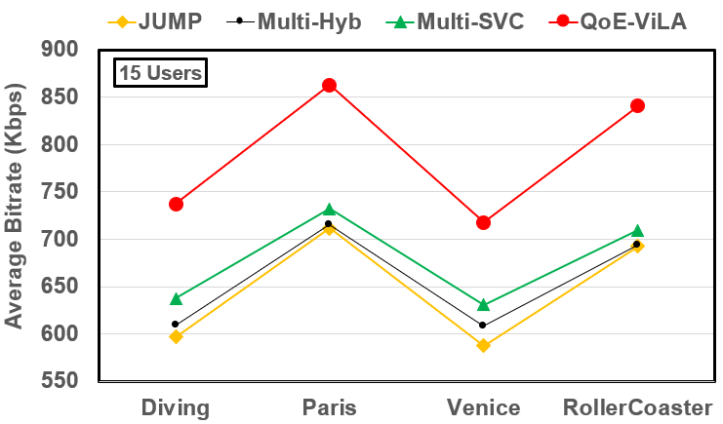
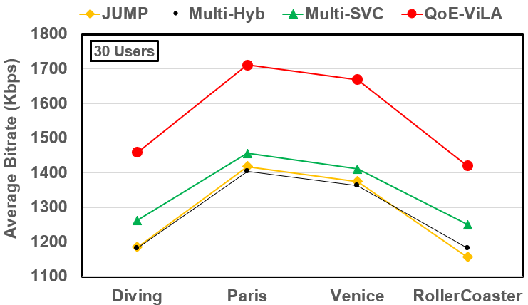
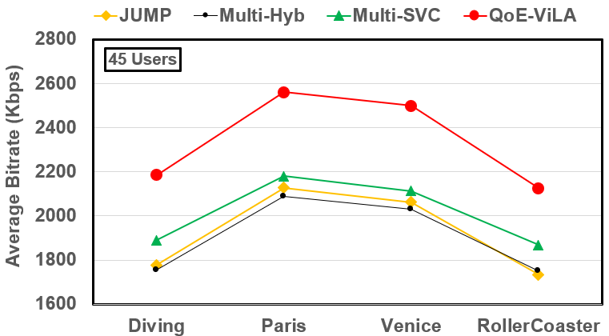
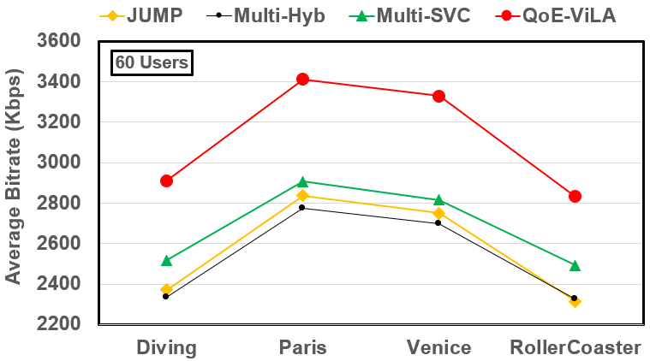
Figure 3. Average bit rate (Kbps) for 15, 30, 45, and 60 users.
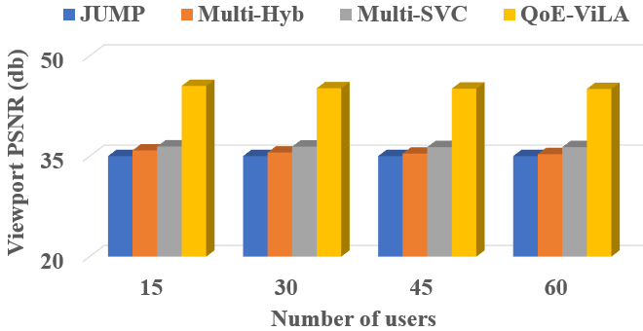
(a) Diving Video
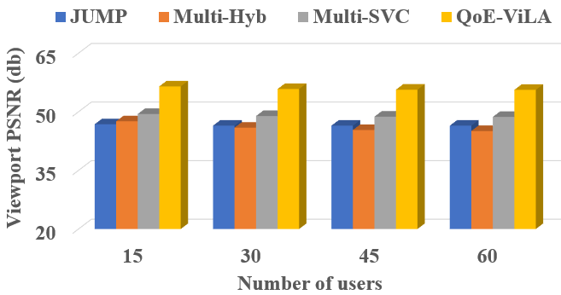
(b) Paris Video

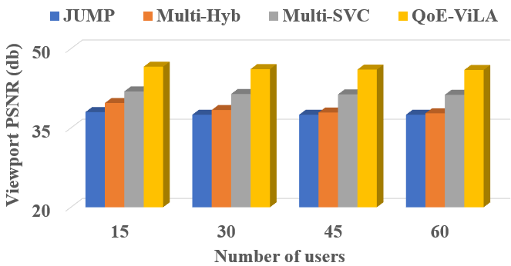
(c) Venice Video

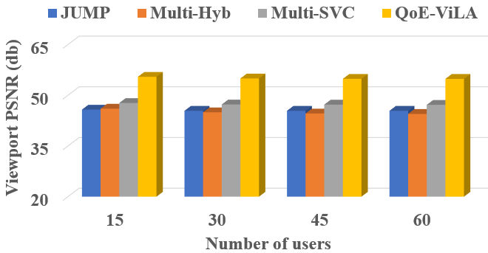
(d) Roller. Video
Figure 4. The performance across different numbers of users (with B = 200.000RBs) varies between the proposed method and the reference methods.
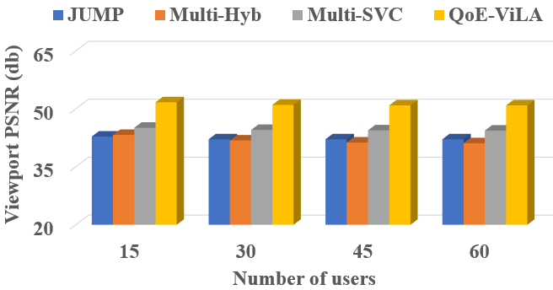
(a) Diving Video
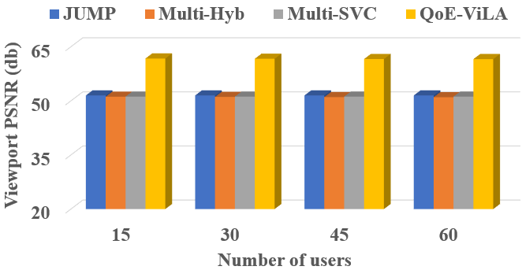
(b) Paris Video

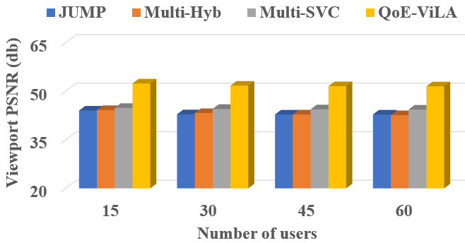
(c) Venice Video
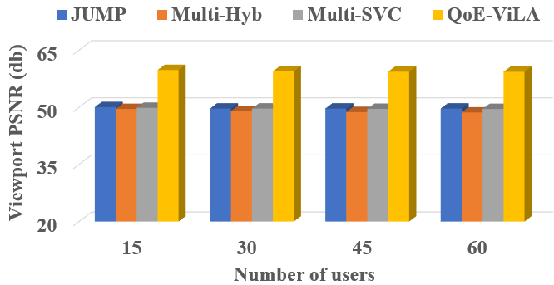
(d) Roller. Video
Figure 5. The performance across different numbers of users (with B = 700.000RBs) varies between the proposed method and the reference methods.
In addition, the performance based on the viewport PSNR metric will have been evaluated across all methods. In the experimental setup of this paper, four values of U—15, 30, 45, and 60—are specifically analyzed. Figures 4 and 5 illustrate the viewport PSNR results for both the proposed and reference methods at B=200.000RBs and B=700.000RBs, respectively. The results clearly show that our approach consistently outperforms all reference methods across all U values. The QoE-ViLA method achieves a viewport PSNR that is at least 6 dB and up to 12 dB higher than the reference methods (JUMP, Multi-Hyb, Multi-SVC) in all scenarios. Moreover, although the viewport PSNR of the proposed method slightly decreases when the number of users increases, the reduction remains minimal.
6. CONCLUSION
In this study, we introduce an innovative viewport prediction approach for multiple-user multicast video transmission over mobile networks. The proposed method utilizes the HEVC (High-Efficiency Video Coding) technique in combination with improved spectrum efficiency to optimize bandwidth usage among users. With the experimental results, it is demonstrated that the proposed method can achieve significant performance improvements, ranging from 11.04% to 24.05% across four test videos. In future studies, we aim to extend the capabilities of the proposed framework to support scenarios involving multiple users concurrently accessing various video assets, including live 360⁰ video streams.
Acknowledgment
This research is conducted within the framework of science and technology projects at institutional level of Quy Nhon University under the project code T2025.893.13.
REFERENCES
1. N. V. Hung, T. D. Chien, N. P. Ngoc, and T. H. Truong, “Flexible http-based video adaptive streaming for good qoe during sudden bandwidth drops,” EAI Endorsed Transactions on Industrial Networks and Intelligent Systems, vol. 10, no. 2, pp. e3–e3, 2023.
2. H. Nguyen, “Mellifluous viewport bitrate adaptation for 360 videos streaming over http/2,” Journal on Information Technologies & Communications, vol. 2024, no. 2, pp. 2–2, 2024.
3. Hung, N. V., Dat, P. T., Tan, N., Quan, N. A., Trang, L. T. H., & Nam, L. M. (2025). Heverl–viewport estimation using reinforcement learning for 360-degree video streaming. Informatics and Automation, 24(1), 302-328.
4. Kockovic, L., Rozinaj, G., & Medvecky, M. (2024, April). Optimizing 360° Video Delivery: Advancements and Strategic Approaches. In Computer Science On-line Conference (pp. 134-149). Cham: Springer Nature Switzerland.
5. K. R. Rao, J. J. Hwang, and D. Kim, High Efficiency Video Coding and other emerging standards. CRC Press, 2022.
6. D. Lecompte and F. Gabin, “Evolved multimedia broadcast/multicast service (embms) in lte-advanced: overview and rel-11 enhancements,” IEEE Communications Magazine, vol. 50, no. 11, pp. 68–74, 2012.
7. B. Damera and P. C. Babu, “Broadcast the user chosen content over lte in a simplified approach using evolved multimedia broadcast multicast service (embms) with optimized mce scheduling algorithm,” in 2014 International Conference on Intelligent Computing Applications, 2014, pp. 90–94.
8. W. Guo, M. Fuentes, L. Christodoulou, and B. Mouhouche, “Roads to multimedia broadcast multicast services in 5g new radio,” in 2018 IEEE International Symposium on Broadband Multimedia Systems and Broadcasting (BMSB). IEEE, 2018, pp. 1–5.
9. J. Chakareski, R. Aksu, X. Corbillon, G. Simon, and V. Swaminathan, “Viewport-driven rate-distortion optimized 360º video streaming,” in 2018 IEEE International conference on communications (ICC). IEEE, 2018, pp. 1–7.
10. Y. Guan, C. Zheng, X. Zhang, Z. Guo, and J. Jiang, “Pano: Optimizing 360 video streaming with a better understanding of quality perception,” in Proceedings of the ACM Special Interest Group on Data Communi- cation, 2019, pp. 394–407.
11. N. Carlsson, D. Eager, V. Krishnamoorthi, and T. Polishchuk, “Opti- mized adaptive streaming of multi-video stream bundles,” IEEE trans- actions on multimedia, vol. 19, no. 7, pp. 1637–1653, 2017.
12. D. Nguyen, N. Viet Hung, T. T. Huong, and T. C. Thang, “A cross- layer framework for multi-user360-degree video streaming over cellular networks,” in 2022 IEEE International Conference on Consumer Elec- tronics (ICCE), Virtual, Jan. 2022.
13. O. Eltobgy, O. Arafa, and M. Hefeeda, “Mobile streaming of live 360- degree videos,” IEEE Transactions on Multimedia, vol. 22, no. 12, pp. 3139–3152, 2020.
14. K. Long, C. Ye, Y. Cui, and Z. Liu, “Optimal Multi-Quality Multicast for 360 Virtual Reality Video,” in 2018 IEEE Global Communications Conference (GLOBECOM), Abu Dhabi, UAE, 2018, pp. 1–6.
15. R. Aksu, J. Chakareski, and V. Swaminathan, “Viewport-Driven Rate- Distortion Optimized Scalable Live 360° Video Network Multicast,” in 2018 IEEE ICME, CA, USA, 2018, pp. 1–6.
16. N. Kan, C. Liu, J. Zou, C. Li, and H. Xiong, “A Server-Side Optimized Hybrid Multicast-Unicast Strategy for Multi-User Adaptive 360-Degree Video Streaming,” in 2019 IEEE ICIP, Taiwan, 2019, pp. 141–145.
17. H. Nguyen, T. N. Dao, N. S. Pham, T. L. Dang, T. D. Nguyen, and T. H. Truong, “An accurate viewport estimation method for 360 video streaming using deep learning,” EAI Endorsed Transactions on Industrial Networks and Intelligent Systems, vol. 9, no. 4, pp. e2–e2, 2022.
18. Y. Ban, L. Xie, Z. Xu, X. Zhang, Z. Guo, and Y. Wang, “Cub360: Exploiting cross-users behaviors for viewport prediction in 360 video adaptive streaming,” in 2018 IEEE International Conference on Multi- media and Expo (ICME), CA, USA, 2018, pp. 1–6.

19. C.-L. Fan, J. Lee, W.-C. Lo, C.-Y. Huang, K.-T. Chen, and C.-H. Hsu, “Fixation prediction for 360° video streaming in head-mounted virtual reality,” in Proceedings of the 27th Workshop on Network and Operating Systems Support for Digital Audio and Video, ser. NOSSDAV’17, Taipei, Taiwan, 2017, p. 67–72. [Online]. Available: https://doi.org/10.1145/3083165.3083180
20. V. H. Nguyen, N. N. Pham, C. T. Truong, D. T. Bui, H. T. Nguyen, and T. H. Truong, “Retina-based quality assessment of tile-coded 360- degree videos,” EAI Endorsed Transactions on Industrial Networks and Intelligent Systems, vol. 9, no. 32, 2022.
21. A. T. Nasrabadi, A. Mahzari, J. D. Beshay, and R. Prakash, “Adaptive 360-degree video streaming using scalable video coding,” in Proceedings of the 25th ACM International Conference on Multimedia, ser. MM ’17, 2017, p. 1689–1697.
22. N. Viet Hung, T. D. Chien, N. Pham Ngoc, and T. H. Truong, “Flexible http-based video adaptive streaming for good qoe during sudden bandwidth drops,” EAI Endorsed Transactions on Industrial Networks and Intelligent Systems, vol. 10, no. 2, p. e3, Jun. 2023. [Online]. Available: https://publications.eai.eu/index.php/inis/article/view/2994.
23. S. Park, A. Bhattacharya, Z. Yang, M. Dasari, S. R. Das, and D. Samaras, in 2019 IFIP Networking Conference (IFIP Networking).
24. D. V. Nguyen, H. T. T. Tran, and T. C. Thang, “Impact of delays on 360-degree video communications,” in 2017 TRON Symposium (TRONSHOW), Tokyo, Japan, 2017, pp. 1–6.
25. D. Nguyen, N. V. Hung, N. T. Phong, T. T. Huong, and T. C. Thang, “Scalable multicast for live 360-degree video streaming over mobile networks,” IEEE Access, vol. 10, pp. 38 802–38 812, 2022.
26. A. Majidi and A. H. Zahran, “Optimized Joint Unicast-Multicast Panoramic Video Streaming in Cellular Networks,” in 2020 IEEE ICNP, Madrid, Spain, 2020, pp. 1–6.

