Thích ứng khung nhìn theo QoE cho việc truyền phát video 360 độ với đơn hướng và đa hướng

Phạm Hồng Thịnh^{1,*}, Hồ Văn Phi¹, Đào Minh Hưng¹, Nguyễn Viết Hùng²

1Trường Đại học Quy Nhơn, Quy Nhơn, Việt Nam
2Trường Đại học Công nghệ Đông Á, Bắc Ninh, Việt Nam
*Email: phamhongthinh@qnu.edu.vn

TÓM TẮT
Nhờ vào khả năng cung cấp trải nghiệm nhập vai cho người dùng, video 360 độ đã trở thành một trong những công cụ hỗ trợ chính của thực tế ảo (VR). Truyền phát trực tiếp video 360 độ mang đến một chất lượng trải nghiệm (QoE) hấp dẫn bằng cách cho phép người dùng thay đổi trường nhìn (FoV) một cách tức thì. Các nghiên cứu gần đây đã đề xuất một mô hình truyền phát video 360 độ thích ứng khung nhìn sử dụng khả năng thích nghi tốc độ bit trong miền không gian và thời gian để sử dụng hiệu quả các nguồn băng thông hạn chế. Trong bài báo này, chúng tôi đề xuất một sự ước tính về truyền phát video 360 độ trực tiếp với đơn hướng và đa hướng trên mạng di động nhằm tối ưu hóa việc phân bổ băng thông cho các nhóm người sử dụng để nâng cao trải nghiệm của họ trong khi tận dụng sự đa dạng vốn có trong các điều kiện mạng và trường nhìn (FoV) của người dùng. Kết quả thí nghiệm của chúng tôi cho thấy giải pháp đề xuất nâng cao ít nhất từ 10,05% đến 23,04% về tốc độ bit FoV khi so sánh với một số giải pháp đang tồn tại.
Từ khóa: Truyền tải thích ứng, Chất lượng trải nghiệm, Thực tế ảo, Video 360 độ.

QoE-Driven viewport Adaptation for Live 360 Degree Video Streaming with Unicast and Multicast

Pham Hong Thinh^{1,*}, Ho Van Phi¹, Dao Minh Hung¹, Nguyen Viet Hung²

1Quy Nhon University, Quy Nhon, Vietnam
2East Asia University of Technology, Bac Ninh, Vietnam
*Corresponding author. Email: phamhongthinh@qnu.edu.vn

Abstract
Thanks to its ability to provide immersive experience to users, 360-degree video has become one of the key enablers of Virtual Reality (VR). Live 360-degree video streaming offers an engaging Quality of Experience (QoE) by enabling users to change their field of view (FoV) instantly. Recent works have proposed a viewport adaptive 360-degree video streaming model that uses bitrate adaptation in spatial and temporal domains to utilize limited bandwidth resources efficiently. In this paper, we propose an estimate of Live 360 Degree Video Streaming in Unicast and Multicast over Mobile Networks that optimizes bandwidth allocation to user groups to enhance their experience while taking advantage of the inherent diversity in network conditions and users’ field of view. Our experimental results show that the proposed solution enhances at least 10.05% up to 23.04% in term of FoV bitrate in comparison with some existing solutions.
Keywords: Adaptive Streaming, Quality of Experience, Virtual Reality, 360-degree Video.

1. INTRODUCTION
Virtual reality¹⁻⁴ is a simulated environment generated by computer technology that users can explore in 360 degrees. It enables users to view, navigate, and engage with three-dimensional (3D) worlds. By using a virtual reality headset or other display devices, VR offers an immersive and interactive experience that brings the virtual world to life. With technological advancements, Virtual Reality applications have been developed across multiple fields, including education, healthcare, manufacturing, and entertainment
Viewed from a different angle, High-Efficiency Video Coding is a video compression standard designed to greatly enhance compression efficiency without compromising video quality⁵. Compared to H.265/AVC, HEVC can reduce the bitrate by as much as 50%, while accommodating a wide range of video resolutions, including 8K ultra-high definition.
In addition, the Evolved Multimedia Broadcast Multicast Services (eMBMS) supported by 4G-LTE mobile networks enable multicast transmission to multiple users⁶. This allows a group of users to stream and watch live 360-degree video over a mobile network using a Head-mounted Display. As shown in Figure 1, MBMS provides an effective solution for distributing high-quality video content over cellular networks by employing video standardization through H.265/HEVC to the encoder⁷. Through multicast or broadcast transmission, MBMS technology enhances network resource utilization and lowers the total bandwidth needed to deliver multimedia content to multiple users⁸.
This paper introduces a novel viewport prediction method designed for multi-user 360-degree video streaming over mobile networks. The client-based approach, referred to as QoE-ViLA (Viewport-based Live-streaming Adaptation in unicast and multicast), allows for the assessment of spectral efficiency to enhance video quality on the client side in the context of QoE-Driven Viewport Adaptation for Live 360° Video Streaming in both Unicast and Multicast modes. Within QoE-ViLA, video tiles are encoded into multiple representations using High-Efficiency Video Coding (HEVC). The main contributions of the proposed method are outlined as follows:

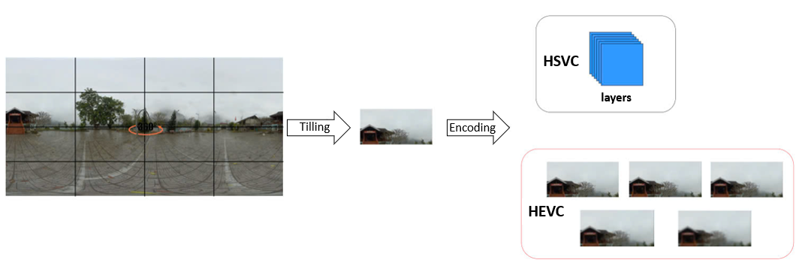
Figure 1. Video encoding standardized using H.265/HEVC

- Throughout a video streaming session, tiles outside the user’s viewport are delivered only in a base version that ensures basic quality, while tiles within the viewport are transmitted in several enhanced versions. As a result, QoE-ViLA achieves more efficient use of available network resources compared to traditional methods.
- Impact of spectrum efficiency on different versions of multicast transport modes for minimizing network bandwidth usage.
The rest of the paper is structured as follows: Section 2 discusses about the state of the art. The resource allocation problem is shown in Section 3. The proposed method - QoE-ViLA - is described in Section 4 followed by an evaluation in Section 5. Finally, the conclusion is discussed in Section 6.
2. RELATED WORKS
Currently, researchers are making significant efforts to provide smooth omnidirectional video streaming with low latency, ensuring a satisfying viewing experience for users even under constrained network bandwidth. In the referenced study⁹, the authors introduce a 360-degree video streaming framework that adjusts bitrate according to the user's viewport. This approach incorporates the spatiotemporal rate-distortion properties of 360-degree videos along with user navigation patterns. By analyzing user behavior to predict viewport transitions, the system adapts video quality accordingly, resulting in an enhanced quality of experience¹⁰. Another study¹¹ proposes an optimized video streaming approach using a chunk download scheduling framework, which enables the adjustment of each parallel stream's quality based on current bandwidth availability and the probability of stream switching.
Several recent studies¹²⁻¹⁴ have addressed the challenges associated with multicasting/unicasting 360-degree video to multiple mobile users, including large video data volumes, varying network conditions, limited bandwidth resources, and levels of user interaction. Paper¹⁴ presents a multi-quality multicast streaming approach for 360-degree videos targeting multiple users via time division multiple access (TDMA). To enhance transmission efficiency, the authors propose dividing encoded tiles into several representations at varying quality levels, enabling optimized decisions on quality selection, time allocation, and power distribution. Meanwhile, in paper¹³, users are grouped into multiple multicast clusters, each assigned a specific quality representation to maximize perceived video quality. This approach ensures smooth playback quality of 360-degree content while conserving energy without compromising visual fidelity. In paper¹², the multi-session Omnicast system is employed to optimize the delivery of 360-degree video to multiple users under limited network resource conditions. Paper¹⁵ proposes a framework for view-oriented, scale-optimized 360° video streaming, taking into account user viewport navigation behavior and the spatial scale distortion characteristics of 360° video content. Users are categorized into different classes based on their network bandwidth, with each layer corresponding to a multicast group receiving an identical set of tiles. In paper¹⁶, a multicast fusion approach is introduced for adaptive multi-user 360-degree video streaming, aiming to maintain high quality of experience (QoE) in bandwidth-constrained scenarios. This solution allows for dynamic selection between multicast and unicast modes, as well as bitrate adaptation for each cell based on the user's available bandwidth and field of view (FoV).

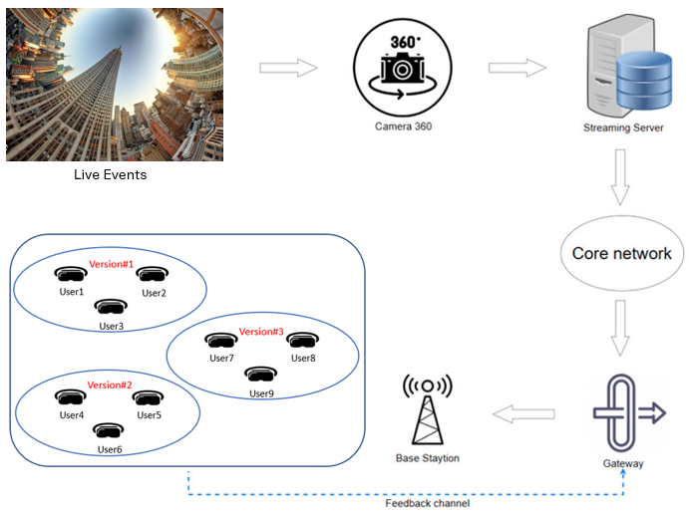
Figure 2. System Architecture Overview
Alternatively, Viewport Adaptive Streaming (VAS) enhances user experience under fluctuating network throughput and dynamic head movements. Besides, VAS approaches also rely on accurate head movement data and highly reliable viewport motion prediction¹⁷. By leveraging users’ past viewport data, cross-user behavior patterns¹⁸, and video content characteristics^{19,20}, it is possible to forecast users’ future viewport positions. To address this challenge, another solution involves using Scalable Video Encoding, which encodes individual tiles into a base layer and multiple enhancement layers²¹. Initially, the base layers of all tiles are downloaded, while the enhancement layers of visible tiles are subsequently retrieved to enhance frame quality and ensure smooth video playback under varying frame and network conditions. This approach also allows users the flexibility to select which part of the video they wish to view at the highest Quality of Experience (QoE), limited to the visible portion within the video’s viewport (View Field). In paper²², the authors propose a method that maintains a high buffer level and ensures consistent quality in subsequent segments, even when the average bitrate drops, thereby improving overall QoE. Since users seldom view areas outside their current viewports, more than 80% of bandwidth is wasted during 360° video streaming²³. Viewport Adaptive Streaming addresses this inefficiency by delivering the viewport region in high quality while encoding the remaining areas at lower quality, thereby optimizing bandwidth usage and reducing data waste²⁴.
3. RESOURCE ALLOCATION PROBLEM
As context, Figure 2 illustrates our proposed system for live 360-degree video streaming over mobile networks, which enables flexible distribution of multimedia content in multiple versions. This system leverages HEVC (High-Efficiency Video Coding) to address the resource allocation challenge.
Let β_{nh} denote the bitrate, and let ∆_{nh} represent the quality of layer h for tile n. The parameters H, M, and N correspond to the number of layers, users, and tiles, respectively. A resource block (RB) is denoted as R. Furthermore, each group's traffic is allocated R resource blocks (RBs), with the group's minimum spectral efficiency represented by σ.
Suppose that R network resource blocks are allocated to a specific user group. The spectral efficiency of user m (where 1 ≤ m ≤ M) characterizes the quality of the wireless link between the base station and the user's terminal device. A live 360-degree video stream is divided into N tiles, each of which is encoded into (H + 1) layers of different quality levels, with each layer representing a distinct version. For each tile n (1 ≤ n ≤ N), layer h (0 ≤ h ≤ H) is associated with a bitrate β_{nh} and quality ∆_{nh}, corresponding to version h. Furthermore, each version is partitioned into segments, with each segment having a playback duration of τ seconds. The following formula specifies the number of network resource blocks, denoted as R_{mnh}, required to transmit version h of each tile to user m:
$$R_{mnh}=\frac{β_{nh}×τ }{σ^{m}}$$ | (1)
where σ^{m} denotes the spectral efficiency of the wireless communication link between the base station and the user's terminal device.
The proposed system supports two transmission methods for delivering a version: unicast and multicast. In unicast mode, the version is transmitted to an individual user, whereas in multicast mode, it is distributed to a group of users. Furthermore, the spectral efficiency of multicast transmissions is constrained by the user with the lowest spectral efficiency in the group, which limits the overall multicast capacity.
4. PROPOSED SOLUTIONS (QoE-ViLA)
When viewing 360-degree videos under fluctuating mobile network bandwidth conditions that may cause buffering or playback interruptions, it becomes essential to adapt in real-time by dynamically modifying parameters like tile quality and transmission rate. By constantly tracking network performance and factoring in available bandwidth, latency, device capabilities, and the viewer’s current viewport, the system can maintain smooth playback and high visual quality, ensuring a seamless and enjoyable viewing experience.
This subsection introduces the two transmission modes for each tile’s layer using two binary variables, γ_{nh}, φ_{mnh} ∈ {0, 1}, ∀h ∈ H, n ∈ N, m ∈ M, as described below:
- γ_{nh} = 1: if layer h of tile n is sent in multicast mode to all users;
- φ_{mnh} = 1: if layer h of tile n is sent in unicast mode to user m;
- γ_{nh} = 0 or φ_{mnh} = 0: otherwise.
The objective function governing network resource allocation for streaming to multiple users is formulated as follows:
$$maxx\sum_{m∈M}{\sum_{n∈N}{\sum_{h∈H}{Ω_{mn}∆_{nh}(γ_{nh}+φ_{mnh})}}}$$ | (2)
With constraints:

$$\sum_{n∈N}{\sum_{h∈H}{\frac{β_{nh}×τ}{\min_{M∈βnh)=1}σ^{m}}≤R}}$$  Where:  β_{nh}​={ m∈ {1,...,M} ∣ γ_{nh​}+φ_{mnh}​=1} | (3)
$$\sum_{m}{\sum_{n}{φ_{mnh}≤1, ∀m ϵ M, n ϵ N, h≥1}}$$ | (4)

Table 1. The average bitrate (kbps) and quality (dB) of the four 360-degree videos utilized in the experiment for the Multicast-all and Multicast-sca approaches
Version | Diving |  | Paris |  | Venice |  | RollerCoaster
Version | Bitrate | Quality | Bitrate | Quality | Bitrate | Quality | Bitrate | Quality
Version 1 | 158.73 | 34.50 | 61.45 | 38.20 | 50.35 | 32.74 | 55.34 | 39.46
Version 2 | 313.77 | 38.24 | 88.73 | 41.93 | 114.25 | 35.91 | 106.75 | 42.71
Version 3 | 504.53 | 40.84 | 114.01 | 44.62 | 216.23 | 38.50 | 179.10 | 44.74
Version 4 | 1036.98 | 43.88 | 191.32 | 47.54 | 483.59 | 41.56 | 389.13 | 27.13
Version 5 | 1418.45 | 46.22 | 293.74 | 50.41 | 824.69 | 44.52 | 632.93 | 49.23
Table 2. The average bitrate (kbps) and quality (dB) of the four 360-degree videos utilized in the experiment for the QoE-ViLA and JUMPS approaches
Version | Diving |  | Paris |  | Venice |  | RollerCoaster
Version | Bitrate | Quality | Bitrate | Quality | Bitrate | Quality | Bitrate | Quality
Version 1 | 158.15 | 34.49 | 60.78 | 38.20 | 60.07 | 32.73 | 54.86 | 39.45
Version 2 | 393.63 | 38.22 | 130.38 | 42.19 | 183.02 | 36.07 | 131.71 | 42.86
Version 3 | 752.26 | 40.97 | 209.69 | 44.99 | 384.87 | 38.69 | 250.53 | 44.99
Version 4 | 1481.51 | 44.01 | 340.25 | 47.88 | 826.38 | 41.76 | 515.88 | 47.28
Version 5 | 2499.02 | 46.57 | 532.44 | 50.72 | 1520.15 | 44.76 | 933.84 | 49.42

$$\sum_{n}{γ_{n0}+φ_{mn0}=1, ∀m ϵ M,∀n ϵ N}$$ | (5)
$$σ^{m}=\frac{R_{m}(1-γ) }{B}$$ | (6)
Where: Ω_{mn} represents the weight of tile n for user m; B denotes the user's bandwidth, while B also refers to the channel bandwidth at the core; R_{m} indicates the number of network resource blocks required by user m; and σ^{m} denotes the spectral efficiency of the wireless communication between the base station and the user terminal.
Accurate prediction of the future viewport direction is essential for effective network resource allocation, as it guides the selection of γ_{nh} and φ_{mnh} values (as defined in Equation 2). The predicted direction influences γ_{nh}, which determines the weight assigned to each view or tile in a 360-degree video. By anticipating which areas the viewer is likely to focus on, higher γ_{nh} values can be allocated to those tiles, ensuring attention is directed toward the most relevant content. Likewise, φ_{mnh}—indicating the quality or level of detail of each tile—is also affected by the predicted direction, allowing for optimized visual fidelity where it matters most. By predicting the future viewing direction, higher quality or more detailed tiles can be assigned to regions likely to be viewed, thereby improving visual fidelity in those areas. In this study, two constraints are applied: the first ensures that the total network resources allocated in both multicast and unicast modes do not exceed the limit R, as defined in Equation 3. Additionally, the constraints in Equations 4 and 5 guarantee that each user receives every Field of View (FoV) tile only once. Moreover, each user is consistently provided with the base layer for all tiles.
5. PERFORMANCE EVALUATION
5.1. Experimental Settings
In this section, we prepare four 360-degree videos, namely Diving, Paris, Venice and RollerCoaster. Each video has a resolution of 3840×2048 and a duration of 60 seconds. Using the 360Lib software, we convert these videos into the CubeMap format with a resolution of 2890×1920. The videos are then divided into 24 tiles, each sized 480×480 pixels. Each tile is continuously encoded into five layers: one base layer and four enhancement layers. The Quantization Parameters for the respective layers are fixed as specified in Table 1 and Table 2.
Following the setup in paper²⁵, we set the number of users M to 15. The σ^{m} values are applied as defined in Equation 6. The experimental evaluation was conducted on a system running a 64-bit Windows 10 operating system with 8GB of RAM and a 3.8GHz Intel Core i7 processor. We compared the proposed QoE-ViLA method with reference methods, including the approach from paper²⁵ (referred to as Multicast-sca), Multicast-all¹², and JUMPS²⁶. Additionally, we recalculated the performance of the proposed and reference methods using the average viewport PSNR (Peak Signal-to-Noise Ratio), based on the following formula:
$$UVPR=\frac{1}{M}\sum_{m=1}^{M}{{UVPR}_{m}}$$ | (7)
$${UVPR}_{m}=\sum_{m=1}^{M}{Ω_{mn}^{a}×∆_{{nh}_{m}^{a}}}$$ | (8)
Where: UVPR_{m} denotes the viewport PSNR for user m; $Ω_{mn}^{a}$ represents the weighted sum of the quality of visible tiles; and $h_{m}^{a}$ indicates the highest layer of tile n streamed to user m.
Table 3. Average bitrate (kbps) in the case of 15 users
Videos | JUMPS | Mul-all | Mul_sca | QoE-ViLA
Diving | 597.00 | 609.39 | 637.68 | 737.50
Paris | 711.78 | 715.97 | 732.35 | 863.02
Venice | 587.74 | 608.11 | 630.63 | 718.01
Roller. | 692.71 | 693.64 | 709.58 | 840.78

Table 4. Average bitrate (kbps) in the case of 30 users
Videos | JUMPS | Mul-all | Mul_sca | QoE-ViLA
Diving | 1185.20 | 1182.82 | 1263.17 | 1459.63
Paris | 1417.94 | 1403.60 | 1456.70 | 1711.17
Venice | 1375.00 | 1362.06 | 1410.78 | 1669.13
Roller. | 1156.68 | 1181.48 | 1249.86 | 1420.57

Table 5. Average bitrate (kbps) in the case of 45 users
Videos | JUMPS | Mul-all | Mul_sca | QoE-ViLA
Diving | 1777.80 | 1756.00 | 1890.65 | 2184.71
Paris | 2126.90 | 2089.08 | 2180.62 | 2561.09
Venice | 2062.48 | 2029.02 | 2112.20 | 2499.06
Roller. | 1735.06 | 1752.80 | 1869.06 | 2125.93

Table 6. Average bitrate (kbps) in the case of 60 users
Videos | JUMPS | Mul-all | Mul_sca | QoE-ViLA
Diving | 2370.39 | 2332.60 | 2518.09 | 2910.43
Paris | 2835.86 | 2776.22 | 2905.89 | 3412.17
Venice | 2749.95 | 2698.42 | 2814.74 | 3330.21
Roller. | 2313.41 | 2326.90 | 2490.91 | 2831.55

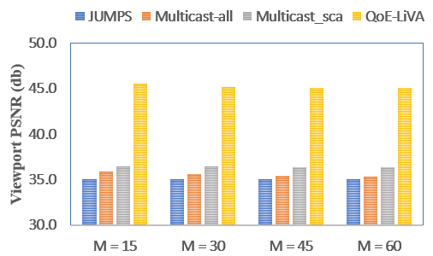
(a) Diving Video

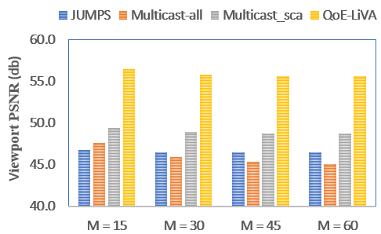
(b) Paris Video

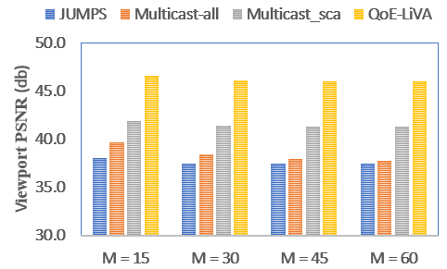
(c) Venice Video

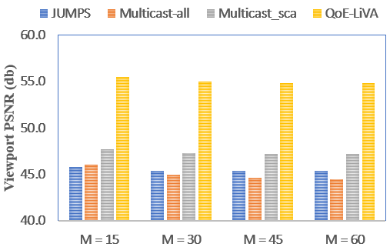
(d) RollerCoaster Video
Figure 3. The performance across different numbers of users (with R = 200000 RBs) varies between the proposed method and the reference methods.
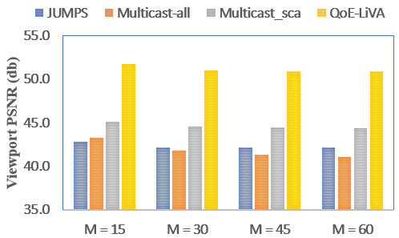
(a) Diving Video

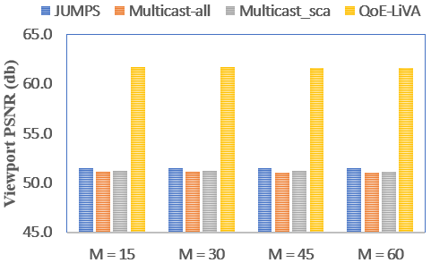
(b) Paris Video

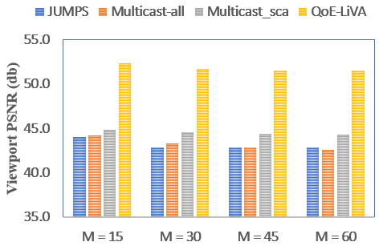
(c) Venice Video
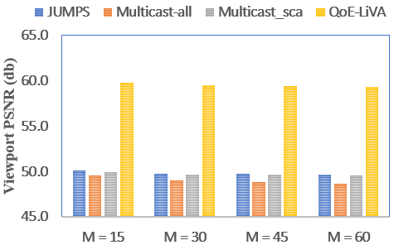
(d) RollerCoaster Video
Figure 4. The performance across different numbers of users (with R = 700000 RBs) varies between the proposed method and the reference methods.

5.2. Experimental Results and Discussion
In this section, we evaluate the performance of the proposed framework in comparison with reference methods. A bitrate analysis is conducted using R multicast transmissions for user groups of 15, 30, 45, and 60 users, with R varying from 20 kRBs to 700 kRBs. As shown in Tables 3 through 6, the QoE-ViLA method consistently outperforms all other referenced approaches across all four videos. Specifically, the proposed method improves the average bitrate by more than 14.10% and 17.89% compared to the Multicast-sca and JUMPS methods, respectively. In comparison with Multicast-all, the performance gain ranges from 16.85% with 15 users to 18.83% with 60 users.
Additionally, we examine the effectiveness of the proposed method in terms of viewport PSNR. In our experiments, four values of M—15, 30, 45, and 60—are specifically analyzed. Figures 3 and 4 illustrate the viewport PSNR results for both the proposed and reference methods at 200000 RBs and 700000 RBs, respectively. The results clearly show that our approach consistently outperforms all reference methods across all M values. The QoE-ViLA method achieves a viewport PSNR that is at least 5 dB and up to 10 dB higher than the other methods in all scenarios. Moreover, although the viewport PSNR of the proposed method slightly decreases as the number of users increases, the reduction remains minimal.
6. CONCLUSION
This paper proposes a novel viewport prediction approach for multi-user omnidirectional video streaming over cellular networks. The method leverages High-Efficiency Video Coding (HEVC) along with enhanced spectral efficiency to optimize bandwidth usage across users. Experimental results demonstrate that the proposed method can achieve significant performance improvements, ranging from 10.05% to 23.04% across four test videos. In future work, we aim to extend the capabilities of the proposed framework to support scenarios involving multiple users concurrently accessing various video assets, including live 360-degree video streams.
Acknowledgment
This research is conducted within the framework of science and technology projects at institutional level of Quy Nhon University under the project code T2025.893.13.
REFERENCES
1. N. V. Hung, T. D. Chien, N. P. Ngoc, and T. H. Truong, “Flexible http-based video adaptive streaming for good qoe during sudden bandwidth drops,” EAI Endorsed Transactions on Industrial Networks and Intelligent Systems, vol. 10, no. 2, pp. e3–e3, 2023.
2. H. Nguyen, “Mellifluous viewport bitrate adaptation for 360 videos streaming over http/2,” Journal on Information Technologies & Communications, vol. 2024, no. 2, pp. 2–2, 2024.
3. Hung, N. V., Dat, P. T., Tan, N., Quan, N. A., Trang, L. T. H., & Nam, L. M. (2025). Heverl–viewport estimation using reinforcement learning for 360-degree video streaming. Информатика и автоматизация, 24(1), 302-328.
4. Kočkovič, L., Rozinaj, G., & Medvecký, M. (2024, April). Optimizing 360° Video Delivery: Advancements and Strategic Approaches. In Computer Science On-line Conference (pp. 134-149). Cham: Springer Nature Switzerland.
5. K. R. Rao, J. J. Hwang, and D. Kim, High Efficiency Video Coding and other emerging standards. CRC Press, 2022.
6. D. Lecompte and F. Gabin, “Evolved multimedia broadcast/multicast service (embms) in lte-advanced: overview and rel-11 enhancements,” IEEE Communications Magazine, vol. 50, no. 11, pp. 68–74, 2012.
7. B. Damera and P. C. Babu, “Broadcast the user chosen content over lte in a simplified approach using evolved multimedia broadcast multicast service (embms) with optimized mce scheduling algorithm,” in 2014 International Conference on Intelligent Computing Applications, 2014, pp. 90–94.
8. W. Guo, M. Fuentes, L. Christodoulou, and B. Mouhouche, “Roads to multimedia broadcast multicast services in 5g new radio,” in 2018 IEEE International Symposium on Broadband Multimedia Systems and Broadcasting (BMSB). IEEE, 2018, pp. 1–5.
9. J. Chakareski, R. Aksu, X. Corbillon, G. Simon, and V. Swaminathan, “Viewport-driven rate-distortion optimized 360º video streaming,” in 2018 IEEE International conference on communications (ICC). IEEE, 2018, pp. 1–7.
10. Y. Guan, C. Zheng, X. Zhang, Z. Guo, and J. Jiang, “Pano: Optimizing 360 video streaming with a better understanding of quality perception,” in Proceedings of the ACM Special Interest Group on Data Communi- cation, 2019, pp. 394–407.
11. N. Carlsson, D. Eager, V. Krishnamoorthi, and T. Polishchuk, “Opti- mized adaptive streaming of multi-video stream bundles,” IEEE trans- actions on multimedia, vol. 19, no. 7, pp. 1637–1653, 2017.
12. D. Nguyen, N. Viet Hung, T. T. Huong, and T. C. Thang, “A cross- layer framework for multi-user360-degree video streaming over cellular networks,” in 2022 IEEE International Conference on Consumer Elec- tronics (ICCE), Virtual, Jan. 2022.
13. O. Eltobgy, O. Arafa, and M. Hefeeda, “Mobile streaming of live 360- degree videos,” IEEE Transactions on Multimedia, vol. 22, no. 12, pp. 3139–3152, 2020.
14. K. Long, C. Ye, Y. Cui, and Z. Liu, “Optimal Multi-Quality Multicast for 360 Virtual Reality Video,” in 2018 IEEE Global Communications Conference (GLOBECOM), Abu Dhabi, UAE, 2018, pp. 1–6.
15. R. Aksu, J. Chakareski, and V. Swaminathan, “Viewport-Driven Rate- Distortion Optimized Scalable Live 360° Video Network Multicast,” in 2018 IEEE ICME, CA, USA, 2018, pp. 1–6.
16. N. Kan, C. Liu, J. Zou, C. Li, and H. Xiong, “A Server-Side Optimized Hybrid Multicast-Unicast Strategy for Multi-User Adaptive 360-Degree Video Streaming,” in 2019 IEEE ICIP, Taiwan, 2019, pp. 141–145.
17. H. Nguyen, T. N. Dao, N. S. Pham, T. L. Dang, T. D. Nguyen, and T. H. Truong, “An accurate viewport estimation method for 360 video streaming using deep learning,” EAI Endorsed Transactions on Industrial Networks and Intelligent Systems, vol. 9, no. 4, pp. e2–e2, 2022.
18. Y. Ban, L. Xie, Z. Xu, X. Zhang, Z. Guo, and Y. Wang, “Cub360: Exploiting cross-users behaviors for viewport prediction in 360 video adaptive streaming,” in 2018 IEEE International Conference on Multi- media and Expo (ICME), CA, USA, 2018, pp. 1–6.
19. C.-L. Fan, J. Lee, W.-C. Lo, C.-Y. Huang, K.-T. Chen, and C.-H. Hsu, “Fixation prediction for 360° video streaming in head-mounted virtual reality,” in Proceedings of the 27th Workshop on Network and Operating Systems Support for Digital Audio and Video, ser. NOSSDAV’17, Taipei, Taiwan, 2017, p. 67–72. [Online]. Available: https://doi.org/10.1145/3083165.3083180
20. V. H. Nguyen, N. N. Pham, C. T. Truong, D. T. Bui, H. T. Nguyen, and T. H. Truong, “Retina-based quality assessment of tile-coded 360- degree videos,” EAI Endorsed Transactions on Industrial Networks and Intelligent Systems, vol. 9, no. 32, 2022.

21. A. T. Nasrabadi, A. Mahzari, J. D. Beshay, and R. Prakash, “Adaptive 360-degree video streaming using scalable video coding,” in Proceedings of the 25th ACM International Conference on Multimedia, ser. MM ’17, 2017, p. 1689–1697.
22. N. Viet Hung, T. D. Chien, N. Pham Ngoc, and T. H. Truong, “Flexible http-based video adaptive streaming for good qoe during sudden bandwidth drops,” EAI Endorsed Transactions on Industrial Networks and Intelligent Systems, vol. 10, no. 2, p. e3, Jun. 2023. [Online]. Available: https://publications.eai.eu/index.php/inis/article/view/2994.
23. S. Park, A. Bhattacharya, Z. Yang, M. Dasari, S. R. Das, and D. Samaras, in 2019 IFIP Networking Conference (IFIP Networking).
24. D. V. Nguyen, H. T. T. Tran, and T. C. Thang, “Impact of delays on 360-degree video communications,” in 2017 TRON Symposium (TRONSHOW), Tokyo, Japan, 2017, pp. 1–6.
25. D. Nguyen, N. V. Hung, N. T. Phong, T. T. Huong, and T. C. Thang, “Scalable multicast for live 360-degree video streaming over mobile networks,” IEEE Access, vol. 10, pp. 38 802–38 812, 2022.
26. A. Majidi and A. H. Zahran, “Optimized Joint Unicast-Multicast Panoramic Video Streaming in Cellular Networks,” in 2020 IEEE ICNP, Madrid, Spain, 2020, pp. 1–6.

