Nghiên cứu đặc trưng cấu trúc và hoạt tính quang xúc tác phân hủy dung dịch RhB của vật liệu màng C/g-C₃N₄/PVDF

Phan Thị Thùy Trang^{1*}, Trịnh Ngọc Đạt², Lê Vũ Trường Sơn², Đinh Thanh Khẩn², Huỳnh Văn Nam¹, Đinh Quốc Việt¹, Nguyễn Minh Vương¹, Nguyễn Tấn Lâm¹, Nguyễn Văn Thắng¹, Nguyễn Thị Lan^{1*}

¹Khoa Khoa học Tự nhiên, Trường Đại học Quy Nhơn, Việt Nam
²Trường Đại học Sư phạm, Đại học Đà Nẵng, Việt Nam

*Tác giả liên hệ chính. Email: phanthithuytrang@qnu.edu.vn, nguyenthilan@qnu.edu.vn

TÓM TẮT

Vật liệu composite carbon/graphit carbon nitride/polyvinylidene fluoride (C/g-C₃N₄/PVDF) có cấu trúc dị thể được tổng hợp thành công bằng phương pháp đảo pha đơn giản. Hình thái, cấu trúc và hoạt tính quang xúc tác của các hạt C/g-C₃N₄ và màng composite đã được đánh giá. Nhờ hiệu ứng hiệp trợ giữa carbon và g-C₃N₄ được phân tán trên màng PVDF đóng vai trò là chất xúc tác đã cải thiện một cách đáng kể khả năng phân hủy chất màu rhodamine B trong dung dịch. Cụ thể, vật liệu C/g-C₃N₄/PVDF thể hiện hiệu suất quang xúc tác cao nhất (H = 89%) so với các vật liệu g-C₃N₄/PVDF (H = 45,92%) sau 160 phút chiếu sáng dưới vùng ánh sáng khả kiến. Với phương pháp đưa vật liệu lên màng đã khắc phục được những nhược điểm vốn có của các loại xúc tác truyền thống như khó thu hồi và khả năng tái sử dụng xúc tác với hiệu suất thấp sau nhiều chu kì. Vì vậy, nghiên cứu này dự kiến sẽ được mở rộng một cách triển vọng trong lĩnh vực xúc tác quang.

Từ khóa: Composite, polyvinylidene fluoride, C/g-C₃N₄/PVDF, rhodamine B, chất xúc tác quang.

Study structure characteristics and the photocatalytic activities degradation of RhB solution on C/g-C₃N₄/PVDF membrane material

Phan Thi Thuy Trang^{1*}, Trinh Ngoc Đat², Le Vu Truong Son², Đinh Thanh Khan², Huỳnh Văn Nam¹, Đinh Quoc Viet¹, Nguyen Minh Vuong¹, Nguyen Tan Lam¹, Nguyen Van Thang¹, Nguyen Thi Lan^{1,*}

¹Faculty of Natural Sciences, Quy Nhon University, Vietnam
² The University of Da Nang, University of Science and Education, Viet Nam

*Corresponding author. Email: phanthithuytrang@qnu.edu.vn, nguyenthilan@qnu.edu.vn

ABSTRACT

Heterogeneous carbon/graphite carbon nitride/polyvinylidene fluoride (C/g-C₃N₄/PVDF) composite materials were successfully synthesized by a simple phase inversion method. The morphology, structure, and photocatalytic activity of C/g-C₃N₄ particles and composite films were evaluated. Thanks to the synergistic effect between carbon and g-C₃N₄ dispersed on the PVDF membrane acting as a catalyst, the ability to decompose rhodamine B dye in solution was significantly improved. Specifically, the C/g-C₃N₄/PVDF material exhibited the highest photocatalytic efficiency (H = 89%) compared to the liệu g-C₃N₄/PVDF material (H = 45,92%) after 160 minutes of illumination under visible light. The method of putting materials on the membrane has overcome the inherent disadvantages of traditional catalysts, such as difficulty in recovery and the ability to reuse the catalyst with low efficiency after many cycles. Therefore, this study is expected to be prospectively extended in photocatalysis for the treatment of polluted water.

Keywords: composite, polyvinylidene fluoride, C/g-C₃N₄/PVDF, rhodamine B, photocatalyst.

1. INTRODUCTION
Photocatalysis has emerged as one of the most promising green technologies thanks to its environmental benefits, cost-effectiveness, and high efficiency. It has found widespread applications in environmental management and energy conversion.^{1,2} A crucial aspect of advancing photocatalytic technology lies in developing new photocatalysts that efficiently harness solar energy, addressing the pressing need for environmental remediation today.
Rhodamine B (RhB) is one of the most popular dyes for the printing, textile, and leather industries, which could cause environmental pollution if not treated appropriately. Various technologies have been explored recently to develop effective methods for completely removing pharmaceutical and dye compounds from water.^{3,4} Among these, advanced oxidation processes (AOPs) have been identified as a promising solution for treating difficult-to-degrade compounds. AOPs, remarkably heterogeneous photocatalysis, have received significant due to their high efficiency in removing pharmaceuticals.^{5,6} Photocatalysts absorb photons from an external light source to generate electron-hole pairs, participating in redox reactions. Among the various photocatalysts, graphitic carbon nitride (g-C₃N₄) has emerged as a promising metal-free, layered material easily synthesized by thermal condensation using inexpensive and abundant organic precursors in soil, such as urea.⁷
As a narrow band gap semiconductor (2.7 eV), g-C₃N₄ demonstrates stable physicochemical properties, excellent thermal stability, and remarkable photoelectron transfer capabilities. Additionally, it is non-toxic, easy to store, and can be obtained from various sources.⁸ Recently, g-C₃N₄ has become an optimal choice for forming heterostructured materials with wide-band gap semiconductors. For example, Wang et al. developed a unique in situ microwave-assisted synthesis method to fabricate N-TiO₂/g-C₃N₄ composites, which showed significant improvements in photocatalytic activity.⁹ Similarly, Miranda et al. successfully obtained g-C₃N₄/TiO₂ composites with high photoactivity by combining hydrothermal and sintering methods, achieving a final phenol conversion rate of approximately 90%.¹⁰ However, g-C₃N₄ has shortcomings, such as a small specific surface area and a high recombination rate of photogenerated electron-hole pairs. To overcome this drawback, many methods have been applied to modify g-C₃N_{4,} such as preparing g-C₃N₄ in capillary structures and modifying g-C₃N₄ by doping techniques or grafting with other semiconductors to composite materials. ^{11,12}
Polyvinylidene fluoride (PVDF) is widely used for membrane fabrication due to its high mechanical strength, chemical resistance, and thermal stability.^{13,14} Several g-C₃N₄-PVDF membranes have been developed and successfully applied in studies aimed at removing pollutants from water in continuous flow mode, with photocatalysts serving as self-cleaning materials that exhibit antifouling properties.^{15,16}
The main objective of this study is to modify the surface of PVDF membranes with g-C₃N₄. The performance of the modified membranes was evaluated in the degradation of Rhodamine B dye.
2. EXPERIMENTAL
2.1. Material synthesis
Chemicals: All chemicals used for material synthesis include potassium hydroxide (KOH, 90%), hydrochloric acid (HCl, 37%), polyvinylidene fluoride (PVDF), N-Methy-2-pyrrolidone (NMP) urea (CO(NH₂)₂, ≥99%) (Sigma-Aldrich) and rhodamine B (C₂₈H₃₁ClN₂O₃) Merck
2.2. Materials synthesis:
2.2.1. Synthesis of g-C₃N₄
Ten grams of the precursor urea was finely ground and transferred into a ceramic cup. The cup was then heated in a furnace at 550 ºC with a heating rate of 10 ºC/min under an Ar atmosphere for one hour. The obtained powders was washed with water, dried, and ground. The sample denoted g-C₃N₄.
2.2.2. Synthesis of C/g-C₃N₄ membrane material
A mixture of urea (15 g) and C¹⁷ (0.1 g) was dispersed in a water-alcohol solution (1:1 ratio) and then subjected to ultrasonic vibration for 30 minutes. The mixture was continuously stirred at 60 ºC until the water and alcohol wholly evaporated. The resulting solid was ground and heated in Argon gas at 550 ºC for 1 hour. The product was washed, filtered, and dried at 80 ºC for 12 hours to obtain the final product, C/g-C₃N₄.
2.2.3. Synthesis of C/g-C₃N₄/PVDF membrane material
Add 0.1 grams of C/g-C₃N₄ material to a glass jar with a lid, then add 5 mL of N-Methyl-2-pyrrolidone (NMP). Sonicate the mixture for 10 minutes, followed by stirring for 30 minutes. Afterward, continue sonicating for another 20 minutes and stir for 20 minutes. Next, add 0.646 grams of polyvinylidene fluoride (PVDF) and stir the mixture at 40 ºC for 4 hours. Allow the mixture to stand for 3 hours. Use a stainless steel knife (250 µm x 15 cm) to evenly roll the mixture onto a glass surface to form a composite film. Quickly immerse the glass with the film into the water to perform the phase inversion process.¹⁷ The resulting product is denoted as C/g-C₃N₄/PVDF.
The process for dispersing g-C₃N₄ onto PVDF polymer is carried out similarly, and the product obtained is denoted as g-C₃N₄/PVDF.
2.3. Material characterization
The synthesized materials were characterized using several techniques. Infrared spectroscopy IR was performed on a Shimadzu IR Prestige-21). The crystal phase was analyzed by X-ray diffraction (XRD) using a Siemens D-500 Bruker system. Scanning electron microscopy (SEM) and X-ray energy dispersive spectroscopy (EDS) were conducted using a JSM-7600F device. Photoluminescence (PL) spectra were measured on a Hitachi F-7000 instrument with an excitation wavelength of 360 nm.
2.4. Photocatalytic evaluation
The photocatalytic activity of the obtained materials was evaluated by the decomposition of Rhodamine B (RhB) in an aqueous solution under visible light irradiation. Materials membrane containing 0.1 g of the photocatalyst was added to 100 mL of RhB solution with a concentration of 10 mg/L and stirred in the dark for 30 minutes to achieve adsorption-desorption equilibrium. The photocatalytic process was then initiated under a 30W LED light. Every 20 minutes, 5 mL of the solution was centrifuged to remove the solid part. The concentration of RhB in the solution was determined on a UV-Vis meter (CE-2011) at a wavelength of 553 nm.
3. RESULTS AND DISCUSSION
3.1. Material characteristics
XRD patterns were used to determine the crystalline phase of g-C₃N₄/PVDF and C/g-C₃N₄/PVDF composites, as shown in Figure 1a.
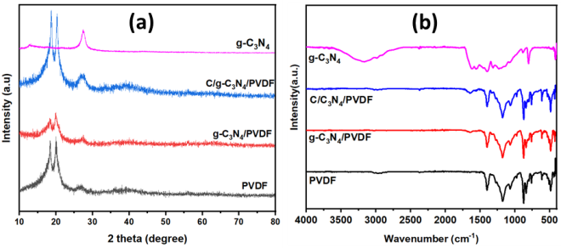
Figure 1. (a) XRD and (b) FT-IR patterns of PVDF, g-C₃N₄, g-C₃N₄/PVDF, and C/g-C₃N₄/PVDF.
PVDF is a semi-crystalline polymer with two main crystalline phases, α and β.^{18,19} The results in Figure 1 indicate three characteristic peaks at 18.5º, 20.1^{o,} and 26.7º, which are assigned to the reflection planes of (020), (110), and (021), corresponding to the α crystalline phase. When g-C₃N₄ or C/g-C₃N₄ were added to the PVDF polymer to form g-C₃N₄/PVDF and C/g-C₃N₄/PVDF composites, no significant change was observed compared to the pure PVDF sample. The three peaks attributed to the reflections of PVDF remain at nearly the same position but with varying intensities. The XRD pattern of g-C₃N₄ (Figure 1a) shows two characteristic peaks at 27.6º and 13.1º corresponding to the (002) and (100) reflection planes of graphite-structured materials.²⁰ In addition, the characteristic peak at 27.6º corresponding to the (002) plane of g-C₃N₄ appears in both the g-C₃N₄/PVDF and C/g-C₃N₄/PVDF samples (Figure 1a). The peak at 27.6º corresponding to the (002) plane of g-C₃N₄ is believed to result from the alternating stacking of conjugated aromatic units, similar to graphite structure.²¹ The peak at 13.1º of g-C₃N₄ was not seen in the XRD patterns of g-C₃N₄/PVDF and C/g-C₃N₄/PVDF materials, possibly due to the small amount of g-C₃N₄ in the sample. The diffraction peaks of the C/g-C₃N₄/PVDF composite are more intense than those of the g-C₃N₄ sample, likely due to carbon increasing the intensity of the peaks in this material sample.
FT-IR spectra were employed to characterize the chemical bond characteristics of the samples, and the results are presented in Figure 1b. The FTIR spectrum of g-C₃N₄ shows broad shoulder absorption bands at 3187 cm⁻¹ corresponding to the stretching vibrational pattern of N-H in the incompletely condensed amine group or OH of the adsorbed water. In addition, there are some dominant, strong bands in the 1100–1700 cm⁻¹ region in the IR spectrum, corresponding to the characteristic vibrational pattern of CN heteroaromatic rings. Specifically, the peaks around 1639 cm⁻¹ and 1574 cm⁻¹ can be attributed to the characteristic vibrational pattern of C=N bonds, while the peaks at 1247 cm⁻¹ to 1458 cm⁻¹ are assigned to the stretching vibrational pattern of C-N bonds in conjugated aromatic rings. The bands at 1325 cm⁻¹ and 1247 cm⁻¹ correspond to the valence vibrations of the C-N(-C)-C bridging units with a fully condensed system or C-NH-C with a partially condensed system. In addition, a sharp absorption band at 820 cm⁻¹ is attributed to the deformation vibrations of the N-H groups of the triazine units. ^{22,23}.
The FTIR spectrum of the PVDF membrane shows that the peak at 763 cm⁻¹ corresponds to the bending vibration of the CF₂ group. The peaks at 794 and 977 cm⁻¹ are attributed to the shaking vibration of the CF₂ group, while the peak at 1170 cm⁻¹ is associated with the valence vibration of the CF₂ group.^{24,25} The peak at 1413 cm⁻¹ is deemed to be the valence vibration of the C-H functional group. In addition, the PVDF sample exhibits peaks at 875, 615, 531, and 490 cm⁻¹, all of which correspond to PVDF's α phase crystal structure.²⁶ For the composite membrane materials g-C₃N₄/PVDF and C/g-C₃N₄/PVDF, the peak appearing at 1639 cm⁻¹ is attributed to the valence vibration of the C=N group.²⁷ The peaks at 2979 and 1411 cm⁻¹ are assigned to the valence and deformation vibrations of the CH₂ group, respectively. In addition, the peak at 1181 cm-1 vibration is related to the valence vibration of the CF₂ group.²⁸
The SEM images reveal that the surface of pure PVDF (Figure 2a) exhibits a homogeneous morphology. In comparison, the SEM image of g-C₃N₄/PVDF (Figure 2b) shows numerous voids between g-C₃N₄ and polymer chains, which are formed due to the particle distribution during the sample preparation. The SEM image of the C/g-C₃N₄/PVDF composite (Figure 2c) shows that many small particles are evenly dispersed on the PVDF substrate. These observations confirm that the presence of carbon in the composite sample influences the voids between particles and polymer chains.²¹
Figure 2. FE-SEM images of (a) PVDF, (b) g-C₃N₄/PVDF, (c) C/g-C₃N₄/PVDF, (d) mapping images of N, (e) C and (g) F elements.
The EDX spectrum in Figure 3 was used to identify the elements in the characterized C/g-C₃N₄/PVDF composite membrane material.
The mapping images in Figures 2 d, e, g, and Figure 3a confirm the presence of C, F, and N elements in the C/g-C₃N₄/PVDF composite. The results showed that the elements on the surface membrane were mainly C, F, and N, with contents of 39.61%, 56.44%, and 3.95%, respectively, indicating that the membrane agglomeration was a C/g-C₃N₄ catalyst.
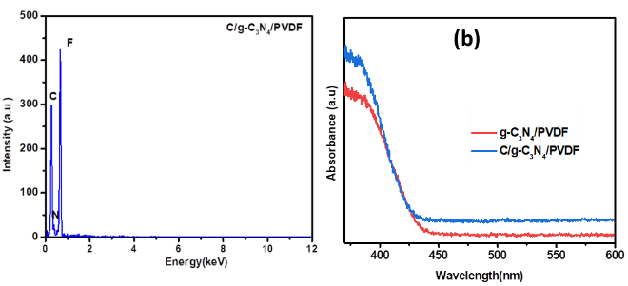
Figure 3. (a) EDX spectrum of C/g-C₃N₄/PVDF and (b) UV-Vis DRS spectra of g-C₃N₄/PVDF and C/g-C₃N₄/PVDF composite membrane.
The UV-Vis spectra of g-C₃N₄/PVDF and C/g-C₃N₄/PVDF composite membrane materials are shown in Figure 3b.
The results show that g-C₃N₄/PVDF and C/g-C₃N₄/PVDF composite membranes absorb in the ultraviolet region and extend into the visible. Compared with the g-C₃N₄/PVDF sample, the C/g-C₃N₄/PVDF composite membrane has a higher absorption intensity than the g-C₃N₄/PVDF in the visible region. This may be due to the presence of carbon in the composite.
As the photocatalytic activity of semiconductor materials is greatly affected by the recombination rate of photogenerated electron and hole pairs, the photoluminescence (PL) spectrum is used to evaluate this recombination ability. The photoluminescence spectra of PVDF, g-C₃N₄/PVDF, and C/g-C₃N₄/PVDF materials are presented in Figure 4.
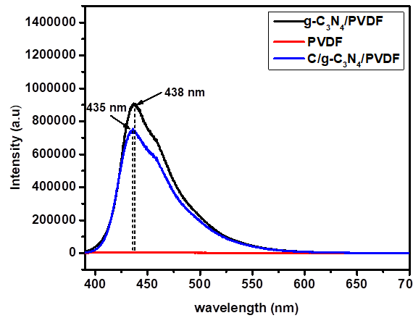
Figure 4. PL spectra of PVDF, g-C₃N₄/PVDF, and C/g-C₃N₄/PVDF materials.
PL spectra of PVDF, g-C₃N₄/PVDF, and C/g-C₃N₄/PVDF materials were conducted with an excitation wavelength of 390 nm. As shown in Figure 4, the C/g-C₃N₄/PVDF and C₃N₄/PVDF show peaks at 435 and 438 nm, respectively. However, the C/g-C₃N₄/PVDF composite membrane material exhibits lower emission intensity than g-C₃N₄/PVDF, which may be due to the addition of carbon helping improve the dispersion of the material. No significant PL intensity is observed across the entire measured PL spectrum for the PVDF membrane, indicating its limited adsorption properties. Consequently, the luminescence intensity is very low and nearly non-existent. Since PVDF does not have inherent luminescence, the observed PL shift is attributed to the excitation effect induced by adding g-C₃N₄ and carbon.²⁹ The PL spectral results suggest that the recombination rate of electron-hole pairs in C/g-C₃N₄/PVDF is lower than in g-C₃N₄/PVDF. This enhanced electron separation in C/g-C₃N₄/PVDF creates favorable conditions for photogenerated electrons to diffuse to the catalyst surface, where they interact with adsorbed H₂O or O₂ molecules to generate active free radicals, thus improving the efficiency of pollutant treatment.
3.2. Photocatalytic performance
The results of the photocatalytic evaluation for PVDF, g-C₃N₄/PVDF, and C/g-C₃N₄/PVDF are shown in Figure 5a.
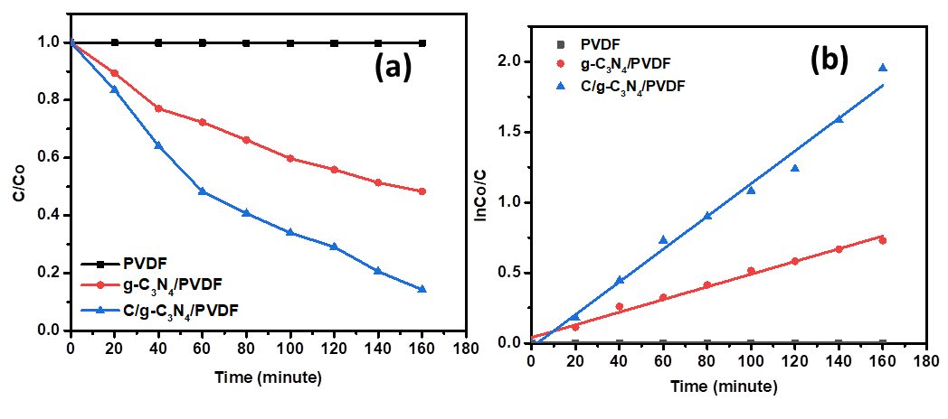
Figure 5. (a) RhB decomposition and (b) pseudo-ﬁrst-order kinetic model under visible light of g-C₃N₄/PVDF, C/g-C₃N_{4,} and C/g-C₃N₄/PVDF materials.
After 160 minutes of illumination, the RhB decomposition efficiency of the C/g-C₃N₄/PVDF composite membrane reached 89%, which was higher than that of C₃N₄/PVDF, which achieved efficiencies of 45.92%. For the RhB solution of the PVDF fiber membrane without catalyst powder, the concentration remained almost unchanged under dark adsorption and light conditions, and the adsorption of RhB in the dark was only 2.09%, which also shows that pure PVDF has no degradation ability for RhB under natural conditions. After the PVDF membrane was laminated with g-C₃N₄ or C/g-C₃N₄ composite, the adsorption capacity of RhB in the dark was enhanced, which also shows that part of the g-C₃N₄ or C/g-C₃N₄ catalyst was exposed on the membrane, thereby increasing the dark adsorption of RhB by the composite membrane. Therefore, the ability to decompose RhB will increase when exposed to light. This is consistent with the results discussed in PL and UV-Vis DRS spectra.
These results highlight the potential of g-C₃N₄/PVDF, C/g-C₃N₄/PVDF composite for practical membrane-based environmental treatment applications.
Furthermore, Figure 5b presents the fitting results of the photoreduction kinetic curves of RhB over different samples using the first-order reaction kinetics equation of -ln(C/C_{o})=kt. The maximum photoreduction rate constant of RhB over the C/g-C₃N₄/PVDF photocatalysis membrane is 0.0116 min⁻¹, which is about 2.6 times that of g-C₃N₄/PVDF (0.0045 min⁻¹). These results demonstrate that the synergistic effect of C/g-C₃N₄ and PVDF membrane improves the photoreduction performance of g-C₃N₄.³⁰
3.3. Photocatalytic cycle experiment
The photocatalytic stability of the C/g-C₃N₄/PVDF composite membrane was analyzed by conducting a cycle stability experiment (Figure 6).
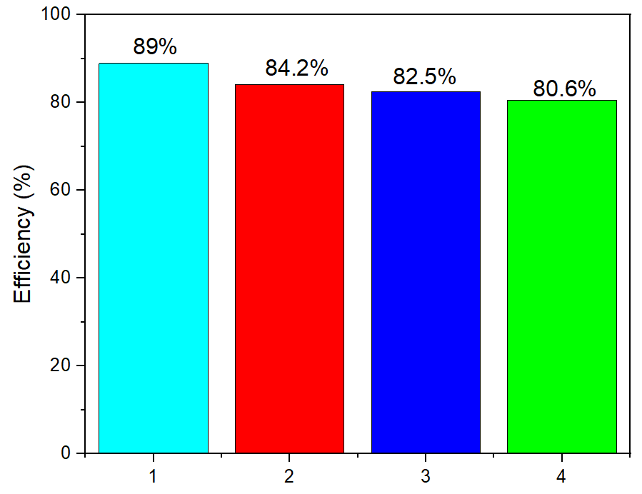
Figure 6. Reusability of C/g-C₃N₄/PVDF membrane materials.
The results showed that the removal rate of RhB was 89% when the C/g-C₃N₄/PVDF composite membrane was used for catalytic degradation once. After ultrasonic cleaning of the recovered composite membrane, the degradation efficiency of RhB was 84.2% (second time) after 160 min of illumination. After repeating twice, the removal rates of RhB were 82.5% (third time) and 80.6% (fourth time), respectively. This shows that the membrane can effectively photocatalytically degrade RhB and can be reused through water-washing regeneration. After regeneration three times, the membrane maintained a high efficiency, indicating that the prepared C/g-C₃N₄/PVDF membrane has efficient photocatalytic and excellent regeneration performance for RhB.
4. Conclusion
The phase inversion method successfully synthesized g-C₃N₄/PVDF, C/g-C₃N₄/PVDF materials. The C/g-C₃N₄/PVDF composite membrane exhibits excellent photocatalytic activity under visible light with an efficiency of 89% after 160 min of illumination, which was superior to those of g-C₃N₄/PVDF and pure PVDF membranes (45.92% and 2.09%, respectively). At the same time, it has stable recycling performance. Even after 4th recycling, the degradation efficiency reaches 80.6%, indicating that the C/g-C₃N₄/PVDF composite membrane has broad application prospects in the photocatalytic degradation of organic dyes in wastewater.
Acknowledgments
This research is funded by the Vietnamese Ministry of Education and Training under Grant B2023-DQN-02.

REFERENCES
1. Harish, K.; Bhojya Naik, H.; Prashanth Kumar, P.; Viswanath, R. Optical and photocatalytic properties of solar light active Nd-substituted Ni ferrite catalysts: for environmental protection. ACS Sustainable Chemistry & Engineering, 2013, 1 (9), 1143-1153.
2. Chen, J.; Poon, C.-s. Photocatalytic cementitious materials: influence of the microstructure of cement paste on photocatalytic pollution degradation. Environmental science & technology, 2009, 43 (23), 8948-8952.
3. Benner, J.; Helbling, D. E.; Kohler, H.-P. E.; Wittebol, J.; Kaiser, E.; Prasse, C.; Ternes, T. A.; Albers, C. N.; Aamand, J.; Horemans, B. Is biological treatment a viable alternative for micropollutant removal in drinking water treatment processes? Water research 2013, 47 (16), 5955-5976.
4. Kanakaraju, D.; Glass, B. D.; Oelgemöller, M. Advanced oxidation process-mediated removal of pharmaceuticals from water: A review. Journal of environmental management, 2018, 219, 189-207.
5. Antonopoulou, M.; Kosma, C.; Albanis, T.; Konstantinou, I. An overview of homogeneous and heterogeneous photocatalysis applications for the removal of pharmaceutical compounds from real or synthetic hospital wastewaters under lab or pilot scale. Science of the total environment, 2021, 765, 144163.
6. Meijide, J.; Lama, G.; Pazos, M.; Sanromán, M.; Dunlop, P. S. Ultraviolet-based heterogeneous advanced oxidation processes as technologies to remove pharmaceuticals from wastewater: An overview. Journal of Environmental Chemical Engineering, 2022, 10 (3), 107630.
7. Wen, J.; Xie, J.; Chen, X.; Li, X. A review on g-C₃N₄-based photocatalysts. Applied surface science, 2017, 391, 72-123.
8. Zhou, S.; Liu, Y.; Li, J.; Wang, Y.; Jiang, G.; Zhao, Z.; Wang, D.; Duan, A.; Liu, J.; Wei, Y. Facile in situ synthesis of graphitic carbon nitride (g-C₃N₄)-N-TiO₂ heterojunction as an efficient photocatalyst for the selective photoreduction of CO₂ to CO. Applied Catalysis B: Environmental, 2014, 158, 20-29.
9. Wang, X.-j.; Yang, W.-y.; Li, F.-t.; Xue, Y.-b.; Liu, R.-h.; Hao, Y.-j. In situ microwave-assisted synthesis of porous N-TiO₂/g-C₃N₄ heterojunctions with enhanced visible-light photocatalytic properties. Industrial & Engineering Chemistry Research, 2013, 52 (48), 17140-17150.
10. Miranda, C.; Mansilla, H.; Yáñez, J.; Obregón, S.; Colón, G. Improved photocatalytic activity of g-C₃N₄/TiO₂ composites prepared by a simple impregnation method. Journal of Photochemistry and Photobiology A: Chemistry, 2013, 253, 16-21.
11. Cao, S.; Low, J.; Yu, J.; Jaroniec, M. Polymeric photocatalysts based on graphitic carbon nitride. Advanced Materials, 2015, 27 (13), 2150-2176.
12. Deng, Y.; Liu, J.; Huang, Y.; Ma, M.; Liu, K.; Dou, X.; Wang, Z.; Qu, S.; Wang, Z. Engineering the photocatalytic behaviors of g/C₃N₄‐based metal‐free materials for degradation of a representative antibiotic. Advanced Functional Materials, 2020, 30 (31), 2002353.
13. Yang, F.; Ding, G.; Wang, J.; Liang, Z.; Gao, B.; Dou, M.; Xu, C.; Li, S. Self-cleaning, antimicrobial, and antifouling membrane via integrating mesoporous graphitic carbon nitride into polyvinylidene fluoride. Journal of Membrane Science, 2020, 606, 118146.
14. Zhou, T.-T.; Zhao, F.-H.; Cui, Y.-Q.; Chen, L.-X.; Yan, J.-S.; Wang, X.-X.; Long, Y.-Z. Flexible TiO₂/PVDF/g-C₃N₄ nanocomposite with excellent light photocatalytic performance. Polymers, 2019, 12 (1), 55.
15. Kolesnyk, I.; Kujawa, J.; Bubela, H.; Konovalova, V.; Burban, A.; Cyganiuk, A.; Kujawski, W. Photocatalytic properties of PVDF membranes modified with g-C₃N₄ in the process of Rhodamines decomposition. Separation and Purification Technology, 2020, 250, 117231.
16. Huang, J.; Hu, J.; Shi, Y.; Zeng, G.; Cheng, W.; Yu, H.; Gu, Y.; Shi, L.; Yi, K. Evaluation of self-cleaning and photocatalytic properties of modified g-C₃N₄ based PVDF membranes driven by visible light. Journal of colloid and interface science, 2019, 541, 356-366.
17. Lan Nguyen Thi, Thi Thuy Trang Phan, Lam Nguyen Tan, Thanh Lieu Thi Le, Le Tuan Nguyen, Nguyen Tien Hoang, Vien Vo, Dinh Quang Khieu. Activated carbon/g-C₃N₄ /H₂O₂ system with enhanced photocatalytic activity for Rhodamine-B degradation under the visible light, Environmental Engineering Research, 2024, 30(1), 240121.
18. Valenzuela, L.; Pedrosa, M.; Bahamonde, A.; Rosal, R.; Torres-Pinto, A.; Silva, C. G.; Faria, J. L.; Silva, A. M. Carbon nitride–PVDF photocatalytic membranes for visible-light degradation of venlafaxine as emerging water micropollutant. Catalysis Today, 2023, 418, 114042.
19. Vidhate, S.; Shaito, A.; Chung, J.; D'Souza, N. A. Crystallization, mechanical, and rheological behavior of polyvinylidene fluoride/carbon nanofiber composites. Journal of applied polymer science 2009, 112 (1), 254-260.
20. Song, R.; Yang, D.; He, L. Effect of surface modification of nanosilica on crystallization, thermal and mechanical properties of poly (vinylidene fluoride). Journal of materials science, 2007, 42, 8408-8417.
21. Zhu, B.; Xia, P.; Li, Y.; Ho, W.; Yu, J. Fabrication and photocatalytic activity enhanced mechanism of direct Z-scheme g-C₃N₄/Ag₂WO₄ photocatalyst. Applied Surface Science, 2017, 391, 175-183.
22. Zhu, L.; Wang, Y.; Hu, F.; Song, H. Structural and friction characteristics of g-C3N4/PVDF composites. Applied Surface Science, 2015, 345, 349-354.
23. Liu, J.; Zhang, T.; Wang, Z.; Dawson, G.; Chen, W. Simple pyrolysis of urea into graphitic carbon nitride with recyclable adsorption and photocatalytic activity. Journal of Materials Chemistry 2011, 21 (38), 14398-14401.
24. Yan, S.; Li, Z.; Zou, Z. Photodegradation performance of g-C₃N₄ fabricated by directly heating melamine. Langmuir, 2009, 25 (17), 10397-10401.
25. Abzan, N.; Kharaziha, M.; Labbaf, S. Development of three-dimensional piezoelectric polyvinylidene fluoride-graphene oxide scaffold by non-solvent induced phase separation method for nerve tissue engineering. Materials & Design, 2019, 167, 107636.
26. Kim, M.; Wu, Y. S.; Kan, E. C.; Fan, J. Breathable and flexible piezoelectric ZnO@ PVDF fibrous nanogenerator for wearable applications. Polymers, 2018, 10 (7), 745.
27. Tan, K.; Gan, W.; Velayutham, T.; Abd Majid, W. Pyroelectricity enhancement of PVDF nanocomposite thin films doped with ZnO nanoparticles. Smart materials and structures, 2014, 23 (12), 125006.
28. Cui, Y.; Yang, L.; Meng, M.; Zhang, Q.; Li, B.; Wu, Y.; Zhang, Y.; Lang, J.; Li, C. Facile preparation of antifouling gC₃N₄/Ag₃PO₄ nanocomposite photocatalytic polyvinylidene fluoride membranes for effective removal of rhodamine B. Korean Journal of Chemical Engineering, 2019, 36, 236-247.
29. Nikooe, N.; Saljoughi, E. Preparation and characterization of novel PVDF nanofiltration membranes with hydrophilic property for filtration of dye aqueous solution. Applied Surface Science, 2017, 413, 41-49.
30. Vilamova, Z.; Svoboda, L.; Bednar, J.; Simonova, Z.; Dvorsky, R.; Silva, C.; Faria, J. Enhancing photocatalytic g-C₃N₄/PVDF membranes through new insights into the preparation methods. Polymer, 2024, 127238.
31. Wang, H.; Gong, R.; Qian, X. Preparation and characterization of TiO₂/g-C₃N₄/PVDF composite membrane with enhanced physical properties. Membranes, 2018, 8 (1), 14.

