Study on the effect of pure fermentation starters (banh men) on the quality of fermented glutinous rice (com ruou)

Le Bich Tuyen¹, Huynh Van Quoc Canh^{1,*}, Truong Thi Tu Tran¹

¹Faculty of Food Science and Health, Kien Giang University

ABSTRACT
This study aimed to apply pure microbial strains from traditional fermentation starters (bánh men) to enhance the quality of cơm rượu—a traditional fermented glutinous rice product—in Gò Quao District, Kiên Giang Province. Traditional bánh men harbors essential microorganisms, including yeasts, molds, and lactic acid bacteria, which are responsible for the conversion of starch into alcohol and the development of characteristic flavors during fermentation. Experiments were conducted using varying concentrations of pure bánh men (0.4%, 0.6%, and 0.8%), with 0.4% yielding the most favorable sensory attributes while maintaining desirable physicochemical parameters such as moisture content, pH, lactic acid levels, and a high alcohol concentration (~10% v/v). Fermentation time was also evaluated over a period of 2 to 4 days, with results indicating that optimal fermentation occurred after 3 days, when key indicators such as pH, alcohol, and lactic acid stabilized. Importantly, no harmful by-products such as methanol or furfural were detected. These findings provide a scientific basis for the use of pure bánh men cultures to improve the consistency and quality of traditional cơm rượu, while also contributing to the preservation and development of local fermentation practices.
Keywords: Fermented glutinous rice , Go Quao, yeast, mold, lactic acid bacteria

Study on the effect of pure fermentation starters (banh men) on the quality of fermented glutinous rice (com ruou)

Le Bich Tuyen¹, Huynh Van Quoc Canh^{1,*}, Truong Thi Tu Tran¹

¹Faculty of Food Science and Health, Kien Giang University

ABSTRACT
This study aimed to apply pure microbial strains from traditional fermentation starters (bánh men) to enhance the quality of cơm rượu—a traditional fermented glutinous rice product—in Gò Quao District, Kiên Giang Province. Traditional bánh men harbors essential microorganisms, including yeasts, molds, and lactic acid bacteria, which are responsible for the conversion of starch into alcohol and the development of characteristic flavors during fermentation. Experiments were conducted using varying concentrations of pure bánh men (0.4%, 0.6%, and 0.8%), with 0.4% yielding the most favorable sensory attributes while maintaining desirable physicochemical parameters such as moisture content, pH, lactic acid levels, and a high alcohol concentration (~10% v/v). Fermentation time was also evaluated over a period of 2 to 4 days, with results indicating that optimal fermentation occurred after 3 days, when key indicators such as pH, alcohol, and lactic acid stabilized. Importantly, no harmful by-products such as methanol or furfural were detected. These findings provide a scientific basis for the use of pure bánh men cultures to improve the consistency and quality of traditional cơm rượu, while also contributing to the preservation and development of local fermentation practices.
Keywords: Fermented glutinous rice , Go Quao, yeast, mold, lactic acid bacteria

1. INTRODUCTION

Fermented foods constitute an important part of the culinary culture of many countries, including Vietnam. Among them, traditional fermented glutinous rice (cơm rượu) is a representative product closely associated with the daily life of the people. The production process of traditional fermented glutinous rice is influenced by starter cakes, which contain molds, yeasts, and lactic acid bacteria. These microorganisms initiate and sustain the transformation of starch into alcohol, while also contributing to the characteristic flavor of traditional fermented glutinous rice .
Starter cakes are typically produced using traditional methods, which involve mixing various medicinal herbs with rice flour and allowing the mixture to ferment under natural conditions. This process creates a favorable environment for the growth of diverse microorganisms, the most important of which are yeast species (e.g., Saccharomyces cerevisiae), molds (Aspergillus, Rhizopus, etc.), and lactic acid bacteria (including both lactic and acetic acid bacteria).
However, since the traditional production of starter cakes relies heavily on folk experience and lacks scientific and technical control, fermentation efficiency is often inconsistent, alcohol yield is low, and contamination risk is high. This underscores the urgent need for research and improvement in the production process.
Previous studies have demonstrated significant potential in isolating and applying indigenous microorganisms from starter cakes. Specifically, Ngô Thị Phương Dung developed and applied defined starter cultures in the fermentation of black glutinous fermented glutinous rice , using Amylomyces rouxii and Saccharomyces cerevisiae as inoculum strains in the production of defined fermented glutinous rice starter.¹ Similarly, Nguyễn Văn Huế investigated the antioxidant and antibacterial properties of plant leaf extracts and applied them in the production of herbal starter cakes for fermented glutinous rice fermentation.² His findings showed that fermented glutinous rice produced with lab-made starter cakes containing leaf extract had alcohol concentrations comparable to wine fermented using traditional starter cakes obtained from local producers in Đá Bàn commune.
In addition, Đoàn Thị Kiều Tiên and colleagues isolated Saccharomyces cerevisiae from Giac fruit (Antidesma bunius) and assessed its fermentation performance and storage conditions for Giac fruit wine.³ However, practical application studies of these strains under production conditions remain limited.
In the Mekong Delta region, which boasts a rich culinary culture and abundant agricultural resources, traditional starter cake villages are facing multiple challenges—from the loss of traditional knowledge to the pressure of competition from industrial products. In this context, conducting scientific research to evaluate and standardize starter cake production processes is a necessary direction. Such efforts not only help preserve and develop traditional crafts but also enhance product value, meeting the increasing demands for food safety and product quality.
From the issues outlined above, this study aims to investigate the production process of fermented glutinous rice using isolated starter cultures, with key objectives including the application of selected microbial strains in a pilot fermentation process and evaluation of fermentation performance using local raw materials
2. MATERIALS AND METHOD

2.1 Materials and chemicals
Pure fermentation starters (banh men) were produced in the laboratory of Kien Giang University with the following microbial densities: molds at 10⁷ CFU/g, yeasts at 10⁷ CFU/g, and lactic acid bacteria at 10⁸ CFU/g.
Chemicals: 3.5-Dinitrosalicylic acid (China), NaOH 0.1N (Cemaco, Vietnam).
Culture media used for microbial propagation: YPD (Yeast extract Peptone Dextrose) medium, PDA (Potato Dextrose Agar) medium, MRS Broth medium, and various synthetic media from Himedia (India).

2.2 Methods
+ Moisture (% w/w): 10 g of fermented glutinous rice was determined for moisture content using a moisture balancer MOC-63u (Shimadzu, Japan).
+ Brix: 10 mL of water and fermented glutinous rice mixture, then measure Brix with Master-3T refractometer (Atago, Japaen).
+ The pH value: Using 10 mL of water and fermented glutinous rice mixture, dip the electrode of the pH meter MI150 MARTINI (Romania) into the solution to determine the pH.
+ Alcohol content (% v/v): Determine the alcohol content by alcohol recovery distillation method, using alcohol distillation kit 2505200 (Witeg, Germany), then measure the alcohol concentration CHG-3C33 (China) and convert to 20°C.⁴
+ Titratable acidity (as %lactic acid) (mg/mL): Put 10 mL of water and fermented glutinous rice mixture into a test tube. Add 20 mL of distilled water. Add 1-2 drops of phenoltaphlein. Shake well to mix the substances evenly. Titrate the solution with 0.1N NaOH until the solution turns pink, then stop.⁵
Lactic acid concentration is calculated in degrees Therner:
ºT = V_{NaOH}*10
% acid lactic (mg/mL) = ºT * 0.009
In which: ºT: degrees Therner, 1 ºT corresponds to 9 mg of lactic acid. V_{NaOH}: volume of 0.1N NaOH consumed (mL)
Formula for calculating lactic acid concentration (mg/mL) = V_{NaOH}*10*0,009
+ Methanol content (%) Using gas chromatography method according to TCVN 8010:2009
+ Furfurol content (%) Using gas chromatography method according to TCVN 7886:2009
- The density of yeast, mold and lactic acid bacteria density by live count method on culture media:
The fermented glutinous rice samples were homogenized by placing 10 g of sample in a stomacher bag containing 90 mL of 0.85% NaCl solution, and the sample was ground for 1 min at 260 rpm. The samples were diluted to the appropriate concentration.
+ Determining the density of yeast: 0.1 mL of the diluted sample at a dilution of 10⁻⁵ was spread on plates containing YPD agar and incubated in a UN110 incubator (Memmert, Germany) at 30 °C for about 48 h.⁶
+ Determining the density of mold: 0.1 mL of the diluted sample at a dilution of 10⁻⁵ was spread on plates containing PDA and incubated in a UN110 incubator (Memmert, Germany) at 37 °C for about 72 h.⁷
+ Determining the density of lactic acid bacteria (LAB): : 0.1 mL of the diluted sample at a dilution of 10⁻⁵ was spread on plates containing MRS agar and incubated in a UN110 incubator (Memmert, Germany) at 37 °C for about 48 h.⁸
Formula for calculating density: CFU/g = a x n x 10 In which a: Number of colonies in 0.1 mL of sample; n: dilution.
2.3 Data Analysis
The results were processed and graphed using Microsoft Excel 2013 software (Microsoft Corporation, USA). The data were processed and statistically analyzed using Statgraphics Centurion XIX software (Statpoint Technologies Inc., USA).

3. RESULTS AND DISCUSSION
Sticky rice was finely ground and dried at 100°C for 24 hours to reduce moisture content and stabilize the raw material. The rice flour was then mixed with a microbial consortium consisting of mold, yeast, and lactic acid bacteria. These microorganisms were previously propagated in suitable media: yeast in YPD, mold in PDA, and lactic acid bacteria in MRS broth, each incubated at 30°C for 24 hours.
After mixing the rice flour with the microbial cultures, sterilized water was added to achieve the desired moisture content. The mixture was thoroughly blended and formed into pellets. These pellets were incubated at 30°C for 24 hours to increase the microbial population. Following incubation, the fermented mass was dried at 42°C until the moisture content reached approximately 15%.
Traditional Fermented glutinous rice (Cơm rượu) Production Process (for reference):
Sticky rice → First wash → Drained → First steaming (30 min) → Cooled → Second wash → Second steaming (30 min) → Cooled → Shaped into balls (hands moistened with salt water, salt/water ratio = 1:4) → Starter preparation → Starter ground finely → Evenly sprinkled over rice balls → Wrapped in banana leaves → Fermented in a plastic basket covered with PE film at room temperature → Collected fermented rice and extract. The final fermented rice product (cơm rượu) was analyzed for various quality parameters, and the specific results are presented as follows:
3.1 Effect of the Proportion of Isolated Starter Culture on the Quality of Fermented Rice (Cơm rượu)

To evaluate the quality of cơm rượu using isolated fermentation starters at three different concentrations—0.4%, 0.6%, and 0.8% (w/w based on cooked glutinous rice)—a traditional local production method was followed. The procedure included washing the rice, steaming twice (30 minutes each), cooling, shaping into balls with hands moistened in saltwater (ratio 1:4), sprinkling with finely ground fermentation starter, and fermenting the rice balls wrapped in banana leaves and placed in PE bags for 3 days to collect the sweet liquid extract. After fermentation, the samples were transported to the laboratory at Kien Giang University for quality analysis. The parameters assessed included pH, Brix value, alcohol content, mold, yeast and lactic acid bacteria counts, as well as sensory evaluation. The results aim to improve product quality and consistency for future commercialization. The findings are presented in Table 1:

Table 1. Effect of isolated yeast on the quality of fermented glutinous rice
concentration | Moisture  (% w/w) | pH | Brix | Alcohol | Titratable acidity (mg/ml)
0,4% | 47,5^{b} ± 1,8 | 3,98^{b}±0,06 | 40,33^{b}± 0,57 | 10,2^{b}±0,4 | 0,89^{b}±0,1
0,6% | 44,8ª± 0,72 | 3,71ª±0,04 | 31,67ª± 0,3 | 9ª±0,2 | 0,75ª±0,05
0,8% | 43,76ª± 0,76 | 3,91^{b}±0,08 | 32,67ª± 0.5 | 8,8ª±0,2 | 0,98^{b}±0,02
Data are the mean values of triplicates. In the same column, different letters (a, b) indicate statistically significant differences at the 95% confidence level (p < 0.05).

Based on Table 1, the concentration of the isolated starter culture significantly influenced the moisture content of the fermented rice. Increasing the starter culture concentration from 0.4% to 0.6% and 0.8% resulted in a corresponding decrease in moisture content from 47.5% to 44.8% and 43.76%, respectively. The 0.4% sample exhibited the highest moisture content, which was statistically significantly different from the other two samples, while no significant difference was observed between the 0.6% and 0.8% samples. The moisture content of all samples ranged from 43% to 47% w/w. Moisture content reflects the water content in the food matrix, affecting quality, stability, and shelf life.⁹ Overall, the fermented rice in this study had moisture content below 50%, lower than that reported for Khao-Mak (50.76–53.04%).^{10,11} Table 1 also shows that the total soluble solids (TSS) of the finished fermented rice ranged from 31 to 40 °Brix. During fermentation, microorganisms secrete enzymes that metabolize starch into sugars, alcohol, and acids.^{12,13} In the initial phase, molds produce enzymes that degrade starch into soluble sugars. However, as fermentation progresses, the total soluble solids decrease due to the utilization of sugars as substrates by yeasts and other microorganisms.^9 A similar decreasing trend has been observed during the production of Jiu Niang.¹⁴
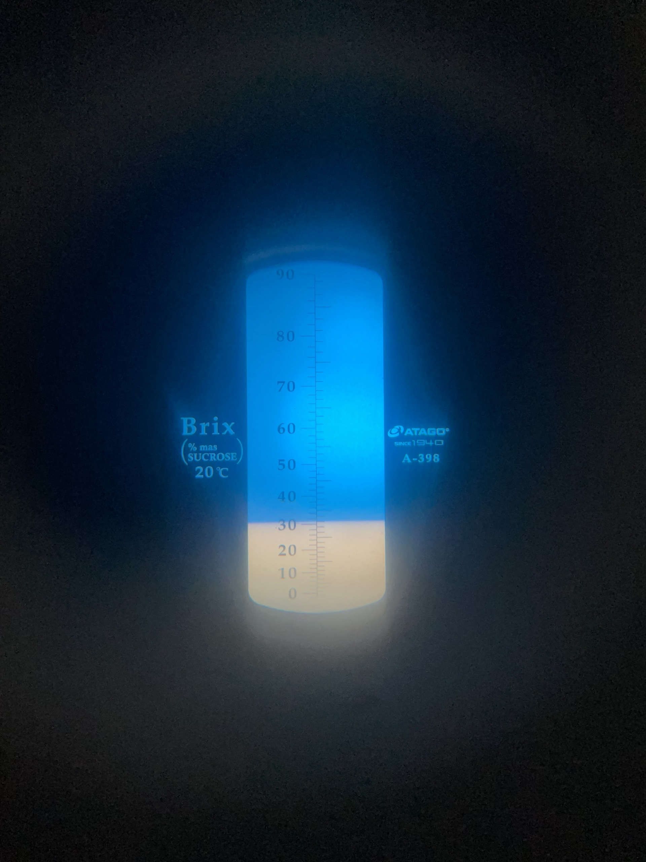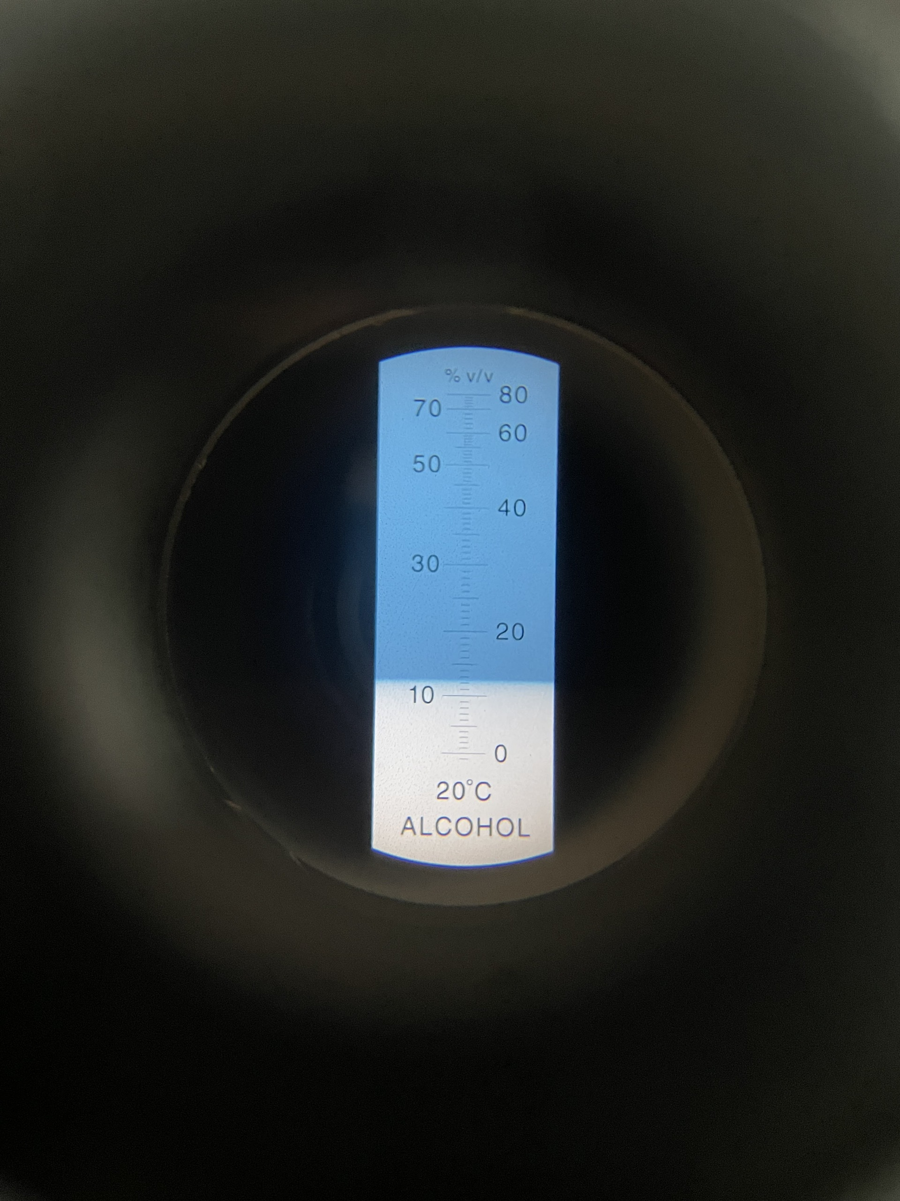
Figure 1 Measurement of moisture, Brix and alcohol content of sample
The alcohol content of the fermented rice samples ranged from 8% to 10% v/v, with statistically significant differences observed among them. Saccharification by molds and alcoholic fermentation by yeasts convert glucose into alcohol.⁷ A small amount of alcohol can also be produced by lactic acid bacteria during fermentation at temperatures above 30 °C in the presence of maltose.¹⁵ Compared to previous studies, the alcohol levels reported here are relatively high. For example, Khao-Mak from Thailand reached only 2.15–2.58% v/v after 3 days of fermentation,¹⁰ while other studies reported alcohol concentrations below 0.5% v/v at day 3, gradually increasing to 1–2% v/v by day 7.¹⁶ This discrepancy may be attributed to differences in raw materials.¹⁶
The lactic acid content in the fermented rice samples ranged from 0.75 to 0.99 mg/mL. An inverse correlation was observed between alcohol and lactic acid concentrations: alcohol accumulation inhibits acid production, thereby helping to control acidity and reduce spoilage.¹⁵ The 0.6% starter culture sample exhibited the lowest lactic acid concentration (0.75 mg/mL), whereas the 0.8% sample had the highest (0.98 mg/mL), similar to the lactic acid content reported in Khao-Mak fermentation after 3 days.² Jiu Niang also contains various organic acids, primarily lactic acid, along with malic, fumaric, acetic, tartaric, citric, and succinic acids, with total concentrations increasing over time and slightly decreasing after 60 hours.¹⁴ This phenomenon is related to the complex activity of the microbial community in the starter culture or possible contamination.¹⁷
The pH values of the fermented rice samples ranged narrowly from 3.9 to 3.9, corresponding to their acid content. This reflects the relationship between pH and the ionization strength of acids. In the case of Khao-Mak made from black rice, the pH decreased from 6.00 to 4.00–4.27 after 3 days of fermentation.¹⁸ Yeasts and molds participate in the conversion of sugars into alcohol and acids, contributing to the pH reduction and creating an antimicrobial environment that ensures food safety.¹⁷ Overall, the quality of fermented rice varies depending on the source of the starter culture, traditional processing methods, environmental conditions, and fermentation duration.
In addition to physicochemical parameters such as moisture content, pH, acid concentration, Brix value, and alcohol content, the fermented rice product was also subjected to sensory evaluation to assess consumer preference. The results of the sensory evaluation are presented in Table 2.

Table 2. Effect of Isolated Starter Culture Concentration on the Sensory Quality of Fermented Rice Product
Concentration | Average Sensory Scores | Methol (%) | Furfurol (%)
0,4% | 18,41^{b} ± 0,27 | - | -
0,6% | 16,41ª± 0,34 | - | -
0,8% | 16,0ª± 0,25 | - | -
Data are the mean values of triplicates. In the same column, different letters (a, b) indicate statistically significant differences at the 95% confidence level (p < 0.05).

The average sensory score at a starter culture concentration of 0.4% was 18.41 ± 0.27, which was statistically significantly different from those at 0.6% (16.41 ± 0.34) and 0.8% (16.00 ± 0.25). No significant difference was observed between the sensory scores of the 0.6% and 0.8% samples. These results indicate that the product achieved the highest sensory acceptance at a starter culture concentration of 0.4%.
Moreover, the analysis showed that two undesirable compounds, methanol and furfural, were not detected in the fermented rice product. These compounds are known to cause headaches and have neurotoxic effects on consumers. Therefore, the absence of these substances in the experimental samples is highly significant for future commercialization.
In addition to physicochemical and sensory parameters, microbiological characteristics of the fermented rice samples were also analyzed, including determining the density of molds, yeasts, and lactic acid bacteria. This provided an overview of the microbial populations present in the product. The results of microbial enumeration are presented in Table 3.

Table 3. Effect of Isolated Starter Culture Concentration on the Pathogenic Microbial Counts in the Product
Concentration | Molds  (Log₁₀ CFU/g) | Yeasts  (Log₁₀ CFU/g) | Lactic acid bacteria  (Log₁₀ CFU/g)
0,4% | 7,27^{c} ± 0,02 | 7,28^{c}±0,01 | 8,22ª±0,01
0,6% | 6,22ª± 0,02 | 7,27^{b}±0,01 | 8,27^{b}±0,02
0,8% | 6,92^{b}± 0,01 | 7,20ª±0,01 | 8,24ª±0,01
Data are the mean values of triplicates. In the same column, different letters (a, b) indicate statistically significant differences at the 95% confidence level (p < 0.05).

The analysis results presented in Table 3 indicate that the fermented rice sample with 0.4% isolated starter culture had the highest yeast and mold counts, at 7.27 log₁₀ CFU/g and 7.28 log₁₀ CFU/g, respectively, while the lowest counts were observed in the 0.6% sample, with yeast and mold counts of 6.22 log₁₀ CFU/g and 7.27 log₁₀ CFU/g, respectively. These findings confirm the presence of both molds and yeasts in the fermented rice samples. These two groups of microorganisms play key roles and exhibit principal activities during saccharification and alcoholic fermentation processes.^{19,20}
Similarly, a study on Khao-Mak fermentation^6 reported comparable results, where at the end of the fermentation period (day 3), total mold and yeast counts were 7.00 × 10² CFU/g and 5.40 × 10⁵ CFU/g, respectively.¹¹ Additionally, lactic acid bacteria were also detected. Besides molds, certain bacteria are capable of producing enzymes that hydrolyze starch in raw materials into sugars, which yeasts can subsequently utilize for alcohol production.²¹
For this reason, research on the production of Tapai—a traditional Indonesian product similar to Vietnamese fermented rice—has explored supplementation with Lactobacillus plantarum strains alongside starter cultures. The results demonstrated that Tapai fermented with L. plantarum exhibited slightly different characteristics compared to traditional Tapai and received higher acceptance scores from sensory panelists.²²
3.2 Effect of fermentation time on the quality of Fermented Rice
The fermentation process of fermented rice exhibited significant changes in physicochemical parameters over time. Table 4 presents data on Brix value, pH, alcohol content, and sensory scores at fermentation intervals of 2, 3, and 4 days.
.
Bảng 4. Ảnh hưởng thời gian lên men đến chất lượng cơm rượu
Parameter | Fermentation Time (days)
Parameter | 2 | 3 | 4
Brix (ºBrix) | 39.4^{c}±0.52 | 38.1^{b}±0.26 | 35.6ª±0.2
pH | 3.82ª±0.02 | 4.05^{c}±0.04 | 3.91^{b}±0.01
Alcohol (% v/v) | 8.0ª±0.2 | 10.67^{b}±0.58 | 11.02^{b}±0.57
Sensory Evaluation (Scores) | 14.50ª±0.32 | 17.44^{c}±0.14 | 16.25^{b}±0.26
Moisture (% w/w) | 44.3ª±0.67 | 47.5^{b}±0.05 | 49.2^{c}±0.22
Titratable acidity (mg/ml) | 0,87ª±0,05 | 0,99^{ab}±0,01 | 1,05^{b}±0,05
Methanol (%) | - | - | -
Furfurol (%) | - | - | -
Data are the mean values of triplicates. In the same row, different letters (a, b) indicate statistically significant differences at the 95% confidence level (p < 0.05).

The study results demonstrated that fermentation time significantly influenced the physicochemical and sensory parameters of the product. The Brix value gradually decreased from 39.4 °Brix on day 2 to 38.1 °Brix on day 3 and further to 35.6 °Brix on day 4. This reduction was statistically significant and reflects the conversion of sugars into alcohol and other by-products. The pH of the samples showed fluctuations, with a slight increase from 3.82 to 4.05 on day 3, followed by a decrease to 3.91 on day 4. These changes may be associated with the formation and degradation of organic acids during fermentation, although the pH remained within the weak acid range appropriate for fermented food products.
The alcohol content in the product increased from 8.0% on day 2 to 10.67% on day 3, reaching 11.02% on day 4. The difference between day 2 and the subsequent time points was statistically significant; however, the variation between days 3 and 4 was not significant, indicating that the rate of alcohol biosynthesis peaked around day 3. The sensory score rose sharply from 14.50 on day 2 to 17.44 on day 3, followed by a slight decrease to 16.25 on day 4. The sample fermented for 3 days was rated as having the best sensory quality, reflecting a balanced combination of flavor, alcohol content, and acidity.
The moisture content of the product gradually increased over time, from 44.3% to 49.2%, reflecting the breakdown and dissolution of compounds during raw material hydrolysis. Concurrently, the total acid content also showed a slight increase from 0.87 to 1.05 mg/mL, consistent with the accumulation of organic acids due to microbial activity. Notably, neither malcohol nor furfural was detected in any of the samples, confirming the safety of the fermentation process.
In addition to physicochemical and sensory parameters, microbiological indicators of the fermented rice samples were also analyzed, including the enumeration of molds, yeasts, and lactic acid bacteria. This provided an overall overview of the microbial populations present in the fermented rice product. The results of the microbial counts are presented in Table 5:
Table 5. Effect of fermentation time on microbial population in the product
Fermentation Time (days) | Molds  (Log₁₀ CFU/g) | Yeasts  (Log₁₀ CFU/g) | Lactic acid bacteria  (Log₁₀ CFU/g)
2 | 7,01^{c} ± 0,05 | 7,03^{c}±0,01 | 8,14ª±0,01
3 | 6,13^{b}± 0,03 | 7,15^{b}±0,01 | 8,23^{b}±0,02
4 | 5,92ª± 0,02 | 7,6ª±0,01 | 8,34^{c}±0,01
Data are the mean values of triplicates. In the same row, different letters (a, b) indicate statistically significant differences at the 95% confidence level (p < 0.05).

During the fermentation process, significant changes in the population densities of microbial groups were observed over time. The mold count gradually decreased from 7.01 log₁₀ CFU/g on day 2 to 6.13 log₁₀ CFU/g on day 3, reaching the lowest level of 5.92 log₁₀ CFU/g on day 4. This reduction was statistically significant, as indicated by different letter notations on the mean values (p < 0.05). In contrast, yeast populations increased significantly over time, from 7.03 log₁₀ CFU/g on day 2 to 7.15 log₁₀ CFU/g on day 3 and 7.60 log₁₀ CFU/g on day 4, with the increase also showing statistical significance. Similarly, lactic acid bacteria exhibited strong growth trends, with counts rising from 8.14 log₁₀ CFU/g to 8.23 and 8.34 log₁₀ CFU/g on days 2, 3, and 4, respectively. Mean values with different letter notations confirmed significant differences between days (p < 0.05).
These results indicate that the fermentation process created favorable conditions for the proliferation of yeasts and lactic acid bacteria—two beneficial microbial groups—while substantially inhibiting mold growth, thereby contributing to the quality and microbiological safety of the product. This trend aligns with international reports on alcoholic fermentation. According to Fleet,²³ during wine fermentation, Saccharomyces cerevisiae is the dominant yeast species, which grows vigorously and produces a harsh environment (alcohol and low pH) that suppresses undesirable microorganisms such as molds and aerobic bacteria. Yoon similarly reported approximately 4.6 × 10⁷ CFU/mL of Saccharomyces cerevisiae present in fermented rice water after 48 hours of fermentation.²⁴
Collectively, these findings suggest that a fermentation period of 3 days is optimal, yielding high alcohol content, favorable sensory qualities, and satisfactory safety parameters. This duration is recommended for practical application to maximize product quality and food safety.
Thus, the optimal fermentation time for fermented rice is 3 days using a 0.4% starter culture concentration, ensuring ideal quality parameters such as pH, Brix, alcohol concentration, acid content, and counts of molds, yeasts, and lactic acid bacteria. Additionally, the final product received positive sensory evaluations from consumers.

4. CONCLUSIONS
The study demonstrated that the concentration of isolated starter culture and fermentation duration are two critical factors significantly affecting the quality of traditional fermented rice (com ruou). Increasing the starter concentration from 0.4% to 0.8% resulted in a decrease in moisture content and soluble solids (°Brix), while also influencing parameters such as pH, alcohol content, lactic acid concentration, and characteristic microbial counts. Among the tested concentrations, 0.4% isolated starter yielded the best sensory evaluation scores along with the highest mold and yeast counts, indicating effective fermentation activity and a product flavor preferred by consumers.
Regarding fermentation time, physicochemical parameters including °Brix, pH, alcohol content, moisture, and acid levels varied in a manner consistent with natural fermentation progression, achieving optimal quality after 3 days of fermentation. At this point, alcohol concentration exceeded 10% v/v, pH stabilized, acidity was moderate, and sensory scores were highest. Microbial populations also changed markedly over time, with mold density decreasing while yeast and lactic acid bacteria counts increased, reflecting the dynamic development and balance of the microbial community during fermentation.
Importantly, no methanol or furfural—known toxic compounds—were detected in any samples, ensuring the food safety of the fermented rice product. The results provide a significant scientific basis for optimizing traditional fermentation processes to enhance product quality, stability, and commercialization potential. Furthermore, these findings contribute to the sustainable and safe development of the traditional fermented food industry.

REFERENCES
1. N. T. P. Dung, F. Rombouts, M. Nout. Characteristics of some traditional Vietnamese starch-based rice wine fermentation starters (men), LWT-Food Science and Technology, 2007, 40, 130-135.
2. N. V. Hue, N. T. V. Anh, and H. T. Kim. Antioxidant and antibacterial activities of leaf extracts and their application in starter cake production for leaf yeast wine fermentation (Vietnamese). Hue University Journal of Science: Agriculture and Rural Development, 2021, 130, 57–73-57–73.
3. D. T. K. Tien, H. T. N. Mi, H. X. Phong, N. N. Thanh, B. H. D. Long, H. T. Toan, N. T. P. Dung. Isolation, selection, and application of thermotolerant yeast in Giac fruit wine fermentation (Vietnamese). Can Tho University Journal of Science, 2021, 57, 132-143.
4. N. D. Thuong, N. T. Hang. Technology of Alcohol Production and Analysis (Vietnamese). Science and Technology, 2007.
5. N. T. M. Hang, N. M. Thu. Isolation and selection of some lactic acid bacteria strains capable of synthesizing amylase and bacteriocin (Vietnamese). Journal of Forestry Science and Technology, 2013, 003–010.
6. C. P. Kurtzman, J. W. Fell, T. Boekhout, V. Robert. (2011). Methods for isolation, phenotypic characterization and maintenance of yeasts. In The Yeasts, Elsevier, 2011, 87–110.
7. L. V. X.-Cong, Z. Q. Huang, W. Zhang, P.-F. Rao, L. Ni. Identification and characterization of filamentous fungi isolated from fermentation starters for Hong Qu glutinous rice wine brewing. The Journal of General and Applied Microbiology, 2012, 58, 33–42.
8. T. T. X. Mai. Molecular Biology Laboratory Manual. Institute for Research and Development of Biotechnology (Vietnamese). Can Tho University Press, 2010.
9. H. T. Thanh, H. Q. Huy, N. T. N. Anh, L. M. Chau, N. N. Thanh, B. H. D. Long, H. X. Phong. Investigation of quality and isolation of yeast and mold from fermented glutinous rice (com ruou) produced in Can Tho City (Vietnamese). Can Tho University Journal of Science, 2024, 60, 461–472.
10. V. Surojanametakul, W. Panthavee, P. Satmalee, N. Phomkaivon, T. Yoshihashi. Effect of traditional dried starter culture on morphological, chemical, and physicochemical properties of sweet fermented glutinous rice products, 2019.
11. V. Surojanametakul, W. Panthavee, P. Satmalee, N. Phomkaivon, T. Yoshihashi. Effect of traditional dried starter culture on morphological, chemical, and physicochemical properties of sweet fermented glutinous rice products. Journal of Agricultural Science, 2024, 11, 1–43.
12. N. D. Luong. Microbial Technology, Volume 3: Traditional Fermented Foods (Vietnamese). Ho Chi Minh City University of Technology, 2005.
13. L. D. Pham. Industrial Yeasts (Vietnamese). Science and Technology Publishing House, Hanoi, 2006, 9–18.
14. Y. Xu, Y. Jin, J. Su, N. Yang, X. Xu, Z. Jin, B. Cui, F. Wu. Changes in the nutritional value, flavor, and antioxidant activity of brown glutinous rice during fermentation. Food Bioscience, 2021, 43, 101273.
15. C. Åkerberg, K. Hofvendahl, G. Zacchi, B. Hahn-Hägerdal. Modelling the influence of pH, temperature, glucose, and lactic acid concentrations on the kinetics of lactic acid production by Lactococcus lactis ssp. lactis ATCC 19435 in whole-wheat flour. Applied Microbiology and Biotechnology, 1998, 49, 682–690.
16. J. Wongsa, V. Rungsardthong, T. Yasutomo. Production and analysis of volatile flavor compounds in sweet fermented rice (Khao Mak). In MATEC Web of Conferences, EDP Sciences, 2018, 192, 03044.
17. C. Zhao, W. Su, Y. Mu, L. Jiang, Y. Mu. Correlations between microbiota with physicochemical properties and volatile flavor components in black glutinous rice wine fermentation. Food Research International, 2020, 138, 109800.
18. A. Manosroi, W. Ruksiriwanich, B. O. Kietthanakorn, W. Manosroi, J. Manosroi. Relationship between biological activities and bioactive compounds in fermented rice sap. Food Research International, 2011, 44, 2757–2765.
19. C. Hesseltine, R. Rogers, F. Winarno. Microbiological studies on amylolytic oriental fermentation starters. Mycopathologia, 1998, 101, 141–155.
20. C. Nwosu, P. Ojimelukwe. Improvement of the traditional method of ogiri production and identification of the micro-organisms associated with the fermentation process. Plant Foods for Human Nutrition, 1993, 43, 267–272.
21. L. Hong, G. Fu, T. Liu, Y. Chen, S. Wu, W. Cai, Z. Xie, Y. Wan. Functional microbial agents enhance ethanol contents and regulate the volatile compounds in Chinese Baijiu. Food Bioscience, 2021, 44, 101411.
22. Y. Yusmarini, V. S. Johan, S. Fitriani, R. Rahmayuni, V. F. Artanti, U. Pato. Characteristics of probiotic tapai made by the addition of Lactobacillus plantarum 1. International Journal of Agricultural Technology, 2019, 15(1), 195–206.
23. G. H. Fleet. Yeast interactions and wine flavour. International Journal of Food Microbiology. In: Food Biology: Safety, Biotechnology, Authenticity & Traceability. John Wiley & Sons, 2003, 86, 11–22.
24. S. S. Yoon, J. A. Choi, K. H. Kim, T. S. Song, Y. S. Park. Populations and potential association of Saccharomyces cerevisiae with lactic acid bacteria in naturally fermented Korean rice wine. Food Science and Biotechnology, 2012, 21, 419–424.

