Đặc điểm thích nghi về cơ quan sinh dưỡng của một số loài thực vật ven sông sống chủ yếu tại khu vực hạ lưu sông Côn, xã Phước Hòa, huyện Tuy Phước, tỉnh Bình Định
Dương Tiến Thạch *, Phan Hoài Vỹ, Bùi Hồng Hải
Khoa Khoa học Tự nhiên, Trường Đại học Quy Nhơn, Việt Nam

TÓM TẮT
Hệ thực vật ven sông hạ lưu sông Côn có vai trò rất lớn trong việc điều hòa khí hậu, giữ đất, phòng hộ trong mùa mưa bão và đóng góp vào môi trường sống của các loài thủy sản. Nghiên cứu được tiến hành trên 4 loài thực vật, gồm thân cỏ và thân bụi nhỏ thuộc ngành Ngọc Lan (Magnoliophyta). Các phương pháp hình thái so sánh, vi phẫu, nhuộm kép, đo mẫu và chụp ảnh hiển vi rễ, thân và lá cây được thực hiện để xác định các đặc điểm thích nghi về cơ quan sinh dưỡng của các đối tượng nghiên cứu. Kết quả nghiên cứu cho thấy, các loài thực vật tại khu vực nghiên cứu thích nghi với điều kiện ánh sáng mạnh: biểu bì lá phân bố nhiều lông che chở và mô giậu phát triển (chiếm đến 56.22% độ dày phiến lá). Mô khuyết phát triển mạnh, có nhiều khoang trống lớn trong rễ và thân (chiếm đến 63.49% bán kính rễ), số lượng mạch gỗ ít và đường kính mạch lớn (25.00 ± 4.00 mạch/ mm2 và đường kính mạch 109.92 ± 13.15 µm ở rễ thứ cấp, 5.33 ± 0.33 mạch/ mm2 và đường kính mạch 114.83 ± 20.08 µm ở thân sơ cấp) giúp cây thích nghi với điều kiện thiếu oxy và ngập nước trong mùa mưa. Mô cứng bao quanh các bó mạch ở rễ, tạo thành dải bao quanh thân, rải rác tinh thể oxalate calcium và tế bào đá trong mô mềm thịt lá giúp các đối tượng nghiên cứu chịu được các tác động cơ học (gió, bão).
Từ khóa: Giải phẫu, hình thái, sông Côn, thích nghi, thực vật ven sông.
Adaptive features of the vegetative organs of some common riparian plants in the lower Con river, Phuoc Hoa Commune, Tuy Phuoc District, Binh Dinh Provine
Duong Tien Thach *, Phan Hoai Vy, Bui Hong Hai
Faculty of Natural Sciences, Quy Nhon University, Vietnam
ABSTRACT
The riparian vegetation along the lower Con River plays a crucial role in regulating the microclimate, stabilizing soil, providing protection during the rainy and stormy season, and contributing to the aquatic ecosystem. This study was carried out on four herbaceous and undershrub species in Magnoliophyta. Morphological comparison, microsurgery, double-staining, microscopic measurements and imaging of roots, stems, and leaves were applied to identify adaptive features in the vegetative organs of the studied species. The results revealed that the plant species in the study area are adapted to high light conditions, as evidenced by the abundance of trichomes on the leaf epidermis and the well-developed palisade mesophyll (accounting for up to 56.22% of leaf thickness). Aerenchyma tissues were strongly developed, forming large air cavities in both roots and stems (up to 63.49% of root radius). These species also exhibited a low number of xylem vessels with large vessel diameters (25.00 ± 4.00 vessels/mm² and 109.92 ± 13.15 µm in secondary roots; 5.33 ± 0.33 vessels/mm² and 114.83 ± 20.08 µm in primary stems), facilitating adaptation to hypoxic and waterlogged conditions during the rainy season. The presence of sclerenchyma surrounding vascular bundles in roots and stems, scattered distribution of calcium oxalate crystals and sclereids in the leaf mesophyll support the species’ tolerance to mechanical stress, such as wind and storms.
Keywords: Anatomy, morphology, Con River, adaptation, riparian vegetation.

1. INTRODUCTION
The Con River is the largest river in Binh Dinh Province, originating from the eastern mountainous region of the Truong Son Range, at an elevation of over 1000 meters. In its upper course, the river flows in a northwest-southeast direction; upon reaching Vinh Son, it shifts to a north-south orientation, and at Binh Thanh, it turns west-east before emptying into the Thi Nai Lagoon. At Binh Thanh, the Con River bifurcates into two main distributaries: the Tan An and Dap Da Rivers. The Tan An River subsequently discharges into the Go Boi – Tan An estuary, representing the lower course of the Con River. The ecosystem in this area is highly diverse and is characteristic of riparian ecosystems within the province, with vegetation exhibiting numerous adaptive traits to the local environmental conditions. In addition to its crucial role in climate regulation, participation in essential biological processes, water provision, and serving as a vital habitat for aquatic species, the riparian ecosystem also contributes to soil retention and provides natural protection during the rainy and storm seasons.¹ Despite its significant ecological importance, this area has yet to receive adequate research attention and conservation efforts. The vegetation in the study area is primarily composed of shrub and herbaceous plant species. However, the number of species has been severely declining due to the construction of irrigation and civil infrastructure by local communities along the river basin. Given the urgent need to protect the downstream ecosystem of the Con River, it is essential to study the common adaptive characteristics of riparian plant species to establish a scientific basis for proposing effective restoration measures and promoting the sustainable development of the riparian ecosystem in this region.
2. SUBJECTS AND METHODS
2.1. Subjects
The research subjects include four common plant species found in the lower Con River, Binh Dinh Province: Ludwigia octovalvis (Jacq.) Raven - Onagraceae and Celosia argentea L. - Amaranthaceae, both belonging to the class Magnoliopsida; Melinis repens (Willd.) Zizka – Poaceae and Commelina longifolia Lam. - Commelinaceae, both belonging to the class Liliopsida.
2.2. Methods
2.2.1. Field study methods
The vegetative organs (roots, stems, and leaves) of the studied plant species were observed, described, and measured for morphological characteristics, root length, stem height, and leaf area, and were photographed under natural conditions. Subsequently, the vegetative organs were collected following the botanical survey method,² stored in plastic bags, and transported to the laboratory for preservation and further analysis.
2.2.2. Laboratory study methods
Sample sectioning and double staining method
After collection, the samples were rinsed with water, then fixed and preserved in a FAC solution comprising 96% ethyl alcohol, 40% acetic acid, formalin, and distilled water.³ Samples were sectioned thinly with a razor blade, subjected to double staining, and prepared as temporary slides. The double-staining technique distinguishes cells with cellulose walls (stained red by carmine) and cells with lignified walls (stained blue by methylene blue).⁴ This method helps identify the presence and distribution of tissue types that enable plant adaptation to specific ecological factors.
Microscopy method
Samples were observed and photographed under a Kruss MBL 2000-T microscope (Germany). Staining allowed identification of lignified cell groups (fibers and sclereids), and collenchyma with cellulose walls which provide mechanical support for plant bodies;⁵ xylem vessels and tracheids also possess lignified secondary walls (stained blue), and the dense distribution of these conductive elements facilitates plant adaptation to drought conditions.³
The dimensions of structural components in roots, stems, and leaves were measured using the measurement tools integrated into the Microscope Manager software. The comparative proportions of these components are related to plant adaptation to environmental conditions. Adaptations to intense light and high temperatures are reflected in the well-developed palisade tissue in leaf blades, the presence of dense trichomes, and protective cutin layers.³
Measurement data were statistically processed using Microsoft Excel 2016 to determine:
Mean value: $\overline{X}$ = $\frac{\sum_{i=1}^{n}{x_{i}}}{n}$ (n = 6)
Standard deviation: S = $\sqrt{\frac{\sum_{\text{i=1}}^{\text{n}}{{\text{(}x_{i}\text{-}\overline{X}\text{)}}^{\text{2}}}}{\text{n-1}}}$ (n < 30)
Comparative morphology method
Plant classification was based on morphological characteristics, especially those of reproductive organs, which are less affected by environmental changes compared to vegetative organs.⁶
Scientific identification method
Specimen identification was carried out using the references of Ho and Ban.^{7,8}
3. RESULTS AND DISCUSSION
3.1. Morphological adaptations
3.1.1. Roots
Melinis repens (Willd.) Zizka and Commelina longifolia Lam. possess fibrous root systems that exhibit extensive growth, enabling them to effectively compete for water and mineral nutrients with other species by spreading horizontally.⁹ In contrast, Ludwigia octovalvis (Jacq.) Raven and Celosia argentea L. develop prominent taproot systems (Figure 2). Additionally, the nodes of C. longifolia and L. octovalvis, particularly along the creeping stems, produce adventitious roots that anchor the plant to the ground and facilitate horizontal expansion, thereby enhancing resistance to mechanical forces such as wind and flooding. Root diameters for M. repens, C. longifolia, L. octovalvis, and C. argentea were recorded as 1.72–1.78 mm, 1.84–1.87 mm, 4.28–4.34 mm, and 7.65–7.69 mm, respectively.
3.1.2. Stems
M. repens and C. argentea possess erect stems, with heights ranging from 77–105 cm and 90–110 cm, respectively. The height of M. repens in the present study area is lower than that reported by Corrales-Lerma et al. in Chihuahua, Mexico, likely due to different environmental conditions.¹⁰ L. octovalvis exhibits a mostly erect stem or partially horizontal growth habit, whereas C. longifolia features a creeping stem morphology, with recorded heights of 90–130 cm and 22–61 cm, respectively (Figure 1). Most study species grow in dense clumps, with notable stem branching observed in L. octovalvis. These morphological characteristics are considered adaptive features that mitigate mechanical stress from environmental factors, such as strong winds and flood-induced water flow.¹¹ Secondary stems of L. octovalvis develop cork layers with longitudinal grooves, enhancing gas exchange during inundation seasons and high river water levels.⁵
3.1.3. Leaves
All investigated species exhibit small, elongated leaf blades, an adaptation believed to reduce wind impact during storms.¹² Leaf blade surface areas were recorded as follows: 6.72–11.55 cm² (C. longifolia ), 9–15.68 cm² (M. repens), 7.8–16.8 cm² (C. argentea), and 7.82–14.4 cm² (L. octovalvis). The leaf area of C. longifolia is smaller than that reported by Huy et al. in Long An Province (16–30 cm²),¹¹ potentially due to more favorable climatic conditions and reduced storm frequency in that region, which may allow for better growth and larger leaf size. Leaf thickness values were as follows: 348.37 ± 41.64 µm (C. longifolia), 233.27 ± 27.69 µm (M. repens), 392.37 ± 75.26 µm (C. argentea), and 244.10 ± 18.73 µm (L. octovalvis). The outer epidermal surfaces of all species, except C. argentea, are covered with protective trichomes, most abundant in L. octovalvis, which function to protect leaf tissue from heat stress and reduce water loss through stomatal transpiration.¹³

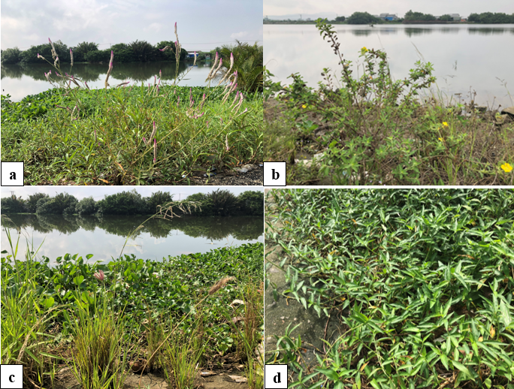
Figure 1. Growth forms of the investigated plant species
a. Celosia argentea L., b. Ludwigia octovalvis (Jacq.) Raven, c. Melinis repens (Willd.) Zizka, d. Commelina longifolia Lam.

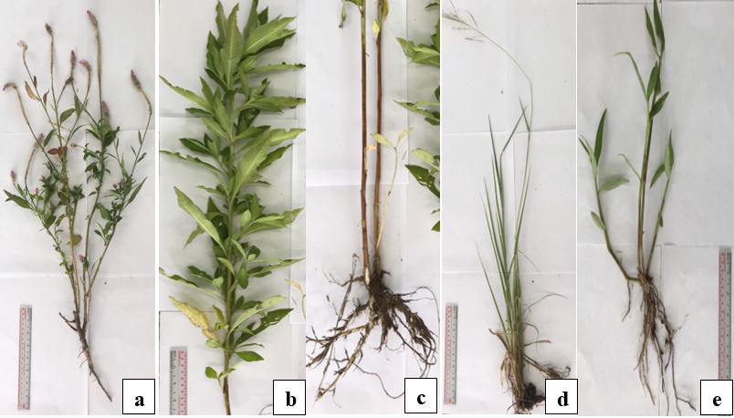
Figure 2. Morphological characteristics of the investigated plant species
a. Celosia argentea, b. and c. Ludwigia octovalvis, d. Melinis repens, e. Commelina longifolia

3.2. Adaptive Anatomical Characteristics

3.2.1. Roots
The roots of M. repens and C. longifolia exhibit a primary anatomical structure comprising four main components: epidermis, cortex, stele, and pith. The epidermis consists of 1–2 cell layers, with large cells accounting for 5.98% and 5.11% of the root radius in M. repens and C. longifolia, respectively (Table 1). The cortex in both species features well-developed aerenchyma (Figure 3), forming numerous large intercellular spaces that account for 63.49% and 62.49% of root radius in M. repens and C. longifolia, respectively. In M. repens, aerenchyma cells are radially arranged from the stele to the epidermis, while in C. longifolia, they are uniformly distributed, forming rhomboid-shaped spaces. These air spaces function in gas storage and facilitate gas exchange under low-oxygen environmental conditions.¹³ In C. longifolia, 2–3 layers of lignified cells encircle the cortex region, and the stele in both species is reinforced with multiple layers of sclerenchyma surrounding the xylem vessels, enhancing the mechanical strength of the roots.⁵
The secondary roots of C. argentea and L. octovalvis consist primary components: bark and secondary xylem. Secondary xylem is dominant, comprising 83.88% and 75.15% of the root radius in C. argentea and L. octovalvis, respectively (Table 2). In C. argentea, secondary xylem is clustered and embedded within parenchyma tissue (Figure 4), similar to findings by Rajput on the genus Celosia.¹⁴ In L. octovalvis, well-developed xylem rays facilitate radial transport.¹² According to the study by Bedoya and Madriñán on the genus Ludwigia, in mature plants, aerenchyma tissue is extensively developed from the phellogen.¹⁵
The xylem vessel density per mm² in the roots of M. repens, C. longifolia, C. argentea, and L. octovalvis are 44.33 ± 4.33, 22.20 ± 1.12, 23.33 ± 2.33, and 25.00 ± 4.00 vessels/mm², respectively. These values are lower than those reported by Thach and Dieu for species in arid environments - coastal rocky hills, where vessel densities exceed 100 vessels/mm².¹⁶ Vessel diameters in the studied species range from 52–118 µm. According to Thomas, the average vessel diameter in Angiospermatophyta is approximately 40 µm,¹⁷ indicating that the studied species have relatively wide vessels - an adaptive trait suitable for water-abundant environments.

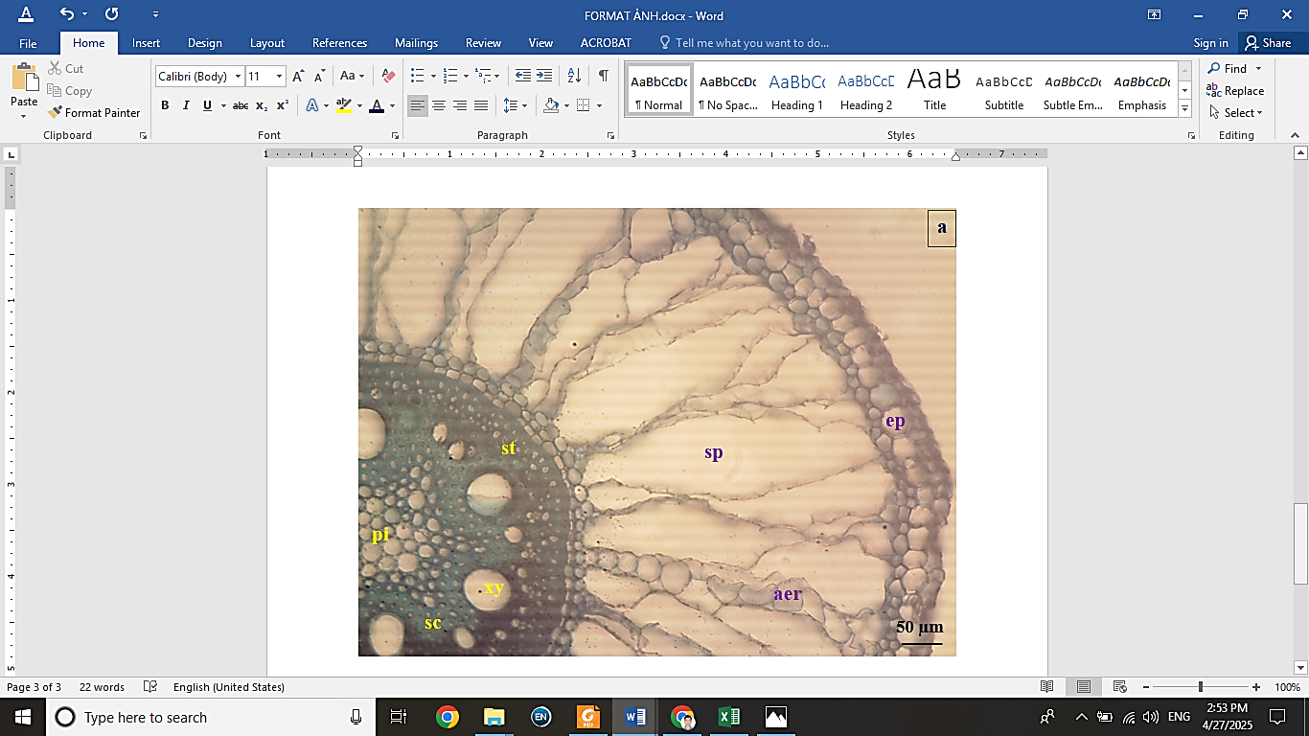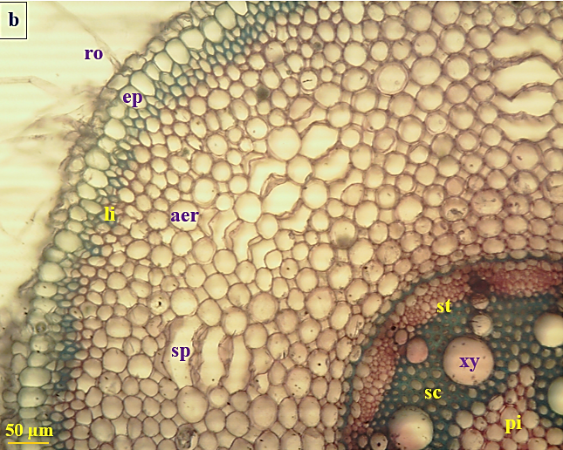
Figure 3. Anatomical features of the primary root structures in the investigated plant species
a. Melinis repens, b. Commelina longifolia, ro: root hair, ep: epidemis, li: lignified cell, aer: aerenchyma, sp: intercellular space, st: stele, sc: sclerenchyma, xy: xylem vessel, pi: pith

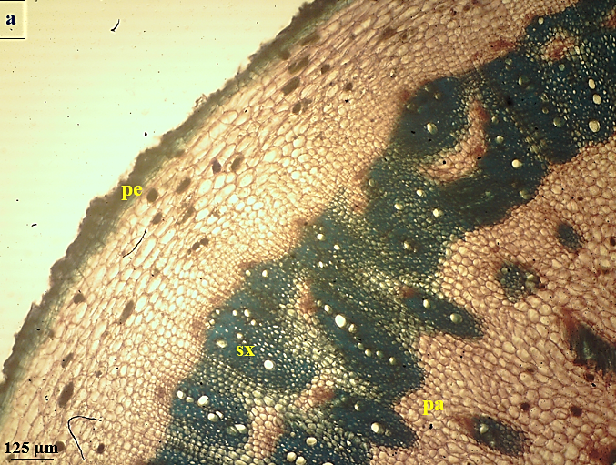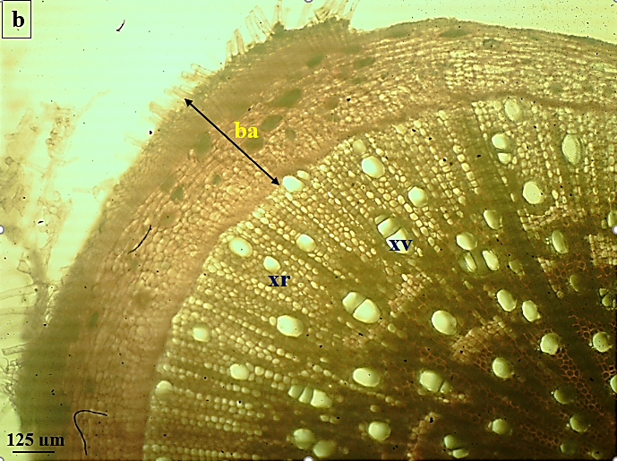
Figure 4. Anatomical features of the secondary root structures in the investigated plant species
a. Celosia argentea, b. Ludwigia octovalvis, ba:bark, pe: periderm, sx: secondary xylem, pa: parenchyma, xr: xylem ray, xv: xylem vessel

Table 1. The dimensions of primary root structures in the studied plant species
RR: root radius

Species | Primary root
Species | Epidermis |  | Cortex |  |  | Stele |  |  |  |  |  | Pith
Species | $\overline{X}$ ± S (µm) | % RR | $\overline{X}$ ± S (µm) | % RR | $\overline{X}$ ± S (µm) |  | % RR | Vessel density  ($\overline{X}$ ± S)  (No. of vessels per mm²) | Vessel diameter  ($\overline{X}$ ± S) (µm) |  | $\overline{X}$ ± S (µm) |  | % RR
Melinis repens (Willd.) Zizka | 52.37  ± 1.12 | 5.98 | 555.70  ± 36.27 | 63.49 | 158.27  ± 16.96 |  | 18.08 | 44.33  ± 4.33 | 88.00  ± 1.00 |  | 108.93  ± 24.86 |  | 12.45
Commelina longifolia Lam. | 47.27  ± 1.49 | 5.11 | 577.77  ± 27.26 | 62.49 | 192.17  ± 27.02 |  | 20.78 | 22.20  ± 1.12 | 72.13  ± 1.05 |  | 107.43  ± 16.96 |  | 11.62

Table 2. The dimensions of secondary root structures in the studied plant species
RR: root radius

Species | Secondary root
Species | Bark |  |  |  | Secondary xylem
Species | Cork |  | Secondary phloem
Species | $\overline{X}$ ± S (µm) | %  RR | $\overline{X}$ ± S (µm) | % RR | $\overline{X}$ ± S (µm) | %  RR | Vessel density  ($\overline{X}$ ± S)  (No. of vessels per mm²) | Vessel diameter  ($\overline{X}$ ± S)  (µm)
Celosia argentea L. | 116.17  ± 15.08 | 3.03 | 502.08  ± 42.15 | 13.09 | 3217.50  ± 131.25 | 83.88 | 23.33  ± 2.33 | 51.92  ± 2.77
Ludwigia octovalvis (Jacq.) Raven | 157.75  ± 16.00 | 7.32 | 377.92  ± 25.52 | 17.53 | 1620.33  ± 113.02 | 75.15 | 25.00  ± 4.00 | 109.92  ± 13.15

3.2.2. Stems
The primary stems of M. repens and C. longifolia exhibit aerenchyma development: 4–5 layers of aerenchymatous cells below the epidermis in M. repens, and throughout the stem in C. longifolia , forming large gas cavities (Figure 5) that enhance gas exchange.¹¹ A similar observation was made by Nhanh in Panicum repens L. (Poaceae), which also exhibits abundant intercellular spaces.¹⁸ Inside the 4–5 layers of cortical parenchyma cells, a continuous band of sclerenchyma tissue is formed encircling the stem. Sclerenchyma also surrounds the vascular bundles, consistent with the findings of Wahua on Commelina erecta L..¹⁹ Oval-shaped calcium oxalate crystals are scattered within the aerenchyma of C. longifolia stem, collectively contributing to the mechanical reinforcement of the primary stems.⁵
C. argentea and L. octovalvis possess secondary stem structures. The cork layer is thin, accounting for 1.41% and 4.3% of the stem radius in C. argentea and L. octovalvis, respectively (Table 4), compared to herbaceous species living in coastal rocky areas.¹⁶ This is completely consistent with plant species adapted to moist environments. In C. argentea, the secondary xylem appears in clusters interspersed with parenchyma. In contrast, a study by Rajut on Aerva sanguinolenta (L.), a species belonging to the same family Amaranthaceae, reported that its secondary xylem forms a continuous ring.²⁰ In L. octovalvis, secondary xylem develops continuously below the vascular cambium and features abundant fibers, enhancing mechanical strength, a pattern consistent with Scremin-Dias et al.²¹ Prominent xylem rays support radial transport of nutrients and gases (Figure 6), aiding adaptation to hypoxic conditions during seasonal flooding.³
Xylem vessel density in stems ranges from 5 to 32 vessels/mm², and vessel diameters range from 55 to 117 µm (Table 3 and 4). Compared to the study by Thach and Dieu on herbaceous species in mangrove swamps,²² the studied species have wider vessel diameters. This is consistent with their freshwater riparian habitat, whereas smaller vessel diameters in mangrove species may promote faster flow and limit salt toxicity.

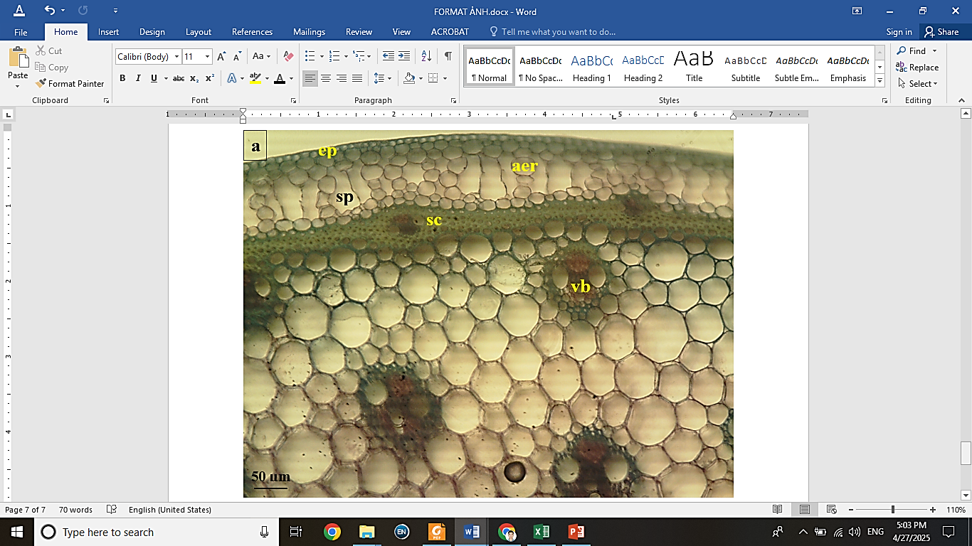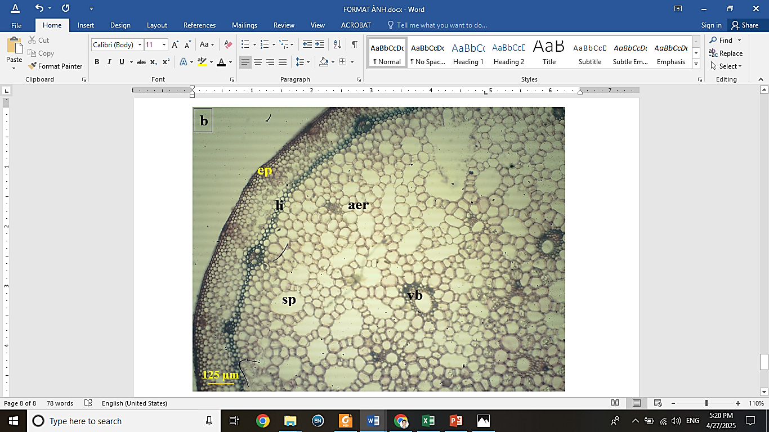

Figure 5. Anatomical features of the primary stem structures in the investigated plant species
a. Melinis repens and b. Commelina longifolia, ep: epidermis, aer: aerenchyma, sp: intercellular space, sc: sclerenchyma ring, vb: vascular bundle, li: lignified cell

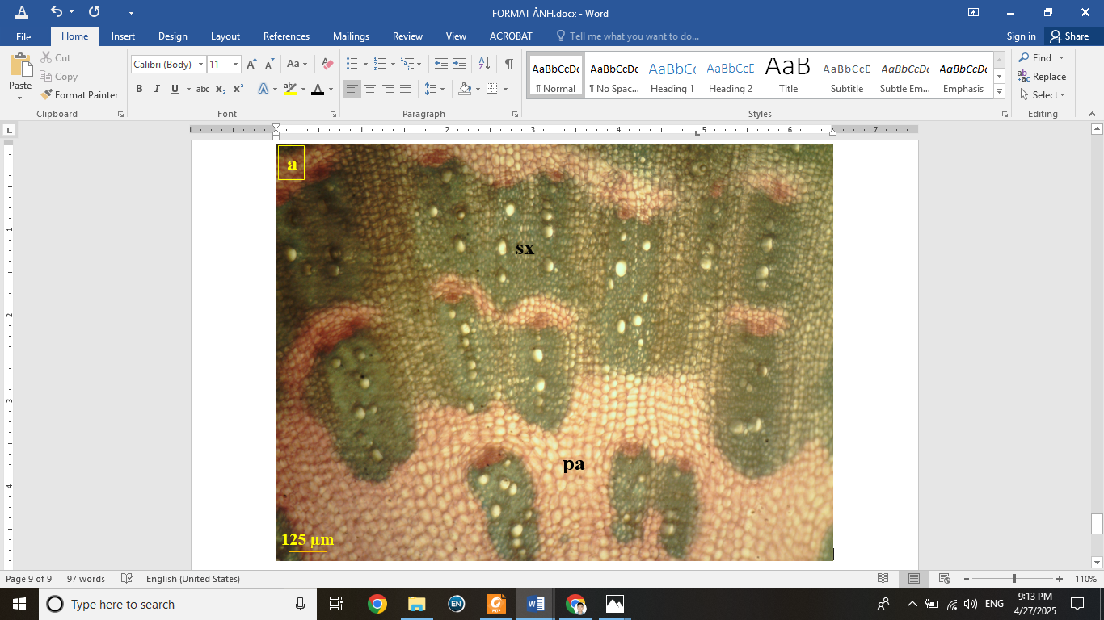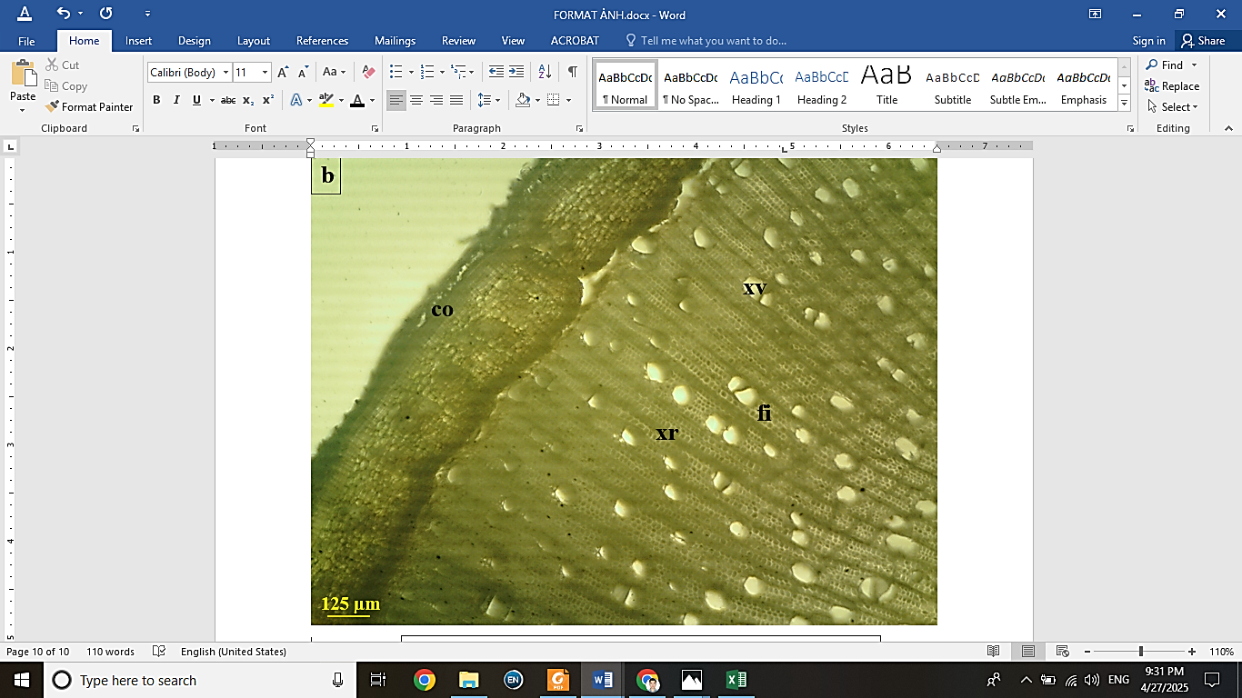

Figure 6. Transverse section through the secondary xylem of the secondary stem of Celosia argentea (a) and the secondary stem of Ludwigia octovalvis (b), sx: secondary xylem, pa: parenchyma, co: cork, xr: xylem ray, xv: xylem vessel, fi: fiber

Table 3. The dimensions of primary stem structures in the studied plant species
SR: stem radius,, "–": absent

Species | Primary stem
Species | Epidermis |  |  | Parenchyma and vascular bundles |  |  |  | Pith cavity
Species | $\overline{X}$ ± S (µm) | % SR | $\overline{X}$ ± S (µm) | % SR | Vessel density  ($\overline{X}$ ± S) (No. of vessels per mm²) | Vessel diameter  ($\overline{X}$ ± S) | $\overline{X}$ ± S (µm) |  | % SR
Melinis repens (Willd.) Zizka | 12.58  ± 0.27 | 0.60 | 1365.00  ± 81.25 | 64.69 | 28.67  ± 4.33 | 55.42  ± 3.65 | 732.50  ± 25.00 |  | 34.71
Commelina longifolia Lam. | 21.17  ± 1.08 | 1.02 | 2053.33  ± 109.90 | 98.98 | 5.33  ± 0.33 | 114.83  ± 20.08 | - |  | -
Table 4. The dimensions of secondary stem structures in the studied plant species
ST: stem radius, "–": absent

Species | Bark |  |  |  |  | Secondary xylem |  |  |  | Pith parenchyma
Species | Cork |  | Secondary phloem
Species | $\overline{X}$ ± S  (µm) | % SR | $\overline{X}$ ± S  (µm) | % SR | $\overline{X}$ ± S  (µm) |  | % SR | Vessel density  ($\overline{X}$ ± S) (No. of vessels per mm²) | Vessel diameter  ($\overline{X}$ ± S)  (µm) | $\overline{X}$ ± S  (µm) | % SR
Celosia argentea L. | 137.17  ± 40.90 | 1.41 | 1440.83  ± 127.08 | 14.80 | 8159.42  ± 742.90 |  | 83.79 | 15.33  ± 2.33 | 82.75  ± 1.31 | - | -
Ludwigia octovalvis (Jacq.) Raven | 265.58  ± 21.65 | 4.30 | 366.17  ± 34.08 | 5.93 | 3901.42  ± 372.90 |  | 63.18 | 32.67  ± 4.33 | 117.75  ± 18.81 | 1642.08  ± 113.02 | 26.59

3.2.3. Leaves

The leaf blades of M. repens and C. longifolia are characteristic of monocots. In C. longifolia, the epidermal cells are large, occupying 23.31% (upper) and 15.07% (lower) of total leaf thickness (Table 5). These results are generally consistent with the findings of Huy et al..¹¹ It also has protective trichomes on the upper epidermis. Many sub-stomatal chambers are present in M. repens, while scattered intercellular spaces are observed in C. longifolia (Figure 7), facilitating gas exchange.¹⁸ Sclerenchyma clusters beneath the epidermis in M. repens increase mechanical strength, the vascular bundles exhibit a Kranz anatomy.²³ In contrast, C. argentea and L. octovalvis have dicotyledonous leaf structures. The epidermis of L. octovalvis is densely covered with protective trichomes (Figure 7), and stomata are distributed on both surfaces of the leaf blade, though more abundantly on the abaxial side.²⁴ In the upper epidermis of C. argentea, epidermal cells exhibit considerable variation in size, whereas the lower epidermal layer is thinner and possesses an undulating surface.²⁵ In C. argentea, the palisade and spongy mesophyll comprise 44.18% and 39.18% of the total leaf thickness, respectively (Table 5). Spherical crystals and sclereids are scattered throughout the mesophyll of L. octovalvis leaves (Figure 8), consistent with findings by Scremin-Dias et al. in Ludwigia grandiflora,²¹ and contribute to increased mechanical resistance against wind and storm damage.

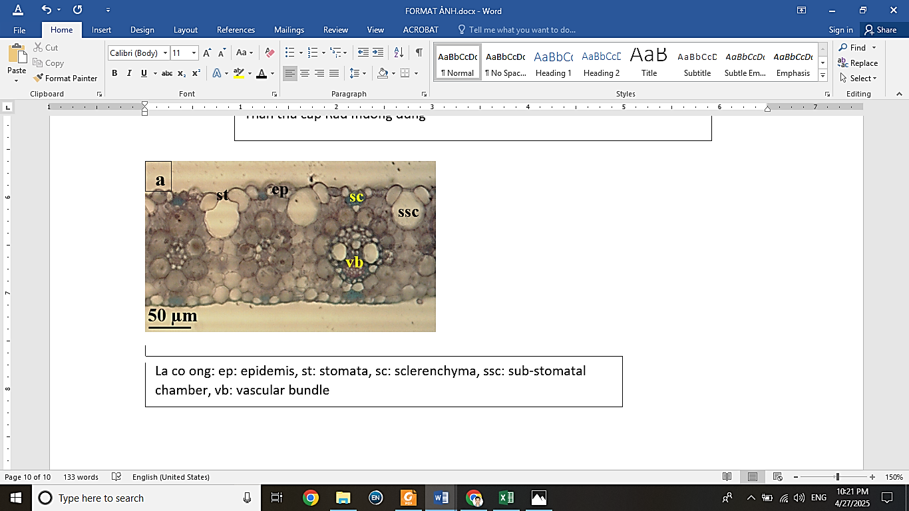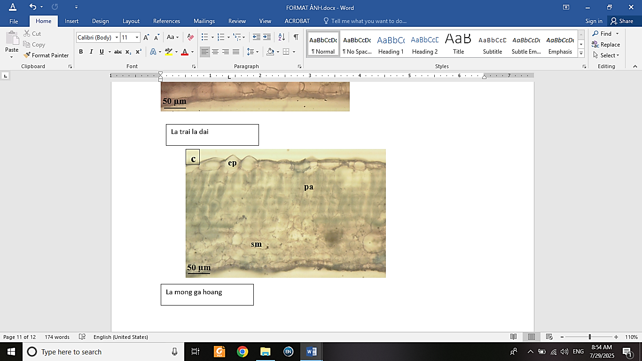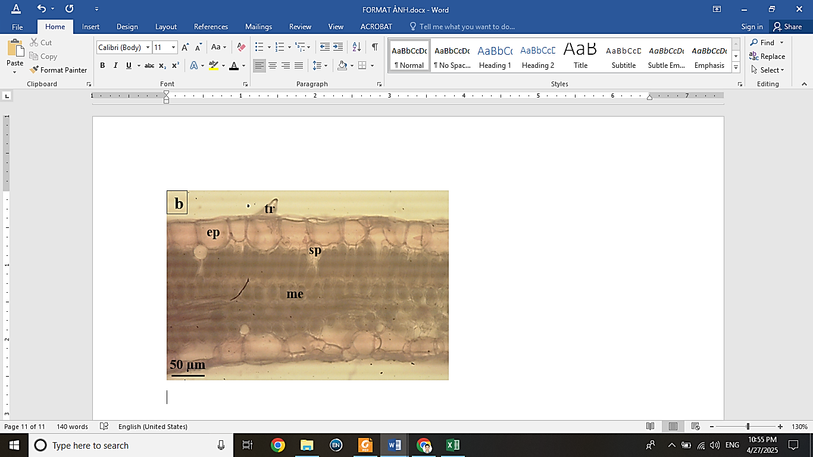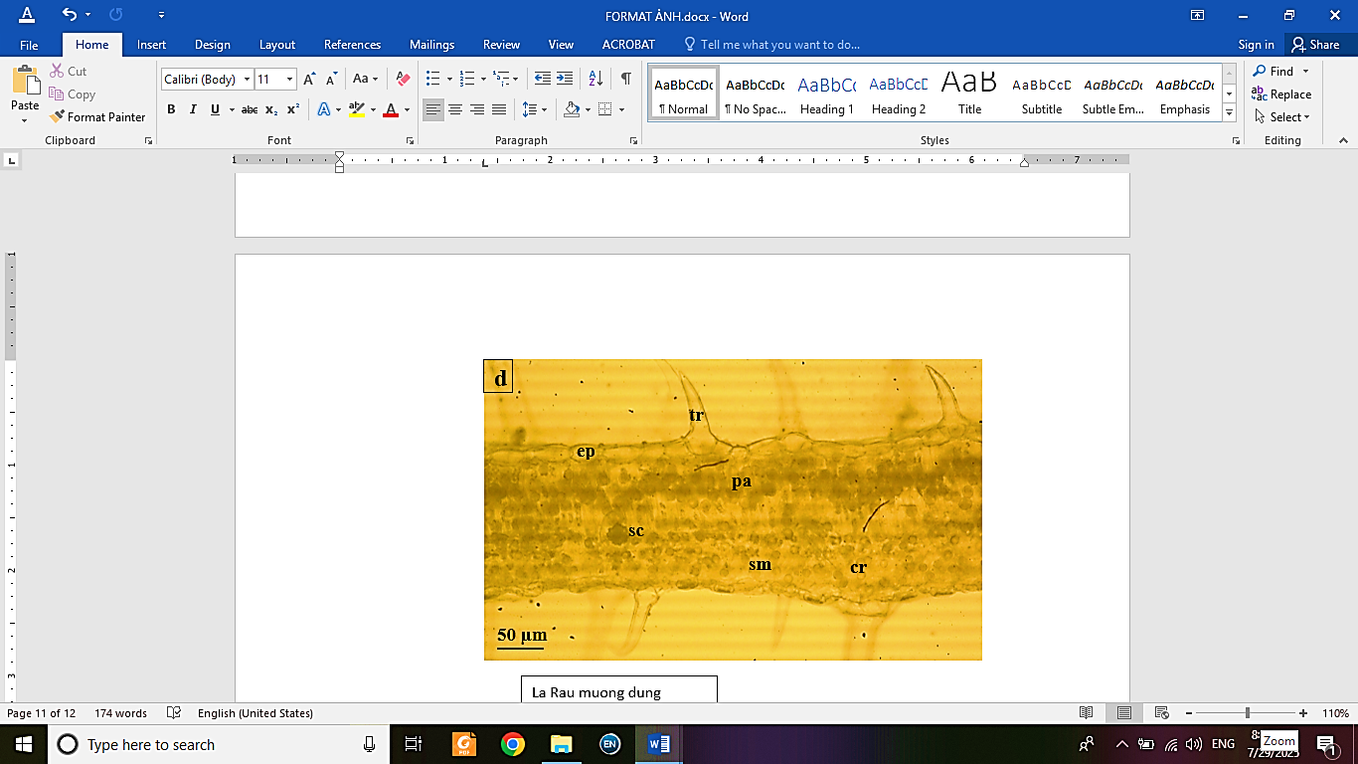

Figure 7. Anatomical features of the leaf blade structures in the investigated plant species
a. Melinis repens, b. Commelina longifolia, c. Celosia argentea, d. Ludwigia octovalvis, tr: trichome, ep: epidemis, st: stomata, ssc: sub-stomatal chamber, sc: sclerenchyma, , vb: vascular bundle, sp: intercellular space, me: mesophyll, pa: palisade mesophyll, sm: spongy mesophyll, sc: sclereid, cr: crystal

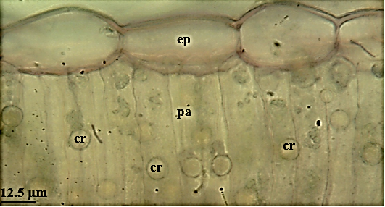
Figure 8. Transverse section through the palisade mesophyll of Ludwigia octovalvis leaf blade
ep: epidemis, pa: palisade mesophyll, cr: crystal

Table 5. The dimensions of leaf blade structures in the studied plant species
TLT: total leaf thickness

Species | Leaf blade
Species | TLT (µm) | Upper epidermis  (µm) | % TLT | Lower epidermis (µm) | % TLT | Palisade mesophyll (µm) | % TLT | Spongy  mesophyll (µm) | % TLT
Species | $\overline{X}$ ± S | $\overline{X}$ ± S |  | $\overline{X}$ ± S |  | $\overline{X}$ ± S |  | $\overline{X}$ ± S
Celosia argentea L. | 392.37  ± 75.26 | 42.23  ± 3.06 | 10.76 | 23.07  ± 1.21 | 5.88 | 173.33  ± 10.29 | 44.18 | 153.73  ± 12.41 | 39.18
Ludwigia octovalvis (Jacq.) Raven | 244.10  ± 18.73 | 26.47  ± 2.12 | 10.84 | 15.53  ± 0.82 | 6.36 | 137.23  ± 23.12 | 56.22 | 64.87  ± 2.24 | 26.58
Melinis repens (Willd.) Zizka | 233.27  ± 27.69 | 16.13  ± 1.22 | 6.92 | 22.13  ± 1.10 | 9.49 | Mesophyll |  | % TLT
 |  |  |  |  |  | 195.00  ± 12.96 |  | 83.60
Commelina longifolia Lam. | 348.37  ± 41.64 | 81.20  ± 4.21 | 23.31 | 52.50  ± 4.99 | 15.07 | 214.67  ± 25.33 |  | 61.62

4. CONCLUSION
Riparian plant species are heliophilous, with features such as protective trichomes on the outer epidermis and highly developed palisade tissue (up to 56.22% of total leaf thickness).
These species are adapted to water-abundant, low-oxygen environments, as evidenced by low xylem vessel densities (lowest in C. longifolia: 22.20 ± 1.12 vessels/mm² in roots and 5.33 ± 0.33 vessels/mm² in stems) and wide vessel diameters (widest in L. octovalvis: 109.92 ± 13.15 µm in roots and 117.75 ± 18.81 µm in stems). Aerenchyma is well-developed in roots and stems (up to 63.49% of root radius in M. repens), and intercellular spaces are scattered throughout the leaves.
These species also exhibit adaptations to mechanical stress from wind and flooding: growth in dense clumps, adventitious rooting from prostrate stems, presence of sclerenchyma bands or clusters surrounding xylem vessels or stems, and scattered calcium oxalate crystals in stem and leaf parenchyma.
Acknowledgement
This research is conducted within the framework of science and technology projects at institutional

level of Quy Nhon University under the project code T2024.839.10.
REFERENCES
1. Department of Science and Technology of Binh Dinh province. Development of the Binh Dinh Biodiversity Action Plan Toward 2010, Hanoi, 2005.
2. R. Klein, D. Klein. Plant research methods (translators: Ban Nguyen Tien, Khanh Nguyen Nhu), Hanoi Science and Technology Publishing House, Hanoi, 1979.
3. N.K. Lan. Adaptive morphology and anatomy of plants, Education Publishing House, Hue, 1997.
4. H.T. San, N.T. Chinh. Practice of Plant Morphology and Anatomy, Education Publishing House, Hanoi, 1982.
5. N. Ba. Plant morphology, Education Publishing House, Hanoi, 2005.
6. H.T. San, H.T. Be. Plant Taxonomy, Education Publishing House, Hanoi, 2001.
7. P.H. Ho. Vietnamese Flora, Youth Publishing House, Ho Chi Minh city, 1999.
8. N.T. Ban. Catalogue of Plant Species of Vietnam, Agriculture Publishing House, Hanoi, 2003-2005.
9. K.J.D. Remarchuk. Demography and genetic diversity in Tradescantia occidentalis (Commelinaceae), Master thesis, University of Saskatchewan, 2006.
10. R. Corrales-Lerma, C. Morales-Nieto, F. Villarreal-Guerrero, E. Santellano-Estrada, A. Melgoza-Castillo, A. Álvarez-Holguín, C. Avendaño-Arrazate. Morphological and nutritional characterization of Natal grass (Melinis repens (Willd.) Zizka) in the state of Chihuahua, Agroproductividad, 2017, 10(10), 103-109.
11. T.M. Huy, N.L.A. Kiet, P.V. Ngot. Research the morphological and anatomical characters of Commelina longifolia and Monochoria hastata in Lang Sen wetland reserve, Long An province, Thu Dau Mot University Journal of Science, 2021, 5, 3-15.
12. D.T. Thach, H.L. Giang. Adaptive features of the vegetative organs of some common riparian plants in the lower Ha Thanh river, Nhon Binh ward, Quy Nhon city, Binh Dinh province, Dalat University Journal of Science, 2020, 10, 71-84.
13. T.T. Hue. Actuality and adaptive ability of some riparian plants in Huong river, Master thesis, Hue University, 2010.
14. K.S. Rajput. Stem anatomy of Amaranthaceae: Rayless nature of xylem, Flora, 2002, 197, 224-232.
15. A.M. Bedoya, S. Madriñán. Evolution of the aquatic habit in Ludwigia (Onagraceae): Morpho-anatomical adaptive strategies in the Neotropics, Aquatic Botany, 2015, 120, 352-362.
16. D.T. Thach, P.T. Dieu. Morphological and anatomical features related to adaptibility of some coastal rock plants in Nhon Ly commune, Quy Nhon city, Binh Dinh province, Can Tho University Journal of Science, 2018, 54, 20-28.
17. B. Thomas. Encyclopedia of applied plant sciences, Academic Press, United States, 2016.
18. N.T.B. Nhanh. Study on adaptive features of some typical plant species in Tram Chim National Park, Tam Nong, Dong Thap, Master thesis, Hue University, 2007.
19. C. Wahua, R. Peter, Investigation of the Morpho-Anatomical and Epidermal Properties of Commelina erecta L, Journal of Applied Sciences and Environmental Management, 2024, 28, 419-423.
20. K.S. Rajput, Secondary growth of the stem of Celosia argentea L. and Aerva sanguinolenta (L.) Blume (Amaranthaceae), Phyton, 2001, 41, 169-177.
21. E. Scremin-Dias, B.B. Silveira, V.S. Fabiano, G. Catian. Vegetative organs morphological plasticity of Ludwigia grandiflora in flooded and flood-free habitats, Plant Systematics and Evolution, 2023, 309, 018444.
22. D.T. Thach, P.T. Dieu. Adaptive features of the vegetative organs of some mangrove plants in Thi Nai lagoon, Binh Dinh province, Proceeding of the 4th national scientific conference on biological research and tearching in Vietnam, VinhPhuc, Vietnam, 2020.
23. A.S. Soares‐Cordeiro, S.P. Driscoll, T.K. Pellny, E. Olmos, M.C. Arrabaca, C.H. Foyer. Variations in the dorso‐ventral organization of leaf structure and Kranz anatomy coordinate the control of photosynthesis and associated signalling at the whole leaf level in monocotyledonous species, Plant, Cell & Environment, 2009, 32,1833-1844.
24. L.W. Aung, D.K.E. Chaw. Study on morphology, anatomy, preliminary phytochemical test, nutritional values and antimicrobial activities of leaves of Ludwigia octovalvis (Jacq.) Raven, Dagon University Commemoration of 25th Anniversary Silver Jubilee Research Journal, 2019, 9 321-327.
25. C. Ilodibia, C. Chukwuka, E. Akachukwu, R. Adimonyemma, N. Igboabuchi, M. Chukwuma, Anatomical, proximate, mineral and vitamin studies on Celosia argentea (Linn), British Biotechnol J, 2016, 15, 1-7.

