Mô phỏng đa vật lý và phân tích lỗi hệ thống khởi động ô tô bằng phần mềm Siemens Simcenter

Dương Trọng Chung*, Nguyễn Quốc Hoàng

Khoa Kỹ thuật & Công nghệ, Trường Đại học Quy Nhơn

TÓM TẮT
Bài báo trình bày phương pháp mô phỏng và chẩn đoán sớm hư hỏng trong hệ thống khởi động ô tô thông qua mô hình tích hợp điện – cơ – nhiệt trên nền tảng phần mềm Simcenter Amesim. Các tình huống hư hỏng điển hình được mô phỏng để phân tích sự biến đổi của các thông số đặc trưng như dòng điện, điện áp, tốc độ trục khuỷu và nhiệt độ trong quá trình khởi động. Kết quả mô phỏng giúp làm rõ mối quan hệ giữa các thông số, từ đó phát hiện sớm các dấu hiệu về sự suy giảm hiệu suất hoặc khả năng khởi động. Nghiên cứu này cung cấp cơ sở kỹ thuật vững chắc cho việc phát triển các giải pháp chẩn đoán sớm, nhằm tối ưu hóa quá trình bảo dưỡng và nâng cao độ tin cậy của hệ thống khởi động trên ô tô.
Từ khóa: hệ thống khởi động, điện trở phần ứng, simcenter amesim, chổi than, dòng điện.

Multiphysics simulation and fault analysis of the automotive starting system using Siemens Simcenter software

Duong Trong Chung*, Nguyen Quoc Hoang

Department of Engineering and Technology, Quy Nhon University, Vietnam.

ABSTRACT
The paper presents a method for simulating and early diagnosing faults in the automotive starting system through an integrated electrical-mechanical-thermal model on the Simcenter Amesim platform. Typical fault scenarios are simulated to analyze the variation of characteristic parameters such as current, voltage, crankshaft speed, and temperature during the starting process. The simulation results help clarify the relationship between these parameters, enabling the early detection of signs of performance degradation or starting ability issues. This study provides a solid technical foundation for developing early diagnostic solutions to optimize the maintenance process and enhance the reliability of the automotive starting system.
Keywords: start system, armature resistance, simcenter amesim, brush, current.

1. INTRODUCTION
The starter system plays a crucial role in the operation of vehicles using internal combustion engines, as it is responsible for transitioning the engine from a static state to a stable operating state. With the increasing widespread use of Start-Stop technology in modern vehicles, the frequency of starter system operation has significantly increased, placing continuous electrical and mechanical pressure on components such as the starter motor, battery, brushes, and drive system.¹
However, unlike safety systems such as brakes, steering, or engine control, which are equipped with continuous monitoring sensors, the starter system typically lacks dedicated sensors to monitor its operational status or provide fault warnings. When a failure occurs, users usually only detect it when the engine fails to start, which impacts operational readiness and increases risks in emergency situations.²
Given this reality, there is a strong need to develop a simulation model of the starter system capable of accurately replicating its electrical, mechanical, and thermal characteristics. In recent years, several studies have focused on analyzing electrical signals during the starting process – such as excitation current, rotational speed, and terminal voltage – with the aim of early fault detection using intelligent algorithms such as fuzzy logic or adaptive neuro-fuzzy inference systems^{3,4} or simply conducting assessments of the starter motor’s service life.⁵
However, these experimental studies often encounter significant limitations due to the simultaneous influence of various uncontrollable factors, such as ambient temperature, battery charge status, or load fluctuations. Additionally, signal acquisition on real vehicles requires specialized measurement systems, which complicates implementation and limits the ability to investigate specific fault scenarios proactively.
Based on this, the study adopts a simulation model approach for the starter system on the Simcenter Amesim software platform. The model is built for a 4-cylinder diesel engine, allowing for the proactive simulation of typical fault scenarios such as brush wear, increased mechanical resistance, or reduced starter motor efficiency–faults that significantly affect the electrical-mechanical signal characteristics. Thanks to the simulation environment that allows full control of system parameters, the study aims to quantify the signal features in each fault scenario, thereby developing a set of criteria for early diagnosis and optimizing the maintenance of starter systems in modern vehicles. This approach not only enhances the understanding of fault behavior under various conditions but also contributes to the advancement of intelligent maintenance strategies for automotive electrical systems.
2. CONTENT
2.1. Theoretical basis and research methodology
2.1.1. Characteristics of the automotive starting system
The starter system in automobiles plays a vital role in initiating the operation of the internal combustion engine by providing enough initial torque to rotate the crankshaft, thus triggering the intake-compression-ignition-exhaust cycle in the cylinders. The operation principle of this system is demonstrated through two main aspects:
When the driver turns the ignition key (or presses the Start button for push-button start systems), the control circuit supplies power to the starter relay. This relay activates a high current from the battery to the starter motor. At the same time, the gear mechanism (usually Bendix) is pushed into engagement with the flywheel's gear ring. The starter motor rotates, turning the flywheel and crankshaft. Once the crankshaft reaches sufficient speed, the ignition or fuel injection system is activated, and the engine begins to run independently through the combustion process. Afterward, the starter gear disengages, and the motor is switched off.
During the starting phase, the torque generated by the starter motor must be large enough to overcome the total resisting torque acting on the crankshaft. If the starter torque is smaller than the resisting torque, the engine will not be able to reach the required rotational speed to sustain operation, resulting in a failed start. Therefore, understanding this torque interaction is a critical foundation for building simulation models and fault analysis of the starter system.
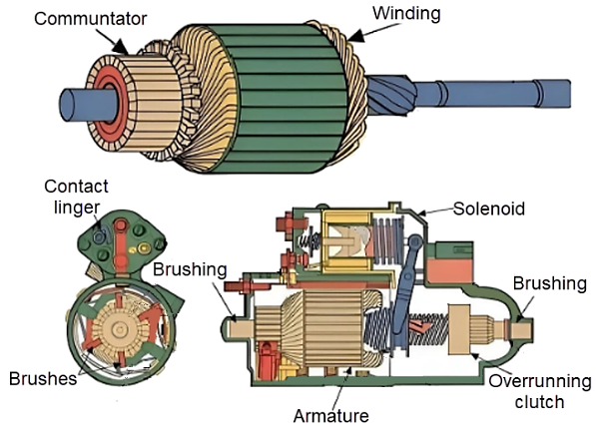
Figure 1. Automotive starter motor structure
The main power source of the starter system is the series-wound DC motor, which generates high torque right at the moment of starting. This characteristic allows the starter motor to overcome significant initial resistances such as mechanical friction, air pressure in the cylinders, and the rotational inertia of the engine components. Figure 1 illustrates the typical structure of the motor.
Common faults of the starter system:⁶
• Increased contact resistance or brush wear: Both of these phenomena lead to an increase in resistance in the power circuit to the starter motor, reducing the starting current and output torque. As a result, the motor rotates weakly, the crankshaft speed fails to reach the required level, and the starting process becomes slow or completely fails. Weak or intermittent starting sounds often accompany the phenomenon.
• Increased mechanical resistance: Causes such as lack of lubrication, worn bearings, seized shaft bearings, or dirt and foreign objects entering the mechanical system can significantly increase the resisting torque during the starting process. As the resisting torque increases, the starter motor must generate higher current to maintain the ability to rotate the crankshaft. In severe cases, especially when the ambient temperature is low or the battery is weak, the starter motor may not generate enough force to rotate, leading to a failed start.
2.1.2. Mathematical model of the series-wound DC motor:⁷
• Back electromotive force
$bemf=K_{t}.ω_{dif}$ (1)
Where
bemf: Back electromotive force (V)
Kₜ: Torque and electromotive force constant (Nm/A or V.s/rad)
ω_{dif}: Relative speed between rotor and stator (rad/s)
• Current through the armature winding
$\frac{{dI}_{s}}{dt}=\frac{U_{s}-R_{s}.I_{s}-bemf}{L_{s}}$ (2)
Where
Iₛ: Current through the series-wound excitation coil (A)
Uₛ: Voltage across the coil (V)
Rₛ: Resistance of the coil (Ω)
Lₛ: Inductance of the coil (H)
• Electromagnetic torque generated
$M_{e}=K_{t}.I_{s}$ (3)

Where
Kₜ: Torque constant
Iₛ: Starting current (A)
• Temperature compensation
Torque constant:
$K_{t}=K_{t0}\left(1+α_{Kt}\left(Temp-T_{0}\right)\right)$ (4)
Coil resistance:
$R_{s}= K_{t0}\left(1+α_{Rs}\left(Temp-T_{0}\right)\right)$ (5)
Where
Kₜ₀: Torque constant at the reference temperature T₀
αₖₜ: Temperature coefficient of the torque constant
Temp: Current operating temperature
• Dynamics equation
During the starting process, the rotating system, including the crankshaft, flywheel, and pistons, has a moment of inertia that varies with the rotational angle. The general equation is as follows:⁸
$\frac{dI}{{dφ}_{r}}.\frac{ω_{r}^{2}}{2}+\frac{dω_{r}}{dt}.I=M_{e}+M_{a-t}+M_{loss}$ (6)
Where
I: Moment of inertia of the rotating mass (kg⋅m²)
dI/dφᵣ: Rate of change of the moment of inertia with respect to the crankshaft rotational angle (rad⁻¹)
ωᵣ: Crankshaft angular velocity (rad/s)
Mₑ: Electromagnetic torque from the starter motor (Nm)
M_{a-t}: Torque due to compressed air in the cylinders (Nm)
M_{loss}: Mechanical loss torque (Nm)
From this model, signals such as starting current Iₛ, torque Mₑ, and crankshaft speed ωᵣ can be monitored and recorded. These signals will exhibit significant variations when system faults occur, allowing for early fault detection without dismantling the system.
2.1.3. Overview of Simcenter Amesim Software
Simcenter Amesim is a multi-domain physical modeling simulation software developed by Siemens Digital Industries Software. The software supports the design, analysis, and optimization of electrical, mechanical, thermal, and hydraulic systems in real time. With its intuitive drag-and-drop interface and extensive simulation block library, Simcenter Amesim allows users to quickly, accurately, and flexibly build complex system models across various fields, including mechatronics, automotive, energy, and automation.⁹
Currently, Quy Nhon University has been granted legal access to use Simcenter Amesim software through Siemens' official licensing program, serving the purposes of teaching, research, and the development of engineering simulation models. Owning the software license allows the university to access modern tools, enhancing the quality of education, particularly in the fields of mechanical engineering, electrical-electronics, and automotive engineering.
Some characteristic blocks used in simulating the starter system include:
• Motor DC: Simulates the electrical-mechanical characteristics of the series-wound starter motor.
• Friction: Describes the torque loss due to friction between rotating components.
• Shaft: Represents the rotating shaft that transmits motion between components like the motor, gears, and flywheel.
• Crankshaft: Simulates the crankshaft mechanism of an internal combustion engine.
• Battery: The main power source providing energy to the starter system.
• Transmission: The reduction gear between the starter motor shaft and the engine crankshaft, increasing the starting torque.
• Load: The mechanical load block simulating resisting torque, which can be constant, time-varying, or speed-dependent.
2.2. Simulation model construction
2.2.1. Model structure
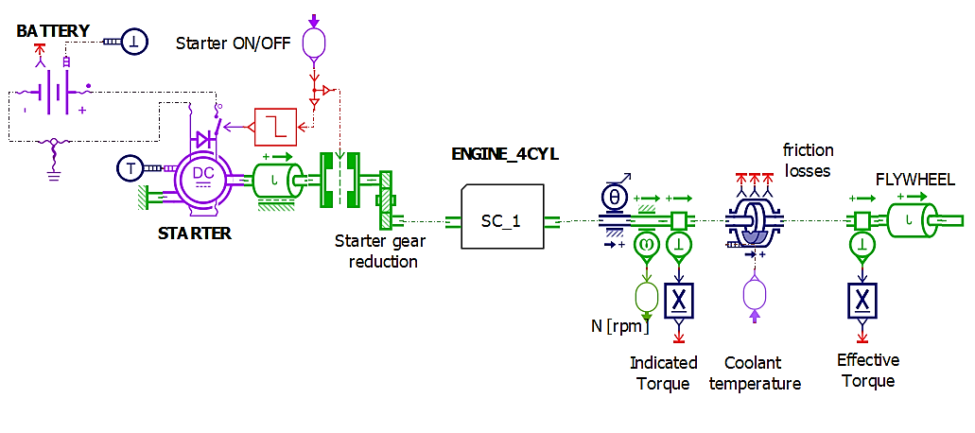
Figure 2. Engine starting model on Simcenter Amesim
The starter system model for a 4-cylinder diesel engine is built on the Simcenter Amesim software (Figure 2). The model consists of the main blocks: battery, DC starter motor, reduction gearbox, engine crankshaft, and flywheel. The transmission process begins with the current that activates the starter motor, generating torque and transmitting it through the starter gearbox to the crankshaft. The system also integrates simulated sensors such as current measurement, rotational speed, coolant temperature, and adequate torque, to accurately replicate the electrical-mechanical-thermal characteristics during the starting phase.
2.2.2. Input Parameters for Simulation
The model's input parameters were collected from the technical data of a Hyundai Avante CRDi vehicle using a 4-cylinder diesel engine. This data provides the necessary foundation for the model to accurately reflect the operational characteristics and the system's actual starting process.
Table 1. Technical specifications of the engine and starter motor for Hyundai Avante CRDi.¹⁰
Parameter | Value
ENGINE
Piston diameter | 77.2 mm
Piston stroke | 84.5 mm
Compression ratio | 17.3
Number of cylinders | 4
Connecting rod length | 143.5 mm
Engine displacement | 1582 cc
STARTER MOTOR
Motor type | DC electric motor
Rated voltage | 12V
Power | 1.8 kW
Minimum starting speed | ≥ 150 rpm
Gear ratio | 10:1
Manufacturer | Bosch
2.2.3. Simulation conditions
The model is set up for a 4-cylinder inline diesel engine with a displacement of 1.6 L. It uses a DC motor starter system and a gear reduction transmission. The power supply is a stable 12 VDC, and the simulation time is set to 1.6 seconds. The surrounding ambient temperature is assumed to be 30°C. At the same time, the compression pressure in the cylinders is considered uniform to simplify the calculations and focus on evaluating the system's electrical-mechanical characteristics during the starting process.
2.3. Simulation of starter motor characteristics and fault analysis on Simcenter Amesim
2.3.1. Normal operation of the starter motor
In the standard starter motor operation simulation scenario, all system parameters are set according to the manufacturer's standard values, ensuring no technical faults or performance degradation occur. In this case, the primary objective of the simulation is to test the system's ability to start reliably, while also analyzing the electrical-mechanical-thermal characteristics of the starter motor, such as current consumption, voltage variation, and crankshaft speed during operation.
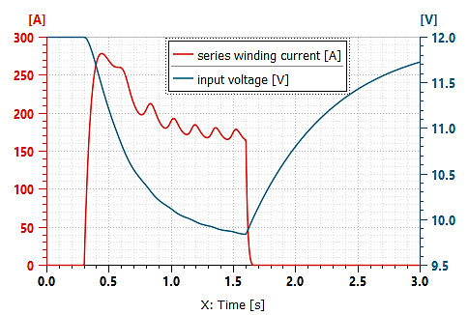
Figure 3. Variation of coil current and input voltage of the starter motor during the starting process
The simulation results show that the initial starting current rapidly increases to a peak value of approximately 280A, then gradually decreases as the crankshaft speed increases. Simultaneously, the input voltage drops from 12V to about 10V before recovering progressively. The electromagnetic torque generated by the motor reaches a sufficient value to overcome the resisting torque due to compression and friction, allowing the crankshaft to reach a speed of approximately 160–210 RPM after 1.0–1.5 seconds. This speed is sufficient for the diesel engine to begin the self-sustaining combustion.
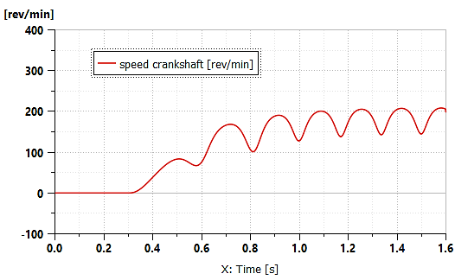
Figure 4. Crankshaft speed during normal starting conditions
In addition, the crankshaft speed exhibits a characteristic periodic oscillation, reflecting the compression-expansion cycle in the cylinders. The obtained waveform reflects the normal starting process, with the system operating stably and no signs of abnormality.
The results from this simulation play an essential role in establishing the baseline for comparing and evaluating future fault scenarios.
2.3.2. Case of brush wear and poor contact at the commutator
One of the common faults of the starter motor is poor contact between the brushes and the commutator, typically arising from mechanical wear, oxidation of the commutator surface, or reduced elasticity of the brush holder. These factors increase the overall contact resistance, thereby reducing the starting current, causing voltage loss, and decreasing the efficiency of torque transmission to the engine crankshaft.
In this study, the phenomenon is simulated by increasing the armature resistance in the DC motor model to investigate the impact of various levels of wear on the electrical-mechanical characteristics during the starting phase.
Figure 5 shows the variation of current through the starter motor winding at different simulated contact resistance levels. Under good contact conditions (solid line), the starting current rapidly increases to about 280 A, then gradually decreases over time as the crankshaft speed increases. The rotational speed reaches over 200 RPM after 1.1 seconds, which is sufficient for the diesel engine to start the self-sustaining combustion process. In this case, the motor's input voltage remains stable around 11.5–12 V, reflecting low voltage loss and high energy conversion efficiency.
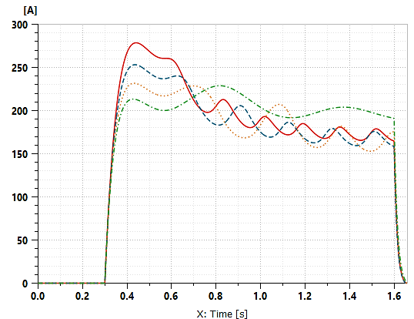
Figure 5. Variation of starting current with different contact resistance levels
As the contact resistance increases (dashed line – corresponding to moderate wear or unstable contact), the starting current decreases to 150–250 A, and the crankshaft speed reaches only 150–190 RPM. The acceleration time is prolonged, and the amplitude of the speed oscillations decreases, indicating a decline in system efficiency. At the same time, the input voltage decreases slightly, fluctuating around 10–11 V.
In this case, the motor can still start the engine, but issues such as slow starting, weak cranking, or instability during continuous cranking may occur.
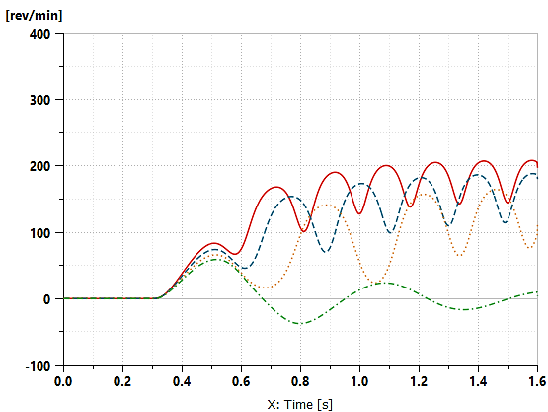
Figure 6. Variation of crankshaft speed in cases of brush wear
Notably, when the resistance reaches a high threshold (dash-dotted line – simulating heavy wear or severe damage at the commutator), the starting current decreases sharply to 130–210 A, and the crankshaft speed does not exceed 100 RPM, with a tendency for weak oscillations and occasional reverse rotation. The acceleration time is extended but fails to reach the required threshold to maintain the compression-ignition process. In this scenario, the input voltage drops significantly to 9–10 V, indicating that electrical energy is consumed but not effectively converted into mechanical motion. The system enters a state where it cannot start, causing energy loss and serving as a warning sign for severe damage that requires maintenance intervention.
The simulation results suggest that electrical signals during the starting phase–especially a starting current below 150 A combined with a crankshaft speed not exceeding 100 RPM–can be used as early diagnostic indicators for brush wear or poor contact at the commutator. This opens the possibility of integrating early fault warning mechanisms in control systems, enabling proactive maintenance and preventing sudden failure of the starter system. Such integration not only enhances system reliability but also extends the operational lifespan of the starting components by addressing issues before they escalate.
2.3.3. Case of worn bearings, dust accumulation, dry lubrication, or seized motor shaft
In practical operation, mechanical faults such as worn bearings, dust accumulation, dried lubrication, or a seized rotating shaft can increase the resisting torque during the starting phase. These faults force the starter motor to work under greater mechanical load, significantly altering the electrical-mechanical signals, directly impacting the motor's ability to start the engine.
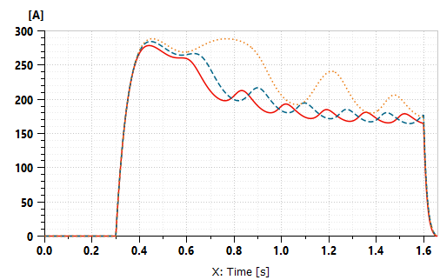
Figure 7. Variation of current with increased starting torque
Figure 7 shows the starting current variation at different resistance torque levels. Under standard conditions (solid line), the current peaks at approximately 280 A and quickly decreases over time. When the resisting torque increases slightly (dashed line), the current remains high for a longer period (~280 A) with a larger oscillation amplitude – indicating a heavier mechanical load that forces the motor to increase its power to start. In the case of unusually high resisting torque (dotted line), the current stays at a high level continuously, without decreasing over time, indicating an overloaded operating condition that can easily lead to motor damage.
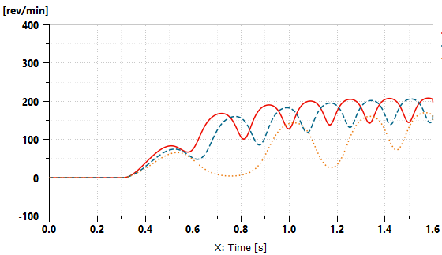
Figure 8: Engine speed with increased starting torque
Figure 8 illustrates the variation in crankshaft speed under the conditions mentioned above. Under standard conditions, the speed increases steadily, reaching approximately 210 RPM after about 1.1 seconds – sufficient for the diesel engine to complete the compression-ignition cycle. With light resistance, the speed only reaches about 180 RPM, with a longer acceleration time (~1.4 seconds) and stronger oscillations. In the case of unusually high resistance, the crankshaft speed fluctuates around ~120–130 RPM and experiences very strong oscillations, failing to meet the required conditions for starting.
The results indicate that the combination of high current sustained over time and low crankshaft speed effectively indicates mechanical issues within the starter motor assembly or the starting drive system. Such symptoms can be used to establish warning thresholds in early diagnostic systems, allowing for timely detection of signs of bearing wear, dry lubrication, or seized components before they cause severe damage or a complete loss of starting capability.
2.3.4. Effect of temperature on starting
The simulation results in Figures 9 and 10 show that the ambient temperature significantly impacts the performance and electrical-mechanical characteristics of the engine starter system. In the three conditions investigated (0°C, 30°C, 90°C), the current and crankshaft speed signals vary differently, reflecting the simultaneous change in mechanical load and electromagnetic efficiency.
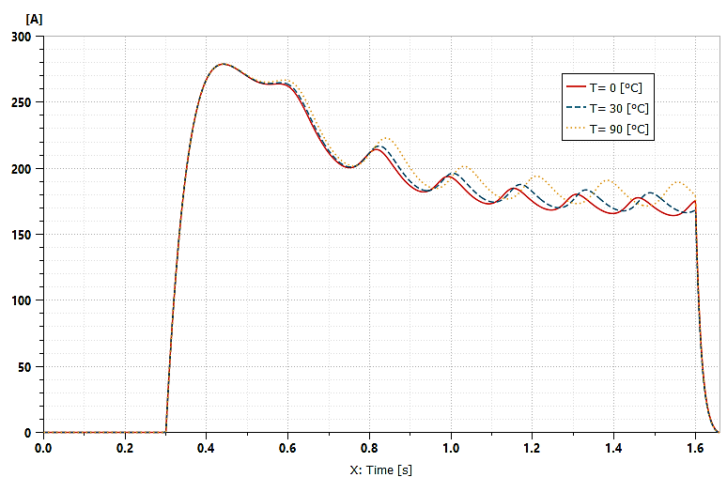
Figure 9. Variation of current with changing starting temperature
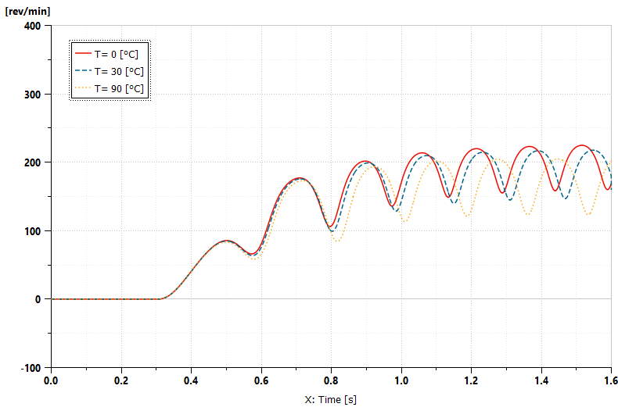
Figure 10. Engine speed with changing starting temperature
At 0°C, although the resisting torque increases due to thicker oil and higher friction, the engine still achieves stable starting speed, thanks to the maintained electrical-mechanical efficiency due to the low coil resistance. In contrast, at 90°C, despite the reduced mechanical load, the increased coil resistance reduces the effective torque, leading to a lower starting speed and stronger oscillations. The 30°C condition provides the most balanced results regarding current, speed, and oscillations, reflecting the optimal operating state of the starter system.
Figure 9 illustrates the variation of starting current over time at three different temperatures. Although the peak current is similar (~275–280 A), at higher temperatures, the current remains at a high level for longer and exhibits larger oscillations, indicating a decline in electrical-mechanical efficiency. Figure 10 clearly shows the separation of crankshaft speed at different temperatures: at 0°C, the speed reaches its highest peak, while at 90°C, the maximum speed is lower and the oscillations are stronger.
Additionally, under real operating conditions, if the engine is required to start multiple times consecutively within a short period, the temperature in the motor windings can increase rapidly. As a result, the coil resistance continuously increases, causing a decrease in output torque, even though the current remains high. This leads to a gradual reduction in rotational speed after each start, with the time to reach the required speed becoming longer and oscillations becoming stronger, which can result in a failed start if the load conditions increase or the battery weakens.
This indicates that the system is operating outside its optimal efficiency range. Therefore, it is necessary to integrate an algorithm that limits the number of consecutive start cycles or use temperature monitoring sensors to provide early warnings of thermal overload risks and the degradation of starting efficiency.
3. CONCLUSION
The study successfully developed a simulation model of the diesel engine starting system on the Simcenter Amesim platform, accurately simulating the interaction between electrical, mechanical, and thermal factors throughout the starting cycle. The model reflects the standard operating condition and allows for the analysis of typical fault scenarios such as increased contact resistance, brush wear, increased mechanical resistance, and the impact of ambient temperature on starting performance.
Through the simulation process, the research team identified several characteristic electrical-mechanical indicators that can be used to diagnose abnormalities in the starter system early. Specifically:
• An initial peak current exceeding the design threshold may indicate an abnormal starting load, possibly caused by mechanical jamming, increased friction, or excessive opposing torque.
• An extended cranking time beyond the standard limit reflects the potential presence of faults such as worn brushes or increased internal resistance of the winding.
• A low crankshaft speed within the first 0.5–1.0 seconds may signal degraded electrical contacts or elevated contact resistance, resulting in localized voltage drops during startup.
• Irregular current or rotational speed fluctuations throughout the starting cycle indicate electromechanical instability within the system.
Notably, the research results open up the possibility of applying existing measurement signals from the vehicle's electronic system, such as data from the ECU, current sensors, voltage sensors, and rotational speed, to develop a sensorless diagnostic solution for the starter system. This approach enables monitoring the operational status and early detection of performance degradation in the starter system through parameters already recorded by the vehicle's electronic system during operation.
Acknowledgment
We sincerely thank Quy Nhon University for funding this research through the scientific research project number T2024.850.21.
REFERENCES
1. Argonne National Laboratory. Stop and Restart Effects on Modern Vehicle Starting System Components, U.S. Department of Energy, USA, 2015.
2. M. Dziubiński, M. Plich, A. Drozd. Modelling and simulation characteristics of starting system, Journal of KONBiN, 2016, 1(37), 277-296.
3. Ömer Faruk Bay, Raif Bayir. A Fault diagnosis of engine starting system via starter motors using fuzzy logic algorithm, Gazi Journal University of Science, 2011, 24(3), 437–449.
4. E. Ebrahami, K. Mollazdade. Intelligent fault classification of a tractor starter motor using vibration monitoring and adaptive neuro fuzzy inference system, Insight-Non-Destructive Testing and Condition Monitoring, 2010, 52(10), 561–566.
5. M. Mayda and N. Gultekin. Deterministic and probabilistic life assessment of a traditional car starter motor based on number of stop/start cycles, Journal of Advanced Mechanical Design, Systems, and Manufacturing, 2018, 12(1), 1–8.
6. S. A. Habib, S. M. A. S. Rafik, and Y. A. Sanjay. A review on starter motor in automobiles, International Research Journal of Modernization in Engineering Technology and Science, 2022, 4(12), 893–899.
7. Hughes, Austin, and Drury, Bill. DC Motor Principles. Electric Motors and Drives (5th), Elsevier, Oxford, United Kingdom, 2019.
8. M. Dziubiński, A. Drozd, P. Kordos, and A. Syta. Diagnosing the automobile starting system, Combustion Engines, 2017, 170(3), 19–23.
9. Siemens Industry Software Pte. Ltd. Software license certification for Simcenter Amesim 1D, NX CAD/CAM, Simcenter 3D, Singapore, 2023.
10. Hyundai Motor Company. Hyundai Avante CRDi Service Manual, Hyundai Motor Company, Seoul, 2020.

Contact information: Duong Trong Chung
Quy Nhon University
170 An Duong Vuong, Quy Nhon Nam Ward, Gia Lai Province, Vietnam
Email: duongtrongchung@qnu.edu.vn
Phone: +84 987 851 1856

