REPLY LETTER
Dear Reviewers,
We are grateful to the reviewers for your time and constructive comments on our manuscript. We have implemented your comments and suggestions and wish to submit a revised version of the manuscript for further consideration in the journal. Changes in the initial version of the manuscript are highlighted in yellow for added figures and sentences in the revised version. Below, we also provide a point-by-point response explaining how we have addressed each of the reviewers’ comments. We look forward to the outcome of your assessment.
Yours sincerely,
On behalf of the co-authors

Reviewer 1:
- Comment: “Some grammatical inconsistencies and technical writing issues in the English version should be revised for clarity and correctness.”
Answer: The authors have reviewed and revised several grammatical inconsistencies and issues related to technical writing.

- Comment: “The authors should add the simulated S11 of 1×8 elements array.”
Answer: The authors have added the simulated |S₁₁| of 1×8 elements array, shown in Figure 11 of sub-section 3.2.
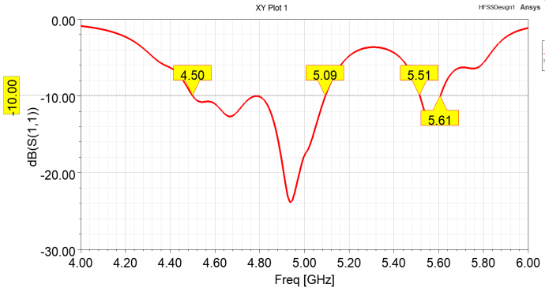
Figure 11. Simulated |S₁₁| of of 1×8 elements array

- Comment: “For the further studies, the quality of the paper will be improved if experimental measurements are carried out.”
Answer: In the future, the authors plan to evaluate the feasibility of fabricating the proposed antenna and performing measurements on the prototype.
-----------------------
Reviewer 2:

- Comment: Some plots (e.g., Fig. 4, Fig. 6, Fig. 11) lack axes labels or units.”
Answer: The authors have added the missing axis labels to Fig. 6, Fig. 7, and Fig. 12 (corresponding to Fig. 11 in the submitted manuscript).
- Comment: There are some grammatical and typographical errors (e.g., “frequency one” instead of “center frequency shifts slightly,” “bellowed –28 dB” instead of “below –28 dB”).
Answer: The authors have fixed grammatical and typographical errors as Reviewer 2’s comment.

- Comment: Some figure captions are too brief or inconsistent in format. For instance, “Figure 11. Radiation pattern simulated of 1x8 array...” should be revised to: “Figure 11. Simulated radiation pattern of the 1×8 array at 4.9 GHz (solid line: co-pol, dashed line: cross-pol).”
Answer: The authors have made the revised as Reviewer 2’s comment.

-------------------------

Moreover, we also updated the number of figures as follows:
Figure 11 -> Figure 12
Figure 12 -> Figure 13

