06-August-2025
Journal: Tạp chí Khoa học Trường Đại học Quy Nhơn
Manuscript ID: QNUJS-B2516
Title: " Synthesis of bioplastic films from Vitex negundo L. leaf extract based on sweet potato starch and investigation of antibacterial activity of the products "
Author(s): Phạm Khánh Nguyên Huân, Lê Hồng Ngọc Bảo, Nguyễn Thị Kiều Tiên, Hà Thị Kim Quy

I. NHẬN XÉT CỦA PHẢN BIỆN 1
1. Nhận xét về nội dung, phương pháp (tính nguyên bản, ý tưởng mới, độ tin cậy, giá trị khoa học và thực tiễn,…)
The overall topic of the manuscript is relevant and aligns with current research interests in the field.
2. Nhận xét về hình thức (bố cục, hành văn, cách trình bày, tài liệu tham khảo,…)
The manuscript is well-organized, with a clear and logical flow of information across all sections.
3. Các điểm cần bổ sung, chỉnh sửa (những sai sót / sai sót cần được sửa chữa, đề xuất về nội dung để nghiên cứu thêm hoặc cải tiến, v.v.)
1. The authors have made efforts to revise the manuscript accordingly. However, it remains difficult to accurately assess the antibacterial properties of the membrane without reporting the inhibition zone diameter. At a minimum, the authors should provide relevant figures in the supplementary materials.
→ Answer: We appreciate the reviewer's concern about quantitative assessment. However, our study performed the soft agar overlay method, which is fundamentally different from the agar well diffusion technique used for soluble antimicrobial agents. This methodological distinction is crucial for understanding our results:
- Scientific rationale for qualitative assessment
+ The soft agar overlay method is specifically designed for direct-contact antimicrobial evaluation of solid materials [1], and our lab has experimented with this method [2].
+ Unlike traditional diffusion methods, where soluble compounds create measurable zones, film-incorporated antimicrobials exhibit localized activity at the material-substrate interface [3]. Our bioplastic films function through controlled release mechanisms rather than rapid diffusion, making radial zone measurements inappropriate for this material system.
- Recent studies on antimicrobial packaging applications
Leading studies in active packaging consistently employ qualitative assessment for solid antimicrobial materials. Appendini & Hotchkiss (2002) [4] and Suppakul et al. (2003) [3] established this methodology as standard practice for evaluating antimicrobial packaging materials.
- Methodological validation
The antibacterial activity assessment using this double-layer agar method (soft agar overlay method) is a qualitative experiment. This method has been previously implemented in our laboratory for published works, with detailed descriptions provided in the manuscript as well as explanations with supporting references above.
These results can be clearly observed with the naked eye using an oblique viewing angle to assess the transparency of the upper soft agar layer, with evaluation criteria clearly described. Meanwhile, conventional photographs taken at perpendicular angles fail to clearly demonstrate the results due to different film material properties that produce varying colors and opacity levels. Therefore, we did not include images in the manuscript or previous explanations. Following the reviewer's suggestion, we have attached perpendicular photographs. Please note that perpendicular photos will be affected by the color of the films.
The provided Figure 1 demonstrates bacterial growth inhibition directly beneath the film samples. This contact-dependent inhibition is characteristic of immobilized antimicrobial systems and represents the actual mechanism of action in food packaging applications. The method for observing experimental results involves recording bacterial density development directly beneath the soft agar layer at the location where the bioplastic film is placed.

Our qualitative assessment criteria are based on established protocols:
- (++) Good antimicrobial activity: Clear bacterial growth inhibition zone beneath the film
- (+) Moderate (or fairly good) activity: Visible reduction in bacterial density
- (+/-) Weak activity: Slight inhibition with limited clarity
- (-) No activity: No observable growth inhibition.
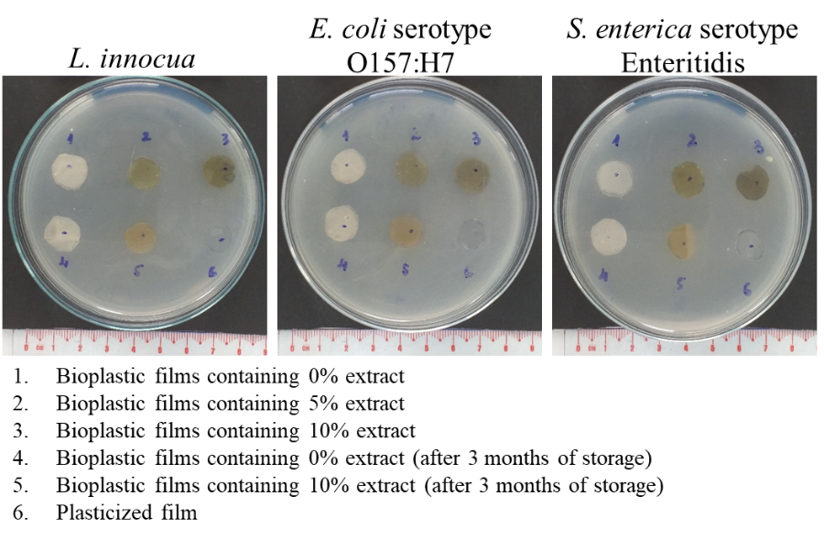
Figure 1: Antibacterial activity assessment of bioplastic films containing extract.
Ref:
[1] Hockett, K. L., & Baltrus, D. A. (2017). Use of the soft-agar overlay technique to screen for bacterially produced inhibitory compounds. Journal of Visualized Experiments (JoVE), (119), e55064.
[2] Pham-Khanh, N. H., Sunahara, H., Yamadeya, H., Sakai, M., Nakayama, T., Yamamoto, H., ... & Kamei, K. (2019). Isolation, characterisation and complete genome sequence of a Tequatrovirus phage, Escherichia phage KIT03, which simultaneously infects Escherichia coli O157: H7 and Salmonella enterica. Current Microbiology, 76(10), 1130-1137.
[3] Suppakul, P., Miltz, J., Sonneveld, K., & Bigger, S. W. (2003). Active packaging technologies with an emphasis on antimicrobial packaging and its applications. Journal of food science, 68(2), 408-420.
[4] Appendini, P., & Hotchkiss, J. H. (2002). Review of antimicrobial food packaging. Innovative Food Science & Emerging Technologies, 3(2), 113-126.
2. Additionally, all corrections should be clearly incorporated into the revised manuscript.
→ Answer:
We thank the reviewer for their request. However, Journal-specific formatting requirements of "Tạp chí Khoa học Trường Đại học Quy Nhơn" mandate the use of red highlighting rather than track changes for revision identification. This standardized approach ensures consistency across all submissions to the journal.
Transparency measures implemented:
- All modifications are systematically highlighted in red throughout the revised manuscript.
- Comprehensive point-by-point responses are provided in this document with specific page and line references.
- Before-and-after comparisons are included for significant changes.
This approach maintains full transparency while adhering to journal formatting standards, ensuring that all revisions are identifiable for editorial review.

3. From another perspective, a moisture absorption test would be more appropriate than a water absorption test in this study. If the films absorb nearly 80% of water within just five minutes, are they truly suitable for application in food packaging? Furthermore, how might this high water absorption impact the antibacterial properties of the membrane?
→ Answer: The authors explain the reasons for not being able to perform the moisture absorption test:
Equipment limitations: Our laboratory currently lacks precise humidity control equipment (humidity chamber) according to ASTM E96 standard, which is necessary for standardized moisture absorption testing. Furthermore, this method requires extended testing periods (2-4 weeks) under strictly controlled conditions for commercialized products, exceeding our current research purpose.
Regarding the suitability of high water absorption capacity of bioplastic films:
+ Specific target applications: Bioplastic films are suitable for dry food packaging (such as bread) rather than fresh foods with high moisture content.
+ Protection mechanism: High water absorption capacity helps maintain stable moisture content for products inside, similar to silica gel used in packaging.
+ Similar studies: Studies by Piñeros-Hernandez et al. (2017) [1] and Menzel (2020) [2] both reported water absorption capacity of 70-90% for starch films and are still successfully applied in food packaging.
Regarding the impact on antibacterial properties: Importantly, our 3-month storage stability data demonstrate that high water absorption does not compromise antimicrobial activity. The covalent integration of Vitex negundo compounds within the starch polymer matrix prevents leaching of bioactive compounds during water exposure, maintaining sustained antimicrobial efficacy as evidenced by retained activity after prolonged storage.
Ref:
[1] Piñeros-Hernandez, D., Medina-Jaramillo, C., López-Córdoba, A., & Goyanes, S. (2017). Edible cassava starch films carrying rosemary antioxidant extracts for potential use as active food packaging. Food hydrocolloids, 63, 488-495.
[2] Menzel, C. (2020). Improvement of starch films for food packaging through a three-principle approach: Antioxidants, cross-linking and reinforcement. Carbohydrate Polymers, 250, 116828.

II. MỘT SỐ CHỈNH SỬA KHÁC
Nhóm tác giả có điều chỉnh một số lỗi ngữ pháp tiếng anh (phần chữ tô đỏ) trong file bản thảo chỉnh sửa.

