Nghiên cứu phân tán vật liệu SiO₂/g-C₃N₄ trên nền polyvinylidene fluoride và hoạt tính quang xúc tác phân hủy dung dịch RhB trong môi trường nước

Phan Thị Thùy Trang, Trương Thanh Tâm, Đặng Thị Tố Nữ, Nguyễn Tấn Lâm,
Nguyễn Thị Lan

¹Khoa Khoa học Tự nhiên, Trường Đại học Quy Nhơn, Việt Nam

*Tác giả liên hệ chính. Email: nguyenthilan@qnu.edu.vn

TÓM TẮT
Vật liệu SiO₂/g-C₃N₄ được phân tán lên màng polyvinylidene fluoride (PVDF) bằng phương pháp đảo pha thu được màng quang xúc tác phân hủy chất màu hữu cơ rhodamnie B (RhB) trong môi trường nước dưới vùng ánh sáng khả kiến. Hình thái, cấu trúc và hoạt tính quang xúc tác của các vật liệu đơn và composite phân tán lên màng PVDF được đánh giá. Với vật liệu composite SiO₂/g-C₃N₄ có tính chất xốp hơn, có nhiều vị trí khuyết tật hơn so với các vật liệu SiO₂ hay g-C₃N₄ đơn chất khi phân tán lên màng làm cải thiện đáng kể hiệu quả quang xúc tác của vật liệu. Cụ thể, hiệu suất phân hủy RhB khỏi màng composite SiO₂/g-C₃N₄/PVDF dưới tác động của ánh sáng khả kiến đạt 81,35% vượt trội hơn so với g-C₃N₄/PVDF (46,07%) và SiO₂/PVDF (14,79%). Do đó, nghiên cứu này được kỳ vọng sẽ mở rộng triển vọng trong lĩnh vực công nghệ lọc màng.
Từ khóa: SiO₂, g-C₃N₄, SiO₂/g-C₃N₄, PVDF

Study on dispersion of SiO₂/g-C₃N₄ on polyvinylidene fluoride substrate and photocatalytic activity in decomposing RhB solution in aqueous environment

Phan Thi Thuy Trang, Truong Thanh Tam, Dang Thi To Nu, Nguyen Tan Lam,
Nguyen Thi Lan

¹Faculty of Natural Sciences, Quy Nhon University, Vietnam

*Corresponding author. Email: nguyenthilan@qnu.edu.vn

ABSTRACT
SiO₂/g-C₃N₄ material was dispersed onto polyvinylidene fluoride (PVDF) membrane by the phase inversion method to obtain a photocatalytic membrane for decomposing organic dye rhodamine B (RhB) in aqueous medium under visible light. The morphology, structure, and photocatalytic activity of single and composite materials deposited on PVDF membranes were evaluated. With SiO₂/g-C₃N₄ composite material having more porous properties and more defect locations than single SiO₂ or g-C₃N₄ materials when dispersed onto the membrane, the photocatalytic efficiency of the material is significantly improved. Specifically, the degradation efficiency of RhB from SiO₂/g-C₃N₄/PVDF composite membrane under the influence of visible light reached 81.35%, which was superior to g-C₃N₄/PVDF (46.07%) and SiO₂/PVDF (14.79%). Therefore, this study is expected to expand the prospects in the field of membrane filtration technology.
Keywords: SiO₂, g-C₃N₄, SiO₂/g-C₃N₄, PVDF

1. INTRODUCTION
Water pollution by persistent organic compounds – dyes, pesticides, and pharmaceutical residues – is becoming one of the most serious environmental challenges today. These compounds are often highly toxic, difficult to biodegrade, and accumulate in the environment for long, requiring effective and eco-friendly treatment methods.¹ Among modern treatment technologies, heterogeneous photocatalysis under visible light is a promising method due to its ability to completely decompose organic pollutants into non-toxic products such as CO₂ and H₂O without leaving secondary residues.^{2, 3} In the field of photocatalytic materials, graphitic carbon nitride (g-C₃N₄) is considered a potential candidate due to its narrow band gap (~2.7 eV), good visible light absorption, high chemical stability, and simple synthesis from precursors such as melamine or urea.⁴ However, g-C₃N₄ has limitations, typically low surface area, poor adsorption capacity, and a fast recombination rate of electron pairs.⁵ To improve the catalytic efficiency, forming composite materials between g-C₃N₄ and supporting materials is considered an effective strategy. Silicon dioxide (SiO₂) – a potential semi-doped material with a porous structure, large surface area, and high stability – not only enhances the dispersion of g-C₃N₄ but also improves the charge transfer process in the photocatalytic reaction. ^{6, 7} Similar to SiO₂, several approaches have been taken to improve the photocatalytic activity of g-C₃N₄, including incorporating dopants and coupling with other semiconductors. Extensive efforts have been devoted to improving the photocatalytic activity of g-C₃N₄, and numerous novel g-C₃N₄-based photocatalysts have been reported, such as ZnO/g-C₃N₄ ⁸, SmVO₄/g-C₃N₄ and TaON/g-C₃N₄. ⁹⁻¹¹ These photocatalysts were mainly developed based on the coupling effect. In addition, metal or non-metal element doping is typically used to improve the photoactivity of g-C₃N₄ (such as g-C₃N₄ and Fe–g-C₃N₄), ^{12, 13}, which is based on energy band engineering. The hybridization of SiO₂ and g-C₃N₄ achieves a synergistic effect to overcome the major disadvantages of each material and create composite materials with good photocatalytic activity. In treating polluted water, the direct use of catalysts has the advantage of very high photocatalytic activity. However, these materials are still in powder form. Hence, they are challenging to recycle after the photocatalytic process. ^{14, 15} This causes significant waste of photocatalysts but also causes secondary pollution to the environment. Therefore, finding solutions to the problem of material recovery is of interest to researchers. Several methods for recovering inorganic photocatalysts have been reported, such as adding magnetic materials, forming rigid, recyclable, and flexible thin film materials, and loading them onto organic polymer materials ^{16, 17}. The major drawback of immobilizing the catalyst materials onto the substrate is the reduction of the active site, and the durability of the catalyst materials with the substrate is also of great concern. Poly(vinylidene fluoride) (PVDF) is a fluoropolymer with good chemical stability, good mechanical properties, and easy to process into films, which is very suitable as a substrate for membrane-based photocatalyst systems, which helps to improve the applicability and reusability ¹⁸. In this study, SiO₂/g-C₃N₄ composite materials loaded onto PVDF were synthesized by a simple phase inversion method. This study focused on the synthesis, chemical characterization, and evaluation of the treatment performance of SiO₂/g-C₃N₄/PVDF materials for typical organic compounds in wastewater such as RhB, enhancing the photocatalytic activity under visible light, and improving the stability and recovery of materials after treatment.
2. EXPERIMENTAL
2.1. Material synthesis
Chemicals: All chemicals used for material synthesis include urea ((NH₂)₂CO), TEOS (Tetraethyl orthosilicate) (C₈H₂₀O₄Si), CTAB (Hexadecyl trimethyl ammonium bromide), ([(C₁₆H₃₃)N(CH₃)₃]Br ), polyvinylidene fluoride (PVDF), N-Methy-2-pyrrolidone (NMP) and rhodamine B (C₂₈H₃₁ClN₂O₃), Merck.
2.2. Materials synthesis:
2.2.1. Synthesis of g-C₃N₄ material
g-C₃N₄ material was prepared by a simple method using urea as raw material. The first, 10 grams of finely ground urea then transferred into alumina crucible, sealed with aluminum foil and calcined at 550 ºC for 1 hour. The solid obtained was pale yellow, washed with distilled water and ethanol, then dried at 80 ºC for 12 hours. The product is finely ground and marked g-C₃N₄.
2.2.2. Synthesis of SiO₂ material
SiO₂ material is synthesized according to the following process: Add 0.16 g of hexadecyl trimethyl ammonium bromide (CTAB) to 50 mL of distilled water, then slowly add 15 mL of ethanol and 1 mL of solution. Stir for 0.5 hour, slowly add 1 mL tetraethyl orthosilicate (TEOS) dropwise into the solution, and stir for 24 hours. The obtained product was washed with deionized water and ethanol three times, dried for 24 h at 60 ºC, and denoted SiO₂.
2.2.3. Synthesis of SiO₂/g-C₃N₄ composite material
Samples were prepared by a simple method using SiO₂ powder and urea as precursors. First, a mixture of 0.1g SiO₂ and 3g urea into an agate mortar and grind finely. Then, the as-prepared mixtures were then transferred into an alumina crucible, sealed with aluminum foil, and heat it in an inert Ar gas environment at 550 ºC for 1 hour. Cool to room temperature, grind and wash the sample with distilled water until neutral. The solid was dried at 80 ºC for 12 hours and denoted as SiO₂/g-C₃N₄.
2.2.4. Synthesis of SiO₂/g-C₃N₄/PVDF material
SiO₂/g-C₃N₄/PVDF material was prepared using the following procedure. Firstly, put 0.1g of SiO₂/g-C₃N₄ material into a glass jar with a lid, add 5 mL of NMP solution, and sonicate for 10 minutes. Then stir well on a magnetic stirrer for 30 minutes. Continue ultrasonic vibration for another 20 minutes and stir evenly on a magnetic stirrer for 20 minutes. Continue ultrasonic vibration for another 20 minutes and stir evenly on a magnetic stirrer for 20 minutes. Then let the mixture sit for 3 hours. Using a stainless steel scraper (250 µm x 15 cm), roll the mixture evenly onto the glass to form a composite film, quickly put the glass with the film into water to perform the phase reversal process, and the material is denoted as SiO₂/g-C₃N₄/PVDF.
2.3. Material characterization
The synthesized materials were characterized using several techniques. Infrared spectroscopy IR was performed on a Shimadzu IR Prestige-21. The crystal phase was analyzed by X-ray diffraction (XRD) using a Siemens D-500 Bruker system. Scanning electron microscopy (SEM) and X-ray energy dispersive spectroscopy (EDS) were conducted using a JSM-7600F device. Photoluminescence (PL) spectra were measured on a Hitachi F-7000 instrument with an excitation wavelength of 360 nm.
2.4. Photocatalytic evaluation
The photocatalytic activity of the obtained materials was evaluated by the decomposition of Rhodamine B (RhB) in an aqueous solution under visible light irradiation. Materials containing 0.1 g of the photocatalyst were added to 100 mL of RhB solution with a concentration of 10 mg/L and stirred in the dark for 60 minutes to achieve adsorption-desorption equilibrium. The photocatalytic process was then initiated under a 40W LED light. Every 30 minutes, 7 mL of the solution was centrifuged to remove the solid part. The concentration of RhB in the solution was determined on a UV-Vis meter (CE-2011) at a wavelength of 553 nm.
3. RESULTS AND DISCUSSION
3.1. Material characteristics
The crystal structures and phase compositions of the synthesized SiO₂, g-C₃N₄, SiO₂/g-C₃N₄ powders, and PVDF, SiO₂/PVDF, g-C₃N₄/PVDF, and SiO₂/g-C₃N₄/PVDF films are shown in Figure 1. 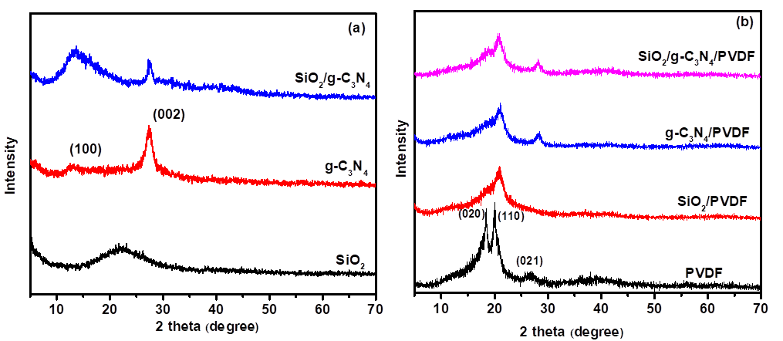
Figure. 1. (a) XRD patterns of SiO₂, g-C₃N₄, SiO₂/g-C₃N₄ and (b) PVDF, SiO₂/PVDF, g-C₃N₄/PVDF and SiO₂/g-C₃N₄/PVDF.
Figure 1a shows that the SiO₂ material exhibits a broad peak at 2θ ≈ 23° corresponding to the amorphous nature of SiO₂.¹⁹ g-C₃N₄ shows typical diffraction peaks corresponding to the (002) and (100) planes of g-C₃N₄.²⁰ Specifically, the peak at 2θ = 13.5° can be attributed to the in-plane structural stacking motif in the tri-s-triazine (s-heptazine)-based structure of g-C₃N₄, while the strong diffraction peak located at 2θ = 27.6° is a result of the inter-plane stacking of the conjugated aromatic units of g-C₃N₄.²¹ XRD results of SiO₂/g-C₃N₄ composite material fully show the characteristic peaks of both g-C₃N₄ and SiO₂. The SiO₂ peak at 23° is not clearly shown in the composite sample, possibly due to the amorphous SiO₂ structure and the stacking of g-C₃N₄. Thus, the SiO₂ added to the g-C₃N₄ substrate does not change the crystal structure. The results in Figure 1b show that PVDF has 3 characteristic peaks at 18.5º, 20.1º, 26.7º corresponding to the planes (020), (110), (021). When dispersing g-C₃N₄, SiO₂, SiO₂/g-C₃N₄ onto PVDF polymer matrix, the PVDF peaks still appear at almost the same position but the intensity is reduced. For the g-C₃N₄/PVDF sample, a characteristic strong peak at 27.6° and a weak peak at 13.5° corresponding to the (002) and (100) reflection planes of graphite-structured materials appear.²²
Figure 2 shows the FT-IR spectrum of the synthesized material samples, demonstrating no change in the PVDF polymer structure.
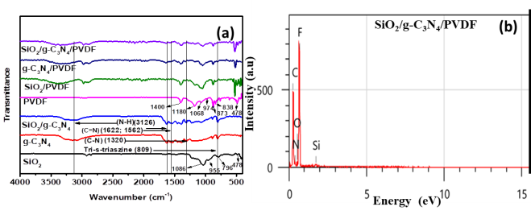
Figure 2. (a) FT–IR spectra of SiO₂, g-C₃N₄, SiO₂/g-C₃N₄, PVDF, SiO₂/PVDF, g-C₃N₄/PVDF, SiO₂/g-C₃N₄/PVDF, and (b) EDX spectra of SiO₂/g-C₃N₄/PVDF.
The FT-IR spectrum of pure PVDF shows the combination of α and β phases. The characteristic absorption bands for the α form are 1180 and 974 cm⁻¹, and for the β form are 1400, 1068, 873, and 838 cm⁻¹. The absorption bands at 1400, 873 cm⁻¹ represent the valence vibration of the C-F bond, at 1180 and 487 cm⁻¹ represent the C-C bond and the bending vibration of CF₂. These absorption bands are present in all FT-IR spectra of the material films without any structural changes, which may be caused by chemical bonding. Furthermore, the FT-IR spectra of SiO₂/PVDF and g-C₃N₄/PVDF materials showed characteristic absorption bands for g-C₃N₄ and SiO₂. Typical absorption bands for g-C₃N₄ are located at 3126 cm⁻¹ corresponding to N–H groups, at 1622 and 1562 cm⁻¹ belonging to C=N bonds, at 1320 cm⁻¹ corresponding to C–H bonds, and the absorption band at 809 cm⁻¹ corresponding to tri-s-triazine units. ²³
In the IR spectrum of SiO₂, strong absorption bands appear at wave numbers 1086, 955, and 796 cm⁻¹ corresponding to the bonds of Si-O-Si, the deformation vibration of Si-OH, and the symmetric valence vibration of the Si-O bond. The peak observed at 478 cm⁻¹ in the composite film material is related to the Si–O–Si stretching vibration of SiO₂. ²⁴
SEM images show a clear difference in the distribution of materials on the polymer membrane. PVDF material (Figure 3a) has a reasonably smooth surface with a uniform surface structure and is applied as a good substrate membrane. Figure 3b shows that the SiO2 particles are relatively uniformly distributed in the PVDF matrix. The surface of the material becomes more porous and increases the surface area. The g-C₃N₄ material is in sheet form, so when dispersed on the PVDF substrate (Figure 3c), it creates density heterogeneity, large particle clusters, uneven structure, and increases the material's porosity. The combination of SiO₂ and g-C₃N₄ (Figure 3d) shows a significantly more porous surface, showing dispersed phases and many defect sites. This improves the photocatalytic properties, mechanical strength, and membrane permeability.

Figure 3. SEM images of PVDF (a), SiO₂/PVDF (b), g-C₃N₄/PVDF (c), SiO₂/g-C₃N₄/PVDF (d).
Energy dispersive X-ray (EDX) spectrum was characterized for the SiO₂/g-C₃N₄/PVDF composite sample (Figure 2b). The results from EDX images show the full presence of elements F, C, O, Si, and N in the sample, proving the successful synthesis of the material.
PL spectra of the materials were performed with an excitation wavelength of 390 nm at room temperature to study the photogenerated electron-hole recombination, and solid UV-Vis spectra determined the band gap energy of the materials, as shown in Figure 4.
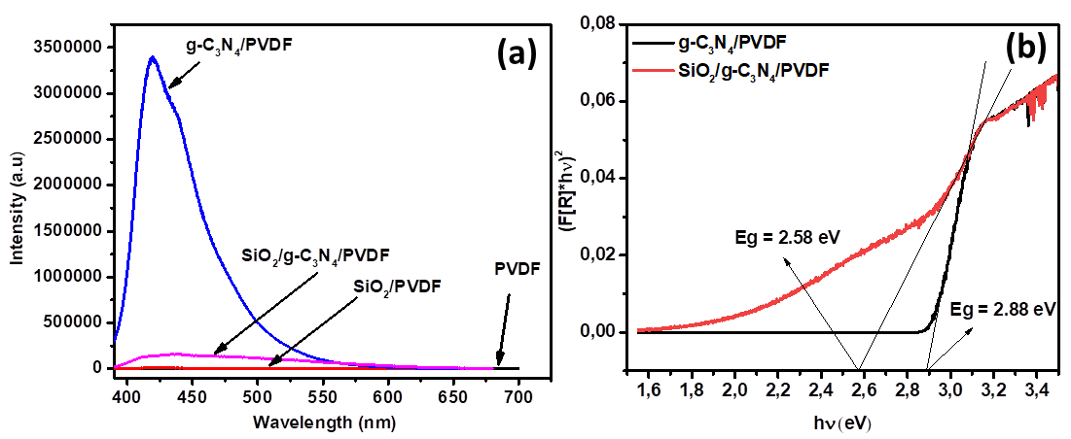
Figure. 4. (a) PL spectra of g-C₃N₄/PVDF, SiO₂/PVDF, PVDF, SiO₂/g-C₃N₄/PVDF (a) and (b) Band gap energy of g-C₃N₄/PVDF, SiO₂/g-C₃N₄/PVDF.
For PVDF, no PL intensity was observed over the entire spectral range. The g-C₃N₄ particles dispersed on the PVDF membrane have a maximum intensity corresponding to a wavelength of 419 nm, where the molecules with amino groups, such as g-C₃N₄, the nucleophile attack of the amino group on the carbon atom will lead to the nucleophile substitution of fluorine to form a covalent bond between PVDF and g-C₃N₄. The observed PL intensity of g-C₃N₄ is higher, which indicates a faster recombination rate between photogenerated electrons and holes. As for the PL spectrum of SiO₂/PVDF, the emission intensity is very low, almost equivalent to the PL spectrum of PVDF. This is explained by the fact that SiO₂ has a significant band gap energy and poor photocatalytic activity in the visible light region. On the other hand, the PL spectrum of the SiO₂/g-C₃N₄/PVDF composite material has a reduced fluorescence emission intensity compared to g-C₃N₄/PVDF (Figure 4a) and the band gap energy of the SiO₂/g-C₃N₄/PVDF material (Eg = 2.58 eV) is lower than that of g-C₃N₄/PVDF (Eg = 2.88 eV) (Figure 4b). Therefore, when there is radiation, electrons move from g-C₃N₄ to the conduction band of SiO₂ and then quickly move to the catalyst's surface to perform a reduction reaction with oxygen molecules, limiting the ability to recombine.
3.2. Photocatalytic performance
The results of the photocatalytic evaluation for PVDF, g-C₃N₄/PVDF, and C/g-C₃N₄/PVDF are shown in Figure 5.
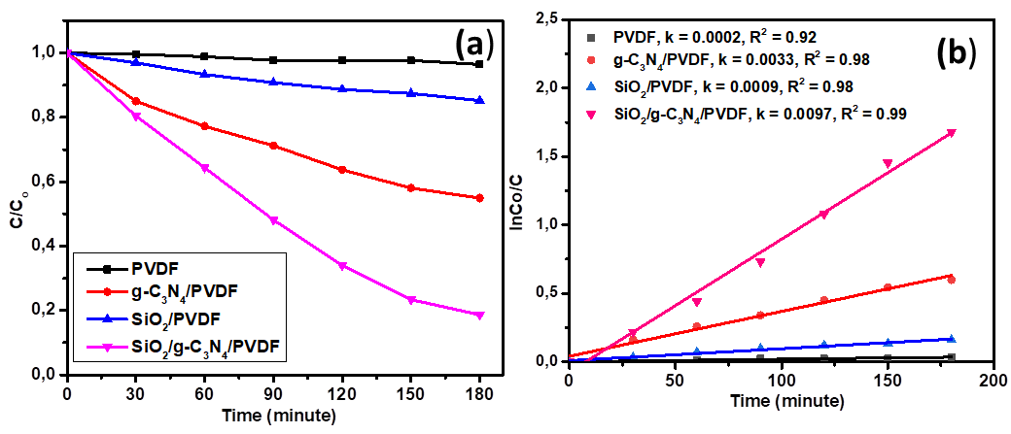
Figure 5. (a) RhB decomposition and (b) pseudo-ﬁrst-order kinetic model under visible light of g-PVDF, C₃N₄/PVDF, SiO₂/g-C₃N_{4,} and SiO₂/g-C₃N₄/PVDF.
The graph shows that after 180 minutes of illumination under a 40W LED lamp, the decomposition efficiency of RhB solution of SiO₂/g-C₃N₄/PVDF sample is the highest at 81.35%, the materials g-C₃N₄/PVDF, SiO₂/PVDF have decomposition efficiency of 46.07% and 14.79% respectively. This may be because the band gap energy of the SiO₂/g-C₃N₄/PVDF material (2.58 eV) is lower than the band gap energy of the g-C₃N₄ material (2.88 eV), which makes the ability to separate and move photogenerated electrons and holes to the material surface to perform reactions faster, limiting the ability to recombine between charge carriers. SiO₂/PVDF material works well in the ultraviolet region, which is understandable because the photocatalytic efficiency in the visible light region is only 14.79%. The PVDF membrane alone did not show photocatalytic activity, indicating that the photocatalytic activity was due to the composite material; the single dispersed materials were exhibited. The kinetic model of RhB degradation of SiO₂/g-C₃N₄/PVDF material has a rate constant of 0.0097 (min⁻¹) which is much larger than that of C₃N₄/PVDF and SiO₂/PVDF materials (0.0033 and 0.0009 min⁻¹) (Figure 5b). A comparison of the rate constant of the present work with the previous works is listed in Table S1. However, the comparison is lame because the reaction conditions are not the same. However, Table S1 shows that the rate constant of SiO₂/g-C₃N₄/PVDF is relatively high compared to previous studies. This result confirms the potential application of SiO₂/g-C₃N₄/PVDF material in the treatment of organic pollutants under visible light in aquatic environments.

4. CONCLUSION
In this study, PVDF composite films modified with SiO₂ and g-C₃N₄ were successfully synthesized. XRD and FT-IR results showed that the incorporation of fillers did not change PVDF's crystal structure and polymer framework. The surface morphology is significantly improved with the appearance of a porous structure and a uniformly dispersed phase. PL spectrum and band gap analysis showed that the SiO₂/g-C₃N₄/PVDF sample can inhibit e⁻/h⁺ recombination, and the band gap is suitable for visible light absorption. Photocatalytic testing showed that the SiO₂/g-C₃N₄/PVDF sample had the highest RhB degradation efficiency (81.35%), confirming its potential application in organic pollution treatment under visible light.
Acknowledgments
This research is conducted within the framework of a science and technology project at the institutional level of Quy Nhon University under the project code T2025.885.05.
REFERENCES
(1) K. Sun, Q-Y. Lv, X-L. Chen, L-B Qu and B. Recent advances in visible-light-mediated organic transformations in water. Green Chemistry, 2021, 23 (1), 232-248.
(2) H. Lin, J. Wu, F. Zhou, X. Zhao, P. Lu, G. Sun, Y. Song, Y. Li, X. Liu, H. Dai. Graphitic carbon nitride-based photocatalysts in the applications of environmental catalysis. Journal of Environmental Sciences, 2023, 124, 570-590.
(3) P. B. B. Long, V. C. Nguyen, H. A. Le Pham, Q. T. H. Ta, H. P. Dang. Effect of the Dimethylformamide/Isopropanol Solvent Ratio on the Structure, Optical Properties, and Photodegradation Performance of RhB Using Bi-MOF. Bulletin of Chemical Reaction Engineering & Catalysis, 2025, 20 (1), 166-176.
(4) T. K. A. Nguyen, T. T. Pham, H. Nguyen-Phu, EW. Shin. The effect of graphitic carbon nitride precursors on the photocatalytic dye degradation of water-dispersible graphitic carbon nitride photocatalysts. Appl. Surf. Sci. 2021, 537, 148027-148038.
(5) Yu. Yutang, H. H. Coupled adsorption and photocatalysis of g-C₃N₄ based composites: Material synthesis, mechanism, and environmental applications. Chemical Engineering Journal, 2023, 453, 139755.
(6) Q. Hao, X. Niu, C. Nie, S. Hao, W. Zou, J. Ge, D. Chen, W. Yao. Highly Efficient g-C₃N₄/SiO₂ Heterojunction: The role of SiO₂ for the Enhanced Visible Light Photocatalytic Activity. Phys. Chem. Chem. Phys, 2016, 18 (1-25).
(7) X. Wang, S. Wang, W. Hu, J. Cai, L. Zhang, L. Dong, L. Zhao, Y. He. Synthesis and photocatalytic activity of SiO₂/g-C₃N₄ composite photocatalyst. Materials Letters, 2014, 115, 53-56.
(8) Q. T. H. Ta, G. Namgung, J. S. Noh. Facile synthesis of porous metal-doped ZnO/g-C₃N₄ composites for highly efficient photocatalysts. Journal of Photochemistry and Photobiology A: Chemistry, 2019, 368, 110-119.
(9) T. Li, L. Zhao, Y. He, J. Cai, M. Luo, J. Lin. Synthesis of g-C₃N₄/SmVO₄ composite photocatalyst with improved visible light photocatalytic activities in RhB degradation. Applied Catalysis B: Environmental, 2013, 129, 255-263.
(10) Y. He, J. Cai, T. Li, Y. Wu, Y. Yi, M. Luo, L. Zhao. Synthesis, characterization, and activity evaluation of DyVO₄/g-C₃N₄ composites under visible-light irradiation. Industrial & engineering chemistry research, 2012, 51 (45), 14729-14737.
(11) S. C. Yan, S. B. Lv, Z. S. Li, Z. G. Zou. Organic–inorganic composite photocatalyst of gC₃N₄ and TaON with improved visible light photocatalytic activities. Dalton Transactions, 2010, 39 (6), 1488-1491.
(12) G. Liu, P. Niu, C. Sun, S. C. Smith, Z. Chen, G. Q. Lu, H. M. Cheng. Unique electronic structure induced high photoreactivity of sulfur-doped graphitic C₃N₄. Journal of the American Chemical Society, 2010, 132 (33), 11642-11648.
(13) X. Chen, J. Zhang, X. Fu, M. Antonietti, X. Wang. Fe-g-C₃N₄-catalyzed oxidation of benzene to phenol using hydrogen peroxide and visible light. Journal of the American Chemical Society, 2009, 131 (33), 11658-11659.
(14) C. Yao, A. Yuan, H. Zhang, B. Li, J. Liu, F. Xi, X. Dong. Facile surface modification of textiles with photocatalytic carbon nitride nanosheets and the excellent performance for self-cleaning and degradation of gaseous formaldehyde. Journal of Colloid and Interface Science, 2019, 533, 144-153.
(15) J. Zhao, J. Wang, L. Fan, E. Pakdel, S. Huang, X. Wang. Immobilization of titanium dioxide on PAN fiber as a recyclable photocatalyst via co-dispersion solvent dip coating. Textile Research Journal, 2017, 87 (5), 570-581.
(16) L. Peng, W. Chen, B. Su, A. Yu, X. Jiang. CsxWO₃ nanosheet-coated cotton fabric with multiple functions: UV/NIR shielding and full-spectrum-responsive self-cleaning. Applied Surface Science, 2019, 475, 325-333.
(17) C. Shi, J. Zhu, X. Shen, F. Chen, F. Ning, H. Zhang, YZ. Long, X. Ning, J. Zhao. Flexible inorganic membranes used as a high thermal safety separator for the lithium-ion battery. RSC advances, 2018, 8 (8), 4072-4077.
(18) I. Kolesnyk, J. Kujawa, H. Bubela, V. Konovalova, A. Burban, A. Cyganiuk, W. Kujawski. Photocatalytic properties of PVDF membranes modified with g-C₃N₄ in the process of Rhodamines decomposition. Separation and Purification Technology, 2020, 250, 117231.
(19) K. Prakash, PS. Kumar, P. Latha, K. Saravanakumar, S. Karuthapandian. Design and fabrication of a novel metal-free SiO₂/gC₃N₄ nanocomposite: a robust photocatalyst for the degradation of organic contaminants. Journal of Inorganic and Organometallic Polymers and Materials, 2018, 28, 268-278.
(20) Y. Shen, X. Guo, X. Bo, Y. Wang, X. Guo, M. Xie, X. Guo. Effect of template-induced surface species on electronic structure and photocatalytic activity of g-C₃N₄. Applied Surface Science, 2017, 396, 933-938.
(21) Z. Mo, X. She, Y. Li, L. Liu, L. Huang, Z. Chen, Q. Zhang. Synthesis of g-C₃N₄ at different temperatures for superior visible/UV photocatalytic performance and photoelectrochemical sensing of MB solution. RSC advances, 2015, 5(123), 101552-101562.
(22) B. Zhu, P. Xia, Y. Li, W. Ho, J. Yu, Fabrication and photocatalytic activity enhanced mechanism of direct Z-scheme g-C₃N₄/Ag₂WO₄ photocatalyst. Applied Surface Science, 2017, 391, 175-183.
(23) Z. Vilamova, P. Czernek, J. Zagora, L. Svoboda, J. Bednar, Z. Simonova, D. Placha, R. Dvorsky. Fibrous PVDF membranes modified by anchored g-C₃N₄@ GO composite with enhanced photocatalytic activity. Applied Surface Science, 2024, 677, 161055.
(24) Y. J. Kim, C. H. Ahn, M. B. Lee, M. S. Choi. Characteristics of electrospun PVDF/SiO₂ composite nanofiber membranes as polymer electrolyte. Materials Chemistry and Physics, 2011, 127 (1-2), 137-142.

