Manuscript Template

Đánh giá tiềm năng tái sử dụng bùn thải từ nhà máy nước để thay thế một phần xi măng trong vật liệu bê tông xây dựng

Châu Ngọc Bảo^{1,}*, Vương Lê Thắng¹, Nguyễn Văn Phú Đạt¹, Trần Thanh Bình¹

¹Đại học Đà Nẵng-Trường Đại học Bách khoa, 54 Nguyễn Lương Bằng, Đà Nẵng, Việt Nam

*Tác giả liên hệ. Email: cnbao@dut.udn.vn

Ngày nhận bài: dd/mm/yyyy; Ngày sửa bài: dd/mm/yyyy;
Ngày nhận đăng: dd/mm/yyyy; Ngày xuất bản: dd/mm/yyyy

TÓM TẮT
Sự gia tăng nhanh chóng của dân số và đô thị hóa trong những năm gần đây đã làm gia tăng lượng chất thải, bao gồm cả bùn thải từ các nhà máy xử lý nước sinh hoạt, nước thải và các quy trình công nghiệp. Theo phương pháp truyền thống, bùn thải thường được xử lý bằng cách chôn lấp tại các khu vực quy định, gây ra vấn đề môi trường và chi phí cao. Đồng thời, nhu cầu ngày càng lớn về vật liệu xây dựng, đặc biệt là bê tông – một trong những vật liệu xây dựng chủ đạo trên toàn cầu – đã làm gia tăng việc khai thác tài nguyên thiên nhiên và góp phần đáng kể vào lượng phát thải CO₂, nhất là từ sản xuất xi măng Portland. Những vấn đề trên cho thấy sự cần thiết phải tìm kiếm các vật liệu thay thế nhằm giảm thiểu tác động môi trường. Trong bối cảnh đó, việc sử dụng bùn thải từ nhà máy xử lý nước như một phần thay thế xi măng trong sản xuất bê tông nổi lên như một giải pháp tiềm năng. Cách tiếp cận này mang lại nhiều lợi ích: giảm chất thải, tiết kiệm tài nguyên, giảm tiêu thụ năng lượng và hạn chế phát thải CO₂ từ sản xuất xi măng. Nghiên cứu này nhằm đánh giá tiềm năng sử dụng bùn thải xử lý nước như một chất thay thế một phần cho xi măng trong các hỗn hợp bê tông. Kết quả cho thấy tính khả thi của giải pháp và đóng vai trò làm nền tảng cho các nghiên cứu tiếp theo, hướng đến ứng dụng thực tiễn và phát triển bền vững trong xây dựng.
Từ khóa: bùn thải nhà máy nước, bê tông, thay thế xi măng, phát triển bền vững.

Manuscript Template

Assessing the Potential of Water Treatment Sludge for Cement Replacement in Concrete

Chau Ngoc Bao^{1,}*, Vuong Le Thang¹, Nguyen Van Phu Dat¹, Tran Thanh Binh¹

¹The University of Danang, University of Science and Technology, 54 Nguyen Luong Bang, Danang, Vietnam

*Corresponding author. Email: cnbao@dut.udn.vn

Received: dd/mm/yyyy; Revised: dd/mm/yyyy;
Accepted: dd/mm/yyyy; Published: dd/mm/yyyy

ABSTRACT
The rapid growth of population and urbanization in recent years has led to a significant increase in waste generation, including sludge produced from domestic water treatment plants, wastewater treatment facilities, and various industrial processes. Conventionally, the disposal of such sludge is carried out through landfilling at designated sites, which not only poses environmental challenges but also incurs substantial associated costs. Concurrently, the rising demand for construction materials, particularly concrete, which constitutes a major portion of global building materials, has escalated the consumption of natural resources and contributed to considerable CO₂ emissions, especially from the production of Portland cement. These concerns underscore the urgent need to explore alternative materials that can mitigate environmental impacts. In this context, the reuse of sludge from water treatment plants as a partial replacement for cement in concrete production emerges as a promising solution. This approach offers multiple benefits, including waste reduction, conservation of raw materials, energy savings, and a decrease in CO₂ emissions associated with cement production. This study aims to evaluate the potential of utilizing water treatment sludge as a partial substitute for cement in concrete mixtures. The results highlight the feasibility of this approach and serve as a foundation for further research toward its practical application, contributing to sustainable development in the construction sector.
Keywords: water sludge treatment, concrete, cement replacement, sustainable development.

1. INTRODUCTION
The production of waste materials is an ever-increasing global challenge, particularly the large quantities of sludge generated by wastewater treatment processes and water treatment plants (WTPs) ^{1–3}. In Danang city, the volume of municipal sewage sludge has been estimated at approximately 6 million m³/year ⁴. The direct disposal of this sludge, whether from wastewater or water treatment, poses serious environmental concerns due to the presence of pathogens, heavy metals, unstable organic matter, and the limited landfill space ^{1,2,4,5}. These issues necessitate a critical search to identify effective and environmentally safe management alternatives.
The construction industry, known for its high demand for resources and materials, presents a significant opportunity for the valorization and reuse of waste materials generated by its own activities and other sectors ⁶. Utilizing waste into construction can decrease energy consumption, conserve non-renewable natural resources, and reduce the volume of material sent to landfills ⁶. Given its substantial volume and potential environmental impact, sludge from water and wastewater treatment has been identified as a promising material for application in the construction sector ^{6–11}. However, the use of wastewater treatment sludge is limited by the presence of undesirable constituents, such as heavy metals and complex organic compounds, as well as the need for extensive pre-treatment ¹². Conversely, water treatment sludge (WTS) originating from drinking water treatment plants typically contains lower levels of these contaminants, rendering it more suitable and increasingly considered for use in construction materials. Various recycling and recovery options have been developed for sewage sludge, including its use in manufacturing ceramic tiles and bricks, synthesizing lightweight materials, producing cementitious binders, and serving as an alternative fuel in the clinkerization process. Water treatment sludge (WTS) has also been explored for use in ceramic materials and as a lightweight aggregate ^{3,7}.
Previous research has explored the effects of incorporating WTS, in various forms and treatments, into concrete and cement-based materials. Using WTS as a partial replacement for aggregate in concrete has shown potential benefits for mechanical properties and durability ¹³. Investigations into replacing clinker or cement with WTS have yielded varying results ^{8,14}. For example, studies on eco-cement produced with dry WTS as a partial replacement of raw materials indicated that chemical composition is comparable to ordinary Portland cement, although properties such as specific gravity, fineness, setting times, and workability are affected ^{2,15}. Mechanical strengths can be comparable to control samples, particularly at later curing ages, but notable reductions might occur depending on the replacement level and water/cement ratio.The incorporation of raw or wet WTS has generally been found to reduce concrete strength, making it less suitable for structural applications, though it remains viable for non-structural concrete at low replacement levels ^{7,9,10}. The porous and irregular morphology of sludge particles can increase water demand and negatively affect workability. This variability underscores the importance of evaluating WTS in specific local contexts, considering both material properties and practical application requirements.
Despite its promising potential and environmental benefits, in Vietnam, research on the reuse of WTS in construction remains limited, despite the country facing growing urbanization, infrastructure demand, and environmental pressures from waste disposal. To address this gap, the present study investigates the potential of WTS sourced from the Cau Do Water Treatment Plant in Danang City as a partial replacement for Portland cement in concrete. Specifically, the study examines the effects of incorporating thermally treated WTS at different replacement levels on the compressive strength of concrete at various curing ages. By providing experimental evidence within the Vietnamese context, this work aims to assess the technical feasibility of WTS recycling, support sustainable waste management practices, and contribute to advancing circular economy approaches in the construction industry
2. COLLECTION OF WATER TREATMENT SLUDGE FROM WATER TREATMENT
The water treatment sludge (WTS) utilized in this study was sourced from the Cau Do Water Treatment Plant, located in Cam Le District, Da Nang City, Vietnam. The facility, occupying an area of approximately 124,916 m², abstracts raw water from the Cam Le River and serves as a primary source of potable water for the urban population. Initially designed with a treatment capacity of 170,000 m³/day, the plant was upgraded in 2020 to increase its capacity to 290,000 m³/day. Future development plans aim to further expand this capacity to 390,000 m³/day by 2030 to meet the city's growing water demand. The Cau Do Water Treatment Plant is a critical component of Da Nang's water supply infrastructure, accounting for approximately 82% of the city's total water treatment capacity.

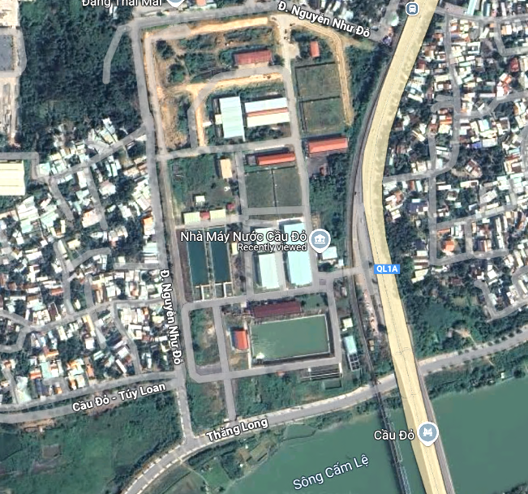
Figure 1. Location of Cau Do Water Treatment Plant.
During the treatment (Figure 2) of raw river water for domestic use at the Cau Do Water Treatment Plant, the processes of suspended solids and turbidity removal result in the generation of substantial quantities of sludge. The principal sources of this sludge are the sedimentation process-following by the dosing of coagulant chemicals, where flocculated particles aggregate and settle at the bottom of sedimentation basins, and the routine backwashing of sand filters, which removes accumulated particulates. Sludge from the sedimentation tanks, along with the solids-laden backwash water, is collected via an integrated system of pipelines and pumps, and subsequently conveyed to the plant’s designated sludge treatment facility. At this stage, the sludge undergoes dewatering and is encapsulated in specialized containment bags to facilitate handling, transport, and subsequent disposal or further treatment

Figure 2. The process of a Water treatment plant.

3. CONCRETE MIXTURE WITH WATER TREATMENT SLUDGE AS PARTIAL CEMENT SUBSTITUTE
Water treatment sludge collected from the treatment plant was subjected to thermal processing at temperatures of 300°C in a controlled heating chamber (Figure 3). This thermal treatment aimed to eliminate residual moisture content within the sludge. The process duration ranged from 2 to 3 days, depending on the initial moisture content. The heating process was considered complete when the mass difference between two consecutive weight measurements became negligible, indicating the attainment of a constant weight.
Figure 4 presents the chemical compositions of WTS in its original state (sample M1) and after heating at 300°C (sample M2). Following thermal treatment, the Loss On Ignition (LOI) content decreased significantly, from nearly 30% in the original state to approximately 5% at 300°C. This expected behavior reveals a possibility to remove unwanted moisture and organic matter from the WTS for further use as a cement substitute.
Following thermal treatment, the water treatment sludge (WTS) was allowed to cool to room temperature, then crushed and sieved to obtain particles with diameters smaller than 0.09 mm—comparable to the fineness of Portland cement. To prevent agglomeration caused by ambient moisture, the processed WTS was subsequently stored in sealed plastic bags and placed in a controlled dry chamber to maintain its stability before further use

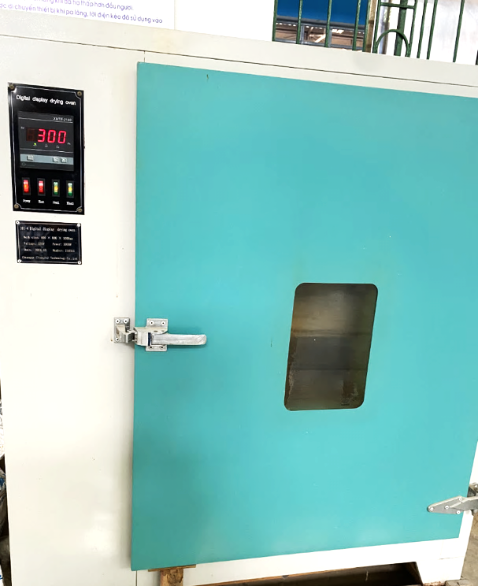
Figure 3. Heating Chamber
The concrete mixtures was designed for concrete of strength grade B15 according to The Vietnamese Standard TCVN 5574:2018 ¹⁶. Different mixtures were prepared corresponding to different replacement ratios of WTS for Portland cement: 0%, 5% and 10% at 300°C. The grade cement used in this study was PCB40, manufactured by Hoang Thach Company, and mixed with river sand and coarse aggregate with particle sizes ranging from $1÷2cm$ (Table 1)
Cubic concrete specimens measuring 150mm x 150mm x 150mm were prepared, cured and tested for compressive strength in accordance with the Vietnamese Standard TCVN 3118:2022 (Figure 5, Figure 6). The mixtures were designed to achieve a target compressive strength of grade B15 following the Vietnamese Standard TCVN 5574:2018 ¹⁶. The experimental program included mixtures with varying replacement levels of Portland cement by water treatment sludge (WTS) calcined at 300°C, specifically at substitution rates of 0%, 5%, and 10% by mass.
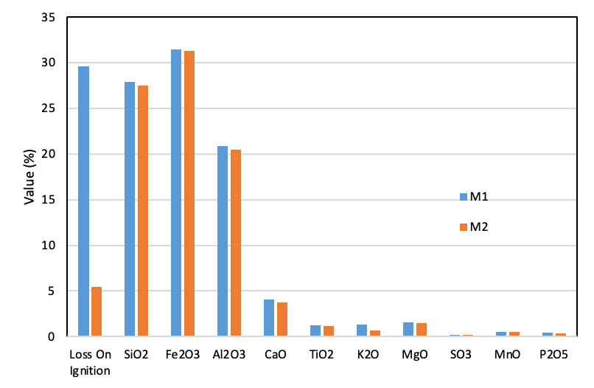
Figure 4. Chemical composition of WTS after thermal treatment

Table 1. Mixture of concrete with partial replacement of cement by WTP
No | Substitution Rate | Adhesive Aggregate  (kg) |  | Stone (kg) | Sand (kg) | Water to Cement Ratio | Heating  Temperature (°C) | Number of sample | Slump (cm)
No | Substitution Rate | Cement | WTS
1 | 0% | 305.00 | 0 | 1120.9 | 728.3 | 0.69 | 0 | 3 | 9
2 | 5% | 289.75 | 15.25 | 1120.9 | 728.3 | 0.69 | 300 | 3 | 8
3 | 10% | 274.50 | 30.50 | 1120.9 | 728.3 | 0.69 | 300 | 3 | 6

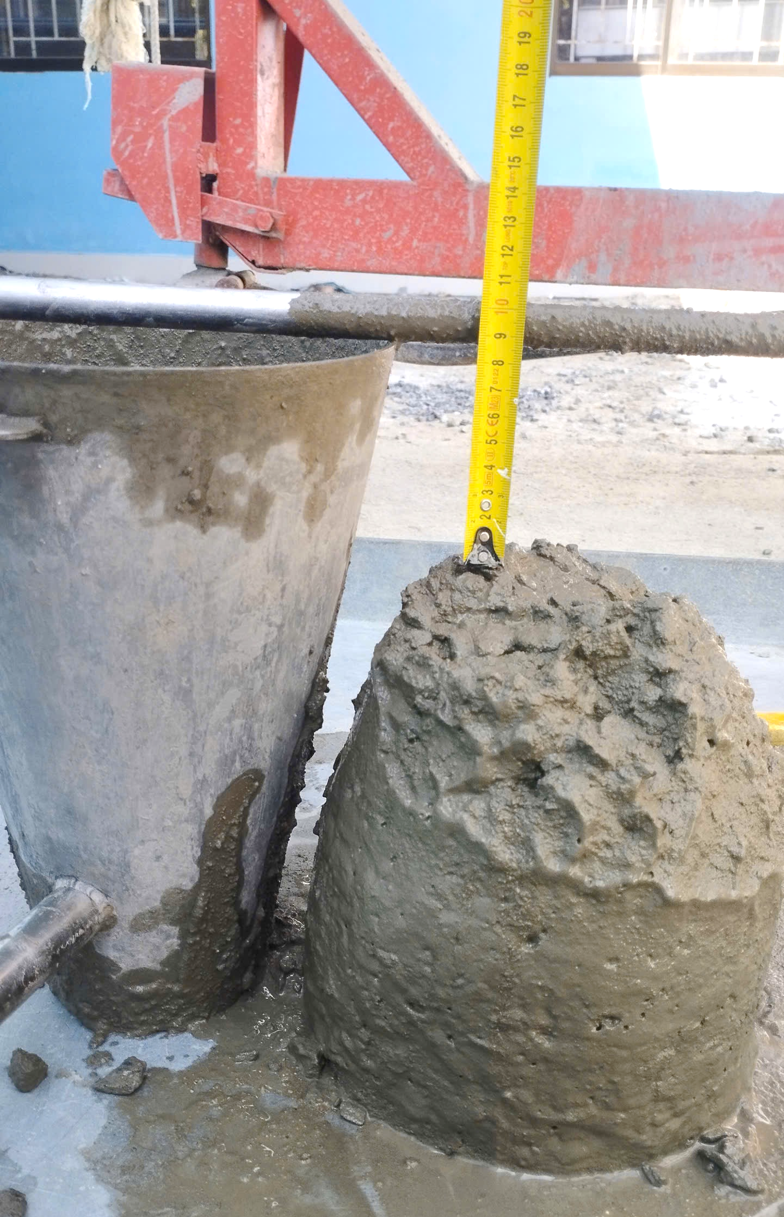 | 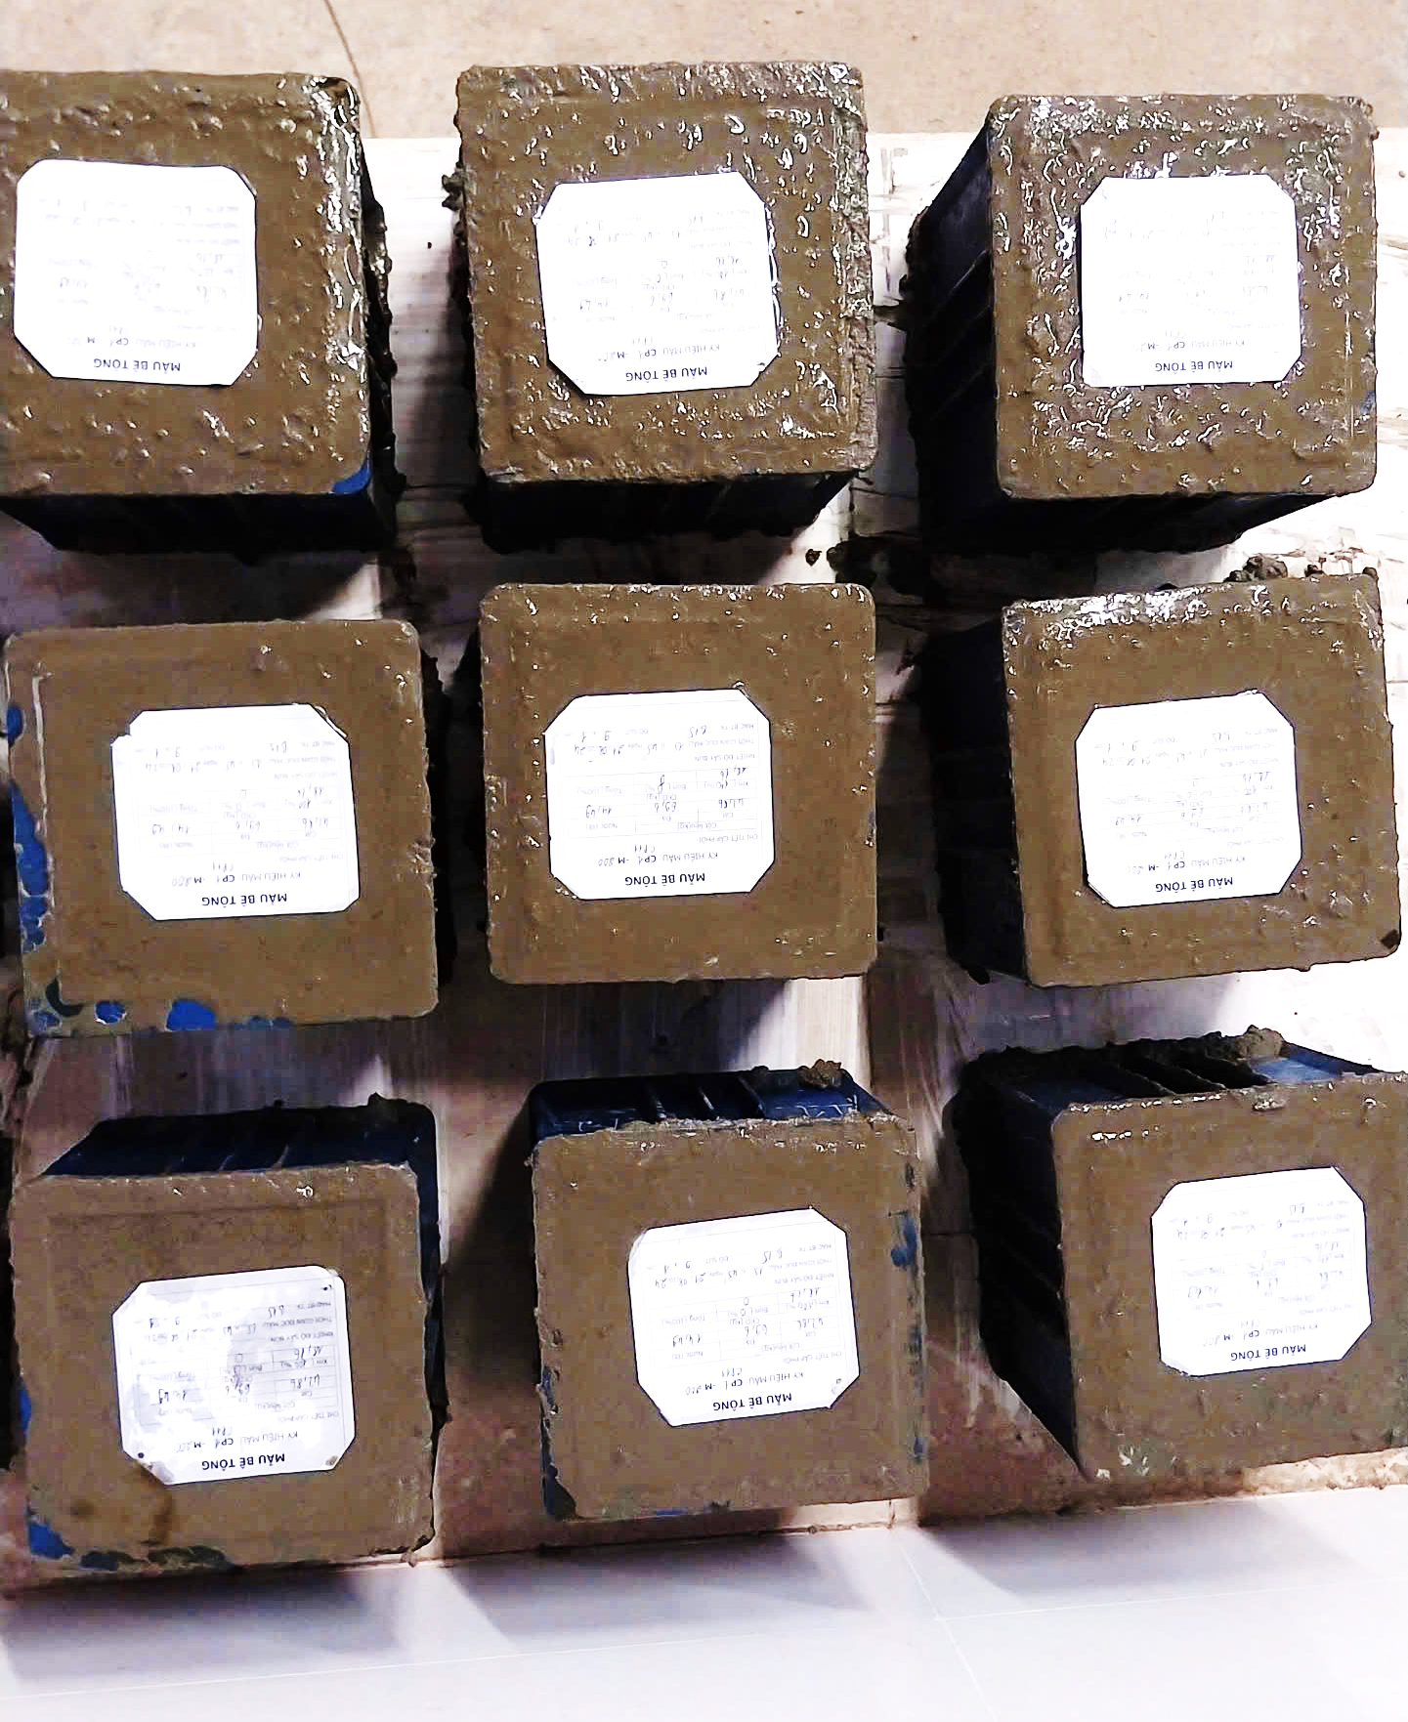 | 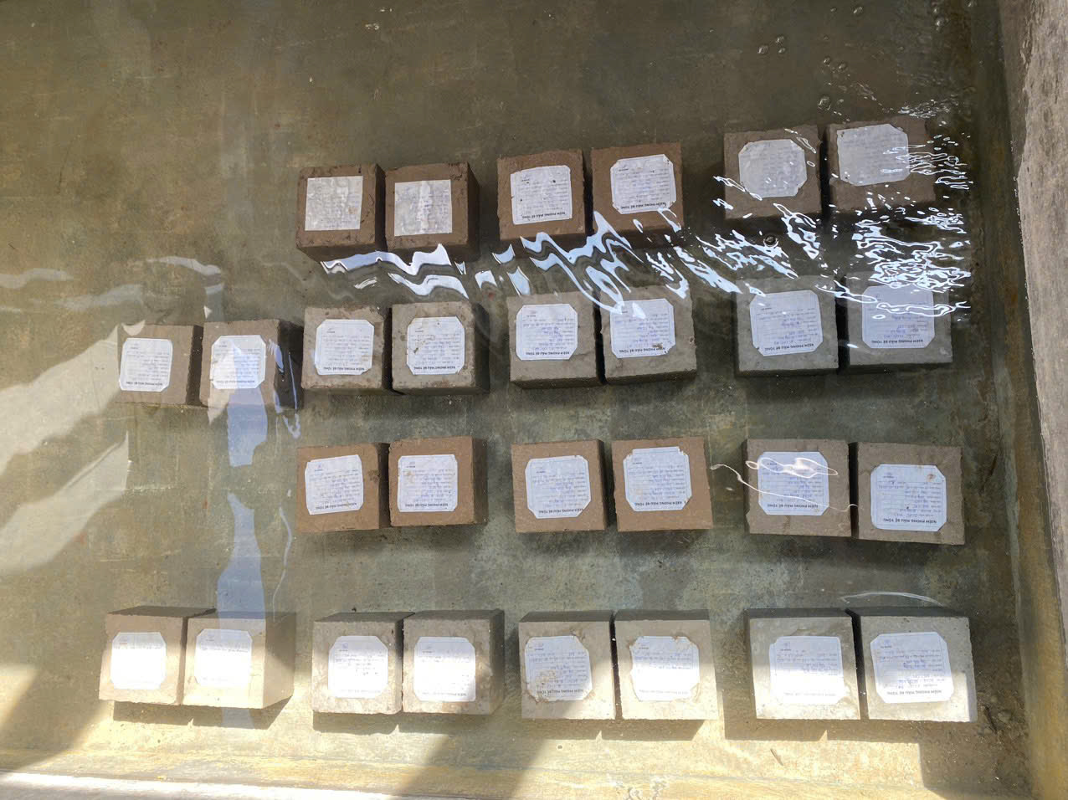
(a) | (b) | (c)
Figure 5. (a) Slump tests, (b) Concrete samples after casting and (c) Curing of concrete samples.

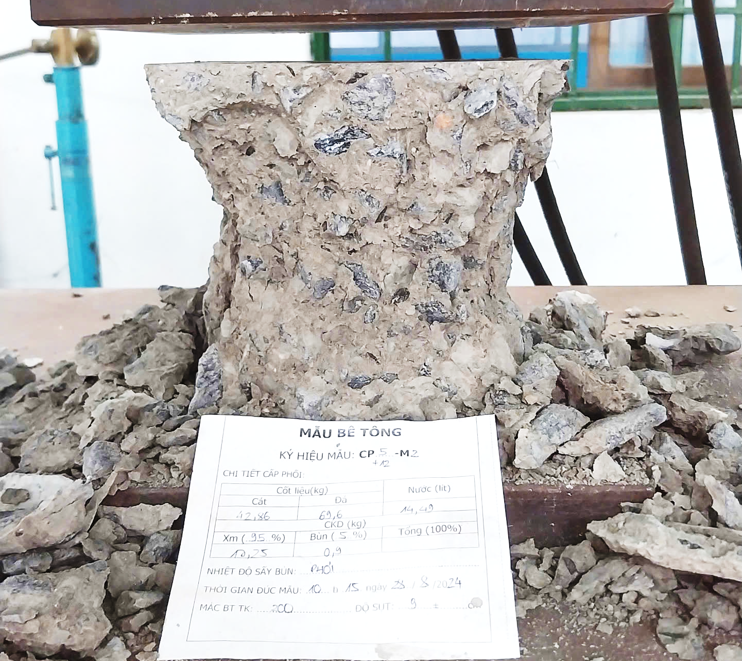 | 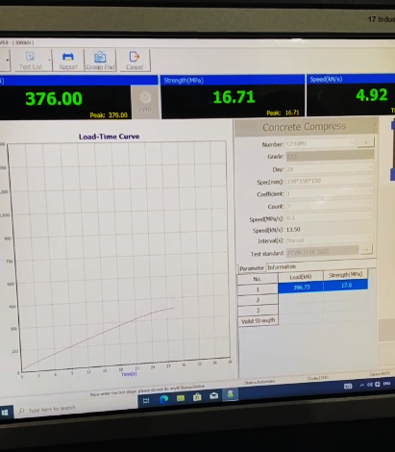
(a) | (b)
Figure 6. (a) Compressive test, (b) Monitoring the compressive result.

4. EVALUATION OF COMPRESSION STRENGTH OF CONCRETE USING WATER TREATMENT SLUDGE
This section presents the compressive strength results of various concrete mixtures incorporating water treatment sludge (WTS) as a partial replacement for cement. The WTS was collected from a municipal water treatment facility and subsequently dried at 300°C to eliminate residual moisture. Following this pre-treatment, the WTS was used to partially replace cement in different concrete mix designs, as detailed in Section 3. Compressive strength tests were conducted at curing ages of 3, 7, and 28 days (Figure 7). For comparison, the compressive strength of a reference concrete mix without WTS was also evaluated at each corresponding age.
As illustrated in Figure 7, the compressive strength of concrete increased with curing time. However, achieving compressive strength comparable to the reference mixture proved challenging when incorporating WTS as a partial cement replacement. Across all tested mixtures, those without WTS consistently exhibited higher compressive strength than those containing WTS. Nonetheless, the degree of compressive strength reduction varied with different replacement ratios. Among the investigated proportions, a 5% WTS replacement demonstrated the most favorable performance, consistently yielding higher compressive strength than 10% replacement level. Notably, at 28 days, the compressive strength of the 5% WTS mixture approached 91% of the reference value when dried at 300 °C. These findings suggest that a 5% WTS replacement may represent an optimal ratio for maintaining compressive strength comparable to conventional concrete formulations. This result is consistent with the findings of Gomes et al,. ^{3,7} who reported that the negative effect of WTS became more significant at replacement level higher than 5%.

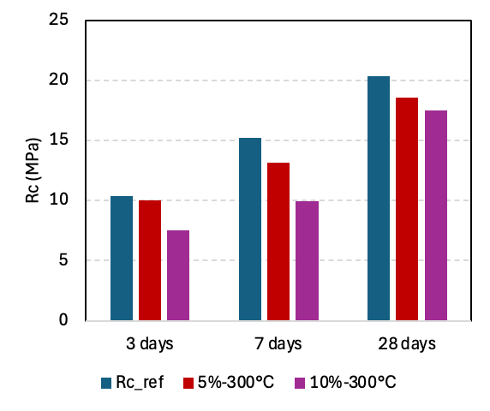
Figure 7. Compression Strength of different concrete mixture with WTS drying at 300°C.
5. CONCLUSIONS
This study evaluated the use of thermally treated water treatment sludge (WTS) from the Cau Do Water Treatment Plant as a partial cement replacement in concrete. At a 5% replacement level, WTS treated at 300 °C retained up to 91% of the 28-day compressive strength, indicating improved pozzolanic activity. Although strength reductions were observed, results suggest WTS can be applied in non-structural concrete, supporting waste valorization and sustainable construction. Further studies on durability, workability, and environmental impacts are recommended.
Acknowledgments
This work was supported by The University of Danang – University of Science and Technology, code number of Project: T2024-02-08.
REFERENCES
1. Naamane, S., Rais, Z. & Taleb, M. The effectiveness of the incineration of sewage sludge on the evolution of physicochemical and mechanical properties of Portland cement. Constr Build Mater 112, 783–789 (2016).
2. Rezaee, F., Danesh, S., Tavakkolizadeh, M. & Mohammadi-Khatami, M. Investigating chemical, physical and mechanical properties of eco-cement produced using dry sewage sludge and traditional raw materials. J Clean Prod 214, 749–757 (2019).
3. Gomes, S. D. C., Zhou, J. L., Li, W. & Qu, F. Recycling of raw water treatment sludge in cementitious composites: effects on heat evolution, compressive strength and microstructure. Resour Conserv Recycl 161, 104970 (2020).
4. Huan, N. X. et al. Properties and Potential Application of Urban Sewage Sludge as Construction Material in Da Nang City. VNU Journal of Science: Earth and Environmental Sciences 40, 51–58 (2024).
5. Mojapelo, K. S., Kupolati, W. K., Ndambuki, J. M., Sadiku, E. R. & Ibrahim, I. D. Case Studies in Construction Materials Utilization of wastewater sludge for lightweight concrete and the use of wastewater as curing medium. Case Studies in Construction Materials 15, e00667 (2021).
6. Baeza-Brotons, F., Garcés, P., Payá, J. & Saval, J. M. Portland cement systems with addition of sewage sludge ash. application in concretes for the manufacture of blocks. J Clean Prod 82, 112–124 (2014).
7. Ramirez, K. G., Possan, E., Dezen, B. G. dos S. & Colombo, M. Potential uses of waste sludge in concrete production. Management of Environmental Quality: An International Journal 28, 821–838 (2017).
8. Nayeri, D. & Mousavi, S. A. A comprehensive review on the coagulant recovery and reuse from drinking water treatment sludge. J Environ Manage 319, (2022).
9. Arsh, K., Mondal, B. C. & Masum, M. M. H. Characterization of water treatment sludge and its implications on concrete and cement mortar as a partial replacement of cement. Constr Build Mater 458, 139454 (2025).
10. Morselli, L. B. G. A. et al. Water treatment sludge as a sustainable cement material in Brazil. Constr Build Mater 484, (2025).
11. He, Z.-H. et al. Recycling of water treatment sludge in concrete: The role of water-binder ratio from a nanoscale perspective. Science of The Total Environment 873, (2023).
12. Silva, J. R., de Carvalho, M. H., Dantas de Jesus, A. M. & Fiore, F. A. Effect of thermal drying on the physico-chemical and microbiological characteristics of drinking water treatment sludge. Clean Eng Technol 26, 100947 (2025).
13. Raman, P., Vembu, S. & Ammasi, A. K. Materials Today : Proceedings Strength and durability of dry sewage sludge ( DSS ) as a replacement for fine aggregates. Mater Today Proc 61, 232–236 (2022).
14. N. Daza-Marquez, A. Guzmán, Y. Avila, J. A.-G. Exploring the potential of nitrophosphogypsum and calcined water-treatment plant sludges in mortar mixtures: A study on workability and strength. Constr Build Mater 432, (2024).
15. Mathye, R. P., Ikotun, B. D. & Fanourakis, G. C. The effect of dry wastewater sludge as sand replacement on concrete strengths. Mater Today Proc 38, 975–981 (2021).
16. Vietnam Institute for Building Science and Technology (IBST). (2018). ‘National Standard- Design of Concrete and Reinforced Concrete Structures’, TCVN 5574:2018.

